American
Printing House
For The Blind

Department of Research

Annual Report
of Research &
Development Activities

Fiscal Year 2017

Table of Contents

MISSION STATEMENT 6
Letter From Director of Educational Product Research 7
Advisory Committees 8
DEPARTMENT OF RESEARCH STAFF 9
Agencies Participating in Research (104) 11
Consultants (103) 14
Field Evaluators / Expert Reviewers (158) 20
ACCESSIBLE TESTS 28
EDUCATIONAL PRODUCT RESEARCH 34
ADULT LIFE 35
AFB Foundations of Rehabilitation Teaching Kit 36
Color-Star® 36
CORE CURRICULUM 38
BUSINESS AND VOCATIONAL EDUCATION 39
FINE AND PERFORMING ARTS 39
Carousel of Textures II 39
Color-by-Texture CIRCUS Coloring Pages 43
Feel the Beat: Braille Music Curriculum 45
Paint-By-Number Safari™ (Series) 47
Strike-A-Pose: Body Awareness Cards for Students with Visual Impairments and Blindness 57
MATHEMATICS 61
AnimalWatch VI Suite 61
AnyMath Kit 63
Common Core Math Kits 66
Flip-Over Concept Books: FRACTIONS 68
Flip-Over Concept Books: TELLING TIME 72
Hundreds Board and Manipulatives 77
Math Homework Kit 78
Math Robot™ 80
MathBuilders 81
Nemeth Code Reference Sheet for Basic Mathematics [Modernization] 84
Place Value Setter 85
Practice2Master Fractions 88
Publisher Collaboration – Pearson (enVisionmath 2.0) 89
Slapstack Math iOS® App 90
Tactile Algebra Tiles 93
Tactile Five and Ten Frames 96
PHYSICAL EDUCATION / HEALTH 105
Count Me In: Motor Development in a Box 105
Gross Motor Development Study and Curriculum 108
Health Education for Students With Visual Impairments: A Guidebook for Teachers 127
Hop-A-Dot Mat 130
Physical Education, Recreation, and Health Web Site 148
Physical Education and Health Special Projects and Needs 149
SPORTS COURTS 150
READING AND LANGUAGE ARTS 174
Early Braille Trade Books 174
Expanded Dolch Word Cards [Modernization] 177
Wilson Reading System 178
SCIENCE 181
Adapted Biology Lab Manual (ABLM) 181
Adapted Science Materials Kit (ASMK) 182
Azer’s Interactive Periodic Table Study Set 185
Build-A-Cell 187
Earth Science Tactile Graphics (ESTG) 188
Light In-Sight: Reflection & Refraction Kit 190
Periodic Table of the Elements Reference Chart and Booklet 193
Protein Synthesis Kit (PSK) 195
Snap Circuits Jr.® Access Kit 197
Submersible Audio Light Sensor (SALS) 202
Talking Scientific Balance 206
Talking Scientific Thermometer 208
SOCIAL STUDIES 209
Tactile World Globe 209
TECHNOLOGY AND MEDIA 222
EARLY CHILDHOOD 223
Animal Recipes 224
Astro Adventure Balls: Swirl, Twirl, & Whirl 225
Art Digitizing/Modernizing of On the Way to Literacy Storybooks 227
Early Childhood Needs 234
Emergent Numeracy Kit For Preschool 235
Fingers That Dream 237
FirstTouch Books 244
Laptime and Lullabies 252
Moving Ahead: Tactile Graphic Storybooks 258
O&M for iPad® 261
Tactile Book Builder 300
Tactile Book Texture and Item Accessory Pack 310
The Best for a Nest [Modernization] 312
Visio Tactual Profile 313
What Is It? [Modernization] 315
EXPANDED CORE CURRICULUM 317
ECC Icon Poster 318
Multiple Disabilities Projects and Needs 320
Quick & Easy ECC Mobile App 322
Visual and Multiple Impairments Website 323
ASSISTIVE TECHNOLOGY AND ELECTRONICS 324
APH SMART Brailler by Perkins 324
Joy Player Digital Cartridge 335
CAREER EDUCATION AND TRANSITION 336
Transition Program Components 336
COMPENSATORY AND ACCESS SKILLS 340
MATCH-IT-UP Frames (Large Set and Small Set) 340
Braille 353
ABCs of Braille: Teachers Guide and Student Book [Modernization] 353
Braille Buzz 354
Braille Contraction Cards [Modernization] 358
Braille Formats: Principles of Print-to-Braille Transcription 359
Braille Literacy Web Site 360
Braille Reading Readiness Workbook 361
Building on Patterns Unified English Braille Supplements 362
Building on Patterns, Second Edition: Kindergarten Level 367
Building on Patterns, Second Edition: Prekindergarten Level 376
Individualized Meaning-Centered Approach to Braille Literacy Education (I-M-ABLE) 391
Low Cost Brailler/Embosser 394
Music Braille Code 394
Quick Pick Braille Contractions [Modernization] 396
Handwriting 397
Study Skills / Organizational Skills 397
Tactile Graphics 397
Feel 'n Peel Stickers: Braille/Print Capital Letters A-Z 397
Finger Walks 400
Flip-Over Concept Books: MAKE A FACE 401
Room with a View: Map-Reading Concepts and Skills 403
Tactile Graphic Art Tape 422
Tactile Graphic Line Slate 424
Tactile Graphics Research 438
Tactile Skills Online Matrix 440
TactileDoodle 444
TG TV 459
INDEPENDENT LIVING SKILLS 460
ORIENTATION AND MOBILITY 460
Crossings With No Traffic Control: Teaching Concepts and Skills to Deal With Them 460
Echolocation and FlashSonar 464
O&M Trivia 467
Teaching Street Crossing to Students With Visual Impairments: How to Teach, Not What to Teach 468
RECREATION AND LEISURE 470
SELF-DETERMINATION 470
V-file 470
SENSORY EFFICIENCY SKILLS 472
DeafBlind Pocket Communicator 472
Let’s Join In [Modernization] 476
SLK: Sensory Learning Kit (Revision) 477
Cortical Visual Impairment 478
Color Raceway 478
Cortical Visual Impairment (CVI) Projects and Needs 481
CVI Book Builder [Modernization] 482
CVI Practitioner’s Guide 484
CVI Web site 485
Increasing Complexity Pegset 486
Mini-Lite Box Overlays 489
Spinner Overlays for the Light Box 493
Visual Organization Toolbox 494
Low Vision 496
Barraga Visual Efficiency Program 496
Decision Making Guide 524
Detachable Light Box Ledge 528
Explorer Bright Ray: LEDs for Persons with Low Vision 528
LED Mini-Lite Box 531
Light Box and Reading Stand Mounting System 532
MATT Connect 533
See Like Me: Low Vision Simulators 534
TADPOLE Overlay Electronic Version [Modernization] 543
Topaz Filters [Modernization] 545
VisioBook® Bag [Modernization] 546
SOCIAL INTERACTION SKILLS 547
TESTS AND ASSESSMENTS 548
Boehm Test of Basic Concepts, Third Edition (Boehm-3): Tactile and Large Print Adaptations 549
Functional Skills Assessment 550
KeyMath™-3 Braille Adaptation 554
NewT: New Tools for Use with FV/LMA 556
Test and Assessment Needs 559
Woodcock-Johnson® IV – Tactile and Large Print Adaptation 562
TECHNOLOGY PRODUCT RESEARCH 566
40-Cell Braille Display with a QWERTY Keyboard 567
Book Port Plus 568
Book Wizard Producer 569
BrailleBlaster 570
Graphiti™ 572
Indoor Explorer Feature for Nearby Explorer 574
Math Flash Online [Modernization] 575
Money Talks 576
Monitoring Technological Developments and Educational Applications 577
Nearby Explorer 580
Nemeth Tutorial 582
Orbit Reader 20™ 584
Orion TI-30XS MultiView™ Talking Scientific Calculator – Software Upgrade 599
Orion TI-84 Plus Talking Graphing Calculator™ – Software Upgrade 600
Studio Recorder 602
Talking Typer for iOS® [Modernization] 603
Talking Typer Web Application 604
Talking Word Puzzles [Modernization] 605
Teacher’s Pet Web Application 607
Visual Brailler 608
UEB Math Tutorial 609
TECHNICAL & MANUFACTURING RESEARCH 612
Technical & Manufacturing Research Activities 613
Other Technical and Manufacturing Research Projects 647
PRESENTATIONS & WORKSHOPS 650
PRODUCT MATERIALS 655
PUBLICATIONS 657
NEW PRODUCTS 659
Complete Projects 662
Active Projects 663
Pipeline Projects 664
Compilation of Projects 665
Status of Product Development 666
Proper Trademark Notice and Attribution 668

MISSION STATEMENT

The American Printing House for the Blind promotes independence of people who are blind and visually impaired by providing specialized materials, products, and services needed for education and life.

Letter From Director of Educational Product Research

October 1, 2017

Dear Friends and Colleagues of APH,
I am excited to present to you the FY 2017 Annual Research Report. In this report, you will find details regarding each product we worked to develop this past year. You can find the reasons for decisions made, detailed field test data, and plans for upcoming products. This work could not happen without the dedication of APH staff, Ex Officio Trustees, and the hundreds of consultants, field testers, and expert reviewers who submitted their ideas for new products, helped to develop products, and provided essential guidance in decision-making through field test participation. I hope that the data here gives you the detailed information on our work from this past year and that it also helps to inform your work.
Dr. Ralph Bartley, Executive Director of Research, retired on October 1, 2016. During his 13 years in this role, he met the APH mission by overseeing the release of 1,117 products that served to educate and bring further independence to people who are blind and visually impaired. Dr. Bartley is a servant leader, who uses the power of consensus, the passion of our mission, and the impact of data to make the best decisions, always considering the needs of our customers first. In the FY 2004 Annual Research Report, Dr. Bartley referred to the challenge of combining both passion and data to provide the best education possible to students. He said, “Ours is an opportunity of a lifetime. Let us respond to the challenge as our leaders and legends have done before us. Together we will make a difference.” His words ring as true today. By combining our passion for this mission with data such as this report, let US continue to respond to the challenge as OUR leaders and legends have done.
Sincerely,
Kate Herndon
Director of Educational Product Research

Advisory Committees

APH especially wishes to acknowledge the superb leadership and guidance from the Ex Officio Trustees serving as members of the Educational Products Advisory Committee (EPAC) and the Educational Services Advisory Committee (ESAC).
Educational Products Advisory Committee – FY 2017
Chair – Eric Guillory (LA)

Doug Anzlovar (IL)
Kristin L. Oien (MN)
Paul Olson (ND)
Christine Short (IA)
Mary Jo Wagner (WV)
Angyln Young (AR)

Alternate – Stephanie Bissonette (VT)
Educational Services Advisory Committee – FY 2017

Chair – Robin King (LA)

Suzanne Dalton (FL)
Donna B. Earley (SC)
Mary T. Lane (NH)
Marty McKenzie (SC)
Serena Preston (IL)
Daniel Wenzel (MN)

Alternate – Carolyn Laseter (UT)

DEPARTMENT OF RESEARCH STAFF

Accessible Tests
Knight, Priscilla, M.A. …………..………………………………………………… Accessible Test Editor
Moschowsky, Daria, B.A. ……………………………………………..………… Accessible Test Editor
Padgett, Katherine, M.L.S. ……………………………………………………… Accessible Test Editor
Louise Knapp, B.A. ………………………………………………………………….Accessible Test Editor
Scott, Kristopher, M.A. …………………………………………………………… Accessible Test Editor
Thompson, Jane, M.A. …….………… Director, Accessible Tests and Textbook Department

Educational Product Research
Greenwell, Laura, B.A….. ………………………………………………………………Graphic Designer
Grimany, Emily, B.A..…………………………………………………………………Research Assistant
Herndon, Kate, M.S.L.I.S…….………………………..Director of Educational Product Research
Hoffmann, Rosanne, Ph.D……………………………………………………….Project Leader (STEM)
Jones, Anthony, B.F.A.…………………………………………….Art Production & Design Manager
Lee, Sara, B.A……………………………………………………………………………..Research Assistant
Mimms, Kelly Kennedy, M.F.A..……………………………………..………………Research Assistant
Monson, Martin, Ed.D.………………………………………………………………..……..Project Leader
Otto, Fred, B.A……………………………………..….Project Leader (Tactile Literacy) (part-time)
Parker, Amy, Ed.D…………………………………………………………………………….Project Leader
Pierce, Tristan, M.I.A……………..……….Project Leader (Multiple Disabilities/Health & P.E.)
Poppe, Karen, B.A…………………….……………………………..Project Leader (Tactile Literacy)
Poppe, Matthew, B.A.……………………………………………………………………Graphic Designer
Renfrow, Mark, M.B.A………………………………………………………………….Program Manager
Rose, Jeremiah, M.A.....................................................................Research Assistant
Senft-Graves, Cathy, M.Eng…………………..Project Leader (Braille Literacy & Technology)
Sullivan, Susan, M.Ed...................................................................Project Leader (CVI)
Twyman, Leasha, M.A.……………………………………………………………….Research Assistant
White, Rachel, M.F.A…………………………………………………………………...Research Assistant
Wicker, Jeanette, M.S.Ed………………………………………………………….………..Project Leader
Wilkinson, Dawn, M.Ed………….................................... Project Leader (Early Childhood)
Willingham, Adrienne, B.A…………………………………………………….. Business Administrator
Wright, Suzette, B.A……………………………………….……Project Leader (Emergent Literacy)
Zhou, Li, Ed.D…………………………………………………………Project Leader (Core Curriculum)
Zierer, Carolyn, M.Ed..........................................Project Leader (Tests & Assessments)
Zierer, Laura, B.A...…………………………………………………………………………..Project Leader

Technology Product Research
Blakey, Leon…………………………………………………………………………………………Programmer
Conaghan, Robert, B.A...................................................Technology Product Specialist
Creasy, Keith, M.S…………………………………………………………………………………Programmer
Freeman, William, B.A.…………………………………………..............Quality Assurance Analyst
Hedges, John, B.S.………………………………………….…………………………………...Programmer
Hodges, Joseph, B.S…………………………………………………………Quality Assurance Analyst
Kennedy-MacKenzie, Heather, M.A…..……………………………Technology Program Manager
Klarer, Mark, M.A……..……………..……………………………………………………………Programmer
Knapp, Corey, B.A..………………………………………………………………………………Programmer
Lovelace, Lawrence, M.S..…………………..……………………………………………iOS® Developer
Luttmer, Rebecca, B.S….………………………………………………………………………Programmer
McDonald, Michael, B.S ………………………………………………………………………..Programmer
Meredith, Rob……………………………….…………………………….……………………….Programmer
Milallos, Rezylle, B.S. .……………………………………………….…………………………Programmer
Perry, Ken, B.S…………………………………………………………………………….…….. Programmer
Pike, Haden, B.S…………………………………………………………………………………..Programmer
Skutchan, Larry, B.A.…………………………………. Director of Technology Product Research
Snow Wilson, Denise, M.S.……………..…………………Technical Communications Specialist
Tribbey, William, Ph.D…………………………………………………………………………..Programmer
Valdes, Leyvis, B.S………………………………………………………………………………..Programmer
Wegner, Joseph…………………………………………………………………………..……….Programmer

Technical & Manufacturing Research
Clark, Adam, B.A...................................................................Manufacturing Specialist
Corcoran, Katherine, B.S., B.F.A…………………………………………………Model/Pattern Maker
Dakin, Andrew, B.F.A.…………………………………………………….…………Model/Pattern Maker
Dixon, Rod, M.F.A……………………………………………………………....Manufacturing Specialist
Etter, Nancy……………………………………………………………….….…..Administrative Assistant
Hayden, Frank, A.A.S., C.E.T.………………Director of Technical & Manufacturing Research
Moulton, Andrew, B.S., M.E.………………Manager of Technical & Manufacturing Research
Poppe, Tom…………………………………………………………………………….Model/Pattern Maker
Robinson, James, M.S, E.E.…………………………………….…………...Manufacturing Specialist
Rogers, Bryan, A.A.S. …………………………………………………….…..Manufacturing Specialist
White, Patrick, M.A.....................................................................Model/Pattern Maker

Agencies Participating in Research (104)

Academy School District 20, Colorado Springs, CO
Adams 12 Five Star Schools, Thornton, CO
Alabama Institute for the Deaf and Blind, Talladega, AL
Alabama School for the Blind, Talladega, AL
Allegheny Intermediate Unit, Homestead, PA
Alphapointe, Kansas City, MO
Anderson County Schools, Lawrenceburg, KY
Arizona State Schools for the Deaf and the Blind, Tucson, AZ
Association for the Blind and Visually Impaired, Grand Rapids, MI
Berks County Intermediate Unit #13 Early Intervention, Reading, PA
BLaST Intermediate Unit 17, Williamsport, PA
Blind Independence, Richland, MS
Broward County Public Schools, Ft. Lauderdale, FL
California Deafblind Services, San Francisco State University, San Francisco, CA
Catholic Charities, Eliot, ME
Catoosa County Public Schools, Ringgold, GA
Children’s Center for the Visually Impaired, Kansas City, MO
Colorado School for the Deaf and the Blind, Colorado Springs, CO
Columbia Regional Program, Portland, OR
Columbus City School District, Columbus, OH
Cooperative Educational Service Agency 8, Gillett, WI
Cupertino Union School District, Sunnyvale, CA
Delrey School, Baltimore, MD
Denver Public Schools, Denver, CO
Department of Human Movement Sciences, Old Dominion University, Norfolk, VA
Edward Hines, Jr. VA Hospital, Hines, IL
Emporia State University, Emporia, KS
Fort Myers High School, Fort Myers, FL
Genesee School District, Genesee, MI
Greenbush Southeast Kansas Education Service Center, Girard, KS
Hastings Public Schools, Hastings, NE
Helen Keller National Center, Sands Point, NY
Illinois School for the Visually Impaired, Jacksonville, IL
Independence Science, LLC, West Lafayette, IN
Indian Prairie School District #204, Naperville, IL
Indiana School for the Blind & Visually Impaired, Indianapolis, IN
Iowa Educational Services for the Blind and Visually Impaired, Vinton, IA
Issaquah School District, Issaquah, WA
Jefferson County Public Schools, Louisville, KY
Jefferson School, Rapid City, SD
Kalamazoo Regional Educational Service Agency, Kalamazoo, MI
Kansas State School for the Blind, Kansas City, KS
Kentucky DeafBlind Project, University of Kentucky College of Education, Lexington, KY
Kentucky School for the Blind, Louisville, KY
Liberty Public Schools, Liberty, MO
LightHouse for the Blind and Visually Impaired, San Francisco, CA
Lillie Jackson Early Childhood Center, Lewisville, TX
Lincoln Parish Schools, Ruston, LA
Lloyd Memorial High School, Erlanger, KY
Louisiana School for the Visually Impaired, Baton Rouge, LA
Mansfield Independent School District, Burleson, TX
Metcalf Laboratory School, Illinois State University, Normal, IL
Ministère de l’Éducation et du Développement de la petite enfance, Fredericton, NB, Canada
Minnesota Department of Education: Division of Special Education, Roseville, MN
Mississippi School for the Blind, Jackson, MS
New Mexico School for the Blind and Visually Impaired, Alamogordo, NM
New Mexico School for the Blind and Visually Impaired: Early Childhood Programs, Albuquerque, NM
New York Institute for the Visually Impaired, Bronx, NY
North Kansas City School District, Kansas City, MO
Northern Illinois University, DeKalb, IL
Northwest Suburban Special Education Organization, Arlington Heights, IL
Ohio State School for the Blind, Columbus, OH
Orange County Public Schools, Orlando, FL
Perkins School for the Blind, Watertown, MA
Phantom Concepts (for PlayAbility Toys™), San Leandro, CA
PlayAbility Toys™, LLC, Tucson, AZ
Prairie Spirit School Division 206, Osler, Saskatchewan, Canada
Prince George’s County Public Schools, Landover, MD
Project Reach: Illinois DeafBlind Project, Philip Rock Center, Glen Ellyn, IL
Racine Unified School District, Racine, WI
Rufus King International Baccalaureate High School, Milwaukee Public Schools, Milwaukee, WI
San Antonio Independent School District, San Antonio, TX
San Diego County Office of Education North Coastal Consortium for Special Education, San Marcos, CA
School Association of Special Education in DuPage, Elmhurst, IL
School District 61 Greater Victoria, British Columbia, Canada
Seattle Lighthouse for the Blind, Seattle, WA
South Carolina School for the Deaf and the Blind, Spartanburg, SC
South Central Service Cooperative, North Mankato, MN
South Dakota School for the Blind and Visually Impaired, Aberdeen, SD
South Harrison High School, Bethany, MO
Special School District of St. Louis County, Town and Country, MO
St. Louis Society for the Blind and Visually Impaired, St. Louis, MO
Texas School for the Blind and Visually Impaired, Austin, TX
Texas Workforce Commission, Vocational Rehabilitation Services, Austin, TX
The College at Brockport, Brockport, NY
The Ohio State School for the Blind, Columbus, OH
The Ohio State University, Columbus, OH
The School Association for Special Education in DuPage County, Lombard, IL
The Sherlock Center at Rhode Island College, Providence, RI
Thomas Jefferson Primary School, Peoria, IL
Thompson School District, Loveland, CO
Tustin Unified School District, Santa Ana, CA; Tustin, CA
University of Arizona, Tucson, AZ
University of British Columbia, Vancouver, British Columbia, Canada
Vermont Association for the Blind and Visually Impaired, Rutland, VT
VISTAS Education Partners, Highland Park, NJ
Visually Impaired Preschool Services (VIPS), Louisville, KY
Washington State Department of Services for the Blind, Tacoma, WA
Washington State School for the Blind, Vancouver, WA
Watertown Unified School District, Watertown, WI
West Chester University, West Chester, PA
West Virginia School for the Blind, Romney, WV
Western Pennsylvania School for Blind Children, Pittsburgh PA
Winnfield Kindergarten School, Winnfield, LA

Consultants (103)

Allen, Tim, B.S., APH Technology Consultant, Louisville, KY
Anderson-Ituarte, Julie, M.A. in Visual Impairment, Blind Skills Specialist, Missouri State University, Regional Professional Development Center, Springfield, MO [Building on Patterns Unified English Braille Supplements]
Bailey, Ian, O.D., Optometrist, University of California, Berkeley, CA, [Decision Making Guide]
Baker, Sandi, M.S.Ed., Core Curriculum Consultant, Louisville, KY [Flip-Over Concept Books: FRACTIONS]
Banman, Joanne C., Educational Associate, Prairie Spirit School Division 206, Osler, Saskatchewan, Canada [MATCH-IT-UP Frames]
Barker, James, Multimedia Producer, Northern Illinois University, DeKalb, IL [Health Education for Students With Visual Impairments: A Guidebook for Teachers]
Bender, Dianne, M.A., Retired Teacher of Students with Visual Impairments, Plattsmouth, NE [Functional Skills Assessment]
Black, Amanda, M.Ed., Teacher of the Visually Impaired, Metro Nashville Public Schools, Nashville, TN [Feel the Beat: Braille Music Curriculum]
Blankenship, Karen, Ph.D., Assistant Professor of the Practice, Department of Special Education, Vanderbilt University, Nashville, TN [Gross Motor Development Study and Curriculum]
Blaylock, Luanne, Educational Vision Specialist, Pulaski County Special School District, Retired, Little Rock, AR [Building on Patterns Second Edition, Prekindergarten and Kindergarten]
Brewer, Alison, Health and Physical Education Teacher, The Ohio State School for the Blind, Columbus, OH [Health Education for Students With Visual Impairments: A Guidebook for Teachers]
Buhler, Kristen, M.S.Ed, M.M. Choral Conducting, Teacher of Students with Visual Impairments, Columbia Regional Program, Portland, OR [Building on Patterns Second Edition, Prekindergarten and Kindergarten]
Clarke, Kay, Ph.D., Teacher of the Visually Impaired, Certified Orientation and Mobility Specialist, Visual Impairment Consultant, Worthington, OH [Laptime and Lullabies]
Croft, Jo Ellen, M.Ed., Certified Orientation and Mobility Specialist, Educational Vision Consultant, Educational Services for the Visually Impaired, Little Rock, AR [Building on Patterns Second Edition, Prekindergarten and Kindergarten]
Dailey Data Group LLC, Shoreline, WA [Woodcock-Johnson® IV – Braille Adaptation Scoring Software]
Dalton, Susan, M.S.Ed., Director/Transition Specialist, TransVision, Sycamore, IL [Transition Program Components]
Daugherty, William, Superintendent, Texas School for the Blind and Visually Impaired, Austin, TX [Barraga Visual Efficiency Program]
Davidson, Whitney Blair, M.S., Educational Aide, Lillie Jackson Early Childhood Center, Lewisville, TX [Adapted Biology Lab Manual]
Dawson, Rosemary, M.S., Teacher of the Visually Impaired, Jefferson County Public Schools, Louisville, KY [Common Core Math Kits]
De Lucchi, Linda, FOSS Co-Director, Lawrence Hall of Science, University of California, Berkeley, CA [Adapted Science Materials Kit]
Dibble, Frances, M.A., Teacher of Students with Visual Impairments, Administrator of High School and Special Education Services, and Coordinator of the Assessment Program at the California School for the Blind (retired); Supervisor of Student Teachers at San Francisco State University; Oakland, CA [Building on Patterns Second Edition, Prekindergarten]
Dilworth, Kate, M.S. Special Education, Teacher of Students with Visual Impairments, Certified Orientation and Mobility Specialist, Columbia Regional Program, Portland, OR [Building on Patterns Second Edition, Prekindergarten and Kindergarten]
Dotseth, Kimberly, Masters Candidate, Department of Special and Early Education, College of Education, Northern Illinois University, DeKalb, IL [Health Education for Students With Visual Impairments: A Guidebook for Teachers]
Ely, Mindy, M.S.Ed., ABD, Assistant Professor, Low Vision Blind Program, Coordinator EL VISTA Project, Department of Special Education, Illinois State University, Normal, Illinois [CVI Practitioner’s Guide]
Erin, Jane, Ph.D., Professor, College of Education, University of Arizona, Retired, Tucson, AZ [AnimalWatch VI Suite], [Barraga Visual Efficiency Program], [Woodcock-Johnson® IV – Tactile Adaptation]
Ethridge, Edith, M.A.Ed., Certified Low Vision Therapist, Low Vision Specialist, Kentucky School for the Blind, Retired, Louisville, KY [V-file]
Ferrell, Kay Alicyn, Ph.D., Professor Emerita of Special Education, University of Northern Colorado, Greeley, CO [Barraga Visual Efficiency Program], [Building on Patterns Second Edition, Prekindergarten], [Boehm Test of Basic Concepts, Third Edition (Boehm-3)]
Filicetti, Mary, M.Ed. Early Childhood Special Education, Teacher of Students with Visual Impairments, Certified Orientation and Mobility Specialist, Fairfax County Public Schools, Fairfax, VA [Building on Patterns Second Edition, Kindergarten]
Friehoff, Thomas, Dipl. Inform., CTO, BAUM Retec AG, Wiesenbach, Germany [Refreshabraille 18]
Furze, Melody Zagami, M.S.Ed., Teacher for children with visual impairments, Tacoma Public Schools, Washington State, Vision Early Interventionist [CVI Practitioner’s Guide]
Gray, Michael, APH Technology Consultant, Louisville, KY
Hadfield, Nick, Teacher of the Blind and Visually Impaired, Certified Orientation and Mobility Specialist, Clearwater, MN [LED Mini Lite Box and Mounting System]
Haegele, Justin A., Ph.D., CAPE, Assistant Professor, Department of Human Movement Sciences, Old Dominion University, Norfolk, VA [SPORTS COURTS]
Haibach, Pamela, Ph.D., Associate Professor, The College at Brockport: State University of New York, Brockport, NY [Count Me In: Motor Development In a Box]
Hapeman, Julie, Certified Orientation and Mobility Specialist, Certified Vision Rehabilitation Therapist, Teacher of the Visually Impaired, Clinician, Milwaukee, WI [O&M Trivia]
Hicks, Tom, Programmer, University of Arizona, Tucson, AZ [AnimalWatch VI Suite]
Holbrook, Cay, Ph.D., Professor, Educational and Counseling Psychology and Special Education, University of British Columbia, Vancouver, British Columbia, Canada [Building on Patterns Second Edition, Prekindergarten and Kindergarten]
Hook, Jo, M.Ed., Diploma in Rehabilitation Work for the Visually Impaired, West Sussex, England [Echolocation & FlashSonar]
Ilic, Sanja, Ph.D., Assistant Professor, Human Sciences, College of Education and Human Ecology, The Ohio State University, Columbus, OH [Health Education for Students With Visual Impairments: A Guidebook for Teachers]
Jaffe, Lynne E., Ph.D., Learning Disabilities and Reading Specialist, Tucson, AZ [Woodcock-Johnson® IV – Tactile Adaptation]
Johnson, Catherine, M.A.Ed., Director of Outreach, Kentucky School for the Blind, Retired, Louisville, KY [V-file]
Kaiser, Justin, PH.D., Certified Orientation and Mobility Specialist, University of South Carolina Upstate, Spartanburg, SC [O&M for iPad®]
Kapperman, Gaylan, Ph.D., Professor, Department of Special and Early Education, College of Education, Northern Illinois University, DeKalb, IL [Health Education for Students With Visual Impairments: A Guidebook for Teachers], [Nemeth Tutorial]
Kelly, Stacy, Ed.D., Assistant Professor, Department of Special and Early Education, College of Education, Northern Illinois University, DeKalb, IL [Health Education for Students with Visual Impairments: A Guidebook for Teachers]
Kish, Daniel, M.A., M.A., Certified Orientation and Mobility Specialist, NOMC, President, World Access for the Blind, Placentia, CA [Echolocation & FlashSonar]
Larkin, Sara, M.A., Statewide Mathematics and Science Consultant for the Blind and Visually Impaired, Iowa Educational Services for the Blind and Visually Impaired, Vinton, IA [AnimalWatch VI Suite], [Publisher Collaboration – Pearson (enVisionmath2.0)]
Lau, Shuk-Man Mandy, BENG (Hons), M.Des, Social Designer, Melbourne, Australia [Reach & Match® Learning Kit]
Lepore, Monica, Ed.D., CAPE, Professor, Department of Kinesiology, Coordinator of Adapted Physical Activity Programs, West Chester University, West Chester, PA [SPORTS COURTS]
Lepore-Stevens, Maria, M.A., CAPE, COMS, West Chester University, West Chester, PA [SPORTS COURTS]
Lieberman, Lauren, Ph.D., Distinguished Service Professor, The College at Brockport: State University of New York, Brockport, NY [Count Me In: Motor Development In a Box], [SPORTS COURTS]
Lopez, Joyce, Product Developer, Phantom Concepts (for PlayAbility Toys™), San Leandro, CA [Paint-By-Number Safari™]
Lueck, Amanda, Ph.D., Associate Professor, San Francisco State University, San Francisco, CA [Decision Making Guide], [Barraga Visual Efficiency Program]
Maffei, Patricia, M.A., Program Director, The Hatlen Center for the Blind, San Pablo, CA [Quick & Easy ECC Mobile App]
Martin, Erika, Ph.D., Biology Lab Coordinator, Emporia State University, Emporia, KS [Adapted Biology Lab Manual]
McCarthy, Tessa, Ph.D., Assistant Professor, Department of Instruction and Learning, University of Pittsburgh [Teaching Street Crossings]
Meza, Rene, APH Technology Consultant, Louisville, KY
Miyake, Yoshi, B.S., Freelance Graphic Artist [NewT], [Explorer Bright Ray]
Montgomery, Marshall, Manufacturer, Napa, CA [Adapted Science Materials Kit]
Moore, Alexis Pierce, M.S.Ed., Teacher of the Blind and Visually Impaired, Special School District of St. Louis County, St. Louis, MO [Common Core Math Kits]
Neybert, Ashley, Overland Park, KS [Submersible Audible Light Sensor]
Nuzzo, Lorette, M.A., Teacher of the Visually Impaired, Jefferson County Public Schools, Louisville, KY [Common Core Math Kits]
Orel-Bixler, Deborah, Ph.D., O.D., Professor of Clinical Optometry, University of California, Berkeley, School of Optometry [Barraga Visual Efficiency Program]
Osterhaus, Susan, M.Ed., Statewide Mathematics Consultant, Outreach Program, Texas School for the Blind and Visually Impaired, Austin, TX [Nemeth Code Reference Sheet for Basic Mathematics]
Peek, Rebecca, M.Ed. Special Education, M.Ed. Early Childhood Special Education, M.Ed. Curriculum and Instruction (Reading), Teacher of Students with Visual Impairments, Fairfax County Public Schools, Fairfax, VA [Building on Patterns Second Edition, Kindergarten]
Ramella, Beth, B.S., M.Ed., Outreach Director and CVI Project Leader, Teacher of the Visually Impaired, Certified Orientation and Mobility Specialist, Certified in Special Education Supervision, Western Pennsylvania School for Blind Children, Pittsburgh, PA [Spinner Overlays for the Light Box], [Color Raceway]
Read, Izetta, B.A., Teacher of Students with Visual Impairments, Santa Barbara County Education Office, Santa Maria, CA [Building on Patterns Second Edition, Prekindergarten and Kindergarten]
Rines, Justine Carlone, M.S., CCC-SLP, Perkins School for the Blind, Watertown, MA [Wilson Reading System]
Roman-Lantzy, Christine, Ph.D., Consultant, Allison Park, PA [Barraga Visual Efficiency Program]
Rosenblum, L. Penny, Ph.D., Adjunct Associate Professor, Department of Special Education, Rehabilitation, and School Psychology, University of Arizona, Tucson, AZ [AnimalWatch VI Suite], [Barraga Visual Efficiency Program]
Ross, Karen S., Ph.D., Former Director of Education and Community Outreach at Carrol Center for the Blind, Sudbury, MA [V-file]
Rowley, Rosalind, M.Ed., Teacher of the Visually Impaired, Perkins School for the Blind, Watertown, MA [Wilson Reading System]
Runyan, Marla, Teacher of Students with Visual Impairments, Lane Regional Programs, Eugene, OR [Gross Motor Development Study and Curriculum]
Sauerburger, Dona, M.A., COMS, Consultant, Gambrills, MD [Crossings with No Traffic Control]
Schaper, Miriam (Mimi) H., M.A., Teacher of Students with Visual Impairments and Certified Orientation and Mobility Specialist, Cherry Creek School District, Greenwood Village, CO [Common Core Math Kits]
Schimmelpfennig, Sue, M.S. Special Education, Teacher of Students with Visual Impairments, Northwest Regional Education Service District, Hillsboro, OR [Building on Patterns Second Edition, Prekindergarten and Kindergarten]
Scoggins, Deanna, M.A.T., M.S.S.W., Teacher of Students with Visual Impairments, Retired, APH Braille Projects Consultant, Louisville, KY [Building on Patterns Second Edition, Prekindergarten]
Shiroki, Takura, B.S., Assistant Manager, Shinano Kenshi Co.,Ltd. Assistive Technology Products Business Unit, Ueda-Shi, Nagano-Ken, Japan [Book Port DT], [Book Port Plus]
Short, Christine, M.Ed., Teacher of the Visually Impaired, Braille and Low Vision Literacy Consultant, Iowa Educational Services for the Blind and Visually Impaired, Vinton, IA [Feel the Beat: Braille Music Curriculum]
Smith, Daniel, M.Eng., APH Technology Consultant, Louisville, KY
Smith, Derrick W., Ed.D., University of Alabama in Huntsville, Huntsville, AL [MathBuilders], [Nemeth Code Reference Sheet for Basic Mathematics]
Smith, Millie, M.Ed., Teacher of Student With Visual Impairments (retired), Consultant, Farmersville, TX [Barraga Visual Efficiency Program], [Multiple and Visual Impairments Web site], [Sensory Learning Kit Revision]
Smoker, Kari, M.S., J.D., Parent of a child with visual impairments, The College at Brockport, State University of New York [Gross Motor Development Study and Curriculum]
Smyth, Catherine, Teacher of Students with Visual Impairments and Doctoral Student, Anchor Center for Blind Children, Denver, CO and University of Northern Colorado, Greeley, CO [Boehm Test of Basic Concepts, Third Edition (Boehm-3)]
Squire, Deborah, M.S., Teacher of the Visually Impaired, Mathematics Teacher, Indiana School for the Blind & Visually Impaired, Indianapolis, IN [Common Core Math Kits]
Sticken, Jenna, M.S.Ed., Teacher of the Visually Impaired, COMS, Indian Prairie School District #204, Naperville, IL [SPORTS COURTS]
Stocker, Jennifer, M.H.S., OTR/L, Kentucky School for the Blind, Louisville, KY [V-file]
Supalo, Cary, Ph.D., President, Independence Science, LLC, Purdue Research Park, West Lafayette, IN [Submersible Audible Light Sensor]
Supalo, Ron, Project Manager, Independence Science, LLC, Purdue Research Park, West Lafayette, IN [Submersible Audible Light Sensor]
Swain, Mark, Owner, Precision Circuit, LLC, Columbus, IN [Submersible Audible Light Sensor]
Swenson, Anna, M.Ed., Teacher of the Visually Impaired, Fairfax Co. Public Schools, Retired, Dunn Loring, VA [Building on Patterns Second Edition, Prekindergarten and Kindergarten], [Early Braille Trade Books]
Topor, Irene, Ph.D., Adjunct Associate Professor/Specialization in Vision Program, Department of Disability and Psychoeducational Studies, University of Arizona, Tucson, AZ [Barraga Visual Efficiency Program]
Vaught-Compton, Monica, M.S.S.W., APH Project Consultant, Louisville, KY
Weaver, Erin, Teacher of Students with Visual Impairments, Genesee Valley Educational Partnership, Leroy, NY [Gross Motor Development Study and Curriculum]
Wejrowski, Mary, Certified Orientation and Mobility Specialist, Milwaukee, WI [O&M Trivia]
Whapples, Michael, APH Technology Consultant, Louisville, KY
Whitworth, Louise, B.S.Ed., M.M. Opera Performance, Certified Teacher of the Visually Impaired, Jefferson City Public Schools, Jefferson City, MO [Building on Patterns Unified English Braille Supplements]
Wild, Tiffany, Ph.D., Assistant Professor, Department of Teaching and Learning, College of Education and Human Ecology, Visually Impaired Program, The Ohio State University, Columbus, OH [Health Education for Students With Visual Impairments: A Guidebook for Teachers]
Williams, Greg, Ph.D., Director of Products and Training, Independence Science, LLC, Purdue Research Park, West Lafayette, IN [Submersible Audible Light Sensor]
Wilson, Kim, M.S., Teacher of the Visually Impaired, Jefferson County Public Schools, Louisville, KY [Common Core Math Kits]
Wingell, Robin, B.S.Ed., Teacher of Students with Visual Impairments, Santa Barbara County Education Office, Santa Maria, CA [Building on Patterns Second Edition, Prekindergarten and Kindergarten]
Wormsley, Diane P., Ph.D., Brenda Brodie Endowed Chair, North Carolina Central University – Retired, Pittsburgh, PA [I-M-ABLE]
Wright, Lisa, M.S., Instructional Specialist Vision, Prince George’s County Public Schools, Upper Marlboro, MD [Common Core Math Kits]

Field Evaluators / Expert Reviewers (158)

Art Digitizing/Modernizing of On the Way to Literacy Storybooks
Emmons, Ashley, Early Interventionist and Teacher of the Visually Impaired, Visually Impaired Preschool Services, Louisville, KY
Maynard, Paige, Early Interventionist and Teacher of the Visually Impaired, Visually Impaired Preschool Services, Louisville, KY
Maynard, Staci, Teacher of the Visually Impaired, Visually Impaired Preschool Services, Louisville, KY

Build-A-Cell
Freimark, Norma, Teacher of the Visually Impaired, Broward County Public Schools, Ft. Lauderdale, FL
Fraser, Kate, Teacher of the Visually Impaired & Science Teacher, Perkins School for the Blind, Watertown, MA
Hospitál, Laura, Science Teacher, Texas School for the Blind and Visually Impaired, Austin, TX
Michell, Gina, Teacher of the Visually Impaired, Tustin Unified School District, Santa Ana, CA
Moreland, Lydia, Science Teacher, West Virginia School for the Blind, Romney, WV
Mundschenk, Jane, Science Teacher, South Dakota School for the Blind and Visually Impaired, Aberdeen, SD
Rosenbergh, Lauren, Teacher of the Visually Impaired, Rufus King International Baccalaureate High School, Milwaukee, WI
Warford, Tammy, Teacher of the Visually Impaired, Greenbush Southeast Kansas Educational Service Center, Girard, KS
Wright, Leslie, Teacher of the Visually Impaired & Biology/Chemistry Teacher, Alabama School for the Blind, Talladega, AL

Building on Patterns, Prekindergarten
Adams, Colton, Teacher of the Visually Impaired, Liberty Public Schools, Liberty, MO
Adelson, Beth, Teacher of the Visually Impaired, Hastings Public Schools, Hastings, NE
Brasher, Jeanie, Retired Teacher of the Visually Impaired, Little Rock, AR
Byrne, Casey, Teacher of the Visually Impaired, Northwest Suburban Special Education Organization, Arlington Heights, IL
Coburn, Tonya, Preschool Teacher, Indiana School for the Blind and Visually Impaired, Indianapolis, IN
D’Andrea, Frances Mary, Ph.D., Educational Consultant, Pittsburgh, PA
Dixon, Jeanne, Certified Teacher of the Blind/Early Interventionist, Catoosa County Public Schools, Ringgold, GA
Edstrand, Kitty, Ph.D., Certified Orientation and Mobility Specialist/Teacher of the Visually Impaired/Early Childhood Special Education/Early Childhood Instructor, New Mexico School for the Blind and Visually Impaired: Early Childhood Programs, Albuquerque, NM
Emmons, Ashley, Certified Orientation and Mobility Specialist/Teacher of the Visually Impaired, Visually Impaired Preschool Services, Louisville, KY
Hahn, Helen, Certified Teacher of the Visually Impaired/Certified Vision Rehabilitation Therapist/Braille and Academics Instructor, Alphapointe, Kansas City, MO
Harper, Ginna, Teacher of the Visually Impaired, South Carolina School for the Deaf and the Blind, Spartanburg, SC
Head, Debra, Teacher of the Visually Impaired/Independent Contractor, St. Peters, MO
Heath, Abbe, Teacher of the Visually Impaired, BLaST Intermediate Unit 17, Williamsport, PA
Hensel, Karin, Teacher of the Visually Impaired/Certified Orientation and Mobility Specialist/Certified Low Vision Therapist, Denver Public Schools, Denver, CO
Hitchcock, Daphne, Teacher of the Visually Impaired, School District 61 Greater Victoria, British Columbia, Canada
Hoffert, Sheri, Teacher of the Visually Impaired, Berks County Intermediate Unit #14 Early Intervention, Reading, PA
Hofmeister, Debra, Teacher of Students with Visual Impairments/Orientation and Mobility Specialist, Allegheny Intermediate Unit, Homestead, PA
Kendall, Cathy, Vision Itinerant, Special School District of St. Louis County, Town and Country, MO
Kinate, Jensine, Teacher of the Visually Impaired, North Kansas City School District, Kansas City, MO
Korenek, Vickie, Certified Teacher of the Visually Impaired/Certified Orientation and Mobility Specialist, Mansfield Independent School District, Mansfield, TX
Maynard, Paige, Teacher of the Visually Impaired, Visually Impaired Preschool Services, Louisville, KY
O’Brien, Teresa, Certified Teacher of the Visually Impaired/Certified Orientation and Mobility Specialist, Thompson School District, Loveland, CO
Paoletti, Janine, Teacher of the Visually Impaired, School Association of Special Education in DuPage, Elmhurst, IL
Passarieu, Shawn, Teacher of the Visually Impaired/Orientation and Mobility, San Diego County Office of Education North Coastal Consortium for Special Education, Oceanside, CA
Poisson, Nichole, Teacher of the Visually Impaired, Catholic Charities, Portland, ME
Robertson, Casey, Teacher of Blind Students, Blind Independence, Hamilton, MS
Savell, Sarah, Teacher of the Visually Impaired, Winnfield Kindergarten School, Winnfield, LA
Schott, Kathrin, Teacher of Students who are Blind and Visually Impaired, Racine Unified School District, Racine, WI
Shannon, Cayla, Pre-K Teacher, Louisiana School for the Visually Impaired, Baton Rouge, LA
Shular, Melissa, Teacher of the Visually Impaired/Certified Orientation and Mobility Specialist, Academy School District 20, Colorado Springs, CO
Sitar, Debbie, Teacher of the Visually Impaired/Certified Orientation and Mobility Specialist, Victoria, British Columbia, Canada
Taylor, Molly, Teacher of the Visually Impaired/Braille Instructor, Children’s Center for the Visually Impaired, Kansas City, MO
Tietz, Meridith, Teacher of the Blind/Visually Impaired, South Central Service Cooperative, North Mankato, MN
Wagner, Mary Beth, Teacher of the Visually Impaired, Columbia Regional Program, Portland, OR
Zebehazy, Kim, Associate Professor, University of British Columbia, Vancouver, British Columbia, Canada

Color Raceway
Best, Katrina, Teacher of the Visually Impaired, Fort Myers High School, Fort Myers, FL
Byrd, Margaret, Teacher of the Visually Impaired, Metcalf Laboratory School, Illinois State University, Normal, IL
Etter, Joan, Teacher of the Visually Impaired, Lloyd Memorial High School, Erlanger, KY
Fiedler, Ardell, Orientation and Mobility Specialist, South Dakota School for the Blind and Visually Impaired, Aberdeen, SD
Hehner, Jennifer, Teacher of the Visually Impaired, Thomas Jefferson Primary School, Peoria, IL
Locke, Yvonne, Independent CVI Consultant, New Milford, CT
Ramella, Beth, Outreach Director and CVI Project Leader, Teacher of the Visually Impaired, Certified Orientation and Mobility Specialist, Certified in Special Education Supervision, Western Pennsylvania School for Blind Children, Pittsburgh, PA
Sheline, Diane, Independent CVI Consultant, Sugar Land, TX

Crossings With No Traffic Control
Grismanauskas, Dayna, Blind Rehabilitation/Orientation & Mobility Specialist, Edward Hines, Jr. VA Hospital, Hines, IL
Guitar, Denise, Orientation & Mobility Specialist, Ministère de l’Éducation et du Développement de la petite enfance, Fredericton, NB, Canada
Kaufman, Alan, Certified Orientation & Mobility Specialist, Prince George’s County Public Schools, Landover, MD
Martin, Josée, Certified Orientation & Mobility Specialist, Ministère de l’Éducation et du Développement de la petite enfance, Moncton, NB, Canada
Nero, Corinne, Blind Rehabilitation/Orientation & Mobility Specialist, Edward Hines, Jr. VA Hospital, Hines, IL
Smith, Scott, Blind Rehabilitation/Orientation & Mobility Specialist, Edward Hines, Jr. VA Hospital, Hines, IL
Stevens, Eileen, Blind Rehabilitation/Orientation & Mobility Specialist, Edward Hines, Jr. VA Hospital, Hines, IL
Sutton, Beth, Certified Orientation & Mobility Specialist, Washington State Department of Services for the Blind, Tacoma, WA
Tabb, Chris, Orientation & Mobility Specialist, Texas School for the Blind and Visually Impaired, Austin, TX

DeafBlind Pocket Communicator
Barber, Susan, Teacher of the Visually Impaired, Pratt, KS
Clyne, Michelle, DeafBlind Project Coordinator & Teacher of the Visually Impaired, Project Reach: Illinois DeafBlind Project, Philip Rock Center and School, Glen Ellyn, IL
Harrison, Joseph, Ed.D., Teacher of the Visually Impaired and Certified Orientation and Mobility Specialist, Jefferson School, Rapid City, SD
Kenrick, Sandra, Parent and Teacher, Rapid City, SD
Laurito, Chelsey, Certified Orientation and Mobility Specialist, Helen Keller National Center, Sands Point, NY
Marquez, Maricar, Independent Living Specialist, Helen Keller National Center, Sands Point, NY
Miller, David, Certified Orientation and Mobility Specialist, Seattle Lighthouse for the Blind, Seattle, WA
Oien, Kristin, Specialist for the Blind/Visually Impaired Special Education Policy, EOT, Minnesota Department of Education: Division of Special Education, Roseville, MN
Snyder, Donna, Kentucky DeafBlind Project State Coordinator, University of Kentucky College of Education, Lexington, KY
Sponseller, Barbara, DeafBlind Adult, Pierceton, IN
Sveen, Elaine, DeafBlind Services Director, Texas Workforce Commission, Vocational Rehabilitation Services, Austin, TX

Feel the Beat: Braille Music Curriculum
Anderson, Cynthia, Itinerant Teacher of the Visually Impaired, Arlington, TX
Chernyak, Irina, Itinerant Teacher of the Visually Impaired/Music Teacher, Ellicott City, MD
Key, Stephanie, Itinerant Teacher of the Visually Impaired, Ontario, Canada
Liljegren, Karen, Itinerant Teacher of the Visually Impaired, Groton, MA
Michael, Tuttle, Itinerant Teacher of the Visually Impaired, Franklin, TN
Novak, Julie, Music Teacher at a school for the blind, Colorado Springs, CO
Taylor, Amanda, Resource Room Teacher of the Visually Impaired, Powder Springs, GA

Graphiti™
O’Brien, Susan, Adapted Materials Coordinator and Training Specialist, Texas School for the Blind and Visually Impaired, Austin, TX
Osterhaus, Susan, Statewide Mathematics Consultant, Texas School for the Blind and Visually Impaired, Austin, TX
Smith, Derrick, Department Chair, University of Alabama in Huntsville, Huntsville, AL

Health Education for Students With Visual Impairments: A Guidebook for Teachers
Belote, Maurice, Project Coordinator, California Deafblind Services, San Francisco, CA
Millar, Laura, Sexual Health Service Program Coordinator, LightHouse for the Blind and Visually Impaired, San Francisco, CA

Key Math3 Large Print and Braille
Botsford, Kathyrn, Ph.D., Research Assistant Professor, Visually Impaired Learner Program, Portland State University, Portland, OR
Larkin, Sara, M.A., Statewide Mathematics and Science Consultant for the Blind and Visually Impaired, Iowa Educational Services for the Blind and Visually Impaired, Vinton, IA
Smith, Derrick W., Ed.D., COMS, Department of Curriculum and Instruction Associate Professor, University of Alabama in Huntsville, Huntsville, AL

MATT Connect
Futty, Allie, Teacher of the Visually Impaired, Certified Orientation and Mobility Specialist, Vermont Association for the Blind and Visually Impaired, South Burlington, VT
Layfield, Terry, Teacher of the Visually Impaired, Red Oak Independent School District, Red Oak, TX
Pruitt, Shannon, Teacher of the Visually Impaired, Winston-Salem/Forsyth County Schools, Winston-Salem, NC
Moroz-White, Lori, Teacher of the Visually Impaired, Transition and Technology Specialist, Clark County School District Vision Services, Las Vegas, NV
Stockton, Annie, Teacher of the Visually Impaired, Washington State School for the Blind, Vancouver, WA
Williams, Cindy, Teacher of the Visually Impaired, North Dakota Vision Services/School for the Blind, Grand Forks, ND

Reach & Match® Learning Kit
Anonymous, Behavior Analyst, Bluegrass Center for Autism, Louisville, KY
Bissonette, Stephanie, Teacher of Students with Visual Impairment, Vermont Association for the Blind & Visually Impaired, Burlington, VT
Edstrand, Catherine, Teacher of Students with Visual Impairment, New Mexico School for the Blind and Visually Impaired, Albuquerque, NM
Fletcher, Amy, Developmental Vision Specialist, New Mexico School for the Blind and Visually Impaired, Carlsbad, NM
King, Kelly, Orientation and Mobility Specialist, Stockton Unified School District, CA
Lyons, Dana, Teacher of Students with Visual Impairment, New Mexico School for the Blind and Visually Impaired, Alamogordo, NM
Maynard, Paige, Teacher of Students with Visual Impairment, Visually Impaired Preschool Services, Louisville, KY

Room with a View: Map-Reading Concepts and Skills
Ball-Swartwout, Mary, Certified Orientation and Mobility Specialist, Ohio State School for the Blind, Columbus, OH
Connelly, Rishi, Teacher of the Visually Impaired/Orientation and Mobility Student, Vermont Association for the Blind and Visually Impaired, Rutland, VT
Floegel, Maureen, Lead Teacher of the Visually Impaired/Certified Orientation and Mobility Specialist, Orange County Public Schools, Orlando, FL
Gage, Christi, Orientation and Mobility Instructor/Teacher of the Visually Impaired, Mississippi School for the Blind, Jackson, MS
Hawkes, Alexis, Orientation and Mobility Specialist, Cupertino Union School District, Sunnyvale, CA
Lambert, Judi, Certified Orientation and Mobility Specialist, Rhode Island Vision Education and Services Program, The Sherlock Center at Rhode Island College, Providence, RI
Mendoza, Debbie, Certified Orientation and Mobility Specialist, Adams 12 Five Star Schools, Thornton, CO
Misner, Nancy, Certified Orientation and Mobility Specialist, Association for the Blind and Visually Impaired, Grand Rapids, MI
Murphy, Christina, Licensed and Certified Orientation and Mobility Specialist, Iowa Educational Services for the Blind and Visually Impaired, Vinton, IA
Plansker, Mike, Teacher of Students with Visual Impairments/Certified Orientation and Mobility Specialist, Adams 12 Five Star Schools, Thornton, CO
Zachariah, Sara, Specialist/National Board Certified Teacher in area of Visual Impairment, Issaquah School District, Issaquah, WA

Slapstack Math iOS® App
Buclous, Kathy, Teacher of Students with Visual Impairments, Western Pennsylvania School for Blind Children, Pittsburgh PA
Coleman, Monique, Teacher of Students with Visual Impairments, VISTAS Education Partners, Highland Park, NJ
Kempler, Sara K., Special Educator/Specialist in Instruction of those with Deaf-Blindness, Delrey School, Baltimore, MD
Lyons, Dana, Teacher of Students with Visual Impairments, New Mexico School for the Blind and Visually Impaired, Alamogordo, NM
Michell, Gina, Teacher of Students with Visual Impairments, Tustin Unified School District, Tustin, CA
Purchis, Laura, Teacher of Students with Visual Impairments, San Antonio Independent School District, San Antonio, TX
Taylor, Robert G., Educational Technologist, Kansas State School for the Blind, Kansas City, KS

Tactile Five and Ten Frames
Buchanan, Tricia, Teacher of the Visually Impaired, Rivendale Institute of Learning, Springfield, MO
Callas, Sherry, Teacher, Indiana School for the Blind and Visually Impaired, Indianapolis, IN
Christenson, Debra, Teacher of the Visually Impaired/Orientation and Mobility Specialist, Nevada County Superintendent of Schools, Nevada City, CA
Di Lullo, Cristina, Teacher of the Visually Impaired, Cuyahoga County Educational Service Center, Independence, OH
Fields, Sarah, Teacher of the Visually Impaired/Orientation and Mobility Specialist, Kansas City Public Schools, Kansas City, MO
Goldman, Edie, Teacher of the Visually Impaired, New York Institute for the Visually Impaired, Bronx, NY
Grender, Kristin, Teacher of the Visually Impaired/Orientation and Mobility Specialist, Watertown Unified School District, Watertown, WI
Guillory, Krystal, Teacher of the Visually Impaired, Lincoln Parish Schools, Ruston, LA
Gunning, Amy, Teacher of the Visually Impaired/Elementary Math/Social Studies Teachers, Colorado School for the Deaf and Blind, Colorado Springs, CO
Hidalgo, Denise, Teacher of the Visually Impaired, New York Institute for the Visually Impaired, Bronx, NY
Lyons, Dana, Teacher of the Visually Impaired, New Mexico School for the Blind and Visually Impaired, Alamogordo, NM
Pritchett, Lindsay, Teacher of the Visually Impaired, Anderson County Schools, Lawrenceburg, KY
Shaw, Eric, Teacher of the Visually Impaired/Orientation and Mobility Specialist, Vermont Association for the Blind and Visually Impaired, Rutland, VT
Steffer, Stephanie, Teacher of the Visually Impaired, Kalamazoo Regional Educational Service Agency, Kalamazoo, MI
Vande Hei, Erin, Teacher of the Visually Impaired, Cooperative Educational Service Agency 8, Gillett, WI
Wilcox, Laura, Teacher of the Visually Impaired, St. Louis Society for the Blind and Visually Impaired, St. Louis, MO
Zajac, Rebecca, Teacher of the Visually Impaired, Genesee School District, Genesee, MI

Visio Tactual Profile
Ely, Mindy, M.S.Ed., ABD, Assistant Professor, Low Vision Blind Program, Coordinator EL VISTA Project, Department of Special Education, Illinois State University, Normal, IL
Emmons, Ashley, Early Interventionist and Teacher of the Visually Impaired, Visually Impaired Preschool Services, Louisville, KY
Hasty, Lucia, M.A., Retired Teacher of the Visually Impaired, Colorado Springs, CO
Holbrook, Cay, Ph.D., Associate Professor, Educational and Counseling Psychology and Special Education, University of British Columbia, Vancouver, British Columbia, Canada
Lesousky, Mary, Teacher of the Visually Impaired, Visually Impaired Preschool Services, Louisville, KY
Maynard, Staci, Teacher of the Visually Impaired, Visually Impaired Preschool Services, Louisville, KY
McKerracher, Amanda, School Psychologist, California School for the Blind, Fremont, CA

Woodcock-Johnson® IV Large Print
Gaines, Sarah, School Psychologist, Arizona State Schools for the Deaf and the Blind, Tucson, AZ
Ho, Selina, School Psychologist, Indiana School for the Blind & Visually Impaired, Indianapolis, IN
Ihorn, Shasta, Ph.D., LSSP, Texas School for the Blind and Visually Impaired, Austin, TX
Lackey, Anna, School Psychologist, Alabama Institute for the Deaf and Blind, Talladega, AL
Liskowiak, Lindsay, School Psychologist, Columbus City School District, Columbus, OH
Loyer, Karen, School Psychologist, The School Association for Special Education in DuPage County, Lombard, IL
McGrath, Jennifer, Educational Diagnostician/TVI, Texas School for the Blind and Visually Impaired, Austin, TX
Wilson, Courtney, LSSP, Texas School for the Blind and Visually Impaired, Austin, TX

ACCESSIBLE TESTS

Jane Thompson, Director of Accessible Tests and Textbooks

Accessible Tests Department

Purpose
The Accessible Tests Department provides high stakes tests and test-related materials in high-quality accessible media. Accessible Tests addresses, conveys, and facilitates best practices and appropriate accommodations when testing or assessing individuals who are blind and visually impaired. The department promotes the inclusion of visual impairment professionals and individuals with visual impairments during test development, and it seeks to enhance the test performance of blind and visually impaired individuals through research, education, and communication.

Background
In FY 2000, the initiative called Test Central, which had been prepared by Debbie Willis while Director of APH’s Educational Research Department, received federal funding. In FY 2002, Test Central became APH’s new Accessible Tests Department. The primary focus of the department was, and continues to be, the review and editing of high stakes test materials to be produced in accessible media, delivered in a timely manner, and administered to individuals who are blind and visually impaired. The initial goal of the new department’s charge was expanded in FY 2003 to provide practice tests and test-prep materials in accessible media. The department encounters primarily high stakes, standardized tests for grades 3 through 12, including math, science, social studies, and English Language Arts tests. Additionally, Accessible Tests staff has reviewed for bias and accessibility thousands of items for possible inclusion on future assessments.

Past and present customers have included the following: American College Testing (ACT®) Central Services; American Institutes for Research® (AIR®); Association of American Medical Colleges; Cheeney Media Concepts; College Board®; Comprehensive Adult Student Assessment Systems (CASAS®); CTB McGraw-Hill; Data Recognition Corporation (DRC); Discovery Communications™; Dynamic Learning Maps™ (DLM®); Alternate Assessment ​System Consortium; Measured Progress™; Measurement Incorporated®; NCS Pearson, Inc.; New England Common Assessment Program​ (NECAP); Partnership for Assessment of Readiness for College and Careers (PARCC); Questar Assessment, Inc.TM; Smarter Balanced Assessment Consortium (SBAC); ThinkLink; Touchstone Applied Science Association; multiple states’ departments of education; National Center and State Collaborative (NCSC); and WiDA™ Consortium.

The number of unique tests that Accessible Tests has provided each year in accessible media continues to indicate a strong demand for such materials, as the following table reflects. In 2001, the number of unique tests produced was 232. In 2017, the number of different tests reviewed and edited was 1,631. Further, by 2015, Accessible Tests had produced tests for nearly every state in the United States via our routine test contracts and our working relationship Smarter Balanced, PARCC, and the minor consortia.

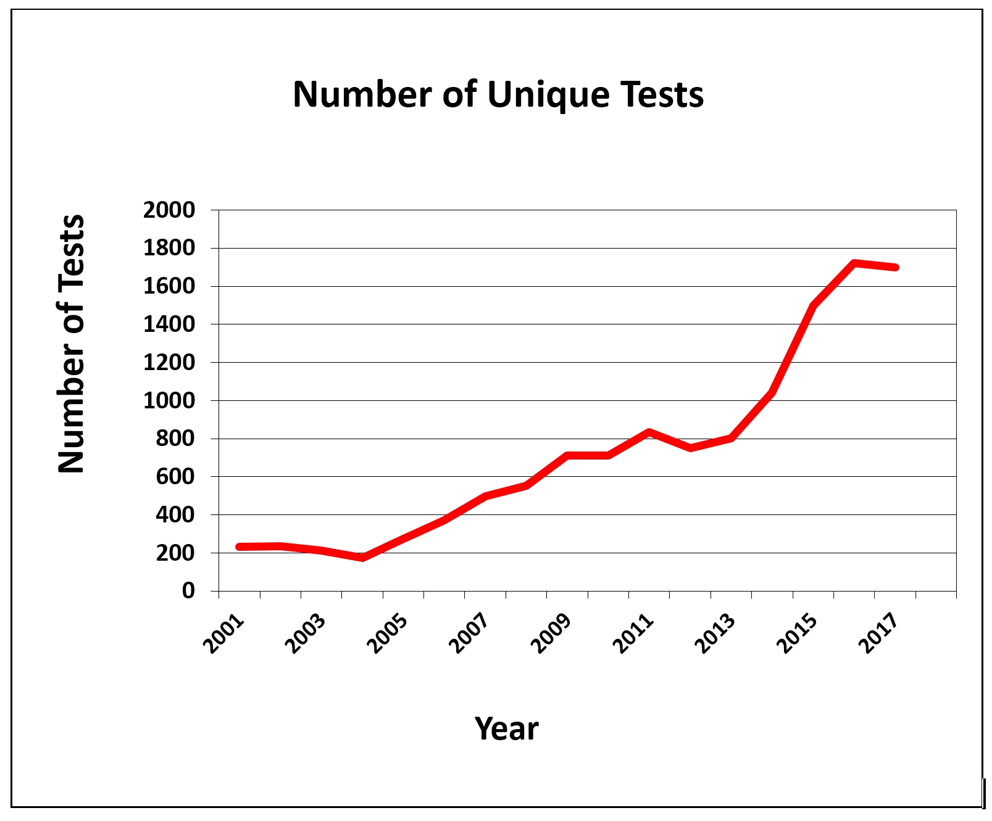

Year | Number of Unique Tests | Quantity Invoiced
2001 | 232 | 21,774
2002 | 236 | 12,444
2003 | 214 | 9,116
2004 | 173 | 9,604
2005 | 273 | 16,135
2006 | 371 | 24,929
2007 | 497 | 31,750
2008 | 551 | 34,179
2009 | 712 | 36,343
2010 | 711 | 17,733
2011 | 834 | 44,328
2012 | 751 | 19,359
2013 | 803 | 25,793
2014 | 1,041 | 39,761
2015 | 1,497 | 35,094
2016 | 1,875 | 48,795
2017 | 1,631 | 53,860

Work during FY 2017
Our ability and need to provide assistance to test takers who are blind and visually impaired, test publishers, and assessments teams has continued to grow at a brisk rate during the past 10 years. The volume of work has grown from reviewing and making suggested edits on approximately 100 unique tests to over 1,600 unique tests in FY 2017. Such growth is expected to continue. According to information provided by Chris Prentice, Manager of Business, APH’s test production demand increased 82.3% during the period from FY 2011 through FY 2015 with that same percentage increasing to 159.2% in 2016.

Moreover, work and tasks have grown to include online assessments with access via assistive technology such as speech output and refreshable braille displays. Accessible Tests staff continue to write text-based descriptions of graphical information to be used with speech output and tactile graphics during high stakes testing.

Additionally, work continues on the Accessible Tests Resource Center Web site, as the evolving field of blindness/visual impairment demands that staff diligently update site content.

Work planned for FY 2018
The continued editing of high stakes assessments for students who are blind and visually impaired will remain the primary focus of the Accessible Tests Department in FY 2018. Additionally, the department seeks to expand collaboration with, and education of, test publishers, test developers, school psychologists, state assessment personnel, test administrators, parents/caregivers, and test takers.

Such cooperation will enhance the exploration of issues specific to assessing students who are blind and visually impaired on Common Core Standards, state standards, and
the wide range of media and assistive technology encountered during online testing.
Accessible Tests staff will continue disseminating information related to assessment processes, accommodations, and assistive technology to parents, caregivers, and students so they may better advocate for themselves and their children.

Position papers, new and revised guidelines, online publications, catalogs, and brochures will be developed and made available to these stakeholders and others interested parties.

Accessible Tests Department goals for FY 2018 include the following:
- To continue partnering with test developers, publishers, and state assessment personnel, thereby better ensuring the availability of accessible tests and practice tests and test-related tools and materials
- To continue refining existing guidelines as research results and additional information become available
- To work with PARCC and SBAC so that assessments developed via these consortia will be accessible for students who are blind and visually impaired
- To work with ILSSA and other organizations so that alternate assessments developed will be accessible to severely cognitively impaired students who are blind and visually impaired
- To continue educating school psychologists, teachers, test personnel, parents, and caregivers regarding standardization of the test environment and select aspects of the administration/scoring of tests for individuals who are blind and visually impaired
- To continue emphasizing the need for test preparation materials and practice tests in legible formats and colors, where applicable, and in the same media/format as the actual tests
- To continue collaboration with the Braille Authority of North America (BANA) on developing and implementing guidelines for transcription and formatting of standardized tests and readable tactile graphics with or without accompanying text-based descriptions
- To promote the inclusion of individuals who are blind and visually impaired and/or professionals in the area of visual impairment during the initial stages of test development
- To collaborate on research, product development, literature reviews, resources, guidelines, position papers, and informational papers
- To collaborate with organizations as they refine and promote elements of universal design
- To continue providing test-related training and information in the form of workshops, teleconferences, webcasts, pod casts, resource lists, website postings, publications, and presentations
- To serve as a resource on the development and production of state and local assessments, alternate assessments, and assessments for English language learners in various accessible media
- To explore the delivery of test items via various electronic devices with or without the use of assistive technology
- To prepare alt-tags and text-based descriptions of graphics-based information for use with assistive technology, such as speech output and refreshable braille displays
- To explore the appropriate delivery of mathematical and scientific equations, formulas, and symbols via use of MathML, MathPlayer, and MathType
- To promote instruction and assessment of specific expanded core curriculum areas such as compensatory skills that directly affect the test performance of students who are blind and visually impaired
- To serve on relevant committees such as Item Review and Bias Review Committees, BANA’s Test Committee, assisting them with development of guidelines and training materials for making test items accessible
- To identify topic-specific websites and other relevant resources that may serve students, parents, and medical and educational professionals
- To promote collaborative efforts with universities, experts in assessment, and leaders in vision education fields, disability-related fields, and test publishers to enhance knowledge and promote product development efforts
- To explore possible uses of 3-D printers for creation of tactile objects
- To support and fully participate with APH’s internal departments on the REAL [Resources with Enhanced Accessibility for Learning] Plan to ensure that students who are blind or visually impaired have timely access to educational materials

EDUCATIONAL PRODUCT RESEARCH

Kate Herndon, Director

ADULT LIFE

AFB Foundations of Rehabilitation Teaching Kit
(New)

Purpose
A group of products that APH either currently produces or will produce to help teach the concepts and skills discussed in the new edition of the Foundations of Rehabilitation Teaching textbook

Project Staff
Martin Monson, Project Leader

Background
The idea for this project followed the normal trajectory for an APH product; it was reviewed and approved by both the Product Evaluation Team and the Product Advisory and Review Committee. While called a “product,” this will actually be a number of products that will be kitted together. Some products in the kit will be current products, and others will be purchased or newly developed products. The kit will also contain a copy of a new textbook currently being written by the American Foundation for the Blind® (AFB). The products in the kit supplied by APH will function to support the concepts and exercises discussed in the textbook. The concept behind the product is the same as that of the kit being developed for the I-M-ABLE textbook.

Product Description
This product is a kit of items currently produced by APH, items that will be produced by APH, or items purchased by APH to support the teaching and implementation of skills and concepts discussed in the next edition of the Foundations of Rehabilitation Teaching book published by AFB.

Work during FY 2017
A copy of the current edition was purchased and reviewed for possible products to include in the kit. A wide range of products was identified, from very simple and inexpensive (bold-line writing paper) to high-end assistive technology devices (VisioBook®). The list was shared with our contact at AFB.

Work planned for FY 2018
AFB will identify authors for each chapter of the textbook. As chapter titles and rough drafts of chapters are developed, they will be provided to APH. In conjunction with the list that was developed for the previous edition, new products will be added or identified to match the new text.

Color-Star®
(New)

Purpose
To provide a new color identifier device for individuals with visual impairments

Project Staff
Laura Zierer, Project Leader

Background
Identification of colors is a useful skill for many reasons. A device that assists individuals with visual impairments to perform this function will allow them to gain independence by not requiring assistance for this task. The need for a portable color identifier is evident by the variety of units being sold and portable apps available on mobile devices. Unfortunately, the apps are not always accurate, and must be calibrated before each use.

In May 2017, CareTec approached Craig Meador at the SightCity exhibition in Frankfurt, Germany, with their newest color identifier—Color-Star®. Currently, APH offers two similar products: ColorTest II (available with Quota funds) and Colorino (not available with Quota funds). Lately, there has been concern regarding the ColorTest II, as CareTec will no longer support repairs for this device.

Work during FY 2017
The Color-Star® unit was reviewed by Zierer and three employees who are visually impaired. Durability, accuracy, and features were tested. All in-house reviewers agree to sell this product, preferably on Quota. Color-Star® detects light, compares colors, and performs pattern recognition in addition to basic features. The Color-Star® unit is smaller and sleeker than the ColorTest II, and contains many useful functions for individuals who are visually impaired.

Zierer submitted a Product Modernization Form on May 31, 2017, recommending APH replace ColorTest II with Color-Star®. More information about this existing product can be found on the CareTec Web site.

Work planned for FY 2018
Four units have been purchased for evaluative purposes. An expert review will be conducted in FY 2018. Zierer will create a Quick Start Guide to be provided in large print and braille. The User’s Manual provided from CareTec will be converted into a Microsoft® Word® document and made available for digital download on the APH Web site.

CORE CURRICULUM

BUSINESS AND VOCATIONAL EDUCATION

For FY 2017, there are no active Business and Vocational Education products to report.

FINE AND PERFORMING ARTS

Carousel of Textures II
(Modernization)

Purpose
To provide an extended assortment of textured and brightly colored sheets that can be used by teachers, transcribers, students, parents, and adults with blindness and visual impairments for a variety of purposes, including adapting/creating storybooks, classroom worksheets, or commercial game boards; preparing collage tactile displays; labeling purposes; coloring activities; arts and crafts; and so forth

Project Staff
Karen J. Poppe, Tactile Literacy Project Leader

Background
The original kit of Carousel of Textures (Catalog No. 1-08863-00), designed by the project leader, was released on November 11, 2011. After many years of availability, the kit remains among APH’s top-selling products and consistently sells over 2,000 units annually. Although the original kit offers a plethora of textured sheets in a variety of colors, the project leader recognized the need for a larger “toolbox” of options. The second collection, titled Color-by-Textures II, will expand the current texture palette that teachers, parents, and students can select from for project-specific needs. This unique collection of textures will provide a convenient, one-stop source for those who do not have the time nor purchasing volume to quickly and cost-effectively acquire a variety of unique textured sheets. The field evaluators of the original Carousel of Textures indicated many applications, such as the following:
- Adapting tactile displays
- Enhancing commercial and self-made tactile books
- Providing open-ended art activities
- Math assignment adaptations
- Light box matching (color and texture) activities
- Art class activities
- Coloring and writing activities
- Bar graph and pie chart construction
- “Same/different” cards
- Construction of experience books related to orientation and mobility
- Creation of maps of classrooms and business areas
- “Touchy” shapes and numbers

Work during FY 2017
In February 2017, the project leader prepared a formal Product Modernization Form that detailed the expected contents of Carousel of Textures II. In April 2017, the modernization proposal was presented to the Product Evaluation Team; and in May 2017, it was presented to the Product Advisory and Review Committee. Both committees supported the product endeavor. The project was assigned Grant #684.

Before launching into the identification and selection of textures for Carousel of Textures II, the project leader developed and posted an online survey to garner advice and feedback from current customers and users of the original kit; the survey link (https://www.surveymonkey.com/r/CarouselofTextures) was posted in the July issue of APH News. In August 2017, the project leader reviewed the responses to the survey submitted by 32 teachers of the visually impaired, certified orientation and mobility specialists, braille transcribers, and regional VI assistants from across the United States. All of the survey respondents, except one who was “uncertain,” indicated that they had purchased multiple kits of Carousel of Textures in the past; 38% had purchased 2-5 kits, 25% had purchased 6-10 kits, and 34% had purchased more than 10 kits. Supportive comments included the following:
- “This is one of our most used and favorite items!”
- “Love them.”
- “A must-have product.”
- “We use Carousel of Textures for many of the projects we have for students of all grades.”

The survey respondents indicated an eclectic use of Carousel of Textures and echoed many of the uses reported by the original field evaluators. The following list details some of their common, varied, and specific applications of the kit:
- “Art projects, books, games, tactile discrimination between color-coordinated items in the classroom.”
- “I use the textures to support functional braille reading for my student with intellectual disabilities. I use the textures to create simple pictures as word cues. I also use the C-of-T with students with multiple disabilities to make simple books. The translucent sheets are great to make cutouts for the light box.”
- “Graphs, labeling areas, art projects.”
- “Use the textures for our projects, adapting games, and books. I use every sheet in the Carousel of Textures. It just depends on the needs that I have and the needs of my students.”
- “We use the sheets when we add textures to books for young children.”
- “Art class; students use to illustrate their writing, mark items in the classroom, creating tactile books.”
- “Adaptation of story books, maps, graphs, tactile symbols.”
- “Shapes, letters, numbers. Stories, concept development, designating centers or labeling rooms, maps, graphs, tracking sheets, prebraille, rubbings for coloring or writing.”
- “Tactile maps, graphs, diagrams for science, tactile pictures, adapting games for blind children use.”
- “I use them to create tactile symbols and other tactile materials for students (e.g., schedules, numbers, etc.). I also use them to add textures to other instructional materials, including books and adaptive switches.”
- “Adapted art; use to adapt classroom projects and worksheets.”
- “Maps, art, math, story, and science tactiles.”
- “We create different activities for our students such as identifying and matching textures, games, and use in creating stories.”
- “Making different sections for eye diagrams for low vision students studying anatomy.”
- “Tactile graphic organizers, tangible symbols, adding textures to books, making maps, making tactile graphics (math), art projects, and matching games.”
- “Used for maps—show land, water. Math—points on graph.”
- “We cut out the corrugated paper and use pins to attach it to the graphing or cork boards.”

Survey respondents indicated their preferences for the additional textures proposed by the project leader for inclusion in Carousel of Textures II. Table 1 shows the results of their feedback:

Table 1
Textures Preferred by Survey Respondents
Suggested Texture | Percentage of Survey Respondents Preferring Inclusion of Suggested Texture
Wavy |  | 81%
Zigzag |  | 78%
Coarse sandpaper |  | 69%
Scalloped |  | 66%
Brick pattern |  | 72%
Soft/plush |  | 78%
Fabric-like |  | 69%

Other textures (and colors) suggested by the respondents included the following:
- translucent textures
- shiny/metallic (foil-like)
- polka dot, more black sheets
- “longer shaggy texture”
- “feather and grass textures”
- glitter-free options

Additional work undertaken by the project leader during the latter part of the fiscal year included the following:
- Ordered and reviewed commercially-available materials and textures (e.g., embossed pebbled texture, alligator texture, brick pattern).

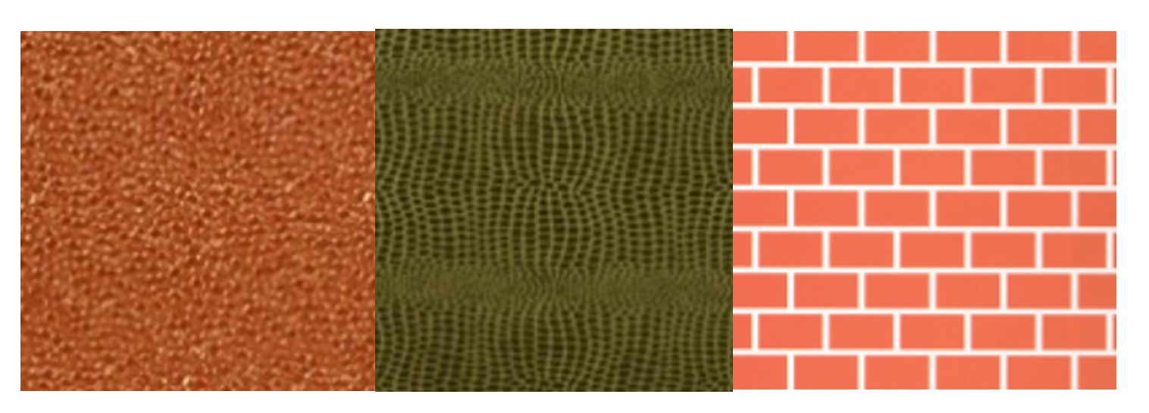

- Ordered commercially-available adhesive materials/sheets (e.g., Grafix® Artist-tacTM)
- Met with another project leader to avoid duplication of items planned for a theme-based textured sheet package (e.g., an “outdoor” package) for tactile book construction
- Conducted a Product Development Committee (PDC) meeting to review the purpose and expected design of the product with in-house staff

Work planned for FY 2018
The project leader will continue to locate and identify ideal textures and related materials for inclusion in Carousel of Textures II. Product decisions will be conveyed to the PDC members; outside suppliers will be chosen and in-house tooling for eventual production will be planned. Formal field test is unnecessary due to the similar structure of the original Carousel of Textures kit.

Color-by-Texture CIRCUS Coloring Pages
(Ongoing Series)

Purpose
To provide additional raised-line coloring page packets to complement the newly-introduced Color-by-Texture Marking Mats

Project Staff
Karen J. Poppe, Tactile Literacy Project Leader
Matthew Poppe, Graphic Designer
Rod Dixon, Manufacturing Specialist

Background
Color-by-Texture Marking Mats (Catalog No. 1-03332-00) was introduced for sale on August 26, 2016, and is available with Federal Quota funds. In addition to tactile marking mats and coloring tray, the kit includes a package of 25 raised-line coloring pages depicting a variety of objects including a kite, apple, teddy bear, beach ball, mitten, and much more. This package of coloring pages is available for separate purchase. Between September and December 2016, Color-By-Texture Marking Mats experienced brisk sales of 285 units. The sales of the full kit were complemented by 122 purchases of the related Raised-Line Coloring Pages (Part No. 62-114-012).

Approximately one month after the introduction of Color-by-Texture Marking Mats, the project leader constructed and posted an online Product Feedback Survey (https://www.surveymonkey.com/r/G2G5PSS) to garner additional feedback about the end product. This survey was announced via several venues including APH’s Facebook® and Twitter® pages https://twitter.com/APHfortheBlind/status/796722261843709952, the December 2016 issue of APH News, and direct e-mails to Educational Products Advisory Committee members for dissemination to teachers in their respective states. Many survey respondents requested additional coloring page options and/or additional textured mats including the following:
- “Our students love seasonal and holiday-themed activities as well as their sighted peers. Please provide these mats with seasonal textures (i.e., Fall leaves, acorns, bats, spiders, snowflakes, etc.).”—TVI in Nebraska
- “Holiday packets (one for each holiday); birthday packets; different themes—farm, circus, school, dolls, animals, etc.”—TVI/O&M Instructor in Nebraska
- “Holiday/season coloring pages; animals divided by farm/zoo/jungle, etc.; baby animals; insects; vehicles (cars, trucks, ambulance/fire truck, etc.); geometric shapes (like adult coloring for older students); and fairy tales (e.g., castles, fairies, princesses, knights, dragons).”—TVI in Minnesota
- “Variety of coloring/raised line designs.”—TVI in Michigan

In response to the common request for thematic coloring page packets, the project leader prepared a product modernization form on January 3, 2017. Later that month, the Product Evaluation Team and Product Advisory and Review Committee gave approval for the product’s development, beginning with the circus-theme coloring page packet.

Work during FY 2017
On March 24, 2017, the project leader conducted a meeting with the Product Development Committee to review the intended design of the product. Because the production processes and materials needed to produce the circus-theme coloring pages mirrored those of the original Raised-Line Coloring Pages, a quick development timeline was anticipated. Initial efforts began with the project leader and graphic designer creating unique coloring page images related to the circus theme. A total of 25 images were rendered to ensure ideal translation to thermographic output via the in-house Green Machine method. Each image has a print and braille label.

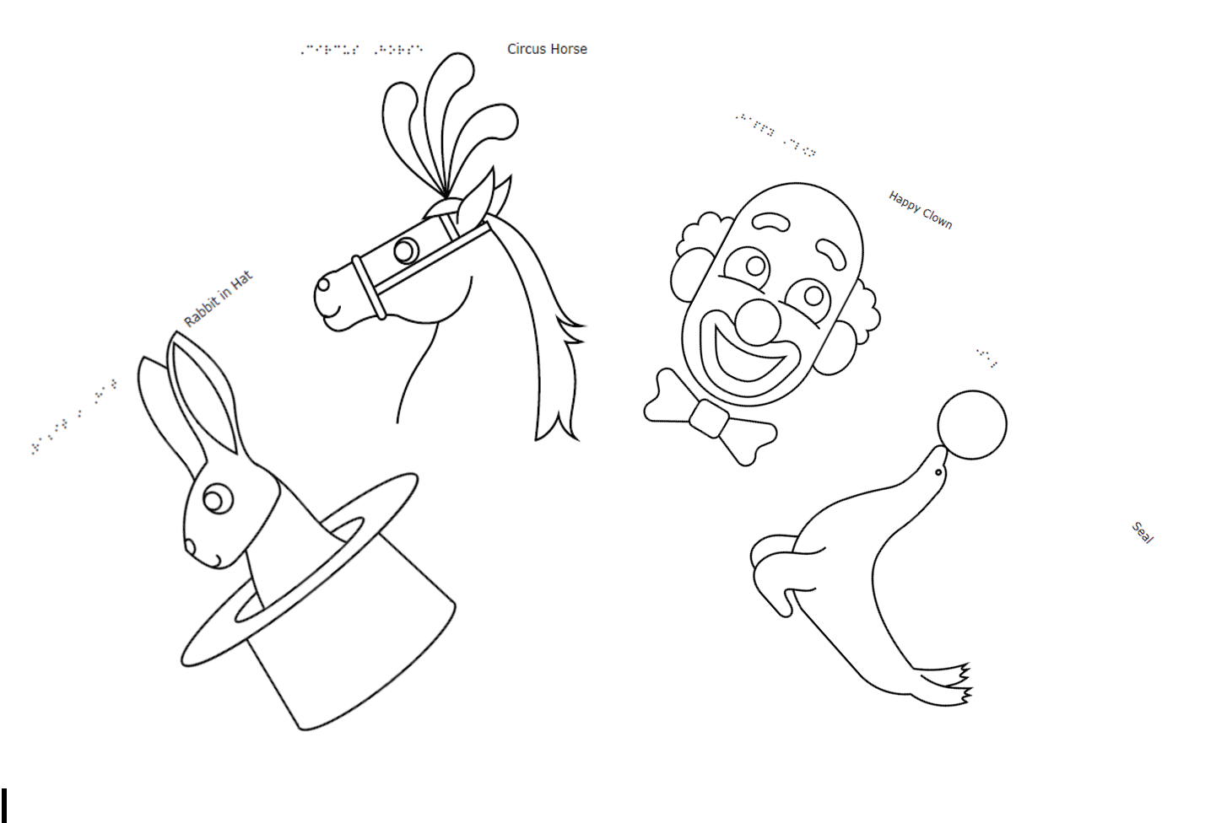

A brief insert with cover art and the assigned catalog number were prepared; braille translation of the insert was completed in April. The manufacturing specialist quickly prepared the product specifications document and presented this to Production staff in mid-June. Production quantities for the pilot and production runs were forecasted.

Work planned for FY 2018
The introduction of Color-by-Texture CIRCUS Coloring Pages is anticipated for the first quarter of FY 2018. Once introduced, the 25 coloring page images will be uploaded to the Tactile Graphic Image Library for free download. The project leader will continue to develop additional coloring page packets that address themes suggested by the field (e.g., transportation, animals, seasons).

Feel the Beat: Braille Music Curriculum
(Continued)

Purpose
This product is intended to be used with students who read braille in grades 2 through 8 so he or she can learn both music and the braille music code using the same instrument and at the same time as sighted peers. Full implementation of the curriculum will allow students to learn to read and to write music braille.

Teachers of the visually impaired (TVIs) who do not know music or the braille music code can use this curriculum, and general music teachers who don’t know braille can also use this curriculum. The curriculum uses the Soprano Recorder, which is used throughout the United States, to teach beginning music concepts.

Project Staff
Martin Monson, Project Leader
Leasha Twyman, Research Assistant

Background
Christine Short, an Ex Officio Trustee from Iowa, submitted the idea for this product. Christine developed the product over a period of years and has submitted it to APH for completion and production. The curriculum uses the Soprano Recorder to teach the basics of the music braille code to students already proficient in literary braille and is intended for early elementary to middle school age use.

Relevance
The prevalence of recorder use in the United States was briefly surveyed with a poll to two groups of TVIs with members from all areas of the nation. TVIs were simply asked to reply if they had students in districts that still utilized the recorder as a tool to teach music. TVIs in Wyoming, Maryland, Philadelphia, Texas, Virginia, Iowa, and several others, including a residential school, all replied that recorders are still used in music classes.

APH does not produce a similar product. A search of the Internet did not produce a similar product. The product idea and introductory pages from music lessons were shared with two staff members at APH who have a music background as well as the music teacher at the Kentucky School for the Blind (KSB). The music teacher at KSB notes: This is a great resource and very well written and easy to understand. Recorders are usually a great instrument to teach classes in general music about the basics of music and notes/rhythms, and I know a lot of public school teachers who use them quite a bit.

Comments from staff at APH:
Dawn Wilkinson: I don’t think it’s a necessary part of life, vital to daily functioning, or essential to our existence. But, people will snap this up like there is no tomorrow. What it does do is present a very easy and fun introduction to braille music; very different than the hideous experience I had with it. It also addresses that students will read a measure and then memorize it; never being able to play and read at the same time.

Terrie Terlau: I think this is well done. I learned to read braille music outside of school, and I never knew why the braille D indicates the note C, etc. Now I do! And the explanation of why braille note states whole, half, quarter, and eighth notes the way it does would have been very helpful for me to have known as a child. And it would be something fun for the child and TVI to do that would put the child on an equal footing with her sighted peers in music class. It also would be a good precursor for the instructional music materials that a music teacher at the California School has developed.

Work during FY 2017
This product was approved by the Product Advisory and Review Committee in August 2016 and was approved by the voting members. The project leader identified several consultants to provide input, ideas, and feedback into the project. Consultants included Short, the Ex Officio Trustee who developed the draft of the product and submitted the idea, Amanda Black, an itinerant teacher of the visually impaired with a Master of Arts in Music, and Peggy Spiess, a certified braille music transcriber. Spiess removed herself from the project as other work demands started to increase. She did provide a name of another certified transcriptionist. That person is currently under contract with APH to work on this project but did no work in FY 2017.

A review of the product was undertaken by the two TVI consultants, and several changes and additions to the music instruction were proposed. These changes were reviewed, and it was decided that any additions to the music component of the product would not be incorporated. This decision was based on the premise that the product is intended to teach primarily the braille music code. At that same time, it was decided that since the draft form of the product had been reviewed informally by TVIs over the past few years and changes had been made to the product based on that input, APH would have the product go through the expert-review process rather than the field-testing process. Expert reviewers were identified through a volunteer request placed on several social media pages. Expert reviewers were identified and selected from the responses received. Copies of the Teachers Edition and Student Song Book were edited for basic formatting and typographical errors, and then printed, bound, and mailed to the expert reviewers. At the writing of this report, the reviewers are still submitting reviews of the product.

Work planned for FY 2018
The expert reviewers should finish their work, and the results will be compiled and examined for commonalities in the responses. Once the data from the reviewers has been examined, it will be shared with Short, the consultant and author of the product. Changes to the product, based on input from the expert reviewers, will be made. Once the changes are complete, the book will be sent to the braille music transcriber consultant.

Copyright permission for the use of some of the songs and the font used in the recorder fingerings may need to be acquired. The author has stated that the songs used are old enough that copyright permission is not needed, and the fingering font is a public domain font. APH’s copyright specialist will review all the songs being used to determine if a permission is needed or if a simple acknowledgement will suffice. The anticipated completion date is the end of FY 2018 or the beginning of FY 2019.

Paint-By-Number Safari™ (Series)
(Completed/Ongoing)

Purpose
To provide an art product that gives a fun and educational glimpse into how subjects in the world look, live, eat, and function

Project Staff
Tristan Pierce, Project Leader
Fred Otto, Tactile Literacy Project Leader/Advisor
Kelly Kennedy Mimms, Research Assistant
Joyce Lopez, Consultant

Product Description
Paint-by-Number Safari™ is a series of paint-by-number books that represent five (possibly six) animal locations: tropical rainforest, jungle, under the sea, desert, and backyard animals. Each print tactile drawing has information relating to core subjects, (e.g., size–math, habitat–social studies, etc.). The product includes color mixing instructions to create "real-world colors." The target market is K-12 students who have visual impairment and blindness.
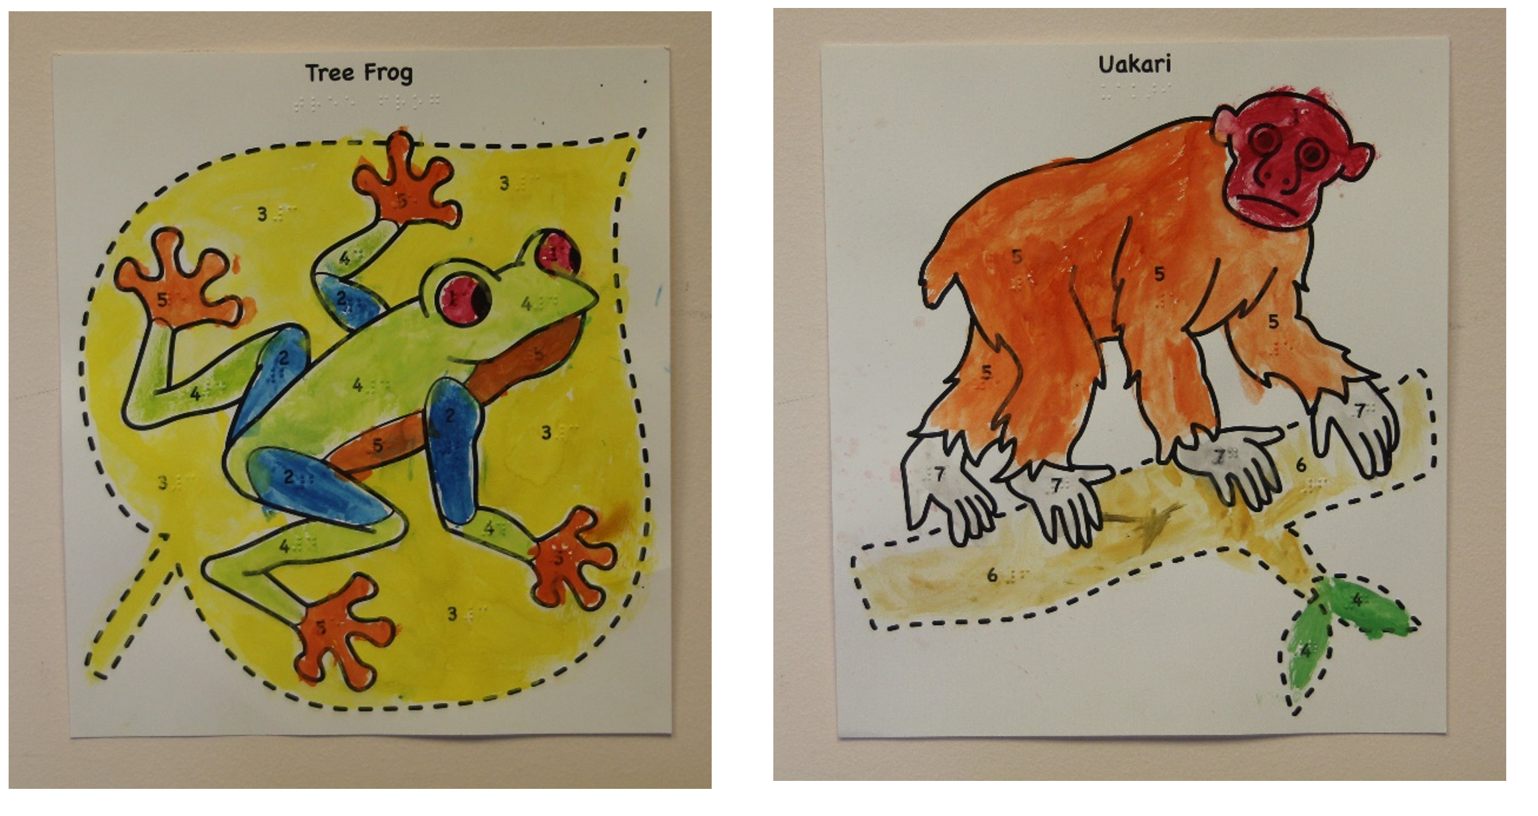

Background
Paint-by-Number Safari™ is a series of interesting and fun subject matters presented in print-raised line art format. The “Paint-by-Number” concept is similar to traditional Paint-by-Number products with the addition of the following:
- Braille translation for all of the words (name of subject matter, colors, and numbers that coincide with the colors)
- Carefully executed, easy to follow lines for each subject matter
- Fun and interesting facts about each subject matter

Relevance
The American Printing House for the Blind (APH) made the decision to produce Paint-by-Number Safari™ based on APH’s standardized process of product development. Joyce Lopez submitted the New Product Idea Submission Form on September 5, 2014. Lopez is a product developer for PlayAbility Toys™, a company that designs toys, games, and educational materials for special needs populations. APH has a history of successful collaboration with PlayAbility Toys™ (e.g., Rib-it-Balls, Paint Pot Palette). The Multiple Disabilities Project Leader presented the idea to the Product Evaluation Team (PET) on November 18, 2014. The committee approved it and forwarded the product submission to the Product Advisory and Review Committee (PARC). PARC members approved Paint-by-Number Safari™ on November 20, 2014. Upon submission, the name of the product was Tactile, Braille, and Fun Facts–Paint by Number! Kit. During development, APH and PlayAbility Toys™ agreed on the new name.

Paint-by-Number Safari™ is fully accessible to the population using it. It features large print and braille for the Fun Facts and the words (name of subject matter, colors, and numbers) that coincide with the colors. The raised-line drawings are easy to follow. With the exception of the hummingbird and toucan, the drawings present the subjects in a frontal view, which presents both eyes and all appendages. APH made an exception with the birds because their long, pointed bills are the main discriminatory feature of each animal, therefore it presents best in profile.

This product follows APH Research Guidelines for determining relevance for a product. The Smithsonian National Museum of American History exhibited (April 6, 2001 through January 7, 2002) the paint-by-number phenomenon as a window on the history of creativity, leisure, and domesticity in postwar America. The project leader conducted a review of commercially available paint-by-number kits that proved the activity has a long history of popularity and that people still love it today. Large retailers, such as Jo-Ann Fabric and Craft Stores®, Walmart®, and Amazon® offer a plethora of paint-by-number kits to keep children and adults occupied happily for many years. Young children practice color and number recognition and patterning, while developing fine motor skills. This tactile version of a paint-by-number kit will allow students with visual impairment to enjoy this educational and popular activity with their families and peers.

APH examined the need for a product like the Paint-by-Number Safari™. The Lopez new product submission was not the first submission requesting that APH produce a paint-by-number product. A teacher from DeKalb, Illinois, submitted a product named Tactile Paint by Number Kit on January 21, 2014. APH selected the Lopez submission because the execution of the uniform-sized art, thematic units tied to literacy and social engagement, and that PlayAbility Toys™ is in the position to provide tooling and manufacturing, thus freeing up APH’s resources and schedule for additional products in development. On April 2, 2015, the Multiple Disabilities Project Leader conducted an online needs survey. Teachers and parents (39 respondents) completed the survey over 25 days. The respondents (97%) stated that children with visual impairment or blindness want to know the “real colors” for things in nature. They (97%) believed that using a paint-by-number product provides an opportunity for children to practice following instructions (e.g., painting a section of the drawing with the correct color, mixing colors).

The following is a sample of comments regarding the need for this kind of product:
- I think this is a simple yet genius idea to help visually impaired students enjoy arts and crafts more.
- I like the idea of thematic units. I work with adults and it is often difficult to find “age appropriate” stuff, without having to make it myself. Themes seem like it may be something that can be used with adults as well as children.
- Many more inventive products are needed for blind children of all ages. This is a good first step.

APH sought the opinion of knowledgeable individuals to determine the need for Paint-by-Number Safari™. People who are blind, parents of children who are blind, teachers of students with visual impairments, and art teachers of individuals with visual impairments completed the APH needs survey. Prior to the product submission, Lopez worked closely with the art teacher at the California School for the Blind, who supports the need for such a product.

The Paint-by-Number Safari™ addresses an identified need for a person who meets the definition of “visually [and multiply] impaired.” This product makes it possible for children and adults who are blind to learn to create art using “real world colors” by following directions. Although most children—sighted or blind—use any color(s) they want to create art, individuals with blindness often want to know “the real colors for things.” Paint-by-Number Safari™ uses real world colors for each image presented along with “Fun Facts” that describe the images and explain why and how creatures live, function, and are the way they are. This blending of creativity, fun, and learning (understanding of vocabulary and concepts) is an ideal combination for learners of any age.

Research
APH gathered data using an appropriate method. APH created two additional online surveys via SurveyMonkey® for field testing, the teacher survey and the student survey. Teachers completed a 26-question survey that consisted of multiple-choice, open-ended response, and rating scale. Teachers completed questions 1-9 (demographic) on the student survey and then the students completed questions 10-21. Teachers and students had multiple opportunities to submit comments.

The development of Paint-by-Number Safari™ followed APH research guidelines.
- Input from the field—During the development of Paint-by-Number Safari™, the project leader received input on embossing height and tactile discrimination of the drawings from a colleague who is blind. The product needs survey provided APH with a valuable baseline from which to start the product development. APH received additional feedback from field evaluators.
- Safety Report/Technical Review—not applicable to this product
- Representative product prototype—The prototype books had spiral binding for the large print and braille product introduction and Fun Facts. The embossed black line drawings rested in a folder-type pocket on the inside back cover of the book. This is representative of the final product.
- Outside evaluators—APH selected field test sites by location, educational setting, student/client size, and evaluator qualifications. The time constraints required the project leader to orchestrate the evaluation with Ex Officio Trustees in two of the states.
- Evaluation tool and collection—The project leader and research assistant created the field test packets and sent them to the field test sites. Data collection was through SurveyMonkey®.
- Sufficient time—The field test time was 2 months (February 10 – April 8, 2016). One site did not submit the evaluation forms until May 5, 2016. A second site notified APH after the deadline that she did not do it; so the project leader requested she return the materials, which she did. Two teachers at the Kentucky School for the Blind offered to take the returned materials and work with their students. They completed the artwork and evaluations by May 12, 2016.
- Reporting—The project leader presented the field test results to PlayAbility Toys™. Throughout the development of the product, the project leader reported updates at the monthly New Products Meeting and in the APH Annual Research Report.
- Modifications—APH and PlayAbility Toys™ determined modifications based on teacher and student evaluations, market availability, and cost.
- Quota Approval—The project leader submitted the Paint-by-Number series to the Educational Products Advisory Committee (EPAC) and received approval in October 2016.
- Specifications—On March 8, 2017, APH held a modified specification meeting for the “pass-through” product. PlayAbility Toys™ manufactures the product, and it arrives on APH’s dock ready to ship to the end user.
- Marketing—APH and PlayAbility Toys™ promote the product on their websites and hardcopy catalogs. APH displays the series at conferences and provides product brochures on request.
- APH Communications created the Paint-by-Number Safari™ Series Product Brochure. APH Field Services and the project leader create Quick Tip videos.

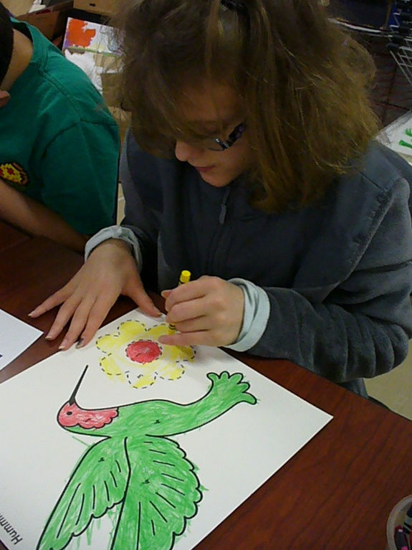

The research method used collected sufficient information. The prototype book included four print-raised drawings of animals living in a Tropical Rainforest: tree frog, sloth, hummingbird, and uakari monkey. APH removed the chameleon prior to shipping because of one braille error and one print error. Teachers and students submitted evaluation forms, and several teachers submitted photographs (with an APH Model Release Form).

Teacher Responses
Four of the 10 teachers (40%) rated the value of the Fun Facts as very high. Five teachers (50%) rated the value as high.

Eight teachers (80%) used reading the Fun Facts as an opportunity to prompt class discussion and to promote the understanding of vocabulary and concepts. Of these eight teachers, three (37.5%) found this use of the Fun Facts extremely beneficial, three teachers (37.5%) found it very beneficial, and three teachers (37.5%) found it somewhat beneficial.

Nine teachers (90%) used the Fun Facts as an opportunity for the students to practice print- or braille-reading skills.

All 10 teachers responded that the Paint-by-Number Safari™ provides an opportunity for their students to practice following instructions (e.g., painting a section of the drawing with the correct color, mixing colors).

Four teachers (40%) responded that Paint-by-Number Safari™ teaches color concepts with an emphasis on real world colors extremely well. Another four teachers (40%) responded that it teaches color concepts very well.

Four teachers (40%) responded that Paint-by-Number Safari™ drawings encourage visual exploration extremely well. Three teachers (30%) responded that it encourages visual exploration very well.

When asked to rate how well Paint-by-Number Safari™ drawings encourage tactile exploration, four of the 10 teachers (40%) answered extremely well. Four more teachers (40%) responded that the drawings encourage tactile exploration very well.

Two teachers (20%) responded that the Paint-by-Number Safari™ teaches shape recognition extremely well.

Three teachers (30%) responded that Paint-by-Number Safari™ encourages social engagement extremely well. Five teachers (50%) responded very well.

When asked to describe their classroom materials, five of the 10 teachers (50%) responded that their students need the books and a set of large print/braille adhesive labels for their existing crayons, paints, pencils, and markers. Three teachers (30%) said that their students just need the Paint-by-Number Safari™ books because they already have a good supply of paints, colored pencils, crayons, and markers with tactile color identification (e.g., APH Feel ‘n Peel Number Stickers). Two of the 10 teachers (20%) responded that their students need each book to come with a set of paints that have braille labels.

When asked their preference (1=second book in series or most preferred and 5=least favorite/drop from series or least preferred) for the theme of the next Paint by Number book, five of the 10 teachers (50%) preferred a backyard theme. Three teachers (30%) answered “Under the Sea” theme, and two teachers (20%) preferred a jungle theme. Backyard and Under the Sea scored equally with 3.60 (SUM/#RESPONENTS).

Theme | 1 | 2 | 3 | 4 | 5 | Total | Score
Desert | 0.00%  0 | 10.00%  1 | 10.00%  1 | 20.00%  2 | 60.00%  6 | 10 | 1.70
Backyard | 50.00%  5 | 10.00%  1 | 10.00%  1 | 10.00%  1 | 20.00%  2 | 10 | 3.60
Jungle | 20.00%  2 | 10.00%  1 | 20.00%  2 | 40.00%  4 | 10.00%  1 | 10 | 2.90
Forest | 0.00%  0 | 50.00%  5 | 20.00%  2 | 30.00%  3 | 0.00%  0 | 10 | 3.20
Under the Sea | 30.00%  3 | 20.00%  2 | 40.00%  4 | 0.00%  0 | 10.00%  1 | 10 | 3.60

When asked which additional animals APH and PlayAbility Toys™ should include in the Tropical Rainforest book, all 10 teachers responded that the following animals would be a good representation of animals living in a tropical rainforest: chameleon, capybara, toucan, frilled lizard, coral snake, and butterfly.

Additional comments offered by teachers:
- The capybara and toucan may be a bit hard for the student to identify with.
- I like the idea that some may be familiar while others may not be familiar to students.

All 10 teachers responded that they would recommend that their school purchase Paint-by-Number Safari™: Tropical Rainforest.

Student Responses

When asked if they enjoyed learning the “real world” colors of the Tropical Rainforest, 20 of the 21 students (95%) answered yes.

Eleven students (52%) used paint to color their artwork, 10 of them (48%) used crayons, and five (24%) used markers. Finally, two of the students (9.5%) indicated that they used other materials to color their artwork. They specified their responses with the following comments:
- I enjoyed using the paint by number coloring sheets with markers and crayons. But when I used watercolors, I could not feel the raised lines.
- [I used] oil pastels.

APH asked the 16 students who used the tactile lines if the embossed lines on the drawings were high enough to follow with their fingers. Eleven of the 16 students (69%) responded yes. Five students (31%) answered no. Five students did not use the tactile lines, so they are not included in this sample. Following are comments submitted by some of the 11 students (or their teachers):
- He said he “got lost” sometimes when painting.
- Would have liked them higher.
- Hard to tell where lines crossed and follow the outline of color areas.
- [I could not distinguish the lines] when I was using the paints and markers because they rubbed out the raised line. Please make them a little higher next time.

Of the 16 students who used the tactile lines on the drawings, 11 (69%) said they could distinguish between the thick solid line, the thin solid line, and the dashed line on the tactile drawings. Five of the 16 students (31%) said they could not. Again, this sample does not include the five students who did not use the tactile lines. Student comments included the following:
- I could tell the difference between the dashed line and the solid line, but I could not tell the difference between the thick solid line and the thin solid line.
- Sloth and Uakari monkey had only dotted and thick solid lines.

Of the 15 students who used the black lines on the drawings, 12 (80%) said they could distinguish between the thick solid line, the thin solid line, and the dashed line. Three (20%) students said they could not distinguish between the black lines. Six students responded that they did not use the black lines on the drawings.

The number of student responses indicates that 10 students used the tactile lines and the black lines in tandem.

Twenty of 21 (95%) students responded that they liked using Paint-by-Number Safari™. They provided the following comments:
- She stated, “I would like a more prettier one, I don’t like the monkey.”
- He stated, “He doesn’t like to paint, that it got his hands messy and he didn’t like that.”
- I would be interested to learn more about different kinds of animals.
- I liked that the stories were in braille.

Twenty of the 21 (95%) students responded that they would like to have other books like Paint-by-Number Safari™ with more animals. The following is a sample of their comments:
- This was fun—liked to color the animals.
- I would love to have more color/paint by number books with other animals!
- Can you make a book about dinosaurs?
- Sea animals—octopus, fish, crabs, etc.
- This was fun! Wish there were more!

APH collected data from a geographically diverse population. The field testers (one male and nine females) were located at nine schools in seven states: South Carolina and Kentucky at schools for the blind; and Massachusetts, Washington, Missouri, Virginia, and Vermont at public schools.

APH gathered data from appropriately qualified individuals. All field testers were teachers: two art teachers, two elementary teachers, and six teachers of students with visual impairments. The field testers’ years of professional experience ranged from 3 to 26 years, with an average of 11 years of experience.

APH gathered data from an adequate number of sources. Ten teachers evaluated Paint-by-Number Safari™ with 21 students. The students ranged in age from 7 to 18 years. The average age was 10.5.

Eight of the 21 students (38%) have another disability in addition to vision impairment.
Two of the students (9.52%) have mild visual impairment, four (19.05%) have moderate visual impairment, six (28.5%) have severe visual impairment, five (23.81%) have near blindness, and four (19.05%) have total blindness.

APH gathered data on student/consumer outcomes by asking the students to reflect on what they learned from using Paint-by-Number Safari™. Nineteen of the 21 students (90%) responded that they learned about an animal that they did not know about before using the Paint-by-Number Safari™. Of those 19 students, 17 identified the animal about which they learned: eight named the uakari monkey, four named the sloth, two named the tree frog, and three named the hummingbird.

APH asked the students to name a feature of an animal that they learned from using Paint-by-Number Safari™. Below is a synopsis of student responses:
- There are over 5000 species of frogs. Tree frogs have wide disks on the tips of their fingers and toes. They can blend in with different colors in the rainforest to hide.
- Hummingbirds are very small.
- Sloths can swim.

Seventeen students named the color of the newly learned feature. Four students (24%) named green, another four students (24%) named orange, three (18%) named gray, two students (12%) named red, and another two students (12%) answered “many colors.” One student (6%) responded that he did not know the color.

APH asked students to name one fact that they learned about each of the animals when they read the Fun Facts. Below is a sample of some of the responses:
Tree Frog
- They fit on a finger
- They are lots of colors
- There are only four main species of tree frogs.
Sloth
- Diet is mainly leaves
- It can have algae on it from being so slow.
- They can swim
Hummingbird
- Smallest of all birds
- It can hover.
Uakari Monkey
- Spends time in a troop
- The monkeys live by the Amazon River basin. I would have liked to have seen that area on a small map.
- It can be bald!
- They have orange hair!

APH considered research data as part of decision-making in product completion. Half of the teachers responded that APH should include print/braille clear adhesive labels with each book. After careful consideration, PlayAbility Toys™ and APH decided that without a majority, it would be best to explore offering print-braille labels as a separate product so the other 50% of the consumers would not have to pay extra for stickers that would come with each book. APH sells the Feel ‘n Peel color name stickers that includes red, yellow, blue, green, orange, purple, black, brown, and white. It does not include gray, which is a prominent color in the Tropical Rainforest and with animals worldwide. PlayAbility Toys™ and APH dismissed including a pack of Feel ‘n Peel color name stickers with each book for two reasons: too costly and too great a quantity (20) of each color in a pack.

The teachers rated their preference on the proposed thematic units of the remaining four books. The least preferred theme was the desert. Eight U.S. states have one or more of the four U.S. deserts (Chihuahuan, Sonoran, Mojave, and Great Basin Desert). These deserts offer national parks, state parks, monuments, cities, towns, and more for family fun vacations. PlayAbility Toys™ and APH decided learning about the desert is equally important to the other themed books and will consider expanding the series to six books, depending on sales of the other five themed books.

Per the requests of several students who used the tactile lines, PlayAbility Toys™ will create more distinction between the thin and thick raised lines.

Work during FY 2017
APH approved the drawings for all the artwork and the text for the Fun Facts on each animal as recommended in field testing. APH approved production samples. The product became available for sale in August 2017.

Strike-A-Pose: Body Awareness Cards for Students with Visual Impairments and Blindness
(New)

Purpose
To provide a set of tactile/print cards that feature various body positions/movements that a student can mimic with her own body or with a 3D model/human figurine (e.g., reaching upward, stretching arms out to one’s side, bending an elbow/knee, leaning forward, touching toes, etc.).

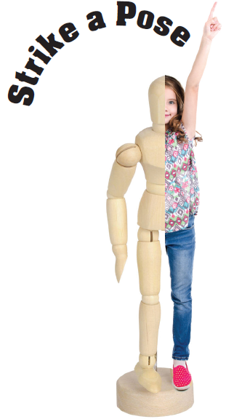

Project Staff
Karen J. Poppe, Tactile Literacy Project Leader
Rachel White, Research Assistant
Laura Greenwell, Graphic Designer

Background
In January 2017, the project leader submitted a formal product submission form that described the instructional value and expected tangible design of Strike-A-Pose: Body Awareness Cards for Students with Visual Impairments and Blindness. The intention was to provide a set of tactile/print cards that feature various body positions and movements (e.g., reaching upward, stretching arms out to one’s side, bending an elbow/knee, leaning forward, raising one arm, touching toes, etc.). Similar cards are sold commercially to provided yoga, dance, and gymnastics instruction as shown below:

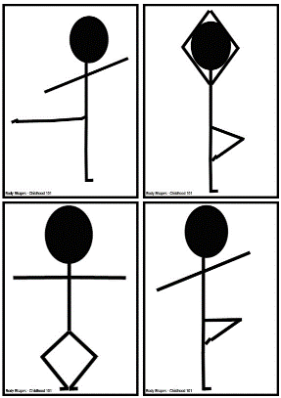

The project leader detailed many skills and concepts that would likely be addressed by Strike-A-Pose including the following:
- Develop spatial awareness through movement
- Improve physical coordination, gross motor skills, and balance
- Increase understanding of spatial terminology and directional concepts
- Encourage movement and increase mobility skills
- Build muscular strength
- Promote creative self-expression

From a tactile literacy focus, Strike-A-Pose could effectively facilitate a young child’s interpretation of tactile illustrations by showing body positions from different perspectives (front view and side view). It will also help the child navigate from his own body to a realistic model and then to a representative 2D tactile graphic. This tactile continuum is emphasized within several APH products, especially Setting the Stage for Tactile Understanding and Room with a View (see separate annual report).

Several online articles and research studies stress the importance of body awareness concepts for students with visual impairments and blindness:

- Carmen Willings, Teacher of Students with Visual Impairments, states that “Physical experiences will help lay the foundation for development. Once a student has learned the concepts using their bodies, they can then develop concepts related to models and representation.” Retrieved from http://www.teachingvisuallyimpaired.com/concept-development.html

- “Children who grow up without useful visual information often have difficulties with motor planning, are at risk for delayed motor development, and may have sensory integration deficits. Body awareness leads to concept development which is a foundation for more complex concepts and abstract reasoning. Motor responses significantly increase when modeled. Concepts must be taught more deliberately to students who are blind and visually impaired.” Retrieved from: http://scholarworks.sfasu.edu/cgi/viewcontent.cgi?article=1028&context=brightideas

- “Poor motor skills may lead to poor performance in physical activities, which may reduce a child’s sense of competence. This may lead to withdrawal from movement activities that would, in turn, lead to limited opportunities to practice motor skills and participate socially (Skinner and Peck).” Houwen, S., Visscher, C., Lemmink, K. A., & Hartman, E. (2009, May 1). Motor skill performance of children and adolescents with visual impairments: A review. Exceptional Children, 75(4), 464-492.

The product concept was formally reviewed by fellow project leaders who could objectively evaluate it based on several criteria. Amy T. Parker, Product Development Project Leader, indicated the following:
“The need for activities, games, and supports that help teach blind and deafblind students in the areas of body movement, body awareness, body positioning, posing is well documented. Teaching students to purposefully use body poses and positions are related to areas within the Expanded Core Curriculum, including orientation and mobility; social skills; recreation/leisure; and employment skills. People who are blind and deafblind are at risk for passivity and learned helplessness. Body awareness, strength and confidence are associated with increased quality of life, positive transition outcomes, and favorable employment outcomes. Some practitioners and researchers have incorporated activities such as yoga, which include body positioning and awareness, into interventions with students who are blind and deafblind and have seen positive behavioral and emotional outcomes.”

The project leader envisioned the Strike-A-Pose kit consisting of the following components:
- Print/tactile body position cards
- Small wood manikin from outside vendor
- Instruction Booklet in large print and braille versions
- Carrying/sorting box for materials
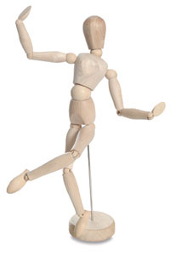

Work during FY 2017
In April 2017, the development and production of Strike-A-Pose was presented to the Product Evaluation Team, and in May 2017, to the Product Advisory and Review Committee. The project was assigned the grant #690.

Minimal work on this newly-approved product occurred during the fiscal year. However, the project leader and project staff partook in the following tasks:
- Locating a 3D model that does not rest on a metal rod (potentially misinterpreted as a third leg)
- Reviewing relevant literature and products that addressed body awareness concepts, such as the Hill Performance Test of Selected Positional Concepts, published in 1981 and developed by Everett W. Hill, Ed.D.
- Dabbling in possible graphical presentations that merge images of real children with the 3D model, as well as related body position cards

Work planned for FY 2018
The primary effort will be on the development and construction of multiple prototypes for field-test purposes. The project leader will seek opportunities to gather guidance from teachers and experts in the field regarding ideal components and design elements. The field-test stage will likely occur during the second quarter of the fiscal year.

MATHEMATICS

AnimalWatch VI Suite
(Continued)

Purpose
To provide a fun and interesting iPad® mobile device application for students with visual impairments in grades 5-9 to build math problem solving skills using scientific information and data about endangered animal species

Project Staff
Rosanne Hoffmann, STEM Project Leader
Li Zhou, Core Curriculum Project Leader
Frank Hayden, Director of Technical & Manufacturing Research
Lawrence Lovelace, iOS® Programmer
Tom Hicks, Programmer
L. Penny Rosenblum, Consultant
Carole Beal, Consultant
Jane Erin, Consultant
Sara Larkin, Consultant

Background
AnimalWatch VI Suite (AWVIS) uses data and information about 12 endangered species in a series of 24 lessons designed to develop pre-algebra math skills of grade 5-9 students. The original conception of this product included an iPad® mobile device app, User’s Guide, 68 full color tactile graphics and braille text for braille reading students, 65 full color tactile graphics for students with low vision, miniature models of the 12 endangered animals, a user guide, print screenshot book, and a storage container. All items, including the iPad® app, were developed by the consultants; the braille and tactile graphics for preliminary field testing were produced by an outside vendor. After a local study at the University of Arizona was completed in December 2013, the consultants approached APH for production of the braille and tactile graphics and ultimately the distribution of the entire kit as an APH product. While the product idea was under consideration by APH, the consultants conducted a feasibility study throughout the state of Arizona, which took place from January 13 through April 25, 2014.

Two project leaders (Zhou & Hoffmann) reviewed the product submission in December 2013, and AWVIS became an official product under development in July 2014. The results of the statewide Arizona study conducted by the consultants confirmed the outcome of the local study and supported APH’s endorsement for product development. Feedback from the statewide Arizona study included the following recommendations with regard to the iPad® app: improve the scratch pad capability (for math calculations) and include a setting for gridlines; replace the help videos with a solution video for each math problem; rework the hints for all problems to provide scaffolding information; include measurement units in the answer pad, audio feedback during keystrokes, audio read back of entered answers, and Nemeth code display for use with refreshable braille; devise introductory screens to familiarize users with the app; and add a login screen with icons indicating a student’s progress within each unit. The product was also streamlined by the elimination of a print screenshot book and the miniature models of 12 endangered animals included in the original product design.

The consultants conducted a nationwide intervention study (field test) of the revised AWVIS app with accompanying braille text and braille and print full color tactile graphics during the 2014-2015 school year. In all, 44 teachers and 66 students in 22 states participated in the study.

As part of the product development process, Tactile Vision Graphics (Windsor Ontario, Canada) was originally selected to produce the high-quality full color tactile graphics that correspond to the images in the AWVIS app. The tactile graphics were designed with large print titles and labels for low vision students and literary braille and Nemeth code for students who read braille; these versions were used in all field test studies. In light of new UEB regulations, the tactile graphics and braille app text were transcribed to UEB at APH, to be offered in addition to the large print and literary braille/Nemeth code versions. To that end, transcription of the tactile graphics and app text to UEB by the APH Braille Department took place between April and August 2015.

The technical data transfer necessary for programming and maintenance of the AWVIS iOS® app took place in June 2015 from Tom Hicks at the University of Arizona to Lawrence Lovelace at APH. Since then, the iOS® AnimalWatch VI Suite app has been kept up to date by Lovelace.

During this time, single samples of all large print and literary braille/Nemeth tactile graphics were ordered and received from Tactile Vision Graphics for review by APH. Four of the sample graphics were not acceptable and required redesign. The project leader submitted new files for the four full color tactile graphics to Tactile Vision Graphics for new samples in August 2015. The project leader did not receive the new samples in a timely fashion and therefore sought a new vendor in 2016. A company in Lafayette, IN (gH) was approached, but ultimately rejected because of their high prices. Throughout the spring, summer and early fall of 2016, the project leader investigated the possibility of producing the tactile graphics at APH with either the Green Machine or the Roland® Large Format Printer.

Also during this time, field test evaluations from the nationwide pool of teachers and students obtained by telephone interview were analyzed by the consultants. In general, the response to the app and tactile graphics was very good; however in July 2016, the project leader decided to eliminate the solution videos embedded in the AWVIS app for two reasons. Less than 10% of the students involved in the national field test actually used them, and after extensive analysis by math expert Sara Larkin it was revealed that many errors in terminology and presentation were identified in all but 12 of the 147 solution videos. A total redo of the solution videos was cost-prohibitive with regard to the continued development of this product. Lawrence stripped the solution videos from the app in October 2016.

Work during FY 2017
By December 2016, the project leader was informed that in-house production of the full color braille and print tactile graphics at APH was not possible with the Green Machine and too costly and time consuming to be accomplished with the Roland®. A major revamp of the product was discussed with the consultants. Since the product had already been simplified to include an iOS® app, user guide, and accompanying braille text and print/braille tactile graphics, a decision was made to house digital text and graphics files on the APH server and make them available for free download with purchase of the iOS® Animal Watch VI Suite app. The consultants redesigned the tactile images as fuser ready graphics files that can be downloaded, printed, and processed through a swell form machine to create the tactile graphics on demand. The consultants updated the user guide to reflect changes in product design. All files for this product (User Guide, braille text files, and print and braille tactile graphics files available in literary braille/Nemeth and UEB) were uploaded to the APH server by September 2017 at the same time the AWVIS iOS® app was made available for purchase at the App Store®.

Work planned for FY 2018
No further work is planned for this product.

AnyMath Kit
(Continued)

Purpose
To develop an adaptable, accessible kit that allows blind or visually impaired users to graph and label a wider variety of math problems and functions than currently available kits do

Project Staff
Li Zhou, Core Curriculum Project Leader
Fred Otto, Tactile Literacy Project Leader
Frank Hayden, Director of Technical and Manufacturing Research
Andrew Moulton, Manufacturing Specialist
Katherine Corcoran, Model/Pattern Maker

Background
The idea for the kit took shape when the Core Curriculum Project Leader proposed reworking APH's Graphic Aid for Mathematics (GAM) to allow for easier graphing of curves and easier labeling. Discussions led to the need for using low-profile hook material as the base of the board with grid lines represented by narrow gaps in the material. This allows users to apply certain kinds of string or cord to make curves and shapes. Also envisioned were a variety of pre-made geometric outline shapes, raised point symbols, and print/braille labels with letters and numerals; all backed with loop material to hold them to the board. The project came to be called AnyMath Kit.

After trying out low-profile hook fabric with many kinds of cords, string, laces, and rope, project leaders selected a combination of a black background board, a white hook material, and two types of nylon cord in contrasting colors. These proved to offer good adhesion, reusability, and tactual readability.

The model makers produced a few sample boards, labeling tiles, and geometric shapes to aid in the in-house evaluation, and later 18 sets for the field evaluation.

The evaluation period was March through May 2014. Fifteen educational sites were selected for the field evaluation, some with multiple teacher reviewers for a total of 18 evaluations. Sites were located in the following states: Arizona, Iowa, Kansas, Missouri, Montana, New Mexico, New York, North Carolina, Ohio (two sites), Oklahoma, Pennsylvania (two sites), Texas, and Virginia. Nine of the sites were residential schools, and six were public school settings.

In all, 80 students participated in the field test. Here is a breakdown of their demographics:

- Students were divided evenly by gender.
- Over half (44) reported ethnicity as White/Caucasian, 14 reported Black/African-American, 8 reported Hispanic, and the rest reported in other categories.
- Academic levels ranged from grades 3 through 12, with the mode (most frequently reported grade) being 8.
- For primary reading medium, 43 listed braille, 17 large print, and 4 audio; and the rest listed a combination or transition from one medium to another.

Responding to a question on the overall utility of the kit, 17 evaluators (one of the 18 evaluators did not answer this question) said that MGK would be highly useful in their classroom exactly as envisioned in the evaluation kit (n = 5) or MGK would be highly useful if their suggested revisions were incorporated (n = 13) (one evaluator chose both).

As part of the evaluation, teachers were asked to devise three graphing or calculation tasks for each student to try on the MGK and to report whether students performed each task with more or less ease than when using other tools. A Likert-type scale was used for reporting these outcomes. The data indicate that of 196 tasks performed by 80 students, 125 (64%) were done with more ease on the MGK than on other graphing materials. Some evaluators, however, voiced strong support for both the Graphic Aid for Mathematics and Math Window® in specific situations, and the overall opinion was that all three products have their place in the math classroom.

Only one evaluation site expressed reservations about the grid board format (i.e., raised squares with gaps between them to form the grid), and even with those reservations had largely positive experiences with the kit components. Most of the changes recommended by evaluators involved preferences (such as more or different geometric shapes) rather than problems with the concept or basic design of the kit.

Another opportunity to receive feedback arose at a professional in-service in Michigan in summer 2014. Project leaders sent a prototype kit along with a simple questionnaire to gather impressions about the kit's potential usefulness. The responses to the questions were added to those gathered from the earlier field evaluation.

The project leaders decided on final design changes and additions to the kit and worked with the Model Shop and Technical Research to get the production tooling made. The most significant changes were the following:
- revise the size of circular dots and include “V” shaped point symbols;
- change the shape of letter labels to make them different from number labels;
- add mid-point marks on the grid and blank boards;
- add uncapitalized letters and more Nemeth symbols;
- provide duplicates of some geometric shapes to allow for comparison;
- add more geometric shapes (e.g., rhombus, hexagon, more triangles); and
- add straight line shapes for various uses.

Project leaders made the Teacher’s Guide content final, and the graphic designer created the art for the booklet and storage box.
The manufacturing specialists worked with a local carton vendor to design a carrying box that will be durable and appealing.

An emphasis was given to designing tooling and procedures in the most efficient way to reduce time and waste of materials. It came to light that laser cutting, which was assumed to be the best way to make the labeling tiles and shapes, would not work for the type of vinyl specified for these parts. Technical Research staff obtained new samples from a local vendor using a water-jet cutting process; and while these appeared to be acceptable at first, they were later deemed to be too ragged for use.

Work during FY 2017
Technical Research staff communicated several times with vendors, sometimes getting replies that indicated the vendors’ uncertainty about their ability to do the work. Late in the year, a vendor supplied samples of the outline shapes that corrected the quality problems that were evident in previous samples. Work then resumed on final tooling of the labeling tiles and writing production specifications.

Work planned for FY 2018
Any changes to the Teacher’s Guide necessitated by material or tooling changes will be incorporated in the final content. Final production specifications will be written this year by Technical Research staff. A pilot run should be completed during the year, and any lingering difficulties with coordinating manufacturing processes will be addressed.

Common Core Math Kits
(Continued)

Purpose
To provide teachers with manipulatives to teach and reinforce the concepts identified in the Common Core State Standards in Mathematics

Project Staff
Jeanette Wicker, Project Leader (Core Curriculum Consultant)
Derrick Smith, Project Consultant
Lisa Wright, Project Consultant
Rosemary Dawson, Project Consultant
Alexis Moore, Project Consultant
Lorette Nuzzo, Project Consultant
Miriam Schaper, Project Consultant
Deborah Squire, Project Consultant
Kim Wilson, Project Consultant
Frank Hayden, Director of Technical & Manufacturing Research
Ricky Irvine, Website and Video Designer
Andrew Moulton, Manager of Technical & Manufacturing Research

Background
Forty-five states and three territories have adopted the Common Core State Standards (CCSS). Students in these states will be tested on the reading and math standards in the 2014-2015 school year. Traditionally, students who are blind and visually impaired do not perform well in math or math assessments due to the visual nature of math. APH has developed the MathBuilders series for grades K-3 but has no formal collection of manipulatives and tools for other grades.

A math survey was sent to all Ex Officio Trustees for input as to the need for math products. Respondents were asked to rank a list of eight items as to their greatest need. These eight items were recommended by attendees at a “Meeting of the Minds” held in Louisville, KY; product submissions; and/or informal request received during product displays. Two of the three highest rated needs were Student Math Kits for Common Core Grades 4-5 (3rd place) and Student Math Kits for Common Core Grades 6-8 (2nd place).

Preliminary Research
- An Internet search found that there are no math kits with manipulatives aligned to teach the CCSS available for students with visual impairments. However, there are several kits available for the regular education classroom.
- A survey sent to Ex Officio Trustees identified a need for such a product.
- A review of the Maryland Common Core State Curriculum Framework for Braille found identification and recommendations for manipulatives and tactile graphics that could be used for instruction.
- A survey was sent to Ex Officio Trustees to identify other states that have developed Curriculum Frameworks for Braille students—none were identified.

In FY 2012, a product submission form was developed by the project leader and approved by the Product Evaluation Team and Product Advisory and Review Committee. A Product Development Committee meeting was held to get input from other project leaders. A group of eight TVIs met for 4 days in July 2012 to begin work on the project. It was determined that there was a need for two different tools for TVIs:
- A website that would identify existing products and manipulatives available to teach the standards for grades K-8 and high school
- Kits with tools and manipulatives for grades 4-5 and grades 6-8
The committee identified materials for grades 4-5 and for geometry for all grades 4-8.

In FY 2013, a website was developed to provide TVIs with a reference tool to determine currently available math products for grades K-8 that may be used to teach the standards identified in the CCSS or to share with classroom teachers who have a braille student in their classes. Additionally, the site links to other resources for TVIs including the Maryland Common Core State Curriculum Framework for Braille. Components for the kits have been outlined. Manipulatives were identified for kits for grades 4-5, and development was started by Technical Research. Tactile graphics needed to teach the standards for grades 4-5 have been identified.

In FY 2014, the website was completed for math products for the high school level CCSS. APH products are now linked to all CCSS for Mathematics grades K-12. In FY 2015, the website was monitored and updated as new math products became available from APH.

Work during FY 2017
The website was monitored and updated as new math products became available from APH.

Work planned for FY 2018
The website will be monitored and updated as new math products become available from APH.

Flip-Over Concept Books: FRACTIONS
Formerly Flying Through Fractions
(Continued)

Purpose
To provide teachers with a tool, in the form of a flip-chart type booklet, that will assist primary and intermediate students in learning fractions

Project Staff
Li Zhou, Co-Project Leader, Core Curriculum Project Leader
Karen J. Poppe, Co-Project Leader, Tactile Literacy Project Leader
Katherine Corcoran, Model/Pattern Maker
Patrick White, Model/Pattern Maker
Andrew Moulton, Manager of Technical & Manufacturing Research
Rachel White, Research Assistant
Laura Greenwell, Graphic Designer
Frank Hayden, Director of Technical & Manufacturing Research
Anthony D. Jones, Art Design/Production Manager
Anthony Slowinski, Graphic Designer
Sandi Baker, Core Curriculum Consultant
Jeanette Wicker, Core Curriculum Consultant
Cathy Senft-Graves, Research Assistant
Terri Gilmore, Graphic Designer

Background
The product submission for this product came from a teacher of the visually impaired. The original product idea was to develop a pin screen that could be explored tactually. The pins would be stable enough to remain in position during tactile exploration, yet loose enough to depress with a template. Templates would be created for fractional sections of common shapes. The templates would be pushed onto the pin board, and the sections of the fraction would appear. A full-sized plate would be used to “clear” the pin screen. This tool would provide students who are blind and visually impaired with an instant tactile representation of the fractions that their sighted peers are seeing.

In January 2010, this product underwent product review. It was determined that the cost to develop and produce it as originally presented would be prohibitive. APH staff came up with two different potential options. The project leader at the time contacted the teacher who had submitted the product idea to discuss these options. After consulting with Technical Research and the teacher, a low tech option was chosen. For each fraction, there would be a small booklet. The booklet would be hole-punched in the upper corner with a ring binding. On the first page would be a circle divided into the appropriate fractional part with the fractional name; the pages that followed would include a tactile representation of the fraction as well as the fraction written in braille and large print. The teacher or student could then quickly flip to the correct fraction for identification or comparison. The book could be taken apart at the ring binding to easily compare fractions.

The project was turned over to project leader Sandi Baker in October 2011. It went to the Product Evaluation Team and the Product Advisory and Review Committee in November 2011. A Product Development Committee meeting was held in January 2012. After much discussion, it was decided that this product will become part of the Flip-Over Concept Books series and utilize the format of the previous Flip-Over books, the exception being that this book will have two possible display options: flat or easel style. It will be an interactive print and tactile booklet that will provide support for students who are beginning to learn about and understand fractions, decimals, and percents, and will focus on halves, thirds, fourths, fifths, sixths, eighths, and tenths. This product will consist of a series of print/tactile panels and two booklet covers on which to display the panels. The print/tactile panels will be divided into five categories: Piece of the Pie, Pie Chart, Fractions, Decimals, and Percents. Fractions will utilize the same special binding as the previous Flip-Over books, and will include one 4-panel-wide booklet cover and one 2-panel-wide booklet cover.

In June 2011, the project leader met with Technical Research to present the layout design for the panels. In July, the project leader met with Technical Research to review the vacuum-form and line art. Also in July, the project leader completed the first draft of the teacher's guide and submitted it to the research assistant for review and editing.

In FY 2012, the content of the teacher's guide was finalized and turned over to Terri Gilmore for design.

The project was turned over to current project leaders in January 2014. After project staff met and reviewed previous product design, some changes were made. For example, easel style as a display option was dropped. Instead of providing two booklet covers, only one 3-panel-wide booklet cover would be provided. The teacher's guide was revised to reflect the changes.

In 2015, provision of print/tactile panels was revised after checking related math standards. Changes included dropping the Piece of the Pie category, reducing the number of panels in the Decimal and Percent categories, and adding a Comparison Sign category. Print and tactile graphics of the Pie Chart panels were revised to increase readability.

To increase the pace of the prototype stage, as well as to enhance the quality of the tactile presentations of the pie charts, the Tactile Graphics Project Leader encouraged a shift away from CNC-router generated parts. Instead, tactile masters of the pie charts were generated via the Roland® UV printer and were later used by Katherine Corcoran to make vacuum-form masters. By mid-summer of 2015, vacuum-form patterns of all needed panels were constructed. Print and tactile covers of the booklet were designed as well.

Field test of the Flip-Over Concept Books: FRACTIONS was conducted during October and November 2015. Eight teachers completed the field test. They were from eight states: California, Illinois, Iowa, Montana, Nevada, New York, Tennessee, and West Virginia. Participants were selected based on the number of available students, diversity of setting, and geography.

Seven of the eight participating teachers were teachers of students with visual impairments, and one was an instructional assistant. Regarding their years of experience teaching students with visual impairments, four teachers were between 0 and 5 years, one was between 11 and 15 years, one was between 16 and 20 years, and two were more than 20 years. Six teachers worked in itinerant positions, one taught in a resource classroom, and one worked as a state math and science consultant for the blind and visually impaired.

In all, the participating teachers worked with 20 students in this field test. Below is a breakdown of students' demographics:
- Nine students (45%) were female, and 11 (55%) were male.
- Fourteen (70%) reported their ethnicity as White, three (1.5%) reported Black/African-American, two (1%) reported Hispanic, and one (0.5%) reported two or more races.
- Students' ages ranged from 7 to 16 years, with the average being 9.9 and the mode (most frequently reported age) being 9.
- Academic levels ranged from 1 through 7, with the mode (most frequently reported grades) being 3 (six students).
- Eleven students (55%) had blindness, and nine students (45%) had low vision.
- For primary reading medium, nine (45%) listed braille, 10 (50%) large print, and one student did not answer this question.
- Five students (25%) had disabilities in addition to their visual impairments. Their conditions included hearing impairment, ADHD, learning disabilities, and emotional disturbance.

After testing the product with each of their students, teachers were asked to what extent they agreed or disagreed that this product was helpful to that particular student for achieving his/her learning objectives. The scale ranged from 1 (strongly disagree) to 6 (strongly agree). Out of 20 students, teachers answered 1 (strongly disagree) for three students (1.5%), 2 (disagree) for one student (0.5%), 4 (somewhat agree) for one student (0.5%), 5 (agree) for eight students (40%), and 6 (strongly agree) for six students (30%, one student did not answer this question). The average was 4.5.

Based on teachers' observations, most students (13 of 18 students, two students did not answer this question) were very interested in using this product. The other five students were somewhat interested in using it.

After working with all students, teachers were also asked about their overall opinion of this product. Three teachers (37.5%) strongly agreed and five teachers (62.5%) agreed that this product could assist students with visual impairments in learning about the concept of fractions. All teachers (100%) said that APH should produce this product and make it available. Below are quotes from some of the teachers:
- "It is a tactile tool that is useful in explaining and demonstrating the fraction and decimal connection. Demonstrated fractions on multiple levels of understanding. Is accessible to both blind and vision impaired students to support learning about fractions."
- "The quality of the graphics and braille were outstanding. Also, because of the nature of the binding it would stay put for the student, but also allowed for use in a variety of ways. It is also extremely portable and doesn’t take up a lot of desk space."
- "The comparison practice was very helpful. The actual use of the book w/ the easy to flip spirals was very handy. The spirals also made changing cards much less of a hassle."
- "This student really benefited from both the tactile and braille on the cards. This tool brought the concepts conveniently together to help her make the connections."
- "To see sighted peers get excited & engage with a blind student to learn collaboratively was great!"
- "I Loved that it attracted multiple students (with no vision impairment) to ask if they could see it (check it out). They wanted to join in with the student who was blind and share in the learning lesson. Once there were 5-7 students at the table, I gave them stacks of cards to share and play a matching game. They worked together collaboratively to learn the meaning of the fractions."

Teachers and students suggested several changes. The development team discussed all suggestions and decided to incorporate the followings into the final design of this product:
- This product would be made available in two separate versions, one in UEB code and the other in Nemeth code. Both the guidebooks and panels were made distinguishable between two versions.
- Eight new percent panels and one new comparison sign panel were added.
- Shape of decimal indicators used on the panels was changed from square to round.
- Size of print comparison signs was increased.
- A thicker material was used for the back cover.

Work during FY 2017
Large print and braille guidebooks were completed and submitted to Production. Project staff has worked on the product tooling.

Work planned for FY 2018
Product tooling and specifications will be completed. The project staff will monitor the quality of samples during the pilot and initial production run. Production will be completed, and the product will become available for purchase.

Flip-Over Concept Books: TELLING TIME
(Continued)

Purpose
To provide young children with an interactive tactile book series that encourages the development and understanding of basic concepts and tactile skills related to shape, texture, spatial concepts, and so forth. The Flip-Over Concept Books: TELLING TIME will provide an interactive way to practice telling time on analog and digital clocks via the flip-over panel format.

Project Staff
Karen J. Poppe, Tactile Literacy Project Leader
Rachel White, Research Assistant/Editor
Matthew Poppe, Graphic Designer
Anthony Jones, Art Production/Design Manager
Adam Clark, Manufacturing Specialist
Andrew Moulton, Manufacturing Specialist
Andrew Dakin, Model/Pattern Maker
Patrick White, Model/Pattern Maker
Tom Poppe, Model/Pattern Maker
James Williams, Braille Transcriber

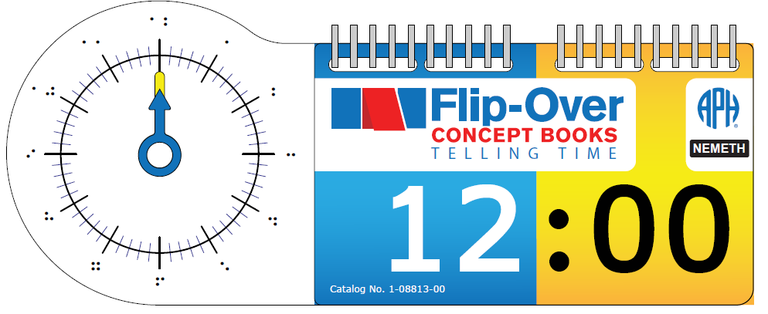

Background
In April 2006, the project leader submitted a formal proposal to develop a series of interactive tactile/print books to encourage young children's development and understanding of basic concepts related to shape, texture, spatial concepts, counting, and so forth. Flip-Over Concept Books incorporates an interactive feature whereby the child independently flips pages or adjacent print/tactile panels that can be matched or sequenced. The panels turn so that, for instance, the child can find all of the panels that have a rough texture, continue a line path, complete a sequence, build an image, and so forth. Over a decade later, APH has introduced three unique books as part of the Flip-Over Concept Books series, including LINE PATHS, PARTS OF A WHOLE, and TEXTURES; two additional books—FRACTIONS and MAKE A FACE—are currently under development (see separate annual reports). Despite years of availability, the first three books continue to sell in large numbers: LINE PATHS—430 (FY14); 317 (FY15); 311 (FY16); PARTS OF A WHOLE—407 (FY14); 387 (FY15); 263 (FY16); TEXTURES—810 (FY14); 787 (FY15); 567 (FY16).

In January 2011, the project leader reviewed a product submission idea received from two teachers of the visually impaired who requested tactile “Analog Clock Flash Cards.” The requested product was described as a set of tactile analog clock flash cards including all times on the hour, half hour, and at least one example of each time on the 5-minute intervals (e.g., 1:10, 2:35). A cardboard clock with moveable hands was suggested as well. The identified target audience included tactile readers and low vision readers in elementary grades through middle school. The project leader listed the following advantages of the proposed product:
- The product would be a nice complement to APH’s existing analog clock model.
- The product would provide good practice of tactile graphic interpretation skills needed for success on standardized tests and in the classroom.
- The product would have appeal for a wide audience.
- The product would offer an ideal way to illustrate proper tactile illustration of clock faces according to Braille Authority of North America (BANA) guidelines for transcribers and teachers.

Although recognized as a viable product idea, the Analog Clock Flash Cards lingered on APH’s “PARC-ing Lot” for a lengthy period of time due to higher company-identified product priorities. The project leader later determined that the product concept could be addressed as a Flip-Over Concept Book. In June 2016, the product transitioned to the active product timeline with official approval from the Product Advisory and Review Committee.

Work during FY 2017
The Flip-Over Concept Books: TELLING TIME will function similarly to previous Flip-Over Concept Books. Specifically, it will feature freely rotating panels that are threaded onto a ProClick® binding, allowing the removal and repositioning of panels, if desired. However, rather than three panels wide, the book will feature HOUR and MINUTE stacks that are positioned next to an analog clock model with movable HOUR and MINUTE hands. The HOUR and MINUTE panels will be printed and vacuum-formed on .010-in. white vinyl.

Given the successful design of previous Flip-Over Concept Books, formal field testing of TELLING TIME was deemed unnecessary; however, guidance and feedback was garnered from in-house staff, especially from tactile/braille readers, as the optimal visual and braille design was fleshed out. Additionally, project leaders with expertise in Core Curriculum instruction were consulted; guidance from APH tactile graphic designers versed in BANA’s braille and tactile guidelines was invited as well. The design of the tactile analog clock for TELLING TIME mirrors expected design elements (e.g., discriminable textures and lengths of clock hands, placement and lengths of MINUTE and SECOND tic marks, position of braille labels). Correct NEMETH and Unified English Braille (UEB) braille notations were utilized for the two complementary TELLING TIME flip-over books.

The project leader conducted repeated Product Development Committee (PDC) meetings throughout the fiscal year to review the expected product design, invite input from others, and monitor and test experimental tooling samples for eventual production of the book. Details discussed by PDC members encompassed a wide variety of product-building topics, including the following:
- Die-cutting of clock hands
- Ideal color and texture of clock hands
- Layout for the HOUR and MINUTE panels for printing and vacuum-forming
- Assembly of central hub of analog clock to ensure ideal tension for the rotation of clock hands
- Thickness and overall shape of back polyethylene panel
- Radius corners of book to ensure smooth edges
- Provision/packaging of separate UEB and NEMETH versions of the same flip-over book

The project leader prepared a suggested multi-up panel arrangement for the NEMETH and UEB panels for both books with simbraille for reference. The UEB flip-over HOUR and MINUTE panels are shown below:
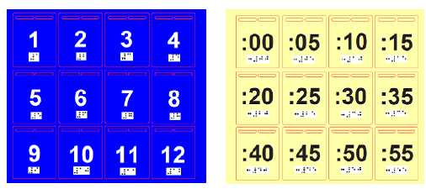

The NEMETH flip-over HOUR and MINUTE panels are shown below:
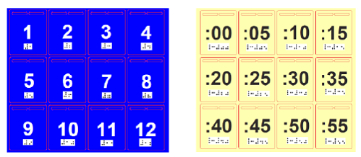

In January 2017, catalog numbers were assigned to the UEB and NEMETH versions of the accompanying Reader’s Guide—1-08814-00 and 1-08813-00, respectively. The project leader authored content for the accompanying Reader’s Guide. The content for the UEB and NEMETH versions of the Reader’s Guide is nearly identical except for needed references to unique braille notation represented on the panels of the flip-over book. After careful editing by Rachel White, the final content was provided to Matt Poppe for final layout and design. In early February, the project leader forwarded the clean files and the final graphical layout of each version of the Reader’s Guide to the manufacturing specialist for delivery to the Braille Department. Braille translation was prepared and approved for production in May after multiple reviews by the Braille Department and Research staff. Final page counts for print and braille versions of the Reader’s Guide were incorporated into the product specifications.

Work planned for FY 2018
Staff in various APH departments—Model Shop, Technical Research, Graphic Design, and Braille Transcription—will be pivotal during the construction of necessary production tools for the eventual manufacturing of Flip-Over Concept Books: TELLING TIME, including the following items:

VACUUM-FORM PATTERNS
1 | Pattern for UEB panels (HOURS)
2 | Pattern for UEB panels (MINUTES)
3 | Pattern for NEMETH panels (HOURS)
4 | Pattern for NEMETH panels (MINUTES)
5 | Pattern for UEB flip-over book clear cover
6 | Pattern for NEMETH flip-over book clear cover
7 | Pattern for clock (generic design for both UEB and NEMETH books)
CUTTING DIES
1 | Multi-up cutting die for HOUR and MINUTE panels (will serve for both UEB and NEMETH books)
2 | Multi-up cutting die for CLOCK—likely 4-up (will serve for both UEB and NEMETH versions)
3 | Multi-up cutting die for front, clear flip-over cover (will serve for both UEB and NEMETH books)
4 | Cutting die (possibly multi-up) for white polyethylene back cover
5 | Multi-up cutting die for HOUR hand (blue/textured)
6 | Multi-up cutting die for MINUTE hand (yellow/smooth)
PRINT FILES
1 | UEB Reader’s Guidebook—completed
2 | NEMETH Reader’s Guide—completed
3 | Cover art for NEMETH flip-over book (w/assigned cat. #)
4 | Cover art for UEB flip-over book (w/assigned cat. #)
5 | Clock face with print numbers using multi-up die template—will be used for both NEMETH and UEB books)
6 | UEB panels using multi-up die template (HOURS)
7 | UEB panels using multi-up die template (MINUTES)
8 | NEMETH panels using multi-up die template (HOURS)
9 | NEMETH panels using multi-up die template (MINUTES)
10 | SMALL PARTS Warning Label (existing part)
11 | Print Parts List
BRAILLE FILES
1 | Braille translation of Reader’s Guide (NEMETH)—completed 5/22/17
2 | Braille translation of Reader’s Guide (UEB)—completed 5/22/17
3 | SMALL Parts Warning Label (existing APH part)
4 | Braille Parts List

The project leader will periodically convene the project team to monitor progress, provide information for the specifications document, and approve sample parts. Steady accomplishments on tooling completion might be impacted by concurrent work on other higher priority products, but it is anticipated that all related tooling for the production of TELLING TIME will be completed by the middle of 2018. The specifications document will be formally presented to Production staff; quantities for initial pilot and production runs will be determined. Actual availability of TELLING TIME is expected in FY 2019, following the introduction of Flip-Over Concept Books: FRACTIONS.

Hundreds Board and Manipulatives
(New)

Purpose
To modernize the current Hundreds Board and Manipulatives to include both a Nemeth and Unified English Braille (UEB) version

Project Staff
Jeanette Wicker, Project Leader (Core Curriculum Consultant)
Laura Zierer, Project Leader
Frank Hayden, Director of Technical & Manufacturing Research
Andrew Moulton, Manager of Technical & Manufacturing Research
Patrick White, Model/Pattern Maker
Adam Clark, Manufacturing Specialist

Background
The Hundreds Board is a math tool used in many elementary classrooms to teach number concepts. The use of the Hundreds Board is supported by the Common Core State Standards and the National Council of Teachers of Math (NCTM) Standards. As APH is currently offering many math products in both UEB and Nemeth, it is appropriate to produce the Hundreds Board and Manipulatives in both formats.

The product submission from a teacher in the field was reviewed and received approval from the Product Evaluation Team in January 2017 and the Product Advisory and Review Committee in February 2017.

Project leaders met with staff from Technical Research and Production to determine parts that could be shared between the two versions of the Hundreds Board. Part numbers and catalog numbers were requested and received. The model maker began the process of developing the Number Board in UEB.

Work planned for FY 2018
The Model Shop will continue to develop the new parts needed for the kits. The guidebook will be revised. Technical Research will begin work on writing the specifications for the two products.

Math Homework Kit
(Continued)

Purpose
To develop an inexpensive, consumable set of items that allow blind or visually impaired students to make math graphs that can be turned in for homework, read by the teacher, and kept by the student for later review. Ease of use, readability, and marking on the top side of the graph sheet (rather than from the reverse) are among the aims for the product.

Project Staff
Li Zhou, Core Curriculum Project Leader
Fred Otto, Tactile Literacy Project Leader
Frank Hayden, Director of Technical and Manufacturing Research
Andrew Moulton, Manufacturing Specialist
Rod Dixon, Manufacturing Specialist
Tom Poppe, Model/Pattern Maker

Background
Blind students in math classes face considerable challenges in producing graphs, particularly when those graphs are to be turned in for grading. While a tool such as APH’s Graphic Aid for Mathematics works admirably for classroom demonstration, it is much too bulky to carry home, and each graph must be taken apart before another one is made. Some students have solved this problem by turning in photos of each graph they make on the board, but this method may be beyond the ability of many students. It also offers no tangible way to review the graphs after they have been taken apart.

Many students use raised-line graph paper and embossing tools as an alternative to the large graphing boards. The major drawback to this method is that the embossing must be done from the back of the sheet in order to be felt on the top surface, meaning that a mental reversal must be done on the image as it is being constructed. This, too, puts an extra burden on the student and makes the graphing task much more exacting. Waxed string products are also widely used, but these may fall off or cause sheets to stick together, and they provide no tactual contrast.

This project aims to give students and teachers an easy way to make raised-line graphs directly on top of a graph sheet. These graphs will allow for revision, be durable enough to carry around and review, and provide strong tactile and visual contrast for good readability. The materials will also be inexpensive and appealing to use.

The project leaders researched and experimented with numerous commercially available adhesive tapes and fabrics capable of producing tactual lines. Model Shop staff also produced some embossing tools and plates with raised points to try out. Although some of the ideas tried out may be worth pursuing later, they all gave way once the idea of using adhesive foam strips was tried.

The project leaders submitted their idea and received approval for the project. They obtained peel-and-stick foam sheets—one with a smooth texture and one with a glitter surface—which provide visual and tactile contrast. The model maker produced a set of sample foam strips and point symbols with various dimensions.

Project leaders began working with the Purchasing Department to find a source for the glitter sheets, which are not as readily available in the quantities needed as the smooth sheets.

Work during FY 2017
Project staff had discussions with a local vendor to see if the foam sheets could be “kiss-cut” into strips and point symbols as desired (i.e., die-cut but with the backing sheet left intact, so items can be peeled off the sheet). The vendor expressed confidence that it could be done.

Project leaders continued to investigate and obtain samples of numerous kinds of textured foam to serve as tactual contrast to the smooth foam already selected for the kit. Staff also discussed printing a texture onto foam sheets as another option. Technical Research staff then suggested using an adhesive-backed non-skid rubber, already used in other APH products, as an alternative. Because this material has a distinctive texture and can be die-cut easily, project leaders agreed that it is the best choice.

Work planned for FY 2018
A field evaluation is planned for the fall of 2017. The proposed kit will contain a quantity of each kind of foam, cut into strips and point symbols, and some APH Low-Relief Graph Sheets.

Project leaders will work with graphic designers to develop a cover sheet and logo for the kit. The evaluation results will be compiled and analyzed, and changes to the product design will be made as needed. Project staff will work on final product specifications.

Math Robot™
(Continued)

Purpose
To provide math flash card style functionality for both speech and braille feedback in a fun and compelling environment for iOS® devices

Project Staff
Heather MacKenzie, Project Leader
Lawrence Lovelace, Programmer
Bryan Enders, Project Leader
Cathy Senft-Graves, Braille Literacy & Technology Project Leader
Denise Snow Wilson, Technical Communications Specialist

Background
APH has shifted its technological focus to portable devices, such as those running on iOS® and Android™ platforms, in response to requests from teachers and students. One such request was for an iOS® version of Math Flash. (See tech.aph.org/mf_info.htm.) Math Flash provides drill, practice, and tests for simple, configurable math problems with speech and braille feedback.

To respond to this request, APH began work with the following tasks:
- Hired an iOS® programmer
- Wrote objective coding guidelines
- Wrote tests
- Wrote touch input and external hardware input to work with hardware keyboards or braille display
- Recorded sounds
- Developed user interface art
- Developed user interface
- Developed math problem models
- Created animations
- Integrated braille feedback and input

Work during FY 2017
The following project tasks were completed:
- Some work was done creating the storyboards for the universal version; not enough progress was made to create a release for testing

Work planned for FY 2018
Project staff will work to complete the following tasks:
- Continue work on a universal version
- Ensure the current version is compatible with iOS® 11

MathBuilders
(Continued)

Purpose
To develop instructional math materials for use with students in the primary grades who are blind and visually impaired either as a supplement to the classroom math program or as a core curriculum

Project Staff
Jeanette Wicker, Project Leader (Core Curriculum Consultant)
Li Zhou, Core Curriculum Project Leader
Derrick Smith, Project Consultant
Anthony D. Jones, Art Production/Design Manager
Frank Hayden, Director of Technical & Manufacturing Research
Andrew Moulton, Manager of Technical & Manufacturing Research
Patrick White, Model/Pattern Maker II
Rachel White, Research Assistant

Background
Math achievement of blind students has been consistently behind that of their sighted peers. In recent years, very little research and product development has been done to improve this situation. Teachers of students who are blind, however, have continuously requested special braille curricular materials for math similar to those in the Patterns program developed at APH to teach braille reading. Because of the dramatic increases in the number of blind students mainstreamed, the use of the itinerant special education teacher model, the math priority stated in GOALS 2000, and new teaching standards adopted by the National Council of Teachers of Mathematics, it became critical to focus once again on math materials for visually impaired students. This project received special funding as part of a 3-year research initiative to develop new products in math, science, and geography.

During the Mathematics Focus Group Meeting in September 1994, this program was discussed and specifications were determined. During FY 1995, work on the project included a review of the research and literature on math instruction for visually impaired students; analyses of math curriculum guides; thorough analyses of current textbooks to determine mathematical symbols, terms, and concepts being taught; a search of the catalogs for commercially-available math related products; and a review of programs on abacus instruction. By 1996, prototypes of eight Primary Math Units and a general guidebook began to take shape with guidance from William E. Leibfritz, math consultant. In July 1996, a group of teachers of the visually impaired met at APH to share ideas they found to be particularly effective for developing math concepts and practice materials for their visually impaired students in the primary grades.

In July 1997, project consultants, Leibfritz and Susan Millaway, met at APH and reviewed in detail the teaching strategies for the kindergarten and first grade Primary Math Units. A draft of an introductory book that presents the philosophy and overview of the program was developed by the project leader later in FY 1997. In FY 1998 and 1999, worksheets were developed to supplement the Lessons for Unit 1: Matching, Sorting, and Patterning for kindergarten through third grade.

In FY 2000, the decision was made to field test by units rather than waiting for the program to be finished in its entirety. Tooling of Unit 1 prototype worksheets for field testing began. In FY 2001, evaluation forms for the introduction and Unit 1 were drafted. Tooling of the prototype worksheets continued with coordination of the print and braille requiring much more time than originally planned.

In FY 2002-2003, Jenny Dortch completed the final draft of the introductory book and Unit 1. The evaluation forms for the book, lessons, and worksheets were developed. During FY 2004, the evaluation forms, Guidelines (introductory material), and Unit 1 Lessons for kindergarten through third grade were finalized and prepared for field testing. Materials were placed with teachers having braille reading students in kindergarten through third grade for approximately six to eight weeks and then returned to APH for compilation and analyses of data. Results were extremely positive with only a little revision required. Dortch continued work on Units 2, 3, and 4 during FY 2004 and 2005. These units cover Number Concepts, Place Value, and Number Operation. Eleanor Pester served as project leader during this phase of development.

In FY 2006, the project was assigned to Jeanette Wicker, Core Curriculum Project Leader (a newly created position). Revisions were made to Unit 1, Matching, Patterning, and Sorting and to the General Guidelines based on the feedback from the field testing. MathBuilders was selected as the name for the series. Manipulatives were added to Unit 1 based on feedback from field testing. Graphic design and braille translation were completed. Tooling for worksheets began. A consultant, Derrick Smith, was hired for Unit 6, Geometry and Unit 8, Data Collection, Graphing, and Probability/Statistics. Objectives were reviewed for alignment with Principles and Standards for School Mathematics from the National Council of Teachers of Math for Units 6 and 8.

In FY 2007, Unit 1 and the General Guidelines became available for sale. A prototype of the Geometry Unit was completed and field tested at 10 sites for 3 months in the spring of 2007. The text for Unit 8 was written, and the development of a prototype was initiated.

In FY 2008, revisions based on field reviewers’ comments were completed for Unit 6, Geometry. Production was completed, and the Unit became available for sale in May 2008. Field testing of Unit 8, Data Collection, Graphing, and Probability/Statistics was completed, and revisions were made based on field reviewer’s comments. A prototype of Unit 7, Fractions, Mixed Numbers, and Decimals was completed.

Unit 8, Data Collection, Graphing, and Probability/Statistics became available in September 2009. Unit 7, Fractions, Mixed Numbers, and Decimals was field tested in FY 2009. The development of Unit 5, Measurement began in FY 2009.

In FY 2010, revisions to Unit 7, Fractions, Mixed Numbers, and Decimals were completed. A specification meeting was held on May 3, 2010. Production was scheduled for February 2011. Unit 7, Fractions, Mixed Numbers, and Decimals became available for sale in April 2011.

Unit 5, Measurement was field tested from February to May 2010 at 13 different sites. An analysis of the evaluations provided feedback as to the needed changes to the prototype. Revisions to Unit 5, Measurement were completed, and manipulatives were finalized. Specifications were written.

In February 2012, Unit 5, Measurement became available for sale. Five of the eight units are now available for use in the classroom. The objectives for the last three units of the series were developed and organized in a series of meetings with the consultant for this project, Derrick Smith. Work on the last three units, Number Concepts, Place Value, and Number Operations was started. Some lessons were written and some worksheets designed. Technical Research began work on some of the manipulatives.

In FY 2013, project staff continued working on the last three units. Li Zhou was hired as the Core Curriculum Project Leader and will assist with this project. Lessons were drafted for Unit 3, Place Value, and work continued on Unit 2 and Unit 4. Technical Research created prototypes of several manipulatives and continued work to complete the remaining pieces.

A working session was held in June 2014 to complete revisions to Unit 3. Work began on writing and revising Units 2 and 4 during this work session. Prototypes of all three of the last units will be field tested together as the concepts of Place Value, Number Concepts, and Number Operation overlap. One set of manipulatives will be used for all three units.

In FY 2015 and FY 2016, the project leaders and Smith continued to write the lessons for Units 2, Number Concept and Unit 4, Number Operations.

Work during FY 2017
There was no major work on this project in the last year. Lessons were edited and revised for Unit 3.

Work planned for FY 2018
Project staff will complete the remaining lessons for Units 2 and 4. Staff will develop prototypes for field testing of all three remaining units including manipulatives and worksheet.

Nemeth Code Reference Sheet for Basic Mathematics [Modernization]
(Continued)

Purpose
To revise and expand the Nemeth Code Reference Sheet for Basic Mathematics, a quick reference sheet of basic Nemeth Code

Project Staff
Jeanette Wicker, Project Leader (Core Curriculum Consultant)
Cathy Senft-Graves, Braille Literacy and Technology Project Leader
Susan Osterhaus, Project Consultant
Derrick Smith, Project Consultant
Sara Lee, Research Assistant
Frank Hayden, Director of Technical & Manufacturing Research

Background
Ex Officio Trustees have requested additional supports for teachers and students using Nemeth Code. Additionally, with the advent of Common Core State Standards, the emphasis on high stakes testing, and the increased emphasis on STEM classes and careers, staff at APH reviewed existing products that needed updating. The current Nemeth Code Reference Sheet for Basic Mathematics is very general in the Nemeth Code listed. Some of the code would be taught in an elementary class while some would be taught in an advanced mathematics class.

In FY 2014, a Product Modernization form was submitted. The revised Nemeth Code Sheet will be three individual bi-fold sheets: Beginning Level, Intermediate Level, and Advanced Level. The Maryland Common Core State Curriculum Framework for Braille, Mathematics outlines the Nemeth Code needed by grade level to participate successfully in math classes. This document, the work of Gaylan Kapperman, and the work of Susan Osterhaus were used to identify the symbols to be included at each level. Osterhaus and Derrick Smith agreed to be reviewers, and to make recommendations as to the final content.

In FY 2105, the project leader developed a draft listing of the three levels of Nemeth Code using the Maryland Common Core State Curriculum Framework, the APH Nemeth Tutorial developed by Kapperman, TSBVI Nemeth Code Reference Sheets, and the APH Nemeth Code Reference Sheet for Basic Mathematics. These were sent to Osterhaus and Smith for review. Their suggestions for additions and revisions were incorporated. Additionally, Cathy Senft-Graves, Braille Literacy and Technology Project Leader, reviewed the listings for appropriate groupings of the Nemeth Code Symbols. The project leader finalized the content for the Beginning Level and the Intermediate Level.

In FY 2016, the project leader finalized the content for Advanced Level of the Braille Reference Sheets with input from Osterhaus and Smith. The project leader began the development of the chart of the Nemeth Code for each of the three levels.

Work during FY 2017
The braille translation of the content and layout of the beginning level was completed, proofed, and revised. Work began on the content and layout of the intermediate level.

Work planned for FY 2018
The project leader will finalize the three charts. Project staff will complete graphic design and braille translation of the three sheets in preparation for field evaluation.

Place Value Setter
(Continued)

Purpose
To give early elementary school students with blindness or low vision a quick, fun, and hands-on way to learn about and develop a firm understanding of the basic math concept place value

Project Staff
Li Zhou, Core Curriculum Project Leader
Andrew Dakin, Model/Pattern Maker
Adam Clark, Manufacturing Specialist
Rachel White, Research Assistant
Matthew Poppe, Art Designer
Frank Hayden, Director of Technical & Manufacturing Research
Andrew Moulton, Manager of Technical & Manufacturing Research

Background
Place value is a positional notation system in which the position of a digit determines its value. For example, in the base 10 number system that we use every day, each place has a value 10 times that of the place to its right. As the basis for students' understanding of numbers, place value is a fundamental concept that must be acquired prior to moving onto more complex math skills and concepts.

To fully understand place value, students must gain knowledge of conceptual models of place value and then connect that knowledge with written representations. To facilitate number setting with written digits for students with blindness and low vision, a teacher of students with visual impairments in Manahawkin, NJ, submitted the idea of a new product Place Value Setter: In Braille and Large Print to APH in July 2014. After a thorough evaluation, APH accepted that idea and assigned it to the current project leader.

The Place Value Setter is designed to have number strips installed on a base board. Strips have written digits in both large print and braille, which allows braille students to work together with non-braille readers. Sliding the strips allows students to show place value digits. With that refreshable and concrete display, the Place Value Setter will give students with blindness and low vision as well as their teachers a prompt way to represent numbers using written digits. Designed for elementary school students, especially 1st to 3rd graders, this tool will be particularly useful for the following groups:
- students with blindness and low vision who need to practice quick and simple place value setting;
- teachers or teaching assistants of students with visual impairments who want to set up place value problems quickly so that, in inclusive settings, their students can follow classroom math teachers' instructions and participate in real time classroom activities;
- for non-braille readers such as parents and sighted students to work together with students with visual impairments; and
- for students who benefit from hands-on learning to get a concrete learning experience.

In 2015, prototypes for use in field test were designed and made. Field test documents were completed. Field test sites were identified. Field test began in September 2015.

Field test of the Place Value Setter was conducted from September to November 2015. Eight teachers completed the field test. They were from seven states including Illinois, Iowa, Kansas, New York (2), Pennsylvania, Texas, and Washington. Participants were selected based on the number of available students, diversity of setting, and geography.

All participating teachers were teachers of students with visual impairments. Their years of experience teaching students with visual impairments ranged from 2 to 41 years, with the average being 14 years. Most teachers (6, 75%) worked in itinerant positions, one teacher (12.5%) worked at a residential school for students with visual impairments, and one (12.5%) worked in an inclusive classroom at a regular school.

In all, the participating teachers worked with 30 students in this field test. Below is a breakdown of students' demographics:
- Fourteen students (46.67%) were female, and 16 students (53.33%) were male.
- Eleven students (36.67%) reported their ethnicity as White, six (20%) reported Hispanic, three (10%) reported Black/African-American, two (6.67%) reported Asian, and one (3.33%) reported Russian. Seven students did not provide this information.
- Students' ages ranged from 6 to 12, with the average being 8 and the mode (most frequently reported ages) being 9 (10 students).
- Academic levels ranged from 1 through 5, with the mode (most frequently reported grades) being 2 (eight students).
- Twenty students (66.67%) had low vision, and nine students (30%) had blindness. One student did not provide this information.
- For primary reading medium, 11 students (36.67%) used braille, 18 students (60%) used large print material, and one (3.33%) reported regular print.
- Thirteen students (43.33%) had disabilities in addition to their visual impairments. Their conditions included hearing impairment, ADHD, cognitive impairment, speech disorder, learning disabilities, and cerebral palsy.

After testing the product with each of their student, teachers were asked to what extent they agreed or disagreed that this product was helpful to that particular student for achieving his/her learning objectives. The scale ranged from 1 (strongly disagree) to 6 (strongly agree). Of 30 students, teachers answered 2 (disagree) for one student (3.33%), 4 (somewhat agree) for seven students (23.33%), 5 (agree) for 14 students (46.67%), and 6 (strongly agree) for eight students (26.67%). The average was 4.9.

After working with all students, teachers were also asked about their overall opinion of this product. Five teachers (62.5%) strongly agreed and two teachers (25%) agreed that this product could help students with visual impairments study the concept of place value. One teacher (12.5%) somewhat agreed with that. Seven teachers (87.5%) thought that this product would be highly useful in their classrooms if the changes they suggested were made. One teacher (12.5%) thought that this product would probably not be very useful in her classroom. Following is a quote from a teacher: "To gain a full understanding place value requires the student to understand the connection between base ten units, how they can be bundled and unbundled, and positional notation. In my opinion, the place value setter goes beyond where other manipulative tools leave off in that it reinforces positional notation and helps students' conceptual understanding in a way that cubes or rods alone cannot. The place value tool is helpful for students with blindness or low vision because it brings all three conceptual requirements together and gives them a means of writing numbers with an understanding of how the digits have value based on their position within a number."

Teachers and students suggested several changes. The development team discussed all of them and decided to make the following revisions:
- Increase the dimension of the base board
- Increase font sizes of print letters, numbers, and symbols
- Increase the height of the number window area
- Change abbreviations of place value digits
- Add tactile symbols to help with orientation for students with blindness
- Provide better color contrast to help with orientation for students with low vision

Work during FY 2017
Print and braille guidebooks were completed. Project staff worked on product tooling and specifications.

Work planned for FY 2018
Product tooling and specifications will be completed. The project staff will monitor the quality of samples during the pilot and initial production run. Production will be completed, and the product will become available for purchase.

Practice2Master Fractions
(New)

Purpose
To give students who are visually impaired an accessible app for fraction calculation study

Project Staff
Li Zhou, Co-Project Leader, Core Curriculum Project Leader
Fred Otto, Co-Project Leader, Tactile Literacy Project Leader
Rachel White, Research Assistant
Lawrence Lovelace, iOS® Developer
Laura Greenwell, Graphic Designer
Anthony D. Jones, Art Design/Production Manager

Background
Basic fraction calculation, including addition, subtraction, multiplication, and division, is an important but sometimes difficult part of elementary and middle school math study. For students to achieve fluency in fraction calculation, adequate practice is a must. Many smart phone and tablet apps have been developed to help students with this. However, because the design of these apps does not give adequate if any consideration to the special needs of students with disabilities, it is very hard for students who are blind or have low vision to use them effectively and benefit from them as their sighted peers do. Lack of access to such tools might put these students at a disadvantage in fraction study.

To give students who are visually impaired an accessible fractions app, the project leaders submitted this new product idea in September 2016. Although Practice2Master Fractions is specifically designed for students with vision loss, it can be used by all students. Among its many features, this app allows students and teachers to do the following:
- Do free practice in fraction addition, subtraction, multiplication, and division and get assistance from the app when needed.
- Take drills on fraction calculation and save drill reports for future reference.
- Create users' own fraction calculation problems for future practice and drills.
- Customize the app by setting problem types, difficulties, and so forth.
- Learn how to use the app through written instructions and video demonstrations.

Work during FY 2017
In February 2017, this new product idea was approved by the Product Evaluation Team and the Product Advisory and Review Committee and became an active project.
Staff of this project has been building a prototype for use in the field test.

Work planned for FY 2018
Field test of the Practice2Master Fractions app will be conducted, and necessary changes to the app will be made based on field testers' feedback. Then, the app will be released.

Publisher Collaboration – Pearson (enVisionmath 2.0)
(Continued)

Purpose
To collaborate with a publisher of a mainstream math program in producing accessible materials for students who are blind and visually impaired that will allow them to participate fully in the regular education classroom

Project Staff
Jeanette Wicker, Project Leader (Core Curriculum Consultant)
Sara Larkin, Project Consultant
Rod Dixon, Manufacturing Specialist
Frank Hayden, Director of Technical & Manufacturing Research
Anthony D. Jones, Art Production/Design Manager
Andrew Moulton, Manager of Technical & Manufacturing Research
Patrick White, Model/Pattern Maker
Rachel White, Research Assistant

Background
The enVisionmath2.0 by Pearson Publishing for grades K-6 became available for sale in December 2105. The program is aligned to the Common Core State Standards and supports print, blended, and a digital learning experience. The program includes an online component that students use in conjunction with the print math book and a set of manipulatives.

APH was approached to work in collaboration with Pearson Publishing to develop materials including a set of manipulatives for students who are blind and visually impaired that aligns with the enVisionmath2.0 program.

The product submission was reviewed and received approval from the Product Evaluation Team and the Product Advisory and Review Committee in August 2015.

Sara Larkin, the Statewide Mathematics and Science Consultant for the Blind and Visually Impaired from the Iowa Educational Services for the Blind and Visually Impaired, signed a contract with APH to act as a consultant for this project. Larkin and the project leader met at APH in October 2015 to begin work on the project. They reviewed the manipulatives, the student books, and the teacher’s manuals for each grade level.

A contract was finalized with Pearson Publishing in February 2016.

Many existing math manipulatives from APH are accessible version of the manipulatives used in the enVisionmath2.0 program and will be included in the kits. Project staff began the process of designing and developing new manipulatives needed to accompany the kits. As many of the same manipulatives are used in several grades, it was decided to have one kit of manipulatives for grades K-2 and three separate manuals for each of the three grades. Larkin and the project leader met via telephone/video conferences throughout the winter and spring to develop the manual for Kindergarten.

Larkin and the project leader worked again at APH in June 2016 to complete a draft of the Kindergarten Manual. The draft of the first Kindergarten topic was sent to Pearson for review. Revisions to the manual were made based on this feedback. Pearson agreed to review the first topic of each grade level.

Work during FY 2017
Larkin and the project leader reviewed and revised the Kindergarten Teacher’s Manual. Graphic design completed the layout of the Kindergarten Teacher’s Manual. Work began on the Teacher’s Manual for Grade 1.

Work planned for FY 2018
The kits and the Kindergarten Teacher’s Manual will be reviewed by teachers of the visually impaired who use the enVisionmath2.0 program with their students.

Work will continue on the Teacher’s Manuals for Grade 1; work will begin on the manual for Grade 2.

Slapstack Math iOS® App
(New/Completed)

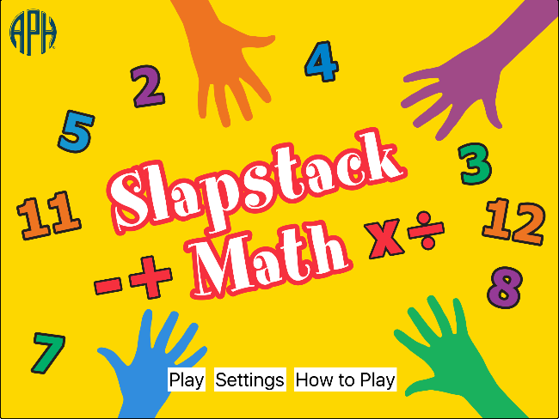

Purpose
To create a fully accessible educational game for iOS® devices that combines math practice, memory, movement, and fun

Project Staff
Fred Otto, Tactile Literacy Project Leader
Li Zhou, Core Curriculum Project Leader
Rachel White, Research Assistant
Laura Greenwell, Graphic Designer
Anthony D. Jones, Art Production/Design Manager
Lawrence Lovelace, iOS® App Developer

Background
The project co-leaders began by discussing games that would lend themselves well to adaptation as iOS® apps, and eventually focused on a variation of the card game Slapjack. In this variation, cards from a deck are turned up one at a time, and certain cards have a required action assigned to them (e.g., slapping the table, making animal sounds, clapping hands, etc.). The first player to perform the required action when one of those cards appears gets to claim the stack of cards dealt up to that point. With each round played, players assign actions to new cards, making more and more requirements to remember as the game progresses. The game typically gets noisy and silly as it goes on.

The twist envisioned for the iOS® version was to incorporate practice with math operations into the game. Thus, in addition to single numbers coming up, the app produces basic problems in addition, subtraction, multiplication, and division, similar to flash cards. Players still have to perform required action for certain numbers, but they must calculate the answers to the math problems first. The game thereby calls on math computation, memory, and attention, while still being motivating and entertaining to play.

The app improves on regular cards (or flash cards) by voicing all the numbers and displaying them in large, high-contrast print. Players may take turns deciding on what actions to assign to different numbers. To claim “cards” (points), a player puts three fingers at the center of the screen and drags them toward one of the colored areas at the edge of the screen. All elements of the game and menus are designed to be equally accessible to blind, low-vision, and sighted players, making the app ideal for social integration with different groups.

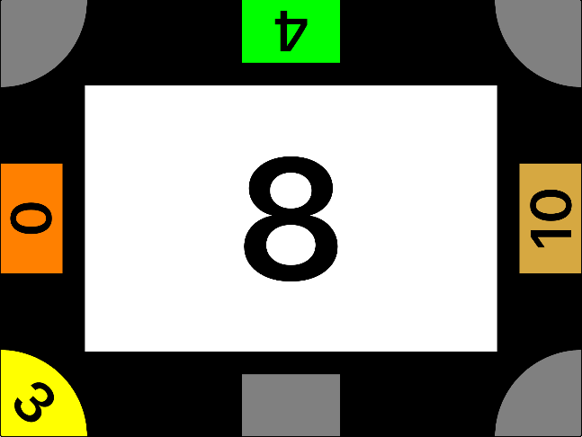

Work during FY 2017
Project leaders created a basic prototype of the app to demonstrate and offered the idea through the product submission process. Approval for the project was given in February.

Project leaders revised the elements and appearance of the app repeatedly in preparation for field evaluation. Sound effects were added as surprise elements and to stimulate interest. A video demonstration of the game was made using APH staff and included with the evaluation version of the app.

A call for evaluators was issued in March, and the evaluation was conducted in April and May of 2017.

Seven teachers of students with visual impairments completed the field test. They were from seven states: California, Kansas, Maryland, New Jersey, New Mexico, Pennsylvania, and Texas.

In all, the participating teachers worked with 18 students in this field test. Below is a breakdown of students' demographics:
- Eight students (44%) were female, and 10 (56%) were male.
- Over half (10, 56%) reported their ethnicity as White/Caucasian, four (22%) reported Hispanic, two (11%) reported Black/African-American, one (5%) reported Chinese, and one (5%) reported Indian.
- Academic levels ranged from pre-K through 11, with the most frequently reported grade being 1 (three students).
- Ten students (56%) had disabilities in addition to their visual impairments, such as speech disorder, autism, and cognitive disability.

Field testers gave several comments and suggestions. Based on their feedback, the following changes were made to the app:
- The app was made to run on the iPhone® and iPod touch® in addition to the iPad®.
- Some user interface features such as size of player areas and location of buttons were revised to make the app easier to use by users who are blind.
- Two sound effects that might annoy some users were removed.
- Instructions on playing the game were revised to make them more direct and user friendly.

After the revisions, the demonstration video was redone to reflect final design of the app and to show the game being played by students. APH’s Quality Assurance staff then gave the app a thorough review, and minor fixes were made. The finished app was then posted to the App Store®, where it is available for free download.

Work planned for FY 2018
Routine maintenance is the only future work anticipated for this project.

Tactile Algebra Tiles
(Continued)

Purpose
To provide math students who are visually impaired with an accessible version of algebra tiles, a math manipulative used in elementary, middle, and high school algebra study

Project Staff
Li Zhou, Core Curriculum Project Leader
Katherine Corcoran, Model/Pattern Maker
Rod Dixon, Manufacturing Specialist
Rachel White, Research Assistant
Matthew Poppe, Graphic Designer
Frank Hayden, Director of Technical & Manufacturing Research
Andrew Moulton, Manager of Technical & Manufacturing Research
Anthony D. Jones, Art Production/Design Manager

Background
Algebra tiles are mathematical manipulatives that provide students with concrete models for understanding abstract algebraic concepts and procedures. With tiles representing variables and constants, algebra tiles can be used by students from elementary to high school for adding, subtracting, and multiplying integers; simplifying expressions; solving linear and quadratic equations; and multiplying and factoring polynomials. By providing students with a graphical way to solve algebraic problems in addition to abstract manipulation, algebra tiles are seen as helpful tools that meet students' diverse needs in algebra study.

Preliminary research has found that algebra tiles are commercially available through many vendors of educational manipulatives. However, these tiles are not readily accessible for students who are visually impaired. For example, the tiles come in different colors, but students who are blind cannot distinguish colors; the tiles are often small, which makes it difficult for students with visual impairments to manipulate them; and physically touching tiles, which might be helpful for visually impaired students, interferes with laying the them out into graphical patterns because they are not fixed on a desktop. The National Council of Teachers of Mathematics (NCTM) has developed a free online illumination of algebra tiles, but it is not accessible for students with severe vision loss.

In the summer of 2011, APH Core Curriculum Project Consultant, Jeanette Wicker, and Core Curriculum Project Leader, Sandi Baker, surveyed about 70 math teachers and teachers of students with visual impairments about potential math products. Algebra tiles were found to be one of the top three products that these teachers wanted the most for their students.

Therefore, the project leader submitted the product idea of adapting algebra tiles for students with visual impairments.

In 2014, the project leader presented the new product to the Product Evaluation Team and Product Advisory and Review Committee. Approval was received, and project staff began designing the product.

In 2015, design of the prototype for use in field testing was completed, and the Model Shop and Technical Research made prototypes for the field test. The project leader prepared field test documentations including a user's guide and evaluation forms.

Field testing of Tactile Algebra Tiles was conducted during January and April 2016. Eight teachers completed the field test. They were from seven states including Indiana, Kentucky, Missouri (2), New Jersey, Tennessee, Texas, and Wisconsin. Participants were selected based on number of available students, diversity of setting, and geography.

All participating teachers are teachers of students with visual impairments. Their years of experience teaching students with visual impairments ranged from 3 to 25 years, with the average being 7.6 years. Half of the teachers (4, 50%) worked in itinerant positions, and the other half (4, 50%) worked at residential schools for students with visual impairments.

In all, the participating teachers worked with 28 students in this field test. Below is a breakdown of the students' demographics:
- Thirteen students (46.43%) were female, and 15 students (53.57%) were male.
- Thirteen students (46.43%) reported their ethnicity as White, eight (28.57%) reported Black/African-American, six (21.43%) reported Hispanic, and one (3.57%) reported Asian.
- Students' ages ranged from 6 to 18 years, with the average being 14.36 and the modes (most frequently reported ages) being 14 and 16 (six students each).
- Academic levels ranged from K through 12, with the modes (most frequently reported grades) being 8 (seven students).
- Fifteen students (53.57%) had low vision, and 13 students (46.43%) had blindness.
- For primary reading medium, 17 students (60.71%) used braille, four students (14.29%) used large print material, six (21.43%) reported electronic, and one (3.57%) reported regular print.
- Seven students (25%) had disabilities in addition to their visual impairments. Their conditions included hearing impairment, ADHD, learning disabilities, and cerebral palsy.

After testing the product with each of their students, teachers were asked to what extent they agreed or disagreed that the product was helpful to that particular student for achieving his/her learning objectives. The scale ranged from 1 (strongly disagree) to 6 (strongly agree). Of the 28 students, teachers answered 2 (disagree) for one student (3.57%), 4 (somewhat agree) for three students (10.71%), 5 (agree) for seven students (25%), and 6 (strongly agree) for 17 students (60.71%). The average was 5.4.

Based on teachers' observations, most students (21 of 28 students, 75%) were very interested in using the product. Five students (17.86%) were somewhat interested, and two (7.14%) were uninterested.

After working with all students, teachers were asked about their overall opinion of the product. Four teachers (50%) strongly agreed and two teachers (25%) agreed that the product could help students with visual impairments in algebraic study. One teacher (12.5%) somewhat agreed with this statement, and one teacher (12.5%) disagreed. One quote from each teacher is listed below that represents his or her opinion of the product:
- "This is an excellent tool for teaching a number of algebraic skills."
- "The Tactile Algebra Tiles provided a fully accessible model of several algebraic concepts for students with visual impairments. The use of the tiles increased the acquisition and mastery of the concepts. The color contrast and tactile qualities were of the highest qualities, which enabled all of my students who practiced with the tiles the ability to model the polynomial problems independently!"
- "Very good tactile representation. Could use more tiles."
- "In each instance I used the tiles they were helpful and easy for the students and facilitators to understand. Each student was asked to use the tiles in their classroom math class for a week and then tell me how they worked or didn’t work. In each case the student and facilitator reported positive responses."
- "THE STUDENT FELT THE TILES COULD HAVE MANY USES AND BE VERY HELPFUL FOR THE VISUALLY IMPAIRED AND EVEN HELP THOSE WHO ARE NOT VISUALLY IMPAIRED DUE TO THEIR USES AND ABLE TO EXPLAIN THE ‘BALANCING OF EQUATIONS.’"
- "These tiles are so helpful that I hate to send them back (but will!). I'll make some temporary tactile tiles to hold us over until APH makes them available (soon I hope!?)."
- "I feel that this tool can be useful to teach the initial concept such as solving a two-step algebra problem. Ultimately, the student’s answer must be recorded (I.E.) pencil/paper, electronic device, braille writer. Once the student learns the concept then they should try solving the problem without the tactile tiles."
- "I like the idea, but it is just too confusing for tactile users; at least, it was for mine."

Teachers and students suggested few changes. The development team discussed field test findings and decided to add one more steel board to the kit to provide more room for tile storage.

Work during FY 2017
Product tooling and specifications have been completed. The product has been submitted to the Production.

Work planned for FY 2018
The project staff will monitor the quality of samples during the pilot and initial production run. Production will be completed, and the product will become available for purchase.

Tactile Five and Ten Frames
(Continued)

Purpose
To provide students who are blind and visually impaired a math manipulative comparable to that used in the elementary classroom by sighted peers

Project Staff
Jeanette Wicker, Project Leader (Core Curriculum Consultant)
Laura Greenwell, Graphic Designer
Frank Hayden, Director of Technical & Manufacturing Research
Anthony D. Jones, Art Production/Design Manager
Andrew Moulton, Manager of Technical & Manufacturing Research
Patrick White, Model/Pattern Maker
Rachel White, Research Assistant

Background
Five and ten frames are graphic organizers designed to help young children visualize sets of five and ten. These frames can help students develop subitizing skills, the ability to instantly see “how many.” When a student instantly “sees 5” on a domino or die, she is using her subitizing skills.

The understanding that numbers are composed of tens and ones is an important foundational concept. A strong sense of 10 is a prerequisite for number sense, composing and decomposing numbers, place value understanding, and mental calculations.

Many mainstream math textbooks incorporate the use of five and ten frames into math activities. In order for students with visual impairments to be included in the mainstream math class, it is important that they have similar tools.

Tactile Five and Ten Frames were planned for inclusion in MathBuilders Units 2 and 4. The design and development of the molds had previously been completed for these units. A product submission was received from a teacher of the visually impaired in Kentucky requesting the frames as a separate project.

The product submission was reviewed and received approval from the Product Evaluation Team in June 2015 and the Product Advisory and Review Committee in August 2015.

The Model Shop and Technical Research prepared additional frames for field evaluation, a manual to accompany the frames was completed, and graphic design prepared labels for the carrying case.

Work during FY 2017
The announcement for the field testing of the Tactile Five and Ten Frames was included in the September APH News. Thirty-one teachers responded to the announcement. Eighteen sites were selected to field test the prototypes from October 2016 through February 2017.

Field Evaluator Test Sites: The Tactile Five and Ten Frames were sent to 18 field evaluators in 12 states.
- States represented in the evaluation were California, Colorado, Indiana (2), Kentucky, Louisiana, Michigan (2), Missouri (3), New Mexico, New York (2), Ohio, Vermont, and Wisconsin (2).

Field Evaluators: The Tactile Five and Ten Frames were sent to 18 sites for review by teachers with students who are blind and visually impaired.
- Four evaluators reported 0-5 years of experience (22%), six reported 6-10 years of experience (33%), three reported 11-15 years of experience (17%), and five reported 16-20 years of experience (28%).
- One evaluator is Hispanic (6%), and 17 evaluators are White (94%).
- Sixteen of the evaluators listed their preferred reading medium as print (89%); two listed Large Print as the preferred reading medium (11%).
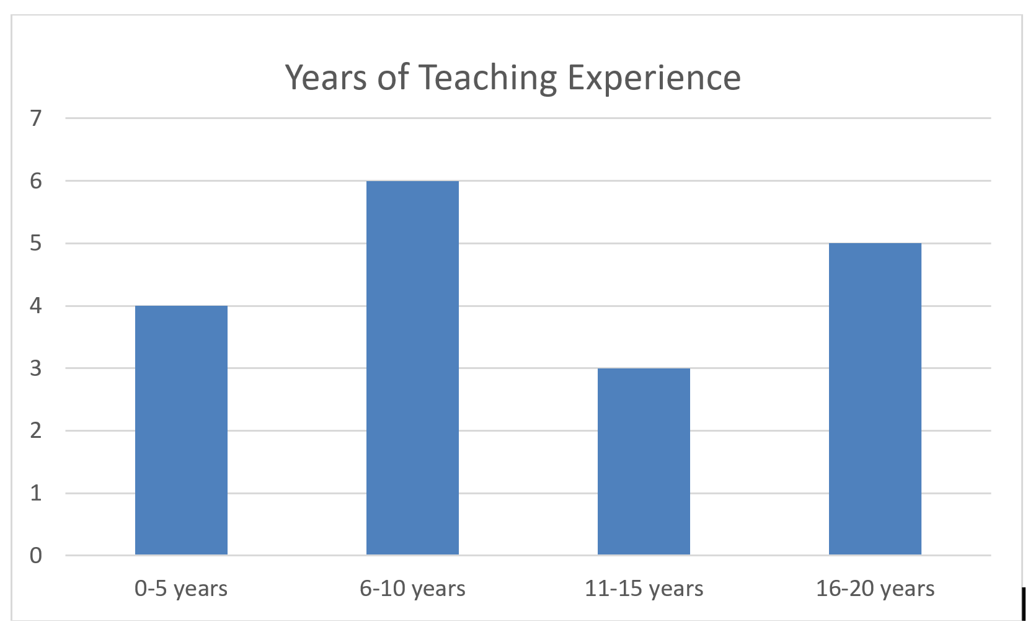

Students: Thirty-seven students used the Tactile Five and Ten Frames in the field test.
- Twenty-one of the participants are female (57%), and 16 are male (43%).
- Of the 37 students, 21 are White (56%), six are Black/African American (16%), five were reported as two or more races (14%), four are Hispanic (11%), and one is Middle Eastern (3%).
- Seventeen of the students received services in an itinerant setting (46%), 13 received services in a residential setting (35%), five received services in a resource room (13%), one student was in a self-contained setting (3%), and one student was home schooled with services provided by a TVI (3%).
- Twenty of the students were braille readers (54%), nine students were print reader (24%), five used a combination of print and braille (14%), and teachers reported for three students that they are “not certain at this time” as to the reading medium (8%).
- Teachers reported that 21 students (57%) had other disabilities/conditions that might impact math skills while 16 (43%) students had no additional disability that might impact their math skills.
- Students ranged in ages from 5 to 13 at the time of the evaluation. Seven students were 5 years old (19%), six were 6 years old (16%), 12 were 7 years old (32%), six were 8 years old (16%), three were 9 years old (8%), two were 10 years old (6%), and one student was 13 years old (3%).
- Three of the students were enrolled in a Pre-K class (8%), nine were enrolled in a Kindergarten class (24%), 12 were enrolled in first grade (32%), eight were enrolled in second grade (22%), four were enrolled in third grade (11%), and one student was enrolled in an ungraded classroom (3%).
- Teachers were also asked to report the level of math skills of the students. Six students were functioning at a Pre-K level (16%), 12 were functioning at a Kindergarten level (32%), 13 were functioning at a first grade level (35%), five were functioning at a second grade level (14%), and one student was functioning at a third grade level (3%).
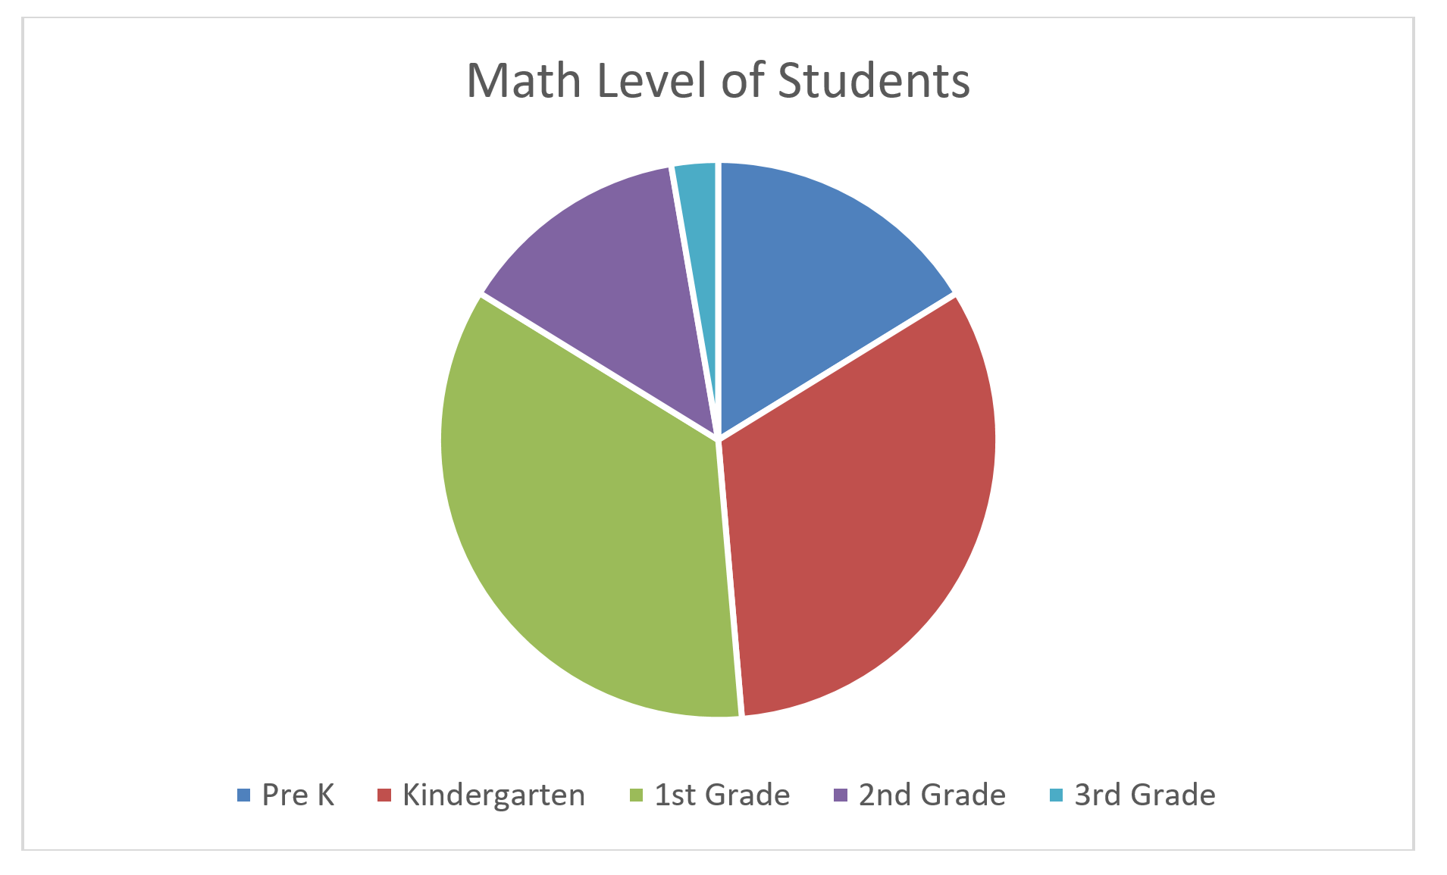
Evaluation: All students were asked to complete four types of tasks using the Tactile Five and Ten Frames. The field evaluator determined the student’s success in completing the task and reported the results.

Task | Yes | No | Sometimes
Is the student able to recognize a grade/age appropriate number of tiles in the frame(s)? | 30  (81% | 3  (8%) | 4  (11%)
Is the student able to recognize the benchmark numbers of 5 and/or 10 using the frames and tokens? | 27  (73%) | 6  (16%) | 4  (11%)
Is the student able to perform grade/age appropriate addition problems using the frames and tokens? | 21  (57%) | 10  (27%) | 6  (16%)
Is the student able to use the frame with sighted peers? | 20  (54%) | 1  (3%) | Sometimes – 1  (3%)  N/A – 15  (40%)

There were 20 “No” responses recorded by teachers. Of the 20 student “No” responses, 19 of those responses were from students who had other disabilities/conditions that might impact math skills.

There were 15 “Sometimes” responses recorded by teachers. Of the 15 student “Sometimes” responses, nine of those responses were from students who had other disabilities/conditions that might impact math skills.

Teacher Guidebook: Evaluators were asked to provide feedback on the guidebook included in the kit.

Guidebook | Strongly Agree | Agree | Somewhat Agree | Disagree | Strongly Disagree
The guidebook was clear and concise. | 8  (45%) | 10  (55%) | 0 | 0 | 0
The activities in the guidebook were helpful in using/learning to use the frames. | 9  (50%) | 6  (33%) | 3  (17%) | 0 | 0
The pictures of the frames were helpful in understanding how to use the frames. | 11  (61%) | 6  (33%) | 1  (6%) | 0 | 0

Teacher Comments:
- “I felt the Guidebook did a nice job explaining activities and how to use the frames.”
- “Would like to see more materials for students with multiple disabilities.”

Tactile Five and Ten Frames: Evaluators were asked to provide feedback on the Tactile Five and Ten Frames.

Tactile Five and Ten Frames | Strongly Agree | Agree | Somewhat Agree | Disagree | Strongly Disagree
The frames were sturdy and of good quality. | 12  (66%) | 3  (17%) | 3  (17%) | 0 | 0
The frames were an appropriate size and depth to accommodate the tokens. | 11  (61%) | 4  (21%) | 1  (6%) | 1  (6%) | 1  (6%)
There were an appropriate number of frames in the kit for classroom activities. | 6  (33%) | 8  (44%) | 3  (17%) | 1  (6%) | 0
The frames were appropriate to share with sighted peers in a classroom setting. | 10  (56%) | 7  (39%) | 0 | 0 | 0  N/A – 1  (6%)

Teacher Comments:
- “Maybe just a hair more height on the dividing of the columns/rows (grid).”
- “Yes, the tokens fit perfectly into each frame. Tactually it was easy to place tokens into different frame boxes.”
- “The frame is not very deep, so both of my student had difficulty when they would place a piece in the frame as they moved to the next box the piece would slide out. I believe the depth is what kept my students from being able to use the frames more accurately. It would have been nice to have four frames so my student could have participated in more of a small group setting with their peers.”
- “Somewhat Agree – Stored inside student’s desk with other books so it took a beating.”
- “Somewhat Agree – There were only three available.”
- “The frames accommodated the tokens and any other token utilized by the student and her peers within the classroom setting very easily – very adaptable. Her peers loved using the frames when working with my student and she loved being fully included without the needing as much adult assistance.”
- “The tokens did not stay in the spaces well enough. This made them unusable. A magnetic set works much better.”

Tactile Tokens: Evaluators were asked to provide feedback on the Tactile Tokens.

Tactile Tokens | Strongly Agree | Agree | Somewhat Agree | Disagree | Strongly Disagree
The Tactile Tokens were sturdy and of good quality. | 12  (66%) | 4  (22%) | 2  (11%) | 0 | 0
The Tactile Tokens were an appropriate size for elementary students. | 12  (67%) | 6  (33%) | 0 | 0 | 0
The opposite sides of the Tactile Tokens were tactually discernable. | 12  (67%) | 4  (22%) | 1  (6%) | 1  (6%) | 0
There were an appropriate number of tokens in the kit for classroom activities. | 8  (44%) | 7  (39%) | 2  (11%) | 1  (6%) | 0
The Tactile Tokens were appropriate to share with sighted peers in the classroom. | 10  (56%) | 6  (32%) | 1  (6%) | 0 | 0  N/A – 1  (6%)

Teacher Comments:
- “Students had no difficulty discriminating. It was helpful with counting one-to-one correspondence. There were more than enough tokens provided.”
- “The tokens were very light. Easily got misplaced. The tokens are not very heavy. They easily get knocked out of the tray.”
- “Both of my students have CP. It would have been nice if the pieces were thicker or more weighted so they stayed in the frame a little easier as well.”
- “They need Velcro.”
- “Enough to fill three frames.”
- “I wish there were a way to adhere the tokens in their spot. There were times she would check her tokens and they’d move on her. I was trying to think of Velcro or something similar but without it interfering with the textured sides.”
- “Very helpful and versatile.”
- “Excellent quality! These were also the perfect size for preschoolers!”
- “The students I work with were able to handle/manage the Tactile Tokens easily and were able to tactually distinguish the different textures, even some of the students who have some limited fine motor/tactile discrimination skills at this time. For a classroom of many students who all have visual impairments, I would need to order multiple sets, but I think an itinerant teacher working with only 1-2 students with visual impairments in a particular classroom there would be enough. I think they would be appropriate to share. I work in a residential setting where all the students have a visual impairments and I know they all had a good time with the frames and tokens. I would imagine they would be appropriate in a public school setting.”

Teachers were asked to respond to several general questions about the Tactile Five and Ten Frames.

Tactile Five and Ten Frame Kit | Yes | No
Did your student experience and particular difficulties with the Tactile Five and Ten Frames? | 5  (28%) | 13  (72%)
Did your students have any notable comments about the Tactile Five and Ten Frames? | 5  (28%) | 13  (72%)
Do you feel your students benefited from using the Tactile Five and Ten Frames? | 17  (94%) | 1  (6%)
Were the Tactile Five and Ten Frames a good solution for incorporating your students in math class activities whey the class was using Five and Ten Frames? | 16  (88%) | 1  (6%)  NA -1  (6%)
Do you recommend that APH produce the Tactile Five and Ten Frame Kits? | 17  (94%) | 1  (6%)

Teacher Comments:
- “Easy to use for solving math problems and bar graphs – tokens stay in place so no slipping around or losing pieces. Easy to explore hands on. This was very helpful when discussing the presidential election. Print math books uses five and ten frames as part of the common core standards. It is wonderful to have a tactile version for students who are blind and visually impaired to use hands-on so they can solve problems such as recognizing more or less. This is a wonderful kit to help a child who is blind learn hands-on tactilely the concepts in math books. The child does not get frustrated about pieces moving around since each token has its own square. Very well done.”
- “She likes ‘playing with’ or moving her ‘math’ and setting up problems for me to solve.”
- “Yes, it is something I will continue to use. It has been great for concept development, one to one correspondence, introducing new skills and practicing old. This was a great supplemental material to use alongside the curriculum. It can be incorporated in many different ways in the classroom (independent work, group work, direct instruction, etc.) Overall, it was a good kit to help reinforce those important basic math skills.”
- “I enjoyed using the materials with my student.”
- “Making the tokens heavier and magnetic would help them stay put. Change the token issue.”
- “My students had difficulties with the frames. The pieces would come out as they were counting and moving to the next space in the frame. Even though they had difficulties, I felt it was beneficial for my students. Their sighted peers enjoyed the frames and it helped them feel more like a part of the class setting. I hope it can be revised to add more depth to the frame.”
- “The Tactile Frames seemed to make this visual activity much more beneficial for my students to be independent during classroom activities.”
- “This is a wonderful tool in many ways for our students.”
- “The product is very helpful and keeps items organized for the students to be able count and move things without double counting or losing the items on the desk.”
- “The five and ten frames were nicely designed to suit the needs of students with visual impairments. The frame gives the students an opportunity to be physically engaged and active during math. The frames allow students to associate the number with a visual/tactile image.”
- “This is a huge part of the common core math, so having a ready-made, durable accommodation in place is extremely helpful.”
- “Tokens do not stay in place will enough.”
- “Occupational Therapist also used them.”
- “The students I worked with really enjoyed these materials and had more success using/understanding them than from the pictures/tactile graphics from their textbooks. They really helped the students with their subtraction skill.”

Changes to Kit based on Teacher Feedback
- Addition of a second 5 frame
- Addition of a second bag of tokens
- Changed the depth of the frames to 1/4 inch to resolve issue of slipping tokens
- Changes to the teacher’s guide to reflect the changes mentioned above

Work planned for FY 2018
The project leader will finalize all components, a specification meeting will be held, and the project will be released to production.

PHYSICAL EDUCATION / HEALTH

Count Me In: Motor Development in a Box
(Continued)

Purpose
To provide a product to help early childhood professionals and parents teach and encourage locomotor skills and object control skills prior to young learners entering school

Project Staff
Tristan Pierce, Physical Education Project Leader
Lauren Lieberman, Consultant
Pamela Haibach, Consultant
Monica Vaught-Compton, Project Assistant
Frank Hayden, Director of Technical & Manufacturing Research
James Robinson, Electronics Specialist
Andrew Dakin, Model Maker

Product Description
Count Me In is a box of adapted sports equipment with quick-step instructions.

Background
APH considered creating Count Me In: Motor Development in a Box after Lauren Lieberman, The Brockport College at SUNY, presented to a standing-room-only crowd at the 2011 APH Annual Meeting of the Ex Officio Trustees in Louisville, KY. Attendees and APH’s Early Childhood Project Leader requested that the Gross Motor Development Curriculum include preschoolers. Because children who are 3 years old require physical and motivational supports that older children may not, the Physical Education Project Leader and the consultants decided to create Count Me In to meet the specific needs of very young children who are just learning to move independently in their environment. The product “box” will include adapted equipment for children 3-years-old and up to learn locomotor and object control skills.

Relevance
APH made the decision to produce this product based on a standardized process of product selection. Lieberman and Pamela Haibach (also a professor at The Brockport College at SUNY) submitted the project idea on October 17, 2011. The project leader presented the product submission to the Product Evaluation Team (PET) on November 3, 2011. PET voted to move the project forward. On November 9, 2011, the Product Advisory and Review Committee approved the project, and assigned it grant #507.

This product will be fully accessible to the population who will use it. The Count Me In instruction cards will be available in print, BRF, text file, and HTML to meet APH requirements for accessibility. APH has the online link to access the Motor Development videos. (See report on Gross Motor Development Curriculum.)

This product follows APH guidelines for determining relevance of a product. The consultants conducted research with over 90 children with visual impairments throughout the United States. (See report on Gross Motor Development Curriculum.) Motor skill activities help to improve agility, balance, motor coordination, manipulation skills, and eye-hand and eye-foot coordination (Lieberman & Pecorella, 2006). These skills promote independence, self-esteem, and a feeling of competence.

There is evidence of an examination of the need for this product. The most prevalent barriers for children with visual impairment to participate in general physical education are professional preparation, equipment, programming, and time (Lieberman, Houston-Wilson, & Kozub, 2002). Count Me In will help address professional preparation and equipment so very young children will have an opportunity to develop gross motor skills prior to entering school.

APH did not seek opinions of knowledgeable individuals to determine the need for this product because attendees at the 2011 APH Annual Meeting of the Ex Officio Trustees voiced the need for the product. (See Background section of this project.)

This product addresses an identified need for a person who meets the definition of “visually impaired.” The adapted equipment in the “box” will include items that are not available on the commercial market. The custom-made items will help young children with visual impairment and blindness feel more comfortable and be motivated to move in their environment. APH is exploring several items for possible inclusion in the kit, including a beep-t-stand, a tactile guidebar, and motivational switches.

Research
Initial piloting of the guidebar at Visually Impaired Preschool Services in Louisville, KY, resulted in a new prototype with a tactile surface. An APH model maker and an electrical engineer created prototypes of a beep-t-ball, motivational switch, and tactile guidebar. The beep-t-ball was run through a battery of tests (hits with an aluminum bat), and multiple prototypes with housing and foam variations were tried. At the National Family Conference in Boston, MA, and at the Center for Courageous Kids in Scottsville, KY, young children used the beep-t-ball and running guidebar; the project leader took photographs at both venues. Students from the Kentucky School for the Blind and several adults with blindness played with the prototype beep-t-balls at Louisville Slugger Field in Louisville, KY. Manufacturing specialist Andrew Dakin researched a better fastener (than glue) for the tactile covering on the running guidebar.

The project leader, manufacturing specialist, and model maker were not happy with the weight and performance of the prototype beep-t-ball. They redirected to explore the possibility of a beep-t-stand. The project leader used the tactile running guidebar and the motivator switches in a simulation activity at the 2014 AER International Convention in San Antonio, TX.

References
Lieberman, L. J., & Pecorella, M. (n.d.) Activity at home for children and youth who are deafblind. Retrieved from http://mtdeafblind.ruralinstitute.umt.edu/MainMenu/InformationalResources/ArticlesMonographs/Lieberman_Activity.pdf
Lieberman, L. J., Houston-Wilson, C., & Kozub, F. M. (2002) Perceived barriers to including students with visual impairments in general physical education. Kinesiology, Sport Studies and Physical Education Faculty Publications. Paper 21. Available from http://digitalcommons.brockport.edu/pes_facpub/21

Work during FY 2017
The project leader held a session during the 2016 APH Annual Meeting to discuss several problematic design obstacles related to cost, weight, easy transportation, and an accurate figure model. The project leader and model maker researched and tested new options for the running guidebar stand and placed an advanced order for a posable figure model called Stickybones, which is still in development. The project leader showed the Stickybones website to a member from the Educational Products Advisory Committee (EPAC) who had attended the product session at Annual Meeting and received positive feedback on the posable model from her as well as another EPAC member.

Work planned for FY 2018
The project leader will continue to test prototypes of adapted equipment and create the quick-step instructions from the completed Gross Motor Development Curriculum.

Gross Motor Development Study and Curriculum
(Completed)

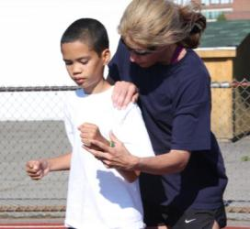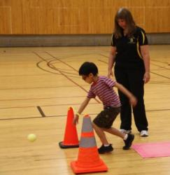

Purpose
To determine major needs areas in motor development for children who have visual impairment and then to develop a comprehensive curriculum to teach locomotor skills and object control skills

Project Staff
Tristan Pierce, Physical Education Project Leader
Lauren Lieberman, Consultant, Principle Investigator, Co-author
Pamela Haibach, Investigator, Co-author
Monica Vaught-Compton, Project Assistant

Advisory/Review Team
Karen Blankenship
Monica Lepore
Marla Runyan
Kari Smoker
Erin Weaver

Product Description
Gross Motor Development Curriculum (GMDC) is a book with an accompanying online video.

Background
The GMDC is a book and video for physical education teachers, teachers of students with visual impairments, orientation specialists, recreation specialists, camp counselors, parents, and families. The authors recommend using it in professional preparation programs in all of these fields. The book provides a description, a list of needed materials, directions, a task analysis, teaching modifications and adaptations for one perceptual motor skill, seven locomotor skills, six object control skills and two physical fitness skills. The book includes practice records to track a student's progress, which are available online also. The instructional video is available on the Internet.

In 2011, APH funded motor skill ability research of over 90 children who attended sports camps or residential schools for the blind summer programs. The authors and coaches filmed children while they performed 12 gross motor skills: Six demonstrated object control, and six demonstrated locomotor ability. They collected data from camps in Alaska, Arizona, California, Connecticut, Kentucky, Maryland, New York, and Pennsylvania. The research showed a large motor skill deficit in all levels of vision and a significant deficit in children who are blind at all ages. This was the foundation to create the GMDC.

In 2013, initial editing of the video was complete. Development of the project was on hold pending completion of other products. Research in Developmental Disabilities published the following article, in which the authors acknowledged APH for financial support of this research project.

Wagner, M. O., Haibach, P. S., & Lieberman, L. J. (2013). Gross motor skill performance in children with and without visual impairments—Research to practice. Research in Developmental Disabilities, 34, 3246-3252. doi:10.1016/j.ridd.2013.06.030

Before APH incurred the expense of adding captioning to the video, the project leader posted it on the APH Web site for volunteer feedback from the field. The authors showed the video at four conferences and to two graduate classes. Volunteer feedback on the video was minimal; thus in 2015, the project leader identified two adapted physical education professors, Dr. Patricia Hacker, South Dakota State University, and Dr. Rebecca Lytle, California State University at Chico to review the video. They provided feedback prior to field testing.

The authors had the following articles published from the research on this project:

Haibach, P. S., Wagner, M. O., & Lieberman, L. J. (2014). Determinants of gross motor skill performance in children with visual impairments. Research in Developmental Disabilities, 35, 2577-2584. doi:10.1016/j.ridd.2014.05.030
Lieberman, L. J., Haibach, P., & Wagner, M. (2014). Let's play together: Sports equipment for children with and without visual impairments. Palaestra, 28, 13-15.
Samalot, A., Lieberman, L. J., & Haibach, P. (2015). Teaching two critical locomotor skills to children who are blind or visually impaired. Journal of Visual Impairment & Blindness, 109, 148-153.

Relevance
APH made the decision to produce the GMDC based on APH’s standardized process of product development. Lieberman, Ph.D., The College at Brockport, SUNY, submitted the New Product Idea Submission Form under the name of Comprehensive Motor Development Curriculum (Includes Playground Guidance) on March 15, 2011. The project leader presented the idea to the Product Evaluation Team (PET) on April 6, 2011. The committee approved it and forwarded the product submission to the Product Advisory and Review Committee (PARC). PARC members approved GMDC on April 13, 2011. After teachers and students field tested the prototype (book and video), the project leader compiled the data for the Field Test Report. The project leader included the report in the Quota Approval Form.

This product is fully accessible to the population who will use it. In order to meet APH requirements for accessibility, the GMDC will be available in print and electronic formats for use with screen readers. The video includes closed-captioning and a script, which refreshable braille displays read.

The GMDC follows APH guidelines to determine relevance of a product. According to The Society of Health and Physical Education (SHAPE America), the goal of physical education is to develop physically literate individuals who have the knowledge, skills, and confidence to enjoy a lifetime of healthful physical activity. SHAPE America outlines the national standards and grade level outcomes for K-12 physical education in their chart, Scope & Sequence for K-12 Physical Education. The information is available online at National PE Standards. The chart represents the grade levels at which teachers should introduce and provide practice opportunities for physical skills and knowledge, as well as when competency and application should occur. The chart provides score options of emerging, maturing, and applying for each skill. Standard 1 reads that the physically literate individual demonstrates competency in a variety of motor skills and movement patterns. The Adapted Physical Education National Standards (2nd Ed.), published by the National Consortium for Physical Education and Recreation for Individuals With Disabilities lists Standard 2 as motor behavior. Whether a student follows general physical education national standards or adapted physical education national standards, motor skill development is required and relevant to education, resulting in student attainment of outcomes and producing physically literate individuals.

Students can meet the nine components of the expanded core curriculum (ECC) through physical activity, sport, and recreation. Fundamental motor skills are the foundation of the components that drive the ECC. For example, recreation and leisure skills for students with visual impairment must be planned and deliberately taught, and should focus on the development of life-long skills. Individuals with blindness do not learn social interaction skills casually and incidentally as do persons with sight; it is necessary to teach these skills carefully, consciously, and sequentially. Before a student can play goalball, he or she must learn the motor skills of a three-step approach: the lunge, the underhand throw, and the slide. Social interaction skills are practiced during instruction, training, and when playing on a team.

There is evidence of an examination of the need for this product. Fundamental motor skills are the foundation of the nine expanded core curriculum (ECC) components, one of which is recreation and leisure skills. Lubans, Morgan, Cliff, Barnett, and Okely (2010) reviewed 21 studies that identified strong positive relationships between motor skill competence (MSC) and health-related fitness (HRF) variables, such as cardio respiratory fitness, muscular strength and endurance, composite fitness scores, body composition, and physical activity. Stodden, True, Langendorfer, and Gao (2013) studied the relationship between MSC and HRF. They learned that students who test poor in MSC are unlikely to demonstrate high HRF levels, and students who test high in MSC are unlikely to demonstrate poor fitness. Children with visual impairment consistently show that they lag behind their sighted peers in motor development and fundamental motor skills (Houwen, Visscher, Lemmink, & Hartman, 2008; Lieberman & McHugh, 2001; Skaggs & Hopper, 1996; Winnick & Short, 1985, 1999). At the time Lieberman submitted this New Product Idea Submission Form to APH, she and colleagues Matthias O. Wagner and Haibach submitted study results to Research in Developmental Disabilities (RDD) that showed children who are blind perform significantly worse in all assessed locomotor and object control skills. RDD published the article in 2013. In addition, adults and peers leave children with visual impairment out of basic games and activities during recess or on playgrounds (Lieberman & Robinson, 2004; Huurre et al., 1999). Peers generally chose last a child who is less skilled to participate in games during recess or after-school activities. This directly affects socialization and self-esteem (Ulrich, 2000). The better children (with visual impairment) feel about moving, the more they will move, which results in them being more fit. Lieberman explained that various motor skill assessments that are available on the commercial market are not validated for students with visual impairments. The TGMD-2 (Pro Ed) is validated for students with visual impairments; but when teachers use it, they do not have the adaptations and modifications to pre-teach students with visual impairment. Without the opportunity to learn a skill before testing, students with visual impairment are at a disadvantage. APH constructed Table 1: Motor Skill Identifier to identify specific skills within a particular assessment available to teachers. The assessments do not provide accommodations and modifications for students with visual impairment. APH's GMDC does.

Table 1: Motor Skill Identifier
Skill | Assessments*
Balance | APEAS II |  | BOT™-2 | DEVPRO
Run | APEAS II | BPFT | BOT™-2 | DEVPRO |  | TGMD-2
Gallop | APEAS II |  |  | DEVPRO |  | TGMD-2
Hop | APEAS II |  | BOT™-2 | DEVPRO |  | TGMD-2
Leap |  |  |  |  |  | TGMD-2
Hor. Jump | APEAS II |  | BOT™-2 | DEVPRO |  | TGMD-2
Slide |  |  |  | DEVPRO |  | TGMD-2
2-Hand Strike |  |  |  | DEVPRO |  | TGMD-2
1-Hand Forehand Strike |  |  |  |  |  | TGMD-3**
Dribble |  |  | BOT™-2 | DEVPRO |  | TGMD-2
Catch | APEAS II |  | BOT™-2 | DEVPRO |  | TGMD-2
Kick | APEAS II |  |  | DEVPRO |  | TGMD-2
Overhand Throw | APEAS II |  | BOT™-2 | DEVPRO |  | TGMD-2
Underhand Roll |  |  |  |  |  | TGMD-2
Skip | APEAS II |  |  | DEVPRO |  | TGMD-3**
Curl-ups/Sit-ups | APEAS II | BPFT | BOT™-2 |  | FITNESSGRAM®
Push-ups | APEAS II | BPFT | BOT™-2 |  | FITNESSGRAM®
*Adapted Physical Education Assessment Scale II (APEAS II); Brockport Physical Fitness Test (BPFT); Bruininks-Oseretsky Test of Motor Proficiency, Second Edition (BOT™-2); DEVelopmental PROgramming Motor Skills Assessments (DEVPRO); FITNESSGRAM®; Test of Gross Motor Development, Second Edition (TGMD-2) and **TGMD-3 (in development)

The need for a curriculum was reinforced when the TGMD-2, 2nd ed. (Pro-Ed), dropped the balance skill from its assessment tool. Balance—a fundamental skill—is required for most other motor skills. The authors and project leader conducted a literature review.

Houwen, S., Hartman, E., & Visscher, C. (2009). Physical activity and motor skills in children with and without visual impairments. Medicine & Science in Sports & Exercise, 41, 103-109.
Houwen, S., Hartman, E., Jonker, L., & Visscher, C. (2010). Reliability and validity of the TGMD-2 in primary-school-age children with visual impairments. Adapted Physical Activity Quarterly, 27, 143-159.
Houwen, S., Visscher, C., Lemmink, K. A. P. M., & Hartman, E. (2008). Motor skill performance of school-age children with visual impairments. Developmental Medicine & Child Neurology, 50, 139-145. doi:10.1111/j.1469-8749.2007.02016.x

The project leader then conducted another literature review on perceptual motor skills.

Jazi, S. D., Purrajabi, F., Movahedi, A., & Jalali, S. (2012). Effect of selected balance exercises on the dynamic balance of children with visual impairments. Journal of Visual Impairment & Blindness, 106, 466-474.
Winnick, J. P., & Lavay, B. W. (2005). Perceptual—Motor development. In J. P. Winnick (Ed.), Adapted physical education and sport (pp. 359-372). Champaign, IL: Human Kinetics.

There is evidence that APH sought opinions of knowledgeable individuals to determine the need for this product. APH and the authors sought a panel of professionals and one parent to review and provide feedback to complete the written documentation and to provide guidance during instructional photo shoots. One member of the panel is legally blind and a 2X Olympian; she wrote the preface of the book. The panel's commitment to the project validates each member's belief in the need for the product. They agreed to participate as curriculum reviewers.

This product addresses an identified need for a person who meets the definition of “visually impaired.” Individuals with visual impairment cannot learn incidentally; teachers and peers must purposefully teach gross motor skills. The curriculum provides step-by-step approaches to teaching strategies specific to persons with visual impairments for each locomotor skill and object control skill. These instructional strategies are pre-teaching, whole-part-whole instruction, verbal instruction, task analysis, and tactile teaching (tactile modeling, coactive movement, and physical guidance). The book also addresses the need for alternative communication methods and systems for students with dual sensory impairments. The research conducted by the authors in 2011 (see Background of this product report) confirms the need for students with visual impairment to be pre-taught motor skills prior to assessment. In 2012, the authors completed the manuscript, and the advisory panel reviewed it. The project leader, co-author Lieberman, and advisor Dr. Monica Lepore drafted the video manuscript. The project leader took the majority of the curriculum photography at Camp Abilities (NY), the National Family Conference (MA), and Center for Courageous Kids (KY). SUNY videographer students filmed the video at Camp Abilities.

Research
APH gathered field test data using several appropriate methods:
- APH used the online program SurveyMonkey® to collect teacher demographics, video to book cohesiveness, curriculum content, and product summary.
- APH used an Excel® spreadsheet to collect student information and identify instructional strategies used with students.
- APH used pre and post practice records (included with the curriculum) to identify students' base level of motor skill competencies and to measure student outcomes. Some teachers submitted the forms via e-mail and others printed out the forms, completed them by hand, and mailed them via USPS.
- APH used a video time code grid to gather information on the curriculum video.
- APH used follow up phone calls to some field testers to acquire missing information on various documents.

There is evidence that APH considered research data as part of decision-making in product completion.
- APH made video edits (deletions and additions) in response to feedback on the video time code grid.
- The Motor Skill Identifier (page 5 of the curriculum) showed that only two of the six motor skill assessments, DEVelopmental PROgramming Motor Skills Assessments (DEVPRO) and the Test of Gross Motor Development 2 (TGMD-2) assess the skill of striking. The TGMD-3 (in development by Pro-Ed) divides the skill of striking into two skills: two-hand strike of a stationary ball and one-hand forearm strike of a self-bounced ball. APH asked the evaluators if the GMDC should align with the DEVPRO or the TGMD3. Four (80%) chose the TGMD-3 while one (20%) selected the DEVPRO. APH and the authors updated the Motor Skill Identifier chart and the curriculum to include the one-hand forearm strike of a self-bounced ball.
- One evaluator requested a replacement coactive movement example for push-up. Proper form of the push-up is very difficult to learn, and coactive movements require touching of the learner and partner. APH and the authors provided partner alternatives on how to accomplish this coactive example.
- Video and book comments resulted in rewriting the task analysis/practice for the locomotor skill Run in the book.

The development of the GMDC followed APH Research Guidelines.
- Input from the field—At the onset of project, coauthor Lieberman, and Lou Tutt, Executive Director of the Association for Education and Rehabilitation of the Blind and Visually Impaired, conducted an input session at the 143rd Annual Meeting of APH Ex Officio Trustees. The subject of motor skill development was in such demand that the room, full to capacity, had standing room only. Throughout the development of the GMDC, APH received input from the advisory panel on the curriculum. Authors Lieberman and Haibach, and project leader Tristan Pierce presented the curriculum and solicited feedback at the 2014 AER International Conference in San Antonio. APH received professional reviews from two college professors on the video: Dr. Lytle, Dean of Professional and Graduate Studies at Keene State College (NH) and Dr. Hacker, Professor Physical Education Teacher Education at South Dakota State University. The feedback from these multiple sources helped APH create the prototype for field testing. APH also received additional feedback from field evaluators.
- Safety Report/Technical Review—not applicable to this product
- Representative product prototype—Visually the prototype curriculum replicated final product minus final credits and catalog. The video was complete minus captioning.
- Outside evaluators—APH selected field test sites by location, educational setting, student/client size, and evaluator qualifications.
- Evaluation tool and collection—The project leader, a consultant, a research assistant, and the two authors developed the evaluation materials and surveys. APH mailed the books via USPS and sent forms electronically. Evaluators returned materials by the same means.
- Sufficient time—APH began sending materials to confirmed evaluators in August and continued to send materials though September 2015. All but one evaluator returned all materials by December 31, 2015. That one evaluator sent partial information (electronic forms) by the due date, and APH received the remaining hard copy materials on February 1, 2016.
- Reporting—The project leader presented the field test results to the Product Development Committee, and then the group met to determine future steps. Throughout the development of the product, the project leader reported updates at the monthly New Products Meeting and in the APH Annual Research Report.
- Modifications—APH completed the changes to the video and book in March 2016.
- Quota Approval—The project leader submitted the product for Quota approval in April 2016.
- Specifications—completed July 2016
- Marketing—March 2017

The research method used collected sufficient information. APH asked the evaluators to rate how parallel the content of the online video was to the content of the book. Four (80%) evaluators responded the two were very parallel, one (20%) said somewhat parallel, and no one selected the three remaining responses (neither parallel nor unparallel, somewhat parallel, or not at all parallel). Three evaluators provided the following comments.
It is very helpful to see the instructions in action to make sure I'm interpreting and applying the curriculum the way it was meant to be used.

As someone without a lot of experience teaching students with visual impairments, I found the combination of the video and the book very helpful.

Some terminology used in the video was not in the book. All the skills were in the same order.

The two professional reviewers and the several evaluators provided general comments on the video.
This is a great instructional video and shows many wonderful modifications for VI. I like the part of guiding and instructional strategies! This is great. As for the cues for the skills, I think this will be helpful in that there are a few modifications illustrated here as well. Also helpful for a teacher who may not know the basic motor skills. Wonderful project.

This will be a very helpful video if some of these comments about the errors are corrected. The information will be really good for those who do teach students with visual and auditory impairments, but it will also be good for those who are teachers of the general classes, and also for those who teach college/university introductory adapted physical education class. It has good suggestions and basic information that will give introductory students a good start in working with students who have these impairments.

I found the video to be very helpful and I don’t have any specific suggestions for any of the skills or techniques demonstrated. I was so grateful to be given the opportunity to review this curriculum and use it as a resource – my student and I both found it SO HELPFUL. My suggestion is that at the end of part one, you provide a brief summary of what you covered – like a quick recap with bullet points – to help those of us for whom this is all really new information. I think it would help us to absorb what we just viewed to have a quick recap.

I liked the video a lot. I think it is an excellent addition to the curriculum book. Hearing and seeing the skills, techniques and strategies in action was extremely helpful. It clarified sections, which in the written form in the book were less clear, such as the explanation of “whole-part-whole.”

All evaluators (100%) said that APH should release the video to complement the book.
YES! Very helpful for those that may not quite understand the written instructions right way.

I think the video does a really good job of showing general PE teachers like myself what students with visual impairments are capable of. After working with my student on this curriculum, I want to invite her to be part of our Unified Sports team. Our team of coaches had not previously asked her because we weren't sure how to include her in many of the ball sports and now we have some concrete strategies to use.

It would be nice to break the video into chapters to navigate to more quickly as needed.

Getting the information in a variety of formats is helpful. Seeing the video reinforces the book.

The GMDC lists 23 tips for teaching children who have visual impairment. APH encouraged evaluators to submit tips that are successful in their classrooms.
Many general PE teachers use music in class, for many purposes. I use music to signal activity time–we play when the music is playing, we stop when the music stops. If we are doing station activities, students know that when the music stops and a new song starts, it is time to rotate clockwise to the next station. If you have any specific suggestions about the use of music that would be helpful, please include them.

The authors included three examples of coactive movement (slide, push-up, and weight shift for throwing or batting) in the curriculum. The majority (60%) of the evaluators said no additional examples are necessary. One teacher requested that APH replace the coactive example for push-up. Comments included:
Examples of modeling some of the other skills are available under other headings such as task analysis and tactile teaching.

I feel as though it gives an overview of what to do with the other movements.

I feel one from each domain was selected (locomotor, fitness, object control), and I also feel the ones selected are the more complex skills to teach.

APH asked evaluators to rate how complete or incomplete the book's list of task analysis/practice is for each motor skill. The majority (80%) responded very complete, and 20% responded somewhat complete. No one selected the three remaining response options: neither complete nor incomplete, somewhat incomplete, and very incomplete. Comments:
I think that the Run skill could be reworded and even made a bit more detailed.
Leap: I was challenged to teach the concept of "pushing off the back foot" to one of my students. Thankfully, he was small enough for me to physically lift him off the ground during the execution phase, but that's not going to happen with my older and bigger students!

My student was especially excited by the horizontal jump. She did not understand how to jump prior to this instruction. Using the task analysis and giving her the instructions step by step, she was able to execute it on her very first attempt! It was such an Aha moment and she was so excited!

I think specific terminology used in teaching needs to be included. This is mentioned in the beginning chapters but not in instruction.

When working together with the student's P.E. teacher on the skill of overhand throw, the teacher had a slightly different way of instructing and breaking it down. The student felt inclined to follow his P.E. teacher's method.

APH asked the evaluators how satisfied they were with the book's explanation of the strategy of pre-teaching. Most (60%) responded very satisfied, 20% replied somewhat satisfied, and 20% said neither satisfied nor dissatisfied. No evaluators selected somewhat dissatisfied or very dissatisfied.
I think the explanation of pre-teaching can help many APE teachers stay aware of the importance of collaborating with the GPE teacher if the student with VI is able to participate in the GPE setting.

It makes so much sense that because students with visual impairments can't use visual imitation to learn new skills, that they will need to spend some extra time beforehand in order to keep up with their sighted peers. This is both very helpful for me to understand and at the same time very frustrating because my time with all of my students is so limited (I see my students once per week and I split my time between two schools. But I will continue to carve out 30 minutes in the week prior to pre-teach the most crucial skills to my student.)

They could have elaborated more.

Most evaluators (60%) responded that they are very satisfied with the authors' explanation of whole-part-whole instruction, and 40% responded somewhat satisfied.
I appreciated the incorporation of research articles cited in this section, as far back as 1988. I feel it justifies the effectiveness of this method.

Again, it makes sense that a person would need to get the whole idea of a skill to understand how the parts are important, but will then need to work on each part individually before putting them together.

This is generally how a lecture with new material is presented: 1) this is what we will be covering (to prepare audience) 2) Cover all points 3) Summarize what was covered. This was my suggestion for part one of the video - nice intro, good job covering points, please add summary.

I found all the citation credits (which I know are necessary to include) distracting when reading this material. Even though it sounds simple, I found it a little confusing. It would be helpful to have more graphic examples available of this method.

The majority of evaluators (60%) responded very satisfied with the explanation of task analysis. One (20%) responded replied somewhat satisfied, and one (20%) responded very dissatisfied.
Some are too simple to read.

I feel task analysis is not only a teaching strategy, but also a reminder for us educators that teaching a skill takes time and several steps are involved for the whole movement to come together. Task analysis helps me to be patient and stay focused on teaching at the pace that's appropriate for the student.

I found the task analysis to be probably the most helpful strategy. The cues were almost always clear to my student and she frequently found success pretty quickly by following them.

More graphic examples are always welcome.

Four evaluators chose equally between very satisfied (40%) and somewhat satisfied (40%) in regards to the explanation of tactile teaching. One (20%) responded neither satisfied or dissatisfied with the explanation.
Tactile teaching has been helpful to communicate the correct/incorrect form of the movements to my students. If I'm not able to explain effectively the movement verbally, tactile teaching is the next step for me, and in many cases, my students were able to understand the movement better. If that wasn't as effective, we moved on to physical guidance.

The book's explanation of this strategy was clear and made sense. The examples provided were good ones. I think the reason that this strategy is so foreign to general PE teachers (and we may need some extra help with it) is because the idea of being very careful with our boundaries with students is stressed to us so often. For example, when teaching my student proper form for a push up, it was necessary to employ this strategy to help her understand proper form. For her to understand how to keep her back, hips and legs straight, I had to let her feel what that looked like when I performed the skill. But generally speaking, we would not allow our students to touch us like this and we are coached to be very careful in how we touch our students, which is why this strategy was not something that came as naturally and intuitively to me as some of the others.

As an itinerate instructor I did not have access to a gym, or equipment. It would be good to provide an example of tactile modeling for a skill that did not require equipment such as a trampoline or balance beam.

APH asked the evaluators to explain why they chose the teaching methods from the book that they used with their student(s). All agreed that it was student dependent (ability and pre-knowledge of a skill), and all used verbal instruction and tactile teaching. Two evaluators replied that they used "tactile teaching, physical guidance, and coactive movement." This may demonstrate a lack of understanding because physical guidance and coactive movement, along with tactile modeling are forms of tactile teaching. Perhaps both evaluators mistakenly typed "tactile teaching" instead of "tactile modeling." One evaluator describes using whole-part-whole first and then verbal instruction with task analysis, and then only if necessary, tactile teaching.

Three evaluators (60%) said they knew the teaching strategy terms physical guidance and tactile modeling before reading the book.

No evaluator used the section titled, "Teaching children who have deafblindness."

APH asked the evaluators to rate the value of Appendix A: Protocol for Children who Have Visual Impairment. This question sought their professional opinions whether they used or did not use Appendix A with students. The evaluators selected answer options "very high value" (40%) and "somewhat high value" (60%). No one selected neither high value nor low value, somewhat low value, or very low value.

APH asked the evaluators to rate the value of Appendix B: Lead-up Activities. Again, this question sought their professional opinions whether they used or did not use Appendix B with students. Like the previous appendix, the evaluators selected answer options "very high value" (40%) and "somewhat high value" (60%). No one selected neither high value nor low value, somewhat low value, or very low value.

APH provided the evaluators with the opportunity to submit any additional comments about the prototype product. Four evaluators submitted comments.
This is a wonderful resource, and I look forward to it being produced and available to the general public. I have actually used several of the modifications/adaptations for my students with vision, and it was effective for them as well.

As a general PE teacher who works in an inclusion model, I found this to be a tremendously helpful resource! Because everything is generally so visual in the PE environment and because severe visual impairments are a low incidence disability, working with students who are blind is very challenging. Having a resource like this will be so very helpful for teachers like me.

I think the teaching strategies in the appendix should be included in the section with the skills rather than an appendix.

I really liked the curriculum. It broke down the skills in a way that is easy to explain to students. It was printed in a larger font size that was comfortable to read and the many photographs were very helpful. The only area where I thought the explanation was not so clear was the section on "whole-part-whole."

The numerous citations interfered with the flow of the passage. The video provided a clearer explanation. I think the video is an important component. I found seeing the movements in action and hearing the explanation very helpful.

All evaluators (100%) said APH should publish GMDC (with video) and that they would recommend that their school purchase it.

The field test gathered data on 11 students, seven males (64%) and four girls (36%). The average age was 9 years old. One student was 6 years, five students were 8 years, three students were 11 years, and two students were 12 years. One student has retinopathy of prematurity, and two students have no light perception (Lebers). Evaluators said three students have visual impairment but gave no specific eye diagnosis. Evaluators stated the eye diagnosis for five students is unknown, but one of them sees shadows and some light. The TVIs and COMS knew the eye diagnosis for their students; the physical education teachers and adapted physical education teacher did not. Seven (64%) of the students have a disability accompanying their visual impairment. The data included seven locomotor skills, six object control skills, and two physical fitness skills on each student.

APH gathered data from a geographically diverse U.S. population. The evaluation sites are located in five states: California, Colorado, Connecticut, Missouri, and Maine. The sites included one residential school for the blind, one state agency for the blind, and three public schools. APH sent out 11 field test packets, but six dropped out for various reasons, including the student left the school, student was out sick during the majority of the field test time, teacher felt his students (multiply disabled) were not a good match, teacher could not find the shipped book, and teacher's workload became too heavy. APH documents in the Research Department's field tester database teachers who do not complete the field testing with comments and reasons for dropping out.

APH gathered data from appropriately qualified individuals. The evaluators are a physical education teacher, a physical education and health teacher, an adapted physical education specialist, an orientation and mobility instructor, and a teacher with dual certification (i.e., teacher of students with visual impairments and orientation and mobility). The evaluators had an average of 15.3 years teaching experience and an average of 10.5 years of experience teaching students who have visual impairments. Table 2: Teaching Experience shows each evaluator's total years teaching and the number of years of experience in the vision field.

Table 2: Years of Teaching Experience
Respondent title | Number of years teaching | Number of years teaching students with VI
1. PE & Health Teacher | 1.0 | 1.0
2. APE Specialist | 4.5 | 1.5
3. PE Teacher | 20.0 | 8.0
4. TVI & COMS | 10.0 | 10.0
5. O&M Instructor | 42.0 | 40.0

APH collected information on student outcomes through the student evaluation form and the pre and post practice records (Table 3), the latter of which are part of the GMDC.

Table 3: Gross Motor Development Curriculum – Practice Records
Notes:
For teachers who did not truly complete all the Pre/Post records, APH recorded information so that Trial 1 was Pre trial and subsequent trials were Post trials. In this case, a successful completion of the Pre trial with only one trial date was equal to 1/3 of the score of a successful completion on a Pre Trial that included all three trial dates.
APH recorded students who completed the Pre trial successfully as an N/A on improvement.
APH recorded students who did not show improvement from Pre to Post (which includes those who actually scored lower on Post trials and those who failed to complete a successful Pre trial and did not complete a Post trial at all) as a No on improvement.
Skill: Balance
11 students completed Pre trial(s), and 11 completed Post trial(s).
18.2% (2/11) of students did not show an improvement from Pre to Post trials.
18.2% (2/11) of students showed an improvement from Pre to Post trials.
63.9% (7/11) of students completed the skill successfully on Pre trial.
82.1% (9/11) of students either showed improvement from Pre to Post trials, or completed the skill successfully on Pre trial.
Skill: Run
11 students completed Pre trial(s), and 11 completed Post trial(s).
9.1% (1/11) of students did not show an improvement from Pre to Post trials.
54.5% (6/11) of students showed an improvement from Pre to Post trials.
36.4% (4/11) of students completed the skill successfully on Pre trial.
90.9% of students either showed improvement from Pre to Post trials, or completed the skill successfully on Pre trial.

Skill: Hop
11 students completed Pre trial(s), and 9 completed Post trial(s). For the 2 students who did not complete Post trial, there is no reason given – they simply did not complete Post trials, but were not successful in Pre trial either—thus No improvement was shown.
18.2% (2/11) of students did not show an improvement from Pre to Post trials.
45.5% (5/11) of students showed an improvement from Pre to Post trials.
36.4% (4/11) of students completed the skill successfully on Pre trial.
81.9% (9/11) of students either showed improvement from Pre to Post trials, or completed the skill successfully on Pre trial.
Skill: Horizontal jump
11 students completed Pre trial(s), and 11 completed Post trial(s).
9.1% (1/11) of students did not show an improvement from Pre to Post trials.
72.7% (8/11) of students showed an improvement from Pre to Post trials.
18.2% (2/11) of students completed the skill successfully on Pre trial.
90.9% (10/11) of students either showed improvement from Pre to Post trials, or completed the skill successfully on Pre trial.

Skill: Skip
9 students completed Pre trial(s), and 9 completed Post trial(s).
22.2% (2/9) of students did not show an improvement from Pre to Post trials.
77.8% (7/9) of students showed an improvement from Pre to Post trials.
0% (0/9) of students completed the skill successfully on Pre trial.
Skill: Gallop
9 students completed Pre trial(s), and 9 completed Post trial(s).
0% (0/9) of students did not show an improvement from Pre to Post trials.
55.6% (5/9) of students showed an improvement from Pre to Post trials.
44.4% (4/9) of students completed the skill successfully on Pre trial.
100% (9/9) of students either showed improvement from Pre to Post trials, or completed the skill successfully on Pre trial.

Skill: Slide
10 students completed Pre trial(s), and 9 completed Post trial(s). The 1 who did not complete Post trial completed the Pre trial successfully.
10% (1/10) of students did not show an improvement from Pre to Post trials.
30% (3/10) of students showed an improvement from Pre to Post trials.
60% (6/10) of students completed the skill successfully on Pre trial.
90% (9/10) of students either showed improvement from Pre to Post trials, or completed the skill successfully on Pre trial.
Skill: Leap
9 students completed Pre trial(s), and 9 completed Post trial(s).
33.3% (3/9) of students did not show an improvement from Pre to Post trials.
66.7% (6/9) of students showed an improvement from Pre to Post trials.
0% (0/9) of students completed the skill successfully on Pre trial.

Skill: Bat
9 students completed Pre trial(s), and 9 completed Post trial(s).
44.4% (4/9) of students did not show an improvement from Pre to Post trials.
55.6% (5/9) of students showed an improvement from Pre to Post trials.
0% (0/9) of students completed the skill successfully on Pre trial.
Skill: Stationary dribble
11 students completed Pre trial(s), and 10 completed Post trial(s). For the 1 student who did not complete Post trial, there is no reason given – student simply did not complete Post trial, but was not successful in Pre trial either—thus No improvement was shown.
36.4% (4/11) of students did not show an improvement from Pre to Post trials.
45.5% (5/11) of students showed an improvement from Pre to Post trials.
18.2% (2/11) of students completed the skill successfully on Pre trial.
63.7% (7/11) of students either showed improvement from Pre to Post trials, or completed the skill successfully on Pre trial.

Skill: Catch
9 students completed Pre trial(s), and 9 completed Post trial(s).
0% (0/9) of students did not show an improvement from Pre to Post trials.
55.6% (5/9) of students showed an improvement from Pre to Post trials.
44.4% (4/9) of students completed the skill successfully on Pre trial.
100% (9/9) of students either showed improvement from Pre to Post trials, or completed the skill successfully on Pre trial.
Skill: Kick
9 students completed Pre trial(s), and 9 completed Post trial(s).
0% (0/9) of students did not show an improvement from Pre to Post trials.
55.6% (5/9) of students showed an improvement from Pre to Post trials.
44.4% (4/9) of students completed the skill successfully on Pre trial.
100% (9/9) of students either showed improvement from Pre to Post trials, or completed the skill successfully on Pre trial.

Skill: Overhand throw
11 students completed Pre trial(s), and 11 completed Post trial(s).
9.1% (1/11) of students did not show an improvement from Pre to Post trials.
54.5% (6/11) of students showed an improvement from Pre to Post trials.
36.4% (4/11) of students completed the skill successfully on Pre trial.
90.9% (10/11) of students either showed improvement from Pre to Post trials, or completed the skill successfully on Pre trial.
Skill: Underhand roll
10 students completed Pre trial(s), and 10 completed Post trial(s).
0% (0/10) of students did not show an improvement from Pre to Post trials.
50% (5/10) of students showed an improvement from Pre to Post trials.
50% (5/10) of students completed the skill successfully on Pre trial.
100% (10/10) of students either showed improvement from Pre to Post trials, or completed the skill successfully on Pre trial.

Skill: Curl-ups
9 students completed Pre trial(s), and 8 completed Post trial(s). The 1 who did not complete Post trial completed the Pre trial successfully.
55.6% (5/9) of students did not show an improvement from Pre to Post trials.
11.1% (1/9) of students showed an improvement from Pre to Post trials.
33.3% (3/9) of students completed the skill successfully on Pre trial.
44.4% (4/9) of students either showed improvement from Pre to Post trials, or completed the skill successfully on Pre trial.
Skill: Push-ups
11 students completed Pre trial(s), and 9 completed Post trial(s). For the 2 students who did not complete Post trial, there is no reason given – students simply did not complete Post trial, but were not successful in Pre trial either—thus No improvement was shown.
54.5% (6/11) of students did not show an improvement from Pre to Post trials.
45.5% (5/11) of students showed an improvement from Pre to Post trials.
0% (0/11) of students completed the skill successfully on Pre trial.
APH asked the evaluators three questions that align to the national standards for physical education (Table 4).

Table 4: Responses to questions related to National Standards

Question | Yes | No
Could the student, during field testing, explain, "What are we learning?" | 82%  (9 students) | 18%  (2 students)
Could the student, during or after participating in field testing, explain, "Why are we learning it?" | 73%  (8 students) | 27%  (3 students)
Could the student, during or after participating in field testing, explain, "How will we know if we are successful?" | 64%  (7 students) | 36%  (4 students)

The evaluators listed all instructional strategies that they used with each student. The evaluators used pre-teaching with four (36%) students, whole-part-whole instruction with 11 (100%) students, verbal instruction with 10 (90%) students, task analysis with 11 (100%) students, and tactile teaching with seven (64%) students.

The student evaluation showed that prior to using the GMDC, seven (64%) students did not know that they had a choice between tactile modeling, co-active movement, and physical guidance when verbal instruction was not enough.

If a student required more than verbal instruction, which all students participating in the field tested did, physical guidance was preferred by most (64%) followed equally by tactile modeling (18%) and co-active movement (18%).

The evaluators said that all 11 students benefited from the whole-part-whole instruction.

If a student required additional materials, task analysis, or modifications and adaptations than what the book provided to learn and perform a skill, APH ask evaluators to list them.
- Balance: One evaluator instructed the student to lift foot slowly, focus weight to foot on the ground, try to curl to use and grip floor for balance.
- Slide: One evaluator instructed the student to slide the feet along a rope taped to the floor.
- Strike/Bat: One evaluator used a Wiffle® ball bat.
- Push-up: One evaluator used the student's long cane pivoting up and down at an angle to the floor to demonstrate how the body maintains a straight position.
- Underhand roll: One evaluator used a 2x4 piece of lumber to keep feet facing forward and to help separate the feet on the step forward.

Ten (91%) students required the use of verbal and tactile cues described in Appendix A: Protocol for Children who Have Visual Impairment. The protocols that teachers used most frequently and proved to be successful were for catch (cited four times); stationary dribble (cited three times); overhand throw, horizontal jump, and hopping (each cited twice).

Only four (36%) students required lead-up activities as described in Appendix B: Lead-up Activities. The activities that teachers cited as successful were slide and jump. One teacher cited that using a suspended beach ball on a string was not successful. However, the activity suggested a balloon suspended on a string; a beach ball is too heavy for that activity.

Evaluators stated that all 11 children benefited from using the GMDC. One evaluator commented that her students benefited, but there is a long way to go and that they will continue to work on these skills all year as part of O&M lessons because they wrote these skills into the IEP.

References
Houwen, S., Visscher, C., Lemmink, K. A. P. M., & Hartman, E. (2008). Motor skill performance of school-age children with visual impairments. Developmental Medicine & Child Neurology, 29, 650-658.
Huurre, T. M., Komulainen, E. J., & Aro, H. M. (1999). Social support and self-esteem among adolescents with visual impairment. Journal of Visual Impairment & Blindness, 93, 26–37.
Lieberman, L. J., & Haibach, P. S. (in press). Gross motor development curriculum. Louisville, KY: American Printing House for the Blind.
Lieberman, L. J., & McHugh, B. E. (2001). Health related fitness of children with visual impairments and blindness. Journal of Visual Impairment & Blindness, 95, 272-286.
Lubans, D., Morgan, P., Cliff, D., Barnett, L., & Okely, A. (2010) Fundamental movement skills in children and adolescents: Review of associated health benefits. Sports Medicine, 40, 1019-1035.
National Consortium for Physical Education and Recreation for Individuals With Disabilities. (2006). Kelly, L. E. (Ed.). The adapted physical education national standards (2nd ed.). Champaign, IL: Human Kinetics.
Robinson, B. L., & Lieberman, L. J. (2004). Effects of visual impairment, gender, and age on self-determination. Journal of Visual Impairment & Blindness, 98, 351-366.
Samalot, A., Lieberman, L. J., & Haibach, P. (2015). Teaching two critical locomotor skills to children who are blind or visually impaired. Journal of Visual Impairment and Blindness, 109, 148-153.
SHAPE America. (2013). Scope & sequence for K-12 physical education. Reston, VA: SHAPE America.
Skaggs, S., & Hopper, C. (1996). Individuals with visual impairments: A review of psychomotor behavior. Adapted Physical Activity Quarterly, 13(1), 16-26.
Stodden, D., True, L., Langendorfer, S., & Gao, Z. (2013). Associations among selected motor skills and health related fitness: Indirect evidence for Seefeldt's proficiency barrier in young adults? Research Quarterly for Exercise and Sport, 84, 397-403.
Ulrich, D. A. (2000). Test of gross motor development (2nd ed.). Austin, TX: PRO-ED.
Winnick, J. P., & Short F. X. (1985). Physical fitness testing of the disabled. Champaign, IL: Human Kinetics.
Winnick, J. P., & Short, F. X. (1999). The Brockport physical fitness test. Champaign, IL: Human Kinetics.

Work during FY 2017
The book became available for sale; the HTML, BRF, and Practice Records are available as free downloads. The instructional video is online: www.youtube.com/watch?v=AaBZYEGINKs&feature=youtu.be. An APH Quick Tip video is available at www.youtube.com/watch?v=uFE0YU6fRNI. The project leader defended the product to the U.S. Department of Education Expert Panel Review in March 2017.

Health Education for Students With Visual Impairments: A Guidebook for Teachers
Formerly Health Education for Students With Visual Impairments Teacher’s Manual
(Continued)

Purpose
To provide teachers of the visually impaired (TVIs) and classroom teachers with a guidebook that assists in teaching health education curricula to students with visual impairments

Project Staff
Rosanne Hoffmann, STEM Project Leader
Fred Otto, Tactile Learning Project Leader
Monica Vaught-Compton, Consultant
Tiffany Wild, Consultant
Gaylen Kapperman, Consultant
Stacy Kelly, Consultant
Alison Brewer, Consultant
Sanja Ilic, Consultant
Kimberly Dotseth, Consultant
James Barker, Multimedia Producer
Anthony D. Jones, Art Production/Design Manager
Laura Greenwell, Graphic Design

Background
Gatherings of professionals over the past 5 years (e.g., Meeting of the Minds, 2011 & 2014) verified a need for assistance when teaching the various aspects of health education to students with visual impairments. Recent published research and input from educators at residential and public schools confirmed this need. Health Education for Students With Visual Impairments: A Guidebook for Teachers is designed to assist K-12 classroom teachers, TVIs, and Health Education teachers to adapt existing health education curricula for students with visual impairments. Because of the sensitive nature of the curriculum content (e.g., human anatomy, reproduction, etc.) and the teaching challenges presented by visual impairment, health education curricula require special adaptations in order to make this content accessible and appropriate for the audience of visually impaired students. While not a curriculum itself, the guidebook is organized to include pre-teaching guidance, links to videos that cover important concepts such as hand-washing and accessible science experiments, a resource guide for appropriate anatomical models and reliable information sources, and a flash drive containing short videos on specific aspects of sex education, in addition to accessible versions of the guidebook (HTML and BRF). The curriculum areas for adaptation, that also correspond to the five chapters, include diet and nutrition, personal health, sex education, communicable and noncommunicable diseases and disease prevention, and injury prevention and safety.

Work began on this project in February 2015. Wild, Kapperman, Kelly, Ilic, and Brewer completed the first draft of the five chapters described above in August 2015. A resource guide including sources for products and models as well as informational links was compiled and placed at the end of each chapter. Video scripts highlighting hand washing and food safety, preparation and shopping were composed but not pursued because appropriate videos with the same content exist and are readily available on YouTube™.

During the fall of 2015, Hoffmann and Vaught-Compton edited all chapters of the guidebook and prepared prototypes of print copies in three-ring binders for field testing.
Kelly and Kapperman investigated the possibility of 3-D printing models needed for the chapter on sex education, but this was abandoned due to the high cost of the design process. Instead, Kelly and Kapperman worked with Dotseth to prepare teacher-made models of male and female genitalia and internal anatomy using simple and easily obtainable materials from hardware and discount stores. Detailed instructions with labeled photographs for building the models were included in the sex education chapter. Twenty-five videos demonstrating the construction and appropriate uses of the teacher-made and commercial models were prepared by Barker, Kelly, Kapperman, and Dotseth. All 25 videos were loaded onto flash drives along with an electronic version of the guidebook and BRF files of four age-appropriate sex education books.

Field testers and expert reviewers were solicited via the November 2015 APH News and materials sent to 11 field testers and four expert reviewers in January 2016. In addition to the print guidebook and flash drive, field testers received all materials needed to construct the teacher-made models using the instructions provided by the guidebook and videos. Expert reviewers received the same materials except the teacher-made models were premade for them. Both the field testers and expert reviewers also received a total of nine different commercially available models/kits that are recommended resources in the sex education chapter of the guidebook for their review. The models covered topics including male and female anatomy, self-exam health (e.g., breast and testicle), birth control, and general sex education appropriate for a wide range of student ages. Evaluations of the guidebook, videos, models, and braille books were received from nine field testers and all four expert reviewers by June 2016.

Hoffmann and Vaught-Compton reviewed the comments provided by the field testers and expert reviewers and incorporated editorial revisions into a second draft of the guidebook in the summer and fall of 2016.

Work during FY 2017
Field and expert review revealed that information including accessible demonstrations and modeling of human anatomy and physiology (in addition to what was already presented for the reproductive system) was needed in the Personal Health chapter (Chapter 2). In late fall 2016, Wild and Brewer were tasked with writing an additional section that addressed the digestive, cardiovascular, muscular, nervous, respiratory, skeletal, lymphatic, endocrine, and excretory systems; this was received in January 2017. Readers are referred to the Sex Education chapter (Chapter 3) for details on the anatomy and physiology of the reproductive system.

Field and expert review also revealed that students with visual impairments would benefit from a set of tactile graphics to augment the anatomy and physiology sections of Chapters 2 and 3 (Personal Health and Sex Education chapters, respectively). The project leader found several sources of tactile graphics that addressed some of these systems, but it was ultimately decided that APH would design and produce a complete set of high-quality tactile images for a product separate from but applicable to the health education guidebook. Hoffmann and Otto began work on image design in June 2017 and plan to submit 20 images to the Model Shop for pattern making in the fall. Tactile graphics will be full-color thermoformed plastic with print and braille labels, and illustrate aspects of the male and female human reproductive systems, as well as the human skeletal, muscular, digestive, circulatory, respiratory, excretory, endocrine, nervous, and lymphatic systems.

The project leader was given the opportunity to get feedback on the Sex Education chapter from two external reviewers: Laura Millar (Sexual Health Services Program Coordinator - LightHouse for the Blind and Visually Impaired) and Maurice Belote (Project Coordinator - California Deafblind Services), both located in San Francisco, CA. Their comments were reviewed by Kelly and Kapperman, and some new information was added to the Sex Education chapter. For example, an effective demonstration on the proper (and improper) use of lubricants with condoms is now included.

After editing and acquiring publisher permissions, Hoffmann and Vaught-Compton added the “Systems of the Body” section to Chapter 2 in the spring of 2017. Kelly and Kapperman added a two-page introduction to the guidebook, specifying the purpose and goals of the publication. Finally, each author was asked to provide a short biography to include in the front matter.

The completed second draft of the guidebook was given to the APH President, the APH Vice President of Advisory Services and Product Development, and the Director of Educational Product Research for review in June 2017.

Work planned for FY 2018
Working with Kapperman and Kelly, James Barker will provide professional still photographs of the teacher-made models for the Sex Education chapter. These consultants will also work together to modify the videos for the sex education chapter according to suggestions made by the field/expert reviewers and approved by the project leader. Layout of the guidebook by the graphic designers will begin in the fall of 2017. Braille translation and conversion to HTML will take place after guidebook layout to provide accessible formats on flash drive and via free download with purchase of the product.

Katherine Corcoran will prepare the patterns needed for thermoform molds for the production of 20 tactile graphics that illustrate the human anatomy systems listed above. This will be the basis of a new and separate product called Health Education Tactile Graphics. Hoffmann and Otto will write a Teacher’s Guide to accompany the set of images, and all components will be presented in a three-ring binder.

Health Education for Students With Visual Impairments: A Guidebook for Teachers will be presented for Quota approval at the APH Annual Meeting for Ex Officio Trustees in October 2017.

Hop-A-Dot Mat
(Continued)

Purpose
To provide a durable foam floor mat in the shape of a braille cell that encourages young students to learn the braille cell and dot configurations for each alphabet letter (or single-cell contractions) through movement and activity, especially in recreational contexts with peers

Project Staff
Karen J. Poppe, Tactile Literacy Project Leader
Rachel White, Research Assistant
Tom Poppe, Model/Pattern Maker
Andrew Moulton, Manufacturing Specialist
Adam Clark, Manufacturing Specialist
Matthew Poppe, Graphic Designer

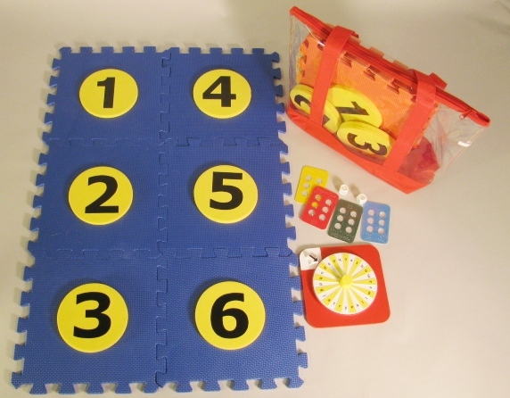

Background
The idea for Hop-A Dot Mat occurred to the project leader while attending a presentation by Dr. Penny Rosenblum at the 2014 Ohio AER Conference; the presentation outlined ways to provide a braille-rich environment for tactile readers. The project leader shared the idea of the Hop-A-Dot Mat with a teacher of the visually impaired who was attending the conference and who regularly works with young students. The teacher encouraged the project leader to submit and pursue the idea after citing the many benefits of the braille mat for her young braille students, adding that her “little ones love taking their shoes off and touching textures with their feet.” This casual conversation sparked a variety of ideas for possible games and activities to enhance the use of the mat, including braille-learning sing-alongs.

The primary objective of the Hop-A-Dot Mat is to encourage young children to learn the braille cell and dot configurations for each alphabet letter (or single-cell contractions) through movement and physical activity with peers. As described in the product submission form, the product will consist of six interlocking EVA (ethylene vinyl acetate) foam floor mats that can be displayed in the configuration of a large braille cell. Each interlocking square will have six removable foam circles. The circles, when removed, will provide large openings in the mat into which the child can place a foot/hand when locating dot numbers/positions. The removable circular pieces will be printed with the dot numbers and constructed so they are elevated slightly above the rest of the mat, forming short “steps.” The students can then tactually locate these steps with their feet or hands when identifying dot positions. Fun, “Twister® game-like” contortions would be accommodated (e.g., letter “c” can be formed by placing left foot on Dot 1 and right foot on Dot 4 simultaneously). As a variation, the student can hop or step on the elevated circles to build a braille letter/single-letter contraction. As another option, the student can insert the foam circles into openings of the mat to build a chosen letter. Note: EVA foam is a nontoxic material that is safe (does not contain plasticizers), waterproof, and washable, thus suitable for use with young children.

The Hop-A-Dot Mat will allow young children to become enthused about learning braille in an active way. Many braille learning tools currently offered by APH present braille learning through sedentary activities, and routine tools and materials. Learning through movement and kinesthetic reinforcement appeals to young children who learn experientially through play, experimentation, exploration, and discovery. Young students with visual impairments and blindness especially need opportunities to be physically active to reinforce important skills related to body awareness and spatial concepts (e.g., top, bottom, left, right, next to, between). The following image from an online slide presentation posted by the New Mexico School for the Blind in 2010 illustrates the importance of movement specific to learning braille and is accompanied by the following quote: “The Arts are not meant to replace the traditional methods of teaching braille. Instead, they should be used along with teaching the contractions to increase motivation and learning. You will find the Arts make teaching and learning more enjoyable and meaningful.” Movement stimulates the brain and strengthens memory.

The product submission form was shared with outside expert reviewers. Their ratings, according to specific criteria (e.g., overall need, appropriate target populations, originality), were collected prior to presentation of the product idea to in-house product review committees. Many of the reviewers’ comments alluded to anticipated benefits of the Hop-A-Dot Mat including the following:
- “This is a great product! It embeds so many necessary core areas in one activity.” – Lauren Lieberman, Ph.D., Professor, The College at Brockport, Brockport, NY
- “I think this will be a fun product for children to use and one that sighted children can also use as a way for them to learn braille with classmates and positional concepts. I love the tie in to movement as well as literacy. I can see a lot of games that can be created to use with this mat.” – Penny Rosenblum, Ph.D., Adjunct Associate Professor, Department of Special Education, Rehabilitation, and School Psychology, University of Arizona, Tucson, AZ
- “Benefits: active learning; encourage physical movement (so important for our kids especially); good way to break up a lesson and get little ones up so they are not sitting forever; reinforces braille dot positions; has the potential for many games that can be played with the mat.” – Frances Mary D’Andrea, Ph.D., Independent Educational Consultant in Visual Impairments, Pittsburgh, PA

On March 24, 2015, the product idea of the Hop-A-Dot Mat was considered and approved by the Product Evaluation Team who assessed its product development difficulty as “medium” and production difficulty as “high.” The estimated yearly volume for the first 3 years is 800 units. On April 3, 2015, the Product Advisory and Review Committee reviewed and approved the development of the product. The product transitioned immediately to the active timeline and was assigned the grant number 583.

Throughout May and June 2015, rapid progress was made by the project staff with regard to prototype development. Specifically, the project leader located and acquired EVA foam in a variety of colors and worked with the model/pattern maker to create the first prototype options of the Hop-A-Dot Mat. Attention was given to making the removable braille dots sit higher than the mat itself to make locating the foam braille dots within the entire mat easier by hand or foot. The best foam colors and sizes for the interlocking frames and circles were chosen.

The remainder of FY 2015 was focused on the creation of suggested activities for the Hop-A-Dot Mat, as well as the development of accessory items (e.g., print/braille alphabet spinner) as suggested by the expert reviewers. Structural options for linking multiple Hop-A-Dot Mats were explored and tested as well.

Prototype design and construction characterized the first and second quarters of FY 2016. A decision was made to include two Hop-A-Dot Mats in each kit—one with a blue frame with yellow numbered circles and one with a red frame with yellow numbered circles. As anticipated, the numbered circles where constructed by laminating two layers of EVA foam disks together; this extra thickness ensured a height difference between the circles and surrounding frame. Large adhesive-backed print numbers (output on the Roland® UV printer) were applied to the foam circles.

As the multiple Hop-A-Dot Mats were constructed, the project leader and model/pattern maker focused on the original design of the accompanying Print/Braille Alphabet Spinner. They made decisions regarding color, tactile arrow style, and braille/print letter placement. The spinner was designed with a flexible plastic “tongue” that clicks along a grooved vacuum-formed disk, providing auditory reinforcement. Additionally, the grooves of the disks assist in aligning the pointer with each alphabet letter.

The project leader located and gathered accessory materials (commercial and existing APH items) to accommodate a variety of braille activities that could be used with the Hop-A-Dot Mat. These materials included four Pop-A-Cells, a pair of tactile dice, and six bean bags in assorted colors. The project leader authored and graphically prepared an Activity Booklet for field test purposes. Activities included the following:

- Build-A-Cell
- Roll-A-Dot
- Letter Twist
- Roll-A-Letter
- Spin-A-Letter
- Pop-A-Cell to Hop-A-Dot
- Bean Bag Braille
- Two-Cell Rock
- All Feet on Deck
- Spell Your Name
- Braille Cha Cha Cha
- Braille Punch
- Puddle Dots
- Build-A-Number
- Color-A-Cell

The Activity Booklet also offered “Body Building Braille Tips,” which suggests ways to form braille letters with your body on the Hop-A-Dot Mat, as well as care and safety instructions when using the mat. The addition of a durable color-coded carrying/storage bag for each Hop-A-Dot Mat was the finishing touch to the prototype.

A field test announcement was posted in the March 2016 issue of the APH News (www.aph.org/news/march-2016/). Approximately 25 teachers expressed interest in participating in the evaluation of the Hop-A-Dot Mat. From this sample, 11 field evaluation sites were selected based upon geographic location, number of available students, and type of instructional setting; preference was given to those who had not recently field tested an APH product. Some selected sites allowed multiple teachers to share and evaluate the prototype.

Potential evaluators gave reasons for wishing to field test with their students with visual impairments and blindness; reasons hinted at the product’s usefulness even before formal field test. Their shared explanations included the following:
- “This looks like a great opportunity for my kindergartners and fourth grader who are learning Braille to get out of their desks and become more aware of their bodies while learning and practicing the Braille cell.”
- “My students are new Braille learners who may benefit from the large motor movements involved in playing this game.”
- “It looks like great fun for Braille introduction, as well as a way to engage our sighted peers in the process.”
- “My second grade student has some vision (ONH, roughly 20/200) and really is struggling to learn braille. He is at a kinder/first grade level in braille; just started the first grade Patterns series with him. Having a physical way to learn and understand the braille cell and how the dots are arranged would be hugely beneficial to him. He is very overweight but loves dance, games, and moving, and this type of learning activity would really engage all of his senses to learn in a visceral way. This might be the breakthrough we’ve been waiting for!”
- “I am always looking for ways to insert fun into Braille lessons. Having physical movement is always a plus when learning a new skill.”
- “I currently work with three students who are beginning to learn how to read. Two of these students need to be moving in order to stay engaged in learning; the third student has emerging gross motor and fine motor skills and so I am continually looking for ways to integrate meaningful movement into Braille lessons.”

Prototypes of the Hop-A-Dot Mat and related materials were mailed on March 17, 2016.
Evaluators were asked to return their completed evaluation forms and student outcome forms by May 15, 2016.

While the field test stage was underway, the project leader conducted a Product Development Committee (PDC) to acquaint members with the anticipated contents of the kit and to start investigating and acquiring material samples (e.g., EVA foam) from multiple vendors. Early experimentation of Roland® printed numbers on the thick EVA substrate was tested with successful outcomes. The tactile residue of the Roland® printed numbers proved a welcomed feature for the product and helpful to the end user.

In June 2016, the project leader compiled a final field test report. Field test evaluation forms were completed by 12 teachers of the visually impaired and blind. (One selected evaluator from Louisiana did not complete and return her evaluation form.) The field evaluators represented the states of Alabama, California, Florida, Georgia, Kentucky (2), Missouri (2), Ohio, South Dakota, and Virginia (2). The largest percentage (66%) of sites represented itinerant or itinerant/resource settings. Table 1 and Figure 1 show the distribution of field test sites according to type of educational setting and geographical location.

Table 1
Type of Educational Setting
Type of Educational Setting | State Location of Field Test Sites | Percentage
Residential | MO, SD | 17%
Itinerant | VA (2), FL, CA, GA, OH, MO | 58%
Itinerant/Resource | AL | 8%
Center-based/onsite Preschool/reverse inclusion | KY (2) | 17%
N = 12 |  | 100%
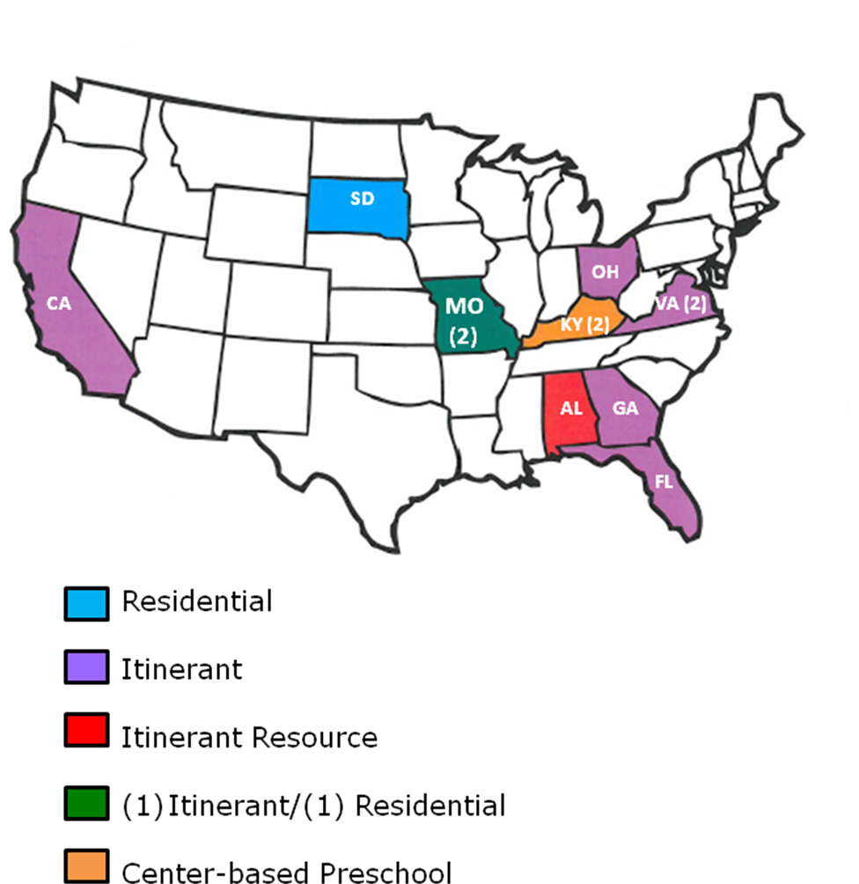
Figure 1. Geographical Distribution and Educational Setting of Field Test Sites.
Participating field evaluators represented a young generation of teachers of the visually impaired; 75% had 5 or less years of teaching experience and the remaining 25% had 6-10 years of teaching experience. A large percentage (83%) of the evaluators reported teaching braille reading “frequently” to their students with visual impairments and blindness. Prior to field testing, two of the teachers reported having created a floor-size representation of the braille cell; one did so using hula hoops, each labeled with a braille dot.

The field evaluators used the Hop-A-Dot Mat and related accessories with a total of 32 students who represented slightly more males (59%) than females (41%). The sample population represented cultural diversity: 72% White, 13% Black, 6% Asian, 3% Hispanic, 3% American Indian, and 3% two or more races. Half of the students had other disabilities such as autism, cognitive disabilities, developmental disabilities, and orthopedic impairments.

Students ranged in age from 3 to 16 years of age. Equal percentages were either 3 to 5 years old (25%) or 6 to 8 years old (25%). Another noticeable percentage (38%) were 9 to 11 years old. Only 12% were teenagers. (See Figure 2.)
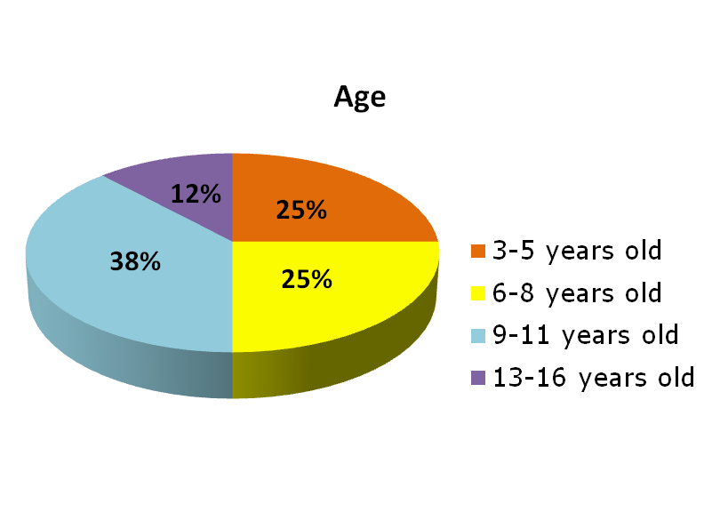
Figure 2. Students’ Age Range

With regard to grade level representations, equal percentages of students were classified as either preschoolers (19%) or kindergarteners (19%); 28% were in Grades 1 to 3, 25% were in Grades 4 to 6, and 9% were in Grades 7 to 9. (See Figure 3.)

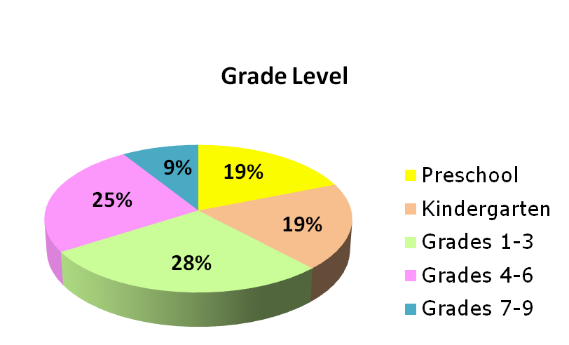
Figure 3. Students’ Grade Level
Nearly equal percentages of the student sample were reported as primarily braille readers (31%) or large print readers (28%); 22% were dual readers (e.g., auditory/braille or braille/large type), 9% read print with magnification, 6% were prereaders, and 3% were primarily auditory readers. (See Figure 4.)

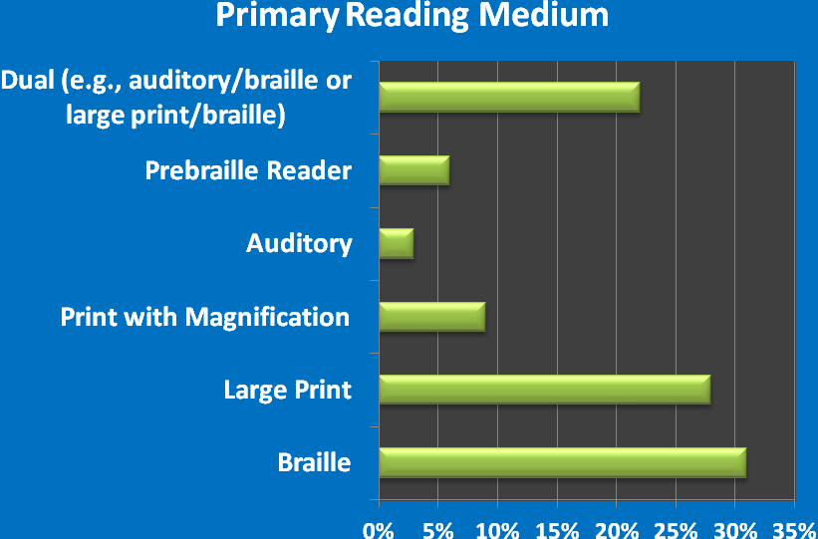
Figure 4. Students' Primary Reading Medium
The students’ level of braille knowledge varied with 25% unfamiliar with braille; 38% were familiar with the braille configuration and dot numbers, 28% knew the braille alphabet letters, 19% read uncontracted (letter-for-letter) braille, and 25% read contracted braille.

The field evaluation form allowed teachers to rate each feature of the Hop-A-Dot Mat. [Note: Two Hop-A-Dot Mats were provided to each evaluator in two different color schemes—blue frame with yellow braille dots and red frame with yellow braille dots.] Table 2 provides the average rating for each feature of the mat.

Table 2
Overall Design of Hop-A-Dot Mat
Rating Scale: 5 = Excellent to 1 = Poor (or Unneeded)
Product Feature | Number of Evaluators | Average Rating | 5 | 4.5 | 4 | 3 | 2 | 1
Overall size of Hop-A-Dot Mat | N = 12 | 4.5 | 67% | 8% | 25%
Quantity of provided Hop-A-Dot Mats (2 total) | N = 12 | 5.0 | 100%
Visual contrast of blue Hop-A-Dot Mat with yellow foam dots | N = 12 | 5.0 | 100%
Visual contrast of red Hop-A-Dot Mat with yellow foam dots | N = 12 | 4.92 | 92% |  | 8%
Size of numbers on foam dots | N = 12 | 4.92 | 92% |  | 8%
Ease of assembly/setup (i.e., linking squares and inserting foam dots). | N = 12 | 4.92 | 92% |  | 8%
Storage style (i.e., each Hop-A-Dot Mat stored in its own individual carrying bag) | N = 12 | 5.0 | 100%
Durability of Hop-A-Dot Mat | N = 12 | 4.75 | 75% |  | 25%
Portability of Hop-A-Dot Mat | N = 12 | 5.0 | 100%

Specific evaluators’ comments related to the features of the Hop-A-Dot Mat supported its overall strong ratings; comments included the following:
- “I liked how big it was [when] put together, but I especially like the fact that it could be taken apart, which made it so much more portable.”
- “Held up well under some active, occasionally rough play.”
- “Students could do this [assemble the mat] themselves with just a little verbal guidance.”
- “I thought the storage was very convenient.”

Planned improvements to the final product were decided based on ratings and comments. One such improvement will be the provision of braille number stickers to label the foam circles. This adaptation was used by one of the field evaluators using APH’s number stickers.

The field evaluation form allowed teachers to rate each and every feature of the Braille/Print Alphabet Spinner. Table 3 provides the average rating for each feature of the spinner.

Table 3
Overall Design of Braille/Print Alphabet Spinner
Rating Scale: 5 = Excellent to 1 = Poor (or Unneeded)
Product Feature | Number of Evaluators | Average Rating | 5 | 4 | 3 | 2 | 1
Overall visual presentation/color contrast | N = 11 | 4.91 | 91% | 9%
Overall size | N = 11 | 4.72 | 91% |  |  | 9%
Arrow position and style | N = 11 | 4.18 | 45% | 36% | 9% | 9%
Alternating color bands | N = 11 | 4.91 | 91% | 9%
Readability of print letters | N = 11 | 4.36 | 64% | 18% | 9% | 9%
Readability of braille letters | N = 11 | 4.91 | 91% | 9%
Random order of alphabet letters on spinner | N = 11 | 4.55 | 73% | 9% | 18%
Auditory sound made my spinner | N = 11 | 5.00 | 100%
Stability of spinner on flat surface | N = 11 | 5.00 | 100%
Knob in center of spinner for grasping/turning | N = 11 | 5.00 | 100%
Note: One of the 12 evaluators who shared the prototype with another colleague did not receive the spinner for review; therefore, only 11 evaluators reported ratings for this component.

Specific evaluators’ comments related to the features of the Braille/Print Alphabet Spinner supported its overall strong ratings, including the following:
- “Good size for students’ hands.”
- “My blind student was able to read the braille letters very well.”
- “Students were really attracted to this feature [auditory sound].”
- “All students could grasp [the knob].”

Planned improvements to the spinner were decided based on these ratings and comments (e.g., to enlarge print letters some). The majority of the evaluators (83%) recommended that APH offer the Braille/Print Alphabet Spinner as a separate product as well, apart from the Hop-A-Dot Mat. They also encouraged the development and production of a similar number spinner. Teachers suggested that the Braille/Print Alphabet Spinner could be used for a variety of word games and activities. One teacher stated, “This spinner is simply fantastic! I will be using it for many different things.”

One hundred percent of the field evaluators thought the accompanying Activity Guide sufficiently described the purpose and the use of the Hop-A-Dot Mat; they unanimously liked the layout and design of the booklet as well. Related comments included the following:
- “The activity guide gave more ideas than I have thought of on how to use the product.”
- “Brief and to the point. Just enough detail.”
- “The description of the game rules and body movements were very well understood.”
- “Attention grabbing, easy to read and understand.”
- “Visually appealing and handy to refer to all activities possible.”
- “Helped the classroom teacher to understand; full knowledge of braille not needed.”
- “It has enough variety for most TVIs and leaves room for them to design their own activities.”

The Activity Booklet presented an assortment of activities and games that could be played using the Hop-A-Dot Mat and related accessories. With the exception of one, all of the games and activities were performed with students during the field test period. The games “Build-A-Cell,” “Spin-A-Letter,” and “Bean Bag Braille” were among the most frequently used. These three activities/games were also reported as the students’ favorites. Table 4 indicates the frequency of use for each game/activity.

Table 4
Frequency of Game/Activity Use
Activity/Game | Number of Evaluators | Frequently | Occasionally | Never
Build-A-Cell | N = 12 | 67% | 33%
Roll-A-Dot | N = 12 | 50% | 17% | 33%
Letter Twist | N = 12 | 25% | 50% | 25%
Roll-A-Letter | N = 12 | 25% | 42% | 33%
Spin-A-Letter | N = 12 | 75% | 17% | 8%
Pop-A-Cell to Hop-A-Dot | N = 12 | 25% | 33% | 42%
Bean Bag Braille | N = 12 | 58% | 33% | 8%
Two-Cell Rock | N = 12 | 8% | 8% | 83%
All Feet on Deck | N = 12 | 8% | 17% | 75%
Spell Your Name | N = 12 | 17% | 42% | 42%
Braille Cha Cha Cha | N = 12 | 17% | 25% | 58%
Braille Punch | N = 12 | 8% | 17% | 75%
Puddle Dots | N = 11 | 0% | 36% | 64%
Build-A-Number | N = 12 | 8% | 33% | 58%
Color-A-Cell | N = 12 | 0% | 0% | 100%

As expected and encouraged, the teachers and students created games of their own using the Hop-A-Dot Mat such as “Alphabet Relay” and “Which One is Missing?” The project leader intends to incorporate these additional activity ideas into the final Activity Booklet. One of the evaluators suggested creating a blog with additional ideas.

Along with the Braille/Print Alphabet Spinner, additional game accessories were included with the prototype of the Hop-A-Dot Mat including a pair of tactile dice, four APH Pop-A-Cells, and six bean bags. The evaluators were asked if each accessory should remain a part of the kit, and if so, to indicate the ideal quantity. Table 5 shows the results of their feedback.

Table 5
Need for Accessories
Accessory | Number of Evaluators | YES, include with Hop-A-Dot Mat | NO, omit from Hop-A-Dot Mat
Pair of tactile dice | N = 12 | 83% | 17%
Pop-A-Cells | N = 12 | 67% | 33%
Print/Braille Alphabet Spinner | N = 11 | 100%
Bean Bags | N = 12 | 83% | 17%

Evaluation of the tactile dice (purchased from an outside vendor, but used in many of APH’s game kits) illuminated the need for less “prickly” dots. The project leader will pursue the product idea of a more tactually pleasant pair of dice for immediate or eventual inclusion with the Hop-A-Dot Mat.

The Hop-A-Dot Mat was favorably received by the students themselves. Evaluators indicated that 100% of the students enjoyed using the mat. Comments ranged from a short, enthusiastic “Loved it!” to lengthier explanations for its positive reception: “Greatly improved overall class interest in braille in general,” “This was a great rewards for completing work!” and “My students asked to play Hop-A-Dot at the beginning of each class period.” According to 92% of the evaluators, the mat enhanced students’ interest in braille. Some of the comments captured on the Student Outcome Forms included the following:
- “He loved it—extremely motivating and engaging.”
- “Student is naturally very active. He seemed to enjoy using it. It was likely more fun than tactually reading braille.”
- “This student enjoys playing games. She is very tactile and enjoyed a different approach to braille.”
- “Since braille is usually 1-on-1 with a teacher or working with one other student, it increased his excitement to have everyone in the class exploring braille. He also liked the active aspect of the product.”
- “She liked that it was a game she could play better than others because she knows braille and they don’t.”

In some cases, the transition between the large presentation of the braille cell and standard braille size posed difficulties for students, yet 58% reported no observed hindrance. Usually this type of challenge was experienced by students with intellectual disabilities.

Half of the field evaluators indicated that sighted peers participated in the use of the Hop-A-Dot Mat with their students. Specific comments highlighted how the mat provided social interaction opportunities:
- “It started lots of conversations about braille, about sharing with peers, how to explain braille, and how to explain visual impairment, etc.”
- “They used the mats as much as their visually impaired friends, playing right alongside them. They were very interested in this active way to learn braille.”
- “We put the Hop-A-Dot in the kindergarten classroom as a center. The sighted kids spun the spinner, the braille student read the letter tactually, then made it with the bean bags. The sighted children were able to use the braille configuration on the spinner to tell if she had done it correctly or not.”

The majority (75%) of the evaluators indicated that the Hop-A-Dot Mat offered specific advantages over other braille awareness/instruction products including “ease of use,” “getting kids up and moving enhances learning,” “the physical aspect of it,” “very engaging,” and “a way for regular ed staff to better understand the braille cell.” Ninety-two percent of the evaluators indicated being more impressed and pleased by the Hop-A-Dot’s usefulness for students with visual impairments and blindness compared to their original expectations prior to field testing. Using a rating scale of 7 = Strongly Agree to 1 = Strongly Disagree, the evaluators gave a combined score of 6.67 when asked to indicate how well the Hop-A-Dot met its original goal and objective of increasing braille awareness and knowledge within a recreational context. As shown in Table 6, data collected on each of the 32 returned Students Outcome Forms reiterated this positive impact.

Table 6
Impact on Student’s Braille Awareness and Knowledge
Did the Hop-A-Dot Increase Student’s Braille Awareness and Knowledge?
N = 32
Strongly Agree | Agree | Somewhat Agree | Somewhat  Disagree | Disagree | Strongly  Disagree
38% | 34% | 22% |  | 6%

Teachers described the impact of Hop-A-Dot Mat on their students’ braille knowledge and awareness:
- “She loved it and I saw faster progress with spatial awareness and recognition of dot numbers than I have ever seen with her before.”
- “This was helping her form more concrete knowledge of Braille.”
- “This activity feeds into this particular child’s intellect. He really enjoys Braille and telling others about it.”

Table 7 indicates the evaluator ratings for the product usefulness for promoting other skills and concepts beyond braille knowledge and awareness.

Table 7
Other Skills/Concepts Promoted with Use of the Hop-A-Dot Mat
Skill/Concept | Number of Evaluators | Average Rating | 7 | 6 | 5 | 4 | 3 | 2 | 1
Social Interaction | N = 11 | 5.65 | 55% |  | 18% | 8% | 18%
Self-Expression | N = 12 | 5.08 | 17% | 25% | 33% |  | 25%
Physical Activity/Exercise | N = 12 | 6.50 | 67% | 17% | 17%
Body Awareness and Coordination | N = 12 | 6.08 | 50% | 25% | 8% | 17%
Tactile Discrimination | N = 12 | 4.80 | 17% | 17% | 33% | 17% |  | 17%
Understanding Spatial Concepts | N = 12 | 5.50 | 25% | 33% | 17% | 17% | 8%

Data collected via 32 Student Outcome Forms also illuminated strides made by individual students (see Table 8). Many of the students improved in multiple skill areas: 31% in two skill areas, 16% in three skill areas, 9% in four skill areas, and 9% in five skill areas.

Table 8
Individual Student Improvements in Skill Area(s)
Did you observe the student improve in any of the following areas after using the Hop-A-Dot Mat [check all that apply]? N = 32
Social Inter-action | Self-  Ex-pression and Creativity | Physical  Activity/Exercise | Body Awareness and Coor-dination | Tactile  Discrim-ination | Under-  standing of Spatial  Concepts | Other skill/con-cept (indicate)
47% | 22% | 44% | 38% | 5% | 14% | 9% (Team Work)

One hundred percent of the field evaluators recommended that APH produce Hop-A-Dot Mat. Supportive comments regarding its strengths included the following:
- “Makes braille fun and a social activity.”
- “It helps the child develop associative thought between the large circles and the Braille cell.”
- The mat “adds another dimension to braille instruction that we haven’t had before.”
- “It makes learning the braille cell fun. Student doesn’t have to stay seated at a desk.”
- “Great reward/motivator.”
- “Supported learning of new braille letters and contractions.”
- “Works on cognitive and motor skills simultaneously.”
- “Good proprioceptive practice” and “good spatial awareness practice.”
- “It is fun and the kids thought of it as a game.”
- “It included many pieces that can be used for a variety of activities.”
- “It encourages turn-taking skills when others must shake dice, jump on the mat, etc.”
- “Class discussion of Braille was the strength of Hop-A-Dot.”
- “Portable, something different, moving the entire body, games that can involve sighted peers.”

As Table 9 reveals, the most appropriate target populations for the Hop-A-Dot as assessed by the 12 field evaluators were tactile and low vision preschoolers, kindergarteners, and students in early elementary grades. However, use with older students was possible as well.

Table 9
Appropriate Target Populations
Target Population | Percentage of evaluators  (N =12) indicating appropriateness of product for target population
Preschoolers who are blind | 83%
Preschoolers who are low vision | 83%
Low vision students in Grades K-2 | 83%
Tactile readers in Grades K-2 | 100%
Low vision students in Grades 3-5 | 50%
Tactile readers in Grades 3-5 | 75%
Low vision students in Grades 6-8 | 17%
Tactile readers in Grades 6-8 | 25%
High school students with low vision/blindness | 8%
Students with additional physical disabilities | 33%
Students with deafblindness | 33%
Sighted peers | 50%
Adults who are beginning braille readers | 17%
Low vision adults | 8%
Sighted adults | 25%
Other (indicate): | - Sighted adults when playing with a visually impaired child  - Any NEW braille reader

Formal field test feedback was complemented by supportive and enthusiastic comments from the writers of Building on Patterns who got a sneak preview of the Hop-A-Dot Mat and the Braille/Print Alphabet Spinner during their onsite work meeting at APH in June 2016. They wanted to see the product available as soon as possible.

In late July, the graphic designer initiated work on the layout of the Activity Booklet using final content authored by the project leader and edited by the research assistant. The guidebook incorporated new games and activities proposed by the field evaluators, such as “Braille Relay” and “Braille Bingo.” The graphic designer enhanced the “Body Building Braille Tips” section by including pictorial icons of hands, feet, and knees to illustrate suggested ways to form the braille alphabet letters.

In mid-August, the following catalog numbers were assigned to the final product and associated spinners.
- Hop-A-Dot Mat (1-08819-00)
- Braille/Print Alphabet Spinner (1-08817-00)
- Braille/Print Number Spinner (1-08818-00)
In late August, the project leader prepared the Braille Order Detail Form to request in-house braille translation of the Activity Booklet. Braille translation was completed in early September. Page counts of both the print and braille booklets were furnished to the manufacturing specialist to incorporate into the final product specifications.

In mid-September, the project leader regrouped the PDC members to transition the product to the “tooling stage” and review needed updates based upon feedback and suggestions from field evaluators. The following notable improvements and provisions were anticipated:
- Slightly larger print letters on the Braille/Print Alphabet Spinner
- Addition of a Braille/Print Number Spinner
- Addition of braille number stickers to label the foam dots
- Creation and assignment of separate replacement part numbers for blue and red Hop-A-Dot Mats to allow separate purchase apart from the full kit, if desired

Work during FY 2017
In October, Quota approval for the Hop-A-Dot Mat and related spinners was requested and received from the Educational Products Advisory Committee (EPAC) during Annual Meeting.

Prior to his retirement, Tom Poppe finalized the majority of the production tooling needed to produce the two spinners, which included the vacuum-form master for the upper disc with braille numbers (or letters), a multi-up vacuum-form master for the spinner’s arrow/pointer, the cutting die design for the spinner’s sound-generating “tongue,” and a cutting die for the spinner’s rigid foam base. A vendor was identified for the rubber cap to apply to the spinner hub.

In late October, PDC members reviewed remaining tooling tasks and material selections. Although progress was sporadic in the coming months because of other higher product priorities, notable strides included the following:
- Purchasing staff secured cost for the clear vinyl carrying/tote bags. The graphic designer prepared related art for the bag insert.
- Samples of numbers printed onto EVA foam via the Roland® UV printer were generated so the project leader could select the ideal number of print layers to achieve a discernible tactile “footprint.”
- The project leader acquired interlocked EVA foam frames from the expected supplier for safety testing purposes and for cutting die layout.
- The graphic designer prepared the print design of the new Braille/Print Number Spinner and provided this to the manufacturing specialist to drop into a template for eventual printing and die cutting operations.
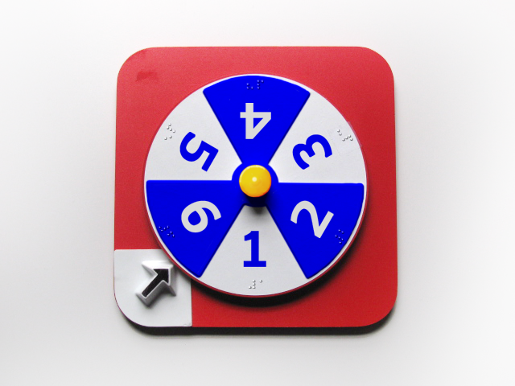
- Final packaging styles, including needed braille/print labels for the spinners and mats, were determined for warehousing and shipping purposes.

In April, the project leader conducted another PDC meeting; however, progress continued to stall due to higher product priorities assigned to Technical Research staff. Frank Hayden received safety-testing results that confirmed the safety of the EVA foam according to Consumer Product Safety Improvement Act (CPSIA) guidelines.

Work planned for FY 2018
The project leader will continue to conduct PDC meetings to maintain momentum on the product, monitor progress, and provide approvals of generated production samples. Final fabrication of all needed production tooling, as well as finalization of the product specifications, will be completed. Actual production of the final kit will likely occur before the beginning of the next school year. The project staff will closely monitor the quality of the initial pilot and production runs of the Hop-A-Dot Mat and related spinners.

Physical Education, Recreation, and Health Web Site
(Ongoing)

Purpose
To provide individuals with visual impairments and blindness, parents, and teachers with a resource list that promotes health, physical education, and recreation

Project Staff
Tristan Pierce, Physical Education Project Leader
Kelly Kennedy Mimms, Research Assistant
Monica Vaught-Compton, Project Assistant
Malcolm Turner, Database and Website Coordinator
Ricky Irvine, Website and Video Designer

Background
APH funded a 3-year study on parent-child physical activity intervention among families of children with visual impairments. The investigators who conducted the study were Moira Stuart, Ph.D., Northern Illinois University; Lauren Lieberman, The College at Brockport; and Nicole Riscica, The College at Brockport. During year three of the study, APH produced a resource manual for the participating families. Upon completion of the study, APH decided to make the information available on its website. Staff updated the original resource manual and launched it on the APH Web site. Viewers can navigate between PE programs, nutrition, organizations, articles, books, equipment, events, magazines, mailing lists, national services, regional and state services, sport camps, stories, toys and games, videos, and websites. This is a live document; viewers can submit items for review and possible placement on the APH PE Web site.

Work during FY 2017
Staff posted the 2017 winter and summer sports camps. Once posted, as camp directors submitted updates, APH edited the camp listing as needed. Staff updated the Events page to include 2016 events, such as the 360 Invitational Goalball Tournament, the 2017 National Goalball Championships, and the 2017 Beep Baseball World Series. Staff created new features that included the, “I Am” Challenge: Olympics/Paralympics and Equipment Modifications: Hurdles. Throughout the year, staff added new online videos to the video library.

Work planned for FY 2018
Staff will continue to launch new material and to udpate website.

Physical Education and Health Special Projects and Needs
(Ongoing)

Purpose
To research, identify, and develop products that promote physical activities, good health practices, social interactions, and self-advocacy

Project Staff
Tristan Pierce, Physical Education Project Leader
Kelly Kennedy Mimms, Research Assistant
Monica Vaught-Compton, Project Assistant

Background
APH recognized the need and began to develop products and fund university research in the area of physical activity in relation to students and adults who have visual impairment, blindness, and deafblindness. The positive feedback from the field prompted a new designation in the budget for Health and Physical Education.

Staff created the APH Physical Education, Recreation, and Health website. APH has since produced two books for teachers, one book for middle school students through adulthood, one storybook at 4th grade reading level, and one electronic book featuring stories by adults with deafblindness; three kits to teach and promote walking/running, jumping rope, and playing tennis; a variety of sound emitting balls; and a portable source.

Work during FY 2017
The project leader continued to maintain the Physical Education, Recreation, and Health Web site. APH launched Gross Motor Development Curriculum (GMDC) and work continued on Count Me In: Motor Development in a Box.

Work planned for FY 2018
Work will continue on Count Me In: Motor Development in a Box. Work will continue on the PE Web site.

SPORTS COURTS
Formerly SPORTS COURTS: Touch and Play
(Continued)

Purpose
To provide a variety of interactive sports courts and fields (e.g., basketball, tennis, football, bowling) with interactive pieces to demonstrate player positions and game rules. The tactile displays will be accompanied by reference booklets coauthored by a team of experts who regularly provide instruction in this content area to students with visual impairments and blindness.

Project Staff
Karen J. Poppe, Tactile Literacy Project Leader/Coauthor
Rachel White, Research Assistant/Primary Editor
Lauren Lieberman, Contributing Author
Justin A. Haegele, Contributing Author
Monica Lepore, Contributing Author
Maria Lepore-Stevens, Contributing Author
Jenna Sticken, Contributing Author
Tom Poppe, Pattern/Model Maker
Andrew Dakin, Pattern/Model Maker
Patrick White, Pattern/Model Maker
Andrew Moulton, Manufacturing Specialist
Anthony D. Jones, Art Production/Design Manager
Matthew Poppe, Graphic Designer
Joon Lee, Copyright and Cataloging Librarian

Background
The prospect of developing an interactive set of tactile sports courts and fields was originally explored by the Tactile Graphics Brainstorming Committee in August 2002. Over the years, the project leader consistently incorporated the development of such a product into her annual budget reports. However, the project was repeatedly sidelined due to higher priority research projects. The product idea gained some careful consideration after repeated product submissions were received from teachers in the field, especially from those who routinely teach physical education to students with visual impairments and blindness.

SPORTS COURTS is expected to address the following needs and requests from the field:
- To provide interactive tactile materials to assist students’ understanding and participation in a variety of sports and physical activities
- To alleviate the burden of teachers having to create and build their own tactile displays for introducing sports-related concepts to their students
Example: “I make tactile boards for my students. If there were commercially-available diagrams, I would buy them! It would be a time saver for me!” – Megan O’Connell, Teacher–Adapted Physical Education, Perkins School for the Blind (survey respondent)
- To address expanded core curriculum skills such as social skills and self-determination
- To broaden APH’s inventory of physical education products and tactile learning materials

Feedback regarding the need for SPORTS COURTS was most directly indicated by 32 respondents to a product-specific survey conducted by the project leader in February 2012. The following are the results of that study.

Survey respondents represented the following states, as well as one Canadian province: Washington (2), California, North Dakota, Colorado, New Mexico (2), Minnesota (2), Iowa (2), Missouri (4), Illinois, Indiana, Alabama (2), Florida (4), Pennsylvania (2), New York (2), Massachusetts (2), Alaska (2), and Calgary, Alberta (1). (Refer to Figure 1.)

Figure 1. Distribution of Survey Respondents by Geographical Location

As Figure 2 illustrates, the respondents reflected a dynamic group with a variety of titles including Teacher of the Visually Impaired, Certified Orientation and Mobility Specialist, Rehabilitation Teacher, Braille Specialist, Vision Specialist, and Physical Education/Recreation Specialist.

Figure 2. Survey Respondents’ Professional Titles

Survey respondents indicated a multitude of barriers to a student’s involvement and understanding of sports if he or she is visually impaired or blind. The top three barriers related to 1) adequate instruction time, 2) others’ attitudes regarding the student’s ability/interest, and 3) available time for instruction. Instructor’s knowledge/background and availability of sports equipment were additional obstacles. The student’s own attitude toward sports and scheduling conflicts seemed to have the least negative impact. (Refer to Figure 3.)

Figure 3. Barriers to Student’s Involvement and Understanding of Sports

The frequency of teaching concepts related to sports courts and fields to students with visual impairments and blindness was nearly equally distributed across the continuum of “frequently (two times a week or more)” to “occasionally (once a month)” to “seldom (two or three times a year)”—31%, 28%, and 34%, respectively. The remaining percentage of respondents reported “never,” “depends on grade level,” “one time a week,” or no response was given. (Refer to Figure 4.)
Figure 4. Frequency of Teaching Concepts Related to Sports

The following graph reflects the “Top 10” most needed sports courts/fields based upon the respondents’ rankings. The “Top 10” included (from most to least) soccer, basketball, baseball/softball, bowling, beep baseball, goalball, track and field, football, volleyball, and tennis. Diminishing in demand were swimming, bocce, hockey, golf, badminton, speedball, lacrosse, and rugby. (Refer to Figure 5.)

Figure 5. Top 10 Requested Sports Courts and Field Layouts

Respondents were asked to indicate the overall need for SPORTS COURTS on a scale from 5 = extremely needed to 0 = not needed. Nearly half (47%) of respondents thought the product was extremely needed, and 31% gave it a “4” rating. (Refer to Figure 6.)

Figure 6. Overall Need for SPORTS COURTS

The results of the SPORTS COURTS survey were presented at APH’s 144th Annual Meeting during a product input session. Although the session was attended by a small audience, a lively discussion addressed possible structural formats from magnetic to VELCRO® brand compatible platforms and from mostly ready-made (static tactile presentations) to very interactive 3D models. To spark conversation, the project leader presented an interactive tennis court she fabricated with moveable players, tactile court lines/boundaries, braille labels, and a 3D net.

On May 8, 2013, the project leader submitted a formal product submission form describing and recommending the development and production of SPORT COURTS. The product idea was approved by the Product Evaluation Team on May 29, 2013, and by the Product Advisory and Review Committee (PARC) on June 13, 2013. The product development difficulty was rated as “high,” as well as the production difficulty. An estimated development time (PARCing Lot to stock) of 2.5 years was forecasted.

Appropriate target populations for SPORTS COURTS will encompass the following:
- Students/adults with visual impairments and blindness who need and want to participate in sports activities
- Adapted physical education teachers
- General physical education teachers
- Orientation and mobility instructors
- Teachers of the visually impaired

Components proposed by the project leader for inclusion in the kit include the following:
- Various multi-color screen printed/vacuum-form sports courts that can be mounted to a metal surface
- Moveable players (e.g., perhaps using Tactile Town’s pedestrian pieces with two colors and two textures) to differentiate between teams or individual players and to demonstrate player positions and movement on the field/court
- Accompanying guidebook highlighting the background/history, adaptations/modifications, and basic rules of various sports. This guidebook will be written and prepared by experts in the field, some of whom submitted similar product submissions to APH in recent years.
- A housing binder with built-in compartments for players and other game pieces

Toward the end of FY 2013, the project leader and Tom Poppe fabricated some possible 3D pieces (e.g., bowling pins, two sizes of goal posts, basketball goals) for consideration, as well as a thermoform pattern of a tactile tennis court.

Significant updates on SPORTS COURTS occurred throughout FY 2014, characterized by the continued development, design, and generation of the first court layout—Tennis. Multiple copies were produced using a prepared vacuum-form pattern and silkscreen art. The project leader devised a way to produce the 3D net with a commonplace needlepoint canvas material. Strong magnetic tabs were located and tested for secure placement of the 3D parts on a metal surface (i.e., APH’s ALL-IN-ONE Board). The colors of the pedestrian pieces from Tactile Town were updated to include a red player.

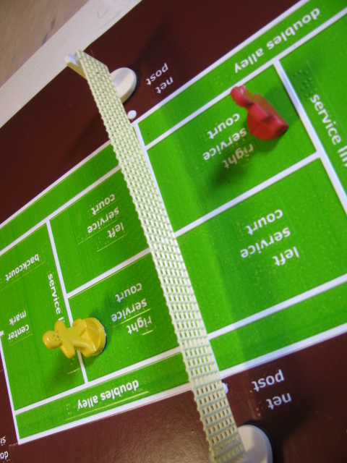

In early January 2014, a team of consultants, some who had previously submitted similar product submissions for tactile court and field layouts, joined the project. The lead consultant, Dr. Lauren Lieberman, worked directly with the project leader to decide on planned courts and fields and related components, based upon earlier survey results. A magnetic platform, based on the initial tennis court layout, was deemed the right direction for the courts versus a VELCRO® brand style surface. The foldable feature was also advantageous for convenient storage in a binder.

The project leader and consultant outlined the purpose, target populations, and expected product components of the kit for the Product Development Committee (PDC). It was decided that the following 11 x 17-in. tactile/print layouts would be readied for field test purposes:
- Badminton
- Baseball
- Basketball
- Beep Baseball
- Bowling
- Floor Hockey
- Football
- Goalball
- Golf
- Lacrosse
- Soccer
- Swimming
- Tennis
- Track and Field
- Volleyball

Additional sports chapters, minus tactile/print layouts, would be provided for Softball (reviewed in combination with the Baseball layout), Ultimate (played on a flat grass field), and Speedball (usually played on a soccer field or basketball court).

Ideal field test times were discussed and tentatively planned, as well as probable field test sites—five summer camps and 15 academic settings. The co-authors/consultants were contacted, contract agreements were signed, and delineation of authoring tasks was determined via a teleconference call. Per the consultants’ request, the project leader developed an initial design of the Tennis chapter that could serve as a starting point for later refinements; a complementary tennis logo was designed to match the basketball motif. Eventually, final content headings were determined by the authoring team and shared in a Google Docs™ template; regular updates were made to each sport chapter throughout April and May.

Concurrent with the aforementioned project-related activities, the project leader assisted APH Development Staff in pulling together product information and budget estimates for grant submission purposes. Several positive outcomes resulted from this mutual effort. Initially, after reviewing a grant application and taking a tour at APH’s research and manufacturing plant, the United States Tennis Association (USTA) Southern granted $1,000 to APH for the development of the SPORTS COURTS kit consisting of 15 different interactive, tactile sports models and guidebook www.aph.org/development/thanks/. Secondly, APH was notified that the development of SPORTS COURTS will be featured in the September 2014 issue of TENNIS magazine, a national magazine that goes to every USTA member in the United States; complementary photo(s) of students with visual impairments and blindness exploring the tactile court layout will be included. The project leader assisted with the photo shoot taken at the Kentucky School for the Blind.

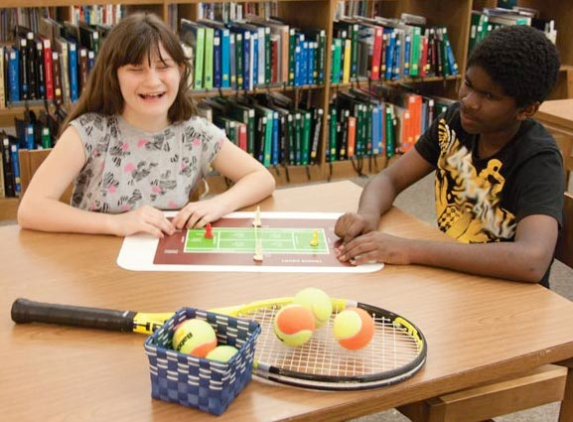

Throughout June and July 2014, the project leader and Tom Poppe concentrated on design of the actual court and field layouts. Because of higher project priorities in Technical Research, the project leader personally assumed the complex task of creating a matrix to accommodate and ensure minimal silkscreen setups using a limited number of ink colors; she also outlined the vacuum-form master setups with a total of eight 2-up patterns needed. This matrix served as a roadmap for all subsequent work on the prototype versions of the courts/fields. Each court/field design was planned taking into account proper dimensions, typical court/field features, visual contrast, texture application, and print and braille label placement. A unified look and feel for the overall presentation of all of the courts and fields was maintained throughout the design process.

Prototype development also encompassed the original molding and fabrication of related 3D manipulatives such as goal posts, bowling pins, basketball nets, and players. Separate thermoform patterns were built to produce magnetic X and O pieces to demonstrate defensive and offensive player positions of team sports (e.g., football, volleyball, soccer). Andrew Dakin and Andrew Moulton generated the basketball backboards via a 3D printer; Tom Poppe fabricated the remaining 3D parts and embellishments.

In August 2014, the project leader took the opportunity to gather additional names and contact information from those attending the 2014 International AER Conference in San Antonio, TX, who might be interested to serve as field evaluators. The field test opportunity was announced at a general session presented by Dr. Lieberman. A total of 20 teachers completed and submitted forms that also captured their ideas for product components. Many of the requested design features echoed the planned blueprint for the product with emphasis on appropriateness for both students with low vision and blindness, portability, simple-but-functional presentation, durability for indoor/outdoor use and by multiple users, easy to share, proper dimensions/ratios of courts, foldable, and different shapes for offensive and defensive players.

Although originally optimistic that the field test stage might begin during FY 2014, it became apparent that the complexity and scope of prototype development, as well as the project staff’s involvement in other project endeavors, would dictate a lengthier timeline.

A steady pace of activities and tasks by the project staff characterized the first two quarters of the FY 2015. Significant strides were made in the preparation and design of the dual tactile/visual layout of each sport court or field layout. First, the dimensions and important features of each field/court were researched; the most tactually meaningful way to show each layout was then determined. Effort was made to incorporate interesting textures and varying elevations of graphic elements into all of the sports layouts (e.g., water texture in Swimming layout, rough sandy bunkers in the Golf layout).

After the tactile layouts were established, complementary silkscreen art was created to generate the print counterparts. Attention was given to utilizing and juxtaposing high-contrast colors within a given field or court layout, always with the low vision reader in mind; large print text was incorporated as well.

To generate multiple copies of each layout for field testing purposes, 2-up images of the sports layouts were screen printed in-house. The printed sheets were then vacuum-formed to create the final combined tactile/color layouts and were trimmed to finished size. Each layout was captured on a single 11 x 17-in. sheet and hinged slightly off center and three-hole punched for inclusion in a binder.
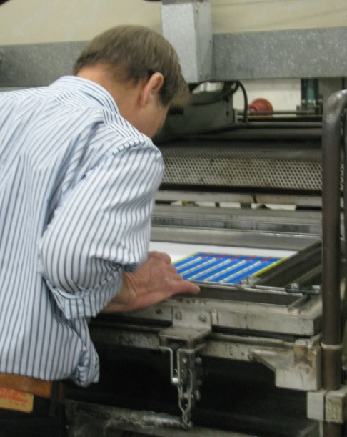
The design of the accompanying 3D features (e.g., players, nets of various lengths, goal posts, bowling pins, basketball nets) was concurrent with the development of the tactile/print sports layouts. The 3D parts were created using a variety of mold-making techniques (e.g., liquid resin process or 3D printer). Hook material and/or magnetic attachments were added to each manipulative for eventual positioning on the corresponding sport field or court. Careful attention was given to the incorporation of high-contrast colors, textures, and recognizable features. For example, the 3D players contrast in both color (red versus yellow) and texture (smooth versus rough). Additionally, the 3D pieces accommodate multiple uses across all of the court and field layouts. For example, the two sizes of goal posts can be used as supports for nets (as in Tennis and Volleyball), goal posts (as in Football), hoops (as in Basketball), or flags (as in Soccer and Golf).

Under the corners of each sports layout are four corner magnetic tabs that secure the layout to a metal surface such as APH’s ALL-IN-ONE Board (as shown in the photo) or to a cookie sheet. The 3D pieces have magnetic bases that can be used in combination with the sports layouts. The layouts can also be used as stand-alone displays on a flat desk or table surface.
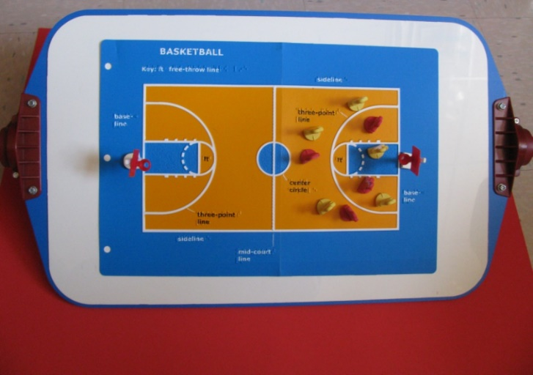

Following the construction of the tangible parts (court/field layouts and 3D items), the project staff’s attention shifted to the editing and layout design of the accompanying sport chapter booklets. Using the chapter content previously submitted by the consultants/contributing authors, the project leader performed the following tasks:
- edited and expanded chapter content
- incorporated new chapter sections (e.g., resources such as videos, adaptive materials/products, and online research/articles)
- guided the general layout and design of the sports chapter, each visually identified by a unique banner/logo created by Anthony Jones
- established a look for the binder cover art
- incorporated final grammatical and typographical corrections throughout all chapter booklets based on needed edits identified by Rachel White
- finalized the layout of each sport chapter booklet and inserted photos of the corresponding field/court layout
- prepared an “Overview” chapter that describes the product’s purpose and target population, the type and quantity of each 3D component, and possible application and recommended setups of the sports fields and courts.

Each sports chapter was printed separately as a saddle-stitch booklet and 3-hole punched for inclusion in the binder with its corresponding tactile/print sports layout.
Chapter subheadings include the following:
- History
- Objective of Game
- Court Dimensions and Layout
- Equipment
- Attire/Uniforms
- Player Positions and Roles
- Game Rules
- Scoring Methods
- Basic Strategies
- Adaptations for Blind and Visually Impaired Students
- Assessment Strategies
- Deafblind Strategies
- Terminology
- Major Sports Events
- Famous Players
- Trivia
- Additional Resources:
- Adaptive Materials/Products
- Online Information, Articles, and Research
- Videos

A field test announcement was posted in the April 2015 APH News; it included a link to a short Google DocsTM survey (goo.gl/forms/1gu7j9MUpZ) that each interested field test evaluator was required to complete to be considered for selection. Besides basic contact information, the survey gathered feedback regarding each respondent’s student population (number and grade level), preferred testing session (summer or fall), types of fields and courts most likely needed, and reason(s) for desiring to field test. Responses to the latter question illuminated the obvious need for the product as demonstrated by the following statements:
- “I am always trying to enhance my teaching strategies when working with my visually impaired students! I find it most difficult to find the resources I need to introduce, implement, and evaluate my work with my VI students. I would love to have the tools to give them knowledge and opportunity to successfully participate in as many sports/activities as possible. I want my students to experience every possible enjoyment that can come from our curriculum.”—Adapted PE Teacher
- “I have made up some of my own sports tactile graphics in the past; they were very helpful, but limited. I like for my students to know about sports as it is such a huge past time in our society. This gives the VI students the ability to talk intelligently about subjects that sighted individuals consistently talk about. It will be a big help for the APE teachers in our district.”—Teacher of the Visually Impaired/O&M Instructor
- “I have students who have expressed a desire during their IEPs to be more physically active during the new school year. I have spoken to them about the importance of playing team sports and have also encouraged them to apply with local agencies, clubs, and centers to get more involved with social activities to foster friendships within their community. As an O&M Specialist, I like to use tactile graphics as often as possible to foster greater problem solving skills and to reinforce map skills and object-to-object spatial relationships.”—O&M Specialist
- “I work with a group of students who have expressed interest in learning more about the sports their siblings are playing. I believe that SPORTS COURTS would complement the research and reading my students have done and would provide them with a better understanding of sports they have chosen to study.”—Teacher of the Visually Impaired
- “I would like a quality standard tactile graphic that I am able to manipulate for instruction. Many home-made graphics I have made in the past are not easily manipulative or not durable to withstand use over multiple years.”—Goalball Specialist
- “I want to encourage greater participation and understanding of sports for students with visual impairments and blindness. While describing the sport and using Draftsman or Picture Maker is my normal go to, it is not the best practice and I want a product to help get the main concepts to my students.”—Teacher of the Visually Impaired/O&M Specialist
- “Some of my students have siblings who participate in sports and are drug along to the games and have no idea about how the game is played.”—Teacher of the Visually Impaired

Survey respondents’ indication of which sport court and field layouts they would likely use during field testing reinforced the need for particular layouts. As illustrated in Figure 7, basketball, track and field, and soccer were among the most needed; conversely, badminton, lacrosse, and golf were among the least in demand.

Figure 7. Need for Sports Layouts by Type

A total of 40 teachers and parents expressed interest in participating in the evaluation of SPORTS COURTS: Touch and Play by completing the initial survey. A spreadsheet of possible field test sites was generated. The titles of survey respondents included teachers of the visually impaired, orientation and mobility instructors, adapted physical education teachers, a goalball specialist, a braille specialist, and program directors, a vision rehabilitation therapist, and one parent. From this sample, five summer camp sites and 12 fall session field test sites were selected. Participants were selected based upon geographic location, number of available students, and type of instructional setting; preference was given to those who had not recently field tested an APH product.

A total of 20 complete prototypes were built and available for field testing by mid-June 2015. On June 17, five prototypes were mailed to five summer camp evaluators who represented the states of Louisiana, New York, Florida, Ohio, and Alaska. On September 1, 12 prototypes were mailed to the fall-session evaluators who represented the states of Arizona, Florida, Indiana, Nebraska, Pennsylvania, Washington, Maine, Minnesota, North Dakota, Texas, and Missouri, as well as Canada. Two prototypes remained at APH for tooling and in-house reference, Quota approval, and product display purposes. The remaining prototype circulated among the co-authors for their review.

Each prototype of SPORTS COURTS: Touch and Play included the following components:
- 1 three-ring binder with all sports courts tactile/print layout and related chapters
- 3D manipulatives including the following:
- 10 bowling pins
- 2 basketball nets
- 2 football U-shaped goals
- 4 tall white goal posts
- 2 short white goal posts
- 6 red players
- 6 yellow players
- 12 “X” players
- 12 “O” players
- 4 red flags
- 1 long yellow net
- 2 long white nets
- 2 medium-sized white nets
- 2 short white nets
- CD-ROM with chapter content for each sport
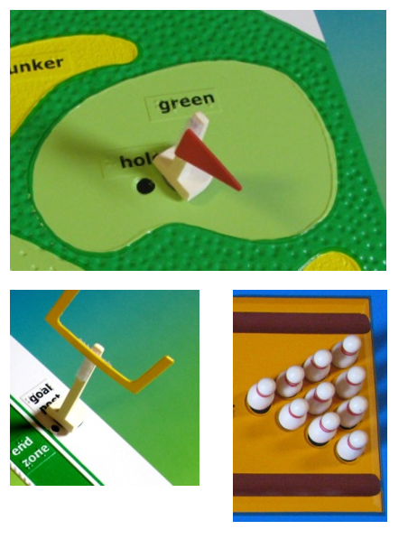

Each prototype was accompanied by an extensive Product Design Evaluation Form, as well as a Student Outcome Form (to be completed for each student involved in the field test activity). Summer camps were asked to return their completed forms by September 1, 2015, and fall-session evaluators were asked to return completed forms by November 20, 2015.

Field test evaluation forms were returned by 18 reviewers representing a variety of professional titles including teacher of the visually impaired, certified orientation and mobility specialist, adaptive physical education teacher, goalball specialist, learning media specialist, youth and family service director, and research assistant/graduate student. Some of the field evaluators requested more time to field test the prototype; extra review time was granted. Multiple evaluation forms were returned from coaches and other specialists using the prototype at Camp Abilities Brockport in New York, but some of their forms were incomplete. As a result, this site was not included in the final evaluator sample (N = 18) for determining average ratings; however, the reviewers’ collective suggestions/comments were recorded throughout the final field test report and taken into consideration. One selected evaluator from Indiana submitted a 2-page summary of her review of the prototype in lieu of a formal evaluation form. Three of the originally selected field test sites from Canada, Minnesota, and Ohio did not return evaluation forms. A final field test report was prepared in April 2016.

The field evaluators (N = 18) represented the states of Alaska, Arizona (2), California, Florida, Georgia, Louisiana, Maine, Massachusetts, Missouri, Nebraska, North Dakota, New York (2), Pennsylvania (2), Texas, and Washington. Table 1 shows the distribution of field test sites according to type of educational setting and geographical location.

Table 1
Type of Educational Setting
Type of Educational Setting | State Location of Field Test Sites | Percentage
Summer/Sports Camp | AK, AZ, NY (2) | 22%
Residential | CA, MA, TX | 17%
Itinerant | FL, GA, ME, MO, ND, NE,  PA (2), WA | 50%
School Based Day School | AZ | 5%
Summer Camp (summer session)/Itinerant (fall session) | LA | 5%

Participating field evaluators varied in their teaching experience with students with visual impairments and blindness. The largest percentage (33%) reported 6-10 years teaching experience, 17% reported 16-20 years teaching experience, and 6% reported 11-15 years teaching experience. The percentage of teachers with fewer than 5 years of teaching experience mirrored the percentage of teachers with more than 21 years of teaching experience—22% within each category.

The majority (72%) of field evaluators indicated that the lack of available instruction time was the most common barrier to students’ involvement and understanding of sports. Other barriers included lack of instructional materials and others’ attitudes regarding the students’ ability and interest.

The evaluators varied in their frequency of teaching sports-related concepts to students with visual impairments and blindness prior to field testing: 39% addressed these concepts “occasionally (once a month),” 33% reported “seldom (2 or 3 times a year),” 11% reported “frequently (2 times a week or more),” 11% reported “never,” and 6% reported “once a week.” They utilized a variety of materials to encourage the students’ participation in sports including beep balls and sound sources, APH products (e.g., 30-Love Tennis, Everybody Plays! How Kids with Visual Impairments Play Sports), and teacher-made tactile boards and models. The majority (72%) of field evaluators indicated having to create teaching tools on their own such as tactile diagrams of baseball fields, tennis courts, and bowling alleys using craft materials (e.g., yarn, glue, tape, puff paint, Wikki Stix®, etc.).

The field evaluators used SPORTS COURTS with a total of 89 students who represented slightly more males (53%) than females (45%); the gender of two students was unreported. The distribution of the student sample across the various types of instructional settings is shown in Figure 8.

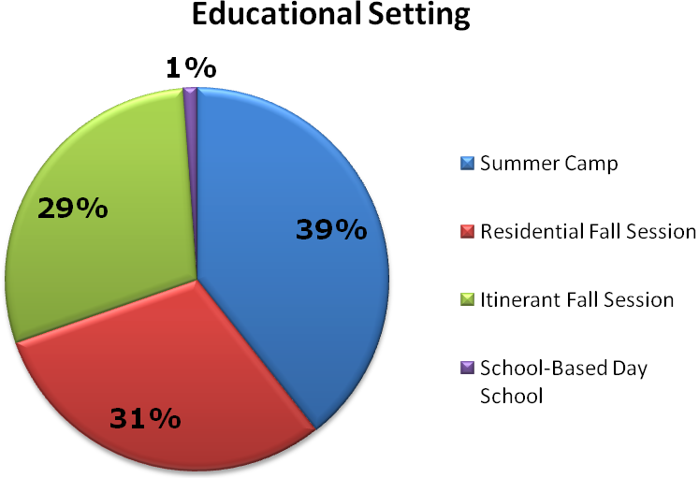
Figure 8. Distribution of Student Sample by Educational Setting

As evident in Figure 9, the student population represented cultural diversity: 39% White, 17% Hispanic, 15% Black, 4% Asian, 3% American Indian, and 4% Two or more races; the ethnicity of 18% of the students was unreported. One-fourth of the students had other disabilities such cerebral palsy, severe or moderate cognitive disabilities, ADHD, autism, and hearing impairment.

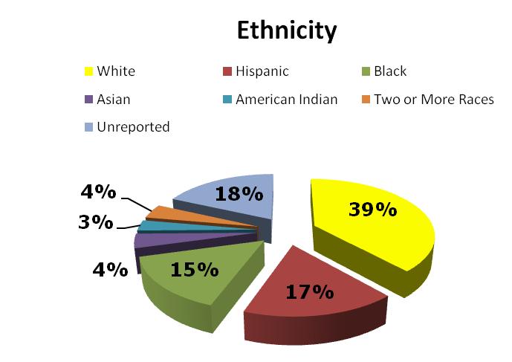
Figure 9. Students’ Ethnicity

Students ranged in age from 6-48 years old. Nearly half (49%) were 14-18 years old, and 34% were 10-13 years old. Identical percentages were either 6-9 years old (8%) or 19-48 years old (8%). The largest percentage (40%) of students were in Grades 9-12, 33% were in Grades 6-8, 8% were in Grades 4-5, 6% were in Grades K-3, and 7% were high school graduates. Grade level was unreported for 6% of students; one adult did not graduate from high school.

As shown in Figure 10, the majority (72%, n = 64) of the students were braille readers. Each remaining classification of primary reading medium was represented by 13% or less of the student sample that included large print readers, auditory readers, dual readers, and regular print readers.

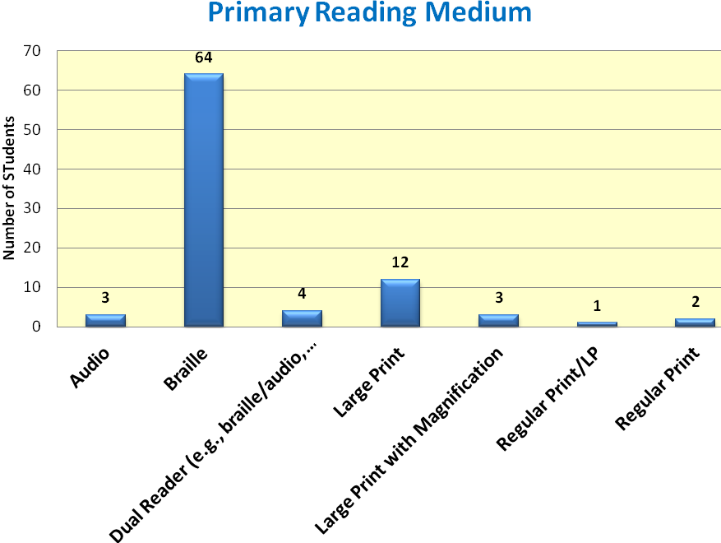
Figure 10. Students’ Primary Reading Medium

The field evaluation form allowed teachers to rate each feature of SPORTS COURTS. Table 2 provides the average rating for each product feature.

Table 2
Overall Design of SPORTS COURTS
Rating Scale: 5 = Excellent to 1 = Poor (or Unneeded)
Product Feature | Number of Evaluators | Average Rating | 5 | 4 | 3 | 2 | 1
Overall design/presentation | N = 18 | 4.39 | 50% | 39% | 11%
Overall visual presentation of individual court/field layouts | N = 18 | 4.83 | 89% | 6% | 6%
Overall tactile presentation of individual court/field layouts | N = 18 | 4.78 | 83% | 11% | 6%
Variety/assortment of provided court/field layouts | N =16 | 4.75 | 81% | 13% | 6%
Size of foldable 11 x 17-in. court/field layouts | N = 18 | 4.72 | 78% | 17% | 6%
Use of court/field layout in combination with 3D manipulatives | N = 17 | 4.12 | 47% | 35% | 6% | 6% | 6%
Durability of court/field layouts | N = 18 | 4.44 | 50% | 44% | 6%
Portability/storage style of court/field layouts (i.e., hole-punched and included in binder | N = 18 | 4.67 | 67% | 33%
Separate booklet style of each sport chapter | N = 15 | 4.90 | 87% | 6% (4)  6%  (4.5)
Content sections for each sports chapter | N = 18 | 4.61 | 78% | 11% | 6% | 6%
Binder cover design and sports logos | N = 18 | 4.83 | 89% | 6% | 6%

The field evaluation form also invited the instructors to assess each 3D manipulative. Table 3 provides the average rating for each of these pieces. Evaluators who did not have access to a magnetic board chose not to rate the 3D pieces due to nonuse or gave the 3D part the lowest possible rating.

Table 3
Overall Design of 3D Manipulatives
Rating Scale: 5 = Excellent to 1 = Poor (or Unneeded)
3D Manipulative | Number of Evaluators | Average Rating | 5 | 4 | 3 | 2 | 1
Bowling pins | N = 15 | 4.33 | 60% | 27% | 6% |  | 6%
Red basketball nets | N = 14 | 4.14 | 50% | 29% | 14% |  | 7%
Football U-shaped goals | N = 14 | 4.43 | 71% | 15% | 7% |  | 7%
Tall white goal posts | N = 15 | 4.40 | 67% | 20% | 7% |  | 7%
Short white goal posts | N = 15 | 4.47 | 73% | 13% | 7% |  | 7%
Red 3D players | N = 15 | 4.27 | 67% | 13% | 7% | 7% | 7%
Yellow 3D players | N = 15 | 4.33 | 73% | 7% | 7% | 7% | 7%
X players | N = 14 | 4.57 | 79% | 14% |  |  | 7%
O players | N = 14 | 4.57 | 79% | 14% |  |  | 7%
Red flags | N = 14 | 4.64 | 93% |  |  |  | 7%
Nets in various lengths | N = 15 | 4.60 | 80% | 13% |  |  | 7%

The majority (83%) of evaluators indicated that SPORTS COURTS offered specific advantages over other similar products, homemade or commercially available including the following: “the quality was great,” “much more colorful (for LV students),” “better, more durable Braille than most graphics,” “it was made of a very nice, durable material,” “saved so much time from trying to create diagrams for students,” “consistent and clear lines,” “creative color combinations,” “made the whole court/field accessible,” and “durable—ready to use!” As indicated in Table 4, SPORTS COURTS was assessed by field evaluators as appropriate for a broad range of students and instructors.

Table 4
Appropriate Target Populations
Target Population | Percentage of evaluators (N = 17) indicating appropriateness of product for target population
Tactile readers in Grades 4-6 | 88%
Low vision students in Grades 4-6 | 88%
Tactile readers in Grades 7-8 | 94%
Low vision students in Grades 7-8 | 88%
Tactile readers in high school | 88%
Low vision students in high school | 88%
Adult tactile readers | 76%
Adults with low vision | 76%
Students with additional physical disabilities | 59%
Students with cognitive disabilities | 64%
Students with deafblindness | 76%
Sighted peers | 82%
Teachers of the Visually Impaired | 88%
Orientation and Mobility Specialists | 94%
Adaptive Physical Education Teachers | 94%
Parents of students with visual impairments | 82%

On April 26, 2016, the project leader conducted a meeting with the PDC team. Anticipated revisions to product were reviewed, as well as expected production processes. Notable structural improvements to the product based on field test results were the following:
- Inclusion of a ready-to-use magnetic board
- Provision of extra 3D parts (e.g., bowling pins) in case pieces are lost
- Design of more realistic sports figurines (instead of the gingerbread man version)
- Updates to the tactile courts and fields as related to label placement, additional labels, color assignments, and tactile enhancements. The number of changes varied from layout to layout and were, for the most part, minimal.
- Elimination of folding of sports layouts to address concern about long-term durability of hinge material
- Strengthening of 3D parts (e.g., basketball goals) prone to breaking
- Revision of product name—omission of subtitle “Touch and Play”
- Added court layout: Ice Hockey
- Tabs for sports chapters housed in binder

On May 31, 2016, the project leader conducted a follow-up meeting to address continuing concerns about amount of product assembly expected of the customer. A compromise was reached to have in-house production staff apply all magnetic backing to needed parts and the customer apply VELCRO® brand strips or tabs to the remaining parts.

In July 2016, the project leader and Tom Poppe reviewed needed revisions to each sport layout. Tooling of the 2-up vacuum-form pattern for Basketball and Track and Field was undertaken first. The transition from silkscreen art (as used for the prototype) to the Roland® printing process (as expected for final production) required testing and reselection of colors based on the UV printer’s ink palette. Registration of the print and tactile artwork is critical.

Field evaluators’ location of some inconsistencies and errors in the sports chapters regarding game rules, strategies, and so forth led the project leader to request additional review by APH staff who coached, played, or were avid fans of a sport(s). Approximately 20 APH staff representing various in-house departments “stepped up to the plate” to offer their expertise on many of the chapters. Their feedback proved invaluable to the accuracy of the content. By the end of summer, the graphic designer initiated work on the layout design of the sports chapters.

Work during FY 2017
Although work on SPORTS COURTS continued at a steady pace throughout the fiscal year, the loss of critical staff and the reassignment of priority to other research projects significantly impacted momentum. Conversion of scanned silkscreen art to digitized files also contributed to a lengthened project timeline. Project milestones and notable tasks accomplished throughout the fiscal year encompassed the following:

October 2016
- SPORTS COURTS was presented to the Educational Products and Advisory Committee at the Annual Meeting; Quota approval was received.
- Prior to his retirement from APH in mid-October, Tom Poppe acquainted Technical Research and Model Shop staff with the existing production tooling for generating the print/tactile sports layouts and related parts (e.g., bowling pins, goal posts). Andrew Dakin was assigned as the primary model/pattern maker.

November 2016
- Andrew Moulton scanned images of the 2-up silkscreen art of the BASKETBALL and TRACK AND FIELD layouts used for field testing. Matthew Poppe then prepared a digital file, which will be used to print the full-color layouts on vinyl via the Roland® UV printer. He also prepared the digital file layout for the Bowling Pin Setup and the braille transparency for reference during the fabrication of the vacuum-form pattern.

December 2016
- The project leader scheduled biweekly Working Meetings with staff from all departments—Research, Model Shop, Technical Research, Graphic Design, and Production—in an attempt to keep steady progress on the product and allow team members to share updates and plan next steps.

January 2017
- Working Meetings were conducted on January 5 and 19.
- Rachel White and the project leader incorporated final edits into the BASKETBALL chapter based on field-test feedback and in-house staff reviews.

February 2017
- Joon Lee verified copyright clearance for the use of the final product title, SPORTS COURTS. The subtitle, Touch and Play, was omitted.
- Working Meetings were conducted on February 2 and 23.
- Patrick White joined the project team and initiated work on the fiberglass vacuum-form pattern for the Bowling Pin Setup using a Roland® UV printer master.
- A catalog number was assigned to the Large Magnetic Dry-Erase Board (1-03557-00) that will be included with SPORTS COURTS, as well as sold as a separate product.
- The final content was reviewed and approved by the project consultants.
- The graphic designer prepared the final layout and design of the print version of the BASKETBALL chapter and incorporated silhouette images of players.
- Joon Lee furnished proper trademark attributions for this chapter, as well as for all sports chapters addressed throughout the year.
- The project leader prepared the clean file of the BASKETBALL chapter for eventual braille translation and HTML conversion.

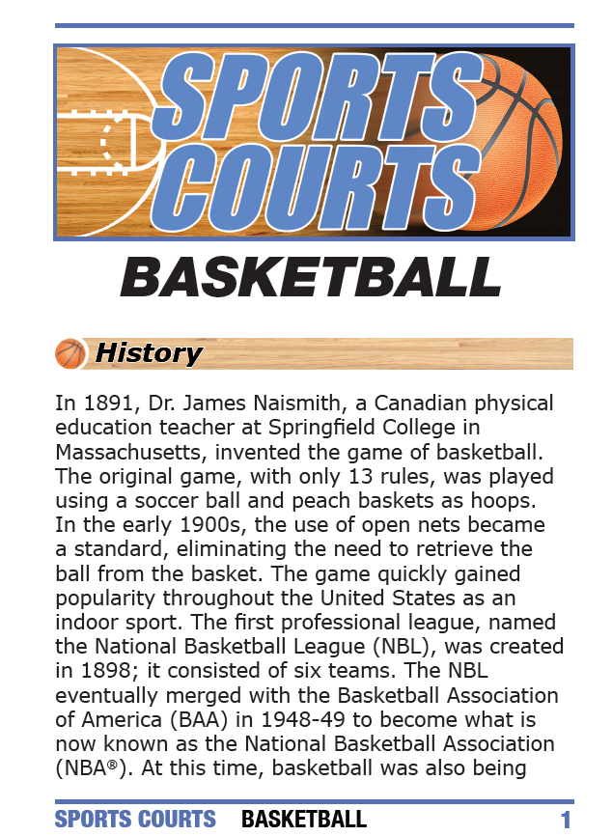

March 2017
- Working Meetings were conducted on March 9 and March 27.
- Rachel White and the project leader incorporated final edits to the TRACK AND FIELD chapter. Consultants reviewed and approved the final chapter content.
- The graphic designer prepared the print layout and design of TRACK and FIELD.
- Andrew Moulton provided scanned images of the 2-up silkscreen art of the FOOTBALL and LACROSSE layouts for digital file conversion.

April 2017
- Working Meetings were conducted on April 5 and April 24.
- Rachel White and the project leader made final edits to the FOOTBALL chapter; final content was approved by the consultants prior to layout and design.
- Patrick White enhanced the design of 3D figurines to be tactually discriminated by base shape, arm position, shirt texture, and/or color. The same figurine styles will be used in Room with a View (see separate annual report).
- Andrew Moulton worked on the product specifications for the Large Magnetic Dry-Erase Board.
- Matthew Poppe prepared the digital file for the FOOTBALL and LACROSSE layouts, as well as the transparency layer for the braille/tactile counterpart.
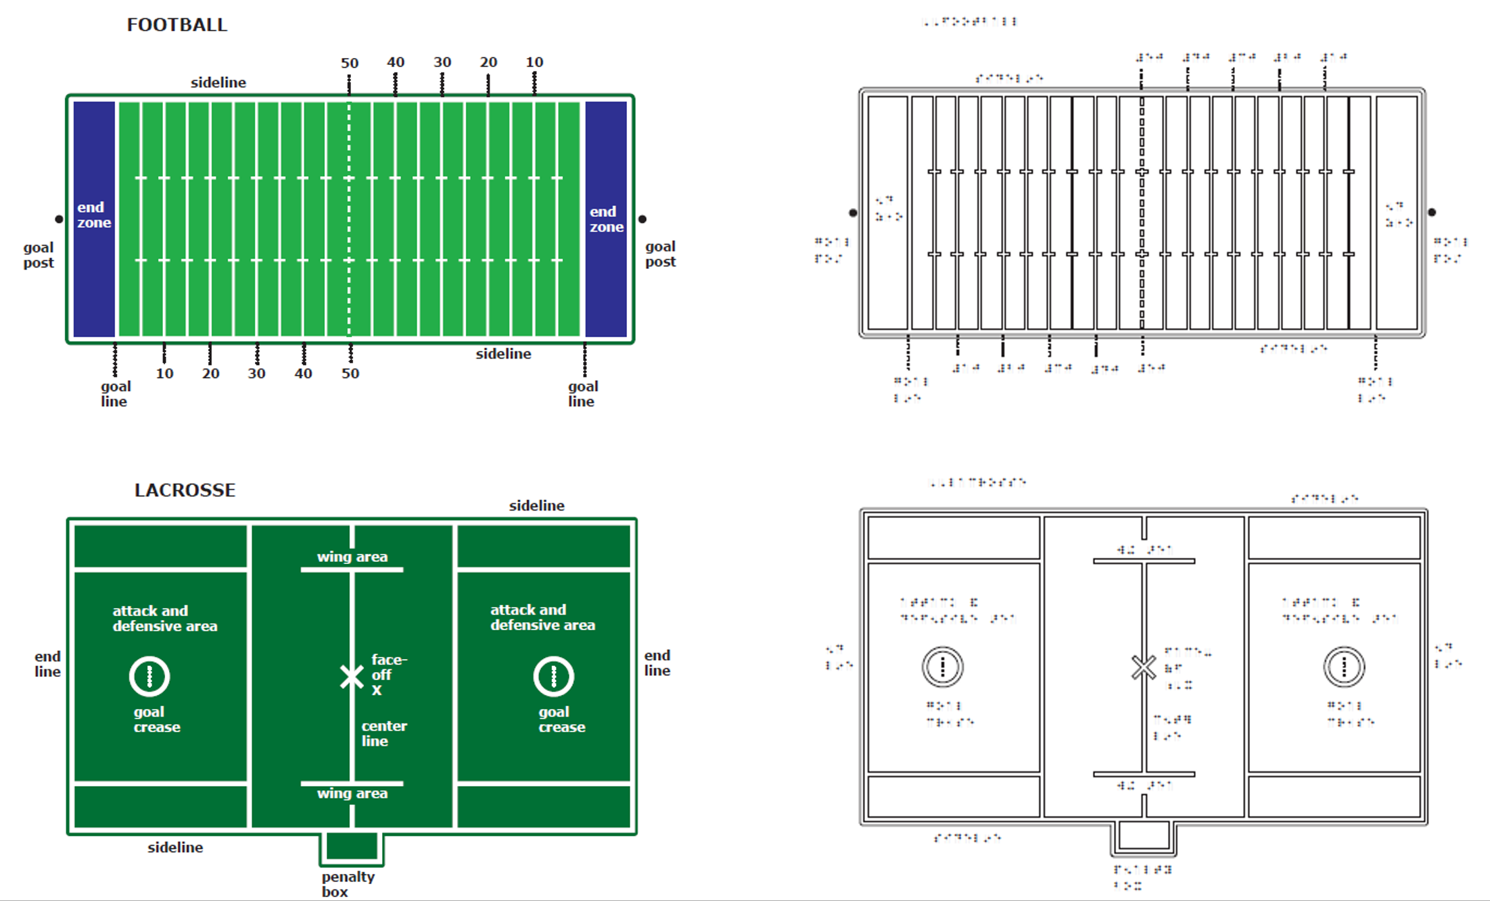

May 2017
- A Working Meeting was conducted on May 19.
- The layout and design of the FOOTBALL chapter was initiated.
- The project leader created the clean file for the TRACK AND FIELD chapter.
- Rachel White initiated edits to the LACROSSE chapter.
June 2017
- Layout and design of the FOOTBALL chapter was finalized.
- Edits were made to the BOWLING chapter.
- The layout/design of the BOWLING chapter was initiated.
- The ideal binder size was chosen for the final product.
- The product specifications meeting was conducted for the Large Magnetic Dry-Erase Board.

July 2017
- The layout/design of the BOWLING chapter was completed.
- Edits were made to the SWIMMING chapter and shared with consultants for approval.
- The layout/design of the SWIMMING chapter was initiated.
- Rachel White edited the TENNIS chapter.
- Andrew Dakin initiated final construction of the FOOTBALL and LACROSSE vacuum-form master.

August 2017
- Working Meetings were conducted August 4 and 18.
- The layout/design of the SWIMMING chapter was completed.
- The TENNIS chapter was approved by the consultants.
- The layout/design of the TENNIS chapter was initiated and completed.
- Andrew Dakin completed final tooling of the FOOTBALL and LACROSSE layouts.
- Rachel White and the project leader made edits to the BADMINTON chapter.
- The final layout/design of the BADMINTON chapter was completed.

September 2017
- Working Meetings were conducted September 1, 15, and 29.
- Andrew Dakin completed final tooling preparation of the FOOTBALL and LACROSSE layouts and tested registration of the printed and vacuum-formed parts.
- Scans were made of all remaining sports layouts for digital file preparation.
- Edits were made to the VOLLEYBALL chapter.

Despite monthly progress throughout the fiscal year, significant tooling was still needed for actual production of SPORTS COURTS.

Work planned for FY 2018
Project staff will usher the project through the remaining goals of documentation completion, tooling construction, and specifications for eventual production. Due to the complexity of the product’s design and number of related components, as well as reassigned priority on other research projects/products, final product availability of SPORTS COURTS is unlikely to occur until FY 2019.

READING AND LANGUAGE ARTS

Early Braille Trade Books
(Continued)

Purpose
To provide emergent and beginning braille readers with a wide selection of small books that provide practice and reinforcement of early reading skills and aid in the development of reading fluency

Project Staff
Jeanette Wicker, Project Leader (Core Curriculum Consultant)
Cay Holbrook, Project Consultant
Anna Swenson, Project Consultant
Frank Hayden, Director of Technical & Manufacturing Research
Anthony D. Jones, Art Production/Design Manager
Michael McDonald, Programmer
Andrew Moulton, Manager of Technical & Manufacturing Research
Rachel White, Research Assistant

Background
The need for Early Braille Trade Books (EBT) was identified by the Early Literacy Focus Group conducted by Suzette Wright in the summer of 2005. These small books for emergent readers are used in classrooms to support the reading curriculum and are available from several publishers. In the winter of 2006, APH conducted a reading survey to determine the types and series of leveled reading materials used by teachers of the blind and visually impaired.

Using information gained from the 2005 Early Literacy Focus Group and the customer surveys, the Wright Group Books were chosen for the first project. Cay Holbrook, Associate Professor at the University of British Columbia, agreed to serve as the consultant for this project. In July 2007, Holbrook along with five of the original members from the Early Literacy Focus Group of 2005 met in Louisville, KY, to review and select books to be included in the kits.

Members of the work group included the following:
- Anthony, Tanni, State Consultant on Visual Impairment, Colorado Department of Education, Denver, CO
- Brasher, Jeanie, Teacher, Kentucky School for the Blind, Louisville, KY
- D’Andrea, Frances Mary, Doctoral Student at the University of Pittsburgh, Pittsburgh, PA
- Hassman, Dotta, Retired, Instructional Materials Center, Iowa Braille School, Vinton, IA
- Swenson, Anna, Teacher of Students with Visual Impairments, Fairfax Co. Public Schools, Dunn Loring, VA

The group developed a rubric based on the work of Holbrook for selection of the books. They also reviewed 90 books from the Wright Group Sunshine Kits and determined the type of information about the book to include for the teacher. Hassman agreed to serve as a consultant to complete a text analysis of each book. One set of 13 books was selected for the development of an initial prototype to be used in field testing and review.

In FY 2008, the prototype of a kit of commercially-available leveled books adapted for braille readers was completed. The initial design of the prototype included a commercially-available book with braille overlays and a guide for the teacher. The teacher’s guide would include the number and frequency of the braille contractions in the book, punctuation marks, and composition signs, as well as the theme of the book with connections to the core curriculum and expanded core curriculum.

In the development of the prototype for field evaluation, the format for the teacher’s guide changed from a print document to a website hosted by APH. The EBT Web site allows the teacher to continually update the student record and access records of books. Anna Swenson became a consultant for the project and wrote the follow-up activities for each book.

The prototypes, including the website, were field tested from September 2008 to March 2009 at 15 sites with 22 different students. The evaluations were positive, and teachers unanimously recommended that APH produce the book with braille label sets and make the website available to customers. Changes and modifications were made to the materials and the website based on reviewers’ feedback.

A work session with the original six members was held in the spring of 2009. Additional books were reviewed, and three new sets were chosen to add to the series. The first set of Books, Sunshine Kit 2, became available for sale in 2009.

In FY 2010, the second set of books, Sunshine Kit 1, became available for sale in November. A total of 26 books were now available to teachers and emerging braille readers. Work began on two sets of nonfiction books at the first grade level. Books were analyzed for contraction type and count. Information on each book as well as activities to use with each of the books was added to the EBT Web site. A specification meeting for the two sets of nonfiction books, TWiG 1 and TWiG 2, was held in September 2010. The EBT Web site was updated to include a connection to the Patterns Reading Series from APH. As a teacher prepares for a lesson in Patterns, he/she may search the EBT Web site for commercially-available books in braille to supplement the new lesson.

In FY 2011, the first set of nonfiction books from Wright Group, TWiG 1, became available for sale in January and TWiG 2 became available for sale in February 2011. With the addition of the two new sets, a total of 46 books became available to emerging braille readers.

The committee selected Rigby Publishing for the next two sets of books. The committee met in June 2011 and reviewed books; they selected 15 fiction books and 14 nonfiction books to add to the EBT collection. Books were analyzed for contraction type and count. Titles were added to the website and the books prepared for braille translation.

Two new sets of books from Rigby were made available for sale in May 2012 adding 29 new titles to the collection. The website was updated to include the two new sets of books including a link to Books to Use with Building on Patterns. Seventy-five books at the first grade level are now available for TVIs to use with emerging braille readers.

In FY 2013, three books from the various collections went out of print. Project staff reviewed other books from various publishers to replace these books. Books were selected, and modifications to the kits and the website were completed.

In FY 2014, project staff continued to monitor the existing kits for books going out of print. The website was updated to include the Developmental Reading Assessment® (DRA) level of each existing book. The Wright Group, the publisher of four sets of books, was purchased by another publisher; a decision was made by the new publisher to eliminate the Sunshine and TWiG series.

With the implementation of UEB and with the loss of the Wright Group Books, a new grouping system of the existing books was developed. Each set would now contain five or six books based on the leveling system used by Fountas & Pinnell and DRA. All existing Rigby books will be retranslated into UEB. The existing website will be retained to support books already in the field. A new link will be established for the books translated into UEB.

New sets of Rigby books were ordered for review. In May 2015, Swenson, Brasher, Susan Spicknall, and Dawn Wilkinson met with the project leader to review a selection of books. Thirty-three new books were selected to add to the existing 30 books for a total of 63 books. There will seven fiction sets and six nonfiction sets for braille readers in late kindergarten through first grade.

In FY 2016, revisions to the EBT Web site began. The website will still support the older books in EBAE but will also introduce the new books in UEB. A conversion software was developed for the website that will allow a teacher to move the contractions learned in EBAE to UEB without the laborious task of reentering all of the contractions by hand.

Work during FY 2017
The first three sets of books were transcribed and files placed on the production server. Graphic design developed new box labels for the first three sets of books. A specification meeting was held, and production was scheduled for June 2017.

Work planned for FY 2018
Work will begin on the first three sets of nonfiction books.

Expanded Dolch Word Cards [Modernization]
(Continued)

Purpose
To modernize an existing product to reflect the change in the braille code from English Braille American Edition to Unified English Braille (UEB)

Project Staff
Martin Monson, Project Leader
Frank Hayden, Director of Technical & Manufacturing Research
Andrew Moulton, Manager of Technical & Manufacturing Research
Anthony D. Jones, Art Production/Design Manager
Mathew Poppe, Tactile Graphics Designer
Jeremiah Rose, Research Assistant
Jonathan Carson, Braille Transcriptionist

Background
The original flashcards, consisting of 220 sight vocabulary words and 95 words with pictures, can be used for reading practice or an informal assessment of a student's ability to read words in contracted braille and to spell words in uncontracted braille.

Cards measure 3 1/2 x 2 inches with an orientation corner cut and an orientation braille line. Words are shown in contracted braille on one side and uncontracted braille on the other, with large print on both sides. Words on the contracted braille side will be converted to use contractions consistent with UEB. Also included will be blank cards for adding words, tabbed indexing cards, and a box for storage.

Work during FY 2017
Input from the Building On Patterns consultant group was gathered in relation to the black-line pictures on 95 of the cards. The pictures were an attempt to represent the braille word on the card. The group consensus was to discontinue the use of the black-line pictures. Braille and print files were made of the cards. Braille plates were made, and a pilot sample was run. Because of how the cards are imprinted and cut, some of the dots in the orientation line were being crushed. The orientation line was reconfigured in the software files. At the writing of this report, new plates are being made.

Work planned for FY 2018
Once the new plates are constructed, a pilot run of the cards will be conducted by Production. The cards will be examined for errors by the project leader. The cards should be available for purchase in FY 2018.

Wilson Reading System
(Continued)

Purpose
To provide a remedial reading program for students with visual impairments

Project Staff
Jeanette Wicker, Project Leader (Core Curriculum Consultant)
Cheryl Kamei Hannan, Project Consultant
Mary McCarthy, Project Consultant
Justine Carlone Rines, Project Consultant
Rosalind Rowley, Project Consultant
Rod Dixon, Manufacturing Specialist
Frank Hayden, Director of Technical & Manufacturing Research
Anthony D. Jones, Art Production/Design Manager
Andrew Moulton, Manager of Technical & Manufacturing Research

Background
The Wilson Reading Program, with its well-developed multi-sensory approach, is one of the most respected programs used to teach reading in the United States. This program has been used to teach reading to students with visual impairments who experience reading difficulties, but the program is not available for sale in large print or braille. Teachers working with students at Perkins School for the Blind, Arizona School for the Blind, and North Carolina Schools for the Blind have reported good results.

The project was approved by the Product Evaluation Team and the Product Advisory and Review Committee in July 2006. Three teachers from Perkins School for the Blind, Justine Rines, Mary McCarthy, and Roz Rowley, were contracted as consultants for the project. A contractual agreement was reached with the Wilson Reading Systems to produce the materials in braille and large print.

As there are many components to the system, it was decided to produce the Readers Levels 1, 2, and 3 in braille as quickly as possible since the readers required no modification.

The Student Readers 1, 2, and 3 became available for sale in braille in February 2008. The consultant from Perkins developed supplemental worksheets that reinforce braille skills and knowledge of braille contractions.

The first three readers and the first six workbooks were reformatted for large type editions. The Readers and Workbooks became available in October 2009.

In FY 2009, prototypes of the first six workbooks were translated and the supplemental worksheets were revised and translated for use in field testing. A set of six modified workbooks was developed and translated for field evaluation. Work started on the prototypes of the Print/Braille Word Cards, Syllable Cards, Sound Cards, and Magnetic Tiles to be used in field testing.

In FY 2010, prototypes of the remaining components of the Wilson Reading System were completed. A call for field evaluators was sent to Ex Officio Trustees in May 2010 and also appeared in the June and July APH News. A 3-day Web Training was held on August 30, 31, and September 1. The three consultants from Perkins (Rowley, McCarthy, and Rines) with the trainer from Wilson provided training to 30 participants on the use of the Wilson Reading System and the modified and adapted braille materials. Dr. Cheryl Hannan trained teachers in the use of data collection tools that would be used to evaluate the effectiveness of these braille materials.

In 2011, field evaluators were recruited from the 30 participants in the Web-based training. Participants were to use the materials daily with their students to determine the effectiveness of the modified/adapted Wilson Reading System. Students were given a pretest, a posttest, and completed weekly DIBLES assessments. The yearlong evaluation of the modified/adapted Wilson Reading materials was completed in May 2011.

In FY 2012, Hannan, Dr. Jane Erin, and two graduate assistants completed the disaggregation of the data from the field evaluation and presented the results at the Getting in Touch with Literacy Conference in Louisville and the National Council for Exceptional Children Conference in Colorado. The data showed positive results and reading gains for braille readers using the Wilson Reading System.

Information from the field evaluation and the expert review were used to begin the revisions and modifications to the many prototypes of the components of the Wilson Reading System. In December 2011, the project leader and the three consultants from Perkins traveled to meet with Ed Wilson and staff at the Massachusetts office. The prototypes as well as the planned changes and information from the field testing were shared with Wilson Staff. Representatives from Wilson reviewed the materials and in March made suggested changes and approved the work. The project leader, the Perkins staff, and APH staff began revisions of prototypes.

In FY 2013, project staff completed the revisions to the readers, workbooks, modified workbooks, supplemental worksheets, letter tiles, and word cards. Revisions were sent to Wilson Reading for approval in November 2012. A final request for revisions and approvals was received from Wilson Reading in March 2013. Project staff implemented these revisions to all print and braille files. Specifications for production were partially completed.

In FY 2014, project staff completed the written specifications and a product specification meeting was held in February. A production schedule was developed for the remaining pieces. The Wilson Card Sets and the Wilson Letter Tiles with Magnetic Journal became available in July 2014. The production schedule of the Wilson Student Braille Kits was staggered. Braille Student Kit Step 1 was scheduled for August 2014, Braille Student Kit Step 2 was scheduled for September 2014, and Braille Student Kit Step 3 was scheduled for October 2013. All items will be available on Quota.

In October 2015, both the Wilson Reading System Braille Student Kit 2 and Wilson Reading System Braille Student Kit 3 became available for sale. Project staff continued to update files of existing products as changes, and revisions were made by Wilson Reading System.

In FY 2016, the conversion to UEB for the braille readers, workbooks, cards, and the WADE began. The Wilson Card Sets were reviewed, and cards were identified for revision. The cards are produced on sheets, and thus several sheets were identified for revision. Production files were requested and received for revision of the Braille Kits 1, 2, & 3.

Work during FY 2017
Plans for the conversion to UEB were placed on hold when the contract with Wilson Reading to produce the materials in Large Print and Braille expired. A contract was signed with Wilson Reading System in July 2017.

Work planned for FY 2018
Work will resume on the conversion of the Wilson materials into UEB.

SCIENCE

Adapted Biology Lab Manual (ABLM)
(New)
Purpose
To provide high school and college instructors with 12 biology laboratory protocols adapted for students with vision impairments including blindness

Project Staff
Rosanne Hoffmann, STEM Project Leader
Frank Hayden, Director of Technical & Manufacturing Research
Erica Martin, Consultant
Whitney Davidson, Consultant

Background
Dr. Erika Martin teaches biology laboratory courses at Emporia State University in Kansas. After making accommodations for several students with visual impairment, she was surprised to learn that there are no published introductory biology laboratory activities with adaptations for students with vision impairment available to instructors. This product aims to change this fact. Martin submitted a New Product Idea form to APH in August 2016. The Adapted Biology Lab Manual (ABLM) consists of 12 modules typical of and appropriate for high school and college introductory biology courses. Martin works in collaboration with Whitney Davidson, a disabilities specialist at the Lillie Jackson Early Childhood Center (Lewisville, TX). The laboratory activities are designed for students with low vision, complete blindness, or typical vision and include an introduction with vocabulary terms (also listed in a separate glossary), hands-on activities (what is actually “done” in the lab), and a teacher’s protocol that includes instructions on how to set up each activity for students who are sighted and non-sighted. Sections intended to be read by students with visual impairments will be made available in large print, embossed braille, and as a BRF file accessed via e-reader. Each module is expected to be approximately 25 print pages and 12 embossed pages, but the length will vary according to the topic and included activities. Some modules might also include established APH products, for example, the 4-box and 16-box Tactile Punnett Squares sheets and bold/tactile line graph paper.

ABLM was reviewed by the project leader in September 2016, presented to the Product Evaluation Team in January 2017, and to the Product Advisory and Review Committee in February 2017. A Product Development Committee meeting was held at the end of January 2017 in order to discuss future production elements. After the details of consultant contracts were worked out, ABLM entered the formal product development pipeline in March 2017.

Work during FY 2017
The project leader received the first two modules of adapted biology laboratory exercises in April 2017 and provided the consultants with comments and suggestions in May. The consultants completed all 12 modules by September 2017, and the project leader began the review and editing process. Throughout the fall, the project leader worked on preparing the 12 adapted laboratory modules for field testing.

Work planned for FY 2018
In the fall of 2017, a geographically diverse set of field testers will be solicited via call out in the APH News. The project leader will write evaluation instruments to collect demographic information and prototype evaluations using Google Drive™ forms. Field testing of the 12 modules will take place from January through May 2018. Suggested changes to the modules will be considered when editing the modules for final publication. Each module will be prepared by the graphic artists at APH. Appropriate sections of each module will be transcribed to braille at APH and prepared as accessible BRF and e-reader files.

Adapted Science Materials Kit (ASMK)
(Continued)

Purpose
To provide a set of science tools adapted for use by K-12 students who are blind or visually impaired, allowing them to participate in science activities alongside their sighted peers

Project Staff
Rosanne Hoffmann, STEM Project Leader
Frank Hayden, Director of Technical & Manufacturing Research
Katherine Corcoran, Model Maker
Patrick White, Model Maker
Laura Greenwell, Graphic Design
Rod Dixon, Manufacturing Specialist
Marshall Montgomery, Consultant
Linda De Lucchi, Consultant

Background
The Adapted Science Materials Kit (ASMK) consists, in part, of science measurement tools originally devised by educators at the Lawrence Hall of Science (LHS in Berkeley, CA) and Delta Education® (Nashua, NH) in the mid-1970s. Funded by the U.S. Department of Education, these tools and a set of corresponding curriculum modules constitute the SAVI (Science Activities for the Visually Impaired) program that was field tested by LHS from 1976-1979. These educational materials have been available from LHS and used with the SAVI, SELPH (Science Enrichment for Learners with Physical Handicaps), and FOSS (Full Option Science System) programs until recently. LHS stopped producing these measurement tools, which was brought to the attention of APH by TVIs. APH intends to kit many of these time-tested science measurement tools into one product along with other adaptive measurement aids, thus making them available again to the community of students with visual impairments and TVIs.

ASMK consists of the following items: 1) Balance; 2) set of 100 one-gram pieces; 3) set of 35 mass pieces (5, 10, and 20 grams); 4) 100-milliliter (ml) modified Tri-Pour® beaker; 5) 1000-ml modified Tri-Pour® beaker; 6) two 50-ml graduated cylinders with braille float scales; 7) two 100-ml graduated cylinders with braille float scales; 8) large print braille tactile meter tape; 9) 50-ml syringe with stop; 10) large print tactile histogram board with round stickers; 11) funnel stand; 12) two tray inserts of the APH Multi-Section Tray (with adhesive backed non-slip rubber pads); 13) talking Fahrenheit/Celsius thermometer; 14) laminated instruction card; and 15) a large bag to hold all items.

Most of the items in ASMK are available from Delta Education® and have been field tested and used successfully by students with visual impairments and TVIs for more than three decades. These include the balance, set of 100 one-gram pieces (a small parts caution statement in print and braille will be adhered to the bag holding this set), set of 35 mass pieces (including 5, 10, and 20-gram masses), 100-ml Tri-Pour® beaker, 1000-ml Tri-Pour® beaker, 50-ml graduated cylinder, 100-ml graduated cylinder, 50-ml syringe with stop, and the funnel stand. The original 35-piece mass set from Delta Education® was discontinued and replaced by a set imported by Delta Education®, LLC, from another vendor. The replacement item complies with CPSIA (Consumer Product Safety Improvement Act) standards for lead. All other items obtained from Delta Education® are made in the USA.

Other items included in the kit are established APH products: The talking Fahrenheit and Celsius thermometer from ThermoWorks, Inc., is available for separate purchase in the APH catalog. Two inserts of the APH Multi-Section Tray replace the sorting tray originally made for LHS by Montgomery.

The large print tactile histogram board will be custom made at APH. The 100-ml and 1000-ml Tri-Pour® beakers will be modified at APH by punching a hole at the 100-ml measurement line and the 1000-ml measurement line, respectively. These items will replicate the same items from the original SAVI program kits sold by LHS.
Although Montgomery produced acceptable samples of 50-ml and 100-ml braille floats, due to equipment, pattern, and materials problems he was unable to make an acceptable sample of the large print braille tactile meter tape. It was also brought to our attention that Montgomery was unable to fill orders for APH due to obligations to other institutions. Consequently, APH is responsible for producing the large print braille tactile meter tape and tactile braille floats for the 50- and 100-ml cylinders in addition to the other items already mentioned. Acceptable samples of the meter tape and tactile and braille scales for the floats were produced in-house on the Roland® Large Format Printer, finalizing the method for their full scale production. These items will replicate the same items from the original SAVI program kits sold by LHS.
The 50-ml and 100-ml graduated cylinder braille float scales will be custom made at APH. Before the end of FY 2016, it was assumed APH could produce the large print braille meter tape. Appropriate materials for manufacture of the large print braille meter tape and the 50-ml and 100-ml cylinder braille float scales were identified.
ASMK will be produced without additional field testing.
Work during FY 2017
Tooling for all APH-modified or produced elements of this product was completed. Due to production limitations at APH, the large print braille tactile meter tape will be printed in-house on the Roland® Large Format Printer and sub-contracted out-of-house for die cutting. Katherine Corcoran built a device to modify the plastic Tri-Pour® beakers in-house, and created the pattern and mold needed to thermoform the histogram board. Patrick White built a device to assemble the floats for the graduated cylinder braille float scales. The project leader worked with Laura Greenwell to create an information card with text and photographs describing all elements of the product. The information card will be printed in-house and laminated out-of-house. The APH Innovations Tote bag was selected as a carry case to contain all items included with the product.

A specifications meeting was held on July 12, 2017, during which production details were discussed and planned.

Work planned for FY 2018
The product is ready for production. A pilot run of 60 units is scheduled for January 2018 and release of the product for sale is scheduled for April 2018.

The project leader will prepare short video describing the use of each item included in the kit; these videos will be posted on the APH YouTube™ channel when the product is released for sale.

Azer’s Interactive Periodic Table Study Set
(Modernization)

Purpose
To modernize Azer’s Interactive Periodic Table Study Set (APH Catalog No. 1-08856-00) with the incorporation of recently-discovered elements according to the International Union of Pure and Applied Chemistry (IUPAC) as well as offer both Nemeth and Unified English Braille (UEB) versions of the kit

Project Staff
Karen J. Poppe, Tactile Literacy Project Leader

Background
In 2009, APH introduced the Azer’s Interactive Periodic Table Study Set that was co-designed by Samir Azer (originator of product idea) and Karen Poppe, APH’s Tactile Literacy Project Leader. The tangible materials included with this study set complement APH’s Periodic Table of Elements Reference Chart (see separate annual report) and allow students to enhance their understanding of concepts aligned with the Next Generation Science Standards (NGSS). This product assists in the instruction and demonstration of concepts related to the arrangement of the periodic table, atomic structure, ionic and covalent bonding, and balancing of chemical equations to students who benefit from hands-on interactive models. The product was carefully designed to ensure tactual discriminability and visual appeal/contrast for the intended target population, yet it is useful for all students in inclusive educational settings. Based on original field test results, the ideal target populations for this product are tactile and low vision readers in secondary grades; 75% of the field evaluators extended suitability to those in Grades 6-8, and 88% rated the product as appropriate for sighted peers as well.

The sales history of the Azer’s Interactive Periodic Table Study Set over the past 3 fiscal years has revealed fluctuating demand; 114 kits purchased in FY 2014, 58 kits purchased in FY 2015, and 89 kits purchased in FY 2016. As of July 2017, 35 kits have been sold.

Work during FY 2017
The modernization of Azer’s Interactive Periodic Table Study Set is critical so that students with visual impairments and blindness have access to the same STEM-learning experiences and information as their sighted peers. The updates planned for this kit will ensure incorporation of formally-named elements reported by the IUPAC (refer to https://iupac.org/iupac-announces-the-names-of-the-elements-113-115-117-and-118/).
Within APH’s current kit, elements 112-118 are named with previously-assigned atomic symbols Uub, Uut, Uuq, UUp, Uuh, Uus, and Uuo; these elements are officially identified by IUPAC as copernicium (Cn), nihonium (Nh), flerovium (Fl), moscovium (Mc), livermorium (Lv), tennessine (Ts), and oganesson (Og). Refer to https://www.iupac.org/cms/wp-content/uploads/2015/07/IUPAC_Periodic_Table-28Nov16.jpg for the 2016 IUPAC version of the table.

In February 2017, the project leader prepared a formal Product Modernization Form that detailed the expected updates to the Azer’s Interactive Periodic Table Study Set, including the provision of both Nemeth and UEB versions to comply with recent shifts and adoptions of the UEB code by some states and/or state districts. In April 2017, the modernization proposal was presented to the Product Evaluation Team, and in May 2017, it was presented to the Product Advisory and Review Committee. Both committees supported the product endeavor. The project was assigned Grant #682.

Work tasks undertaken by the project leader during the latter part of the fiscal year included the following:
- Ordered and reviewed the current product to specify needed updates
- Determined priority of the redesign to the current kit and the new UEB version based on consequential impact on other APH departments and existing production tooling. In-house staff supported the decision to focus initially on the updates to the original kit.
- Conducted the first Product Development Committee meeting to review the purpose and expected redesign of the product
- Initiated edits to content to the accompanying Instruction Booklet

Work planned for FY 2018
The project leader will work with the assigned graphic designer, manufacturing specialist, model maker, and Production staff to incorporate needed updates to the Azer’s Interactive Periodic Table Study Set in the most expedient fashion and will initiate work on the UEB counterpart as soon as possible.

Build-A-Cell
(Continued)

Purpose
To provide an interactive set of biology manipulatives, accessible to students who are blind and with low vision, that allows them to construct models of plant, animal, and bacterial cells

Project Staff
Rosanne Hoffmann, STEM Project Leader
Frank Hayden Director of Technical & Manufacturing Research
Andrew Dakin, Model Maker
Andrew Moulton, Manager of Technical & Manufacturing Research
Rachel White, Research Assistant

Background
Requests for a product similar in design to the DNA-RNA Kit for cell structure have been noted at gatherings of TVIs and other professionals, such as the Meeting of the Minds at APH in 2014 and the Unity Conference at the Tennessee School for the Blind (2013). This product will fulfill these requests and align with the Next Generation Science Standards. The product will consist of full color, tactile outlines or templates of three types of cells (plant, animal, and bacterial) printed and thermoformed on separate 8.5 by 11-inch plastic sheets. These sheets will be three-hole punched to fit in a binder. The center part of the cell outlines will be covered with headliner material that sticks to hook material. The product will also include at least three each of full color, tactile organelles including mitochondria, chloroplasts, nuclei, smooth endoplasmic reticulum, rough endoplasmic reticulum, lysosomes, peroxisomes, vacuoles, cytoskeletal fibers, centrosomes, polysomes, ribosomes, and Golgi bodies. The organelles will be identifiable by their color and shape as well as a single braille letter that will refer to a key. The details of the organelles will be printed in color and thermoformed on plastic, mounted on 1/8-inch thick foam, and then die-cut into appropriate shapes. Hook adhesive dots will be attached to the underside of each organelle. Students can demonstrate their knowledge of plant, animal, and bacterial cell structure by selecting the appropriate organelles for a particular cell template and adhering them to the headliner material background of each cell type. A guidebook with instructions for use will be included in the kit.

The project leader met with Andrew Dakin in early spring 2015 to brainstorm on the original design of the product and prepare preliminary drawings to present to the APH product review committees. A New Product Idea Submission Form was submitted by the project leader on June 18, 2015. The Product Evaluation Team accepted the product idea on October 30, 2015. The Product Advisory and Review Committee recommended that Build-A-Cell enter the product development cycle on January 6, 2016.

Preliminary drawings of all components of the product were completed in June 2016, and Dakin began the production of 10 sets of prototypes for field testing. A call-out for field testers was published in the August 2016 issue of the online APH News and a geographically diverse set of field testers across the U.S. was identified.

Work during FY 2017
Andrew Dakin completed the 10 sets of Build-A-Cell prototypes in April 2017. The project leader prepared a prototype guidebook including descriptive text and photographs of all of the components of the product. The project leader also prepared the online evaluation instrument and demographic information forms using Google Drive™. Prototypes were mailed to 10 field testers in May 2017; nine evaluations were returned by the end of June.

On the whole, field testers were satisfied with the prototype but some suggestions for simplification were given. For example, omitting fimbriae from the bacterial model and the flagella from the animal cell model. Field testers also suggested having a choice of dark or light background headliner material to which the organelles are adhered in order to increase the contrast for students with low vision. Some field testers suggested making a greater distinction between the cell membrane, cell wall (of the bacterial and plant cells), and capsule (of the bacterial cell) using layer thickness and texture, if possible.

The project leader discussed suggested changes and modifications to the Build-A-Cell prototype in September 2017 with Andrew Dakin. Tooling for the product in its final form continued with the production of modified thermoform patterns, molds, and dies.

Work planned for FY 2018
The project leader will edit the guidebook as needed and work with Andrew Dakin regarding changes in the final form of the product. Tooling, including final layout of the instruction manual and design of dies and thermoform molds, will take place in the coming fiscal year.

Earth Science Tactile Graphics (ESTG)
(Continued)

Purpose
To provide a set of color tactile graphics of diagrams and illustrations found in current high school Earth Science textbooks. The intention is to assist the classroom teacher or TVI in providing ready-made tactile representations of typical Earth Science visuals for their students who are visually impaired.

Project Staff
Rosanne Hoffmann, STEM Project Leader
Fred Otto, Tactile Learning Project Leader
Frank Hayden, Director of Technical & Manufacturing Research
Andrew Moulton, Manager of Technical & Manufacturing Research
Rod Dixon, Manufacturing Specialist
Katherine Corcoran, Model Maker
Anthony D. Jones, Art Production/Design Manager
Laura Greenwell, Graphic Design
Denise Snow Wilson, Research Assistant
Rachel White, Research Assistant

Background
Since the release of APH’s Life Science Tactile Graphics in 2010, the project leader received requests from TVIs in the field for an Earth Science product rendered in a similar way. Science textbooks are filled with visual images of all types (graphs, diagrams, illustrations, and photographs), many of which are not accessible to students with visual impairments, particularly those who are blind. Current technology now permits renderings of well-designed thermoformed images with varying tactile heights and high-contrast colors. This process inspired the concept behind Life Science Tactile Graphics and ensured its success; the project leader intends to replicate this for Earth Science Tactile Graphics.

A product input session during Annual Meeting 2012 provided a platform to gather ideas and interest levels for color and tactile presentation of Earth Science diagrams. Responses from attendees indicated a clear need for such a product and provided direction.

The project leaders selected 40 images for tactile rendering using Earth Science textbooks, the Next Generation Science Standards, and online educational resources. Fred Otto prepared each image in CorelDRAW®, modifying the original two-dimensional images as appropriate for tactile rendering yet still conveying the intended Earth Science concept.

The project leaders prepared for field testing in the fall of 2015. Four graphics of varying complexity were selected for tactile rendering for the field test process. Patterns for the four graphics were prepared initially with the Roland® Large Format Printer and completed by Katherine Corcoran in order to make the final thermoform molds. Appropriate numbers of the four tactile graphics were printed and thermoformed, and the same number of the remaining 36 two-dimensional images were printed. All graphics were subsequently collated into binders. Fred Otto wrote the Teacher’s Guide to accompany the set of 40 graphics. Rosanne Hoffmann prepared the online field test demographics and evaluation instruments. Field testers were solicited via the November 2015 issue of the APH News, and prototypes were sent to 12 field test sites in 10 different states over a wide U.S. geographic distribution in December. Eleven field test evaluations were received by the end of April 2016. The project leaders made changes to the Teacher’s Guide and graphics according to the suggestions made by the field testers. For example, colors were modified to enhance image contrast; arrows showing processes were modified to enhance clarity; and the design of a few of the graphics was changed almost entirely to better ensure comprehension. The Teacher’s Guide was edited to reflect these changes. The revised graphics were turned over to Katherine Corcoran who began preparing the patterns for the thermoform molds, and the Teacher’s Guide text was turned over to the Graphic Design Department in summer 2016 for layout.

Work during FY 2017
Tooling for this product was completed by the summer of 2017: Laura Greenwell completed the layout and design of the Teacher’s Guide and binder front and spine inserts; a three-ring binder was selected by the project leaders to hold the tactile graphics and Teacher’s Guide; transcription of the Teacher’s Guide to braille and conversion of the text to HTML were completed in order to provide accessible free downloads of this part of the product when it is available for sale; and Katherine Corcoran completed all 40 of the patterns and molds needed for thermoforming the tactile graphics. A specifications meeting was held in September 2017.

Work planned for FY 2018
Earth Science Tactile Graphics will be presented for Quota Approval at the APH Annual Meeting for Ex Officio Trustees in October 2017. The project leader expects this product to be available for sale in the first half of 2018.

Light In-Sight: Reflection & Refraction Kit
Formerly Light Reflection & Refraction
(Completed)

Purpose
To give middle and high school science students who are visually impaired a tool to construct ray diagrams and to gain a better understanding of light reflection and refraction

Project Staff
Li Zhou, Core Curriculum Project Leader
Katherine Corcoran, Model/Pattern Maker
Rod Dixon, Manufacturing Specialist
Rachel White, Research Assistant
Denise Snow Wilson, Research Assistant
Anthony D. Jones, Art Production/Design Manager
Frank Hayden, Director of Technical & Manufacturing Research
Andrew Moulton, Manager of Technical & Manufacturing Research

Background
As important properties of light waves, reflection and refraction knowledge is required for middle and high school science students. For example, the Next Generation Science Standards require students to develop and use models to describe that light is reflected, absorbed, or transmitted through various materials. Although lacking visual input, students with blindness can learn about light through their sense of touch, such as using tactile graphics. However, since pre-made tactile graphics are static and difficult to manipulate, their use makes it hard to teach and learn in an interactive and dynamic way.

Recognizing the limitation of using tactile graphics, the project leader submitted this product idea to give students a new tool. This tool can be used in teaching and learning a variety of reflection and refraction related topics in science and physics classes (e.g., law of reflection, Snell's law of refraction, total internal reflection, formation of images in plain mirrors, apparent and real depth phenomenon, reflection by concave and convex mirrors, transmission through concave and convex lens, and index of refraction). Different from pre-made tactile graphics, it allows teachers and students to construct their own graphics from scratch and therefore leaves more room for exploration, discussion, and collaboration. It helps teaching and learning to occur in interactive and dynamic ways.

In 2014, the project leader presented this new product to the Product Evaluation Team and Product Advisory and Review Committee. Approval was received. A model maker and a manufacturing specialist were assigned. Design of prototype for use in field test was completed. During the design phase, the project leader consulted a science teacher of students with visual impairments; some of his suggestions were incorporated into the design.

Field test of this product was conducted during September and November 2014. Seven teachers completed the field test. They were from California, Michigan, New York (2), Oklahoma, Virginia, and Calgary (Canada). Participants were selected based on the number of available students, with preference for braille-reading students, progress of students' science curricula, and diversity of setting and geography.

Of the seven teachers, six were certified teachers of students with visual impairments, and one was a teacher consultant for students with visual impairments. Their years of teaching students with visual impairments ranged from 5 to 38, with the average number of years being 14. Five teachers worked in inclusive settings, one at residential schools, and one in a resource classroom.

In all, teachers worked with 10 students in the field test. Here is a breakdown of the students' demographics:
- Six students (60%) were female, three (30%) were male, and one student did not answer this question.
- Four students (40%) reported their ethnicity as White/Caucasian, two (20%) reported Black/African-American, two (20%) reported Hispanic, one (10%) reported Asian, and one did not answer this question.
- Students' ages ranged from 11 to 17 years, with the mean being 14.4 and median being 14.5.
- Academic levels ranged from grades 6 through 12, with the modes (most frequently reported grades) being 6, 9, and 11 (two students in each grade).
- Seven students (70%) had blindness, two (20%) had low vision, and one could not be determined.
- For primary reading medium, seven students (70%) listed braille, and three (30%) listed large print.
- Six students (60%) did not have disabilities in addition to their visual impairments. Two students had cerebral palsy. One student had hearing loss. One student did not answer this question.

During the field test, teachers were given a list of light reflection and refraction topics that this product covered. They were asked to select the topics that were appropriate for their students' science curricula and then use this product to teach those topics. Sample teaching objectives addressed and activities performed by the teachers and students during the field test were reported as the following:
- "Explore how light is reflected off an object and understand that the angle of the outgoing light is equal to the angle of the incoming light (the law of reflection)."
- "Determine how light interacts with concave and convex mirrors and lenses."
- "We reviewed the ideas of convex and concave lenses. We then used the prototype to demonstrate how the light rays change direction when passing through the lenses. We also discussed the use of these lenses to help visual impairments."

Then, for each of their participating students, teachers were asked to what extent they agreed or disagreed that this product was helpful to that particular student for achieving his/her learning objectives. The scale ranged from 1 (strongly disagree) to 6 (strongly agree). Out of 10 students, teachers answered "5, agree" for five students and "6, strongly agree" for five students. The average was 5.5.

Responding to a question on the overall usefulness of the kit, all seven teachers either said that the kit would be highly useful in their classroom exactly as presented in the evaluation prototypes (n = 1) or would be highly useful if their suggested revisions were incorporated (n = 3). The remaining three teachers chose both.

Some sample comments made by teachers were the following:
- "Very interactive, good when working with peers, fun to do sighted or blind and explained the concept better than just a thermoform, by being movable."
- "It provided a large visual for the student to manipulate which allowed for a better understanding for the concept."
- "Quick way to do a demonstration to class + blind student @ same time."
- "It is very difficult for students to understand how light rays behave. This is even more difficult for those without sight. The board makes an easy and fun way for the students to grasp the concepts of what is being taught."

A few revisions were suggested by the teachers and students; of the suggestions, these are the most significant:
- Offer two storage boards rather than one to give users more space to store drawing pieces.
- Offer more pieces of the longer arrows, such as the 5 in. and 7 in. arrow pieces.
- Offer more dashed-line pieces.
- Include drawing pieces of some other shapes to represent objects such as cars and buildings.
- Include a braille copy of the teachers' guide in addition to a large-print copy.
- List, in the users' guide, some online resources where teachers can get information about light reflection and refraction.

Revisions as suggested in items 1, 2, 3, and 5 were incorporated into the final design of this product. In addition, the title of this product has been changed to Light In-Sight: Reflection & Refraction Kit. Tooling of this product was completed, and product specifications were finished.

Work during FY 2017
First production run was completed. The product became available for purchase.

Work planned for FY 2018
This project is completed. No work is planned for FY 2018.

Periodic Table of the Elements Reference Chart and Booklet
(Modernization)

Purpose
To modernize the Periodic Table of the Elements Reference Chart with Print Booklet (7-08855-00) and Braille Booklet (5-08855-00) with the incorporation of recently-discovered elements according to the International Union of Pure and Applied Chemistry (IUPAC) as well as offer both Nemeth and Unified English Braille (UEB) versions of the product
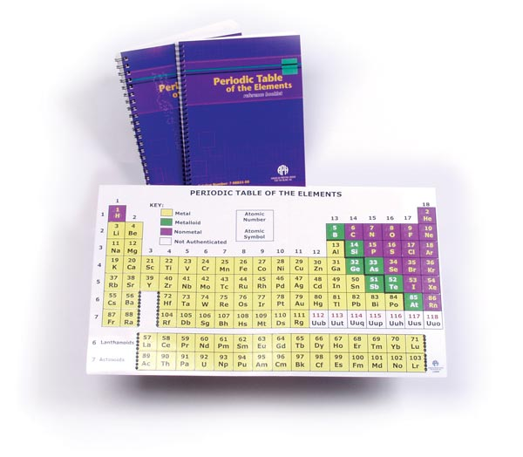

Project Staff
Karen J. Poppe, Tactile Literacy Project Leader

Background
In 2007, APH introduced the Periodic Table of the Elements Reference Chart with Print Booklet (7-08855-00) and Braille Booklet (5-08855-00); this product was designed by Karen Poppe, Tactile Literacy Project Leader. The tactile/print chart is complemented by a reference booklet containing information about each element—atomic name, atomic weight, electron configuration, and so forth. The product allows students to enhance their understanding of concepts aligned with the Next Generation Science Standards (NGSS). The tactile/print chart was carefully designed to ensure tactual discriminability and visual appeal/contrast for the intended target population, yet it is useful for all students in inclusive educational settings. The product is ideal for students in middle school, high school, and college.

The sales history of the product over the past 3 years revealed fluctuating demand for each version. The braille version (5-08855-00) sold 116 in FY 2014, 95 in FY 2015, and 207 in FY 2016; likewise, the print version (7-08855-00) sold 130 in FY 2014, 116 in FY 2015, and 118 in FY 2016.

Work during FY 2017
The modernization of the Periodic Table of the Elements Reference Chart and Booklet is critical so that students with visual impairments and blindness have access to the same STEM learning experiences and information as their sighted peers. The updates planned for this product will ensure incorporation of formally-named elements reported by the IUPAC (refer to https://iupac.org/iupac-announces-the-names-of-the-elements-113-115-117-and-118/). Within APH’s current kit, elements 112-118 are named with previously-assigned atomic symbols Uub, Uut, Uuq, UUp, Uuh, Uus, and Uuo; these elements are officially identified by IUPAC as copernicium (Cn), nihonium (Nh), flerovium (Fl), moscovium (Mc), livermorium (Lv), tennessine (Ts), and oganesson (Og). Refer to https://www.iupac.org/cms/wp-content/uploads/2015/07/IUPAC_Periodic_Table-28Nov16.jpg for the 2016 IUPAC version of the table.

In February 2017, the project leader prepared a formal Product Modernization Form that detailed the expected updates to the Periodic Table of the Elements Reference Chart and Booklet, including the provision of both Nemeth and UEB versions to comply with recent shifts and adoptions of the UEB code by some states and/or state districts. In April 2017, the modernization proposal was presented to the Product Evaluation Team; and in May 2017, it was presented to the Product Advisory and Review Committee. Both committees supported the product endeavor. The project was assigned grant #683.

Work tasks undertaken by the project leader during the latter part of the fiscal year included the following:
- Ordered and reviewed the current product to specify needed updates
- Determined priority of the redesign of the current kit and the new UEB version based on consequential impact on other APH departments and existing production tooling. In-house staff supported the decision to focus initially on the updates to the original kit (Nemeth version), but placed it as second priority after the modernization of the Nemeth version of the Azer’s Interactive Periodic Table Study Set (see separate annual report).
- Conducted the first Product Development Committee meeting to review the purpose and expected redesign of the product
- Initiated edits to content of the accompanying Instruction Booklet
- Planned the graphical conversion from offset printing of the chart, by an outside vendor, to the in-house generation of the chart via the Roland® UV printer. The UV printer will also generate the vacuum-form master to emboss the chart; this process will replace the existing zinc plate for die-press operation. Ultimately, the product’s tactile and print quality will be greatly enhanced because of this conversion.

Work planned for FY 2018
The project leader will work with the assigned graphic designer, manufacturing specialist, model maker, and Production staff to incorporate needed updates to the Periodic Table of the Elements Reference Chart (with related booklets) in the most expedient fashion, and will initiate work on the UEB counterpart as soon as possible.

Protein Synthesis Kit (PSK)
(Completed)

Purpose
To provide students who are visually impaired with an interactive model of translation, or the process of protein synthesis, or decoding a sequence of messenger Ribonucleic Acid (mRNA) to a sequence of amino acids

Project Staff
Rosanne Hoffmann, STEM Project Leader
Frank Hayden, Director of Technical & Manufacturing Research
Andrew Dakin, Model Maker
Andrew Moulton, Manager of Technical & Manufacturing Research
Denise Snow Wilson, Research Assistant

Background
The general educational materials market lacks suitable interactive models of molecular biology processes for students with visual impairments. These models are often made with inappropriate colors, are difficult to assemble, fall apart with tactile exploration, and are not tactually accessible to students who are blind. The PSK is designed to continue the concepts introduced by the DNA-RNA Kit, which demonstrates DNA structure and replication, and transcription of a single strand of DNA to mRNA. Both the DNA-RNA Kit and the PSK are interactive models that reflect the principles of universal design; when used together, they demonstrate the fundamentals of protein synthesis. The first part of the process, or transcription of a segment of DNA to mRNA, is demonstrated by the DNA-RNA Kit. The PSK demonstrates the second part of the process, or how mRNA is translated to a sequence of amino acids. Each product is indispensable to the other; the use of both products together enables all students (not only those with VI) to demonstrate the formation of single and double strands of DNA, replication of double-stranded DNA, transcription of a single strand of DNA to mRNA, and translation of mRNA to a strand of amino acids (protein).

The project leader and model maker designed an interactive model consisting of jigsaw puzzle-like pieces that represent individual subunits, or nucleotides, of transfer RNA (tRNA), start and stop subunits, and amino acids. Ten prototype sets were prepared for field testing that began in the summer of 2013 and was completed in the fall of 2013. Like the DNA-RNA Kit, the PSK subunits are made of die-cut, 1/4-inch thick foam pieces covered with thermoformed laminate of different colors and textures. A draft guidebook explaining how to use the PSK was included in the field test materials.

Field test results helped the project leader decide how many of each type of subunit (tRNA, Start, Stop, Amino acids) to include with the product and the numbers of replacement parts (subunits) to make available for purchase separately. Field testers made several suggestions for improvement of the model itself. Start subunits were redesigned to have a thermoformed raised line around the perimeter in addition to a triangle symbol preceding the word “Start” in print and braille. These features enhance the distinction between the similarly shaped Start and Amino Acid subunits and allow a student without vision to know she is handling a Start subunit immediately upon picking it up. Likewise, redesign of the thermoformed laminate of the Stop subunits includes a rough texture across the entire surface, except in the center where a square symbol is followed by the word “Stop” in print and braille. When a student without vision handles a Stop subunit, it will be immediately apparent by the rough texture. In response to field test comments, the project leader designed a full-color tactile graphic illustrating the final phase of mRNA translation, which will be included in every kit. This product received Quota approval in October 2013.

The artwork and tooling required for the color mRNA translation tactile graphic was completed in 2015. Cutting dies and thermoform molds that reflect suggested changes from field testing were designed, ordered, and made. Layout of the accompanying guidebook including photos of the actual product was also completed. The guidebook was converted to accessible BRF and HTML formats, both of which will be made available for free download with purchase of the product. A specifications meeting took place in July 2016.

Work during FY 2017
A pilot run of 50 units of the Protein Synthesis Kit took place in April 2017. The remainder of the first run of 500 units proceeded in the following months, and the Protein Synthesis Kit was made available for sale on June 15, 2017. On the same day, accessible HTML and BRF versions of the guidebook were uploaded to the APH Web Site. A video explaining the use of the Protein Synthesis Kit with the DNA-RNA Kit was prepared by the project leader and uploaded to the APH YouTube™ channel in August 2017.

Work planned for FY 2018
No further work on this product is planned.

Snap Circuits Jr.® Access Kit
(Continued)

Purpose
To give blind and visually impaired students access to the popular Snap Circuits Jr. ® kit, an entry-level electronics kit used for instruction and recreation

Project Staff
Fred Otto, Tactile Literacy Project Leader
Ken Perry, Programmer III
Heather Kennedy-MacKenzie, Technology Program Manager
Frank Hayden, Director of Technical and Manufacturing Research
Rod Dixon, Manufacturing Specialist
Matt Poppe, Graphic Design
Rachel White, Research Assistant
Leasha Twyman, Research Assistant

Background
Technology staff became interested in the Snap Circuits® line of products after realizing how easily they could be made accessible to blind or visually impaired users. The products, particularly the Snap Circuits Jr.® kit, are already in widespread use in schools, and so making accessible adaptations of them can further the goals of STEM learning and inclusion. 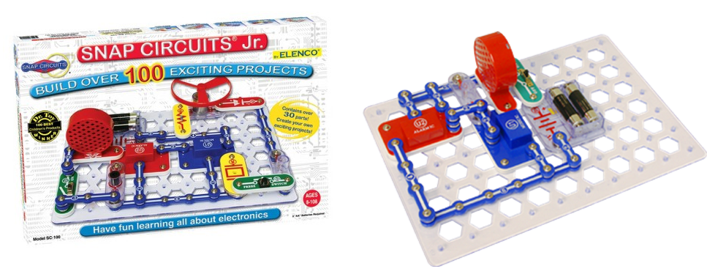

The kit has parts and plans for building over 100 basic electronics projects. Most of the projects produce an effect that can be experienced by a blind student, such as running a fan or making music or sound effects; thus, there is a “payoff” at the end of a completed project. In the kit there is a grid board with fixed pegs, to which all of the various electronic components can be snapped. By snapping components and connectors to the proper coordinates, users can complete a circuit and then close a switch to experience the result.

The instructions are given in a booklet in pictorial form; that is, students are required to duplicate images of the completed circuits. This presents the only major barrier to access because the other needed accessibility modification (labeling the components with braille) is relatively easy to accomplish.

The development of this project began with in-house trials and conversations, with several different options for adaptation discussed. It was decided that written instructions in step-by-step lists were preferable to tactile graphics, both for ease of use and ease of production.

The great interest expressed for the project led to contacts with Elenco®, the manufacturer, arranged through APH’s Vice-President of Development. Representatives from Elenco® visited APH in August 2015 and agreed to assist in the adaptation of the Jr. kit.

The project idea was submitted and approved, and a project leader was assigned. Technology staff had previously made project notes and a timeline to guide the process. The timeline specified preparatory work, braille labels, and written instructions being done in the first half of 2016, along with presentations and discussions at conferences to gauge interest. All of these steps were completed, with Technical and Manufacturing staff overseeing the braille labels and the project leader writing instructions for 20 projects, sufficient for field evaluation.

APH was able to purchase 105 Snap Circuits Jr.® sets at cost from Elenco®. Research staff worked with Development to explore funding sources to support and promote the project further.

Work during FY 2017
Field testing in schools and other locations was conducted in fall 2016. A call for evaluators was put out through APH News, trustees and other personal contacts, and e-mail discussion lists. Because all kinds of input and data were welcome, and because there was an abundance of purchased sets available, nearly everyone who responded to the call was given a kit to evaluate. Thirty-six kits were sent out to 32 sites in early September 2016 for evaluation.

The following is a summary of the field evaluation demographics, settings, and representative comments:

Teacher Data:
- Title
  - 46% (15 of 32) Teachers of the Visually Impaired
  - 25% (8 of 32) Math and/or Science Teachers
  - 15% Media, Technology or Software specialists, teachers, coordinators or engineers.
  - 6% Unspecified Teachers
  - 3% Orientation and Mobility Specialists
  - 3% “N/A”
- States Represented: 20
- Program Type
  - 50% Residential (16)
  - 12.5% Full Inclusion (4)
  - 9.38% Resource (3)
  - 28.13% Other (9)
- Years’ Experience
  - Out of the 32 evaluators, 20 reported more than 10 years of experience teaching Blind/VI students.
Student Data:
  - 131 Total Students
  - Average age: 13 yrs. old
  - Mode: 15 yrs. Old
  - 59.5% Male, 40.4% Female
- Grade Level
  - Average grade: 7th
  - Mode: 10th
- Primary Reading Medium
  - 43.4% Braille readers
  - 38.7% Large Print readers
  - 14.7% Print readers
  - 3.1% Auditory listeners
- 29.7% (39 of 131) identified having a disability other than VI

Classroom Data:
  - 34% science class/classroom
  - 17% resource room
  - 10% applied academics or technology classroom
  - 7% residential home/non-classroom
  - 7% “pull out” setting”
  - <4% for each—general classroom, braille class, fabrication class, TVI office, or N/A
- Is basic electronics regularly included in your students' curriculum?
  - 62.07% Yes
  - 37.93% No
  - 89% said the adapted Snap Circuits Jr.® would fit into a study of electronics in general.
  - The majority of responders (79.31%) said that this product could be used for both educational and recreational purposes.

- Please indicate how each student preferred to access the project instructions (i.e., through hard copy braille, speech access, large print, or hearing them read aloud).
  - Roughly 40% Braille
  - Roughly 30% Large Print
  - Roughly 15% Auditory
  - Roughly 10% Print

Teacher comments/observations:
  - Many students showed interest in building the projects they were assigned. Several responders said their students were interested in making their own circuits after doing the projects. A few responses are as follows:
    - 5th grader wanted to build the whole book!
    - Yes, many of them wanted to just start making their own circuits without following a plan.
    - They all agree that if they are allowed to "play" with the kits - they would all like trying to put things together randomly to "see what would happen..."
    - Students did interchange parts to see effects of sounds and lighting.
  - They wanted to know if they were available at stores so they could ask their parents for them. Many students have asked to use them at other times besides their science class when we explored them.
  - Students were thrilled to succeed in putting projects together and they work. They would trace parts with hands to understand why they worked.
  - They liked that the Braille and large print listed the parts needed and then the 1st, 2nd layer, etc. They liked that the pieces snapped together and didn't need to work with all the wires.
  - Students were pleased to learn that they could independently create working circuits. They were all proud of themselves. Student 1 (totally blind) would have spent hours making all the projects if we had the time.
  - They were very excited when they created circuits that played a noise. They liked having the grid labeled in braille.
  - Blind students or students who used braille were a bit slower than sighted students, but were still able to do a good job.
  - Overwhelmingly, most respondents said their students increased speed and accuracy as they continued to complete projects. One mentioned students needing some assistance for the first few projects, but after that they worked mostly independently.

Final decisions about the product were made based on the evaluators’ responses. There was great overall enthusiasm for the adapted kit; the only negative responses or suggested improvements centered on the placement of braille labels, transcription errors in the instructions, and other details that will be corrected in final production.

Of particular interest were questions about whether the kit should be sold with the braille labels already applied (at higher cost) or with labels for the user to apply. Support was given for both options, but the majority preferred to have the parts pre-labeled and ready to use out of the box. For the convenience of users who already own the commercial kit, a second product called the Snap Circuits Jr.® Access Pack was created; this will include the same labels and instruction booklets as the Access Kit but not the actual Snap Circuits Jr.® materials.

Production staff studied the labeling requirements and determined that they could apply the labels at a reasonable cost if some changes were made to their number and configuration. To this end, Technical Research and the project leader collaborated on revising the labels and producing a pictorial guide to assist workers to apply the labels correctly.

The project leader and assistants completed writing instructions for all 101 projects in the commercial kit. Layouts for the adapted instruction booklets in print and braille were completed, and graphic art for the print materials was created. Tooling for the braille labels was revised. Production specifications were written, and a meeting was held to prepare for production.

Work planned for FY 2018
Approval for Quota sale will be sought. The completed Access Kit and the Access Pack will be offered for sale. Project staff will support the product through demonstrations and marketing. The possibility of creating a webpage or forum for visually impaired users of Snap Circuits® to share projects and ideas will be explored.

Submersible Audio Light Sensor (SALS)
(Continued)

Purpose
To provide a device that allows K-12 students who are visually impaired to participate more fully in scientific experiments and promote their interest in STEM (science, technology, engineering, and mathematics) related fields of study

Project Staff
Rosanne Hoffmann, STEM Project Leader
Frank Hayden, Director of Technical & Manufacturing Research
Lawrence Lovelace, iOS® Programmer
Ken Perry, Programmer
James Robinson, Manufacturing Specialist
Joseph Hodge, Software Quality Assurance Analyst
Larry Skutchan, Director of Technology Product Research
Cary Supalo, President; Independence Science, LLC
Mark Swain, Electrical Engineer; Precision Circuit, LLC
Ron Supalo, Project Manager; Independence Science, LLC
Greg Williams, Director of Products and Training; Independence Science, LLC
Ashley Neybert, Chemist

Background
The SALS device detects changes in light during various applications in air (e.g., placement over dark or light objects) or aqueous solution (e.g., chemical reactions that form precipitates) and converts this signal to equivalent changes in sound. This instantaneous feedback allows students who are visually impaired to observe the same information as students with typical vision in real time, allowing them to be active participants in science experiments. SALS is unique in that the probe detects light while immersed in liquids in addition to detecting light in air.

The first prototype of SALS was developed in 2005 by a team led by Cary Supalo, a scientist who is blind, as part of the Independent Laboratory Access for the Blind (ILAB) project at The Pennsylvania State University, which was funded by a 3-year grant from the National Science Foundation (NSF). Supalo was inspired to design the device after years of experience in the laboratory as an undergraduate and graduate student during which he was dependent upon others to conduct chemistry experiments. The SALS device was field tested with students who participated in the ILAB project over a 3-year period. During this time, suggested modifications from student field testers were incorporated into five subsequent generations of SALS, each one with design improvements. A second NSF grant beginning in 2007 provided funding for continued development and refinement of SALS.

All prototypes of the SALS device at this point in its history consisted of a light-detecting probe (photocell contained within a glass and plastic wand) connected to a standalone output or control box. Detected changes in light intensity due to chemical reactions taking place in a beaker or test tube, such as precipitate formation or pH indicator color change, were immediately converted to pitch changes of sound output over a range of several octaves. For example, as a solid precipitates within a solution, less and less light is detected by the probe. Within the tone output/control box, this response is converted to lower and lower frequencies of sound waves and the device emits sound of decreasing pitch. Data collection was in real time, allowing the student with visual impairment to make the same scientific observations as sighted peers. The control box of the prototype device allowed the user to listen to and store pitch data and compare a current pitch to a reference pitch. Voice output capability further enhanced data retrieval and manipulation.

SALS was never intended to provide precise quantitative data; rather, it indicates whether a reaction is taking place, or whether the light detecting probe is near a dark or light object. Preliminary field test results showed that when used by students who are visually impaired, SALS both increased independence and promoted interest in STEM related fields. In spite of many improvements over several years, the need for a more versatile and state-of-the-art device was clear, prompting a redesign effort.

Mark Swain submitted a SALS Redesign Proposal to APH and Independence Science (IS) in April 2011. APH and IS supported the following engineering changes in the SALS control box: improved audio, a simplified user interface, improved manufacturability to facilitate mass production, improved battery longevity, and interface capability for future applications using the same audio output technology (using sensors other than a light-detecting probe, such as pressure, temperature, acceleration, etc.). A July 2011 update to the proposal added modification of the SALS control box for Universal Serial Bus (USB) capability, thus permitting the use of an external flash/thumb drive. This feature would facilitate speech data programming, mass data storage during an experiment and exportability to Microsoft® Excel®, software upgrades (eliminating the need to return units to APH for reprogramming), and access to USB communication from SALS to a personal computer (a future capability not included in this project). Although this engineering change impacted both the development time and final prototype cost ($14.00 per unit), it was deemed appropriate given the benefits.

Contract negotiations between IS and APH were complete in November 2011, allowing Swain to begin work on a redesigned prototype. Mechanical, electrical, and software requirements were defined in December 2011. Most of the mechanical and electrical designs, including CADD (computer-assisted design and drafting) renderings of the control box housing, were completed between January and May 2012. Preliminary software development, including USB, speech, and tone generation, were completed by August 2012. Using code from hardware verification, the software for basic functionality of the light conversion to sound application was completed and speech capability perfected. A tool and die shop was identified for custom-machining of the prototype control box housing. After some of the circuit boards were reworked and the housing was delivered, a first new prototype of the SALS control box was constructed. The light-detecting probe was assembled and housed in a clear plastic test tube. The project leader received a video demonstrating basic functionality of the first prototype of the redesigned SALS device and light-detecting probe in June 2014. The internal parts needed to build five light sensors were ordered by Swain. Difficulties finding an appropriate light probe housing as well as software and hardware issues set back completion and delivery of the five prototypes needed for field testing.

It was not possible to find over-the-counter glass tubes of the correct size (rather than plastic, which floats and thus interferes with device functioning) to house the light probes. This problem was solved in January 2015 when custom-made glass tubes of the correct size were ordered and received. Five light-detecting probes were constructed at APH with the internal parts ordered by Swain and the custom-made glass housings. Five prototypes of the SALS control box built by Swain were delivered to APH in April 2015. The project leader collaborated with Supalo in writing an Instruction Manual and Activity Guide for field evaluation with the SALS units and light probes. Continued software development and update processing duties were transferred from Swain to Williams.

The project leader identified nine field testers over a wide geographic distribution via call-out in the April 2015 APH News. Evaluations were received from the nine field testers who worked with a total of 25 students in May, June, and July of 2015. Changes to the control box suggested by the field testers included improving connections from the device to the ear bud and AC charger jacks and applying non-slip bumpers on the bottom of the output box. Field testers also suggested changes in the Instruction Manual including better identification of control box buttons, tips on how to hold the light probe for the most consistent data acquisition, ways to prevent damage to the light sensor glass housing, and more suggested activities appropriate to the scientific use of SALS.

Another outcome of the initial spring and summer 2015 SALS field test was that SALS benefitted students with blindness, but not the students with low vision (because they were generally able to use their vision for the suggested experiments). Consequently, the project leader extended the field test by soliciting evaluations from three more TVIs and 17 more students in the fall of 2015. The evaluations and comments received by the second set of field reviewers in February 2016 reiterated those from the first round, thus confirming the value of SALS for students with blindness. During this second field test, Williams updated the SALS control box voicing using recorded files generated in the APH studio.

SALS received Quota approval in October 2015 during the 147th Annual Meeting of Ex Officio Trustees.

During FY 2016, the project leader learned that APH would be responsible for finding manufacturers for all components of the SALS device (probe and control box) rather than Supalo, contrary to the original agreement between APH and IS. Furthermore, in the 5-year period since APH’s involvement in the redesign of SALS, many changes with regard to electronic devices and educational institutions had taken place: cell phones and tablets are more accepted in schools, most students own or have access to cell phones and tablets, and scientific companies are developing applications, or apps, compatible with iPhone® and Android™ devices. Specific apps that exploit the use of these small and now commonplace devices connect with scientific probes directly or wirelessly via Bluetooth®. For example, temperature can be measured with a probe connected wirelessly via Bluetooth® and reported on a cell phone after downloading the appropriate app from Vernier Software & Technology, LLC.

The feasibility of using the SALS light detecting probe with off the shelf mobile devices (instead of a standalone single purpose control box) was tested by Ken Perry, programmer at APH. A sample software app was created on Android™ using a library appropriate for any of the three main OS platforms. The app, which connected to the IOIO-OTG development board from Sparkfun via USB or Bluetooth®, was able to read the same light values that the APH light probe normally sends to the standalone SALS control box and produce a corresponding tone. Work commenced to create a prototype Bluetooth® connected probe and iOS® and Android™ apps that will essentially replace the standalone SALS control box. This will result in lower production costs and decreased production time and ultimately translate to a lower cost to the consumer. The app software is less expensive and can be easily upgraded to include more features than what would be possible with the standalone SALS control box.

Feedback solicited from five of the original SALS field testers was positive regarding the development of a cell phone or tablet app that receives signals from the APH light detecting probe and reports them as corresponding changes in emitted tone, instead of a standalone device.

In March 2016, Supalo hired Ashley Neybert, a chemist who is visually impaired, to design and test more suggested SALS activities to incorporate into the Instruction Manual.

Work during FY 2017
Hardware development of the Bluetooth® light detecting probe and firmware and software for the Android™ and iOS® apps began in the fall of 2016. By December 2016, sample Android™ and iOS® SALS apps created by Perry and Lovelace were working, and 10 SALS lab activities were received from Neybert to include in the revised Instruction Manual. By April 2017, the iOS® beta version of the SALS app could simulate tones and was uploaded. In July, a first model of the light probe with hardware connecting it to the iOS® app on a phone or iPad® via Bluetooth® showed functionality. Nine more light detecting probes with Bluetooth® connection were built for field testing. The SALS Instruction Manual was edited by the project leader to include the new activities from Neybert and reflect SALS design changes. Joseph Hodge added a section to the Instruction Manual about using the voiceover feature of iOS® devices with the app. Seven probes and the revised Instruction Manual were sent to field testers (including those with and without previous experience with earlier versions of SALS) in early fall of 2017 for evaluation.

Work planned for FY 2018
Field test results will be compiled in late fall 2017, and suggested changes in the SALS app and Bluetooth® light detecting probe will be considered and implemented. After finalization of hardware design, the best site for building the light detecting probes will be determined (in-house or out-of-house). The Instruction Manual will be edited to reflect changes suggested by the field testers including tips regarding the best use of the light detecting probe. When complete, the Instruction Manual will be translated to braille. The Instruction Manual will be made accessible as downloadable BRF, HTML, and EPUB® files available with the purchase of the SALS app and Bluetooth® light detecting probe.

Talking Scientific Balance
(Continued)

Purpose
To provide students with visual impairments with an economically priced balance suitable for use in science laboratory activities with a mass readability to the hundredth gram (0.01 gram)

Project Staff
Rosanne Hoffmann, STEM Project Leader
Ken Perry, Programmer
James Robinson, Manufacturing Specialist
Frank Hayden, Director of Technical & Manufacturing Research

Background
This product idea was submitted in August 2015 by a college student with vision impairment who identified a need, from his personal educational experience, for a talking scientific balance with a mass readability of a hundredth gram (0.01gram) for laboratory experiments in high school and college level science classes. This would place students with visual impairments on the same playing field as students with ordinary vision with regard to participating in massing (weighing out) very small quantities of chemicals or detecting very small changes in mass of an object or organism. Talking balances and scales are available but most are associated with cooking and baking and measure in United States customary units (pounds, ounces, etc.) rather than the International System (SI) of units (grams, milligrams, etc.), which is the scientific standard. Some available talking balances do report mass using SI units, but only to the tenth of a gram, and a finer level of readability is called for. Feedback solicited by the project leader via the online APH News in the fall of 2015 from science teachers and TVIs verified the need for this type of balance.

After progressing through the APH Product Evaluation Team and Product Advisory and Review Committee meetings, development of the Talking Scientific Balance commenced in June 2016. The project leader began research for scientific balances with 0.01 g readability and a measuring range from 0.01 to 600 g that can be interfaced with a speaking device.

Work during FY 2017
The project leader identified and purchased a balance with the specified mass measuring range; the unit came equipped with an RS-232 serial port that can be used to connect the balance with other external devices. James Robinson built a cable to fit the port so this possibility could be further explored. Discussions with Ken Perry indicated that three development paths could be pursued: 1) Create an Android™ or/and iOS® app that connects wirelessly to a dongle connected to the balance so the voiceover function of the phone/tablet devices can be used to speak the mass measurement; 2) Build a small external device that physically connects to the balance via the RS-232 port and speaks the measured mass; and 3) Modify the balance internally such that the measurement is spoken. The first path is the most economically and developmentally feasible, the only caveat being that the balance would need to be near the device to which it is connected. It would require developing, building, and selling a dongle for Bluetooth® connection. The second path could go in two directions: APH can build and sell a small wire-connected external device that speaks the measurement, or APH could supply instructions for teachers to build their own. The third path would require purchasing many balances and modifying them internally for resale by APH; this could not be done in-house at APH. Out-of-house work like this would likely be prohibitively expensive.

The project leader and Perry discovered that several companies that make scientific balances in the desired measurement range also make talking balances for cooking and baking for individuals with vision and/or print impairment. But, as discussed above, these particular devices do not have the desired 0.01 gram readability. The project leader and Perry contacted the technical staff at Ohaus (Vermont, US) and MyWeigh to find out whether they would be interested in collaborating with APH in the development of a talking balance with the desired measurement range and readability.

Work planned for FY 2018
The project leader and Perry will discuss options with technical staff at Ohaus and MyWeigh to see if they are interested to design a talking scientific balance from the ground up, rather than modifying an existing balance. If this tack does not work out, the project leader and Perry will pursue the first option described above: designing a dongle to wirelessly connect an appropriate balance with an app that uses device voiceover to speak the mass measurement.

Talking Scientific Thermometer
(Discontinued)

Purpose
To provide students with visual impairments with an economical scientific thermometer suitable for use in science laboratory activities that accurately measures temperature to the hundredth degree Celsius (0.01°C)

Project Staff
Rosanne Hoffmann, STEM Project Leader
Ken Perry, Programmer
Frank Hayden, Director of Technical & Manufacturing Research

Background
This product idea was submitted in August 2015 by a college age student with vision impairment who identified a need, from his personal educational experience, for a talking scientific thermometer capable of measuring temperature to the hundredth degree Celsius (0.01°C) for laboratory experiments in high school and college level science classes. This would place students with visual impairments on the same playing field as students with ordinary vision with regard to measuring the temperature of various substances over a wide range. Feedback solicited by the project leader via the online APH News in the fall of 2015 from science teachers and TVIs verified the need for the development of such a product by APH.

Talking thermometers are available, but many are associated with cooking and baking and measure in degrees Fahrenheit (°F) rather than the International System (SI) of units (°C), which is the scientific standard. Some available thermometers do report temperature in degrees Celsius, but usually to the tenth of a degree. Vernier Software & Technology sells the Talking LabQuest® 2 that reports measurements made with a wide range of detection probes including temperature, also to the 0.10 degree C. An accessible version of the Talking LabQuest® 2 is available from Independence Science, but it is very expensive and requires the purchase of a computer software program (Logger Pro) at an additional cost.

After progressing through the APH Product Evaluation Team and Product Advisory and Review Committee meetings, development of the Talking Scientific Thermometer commenced in June 2016. The project leader began research for scientific thermometers accurate to the hundredth degree Celsius that can be interfaced with a speaking device.

Work during FY 2017
The project leader searched for existing thermometers that measured temperature to the hundredth degree Celsius for modification. Several devices were found, but all were in an unworkable price range. It was then discovered that thermometers used in high schools throughout the U.S. (e.g., Vernier wired and wireless devices) are accurate to the tenth of a degree Celsius. It was further noted that APH sells an accurate and inexpensive talking thermometer that reports temperature to the tenth of a degree in Fahrenheit and Celsius (ThermoWorks model RT8400). The decision was made to promote the use of this particular talking thermometer for students with visual impairments across the country, rather than develop a talking thermometer that is not equivalent to standard devices used in high schools across the U.S. The project leader made this the lead announcement in the new STEM Corner feature of the APH News in January 2018.

Work planned for FY 2018
Development of this product is discontinued, and no further work on it will take place.

SOCIAL STUDIES

Tactile World Globe
(Continued)

Purpose
To update APH’s Globe: Tactile and Visual by applying a topographical relief and braille labels for continents, oceans, and latitude/longitude lines

Project Staff
Karen J. Poppe, Tactile Literacy Project Leader
Andrew Dakin, Model/Pattern Maker
Tom Poppe, Model/Pattern Maker
Patrick White, Model/Pattern Maker
Carie Ernst, Cartographer
Laura Zierer, Research Assistant
Andrew Moulton, Manufacturing Specialist
Matthew Poppe, Graphic Designer

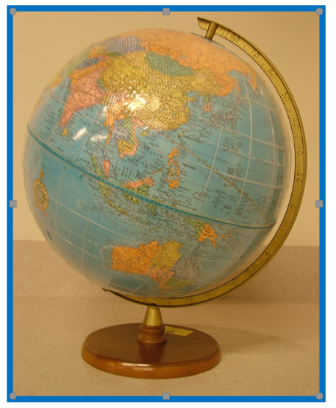

Background
APH has a long history of designing and producing excellent tactile world globes for use by students and adults with blindness and visual impairments. Past models are showcased in the APH Museum. Among the most fondly remembered of these tactile globes is the 30” Floor Pedestal Globe that was first introduced in 1955. According to APH’s Museum collection database, the globe is described in the 1956 edition of the APH product catalog like so:
30-inch diameter, overall height of 51 inches; hollow-plastic construction; painted in contrasting blue and yellow to highlight land and sea areas; with brown stippling for mountainous areas; raised latitude and longitude lines; sturdy metal base
Cost: $225.00

The February 13, 1955, issue of The Courier-Journal Magazine, commemorating APH’s 100th anniversary, described this globe as “the first ‘accurately-exaggerated’ relief globe in the United States. The altitudes are exaggerated 30 times to the flat surface. With such a globe, the world will be at the fingertips of the blind student.”

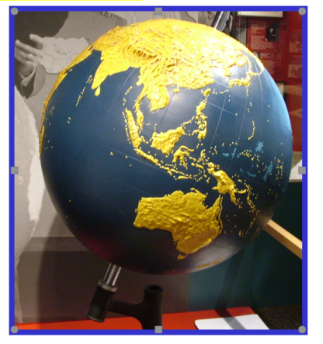

The 30-inch Floor Pedestal Globe, produced in conjunction with the Panoramic Studios of Philadelphia, was still available in the 1980 product catalog, although few were apparently sold. Production between 1975 and 1979 averaged 17 units per year. By 1984, the floor model had been removed from the APH catalog. Some of the original production copies of this globe are still displayed and used throughout the country in residential schools for the blind.

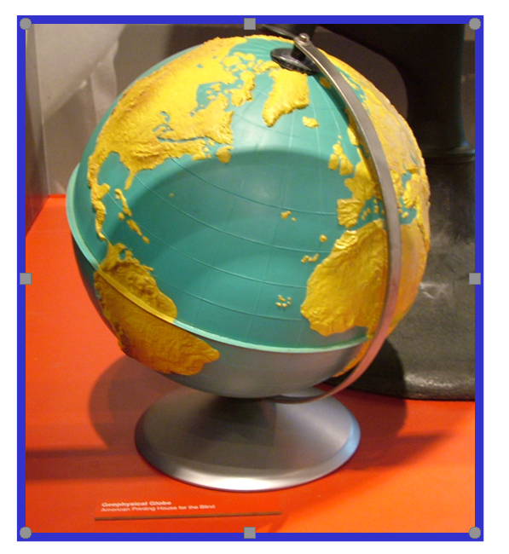

In 1959, APH introduced two 12-inch plastic relief globes—the Panoramic Model Globe and the Geo-Physical Model Globe. These globes were painstakingly hand-painted by APH production staff; they featured topographical detail, and their visual simplicity was ideal for low vision students. Only slight differences distinguished the two globes—type of base (cup-shaped versus tripod), equator design (indented versus a thin lip), and degree of elevation in comparison with horizontal distances (32 to 1 versus 50 to 1). In later years, only the Geophysical Globe was offered, and its base had been updated to a permanent metal stand (as shown in the photograph).

The painting effort required to produce the Geophysical Globe eventually proved too laborious and expensive in the midst of an ever-increasing number of new educational products manufactured in-house during the 1990s. At the sluggish production rate of two painted globes per day, and complicated by the extra step of epoxy reinforcement and limited floor space for drying, an alternative manufacturing approach was needed.

In 1993, the current project leader and T. Poppe addressed the challenge of creating a new tactile globe that imposed less production time and translated into a cost-savings for the customer. Using a production approach conceptualized by the project leader—specifically, the application of two clear vacuum-formed hemispheres onto a commercially-available globe—the model/pattern maker undertook the tooling of a new “world” mold. The new mold featured a pebbly, braille-like texture for continental land masses with higher elevations noted by a slightly different areal pattern; raised latitude and longitude lines were formed as well. The two-part mold was used for vacuum-forming the northern and southern hemispheres out of clear thin vinyl; the two halves were then registered onto a purchased 12-inch table-top political globe. This manufacturing process translated into a 67% cost reduction and the introduction of a new globe—Globe: Tactile and Visual—in 1994.

The urgency to find a solution to the globe’s production difficulties, followed by immediate implementation of the new process, prevented the project staff from conducting a formal field test study of its design. Although the current globe design has served its purpose for two decades, the project staff have always desired to revisit the mold and make improvements to its tactile quality. Prompted by many compliments about the former Geophysical Globe, paired with the arrival of talking globes on the market, globe design discussions surfaced periodically throughout the years. Although tactile adaptations of commercial talking globes were considered in 2003 and proposed in a formal product submission to the Product Evaluation Team and the Product Advisory and Review Committee (PARC), the discontinuation of such globes alerted APH that creating extensive production tooling for a potentially scrapped commercial product was a risky undertaking. In addition, talking globes have the disadvantage of presenting too many sight-dependent tasks, such as asking questions about very specific locations/landmarks; the detail required to perform the tasks cannot be adequately captured in a tactile counterpart.

In June 2012, the project leader visited PARC and proposed active development on the tactile globe. Her idea involved re-introducing the popular topographical relief style encountered in the Geophysical Globe and marrying it with the current print globe; inclusion of braille labels for continents, oceans, and latitude/longitude lines was planned. T. Poppe created a small sample of the anticipated globe design and shared it with the Product Development Committee on August 1, 2012. All attending supported the intended improvements. Production staff were copacetic with the suggested manufacturing procedures.

Significant progress was made on the design and development of the new Tactile World Globe throughout FY 2013. Guided by early feedback garnered during a Product Input Session at APH’s Annual Meeting in October, the project leader and T. Poppe made numerous decisions about various globe features including the type of tactile latitude and longitude lines, braille label positions for all continents and oceans, and topography enhancements to replace the less-desired “pebbled” texture of the existing globe. The staff also located a desirable non-glare vinyl to use for the prototype model.

By the end of March 2013, T. Poppe had completed sculpting the Northern Hemisphere. The decision was made to field test only the Northern Hemisphere to verify that the presentation was ideal for student use before significant tooling effort was undertaken for the production of the entire globe. A fiberglass master for eventual vacuum-forming of the Northern Hemisphere was built and tested. The first attempt to form a part proved successful; the registration of the tactile part to the print globe was ideal, and proper fit was verified. By the end of April, 20 complete prototypes were assembled, each with the transparent, tactile hemisphere applied permanently to the commercial globe.

Anticipating that sufficient time was still available to field test in the spring, the project leader posted a field test announcement in the April issue of APH News. The announcement was also e-mailed to those in Research’s field tester database who had expressed interest in evaluating social studies products. Although approximately a dozen teachers responded to the request, it was decided to postpone the field test activity until the beginning of the 2013-2014 school year to give teachers a lengthier and more convenient timeframe for evaluating the product. The same teachers who expressed interest in field testing agreed to the updated schedule.

Prior to field testing, the project leader constructed an extensive evaluation packet with multiple rating opportunities for each main design feature of the prototype. Beyond just a product evaluation form, a student outcome form was created to assess each student’s basic knowledge of a world globe prior to the use of the prototype. In addition, 25 assessment tasks were devised to test the readability of the new Northern Hemisphere. Carie Ernst reviewed the questions to check for clarity and accuracy from a cartographer’s expertise.

On September 17, 2014, prototypes were mailed to a total of 18 teachers of the visually impaired representing the states of Missouri, Michigan, New York (2), Texas (2), California (2), Louisiana, Tennessee, Nebraska, North Carolina, Maryland, Utah, Ohio, Kentucky, Pennsylvania, and Montana.

A total of 14 completed evaluations and 37 student outcome forms were returned from participating field test sites by January 2015. Some evaluators were unable to complete the evaluation process. Nevertheless, sufficient data was collected to determine the effectiveness of the new bas relief design of the prototype globe. The project leader intermittently recorded data from these student outcome forms as time allowed. The research assistant created a Microsoft® Excel® spreadsheet to report the students’ performances on the pre-quiz and 25 related assessment tasks.

The 14 field evaluators represented the states of California, Ohio, Louisiana, Maryland, Michigan (2), Montana, Nebraska, New York (2), North Carolina, Tennessee, Texas, and Utah.

Type of Educational Setting (N =14)
Itinerant | Residential | Resource
OH, MI (2), NC, NE, NY, TX, UT  57% | LA, MD, NY, TN  29% | CA, MT  14%

Participating evaluators varied in their teaching experience with the largest percentage (33%) reporting 21 or more years teaching experience; 27% had 0-5 years teaching experience, 20% reported 6-10 years teaching experience, and another 20% reported 11-25 years teaching experience. Various titles and professions were represented in this teacher sample (e.g., teacher of the visually impaired, social studies teacher, teacher consultant for the visually impaired, orientation and mobility instructor, vision specialist, and paraprofessional). All of the evaluators were Caucasian/White.

The majority (93%) of the participating evaluators were familiar with APH’s existing globe and had used it with their student(s); 71% had the existing APH globe available for comparison purposes during the field test activity. All evaluators briefly described their current teaching strategies for teaching geography and map skills. Reported strategies included starting with handmade tactile maps of a familiar area (e.g., school, classroom) and then progressing to unfamiliar areas (e.g., globe, US map, world atlas), teaching cardinal directions, introducing concepts of keys and legends, presenting globes and maps in a systematic manner, and so forth. Over one-third (35%) indicated they teach geography/map skills to their students less than once a week. Equal percentages taught these skills/concepts either once a week (14%) or two or three times a week (14%). A smaller percentage (7%) indicated “more than five times a week.” Among the most challenging concepts for the students to grasp were latitude and longitude/imaginary lines and points, location of continents and land features, where objects on a globe/map are in relation to other objects, understanding how the globe relates to a flat tactile map, and “seeing the whole picture and understanding where one part is in relation to another.”

Collectively, the field evaluators used the prototype of Tactile World Globe (the Northern Hemisphere only) with a total of 37 students.
[Note: The decision was made to field test only the Northern Hemisphere to verify that the presentation was ideal for student use before significant tooling effort was undertaken for the production of the entire globe.]

As observed in Table 1, the 37 students varied in age, grade level, ethnicity, and preferred reading medium. A small percentage (16%) were reported as having additional disabilities besides visual impairments and blindness.

Table 1
Student Sample (Gender, Age, Grade Level, Ethnicity, Preferred Reading Medium, and Other Disabilities)
GENDER
Female | 19 |  |  | 51%
Male | 18 |  |  | 49%
N = 37 |  |  |  | 100%
AGE
6 years | 2 | 5% |  |  | 12 | 32%
7 years | 2 | 5% |  |  | 12 | 32%
8 years | 2 | 5% |  |  | 12 | 32%
9 years | 2 | 5% |  |  | 12 | 32%
10 years | 4 | 11% |  |  | 12 | 32%
11 years | 2 | 5% |  |  | 6 | 16%
12 years | 3 | 8% |  |  | 6 | 16%
13 years | 1 | 3% |  |  | 6 | 16%
14 years | 6 | 16% |  |  | 14 | 38%
15 years | 5 | 14% |  |  | 14 | 38%
16 years | 3 | 8% |  |  | 14 | 38%
17 years | 2 | 5% |  |  | 5 | 14%
18 years | 2 | 5% |  |  | 5 | 14%
19 years | 1 | 3% |  |  | 5 | 14%
N = 37 |  |  |  |  |  | 100%
GRADE
Grade 1 | 3 |  | 8% |  | 6 | 16%
Grade 2 | 2 |  | 5% |  | 6 | 16%
Grade 3 | 1 |  | 3% |  | 6 | 16%
Grade 4 | 3 |  | 8% |  | 8 | 22%
Grade 5 | 5 |  | 14% |  | 8 | 22%
Grade 6 | 1 |  | 3% |  | 6 | 16%
Grade 7 | 4 |  | 11% |  | 6 | 16%
Grade 8 | 1 |  | 3% |  | 6 | 16%
Grade 9 | 8 |  | 21% |  | 17 | 46%
Grade 10 | 0 |  | 0% |  | 17 | 46%
Grade 11 | 7 |  | 19% |  | 17 | 46%
Grade 12 | 2 |  | 5% |  | 17 | 46%
N = 37 |  |  | 100% |  |  | 100%
ETHNICITY
White | 16 |  | 42%
Black | 7 |  | 19%
Hispanic | 7 |  | 19%
Asian | 4 |  | 11%
Two or More | 1 |  | 3%
Other: Moroccan | 1 |  | 3%
Unreported | 1 |  | 3%
N = 37 |  |  | 100%
PREFERRED READING MEDIUM
Braille | 27 |  | 73%
Large Print | 3 |  | 8%
LP/Braille | 2 |  | 5%
Print | 4 |  | 11%
Print/Braille | 1 |  | 3%
N = 37 |  |  | 100%
OTHER DISABILITIES
N=37 | 6 |  | 16%
Other Disabilities: ADHD, Cognitive Disabilities, Hearing Impairment, and brain tumor

As highlighted in Table 2, the 37 participating students also differed in their familiarity with world globes prior to field testing, their previous use of tactile maps prior to field testing, and their interest in tactile maps and globes prior to field testing.

Table 2
Students’ Familiarity with World Globes, Tactile Maps, and Interest in Both
Familiarity With
World Globes Prior to Field Testing
Unfamiliar | 7 | 19%
Somewhat familiar | 22 | 59%
Very familiar | 7 | 19%
Unknown | 1 | 3%
N = 37 |  | 100%
Previous Use of Tactile Maps
Prior to Field Testing
Frequently | 4 | 11%
Occasionally | 26 | 70%
None | 4 | 11%
Unknown | 3 | 8%
N = 37 |  | 100%
Interest in Tactile Maps and Globes
Prior to Field Testing
Very Interested | 12 | 32%
Somewhat Interested | 23 | 62%
Uninterested | 2 | 5%
N = 37 |  | 99%

The field evaluation form invited teachers to rate every feature of the prototype of the Tactile World Globe based on the mold of the Northern Hemisphere. Table 3 provides the average rating of each product feature. The ratings were complemented by specific comments and recommendations.

Table 3
Overall Design of Tactile World Globe
Design Features | Number of Eval-uators | Average Rating | % for each rating  5= Excellent to 1 = Poor or “unneeded”
Design Features | Number of Eval-uators | Average Rating | 5 | 4.5 | 4 | 3 | 3.5 | 2 | 1
Overall design/presen-tation | N = 13 | 4.27 | 46% |  | 38% |  | 8% | 8%
Readability of braille | N = 14 | 4.93 | 93% | 7%
Content labeled in braille (e.g., continents, oceans, latitude/longitude lines) | N = 14 | 4.43 | 57% | 36% |  |  |  | 7%
Quality of topography (e.g., elevated/contoured mountain ranges) | N = 13 | 4.35 | 54% | 7% | 15% | 23%
Tactile contrast between International Date Line and latitude/longitude lines | N = 14 | 4.71 | 79% |  | 14% | 7%
Tactile contrast between International Date Line and Prime Meridian | N = 14 | 4.93 | 93% |  | 7%
Tactile contrast of Tropic of Cancer and other latitude lines | N = 14 | 4.71 | 93% |  |  |  |  |  | 7%
Number and location of latitude lines labeled in braille | N = 14 | 4.00 | 29% |  | 57% |  |  | 14%
Number and location of longitude lines labeled in braille | N =13 | 4.15 | 31% |  | 61% |  |  | 8%
Height of Equator | N = 14 | 4.86 | 86% |  | 14%
Coastline elevation above water | N = 14 | 4.36 | 57% |  | 29% | 7% |  | 7%
Visibility of printed content through clear overlay | N = 14 | 4.00 | 64% |  |  | 14% |  | 14% | 7%
Durability and rigidity of plastic overlay | N = 14 | 4.43 | 64% |  | 21% | 7% |  | 7%

Nearly 80% of field evaluators indicated that the new tactile globe design had specific advantages over other globes used in the past, namely: “easier to locate areas,” topography (“gentle bumps to represent hills/land and more pronounced mountains”), addition of braille labels, latitude and longitude degrees, easily-discriminated tactile line types, and minimal glare for students with low vision. Several comments alluded specifically to the beneficial quality of the braille labels:
- “Many students felt comfortable with the globe immediately as the braille students loved finding the names of areas in braille. This was a huge accomplishment for novice globe users.”
- “The braille labels were great and having lines of latitude and longitude with coordinate labels was a great learning experience for the students.”
- The addition of braille labels “make the globe much more accessible to my completely blind students. I like how the landforms like mountains are distinguished better.”

One hundred percent of the students reported that they enjoyed using the prototype globe with supportive, informal comments such as “Yeah, Braille words!”
“Wow, it has braille on it,” and “The bumpy land feels better than the prickly continents [in reference to APH’s existing world globe].” The students’ performance on 25 outlined tasks using the prototype globe revealed specific successes with the globe, as well as highlighted more challenging concepts. (Refer to Figure 1.) Inability to perform a task was often attributed to a student’s unfamiliarity with the concept, or to the fact that the concept/task was too advanced for the student.

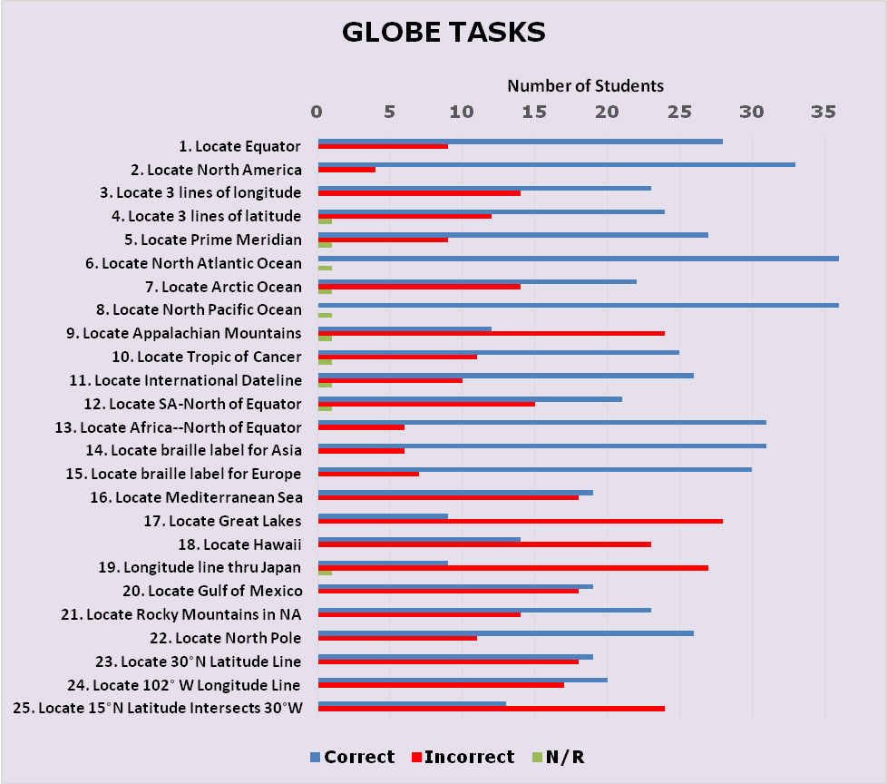
Figure 1. Student Performance on Globe Tasks
Ninety-three percent of field evaluators recommended that APH replace its existing tactile world globe with the prototype’s design, assuming that the Northern Hemisphere’s tactile presentation will be used as model for the construction of the Southern Hemisphere.
Based on field test feedback, anticipated improvements will include the following refinements:
- Non-skid material added to base of globe
- Incorporation of as many braille labels as possible for latitude/longitude lines
- Crisper/more defined edges between some coastlines and water areas
- Inclusion of an instruction booklet (as recommended by 57% of the evaluators) to explain line textures and labeled areas
By the end of FY 2014, the project leader prepared a comprehensive report of the field test results. Quota approval for the Tactile World Globe was requested and received from the Educational Products Advisory Committee at the 146th Annual Meeting in October. Due to the project leader’s and model/pattern maker’s involvement in the prototype development of SPORTS COURTS (see separate project report), active work on the project was curtailed until the second quarter of the fiscal year.

In early February 2015, the project leader regrouped with Technical Research and Model Shop staff to review expected tooling revisions and review intended production processes and assembly procedures of the new globe. Due to T. Poppe’s continued work on SPORTS COURTS, tooling of the globe shifted to A. Dakin. Several world globes were provided to the Model Shop for reference during topographical construction/molding. Tooling work on the Northern Hemisphere was intermittent between March and June. In July, the project leader reviewed the current mold of the Northern Hemisphere and made a short list of needed inclusions (e.g., additional islands), as well as refinements to mountain elevations and a dashed line representing the International Dateline. In September 2015, tooling tasks shifted to the construction of the Southern Hemisphere.

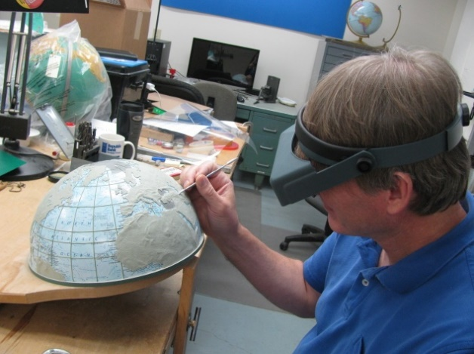

Tooling for the Southern Hemisphere overlay characterized most of the work performed in FY 2016. Work on the project was intermittent as the model/pattern maker tended to the production tooling for other ongoing research products. However, by the third quarter of the fiscal year, a fully constructed globe, using vacuum-formed hemisphere attachments, was assembled. The project leader reviewed the globe and recommended minor refinements and improvements.

In July 2016, momentum toward tooling completion for the Tactile World Globe was slowed by the following tasks:
- Identifying a way to make the base of the globe non-skid, a feature requested by field evaluators. Purchasing staff worked with the outside vendor to obtain non-skid bases to alleviate additional in-house modifications to the globe.
- Problem solving seemingly minor, but impactful deviations in the size of the print globes received from the outside vendor. A slight, unexpected enlargement of the newer globes necessitated identification and application of a clear plastic tape to create the tactile equator (similar to the equator style used for APH’s existing globe) in lieu of a permanently-formed version that was part of the original plan and tooling.

Concurrent tooling efforts included the design of an accompanying print and braille key, formatted at an 8.5 x 11 in. size, to capture the various tactile line types represented on the globe. This added component was also a suggestion from field evaluators. M. Poppe designed the print and braille layouts of the key.

Work during FY 2017
Remaining tooling-related tasks for the new tactile globe continued into FY 2017. In October, the permanent Equator, previously incorporated into the final mold, was removed to accommodate an unexpected, very slight diameter increase (3/16 inches) evident in the manufacturer’s newest globe model; although slight, the size increase prevented the two clear vacuum-formed hemispheres from locking together correctly. Instead, the Equator will be applied in production using a strip of flexible vinyl (as used in the existing APH globe) to form the tactile band that holds the two formed hemispheres together. In November, Patrick White initiated the construction of the 4-up vacuum-form pattern of the tactile key using a Roland®-printed master.

In early January, a fully assembled globe, generated with the use of the new vacuum-form molds, was presented to the project leader for final review and approval. Only slight adjustments were necessary to straighten or nudge a few braille pins in one direction or another. A certified braille transcriber checked all of the braille labels for accuracy. After minor tweaks, the assembled globe was approved by the project leader. The approved globe will be used for reference during the initial pilot run.

Purchasing staff closely monitored the current stock of existing globes to assist in the transition to the new globe style. The vendor agreed to furnish nonskid tabs on the bottom of the globe’s flat, wood base. This feature was a welcome addition that saved the Production staff the laborious in-house steps of die-cutting and adding a foam insert to a concave metal base as originally planned.

In February, White generated a single-up copy of the vacuum-formed part for the project leader’s review. Minor tweaks were needed. This part, too, was reviewed for braille accuracy by a certified braille transcriber. Part number assignment for the print/tactile key was the last step prior to finalizing the production specifications document. Andrew Moulton formally presented the product specifications to Production staff in the third quarter of the fiscal year.

Work planned for FY 2018
Feasible dates for the pilot run will be determined, and inventory of the older globe will be phased out. The project leader, model/pattern makers, and manufacturing specialist will monitor the quality of the first production run of the Tactile World Globe, which will likely occur in the second half of FY 2017. The project leader will assist with post-production tasks. Brochure content will be written; and the new, enhanced globe will be showcased at national conferences and workshops.

TECHNOLOGY AND MEDIA

For FY 2017, there are no active Technology and Media products to report. For related products, see the Assistive Technology section and the Technology Product Research section.

EARLY CHILDHOOD

Animal Recipes
(New)

Purpose
To teach and reinforce a young child’s understanding of the salient features of animals. Animal recipes will be followed to add key “ingredients” that make each animal unique.

Project Staff
Susan Sullivan, CVI Project Leader
Dawn Wilkinson, Early Childhood Project Leader
Kelly Kennedy Mimms, Research Assistant
Leasha Twyman, Research Assistant
Frank Hayden, Director of Technical & Manufacturing Research
Andrew Moulton, Manager of Technical & Manufacturing Research
Adam Clark, Manufacturing Specialist
Anthony D. Jones, Art Production/Design Manager
Matt Poppe, Graphic Designer
Katherine Corcoran, Model/Pattern Maker

Background
Early childhood learning standards in the area of science require that young children be able to observe, investigate, describe, and categorize living things, as well as identify, describe, and compare the physical properties of objects. Language arts benchmarks include describing familiar places, people, and things combined with the ability to provide additional detail. Young children with visual impairment, including cerebral/cortical visual impairment, may not be able to discriminate one animal from another without being specifically taught about what makes them similar, and what makes them different.

Providing children with the ingredients to each animal, paired with the opportunity to create that animal will foster a “hands on” understanding. Three-dimensional models will promote the transfer of knowledge to tactile representations of the animals.

Animal Recipes was submitted by project leaders Susan Sullivan and Dawn Wilkinson in October 2016. It moved through the Product Evaluation Team in November 2016 and through Product Advisory and Review Committee in December 2016. A brainstorming Product Development Committee meeting was held in April 2017 establishing the team and projected dates for development. Depending on the success of this first set of animals, it was determined that more animal kits may be designed in the future.

Product Description
The Animal Recipe farm set will include seven animals: horse, cow, goat, pig, sheep, rooster, and goose. One of the main objectives of this kit is to allow young children to make the connection between the 3D components and the visual/tactile representations. In order to accomplish this concrete to abstract thinking, the foundational components of the kit begin with seven 3D jumbo farm animal figures. Each animal in the set will have a colored Mini-Lite Box underlay representing the animal’s side profile with a corresponding Mini-Lite Box clear tactile overlay side profile that can be associated with the toy figure. A set of clear puzzle pieces (eyes, ears, nose/snout) can then be used to create the image displayed on the colored Mini-Lite Box underlay and matching clear tactile overlay depicting the animal’s face.

Work during FY 2017
Illustrations of animal profiles and faces were created by Graphic Design. Molds were created and the thermoformed patterns of the side profiles made. The puzzle pieces for the face were 3D printed and used by the model maker to design the tactile representations of the face. The project leaders began writing materials for the kit.

Work planned for FY 2018
Ten sets of prototype materials will be sent out for field testing by TVIs and their students over a wide U.S. geographic distribution. Changes will be made to the prototype as recommended, and the product will move forward to production.

Astro Adventure Balls: Swirl, Twirl, & Whirl
(Ongoing)
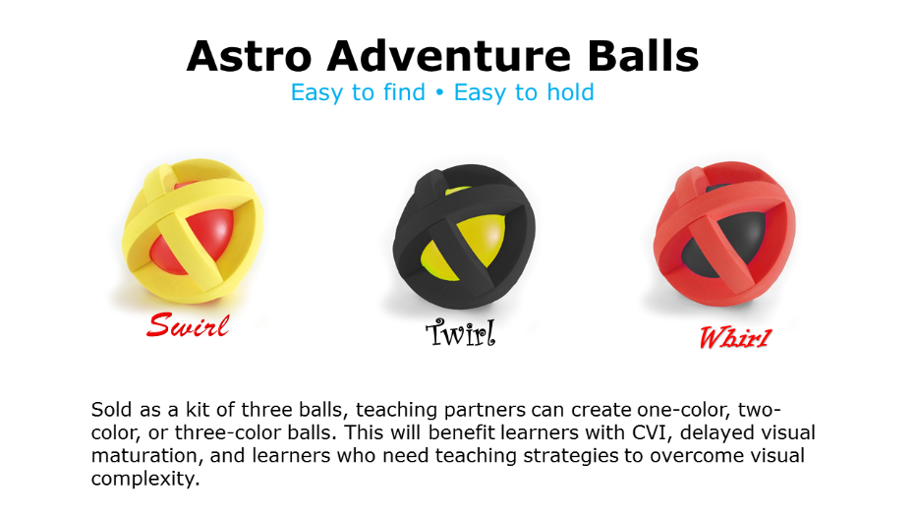
Purpose
Purpose 1: To bring back a discontinued ball that is in high demand by teachers, parents, and children. The commercial manufacturer discontinued it.

Purpose 2: To provide animated cartoons in an app that will help students develop visual complexity skills
Project Staff
Tristan Pierce, Multiple Disabilities Project Leader
Susan Sullivan, CVI Project Leader
Rod Dixon, Manufacturing Specialist
Background
This lightweight plastic ball produces sound for 20 seconds after the ball stops rolling. The dense foam exoskeleton allows small hands to grasp and hold the ball; it is especially good for young learners who are learning hand movement and exploration. APH sold this ball in a variety of colors from 2004-2007. It was not available for purchase with Quota funds; it was a product sold for cash. When the manufacturer discontinued it, APH purchased all balls they had in stock and offered to purchase the tooling so APH could continue to provide the ball too young learners with visual impairments. Unfortunately, the manufacturer decided to sell that division of their business to another toy manufacturer, who then sold it to another. That manufacturer agreed to work with APH, but they could not find the ball among the purchased acquisitions. Also, the patent on the design of the ball did not belong to the original manufacturer; it belonged to an independent toy inventor, with whom APH was unable to open a line of communication. APH waited 10 years for the patent to expire. Over the years, APH has had requests for this ball from swim coaches, teachers who work in early childhood programs, and from APH Ex Officio Trustees.
Work during FY 2017
The Multiple Disabilities Project Leader conducted a short online survey titled, “Where did that ball go?” to confirm that persons familiar with the original ball still wanted APH to provide it again and to see if there was interest from individuals unfamiliar with the original ball. APH received 50 responses during the 30 days of posting. When asked if they would like APH to sell this ball again, 49 individuals answered the question and 100% of them said, “Yes.” Of the original ball colors, the weighted average of each color option shows that respondents preferred the red and yellow ball. APH plans to sell the new ball in a set of three using the colors red, yellow, and black. These high-contrast colors are advantageous for young learners with cerebral/cortical visual impairment; also, children with low vision and children who have no visual impairments enjoy these colors. The design of the ball allows the balls to be unassembled and reassembled to make a one-color ball, a two-color ball, and a three-color ball.

Additionally, APH hopes to incorporate another change from the original ball, which is to have a different sized/type BB ball inside each ball so each ball will have its own sound. Likewise, each ball will have its own name—Swirl, Twirl, and Whirl: The Astro Adventure Balls. The BB ball in the original ball measured 8mm. APH tried smaller and larger BB balls but they did not work.

The Multiple Disabilities Project Leader and the CVI Project Leader began to write the cartoons for the development of the app.

Work planned for FY 2018
The project leader and manufacturing specialist will test BB balls that measure larger than 8mm to see if a difference sound can be produced in each of the three balls. The project leaders will continue to write app scenarios for the animated balls: Swirl, Twirl, and Whirl.

Art Digitizing/Modernizing of On the Way to Literacy Storybooks
(Continued)

Purpose
To replace deteriorating film art with digital art, reduce page sizes to enable in-house production of the books on IGEN® equipment, modify tactile and visual illustrations, convert and produce in Unified English Braille (UEB)

Project Staff
Suzette Wright, Emergent Literacy Project Leader
Anthony D. Jones, Art Production/Design Manager
Frank Hayden, Director of Technical & Manufacturing Research
Monica Vaught-Compton, Project Assistant

Background
The 18 storybooks in the On the Way to Literacy series were first produced in the early 1990s using film art, then standard in the printing industry. The original film art for the books had been deteriorating; some time ago, Production began asking that the print tooling for the books be recreated in digital file formats. In addition, because the cost of offset printing rises dramatically when fewer than 300 to 500 copies are printed, and books are not inventoried, Production staff recommended redesigning the books for IGEN® production. This would make it possible to produce smaller runs in-house. To make this change, however, required a reduction in page dimensions.

Meetings with production staff defined additional objectives for the modernization effort and the opportunity to update other aspects of the books. Consumers and focus group members have repeatedly noted the importance of providing read-aloud books that will also interest sighted peers. For this reason, it was proposed that print illustrations be modified to make the illustrations more visually attractive for sighted audiences without disadvantaging the tactual reader. The new print illustrations accomplish this by suggesting background images that duplicate information already in the tactile illustration or use decorative patterns (a colorful page border) intended only for the sighted reader. The project leader also requested that a more “book-like” binding be considered for some books, a request also voiced by teachers and parents, although this change was not approved at the time.

At the beginning of the effort, the project leader and Director of Technical Research analyzed the 18 books in the On the Way to Literacy series and grouped them according to type and nature of the modifications to be made. Colors were chosen based on IGEN® swatches, and the Low Vision Project Leader was consulted regarding visual art modifications. The project leader worked with the in-house graphic designer and outside graphic designers, under the in-house designer’s supervision, to begin the modernization of the first five books (Something Special, That’s Not My Bear, Giggly Wiggly, The Littlest Pumpkin, and Jennifer’s Messes). Two other titles began the process of modification. During FY 2011, the project leader, Technical Research, and Production staff reviewed test runs of the newly modernized art for Something Special, That’s Not My Bear, and Giggly Wiggly, produced on IGEN® equipment. Some files were modified to address concerns with color consistency and margins. These required repeated testing.

Digitized art for The Littlest Pumpkin was also completed. Updated print art for The Blue Balloon was designed by the project leader, and art files were completed. The graphic designer continued to work on digitizing and redesigning the art for The Longest Noodle. (Because The Littlest Pumpkin, The Longest Noodle, and The Blue Balloon contain multiple large foldout pages, these books were not able to be resized for in-house IGEN® production.)

Due to work on higher-priority projects and the discovery of a “work around” for the deteriorating film art, as well as time required to fit test runs into a busy Production schedule, a decision was made to suspend work on the art digitizing/modernization of the On the Way to Literacy series in FY 2013. Nevertheless, a spreadsheet was developed specifying each of the 15 steps in the redesign and testing process with space to record target dates and progress for each of the 18 titles.

In late 2014, work began again on the project. The progress spreadsheet was used to track progress as files were updated, given to Production for test runs and embossings, and returned for approvals and modifications. Two books (That’s Not My Bear and Giggly Wiggly) were tested again on the IGEN® and test embossed. Files for both books were ready to be posted to the Production server, requiring only that the graphic designer receive from Production information about the numbering and file setup for IGEN® production; this was delayed by negotiations related to the new IGEN® contract.

Following negotiation of the IGEN® contract, Production supplied the necessary information for file numbering so that work could proceed. The new graphic designer was acquainted with the project, status of each book, and located the previous graphic designer’s files. He was provided with templates to guide layout of print and braille interlined text. Specifications for That’s Not My Bear and Giggly Wiggly were provided to Production in January 2015.

In early 2015, the final decision was made to update all 18 titles to UEB. The project leader conducted an examination of all books to assess impact on each book’s layout of text and graphics. Steps for UEB translation and production of new UEB braille plates were added to the progress spreadsheet. It was decided that, beginning with the next book to be modernized, UEB changes would be incorporated into the modernization effort. Books already modernized will receive UEB updates later.

Modernized files (completed before the decision to move to UEB compliant) for Jennifer’s Messes and Something Special had been completed by the previous graphic designer. Braille alignment needed to be checked. The art also needed crop marks and correction of a card insert and punctuation sign. The current graphic designer made these changes. In 2016, modernized digital files with updated print art for Something Special and Jennifer’s Messes were posted to the Large Type server for Production’s use, and final specifications for both books were turned over to Production. The new digitized and redesigned print art files were used to produce Giggly Wiggly, That’s Not My Bear, and Something Special.

In 2016, work began on the next title to be modernized, Geraldine’s Blanket. In accordance with the decision to update to UEB, a new translation was made, checked, and approved. New braille plates were made and corresponding new print copy (with changed line breaks) was given to the graphic designer to produce new print art files. Final digitized and redesigned art files for Geraldine’s Blanket were completed, tested on the IGEN®, and approved. New plates bearing the UEB braille and specification were completed. The file was posted to the Large Type server and ready for Production to use.

As a significant extension of the modernization of this series of books, the project leader had long advocated a more book-like binding and update of tactile illustrations in some books to include collage style illustrations with a wider variety of textures. Research confirms the effectiveness of this type of illustration (Theurel et al., 2013). In 2016, Craig Meador, APH President, and other in-house staff supported an initiative to redesign The Caterpillar, an On the Way to Literacy book written by Josephine Stratton (1991), to create illustrations utilizing textures with multisensory and interactive elements and a more book-like binding and cover.

The project leader selected the book to pilot this more extensive redesign, mocked up two possible devices for creating a moving caterpillar and butterfly, and rewrote the text to be shorter with an altered ending. As a means of increasing the speed of development and providing additional ideas, upper management urged use of a workshop approach to development of The Caterpillar. The goal of the workshop was to gather design and construction ideas from a small group of graphic designers, artists, TVIs, and other in-house staff by providing them with materials to construct rough mockups of the book, utilizing, as much as possible, materials already used and tested in other APH products.

In preparation for the workshop, the project leader laid out UEB and print text and drew up actual size templates group members could use to sketch or mockup tactile/visual illustrations for the book. Production staff worked to provide six sample binders showing materials used in many other APH products. The project leader also reviewed existing APH products to add to the list of available materials for tactile book creation. In addition, the project leader purchased generic materials to be used in the workshop, carefully selecting items that might be useful given the elements of the story needing illustration. Before the workshop the project leader corresponded with participants regarding the purpose of the workshop. She provided them with excerpts from Tactile Book Builder: Guide to Designing Tactile Books to acquaint them with design guidelines for collage illustrations, layout for the story text, and links to view collage style tactile books produced by Les Doigts Qui Rêvent (LDQR).

The day-long workshop was held in late March 2016 and included InGrid designer (Emily Crawford), a local artist working with students at Kentucky School for the Blind (Michelle Amos), APH graphic designer (Anthony Jones), Director of Technical & Manufacturing Research (Frank Hayden), and the CVI Project Leader (Susan Sullivan). The sample binders of APH materials and a variety of collage style books produced by LDQR were laid out. Approved color combinations providing optimal contrast were posted. Making use of the tables of collage materials provided by the project leader, templates, scissors, and glue, group members created mockups of the book. They were encouraged to collaborate or work individually, as they chose. The Emergent Literacy Project Leader and Director of Technical & Manufacturing Research were available to answer questions and offer assistance.

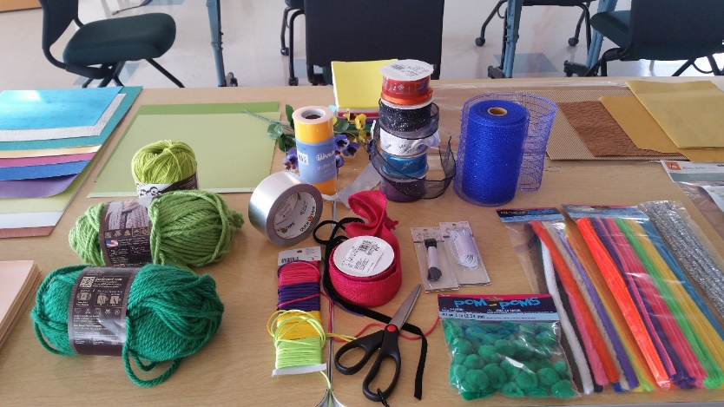

As a side note, the workshop approach was evaluated by sending participants a questionnaire inquiring about the amount of preparation they received before the workshop was held; introduction received at the workshop; structure and format of the workshop; and the time, space, and materials provided. All participants commented they appreciated the information about tactual learning and illustration sent beforehand, posted guidelines, and other tactile books provided at the workshop for inspiration. The sample binders of existing APH materials were considered very helpful. All commented they liked the basic workshop structure that allowed them to work alone, at their own speed, but to share ideas from time to time with other participants. One stated she would have preferred a more structured brainstorming period with the whole group at the beginning of the day. Although the graphic designer suggested more time was needed, another designer commented: "Timing seemed ‘spot on.’” Another stated: “The goals of the workshop and materials I was expected to use were clear. The organizer was very available and present. I felt free to interact with other participants.”

The day following the workshop, the Emergent Literacy Project Leader met with the Early Childhood Project Leader (Dawn Wilkinson) to review all versions created by the workshop members and to solicit her input. As both a TVI and a tactual learner, her feedback was highly important. The in-house staff who had attended the workshop then met with Wilkinson and discussed the mockups made. The Emergent Literacy Project Leader then synthesized all input into a single storyboard to guide InGrid in creating print art for a prototype of The Caterpillar. She provided a sample of print art from an LDQR book as a guide and print art for the entire book was received from InGrid within a few days.

The project leader prototyped all of the book’s tactile illustrations, and in combination with the print art, turned these over to Production staff for further input within 2 weeks. This was received and incorporated. The project leader continued experimentation with construction of tactile elements, particularly for the caterpillar, and timed hand labor involved. Hayden provided a detailed and extensive cost estimate. APH staff met, reviewed the project leader’s mockups of all pages and Hayden’s cost estimate, and elected to pursue development.
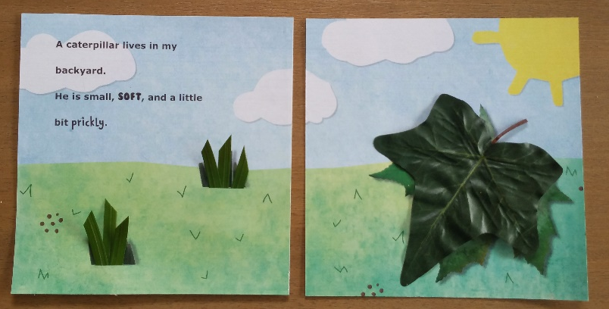

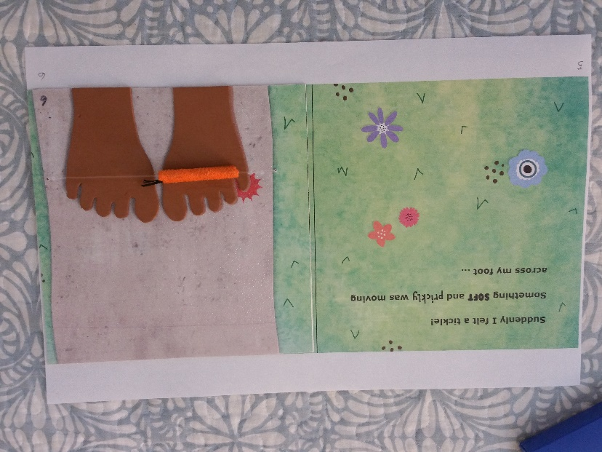

Several subsequent Product Development Committee (PDC) meetings were held with Production staff, Technical Research staff, and model maker Katherine Corcoran. Topics addressed included safety testing, available tools and in-house processes, binding methods, purchase and ordering of materials needed for prototype fabrication, and creation of needed thermoform patterns. In keeping with a request from Production a new paper stock, compatible with IGEN® was found, ordered, test printed and embossed, and approved. Print art was finalized according to instructions given to InGrid by the project leader. All thermoform patterns were completed. Dies were made for the applique pieces in the tactile illustrations. Previous inquiries by the project leader about braille for early books had resulted in a recommendation by APH staff to use UEB contracted braille for this and similar books. The braille files were prepared and proofed.

Numerous designs for creating the tactile caterpillar were explored but were not acceptable for production. After asking input from Production staff, project staff were requested to explore out of house options for making the caterpillar component. An organization was found; however, another design was accepted by Production and work began to locate the needed material and to investigate minimum order quantities and pricing for this less common material.

Work during 2017
VELCRO® brand loop material in orange was found at acceptable minimum quantities, allowing in-house production of the caterpillars. Prototype pages and covers for The Caterpillar were printed on the IGEN®. Although the final book will have embossed pages, braille labels were completed and used for the prototypes. All other materials for the tactile components were purchased or fabricated, and prototypes were completed in early December 2016. A field evaluation questionnaire for teachers and for parents was written, as was a student data form. Prototypes and the questionnaire were delivered to two families of children who attend Visually Impaired Preschool Services (VIPS) for an extended period of home use. VIPS teachers then used the prototypes for the month of January. The project leader and project assistant observed the prototypes in use with students, obtaining video footage to be used in the review process.

Field test results indicated teachers and parents were very pleased with the book as redesigned. The highly positive comments centered around the developmentally appropriate nature of the book, its tactile appeal, and interactive qualities. Comments made included:
- In the past, I have used APH’s older version of a caterpillar story, and it helped students with concept development. However, frankly, the students have shown much more obvious excitement about reading and getting to explore this book.
- I am really excited about the potential for this new series of books. In my opinion, this book is of very high quality, and I cannot wait to be able to use it and any future titles with my students.
- I like how it is just enough – not too wordy, but rich and informative for her developmental level.
- There is a good variety in the tactile/visual illustrations that creates interest in looking and touching.
- Also, I like that the cover of the book is appealing. It looks like any other children’s book, which I think is so important!

All evaluators indicated:
- the book’s text was interesting and appropriate as a read-aloud story for most students in the intended target audience
- the tactile/visual illustrations used in the storybook were interesting and appropriate for most students in the intended target audience
- the construction of the book (durability, ease of use, attractiveness) was suitable for the target population

One evaluator noted the spiral binding worked well but might distract; however, the modified National Library Service style cover and binding chosen for the book was judged to be the best in-house process available, so the spiral binding will remain. One evaluator requested the addition of a cocoon and text about the life cycle of butterflies, but it was decided this would add too much to cost. A suggestion to incorporate the concept of “across” was given, and this limited revision to the text was made.

Small indicated revisions to the book were made, including use of a slightly larger ring size and spine width to facilitate page turning and a laminated cover allowing it to be wiped clean. A second cost estimation of the book was made and given to APH staff for approval to proceed. The project leader worked with InGrid to complete final art for interior pages (including placement marks for tactile elements), slightly enlarged cover and spine, flysheet and wood pattern for “fencepost” fabrication. The project leader opted for VELCOIN® brand tab attachment to replace the elastic attachment of the caterpillar on a single page, further reducing costs. Quotes for orange VELCRO® brand loop strips (.75” x 2.375”) were received. Quotes for 7/8” white low profile VELCRO® brand hook coins were also requested and received. Use of a single, longer strip of sushi grass (164mm) or 6.45 inches) was tested and decision confirmed to use this instead of a type of plastic floral grass. The Manufacturing Specialist is working with an outside printer regarding cover lamination, as this process no longer exists in-house, and has received quotes for outside printing of the cover and laminating of the cover. Other than receiving and approving the cover sample from the vendor development of the book was essentially complete in April of this year.

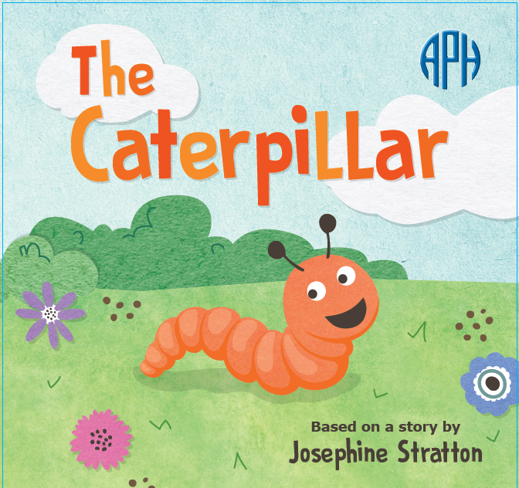

In keeping with the decision to continue modernization of the series, a second title, Jellybean Jungle, was chosen. The workshop to explore ideas for adapting the book was held in February. Participants included Production staff members (Tom Dunn, Denise Merideth), parents of children with visual impairments (Pauletta Feldman, Martha Hack), the InGrid graphic designer (Emily Crawford), and the Emergent Literacy and Early Childhood Project Leaders (Wright and Wilkinson). Preparation for and structure of the workshop were similar to the previous workshop, but more time was spent initially discussing the book as group before breaking to work separately. Some excellent rewrites of the original text were suggested. Following the workshop, the project leader led a group of in-house staff in a discussion of the mockups and alternative texts. Several rewrites of the text have been made, based on texts written by Dunn and Wilkinson. A mockup of Jellybean Jungle is being prepared by the project leader for presentation at the first PDC meeting.

Work planned for FY 2018
Final tooling and specifications for The Caterpillar will be completed and given to Production, allowing production of the book to begin.

The mockup of Jellybean Jungle will be presented to members of the PDC for their input; product development will begin leading to completion of prototypes and field evaluation followed by revision in late FY 2018.

Early Childhood Needs
(Ongoing)

Purpose
To research and develop educational materials that meet the needs of early interventionists, teachers, and parents, which address the diverse needs of children birth to six years with visual impairments

Project Staff
Dawn Wilkinson, Early Childhood Project Leader
Monica Vaught-Compton, Consultant
Rachel White, Research Assistant
Kelly Kennedy Mimms, Research Assistant

Background
Product development in the area of early childhood has continually been a focus of the Research Department. Various project leaders have sought input from the field to develop products that meet the needs of early childhood across the curriculum. Dawn Wilkinson assumed the Early Childhood Project Leader position in March 2014.

Work during FY 2017
The project leader continued to manage the early childhood projects currently under development and review new product submissions, conduct needs and feedback surveys, and so forth. The project leader continued to represent APH at multiple events and network with Ex Officio Trustees, teachers, early interventionists, and parents.

Work planned for FY 2018
Investigation and development of new products for early childhood will continue, along with modernization of existing products. The project leader will collaborate with experts in the field, conduct literature reviews, and present to/attend conferences in order to determine appropriate educational products and materials to address best practices in the area of early childhood and visual impairment.

Emergent Numeracy Kit For Preschool
(Continued)

Purpose
To determine major needs areas in emergent numeracy for young children with visual impairments, and to develop a kit to be used by early interventionists and preschool teachers

Project Staff
Dawn Wilkinson, Early Childhood Project Leader
Jeanette Wicker, Core Curriculum Consultant
Kelly Kennedy Mimms, Research Assistant
Adam Clark, Manufacturing Specialist
Matt Poppe, Graphic Designer

Background
During the past few years, there has been a continual focus in many journal publications concerning teaching emergent numeracy concepts to very young children. There is evidence that combining math and literacy through the use of picture books in a meaningful situation can increase a young child’s understanding of numbers in the real world setting. Since a great deal of research has focused on storybooks that are picture based and use math manipulatives that are color dependent, it is in the best interest of young children with visual impairments that these materials be adapted accordingly. The development of an early childhood numeracy product was subsequently ranked as a very high priority by the Early Childhood Focus Group held at APH in 2012.

On May 30, 2013, APH received a product submission idea form from Christine Moe, a teacher of the visually impaired, suggesting a product that would include a storybook and manipulative to teach specific early numeracy skills to toddlers/preschoolers with visual impairments. This product idea was taken to the Product Advisory and Review Committed on January 9, 2014, by Kate Herndon and moved into active development.

The project leader gathered relevant journal articles addressing best practices in early numeracy. Research included a comparison of the development of numeracy skills by children with and without vision. Top selling commercially available math manipulatives were evaluated for their usefulness and adaptability for children with visual impairments. Popular storybooks addressing math concepts were considered for relevance in this kit. Suggestions were sought from the field concerning teaching beginning numeracy skills to preschoolers. Numerous possibilities of components to be included in the kit were discussed.

In 2015, project staff determined that the areas needing to be addressed encompassed such a wide range of skills that multiple kits would be required. At that time, the project leaders decided to develop from three to five kits with books, based on the five domains of the Common Core State Standards for math that are addressed in kindergarten. These include counting and cardinality, operations and algebraic thinking, number operations, measurement and data, and geometry. Since there are not Common Core standards nationally for preschool, the project leaders compared these domains addressed in kindergarten to several sets of Early Childhood and Pre-K standards from numerous states, determining this to be the most logical approach. Lists of the most popular books taught in general education classrooms were evaluated and the first book was chosen: Five Little Speckled Frogs. The first meeting was held with Technical Research in late January 2015 to discuss the multiple components of the kit for Five Little Speckled Frogs. This first kit will include a print/braille book with some tactile graphics, a storyboard with manipulatives and number tiles, frog and dragonfly manipulatives, and a short teacher guide. Materials were sought to make the manipulatives for the prototypes of Five Little Speckled Frogs, but work on this project was slowed by other priorities.

In 2016, meetings were held to review the prototypes of the 25 frogs and log needed for the Five Little Speckled Frogs book and storyboard. The jumping frogs were remade because they appeared too elongated. The manufacturing process for the log was determined, and the development of prototypes began.

The project leaders submitted permission requests to publishers for adaptations of two other books for the next kits in the Emergent Numeracy series. One book request was declined, but the second book proposed, My First Book of Shapes by Eric Carle, was granted permission by the publisher.

Work during FY 2017
Graphic design completed the artwork to accompany the public domain text of the Five Little Speckled Frogs book, and the text was brailled. A survey for field testers was placed in the February 2017 APH News; a total of 63 participants responded to the survey. Field testing was expected to begin in late spring for the 15 participants who would be selected from those who responded to the early numeracy field test survey. Problems were encountered while making the prototypes for field testing, however, when the printed pages were to be embossed from the braille plates. Both the print pages and the plates had to be redone, and a new texture was chosen during this process for the embossed log. As a result, field testing was delayed, but is expected to begin in the fall.

Work planned for FY 2018
Project staff will work to complete the following tasks:
- Prepare field test evaluation and send out kits for field testing of Five Little Speckled Frogs
- Analyze field test results and make revisions
- Complete tooling of Five Little Speckled Frogs so that it is available for sale
- Complete prototypes of the next numeracy kit

Identify field testers for the next early numeracy kit using a request for field testers in the APH News and/or the early childhood electronic mailing lists, as well as a search in the APH Field Tester Database.

Fingers That Dream
Formerly Tactile Books/International Collection
(Continued)

Purpose
To collaborate in order to provide high-quality tactile illustrated books with print/braille text to support the emergent literacy skills of young children with visual impairments and to join the efforts of Les Doigts Qui Rêvent (LDQR) and other organizations in sharing information leading to improved quality and production of tactile books

Project Staff
Suzette Wright, Emergent Literacy Project Leader

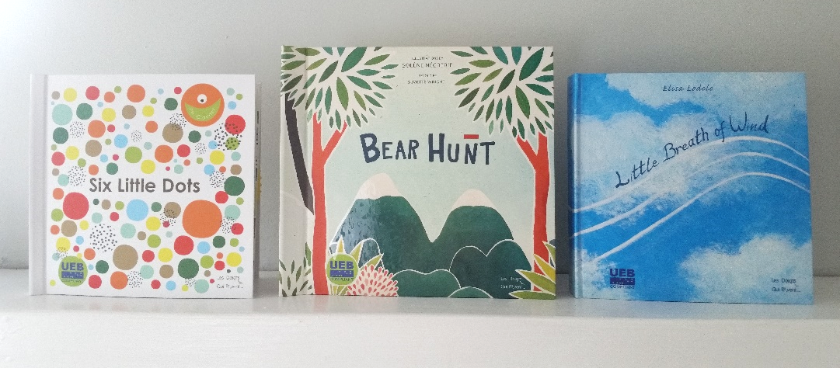

Background
The LDQR workshop, located in Dijon, France, has specialized in the production of collage style tactile illustrated books since its establishment in 1994, producing more than 40,000 books in in multiple languages. Philippe Claudet, a French TVI and director of LDQR, has been in communication with the project leader since 2005. He has presented at APH (2011), Getting in Touch with Literacy (2011), and with the Emergent Literacy Project Leader at the international conference of the Association for Education and Rehabilitation of the Blind and Visually Impaired (2014), and the Western Regional Early Intervention Conference (2015). APH staff and conference participants commented on the high quality of the books’ construction, braille, and use of varied materials with rich textures and interactive materials that invite and encourage tactile exploration.

Richly textured books such as those produced by LDQR meet a need identified by the Early Books Focus Groups (2004, 2007) and Meeting of the Minds (2011) for a greater variety of books for young tactual learners—“something besides raised line drawings and thermoforms.” LDQR’s books include hand labor and often involve sewn parts and special methods of attachment, enabling moving parts, as well as fabric textures.

Available research supports the central role of texture in interpreting tactile illustrations (Theurel, et al., 2013; Gentaz & Hatwell, 2003). Research has shown that even for sighted children up to the age of 6, texture is more salient than shape and is given “massive priority” over shape and size as a classification criterion (Gentaz & Hatwell, 2003; Schwarzer et al., 1999).

After gathering input from in-house staff and others, Little Breath of Wind was chosen as the first book that APH would seek to purchase from LDQR, translate, and distribute. A product submission form for Little Breath of Wind was completed; it was approved by the Product Advisory and Review Committee (PARC) as a “pass through” product. In-house, decisions were made about preferred labeling and packaging methods, the need for safety testing, and issues related to shipping and passage through Customs. Claudet contacted Intertek, an international testing agency recommended by APH, to conduct all necessary safety tests. APH’s Purchasing staff negotiated purchase and terms of delivery with LDQR. The book’s text was translated into English and a braille file given to LDQR by the project leader. Permission to distribute the book as a Quota item was sought and received. All standard U.S. safety tests were passed. In March 2013, the first shipment of 250 copies arrived at APH’s docks, ready to ship. The second shipment of 250 arrived in May. By the end of September 2013, all 500 copies had sold.

Based on the successful purchase and quick sales of the first book, as well as positive feedback from teachers and APH Ex Officio Trustees, it was recommended that a second book be purchased from LDQR for distribution on Quota. The Emergent Literacy Project Leader reviewed copies of many LDQR books to identify those best meeting needs identified by previous focus groups and consultants. She consulted with Claudet about the expense of producing each before selecting 14 books to submit to in-house staff and staff of the Building on Patterns PreK project to obtain their recommendations. Chameleon, a board book written by Antje Sellig, was chosen, featuring collage-style illustrations of a chameleon shape illustrating opposites. It was recommended the book be provided in contracted braille.

Following procedures used with Little Breath of Wind, a purchase of 500 copies of Chameleon was negotiated; APH provided an English translation of the text along with Unified English Braille (UEB) files. Intertek conducted all necessary safety tests, this time at significantly reduced cost since LDQR had identified a way to group materials. The project leader maintained contact with LDQR and communicated with APH’s Purchasing Department concerning progress. Production of Chameleon began in January 2015. In April, the first shipment of 250 books was delivered to APH. These sold quickly. The second shipment of 250 was requested, arrived in early August, and also sold quickly.

An informal written poll of Ex Officio Trustees at the 2015 Annual Meeting indicated many would like APH to repurchase copies of Little Breath of Wind and Chameleon. This was attempted; however, the author of Chameleon demanded a significantly higher payment from LDQR for the second run of this book (10% of APH’s previous selling price), in place of LDQR’s standard, flat fee agreed to in their initial contract. LDQR declined her terms and will not produce the book again.

In place of Chameleon, the project leader proposed another recent title published by LDQR, Little Paths, by Catherine Colin, ideal for promoting tracking skills and encouraging texture discrimination. PARC approved a request for a quote, a purchase was negotiated, appropriate translations made and given to LDQR, and 500 books were received by September 2016.

An additional book favored by APH, Press Here, could not be obtained because the right to make a tactile adaptation for distribution in the U.S. was withheld by Chronicle Books.

Work during FY 2017
Stock of Little Paths was quickly depleted. The purchase of three more titles from LDQR was successfully negotiated this year; all three titles were received and stocked: the requested repurchase of Little Breath of Wind in contracted UEB—and two new titles (Bear Hunt, Six Little Dots).

The project leader worked to guide selection of the books, provide English translations and contracted UEB texts, select substitute materials where needed, comment on design of the books, and act as additional support for APH staff in obtaining quotes, resolving problems, following progress of safety tests, and subsequent costing and advertising of the books.

Little Breath of Wind was received in late November of 2016.

Received in June of this year, Six Little Dots, by Philippe Claudet, was translated into rhyming English text. “Meet Little Dot...he can hop from spot to spot!” begins this texture-rich book about braille fundamentals. Each ½-inch dot is a different and distinctive texture and color. Little Dot 1–sliding on elastic–hops and moves about, exploring different dot positions along the way. The print/braille text introduces and names dot positions 1 through 6. At its simplest level, it encourages fingertip texture discrimination and exposure to spatial concepts—top, middle, bottom, above, below, and under. For students ready to be introduced to dot positions and names, it offers a fun approach to this step in their learning.
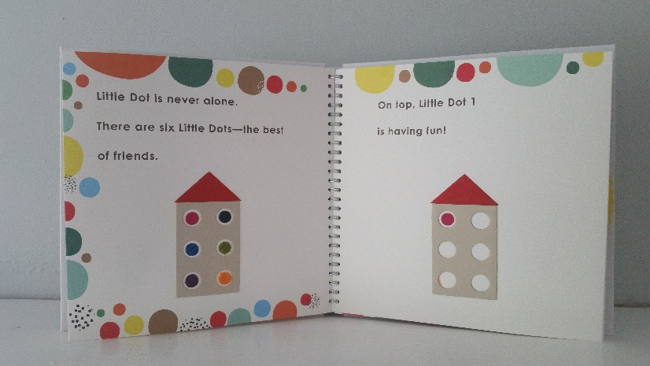

At the end of the book, a rotating game wheel with a window can be turned to show each textured dot and asks the reader—“Which Little Dot am I?”

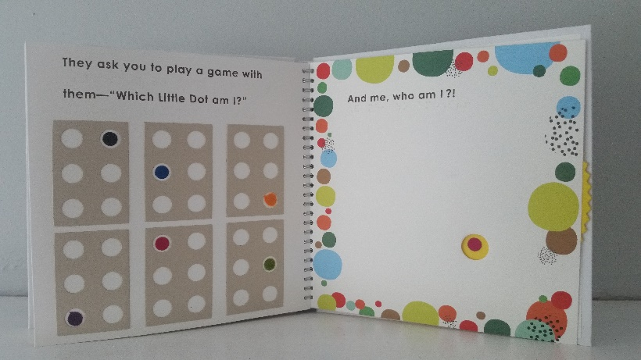
Delivery of Bear Hunt (La Chasse á l’Ours) took place in July. Bear Hunt, a collage style book with moving interactive pieces and diverse textures, is LDQR’s award-winning adaptation of the classic children’s chant. In 2016, the International Bologna Children’s Book Fair, the largest of its kind, established a new award category: books about a character with a disability or books accessible to children with a disability. Bear Hunt was one of five books awarded in this category and the only awarded book in an accessible format. Although LDQR’s text closely follows Michael Rosen’s version of the traditional public domain children’s chant (permitted by French copyright law), the text of the APH version was written to avoid similarities and the possibility copyright permission might be withheld by the holder of the U.S. rights to the Rosen text.

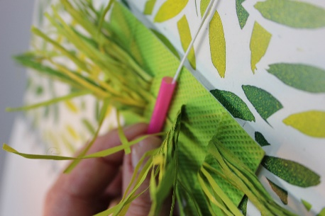
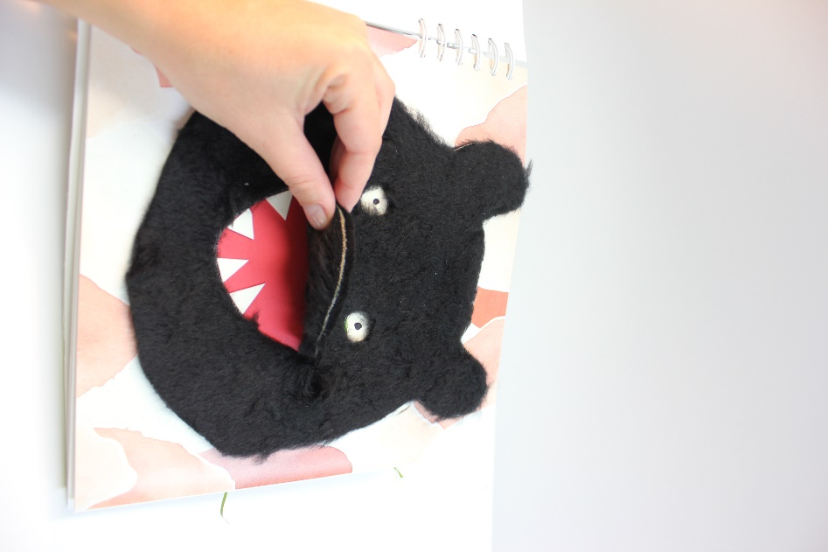

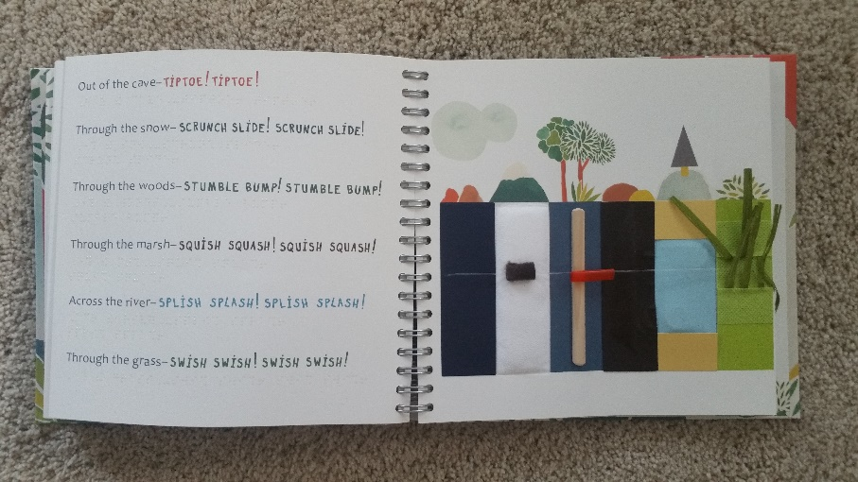
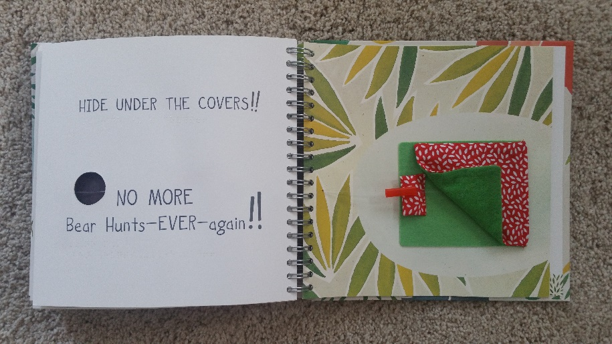

In addition to these titles, the project leader continued to communicate with LDQR about commercially available titles each discovered and discussed possible tactile adaptations. The project leader provided an English translation of a holiday Christmas story. Adaptation of The Gruffalo, by Julia Donaldson, and an initial prototype of another commercially available book, Four Corners of Nothing, by Jerome Ruillier, was made by LDQR based on collaboration between the project leader and LDQR staff.

In August, a recommendation was made to PARC concerning additional titles to be translated and produced for APH in FY 2018. The project leader has chosen from books entered in the 2015 Typhlo & Tactus tactile book competition. These books have been favorably reviewed by their national panel of judges and the international panel of judges that includes professionals involved in tactile book design over a 20-year span. Another book of interest to the project leader and LDQR for the past 3 years was also recommended; a prototype meeting the criteria of the project leader has been developed. The author has agreed to possible production for APH, but permission must be granted by the holder of the rights in the U.S. LDQR has been asked to advise APH on any cost savings that might be realized by aligning production for APH with production of the same title for Germany or France.

APH also began negotiations with LDQR to purchase and distribute the Six Dots Game of Cards, a companion to the book. A game of 42 cards configured to resemble a braille cell, each card uses the same textured dots that appear in the storybook to play a game modeled after “Go Fish”—only the playing field can be leveled when sighted players participate by playing in the dark! Players identify texture and dot position to collect the cards needed to win. The project leader translated the instructions and texture names for the cards.

Work planned for FY 2018
Appropriate permissions will be sought for Four Corners of Nothing. Work on other titles, not affected by copyright permissions because they are original works, will proceed. It is planned that two titles will be produced by LDQR and will be available from APH in FY 2018.

In addition to these two tactile books, production of Six Dots Game of Cards will be completed and made available.

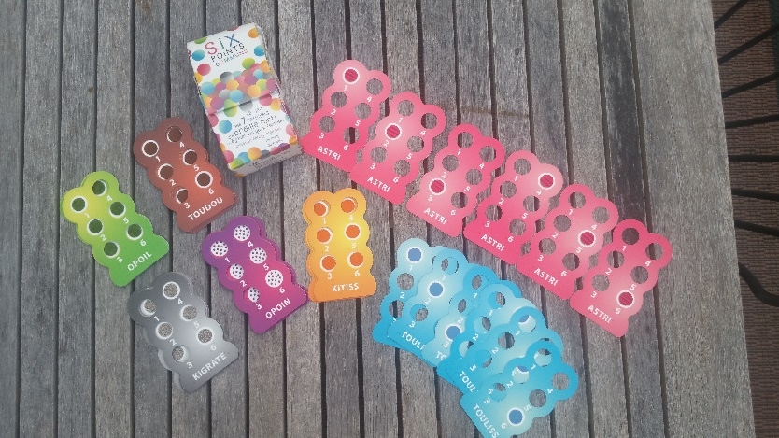

FirstTouch Books
(Continued)

Purpose
To develop read-aloud, tactile illustrated books with interactive features that support the development of emergent literacy skills for students birth to 3 years

Project Staff
Suzette Wright, Emergent Literacy Project Leader
Monica Vaught-Compton, Project Assistant
Wendy Sapp, Consultant

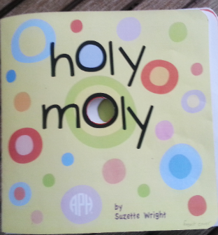

Background
Children take their first steps toward learning to read and write early in life. Reading aloud to a child, from infancy onward, has been cited as a key contributor to later success in learning to read. Early, positive experiences with books motivate children to become readers. Oral language skills, listening skills, and vocabulary are built as the adult reader and young child share a book and talk about its words and illustrations and relate these to the child’s own experiences. Early experiences with books provide opportunities to encounter written words and to learn book-handling skills. Young children who will read braille, however, face a limited selection of books in braille, particularly print/braille books that enable a typically sighted adult to read aloud to the child. Even fewer books contain tactile illustrations, capable of adding interest and meaning to the words of a story. APH and other braille publishers have worked to expand the availability of print/braille books. APH’s On the Way to Literacy books for children, ages 3 to 5 years, and the Moving Ahead Tactile Graphic Storybooks for ages 4 to 6 offer print/braille texts and tactile illustrations designed to introduce children to a range of types of tactile displays. Given the importance of books for young children who will read braille, APH continues to make strong efforts to poll the field to determine current needs and to seek help in prioritizing these needs. In an online survey, 140 of 156 respondents ranked very simple, early books for birth to 3 years as a high need. This need was also noted by focus groups.

The objectives for books for this target audience were defined in detail. The project leader examined current offerings of braille producers to determine what was already available in print/braille for children from birth to age 3. She searched commercially-available print books to identify titles that might be adapted, seeking books with high quality language that would lend themselves to the addition of simple tactile, interactive, or other multisensory components. Hundreds of books found through a wide variety of sources were considered. In addition, designs for a variety of kinds of tactile interactive components were considered and reviewed by in-house staff regarding their feasibility for mass production.

This information was submitted to two consultants with combined experience in teaching and in research regarding emergent literacy for children with visual impairments. The resulting recommendation was that APH develop both types of books for students ages birth to 3 years: adaptations of high-quality, commercially-available books with tactile components added by APH, and APH-created books with simple texts written to support meaningful tactile, interactive components.

The combined efforts of the project leader and consultants to locate a print book that would be excellent, once adapted, for children birth to 3 years were not initially successful. The project leader continues to monitor commercially-available print books for the birth-to-3 age group that could be adapted.

For books in the FirstTouch series, it was proposed that books be developed one at a time. The series will eventually include adaptations of commercially-available books, as suitable ones are discovered, as well as original books. The proposed project received the approval of the Product Evaluation Team and the Product Advisory and Review Committee and was removed from the parking lot in late spring of 2009. In June, the first Product Development Committee brainstorming meeting was held. A number of good ideas regarding book construction were received. Individuals, including both parents and teachers, were encouraged to submit ideas and original drafts. As a result, four promising drafts and sketches or descriptions of accompanying tactile, interactive components were obtained.

These were submitted to the project consultant for a detailed review, including a rating of each draft and ranking of their suitability for the target audience. Two drafts were rated “excellent” as candidates for further development. The draft ranked first, Holy Moly, was roughly laid out in electronic form by the project leader, including dimensions, materials, and tactile as well as visual illustrations. This file was sent to several current and past consultants for a preliminary, informal review and was examined by in-house staff regarding production methods that might be used.

The book includes a rhyming text and features textures, flaps to open, and die-cut holes on each page to be explored, counted, and compared. The braille text is embossed on clear labels applied over the print page. Brightly colored very simple background patterns form the print art. The large print text contrasts with the background colors and is in a san serif font.

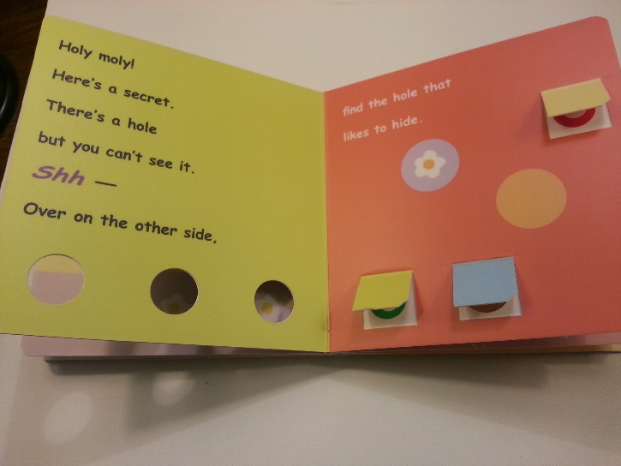

Various production methods for board books were examined and priced. Methods and materials for all of the book’s tactile interactive components were determined and priced; relevant safety standards were investigated to ensure compliance. The text and all tactile interactive components for the book were finalized. The braille tooling for the book has been completed. The project leader provided the graphic designer with the files and information needed to work on the book’s art.

The book was given out for bids, and a vendor was selected. The vendor agreed to provide the prototypes for the field evaluation. The graphic designer was given what was needed to produce print art files.

The braille files for the book were completed; the book is compliant with Unified English Braille (UEB). The graphic designer completed work on print art files. The textures, scented stickers, and cord for the book were selected. Field evaluation sites were sought and contacted. A questionnaire for the books was designed. Problems in obtaining all requested prototypes from the vendor and the winter holiday delayed the start of field evaluation by several months.

Field evaluation began in January, and completed forms were due by March 31; additional time was offered as needed, and all forms were received by end of April. Participating teachers were mailed the book, a general questionnaire and child information forms soliciting each student’s reactions to the book (level of interest, mode of exploration, level of prompts used as the book was read) and other student background information. In addition, a parent/caregiver form was provided to collect the parents’ observations regarding their child’s use of the book. Teachers were encouraged to leave the book in the home, when possible, for parents and caregivers to read to the child. Video footage was requested, if possible, of the first and second readings of the book.

Teacher evaluators were asked to read the book a minimum of 2 to 3 times with each student meeting the following criteria:
- child functions from 0 up to 4 years of age but has a chronological age less than 9 years
- has a severe visual impairment and is primarily a tactual learner or combination tactual and visual learner
- is not yet reading but were he/she to become a reader is likely to need braille
- does not have a motor impairment that significantly limits the child’s ability to use his/her hands and fingers for tactual exploration
- has moved beyond keeping hands in a tightly gripped/closed fist position and is just beginning or is already able to use fingers for exploration
- may or may not have additional disabilities, such as learning delays, mild to moderate cognitive impairment, and mild impairment of his/her ability to use fingers, hands, and arms for tactual exploration

The book was used by 13 TVIs and 16 parents with 27 students, aged 10 months to 5 years (chronological age). Video footage was requested; videos of 11 students were submitted. For three students, videos of the first and second reading were returned.

Data collected from the Child Information Sheet shows that 15 female students and 12 male students took part. Their ages were distributed as follows:
6 to 11 months—1 student (1 female)
12 to 17 months—1 student (1 female)
18 to 23 months—3 students (3 females)
24 to 29 months—7 students (2 females; 5 males)
30 to 35 months—6 students (3 females; 3 males)
36 to 41 months—4 students (3 females; 1 males)
42 to 47 months—1 student (1 female)
48 to 52 months—2 students (2 males)
52 to 60 months—1 student (1 female)
Unknown age—1 student (1 male)

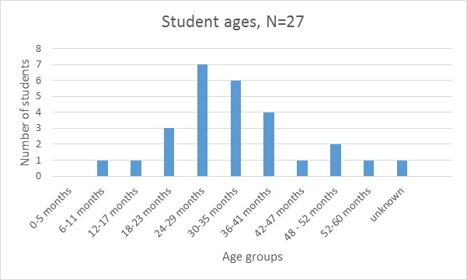

Teachers rated students’ interest from low (0=no interest) to high (3=very interested). Five students were rated “1” (19%). Seventeen students were rated “2” (63%); 5 students were rated “3” (19%).

In terms of interest as a function of gender, male students averaged a rating of 2.2 and females an average of 1.9. A possible mitigating factor in this difference is the fact that the 7 of the 12 youngest students in the evaluation were female, and all 5 of the youngest students were females.

Yet interest did not appear to be age-related in this small sample whose distribution was weighted in favor of children from 18 to 42 months. Of the students rated “3” or “very interested”—ages varied: 10 months, 24 months, and 36 months. (There was one student rated as very interested for whom a birthdate was not given). Similarly, for students rated a “1” (“not very interested”)—ages also ranged widely: 20 months, 24 months, 36 months, and 60 months.

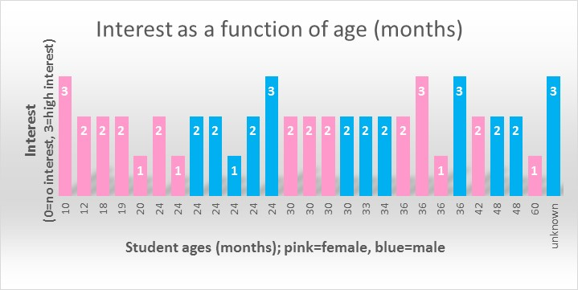

Teachers were asked to indicate how each child explored the book. Overall, 4 of the 27 students explored “only tactually,” 10 explored “primarily tactually,” 9 explored “equally tactually and visually,” and 4 explored “primarily visually.” Analyzing students’ interest in the book as a function of mode of exploration, of students rated “very interested,” 2 were primarily tactual learners, 2 explored equally tactually and visually, and 1 student was primarily visual in his exploration. Of students rated “not very interested,” 1 student was only tactual, 2 students were primarily tactual, 1 student was equally tactual and visual in his exploration, and 1 was primarily visual. These results and observation of student videos inclined the project leader to believe the book may have been slightly less engaging for strong tactual learners. In addition, some of the teachers expressed the opinion that more textures were needed.

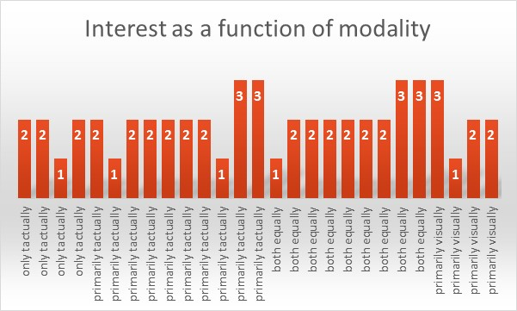

It was noted that only 9 of the 27 students received more than one reading of the book, less than the requested minimum of 2 readings. And it appears that many students receiving 2 or more readings were rated as having higher interest in the book. For several students, teachers commented that the child became more interested by the book after the first or second readings. This was observed in the videos of one student, for whom the teacher supplied videos of an initial and a later reading. In previous evaluations of other tactile books, teacher evaluators have also made this observation: Interest appears to increase over several readings. However, it is also possible that some students received more readings because they requested/accepted additional readings, and that teachers did not repeat readings if a student was initially uninterested.

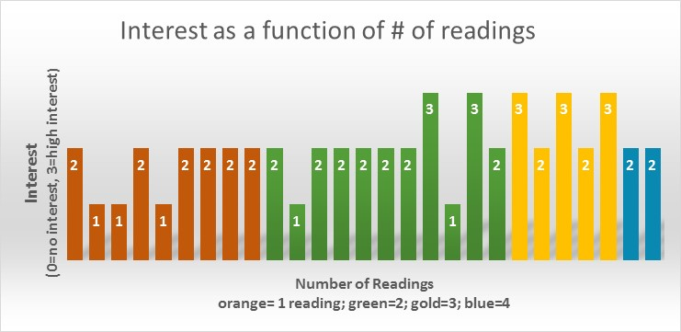
Parents answered similar questions about their child’s apparent interest in the book and mode of exploration. Their answers largely agreed with answers given by teachers on the teacher version of the Child Information Sheet. Separate analyses of parent answers are not provided here with the exception of two students, for whom only the parent version of the Child Information Sheet was returned.

Additional teacher input was collected via the Teacher Questionnaire, which asked the teacher to comment based not only on the current student(s) with whom he/she had used the book but on other students in the target audience with whom she/he had had experience.

Asked if the text was "interesting and appropriate" for children meeting the criteria set out for the field evaluation, 10 of 13 (77%) teachers responded "yes." Comments included the following:
- "I like the repetition of holes and the rhyming words. The book is simple."
- "Use of rhyme and silly language is attractive to these students."
- “I love how it rhymes and how it teaches many different concepts for 2 to 4 year olds.
- "Nice incorporation of concepts that can be incorporated into other prebraille activities."

Two evaluators indicated the text was "too long…babies want to move to the next page" and that "young toddlers" might not be ready for the book. A third evaluator indicated the text was not appropriate because children were directed to "see" but that otherwise, text was appropriate.

Ten of the teachers (77%) responded that the tactile/visual illustrations were "interesting and appropriate" for this population. Comments included the following:
- "Little fingers can easily find the holes and textures—they are just the right size."
- "I like that it looks like a typical book for young children and not something specific for a child who is blind or has disabilities."

Several evaluators indicated that depending on the child's visual diagnosis, colors could be "more stimulating." In addition, a longer cord was requested for the page that features lacing; however safety standards restrict the length to what was provided.

Construction of the book was approved of by all evaluators, who indicated the book's pages were easily turned and the book was durable. Two were concerned that flaps might be eventually torn.

Videos showed wide variation in how adults shared the book: length of time taken to read and explore the book, whether interactions surrounding the book were playful or “educational” in nature, and the extent to which the adult reader followed the child's lead or imposed a pace set by the adult. Videos showed the children covered a wide spectrum from being highly engaged and capably handling the book, to limited engagement and awareness of the activity. In some cases, environment may have contributed: Background noises were noticeably distracting in two videos, and the child was engaged in drinking while being read to, but appeared to need this to settle in the adult’s lap.

Based on the field evaluation, the following revisions were implemented: increasing contrast in indicated areas, adding texture to the spiral on page 1, and devising reinforcement for flaps. The target audience for the book will be defined as being for toddlers and preschoolers through age 3 years (developmental age).

Work during FY 2017
Final specifications for Holy Moly were completed and turned over to Production in July. The project leader approved press proofs from the printer. Possible texts for the next FirstTouch book were sought from commercially available children’s’ books, original texts, and public domain children’s rhymes and songs suited to a toddler audience. A promising out-of-print text was located, and permission to adapt was made.

Work planned for FY 2018
Production of Holy Moly will be completed. The in-house portion of the work includes producing braille labels and providing cut squares of textured materials. All of these will be given to the printer. The book will be printed, assembled, tactile components glued or attached, and braille labels applied by the printer. In-house staff will monitor work at the printer as the book is produced, supplying a correctly assembled version to act as a guide. Holy Moly will be produced, costed, and made available for purchase.

Selection of the second book in this series will occur and development will begin using the workshop model piloted to redesign The Caterpillar and Jellybean Jungle. (For a description of this approach, see the report provided for Art Digitizing/Modernizing of On the Way to Literacy Storybooks.)

Laptime and Lullabies
(Continued)

Purpose
Based on current literature and research in emergent literacy, Laptime and Lullabies (formerly Focus on Fingers Kit) is designed to assist family members, caregivers, and early educators in their quest to prepare infants and young children who are blind or visually impaired and may have additional special needs to enjoy tactile learning and literacy.

Project Staff
Dawn Wilkinson, Early Childhood Project Leader
Kay Clarke, Author/Consultant
Kelly Kennedy Mimms, Research Assistant
Rachel White, Research Assistant
Anthony D. Jones, Art Production Design Manager
Anthony Slowinski, Graphic Design
Bryan Rogers, Manufacturing Specialist
Katherine Corcoran, Model Maker
Monica Vaught-Compton, Project Assistant
Charles “Burt” Boyer, Project Leader Retired

Background
A review of current literature and research on braille literacy reveals a growing body of information to guide our profession in meeting the braille literacy needs of young children and those with multiple disabilities. Present emergent braille literacy materials include lists of early critical skills areas (McComiskey, 1996) and “how-to” chapters and books for teachers of children who are visually impaired (Olsen, 1981; Wright & Stratton, 2007) with a primary focus on early braille reading and writing instruction for children ages 3-5. Strikingly absent are family-friendly materials that promote an overall parental understanding of the earliest skills necessary for tactile learning and literacy, while offering practical, engaging activities that parents may implement at home and with their infants and young children to support these skills. Laptime and Lullabies is an innovative, initial attempt to meet this need.

Clarke states, “It is well known that literacy begins at birth. In contrast to prior products, Laptime and Lullabies (Focus on Fingers: Preparing Little Hands to Enjoy Tactile Learning and Literacy) addresses the earliest stages of tactile learning and literacy in a family-centered and developmentally-appropriate way, empowering families to play an active role in the beginning steps of their children’s tactile learning and literacy. Laptime and Lullabies additionally reflects a shift from traditional thinking about emergent braille literacy as ‘learning ABCs’ to a broader, research-based viewpoint that acknowledges the importance of a variety of early experiences that subsequently may contribute to competent, motivated braille readers and writers.” Laptime and Lullabies has the potential to make a significant difference for young blind or visually impaired children learning braille literacy.

The key is enjoyment! Young learners should have fun as they learn. Functional activities and literacy experiences that are developmentally appropriate and highly engaging best describe this product.

Clarke submitted this product idea to APH for consideration in FY 2010. The Product Evaluation Team recommended this product to the Product Advisory and Review Committee, which approved this product idea for development by APH. The author signed a contract allowing APH to be the sole distributor of Laptime and Lullabies, and an initial timeline to complete the product was developed. In September 2011, the project staff met to discuss the product. They established more definite timelines and a work plan for the completion of the product.

During FY 2012, the author renamed her product Laptime and Lullabies. The new title better reflects the interactive nature of preparing infants, toddlers, and preschoolers for tactile learning and literacy. The author and project leader worked to have the product meet early childhood standards, braille literacy standards, and APH standards. The author submitted six initial storybook prototypes to APH staff and sought feedback on tactile and literacy components. In August 2012, the author presented the product to the Early Childhood Focus Group at APH. Because of the many tactile components of the storybooks in this kit, a significant amount of time will be needed by APH to ready it for field testing as well as production.

In FY 2013, the author worked to complete the handbook content and preliminary prototypes of the storybooks. The author visited APH in mid-August. During the visit, project staff worked to identify product components that are feasible for production by APH. The author has developed Literacy Fun Activity Cards for inclusion in the kit; these may take the place of some of the storybooks. Each storybook is labor intensive and will add greatly to the cost of the final product.

Boyer retired from APH in March 2014, and Wilkinson commenced as project leader for this project. The author worked to complete the handbook content and mock-ups of storybooks and activity cards in the product; she submitted completed files in August 2014. Project staff began edits to submitted materials and provided extensive feedback to the author. The project leader and author worked with Technical Research to determine how the tactile components can be produced best in the field testing stage, with consideration for what materials are possible in final production. It is likely that the storybooks will be bound in three-ring binders similar to storybooks in the On The Way to Literacy Series; however, the binder size will be smaller and more appropriate for very young children to handle. Technical Research began work to design prototypes for two of the kit storybooks, Butterflies and Little Fuzzy.

A prototype of the Little Fuzzy book was completed in early January 2015 and sent to the consultant for review. The project leader and Technical Research met to discuss feedback and make revisions. New materials were sent to the consultant to evaluate for use in the revised prototype. New mock-ups of the gate and door (which are objects in the storybook), and replacement possibilities for a sticky material all had to be obtained and designed by the Model Shop. The Model Shop also began work on the first prototype of Butterflies after decisions were made regarding materials for the butterflies. Specifications for the butterflies were given to graphic design to assist in the creation of this book. The binder option had to be changed, as the On The Way To Literacy binders are approximately $25 per binder as compared to the new binder used in Tactile Book Builder, which is approximately $5 but still gives a small 3-ring binder option as agreed upon.

The handbook was divided into small booklets that will be inserted into a large binder. Graphic Design completed over half of these booklets during 2015. A new timeline was established for completion of this project in order to field test in the Spring of 2016.

In 2016, project staff completed a total of 18 booklets, which will compose the handbook set. The decision was made to include a booklet instead of bath time and bedtime cards to minimize labor and cost. The 18th booklet consists of reference citations. Five prototypes of the storybooks, Little Fuzzy and Butterflies were completed, along with five sets of the 18 saddle-stitched booklets. Field testers were selected using a request for field testers in the APH News and the early childhood electronic mailing lists, and via a search in the APH Field Tester Database. Field testing took place from April-June 2016, with each of the five kits being shared with a second site during the second month of testing, for a total of 10 evaluators in five states. Prototypes were sent to Florida, New Mexico, Arkansas, Illinois, and Colorado.

Although the response/return rate was 70%, results were reported for a total of 39 children receiving early intervention services who used the kit. Responses were provided through SurveyMonkey® to an extensive questionnaire, with all questions requiring a response. Each storybook was analyzed separately, along with each booklet from the handbook, and the kit as a whole. A summation of field testing follows.

Demographics of Field Testers

None of the respondents had worked in the field of visual impairment for less than 5 years, and 57% of the respondents had worked 10 years or more. Two respondents were also parents of children with visual impairments.

Background of Students (39 Total)
Laptime and Lullabies was used with a total of 39 toddlers: 24 male (62%) male, 15 female (38%), between the ages of 8 to 36 months.
Of the 39 children, 26% of them were totally blind; 26% had CVI, and 59% had additional disabilities. Fifty-seven percent of the students were white, 28.5% were Hispanic, and another 28.5% were black.
Where’s Little Fuzzy Storybook
What was your overall impression of the text of Where’s Little Fuzzy?
86% said the kids liked it a lot and; 14% said the kids were somewhat interested.
100% said the book was appealing both visually and tactually.
Comments:
- I would put Little Squeaky at the end of the book because it was the children's favorite and they could squeak it through the other pages so it distracted them from learning the other concepts.
- The colors and simplicity were perfect for my low vision children. Those that had fine motor control really enjoyed lifting the blankets and opening the door, gate, etc. They especially liked hitting Little Squeaky. The book encouraged development of key concepts I work with my children on such as under, open, close, names of textures, colors, and finding hidden objects.

The Where’s Little Fuzzy? Book was appealing:
100% said both visually and tactually.
Butterflies! Storybook
The butterflies were:
43% said “easy to move around.”
57% said “not easy to move around.”

The kids found the text:
71% said “somewhat interesting.”
29% said “not at all interesting.”

The Butterflies! book was appealing:
43% said “both visually and tactually.”
57% said “visually but not tactually.”

The kids found the text:
71% said “somewhat interesting.”
29% said “not at all interesting.”

Did you find the net on the last page with the extra butterfly to be:
86% said “very useful.”
14% said “confusing.”

The butterfly finger puppet was:
86% said “a lot of fun.”
14% said “not very useful.”

Handbook Set:

Which of the following best describes your approach to using this collection of individually bound booklets?
71% said they “would pull out one section at a time randomly as needed.”
29% said they “would prefer to keep everything together at all times.”

Taking each of the sections into account separately, please rate each section on a scale from 1 to 5, where 1 equals strongly dislike and 5 equals strongly like:
(Weighted Averages)
First Chapters of Literacy: 4.71
Establishing Relationships: 4.71
Share Conversations: 4.71
Focus on Vision: 4.71
Grow Listening Skills: 4.86
Enhance Touch: 4.86
Partner in Play: 4.71
Explore the World: 4.71
Read Together: 4.86
Investigate Books: 4.71
Discover Symbols: 4.29
Experiment with Tools: 4.57
Team Up for Literacy: 4.57
Emergent Literacy and Developmental Milestones: 4.86
It Makes Sense to Me: 4.43
Literacy Fun at Bath Time and Bedtime: 4.71
Literacy Activities, Rhymes, and Songs: 4.86

The Laptime and Lullabies Kit as a Whole:

On a scale of 1 to 5, with 1 being not recommended and 5 being highly recommended, how would you rate these materials for use by parents at home, assuming an agency has a loan program or that parents can purchase the kit?
100% answered 5-(“Highly recommended”).

Which best describes the reaction of parents who saw part or all of the kit?
57% answered “very interested.”
43% answered “somewhat interested.”

Which scenario best describes how you feel the kit would most likely be used?
71% answered, “The interventionist loans parents one or two booklets from the handbook collection at a time so they can focus on specific areas of interest and need.”
29% answered, “The kit is viewed and used by parents primarily in the presence of the interventionist.”

Consider the population you feel this kit will serve. Please check all that apply.
100% answered parents; 86% answered early interventionists; 71% answered itinerant TVIs; 29% answered residential schools for the blind; 43% answered university preparation programs.

Comment:
Occupational Therapists

Please rate the need for this product on a scale from 1 to 5, where 1 equals very low and 5 equals very high.
29% rated it a 4; 71% rated it a 5.

Do you think this kit should be made available from APH using quota funds?
100% answered Yes.

Overall thoughts and comments about this kit:
- Kids, parents and professionals liked it and the directions that accompanied the book explaining the important concepts, pre-literacy, pre-Braille and motivation to explore pictures.
- Very well produced. Easy to use.
- Nice kit, felt that more interest was shown to texture books.
- If I had to pick, I would pick the Fuzzy book to start with my families.
- Very good product, especially offering the Handbook Collection. Every parent was requesting copies of each of the Handbook Collection sections, so I know this made a big impression on them. The children I work with are young, so one day they would be interested and the next visit they weren't. By having them interested at least half the time was a good sign in my opinion.
- I was very pleased with the entire kit. Very good information in the booklets. Probably wouldn't use butterfly kit for children under 24 months.
- I love it. It's needed!

Work during FY 2017
The 18 booklets that make up the Laptime and Lullabies handbook, along with the two tips cards that accompany the two storybooks, were recorded by the studio and translated into braille to be put onto a flash drive for inclusion in the kit. Several revisions were made to the two storybooks, Where’s Little Fuzzy? and Butterflies! based on the field evaluation results. Revisions included some changes to textures and colors of objects within the two books, as well as a couple of modifications to the text of the stories. Meetings discussing these revisions were held in January and again in April of 2017 to address changes in production that had transpired since the original field test revisions meeting in August 2016. More than 30 part numbers had to be requested, which further delayed any possibility of releasing the kit during FY 2017. Final tooling was completed, however, and a final specifications meeting was held in August 2017.

Work planned for FY 2018
Product will become available for sale.

Moving Ahead: Tactile Graphic Storybooks
(Continued)

Purpose
To provide print/braille storybooks for upper preschool, kindergarten, and first grade students featuring tactile graphics designed to encourage tactual exploration, refine tactual discrimination, and to introduce tactile symbols, simple keys, and maps in the context of a story

Project Staff
Suzette Wright, Emergent Literacy Project Leader/Author
Monica Vaught-Compton, Project Assistant
Lois Harrell, Consultant/Author
Mila Truan, Consultant
Josephine Stratton, Consultant

Background
Symbolic visual displays, such as maps and diagrams, play an increasingly important role in textbooks and computer displays for students with typical vision. They present a special challenge for students with significant vision loss, who are often expected to use a tactile equivalent in the course of their studies and in test-taking. Observers have suggested that difficulty interpreting tactile displays may be due, in part, to lack of early exposure. Storybooks developed in this project are designed to give young students opportunities to explore and interpret tactile illustrations that feature raised symbols, lines, and areal patterns. Of equal importance, the storybooks offer exposure to braille and foster key emergent literacy skills. The print/braille text of the books is intended to be read aloud by an adult reader. Embedded text (in large print and the user’s choice of either contracted or uncontracted braille) offers opportunities for the student to explore and read single words and short phrases, just as they might read labels included in a tactile diagram.

Initially, project leader efforts focused on identifying objectives and selecting or creating story texts and graphic media to support these. Lois Harrell served as project consultant, authoring a book and reviewing drafts of other books. Based on input from expert reviewers, four stories were chosen from a large pool of drafts. A variety of tactile media were considered. Paper embossed graphics were selected for the first book. A combination of embossed braille and Tactile Vision graphics was selected for three books.

Multiple prototypes of each of the four books were hand-produced. Accompanying storyboards (featuring symbols from the story mounted to attachable pieces) were created to enable students to create their own tactile displays. A Reader’s Guide including information about introducing the child to the book’s tactile graphics and briefly discussing emergent literacy skills and development of tactual learning skills was written to accompany each book.

Seven teacher-evaluators at seven sites participated in an expert review and conducted the field evaluation of the books/storyboards with 23 students ranging in age from 4.5 to 11 years of age, spanning an 8 to 10 week period. Without dissension, teachers indicated texts and tactile graphics for all four books were interesting and appropriate for kindergarten and first grade students; a majority also extended the books’ value upward to second grade students. Teachers reported 94-100% of the students, in their opinion, benefited from using the books during the evaluation period and would benefit from using the books for a longer period of time. Reasons given included the following: “increased motivation to read and exposure to braille and tactile exploration,” “allowed student to experience tactile graphics with a purpose,” “tactile graphics made the books more fun and motivated him to use his hands to explore and draw in information,” and “helped tracking skills.” The tactile graphics were also credited with enhancing understanding of the stories for 90% of the students. Accompanying storyboards were strongly endorsed by the teachers, who stated that their use improved comprehension, offered students an important opportunity to create their own graphics, and were highly motivating. A majority of teachers commented favorably on the Tactile Vision graphics. All evaluators rated the visual graphics in the books as a “very important” component of the books, promoting shared reading with typically sighted peers and adults and supplementing tactual information for the many braille readers with usable vision. The three project consultants also reviewed prototype books, provided favorable reviews, and suggested changes to specific tactile illustrations.

The four Moving Ahead storybooks and accompanying components received approval for sale on Quota. It was decided that each of the four books be produced separately to assist flow through the pre-production/tooling and production phases. Goin’ On a Bear Hunt was produced first and is available.

In order to produce the second storybook (Splish the Fish), sample tests were run to ensure compatibility of the paper stock, the outside vendor’s inks, and the Tactile Vision process; several problems with paper were encountered and resolved. It was necessary to design and add a special switch and tray to the Tactile Vision machine to accommodate the book’s page size. An initial pilot run of 100 books revealed some inconsistency in registration. A debriefing addressed possible sources. Subsequent runs of the book and runs of similarly produced books (The Boy and the Wolf, Turtle and Rabbit) have been problem-free.

The last of the books, Turtle and Rabbit became available for purchase in FY 2012. In FY 2013, the project leader, independently and through communication with the tactile books workshop Les Doigts Qui Rêvent (LDQR), began to look for commercially-available children’s books suited to development as the next Moving Ahead book. The project leader also reviewed a highly textured, interactive version of Goin’ On a Bear Hunt developed at LDQR and made suggestions regarding LDQR’s addition of textures and interactive elements to this book and Splish the Fish.

The project leader worked to select a commercially available children’s book to adapt as the next Moving Ahead storybook. Four commercially available children’s books were identified as promising for the type of tactile illustration used in this series. Four other books fit more appropriately in the On the Way to Literacy series of books for children from 3 to 5 years. A commercially available American children’s book, now out of print, is well suited to this series: Louella Mae, She’s Run Away! has an engaging rhyming text and involves the reader in a search for the title character in the cornfield, barn, and hay, and down by the stream.

The project leader also proposed a tactile adaptation of The Gruffalo to in-house staff and LDQR staff. The Gruffalo, by Julia Donaldson, is a very well-known, bestselling children’s book. First published in 1999, it continues to be read widely and carried in bookstores. The story is of a mouse, on a path through the forest, who must avoid being eaten by a Gruffalo. In rhyme, the Gruffalo is described with frightening features: “terrible tusks, and terrible claws, and terrible teeth in his terrible jaws.” As the story continues, other features are added until the real Gruffalo is met. Working through several ideas, a possible adaptation with tactile parts that can be assembled has been proposed and a map with multisensory elements, such as audio backdrop, was envisioned.

In addition to The Gruffalo, the project leader reviewed and suggested tactile illustrations for several commercially available titles from overseas. One of these is particularly suited to development as Moving Ahead book. In the print version of the book, Dans le Cour de l’Ecole (In the Schoolyard), pink circles (representing girls) and blue circles (boys) line up for lunch, play games, pair up for a dance, and perform other activities.

LDQR staff continued to work on possible tactile designs for The Gruffalo but were not satisfied with the results. The project leader worked with in-house copyright librarians to approach the publisher regarding the right to provide a tactile adaptation of the book to be sold within the U.S.

Work during FY 2017
Uncertainty of obtaining copyright permission and work on higher priority projects prevented the project leader from pursuing further development of the next Moving Ahead book. In the summer of 2017, the project leader contacted the author of the French commercially available book, Dans le Cour de l’ Ècole (In the Schoolyard) regarding copyright permission. Christophe Loupy, himself a teacher, responded very positively to the request and directed APH to inquire about permission with his publisher, Milan. The project leader obtained and gave contact information for Milan’s (now Milan Bayard) foreign distributions rights director to APH’s Joon Lee for further assistance in gaining permission. (The need for permission is due in part to the presence of print text and adapted illustrations replacing the existing illustrations. When a book is only a braille version of the print book, permission issues are not raised.)

Work planned for FY 2018
If permission for Dans le Cour de l’ Ècole or The Gruffalo cannot be obtained, a third commercially available American children’s book, now out of print, is also well suited to this series. Louella Mae, She’s Run Away! has an engaging rhyming text and involves the reader in a search for the title character in the cornfield, barn, hay, and down by the stream. Once permission for a book is obtained, development will begin using the workshop model piloted to redesign The Caterpillar and Jellybean Jungle. (For a description of this approach, see the report provided for Art Digitizing/Modernizing of On the Way to Literacy Storybooks.)

O&M for iPad®
(New)

Purpose
To teach beginning tactile map reading skills through a fun and interactive iPad® app

Project Staff
Dawn Wilkinson, Early Childhood Project Leader
Leasha Twyman, Research Assistant
Frank Hayden, Director of Technical & Manufacturing Research
Andrew Moulton, Manager of Technical & Manufacturing Research
Adam Clark, Manufacturing Specialist
Anthony D. Jones, Art Production/Design Manager
Matt Poppe, Graphic Designer
Andrew Dakin, Model/Pattern Maker

Background
This product idea was submitted to APH in 2015 by two renowned experts in the field of visual impairment: Justin Kaiser, Ph.D., Professor in the Vision Program at South Carolina Upstate and current Chair of the Mobility Division of AER and Tanni Anthony, Ph.D., Director of the Access, Learning, and Literacy team at the Colorado Department of Education. The objectives of this app with tactile overlays are:
- To teach children basic O&M concepts through multisensory play using an iPad® app
- To introduce tactile graphics and braille in fun and creative ways, while encouraging play between children with and without vision
- To provide the foundation for understanding positional and relational concepts for improved performance in O&M
- To develop beginning assistive technology awareness and promote kindergarten readiness

The product was submitted to the Product Evaluation Team in March 2016; a decision was made to gather further information about the need for such a product. A needs survey, Simple Tactile Overlays for the iPad®, was presented in the May 2016 APH News, sent to the AER Technology list serve, and distributed at the Preschool Seminar via SurveyMonkey®.

Excerpts from Product Needs Survey Results
Your students who are expected to become braille readers usually exhibit a strong desire to participate in iPad® activities with sounds, stories, etc.
- 26 of 35 (74%) of participants responded Very often
Even though very early apps that teach shape recognition, choice making, etc. usually do include sound, they are still picture based, and there is a need to make accessible screens for apps.
- 26 of 36 (72%) of participants responded Strongly agree
Having more accessible apps with clear tactile overlays could encourage social play and enhance technology equality between children with visual impairments and their sighted peers or siblings.
- 30 of 36 (83%) of participants responded Strongly Agree
Consider the following scenario for an introduction to spatial relationships, orientation, and maps: The iPad® says: “You are on the playground. This picture shows the monkey bars, the merry-go-round, and the sandbox. You are playing in the sandbox, and it feels like a bumpy rectangle in this picture. Can you find it?” How likely would you be to use or recommend such an app?
- 19 of 36 (53%) of participants responded Very likely
Highlights from the Comments
- “I have brailled overlays since I bought my first iPad. It encourages exploration in infants.”
- “Teaching map reading skills is often overlooked. This would be a good start.”
- “I would love to see apps like the ones described in this survey. I think they would provide a fun way for visually impaired students to practice tactile discrimination skills.”

Based on the results of the needs survey, the Product Advisory and Review Committee approved the product in June 2016. Work began with Justin Kaiser, the consultant on this project, for the story content of the app. A product development committee meeting was held on August 9, 2016, where ideas for attaching the overlays to the iPad® were discussed, as well as material and embossing of the overlays. Technical Research and Graphic Design began to experiment with methods that resulted in the development of a simple plastic frame that adheres to the iPad® allowing each overlay to be placed inside for stability and easily removed. The overlays are embossed on clear vinyl that is five-thousandths thickness and are produced on the Roland®.

Work during FY 2017
Since the basis of the story consisted of three simple tactile representations (a circle for the merry-go-round, bumpy square for the sandbox, and a ladder-like shape for the monkey bars), it was decided that the tactiles should be made first so that the screen could then be forced to match the tactile. In December 2016, the first three sets of overlays with frames were made. Graphic Design then completed the screen files. In February, the recording studio made voice files for the app. The idea was presented at CSUN in March with tactile overlays and the frame, but only showing slides of the screen shots as samples of the audio were played, presenting a scenario of how the story app might work. The feedback received from attendees of the CSUN presentation was very positive, and work began with the programmer to develop the actual app. Screen files were further separated in July by the graphic designer in order to create more visual effects such as the merry-go-round spinning and sand splattering in the sandbox. A couple of voice files were modified by the recording studio to reflect changes in the design of the app. Technical Research began working to produce the quantity of kits needed for field testing.

Work planned for FY 2018
Project staff will work to complete the following tasks:
- Identify field testers for the next O&M for iPad® kit using a request for field testers in the APH News and/or the early childhood electronic mailing lists, as well as a search in the APH Field Tester Database
- Prepare field test evaluation and send out kits of the first story
- Analyze field test results and make revisions
- Launch the app and accompanying overlays for sale
- Complete prototypes of the next O&M for iPad® story kit

Reach & Match® Learning Kit
(New)
Purpose
Primary Purpose: To provide opportunities for target children to learn and engage with their peers in mainstream and self-contained environments. Secondary Purpose: To introduce all children to braille, which may encourage curiosity and future learning experiences that may lead to educational and career choices
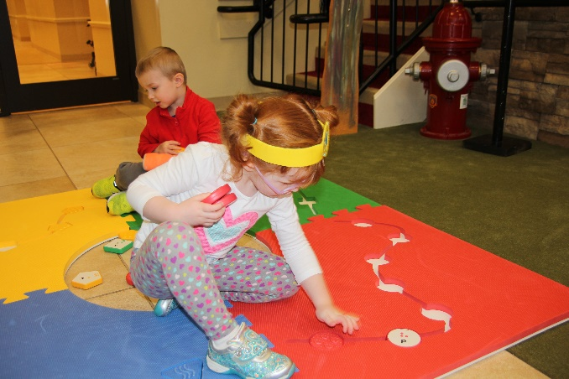

Project Staff
Tristan Pierce, Multiple Disabilities Project Leader
Mandy Lau, Inventor and Designer
Monica Vaught-Compton, Project Assistant

Background
The American Printing House for the Blind (APH) proposes to be the exclusive distributor of the Reach & Match® Learning Kit in the United States. APH will edit and provide the product documentation in all accessible formats. APH conducted field testing in the United States to complement the testing done by the developer in Australia.
The introduction is from Mandy Lau, founder and designer of Reach & Match®, with editing by Tristan Pierce, APH Multiple Disabilities Project Leader.
Reach & Match® is an innovative system for students with sensory impairment and other special needs to learn and engage with their peers. It consists of four double-sided play mats, which can create different 2D and 3D configurations. It includes sensory components such as braille and print tiles, which help students with and without sight to develop literacy. Through well-designed exercises, activities, and games, students develop effective childhood skills such as space and direction; body concept; and motor, cognitive, communication, and social skills.
The double-sided sensory play provides distinctive modes of individual learning and group play. The front side provides toddler training for manual dexterity and identifying tactile patterns. The reverse side provides preschoolers with braille and print learning, motor development, direction, and spatial training.
The design concept and features are the result of a postgraduate research based on early childhood education in students with visual impairment and additional disabilities. It was developed and tested (in Australia) with early childhood educators, therapists, psychologists for early intervention programs, childcare centers, and schools. The design is well accepted among the world and has won recent awards in the areas of assistive technology, education, and social inclusion.
Relevance
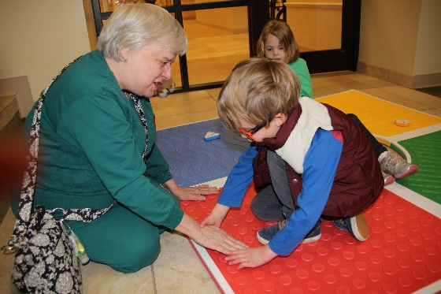
APH made the decision to field test, make the documentation accessible, and submit the product for Quota approval based on APH’s standardized process of product development. Mandy Lau submitted the New Idea Submission Form on October 5, 2016, just prior to attending the APH 148th Annual Meeting of Ex Officio Trustees. The project leader presented the idea to the Product Evaluation Team (PET) on December 13, 2017. The committee approved the PET Form and forwarded the product submission to the Product Advisory and Review Committee (PARC). PARC members approved Reach & Match® on December 15, 2016, and placed it on the parking lot. It quickly moved off the parking lot into the field test stage when APH purchased four production samples. After teachers and students field tested the production samples, APH compiled the data for this field test report.
This product is fully accessible to the population using it. The manual is electronic (HTML and BRF), so it is accessible to teachers and parents. The mat and tiles include large print, braille, tactile patterns, and textured shapes for the student who will use it. During field testing, a young student with low vision showed an adult volunteer, who is blind, the circle pattern on the red mat.
This product follows APH guidelines for determining relevance of a product. The Continuum of Visual Development (Ferrell, 2010) states that in the first month of life, babies show visual behaviors such as interest in pattern details in clothing and the environment. They attend to outside edges of a pattern or stimulus. By 2 months, babies perceive objects as three-dimensional; and by 3 months, they shift fixation from one object to another and watch the actions of others. By 4 months, they reach to visual stimulus. Jumping ahead to 9 months, eye-hand coordination improves and babies use vision to mediate reach and grasp. By 12 months, babies use vision to monitor motor activities and they discriminate same and different based on characteristics. By 18 months, toddlers stack objects vertically; and by 2 years, they stack objects horizontally. They begin to complete simple puzzles and foam boards by age 3 years. By 4 years, they identify red, green, blue, and yellow. By 5 years, children build bridges with blocks and matches by size and shape. Reach & Match® is for toddlers and young children.
According to the website How Kids Develop (2008), students develop skills in five main areas of development: cognitive development, social and emotional development, speech and language development, fine motor skill development, and gross motor skill development. There is a plethora of other student development outlines available to parents and educators today with the click of a quick Google™ search.
Whether one follows the Jean Piaget or Lev Vygotsky (both psychosocial) or the Erik Erikson (cognitive) theoretical approach to student development, or another student development theorist, of which there are many, what remains constant and relevant is that student development is a process that every student goes through. Many developmental skills, including visual behaviors, are attainable when playing with Reach & Match® and following the lessons as they are outlined in the manual. For a student with a visual impairment or blindness, the developmental behaviors may be delayed, but the premise of Reach & Match® is that the social interaction a student obtains while playing with peers encourages these developmental skills and behaviors (State of NSW, Department of Education and Training, 2010).
There is evidence of an examination of the need for this product. There are products that teach specific developmental skills; however, Reach & Match® not only comes with a complete outline of lessons for each skill, it is designed on the premise of playing with peers. Vygotsky encouraged the importance of relationships and interactions between students and more knowledgeable peers and adults. He believed that a student’s cognitive understandings were enriched and deepened when they were “scaffold” by a parent, teachers, or peers. Piaget and Vygotsky saw students as active partners in their own learning. The lessons in Reach & Match® allow and encourage this.
There is evidence that APH sought opinions of knowledgeable individuals to determine the need for this product. Knowledgeable individuals (teachers) sought out APH to communicate that they needed this product. APH heard from teachers in California and later in Vermont that APH should add Reach & Match® to its family of products. The teachers in California recommended that Mandy Lau present her product to APH. Teachers in both states obtained funding to purchase their kits directly from Lau (Australia). They then volunteered to participate in field testing for APH. APH recruited the other field test sites.
This product addresses an identified need for a person who meets the definition of “visually impaired.” The product documentation is electronic, making it accessible to regular print, large print, and electronic readers, including those using a refreshable braille display. The mat pieces provide distinct tactile learning while the tiles provide pre literacy learning and shape, color, and sound recognition.
Work during FY 2017

Research
APH gathered data using an appropriate method. The product development team collected data using SurveyMonkey®, an online survey program. The field test procedure included self-play observation and the playing of games (specific lessons) as outlined in the manual. The evaluation tool included multiple-choice, open-ended questions and comments, and questions that used 4 measure and 5 measure scales. APH collected data in a way to compare three groups of students. The students who participated in the field test were assigned to one of the three groups: students without a visual impairment, students with low vision, and students with little or no light perception.
APH used research data as part of decision-making in product completion. The main decision on this product was either to make it available in the United States or to turn the product down, which would require parents, teachers, and/or school districts to order from Australia. If APH had been involved in the initial development of the product, there are a few things we would have changed (e.g., make print letters raised and make the braille standard braille size on the tiles); but the cost to change tooling at this time is prohibitive. APH will make editorial revisions to the manual.
The product follows APH Research Guidelines (as a potential pass-through product) as outlined below.
- Input from the field—Prior to submission, teachers from California and prior to field testing, teachers from Vermont
- Safety Report/Technical Review—Provided by manufacturer
- Representative product prototype—Product production sample, Australian manual online
- Outside evaluators—APH selected field test sites by availability, location, educational setting, student/client size, and evaluator qualifications.
- Evaluation tool and collection—The project leader, a consultant, and the inventor/author developed the evaluation materials and survey. APH sent the books via Dropbox™ and sent forms electronically. APH hand delivered production samples to two field test locations, and shipped one production sample to New Mexico, where field evaluators shipped it sequentially to each field test location. The last two field test sites had their own Reach & Match® kit. Evaluators returned materials by the same means.
- Sufficient time—The field test sites in California and Kentucky had 2 months to complete the lessons in the book and submit the evaluation form. The evaluators at the three sites in New Mexico chose to divide the 2-month period between themselves. The Vermont site had their own kit and contacted APH shortly after field testing began.
- Reporting—The project leader presented the field test results to the Product Development Committee, and then the group met to determine future steps. Throughout the review of the product and the creation of the accessible documentation, the project leader reported updates at the monthly New Products Meeting.
- Modifications—APH made editorial changes to the manual to comply with APH standards (e.g., use of APA Style in writing, accessibility). APH to submit changes to the shipping box to meet UPS standards.
- Quota Approval—The project leader submitted the product for quota approval in April 2017.
- Specifications—pass through
- Availability—Summer 2017
- Marketing—APH markets the product via their website, print catalog, social media, and through conference presentations, training, and expositions. Mandy Lau continues to market the product worldwide.
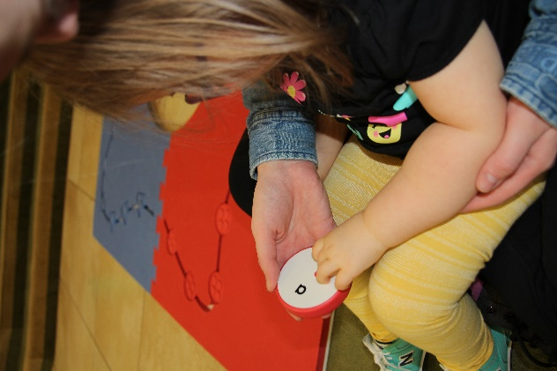
APH gathered data from a geographically diverse U.S. population. APH had seven field test sites in four states: California, Kentucky, New Mexico, and Vermont. The sites included Visually Impaired Preschool Services (students with visual impairment and their sighted siblings), Bluegrass Center for Autism, Vermont Association for the Blind & Visually Impaired, Stockton Unified School District, New Mexico School for the Blind and Visually Impaired (early childhood Program in Albuquerque, outreach in Carlsbad, and main campus in Alamogordo). Four (57.14%) classified their employment as service providers for people with vision impairment, two (28.57%) as schools for the blind and visually impaired, one (14.29%) as an early learning center, two (28.57%) as special schools, and one (14.29%) works directly with families.
The seven field test coordinators identified (per U.S. Census Bureau) as Asian, Black or African American, Hispanic of any origin, Native Hawaiian or other Pacific Islander, and White. Evaluators were asked to check all with which they identify.
APH gathered data from appropriately qualified individuals. Many hold dual or multiple certifications/licenses. Four (57.14%) are early childhood educators, three (42.86%) are orientation and mobility instructors, two (28.57%) are braille teachers/teachers of students with visual impairments, two (28.57%) are speech pathologists, two (28.57%) are special education professionals, one (14.29%) is a behavior analyst, and one (14.29%) is a paraprofessional. Three (42.86%) field test coordinators had 1 to 5 years of experience teaching students who are visually impaired, three (42.86%) had 6 to 10 years of experience, and one (14.29%) has more than 20 years of experience.
APH gathered data from an adequate number of sources. When evaluators filled out the student information portion of the evaluation form, they documented six students without a visual impairment, 14 students with low vision, and seven students with little or no light perception; for a total of 27 students. However, within the 4 measure and 5 measure scales, a total 35 students are represented.
Group A: Students Without a Visual Impairment consisted of six students:
- Age 3 years, cognitive age 1 year, hearing impairment, intellectual disability, developmental delay, limited fine and gross motor skills
- Age 2 years, cognitive age 0 year, limited mobility, developmental disability
- Age 3 years, cognitive age 3 years, mild developmental delay
- Age 5 years, cognitive age 3 years, intellectual disability, developmental delay, limited mobility
- Age less than 1 year, cognitive age 0, developmental disability
- Age 2 years, cognitive age 1 year, autism, intellectual and developmental disability

Group B: Students with Low Vision consisted of 14 students:
- Age 3½ years, cognitive age 2 years, CVI, global delays
- Age 1½ years, cognitive age 0 years, cortical/cerebral visual impairment, intellectual and developmental disability
- Age ?*, cognitive age ?*, autism, limited mobility, limited fine motor skills, retinal atrophy, cerebral palsy *left blank
- Age 9 years, cognitive age 6 years, congenital glaucoma, intellectual and developmental disability, limited fine motor skills, learning difficulties
- Age 3 years, cognitive age 1 year, amblyopia and autism spectrum disorder
- Age 5 years, cognitive age 3 years, cortical/cerebral visual impairment, traumatic brain injury
- Age 2 years, cognitive age 1 year, microphthalmia, learning difficulties
- Age 6 years, cognitive age 5 years, optic nerve hypoplasia, traumatic brain injury, learning difficulties
- Age 3 years, cognitive age 3 years, left homonymous hemianopia and limited fine motor skills
- Age 5 years, cognitive age 3 years, cortical/cerebral visual impairment, tuberous sclerosis
- Age 2½ years, cognitive age 0 year, cortical/cerebral visual impairment, intellectual and developmental disability
- Age 8 years, cognitive age 5 years, optic nerve hypoplasia, traumatic brain injury, learning difficulties
- Age 4 years, cognitive age 3 years, optic nerve hypoplasia and developmental delay
- Age 1 year, cognitive age 0 year, cortical/cerebral visual impairment, intellectual and developmental disability

Group C: Students With Little or No Light Perception consisted of seven students:
- Age 2 years, cognitive age 2 years, no additional disabilities identified at this time
- Age 6 years, cognitive age 1½ years, anophthalmia, global delays
- Age 2 years, cognitive age 1 year, microphthalmia, learning difficulties
- Age 4 years, cognitive age 2 years, familial exudative vitreo retinopathy
- Age 5 years, cognitive age 2 years, limited fine and gross motor, intellectual disability, developmentally delayed
- Age 6 years, cognitive age 2½ years, optic nerve hypoplasia, global delays
- Age 4 years, cognitive age 4½ years, optic nerve hypoplasia

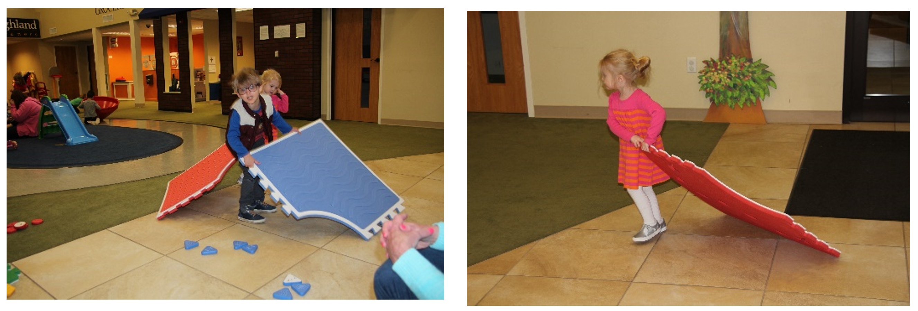
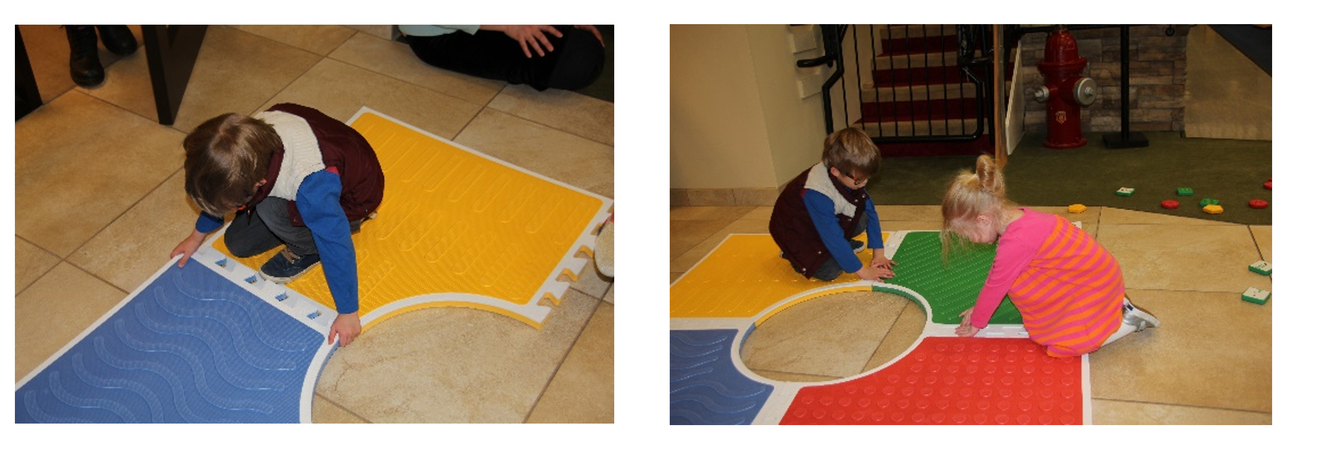
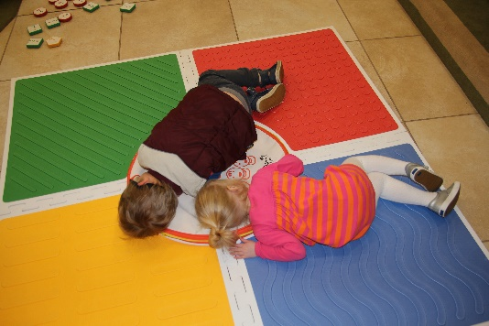
he research method used collected sufficient information. A total of 35 students participated in the study. Teachers observed students as they played with Reach & Match® for the first time, without adult prompting. Of the 34 students for whom teachers reported data for question 19, the majority of students in Group A (n=10) (40%) showed low to no interest/curiosity in the braille dots; the majority of students in Group B (n=18) (38.9%) showed somewhat low interest in the braille dots; while an equal percentage of students in Group C (n=6) (33.3%) showed low to no interest, medium interest, and high interest in the braille dots. Overall, totaling by level of interest, 26% showed low to no interest, 29% showed somewhat low interest, 15% showed medium interest, 15% showed somewhat high interest, and 15% showed high interest in the braille.
Q19. Rate each student's interest/curiosity in the embossed braille dots.
GROUP | Low to no interest | Somewhat low interest | Medium interest | Somewhat high interest | High interest | n =
Group A | 4  (40%) | 3  (30%) | 1  (10%) | 2  (20%) | 0 | 10
Group B | 3  (16.7%) | 7  (38.9%) | 2  (11.1%) | 3  (16.7%) | 3  (16.7%) | 18
Group C | 2  (33.3%) | 0 | 2  (33.3%) | 0 | 2  (33.3%) | 6
Student TOTALS | 9  (26%) | 10  (29%) | 5  (15%) | 5  (15%) | 5  (15%) | 34
APH asked teachers to rate each student’s interest in asking questions about braille, such as its relationship with print letters. Teachers submitted responses for all 35 students. The majority of students in all three groups showed low to no interest in the way of asking questions; however, a larger percentage of students in Group B, the low vision students, expressed more curiosity than their counterparts in Groups A and C.
Q20. Rate each student's interest/curiosity in asking a lot of questions about braille, such as its relationship with print letters.
GROUP | Low to no interest | Somewhat low interest | Medium interest | Somewhat high interest | High interest | n =
Group A | 9  (90%) | 0 | 1  (10%) | 0 | 0 | 10
Group B | 12  (66.7%) | 3  (16.7%) | 3  (16.7%) | 0 | 0 | 18
Group C | 5  (71.4%) | 1  (14.3%) | 1  (14.3%) | 0 | 0 | 7
Student TOTALS | 26  (74%) | 4  (11%) | 5  (14%) |  |  | 35

When asked to rate each student’s initiative in trying to learn braille, teachers provided responses for 35 students. Group A showed initiative in three of the five measures: low to no initiative, somewhat low initiative, and medium initiative. Group B showed initiative in four measures: low to no initiative, somewhat low initiative, somewhat high initiative, and high initiative. All students in Group C showed low to no initiative except one who showed somewhat high initiative.
Q21. Rate each student's initiative in trying to learn braille.
GROUP | Low to no initiative | Somewhat low initiative | Medium initiative | Somewhat high initiative | High initiative | n =
Group A | 8  (80%) | 1  (10%) | 1  (10%) | 0 | 0 | 10
Group B | 14  (77.8%) | 1  (5.6%) | 0 | 2  (11.1%) | 1  (5.6%) | 18
Group C | 6  (85.7%) | 0 | 0 | 1  (14.3%) | 0 | 7
Student TOTALS | 28  (80%) | 2  (5.7%) | 1  (2.8%) | 3  (8.6%) | 1  (2.8%) | 35

Teachers rated each student’s level of attraction to the visual and textual attributes (e.g., bright colors, patterns, and textures). As expected, the students in Group B showed a higher level of attraction; no student showed low to no attraction. Students in Groups A and C had higher numbers showing low to no attraction but did show a spread across the remaining four measures. Overall, the 35 students did not display a wide variance in the levels of attraction to the visual and textual attributes; they ranged from 17% to 29%.
Q22. Rate each student's level of attraction to the bright colors, Q22. Rate each student's level of attraction to the bright colors, patterns, and textures.
GROUP | Low to no attraction | Somewhat low attraction | Medium attraction | Somewhat high attraction | High attraction | n =
Group A | 4  (40%) | 3  (30%) | 0 | 3  (30%) | 0 | 10
Group B | 0 | 2  (11.1%) | 5  (27.8%) | 5  (27.8%) | 6  (33.3%) | 18
Group C | 3  (42.9% | 1  (14.3%) | 1  (14.3%) | 2  (28.6%) | 0 | 7
Student TOTALS | 7  (20%) | 6  (17%) | 6  (17%) | 10  (29%) | 6  (17%) | 35

Teachers rated each student’s level of attraction to the four different sounds created when shaking tiles from each of the four shaped categories (i.e., circle, square, triangle, pentagon). This was the first attribute rating in which all three groups had some student whose level of attraction rated in the top two tiers of the five measures—somewhat high attraction and high attraction. The students with little or no light perception in Group C either showed little to no interest (57.1%) or somewhat high attraction to high attraction (42.9%).
Q23. Rate each student's level of attraction to the different sounds from the tiles.
GROUP | Low to no attraction | Somewhat low attraction | Medium attraction | Somewhat high attraction | High attraction | n =
Group A | 3  (30%) | 2  (20%) | 2  (20%) | 2  (20%) | 1  (10%) | 10
Group B | 5  (27.8%) | 2  (11.1%) | 6  (33.3%) | 2  (11.1%) | 3  (16.7%) | 18
Group C | 4  (57.1%) | 0 | 0 | 1  (14.3%) | 2  (28.6%) | 7
Student TOTALS | 12  (34%) | 4  (11%) | 8  (23%) | 5  (14%) | 6  (17%) | 35

The ratings on the product attributes showed that teachers seldom placed students in the medium initiative measure. When asked to rate each student’s initiative to explore all parts of the kit, this is where the majority of students shined. Half (50%) of the students in Group A and 33.3% of the students in Group B showed medium initiative. Although 57.1% of students in Group C showed low to no initiative to explore all parts of the kit, the combined percentages of Group C students who showed medium, somewhat high, and high initiative equaled 42.9%. It would be nice and optimistic to think that these students took this opportunity to self-implement the whole-part-whole strategy of teaching.
Q24. Rate each student's initiative to explore all the parts of the kit.
GROUP | Low to no initiative | Somewhat low initiative | Medium initiative | Somewhat high initiative | High initiative | n =
Group A | 4  (40%) | 0 | 5  (50%) | 0 | 1  (10%) | 10
Group B | 0 | 4  (22.2%) | 6  (33.3%) | 5  (27.8%) | 3  (16.7%) | 18
Group C | 4  (57.1%) | 0 | 1  (14.3%) | 1  (14.3%) | 1  (14.3%) | 7
Student TOTALS | 8  (23%) | 4  (11%) | 12  (34%) | 6  (17%) | 5  (14%) | 35

The students received high marks in their attempts to exhibit gross motor skills. Teachers rated half (50%) of the students in Group A as somewhat high in their attempts to make a lot of body movements. Once again the students in Group B excelled, with medium and somewhat high attempts rated at 23.5% each and high attempt rated at 47%. Four (57.1%) of the students in Group C were rated low to no attempt, and the remaining three students in Group C were split between medium attempt, somewhat high attempt, and high attempt for a combined percentage of 42.9. Overall, of the 34 students who teachers rated on this question, 20 students (58.8%) showed a somewhat high attempt or high attempt to make body movements compared to eight students (23.5%) who made low to no attempt or somewhat low attempt.

Q25. Rate each student's attempt to make a lot of body movements (gross motor skills).
GROUP | Low to no attempt | Somewhat low attempt | Medium attempt | Somewhat high attempt | High attempt | n =
Group A | 2  (20%) | 1  (10%) | 1  (10%) | 5  (50%) | 1  (10%) | 10
Group B | 1  (5.9%) | 0 | 4  (23.5%) | 4  (23.5%) | 8  (47%) | 17
Group C | 4  (57.1%) | 0 | 1  (14.3%) | 1  (14.3%) | 1  (14.3%) | 7
Student TOTALS | 7  (20.5%) | 1  (3%) | 6  (17.6%) | 10  (29.4%) | 10  (29.4%) | 34

According to Wolfberg, Bottema-Beutel, & DeWitt (2012), peer-play experiences are vital to a student’s socialization, development, and culture. Students with disabilities, especially autism, face challenges in social and imaginary play, which place them at high risk for exclusion by peers. Without well-designed opportunities, they are likely to remain isolated from peers, and thus experience few opportunities that encourage developmental growth. That said, teachers rated the students’ interest in interacting with others while they played with Reach & Match®. Half (50%) of the students in the Group A, 38.9% in Group B, and 42.9% in Group C demonstrated high interest in social interaction with peers. This was good to see because one of the main reasons Mandy Lau created Reach & Match® was to allow students with and without disabilities the opportunity to learn while playing together.

Q26. Rate each student's interest in interacting with others (i.e., teachers, peers) while playing with the kit.
GROUP | Low to no interest | Somewhat low interest | Medium interest | Somewhat high interest | High interest | n =
Group A | 2  (20%) | 1  (10%) | 2  (20%) | 0 | 5  (50%) | 10
Group B | 1  (5.6%) | 3  (16.7%) | 3  (16.7%) | 4  (22.2%) | 7  (38.9%) | 18
Group C | 2  (28.6%) | 1  (14.3%) | 1  (14.3%) | 0 | 3  (42.9%) | 7
Student TOTALS | 5  (14%) | 5  (14%) | 6  (17%) | 4  (11%) | 15  (43%) | 35

The teachers rated the majority of students in Group A (50%) and Group B (27.8%) as having a high use of creativity to figure out games independently. Again, the majority of students in Group C (71.4%) showed low to no use of creativity to figure out games. Teachers of students with visual impairments know that their students need distinct supports when learning a new skill. Many teachers, especially adapted physical education teachers, use the strategy of pre-teaching to a student with visual impairment prior to introducing an activity to the entire class. As mentioned earlier, this may reflect the need for whole-part-whole teaching.

Q27. Rate each student’s use of his/her creativity to figure out the games by himself/herself, for example, putting the tiles into the right pockets of the path, or putting tile with dot pattern on the mat with dot pattern.
GROUP | Low to no use of creativity | Somewhat low use of creativity | Medium use of creativity | Somewhat high use of creativity | High use of creativity | n =
Group A | 3  (30%) | 1  (10%) | 1  (10%) | 0 | 5  (50%) | 10
Group B | 4  (22.2%) | 4  (22.2%) | 2  (11.1%) | 3  (16.7%) | 5  (27.8%) | 18
Group C | 5  (71.4%) | 0 | 0 | 1  (14.3%) | 1  (14.3%) | 7
Student TOTALS | 12  (34%) | 5  (14%) | 3  (8.6%) | 4  (11%) | 11  (31%) | 35

Four of seven teachers (57.14%) observed that the students in Group B were the most surprised and excited about Reach & Match®. One teacher (14.29%) reported that students in Group A were most surprised and excited, and one teacher (14.29%) reported this for students in Group C. One teacher (14.29%) responded that there was no difference in surprise or excitement between the groups.

Three teachers (42.86%) observed that the students with low vision, Group B, ask the most questions about Reach & Match®. One teacher (14.29%) reported that students in Group A asked the most questions, and one teacher (14.29%) reported this for students in Group C. Two teachers (28.57%) responded that there was no difference between the groups on the amount of questions asked.

APH asked teachers which group of students required the most guidance when playing with Reach & Match®. One teacher (14.29%) responded Group A, two teachers (28.57%) responded Group B, two teachers (28.57%) responded Group C, and two teachers (28.57%) responded that there was no difference between the groups.

Three teachers (42.86%) reported that students in Group B required a longer time to explore Reach & Match®. Two teachers (28.57%) reported that Group C required a longer time to explore, and two teachers (28.57%) responded that there was no difference between the groups for time required to explore.

Four of the seven teachers (57.14%) noted that Group B showed the most confidence while playing with Reach & Match®. The remaining three teachers (42.86%) deemed there was no discernible difference in confidence between the groups.

Two teachers (28.57%) said students in Group B were the happiest to try to read the braille tiles; however, five teachers (71.43%) said there was no difference between the groups on this measure.

Data were gathered on student/consumer outcomes. APH asked teachers to indicate if a student could or could not perform a skill before and after playing with Reach & Match® (R&M). Teachers followed the lessons in the electronic manual and rated the students using four choices:
- No-No (Student could not perform skill before or after playing with the product.)
- No-Yes (Student could not do skill before but now performs skill minimally, moderately, or proficiently.)
- Yes-Same (Student could do skill minimally before and still performs skill minimally after playing with the product.)
- Yes-Yes (Student could do skill minimally but now performs skill moderately or proficiently.)

SESSION 1
There are seven sessions in the manual, each designed to teach a specific function. Session 1 teaches the function of braille and print learning. A total of 35 students participated in this study. Question 34a asked teachers to evaluate learning to touch, feel, and explore tactile textures. Of the 34 students for whom teachers reported data on question 34a, 23.5% could not perform the skill before or after playing with the product (no-no response), 14.7% could not perform the skill before but now perform the skill minimally, moderately, or proficiently (no-yes response), 41.2% could do skill minimally before and still perform skill minimally after playing with the product (yes-same response), and 20.6% of students could do the skill minimally but now perform the skill moderately or proficiently (yes-yes response).

Q34. Function: Braille and Print Learning
- Learned to touch, feel, and explore
GROUP | No-No | No-Yes | Yes-Same | Yes-Yes | n =
Group A | 5  50% | 4  40% | 0 | 1  10% | 10
Group B | 1  5.6% | 1  5.6% | 11  61.1% | 5  27.8% | 18
Group C | 2  33.3% | 0 | 3  50% | 1  16.7% | 6
Student TOTALS | 8  23.5% | 5  14.7% | 14  41.2% | 7  20.6% | 34

Question 34b addressed the braille alphabet. Teachers evaluated and reported on 30 students on their ability to learn five or more braille letters. Overall, only three students (9.9%) from Group B succeeded (no-yes + yes-yes). In Group B (n=18), 15 students (83.3%) could not perform skill before or after playing with the product, one student (5.6%) could not read five or more braille letters before playing with the product but could after playing with the product, one student (5.6%) could read five braille letters and maintained that level after playing with the product, and one student (5.6%) could read five braille letters prior to playing with Reach & Match® and improved this skill while playing with the product.

- Learned five or more braille letters
GROUP | No-No | No-Yes | Yes-Same | Yes-Yes | n =
Group A | 8  100% | 0 | 0 | 0 | 8
Group B | 15  83.3% | 1  5.6% | 1  5.6% | 1  5.6% | 18
Group C | 4  100% | 0 | 0 | 0 | 4
Student TOTALS | 27  90% | 1  3.3% | 1  3.3% | 1  3.3% | 30

Question 34c addressed the Roman alphabet. Teachers evaluated and reported on 30 students’ ability to learn five or more Roman letters. Six students (20%) accomplished the function while playing with Reach & Match®. Again, students in Group B (n=18) had more success, with one student (5.6%) in the no-yes category, one student (5.6%) in the yes-same category, and three students (16.7%) in the yes-yes category. One might expect better results with Group A—students without visual impairments—but all the students have additional disabilities. This question was not applicable to students in Group C.

- Learned five or more Roman letters
GROUP | No-No | No-Yes | Yes-Same | Yes-Yes | n =
Group A | 7  87.5% | 0 | 1  1.3% | 0 | 8
Group B | 13  72.2% | 1  5.6% | 1  5.6% | 3  16.7% | 18
Group C | 4  100% | 0 | 0 | 0 | 4
Student TOTALS | 24  80% | 1  3.3% | 2  6.7% | 3  10% | 30

Question 34d addressed the ability of the students to learn letters using the student’s name. Teachers evaluated and reported on 30 students. Overall, 83.3% demonstrated no improvement after using the product. Two students (11.1%) in Group B (n=18) demonstrated improvement on an existing function. The function of writing one’s name is considered a high skill for a typical child under 3 years old, which many of the students who played with Reach & Match® were (under 3 years old) at the time of field testing.

- Learned to write name
GROUP | No-No | No-Yes | Yes-Same | Yes-Yes | n =
Group A | 7  87.5% | 0 | 1  1.3% | 0 | 8
Group B | 14  77.8% | 0 | 2  11.1% | 2  11.1% | 18
Group C | 4  100% | 0 | 0 | 0 | 4
Student TOTALS | 25  83.3% | 0 | 3  10% | 2  6.7% | 30

SESSION 2
The function under Session 2 is cognitive skills. Teachers collected data on 35 students for questions 35a-35f. Question 35a asked teachers to rate their students’ ability to sort the tiles by color, shape, sounds, and patterns. Of the students in Group A (n=10), half showed improvement: Two students (20%) could not sort prior to playing with Reach & Match®, but through play they learned to sort at least minimally; and three students (30%) had a minimum skill of sorting prior to playing with the product and improved through play to a medium or master level. Likewise, 11 students (61.1%) from Group B (n=18) and two students (28.6%) from Group C (n=7) showed improvement from having no skill to at least minimal skill and from having minimal skill to a medium or master level.

Q35. Function: Cognitive Skills
- Sorting
GROUP | No-No | No-Yes | Yes-Same | Yes-Yes | n =
Group A | 5  50% | 2  20% | 0 | 3  30% | 10
Group B | 4  22.2% | 2  11.1% | 3  16.7% | 9  50% | 18
Group C | 4  57.1% | 1  14.3% | 1  14.3% | 1  14.3% | 7
Student TOTALS | 13  37.1% | 5  14.3% | 4  11.4% | 13  37.1% | 35

Question 35b asked teachers to rate their students’ ability to match (i.e., tile to mat with same color, tile to mat with same pattern). The students showed much improvement in their matching skills through playing with Reach & Match®. Of the 35 students, 11 (31.4%) showed no improvement, six students (17.1%) showed improvement from no skill to at least minimal skill, seven students (20%) remained at their previous skill level, and 11 students (31.4%) showed improvement of their prior skill level. In Group A (n=10) and Group B (n=18), the two combined categories of improvement (no-yes + yes-yes) outweighed the two combined categories of no improvement.

- Matching
GROUP | No-No | No-Yes | Yes-Same | Yes-Yes | n =
Group A | 4  40% | 3  30% | 0 | 3  30% | 10
Group B | 4  22.2% | 2  11.1% | 4  22.2% | 8  44.4% | 18
Group C | 3  42.9% | 1  14.3% | 3  42.9% | 0 | 7
Student TOTALS | 11  31.4% | 6  17.1% | 7  20% | 11  31.4% | 35

Question 35c asked teachers to rate their students’ ability to count. This included counting the number tiles for each color, shape, and pattern as well as to count the number of dots/stripes/curvy lines/diagonal lines on the tiles and mats. Four students (40%) in Group A showed improvement in counting through playing with Reach & Match®, while 10 students (55.6%) in Group B showed improvement, and two students (28.6%) in Group C showed improvement.

- Counting
GROUP | No-No | No-Yes | Yes-Same | Yes-Yes | n =
Group A | 5  50% | 0 | 1  10% | 4  40% | 10
Group B | 5  27.8% | 1  5.6% | 3  16.7% | 9  50% | 18
Group C | 5  71.4% | 0 | 0 | 2  28.6% | 7
Student TOTALS | 15  42.9% | 1  2.9% | 4  11.4% | 15  42.9% | 35

Question 35d asked teachers to rate their students’ ability to recognize patterns. Four students (40%) in Group A improved their ability to recognize patterns while playing with Reach & Match® as shown in the no-yes category and the yes-yes category. Nine students (50%) in Group B improved their ability, but no students in Group C showed improvement.

- Pattern recognition
GROUP | No-No | No-Yes | Yes-Same | Yes-Yes | n =
Group A | 6  60% | 1  10% | 0 | 3  30% | 10
Group B | 8  44.4% | 1  5.6% | 1  5.6% | 8  44.4% | 18
Group C | 6  85.7% | 0 | 1  14.3% | 0 | 7
Student TOTALS | 20  57.1% | 2  5.7% | 2  5.7% | 11  31.4% | 35

Question 35e asked teachers to rate their students’ ability to sequence tiles through play. This included sequencing in alphabetical order, color order, and shape order. This particular task proved to be too difficult for the majority of students (65.7%). Group B split down the middle with 50% unable to sequence before or after playing with Reach & Match®, and 50% able to sequence minimally before playing with the product and improved to a medium or master level through play.

- Sequencing
GROUP | No-No | No-Yes | Yes-Same | Yes-Yes | n =
Group A | 7  70% | 0 | 0 | 3  30% | 10
Group B | 9  50% | 0 | 0 | 9  50% | 18
Group C | 7  100% | 0 | 0 | 0 | 7
Student TOTALS | 23  65.7% | 0 | 0 | 12  34.3% | 35

Question 35f asked teachers to rate their students’ ability to use visual or tactile memory. This involved memorizing the order of different sounds, colors, shapes, or patterns as well as to memorize the correct tile by the same attributes. As is often seen in this field test, the two largest majorities of students fall on the outside of the four measures, (i.e., no-no and yes-yes). Fourteen students (40%) did not demonstrate visual or tactile memory prior to or after playing with Reach & Match®, and 13 students (37.1%) possessed a minimal ability to use visual or tactile memory prior to playing with Reach & Match® and improved to a medium or master level through play.

- Visual/Tactile memory
GROUP | No-No | No-Yes | Yes-Same | Yes-Yes | n =
Group A | 5  50% | 0 | 2  20% | 3  30% | 10
Group B | 5  27.8% | 1  5.6% | 2  11.1% | 10  55.6% | 18
Group C | 4  57.1% | 2  28.6% | 1  14.3% | 0 | 7
Student TOTALS | 14  40% | 3  8.6% | 5  14.3% | 13  37.1% | 35

SESSION 3
The function under Session 3 is sensory integration. Teachers collected data on 35 students (group values remain the same) for questions 36a-36c. Question 36a asked teachers to evaluate if students could distinguish between colors, patterns, and shapes of the tiles and mats. As expected, the students in Group A and Group B started and ended with better abilities. Only one student (14.3%) in Group C demonstrated improvement.

Q36. Function: Sensory Integration
- Sight and visual skills
GROUP | No-No | No-Yes | Yes-Same | Yes-Yes | n =
Group A | 3  30% | 0 | 2  20% | 5  50% | 10
Group B | 1  5.6% | 1  5.6% | 5  27.8% | 11  61.1% | 18
Group C | 6  85.7% | 0 | 0 | 1  14.3% | 7
Student TOTALS | 10  28.6% | 1  2.9% | 7  20% | 17  48.9% | 35
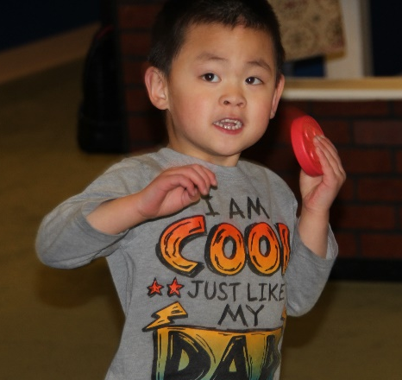
Question 36b asked teachers to determine if the students could distinguish different sounds given from the various tiles. Across the board, the majority of students in all three groups demonstrated improvement. Some students danced and twirled in circles to the sounds they made while shaking the tiles.

- Hearing
GROUP | No-No | No-Yes | Yes-Same | Yes-Yes | n =
Group A | 2  20% | 2  20% | 2  20% | 4  40% | 10
Group B | 0 | 1  5.6% | 6  33.3% | 11  61.1% | 18
Group C | 1  14.3% | 0 | 2  28.6% | 4  57.1% | 7
Student TOTALS | 3  8.6% | 3  8.6% | 10  28.6% | 19  54.3% | 35

Question 36c asked teachers to determine if the students could identify the different textures from the various components; distinguish the difference between patterns on tiles and mats; and use different parts of the body to touch the tactile parts, such as the feet, the hands, the arms, the legs, and the face. Half of the students in Group A demonstrated improvement, and the majority of students in Groups B and C demonstrated improvement through playing with Reach & Match®.

- Touch
GROUP | No-No | No-Yes | Yes-Same | Yes-Yes | n =
Group A | 3  30% | 0 | 2  20% | 5  50% | 10
Group B | 1  5.6% | 1  5.6% | 6  33.3% | 10  55.6% | 18
Group C | 1  14.3% | 0 | 2  28.6% | 4  57.1% | 7
Student TOTALS | 5  14.3% | 1  2.9% | 10  28.6% | 19  54.3% | 35

SESSION 4
The function under Session 4 is body concepts. Teachers collected data on 35 students (group values remain the same) for questions 37a–37c. Question 37a on exploration of body parts asked teachers to evaluate how the students explored the Reach & Match® (e.g., put right hand on mat and lift left hand). Overall, five students (14.3%) improved in the no-yes category and 10 students (28.6%) improved in the yes-yes category. Students in Group A (60%, no-yes + yes-yes) and Group B (44.5%, no-yes + yes-yes) showed improvement, but unfortunately only one student (14.3%, yes-yes) in Group C showed improvement.

Q37. Function 4: Body Concepts
- Exploration of body parts
GROUP | No-No | No-Yes | Yes-Same | Yes-Yes | n =
Group A | 2  20% | 2  20% | 2  20% | 4  40% | 10
Group B | 1  5.6% | 3  16.7% | 9  50% | 5  27.8% | 18
Group C | 3  42.9% | 0 | 3  42.9% | 1  14.3% | 7
Student TOTALS | 6  17.1% | 5  14.3% | 14  40% | 10  28.6% | 35

Question 37b on bodily awareness asked teachers to evaluate how well students learned to perform different body movements (e.g., crawl, jump, skip, lie down, and roll into a ball). Overall, 18 students (54.3%) improved (no-yes + yes-yes). In Group A, 60%; Group B, 66.6%; and in Group C, 14.3% demonstrated improvement.

- Bodily awareness
GROUP | No-No | No-Yes | Yes-Same | Yes-Yes | n =
Group A | 2  20% | 2  20% | 2  20% | 4  40% | 10
Group B | 1  5.6% | 6  33.3% | 5  27.8% | 6  33.3% | 18
Group C | 3  42.9% | 0 | 3  42.9% | 1  14.3% | 7
Student TOTALS | 6  17.1% | 8  22.9% | 10  28.6% | 11  31.4% | 35

Question 37c on spatial concept asked teachers to evaluate the students’ ability to experience the size of the mats (e.g., touching the edge of the mats; learn the distance from one mat to another by counting steps; and following directions, such as turn left and go to the red/circle patterned mat). Overall, 57.2% (no-yes + yes-yes) showed improvement through playing with Reach & Match®. Again, the students in Groups A (60%) and B (66.6%) showed the most improvement. Two students (28.6%) in Group C showed improvement in the yes-yes category.

- Spatial concept
GROUP | No-No | No-Yes | Yes-Same | Yes-Yes | n =
Group A | 2  20% | 2  20% | 2  20% | 4  40% | 10
Group B | 2  11.1% | 6  33.3% | 4  22.2% | 6  33.3% | 18
Group C | 3  42.9% | 0 | 2  28.6% | 2  28.6% | 7
Student TOTALS | 7  20% | 8  22.9% | 8  22.9% | 12  34.3% | 35

SESSION 5
Teachers provided data on 35 students (group values remain the same) for questions 38a–38d on orientation and mobility skills. Question 38a addressed the fine motor skill of finger manipulation. Teachers evaluated if students could pick up a specific tile, grasp a specific tile, and track the path of the mat using fingers. Overall, 51.4% (no-yes + yes-yes) of the students showed improvement through playing with Reach & Match®. Five students (50%) in Group A, 10 students (55.5%) in Group B, and three students (42.9%) in Group C improved.

Q38. Function 5: Orientation and Mobility Skills
- Finger manipulation
GROUP | No-No | No-Yes | Yes-Same | Yes-Yes | n =
Group A | 0 | 5  50% | 5  50% | 0 | 10
Group B | 2  11.1% | 2  11.1% | 6  33.3% | 8  44.4% | 18
Group C | 0 | 0 | 4  57.1% | 3  42.9% | 7
Student TOTALS | 2  5.7% | 7  20% | 15  42.9% | 11  31.4% | 35

Question 38b addressed the motor skill of wrist twisting. Teachers evaluated if students could fit different shapes of tiles into the corresponding pockets and shake the tiles to discover the different sounds. Overall, 19 students (54.3%, no-yes + yes-yes) improved their wrist twisting. Within each group, four students (40%) in Group A, 11 students (61.1%) in Group B, and 4 students (57.1%) in Group C improved.

- Wrist twisting
GROUP | No-No | No-Yes | Yes-Same | Yes-Yes | n =
Group A | 2  20% | 4  40% | 4  40% | 0 | 10
Group B | 3  16.7% | 0 | 4  22.2% | 11  61.1% | 18
Group C | 1  14.3% | 0 | 2  28.6% | 4  57.1% | 7
Student TOTALS | 6  17.1% | 4  11.4% | 10  28.6% | 15  42.9% | 35

Question 38c addresses hand and foot muscle training and development. Teachers evaluated the students’ experience in several locomotor skills (e.g., crawling, walking, jumping, running, hopping, skipping, and leaping; movement at different paces; move following a path; and travel and route planning skills). Overall, 24 students (84.7%) improved (no-yes + yes-yes); and more importantly, all three groups rated highly. Group A had six students (60%), Group B had 14 students (77.8%), and Group C had four students (57.1%) improve.

- Purposeful action movement (gross motor)
GROUP | No-No | No-Yes | Yes-Same | Yes-Yes | n =
Group A | 0 | 5  50% | 4  40% | 1  10% | 10
Group B | 1  5.6% | 1  5.6% | 3  16.7% | 13  72.2% | 18
Group C | 2  28.6% | 0 | 1  14.3% | 4  57.1% | 7
Student TOTALS | 3  8.6% | 6  33.3% | 8  22.9% | 18  51.4% | 35

Question 38d addresses auditory skills. Teachers evaluated the students’ use of sound to identify direction and distance. Overall, the 19 students (54.3%) improved (no-yes + yes-yes). Within the groups, Group A had six students (60%) and Group B had nine students (50%) improve. Again, it is encouraging to see that the majority of students (57.1%) in Group C improved.

- Auditory skills
GROUP | No-No | No-Yes | Yes-Same | Yes-Yes | n =
Group A | 2  20% | 5  50% | 2  20% | 1  10% | 10
Group B | 1  5.6% | 2  11.1% | 8  44.4% | 7  38.9% | 18
Group C | 2  28.6% | 0 | 1  14.3% | 4  57.1% | 7
Student TOTALS | 5  14.3% | 7  20% | 11  31.4% | 12  34.3% | 35

SESSSION 6
Teachers provided data on 32 of 35 students for questions 39a–39e on language enrichment. Many of the students who participated in the field testing were too young (chronologically and cognitively) for this session.

Question 39a asked teachers to evaluate the students’ positional and directional words by turning; walking forward, backward, and parallel to; walking next to; and around corners. They asked students to describe the location of an object using words such as above and below, near and far, front and back, and so forth. This proved to be one of the harder tasks for the students. Overall, 13 students (40.6%) fell in the no-no category. The remaining 18 students (41.4%) dispersed fairly evenly between the other three categories. In Group A (n=10), teachers evaluated five students (50%) as no improvement (no-no + yes-same). In Group B (n=18), teachers evaluated 13 students (72.2%) as no improvement, and in Group C (n=4), teachers evaluated two students (50%) as no improvement.

Q39. Function 6: Language Enrichment
- Positional and directional words
GROUP | No-No | No-Yes | Yes-Same | Yes-Yes | n =
Group A | 5  50% | 3  30% | 0 | 2  20% | 10
Group B | 6  33.3% | 1  5.6% | 7  38.9% | 4  22.2% | 18
Group C | 2  50% | 2  50% | 0 | 0 | 4
Student TOTALS | 13  40.6% | 6  18.8% | 7  21.9% | 5  15.6% | 32

Question 39b asked teachers to evaluate how well students learned to use sensory words (i.e., describe an object using words such as hard, soft, round, pointy, loud, and soft). Overall, 14 students (43.8%) fell in the no-no category and nine students (28.1%) in the yes-yes category. The students in Group A split 50-50 between improvement (no-yes + yes-yes) and no improvement (no-no + yes-same). The students in Group B just missed a 50-50 split with the majority (55.5%) showing no improvement. In Group C, three students (75%) showed no improvement.

- Object description
GROUP | No-No | No-Yes | Yes-Same | Yes-Yes | n =
Group A | 5  50% | 3  30% | 0 | 2  20% | 10
Group B | 6  33.3% | 1  5.6% | 4  22.2% | 7  38.9% | 18
Group C | 3  75% | 1  25% | 0 | 0 | 4
Student TOTALS | 14  43.8% | 5  15.6% | 4  12.5% | 9  28.1% | 32

Question 39c asked teachers to evaluate how well the students asked questions that start with “What,” “Why,” “How,” and “Where.” Again, the overall majority of 19 students (59.4%) fell in the no-no category with another five students (15.6%) in the yes-same category. On the positive side, three students (30%) in Group A and five students (27.8%) in Group B showed improvement (no-yes + yes-yes).

- Questions raising
GROUP | No-No | No-Yes | Yes-Same | Yes-Yes | n =
Group A | 6  60% | 2  20% | 1  10% | 1  10% | 10
Group B | 9  50% | 3  16.7% | 4  22.2% | 2  11.1% | 18
Group C | 4  100% | 0 | 0 | 0 | 4
Student TOTALS | 19  59.4% | 5  15.6% | 5  15.6% | 3  9.4% | 32

Question 39d asked teachers to evaluate how well the students learned descriptive words, such as round, curvy, straight, diagonal, and so forth. This task proved a little easier for Group A students with a 50-50 split between no improvement (no-no + yes-same) and improvement (no-yes + yes-yes). Unfortunately, 12 students (66.6%) in Group B and three students (75%) in Group C showed no improvement.

- Descriptive words
GROUP | No-No | No-Yes | Yes-Same | Yes-Yes | n =
Group A | 5  50% | 3  30% | 0 | 2  20% | 10
Group B | 4  22.2% | 3  16.7% | 8  44.4% | 3  16.7% | 18
Group C | 3  75% | 1  25% | 0 | 0 | 4
Student TOTALS | 12  37.5% | 7  21.9% | 8  25% | 5  15.6% | 32

Question 39e asked teachers to evaluate how well the students learned different body parts, such as hands, fingers, upper body, toes, and so forth. Overall, 19 students (59.3%) showed no improvement (no-no + yes-same) while 13 students (40.7%) showed improvement (no-yes + yes-yes). Within each group the numbers look more positive for two of the groups. In Group A, 40% showed no improvement while 60% did improve. In Group B, 72.2% showed no improvement while the students in Group C had a 50-50 split between improvement and no improvement. It is extremely rare in this field test study that the students in Group B demonstrated less improvement than their classmates in the other two groups.

- Body concept
GROUP | No-No | No-Yes | Yes-Same | Yes-Yes | n =
Group A | 4  40% | 4  40% | 0 | 2  20% | 10
Group B | 4  22.2% | 2  11.1% | 9  50% | 3  16.7% | 18
Group C | 2  50% | 1  25% | 0 | 1  25% | 4
Student TOTALS | 10  31.3% | 7  21.9% | 9  28.1% | 6  18.8% | 32

SESSION 7
Q40. Function: Additional Learning Outcomes
Teachers provided data on 35 students for questions 40a–40d on additional learning outcomes. In this final session, the group values remain the same for the 35 students: Group A (n=10), Group B (n=18), and Group C (n=7). Question 40a asked teachers to evaluate each student’s active participation. Overall, 19 students (54.9%) showed improvement (no-yes + yes-yes). While each group showed some improvement, Group B continued to outpace the other two groups. Group A had three students (30%), Group B had 13 students (72.3%), and Group C had three students (42.9%) who showed improvement.

- Active participation
GROUP | No-No | No-Yes | Yes-Same | Yes-Yes | n =
Group A | 1  10% | 2  20% | 5  50% | 1  10% | 10
Group B | 0 | 3  16.7% | 5  27.8% | 10  55.6% | 18
Group C | 1  14.3% | 0 | 3  42.9% | 3  42.9% | 7
Student TOTALS | 2  5.7% | 5  14.9% | 13  37.1% | 14  40% | 35

Question 40b asked teachers to evaluate the social skill of turn taking. Overall, 24 students (yes-same + yes-yes) (68.5%) demonstrated that they possessed at least a minimal understanding and ability to take turns prior to field testing. Eleven of those students improved their turn taking to a medium or master level through playing with Reach & Match®. Overall, seven students (20%) did not know turn taking prior to field testing; but through playing with Reach & Match®, they learned at least a minimal ability to take turns.

- Turn taking
GROUP | No-No | No-Yes | Yes-Same | Yes-Yes | n =
Group A | 0 | 4  40% | 4  40% | 2  20% | 10
Group B | 2  11.1% | 3  16.7% | 5  27.8% | 8  44.4% | 18
Group C | 2  28.6% | 0 | 4  57.1% | 1  14.3% | 7
Student TOTALS | 4  11.4% | 7  20% | 13  37.1% | 11  31.4% | 35

Question 40c asked teachers to evaluate the students’ ability to communicate with their peers while playing with Reach & Match®. Overall, three categories (no-no, yes-same, and yes-yes) each had 11 students (31.4%) with only two students (5.7%) in the no-no category. Group A had seven students (70%) who showed no improvement (no-no + yes-same) and three students (30%) who showed improvement (no-yes + yes-yes). Group B split 50-50 the students who showed no improvement versus those who did. Group C had six students (85.7%) who showed no improvement while one student (14.3%) did improve.

- Communication with peers
GROUP | No-No | No-Yes | Yes-Same | Yes-Yes | n =
Group A | 5  50% | 1  10% | 2  20% | 2  20% | 10
Group B | 2  11.1% | 1  5.6% | 7  38.9% | 8  44.4% | 18
Group C | 4  57.1% | 0 | 2  28.6% | 1  14.3% | 7
Student TOTALS | 11  31.4% | 2  5.7% | 11  31.4% | 11  31.4% | 35

Question 40d asked teachers to evaluate how well the students cooperated with their peers. Overall, 21 students (60%) did not improve (no-no + yes-same) their ability to cooperate with peers while 13 students (37.14%) learned this skill or improved their ability (no-yes + yes-yes). By groups, six students (60%) in Group A showed no improvement while four students (40%) did improve. In Group B, 10 students (55.5%) showed no improvement while eight students (44.5%) did improve. Finally, in Group C, six students (85.7%) showed no improvement while one student (14.3%) did improve.

- Cooperate with peers
GROUP | No-No | No-Yes | Yes-Same | Yes-Yes | n =
Group A | 5  50% | 2  20% | 1  10% | 2  20% | 10
Group B | 2  11.1% | 1  5.6% | 8  44.4% | 7  38.9% | 18
Group C | 4  57.1% | 0 | 2  28.6% | 1  14.3% | 7
Student TOTALS | 10  28.6% | 3  8.6% | 11  31.4% | 10  28.6% | 35

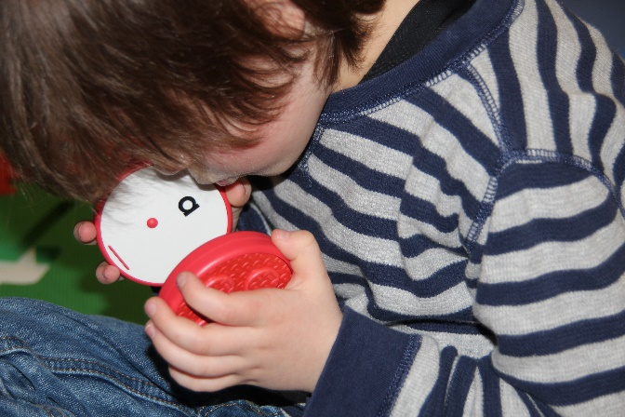
Teachers rated the students’ overall experience playing with Reach & Match® on five components: happiness, confidence, creativity, curiosity, and sharing. In general, teachers reported that students had a positive experience (i.e., rating averages of 3 or higher where 3=medium, 4=somewhat high, and 5=high) on the components of happiness, confidence, curiosity, and sharing. On the remaining component of creativity, teachers reported that students had a less positive experience with an average rating of 2.71 where 2=somewhat low.

APH asked teachers if both sides of the mats provide distinct learning and purposes. The majority (86%) said yes, and 14% said no. The comments below show that the patterns (often referred to as textures) on the sides of the mat and tiles generated the most pro and con remarks. What worked well with one set of students may not have been as purposeful for another set, such as praise for the patterned sides of the tiles for O&M concepts but not for tactile discrimination for young children who are just starting to learn and understand the same/different concept.
- Green and yellow sides were very similar texturally [had similar patterns].
- My students with low vision liked sorting by colors AND both groups liked putting the pieces into the corresponding holes. My blind students could not match the textures [patterns] because the textures [patterns] on the pieces were a "small" version and not actually the same as the textures [patterns] on the mat. Since they are just beginning to understand same/different, the textures [patterns] felt different. This is something I think needs to change in order to engage children who are tactile learners. My low vision students did not match/describe the textures [patterns] at all and only attended to the colors and shapes of the pieces. Additionally, when sorting by shape, they still only sorted by color since all the shapes were the same color, too. In order to really sort by shape, the shapes should be different colors. The students liked both sides of the mats, but side with holes for the pieces was the favorite and engaged both groups of students more.
- The texture [patterned] side was better for my O&M concepts.
- Both sides of the mat have the potential to provide multiple learning opportunities and sensory experiences.
- I used both sides of the mat when using this product. The side with the braille/print lettering on the puzzle pieces [tiles] provided many different experiences: braille identification, sequencing, matching, etc. The other side I was able to use for texture [pattern] matching and also for a student with low vision, who we have just realized that she has more vision than we originally thought, so it was great activity to learn color matching as well.

After reviewing the multiple levels of games provided in the manual, APH asked teachers if the games are versatile/flexible enough for children with visual impairments to play and learn with their peers. Six teachers (86%) said yes, and one (14%) said no. Reach & Match® is targeted for 18 months and older, but two teachers commented that the games were too advanced. One teacher suggested a tabletop version of the kit; offering multiple sizes of the same product is becoming more common in education toys, such as the product Imagination Playground™, available in big, medium, and small.
- I think the games in the manual are appropriate and easy to adapt for different levels of cognition and visual impairment. The materials are different and motivating for the students and the games/activities give so many different ideas! They're great, but most definitely need to be adapted for children who are developmentally below 3-4 years old.
- Overall, yes, the games are versatile/flexible enough, but if a TVI is not in charge of the materials for the class, then they need to collaborate with the teacher to make sure the game is taught and appropriate for the child(ren) with VI. Most of the games as written are too advanced for my students or need to be broken down step-by-step and modeled several times before the students started following along.
- [Yes], but only if an adult is providing support.
- Games and connected materials were not versatile for our learners. Our learners had limited mobility skills and could not fully participate in the activities or explore the entire mat. A smaller version with different sets of matching tiles would be helpful. If the tiles could incorporate other stimuli such as animals, sequencing activities, or numbers.
- The versatility and flexibility of this product is what I enjoyed most about it. This product is a great to complete many activities with sighted peers even involving a sighted younger sibling and having the older sibling with a visual impairment or blindness help them with sequencing or matching activities. It is a great tool to have students with visual impairments play alongside their peers or even teach them or guide them in the activities. I have previously worked with students with significant disabilities and I think Reach & Match® could be used for instruction and to encourage purposeful movement with those types of kiddos!

APH asked the teachers if the students were able to learn by themselves when playing with Reach & Match®. The majority (57%) did not think so. This may reflect the population the teachers had in the classroom—most of the children had multiple disabilities.
- Adult supervision needed to keep child engaged in activity. Children with visual impairments don't learn to play independently at the same time as their peers, they are usually years behind their peers in this area.
- Somewhat. They jumped right in and started sorting by color (the low vision group) and putting the right shapes in the right holes. They are not identifying any lower case letters yet, or braille letters, so they did not pay attention to these features. They also liked labeling the shapes and shaking the pieces to hear the sounds (though none of the students matched the sounds without modeling from an adult). In order to do more than that, students needed adult modeling and directions. (We have no sighted peers in our class.).
- The groups were not offered time outside of instruction to explore the kits after having some practice. (Note: Field test instructions asked that teachers conduct observation prior to instruction.)
- All the children I worked with are under the age of 3 years old, so some guidance and modeling was required. Our learners were not able to explore the materials without direct guidance.
- The children were able to do a lot of exploring on their own and use teamwork to help sequence or match.

APH asked teachers to rate the overall educational value of Reach & Match®. No teacher rated the product as low or somewhat low. Three teachers (43%) rated it medium, one teacher (14%) chose somewhat high, and the last three teachers gave it a high rating. Four teachers provided comments. Only one teacher wrote specific changes.
- I think the overall value and potential of this product is very high. The Speech Language Pathologist LOVED the materials. There's nothing like it out there. My biggest issue is that the braille on the pieces is not real braille, so it is actually harder for children who are braille readers to read it than if real braille was on the pieces—braille reading is done by shape and size recognition, the braille on the pieces is too big and does not maintain the spatial characteristics of braille that they are just beginning to read. Additionally, young children learn capital letters before lower case and my students do not know lower case letters yet and did not even pay attention to the letters on the pieces because they were so small. While the product has a lot of great potential, it's not totally accessible to students who are visually impaired without further modifications. The braille/print learning outcome is not appropriate without real braille on the pieces and large print capital and lowercase letters.
- I think this kit is great! As a traveling O&M specialist, it would have yielded better results if the kits were available for the kids to use more often than O&M lesson time. But I needed to take the kits from site to site.
- Overall the Reach & Match® Sensory Kit was a huge hit with the families and children I introduced it to. We played matching games, stacking, rolling the circles, shaking the different shapes, and putting into/taking out of the bag. The kit provides a variety of teaching and developmental activities.
- The students that used it in my classroom all have low vision. Using and following the activity guide and building off those activities throughout my time with Reach & Match®, I was able to see how great this product is for such a wide variety of students, which makes this product have such a high educational value. Students can explore themselves in so many ways, play games with sighted peers, promotes movement, promotes confidence, and can be used as tool for the student to teach others about braille and tactual discrimination skills.

APH asked teachers to rate the aesthetic design of Reach & Match®. All teachers like the design with 28.5% rating it somewhat high and 71.5% saying high.
- It's beautiful and I loved having it as part of my classroom.
- Every teacher who saw these kits had ideas on how they could use this for many other students who are not visually impaired. It is a wonderful sensory learning kit.
- I really liked all of the colors and overall design of the kit, except for the WHITE bag it comes in. While transporting the bag from point A to point B, I would have to lean the bag against something and I always seemed to pick up dirt, markings, etc. Maybe the bag could be a different color and/or material, so it would be easy to clean off or wipe down.
- The minute that I opened the box and placed it in the classroom, my students were instantly curious and wanted to see what the fun colored and textured 'wall' was. It is such a fun design and encourages curiosity almost instantly!
- It’s very heavy.

APH asked teachers to rate the manufacturing quality of Reach & Match®. Teachers responded with 14% at medium, 29% with somewhat high, and 57% at high. Five teachers submitted comments.
- Foam piece were too heavy. I have seen lighter interlocking alphabet foam pieces. Foam pieces did not interlock when standing nor did they interlock when two tactile sides were intertwined with the two puzzle sides. (Note: The mats do interlock when standing.)
- It's great. Everything is very sturdy and seems well made.
- IT NEEDS WHEELS!!! It is it hard to carry two kits on a cart through doors. It would be awesome if the kit had luggage style wheels.
- Materials were easy to clean and durable. Everything was easily stored.
- The quality and durability of this product in my opinion is great. It is sturdy and made from material that will last over a long time period.

APH asked teachers to rate the educational content in the manual. The teachers responded with 14% medium, 43% somewhat high, and 43% high.
- It took me a while to realize my students were exploring the kit from activities 1.1 to 2.1 to 3.1 and not from 1.1 to 1.2 to 1.3.
- I liked the manual a lot and was impressed with the number of games and ideas that we could do with the Reach & Match! Most games had to be adapted to be developmentally appropriate for my students, but it gives a good idea of what can be done and then I can figure out the starting place and work up to the actual suggested game/learning outcome.
- A creative teacher is still needed even with the manual.

After field testing the Reach & Match®, APH asked teachers if they would like to have a Reach & Match® Kit in their classroom. All (100%) said yes.

Then APH asked if money was no object, how many Reach & Match® Kits would meet the needs of their students best. Most classroom responded with one or two.
- My classroom-1-2, for school 4-5
- I [would] order two kits for several of my sites. I provide services in the homes of my students, so I'd likely just need one. If each family wanted a kit for their homes, I'd need around 12.
- For my classroom, I would only need one Reach and Match kit.
- I do have students on my caseload that are not in my classroom that have multiple disabilities that would benefit from the use of this product, so in all I would need two kits.

APH asked teachers if they had students on the Federal Quota census. Six teachers (86%) responded yes, and one teacher (14%) said no. If teachers responded yes to the question, APH asked if they would recommend that their school/agency use a portion of their Quota funds to purchase Reach & Match®. All six teachers said yes.

At the end of the evaluation, APH offered an opportunity for teachers to submit general comments about Reach & Match®.

Marketing suggestions
- Have you considered selling the tiles separately?
- Have you considered adding a sound component to the puzzle track?
Modification suggestions
- It would take months to years for students with additional disabilities to move through the activities in the manual.
- The kit is very heavy for itinerant teachers to carry it from the office into the car into the home/school and back.
- Make the textures on the pieces the same as the textures on the mat, not smaller versions. They do not feel the same to a totally blind preschooler; they feel different.
- Put capital letters on the pieces, along with lowercase, with space between the two letters and a larger font to make it easy for young children who visually fatigue easily or who have CVI and are learning to use their vision to see the letters.
- An additional change that would make it more certain that children were matching [patterns] textures, have the [patterns] textures on the pieces be white or black so they had to actually match [patterns] textures and couldn't rely on color perception (especially important for dual-media or low vision students). Also, each color should have different shapes instead of all shapes being one color, because then they could also be sorting by color rather than shape. Same thing with the sounds¬¬—don't make all colors/shapes the same sound since they could be matching/sorting by shape rather than sound. So, if you REALLY want to use these materials to teach sorting by shape, texture, or sound, the shape/texture/sound cannot all correspond to the same color and needs to be mixed up. My low vision students all sorted by color, no matter how much they were encouraged to sort by shape, texture, or sound. My blind students couldn't sort by texture since they don't feel the same and really only matched shapes by picking up a piece and finding the right shaped-hole.
- Overall I love the product and think it's such a GREAT idea, but it's not fully accessible to young children who are visually impaired without some major modifications.
- Put real braille on the pieces, not the current braille dots. If needed, this could be done by putting braille letter stickers (like the ones APH already makes) on the pieces (or directing the teacher who orders the kit to do it) if it cannot be done to the plastic pieced directly.
- Consider putting regular sized braille on the tile pieces instead or in addition to the large braille?
Positive remarks
- This kits makes me wish I still worked in Early Childhood Development.
- This kit would benefit ECE aged students.
- Thank you for allowing the children and families I work with to assist in this field test. They are excited about when the R&M Kit becomes available for continued learning opportunities!
- Based on our experience with Reach & Match® this could be a great learning tool for our population of students. Our learners often have limited mobility, so a table top version would make it more assessable for those learners. This would be a great tool for teaching sensory concepts and colors for those not visually impaired.
- Reach & Match® was so much fun to field test, I wish I had more time with it to try it with a variety of students with different needs and especially sighted peers. This product's flexibility, design, learning outcomes, etc. are great for a variety of settings in a variety of conditions. Products like these are invaluable to teachers.

Next Steps
The teachers top three concerns about Reach & Match® are the lack of standard braille on the tiles, the fact that the patterns are different on the tiles and the mats, and that the sound of the tiles are color and shape specific.

APH agrees with the teachers’ comments that standard braille on the tiles would be beneficial to children with total blindness; however, just as sighted children are introduced to all forms of printed type to know that there is an enriched world of typography that portrays importance, emotions, and aesthetics, children who read braille should be afforded this same opportunity. Over and over, through the years, parents and teachers have introduced young children to braille using a muffin tin with six tennis balls. APH offers other products with oversized braille as a way to provide materials that are more universally designed to encourage peer and sibling interaction. APH’s Lots of Dots Series provides two versions of enlarged braille (both bigger than what is on Reach & Match®) and standard braille side by side on the pages. Teachers will always have the option and choice to add braille stickers (APH #1-08849-00) to the tiles. APH will suggest in the American version of the manual that if needed, teachers can place braille stickers on the tiles.

There are different levels of learning, and some students may not be ready for same/similar/different in regards to the patterns being larger or longer on the mats than on the tiles. If a student does not know the concept, APH recommends that teachers use Reach & Match® to help teach it. Teachers begin to teach concepts of small and big and short and long at a very early age using the Light Box (APH #1-08669-00). As an expansion activity to teach shorter and longer, teachers can use two blue segments of the Tangle Toy (APH #1-08750-00) to create the pattern on the blue tiles and then add a third segment to match the top four rows on the blue mat and then add a fourth segment for the remaining rows on the blue mat. Teachers are every creative and will find innovative ways to incorporate Reach & Match® into lessons.

If low vision students do all the activities by color and not by sound or shape, there is always the opportunity to play games where all students wear eye shades. It is like interactive exhibits at zoos and nature preserve centers—stick your hand in a covered box and identify the nature object. APH will add this suggestion to the American version of the manual.

One of the reasons APH was interested in Reach & Match® is that it provides an opportunity for group play during which teachers can observe and take notes on students as they explore, play games, problem solve, and develop their imaginary play skills. APH understands that the product will be cost prohibitive for some schools and agencies, but that should not be a deterrent to provide this excellent educational product to as many students as possible.

References
Ferrell, K. A. (2010). Visual development. In A. L. Corn & J. N. Erin (Eds.), Foundations of low vision: Clinical and functional perspectives (pp. 306-310). New York: AFB Press.
How Kids Develop. (2008). What is child development and what skills do children develop at different ages. Retrieved from http://www.howkidsdevelop.com/developSkills.html
State of NSW, Department of Education and Training. (2010). Child development theorists. Retrieved from https://sielearning.tafensw.edu.au/MCS/CHCFC301A/12048/chcfc301a/lo/12020/index.htm#d27e301
Wolfberg, P., Bottema-Beutel, K., & DeWitt, M. (2012). Including students with autism in social and imaginary play with typical peers: Integrated playgroups model. American Journal of Play, 5(1), 55-80.

In fiscal year 2017, APH conducted field testing, edited the book for distribution in the United States and its outlying areas, and created the HTML and braille-ready file. The project leader presented the field test results at the 2017 CHARGE Foundation Conference in Orlando, FL.

Work planned for FY 2018
APH plans to release the product for sale.

Tactile Book Builder
(Continued)

Purpose
To develop a kit of book-making materials and an accompanying manual to facilitate and guide the creation of individualized tactile books for children; materials support inclusion of text in an appropriate medium as well as a wide variety of types of tactile illustrations including objects from the child’s own environment, shapes, textures, collaged illustrations, and raised-line illustrations.

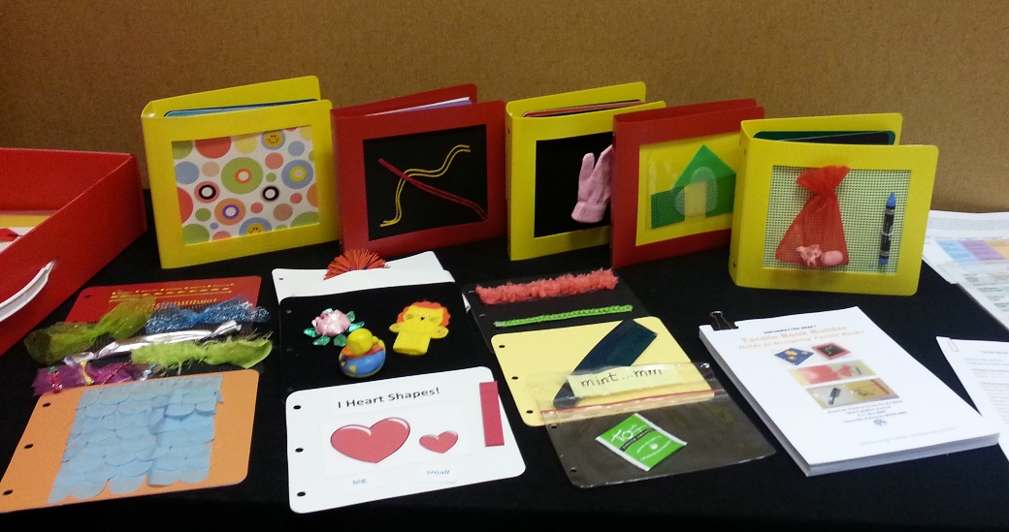

Project Staff
Suzette Wright, Emergent Literacy Project Leader
Monica Vaught-Compton, Project Assistant
Wendy Sapp, Consultant
Dana Fox, Consultant
Jane Barabash, Consultant
Christine Moe, Consultant

Background
The request that APH create a kit of materials enabling users to easily create a variety of individualized, custom-made tactile books has been expressed by focus groups and survey respondents. Because a young child’s concepts and language are limited, individualized books that address familiar topics and include things the child has experienced firsthand are more likely to be meaningful than visually complex, commercially available books designed for a typically sighted child. In addition, when the child helps dictate and produce the written text, the adult is able to use this opportunity to build important early literacy skills. When the child also participates in illustrating the book, it broadens his/her awareness of how tactile displays can be used to communicate meaning. Creating custom-made books, whether done by the adult or in collaboration with the child (participative design), can increase the number of appropriate books available to the child and motivate interest in books and in reading.

The idea for a tactile book-making kit with guidebook received approval from the Product Evaluation Team, and proceeded to the Product Advisory and Review Committee. The project was approved and released for work to begin. A brainstorming session marked the first Product Development Committee meeting and yielded useful suggestions for materials that might be part of the kit. The project leader examined a wide range of materials that could be used for book-making by searching online and in stores. The list of kit components and how they would be grouped was finalized and sketches made to show expert reviewers. Dimensions and quantities for kit materials were selected, and costs were estimated.

The project leader completed a rough draft of a kit guidebook containing guidelines for tactile design and instructions for using the kit materials to construct books with a variety of tactile illustrations.

The basis for the Tactile Book Builder kit is a relatively low cost, reusable, polyblend binder (9” x 8”) provided in two different spine widths: 2.5” to accommodate thicker textures and objects and a 1” binder for less bulky books. The binders feature plastic safety rings. The binders also include a “window” in the front cover for insertion of custom tactile cover art.

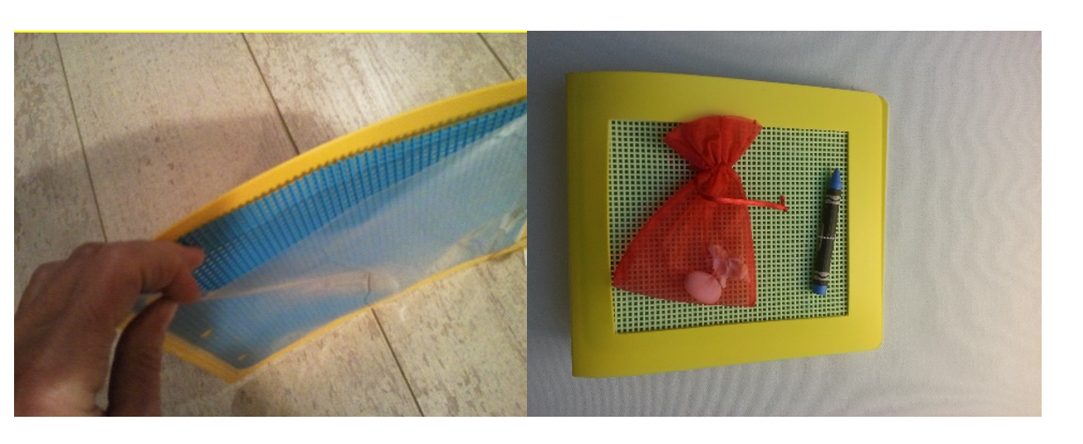

The remainder of the kit consists of blank pages, 3-hole punched, for insertion into the binders. A number of different page types are included for fitting into the binders: colorful board stock pages, polyblend pages, needlepoint canvas pages, polyblend “pocket pages,” Ziploc® pages, magnetic pages, loop material pages, doubled braille paper pages, and clear page protectors used to protect print pages and create twin vision books. Clear, adhesive-backed braille label material in three sizes is included in the basic kit, as well as adhesive-backed hook and loop material attachments, and
adhesive-backed magnetized strips. Also included is a version of the APH SoundPage with recording devices sized for the small binders in the kit.

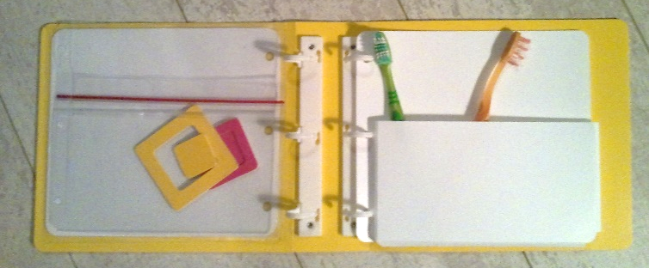
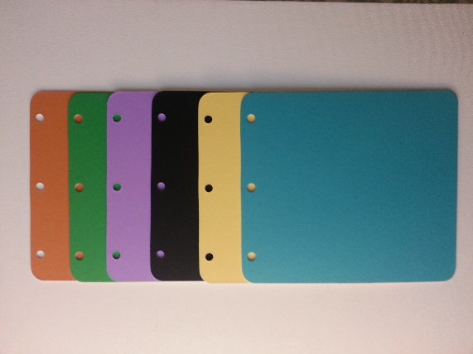

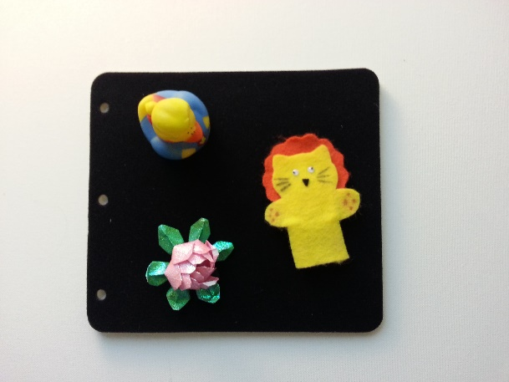

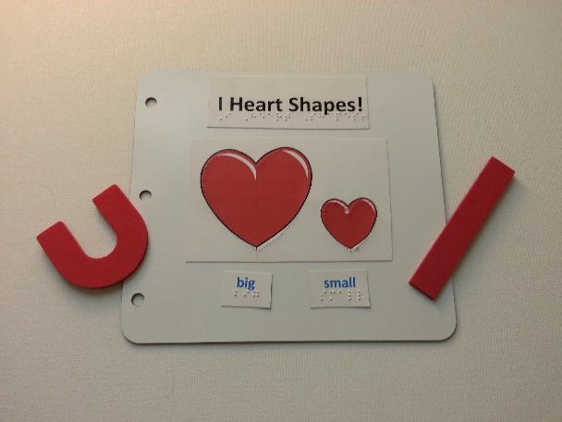

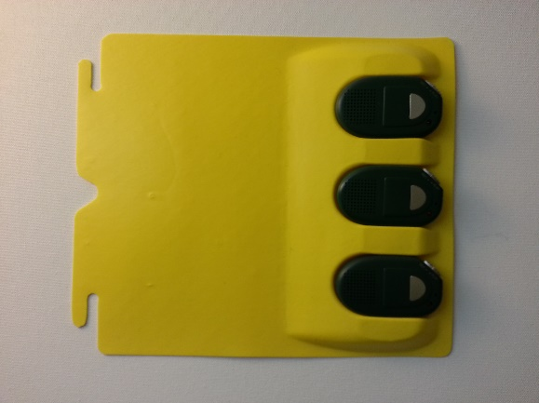

The list of suggested kit items and a draft of the manual were submitted to two consultants for evaluation. Overall, they were pleased with the kit items and contents of the manual. However, they recommended that the manual (Tactile Book Builder Kit Manual) and the Guide to Designing Tactile Illustrations for Children’s Books, a 35-page booklet available since 2008 as a free download from the APH website, be integrated into one document. Originally, the project leader had planned to include the second document as a separate piece.

Technical drawings were made of the kit’s custom binders, pocket pages, and Ziploc® pages. A vendor for these was identified. Several alternatives were explored with the vendor as a means to strengthen the binder cover and retain its open window. The dimensions of the Ziploc® page were also reworked after consultation with the vendor. Drawings were revised and given to vendors for price quotes. Sample prototypes were delivered by the vendors in the last quarter of 2013. A variety of alternatives regarding both the material and fabrication method to be used for the metal/magnetic pages for the kit were explored and sampled with Technical Research staff, the model maker, and outside vendors.

A final design for the binder covers was completed. Finalizing the binder dimensions allowed staff to have needed dies made for cutting the internal pages for the binders. Special high-strength, double-sided magnetic sheeting was located by the project leader, providing a way to produce magnetic pages in a low cost manner. Packaging for the kit was chosen. The project leader and Technical Research staff worked together to locate and order material for all other kit items. A cutting die was made to produce all prototype pages, and 10 prototype kits were fabricated and assembled for field evaluation. Braille templates for the binder pages and label material were designed to assist in planning and aligning braille text.

Extensive work was done on the manual to blend the two documents and update source material. A Quick Start Chart was prepared to show users in a glance how each page type could be used to make a variety of types of tactile illustrations.
Appendices list other products offered by APH that are useful in creating tactile books as well as an extensive illustrated list of suggestions for using available materials that are on hand in a classroom or home, or can be purchased at craft supply stores.

Tactile Book Builder Quick Start Chart
TBB Pages | Real Object Illustrations | Collaged Illustrations | Raised-Line Illustrations
Pocket Pages | Insert objects in pockets
Ziploc® Pages | Enclose objects
Needlepoint Canvas Pages | Attach objects with zip ties, “twisties” |  | Lace yarn, string, pipe cleaners through the canvas to form lines & raised shapes
Polyblend Pages | Attach objects: zip ties, hook/loop, magnetic attachments, glue | Glue or attach textured shapes using hook/loop or magnetic attachments | Glue string, yarn, or Wikki Stix®; apply puff paint to form lines & raised shapes
Board Stock Pages | Attach objects with zip ties, hook/loop, magnetic attachments, or glue | Glue or attach textured shapes using hook/loop or magnetic attachments | Glue string, yarn, or Wikki Stix®; apply puff paint to form lines & raised shapes
Fabric Pages | Attach objects with hook/loop attachments | Use hook attachments to back textured shapes to apply to page | Use hook attachments to back raised and outline shapes to apply to page
Magnetic Pages | Attach objects with magnetic attachments | Use magnetic strips or sheeting to back textured shapes to apply to page | Use magnetic attachments to back raised and outline shapes to apply to page
Card Stock Pages | Attach objects with hook/loop, magnetic attachments, or glue | Glue or attach textured shapes using hook/loop or magnetic attachments | Emboss; glue string, yarn, or Wikki Stix®; apply puff paint to form lines & raised shapes

The resulting 105-page manual was reviewed by Christine Moe, doctoral student at the University of Northern Colorado (UNC). At her recommendation, a brief section on emergent literacy was added; more updates to the manual’s references were provided by Moe; and the project leader drafted a detailed chart listing fine motor, tactual discrimination, cognitive, and language skills needed for effectively using different types of tactile illustration. The developmental chart suggests the illustration style and book genre appropriate for a child at each level. Data assembled from multiple sources by UNC provided the basis for the sequence of tactual discrimination, fine motor, cognitive, and language skills listed in the chart. The unformatted draft of the manual was then readied for field evaluation.

Field evaluation forms containing both closed and open-ended questions were written for the manual and kit items. Eight evaluation sites agreed to participate. In February through March of 2014, nine evaluators at six sites completed the evaluation. Two additional evaluators at one of the sites answered questions regarding kit items although they did not evaluate the manual. An evaluator at a seventh site delegated responsibility for the evaluation; although only parts of the questionnaire were answered, in its place a brief narrative impression of the kit and manual was provided. These results were recorded separately. The eighth site did not return an evaluation.

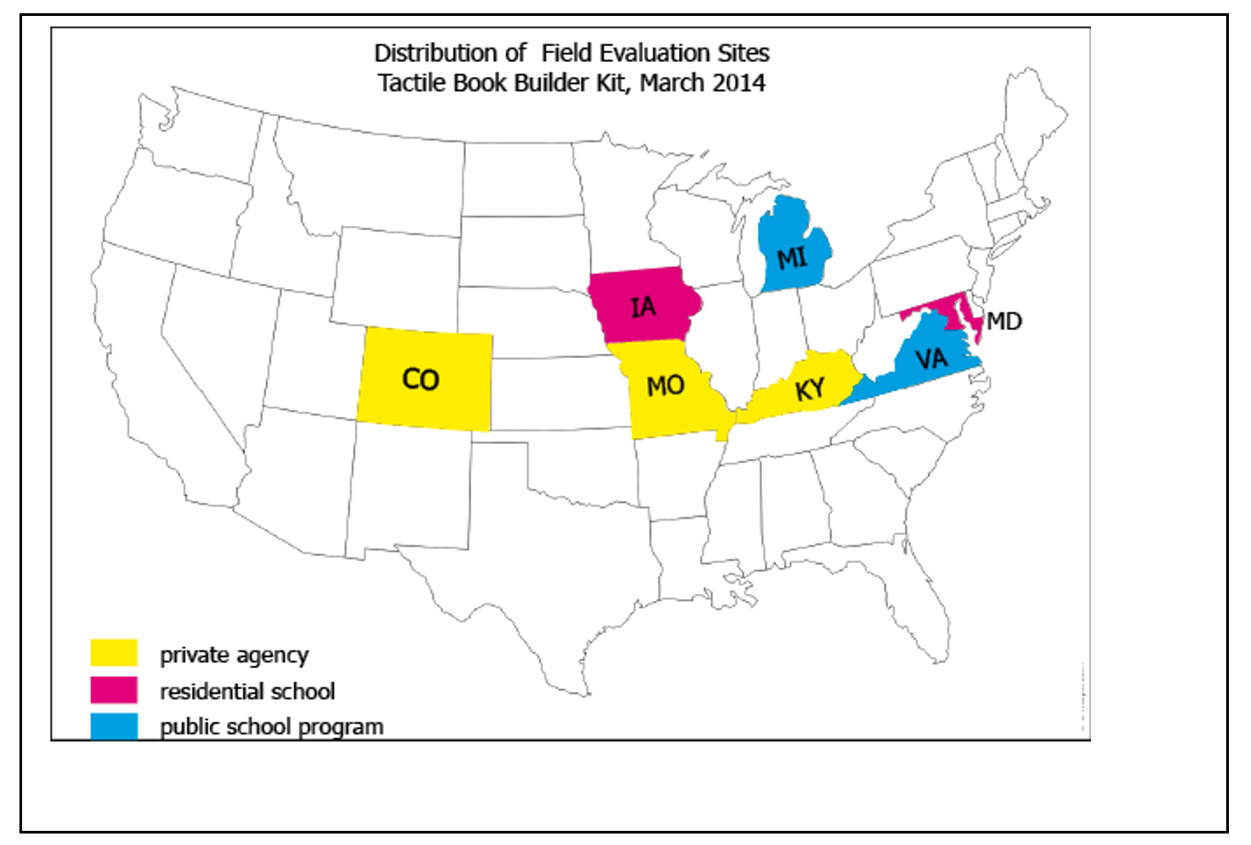

In all, nine TVIs, two TVI/COMS, a parent, and a teaching assistant took part. The TVIs ranged in years of experience from 2 to 24 years. The participating parent had also worked extensively in the field with 29 years of experience. The teaching assistant had been in the field for less than six months.

All nine evaluators completing the full evaluation indicated that each of the three sections of the manual would meet the needs of 80-100% of the TVI audience. Other data include the following:
- 89% of the evaluators rated all of the manual as appropriate for all or almost all early interventionists
- 78% of the evaluators rated all of the manual as appropriate for all or almost all regular education preschool teachers
- 67% of the evaluators rated the manual as appropriate for all or almost all paraprofessionals

Although parent use of the manual was not a primary objective of the project, 67% of the evaluators answered that all or almost all parents could use the manual; however, steps needed to improve the manual for parent use could, a majority indicated, limit its usefulness for the primary audience of TVIs.

Evaluators’ comments about the manual were highly positive:
- “I feel that this information will benefit all those that deal with students with different needs. Explanations are clear and easy to understand. I like the way items are broken down for more clarity.”
- “This is the most comprehensive description and discussion of tactile illustration I’ve seen. This is a fabulous resource for professionals and lay people, including parents and volunteers.”
- “I love it. It explains in a way that is understandable for everyone, yet not too wordy. Very applicable.”
- “I loved all the practical ideas.”
- “Again, I think motivated teachers w/VI child in their class are going to be thrilled to see this. Your info and high level of detail makes this so invaluable.”
- “The manual provides great examples of ideas for writing and making customized books.”
- “Again as with the other sections, information is written well and is easy to read and understand. The pictures are good and help with understanding the examples and suggestions. It is written to be easily understood.”
- “Good reminders for the variety of book topics/ uses. Valuable addition to include examples, suggestions and ideas for the use of TBB materials.”
- “I like the examples of different kinds of books and how they can be used. That way they don't have to come up with ideas from scratch. They can benefit from the books others have made. It also reinforced what I was thinking and spurred other ideas for my students.”

The Quick Start Chart, appendices, and developmental chart were considered useful by 89 to 100% of the field evaluators. Comments:
- “Love the developmental chart!”
- “I like how this [developmental chart] takes skills that blind kids need and puts activities (books) used to develop them. This could be a place where Core Standards for education can be applied and used so people can see how the standards fit in for our kids. This would be helpful for IFSPs and IEPs.”
- “[The developmental chart] is very useful the way that it is organized, divided and color coded as well. This chart can help with a wide variety of students with various needs. It is a good quick reference to use.”
- “[The Quick Start Chart] is great if you don’t have time to read the manual.”

At the seventh site, some parts of the evaluation were completed. The TVI and teaching assistant indicated that most TVIs would or should already know the information contained in the manual. They recommended the manual be divided into two separate documents—a shorter “how to” booklet and a second longer manual for those lacking training and experience. In many respects, this is similar to the two documents submitted to expert reviewers before integration of the two documents was recommended. To address this concern, the Quick Start Chart is being expanded slightly and the manual’s introduction suggests experienced tactile book designers skip the first section of the manual.

The majority of evaluators were pleased with the kit items:
- 89% indicated the basic design of the kit, featuring binders and a variety of page types for custom-making tactile books, “accomplishes its purpose well”
- 100% of evaluators said the binder and pages “were about the right size” for the target audience and purpose
- 89% stated the binders functioned well as a means of making tactile books quickly and easily for the target audience
- 100% favored the inclusion of both the thinner and thicker spine widths for the binder
- 90% indicated the binder was safe and durable (The single dissenting evaluator noted splitting due to pre-scoring of the prototype binder’s spine. This should not occur in production copies of the binder. In addition, a thicker plastic backing for the binder’s front cover, which had already been planned for production, was suggested.)
- 90% indicated all other kit items were safe and durable

Seventy percent stated the kit should be produced “as currently designed”; 30% indicated it should be produced with “a few but significant revisions” yet noted suggested changes were mostly a matter of adjusting colors and quantity of some page types.
- One evaluator suggested that the Ziploc® page be modified to open more easily.
- One suggested the magnetic page should be stronger.
- One requested a means of closing the open pocket page.

The suggested additions to the kit were longer plastic banding ties, page reinforcers for the paper braille pages, and rings to clip pages together for storage.

About the kit, in general, evaluators remarked:
- “I love literacy and making experience books for my students. I love the size of paper that you chose and variety of pages that are included.”
- “[I like] the variety of materials available so you do not have to search for what would be most appropriate.”
- “It supplies all the materials needed for making a tactile book.”
- “All of these materials provide a great variety for making the books. They are all necessary because I never know what I might need. I would like as many of each items as possible while keeping the price low.”
- “I like the variety of materials because I can individualize for each student based on his or her needs.”

The TBB kit and manual were approved for sale on Quota. Indicated revisions and additions to the Tactile Book Builder kit and manual were implemented. Final quantities and colors for all kit items were selected based on field evaluation results and consultation with other APH staff. A Product Structure Meeting was convened to discuss and approve these choices. The kit’s binders and each of the kit’s page types will be available for separate order as Refill Packets bearing part numbers; this allows customers to replenish the kit with the materials they use most often. The manual is also available as a separate purchase.

The manual received a final edit by the project assistant. Further illustrations were added to the manual. Cover art suggestions were given to the graphic designer. Final copy of the manual was given to the designer and the project leader consulted with the designer as work proceeded.

The Emergent Literacy Project Leader showed the kit and manual to the CVI Project Leader as a possible basis for a kit of book-making materials designed around the needs of students with CVI. The CVI Project Leader proceeded with plans to utilize the TBB materials and to develop a separate manual focused on how the kit materials can be used to custom-make books for a child with CVI. That project, as an offshoot of this project, was named CVI Book Builder.

The manual, Tactile Book Builder: Guide to Designing Tactile Books (117 pages), was formatted by the graphic designer. Descriptions were written for the 80 photos showing examples of types of tactile illustrations, a wide variety of tactile books from different sources, and materials used to construct them. Formatting was completed for the chart (Appendix C), designed to help teachers identify the type of tactile illustration and type of story suited to each student’s fine motor, cognitive, and tactile discrimination skills. A notice was added to the manual to explain the relationship between the Tactile Book Builder Kit and the CVI Book Builder Kit. The final file, clean file, and alt tags for the manual were turned over for creation of accessible files.

Work during FY 2017
The HTML and BRF for the manual were completed. Both accessible file types will be available as free downloads. Final specifications for the kit and manual were completed and provided to Production in July.

Work planned for FY 2018
The kit materials and manual will be produced, priced, and made available for order. Refill Packets for each of the page types, additional binders, and the manual will also be available as separate purchases.

Tactile Book Texture and Item Accessory Pack
(New)

Purpose
To develop an accessory pack of textures and items to be used to construct collage style tactile illustrations in books for a young child, such as custom-made books made using the Tactile Book Builder kit materials

Project Staff
Suzette Wright, Emergent Literacy Project Leader
Monica Vaught-Compton, Project Assistant
Bryan Rogers, Manufacturing Specialist

Background
The request that APH create a collection (accessory pack) of materials to make it easier for teachers and parents to create collage style illustrations for custom-made tactile books was expressed by evaluators of the Tactile Book Builder kit in late spring of 2014. Seven of 11 evaluators rated a pack of textured materials as “highly needed,” three rated it “needed,” and one labeled it “not needed.” Many educators and parents agree that custom-made tactile books can be highly effective in promoting an interest in books and reading for young children with visual impairments (Miller, 1985; Swenson, 1999, 2015; Lewis & Tolla, 2003). A book made for an individual child can be about the home environment or other firsthand experiences of the child. Illustrations can be designed with the child, involving him in choosing what has meaning for him and what he prefers to touch.

In particular, tactile illustrations that feature realistic textures offer a means to provide meaningful and engaging illustrations in books for children with visual impairment. A recent study found consistently higher rates of recognition for textured collage illustrations versus thermoform and raised-line drawings; the study was conducted with 23 students ages 6 to 16 years (Theurel, Witt, Claudet, Hatwell, & Gentaz, 2013).

Obstacles to custom-making collage illustrations include the fact that teachers and caregivers frequently lack time to locate and purchase the necessary materials. In addition, book creators must often buy a much larger quantity of material than they need, such as a suitable wallpaper texture, to produce a single book. The proposed product saves teachers’ time and expense, making it more likely that they will create these more effective types of collage style books.

It will be a limited collection of textured materials selected because they are suited to realistically represent the textures of common items included in collage style illustrations in a child’s tactile book (e.g., grass/plastic “turf,” tree trunk/wood textured wallpaper, house/simulated brick texture, door/wood veneer, sidewalk/rough “sanded” wallpaper texture, animal/long fur, animal/short fur, fish/slippery shiny material, and snake/leather-like vinyl). The materials are representative of texture and also general color of the items to enable the illustration to function well visually as well as tactually. The materials can be used alone or with the Tactile Book Builder Kit to custom-make books featuring collage illustrations for a young child. They can also be used by the child to illustrate something of his own choosing.

Work during FY 2017
A Product Submission Form for the product was developed by the project leader after reviewing the types of objects and settings that most commonly appear in children’s books as well as topics most likely to be the focus of a firsthand experience story. Of the many possibilities, textures and small items that depict familiar things likely to be found in a child’s backyard or park were chosen. This provided a theme/focus for the accessory pack, with the possibility that other themed packs (seasonal, common routines, etc.) could later be provided.

The project leader submitted the form after consulting with the Tactile Graphics Project Leader and examining Carousel of Textures and possible plans for an extension of this product. The two worked to define differences in what each would provide and were satisfied the products served different needs and would not result in duplication of effort. The product passed through the standard approval process and was approved by the Product Advisory and Review Committee and removed from the parking lot for work to begin in February 2017. The project leader identified parts from existing APH products, including other tactile books that will be included in the accessory pack. In addition, other items were located and sources identified after exploration online, in craft stores, hardware shops, and do-it-yourself establishments. To the extent possible, costs and quantities for these have been estimated by the project leader. The project leader met with the manufacturing specialist regarding these and an initial Product Development Meeting was held.

Work planned for FY 2018
The manufacturing specialist will work with the project leader to find sources for the items, able to meet the need for low minimum quantity purchases. Safety information about all of the materials will be sought and if not available from the vendor, must be carried out to ensure standards are met. Sample packs of the materials will be submitted to teachers and parents for experimentation and to gather their opinion of suitability for homemade collage style illustrations and the overall functioning of the product. The product will be revised as indicated by field evaluation results and Product Development meetings leading to finalized specifications will take place.

The Best for a Nest [Modernization]
(Completed)

Purpose
To revise The Best for a Nest, a book once printed by APH; to produce an interactive storybook for learners to focus on many concepts, such as positional relationships, prepositions, and use of tactile symbols

Project Staff
Dawn Wilkinson, Early Literacy Project Leader
Charles “Burt” Boyer, Project Leader Retired
Monica Vaught-Compton, Project Assistant
Lois Harrell, Author

Background
The Best for a Nest was originally copyrighted in 1976 by Lois Harrell, and produced as a contract job by APH in 1986. However, at that time, the book was not available from APH as a catalog item. Approximately 70% of the 136-word vocabulary is composed of words that appear on the Dolch list. The material in the story allows opportunity for further elaboration and concept development. In 2008, the project leader worked with APH staff, the author/consultant, and Bisig design firm to complete the version of The Best for a Nest that became for sale by APH in 2011.

After the adoption of the UEB braille code in 2016, The Best for a Nest needed to become UEB compliant. Although additional changes were discussed, such as including tactile graphics in addition to the storyboard manipulatives, as well as changing some of the storyboard pieces, these revisions were not feasible at this time. Due to the over 75 instances of prepositional phrases that are no longer written together in UEB, however, as well as the removal of the signs for the words “to” and “by,” the differences from EBAE are perhaps more evident than some other revised products for UEB to the braille reader.

Work during FY 2017
New catalog numbers were generated to reflect the change to UEB. The Reader’s Guide and storybook were rebrailled. Graphic Design made all necessary changes to printed copy to reflect the new catalog number. All tooling was completed and a specification meeting was held in July 2017.

Work planned for FY 2018
Product will become for sale in early FY 2018.

Visio Tactual Profile
(New)

Purpose
Royal Dutch Visio Tactual Profile is an instrument for observing the tactual functioning of children ages 0-16 with severe visual impairments.

Project Staff
Dawn Wilkinson, Early Childhood Project Leader
Suzette Wright, Emergent Literacy Project Leader
Monica Vaught-Compton, Project Assistant
Kelly Kennedy Mimms, Research Assistant

Background
The Visio Tactual Profile has been validated by the University of Nijmegen in the Netherlands. Areas of sensory functioning, motor functioning, perceptual functioning, and practical skills are addressed. It was distributed by Optelec, U.S. in 2011, but no longer has a U.S. distributor. In an effort to make the product available in the United States, Anneke Blok of Visio, submitted the product to APH in September 2016.

Work during FY 2017
The product was presented to the Product Evaluation Team in February 2017 where it was decided that before proceeding to the Product Advisory and Review Committee (PARC), the product should undergo an expert review. APH purchased two additional Visio Tactual Profiles for a total of three to be sent out for review. A poster presentation demonstrating how APH tactile products support the skill categories addressed in the Visio Tactual Profile was given at the first ever International Tactile Reading Conference in Stockholm in April. Seven expert reviews were conducted in June 2017, and results were analyzed. A few of the questions and responses follow.

How would you rate the overall need in our field for the Visio Tactual Profile, where 1 equals not needed and 5 equals significantly needed?
3 | 14.29% (1)
4 | 42.86% (3)
5 | 42.86% (3)

Check any or all that apply:
Assesses a student's level of tactual development | 85.71% (6)
Identifies tactual strengths and weaknesses | 100.00% (7)
Presents learning to read tactile graphics in a sequential way | 85.71% (6)
Presents concrete to abstract representation | 100.00% (7)
Organizes materials into categories so that skills can be addressed accordingly | 85.71% (6)
Can be used to determine a baseline | 100.00% (7)
Can be used to reevaluate skills over time | 85.71% (6)
Presents tactile graphic use within the much larger context of tactual functioning across a wide variety of tasks | 85.71% (6)
Total Respondents | 7

To what extent do you agree with the following statement: The Visio Tactual Profile, when purchased by an agency, will serve numerous students over multiple years.
Strongly agree | 42.86% (3)
Agree | 57.14% (4)

Six reviewers (85.71%) believe that APH should distribute this product; one reviewer responded that APH should not distribute this product.

The results of the survey, in its entirety, were presented to PARC during the August 2017 meeting.

Work planned for FY 2018
Contract negotiations will take place with Visio. If approved, the product will become available for purchase from APH.

What Is It? [Modernization]
(New)

Purpose
To promote comparative thinking and the ability to generalize

Project Staff
Dawn Wilkinson, Early Literacy Project Leader
Charles “Burt” Boyer, Project Leader Retired
Monica Vaught-Compton, Project Assistant
Lois Harrel, Author

Background
In 2008, the project leader collaborated with Harrell to develop the original APH product. Ten prototypes of the product were developed for field testing purposes. The product for field testing included: Instructional Guidebook, Words and Descriptors (102), and a recipe-type box to store the cards.

What Is It? was field tested in the spring of 2009. Six reviewers, representing the states of Kentucky and Indiana, evaluated the product. Fifteen students used the product. These students ranged in age from 6-14 years old; school grades ranged from Pre K to 8th, with the majority being Pre K. A wide range of visual acuities and eye conditions were represented.

Five of six evaluators recommended that this product be available from APH on Quota. Reviewers reported that 87.5% of students found the game to be both fun and challenging, and the large majority of students wanted to discuss and examine the actual object after identifying it based on the clues. Suggested revisions to the product were (1) use of a thicker card stock for the game cards, (2) revising several word cards so that the word is more specific to the provided clues, and (3) adding an orientation corner cut to the cards for the braille reader. The project leader made all of these requested revisions and the original product became for sale in 2010.

Work during FY 2017
Due to the adoption of UEB, this product was approved for modernization. Only two braille cards need braille change (“table” and “station”), but all cards will need a new catalog number printed. The revision will also include the braille version of the teacher guide. Braille job start forms were initiated, and cover art design for the print to reflect the new catalog number was completed.

Work planned for FY 2018
Tooling will be completed, and the modernized product will become for sale.

EXPANDED CORE CURRICULUM

ECC Icon Poster
(Completed)

Purpose
To provide a large print/braille poster that will encourage general awareness of the Expanded Core Curriculum (ECC). The ECC encompasses nine skill areas important for the specialized instruction of students who are blind or visually impaired.

Project Staff
Karen J. Poppe, Tactile Literacy Project Leader
Rachel White, Research Assistant
Anthony Slowinski, Graphic Designer
Laura Greenwell, Graphic Designer
Andrew Moulton, Manufacturing Specialist
Tom Poppe, Model/Pattern Maker

Background
The product idea for a poster that would highlight the nine instructional areas of the ECC was suggested by Ava Silverstein, a teacher of the visually impaired. Silverstein is a user of the Quick & Easy ECC: The Hatlen Center Guide (1-08204-00), a product introduced by APH in 2014. Specifically, her product submission form suggested the development of a “reproduction of the ECC Icons from the current Quick and Easy Expanded Core Curriculum produced as a wall-sized poster 24" x 16" to either be a standalone product or an update to be included in Quick and Easy Expanded Core Curriculum so it can be posted in every VI classroom to quickly explain to gen ed teachers and families the importance of the Expanded Core Curriculum and the National Agenda for students with visual impairments. Nothing is currently available that does this.”
In November 2015, the product submission, originally titled “Visually Impaired Expanded Core Curriculum Icon Poster,” was forwarded to the project leader for review and evaluation. After overseeing the development and introduction of both the Quick & Easy ECC guide and the Touch, Label, and Learn Poster: Human Skeleton, the project leader quickly assessed the proposed poster as beneficial for general ECC awareness and feasible for production using newly-established processes. The visual ECC icons were uniquely designed by an in-house graphic designer and were available to use without copyright issues; in addition, the icons could translate into tactually distinct symbols.
The product idea for ECC Icon Poster (as officially titled) was formally approved by the Product Evaluation Team on January 11, 2016, and supported by the Product Advisory and Review Committee on February 8, 2016. The product idea immediately shifted to the active product timeline and was assigned the grant number 620.
On March 25, 2016, the project leader conducted the first Product Development Committee (PDC) meeting with APH staff representative of all in-house departments (e.g., Production, Purchasing, Research, Graphic Design). This initial meeting focused on overall design and structure of the product and eventual production materials and processes. Given the simplicity of the design, the straightforwardness of the product’s purpose, and the use of previously evaluated visual icons, a formal field test of the expected poster presentation was deemed unnecessary. The project leader decided to complement the poster with a flyer that would provide a detailed description of each ECC area. The project leader asked permission from the Texas School for the Blind and Visually Impaired to adapt their online ECC Flyer. Permission was granted, and minimal edits to the flyer were incorporated to prepare it for inclusion with the ECC Icon Poster.
Significant tooling efforts were addressed between March and July 2016, including the following tasks:
- The project leader determined the overall design/look of the poster, including the final size—18.5 x 23.5 in.
- Anthony Slowinski, the original visual icon graphic designer, prepared the poster’s final print layout.
- Laura Greenwell prepared the design layout of the large print flyer (portrait orientation on a 17 x 11 in. unfolded sheet).
- Tom Poppe prepared the vacuum-form master for the braille/tactile features of the poster for eventual registration with the printed poster.
- Braille translation of the flyer’s content was completed.

On July 19, 2016, the PDC regrouped to review the first fully-constructed poster adhered to a 2 mm thick white rigid foam substrate. At the end of the fiscal year, only very minor updates and tooling were needed to prepare the poster for production.

Work during FY 2017
In October, Quota approval was requested and received from the Educational Products Advisory Committee (EPAC) at the Annual Meeting. In response to EPAC’s recommendation, the print setup for the accompanying print flyer was changed from a double-sided to a single-sided format in anticipation that teachers would like to showcase the entire content of the flyer in close proximity to the poster. Remaining tooling encompassed ordering a cutting die, preparing print and braille product labels, and selecting a shipping box. The product specifications document was completed by year’s end, and Andrew Moulton conducted a Specifications meeting on January 18, 2017. The poster size was rescaled slightly to accommodate a 2-up, side-by-side print arrangement to maximize sheet size on the Roland® UV printer; this adjustment did not necessitate changes to the poster art and tactile counterpart.

The pilot run of the ECC Icon Poster was underway by March. In April, the project leader provided a summary of the pilot run outcomes, including the following:
- The print and braille versions of the flyer were correctly printed/embossed.
- The assembly of the posters to the rigid foam was as expected.
- The die cutting of the posters was ideal.

The project leader and production staff noticed a few posters with slightly splattered ink from the Roland® UV printing process. These posters (approximately 14) were scrapped. Replacement posters were printed with efforts to control the static that contributed to the splatter of ink.

The project leader resolved an issue with the oversized shipping box. Production staff found that the assigned box was too large for the poster and required the use of extra packaging material. To alleviate this problem, the project leader suggested leaving the box unassembled with gussets unfolded to form a large, envelope-like box. This packaging style was liked and adopted for future production runs.

The full production of a stockable level of units concluded in July. The “Airplane” for the ECC Icon Poster was released on July 27, 2017, for a selling price of $64.00 (available with Quota funds). The brochure was updated with pricing information.

Work planned for FY 2018
No additional work is expected on the product. The project leader will show the ECC Icon Poster at upcoming conferences and workshops. The product will be cross-marketed with the Quick & Easy ECC: The Hatlen Center Guide.

Multiple Disabilities Projects and Needs
(Ongoing)

Purpose
To assess needs, plan research, and manage product development to serve individuals who are visually impaired and have additional disabilities

Project Staff
Tristan Pierce, Multiple Disabilities Project Leader

Background
A Multiple Disabilities Focus Group met at APH in March 2001. The group identified 48 product ideas and held detailed discussions on the revision of APH’s Sensory Stimulation Kit (SSK), the development of a tactile (communication) symbol system, and the value of adaptable calendar boxes. The project leader developed the 48 product ideas into a needs survey that APH distributed nationally; it received international participation. The project leader presented the survey results at the 2002 Annual Meeting. Ten years later, in 2011, APH hosted two Multiple Disabilities Focus Groups: Children Birth to Grade 12 Multiple Disabilities Focus Group (March) and Adult Multiple Disabilities Focus Group (June). Each group identified product needs for the specific age group and helped design a product needs survey to facilitate prioritization. Group members recruited colleagues to pilot the two surveys. APH made the final surveys available on the Internet that September. The project leader compiled the data and wrote the Report of the APH Birth to Grade 12 Multiple Disabilities Focus Group and Survey and the Report of the APH Adult Multiple Disabilities Focus Group and Survey. APH announced the reports in the APH News and posted them on the APH Web site.

Work during FY 2017
In addition to working on product development, the Multiple Disabilities Project Leader responded to customer service calls and e-mails to help customers with APH multiple disabilities products. During the 2016 Annual Meeting, she conducted a product information session. She provided training to APH staff on new products (e.g., Gross Motor Development Curriculum, Reach & Match®). She worked the APH exhibit booth at OCALICON and AOTA Conference for Field Services. She presented at ATIA and SHAPE America. She presented APH multiple disabilities products to students visiting APH from the University of Kentucky, Vanderbilt University, and Illinois State University. Along with the CVI Project Leader, she attended a workshop by Dr. Jan van Dijk hosted by the Tennessee Deaf-Blind Project. She organized a company training and a community training on adults using the APH Intervention Continuum with Millie Smith. Annually, as needed, the project leader participates in a program to help prepare community-based instruction students at the Kentucky School for the Blind with job interview skills.
Work planned for FY 2018
The Multiple Disabilities Project Leader will continue to work on products recommended by the surveys and submissions from the field, and on existing APH products that may need updates to meet current APH and educational standards.

Quick & Easy ECC Mobile App
(New)
Purpose
To provide teachers of students with visual impairments, certified orientation and mobility specialists, parents, and other members of the educational team with quick, creative lessons designed to teach skills related to the expanded core curriculum to secondary students in school, home, and community settings in a portable manner

Project Staff
Laura Zierer, Project Leader
Patti Maffei, Consultant/Author
Kelly Kennedy Mimms, Research Assistant
Michael McDonald, Programmer
Rezylle Milallos, Programmer

Background
Although instruction in the expanded core curriculum (ECC) has been identified as an important goal of the National Agenda for the Education of Children and Youth with Visual Impairments, Including Those with Multiple Disabilities, teachers of students with visual impairments report that it is difficult to find the time and resources required to consistently and systematically address the various skills contained in the following domains of the ECC: assistive technology/technology, career education, compensatory access skills, independent living, orientation and mobility, recreation and leisure, self-determination, sensory efficiency, and social interaction.

In order to effectively prepare transition students with visual impairments to live independently, Patricia Maffei, Program Director of The Hatlen Center for the Blind, and Patricia Williams, Executive Director of The Hatlen Center for the Blind, have been forced to address their students' lack of proficiency in the ECC. Knowing that this is a concern for almost anyone working with this population, Maffei approached APH in 2009 to develop a guide containing lesson plans and suggested adaptive aids and techniques to facilitate instruction in the ECC across a variety of environments by all members of the educational team, including parents. Quick & Easy ECC: The Hatlen Center Guide (1-08204-00) was released on October 7, 2014. For more information about this related product, please see previous Annual Reports of Research & Development Activities.

While Karen Poppe (Tactile Graphics Project Leader) and Zierer were working with the consultants on Quick & Easy ECC: The Hatlen Center Guide, Maffei expressed a desire to offer the content in the form of a mobile application to make the content more portable and readily available. However, constraints on resources did not make this a feasible plan at the time.

On October 10, 2016, Maffei sent in a New Product Idea Submission Form to revisit the idea of providing the existing content as a mobile application. APH approved this product for development on May 24, 2017. Maffei is listed as a consultant for this product; however, little effort will be required on her part as the content will be identical to the related product previously released.

Work during FY 2017
A conference call was conducted in February 2017 with Maffei, Poppe, Larry Skutchan, and Heather Kennedy-MacKenzie to define the submission idea in terms of the desired end product. In April 2017, Poppe recommended the project be reassigned to Zierer, based on individual workloads. Poppe, Zierer, Skutchan, and Kennedy-MacKenzie met on April 19, 2017, to discuss the proposed product idea and lay out a general structure of the application.

Zierer indexed all lessons by varying characteristics: category (i.e., At School or Home, In the Community), primary ECC area addressed, alphabetically by topic, items required for administration. Zierer began writing specifications, and in-house programmers were identified. Per Zierer’s request, an electronic mailing list was created for the purposes of field input. An announcement was published in the May 2017 APH News.

With very little response to the callout for participation, Zierer turned to social media to garner interest. A similar announcement was posted to four social media groups of which Zierer is a member, incentivizing potential subscribers with the chance to beta test the app. As of the writing of this report, 24 participants have subscribed to the electronic mailing list, with a geographically diverse distribution. Different topics are discussed weekly within this list with active participation from members.

This application will be designed to operate on all devices, regardless of the operating system. This will be APH’s first “universal” application, requiring additional development time in order to acclimate to a new cross-platform development software.

Work planned for FY 2018
Zierer, McDonald, and Milallos will work together to finalize specifications for the application. McDonald and Milallos will collaborate on development. Zierer will maintain the electronic mailing list throughout development. Beta testing is anticipated to begin near the end of FY 2018.

Visual and Multiple Impairments Website
(Ongoing)

Purpose
To provide parents, teachers, and support professionals with product support, information, and resources to help them serve individuals who have multiple disabilities in addition to visual impairment, blindness, or deafblindness

Project Staff
Tristan Pierce, Multiple Disabilities Project Leader
Millie Smith, Consultant
Kelly Kennedy Mimms, Research Assistant
Monica Vaught-Compton, Project Assistant
Malcolm Turner, APH Website Coordinator
Ricky Irvine, Website and Video Designer

Background
APH Customer Service receives calls and e-mail messages from parents and teachers who ask questions about APH multiple disabilities products and services. Attendees of APH National Instructional Partnership workshops requested a location where they could look for information about multiple disabilities and APH products. Over the years, products that are stored at resource centers and shipped to various schools year after year may experience loss of documentation that would assist teachers in using the product. APH decided that a website to support these products that includes videos, questions and answers, sample assessments, downloadable forms, and more would greatly benefit teachers and parents. Staff collected research, documentation, and photos for the future site. The project leader received “maintenance” training on WordPress®.

Work during FY 2017
The project leader and graphic designers completed preliminary editing on several videos. The project leader and outside vendor Ingrid Design completed the opening page design. The project leader met with the new Director of Marketing to discuss website needs.

Work planned for FY 2018
The project leader will continue to research, collect, and write documentation.

ASSISTIVE TECHNOLOGY AND ELECTRONICS

For additional products related to Assistive Technology and Electronics, see the Technology Product Research section.

APH SMART Brailler by Perkins
(Continued)

Purpose
To provide a brailler that provides visual and voice feedback of what is being brailled in order to give immediate feedback to a student who is learning braille and to facilitate communication between a braille-using student and a sighted teacher or parent who does not know braille

Project Staff
Cathy Senft-Graves, Project Leader
Larry Skutchan, Director of Technology Product Research
Eleanor Pester, Braille Project Leader (Retired from APH, December 2012)
Frank Hayden, Director of Technical & Manufacturing Research
Sara Lee, Research Assistant

Background
In 2011, APH and Perkins Products agreed to produce a brailler that provides visual and voice feedback of what is being brailled. Perkins Products chose the name SMART Brailler for this product. Product Development Technologies (PDT) was contracted by Perkins Products to develop the firmware for the brailler. Voices used in the brailler are provided by Acapela Group, and contracted braille translation is provided by Duxbury Systems.

The base unit of the APH SMART Brailler by Perkins is the Perkins-APH Brailler Version 2. The SMART Brailler has a removable, rechargeable battery; a power switch; a power adapter port; and a module attached to the front of the brailler that includes a 4-inch color video screen, a speaker, and the other items shown in the following diagram.
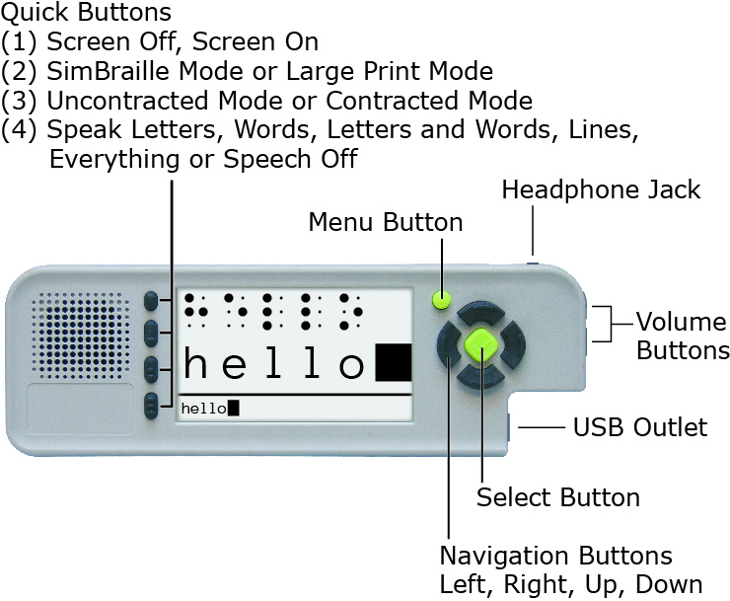
The video screen displays menus and visual feedback when someone is brailling. During braille entry, the screen can display SimBraille and large print, just large print, or be turned off.
- SimBraille mode shows six simulated braille cells above their corresponding print characters in 42-point type.
- In Large Print mode, the SimBraille is replaced by four large print characters in 70-point type.

Both modes display a full line of 28 print characters at the bottom of the screen in 12-point type. When the brailler is set for contracted braille, words containing contractions are underlined in this line.

The four Quick Buttons perform the following functions:
- Turn the screen on or off
- Toggle the screen display between SimBraille mode and Large Print mode
- Toggle the braille translation between contracted braille and uncontracted braille
- Change the speech feedback during braille entry to one of the following options: Speak Letters, Speak Words, Speak Letters and Words, Speak Lines, or Speak Everything

There are other settings that can be changed within the menus on the brailler. There are three text-to-speech voices available on the brailler and six color combination options for the display. The brightness of the display can be adjusted, and there are several options for the screen timer that turns the screen off if the brailler is not in use.

In addition to showing what is being brailled in print on the screen, the brailler stores the print in a text file. The text file can be saved in the brailler’s internal memory or to a USB drive. The text file can be transferred to a personal computer via the USB drive and saved, printed, edited, or e-mailed as needed (e.g., to a teacher or parent). A file can also be printed directly from the brailler to a printer with a USB port via a USB cable compatible with the brailler (USB A type) and the printer.

Up to 30 user accounts can be created on the brailler through the User’s Menu. The default user name and account is “Guest.” Each user account can have its own settings as described above. A file saved in the brailler’s internal memory can only be retrieved when the brailler is set to the same user as it was when the file was saved.

An audio tour, available in the Welcome menu on the brailler, provides an introduction to the brailler and most of the features and functions described above.

Relevance
The SMART Brailler provides immediate feedback to a child or adult who is learning braille via text to speech and a screen that displays SimBraille and large print of what is brailled in uncontracted or contracted braille. This audio and visual feedback also provides information about what a student is brailling for someone who does not know braille, including parents and general education teachers.

Research
During 2011, Research Department staff met to test the functions of prototypes of the brailler and recommend improvements to Perkins and PDT personnel. Members of the Research Department also took different prototype versions to the Kentucky School for the Blind (KSB) 3 times during the year to test with young students who are visually impaired. Perkins and PDT also began development of a software application (app) to provide additional exercises for students being instructed using the Building on Patterns (BOP) Kindergarten curriculum.

In January 2012, the BOP writers were asked to participate in testing and give input on the SMART Brailler. Three of the writers who had young students learning braille were shipped braillers that contained changes and improvements from the earlier prototypes. The writers gave feedback on the braillers’ functions to Perkins. In June 2012, during the Building on Patterns and Braille Literacy Meeting, Perkins brought several SMART Braillers to APH. The BOP writers, consultants, and Research personnel worked with the braillers; a list of issues and comments was created for Perkins and PDT to address.

Two separate field tests were conducted with the SMART Brailler. The first field test was a Perkins and APH joint field test of the braillers begun the third week of August 2012, and continued through the end of October 2012. APH sent braillers to five teachers of students who are blind or visually impaired (TVIs), and Perkins sent braillers to three TVIs who are writers for BOP Second Edition. The TVIs are located in California (2), Colorado, Florida, Indiana, Maryland, Missouri, and Oregon. All the field evaluators except one used the braillers with at least one student learning braille at the kindergarten, first, or second grade level. The evaluators were asked to complete a workbook of exercises themselves, work with a student to complete another set of exercises, work with a student and the BOP Kindergarten App, and provide comments about their experiences with the brailler. They were also asked to ship the electronic files and embossed pages from their work back with the brailler at the end of the field test. One update to the brailler’s core firmware was provided to the field testers during their evaluation period.

Comments from the field evaluators were reviewed and compared to the electronic files and embossed pages where relevant. Issues with the braillers’ performance based on these comparisons and the feedback from the field evaluators were compiled to be addressed in future updates to the brailler. Perkins and PDT made updates to the firmware based on the field test and discussions with APH personnel.

APH conducted a second field test late December 2012 through early February 2013 with braillers loaded with another updated version of the firmware. The TVIs for this field test were referred to APH by Ex Officio Trustees who are members or former members of the Educational Products Advisory Committee and are located in Kansas, Michigan, New Mexico, New York, Ohio, and Vermont. These evaluators also worked with at least one student learning braille at the kindergarten, first, or second grade level. An updated brailler was also sent back to one of the BOP writers in California who participated in the first field test. This test process was similar to that of the first field test (described in the Research section of this project report), but also included instructions for the teacher to use the brailler with a student in day-to-day activities with a student. In-house testing was also done at APH. The field testers documented specific examples of instances where the speech or visual feedback did not match what was brailled.

Summarized Ratings from Field Testers on Feedback Features

Embossed Braille
Good | 6/6
Satisfactory
Needs Improvement

Speech Feedback
Good | 2/6
Satisfactory | 1/6
Needs Improvement | 3/6

Visual Feedback
Good | 4/6
Satisfactory | 2/6
Needs Improvement

The field evaluators also provided these observations about the benefits of the SMART Brailler features:
- My student loves it. He's low vision, but has enough useable vision that he is able to see the letters on the screen.
- I think with all the demand to display students' work and levels the smart brailler is a useful tool.
- My student is LOVING the SMART Brailler. It is helping him figure out the correct fingering positions on the Brailler, as well as giving him the immediate feedback when he presses the wrong keys. (This TVI’s student has Septo-Optic Dysplasia.)
- My student was thrilled to hear his new letters, contractions and sentences. It was really reinforcing for him and motivating. When we turned the speech off and used the Brailler for math he missed it. He quickly learned how to turn the switch on/off and to change between speech on/off. He was so pleased to hear his name when he wrote it in sentences for me. He learned from his mistakes as well and this provided a terrific teachable moment. The classroom teacher does not know Braille and she enjoyed seeing what the student was writing so she could give him direct feedback. The peers in his room thought he was cool that he had a “talking pencil” to write with.

One of the in-house evaluators had this comment: I was able to help evaluate this unit back in the Summer [of] 2012 on earlier prototypes. I will say first and foremost that there have been vast improvements with the accuracy of keys pressed verses text printed out/spoken on the screen. This is not to say that the translation is without flaws… It’s not. There are still cases when the text does not match the Braille.

Comments from the field and APH in-house evaluators were reviewed and compared to the electronic files and embossed pages where relevant. Issues with the braillers’ performances based on these comparisons and the feedback from the evaluators were compiled to be addressed in future updates to the brailler. Hardware problems were also noted, and units with these problems were sent back to Perkins for evaluation.

A field test of the SMART Brailler organized by Perkins was completed in October 2012. APH conducted a second field test in late December 2012 through early February 2013. More information on the field tests are provided in the Research section of this project report. Throughout this process, Perkins, PDT and APH shared information and discussed issues via e-mail and phone. Staff from Perkins came to APH on March 20, 2012, for a more thorough discussion. Perkins and PDT provided several more firmware updates after the March meeting that were tested in-house at APH; the last of these resolved most of the main issues with the brailler’s core firmware functions.

APH tested updates to the BOP Kindergarten App in-house and discussed its performance with the BOP Second Edition writers and consultants. Thorough testing was done to document instances where the text to speech in the app was not clear enough for a student to understand, and this was shared with Perkins and PDT. Improvements were made to the app.

Work began on a quality control process to assess the braillers when they are delivered to APH. The brailler’s recorded audio tour was re-recorded at APH to correct errors, update information, and improve the quality of the recording. Work continued on a user’s manual begun in FY 2012.

In FY 2014, APH project staff and management prioritized the remaining issues in the core firmware and BOP Kindergarten App. Two issues caused by limitations in the electronic components were determined to be acceptable for the brailler’s release. The remaining issues were resolved through multiple updates from PDT and thorough testing by the project leader with assistance from other APH personnel who know braille. Additional issues were found in some of the updates, and those were resolved as well. The versions of the core firmware and BOP Kindergarten App that were tested and found to be acceptable were received January 24, 2014.

The project leader worked with Frank Hayden, Larry Skutchan, and APH Production personnel to develop and finalize the quality control procedures for the brailler. This included setting up a procedure to ensure the pressure required to press down the keys on the brailler was within an acceptable range. This range was based on data from Perkins Products and APH on the pressure required to press down the keys on the Perkins-APH Brailler Version 2, which was designed to require less pressure than the standard Perkins Brailler®.

The first shipment of 10 braillers was received on February 11, 2014. Representatives from Perkins and PDT traveled to APH to observe the quality control check and to be on hand in case of any issues that might arise. During this check, the test team discovered that the braille mode setting was not correct on any of the braillers due to one of the steps in Perkins’s quality control procedure. This problem was manually corrected on the 10 braillers, and Perkins’s personnel said they would change their procedure to prevent this problem in the future. Two of the 10 braillers were rejected for other problems: Both braillers failed to perform the erase function in the electronic file when the erase button was pressed, and key 3 stuck on one of these braillers. A few other minor problems were recorded and corrected.

After a second shipment of 50 braillers was received, it was determined that the electronic erase function did not work consistently unless the end of the erase button closest to the front of the brailler was pressed. Perkins determined that the solution to this problem was to “effectively increase the operating window between the magnet and the sensor” that activates the erase in the electronic file. Perkins’s timeline to implement this solution fully lists December 1, 2014 as the Full Production date. In the meantime, Perkins agreed that in the braillers shipped to APH the erase function would work consistently when the erase button is pressed in the middle. The project leader performed 100% testing for this issue on the second, third, and fourth shipments. While performing these tests, the project leader found other problems that were created due to Perkins’s quality control procedure. Perkins agreed to change their procedure to correct these. The APH quality control procedure was amended to check for these problems. Braillers that did not pass the APH quality control procedure or the 100% erase function test were shipped back to Perkins for repair or replacement.

The text of the user’s manual was finalized and converted into HTML and EPUB® formats. Files in both formats were posted on the APH Downloadable Product Manuals Web page. An electronic mailing list dedicated to questions about product was also established.

The APH SMART Brailler by Perkins was released on June 30, 2014. An AC adapter and lithium-ion battery were released as replacements parts on July 24, 2014.

During FY 2015, the project leader and Ex Officio Trustee Stephanie Bissonette (Vermont), presented training sessions on the APH SMART Brailler by Perkins in October at the 2014 APH Annual Meeting.

An online survey on the APH SMART Brailler was conducted from October 2014 through January 2015. Forty-seven survey responses were collected as of January 20, 2015, via mail and the Web. Most respondents (85.7%) purchased their unit in August, September, or October 2014. The survey was completed by 25.9% of customers who had purchased an APH SMART Brailler by Perkins.

The braillers were mainly used in elementary schools, by an average of 1.89 students each. The average student age was approximately 9 years with the most commonly reported ages being 6 and 8 years. Most of the students are blind, but approximately 30% have low vision. Seventeen respondents listed students using the brailler as having physical or cognitive disabilities.

Of 46 responses, 45.7% indicated their students used the BOP Kindergarten app. The feedback on the BOP Kindergarten app was generally favorable. There were several requests for more activities, including some for more advanced activities, and one comment that it was too slow.

On a scale of 1 (Low) to 5 (High), the average rating of the educational value of the brailler was 4.24. Of respondents, 57.8% gave the device a 5 rating, and 80% gave a rating of 3 or above. Positive comments on the educational value praised the motivational aspect of the brailler’s immediate feedback and an increase in students’ independence. Several respondents reported that their student was learning braille faster using the SMART brailler and that it helped with communication with classroom teachers and sighted peers. Negative comments noted that there were “glitches” that frustrate some students, that “it confuses the voice” when the same letter was typed, and that the voice feedback could be a “crutch” students rely on “instead of their knowledge of braille.”

The average rating of design of the brailler on a scale of 1 (Low) to 5 (High) was 3.38. Of respondents, 15.6% gave a 5 rating, and 84.5% gave a rating of 3 or above. Positive comments on the design of the brailler included that the mechanical part of the brailler was a familiar design, and that the screen and buttons were good. Thirty respondents provided comments that included issues with the design. A majority of the negative comments contained concerns about mechanical issues with the brailler, including loading paper and the sturdiness of the brailler’s body. Two comments reported problems with the battery.

Auditory feedback, visual display/output, and immediate feedback were cited as the most helpful features of the brailler. Comments praised the motivational aspect of the brailler’s immediate feedback and noted an increase in some students’ independence. The visual display was also noted as helpful for the regular classroom teacher.

Of 44 responses, 70.5% indicated they had downloaded the instruction manual. There were 24 respondents who said they found the manual to be helpful. Four respondents wanted more information.

Additional comments regarding the brailler thanked APH for making this product available, provided suggestion for improvement, and described problems with the device. Several people commented on problems with charging the battery. Two comments asked for the ability to use Nemeth code.

In conclusion, respondents indicated the electronic features of the SMART Brailler were significantly helpful for students learning braille, but continuing hardware and battery issues were a problem.

In December 2014, after multiple customer reports of problems with charging the battery, Perkins determined that their vendor had made an unapproved change to the battery safety circuit, which resulted in a configuration that was not compatible with the circuitry of the SMART Brailler. Personnel from several APH departments worked to get information about the problem out to customers and then with Perkins to provide replacement batteries to all customers with affected braillers. Due to the need to find another vendor to build hundreds of batteries, all affected batteries were not replaced until April 2015.

At a meeting in April, Perkins reported a hardware change to increase the hardness of the left and right drum end plates. This change “increased the material hardness on the drum endplates to eliminate the propensity of the drum pin to bend when excessive force is applied to the line spacer.” The “Effectivity Date” of this change was December 23, 2014.

In May, the project leader received a firmware update for the brailler that fixed a few problems and provided a Unified English Braille (UEB) “Language” option. The project leader tested the new firmware with assistance from Research Assistant Jeremiah Rose and the APH Braille Improvement department. Several translation issues were found and reported to Perkins and PDT. As of August 6, 2015, the project leader had not received another version of the firmware to evaluate.

The project leader received another firmware update, 1.1.0.46, in early October 2015. Due to other projects, review of this update was not completed until the end of December. Some issues from the previous release were fixed, but some were not and one regression was discovered.

In April 2016, the project leader received a question about one of the issues found in 1.1.0.46. This was in regard to how the brailler displayed characters in braille that do not have print equivalents, including the transcriber’s notes symbols and typeform indicators. After consulting with APH personnel and BOP consultants, it was decided that the brailler should not show anything on the screen for these symbols.

In mid-May, the Vice President of Educational Services and Product Development, Dorinda Rife, contacted Perkins Solutions (formerly Perkins Products) to strategize the next steps regarding the hardware issues with the brailler. A conference call was set up for June 2. An update to the firmware, 1.1.0.49, was received on June 1. For the meeting, Perkins provided information on their Quality Improvement (QI) initiative to reduce the hardware issues with the brailler. It identified the major defects as the back housing, main housing, paper feed, and carriage jam. The first three of these have been addressed by improvements to the housing and drum assembly. The last of these improvements was implemented October 1, 2015, with brailler serial number SB002793. New braillers were built with these improvements as they became available, and Perkins is replacing the QI parts when braillers are returned for repair. Additional improvements to reduce carriage jam issues and improve the reading rest, paper guide, and main housing support are in process. Perkins stated that the warranty return rate for SMART Braillers sold to APH after implementation of design improvements in FY 2016 (starting July 1, 2015) is 5.4%, the warranty return rate for braillers without the design improvements is 7.9%, and non-warranty return rates are 9.2%. In a summary of the work Perkins is doing, they stated that they are committed to the quality initiative to further reduce the warranty return rate to less than 3% and want to be more informed by the users to feed continuous improvement.

Follow-ups to the June 2 meeting included internal discussions, another teleconference with Perkins on June 17, and several e-mail exchanges to develop the language for a letter about the quality improvements for APH Ex Officio Trustees (EOTs) and other customers. This letter was distributed on the APH website and at the Association for Education and Rehabilitation of the Blind and Visually Impaired conference in Jacksonville, FL, in July. It was agreed that approved firmware updates for the brailler would be provided free of charge on the Perkins website, and the BOP App would also be available there. Offering an extended warranty for the brailler was discussed, and Perkins agreed to work on a cost for that. There are a few braillers that have been returned multiple times. Perkins agreed to consider possibly replacing these braillers, but requested more information about how they are being used; APH Customer Service will lead any discussions involving APH customers and Perkins. Perkins requested information about one of these customers; Marsha Overstreet, Manager of Customer Relations, contacted the customer and provided the information. When asked about past issues with the erase function, Perkins said that they have made changes to address that issue.

With input from the project leader, Perkins also began work to improve their documentation of brailler repairs to include information about the QI work on each brailler returned.

The project leader worked with Research Assistant Sara Lee to test the latest release of the firmware, 1.1.0.49, and Perkins’s download link for firmware updates.

Work during FY 2017
Testing of firmware version 1.1.0.49 was completed in October. Two major issues were found:
- All the braille symbols that start with dots 4-5-6 did not translate correctly. This included the contractions for these words: cannot, had, many, spirit, their, world. The contractions translated as a space and the alphabet contraction for the letter.
- The screen timer was not working correctly. The screen did not turn off automatically at all. The brailler seemed to think it was off (says “screen on” when you press Quick Button #1 [screen off/screen on] after it should have turned off), but it did not go off. This would be an issue for customers because it would cause the battery to run down faster.

Perkins corrected these problems as well as some other minor issues. The project leader received a new release of the firmware, 1.1.0.52, on February 1. Testing completed in early March by Lee and the project leader found that the major issues with the previous release were fixed, but also discovered one regression, a settings issue, and a translation issue.

A shipment of SMART Braillers was rejected in late February due to cracks in the housings of the braillers in the testing sample. The braillers were returned to Perkins to have the issue addressed, and a replacement shipment was received in March. Perkins’s
“Root Cause - Corrective Action Report” stated the following:
As part of the quality initiative, Perkins designed an additional 6 fastening points to more securely attach the plastic housings to the mainframe of the Smart brailler. The failure occurred on the 2 new fastening points located on the back housing. The result of the failure caused a fracture of the plastic around the fastening points.

The failure was caused by compressive force applied to the plastic during the assembly process. The defect was not observed during assembly and was found to be latent by nature, meaning that over time the stress on the plastic finally gives way to failure. This was validated by reproducing the assembly method and leaving them on a shelve for up to 5 days, after 3 days, 1 out of 4 units exhibited the same failure mode.

The next firmware release, 1.1.0.54, was received in late April. The significant issues in the previous release were fixed; however, an issue with the font used when the language is set to UEB was discovered as well as a problem with the “Repeat Item” function in the BOP App. These results were reported to Perkins in mid-May.

At the end of July, Perkins provided firmware release 1.1.0.55 to fix the issues in the previous release. This release was approved by Lee and the project leader. Perkins will load it into the braillers in shipments for APH starting immediately, and it will be distributed to customers who previously purchased braillers from APH.

The project leader had discussions with Perkin about how to distribute the updated firmware to APH customers. With approval from Dorinda Rife, APH Vice President of Educational Services and Product Development, plans were made to provide the firmware updates on the Perkins Web site and directions to that location on the APH Web site. APH customers were notified about the new firmware.

Work planned for FY 2018
APH will continue work with Perkins to make approved firmware with UEB available to customers. Any additional updates to the firmware will be tested. Repairs for the brailler will continue to be monitored.

Joy Player Digital Cartridge
(New)

Purpose
Purpose 1: To provide recordable, blank digital cartridges for The Joy Player to fill the void left when the National Library Service (NLS) put a hold on manufacturing Digital Talking Book (DTB) Cartridges
Purpose 2: To design a cartridge that is easier for individuals to push into and pull out of The Joy Player than the low profile NLS DTB cartridge

Project Staff
Tristan Pierce, Multiple Disabilities Project Leader
James Robinson, Manufacturing Specialist
Frank Hayden, Director of Technical & Manufacturing Research
Andrew Moulton, Manager of Technical & Manufacturing Research

Background
APH designed The Joy Player to work with DTB cartridges, which NLS manufactures. Shortly after The Joy Player became available for sale, NLS announced that they had enough DTB cartridges to meet their needs for the next year or two so they put a hold on future manufacturing. NLS is considering switching all audio books to download format, which would eliminate their need to manufacture DTB cartridges in the future. There is a growing population of individuals—young and old—who need access to music/audio book players in which they make choices and manipulate objects to make the music play. This physical action helps to build the cognitive synapses that help establish meaning of objects and symbols; it teaches ownership of thought and movement. Since The Joy Player’s debut, the project leader has made three videos representing a toddler, an elementary-aged student, and four adults. During filming of the videos, it was apparent that individuals with extended or fisted fingers had difficulty handling the low profile NLS cartridges, so APH believes that a new design would benefit our target population better.

Work during FY 2017
Using Adobe® Illustrator®, the project leader designed a new shape for The Joy Player Digital Cartridge. The Product Development Team approved the design and decided to locate it in the Assistive Technology & Electronics section of the APH shopping site and catalog, along with a secondary location in Early Childhood next to The Joy Player. The manufacturing specialist designed the inside to house the USB. Technical & Manufacturing Research drew everything in CAD to produce a 3-D prototype.

Work planned for FY 2018
Field testing or professional review will take place and production will commence.

CAREER EDUCATION AND TRANSITION

Transition Program Components
(New)

Purpose
To develop a transition product highlighting successful young adults. The young adults will identify the skills, services, products, and overall approach they took in middle and high school when learning the transition skills that helped them become the successful adults they are today.

Project Staff
Martin Monson, Project Leader
Amy Parker, Project Leader
Susan Dalton, Consultant

Background
This product is a combination of two product ideas submitted by Susan Dalton. The first product idea submitted included an overview of an effective transition program (what such a program might look like), lists of possible activities/instructional programming that could be included in such a program, and program content and detailed descriptions of how such activities/instructional programs could be conducted. The second product idea submitted was to develop a video in which former transition students talk about what they did in transition programming, what was helpful to them, and how they have experienced the benefits of the transition programming in young adulthood. The video would be used to educate current transition students about the value that transition programming will have for them in later life. Having this information come from their peers will motivate the students to participate fully in transition activities. The combination of the two product ideas into one was reviewed and approved by both the Product Evaluation Team in November and the Product Advisory and Review Committee in December.

Product Description
This product will be 100% available online. It will be a series of modules and supporting accessible documents to support the learning of the module content. The modules will be divided into broad areas that support the larger topic of transition.

Work during FY 2017
Possible module ideas were developed by Dalton, and group discussions concerning them took place over several phone calls between January and June of 2017. Discussions focused on the content in the modules and how best to deliver the content. An online delivery method was decided upon. The idea of modules was decided upon as items within a module could be updated easily, and new module areas could be added. Five module content areas were identified to start the product development. Those modules and some supporting content ideas are as follows.

Module #1
“I Think I Can”
4Self-Determination
1: ADA 101: To Tell or Not to Tell
2: Resume, Cover Letter & Application Workshop
3: Self-Advocacy
4: Conflict Resolution
5: Practice, Application and Wrap-up

Knowing your rights and being familiar with ways to comfortably discuss your disability and the accommodations you might need at work and at school are essential to being successful; unfortunately, these skills are almost never taught in school and are rarely realistically discussed. These five modules will provide students with information on the laws that protect persons with disabilities, disclosure issues, writing a resume, cover letter and application, being a self-advocate, how to resolve conflicting situations, and being prepared for the workplace.

Module #2
Getting Around the Community
- How good are my personal mobility skills? What can I do to improve them?
- What are transportation options in my community? How can I navigate the system?
- What are some other ways of getting around that I may have overlooked?
- Scheduling: Working on transportation schedules, my schedule, and allowing sufficient time to travel.
- Accessibility options for navigation and travel. Would a guide dog be helpful for my independence?

Module #3
Choosing a Career
- What are some things that I like to do? How can these translate into future employment? What are the skills I need to have to achieve these jobs?
- Have you checked out the current job market? Do you know the trends for the next 10 years? What are employers looking for, and what skills are employers finding missing in many applicants or new employees.
- How can I get my foot in the door to get a job? Who could be in my personal network?
- How can I best use the services of Vocational Rehabilitation to assist me in finding a job? What can they do for me? What will I need to do for them to show that I’m capable of tackling this particular job?
- Hearing from currently employed (or formerly employed) adults to learn of challenges faced, how the challenges are addressed, suggestions for new job seekers.

Module #4
The College Experience: Am I Prepared for the Challenge?
- Choosing the post-secondary program most fitting for you. Are you ready to jump into a four-year university program? Would you benefit from college-prep programs available in your area? Does your job goal really need a bachelor’s degree or specialized technical training?
- Who’s paying the bill? Find out about assistance programs available. VR services. How to find scholarships. Weighing the options: costs, benefits of program, eventual job.
- Working with Disability Services at college. What will they do for me – and more importantly, what do I need to do to obtain the services? What are my responsibilities?
- Time management: Issues faced by college students relating to the change in daily schedules and routines, allowing for travel to and from class, additional reading requirements, troubleshooting if assistive technology fails.
- Self-Advocacy: Knowing your rights and how to present yourself as a capable, knowledgeable individual when dealing with professors, other college staff, and students. Speaking up and feeling confident about your needs and how classroom or assignment challenges can be addressed.

Module #5
Being a Part of the Community
- Basic Social Skills – Nonverbal communication.
- Fashion, grooming, shopping.
- Conflict resolution – how to deal with hurtful/insensitive remarks, explaining your visual disability, clever comebacks.
- Playing the dating game, dance, music, entertainment.
- Becoming a giving member of the community. Ways to volunteer, participate in community groups, taking advantage of community activities.

Work planned for FY 2018
Work during FY 2018 will involve developing content to support the ideas and themes for the various modules. Content is going to include such items as downloadable forms for users to capture information related to the topic, activity lists to help gain or refine skills related to a particular area, and resource lists. Each module will also have a video component connected to it with a young adult or adults speaking about their experiences with regard to that particular content area.

In addition to developing content, a vehicle to disseminate the content will be developed. Due to the need to update and change information, such as the resource lists or content related activities, an online platform will need to be used. In addition, the video content would be best delivered through an online delivery system. Several platforms will be examined and pilot-tested for ease of use and accessibility.

Finally, participants to be filmed for the video portion will be identified. A location to record the vides will also need to be identified, and finally, the videos themselves will be filmed and edited.

COMPENSATORY AND ACCESS SKILLS

MATCH-IT-UP Frames (Large Set and Small Set)
Formerly Match-It Up Board
(Completed)

Purpose
To provide an interactive board that facilitates a variety of matching activities for young students who are visually impaired and blind in grades K-3

Project Staff
Karen J. Poppe, Tactile Literacy Project Leader
Joanne C. Banman, Consultant
Rachel White, Research Assistant
Andrew Dakin, Model/Pattern Maker
Andrew Moulton, Manufacturing Specialist
Adam Clark, Manufacturing Specialist
Anthony Slowinski, Graphic Designer
Anthony D. Jones, Art Production/Design Manager

Background
In January 2009, the consultant submitted a product submission form, along with a handmade prototype, describing an interactive matching board that she had successfully used with her kindergarten student. Her design is a small, slightly raised, and wooden board that fits on a desk or table. Two rows of squares (each with a VELCOIN® brand tab) are divided by a string of red yarn. A single hole is drilled above each of the lower squares and below each of the upper squares. Threaded through each lower hole is a cord with a peg attached to it; the cords are of various colors. The child matches cards in the bottom row to those in the top row by inserting the pegs in the corresponding holes. The consultant made a variety of matching cards to assist in the instruction of tactile shapes, braille letters, braille numbers, and braille words.

In January 2010, the project leader provided a review of the product submission form, rating it high in originality and appropriate target populations. The project leader’s review documented considerations for making the matching board less problematic and expensive to produce.

The product idea was initially reviewed and evaluated by the Product Evaluation Team and officially approved as a viable product by the Product Advisory and Review Committee on January 14, 2010. Shortly after, the project leader hosted a Product Development Committee (PDC) “Brainstorming” Meeting with a wider audience of APH staff from various departments. The PDC supported the project leader’s plan to design a one-piece “board” with open windows that attaches to a VELTEX® brand surface (e.g., ALL-IN-ONE Board); long drapery cords would be replaced by shorter nylon cords that stay in place on a VELTEX® brand band that spans the center of the board. The committee was especially concerned with the safety of the original design given the long cords and potentially detachable small pegs of choking size. The project leader also suggested supplying a “starter kit” of mounting cards (using those included in Tactile Connections) that teachers could use to design and construct matching cards.

Throughout March and April, the project leader and model maker experimented with various layouts of the board. Their search for an ideal nylon cord to stick securely to VELTEX® brand material was unsuccessful. The nylon cords were replaced by various lengths of matching strips cut from polyblend of various colors and backed with hook material; the band in the middle of the board was updated to a soft loop material. The board itself was changed to a bright yellow instead of white. The project leader built a variety of matching cards to use in combination with the board.

In May 2010, a complete prototype of the board was sent to the consultant for direct use with her student. Initial feedback supported the design of the board itself and the provision of the mounting cards, but the matching strips proved challenging for her young student when locating and selecting the correct length of strip to connect a card in the lower row with a card in the upper row.

The project staff continued to modify the prototype to best achieve the objectives of the consultant’s original design. The construction of the first sample board was considerably simplified by eliminating the matching strips. The final prototype version incorporated 10 open “windows” in a two row by five column arrangement, with the two rows separated by a raised tactile bar. The board was sized to fit conveniently onto the VELTEX® brand side of APH’s ALL-IN-ONE Board.

The project leader authored product instructions that provided a variety of ideas for creating matching cards. Examples focused on counting skills, O&M concepts, shape identification, line tracking, texture discrimination, story retelling, sequencing, patterning, braille letters, and calendar activities. Each suggestion was supported by a photograph. Although actual construction of matching cards would be the responsibility of the teacher/parent, a “starter kit” of mounting cards, VELCOIN® brand tabs and strips, and masking overlays (to minimize the number of windows) was included as part of the field test prototype.

By the end of January 2011, multiple copies of the prototype were built and available for field testing. The project leader then collated materials, prepared the final layout of the product instructions, identified field test evaluation sites, and readied an evaluation packet. On February 14, prototypes were mailed to field test sites. Each evaluator was encouraged to use the prototype with as many students as possible until the end of May.

Throughout June and July 2011, the project leader compiled field test data into a final report. The prototype was used by 20 teachers of the visually impaired with a total of 104 students. As shown in Figure 1, evaluators represented the states of Arizona, California (2), Colorado, Indiana, Kansas, Louisiana, Maine, Minnesota, Missouri, Nebraska, North Carolina, North Dakota, Ohio, Oklahoma (2), Texas (2), Virginia, and Wisconsin.
Figure 1. Geographical Distribution of Field Test Sites
The student sample of 104 students ranged in age from 2 to 21 years of age with 26% between the ages of 2 and 4, 30% between the ages of 5 and 7, 18% between the ages of 8 and 10, 17% between the ages of 11 and 13, 7% between the ages of 14 and 17, and 2% between the ages of 18 and 21 (refer to Figure 2).

Figure 2. Age Range of Students
There were noticeably more males than females—62% and 38%, respectively (refer to Figure 3).

Figure 3. Gender of Students
The student population reflected cultural diversity: 69% White, 15% African American, 8% Hispanic, 5% Asian, 3% “two or more races,” and 1% American Indian or Alaskan Native (see Figure 4).

Figure 4. Ethnicity of Students
One-third of the students were preschoolers, 10% were kindergarteners, 24% were in Grades 1-3, and 17% were in Grades 4-6; smaller percentages were in Grades 7-8 (8%), high school (4%), or classified as “ungraded” (4%) (see Figure 5).

Figure 5. Grade Level of Students
The largest percentage of students (27%) were reported as nonreaders; this percentage included subsets of students whose primary reading medium was reported as “nonreader/pictures,” “nonreader/large print,” and “nonreader/auditory.” Nearly equal percentages (17% and 15%) were reported as braille readers and large print readers, respectively; 6% read regular print, and 1% were dual braille/large print readers. Eleven percent of the students were classified as “prereaders,” while a similar percentage (9%) were reported as auditory readers or combinations of auditory/braille, auditory/visual, and auditory/tactile readers. A smaller percentage (8%) of the students were reported as “visual,” “tactile,” or “picture” readers. The primary reading media of the remaining percentage of students (6%) were undetermined or unreported.

Figure 6. Students' Primary Reading Medium
A full 71% of the students were reported as having additional disabilities (e.g., cerebral palsy, cognitive/physical/language delays, ADHD, and autism). Nearly 40% had cortical visual impairment (CVI).

Evaluators’ ratings of the overall design of the Match-It-Up Board were very encouraging. Based upon a rating scale from 5 (Excellent) to 1 (Poor), average scores were for each design feature are shown in Table 1.

Table 1
Overall Design of Match-It-Up Board
Design Feature | Number of  Evaluators |  | Average  Rating
Overall size |  | N = 20 | 4.55
Color |  | N = 20 | 4.35
Number of windows/cutouts |  | N = 20 | 4.40
Size of windows/cutouts |  | N = 20 | 4.45
Distance between windows/cutouts side-by-side |  | N = 20 | 4.45
Distance between windows/cutouts top-to-bottom |  | N = 20 | 4.35
Tactile/print divider line |  | N = 17 | 4.47
Ease of mounting/positioning on a VELTEX® brand surface |  | N = 19 | 4.79
Masking overlays |  | N = 20 | 4.45

One hundred percent of evaluators liked how the board fits comfortably and conveniently on APH’s ALL-IN-ONE Board. One evaluator clarified: “Perfect fit. Easy to adjust angle of board for student’s needs.”

Field results indicated that a variety of methods of matching were utilized when using the Match-It-Up Board with students (refer to Table 2). Eighty-percent of the teachers reported that they frequently (40%) or sometimes (40%) positioned all of the cards on the board in random order and then asked the student to rearrange them in corresponding pairs below and above the raised bar. Ninety percent of the teachers reported that they frequently (50%) or sometimes (40%) positioned only the cards in the top row then asked the student to insert each matching card below its counterpart. Ninety percent reported that they frequently (55%) or sometimes (35%) asked the student to merely point to the matching cards. Only 40% either frequently (20%) or sometimes (20%) played concentration games using the masking inserts. One teacher clarified that the matching method used depended upon the activity and the student’s ability.

Table 2
Frequency of Matching Methods Used
N = 20
Matching Method | Frequently | Sometimes | Never
Instructor positioned all cards on the board in random order; student rearranged them in corresponding pairs below and above the raised bar. | 40% | 40% | 20%
Instructor positioned only the cards in the top row; student inserted each matching card below its counterpart. | 50% | 40% | 10%
Student was asked to point to matching cards. | 55% | 35% | 10%
Concentration games were played using masking inserts. | 20% | 20% | 60%

Using a scale of 5 (Very Well) to 0 (Not at All), teachers rated how well the Match-It-Up Board facilitated a variety of activities. As shown in Table 3, ratings supported the versatility of the board.

Table 3
Versatility of Match-It-Up Board
Activity | Number of  Evaluators |  | Average Rating
Matching |  | N = 20 | 4.90
Sequencing |  | N = 19 | 4.89
Calendar Activities |  | N = 11 | 4.12
Story Retelling |  | N = 8 | 4.36
Matching Games |  | N = 14 | 4.64

Eighty percent of the evaluators indicated that the Match-It-Up Board offered specific advantages over previously-used matching activities and tools. Among the most oft-repeated compliments was its success at providing a clearly-defined working space and placement for cards. Other comments included the following:
- “The board itself gives the opportunity to truly customize the activity to the needs of the student.”
- “The presentation is inviting and provides normalcy in presentation and the kids like it.”
- “Easier to manipulate; be organized and structured; more accessible.”
- “I had some of my easiest matching lessons using this board for multiply handicapped (students)—good, simple, clear presentation. Easy for kids to understand and work with.”
- “The board held the cards in place and allowed the cards to be neatly placed instead of just randomly placed on a VELCRO® brand board.”
- “Durable—looks professional.”
- “I like how it expands the ALL-IN-ONE Board and can be portable, and because of the ALL-IN-ONE Board, angle and positioning can be adjusted.”
- “It really helped to give tactile discrimination when working on above/below, top/bottom, and even left and right.”

Ninety-five percent of the evaluators supported the provision of mounting cards in a variety of colors to help in the construction of teacher-created matching activities. Most thought 10 cards per color would be an ideal amount. One hundred percent of the evaluators recommended the inclusion of VELCOIN® brand tabs and a long strip of VELCRO® brand hook strips. The provided Sticky Dots™ package was used by fewer teachers (65%) to apply objects/textures/pictures to the mounting cards. Teachers reported a variety of other adhesive material that they acquired and used to build matching cards: glue sticks, twist ties, rubber cement, yarn/string, caulking, and double-sided tape.

Evaluators reported appropriateness of the kit for various target populations (see Table 4). Among the most appropriate populations were students with multiple disabilities, preschoolers, kindergarteners, tactile and low vision students in Grades 1-3, and students with CVI.

Table 4
Appropriate Target Populations
Target Population | Percentage of evaluators who found the Match-It-Up Board suitable for target population
Preschoolers with visual impairments/blindness | 90%
Kindergarteners with visual impairments/blindness | 95%
Tactile readers in Grades 1-3 | 90%
Low vision students in Grades 1-3 | 85%
Tactile readers in Grades 4-8 | 45%
Low vision students in Grades 4-8 | 45%
Tactile readers in high school | 20%
Low vision readers in high school | 20%
Students with multiple disabilities | 100%
Students with cortical visual impairment | 90%

All of the students were reported as enjoying the use of the Match-It-Up Board. Noteworthy student comments included “Can I take this home?” “Can you leave this here in my class?” “This is fun,” “I like the bright yellow,” and “I can tell you the story using the board.”

Ninety-five percent of the field evaluators recommended that APH produce the Match-It-Up Board because of its strengths: color, durability, ease of use, portability, spacing of matching windows, size, and versatility with regard to possible matching activities (as illustrated in photos and descriptions provided by evaluators).

Throughout the remainder of the fiscal year, the project leader reviewed the field test results and outlined needed improvements to the prototype prior to production. Input from fellow Research staff and from the outside consultant was invited regarding necessary revisions. Plans included expanding the colors and types of available sorting frames and providing additional activity suggestions within the accompanying guidebook. Ideal shapes, colors, and quantities of matching cards were also determined. The name of the product, based upon the suggestion of one field evaluator, was changed to MATCH-IT-UP Frames.

The project leader conducted a Product Input Session on the MATCH-IT-UP Frames at APH’s Annual Meeting in October 2011. The audience consisted of teachers of the visually impaired, a math teacher, program administrators, a school principal, and a librarian. Their feedback echoed requests from field evaluators, notably the need for various colors of frames and different sizes of frames (to fit both the ALL-IN-ONE Board as well as the new (SM)ALL-IN-ONE Board). Additionally, they encouraged the project leader to consider eventual provision of pre-assembled packages of matching cards such as letter cards and story sequence cards to supplement APH storybooks (e.g., Goin’ on a Bear Hunt).

The project leader furnished Technical Research and Model Shop staff with layout drawings of the nine unique matching frames—six large and three small. Care was taken to a) reduce the distance between the windows/cutouts and the dividing bar, b) enlarge the window/cutout openings on the 5 x 2 frames, c) provide smaller frame options—3 x 2 configurations, and d) make each frame size available in three colors—yellow, black, and white. The yellow and white frames will be backed with hook VELCRO® brand tabs/strips for application to a black VELTEX® brand platform, and the black frames will be magnetic-backed to affix to a metal surface.

During the second quarter of the fiscal year, the model/pattern maker built needed vacuum-form patterns. In March 2012, one sample of each frame type was vacuum-formed and cut to size. The finished parts were reviewed to determine the appropriate application and positioning of VELCOIN® brand tabs and magnetic tabs. Other product components and production processes were planned, including the final color selection for the mounting cards, the salvage of die-cut windows for masking overlays, and the provision of two separate kits—Large Set and Small Set. In May, a Product Structure Meeting was conducted to review the anticipated product design with Production staff. Needed catalog numbers were assigned.

Active work on this project throughout FY 2013 was intermittent and mostly confined to the tooling construction and specifications for the nine separate MATCH-IT-UP Frames. The project leader, the model/pattern maker, and Technical Research staff met repeatedly to fine tune the expected position and amount of magnetic strips and VELCRO® brand tabs/strips for each matching frame. All of the magnetic applications to the white frames will be the responsibility of Educational Aids staff during production; the VELCRO® brand tabs and strips will be applied to the yellow and white frames by the customer. The descriptions of the matching frames are as follows:
MATCH-IT-UP Frames (Large Set):
Large White 5 x 2 Frame
Large Yellow 5 x 2 Frame
Large Black 5 x 2 Frame
Large White 3 x 2 Frame
Large Yellow 3 x 2 Frame
Large Black 3 x 2 Frame

MATCH-IT-UP Frames (Small Set):
Small White 3 x 2 Frame
Small Yellow 3 x 2 Frame
Small Black 3 x 2 Frame

With regard to the authoring and completion of the accompanying guidebook, the project leader’s work on this component was curtailed by higher priority projects throughout FY 2014, including those inherited from other project leaders (e.g., Quick & Easy ECC) or newly-acquired projects (e.g., Interactive U.S. Map with Talking Tactile Pen and SPORTS COURTS: Touch and Play) with time-critical field test goals.

The project leader’s attention to higher-priority and/or time-intensive products (e.g., SPORTS COURTS: Touch and Play) continued to derail significant progress on the MATCH-IT-UP Frames during the first three quarters of FY 2015. However, in July, the project leader returned her focus to the preparation of content and photographs for the accompanying guidebook. Representative photos were taken to illustrate the variety of activities (e.g., matching, counting, sequencing, patterning, etc.) that can be used with this product. The project leader invited ideas from other Research staff to broaden the assortment of activities for ideal target audiences, particularly for students with CVI. Rachel White assisted with editing the content of the instruction booklet prior to formal layout and design. The “Documentation” goal date was set for the end of September 2015.

Various pre-production tasks continued throughout the first and second quarters of FY 2016; accomplishments included the following:
- Content of the instruction booklet was finalized.
- Photographs of additional activity setups were taken.
- Graphic layout of the instruction booklet was prepared.
- Braille translation of instruction booklet was completed.
- Production specifications were outlined and fine-tuned.
- Production tooling (e.g., cutting dies) was readied.

In late May 2016, a Specifications Meeting was conducted and attended by staff from all departments of APH (e.g., Production, Cost, Purchasing, Research, etc.). Staff reviewed the “recipes” for building the large and small frame kits. Production staff established a feasible goal for pilot/production runs.

Work during FY 2017
Although availability of the product was expected to occur in the last quarter of FY 2016 or early FY 2017, the elimination of in-house screen-printing capabilities significantly impacted the production timeline for both sets of MATCH-IT-UP Frames. Consequently, two separate pilot runs were undertaken. The first pilot, conducted in October 2016, utilized the originally planned vacuum-form and screen-print processes to generate the raised tactile bar on each matching frame. Due to poor ink adherence to the black frames only, the project leader personally adhered white graphic art tape strips to 50 units. The second pilot run, underway in June, utilized the updated process of applying thick EVA foam strips (black or white, as needed) to the die-cut frames. The latter method was suggested by the project leader as a production compromise that would maintain the functionality of the tactile bar—that is, provide a discernible visual and tactile separation between the rows of die-cut windows. New cutting dies and part numbers for the purchased foam material were required. The forced shift in the production routine eventually led to a reduction in labor on the production floor, and in turn, a lower end cost to the customer. The project leader and manufacturing specialist monitored the quality of each pilot run. By mid-June, a production run generated a stockable level of units to meet expected first-year sales.
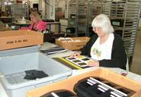

On June 15, 2017, an “airplane” was launched announcing the availability of both sets of MATCH-IT-UP Frames, with a selling price of $219.00 (for the Large Set, Catalog No. 1-08827) and $141 (for the Small Set, Catalog No. 1-08828-00). Both sets are available with Quota funds. The project leader prepared content for the product brochure. Kerry Isham, APH Field Services Representative, created the following Quick Tip Video to highlight the purpose and use of MATCH-IT-UP Frames: https://www.youtube.com/watch?v=6ja1IicH_Vs

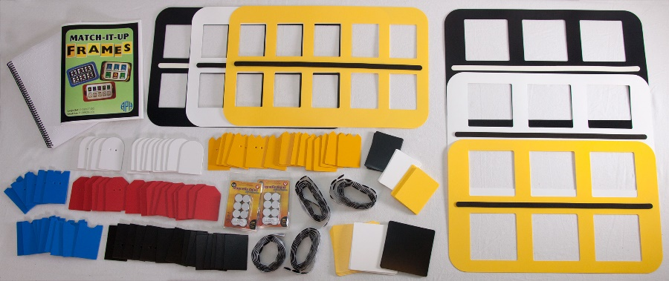

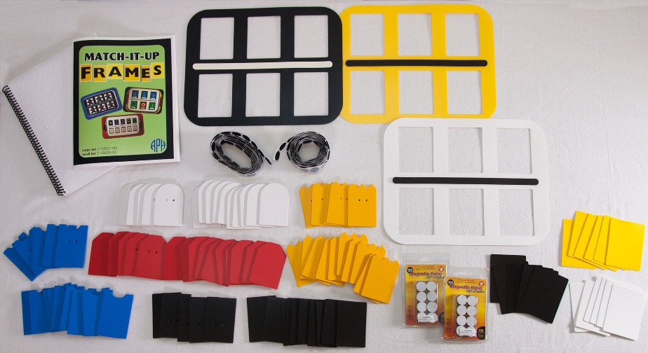

Work planned for FY 2018
The product will be showcased on the APH CVI Web site given its suitability for students with CVI as indicated by 90% of the field evaluators. The project leader will also conduct a post-availability survey to garner direct feedback about the product design and use. If the finished product is selected for review by the Department of Education’s review panel, the project leader will prepare a final report detailing the product’s relevance, research, and utility.

Braille

ABCs of Braille: Teachers Guide and Student Book [Modernization]
(New)

Purpose
To modernize the braille in the product from English Braille American Edition to Unified English Braille (UEB)

Project Staff
Martin Monson, Project Leader
Emily Grimany, Research Assistant

Background
This product followed the normal process of being reviewed by both the Product Evaluation Team and the Product Advisory and Review Committee. It is a modernization of an existing product that was originally produced and published in the 1970s.

Product Description
The ABCs of Braille is a product that introduces the reader to all the braille contractions in one book. The book starts with letters of the alphabet and goes through the contractions in their entirety. It uses word lists and short passages to introduce the new contractions and rules for usage. The student book and teachers guide both contain interlined, single-sided braille. In addition, the student book contains a raised print representation of the letters of the alphabet. The raised print representations are located at the top of each page of the student book when a new letter is introduced.

Work during FY 2017
A braille file was searched for, but one could not be found. A copy of the original product was found, and new Microsoft® Word® files were created using the current product. Two files were generated, a file for the student book and a file for the teacher’s guide.

Work planned for FY 2018
The Microsoft® Word® files will be edited to comply with UEB. The content in the passages will be updated as needed. The need for continued use of the raised print representation of the letters of the alphabet will be investigated with the Building on Patterns group. Once the files have been completed, they will be sent to Transcription to convert them to braille. Once the files have been transcribed, the typical processes of finishing a product and submitting it to the Production Department will be completed. This product should be sent to Production in mid-FY 2018 with production starting before the end of FY 2018.

Braille Buzz
(Continued)

Purpose
To provide young braille readers and writers with an engaging device for learning early braille literacy, and phonics skills, with auditory and tactile support

Project Staff
Dawn Wilkinson, Early Childhood Project Leader
Susan Spicknall, Retired Project Leader
Kelly Kennedy Mimms, Research Assistant
Jeremiah Rose, Research Assistant
Laura Greenwell, Graphic Design
Michael McDonald, Programmer
Daniel Smith, Programmer
Andrew Daken, Model Maker
Frank Hayden, Director of Technical & Manufacturing Research
Larry Skutchan, Director of Technology Product Research

Background
Braille Buzz was adopted as a new product for development in August 2010. It was developed by engineering students, through the collaboration of Diane Brauner, a certified orientation and mobility specialist; Dr. Gary Bishop, a professor in the Department of Computer Science at the University of North Carolina (UNC); and Dr. Richard Goldberg, a professor in the biomedical engineering department at UNC. Dr. Bishop teaches a course called Enabling Technology, in which students are required to create accessible games for individuals with disabilities. Each Spring Dr. Bishop hosts Maze Day, and students with visual impairments, their parents, and their teachers come to UNC-Chapel Hill to try out the games created by Dr. Bishop’s and Dr. Goldberg’s students. Braille Buzz is one of many prototypes developed through this collaborative effort.

The original device, submitted by Diane Brauner in December 2009, consisted of a plastic overlay that transformed a standard computer keyboard into a six-key entry device that emulated a Perkins Braillewriter. Each of the six keys that corresponded to a dot in the braille cell vibrated; the intensity of the vibration could be adjusted. The adapted keyboard was connected to any given computer through a USB port, thereby making it plug ‘n play. The accompanying software consisted of a series of activities to teach the student to form and to recognize specific braille symbols and to associate letters with their phonetic sounds.

The original prototype of the Braille Buzz required special software drivers to operate a modified computer keyboard. There were a number of problems with the software that delayed the project. In addition, changes in APH staff inhibited progress. However, providing a device to support early literacy concept and skill development was a high priority of the Research Department. In August 2013, the Braille Buzz project was assigned to Braille Literacy Project Leader, Susan Spicknall. A number of brainstorming/planning meetings were held to determine the scope and functionality of the machine. The decision was made to target the learning needs of young children with a low-cost, standalone device. A description of the emerging unit is as follows. Braille Buzz will be a toy-computer for young children. The case size will be that of a standard notetaker with textured stripes planned to resemble a cartoon bumblebee—thus retaining the name. Braille Buzz will have a Perkins-style keyboard, and two rows of alphabet buttons. When a braille letter is pressed, the letter will be spoken. Likewise, when the correct combination of keys are pressed, the letter name will be heard. Additional functions will make the device fun and enticing to use. Tamper-proof features will protect both the child and machine.

Specific pre-braille writing skills addressed by Braille Buzz include isolated and coordinated finger movements, tactual discrimination of different braille shapes, and coordinated use of both hands. Braille Buzz will not require the degree of strength and dexterity needed for successful operation of a mechanical brailler. Braille Buzz will introduce and reinforce phonemic awareness by isolating a beginning sound and then pairing a sound with its corresponding letter.

In 2015, a working prototype was developed and made available for in-house testing. Necessary modifications to hardware and firmware were made. Models of the case (resembling a cartoon bumblebee) were fashioned on a 3-D printer. Braille Buzz was presented by Susan Spicknall at the 2015 APH Annual Meeting as an input session. Suggestions were made with regard to functionality and appearance, and persons interested in field testing filled out a contact sheet.

A field test of the Braille Buzz prototype was conducted from December 2015 to March 2016. Diane Brauner also conducted an expert review as part of the field testing process. Prototype devices and surveys were sent to 11 participants in eight states, some of whom shared the device, so responses were obtained from a total of 14 teachers. Participants from Kentucky, Iowa, Alabama, West Virginia, Arkansas, Washington, Michigan, and Massachusetts were included.

Setting
Out of 14 responses, 11 (78.6%) identified the setting as preschool. The other 3 (21.4%) of responses identified it as home, kindergarten, or public school (class level unspecified).

Age
Specific ages were provided for 15 children ranging from age 3 to 6. The average age of children was 4.3.

As field tests were returned, results were compiled by the research assistant in April of 2016. The Braille Buzz Project was then assigned to Dawn Wilkinson, Early Childhood Project Leader.

A meeting was held on May 16, 2016, to discuss field test results and plan for changes accordingly. An account was created from which to purchase realistic sounds and the APH recording studio was given a script from which they made voice recordings. Braille Buzz was granted Quota Approval, and a new projected for sale date of early FY 2018 was set.

Work during FY 2017
The manufacturing specialist and programmers continued to work on modifications to the product. Revisions were made to address the following requests from field evaluators.

Several comments from field evaluators noted that the child liked the rough/smooth texture of the device, while others requested color to make the device more appealing to students with vision. Given varying options of stripes with smooth/rough texture and black/yellow surface and key combinations, the prototype was redesigned to have a black top with textured stripes and yellow keys and buttons, with the bottom surface being yellow.

Volume control
Five of the 14 evaluators wanted adjustable volume. This was implemented using a simple key command and Braille Buzz now has high, medium, and low volume.

On/Off Switch
Six field testers wanted an on/off switch, but this change could not be implemented because of the motherboard. To accommodate this request, the time-out length was increased to approximately two and a half minutes, and the spacebar is no longer used to turn the unit on.

Functionality
Ten of the 14 participants discussed, at some point during the survey, the need for additional functions. Numerous comments from field testers suggested the inclusion of dot numbers and that the spacebar announce its function. Braille Buzz subsequently now has three activity modes:
- Keyboard mode: In this mode, Braille Buzz announces single dot numbers and the spacebar, along with announcing the braille letter buttons.
- Letters mode: In this mode, Braille Buzz only speaks a keyboard combination that is an actual letter. When the braille letter buttons are pressed, dot numbers are given after the letter is spoken. This feature helps children to make the association between reading the braille letter and writing the letter using the corresponding dot numbers.
- Phonics mode: Each letter written or pressed using the braille buttons speaks an associated phonics sound paired with a fun word and sound (e.g., D makes the sound “d” as in dog, and a barking sound plays). This fun feature ensures that Braille Buzz is comparable with commercially available toys that teach phonics, but only have print letters.

Braille Buzz, in its newly revised state, was exhibited by APH and presented by Dawn Wilkinson at the 2017 CSUN International Assistive Technology Conference where it was well received. The revised Braille Buzz also delighted preschoolers and their families during a VIPS Day hosted by APH.

Technical Research began working on a request for proposal to be sent out to potential vendors. The Braille Buzz Quick Start guide was written by the project leader and photos and enhancements were added by Graphic Design. A vendor was selected in August 2017 from the request for proposals for the injection molding of Braille Buzz.

Work planned for FY 2018
Project staff will work to complete the following tasks:
- Finalization and braille transcription of Quick Start
- Complete final tooling and specifications
- Projected product sale in Winter 2018

Braille Contraction Cards [Modernization]
(Continued)

Purpose
To modernize an existing product to reflect the change in the braille code from English Braille American Edition to Unified English Braille (UEB)

Project Staff
Martin Monson, Project Leader
Frank Hayden, Director of Technical & Manufacturing Research
Andrew Moulton, Manager of Technical & Manufacturing Research
Anthony D. Jones, Art Production/Design Manager
Matthew Poppe, Tactile Graphics Designer
Jeremiah Rose, Research Assistant
Jonathan Carson, Braille Transcriptionist

Background
This set of flashcards is to be used for practicing and learning the contractions and braille symbols in the UEB code. Included in both large print and braille are alphabet and numbers, punctuation, composition (typeform, capital, etc.) signs, one-cell whole-word and part-word signs, two-cell contractions, short-form words, and other print symbols.

The first 26 cards contain the braille alphabet on one side and large print on the other side. Remaining cards contain contracted braille on one side and both uncontracted braille and large print on the other side. The cards measure 3 1/2 x 2 inches. Blank cards, indexing cards with tabs, and a storage box are included. All cards have an orientation corner cut and an orientation braille line.

Work during FY 2017
Input from the Building On Patterns consultant group was finalized. This group provided input to determine which additional cards should be included (e.g., +, -, @, etc.). Braille files and print files were produced, and plates were made.

Work planned for FY 2018
A pilot run will be completed. Production should start at the end of FY 2017 or at the very beginning of FY 2018. The product should be available for sale at the beginning of FY 2018 if not at the end of FY 2017.

Braille Formats: Principles of Print-to-Braille Transcription
(Modernization)

Purpose
To provide the current version of the Braille Authority of North America’s Braille Formats: Principles of Print-to-Braille Transcription, 2016, in large print and braille for people who are blind and visually impaired and are not able to access the electronic versions of the document or who prefer a physical copy

Project Staff
Cathy Senft-Graves, Project Leader
Frank Hayden, Director of Technical & Manufacturing Research
Andrew Moulton, Manager of Technical & Manufacturing Research
Adam Clark, Manufacturing Specialist
Anthony D. Jones, Art Production/Design Manager
Matthew Poppe, Graphic Designer
Sara Lee, Research Assistant

Background
In March 2017, the Braille Authority of North American (BANA) released an updated, “pre-production” version of the Braille Formats guidelines, titled Braille Formats: Principles of Print-to-Braille Transcription, 2016. Braille Formats provides a foundation for braille transcribers and teachers to transcribe content in an accurate and consistent manner for braille readers.

This edition aligns the guidelines with Unified English Braille (UEB). The last version of the guidelines, Braille Formats 2011, made extensive changes to the guidelines, but was not produced in hard copy due to the adoption of UEB. That version had major changes, including to braille page numbering, headings, nested lists, and footnotes. This version is an update to that document, which was an update to the 1997 guidelines, the last version produced in hard copy.

APH is the official printing house for BANA, and they requested that this updated codebook be made available in hard copy as was the 1997 version of the codebook. Braille Formats is used extensively by braille transcribers, proofreaders, and teachers of students with visually impairments.

Based on input from the field between March and July 2017, the BANA Publications Committee and BANA Braille Formats Technical Committee made corrections and edits to the pre-production version of the guidelines.

Work during FY 2017
In April, the project leader submitted a Modernization Form for the 2016 version of Braille Formats. In May, Frank Hayden obtained catalog numbers for the hard copy print and braille versions of this product. The project leader discussed preliminary specifications with APH Technical & Manufacturing Research personnel and the Publications Committee. It was determined that the Braille Formats hard copies would be produced with specifications similar to the Music Braille Code, 2015, but that the print pages would not be placed in a binder. BANA also requested that this new edition have a color background for the title page and binder inserts to distinguish it from previous editions.

After receiving input from the Publications Committee, the project leader worked with Adam Clark to develop the production specifications for the print and braille books. Large print and braille files of the final guidelines were received from the Publications Committee in August. The project leader worked with Matthew Poppe to finalize the title pages of the documents and binder inserts for printing on the IGEN®; these were approved by the Publications Committees. The content of the spine labels for the braille volumes were also discussed with the Publications Committee.

Work planned for FY 2018
Any needed tooling will be finalized and a specifications meeting held. Proof copies of the large print and braille books will be approved, and then the books will be produced for sale and released.

Braille Literacy Web Site
(New)

Purpose
To provide teacher resources on braille literacy, including APH product information and links to other resources

Project Staff
Cathy Senft-Graves, Project Leader
Scott Blome, Director, Communications Department
Paul Ferrera, Social Media Coordinator
John Hedges, Programmer
Ricky Irvine, Website and Video Designer
Anthony D. Jones, Art Production/Design Manager
Sara Lee, Research Assistant
Jeremiah Rose, Research Assistant
InGrid Design, Graphic Design and Web Design

Background
In 2016, the project leader began working with InGrid Design on the format of a Building on Patterns (BOP) component for the Braille Literacy Web site. The BOP Web pages will initially contain information and resources related to the existing Kindergarten, First Grade, and Second Grade levels of BOP. InGrid Design was provided with content and images to include about the three levels. Drawing from this information, the designer developed initial designs, including graphical elements, for a BOP home page and pages for the second grade level.

Work during FY 2017
InGrid Design created complete scope and sequence charts for each existing level of BOP; these will be downloadable from the website. Braille versions of these charts were also created. Pages with links to the APH shopping site for each component of the three levels of BOP were created. Sara Lee and the project leader reviewed the BOP Web pages and worked with the designer to edit and correct content. Communications staff did a thorough review of the pages. This included viewing them with different browsers and on different machines (desktop, mobile), and reviewing them for accessibility to visitors from the point of view of screen magnification and contrast, for people who use a screen reader, and for structure. After changes were made to improve accessibility, the pages were reviewed again. Following some additional edits, InGrid Design turned over the website files to APH. Communications staff converted the site to WordPress® and reviewed it for accessibility again. Lee and the project leader also reviewed the site again. Additional edits were made, and the BOP Web site was made public.

Work planned for FY 2018
The BOP Web site will be maintained and additional materials will be added as they are available. BOP Prekindergarten (Pre-K) pages will be developed and added when that curriculum is released. Some resources for these pages have already been created and were made available to field evaluators during the BOP Pre-K field test. Additional braille literacy components for the website will be considered.

Braille Reading Readiness Workbook
(New)

Purpose
This curriculum starts with the very basic concepts for reading, such as shapes, sizes, left, right, top, and bottom and bridges the gap between Touch and Tell, Patterns Pre-braille Program, and UEB BOP. It focuses on emergent braille reading techniques and can be used with beginning braille readers from age 2 and up.

Project Staff
Martin Monson, Project Leader

Background
This product is a past product that was available through APH and was discontinued. Many teachers of the visually impaired use the remnants of the product to teach braille because it provides a strong basis for braille reading and technique. Unlike other braille curriculums, this curriculum includes braille activities that provide beginning readers with good techniques for finger and hand positioning when reading braille.

Product Description
The curriculum is divided into two sets of activities. The first set is a group of developmentally based activities that are separated into the five subcategories of Gross Motor, Fine Motor, Tactile, Auditory, and Language. It is intended to be used with children starting at 3 years of age.

The second set of materials is a multiple-volume braille workbook consisting of 284 pages. It focuses on concepts such as exploring a page, tracking, coloring, marking, counting, biggest and smallest, longest and shortest, above and below, and two dimensional space, among others. The workbook was thermoformed, designed to be disposable, and consisted of six volumes and seven supplements.

Work during FY 2017
This product was approved by the Product Advisory and Review Committee at the May 24, 2017 meeting. As APH does not have a complete set of materials, a review of the portions of the curriculum that could be found was completed. At this point in time, APH has in its possession: a photocopied Introduction to Workbook Volumes I and II, Workbook Volume III and Supplement V (2 copies), and an incomplete teacher’s guide for braille Volumes I through V of the Workbook and Supplements. It also appears that there is a complete teacher’s guide of Developmental Activities related to the five categories listed above.

Work planned for FY 2018
As this product was produced in conjunction with the New Jersey Commission for the Blind, copyright ownership will need to be researched and permissions requested and granted. Assuming permission is granted from the copyright holder, the project staff will attempt to locate the rest of the braille volumes and teachers’ guides. Once that is complete, consultants will need to be identified, and contracts obtained with them. When the contracts are finalized, the work on the actual content of the product can begin. This product could be finalized and available for production in FY 2019.

Building on Patterns Unified English Braille Supplements
(Completed)

Purpose
To provide teachers and students with Unified English Braille (UEB) Building on Patterns (BOP) Kindergarten, First Grade, and Second Grade materials for the 2015-2016 school year due to the January 4, 2016, implementation date for UEB established by the Braille Authority of North America (BANA)

Project Staff
Cathy Senft-Graves, Project Leader
Julie Anderson-Ituarte, Consultant
Louise Whitworth, Consultant
Cay Holbrook, Consultant/Advisor

Background
On November 9, 2014, BANA established January 4, 2016, as the date by which the United States will implement UEB. Because the BOP curriculum will take several years to revise completely for new educational standards and to teach UEB, interim materials are needed for teachers to instruct students who are learning UEB starting in 2015-2016 school year.

Relevance
Several states, including California, Indiana, Maryland, Michigan, Minnesota, North Carolina, Ohio, South Carolina, and Washington, have published UEB transition plans that include instructing students in UEB in 2015.

The BOP UEB Supplements project was approved by the Product Advisory and Review Committee in November 2014.

In FY 2015, the project leader; Cay Holbrook, consultant; Ralph Bartley, Executive Director of Research; and Kate Herndon, Director of Educational Product Research determined that the BOP UEB Supplements should consist of all BOP student materials retranscribed in UEB if any changes for UEB were needed and free downloadable supplements with information on the UEB changes for teachers. In order to be able to have materials available for customers for the 2015-2016 school year, the teacher’s manuals and forms that only the teacher uses should not be updated. However, all the posttest materials for BOP First and Second Grade should be updated to UEB to help ensure these assessments could be administered smoothly. The BOP Kindergarten posttest materials do not need any changes for UEB. A timeline of August 2015 for the BOP Kindergarten and First Grade UEB materials to be available and December 2015 for the BOP Second Grade materials was set.

Using some information she had previously compiled, the project leader further examined the existing BOP materials to determine what student materials needed to be retranscribed. The project leader worked with Technical and Manufacturing Research to define the components and structure of the new kits. It was agreed that it would be less confusing for customers and would help Production to have a “Student Kit” containing just the materials needed for each student and provide the materials for teachers separately rather than continuing with the “Print Kit” and “Braille Kit” structure used for the existing BOP materials.

The consultants worked with the project leader via conference call and e-mail on the teacher supplements for BOP Kindergarten, First Grade, and Second Grade. In addition to informing the teacher of the UEB changes in the student materials, some changes for the instructional text in the teacher’s manuals had to be included in the supplements. The project leader worked with the Transcription department to have the student materials retranscribed as needed. This included changes to the tactile graphic plates. Information about changes to the student materials provided by the transcribers was used in the teacher supplements. The Kindergarten and First Grade supplements and transcriptions were completed.

The project leader contacted National Braille Press to determine if A Braille Spelling Dictionary for Beginning Writers would be available in UEB for the Second Grade Unit 4 UEB Student Kit. The UEB version became available in May 2015.

In March, an e-mail was sent to Ex Officio Trustees (EOTs) and Instructional Materials Resource Centers with a request that they place orders for Kindergarten and First Grade UEB materials for fall fulfillment in order to meet demand and ensure availability. These orders were used to determine estimated sales for the new materials. Production of the English Braille American Edition versions of the materials being updated to UEB was stopped.

In early August, the BOP First Grade Units 1 and 2 teacher supplements were posted to the APH Downloadable Product Manuals webpage and the UEB kits were released. Releases of the Kindergarten materials and the materials for the rest of First Grade followed.

In addition to work previously reported in FY 2015, in late June, after discussions between the project leader and the vendor for the EBAE version of one of the chapter books for BOP Second Grade Unit 7, it was determined that the UEB version of the book would need to be transcribed and produced at APH. The book was turned over to the Transcription department in July, and the manufacturing specialist made the updates to the specifications that were needed due to this change.

First Grade through Unit 5 were released by the end of September. Despite the notice to and preorders from EOTs, these new UEB Student Kits went into backorder soon after they were released.

In early September, a notice was placed in the APH News and an e-mail was sent to EOTs and Instructional Materials Resource Centers with a request for orders for Second Grade UEB materials in order to meet demand and ensure availability. These orders were used to determine estimated sales for the new materials.

Also in September, the BOP First Grade Units 1 and 2 UEB Teacher Supplements were transcribed into braille and posted on the APH Downloadable Product Manuals webpage.

In early October 2016, the BOP First Grade Units 6 and 7 teacher supplements were posted to the APH Downloadable Product Manuals webpage and the UEB kits were released. In mid-October, the First Grade Posttest Teacher’s Manual updated for UEB became available; the UEB Posttest Consumables became available in November.

The project leader continued to work with the consultants, Julie Anderson-Ituarte, Louise Whitworth, and Holbrook to finalize the UEB student material updates and teacher supplements for BOP Second Grade. Deanna Scoggins assisted with determining the changes needed for the Second Grade Posttest materials. Files were turned over to the Transcription department as soon as they were completed, but the student materials were given priority. Overall, the transcriptions and updates to the tactile graphics went smoothly, but there were a couple issues that had to be resolved with misplaced or missing plates. Second Grade Units 1–6 were formally turned over to Production in October and November. Unit 7 was turned over in December. The Posttest materials were turned over in early February.

The Second Grade Unit 1 UEB kit was released and the teacher supplement was posted in early December. Units 2–4, 6, and 7 of Second Grade were released and the supplements posted between December 23, 2015, and February 2, 2016. Unit 5 was not released until late February due to the additional time needed to produce the updated Game Cards that are part of the kit for this unit. The Second Grade Posttest materials became available at the beginning of April.

Transcription of the teacher supplements into braille continued during the fall and winter, and any corrections found during that process were incorporated into the print supplements. The final teacher supplement in braille was completed and submitted to be posted on the website June 28. It was posted July 29.

At the turnover meeting for the Second Grade Posttest in early February, it was decided to complete the production of the Posttest materials before working on the backorders of the First Grade unit materials. As of mid-April, the UEB Student Kits for Kindergarten and First Grade Units 1–7 were all in significant backorder. This was discussed at the Braille Production Meeting on April 18. A major concern is that students get the materials they need at the beginning of the 2016-17 school year. At the meeting, it was reported that two Braillos were running BOP materials exclusively. However, the worksheets needed to be run on the Interpoint 55 Embosser because of the debossed page numbers that were added to the worksheets when First Grade was developed. In order to facilitate production, it was decided to remove those numbers so the files could be run on Braillos.

Another meeting was held June 10 to discuss the Forecast for BOP materials. At that meeting, it was explained that the sales of the old Print Kit and Braille Kit need to be taken into account when forecasting for sales of the new Student Kit. Also discussed was for Production to make an effort to change over to producing a smaller quantity of the BOP units on a monthly basis once they get caught up for what is needed at the beginning of the 2016-17 school year. The smaller monthly quantities would be more manageable for Production, and inventory would build up when demand was lower to meet the demand when it increased. A new forecast for BOP was worked up to show what we would need to provide for projected sales through September and another amount to provide for projected sales during the following 6 months. Production worked to fill the backorders, including working overtime. However, as of the beginning of August, some kits were still in backorder.

Several presentations were made on the updated student materials and UEB Teacher Supplements, including presentations at the Annual Meeting of Ex Officio Trustees of the American Printing House for the Blind, at the 2015 Getting in Touch with Literacy Conference, and for groups of teachers and teachers-in-training.

Work during FY 2017
In October 2017, a small addition was made to the BOP Kindergarten Volume 1 teacher supplement based on input from a teacher in the field.

Backorders continued to be an issue for some materials during this year, especially the Kindergarten Student Kit and some Second Grade Student Kits. This was aggravated by mechanical issues on one or more Braillo embossers that caused some of the Kindergarten Set of Student Textbooks, Second Grade Unit 6 Student Textbook, and Second Grade Unit 7 Student Textbooks (three books in the set) to have missing dots in the first cell on some pages. Teachers in the field reported these issues to APH. Notifications of the problems were posted on the APH Web site. Customers who purchased the Kindergarten and Second Grade Unit 7 Student Textbooks during the time the bad stock was available for purchase were sent replacement books, and the bad stock on hand was replaced. The problem in the Second Grade Unit 6 Student Textbook was not as pervasive; the braille pages in the books on hand were replaced, and customers who reported the problem were sent replacement books.

Information on the updated student materials and UEB Teacher Supplements was provided to groups of teachers-in-training.

Work planned for FY 2018
This project is complete. Except for responding to customer questions and explaining the teacher supplements as needed in presentations about BOP, no other work is planned for FY 2018.

Building on Patterns, Second Edition: Kindergarten Level
(Continued)

Purpose
To revise and update Building on Patterns (BOP): Kindergarten Level by creating a BOP Second Edition Kindergarten Level curriculum

Project Staff
Cathy Senft-Graves, Project Leader
Jo Ellen Croft, Consultant/Head Writer
Luanne Blaylock, Consultant/Writer
Kate Dilworth, Consultant/Head Writer
Kristen Buhler, Consultant/Writer
Sue Schimmelpfennig, Consultant/Writer
Robin Wingell, Consultant/Head Writer
Izetta Read, Consultant/Writer
Mary Filicetti, Consultant/Writer
Rebecca Peek, Consultant/Writer
Cay Holbrook, Consultant/Advisor
Anna Swenson, Consultant/Advisor
Jeremiah Rose, Research Assistant
Sara Lee, Research Assistant
Kelly Kennedy Mimms, Research Assistant
Anthony D. Jones, Art Production/Design Manager
Matthew Poppe, Graphic Designer
Joon Lee, Copyright and Cataloging Librarian
Jeanette Wicker, Core Curriculum Consultant
Suzette Wright, Emergent Literacy Consultant
Elizabeth Schaller, Digital Assets and Metadata Librarian

Background
The Building on Patterns Kindergarten (BOP-K) Level is in need of revision because it will soon be 6 years old. At the April 2012 meeting, the Educational Products Advisory Committee recommended that there be a schedule for regular revisions of BOP.

Relevance
Since BOP-K was written, the Common Core State Standards (CCSS) have been developed and adopted by 45 states, the District of Columbia, four territories, and the Department of Defense Education Activity. These standards include higher expectations in English Language Arts for young students. This edition of BOP will help students who are blind or visually impaired and will be braille readers to meet these new standards while learning braille.

Research
To inform the development of the BOP, Second Edition, APH gathered data on the first edition of Building on Patterns Kindergarten (BOP-K) through an online survey. Teachers of the visually impaired who have used BOP-K were asked to answer questions about how they used BOP-K, how the CCSS would affect their use of the curriculum, what changes and additions they would like to see in BOP-K, and what should be taught in a prekindergarten literacy program.

Data were gathered from qualified individuals. The majority of respondents are teachers of students who have visual impairments (97%). The remaining respondents include a reading specialist and a coordinator for visually impaired programs. Twenty-two respondents (29%) have taught students with visual impairments for more than 20 years, 22 (29%) for 11-20 years, 19 (25%) for 6-10 years, and 12 (16%) for less than 5 years. Of the 75 respondents, most used BOP-K with more than one child: 18 students were at the preschool level, 62 kindergarten, 35 first grade, and 24 at other levels. The other levels included students with additional disabilities and older students who needed to learn braille.

Data were collected from a geographically diverse population. Respondents are located in the United States Virgin Islands (1) and in 22 different states: Arkansas (1), California (2), Colorado (4), Connecticut (1), Illinois (11), Indiana (4), Kansas (6), Kentucky (4), Louisiana (5), Michigan (1), Missouri (5), Montana (2), New Jersey (1), New Mexico (1), New York (1), North Carolina (4), North Dakota (1), Ohio (3), Oklahoma (2), South Carolina (3), Texas (6), and Virginia (5).

The majority of the respondents to the survey used BOP-K as a supplement (38) rather than a complete literacy program (16), but some used it both ways (16). Some stated specifically that they used other materials to supplement BOP-K (2), and a few used it to just teach braille (3).

Seventy-seven percent of respondents indicated that their school district was implementing or planning to implement the CCSS. Most comments about how the CCSS would affect the teachers’ use of BOP-K indicated that they would still use the program and adapt the program to meet the standards required by their district.

Respondents’ comments stated that additional practice activities (21.4%), capitalization (10.7%), and punctuation (10.7%) should be added to the braille instruction in the program. Comments about what is not taught in BOP-K but should be taught before the end of a kindergarten program included sight words (27.5%), punctuation (17.5%), capitals (10%), and more vocabulary (7.5%).

When asked what is taught in BOP-K that should be taught in a prekindergarten emergent literacy program, 41% of the respondents who gave opinions said that phonemic awareness and phonics, the alphabet, or an introduction to the alphabet contractions should be taught at an earlier level. And 12.8% said that at least the first 12 lessons of BOP-K should be taught earlier. Other specific skills that received multiple mentions are these:
- Tracking, reading with both hands
- Rhyming
- Introduction of braille cell
- Capital sign
- Period
- Spatial awareness/directionality: left to right; top, bottom, middle
- Concepts/concept development
- Tactile identification as fun activities
- Listening comprehension
- Vocabulary

Additional comments from respondents included several requests for more practice materials, more tactile diagrams, and stories and poems with language and concepts more appropriate for students at the kindergarten level.

The survey results were compiled. APH staff, BOP writers, and BOP consultants reviewed the information. The group agreed that a majority of the recommendations would be applied in the writing of the prekindergarten and kindergarten levels.

Additional research is described in the remaining sections of this project report.

In June 2012, a conference on Building on Patterns and Braille Literacy was held at APH. Special invitations were sent to Frances Mary D'Andrea, Kelly Lusk, Anna Swenson, Marjorie Ward, and Diane Wormsley. Conferees also included APH staff and the team of BOP writers and consultants. Experts from the general education field made presentations on the Common Core State Standards and A Mainstream Publisher’s View of the Future of Literacy Education. A list of needed braille literacy projects was compiled and discussed, and the group chose the revision of the BOP Kindergarten Level as the number one priority. The BOP Second Grade writers all agreed to work on the revision, and Anna Swenson and Marjorie Ward agreed to join the group as consultants. Because research indicates that children begin the process of emergent literacy very early in life, it was decided that this product should provide instructional support for teachers of students with visual impairments, parents, and preschool teachers to guide braille-reading children ages birth through kindergarten through developmental activities that will strengthen their preparation for a program designed for the first grade level. The group immediately began to discuss and plan the content and format of the revision. Some of the conferees also began checking which Common Core State Standards are addressed and which are not addressed in the current BOP-K Level. A Trello™ account (an online management tool used for project collaboration) was set up for the group to share information.

Following this conference, periodic conference calls were held to further discuss the content and format of the new project. The group also began to gather current general education materials to reference.

The BOP Second Edition project was approved by the Product Advisory and Review Committee in August 2012.

The writing group met October 10-11, 2012, at APH. Regular conference calls were started after the October meeting to work on more details of the project. APH conducted a survey of teachers who have used the current BOP-K curriculum with questions developed by the group. The responses were reviewed and compiled to use as a reference for the writers.

Kay Ferrell agreed to join the BOP group in 2013 and began participating in the conference calls. During those conference calls, the group decided to have two separate curricula for the prekindergarten and kindergarten levels of BOP, Second Edition. General education “readiness” lists, assessments, and curricula for prekindergarten and kindergarten were explored. Suzette Wright shared multiple resources on emergent and early literacy with the group, including information from the 2013 International Preschool Symposium. Cay Holbrook shared information from the 2013 International Reading Association conference. A catalog of developmental skills that are typical precursors for formal braille literacy instruction was created. This catalog of skills was based on numerous existing emergent literacy lists that outline skills desired for children who are candidates to become braille readers. Prekindergarten and kindergarten scope and sequence charts were developed, and the Maryland Common Core State Curriculum Frameworks for Braille were matched up with the kindergarten scope and sequence to help the writers address the CCSS in their work.

The BOP group met at APH the last week in June 2013 for intensive work on the project. Presentations on the National Early Literacy Panel findings and APH early childhood products were given to the group, as well as a workshop on Unified English Braille (UEB). Because the Braille Authority of North America adopted UEB in November 2012, BOP Second Edition will be written to teach UEB

In FY 2014, the BOP group worked on BOP Prekindergarten. In FY 2015, the BOP Writing Group Meeting was held June 25-29, 2015. They discussed what will be needed to start writing for the kindergarten level once the writing groups have all their prekindergarten lessons turned in for editing: updated standards for children to start first grade, look at general education kindergarten curricula, revisit the kindergarten themes discussed in 2012, and organize the work that has already been done for the kindergarten revision. The group agreed that at least the Writing portion of the lessons should be done as a thread to keep them consistent. The Kindergarten level will not use trade books. The group planned to talk more about Kindergarten on conference calls and have a meeting following the Getting in Touch with Literacy conference in November 2015. Work began to compile the existing Kindergarten revision files.

In FY 2016, a folder containing the previous work on revising the existing Kindergarten curriculum was shared with the group. In a meeting following the Getting in Touch with Literacy Conference in November, the head writers and several BOP consultants met in person to discuss the development of the revised curriculum. The revision will take into account the national increased expectations for kindergarteners as was seen in the 2011-12 survey of the first edition of BOP-K and the CCSS. It was agreed that some version of the popular Color Me book, which is part of the current BOP-K kit, would be included in the revision. The group also decided to include some authentic literature (trade) books in this curriculum; this is a change to the previous plan. The number of units and approximate number of lessons was agreed upon; there were discussions about the pace of letter introduction, how to choose the high-frequency words to introduce, and initial lesson-writing assignments; and work assignments were made.

Based on research of several current general education curricula and in group members’ local school districts, the group decided to introduce all the letters of the alphabet by mid-year of the curriculum. Two of the head writers, Jo Ellen Croft and Robin Wingell, developed a systematic plan for letter, high-frequency words, and phonics introduction based on multiple resources and considerations, including the following:
- Ease of tactual distinction
- Letter name and sound similarity
- Frequency of use, based on several high-frequency/sight word lists: Fry, Zeno, Dolch kindergarten, writers’ local and other general education curricula lists
- Dolch Nouns list (to facilitate the inclusion of meaningful text)
- Usefulness in creating connected text
- Word lists from general education assessments: Fountas & Pinnell Benchmark Assessment System and Developmental Reading Assessment®, Second Edition
- Comparison of six current general education kindergarten curricula scope and sequence charts

This plan continued to evolve over the course of several group conference calls. There were several discussions about the introduction of long and short vowels; information was shared on this topic from Maryland’s College and Career Ready Standards for Unified English Braille (called the Maryland Common Core State Curriculum Frameworks for Braille prior to UEB adoption), general education scope and sequences, and several kindergarten teachers contacted by the writers. The introduction of capital letters was discussed and added.

Based on the general education curricula review, it was also decided to add 2 weeks of letter introduction/review at the beginning of the program. These lessons will also include introduction/review of the braillewriter, name writing, and other materials and activities that will be used throughout the rest of the lessons.

Other aspects of the scope and sequence for the program were constructed, including concept development, writing, phonemic awareness, and listening comprehension. For reference on concepts to focus on in the program, Ferrell provided the field test results for concepts tested by the Boehm-3 for children in Kindergarten through Second Grade who are blind or visually impaired. Luanne Blaylock reviewed the Boehm results, Common Core State Standards documents, APH Tactile Treasures, general education kindergarten concept lists, and the existing BOP-K curriculum to come up with a proposed list of concepts to include in the program. The group approved spatial, quantitative, number, shape, color, and other concepts. They also agreed that UEB math symbols should be introduced when appropriate, but that 3D shapes are part of a math curriculum and did not need to be taught explicitly in a literacy program.

A Virginia writing group was added to the BOP team in March. This team consists of two well-qualified teachers of students with visual impairments from the Fairfax County area whom Swenson recruited: Mary Filicetti and Rebecca Peek. Dibble left the team after the completion of the assessment materials for BOP Prekindergarten (Pre-K), and this team was recruited partly to be the lead writers for the new kindergarten assessment pieces. As they become more knowledgeable about the program, they will also work on lesson writing. The group provided immediate contributions to the scope and sequence discussions, including a list of important phonological and phonemic awareness concepts and suggested order of introduction.

Unit themes were agreed upon and assigned to the groups. A list of suggested books to go with the themes was compiled, including books initially suggested for kindergarten during the June 2013 meeting. Jeremiah Rose worked on getting the books from the local library and interlibrary loan in time for the group meeting at APH in June.

Swenson compiled a document with information about writing stages and instructional elements for kindergarten, including the commonly used sequence of spelling stages from Words Their Way: Word Study for Phonics, Vocabulary, and Spelling Instruction (6th ed.) by Bear, Invernizzi, Templeton, and Johnston.

The BOP Writing Group Meeting was held June 27–July 1. All together and in small groups, the team worked on and completed a detailed scope and sequence document for the kindergarten curriculum, paired with Maryland’s College and Career Ready Standards for Unified English Braille. Work also began on a template for the lessons. A significant addition to the instruction will be calendar activities; the writers noted that calendars are an important element of kindergarten and can be used for other number activities. Based on the BOP Pre-K and Second Grade assessment components, and their experience with general education assessments, Filicetti and Peek created an outline of an assessment plan that includes a pre-assessment, quarterly reviews, an end-of-year assessment, and ongoing progress monitoring. The group reviewed and discussed the books to pair with the units. It was agreed that there would be one book paired with each unit and that five of these would be books currently available and five would be commissioned by APH. This decision to have some books commissioned was made to reduce the possibility of one of the books going out of print.

Two researchers made presentations at the June meeting to inform the group about recent research regarding braille literacy. Dr. Robert Englebretson, Associate Professor at Rice University, presented on the topic, “Shifting Perspective on Braille: What We Can Learn from Cognitive Science.” The presentation was based on the paper, “Orthographic Units in the Absence of Visual Processing: Evidence From Sublexical Structure in Braille” by Dr. Simon Fischer-Baum and Dr. Englebretson. (2016) Main points of the presentation included the following:
- Illusions that show how perception is mediated by cognition
- The need for cross-disciplinary (inside and outside the blindness field) work/cooperation in braille literacy
- Reading braille is far more than perceiving dots on a page and decoding them (chunking effects, sublexical structure).
- Braille being a "code" vs. a "writing system"

The group spoke via online video networking with Dr. Mackenzie Savaiano, Assistant Professor of Practice at University of Nebraska-Lincoln, about the paper “Alignment of Braille and Print English for Learning and Instruction” by Savaiano and Dr. Devin M. Kearns, Assistant Professor at University of Connecticut, presented at the International Council on English Braille 6th General Assembly in May 2016. The paper described how the researchers studied a large sample of print to determine how frequently braille characters occur in English texts. The results suggested that braille contractions are a generally strong representation of printed English. However, it questioned the need to teach explicitly some of the contractions for low-occurrence words. There was discussion about teaching students that every word has a vowel and rules for short-form words.

After the June meeting, the group continued to work on the lesson template, finalized the authentic literature book choices, and began writing the lessons for the first unit. Resource Services worked to obtain permissions for the books choices for the project. Kate Herndon, Director of Educational Product Research, provided the project leader with contacts for potential writers for the five books to be commissioned. The project leader investigated and exchanged information with potential writers. Two writers were asked to work on the books.

Reference
Englebretson, R., & Fischer-Baum, S. (2016). Orthographic units in the absence of visual processing: Evidence from sublexical structure in braille. Cognition, 153, 161-174.

Work during FY 2017
The APH staff, BOP writers, and BOP consultants continued to work on the lessons and update the lesson template for the new kindergarten lessons. The format of the kindergarten lessons builds on the format of the BOP Pre-K lessons. In addition to the content noted in the FY 2016 report, a student storybook that introduces new words and provides more reading of continuous text replaces the pre-k tactile storybook in each lesson. The writers completed lessons in the first five units of the program. Swenson and the project leader reviewed the lessons; Kelly Kennedy Mimms assisted with general formatting and checking the lessons against the template. Questions arising from these reviews were addressed.

One writer outside the BOP group was contracted to write the text for the five commissioned books. The BOP group specified a range for the Lexile® level of the books and for the number of words appropriate for kindergarten students. They also decided that most of these books would be nonfiction in order to include a good balance of fiction and nonfiction texts in the curriculum. The text for three books was completed and approved by the BOP writers. Matthew Poppe worked on the illustrations and layout for two of the books.

The BOP group continued to have regular Friday conference calls, including one with guest consultant, Kim Zebehazy, who specializes in research on students’ use of tactile graphics. She provided results of her research into the strategies of students who are more successful acquiring information from tactile graphics and examples of many different types of activities to help children learn to interpret tactile graphics.

The group held a “Winter Work Session” that consisted of daily conference calls and Google Hangouts™ calls December 27–30. Dr. Frances Mary D’Andrea participated in one of the calls to discuss assessments. As a result of this discussion, the writing group decided to add more tools to help teachers determine if a student is ready to move on at the end of each lesson and unit. Other topics of discussion included the following: use of the APH Word PlayHouse in the lessons, the introduction of color words, the format of a coloring book for the revised BOP-K kit, content for the BOP-K Reference Volume, lesson-specific questions, and multiple changes to the lesson template. Apart from the group discussions, the writing groups also worked on their writing assignments.

Filicetti and Peek worked on the format and content of the assessment materials based on group discussions about resources, including the Developmental Reading Assessment® and Fountas & Pinnell Benchmark Assessment System, and what should be assessed when. The group discussed and agreed upon independent, instructional, borderline, and frustration reading levels appropriate for students in BOP-K that will be used to evaluate students’ reading of the student storybook at the end of lessons.

Peek and Swenson reviewed the “Rubric for Evaluating Reading/Language Arts Instructional Materials for Kindergarten to Grade 5” (Foorman, Smith, & Kosanovich, 2017) that was developed to see how consistent instructional materials are with the scientific research on reading instruction. They applied the rubric to what is included in BOP-K. Based on the lesson plans and scope and sequence, they concluded that the BOP-K revision should meet almost all of the criteria.

Several specific topics related to the content of the lessons were researched, including how many numbers to introduce at this level. The group looked at the CCSS Mathematics Standards, and Jeanette Wicker provided standards for number writing at the kindergarten level from states that did not adopt the CCSS. Wicker also counseled that schools or teachers can have higher expectations.

The BOP Writing Group Meeting was held June 26–30. The group reviewed feedback from the field test and expert review of BOP Pre-K and made revisions to some material based on that input. The majority of the time was spent addressing Swenson’s and the project leader’s reviews of the most recently completed lessons for the kindergarten level, continuing to write new lessons, and working on the new assessment materials. APH personnel gave presentations on APH's technology products in development to help the group consider how innovative technology could supplement BOP. Swenson and Kate Dilworth reviewed and rewrote the writing warm-up activities to make them consistent and progressive. In addition, the group decided on activities to include in place of new letter introduction in lessons that only teach one new letter because the current template was written for lessons that teach two new letters.

After the June meeting, the writing groups continued to work on the lessons, assessment materials, and reference materials. Work on the template for the lessons after all the letters and numbers have been taught began.

The project leader and S. Lee consulted with Wicker and Wright about books to list in the lessons for teachers and parents to use as supplemental read-alouds.

Reference
Foorman, B. R., Smith, K. G., & Kosanovich, M. L. (2017). Rubric for evaluating reading/language arts instructional materials for kindergarten to grade 5 (REL 2017–219). Washington, DC: U.S. Department of Education, Institute of Education Sciences, National Center for Education Evaluation and Regional Assistance, Regional Educational Laboratory Southeast. Retrieved from http://ies.ed.gov/ncee/edlabs

Work planned for FY 2018
Most of the additional instructional lessons will be written. Layout of the lessons will begin. The two additional commissioned books will be written, illustrations and/or photos for them will be produced or procured, and the books will be laid out. The assessment materials, including decisions about a pretest, and reference materials will be finalized as much as possible based on what lessons are completed. Tooling, including student and teacher transcriptions of the authentic literature and commissioned books, tactile graphics, and other materials for field test kits will be completed or obtained. The project staff will develop product specifications for field test materials and a timeline.

Building on Patterns, Second Edition: Prekindergarten Level
(Continued)

Purpose
To revise and update Building on Patterns (BOP): Kindergarten Level by creating a BOP Second Edition Prekindergarten Level curriculum

Project Staff
Cathy Senft-Graves, Project Leader
Jo Ellen Croft, Consultant/Head Writer
Luanne Blaylock, Consultant/Writer
Kate Dilworth, Consultant/Head Writer
Kristen Buhler, Consultant/Writer
Sue Schimmelpfennig, Consultant/Writer
Robin Wingell, Consultant/Head Writer
Izetta Read, Consultant/Writer
Cay Holbrook, Consultant/Advisor
Lizbeth Barclay, Consultant/Advisor
Kay Ferrell, Consultant/Advisor
Deanna Scoggins, Consultant/Advisor
Anna Swenson, Consultant/Advisor
Susan Spicknall, Braille Literacy Project Leader
Dawn Wilkinson, Early Childhood Project Leader
Suzette Wright, Emergent Literacy Consultant
Anthony D. Jones, Art Production/Design Manager
InGrid Design, Graphic Design
Matthew Poppe, Graphic Designer
Jeremiah Rose, Research Assistant
Sara Lee, Research Assistant
Kelly Kennedy Mimms, Research Assistant
Emily Grimany, Research Assistant
Leasha Twyman, Research Assistant
Susan Sullivan, CVI Project Leader
Frances Dibble, Consultant/Advisor
Frank Hayden, Director of Technical & Manufacturing Research
Bryan Rogers, Manufacturing Specialist
Andrew Moulton, Manager of Technical & Manufacturing Research
Joon Lee, Copyright and Cataloging Librarian

Background
The Building on Patterns Kindergarten (BOP-K) Level is in need of revision because it will soon be 6 years old. At the April 2012 meeting, the Educational Products Advisory Committee recommended that there be a schedule for regular revisions of BOP.

In FY 2013, as a result of the November-December 2012 BOP-K survey results, work on a possible joint prekindergarten and kindergarten curriculum, and research into general education curricula, the BOP writing group decided to have two separate curricula for the prekindergarten and kindergarten levels of BOP, Second Edition. See Building on Patterns, Second Edition: Kindergarten Level report for more background, relevance, research, and work during FY 2013 in addition to that listed in this report.

In FY 2013, the BOP group met at APH the last week in June for intensive work on the project. Presentations on the National Early Literacy Panel findings and APH early childhood products were given to the group, as well as a workshop on Unified English Braille (UEB). Because the Braille Authority of North America adopted UEB in November 2012, BOP Second Edition will be written to teach UEB. The Director of Education and a Developmental Interventionist from Visually Impaired Preschool Services joined the group during the first 2 days of the meeting and provided helpful input. More details were added to the prekindergarten scope and sequence chart. It was decided that most lessons for prekindergarten would be paired with an authentic literature book that would be included in the kit.

The group worked on a list of books to include in the prekindergarten kit. A writing guide is in development.

In FY 2014, work continued on a writing guide and on a lesson template. The group determined an order for introducing the letters in the alphabet based on the usefulness of the braille contractions that go with them and the configurations of the letters in braille. The Speaking and Listening portion of the template was written to incorporate elements of a research-based interactive read-aloud technique of reading books to young children (McGee & Schickedanz, 2010). This technique incorporates elements of shared reading that the National Early Literacy Panel (2008, p. 162) found “improves oral language skills and print knowledge” for young children.

The group finalized the list of authentic literature books to include in the prekindergarten level, and Resource Services began work to obtain permission for the books to be included in the project. The books were matched up with the lessons based on subject matter of the book, the letters introduced in the lessons, and other concepts in the lessons. Seven high frequency words were chosen to include in the second half of the prekindergarten lessons for richer reading; however, students will not be responsible for independent reading and writing of them at this level.

Members of the group researched and compiled information on the content of general education curricula and preschool/early childhood standards for reference for the program development. Several reference books related to teaching literacy to young students were also evaluated, and copies of the most relevant books were provided to the writing groups, including the following:
- Oral Language and Early Literacy in Preschool: Talking, Reading, and Writing by Kathleen A. Roskos, Patton O. Tabors, and Lisa A. Lenhart
- Promoting Early Reading: Research, Resources, and Best Practice edited by Michael C. McKenna, Sharon Walpole, and Kristin Conradi
- Handbook of Early Literacy Research, Volume 3, edited by Susan B. Neuman and David K. Dickinson
- Teaching With the Common Core Standards for English Language Arts, PreK-2, edited by Lesley Mandel Morrow, Timothy Shanahan, and Karen K. Wixson

The writers began writing the prekindergarten lessons. Lessons 2, 3, and 4 were chosen as the starting point, rather than Lessons 1, 2, and 3, because APH received permissions to use the authentic literature books matched with those lessons when the writers were ready to start. The lessons will include activities and materials to build tactual skills needed for reading and writing braille, including tactile storybooks to provide meaningful tracking activities that do not require reading. A variety of age-appropriate writing activities will also be included that are built on writing support descriptions researched and developed by Anna Swenson. The target for the length of the lessons, 45 minutes to 1 hour, is based on the professional consensus on service delivery time for early formal literacy skills for students in braille literacy programs found in the Delphi study by Koenig and Holbrook (2000).

The project leader and Holbrook conducted a product input session at APH’s Annual Meeting in October 2014. Some of the BOP group gave a presentation on the plans and work being done on the project, titled “Emergent and Early Literacy Instruction: The Construction of Revised Pre-K and Kindergarten Building on Patterns,” at the 20th Anniversary Getting in Touch with Literacy (GITWL) Conference in Providence, RI, in December. Attendees at these presentations confirmed the need for a prekindergarten braille literacy program. The group also planned to consult with Dr. Mary Ehrenworth, who gave the keynote address at the GITWL Conference on the Common Core, when appropriate during the writing process. Lizbeth Barclay, former Coordinator of the Assessment Program at the California School for the Blind, joined the BOP group in June to provide internal expert review and assist with the development of assessment materials. Lea McGee from the Teaching and Learning Administration department at The Ohio State University was added as an early literacy consultant for the group.

A pilot field test was planned to get input on a few of the early lessons from teachers of the visually impaired who work with preschool-aged children at several locations around the country. This test was initiated.

References
Koenig, A. J., & Holbrook, M. C. (2000). Assuring quality literacy instruction in braille literacy programs. Journal of Visual Impairment & Blindness, 94, 677-694.
McGee, L., & Schickedanz, J. (2007). Repeated interactive read-alouds in preschool and kindergarten. The Reading Teacher, 60, 742-751. Retrieved from http://www.readingrockets.org/article/16287
National Early Literacy Panel. (2008). Developing early literacy: Report of the National Early Literacy Panel. Washington, DC: National Institute for Literacy. Retrieved from http://lincs.ed.gov/publications/pdf/NELPReport09.pdf

During FY 2015, research and writing continued on the BOP Prekindergarten lessons, reference materials, and assessment materials.

The project leader and Holbrook conducted the pilot field test between October 2014 and January 2015 at three prekindergarten sites: two centers in Kentucky and New Mexico and one itinerate setting in Florida. Seven teachers (four center-based and two itinerant) and seven children participated. The demographic information on the children is as follows:
- Ages 3 years 11 months to 5 years 11 months
- 5 girls; 2 boys
- 5 also used print in some way; 2 used exclusively braille
- 2 parents were described as “very enthusiastic”; 5 were described as “neutral”
- All children spoke English in the home; 2 also had an additional home language (Spanish, Arabic)
- 3 students had identified additional disabilities

The purposes of the pilot field test was to ask for feedback from pre-K teachers on Lessons 2, 3, and 4; get video examples of pre-K children working through parts of lessons; check length of lessons and activities within lessons; and to gather information about service delivery impact on completion of lessons.

Teachers were provided with the following materials:
- A document explaining the procedures for data collection
- Information forms for the evaluator and the student
- Separate documents with lesson analysis for Lessons 2, 3, and 4
- Pre and Post Skills Checklists for Lessons 2, 3, and 4
- A stapled copy of the current draft of Lesson 1
- A bound book with Lessons 2, 3, and 4
- A stapled copy of the pilot field test Reference Volume
- Print trade books for Lessons 2, 3, and 4
- A fish manipulative for Lesson 4
- Student materials packets including the following:
  - A braille version of each print trade books for Lessons 2, 3, and 4
  - Tracking storybooks for Lessons 2, 3, and 4
  - A workbook for Lessons 2–4
  - A bag with Tactile Weather Pictures for Lesson 3

The teachers recorded their thoughts as they orally reviewed Lessons 2–4 prior to teaching them. The teachers also took videos while teaching portions of the lessons, provided responses to questionnaires about each lesson after teaching them, filled out Pre and Post Skills Checklists for their students, and participated in interviews with Holbrook about the lessons.

The key findings of the pilot field test are listed here:
- Stories (trade books) are interesting, but some are a little long; children responded more (and better) to the second reading of the book.
- Vocabulary words—good balance between simple and challenging words.
- Comprehension—these young children had some difficulty with “open ended” questions and questions that asked children to “personalize” something in the story.
- Children have difficulty producing written work on the braillewriter (Perkins), but teachers saw value in ongoing practice to encourage finger strength, finger isolation and span [writers are including consistent practice in lessons].
- Largest issue was lesson length and consistency.
- Children liked songs and other enrichment activities (“The Wheels on the Bus”; art projects).
- Children liked the Tactile Storybooks.
- Discovered issues that need to be addressed in some way:
  - Rhyming Words
  - Comprehension Questions
  - Introduction of the Swing Cell
  - Enjoyment of tactile graphics symbols
- Teachers reported that even if their student has trouble with some things (e.g., finger strength), it is good to work on them.

Holbrook presented the BOP writing group with the findings of the pilot field test at a special meeting held at APH in January 2015 attended by the lead writers and most of the BOP consultants. At this meeting, the group reviewed and discussed the results of the pilot field test and worked on making changes to shorten and/or reduce the number of activities within the lessons, consolidate activities and reassign them to other lessons to provide greater consistency and reduce lesson length, decrease the length of the curriculum by shortening the length of review and assessment lessons, and attend to needed practice in areas of concern to teachers. The pre-K level structure of 28 instructional lessons and four review lessons, set up in 2014, was retained.

At the January 2015 meeting, attendees also reviewed and discussed an outline for the pre-K Reference Volume developed by Liz Barclay, with assistance from Kay Ferrell and Deanna Scoggins, from the existing BOP First Grade and Second Grade Reference Volumes. In addition, the group reviewed the lessons and scope and sequence for BOP Pre-K against a list of Head Start and preschool state standards, and field test results of concepts tested by the Boehm-3 with children who are blind or visually impaired provided by Ferrell. Based on this review, some concepts were added to the scope and sequence and some were removed.

An extensive review of the common activities, or threads, in the first nine lessons was worked on by APH staff before and by the whole group during the January 2015 meeting. Members of the group reworded, rewrote, or moved some activities, especially the writing activities, based on this review in addition to the changes made due to the pilot field test.

During the period between the January 2015 meeting and the June 2015 meeting, the group continued writing and editing instructional lessons and working on templates for the lessons to be written. The project leader and Anthony Jones worked on finalizing the designs of the tactile graphics from the writers’ drawings and ideas for the completed lessons. Related to this, Technical and Manufacturing Research personnel assisted with creating templates and specifications for the graphics, with testing 0.010-inch vinyl as the thermoform material for that graphics, and obtained 50 3D printed copies of a manipulative for one of the lessons for field testing.

Resource Services personnel continue the pursuit of permissions to use the chosen trade books. Two of the books will not be available from the publisher, and APH obtained the rights to print them. Two other books were replaced with new titles because they went out of print. Permissions for all titles except one were obtained by July 2015. Personnel in the Resource Services department began writing image descriptions to be included in the braille teachers’ transcriptions of the trade books.

Lizbeth Barclay decided to leave the group; Frances Dibble, also a former Coordinator of the Assessment Program at the California School for the Blind, joined the BOP group to provide assist with the development of assessment materials. Susan Sullivan agreed to review some of the lessons based on her experience as a teacher of preschool students who are visually impaired.

The project leader and Robin Wingell presented a session, in part on the development of BOP Pre-K, at the CTEBVI conference in California.

The project leader turned over the first lesson for layout to InGrid Design in March. Some changes to the graphical layout of the lessons were made to distinguish BOP Pre-K from the lessons in the previous BOP teacher’s editions.

The BOP Writing Group Meeting was held June 25-29, 2015. A review of the common activities, or threads, in the second set of six lessons was worked on by APH staff before and by the whole group during the meeting. Minor changes were made to the wording in some activities, but the Writing activities were almost all changed to improve consistency in length and make sure the writing could fit on the paper specified. Work also moved forward on the third set of seven lessons. Dibble, Holbrook, and Swenson began detailed work on the assessment materials; it was decided that the review lessons would incorporate a Language Experience Story. Ferrell, Scoggins, and Susan Spicknall discussed and presented a restructuring of the reference materials. The group agreed that these would now include a reference and resource manual and guidebooks for the teacher of the visually impaired, classroom teacher, and parents. In addition, a template for the last group of six lessons was created and plans for transitioning to work on the BOP Second Edition: Kindergarten level were made.

After the June meeting, writing, editing, and layout work on the prekindergarten lessons continued. Drafts of all the instructional lessons were completed. Writing and editing for the assessment materials and reference materials also continued. The image descriptions for the trade books were completed, and transcriptions for the braille-reading teacher began.

In FY 2016, the BOP group continued to have regular Friday conference calls about the lessons, assessment materials, and reference materials. The writing groups submitted completed drafts of all the instructional lessons by the end of calendar year 2015. All drafts were reviewed and edited by Swenson and the project leader. Sullivan reviewed up through Lesson 24; a few of her suggestions were implemented, and all were saved to consider along with the feedback from the field test and expert review.

The project leader met with Technical & Manufacturing Research personnel to review the draft of the field test specifications. These specifications were edited as needed before components were turned over to Production. A meeting with Production was held in February to go over the components that would need to be produced, and a completion date of the end of July was agreed upon.

Sara Lee transferred from the Braille Transcription department to join Research and the BOP group as a Research Assistant in early January 2016. As an NLS Certified Braille Transcriber, she was able to provide a great deal of assistance preparing the multiple files for the braille student and teacher materials. She and Jeremiah Rose assisted with editing the lessons for grammar, format, and other preparation needed before the lessons were sent for layout. Illustrations for each lesson in the teacher’s manual and a cover design were finalized. S. Lee and the project leader reviewed and edited the lessons after layout. When the PDF files were finalized through Lesson 24, the project leader determined that the print teacher’s manual would have to be six volumes for the field test due to the length of Lessons 18–24 and the limitation of approximately 300 pages per spiral-bound volume. Due to time constraints, the last group of lessons, 26–32, did not go through layout and were provided to evaluators in a printed 8.5 by 11-inch format. All volumes were turned over to Production in July.

Braille transcriptions of the trade books for the students were completed, proofread, and turned over to Production in March and April. Transcriptions of the trade books for the braille-reading teacher (including image descriptions) for the first nine lessons were completed, proofread, and turned over to Production in April.

The project leader worked with Jones and Matthew Poppe to complete the design of all the tactile graphics for the tactile storybooks, workbooks, and worksheets. S. Lee produced the braille-ready files with the text pages for the tactile storybooks and workbooks. The project leader worked with the Braille Transcription department to have Roland® masters of the graphics created to use to produce the thermoformed tactile graphics pages. These were turned over to Production with their corresponding braille files (if one was needed) in April, May, June, and July; the last turnover date was July 5.

Many hours of work and review went into completing the assessment and reference materials, including discussions on the BOP group conference calls. Dibble and Swenson were the primary authors of the assessment Monitoring Charts, Reading Roundup lessons, and Reading Roundup Consumables. S. Lee assisted with the final edits of these documents, and the project leader finalized their format. They were turned over to Production in June.

The reference materials consist of a Reference Volume (at one point titled the Reference and Resource Manual) and three booklets (also called guidebooks): one for the Teacher of Students with Visual Impairments (TSVI), one for the Preschool Teacher, and one for the Parents. The Anchor Center for Blind Children (Denver, CO) Visually Impaired Preschool Services (Louisville, KY), Swenson, Dibble, Sullivan, and others contributed photographs for the introductory booklets. Spicknall was the primary author for the Preschool Teacher Booklet and the Parent Booklet. Ferrell was the primary author of the Reference Volume. Other significant contributions were provided by Holbrook and Spicknall. In addition, the Resource Services department obtained permission to include several excerpts and complete research articles in this document that were requested by Ferrell. The reference materials were finalized and turned over to Production in July.

Dibble, Ferrell, Scoggins, and Spicknall departed the writing team after the completion of the field test materials, but will be available to assist with edits to the documents for which they were primary writers after feedback from the field test is received.

A request for field evaluators was included in the March 2016 APH News, via e-mail to the Ex Officio Trustees, a notice at the Kentucky Association for Education and Rehabilitation of the Blind and Visually Impaired conference, and a notice at the International Preschool Seminar. Out of 48 field evaluator applicants, 36 teachers with a total of 46 students were selected to participate in the field test. Eight of the teachers selected have more than one student: Six have two students, one has three students, and one has four students. Field test sites were screened by the project leader and Holbrook based on the criteria specified in the call for field evaluators:

For this field test, we seek 50 tactual learners
- who are less than 5 years old at the start of the field test,
- with or without prior exposure to braille,
- with or without medically diagnosed additional disabilities,
- who will not be enrolled in kindergarten during the 2016-17 school year, and
- who may or may not live in English-speaking homes.

Students who were not going to be 4 years old by the start of the field test and were not expected to be in kindergarten the year following the field test were excluded because the curriculum was written for students who are further along developmentally. Teachers who reported that they would see the student less than three days or less than two hours per week were excluded.

This is a summary of the characteristics of the 46 selected students reported by their teachers:

Child’s Age (at the time of application [March-June, 2016] or as of September, 2016; age at start of field test will be obtained for all students)
- 3 years old: 1
- 3.5 years old: 1
- 3 years, 11 months: 1
- 4 years old: 41
- 5 years old: 2

Tactual learner
- Yes: 45
- No: 1 (This child was accepted because he has the same TSVI as another child and the teacher’s reasons for including him were persuasive: “My second student just recently started in our district. He appears to be a strong auditory learner with no functional vision. He will begin learning prebraille skills and I think he too can benefit from trying out this new product.” “Student is a strong auditory and tactual. I think he would be a great candidate for BOP.”)

Additional disabilities diagnosed
- Yes: 13
- No: 33

English spoken at home
- Yes: 42
- No: 4

Service delivery setting
- Center-based: 10
- Center-based and Itinerant: 5
- Inclusive: 2
- Inclusive and Itinerant: 6
- Inclusive and Residential: 1
- Itinerant: 18
- Residential: 3
- No information provided: 1

The field test sites chosen were geographically diverse in the United States, as shown in the map below. One field test site was also chosen in British Columbia, Canada.

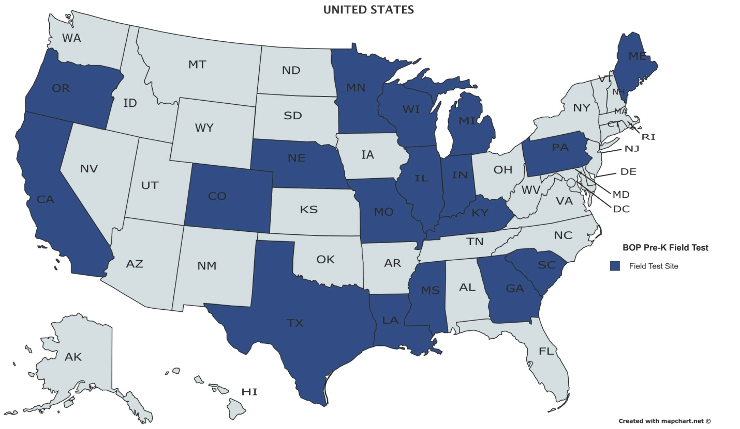

The following is a list of the materials distributed to the field test sites:
- Quick Start (print)
- For the Teacher of Students with Visual Impairments booklet (print)
- Teacher's Manual, Volumes 1–6 (print)
- Reference Volume (print)
- Reading Roundup Booklet (print)

Student Kit with
- Preschool Teacher Booklet (print)
- Parent Booklet (print)
- Set of Print Children’s Books (print)
- Student Set of Braille Children’s Books (braille)
- Student Workbooks and Tactile Storybooks (braille)
- Worksheets (braille)
- Parent Letters (print)
- Monitoring Charts and Reading Roundup Consumables (print)
- Manipulatives Pack (tactile cards: weather cards, emotion cards, plant cycle cards, obstacle cards, animal cards; green APH Scorecard; orange 3D-printed fish model; 1.5-inch natural wood cube; APH Digital Recording Device)

Word files for the Parent Letters, Monitoring Charts, and Reading Roundup Consumables and recordings of songs used in the lesson that are less likely to be familiar to teachers were also made available at this website: www.aph.org/buildingonpatterns/prek. Teachers were asked to customize the Parent Letters to themselves, their student, and their student’s family.

Questionnaires for the field test were developed to be administered via an online survey to obtain the following information:
- Additional demographic information about the teacher and the student(s) they are working with
- Each teacher’s initial reaction to the introductory and reference materials of BOP Pre-K
- Each teacher’s reaction to teaching each lesson (questionnaire to be completed at the end of each lesson) and their assessment of their student’s response to their instruction based on the lesson

Teachers were instructed to provide copies of the data collection forms documenting students’ progress to APH. Teachers were also asked to provide optional photo/video documentation of the student's participation in the lessons. A model release form was provided for teachers who were willing to do this in order to get the family’s permission.

Additional questionnaires will be developed to obtain teachers’ overall reaction to the program and support materials, including the Reference Volume and assessment plan at the mid-point (in December, regardless of how far along the teacher and student are in the program) and end of using the program.

A list of potential expert reviewers was compiled with input from Ralph Bartley, Executive Director of Research; Kate Herndon, Director of Educational Product Research; Diane Wormsley, APH Executive in Residence (at the time); Holbrook; and Ferrell. The project leader sent requests to six candidates to do a complete review of the program and one to a candidate who specializes in tactile graphics. Five of the six complete reviewers and the tactile graphics reviewer agreed to do the expert review. Materials were shipped and questionnaires were sent to Field Evaluators and Expert Reviewers in August.

Some of the BOP group gave a presentation on the changes based on the pilot filed test and the work being done on the project, titled “Prekindergarten Building on Patterns: Lessons Learned,” at the 2015 GITWL Conference in Albuquerque, NM, in November. Attendees at this presentation were enthusiastic about the new level of the curriculum.

Work during FY 2017
Due to quality issues of the materials produced for field testing and expert review, the first set of materials was not shipped to field evaluators and expert reviewers until October. This set contained most of the materials, but only the tactile storybooks and workbook for Lessons 1–9. The rest of the sets of these books were shipped as soon as they became available to all the expert reviewers and to the field evaluators who were progressing in their use of and feedback about the lessons. The set for Lessons 11–16 was available at the end of November, the set for Lessons 18–24 was available in mid-January, and the last set for Lessons 26–31 was available near the end of February.

Holbrook and the project leader agreed that it would be helpful to have one of the expert reviewers, Dr. Frances Mary D’Andrea, focus her evaluation on the assessment materials. A specialized questionnaire was developed and sent to her. Completed questionnaires from all the expert reviewers were received in early to mid-February 2017. S. Lee compiled the criticisms and suggestions from the general expert reviewers and the tactile graphics expert review. She also compiled the field evaluators’ criticisms and suggestions from the responses to the first nine lesson questionnaires and the first Bi-Annual Questionnaire.

In late February, Holbrook and the project leader reviewed some of the compiled feedback; this informed work on the additional questionnaires needed for the field test, including the Second Bi-Annual Questionnaire to be filled out at the end of the field test. They also discussed possible content for a workshop and poster session related to BOP Pre-K at the 2018 Getting in Touch With Literacy Conference. Holbrook composed proposals for these presentations, and the BOP group gave their feedback and approval during a conference call.

Field evaluators were asked to complete all questionnaires by May 22. The last response included in the field test data was received June 8.

Some evaluators and their students withdrew from the field test for various reasons, including student relocation, student’s lack of readiness for the curriculum, and insufficient time for lessons because of the teacher’s caseload. One teacher had a student with behavioral issues that made participation difficult, so she passed on the materials to a colleague who was working with a qualified student. Two of the teachers did not officially drop out but stopped responding and filling out questionnaires; the data for these teachers and their students is not reflected in the final field test report. Another teacher’s student moved away, but her feedback on all the lessons was collected. Of the 36 teachers selected for the field test, 31 were still participating at the end of the evaluation period.

Of the 46 students selected for the field test, 36 were still participating at the end of the evaluation period. This is a summary of the characteristics of those students:

Child’s Age (as of September, 2016)
- 3 years old: 2
- 3.5 years old: 1
- 4 years old: 31
- 5 years old: 2

Tactual learner
- Yes: 35
- No: 1 (This child was accepted because he has the same TSVI as another child and the teacher’s reasons for including him were persuasive: “My second student just recently started in our district. He appears to be a strong auditory learner with no functional vision. He will begin learning prebraille skills and I think he too can benefit from trying out this new product.” “Student is a strong auditory and tactual. I think he would be a great candidate for BOP.”)

Additional disabilities diagnosed
- Yes: 12
- No: 24

English spoken at home
- Yes: 33
- No: 3

Service delivery setting
- Center-based: 10
- Center-based and Itinerant: 1
- Inclusive: 2
- Inclusive and Itinerant: 5
- Inclusive and Residential: 1
- Itinerant: 14
- Residential: 3

The field test sites chosen were geographically diverse in the United States, as shown in the map below. One field test site was also chosen in British Columbia, Canada. (The teacher at the field test site in Michigan dropped out of the field test due to student issues.)

Approximately two-thirds of the field test sites completed Lessons 1–5. After that, the number of lessons completed went down with only a half to a third completing through Lesson 14. Only two teachers with students were able to complete through Lesson 24. Feedback on all the lessons was only received from the teacher from whom only teacher feedback was collected.

In the Second Bi-Annual Questionnaire at the end of the field test, teachers were asked, “If you have a student in prekindergarten in the future, would you use BOP Pre-K?” All of the 26 teachers who responded to the question chose “Yes” as their answer.

At the BOP Writing Group Meeting, June 26–30, Holbrook presented a slideshow with feedback from the field test and expert review of BOP Pre-K. The group discussed this information and made revisions to some materials based on that input. This included changing some of the tactile cards, changing the wording for activities in a few of the lessons, condensing the lesson sequences to two pages, making some additions to the TSVI Booklet, making a change to one of the parent letters, and adding reminders that the letters to the parents can be personalized. It was decided that some of the comments in the feedback could be addressed by adding resources to the BOP Pre-K Web site (which will have this new URL when broadly released): www.aph.org/building-on-patterns/pre-k/. After discussion, the group decided some concerns did not need to be addressed; most of these concerns were only expressed by one evaluator.

In response to feedback that some students would benefit from braille labels in the print children’s books, Emily Grimany helped to prepare braille-ready files that teachers could use to emboss the text of the books onto adhesive labels to place in the books. These will be provided on the BOP Pre-K Web site when ready. Grimany also produced the rest of the transcriptions of the children’s books (including image descriptions) for braille-reading teachers.

S. Lee, Holbrook, and the project leader continued to analyze the field test and expert review data and work on a comprehensive report of the data. Hiring an outside researcher to assist with this work was discussed.

Spicknall and Swenson reviewed and enhanced the content of the Parent Booklet and Preschool Teacher Booklet. Swenson and S. Lee assisted in the post-field test updates to the Reference Volume.

The components that were not formally laid out before the field test were sent to InGrid Design for layout: Volume 6, Lessons 26–32; the Reading Roundup lessons booklet; the Reference Volume; and the booklets for the parents, preschool classroom teachers, and TSVIs. Edits to Volumes 1–5 of the teacher’s manual were made based on the feedback from the field, writing group decisions, and changes for consistency. A scope and sequence was added to each volume of the teacher’s manual. S. Lee and Leasha Twyman assisted in the reviews of the laid out documents.

The publisher informed APH that the book chosen to accompany Lesson 3 will be going out of print. Joon Lee assisted with obtaining permission to use the text of this book to reprint the book. A replacement book for Lesson 30 (confirmed in June 2016 as out-of-print by the publisher) was written by the writer hired to write books for BOP Kindergarten. Jones and other graphic design personnel obtained photos and created illustrations for both books. Three quotes were obtained, and an outside printer was chosen to produce these books as well as the other two books determined in 2015 to not be available from the publisher.

A vendor was chosen to create the mold for the fish model and provide the models for the Student Kits.

Work began to produce the tooling for the tactile graphics for production runs. The five sets of tactile cards in the Manipulatives Pack will be vacuum formed using 0.010-inch vinyl. At the time of this report, a decision had not been finalized on the material to be used for the other tactile graphics.

A plan to release the BOP Pre-K materials to the Production floor in stages, rather than all at one time, was discussed. A list of materials was developed and reviewed with Production and Purchasing personnel. The majority of the production specifications were written. Work to procure the purchased items for the production run of the Student Kit began.

Work planned for FY 2018
The teacher’s manual and other print components not yet in braille will be transcribed into braille. The braille versions of the Monitoring Charts and Reading Roundup Consumables, Preschool Teacher Booklet, and Parent Booklet will only be provided as free downloadable braille-ready files. The production specifications, final versions of the files, and other tooling for production will be completed. A formal specifications meeting will be held with other APH department staff. The remainder of the purchased items for the Student Kit will be procured. Production will be completed, and BOP Pre-K will be released.

The field test and expert review data will continue to be analyzed, and a comprehensive report of the data will be completed.

A workshop and poster session related to BOP Pre-K will be presented at the December Getting in Touch With Literacy Conference.

BOP Pre-K pages will be added to the BOP component of the Braille Literacy Web site. Resources will include those made available to field evaluators during the BOP Pre-K field test. Additional materials to supplement the curriculum will be developed and placed on this website.

Individualized Meaning-Centered Approach to Braille Literacy Education (I-M-ABLE)
(Continued)

Purpose
To provide an alternative model for braille literacy instruction to students with visual and additional disabilities

Project Staff
Diane P. Wormsley, Author/Project Consultant
Monica Vaught-Compton, Project Assistant
Susan Spicknall, Braille Literacy Project Leader
Jeremiah Rose, Research Assistant
Adam Clark, Manufacturing Specialist
Frank Hayden, Director of Technical & Manufacturing Research

Background
The Individualized Meaning-Centered Approach to Braille Literacy Education (I-M-ABLE) project was initiated in early 2014, to address the needs of students learning to read and write braille with additional disabilities. Diane P. Wormsley, Ph.D., developer and author of the I-M-ABLE program, agreed to collaborate with APH to design a kit of instructional aids and materials to accompany the practice guide. The project focuses on providing an ever-growing population of students an appropriate pathway to successful literacy. These students are often not well served by traditional instructional strategies or materials. An individualized approach, which focuses on a student's particular interests to provide relevance and motivation for learning, offers a positive alternative to existing programs.

During 2015, numerous meetings were held to establish a working partnership between the American Foundation for the Blind® (AFB) and APH, to select and design components of the kit, to plan training videos/materials, and to develop a schedule and procedures for the field evaluation. An extensive survey was written with specific criteria for recruitment of field testers. Teachers and students were identified using predetermined profiles for the purpose of obtaining solid data. A teleconference was held with the teachers to explain the schedule and procedure for field evaluation.

An I-M-ABLE training workshop was organized and presented to an audience of six TVIs. Video clips were made of the training corresponding to various components of the I-M-ABLE approach. The rationale behind the approach, background on the differences between braille and print, and the importance of teaching proficient tactile skills were included in the workshop. These clips were edited, and a private link to them was created for access in field testing.

The field test kit consisted of the following:
- A final non-copyedited version of the publication I-M-ABLE
- A Califone® CardMaster™ Card Reader and a set of cards with recording capability. The cards are large enough for a clear recording of a word or a short sentence in braille.
- Chunk Stacker, a phonics teaching game, consisting of two sets of tiles that fit into small trays. The blue tiles are onsets (beginnings of words), and the pink tiles are rimes (word families). Clear braille adhesive labels will be applied to each set for accessibility.
- Four vacuum-formed trays (used for a variety of activities). Each tray will hold four cards.
- Reward Stickers (currently sold by APH)*
- A private link to the training videos, which were developed during 2015

(*The Reward Stickers were not identified by the field testers as critical to the kit, thus they were removed from the items to be included in the final version of the kit.)

Field testing began in October 2015 and extended throughout the remainder of that year and into 2016. Teleconference meetings were held with field testers on a 2-week basis initially, and then monthly as field testers began implementing the approach with their students. An electronica mailing list was created for field testers to use to communicate with each other and with the project leader and consultant.

During January through March 2016, field testing of the I-M-ABLE kit continued. Monthly communication with the field evaluators was held by means of the electronic mailing list in January and February, but by a teleconference call in March since this was the last month of the field testing. The field testers completed a survey to evaluate their experience implementing the kit and answered questions about the importance of the various components of the kit.

In 2016, AFB Press published I-M-ABLE: Individualized Meaning-Centered Approach to Braille Literacy Education. This book will be purchased from AFB Press to form part of the APH I-M-ABLE Kit. To meet accessibility requirements, customers will be able to purchase either a kit with the I-M-ABLE print book or a kit with the I-M-ABLE electronic book. Anticipated kit components to be included in both of these kits were as follows: instruction booklet written by Wormsley, Califone® CardMaster™ Card Reader with set of blank magnetic cards, Chunk Stacker game with braille labels for the game tiles, and four vacuum-formed trays. The instruction booklet includes a private website link to the training videos as well as an appendix with the handouts to accompany the videos.

Work during FY 2017
The manufacturing specialist worked to complete product specifications. In January 2017, the manufacturing specialist discovered that the Chunk Stacker game was recently discontinued by the manufacturer and replaced by a similar game called Chunks. The project leader and author reviewed Chunks and found that it was a suitable replacement for Chunk Stacker in the I-M-ABLE kit. However, the Chunks game tiles contained different rimes and onsets than Chunk Stacker. Thus, re-tooling of the braille labels for the rimes and onsets in the game was necessary. Further, text revisions to the Instruction Booklet were made; this included revisions to the braille-ready file with another proofreading by the Braille Department.

Revisions to the kit due to the Chunks game replacement were complete by May 2017. It was at this time that the manufacturing specialist learned that the Califone® CardMaster™ Card Reader was being discontinued by the manufacturer. Project staff searched extensively for a replacement for the CardMaster™, but one was not found. Therefore, the CardMaster™ was eliminated from the kit. Project staff convened to identify another product to include in the kit. After reviewing the original list of products considered for inclusion in the kit, project staff decided to include the APH Word PlayHouse, uses for which Wormsley describes in the book I-M-ABLE. Word PlayHouse provides opportunities for individualized instruction for braille literacy. With the inclusion of Word PlayHouse, project staff decided that the inclusion of the Chunks game was redundant as Word PlayHouse meets a similar instructional component; therefore, it was eliminated from the kit.

Work planned for FY 2018
Product specifications will be completed, and a Specifications meeting will be held. The product will become available for sale.

Low Cost Brailler/Embosser
(New)

Purpose
To provide a low-cost embosser with the target audience being teachers of the visually impaired, school-age children, and adults who have need of an embosser to produce braille for small embossing jobs (i.e., worksheets in classrooms, student work, or documents in the workplace)

Project Staff
Martin Monson, Project Leader
Frank Hayden, Director of Technical & Manufacturing Research
Larry Skutchan, Director of Technology Product Research

Background
The idea for this product followed the established protocol. Two idea submissions were submitted to APH about embossers. One idea focused on developing a low-cost personal embosser, while the other focused on a portable embosser. During review of the ideas by the Product Evaluation Team and the Product Advisory and Review Committee, the two ideas were combined and assigned a grant number.

Work during FY 2017
Several meetings concerning the possibility of APH producing an embosser were held. The discussions focused on which route to take in developing an embosser: personal, portable, or both. Requests for proposals were developed for both types of embossers. At the writing of this report, no decision has been made on which route APH will take to develop an embosser.

Work planned for FY 2018
Internal discussion about which route APH wants to take to develop this idea will continue. Once a decision is made, a request for proposals will be published.

Music Braille Code
(Modernization/Completed)

Purpose
To provide the current version of the Braille Authority of North America’s Music Braille Code, 2015, in large print and braille for people who are blind and visually impaired and are not able to access the electronic versions of the document or who prefer a physical copy

Project Staff
Cathy Senft-Graves, Project Leader
Frank Hayden, Director of Technical & Manufacturing Research
Andrew Moulton, Manager of Technical & Manufacturing Research
Adam Clark, Manufacturing Specialist
Anthony D. Jones, Art Production/Design Manager
Matthew Poppe, Graphic Designer
Sara Lee, Research Assistant

Background
In June 2016, the Braille Authority of North American (BANA) released an updated version of the Music Code, titled Music Braille Code, 2015. This document provides the guidelines for braille transcribers and teachers to provide musical notation to braille readers.

This edition is intended to extend consistent guidance regarding format. Where appropriate, rules and procedures have been adjusted to comply with the adoption of The Rules of Unified English Braille and of Braille Formats: Principles of Print-to-Braille Transcription. A section about transcribing music for harps, which was not included in the 1997 BANA code, has been added. It also incorporates some signs that are not defined in either that work or in the New International Manual of Braille Music Notation.

APH is the official printing house for BANA, and they have requested that this updated codebook be made available in hard copy as was the previous version of the codebook. Requests for hard copy have been made by NLS and US transcribers, and agencies in Canada, the UK, and New Zealand have expressed interest in hard copy.

In late FY 2016, the project leader began discussion with the BANA Publications Committee about producing the large print and braille hard copies of the music code. With the assistance of Adam Clark, the project leader conducted research to determine the specifications for the production of the last BANA code book APH produced, the Guidelines and Standards for Tactile Graphics, 2010, in order to use them as a model for the specifications for the Music Code. The project leader also submitted a Modernization Form for this product.

Work during FY 2017
In October, Frank Hayden obtained catalog numbers for the hard copy print and braille versions of the Music Code. The project leader received the large print and braille files from the BANA Publications Committee in November. The project leader worked with Clark to develop the production specifications for the print and braille books. The project leader worked with Matthew Poppe, along with input from the Publications Committee members, to improve the BANA logo for the title page of the documents and binder inserts so it would print well on the IGEN®. The content of the spine labels for the braille volumes was also discussed with the Publications Committee.

A specifications meeting was held in April. In June, Hayden was told the print and braille books were put on the production schedule for August. The project leader reviewed proof copies before the production run of the books. While proofing the braille volumes, the project leader found that the braille files did not represent the Roman numeral page numbers with continuation letters correctly. The project leader notified the chair of the BANA General Committee on Unified English Braille about this issues, and the committee decided the problem should be fixed. A member of the BANA Publications Committee made the corrections, and the new files were provided to APH. The production run followed approval of the proof copies made from the corrected files.

Work planned for FY 2018
This project is complete. Except for responding to customer questions, no other work is planned for FY 2018.

Quick Pick Braille Contractions [Modernization]
(Continued)

Purpose
To provide practice materials for elementary students who are learning braille

Project Staff
Dawn Wilkinson, Early Childhood Project Leader
Frank Hayden, Director of Technical & Manufacturing Research
Jeremiah Rose, Research Assistant

Background
A survey was conducted in 2001, in order to determine a need for study materials, in uncontracted and contracted braille. Research verified that drill and practice in identification of contractions increases reading speed and comprehension. The Quick Pick Braille Contractions set was developed in the early 2000s. The kit contains two packets of cards and includes all contractions in literary braille. Each card displays a symbol/group of symbols in contracted form in the upper left-hand corner. Four possible uncontracted equivalents are listed across the card below. A hole under each spelled-out version of the contraction allows the student to choose his/her answer. The reader selects an answer by inserting a stylus into the hole beneath his/her choice. If he/she is correct, the card can be slid from the packet; if incorrect, the card cannot be removed. This format for practice materials had already been used successfully with five previous Quick Picks: Addition, Subtraction, Multiplication, Division, and Counting. Production of this product began in September 2005.

In 2015, Quick Pick Braille Contractions was identified for modernization in order to update the product to incorporate Unified English Braille (UEB). The updated kit will also include a flat stylus to prevent crushing of the braille on the cards.
New catalog numbers were assigned for this new UEB version of Quick Pick. The words on the cards were rearranged for better spacing and alignment. The label for the outer cover for each set of cards was brailled. The project was assigned to Dawn Wilkinson, Early Childhood Project Leader, in April 2016. The project leader and research assistant continued to make adjustments to the product and meet with Technical Research staff.

Work during FY 2017
Graphic Design completed all print files containing the new catalog number for the modernized product. Production continued to work on a solution for the alignment issues on the braille cards.

Work planned for FY 2018
Final tooling and specifications will be completed. The UEB Quick Pick Braille Contractions kit will become available for sale.

Handwriting

For FY 2017, there are no projects in this category to report.

Study Skills / Organizational Skills

For FY 2017, there are no projects in this category to report.

Tactile Graphics

Feel 'n Peel Stickers: Braille/Print Capital Letters A-Z
(New)

Purpose
To provide a new packages of Feel 'n Peel Stickers featuring braille/print capital letters
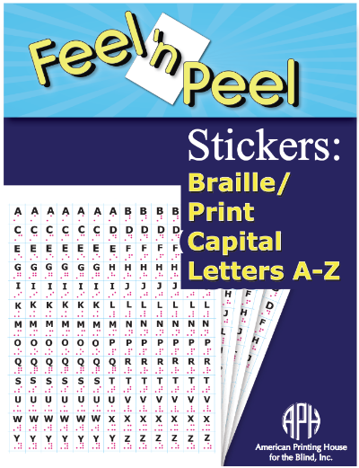

Project Staff
Karen J. Poppe, Tactile Literacy Project Leader
Rachel White, Research Assistant
Adam Clark, Manufacturing Specialist
Anthony Jones, Graphic Designer

Background
For nearly two decades, various types of Feel 'n Peel Sticker packages (a series originated by the project leader in 1999) have been produced by APH. Available kits offer point symbol stickers, reward statement stickers, alphabet stickers, color name stickers, smiley/frowny face stickers, and assorted adhesive-backed textures. After years of availability, the sales of APH’s sticker packages have remained popular and steady. The Feel 'n Peel Stickers: Alphabet Letters (1-08849-00), a package featuring lowercase letters A-Z, consistently appears among APH’s “Top 25” selling products; 1,445 packages were sold in FY 2015, and 1,795 packages were sold in FY 2016 indicating a growing demand for letter stickers.

APH frequently receives requests for additional Feel 'n Peel Sticker packages. A request for capital letter stickers was formally submitted by Stephanie Bissonette, Supervisor of Children’s Services, Vermont Association for the Blind and Visually Impaired. One suggested use for the letter stickers was for the construction and labeling of embossed Punnett squares for biology classes.

Work during FY 2017
In November 2016, the development and production of Feel ‘n Peel Stickers: Braille/Print Capital Letters was presented to the Product Evaluation Team and in December 2016, to the Product Advisory and Review Committee. Formal field testing was deemed unnecessary since the production methods, materials (e.g., clear .005-in. vinyl sheets), and expected customer uses mirrored those of earlier Feel ‘n Peel Sticker packages.

On January 10, 2017, the project leader conducted a Product Development Committee meeting. She shared a digital file that illustrated the expected print layout, braille letter position, and spacing of die-cut lines. This sticker setup, arranged in a 13 x 13 matrix, would generate the exact number of stickers as the counterpart sticker package of lowercase alphabet letters. Production staff expressed some uncertainty regarding the best route for printing the sticker sheets in light of the recent omission of in-house screen-printing capabilities. Alternative paths for printing the stickers were explored, including offset printing in-house or via the Roland® UV printer; the latter option proved to be slow and not cost-effective. Eventually, an outside vendor was identified for printing the sticker sheets; samples were received and approved. The project team anticipated that 1,000 units of this new sticker package would sell within the first year.

A new catalog number (1-08870-00) was assigned to the Feel ‘n Peel Stickers: Braille/Print Capital Letters. The project leader prepared the content for the Suggested Uses insert and provided it to the graphic designer for layout and design. Braille translation of the Suggested Uses insert was initiated during the last quarter of the fiscal year.

Work planned for FY 2018
Tooling tasks will be completed in-house and by the outside vendor to accommodate mass production of the Feel ‘n Peel Stickers: Braille/Print Capital Letters. Specifically, the following will be designed:
- Digital file of the sticker sheet (rendered by the manufacturing specialist)
- Photo-etched magnesium embossing plates (prepared by the outside vendor)
- Cutting dies to face-cut the stickers

Final product specifications will be presented to Production staff. The project leader and manufacturing specialist will monitor the quality of parts received from the vendor and subsequent in-house packaging during the pilot and production runs. The project leader will ready related brochure content.

The Feel 'n Peel Stickers: Braille/Print Capital Letters A-Z will be available with Quota funds. The final sticker package will include the following:
- 4 sticker sheets
- Print Suggested Uses Insert
- Braille Suggested Uses Insert
- Print Parts List
- Braille Parts List

The development of additional packages of Feel 'n Peel Stickers recently requested by the field will be pursued. Currently planned packages include Negative Numbers and UEB Braille/Print Numbers.

Finger Walks
(Continued)

Purpose
To compile a book of thermoformed labyrinth designs, along with a description of how to use them, for recreational and therapeutic use and for tactile and spatial concept development

Project Staff
Fred Otto, Tactile Literacy Project Leader
Frank Hayden, Director of Technical and Manufacturing Research
Andrew Moulton, Manufacturing Specialist

Background
The project idea was submitted by Maia Scott, an arts instructor who is blind, with the title Walking in the Dark. Ms. Scott has extensive experience using both walking labyrinths and finger labyrinths with learners of all ages, and she proposed to work with APH to produce a collection of classic labyrinth designs in a portable, tactile format.

Ms. Scott’s product submission cited several benefits of working with labyrinths, including enhancing spatial awareness; enhancing concentration, calm, and focus; the fun of making rubbings and exploring patterns; quiet play for children; and fine motor development. Research and personal experience of the project leader confirmed that finger labyrinth diagrams are used in schools and other settings as a way to calm and focus students who are overstimulated or acting out.
The project is regarded at APH as enhancing the area of tactile skill development, but also having potential benefits for O&M, social interaction, and sensory efficiency.

The submission was reviewed and discussed by project leaders and other staff, and then approved by the Product Advisory and Review Committee. Preliminary work on layouts and choosing appropriate materials began.

Work during FY 2017
The project leader produced designs of 12 labyrinths, ranging from simple to complex. Technical Research then made two sets of tactile samples using the Roland® UV printer. One set was sent to Ms. Scott, who was greatly pleased with them. The project leader and Ms. Scott agreed that this process could serve as an effective basis for the product.

A product development meeting was held to discuss various options for materials, components, and processes. It was agreed that the final collection of labyrinth pages should be reasonably priced, durable, and cleanable between uses. The best way to satisfy these goals is to make vacuum-formed sheets with matching print and raised outlines.

The tactile labyrinths will be offered in a binder along with a booklet giving brief historical notes and suggestions for use.

Work planned for FY 2018
The project leader will work with the Model Shop and Technical and Manufacturing Research to design and produce tactile samples for field testing. Ms. Scott will contribute content to the written guidebook.

Depending on time and staff availability, field testing in schools may be conducted in the spring or summer of 2018. The project leader and Ms. Scott will also seek comments and input from personal contacts at conferences and workshops.

Flip-Over Concept Books: MAKE A FACE
(Continued)

Purpose
To provide young children with an interactive tactile book series that encourages the development and understanding of basic concepts and tactile skills related to shape, texture, spatial concepts, etc. The Flip-Over Concept Books: MAKE A FACE will focus on changing facial expressions via the flip-over panel format.

Project Staff
Karen J. Poppe, Tactile Literacy Project Leader
Matthew Poppe, Graphic Designer
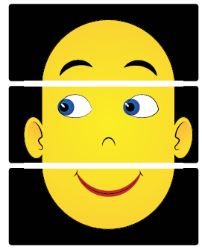

Background
In April 2006, the project leader submitted a formal proposal to develop a series of interactive tactile/print books to encourage young children's development and understanding of basic concepts related to shape, texture, spatial concepts, counting, etc. Flip-Over Concept Books incorporate an interactive feature whereby the child independently flips pages or adjacent print/tactile panels that can be matched or sequenced. The panels turn so that, for instance, the child can find all of the panels that have a rough texture, continue a line path, complete a sequence, build an image, etc. Over a decade later, APH has introduced three unique books as part of the Flip-Over Concept Books series, including LINE PATHS, PARTS OF A WHOLE, and TEXTURES; two additional books—FRACTIONS and TELLING TIME—are currently under development (see separate annual reports). Despite years of availability, the first three books continue to sell in large numbers: LINE PATHS—430 (FY14); 317 (FY15); 311 (FY16); PARTS OF A WHOLE—407 (FY14); 387 (FY15); 263 (FY16); TEXTURES—810 (FY14); 787 (FY15); 567 (FY16).

During the field test of the first two Flip-Over Concept Books, field evaluators requested additional books, including ones with recreational themes. Over half (62%) of the field evaluators requested funny faces that could be built with a stack of facial features.
Unlike previous and more recent Flip-Over Concept Books, MAKE A FACE will not require correct pairing or sequencing of panels; instead, it will encourage open-ended, independent use by the student as she learns to discriminate subtle differences between shapes that represent different eyebrow, eye, and mouth panels. The faces morph with a simple flip of a panel (top, middle, or bottom) to generate a new “face” combination to be explored by the student. In the process, shifting facial features will lead to discussion and exploration of different line types, textures, and tactile shapes. Exploration of the tactile faces will allow “young fingers” to trace the upward or downward curve of a mouth, the downward or upward slant of the eyes/eyebrows, and so forth. Related facial expressions (e.g., happy, sad, surprised, puzzled) can be reviewed as well. MAKE A FACE will accommodate relaxed and recreational tactile learning experiences for young students without the stress of sorting panels in a particular order/sequence.

Work during FY 2017
In January 2017, the project leader submitted a formal product submission form that recommended the development of Flip-Over Concept Books: MAKE A FACE, which will function similarly to previous Flip-Over Concept Books. Specifically, it will feature freely rotating panels that are threaded onto a ProClick® binding, allowing the removal and repositioning of panels, if desired. The panels will be printed and vacuum-formed on .010-in. white vinyl. Separate braille and large print versions of the Reader’s Guide will be included with the flip-over book to outline recommended and extended uses. The student will orient the flip-over book vertically with the binding on the left as panels are flipped right to left or left to right. The back panel will consist of a durable polyblend cover. Raised separators or notches might be formed within the back cover so that panels can be locked into a definite location to minimize scissoring of adjacent panels during tactile exploration. The anticipated overall size of the MAKE A FACE will be larger than previous books in the series.

Prior to review and approval by the Product Evaluation Team (PET) and the Product Advisory and Review Committee (PARC), the product idea was reviewed by additional APH staff. The Early Childhood Project Leader indicated that “The Flip Over Concept book would provide a fun first step in learning about facial expressions which is often difficult for kids with congenital blindness, but moreover present an amazing tactile graphics learning activity. What a great addition to the existing Flip Over series.” In May 2017, the book concept was considered and approved for development by PET and PARC.

Throughout the summer, the project leader and graphic designer experimented with preliminary designs of the facial panels. The panels are separated into three groupings: eyebrow position, eye direction/shape (with constant ear and nose shapes), and mouth shape. The goal is to provide a minimum of 10 unique panels for each facial feature to accommodate 1,000 possible combinations of facial expressions.

Work planned for FY 2018
The project leader and graphic designer will continue to experiment with possible facial expression panels for the MAKE A FACE flip-over book. Given the successful design of previous Flip-Over Concept Books, formal field testing of MAKE A FACE will not be necessary; however, guidance and feedback will be garnered from in-house staff and outside expert reviewers throughout the course of development. For example, APH’s CVI Project Leader will be consulted about ideal colors and simplicity of visual design for children with cortical visual impairment.

A firm art design for the MAKE A FACE will be established and shared with the Product Development Committee, especially the staff in Technical Research and the Model Shop who will proceed with production tooling preparation. Concurrently, the project leader will prepare content for the accompanying Reader’s Guide. Due to other product priorities (including more recent flip-over book developments), MAKE A FACE will likely not be available until FY 2019.

Room with a View: Map-Reading Concepts and Skills
Formerly Room with a View: A Tactile Model of Indoor Settings
(Continued)

Purpose
To provide an interactive “room” with an assortment of realistic models that can be used to represent the interior layout of a single room (e.g., bedroom, kitchen, school classroom) or larger venue (e.g., shopping mall, grocery, library, etc.). Through the use of this tactile room, cognitive mapping skills and spatial understanding can be encouraged and practiced. The product will encourage the transition from three-dimensional models to abstract, two-dimensional layouts as typically encountered in Picture Maker and static raised-line maps.

Project Staff
Karen J. Poppe, Tactile Literacy Project Leader
Rachel White, Research Assistant
Patrick White, Pattern/Model Maker
Andrew Moulton, Manufacturing Specialist
Laura Greenwell, Graphic Designer
Matthew Poppe, Graphic Designer

Background
As conceptualized by the project leader, the product will be an “indoor” equivalent to APH’s Tactile Town. Tactile Town primarily focuses on outdoor settings (e.g., street layouts, multi-block arrangements); in contrast, Room with a View: Map-Reading Skills and Concepts will address indoor surroundings and layouts. The concept of perspective will also be emphasized via tactile observation of the room from various angles (e.g., front view, top view, side view). Lesson plans will encourage the student to “re-draw” the room independently using a variety of tactile materials (e.g., DRAFTSMAN, flat VELCRO® brand compatible or magnetic shapes).

The product addresses the following needs and requests from the field:
- Provide additional interactive tactile materials to assist students’ understanding of the world around them.
- Allow exposure to tactile graphic displays within a purposeful context (e.g., understanding a room layout and how the view of a room can change depending on one’s perspective and physical position in a room).
- Promote the transition from three-dimensional layouts to abstract and/or permanent raised-line graphics.
- Design materials that engage a young child/student in open-ended creative activities (e.g., building and designing room layouts).
- Address specific requests from the field as garnered from Tactile Town field evaluators and attendees of Tactile Town product training sessions such as the following:
- “Expand this fantastic tool to include parts of inside of buildings to orient students to a library, grocery store, and school building.”
- “I would love to have a doll-sized house and store that is designed for teaching O&M to illustrate floors and how rooms and hallways exist in all these structures.”
- The need for this product was echoed at NFB’s 2013 Tactile Graphics Conference in Baltimore, MD, by an audience member during the project leader’s presentation on the development of early tactile skills and concepts.

Successfully navigating an indoor setting can be assisted by the modeling of a room’s layout via the use of models. Creating a tactile map allows a student with visual impairment/blindness to “establish a better understanding of the ‘big picture’ of the classroom layout and/or school environment.” iris.peabody.vanderbilt.edu/module/v01-clearview/cresource/q2/p06/

“Touch plays a role in our understanding of spatial awareness in the same way that we rely on our sense of sight. Feeling a three-dimensional model to comprehend a layout of a room triggers the same part of the brain that would have been activated if the room was seen.”—Dr. Thomas Wolbers, Centre for Cognitive and Neural Systems www.ed.ac.uk/news/all-news/spatial-260511

The former field evaluation of Tactile Town, with 114 students with visual impairments and blindness, will greatly impact and guide the design and presentation of Room with a View. Field test results indicated that a three-dimensional realistic model was beneficial to the target populations because of the following features:
- allows the construction of concrete, understandable representations
- interactive, versatile, and engaging
- accommodates many layouts
- both colorful and tactile
- quick to put together and take apart
- addresses many concepts (e.g., directionality, spatial and positional terms, walking routes, interpretation of tactile layouts/maps)
- realistic detail of manipulative/models
- pretend-play opportunities

Anticipated target populations for Room with a View will likely mirror those for Tactile Town, specifically preschoolers and students in Grades K-3 with visual impairments/blindness, as well as low vision and tactile readers in Grades 4-8. However, the product could potentially be used by older students and adults who want to make a mockup of a layout of a room in a more realistic manner. The format of the product will appeal to sighted peers and family members as well.

In May 2013, the project leader prepared a formal Product Submission Form describing the unique purpose and need for Room with a View. In August 2013, the concept was considered and approved for development by both the Product Evaluation Team and Product Advisory and Review Committee.

Significant work on Room with a View was curtailed during FY 2014 and FY 2015 by the project leader’s involvement in higher priority projects that were in later stages of development, field testing, and/or production. However, the project leader gave periodic thought to anticipated components and tools for Room with a View including the following:
- A pivoting “room” for attaching room features and positioning and re-positioning 3D models (e.g., tables, chairs, windows, doorways, steps, people, and so forth)
- An assortment of models that are APH-designed and/or purchased from outside vendors
- Tactile graphic layouts that serve as examples of room layouts
- Guidebook with lesson plans
- CD with accessible files and recording forms
- Carrying/sorting box for provided materials

The project leader initially focused on finding a feasible production method for designing the walls of the room. Specifically, the project leader needed walls that could be adjusted to various sizes and configurations, but were also durable and colorful with tactually discernible windows and door(s). She built a representative model using 3 mm thick foam with interlocking, jigsaw-puzzle-like sides. When locked together, the walls stand upright and can be positioned on a VELTEX® brand surface via hook material. It is anticipated that the outer sides of the foam wall will be silkscreened with a visual pattern (e.g., brick wall) to provide realism and visual interest/contrast. In theory, sets of walls in different lengths and designs (e.g., with or without doors/windows, etc.) can be provided to accommodate a variety of room scenarios.

The project leader also investigated commercially-available miniature furniture and possible in-house 3-D printing or liquid resin options for generating APH original parts. Plans also included the incorporation of APH existing manipulatives (e.g., people models from Tactile Town).

Noticeable strides were made on the development of the Room with a View prototype throughout FY 2016. Innovative approaches to the design and construction of 3-D manipulatives and related tactile materials were executed, especially the following:
- An in-house 3-D printer was used to generate a variety of common room features (e.g., bed, desk, couch, bookshelf, stairs) as well as a person figure in two different styles. The project team made style tweaks to multiple iterations of the 3-D designs to ensure tactile clarity, durability, and realistic representation. Patrick White created the original STL files, and Andrew Moulton printed them via the 3-D printer.
- The wall styles of two different lengths were die cut out of 3 mm blue EVA foam. The wall styles varied by window and door location and quantity of each.
- Three roof sizes were designed and formed out of yellow polyblend and die cut with a remaining “pie crust” to rest on the upper surface of the vertically positioned foam walls.
- Common 2-D room layouts were designed via CorelDRAW® using the “footprints” of the 3D pieces; one-to-one size and shape consistency was maintained between the two styles. The room layouts captured a variety of settings (e.g., a kitchen, living room, bedroom, classroom, office, bookstore/library, and a grocery store). The two-dimensional room layouts were eventually output via the Roland® UV printer, negating the need for vacuum-form setups. The tactile height, generated via multiple ink passes on the printer, was sufficient for field testing purposes.

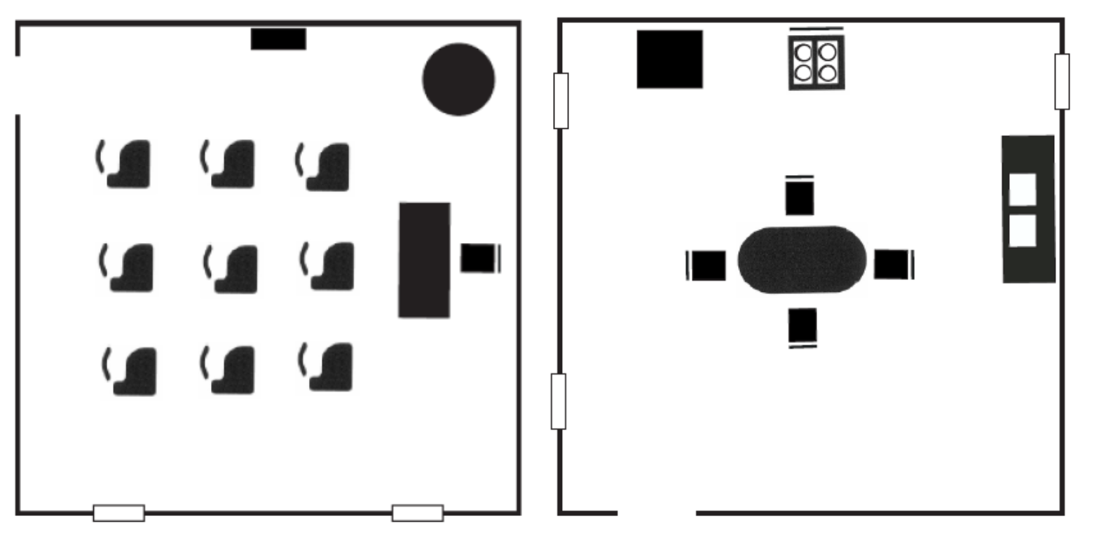

- A Room with a View template was designed to allow instructors to customize their own room layouts. The template includes 2D “footprint” images of the walls and room features included in the kit. Two versions of this template are now available for free download on APH’s Tactile Graphic Image Library—one with an 8.5 x 11-in. canvas and the other with an 11.5 x 11-in. canvas. An accompanying tutorial was scripted, directed, and narrated by the project leader and Matthew Poppe. It is posted online (youtu.be/1NFa9Dirr-w) for field test evaluators to assess its usefulness and application during the field test phase.

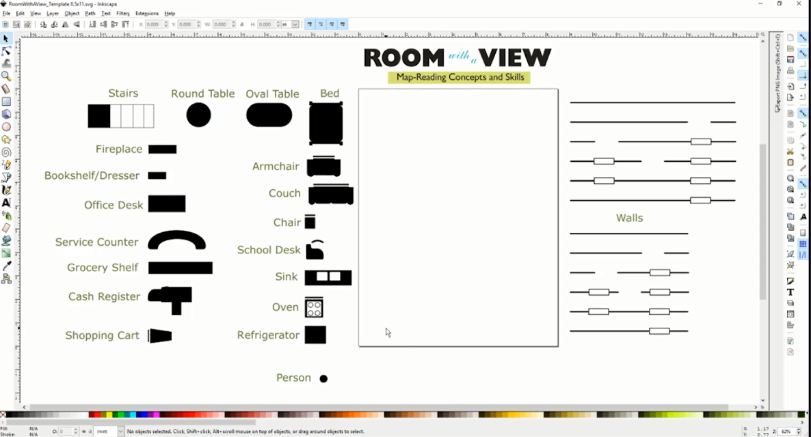

The artwork for the product logo, guidebook covers, felt board inserts, and outer carrying box were prepared by Laura Greenwell. By the end of July 2016, the entire structural design of the product itself was determined. The project leader and research assistant focused the last quarter of the fiscal year on writing and editing the guidebook content, which would be used in field testing.

Work during FY 2017
A field-test announcement was posted in the October 2016 APH News. More than 65 teachers of the visually impaired and orientation and mobility specialists expressed interest in participating in the evaluation of Room with a View. From this sample, 10 field-evaluation sites were selected based upon geographic location, number of available students, and type of instructional setting; preference was given to those who had not recently field tested an APH product. Some selected sites allowed multiple teachers to share and evaluate the prototype.

Potential evaluators gave reasons for wishing to field test Room with a View with their students with visual impairments and blindness; reasons hinted at the product’s usefulness even before the formal field test. Their shared explanations included the following:
- “My interest in this product is that I struggle with how to give students a 3D representation of rooms and interiors of buildings so they can build their mental maps and concept development. This product seems like it would be a great addition to my tools.”
- “I believe this product could benefit a lot of my students in the realm of initial room orientation and familiarization, spatial concepts, positional concepts, cognitive mapping, and room construction.”
- “We have students that struggle with map reading on a 2D level, so having items that are more 3D to use with those students might help with their understanding of how the classrooms and school are laid out.”
- “Most of my students are functional-academic and have some issues with processing and memory. There can be some spatial relation difficulties. I think having an organized system of presenting some of these concepts would be helpful.”
- “We have been saying for years that we need something like this to try with adults who come here who do not have the opportunity to develop spatial understanding and cognitive mapping skills when they were younger.”

Prototypes of the Room with a View were mailed to selected field evaluators on November 28, 2016. Evaluators were asked to return their completed evaluation forms and student-outcome forms by March 10, 2017. The deadline was extended a week or two if additional time was requested by an evaluator. By the end of the month, 100% of the evaluators had returned their forms.
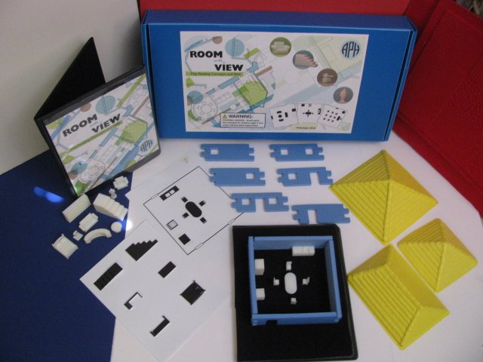

In April 2017, the project leader compiled a final field-test report. Field-test evaluation forms were completed by 11 teachers of the visually impaired and blind and/or certified orientation and mobility specialists (COMS). The field evaluators represented the states of California, Colorado (2), Florida, Iowa, Michigan, Mississippi, Ohio, Rhode Island, Vermont, and Washington. The largest percentage (73%) of sites represented itinerant settings. Table 1 and Figure 1 show the distribution of field-test sites according to type of educational setting and geographical location.

Table 1
Type of Educational Setting
Type of Educational Setting (N=11) | State Location of Field Test Sites | Percentage
Itinerant | CA, CO (2), FL, IA, MI, RI, VT, | 73%
Residential | OH, MS | 18%
Itinerant/Resource | WA | 9%
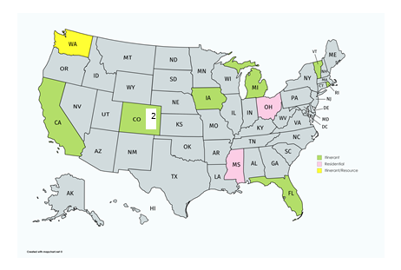
Figure 1. Geographical Distribution and Educational Setting of Field Test Sites.
Participating field evaluators represented teachers of the visually impaired and/or COMS with varied teaching experience; 27% had less than one year of teaching experience, 45% had 6-10 years of teaching experience, 18% had 11-15 years of teaching experience, and the remaining 9% had 21 or more years of teaching experience. All of the field evaluators noted difficulties that students with visual impairments and blindness tend to experience related to map-reading concepts and skills. Some of these challenges included the following:
- “Grasping the large picture of the whole room.”
- “Orienting a map to the real world and keeping it oriented as they move in space.”
- “Understanding a bird’s eye view. Putting themselves into a map mentally. Comparing real world to a map.”
- “Generalizing the map to reality; building on concepts of different rooms within a building—the doorway/window concepts; 3D to 2D.”
- “They have the most difficulty understanding the relationship between things (objects in the rooms, the rooms to each other, buildings to each other, etc.).”

Prior to field testing Room with a View, the field evaluators had used other materials and tools, commercially-available or from APH, to teach map-reading skills and concepts to their students. Commonplace tools included Tactile Town, Picture Maker: Wheatley Tactile Diagramming Kit, TREKS, O&M Tactile Graphics, Quick-Draw Paper, DRAFTSMAN, homemade maps, Wikki Stix®, and foam cutouts/textured paper.

The field evaluators used Room with a View with a total of 48 students who represented noticeably more males (63%) than females (37%). The sample population represented cultural diversity: 56% White, 15% Hispanic, 6% Black, 6% Asian, 2% Native Hawaiian/Pacific Islander, 9% two or more races, and 6% “other” (see Figure 2). The majority (65%) of the students had other disabilities, such as cerebral palsy, Down syndrome, attention deficit disorder, dyslexia, autism, and learning disabilities.

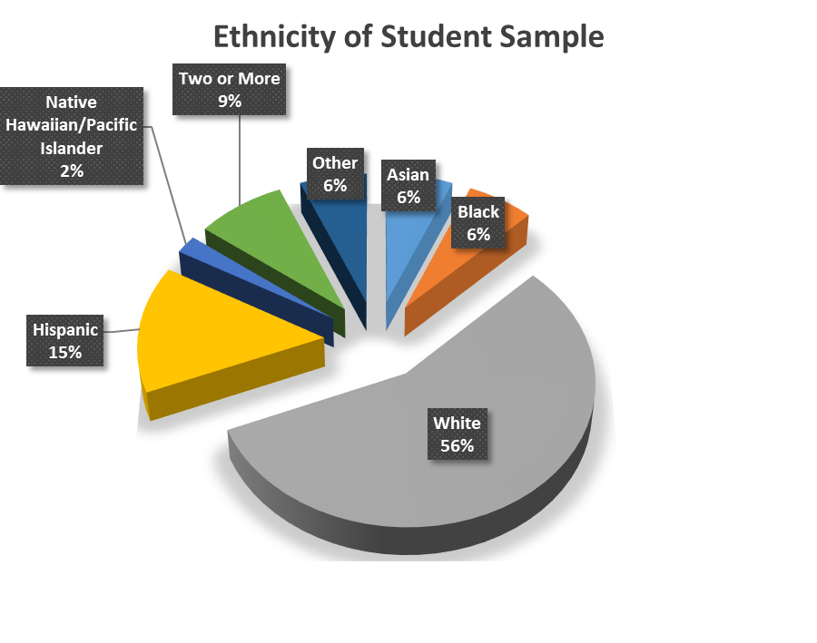
Figure 2. Students’ Ethnicity

Students ranged in age from 4 to 16 years. The majority of the students were either 7 to 9 years old (38%) or 13 to 16 years old (31%); 12% were 4 to 6 years old, and 19% were 10 to 12 years old. (See Figure 3.)

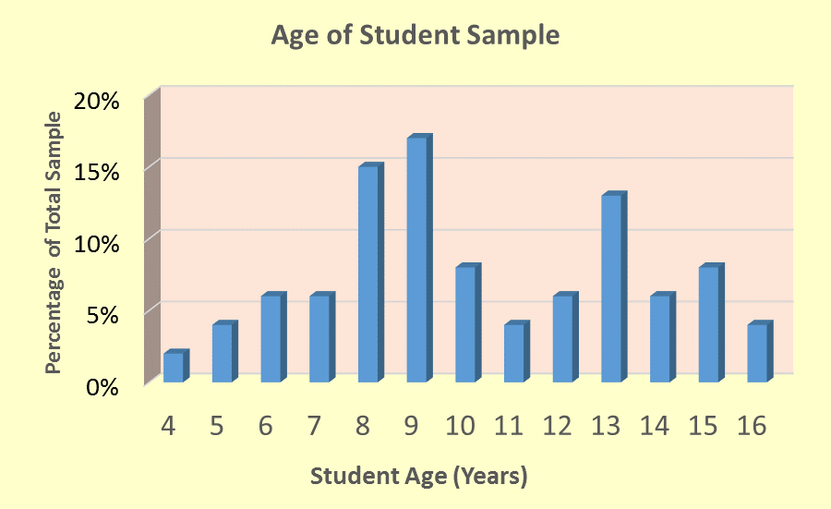
Figure 3. Students’ Age Range

With regard to grade level representations, nearly equal percentages of students were in Grades K to 3 (44%) or Grades 4 to 8 (42%); only 15% were in high school. (See Figure 4.)

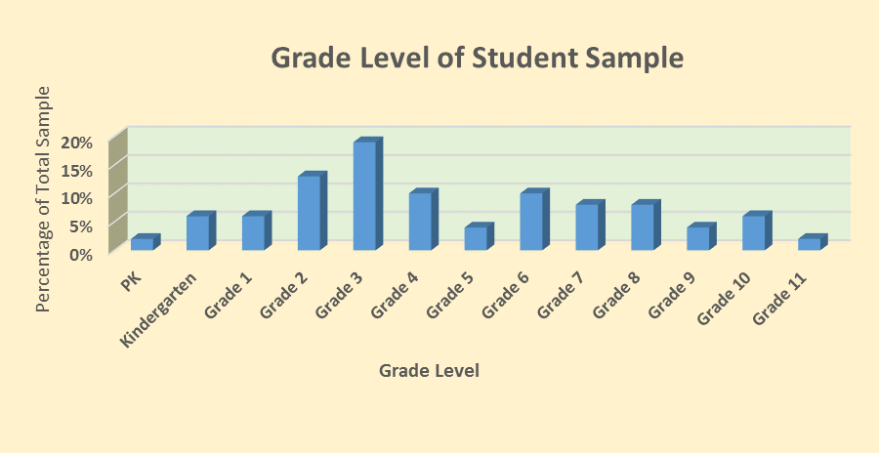
Figure 4. Students’ Grade Level
Braille readers comprised the largest percentage (34%) of the student sample; 25% were large print readers, 18% were dual readers (e.g., auditory/braille, large print/braille), 15% read print with magnification, 6% were auditory readers, and 2% were prereaders. (See Figure 5.)

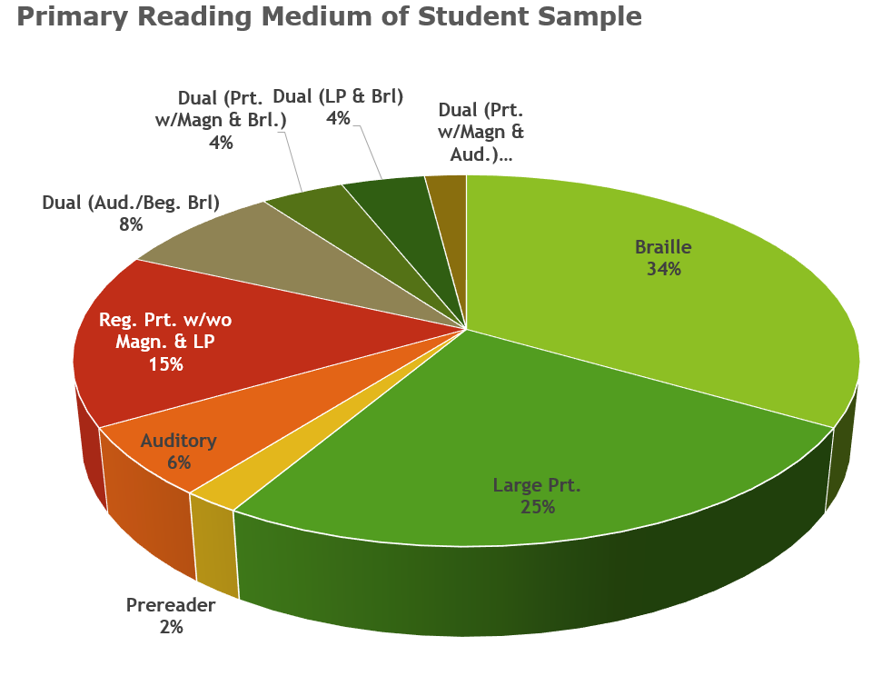

Figure 5. Students' Primary Reading Medium
The field-evaluation form allowed teachers to rate the overall design features of Room with a View. Table 2 indicates the average rating for each feature.

Table 2
Overall Design Features of Room with a View
Rating Scale: 5 = Excellent to 1 = Poor (or Unneeded)
Product Feature | Number of Evaluators | Average Rating | 5 | 4 | 3 | 2 | 1
Overall presentation | N = 11 | 4.36 | 45% | 45% | 9%
Tactile/print 2D room layouts | N = 11 | 4.64 | 64% | 36%
3D models | N = 11 | 3.82 | 9% | 73% | 9% | 9%
RWAV felt board | N = 11 | 4.91 | 91% | 9%
Interlocking foam walls | N = 11 | 4.09 | 18% | 73% | 9%
Roofs (three sizes) | N = 10 | 3.90 | 50% | 30% |  |  | 20%
Instruction booklet | N = 11 | 4.64 | 64% | 36%
RWAV template and related tutorial | N = 8 | 4.63 | 63% | 37%
Packaging/storage style | N = 11 | 3.82 | 9% | 64% | 27%

Field evaluators provided very positive ratings for the 3D models with regard to their overall design (refer to Table 3) and with regard to each model’s specific structural design (refer to Table 4).

Table 3
Overall Design of 3D Models
Rating Scale: 5 = Excellent to 1 = Poor
Product Feature | Number of Evaluators | Average Rating | 5 | 4 | 3 | 2 | 1
Overall size/scale of 3D models | N = 11 | 4.64 | 64% | 36%
Color/contrast with black RWAV felt board | N = 11 | 4.72 | 73% | 27%
Assortment/types of 3D models | N = 11 | 4.45 | 45% | 55%
Durability of 3D models | N = 11 | 3.91 | 27% | 55% | 9% |  | 9%
Storage style | N = 11 | 3.91 | 18% | 55% | 27%

Table 4
Specific Design of 3D Models
Rating Scale: 5 = Excellent to 1 = Poor
Product Feature | Number of Evaluators | Average Rating | 5 | 4.5 | 4 | 3 | 2 | 1
Grocery/bookshelf | N = 11 | 4.82 | 82% |  | 18%
Small bookshelf | N = 11 | 4.55 | 55% |  | 45%
Chest of drawers | N = 11 | 4.73 | 73% |  | 27%
Office desk | N = 11 | 4.45 | 45% |  | 55%
Staircase | N = 11 | 4.77 | 73% | 9% | 18%
Refrigerator | N = 11 | 4.73 | 73% |  | 27%
Oblong table | N = 11 | 4.73 | 73% |  | 27%
Armchair | N = 10 | 4.80 | 80% |  | 20%
Couch/large sofa | N = 11 | 4.82 | 82% |  | 18%
Checkout counter | N = 10 | 4.80 | 80% |  | 20%
Human figurine (2 styles) | N = 11 | 4.55 | 55% |  | 45%
Grocery cart | N = 10 | 4.40 | 50% |  | 40% | 10%
Small chair | N = 11 | 4.36 | 45% |  | 45% | 9%
Round table | N = 10 | 4.60 | 70% |  | 20% | 10%
Kitchen sink | N = 11 | 4.64 | 73% |  | 18% | 9%
Service counter | N = 9 | 4.89 | 89% |  | 11%
Oven/stove | N = 11 | 4.64 | 73% |  | 18% | 9%
Bed | N = 11 | 4.64 | 64% |  | 36%
Classroom desk | N = 10 | 4.20 | 50% |  | 30% | 10% | 10%
TV screen | N = 11 | 4.45 | 64% |  | 27% |  | 9%
Computer monitor | N = 11 | 4.64 | 64% |  | 36%
Fireplace | N = 11 | 4.27 | 64% |  | 18% |  | 18%

Likewise, the 2D room layouts garnered strong evaluator ratings across multiple design features (refer to Table 5). These tactile/print layouts facilitated students’ transition from 3D room displays to less concrete representations showing top-view perspectives of various room scenarios (e.g., grocery, classroom, bedroom, etc.).

Table 5
Design Features of 2D Room Layouts
Rating Scale: 5 = Excellent to 1 = Poor
Product Feature | Number of Evaluators | Average Rating | 5 | 4 | 3 | 2 | 1
Visual presentation/quality | N = 11 | 4.82 | 82% | 18%
Tactile presentation/quality | N = 11 | 4.64 | 73% | 18% | 9%
Assortment of 2D room layouts (13 total) | N = 11 | 4.64 | 64% | 36%
Inclusion of 2D layouts showing top-view and side-view perspectives of desk, stairs, and bed | N = 11 | 4.27 | 64% | 18% | 9% |  | 9%
Usefulness of tactile lines to indicate back of chairs and sofas and denote directionality | N = 10 | 4.60 | 70% | 20% | 10%
Print/braille page number to indicate orientation of layout | N = 11 | 4.91 | 91% | 9%
One-to-one correspondence with 3D models | N = 11 | 4.73 | 73% | 27%
Durability of 2D room layouts | N = 10 | 4.80 | 80% | 20%
Storage style (inside clear folder) | N = 11 | 4.55 | 64% | 27% | 9%

The linkable foam walls received promising ratings for the most part; the “ease of linking walls together” received the lowest rating of 3.91 (refer to Table 6). This feature will be improved in the final product via implementation of an interference fit during the die-cut process; this will ensure a snugger fit when walls are linked together.

Table 6
Design Features of Linkable Foam Walls
Rating Scale: 5 = Excellent to 1 = Poor
Product Feature | Number of Evaluators | Average Rating | 5 | 4 | 3 | 2 | 1
Color (blue) | N = 11 | 4.64 | 64% | 36%
Texture (rough and smooth opposite sides) | N = 10 | 4.80 | 80% | 20%
Ease of linking together | N = 11 | 3.91 | 27% | 36% | 36%
Quantity (10 walls in two different lengths) | N = 11 | 4.64 | 64% | 36%
Door and window configurations and options | N = 11 | 4.55 | 55% | 45%
Length/height of walls in combination with 3D models | N = 11 | 4.82 | 82% | 18%

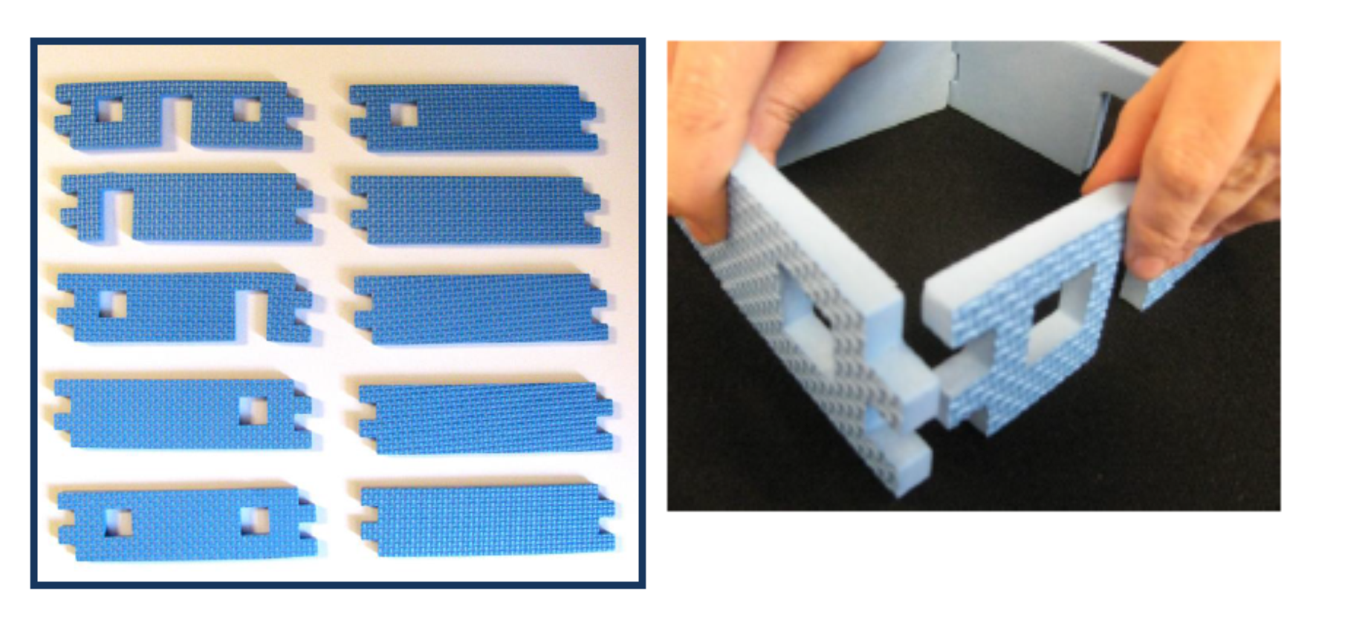
Although the inclusion of a roof to demonstrate top-view perspectives of a room was very helpful, the roofs in three different sizes were not frequently used. The number of roofs also contributed to difficulty closing the outer box lid. Therefore, the number of roofs within the final kit will be trimmed from three to just one. Table 7 provides evaluator ratings for the roof styles.

Table 7
Design Features of Roof Styles
Rating Scale: 5 = Excellent to 1 = Poor
Product Feature | Number of Evaluators | Average Rating | 5 | 4 | 3 | 2 | 1
Assortment of sizes | N = 11 | 4.36 | 73% | 9% | 9% |  | 9%
Color (yellow) | N = 11 | 4.73 | 82% | 9% | 9%
Texture | N = 10 | 4.90 | 90% | 10%
Ease of propping on top of constructed foam walls | N = 10 | 4.90 | 90% | 10%
Storage style | N = 9 | 4.33 | 44% | 44% | 11%

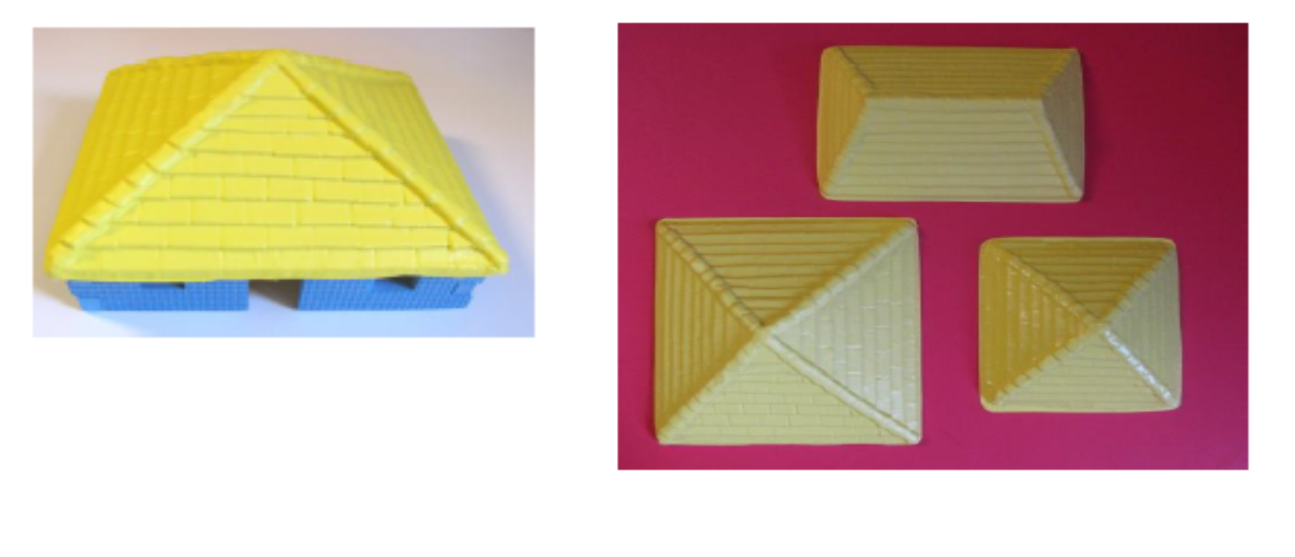
Other unique features of Room with a View received high ratings, including the felt board (4.91) and the template and tutorial (4.63). One evaluator commented that the felt board “worked well with all the pieces in the kit. Having two sides allows the 2D map to be alongside the building space of the 3D map.” With regard to the tutorial, 82% of the field evaluators indicated that this component was helpful in learning how to use the template and that the template itself was a useful component. One evaluator indicated, “This was a very well done tutorial that really seemed to address most issues there could be with the program.” Another teacher noted that the template “is the most flexible piece of the unit and for my older students would be more helpful because they wanted actual room creation capabilities.”

One hundred percent of the field evaluators thought the accompanying Instruction Booklet sufficiently described the purpose and the use of Room with a View; they unanimously liked the layout and design of the booklet as well. Ninety-one percent of the field evaluators described the included “Checklist of Concepts” as a helpful resource. Table 8 shows the degree of usefulness for each chapter section as assessed by the field evaluators.

Table 8
Usefulness of Chapter Sections
N = 11
Chapter Section | Very Helpful | Somewhat Helpful | Not Helpful
List of Materials | 100%
Initial Orientation/Setup | 91% |  | 9%
Focusing on Details | 82% | 18%
Spatial Skills and Concepts Using the 2D Layout | 91% |  | 9%
Spatial Skills and Concepts Using the 3D Layout | 91% | 9%
Change of Perspective | 82% | 18%
Creative Approaches | 82% | 18%
Real Room Experiences | 82% | 18%

Room with a View was favorably received by the students themselves. Evaluators indicated that 100% of the students enjoyed using the prototype. Comments ranged from a short, enthusiastic “Very much!” to lengthier explanations for its positive reception: “They wanted to go through all the pieces and make their own maps,” and “They like making models and seeing how the 2D and 3D representations matched each other. They liked making their own room configurations and describing them to me.” According to 73% of the evaluators, Room with a View increased their students’ interest in reading and constructing maps.

The majority (91%) of the evaluators indicated that Room with a View offered specific advantages over other map-reading products, homemade or commercially available, including
- “The ability to teach perspectives in a tangible way;”
- “More variety of tactile items;”
- “Quick and easy to use;”
- “Very convenient to use and a nice to have accurate furniture pieces;”
- “I never had 2D and 3D maps that matched before and this was very beneficial;”
- “Stronger and better 3D pieces, 2D models, an instructional manual, online tutorial, and nice casing to store it all;”
- “The objects and walls were more interesting than just textures to students.”

Table 9 reveals the field evaluators’ assessment of how effectively Room with a View promoted the development of tactile map-reading skills and concepts.

Table 9
Effectiveness of Room with a View
The purpose of Room with a View is to promote tactile map-reading skills and concepts. Did Room with a View meet this learning objective?
Rating Scale: 7 = Strongly Agree to 1 = Strongly Disagree
N = 10
7  Strongly Agree | 6 | 5 | 4 |  | 3 |  | 2 | 1  Strongly  Disagree
70% | 10% | 20%

Table 10 indicates the evaluator ratings for the product’s usefulness for promoting specific skills and concepts.

Table 10
Skills/Concepts Promoted with Use of Room with a View
Rating Scale: 7 = Extremely well to 1 = Not at all
Skill/Concept | Number of Evaluators | Average Rating | 7 | 6 | 5 | 4 | 3 | 2 |  | 1
Understanding perspective | N = 11 | 6.64 | 73% | 18% | 9%
Understanding spatial skills | N = 11 | 6.36 | 45% | 45% | 9%
Understanding cardinal directions | N = 11 | 6.00 | 55% | 27% |  |  | 18%
Symbolic understanding | N = 11 | 6.50 | 64% | 18%  9% (5.5) | 9%
Transition from 3D to 2D representations | N = 11 | 6.45 | 64% | 27% |  | 9%
Increased interest in constructing tactile maps | N = 11 | 6.09 | 55% | 36% |  |  |  |  | 9%
Interest in pretend play activities | N = 11 | 6.64 | 73% | 18% | 9%

Data collected via 48 Student Outcome Forms also illuminated strides made by individual students. The students’ prior experience with reading tactile maps varied: 25% had no previous experience, 46% had limited experience, 25% had frequent experience, and 4% had extensive experience. The most-witnessed improvements among the student sample related to three skill/concept areas: understanding perspective (73%), symbolic understanding (65%), and increased interest in constructing maps (58%). The degree of interest that the students exhibited during the use of Room with a View ranged from “very interested” (65%) to “somewhat interested” (31%) to “uninterested” (4%). The likelihood of wanting to use the product again in the future was “very likely” for 73% of the students. Specific aspects of the product enjoyed by the students included the following:
- “Loved the pretend play aspect.”
- “Excited that there were actual objects for the things he typically encounters day to day.”
- “Being able to set up and create their classroom.”
- “Really interested in the page of top-view and side-view of objects.”
- “Really liked the Spatial Skills and Concepts questions asked.”
- “Excited to explore the different options for furniture.”
- “Enjoyed building to match the 2D maps and creating a familiar classroom from memory.”
- “Enjoyed creating her own room and talking about how she has similar rooms at home with the same pieces of furniture.”
- “Enjoyed the use of the walls with cutouts representing windows and doors; he felt it made a much better representation than the tactile maps we had used previously.”

One hundred percent of the field evaluators recommended that APH produce Room with a View. Supportive comments regarding its strengths included the following:
- “This is a great product to add to our O&M toolkit.”
- “Absolutely. It is a fantastic conceptual product and idea!”
- “It allows students to create actual environments using actual objects to represent what they find in the real world. This allows them to work on object orientation and relationships between objects that can’t be done in the same way with any other kit I have found.”
- “Engaging for students, flexible uses, ability to customize with 3D template and 3D printing; saves me time in creating materials.”
- “Everything! I really liked this…I think this will be a great addition to APH’s catalog.”
- “Obviously, it is quick to construct a room and the furniture is very true to form and function. I think you thought of everything, with lesson ideas that come with it, the 2D sheets, and the lifelike furniture.”
- “Provides a nice tactile opportunity for students to experience an interior environment, and the various features within it.”

As Table 11 reveals, the most appropriate target populations for Room with a View, as assessed by the 11 field evaluators, are tactile and low vision kindergarteners and students in early elementary grades. A full 91% of the evaluators also noted that tactile readers in Grades 6-8 are an appropriate audience. Use of the product with older students and adults is possible as well. Tactile readers in Grades 3-5 appeared to be the most ideal target population for the product.

Table 11
Appropriate Target Populations
Target Population | Percentage of evaluators  (N =11) indicating appropriateness of product for target population
Preschoolers who are blind | 55%
Preschoolers with low vision | 64%
Low vision students in Grades K-2 | 91%
Tactile readers in Grades K-2 | 91%
Low vision students in Grades 3-5 | 91%
Tactile readers in Grades 3-5 | 100%
Low vision students in Grades 6-8 | 64%
Tactile readers in Grades 6-8 | 91%
High School students with low vision/blindness | 64%
Students with additional physical disabilities | 36%
Students with deafblindness | 64%
Sighted peers | 55%
Adults who are visually impaired/blind | 36%
Low vison adults | 9%
Sighted adults | 18%

Formal field-test feedback was complemented by supportive and enthusiastic comments from conference attendees at the 2017 International AER Orientation & Mobility Conference during the project leader’s presentation titled, “SENSE-able Ways to Build Tactile Literacy Skills.”

In June 2017, the project leader regrouped the PDC members to transition the product to the “tooling stage” and review needed updates based upon feedback and suggestions from field evaluators. The following notable improvements and provisions were anticipated:
- Enhancements to the structure of some 3D pieces. For example, the grocery cart will have a deeper cavity for the basket area, and the school desk will consist of separate tables and chairs (instead of the “old-fashioned” one-piece style).
- Inclusion of new 3D models for a bathroom setting (e.g., toilet, bathtub, and small sink) and end tables
- Provision of 3D models in a variety of colors (in lieu of all white)
- Minimization of number and types of roofs, as well as incorporation of a chimney
- Addition of a “ceiling” to provide tactile/visual separation between room and roof
- Incorporation of an interference fit to hold the linkable foam walls more securely together
- Exaggerated tactile difference between the two human-figurine styles. Figurines will differ in base style, color, arm position, and shirt texture. Note: These models will be included in SPORTS COURTS as well (refer to separate annual report).

Work planned for FY 2018
Project staff will focus exclusively on the tasks to prepare the product for mass production. The “final stretch” of the product continuum will be very involved due to the number and complexity of the included components. However, the success of the various items during the field test will ensure a smoother transition during the final tooling stage. Product specifications will be completed, Quota approval will be requested, and the pilot and initial production runs will be scheduled.

Tactile Graphic Art Tape
(New)

Purpose
To provide an extended collection of graphic art tape in a variety of textures for a myriad of tactile graphic applications by teachers and braille transcribers, as well as by students with visual impairments and blindness

Project Staff
Karen J. Poppe, Tactile Literacy Project Leader

Background
In January 2017, Cindy Queen, Teacher of the Visually Impaired from Kentucky, submitted a formal product submission form that described the need for textured art tape that “could be used for numerous purposes: graphs, charts, art work, underlining (highlighting), graphic organizers, and tactile graphics of all types.” A more diverse assortment of textured tape would complement APH’s existing package of Graphic Art Tape Kit (1-08878-00), which currently offers three widths of black, crepe-textured rolls of commercially-available graphic art tape.

In March 2017, the project leader reviewed the product idea and submitted a formal review of the concept based on several criteria, including the need for the product, originality, appropriate target populations, similarity to existing or planned APH products, and importance when compared to other ongoing projects. The project leader indicated that that the product idea was an oft-repeated request from the field and one revisited over recent years by APH staff to explore possibilities from both purchasing and manufacturing perspectives. This most recent request was the impetus for giving the product possibility more careful consideration. The project leader recommended that APH pursue the development of the product, especially since the demand for the existing Graphic Art Tape Kit has continued to grow in recent years; 1,452 packages sold in FY 2015, and 1,606 packages sold in FY 2016.

To expedite the product through the development stage, the project leader recommended utilizing established textures and production tooling encountered in existing APH products to generate a tactually-robust kit of graphic art tape. She suggested providing adhesive-backed, die-cut strips that are at least 8.5-in. long and a minimum of 0.25 in. wide in a variety of textures (e.g., soft, bumpy, rough); each texture would be available in different colors. Other types of commercially-available textured tape (e.g., glitter tape) could be included with the kit without jeopardizing Quota eligibility. Each type of textured strip could be offered under a different part number to allow repurchasing of specific types of tape based on customer preference.
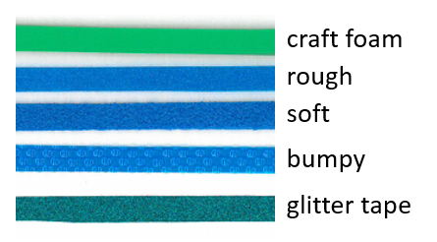

Work during FY 2017
In April 2017, the development and production of Tactile Graphic Art Tape was presented to the Product Evaluation Team; and in May 2017, it was presented to the Product Advisory and Review Committee. Both committees supported active development of this product. The project was assigned grant #688.

Minimal work on this newly-approved product occurred during the fiscal year. However, the project leader accomplished the following:
- The project leader located and ordered glitter tape with adhesive backing from an outside vendor.
- The first Product Development Committee meeting was conducted in late August to review the purpose and expected design of the product with in-house staff from various departments.

Work planned for FY 2018
The primary effort will be on the development and construction of multiple prototypes for field-test purposes. The project leader will seek opportunities to gather guidance from teachers and experts in the field regarding ideal components and design elements. The field-test stage will likely occur during the second quarter of the fiscal year.

Tactile Graphic Line Slate
(Competed)

Purpose
To provide an APH-original slate, in combination with an appropriate stylus, that accommodates the tooling of various types of tactile lines onto a variety of media (e.g., paper, vinyl, drawing film). The tool can be used by teachers, transcribers, and students for preparing graphical displays.

Project Staff
Karen J. Poppe, Tactile Literacy Project Leader
Tom Poppe, Model/Pattern Maker
Andrew Moulton, Manufacturing Specialist
Anthony Slowinski, Guidebook Layout Designer
Rachel White, Research Assistant

Background
The idea of the Tactile Graphic Line Slate was conceptualized by the project leader in 2009. A technical drawing of the product was prepared by the model/pattern maker that illustrated possible line types. Due to higher priority projects, the project leader chose to table the idea for years before formal submission and presentation to in-house committees. Occasionally, the project leader shared the idea with other staff who, in turn, encouraged the development of the tool and described it as innovative and an interesting deviation from typical braille-producing slates.

As conceptualized, the slate would allow tooling of a variety of line types (e.g., narrow solid, wide solid, dashed, dotted, etc.) during the preparation of tactile displays. Ideally, the lines could be drawn onto a variety of media such as standard braille paper, vinyl (e.g., PermaBraille), DRAFTSMAN film, and possibly aluminum foil. Currently available tools to generate quick “line” graphics are limited, complicated, and often produce the same type of line. The slate’s user-friendly design will mimic hinge-style braille slates that have been in use for decades and are familiar to the intended audience.

Following the completion of some major products—for example, Tactile Town and Giant Textured Beads with Pattern Matching Cards—the project leader resurrected the technical drawing of the Tactile Graphic Line Slate and submitted a Product Submission Form in April 2012. In July 2012, the concept was considered and approved for development by both the Product Evaluation Team and Product Advisory and Review Committee. The presentation of the idea was supported by the project leader’s demonstration of actual samples that simulated expected line types and applications onto a variety of media. Possible stylus designs were also shared. The product transitioned to the active timeline by the end of the FY 2012.

Throughout FY 2013, development efforts related to the Tactile Graphic Line Slate were strictly devoted to prototype development. Despite the uniqueness and complexity of the slate’s design, as well as the accompanying stylus, multiple prototypes were quickly generated by the model/pattern maker via a liquid resin casting process. The final prototype design is the outcome of careful fine-tuning of the molded depth of each line type to generate the ideal line height when tooled onto various types of paper and vinyl. Although a clear, transparent version of the slate was originally planned, it became evident during prototype development that a blue, opaque version provided good visual contrast between the slate and white vinyl and paper.

Throughout FY 2014, field test efforts and activities characterized most of the progress on the Tactile Graphic Line Slate. The final prototype can be described concisely as a blue (opaque), hinged slate that measures approximately 12-by-2.5 in. wide to accommodate standard sheet sizes of 8.5-by-11 in. and 11.5-by-11 in. A variety of materials (paper, vinyl, foil, or drawing film) can be sandwiched between the slate’s bottom and top halves; two pins are located on the end opposite the hinge to secure the material while drawing.

With its unique two-ended stylus, the Tactile Graphic Line Slate generates six discernible line types commonly used in the production of tactile graphic materials. With the slate oriented upright with the hinge on the left side, the lines available from top to bottom are:

Large Dotted Line

Small Dotted Line

Wide Solid Line

Dashed Line

Thin Solid Line

Vertical Bar Line

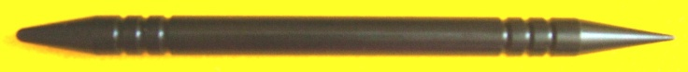

The unbreakable black stylus has two distinguishable tip ends—rounded and pointed. The rounded end of the stylus is used to tool two of the line types (large dotted and wide solid) and the pointed end of the stylus is used to form the remaining four line types. The manner in which the stylus is held will be influenced by the user’s preference and the force required to tool the selected line; more pressure is needed to tool vinyl material as opposed to braille paper, thin film, or heavy-gauge aluminum foil. Some lines (wide and thin solid lines) are drawn with a fluid, gliding motion; other lines (large dotted and small dotted) demand a downward, puncturing style. The dashed line and vertical bar line require a steady stroke to maintain consistent line height and length.
Although the Tactile Graphic Line Slate is best for generating straight tactile lines, it can also be used to make curved lines, as well as hybrid lines by mixing together some of the six line types in various styles (e.g., dot-dash-dot).

A custom-made clear plastic sleeve was created to store and protect the slate and stylus together. A package of PermaBraille—a vinyl type that is particularly conducive to tooling via the slate/stylus—was included with the slate and stylus; sheets of drawing film and standard braille paper were furnished as well. The accompanying instruction booklet was authored and graphically designed by the project leader; photos illustrating proper handling of the stylus and possible graphic outcomes were incorporated. The content on the instruction booklet juxtaposed the advantages and disadvantages of each possible drawing medium.

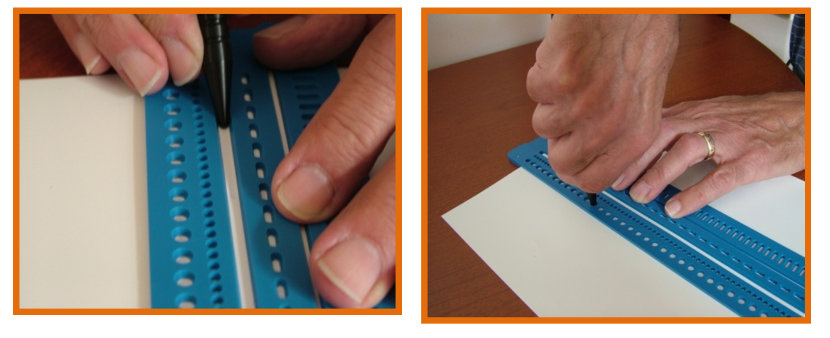
The project leader selected field test sites from a list of those who responded to a field test announcement published in the September online issue of APH News (www.aph.org/advisory/2013adv09.html). Prototypes were mailed to field test sites on October 28, 2013. Evaluators were allowed until the end of January 2014 to use the slate and stylus to prepare tactile graphics of their choosing. Evaluators were expected to complete and return an evaluation form, after which they were allowed to keep the prototype in appreciation for their involvement in the field test endeavor.

In March 2014, the field test stage concluded after the project leader’s preparation of a final field test report, a summary of which follows.

The Tactile Graphic Line Slate was used by a total of 21 evaluators representing the states of Arkansas, Kansas, Ohio (2), Missouri (5), Nebraska, New York (2), Oregon, Texas, South Dakota, and Washington (6). Evaluators included teachers of the visually impaired, braillists/braille transcribers, braille coordinators, orientation and mobility instructors, special education teachers, and sensory impairment specialists. The evaluators’ experience designing tactile graphics varied from 1-5 years to 21 or more years. As shown in Figure 1, the types of educational settings represented by the evaluators varied with over half (53%) as “itinerant” or “itinerant/school-based.”

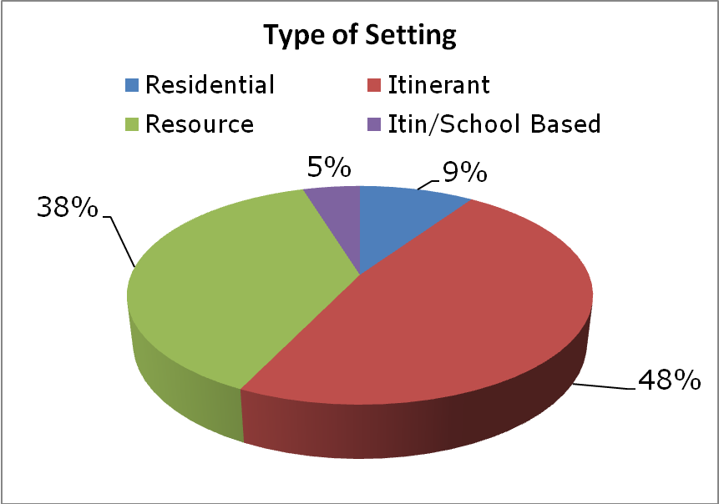
Figure 1. Type of Educational Setting
The field evaluators were well versed in a variety of tactile methods. Collage, serrated spur wheels, and Wikki Stix® were among the most “frequently” or “occasionally” used tools/materials for creating tactile graphic displays. (Refer to Figure 2.)
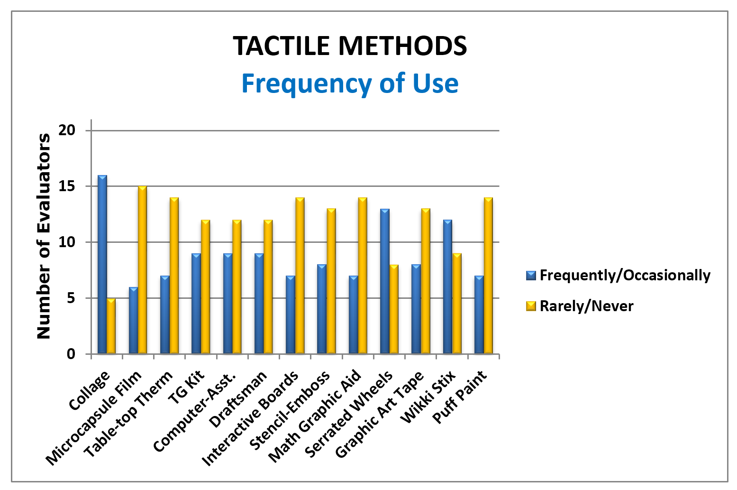
Figure 2. Frequency of Use of Tactile Methods
The types of graphics the field evaluators routinely prepared varied as well, with simple raised lines/shapes the most tooled either “frequently” or “occasionally” by 100% of the evaluators; mathematical displays, science diagrams, and geographical maps were also in demand. (Refer to Figure 3.)
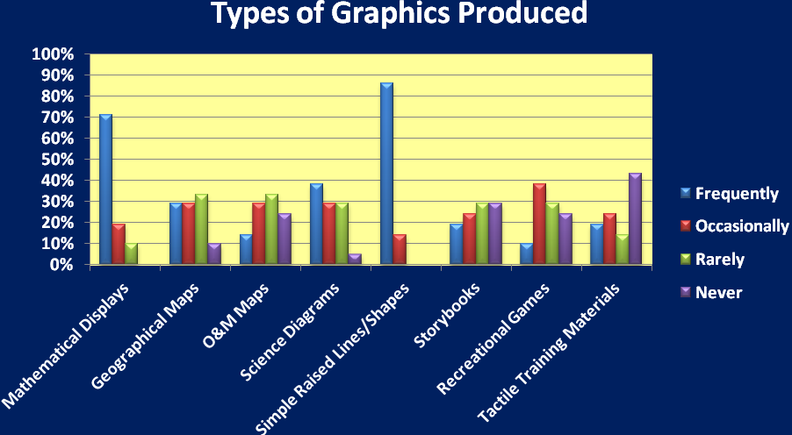
Figure 3. Types of Graphics Produced
The use of tactile graphics routinely produced by the group of field evaluators encompassed a variety of situations:
- 95% indicated that their graphics are typically used by a single student in a classroom setting.
- 43% indicated that their prepared graphics are used by multiple students within a classroom setting.
- 90% plan and create graphics ahead of time for use by students within a classroom setting.
- 81% create spur-of-the-moment graphics based on immediate need of the student(s) within a classroom setting.
- 48% prepare graphics that serve as tactile adaptations to storybooks, games, and so forth.
- 38% of prepare graphics that are inserted/collated into braille textbooks/tests.

The Tactile Graphic Line Slate received consistently high ratings across all evaluated features and components. Table 1 indicates average ratings.

Table 1
Overall Ratings of Tactile Graphic Line Slate
Tactile Graphic Line Slate Feature | Average Rating  (N=21)
Overall Presentation | 4.62
Size/Length | 4.62
Number/Variety of Lines | 4.42
Tactual Differences Between Line Types | 4.67
Color | 4.19
Similarity to Braille Slate Design | 4.62
Ease of Use | 4.43
Accompanying 2-ended Stylus | 4.86
Usefulness w/Variety of Media | 4.52
Possible Uses and Applications | 4.62
Accompanying Instruction Booklet | 4.81

Over 70% of the evaluators gave the highest rating (“5”) to the following features/components: tactual differences between line types, similarity to braille slate design, two-ended stylus, and the accompanying instruction booklet. (Refer to Figure 4.)
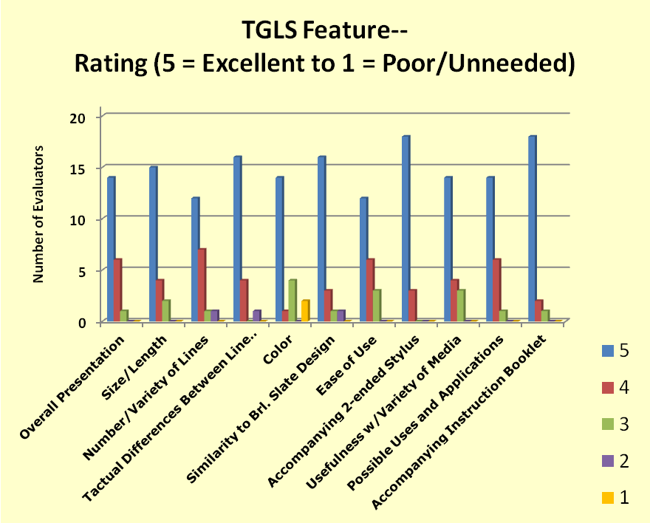

Figure 4. Ratings of Tactile Graphic Line Slate Features

Although (67%) of the evaluators rated the blue color of the line slate a “5,” nearly 30% rated it a “3” or “1.” Those who were dissatisfied with the color suggested making the slate clear/transparent for easier alignment and plotting of tactile elements within a graphic. The results of a follow-up survey with all evaluators echoed a desire for a combined blue and transparent slate; the blue color would continue to provide needed contrast against white paper/vinyl, and transparency would assist in easier positioning of tactile elements.

The evaluators’ use of the Tactile Graphic Line Slate with a variety of materials reinforced the tool’s versatility. Vinyl (APH’s PermaBraille) reportedly generated the best lines across the board. The large and small dotted lines, as well as the dashed and vertical lines, formed well in braille paper. The wide and solid lines took some practice/finesse to minimize tearing of the paper while tooling. Although heavy-gauge foil was only used by three of the evaluators, 100% indicated that all line types formed well on this medium. The DRAFTSMAN drawing film served as a fourth successful tooling option.

Figures 5, 6, 7, and 8 show the reported outcomes of the tooled lines across the four tested media types.
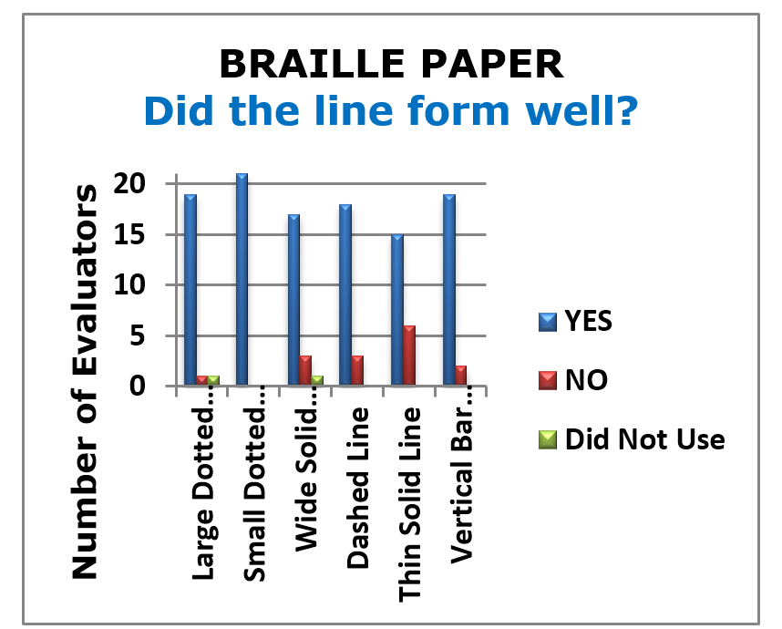
Figure 5. Braille Paper Outcomes

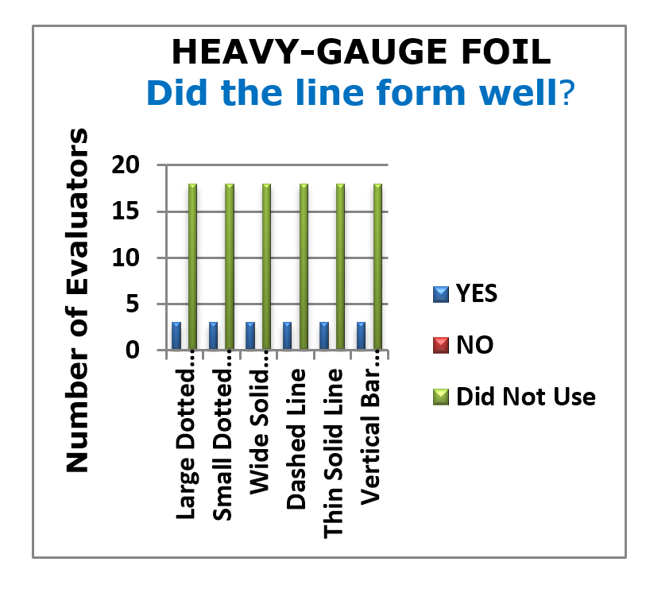
Figure 6. Heavy-Gauge Foil Outcomes

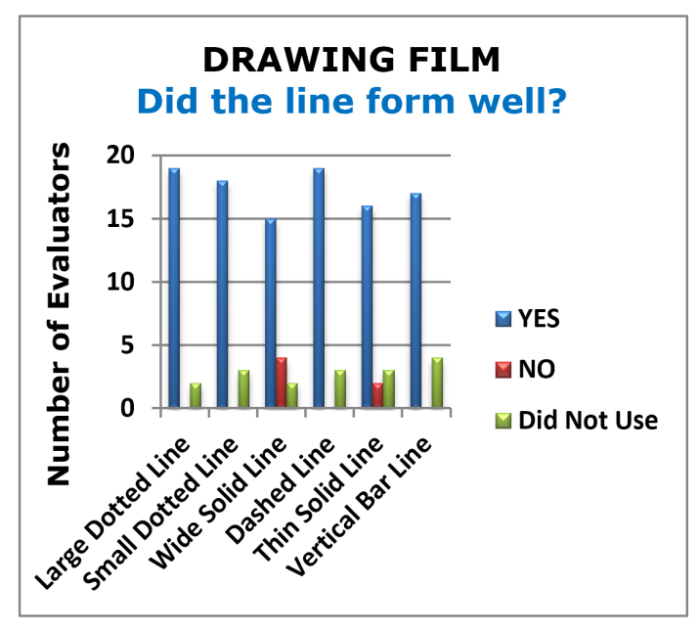
Figure 7. Drawing Film Outcomes

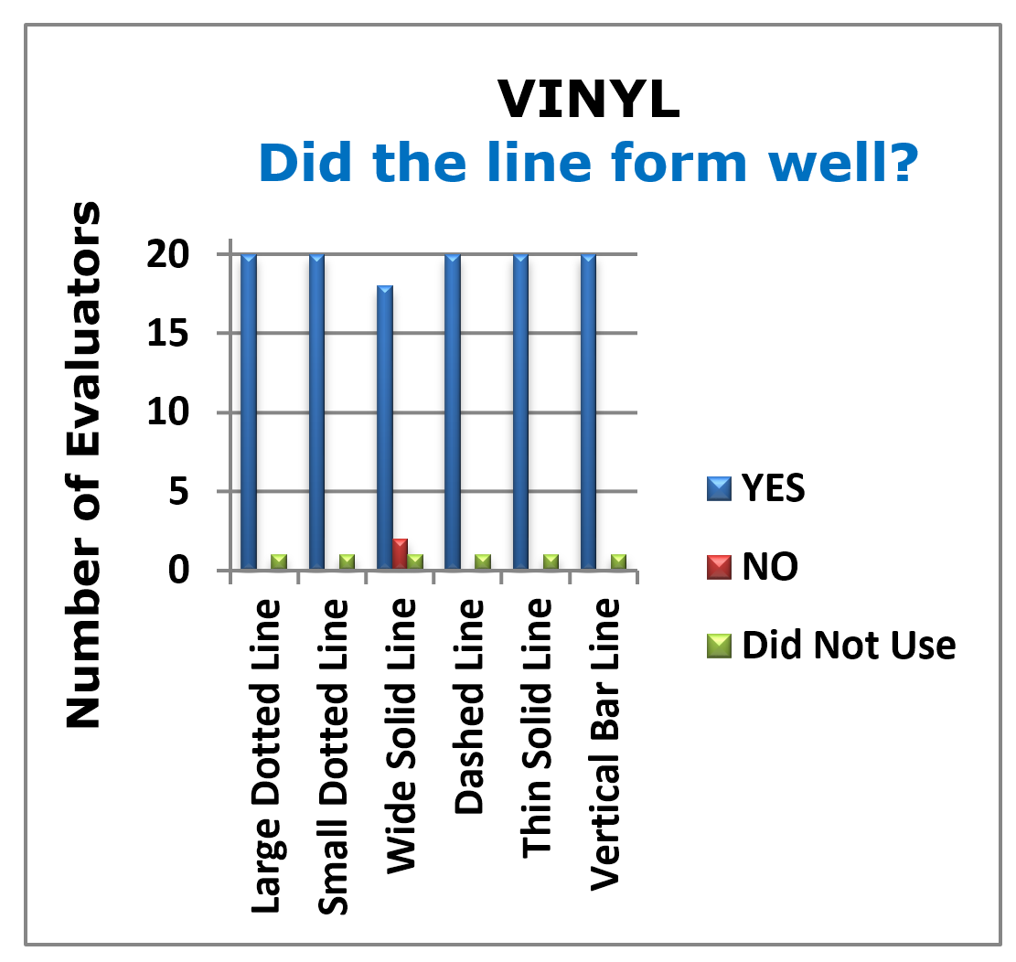
Figure 8. Vinyl Outcomes

All six line types accommodated by the Tactile Graphic Line Slate were used to some extent by the majority of field evaluators. (Refer to Figure 9.) The thin solid line, wide solid line, and dashed line were the most popular. The vertical bar line was reported as unused by 19% of the evaluators.
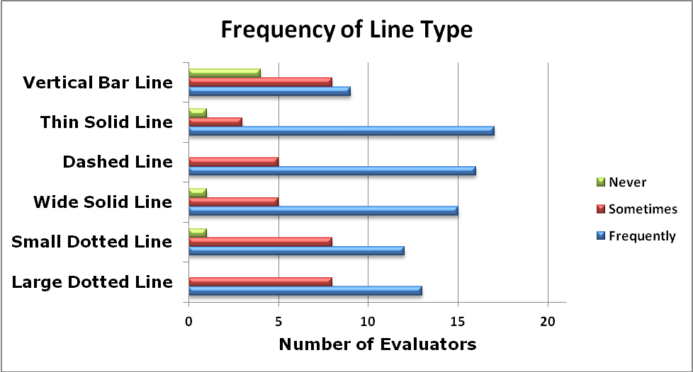
Figure 9. Frequency of Line Type Use
Some evaluators created combination lines with the slate such as a thin solid line with vertical bars for graphs, dash/dot, or repeated sequence of large dot/small dot/small dot.

Evaluators indicated specific advantages of the Tactile Graphic Line Slate over other tactile drawing tools previously used:
- Portable tool with a variety of lines
- “Big improvement over a regular slate because it gives you so many more options to use and produce graphics better and easier.”
- Straighter lines
- Good variety of lines
- Evenly spaced dots/uniformity of dots
- More precise than other tools (e.g., spur wheels, stencils)
- Lightweight but sturdy
- Quick, easy, and fast to use/”accuracy with speed”

Other reported strengths included the following:
- Ease in aligning on a document
- Perfectly measured in accordance with tactile standards/guidelines and typical cell widths
- Two-sided stylus
- Similarity to traditional slate/stylus—shortened learning time
- Can be used alone or with electronically-produced or commercial graphics

Commonly-reported weaknesses were challenges related to creating curved lines, the need for a clear slate for easier positioning of tactile elements, and the tendency to tear braille paper when tooling the wide and thin solid lines. Only one evaluator indicated that the slate needed more line types. With regard to tearing paper, evaluators indicated that this is “a minor weakness and it’s easy to learn to avoid” and “knowing the paper pressure for each line type and stylus point will come with practice and depends on medium.” Evaluators offered new tips/techniques: “Whenever I used the slate with braille paper, I inserted a piece of wax paper between the braille paper and the top hinge. This reduced breakage of the braille paper.”

The 21 field evaluators unanimously recommended that the Tactile Graphic Line Slate be made available from APH. Supportive statements included the following:
- I felt that it was awesome. It was a very useful tool for diagrams from preschool to high school. It really helped out with producing graphics and making it an easier task.
- I have SO enjoyed the Tactile Line Slate. It was an absolute godsend on SO many forms, charts graphs, math sheets, science drawings…the list goes on and on. I will treasure it and the beautiful, FAST drawings it allows me to make for my Braille student. He LOVES tactile information and has also really enjoyed my enhanced tactile materials created with the help of the Tactile Line slate. It’s a wonder! Thanks so much for letting me try this slate!! I love it!!
- This is a nice tool for a collection of tools as well as a nice tool if one is doing a few graphics. I am glad to have one!! The staff who have tried it have assured me they will be borrowing it for future graphics.
- I found with my preschoolers that this tool was great for working on slate and stylus skills and was very motivating for them to use. One 5-year-old student in particular loved to “make art” with this tool.
- This is a wonderful tool! It’s very easy to use and made it a pleasure to produce graphics.
- Familiar shape and style of use to regular stylus and slate made me feel comfortable quickly.
- You are able to use this tool for any grade student—simple drawings for preschool up to complex for Functions, Statistics, and Trigonometry math.

Recommended target populations based upon field test evaluator feedback are listed in Table 2.

Table 2
Appropriate Target Populations
Target Population | Percentage of evaluators who found the Tactile Graphic Line Slate useable by the target population
Braille transcribers/tactile graphic designers | 90%
Teachers of the visually impaired | 100%
Parents of children with visual impairments | 95%
Adults with blindness/visual impairments | 81%
Students who are blind/visually impaired | 86%
Other (indicate): | O&M Instructors

Particularly reassuring was the potential of the Tactile Graphic Line Slate for direct use by students with visual impairments and blindness. Five of the field evaluators observed students independently using the slate to draw lines. The wide solid line and large dotted line were frequently chosen and utilized by the students. One evaluator noted, “My students easily and quickly figured out how to use it.”

Field evaluators returned numerous tactile graphics tooled or embellished with the use of the Tactile Graphic Line Slate. The samples they generated illustrated the diverse use of line types, preferred tactile graphic material, and variety of graphics possible. Applications of the slate included the design of number lines, hour/minute hands on clock faces, O&M maps, flowcharts, counting worksheets, mazes, angles, geometric figures, line graphs, fractions, pie charts, and bar graphs. An evaluator indicated the slate’s myriad uses like so: “We used (the slate) quite often for our first grade braille student. He has a lot of large charts, lists, and page separations. This makes it very easy for him to determine different areas of his work. We have also used it for charting maps with our older students.” An unexpected use noted by another evaluator was its helpfulness in making “raised-line drawings on the vinyl sheets for communication and vocabulary with kids with multiple disabilities to match objects exactly.”

Use of the Tactile Graphic Line Slate during field testing led to the some evaluators envisioning a potential texture and/or point symbol slate for future consideration. Another recommendation by 71% of the field evaluators was a “starter kit” of various materials (braille, paper, vinyl, foil, film) to allow users a chance to test all media with the line slate and see which they prefer. Actual examples from field evaluators are shown below and showcase the variety of media used.

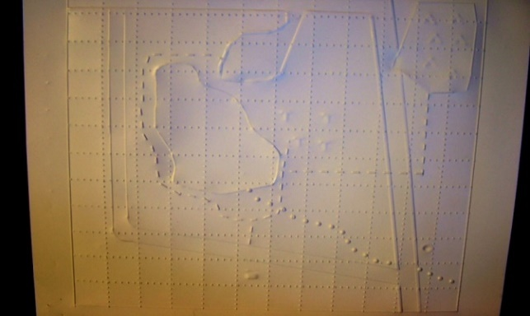

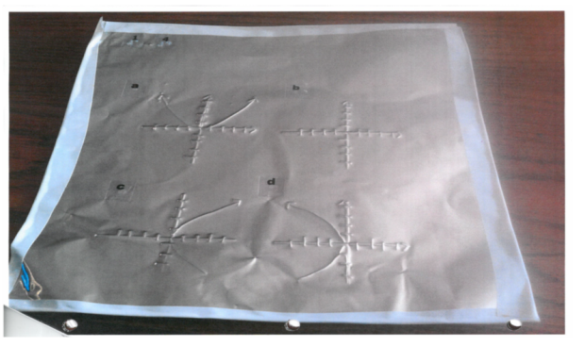
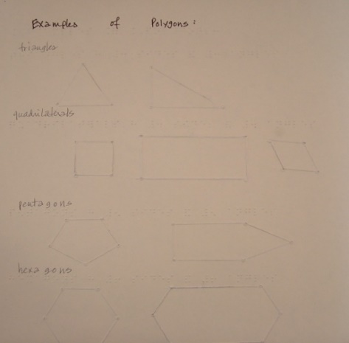

On April 9, 2014, the project leader convened the Product Development Committee to review the field test results. Product revisions and expected production paths were discussed. The project leader located and provided a sample of a transparent, break-resistant blue-tinted plastic that could be matched by the outside vendor during the injection-molding process. A local vendor was contacted to assure the feasibility of producing the desired part at a reasonable cost. The product was presented to the Educational Products and Advisory Committee in May; Quota approval was given. By the end of June 2014, Tom Poppe rendered the technical drawing of the final slate (as well as stylus) design for use by Technical Research staff for preparation of the product specifications, needed CAD drawing(s), and final production.

In FY 2015, the project leader finalized content updates to the product instructions; the updates included reference to the new transparent design of the slate and additional suggestions and usage tips based on feedback from field test evaluators. One hundred percent of the evaluators indicated that the product instructions already provided a helpful overview of the purpose and use of the slate; therefore, content updates were minimal and quick. The final content was provided to the in-house graphic designer for final layout design in early January 2015. By mid-February, the guidebook layout was approved and ready for braille translation. Braille translation, too, was swift with the final page count available by the end of March.

The project leader worked in tandem with Model Shop, Technical Research, Purchasing staff, and the selected vendors to achieve a satisfactory production design of the Tactile Graphic Line Slate, accompanying two-ended stylus, and custom-made storage pouch. A vendor sample of the line slate itself was submitted to APH in late February. Although the first sample closely approximated the intended design, refinements were necessary based on the following assessments:
- The upper and lower leaves of the slate were slightly misaligned.
- Openings of the vertical bar line were nearly out-of-spec with regard to alignment.
- All recesses in the lower leaf of the slate were too shallow, with the exception of the largest dimples that form the large dotted line.
- The left-most incised bar in the vertical bar line was too long.
- Knock-out pins were not flush with the rest of the slate.
- Blue color needed to be slightly less opaque (lighter blue).

In June 2015, a new sample of the line slate was furnished to APH. Most of the aforementioned issues were addressed and corrected. However, slight refinements were still necessary to the depth of some of the incised lines/grooves on the bottom leaf of the slate. The vendor’s enhancement to the color of the slate was approved.

The last quarter of FY 2015 was devoted to final tweaking to the vendor’s tooling for the line slate, as well as the design and approval of the accompanying storage pouch.
Product specifications were presented to Production and Purchasing staff by the end of the fiscal year and pilot/production goal dates were determined.

In the first half of FY 2016, APH awaited actual production samples of the slate, two-ended stylus, and related pouch from outside vendors. The storage pouch was received first and quickly approved in October. However, several rounds of slate samples were received and assessed for proper alignment, closure, and use before approval could be given in February 2016. The Product Specifications were formally presented to Purchasing, Planning, and Production staff on March 31, 2016. A small pilot run of 25 units was scheduled for June, followed by a large full-fledged production run in June.

The original production schedule was impacted by the first shipment of slates, which were showing signs of scissoring between the upper and lower plates. The slates were returned to the vendor and corrected via a two-pin hinge style. Likewise, the first shipment of the two-ended stylus did not meet the original design specifications; the vendor corrected and quickly returned the entire shipment. As of July 2016, production tasks inched closer to completion.

Work during FY 2017
The Tactile Graphic Line Slate (Catalog No. 1-00100-00) was announced as a new APH product in September 2016 with a selling price of $41.00. Post-availability activities continued into the new fiscal year. The project leader first demonstrated the product’s use during an Annual Meeting make-and-take tactile graphic workshop where attendees were given the opportunity to experiment with the slate’s use in combination with a variety of media (e.g., paper, vinyl). The product was also internationally displayed at APH’s product display booth at SightCity Frankfurt in Germany where it received positive feedback; Craig Meador, APH President, reported that one booth visitor mentioned “using it all the time” for tactile graphic design. As of June 2017, 260 units had sold, and the product was on backorder status. Kerry Isham, APH Field Services Representative, created the following Quick Tip Video to highlight the purpose and use of the slate: www.youtube.com/watch?v=gokwM5htV2w&feature=youtu.be

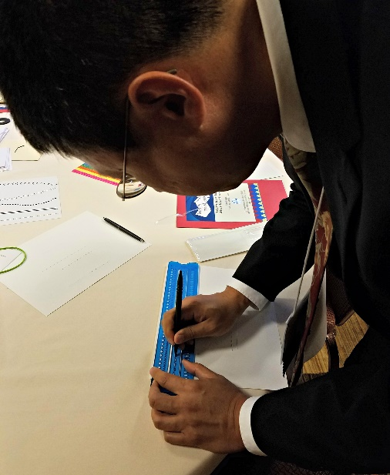

Work planned FY 2018
Formal work on the development and provision of the Tactile Graphic Line Slate is completed. The project leader and other APH staff will continue to demonstrate the slate’s possible uses at future workshops and conferences. The project leader’s hope is that the Tactile Graphic Line Slate becomes a staple, convenient item in the toolboxes of tactile graphics designers, teachers, and students for preparing tactile displays and materials.

Tactile Graphics Research
(Ongoing)

Purpose
To study and develop techniques for making useful tactile graphics, to work toward standards in tactile graphic presentations, and to evaluate product submissions and ideas from the field related to tactile graphics

Project Staff
Karen J. Poppe, Tactile Literacy Project Leader
Fred Otto, Tactile Literacy Project Leader

Background
APH has a variety of means for producing tactile graphics, including embossed paper, puff ink, capsule paper, thermography, vacuum-form, and Roland® UV printer thermoform masters. One goal of this research project is to learn which media are appropriate for which uses. Another goal is to identify and expand the available methods/tools useful for the production of tactile displays, whether by APH or by the individual teacher, transcriber, or student.

In addition, tactile graphic products are frequently submitted by teachers or other professionals who would like to collaborate with APH to produce their materials. Project staff provide written reviews of these submissions. Yet another aspect of this research is to monitor developments in practice, technology, and philosophy as they evolve.

Work during FY 2017
Throughout the year, project staff conducted a variety of tactile graphic workshops and training sessions (both in-house and at national conferences), initiated contacts and gathered input from the field, and proposed new product ideas. Examples of these activities are listed below:

- Reviewed available products or product ideas submitted from the field, such as the following:
    - Don’t Get Creamed
    - Negative Number Stickers
    - Proffitt Prison Braille Tactile Graphic Curriculum
    - Textured Graphic Art Tape
- Submitted product submission forms and/or removed the following products from the PARCing (Product Advisory and Review Committee) Lot. Examples include the following:
- AZER’s Interactive Periodic Table Study Set Modernization
- Flip-Over Concept Books: Make-A-Face
- Mini Roland® UV Printer
- Periodic Table of the Elements Reference Chart and Booklet Modernization
- Slapstack Math iOS® App
- Strike-A-Pose: Body Awareness Cards for Students with Visual Impairments
- Conducted occasional tactile graphic workshops for visiting focus groups, in-house staff, visiting teachers, test developers and administrators, sighted parents and children, and so forth. (See “Presentations” section for a complete listing.)
- Participated in Voice of the Customer, an in-house group comprising staff from several departments seeking closer connections with users of APH products. Among the activities conducted by the group were an online survey about users’ favorite products and a Student Focus group involving Kentucky School for the Blind students of various ages.
- Experimented with new tactile graphic materials/processes
- Constructed the online Tactile Skills Matrix (refer to separate annual report)
- Participated in regular phone meetings of the Diagram Center’s 3D Printing Tactile Standards group
- Posted the following presentation handouts on the APH Web site: www.aph.org/products/tactile-art-products-and-materials/
- Posted several online product surveys to garner feedback about existing APH tactile products (e.g., Carousel of Textures, ALL-IN-ONE Board)
- Oversaw the conversion of production artwork for Sense of Science: ANIMALS and PLANTS modules from silkscreen setups to digitized files for future production runs
- Furnished requested tactile products and materials to other APH staff who were conducting workshops/presentations across the country or internationally
- Provided assistance to APH Development Staff during grant writing activities specific to funding opportunities for new tactile graphic products
- Continued to investigate and analyze the possible use of a white rigid vinyl for possible in-house table-top thermoforming jobs and as a possible replacement for the current Permabraille vinyl.

Work planned for FY 2018
Project staff will continue to monitor advances in technology and practice as they relate to tactile design and teaching, conduct workshops and conference presentations, and work in-house to promote consistently good tactile design.

Tactile Skills Online Matrix
(Ongoing)

Purpose
To provide an online document or “matrix” that cross-references important tactile skills with available APH products

Project Staff
Karen J. Poppe, Tactile Literacy Project Leader
Rachel White, Research Assistant
Ricky Irvine, Website and Video Designer
Scott Blome, Director of Communications Department
Laura Greenwell, Graphic Designer

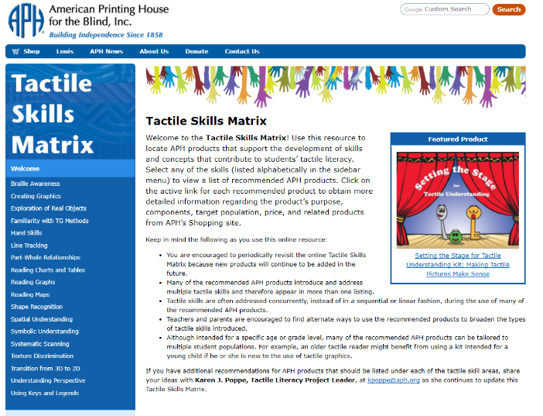
Background
APH frequently receives comments that teachers do not really know about our products or how they can be used in conjunction with others. Just as importantly, APH does not have well-established ways to reach parents to inform them about the need for tactile skills development and what that means for their child or how they can begin to nurture tactile skills development early on. The continuum of tactile skills—such as body and spatial awareness, shape recognition, scanning/tracking ability, perspective understanding, and so on—are known to contribute to successful tactile interpretation. The basic progression needed for tactile learning—from experiences with real objects to models to raised-line images—is well documented and modeled in a variety of APH products (e.g., Setting the Stage for Tactile Understanding). However, students who are tactile learners are likely to be getting piecemeal instruction and are therefore poorly equipped to handle the increasing variety of graphically presented material in textbooks and high-stakes tests.

In October 2010, a sample of a possible Tactile Skills Online Matrix was developed and then presented by the project leader at a Product Input Session during APH’s Annual Meeting. The chart detailed a general progression of identified tactile skills/concepts to support the tactile continuum from exploration of real objects to models to raised-line graphics. The tactile skills/concepts were pictorially cross-referenced with APH products. The project leader explained that the matrix would navigate the user (e.g., parents, teachers, paraprofessionals, etc.) to full product descriptions, a discussion of a specific product’s rationale and methods, or video demonstrations. Theoretically, it would continue to be a live, online document that could be updated with video or written submissions from teachers and parents. The need for this online pictorial and interactive roadmap of tactile skills and related products was echoed by the audience of Ex Officio Trustees and other special guests attending this Annual Meeting session.

In late October 2010, the project leader prepared a Product Submission Form explaining the idea of a prominent link on APH’s Web site that will guide the target audience (teachers, parents, administrators, and paraprofessionals) to a user-friendly, interactive, and accessible chart of tactile skills that promotes a foundation for tactile graphic reading ability and literacy. The product idea was supported by both the Product Evaluation Team and the Product Advisory and Review Committee in January 2011.

The project leader met with staff from the Communications Department who are directly involved in designing and managing APH’s Web site. Early advice was given to the project leader regarding possible visual layouts, as well as considerations for additional features.

The first tactile skill addressed for inclusion in the matrix was “Line Tracking.” In April, the project leader reviewed the APH Product Catalog for products that intentionally taught this skill and identified products that may have exercises/worksheets to foster this same ability. Input from other project leaders, especially those who have worked at APH for many years and are very versed in APH products, was requested. The following list of products (or parts of products) was compiled:
- Flip-Over Concept Books: LINE PATHS
- On the Way to Literacy Books: The Longest Noodle and Bumpy Rolls Away
- Moving Ahead Series: Turtle and Rabbit and Goin’ on a Bear Hunt
- Rolling Into Place
- Web Chase
- Patterns Pre-Braille: First Line Book and Second Line Book
- SQUID: Tactile Activities Magazine – for example, “Stormy Weather” [SQUID Issue 3] and “Mouse Trap” [SQUID Issue 5]
- “Moving On Pages” included in Teaching Touch

The same routine was followed to construct exhaustive lists of products that address the various tactile skills included within the matrix. Thought was also given to alternate approaches to filtering the information onto APH’s Web site in smaller, intermittent amounts—for example, per skill/concept area. Some minimal adjustments to the existing handout chart were made with references to new products and distributed at in-house workshops focusing on tactile graphic instruction and materials.

In 2015, the project leader approached the construction of the Tactile Skills Online Matrix by submitting skill-specific installments for publication in multiple issues of APH’s APH News throughout the year. The first five installments were published in the February, April, March, and August issues:
- Tactile Line Tracking and Discrimination
- Texture Discrimination
- Exploration and Functional Use of Real Objects
- Basic Shape Recognition

Due to extensive work on other products in prototype development and pre-production stages throughout FY 2016, the project leader did not have the time to devote to multiple installments of the Tactile Skills Online Matrix. However, one additional installment was published in the October 2015 APH News. This installment mirrored the format of the previous installments and focused on products that supported the development of spatial skills.

The project leader continued to reference the developing matrix at tactile graphic related workshops and shared hardcopy versions as well. Other project leaders indicated that they used this matrix as a guide during the planning and development of other ongoing tactile literacy products.

Work during FY 2017
In response to frequent clamoring from in-house staff and the field for the Tactile Skills Online Matrix, the project leader abandoned the routine, periodic introduction of new “skill” installments and instead focused on the construction and completion of the entire matrix for immediate posting on APH’s Web site. By mid-October, the project leader had prepared final content for the full construction of the Tactile Skills Online Matrix, having cross-referenced 18 distinct tactile skills/concepts with available and appropriate APH products. The tactile skills/concepts featured in the matrix are the following:
- Braille Awareness
- Creating Graphics
- Exploration of Real Objects
- Familiarity with Tactile Graphic Methods
- Hand Skills
- Line Tracking
- Part-to-Whole Relationships
- Reading Charts and Tables
- Reading Graphs
- Reading Maps
- Shape Recognition
- Spatial Understanding
- Symbolic Understanding
- Systematic Scanning
- Texture Discrimination
- Transition from 3D to 2D
- Understanding Perspective
- Using Keys and Legends

Laura Greenwell designed a decorative border of colorful, overlapping hands to provide an attractive visual design for the online matrix. The tentative look of the Tactile Skills Online Matrix was shared with an Ex Officio Trustee who often championed and supported the creation of this online resource; she indicated that the proposed design for the Tactile Matrix was “colorful and engaging. The list of skill areas are excellent choices. This will be an extremely useful resource for vision teachers and paraprofessionals as they work with our emergent braille readers.”

Ricky Irvine readied the content for online accessibility, maintaining the hyperlinks that navigate the user to additional information on APH’s shopping site. The project leader provided content for a “Welcome” page that described the intended use of the Tactile Skills Online Matrix.

The user merely navigates through the list of skills on the left side of the page and then clicks on the desired skill/concept. This reveals a list of available APH products, such as the ones in this example for “symbolic understanding”: www.aph.org/tactile-skills/symbolic-understanding/

The posting of the Tactile Skills Matrix (as it is concisely referred to) was officially announced in the May 2017 APH News. It is also featured in the “What’s Hot” section of APH’s home page.
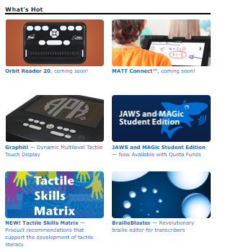

In May, the project leader prepared content for a brochure for the Tactile Skills Online Matrix that could be shared at upcoming conferences/workshops to spread the word about its availability. Kerry Isham, Field Services Representative, also created a Quick Tip video to demonstrate the use of this online resource: www.youtube.com/watch?v=HZPMie4L4ig&feature=youtu.be

Work planned for FY 2018
Although the Tactile Skills Online Matrix is currently available in its entirety on APH’s Web site, the project leader will continue to monitor the introduction of new products and incorporate them into the various tactile skills/concept listings. The project status will remain “ongoing,” with periodic updates throughout the coming years. The project leader will monitor feedback from the field regarding the usefulness of the Tactile Skills Online Matrix and make improvements as needed.

TactileDoodle
Formerly Sketch-A-Doodle
(Continued)

Purpose
To offer an affordable, no-frills drawing surface for producing immediate tactile displays created using the same drawing film offered with the DRAFTSMAN Tactile Drawing Board

Project Staff
Karen J. Poppe, Tactile Literacy Project Leader
Rachel White, Research Assistant
Tom Poppe, Model/Pattern Maker
Patrick White, Model/Pattern Maker
Andrew Moulton, Manufacturing Specialist
Rod Dixon, Manufacturing Specialist
Laura Greenwell, Graphic Artist
Anthony Jones, Art Design/Production Manager
InGrid Design, Photographer

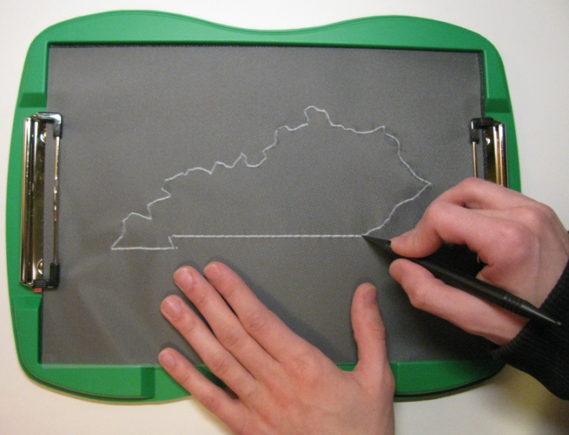

Background
The idea for the Sketch-A-Doodle occurred to the project leader during the development of Color-by-Textures Marking Mats (see separate report). After noticing that the black, underside foam surface of the Color-by-Textures’ nonskid tray provided an ideal drawing pad when combined with the drawing film included with the DRAFTSMAN Tactile Drawing Board (Catalog No. 1-08857-00), the project leader submitted a formal product submission and recommended the development of a significantly less costly drawing board for creating tactile displays. The current cost of the DRAFTSMAN Tactile Drawing Board exceeds $190.00. Although not intended as a substitute for the DRAFTSMAN Tactile Drawing Board, the Sketch-A-Doodle (originally titled “Ready-to-Draw Tray”) will provide an affordable alternative for students to draw their own graphics independently, or for those working with students with visual impairments and blindness.

The product submission form was shared with an expert reviewer who stressed that the “DRAFTSMAN is a wonderful tool for creating quick tactile graphics. However, at a cost of $180, it is hard to justify buying one for each tactile learner. I suspect classrooms share this tool as opposed to having one for each student. There is a definite need for a quick and easy tactile graphic tool…I believe TVIs and families would embrace a more economical solution.”

On January 11, 2016, the product idea for the Sketch-A-Doodle was considered and approved by the Product Evaluation Team who assessed its product development difficulty as “low” and production difficulty as “low.” The estimated yearly volume for the first 3 years is 1,000 units. On February 8, 2016, the Product Advisory and Review Committee reviewed and approved the development of the product. The product transitioned immediately to the active timeline and was assigned the grant number 621.

Prototype design and construction of the Sketch-A-Doodle was swift. Within months after transitioning to the active timeline, the project staff accomplished the following tasks:
- Conducted a Product Development Committee (PDC) meeting to review the expected product design and anticipated production processes
- Identified ideal materials (e.g., 3 mm green rigid foam) for building the drawing board’s outer frame
- Built a vacuum-form pattern to generate the outer frame of the drawing board
- Attached low-profile clips to hold the drawing film onto the board
- Selected a black open-cell sponge rubber to affix within the frame
- Designed a single-tip, short, “chunky” stylus that is easier for smaller hands to grasp
- Authored a brief Instruction Booklet
- Constructed multiple prototypes for field test purposes

A field test announcement was posted in the April 2016 APH News. Approximately 25 teachers expressed interest in participating in the evaluation of the Sketch-A-Doodle. From this sample, 13 field evaluation sites were selected based upon geographic location, number of available students, and type of instructional setting; preference was given to those who had not recently field tested an APH product. Some selected sites allowed multiple teachers to share and evaluate the prototype.

Potential evaluators gave reasons for wishing to field test the Sketch-A-Doodle with their students with visual impairments and blindness; reasons hinted at the product’s usefulness even before formal field testing. Their explanations included the following:
- “A lot of times I need to make something ‘on the fly’ and don’t have time to sit down at a computer to create an embossed tactile graphic.”
- “I am always looking for improvements with tactile drawings for my students and for the students to be able to [draw] their own in the sciences and mathematics.”
- “I can see the Sketch-A-Doodle as a quick way to make on-the-spot maps and also to build environmental and math concepts.”
- “I would like to field test this item to see how it compares to the DRAFTSMAN. Many of my students enjoy using the DRAFTSMAN and I would like to see how it may be different, and if it would be a useful alternative in the art room. I would especially like to see if it is easier to use than the DRAFTSMAN with my younger students and students who have difficulty with their muscle strength.”

Prototypes of the Sketch-A-Doodle and related materials (e.g., styluses, drawing film, and Instruction Booklet) were mailed on April 20, 2016. Evaluators were asked to return their completed evaluation forms and student outcome forms by the June 15, 2016.

Field test evaluation forms were completed by 14 teachers of the visually impaired and blind. One selected evaluator did not complete and return her evaluation form. The field evaluators represented the states of Arkansas, California, Colorado (2), Maine, Michigan, Minnesota (2), North Dakota, New Jersey (2), Pennsylvania, and Washington (2). The largest percentage (71%) of sites represented itinerant settings. Table 1 and Figure 1 show the distribution of field test sites according to type of educational setting and geographical location.

Table 1
Type of Educational Setting
Type of Educational Setting  (N = 14) | State Location of Field Test Sites | Percentage
Residential | AR, CO (2) | 21%
Itinerant | CA, ME, MI, MN (2), ND, NJ (2), PA, WA | 71%
Home school | WA | 7%

Figure 1. Geographical Distribution and Educational Setting of Field Test Sites

Participating field evaluators varied in their teaching experience. The largest percentage (36%) reported 6-10 years teaching experience, 29% reported 11-15 years teaching experience, and 7% reported 16-20 years teaching experience. The percentage of teachers with less than 5 years of teaching experience mirrored the percentage of teachers with more than 21 years of teaching experience—14% within each category.

Most evaluators indicated a prior need to create tactile graphic displays for their students either “frequently” (43%) or “occasionally” (43%); 14% “rarely” or “never” created graphics for reasons such as the following: “Most of my students have braillists working with them on a daily basis. They are the ones making tactile graphics on a consistent basis.”

The majority of evaluators (71%) had previously used APH’s existing DRAFTSMAN Tactile Drawing Board. Repeated complaints revolved around students’ struggles to properly place the drawing film on the board, noting that it was especially “difficult for students with low muscle tone” or younger students. The evaluators were also very familiar with other means of creating tactile displays. Popular materials used were foam stickers, glue, graphic tape, tracing wheels, APH’s Quick-Draw Paper and Picture Maker, as well as specific commercial products—Wikki Stix®, Pictures in a Flash, and Sensational BlackBoard. Many of these tools and materials were also used independently by students.

As shown in Figure 2, field evaluators used the Sketch-A-Doodle with a total of 37 students who represented slightly more males (54%) than females (46%).
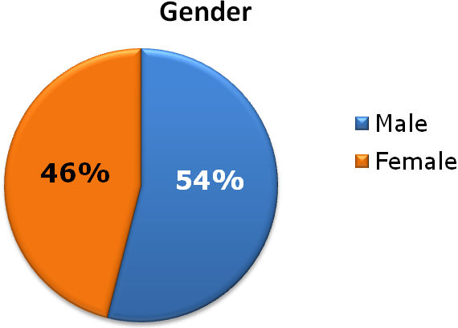
Figure 2. Students’ Gender

As apparent in Figure 3, the sample population represented cultural diversity: 51% White, 8% Asian, 11% Hispanic, 11% American Indian, 5% Black, 8% Two or more races, and 5% Other. Over a quarter (27%) of the students had other disabilities such as cognitive impairment, deafblindness, adjustment disorder, and autism.
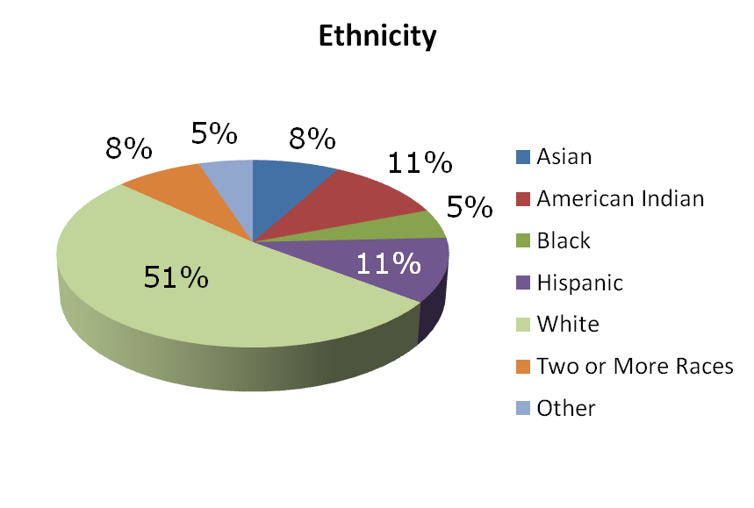
Figure 3. Students’ Ethnicity

Students ranged in age from 5-80 years old. Equal percentages were either 7-9 years old (13%), 16-18 years old (13%), or 39-80 years old (13%). Likewise, identical percentages were either 10-12 years old (22%) or 13-15 years old (22%). The remaining 16% of students were 5-6 years old. (Refer to Figure 4.)
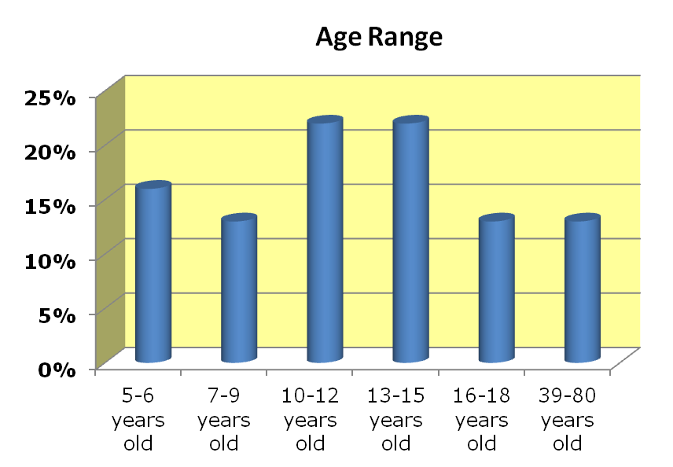
Figure 4. Students’ Age Range

The distribution of students by grade level spanned from kindergarten to college graduate. Nearly equal percentages of the student sample were in Grades K-3 or Grades 4-8—30% and 35%, respectively. Nearly one-fifth (19%) were high school students. The grade level for one student was unreported. (Refer to Figure 5.)
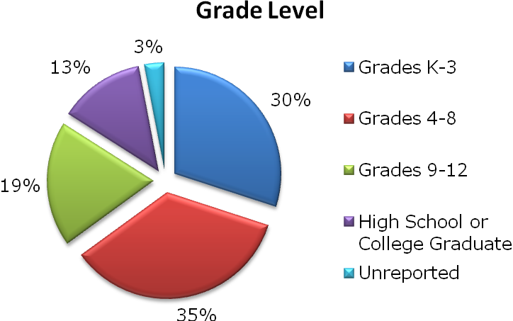
Figure 5. Students’ Grade Level

As evident in Figure 6, over half (51%) of the students were braille readers. Each remaining classification of primary reading medium was represented by 8% or less of the student sample that included large print readers, auditory readers, beginning braille readers, and dual readers. The preferred reading method for one student was unreported.
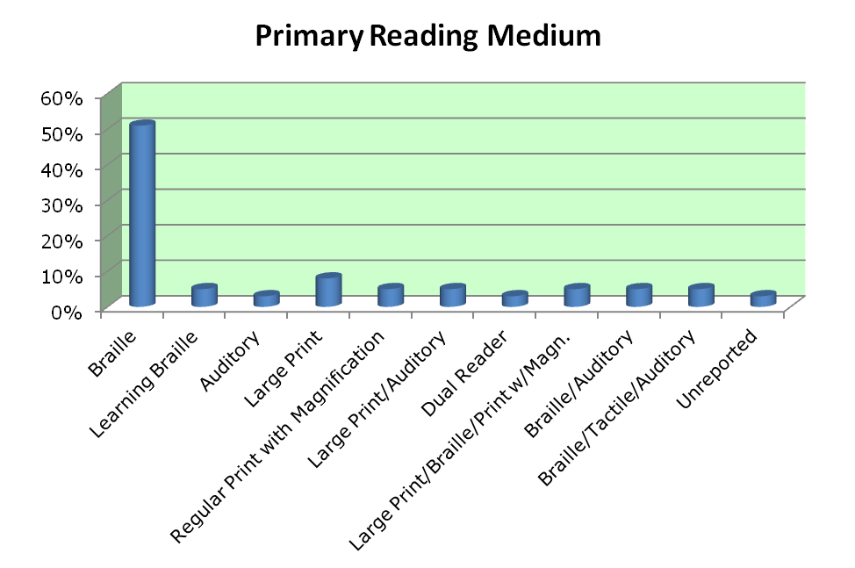
Figure 6. Students’ Primary Reading Medium

The field evaluation form allowed teachers to rate each feature of the Sketch-A-Doodle. Table 2 provides the average rating for each product feature.

Table 2
Overall Design of Sketch-A-Doodle
Product Feature | Number of Evaluators | Average Rating | 5 | 4 | 3 | 2 | 1
Overall look/appearance of product | N = 14 | 4.78 | 79% | 21%
Overall size | N = 14 | 4.57 | 71% | 21% |  | 7%
Color of frame (green) | N = 14 | 4.43 | 57% | 29% | 14%
Color of rubber mat (black) | N = 14 | 5.00 | 100%
Ease of loading drawing film under clips | N = 14 | 3.71 | 43% | 21% | 7% | 21% | 7%
Durability of mat/board | N = 14 | 4.86 | 86% | 14%
Portability/weight | N = 14 | 4.93 | 93% | 7%
Stability provided by rubber feet during drawing tasks | N = 14 | 5.00 | 100%
Quality of tactile lines produced | N = 13 | 3.77 | 30% | 23% | 38% | 8% | 0%
Versatility for various tactile drawing tasks | N = 14 | 4.43 | 57% | 36% |  | 7%

Specific evaluators’ comments related to the features of the Sketch-A-Doodle supported its overall strong ratings; comments included the following:
- “I love the sleek design of the Sketch-A-Doodle.”
- “Lightweight”
- “Very portable”
- “Good size for little hands.”
- “The Sketch-A-Doodle feels very sturdy.”

However, contradictions were encountered in evaluators’ individual assessments of the prototype. For example, some evaluators liked the clips and some didn’t, some liked the quality of tactile lines generated and some didn’t, and some liked the color of the frame and some didn’t. The variance in responses highlighted features for possible improvement for the finished product; features receiving a rating below 4.00 will be addressed.

One hundred percent of field evaluators thought the accompanying Instruction Booklet sufficiently described the purpose and use of the Sketch-A-Doodle. It offered extended uses for creating tactile images (e.g., grids) using the drawing board in combination with off-the-shelf items, such as needlepoint canvas.
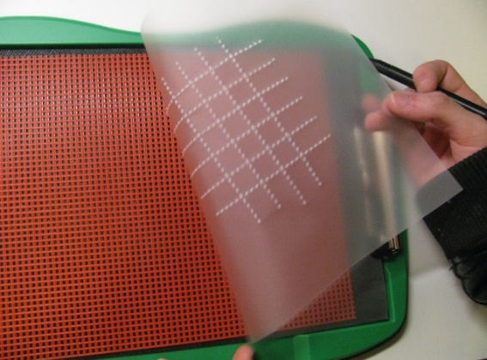

Two types of drawing styluses accompanied the Sketch-A-Doodle—the two-ended stylus included with the DRAFTSMAN, and a noticeably shorter, single-tip stylus. Table 3 shows how frequently each stylus or ballpoint pen was used.

Table 3
Use of Stylus and Drawing Tools in Combination with Sketch-A-Doodle
Stylus/Drawing Tool | Number of Evaluators | Frequently | Occasionally | Never
Two-ended black stylus | N = 14 | 79% | 21%
Short single-tip stylus | N = 14 | 43% | 43% |  | 14%
Ballpoint pen | N = 14 | 21% | 21% |  | 57%

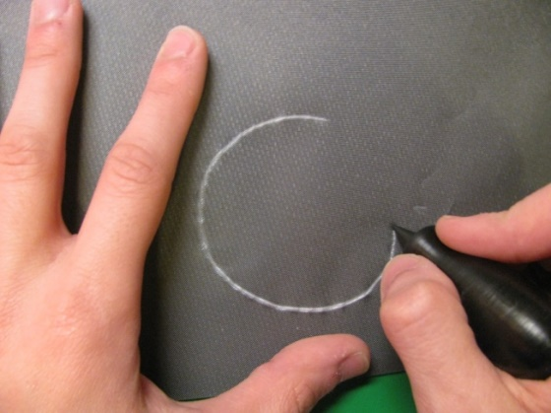

Each stylus type was preferred for different reasons and varied from user to user:
- “Smaller stylus easier to hold and apply pressure.”
- “The short, single-tipped stylus was easier for my student who is a braille user. She is not accustomed to routinely holding/using a pen-style apparatus.”
- “The two-ended black stylus was the most helpful due to ease of the grip and the sharp lines produced.”
- “The advantage with different stylus types was you could make different sized lines.”
- “I liked the big ball end for making landmarks and larger filled in shapes.”
- “Short, single-tipped stylus could be used to make braille dots.”
- “The short stylus has been great with smaller hands, students with CP and other hand-altering issues and students who cannot hold pencils/long stylus/pens and brushes as well.”

Some evaluators/students used other drawing tools such as tracing wheels and a wooden braille eraser.

The Sketch-A-Doodle was favorably received by the students themselves. Evaluators indicated that 100% of the students enjoyed using the drawing board. Supportive comments included the following:
- “Students compared [it] to DRAFTSMAN and found Sketch-A-Doodle easier for circles and curves.”
- “She enjoyed the simplicity of the clips to hold the paper in place.”
- “Students really enjoyed the design. One said, ‘Oh, It’s a clipboard!’”
- “One of my students said it was much easier to draw with; others said the same.”
- “Able to share images faster.”
- “This is so neat to draw and to feel it!”
- “It can be carried around and I can use it if I need to use it while in route as my map.”

Positive statements about the Sketch-A-Doodle’s ease of use were contradicted by expressed frustrations from some teachers and students regarding the clip style. Although the task of loading the film onto the board was easy and intuitive for some students, it posed challenges for others. Some evaluators and students described the clips as “too strong” or “didn’t always hold the film in place.” Younger students and those with fine motor difficulties needed assistance with the clips.

A small percentage (36%) of the field evaluators indicated that the Sketch-A-Doodle was used in the company of sighted peers and family members. Specific comments highlighted sighted peers’ reactions to the board and related tactile drawings:
- “Everyone who tried it enjoyed its different feel and look. Most everyone commented on the black background and great contrast with the film.
- “The kindergarten student’s peers were working on a coloring page when this was introduced. They were all excited that my student was able to do the same task as them.”
- “My students’ sighted classmates were intrigued by the raised lines.”

Sixty-five percent of the evaluators indicated that Sketch-A-Doodle offered specific advantages over other drawing boards or tools for creating tactile graphics: “it’s lighter,” “more streamlined,” “it was ready to go,” “quick, easy, understandable, fun, etc.,” “space and easier to use for a variety of shapes,” and “it’s more convenient for quick tactual displays.” One evaluator also noted a particular advantage over the DRAFTSMAN Tactile Drawing Board: “DRAFTSMAN has harder rubber surface, therefore harder for students/anyone with weak muscles or strength issues of any kind. Sketch-A-Doodle was easier.” More than half (54%) of the evaluators indicated being more impressed and pleased by the Sketch-A-Doodle compared to their original expectations prior to field testing; 23% indicated that its usefulness matched their original expectations; and another 23% indicated being less impressed by its usefulness. An explanation for the latter assessment was disappointment that it didn’t work in combination with regular paper as well as plastic film.

Using a rating scale of 7 = Strongly Agree to 1 = Strongly Disagree, the evaluators gave a combined score of 6.50 when asked to indicate how well Sketch-A-Doodle met its original goal and objective of providing a tool for quickly creating tactile displays for and by students with visual impairments. (Refer to Table 4.)

Table 4
Overall Assessment of Sketch-A-Doodle
Sketch-A-Doodle provided a tool for quickly creating tactile displays for and by students with visual impairments.
N = 14 evaluators
7  Strongly Agree | 6 |  | 5 | 4 | 3 | 2 | 1  Strongly Dis-agree
71% | 14% |  | 7% | 7%
Average Rating
6.50

Evaluators noted a variety of skills and concepts supported by the use of the Sketch-A-Doodle including the following:
- “The Sketch-A-Doodle was helpful for computer math testing.”
- “Spatial awareness”
- “Clocks, handwriting, games, columns/rows, creativity, and tracing”
- “Map making and reading”
- “Braille letters, writing games, drawing shapes”
- “Identifying circles and squares as well as determining amount of pressure to use”
- “Concepts of parallel and perpendicular, square, compass directions, directional corners, and street patterns/layouts”
- “Confirmed information for the student. Made the activity participatory. Concepts = endless!”

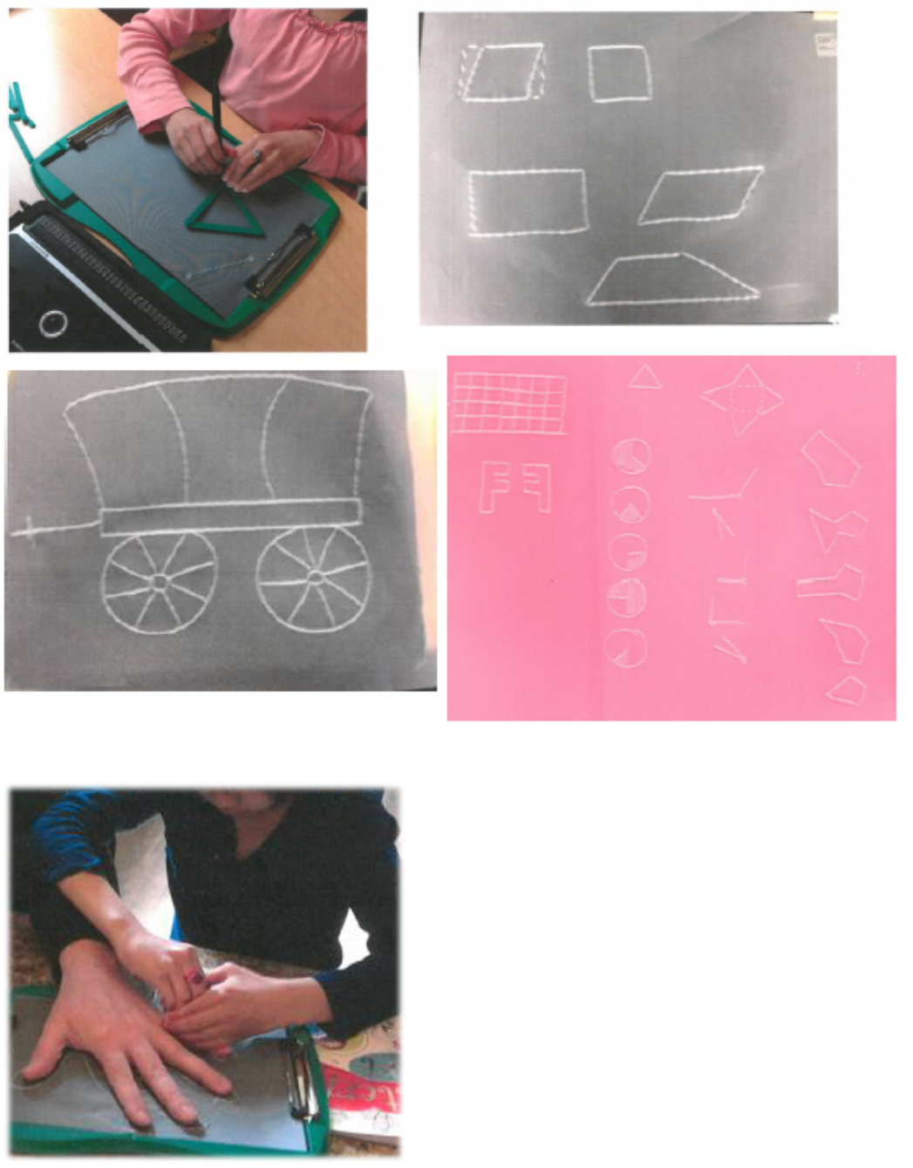

As Table 5 reveals, the most appropriate target populations for the Sketch-A-Doodle as assessed by the 14 field evaluators were preschoolers with blindness, tactile readers in Grades K-8, high school students with low vision and blindness, and adults with blindness.

Table 5
Appropriate Target Populations
Target Population | Percentage of evaluators  (N =14) indicating appropriateness of product for target population
Preschoolers who are blind | 86%
Preschoolers with low vision | 57%
Low vision students in Grades K-3 | 64%
Tactile readers in Grades K-3 | 79%
Low vision students in Grades 4-8 | 57%
Tactile readers in Grades 4-8 | 86%
High school students with low vision and blindness | 93%
Students with additional physical disabilities | 50%
Students with deafblindness | 64%
Sighted peers | 57%
Adults with blindness | 86%
Low vision adults | 7%
Sighted adults | 7%
Other (indicate): | - “Instructors, teachers, employers, etc. Anyone who wants to convey something in a tactile form rather than describing it.”  - “Limitless”

Although not unanimous, the majority (79%) of field evaluators recommended APH produce and make available the Sketch-A-Doodle, 14% were uncertain, and only one teacher indicated “No” because she still preferred the DRAFTSMAN. More than half (67%) of the evaluators indicated a preference for the Sketch-A-Doodle over the DRAFTSMAN, 22% preferred the DRAFTSMAN, and 11% didn’t notice an appreciable difference between the two drawing boards. If the cost of the Sketch-A-Doodle were $80-$100 lower than than the cost of the DRAFTSMAN, 50% of the evaluators would purchase only the Sketch-A-Doodle, 29% would purchase both drawing boards, and 7% would purchase only the DRAFTSMAN; 14% of the evaluators were unfamiliar with the DRAFTSMAN and were therefore unable to make a choice between the two drawing boards.

All of the evalutors thought the final kit should include a Sketch-A-Doodle board, a 25-sheet package of drawing film, the two-ended black stylus, and a print Instruction Booklet; fewer evaluators recommended inclusion of the short single-tip stylus and the a braille Instruction Booklet—79% and 93%, respectively. Several evaluators recommended a different product name (e.g., Sketchman, Tactile Sketch, Tactile Doodle Board, and Make-A-Tactile Board).

On August 16, 2016, the project leader regrouped the PDC to review field test results and determine the final structure of the product. A new product name—TactileDoodle—was selected that was free from copyright infringement. Planned components included the following:
Quantity | Expected Components
1 | TactileDoodle board
1 | 25-sheet package of drawing film
1 | Short single-tip stylus
1 | Instruction Booklet (large print)
1 | Instruction Booklet (braille)
1 | Print Parts List
1 | Braille Parts List

The project leader and Rachel White authored and edited final content for the accompanying Instruction Booklet. Professional layout and design of the booklet was implemented by Laura Greenwell. Photos of additional uses of the drawing board were incorporated into the design.

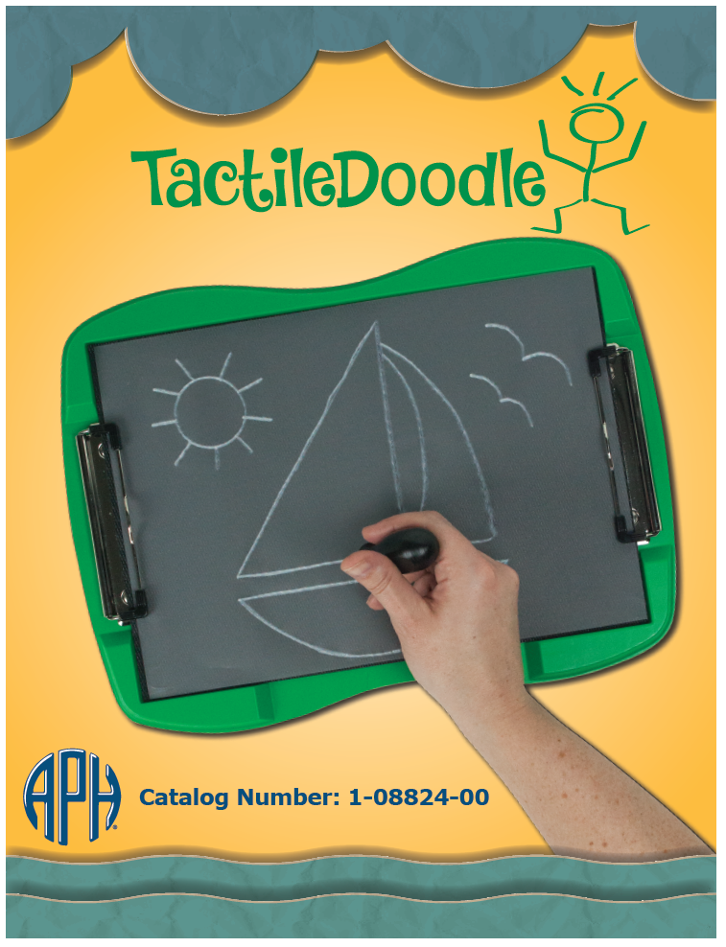

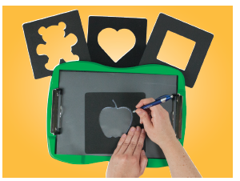

Turnaround time for braille translation of the Instruction Booklet was swift; the braille-ready file was completed by the end of FY 2016.

Work during FY 2017
In October, Quota approval for the TactileDoodle and related single-tip stylus was requested and received from the Educational Products Advisory Committee during Annual Meeting. The project staff undertook remaining tooling tasks to prepare the product for mass production. Prior to his retirement in mid-October, Tom Poppe finalized the majority of the production tooling needed to produce the TactileDoodle. Patrick White then assumed responsibility for the remainder of the tooling; he incorporated embossed typography of the product name into the fiberglass master and added pins to form the equivalent braille text into the frame. Locating fixtures were built as well. By the end of February 2017, all needed production tooling was completed.

Rod Dixon structured the product specifications during the second half of the fiscal year. A Specifications meeting was conducted in September. Production quantities were determined.

Work planned for FY 2018
The project staff will oversee the first pilot and full production run of TactileDoodle to ensure quality of manufactured components, including the short, one-ended Delrin® stylus received from an outside vendor. Actual production of the final product will likely occur before the end of the school year. The project leader will assist with postproduction activities and demonstrate the product at tactile graphic related workshops.

TG TV
(Continued)

Purpose
To create a series of instructional videos that give real-time, specific examples of the thinking that goes into the adaptation of print images into tactile graphics

Project Staff
Fred Otto, Tactile Literacy Project Leader

Background
The previously existing videos related to tactile graphics, from APH and elsewhere, speak either in general terms about philosophy or in specific terms about working with production tools. What was evidently lacking was a discussion of how to adapt a print graphic after deciding what is to be shown—that is, how to convert it into a readable design for a tactile graphic. A video format with actual examples seemed to be an effective way to illustrate good reasoning and good practices.

The project leader experimented with screen-capture programs, which record the onscreen editing of images along with voice-over narration. This is a low-cost, direct technique to use as the foundation of the videos. The same software is used to add music, sound effects, and on-screen text and highlights for a more appealing presentation. The popular screen-capture program Camtasia® was downloaded for trial use and then purchased.

Two videos were produced; one served as an introduction to the series, and the other conveyed content about editing and design decisions. The latter video was screened for APH staff and again for two representatives of the BANA Tactile Graphics Committee to obtain feedback and recommendations.

After lengthy troubleshooting by the Communications Department to resolve the requirements for accessible closed captioning, the first three videos were released for free viewing or download on the APH YouTube™ channel and the APH Web site at this location: www.aph.org/tgtv

Work during FY 2017
No significant work was done on this project during the year.

Work planned for FY 2018
If time and other project priorities permit, one or more new installments of the series will be produced and posted online.

INDEPENDENT LIVING SKILLS

For FY 2017, there are no projects in this category to report.

ORIENTATION AND MOBILITY

Crossings With No Traffic Control: Teaching Concepts and Skills to Deal With Them
(Formerly Concepts and Skills for Crossings with No Traffic Control)
(Continued)

Purpose
To create audio, video, and written materials to help persons with visual impairments learn that it is not necessarily safe to begin a crossing at an uncontrolled intersection when no vehicle is heard

Project Staff
Terrie (Mary T.) Terlau, Adult Life Project Leader
Dona Sauerburger, Consultant
Laura Zierer, Project Leader
William Freeman, Quality Assurance Analyst
Kelly Kennedy Mimms, Research Assistant
Jeremiah Rose, Research Assistant
Leasha Twyman, Research Assistant
Rod Dixon, Manufacturing Specialist
Matthew Poppe, Graphic Design
Intellectyx Inc., Software Developer

Background
Dona Sauerburger, certified orientation and mobility specialist (COMS), has conducted numerous regional and national workshops for other COMS on the topic of teaching students to recognize situations of uncertainty for crossing independently at intersections with no traffic light or stop sign controls. Sauerburger's approach stipulates that if a greater amount of time is required to cross a street than the time during which a student can hear or see the approach of an oncoming vehicle, it is uncertain that the student can cross the street independently and safely. Although Sauerburger's approach has gained acceptance in the O&M field, persons who are no longer O&M students (i.e., adults with visual impairments who completed O&M instruction in the past) have not been taught this life-saving strategy. Sauerburger's Product Idea Submission Form proposes the creation of auditory/visual videos and instructional materials to teach these individuals how to determine such situations of uncertainty and how to develop alternate, safe strategies for managing them.

Preliminary Research
Terlau monitored the reception of Sauerburger's approach in the O&M community on e-mail lists and at numerous regional O&M conferences. Terlau found that Sauerburger's approach to analyzing the level of certainty that an uncontrolled intersection can be crossed safely has gained wide acceptance. Terlau examined Sauerburger's materials on vehicles striking pedestrians with visual impairments and found her conclusion to be sound: Many of these pedestrians were injured or killed because they believed what had been taught since the inception of O&M instruction—"It is safe to cross an uncontrolled intersection when it is quiet, when you can hear no traffic."
Initial Product Development
During FY 2011, the product was accepted for development by APH. Initial discussions about the scope of work between the project leader and Sauerburger were conducted.

During FY 2012, additional discussions were conducted between Sauerburger and the project leader regarding next steps. Sauerburger agreed to submit several videos of intersections she would like to use in the product so that APH staff could determine whether she would need the assistance of a professional videographer or whether her videos were of sufficient quality to be used in the product. Discussion with Larry Skutchan indicated that software could be developed to present video clips and that a software stopwatch necessary for some aspects of the product's functionality could be produced or located.

During FY 2013, additional planning telephone meetings were conducted between Sauerburger and Terlau. Sauerburger submitted draft scripts for the video. It was decided that a professional videographer would record intersections in Louisville, KY, for use in the project under Sauerburger's direction.

Terlau and other attendees at an initial Product Structure Meeting expressed strong concern that students might misunderstand instructions about determining situations of uncertainty and might use information in the video to support dangerous, risk-taking behavior. Terlau and Sauerburger determined that the product should be developed as a teaching tool to be used by orientation and mobility instructors with their students and not as a self-study product for students themselves. Student activities planned originally will be included, but will be packaged as exercises that instructors can use with their students. Additional information on concepts and theory will be provided in the book and video to support instruction in these skills.

During FY 2015, Sauerburger redrafted existing exercises and sections of video text to conform to the new product focus. The draft script for the videos and book has been completed.

Terlau and Sauerburger continued to refine draft text, software requirements, and scripts to be recorded for use in the software. Sauerburger worked with Terlau for one week in Louisville firming up program functions and obtaining traffic videos for use in the product. Terlau and the videographer from InGrid Design conducted four additional traffic video sessions.

Three meetings were held with Larry Skutchan and programmers to discuss feasibility of software requirements. All software requirements were deemed feasible.

Sauerburger completed 10 videos in Maryland for use in the software. Sauerburger created audio and visual clips and created auditory and visual traffic scenarios for use in the software. Terlau prepared a list of product specifications to be submitted for bid.

In FY 2016, with specifications written by Terlau and approved by Larry Skutchan, the RFP was released. Proposal responses to the RFP were received from three companies. Terlau answered questions posed by these respondents and submitted documents requesting clarification or more detail to them. All companies responded to the request for additional information.

Based on an evaluation of initial and updated proposals, Intellectyx Inc. was accepted as the software development company for this product. A contract was provided by Intellectyx. It is anticipated that contract negotiations will be completed and a contract signed before the end of FY 2016.

Terlau refined onscreen and narrated materials for the software and developed clear “if-then” rules for pairing appropriate feedback files with all possible student responses. Material to be recorded was submitted to the studio. It is anticipated that recordings and separation of recorded material into specified small feedback files will be completed before the end of FY 2016.

Work during FY 2017
Upon Terlau’s retirement in September 2016, Zierer took responsibility for overseeing the development and testing of the software. Intellectyx met with Terlau and Zierer in August 2016 to kick-off the project and introduce the team. All finalized text files and logic spreadsheets were handed over to the development team at the completion of this meeting.

Narration files were completed by chapter and delivered to Zierer throughout FY 2017. Zierer, Rose, and Twyman divided chapter content into separate files, which were then passed on to the developers for use in the software.

A new project page was created within a project-management tool shared between APH and Intellectyx. Issues were reported, tracked, and resolved within this system. Progress updates were delivered to Zierer and Freeman through weekly conference calls with the lead developer and project manager. Functionality and accessibility testing were completed in-house for each build delivered from the developers.

Field testing was conducted throughout March, April, and May 2017. Field evaluators were sent a flash drive containing the software and the hardware chosen for the kit (two sets of identical headphones and a Y-splitter).

Nine evaluators participated in the field test. The evaluators were from Illinois (4), Texas, Maryland, Washington, and the New Brunswick province of Canada (2). Evaluators were all O&M Specialists working with school-age children and adults. Participants were selected based on diversity of setting and geography. Testers were queried about the functionality of the software, delivery and organization of the content, and the hardware components supplied with the software. Sequential restrictions were removed, allowing users to move freely about the program. New headphones are being considered for the final product based on field test feedback.

Suggestions were made for improvement:
- “You need to be able to press the buttons to move onto the next one before the reader reads the whole answer every time.”
- “Ex. 5.2 needs a way to advance past instructions/headphones test when you are restarting the exercise.”
- “Need pause option everywhere.”
- “I want to be able to use the hot keys before the reader finishes talking, especially when she is repeating stuff.”
- “The constant review of which keys to press for this exercise becomes tedious and time wasting.”
- “Have control on the speed of the narrator; be able to rewind or forward the narrator.”
- “Instructors need to have at the beginning of each chapter an estimated time of completion. If you want them to use this curriculum, they need to know how much time to schedule with students.”

Zierer also gathered feedback at two sessions of the 2017 AER International O&M Conference where the software demo was presented. Among these, it was suggested that the font be increased throughout the program and a prompt be added to address keypress delay before replaying the scenario.

New features were added into the software to address these concerns.
- Skip Repeat feature was added to allow instructor to decide if student needs to repeat a task that is answered incorrectly.
- Skip Forward feature was added to skip over narration in exercise directions.
- Font will be increased in the final version.
- Prompt will be added in four exercises, which require multiple keypresses.

The estimated time for completion of modules will not be added. This decision is based on the fact that this will vary on student performance.

Work planned for FY 2018
The contract developers have completed high-priority feature addition, and released the source code to APH. In-house developers will address additional features, implement minor text edits, and create an installer for the program. Zierer and Freeman will test the software once these changes are made. Specifications will be finalized once all components are completed, and a specifications meeting will be held. Flash drives will be duplicated by an external vendor. Release is planned for FY 2018.

Echolocation and FlashSonar
(Formerly Echolocation)
(Completed)

Purpose
To create a guidebook to teach persons with visual impairments the use of echolocation to obtain information about surrounding space and environmental features

Project Staff
Terrie (Mary T.) Terlau, Adult Life Project Leader
Daniel Kish, Consultant/Author
Jo Hook, Consultant/Author
Laura Zierer, Research Assistant
Adam Clark, Manufacturing Specialist
Matthew Poppe, Graphic Designer
Anthony D. Jones, Art Production/Design Manager

Background
In the Product Idea Submission Form, Jo Hook proposed to collaborate with Daniel Kish, certified orientation and mobility specialist (COMS) and national orientation and mobility certification (NOMC) on a manual with exercises to teach the use of echolocation techniques. Kish, renowned for both using and teaching echolocation methods, provides content; Hook, noted rehabilitation practitioner and university instructor in the United Kingdom, provides a vision rehabilitation perspective, structure, and writing expertise. Hook and Kish are jointly authoring the book. The manual proposes that echolocation skills can be learned and used by persons with visual impairments to help pinpoint environmental features and move effectively through space. The manual provides exercises to be done with a teacher or instructor or alone to help students build echolocation skills.

Preliminary Research
Terlau reviewed literature on echolocation in humans and its history as an obstacle-avoidance and landmark-location tool for persons who were blind. Terlau also reviewed articles about Daniel Kish's work, including materials showing that spatial areas of the brain became involved when a skilled echo locator listened to a recording of another individual using echolocation techniques. Terlau also attended two presentations in which Kish demonstrated and taught echolocation techniques.

Initial Product Development
During FY 2011, the product was accepted for development by APH. Terlau and Hook began initial discussions regarding scope of work. During FY 2012, APH and the authors continued planning this project.

During FY 2013 and 2014, Hook produced a draft of the first five chapters of the Echolocation book. Terlau edited the first chapter. Kish began reviewing the five draft chapters. During FY 2014, research articles were purchased and provided to Hook per Hook’s request. Hook submitted the draft of Chapter 6. Kish continued editing work on the first six chapters.

During FY 2015, additional research articles were purchased for Hook. Hook and Kish completed the final chapter and proofread the book. The final prototype was received in July 2015. Terlau obtained 10 interested field testers. Terlau and Zierer read and edited the book for grammar and style. Field test materials were prepared.

During FY 2016, field testing was conducted between October 2015 and February 2016. Thirteen orientation and mobility specialists read Echolocation and FlashSonar and tested exercises with 35 students.

The instructor group did not reflect an appropriate gender distribution based on that in the U.S. population. Eleven of the 13 instructors, 85% (11) were female and 15% (2) were male. Because the majority of orientation and mobility instructors in the U.S. are female, results favoring female instructors are fairly representative of the profession. Twenty-three of the 35 students, 66% (13) were male, and 34% (12) were female. This does not reflect the gender distribution in the U.S. However, echolocation research cited in Echolocation and FlashSonar does not indicate gender differences in the ability to learn echolocation skills. This gender disparity is not expected to influence results.

The instructor and student field test groups did not reflect an appropriate geographical distribution. One instructor (8%) was from the Northeast, two instructors (15%) were from the Midwest, five instructors (40%) were from the South, and five instructors (40%) were from the West. Similarly, three students (9%) were from the North, four students (11%) were from the Midwest, 14 students (40%) were from the South, and 14 students (40%) were from the West. Although the North and Midwest regions are under-represented for both instructors and students, this is not expected to impact field test results because the ability to hear sound echoes is not expected to vary in subjects by geographic region.

The instructor group did not reflect the racial/ethnic diversity characteristic of the United States, with 12 (92%) of all instructors being White and one instructor (8%) of all instructors, being African-American. However, the student group did reflect appropriate racial/ethnic diversity. Sixteen students (48%) were White, seven (20%) were Native Hawaiian or Other Pacific Islander, five (14%) were African-American, three (9%) were Asian, three (9%) were from two or more races, and one (3%) had no race/ethnicity noted.

Final changes to Echolocation and FlashSonar were completed in June 2016. Changes resulting from field testing were largely text edits. Approximately half of the testers wanted repetitive material to be omitted, while the other half found it useful. These results were inconclusive. Therefore, repetitive material was not removed. Instructors used beginning and intermediate Echolocation exercises with their students, and reported moderate to very positive results. As a result of these findings, training exercises were not altered except for style edits.

Layout of the print book was completed by in-house graphic designers on July 20, 2016. A clean electronic file and a printout of the final layout of the book were submitted to Braille Translation on August 2, with a formatted braille file of the book to be provided as a free download on the APH Web site.

The project leader, research assistant, and manufacturing specialist met to discuss specifications. The book will be printed backed up with no bleed on 80 pound paper and spiral bound. It was anticipated that the specification meeting would be held before the end of FY 2016.

Work during FY 2017
The print book was made available for sale and the downloadable braille file placed on the APH Web site in January 2017.

O&M Trivia
(New)

Purpose
To provide orientation and mobility trivia questions that can be accessed through voice assistant devices in order to reinforce O&M skills, provide an indoor activity during inclement weather, and promote small group activities

Project Staff
Amy Parker, Project Leader
Laura Zierer, Project Leader
Julie Hapeman, Consultant
Mary Wejrowski, Consultant
Leasha Twyman, Research Assistant

Background
Orientation and mobility skills are imperative for individuals who are blind or visually impaired in order to travel safely and efficiently, allowing greater independence. Teachers and COMS use informal versions of trivia games based on O&M terminology frequently with their students to reinforce these concepts.

A Product Idea Submission Form was completed by Julie Hapeman and Mary Wejrowski in January 2017 (originally submitted under the name Don’t Get Creamed). These O&M professionals designed trivia questions to be used in conjunction with a commercially-available game in their classrooms. The submission was to offer this content along with the game board for O&M instructors to use when reviewing concepts with students. This proposed O&M trivia game comes at a time when APH is exploring the development of audio-based games for voice assistant devices. Parker recommended this content be available through these means.

Work during FY 2017
The product submission was reviewed by two project leaders and approved for development on May 24, 2017. Hapeman and Wejrowski agreed to be consultants for this project. Content development began in July 2017. Trivia questions will be categorized into three levels: Beginner, Intermediate, and Advanced. Question content will be based on different O&M concepts such as compass directions, body/positional awareness, cane techniques, and shapes. The first 125 questions were submitted for review.

Work planned for FY 2018
Content submissions will be reviewed by Zierer and Twyman. Coding for use on voice assistant devices will be handled by Technology Product Research once content has been finalized.

Teaching Street Crossing to Students With Visual Impairments: How to Teach, Not What to Teach
(Formerly Teaching Street Crossings)
(Completed)

Purpose
To provide a guidebook summarizing promising pedagogical methods for teaching street crossings to persons with visual impairments

Project Staff
Terrie (Mary T.) Terlau, Adult Life Project Leader
Tessa McCarthy, Author/Consultant
Rod Dixon, Manufacturing Specialist
Laura Greenwell, Graphic Designer
Monica Vaught-Compton, Project Assistant
Laura Zierer, Project Assistant

Background
Tessa McCarthy, PhD, COMS, (who was Coordinator of the Visual Impairment Program at the University of Nebraska–Lincoln at time of submission) noted in her Product Idea Submission Form that, although techniques for successfully crossing streets by persons with visual impairments are well established, little is known about effectiveness of various pedagogical methods for teaching these techniques. Crossing streets safely is a skill that travelers with visual impairments must master in order to travel independently. If all instructional methodologies are not created equal (i.e., if some result in higher levels of skill mastery than others), it becomes imperative to discover which methodologies produce the best results.

Preliminary Research
McCarthy provided data derived from her doctoral dissertation that demonstrated greater effectiveness of specific instructional methodologies and also conducted a survey of practicing certified orientation and mobility specialists to determine methodologies currently in use.

During FY 2011, a contract was developed and signed by APH and McCarthy. A procedure was developed for provision of funds from APH through the University of Nebraska to Wright for purchase of mailing lists and other project necessities. McCarthy developed a survey to be sent to selected COMS and requested research approval from the Institutional Review Board (IRB) at the University of Nebraska.

During FY 2012, McCarthy obtained research approval from the IRB at her university. She selected research participants via randomization and geographic balance, sent out surveys, and received 27 survey results. Preliminary analysis of results indicated that respondents offered a great deal of useful information. However, because the number of respondents was small, she continued to collect survey data at the Association for the Education and Rehabilitation of the Blind and Visually Impaired conference and elsewhere.

Initial Product Development
Based on her dissertation and survey research, McCarthy proposed the development of a guidebook to point to promising pedagogical practices for teaching street crossings to persons with visual impairments. This guidebook would assist instructors to recognize their pedagogical practices and add new ones to better support student skill acquisition.

During FY 2013, McCarthy completed survey analyses, finding that instructors used a wide variety of instructional methodologies. Her unpublished dissertation, which is the only experimental pedagogical intervention study related to teaching street crossing to students with visual impairments, paired verbal rehearsal with graduated guidance and was very successful in teaching the skills of street crossing. She developed the scope of the book based on findings from this study and strong evidence from related fields. Plans were made for the development of a guidebook suggesting practical methods for teaching street crossing techniques using verbal rehearsal with graduated guidance, practicing these methods with environmental models made from designs offered in the book, and then using this pedagogy for instruction. McCarthy submitted a partial draft of the book during FY 2014.

During FY 2015, McCarthy provided a complete draft of the book, which was edited by Terlau. McCarthy made requested changes, and the book was again edited by Terlau. McCarthy completed a final draft including all new changes requested.

Terlau sought expert reviewers for this book, and Terlau and Zierer prepared expert review evaluation forms.

During FY 2016, the expert review was conducted from October 2015 through January 2016. Reviews were submitted by five nationally renowned orientation and mobility specialists. Reviewers did not reflect diversity characteristic of the U.S. in race/ethnicity or geographic region. All reviewers were White. Three were from the Midwest, one was from the South, and one was from the Northeast. Three were female, and two were male. Reviewers were selected on the basis of expertise in the field, not according to demographics. Reviews are not expected to be influenced by racial/ethnic, regional, or gender variables.

The primary change made as a result of the expert review was the restructuring of the first chapter to better reflect the structure of the rest of the book. Expert reviewers were divided on their evaluations of the need for this book, with the majority noting that orientation and mobility specialists needed exposure to pedagogical strategies as applied to orientation and mobility instruction and the minority noting that such exposure was provided during graduate school orientation and mobility programs. These review results suggest that this book may be most valuable to orientation and mobility specialists who did not experience a pedagogical emphasis in their university program.

The book was laid out by in-house graphic design, with layout being completed in June 2016. The specifications meeting was held on July 13.

A clean electronic file and a printout of the final layout of the book were provided to Braille Translation on August 2. A formatted braille file of the book will be made available to those who purchase the book as a free download from the APH Web site.

Work during FY 2017
The print book was made available for sale and the downloadable braille file placed on the APH Web site in September 2016.

RECREATION AND LEISURE

For FY 2017, there are no projects in this category to report.

SELF-DETERMINATION

V-file
Formerly Personal Vision Portfolio
(Continued)

Purpose
To provide students, teachers, counselors, and parents of visually impaired students a tool to collect, organize, and document pertinent information and materials that will aid in transition from kindergarten through adult life

Project Staff
Jeanette Wicker, Project Leader (Core Curriculum Consultant)
Karen Ross, Project Consultant
Edith Ethridge, Project Consultant
Catherine Johnson, Project Consultant
Jennifer Stocker, Project Consultant
Frank Hayden, Director of Technical & Manufacturing Research
Bryan Rogers, Manufacturing Specialist

Background
Edith Ethridge developed the Personal Vision Portfolio during her tenure as low vision specialist at Kentucky School for the Blind. She used this portfolio with students across Kentucky through the Outreach Program at the school. This portfolio becomes a working file of activities, documents, and resources used by the student and teacher. It is an aid to students through a variety of transitions: from teacher to teacher, middle to high school, from high school to college, and work/adult life. Ethridge retired from her position on July 1, 2006. The popularity and continued demand for the sharing of her work by groups and organizations around the U.S. led to a product submission. In January 2006, the product idea was approved by the Product Evaluation Team and the Product Advisory and Review Committee. Ethridge agreed to serve as a consultant. The initial work of writing and revising the portfolio began.

Work was delayed due to illness of the consultant. She continued to write, revise, and update the text for the teacher’s manual as well as the various forms to be used in the portfolio. The Technical Research Department developed models of the parts of the eye that could be used with a story board as well as patterns for a tactile graphic of the eye. The consultant completed the recording forms for TVIs, parents, and students to use with the portfolio.

In FY 2013, Ethridge continued to write, revise, and update the text for the teacher’s manual as well as the various forms to be used in the portfolio. She was able to use portions of the prototype with students at Kentucky School for the Blind during the school’s Low Vision Clinic. During this process, she identified areas of needed revision.

In FY 2014, work was again delayed due to illness of the consultant and that of her husband. The project leader and the consultant met throughout the year as the consultant’s health permitted. Ethridge continued to write, revise, and update the text for the teacher’s materials.

In FY 2015, Cathy Johnson, retired Outreach Director from Kentucky School for the Blind, agreed to assist in the development and completion of the project. Johnson, Ethridge, and the project leader met regularly throughout the year for writing sessions. The group was able to finalize the first two sections of the teacher’s manual. The project leader and the writing team continued to meet through FY 2016.

Work during FY 2017
Ethridge’s family obligations forced her to resign from the project. Karen Ross signed a contract to become the new consultant for the v-file. Ethridge, Ross, and Wicker met in July 2017 to transition the project materials and plan for the completion of the prototype.

Work planned for FY 2018
The writing team will continue to meet on a regular basis to complete the remaining sections of the teacher’s manual and plan for field evaluation.

SENSORY EFFICIENCY SKILLS

DeafBlind Pocket Communicator
(Continued)

Purpose
To provide a portable, low tech communication tool for use between a consumer who is DeafBlind and another communicator. The speaker talks by guiding the receiver’s fingers over the text to spell out words and sentences.

Project Staff
Susan Sullivan, CVI Project Leader
Amy Parker, Product Development Project Leader
Leasha Twyman, Research Assistant
Laura Zierer, Research Assistant
Frank Hayden, Director of Technical & Manufacturing Research
Andrew Moulton, Manager, Technical & Manufacturing Research
Anthony D. Jones, Art Production/Design Manager

Product Description
The DeafBlind Pocket Communicator (DBPC) is a slim, double-sided, pocket-sized, and no-tech device that displays the braille alphabet embossed beneath the corresponding raised print letters, numbers, and symbols. Intended to be used as a communication card, the speaker "talks" by moving the receiver’s fingers over the letters. It is a conversation tool for the DeafBlind and those who cannot fingerspell, communicating limited braille messages. This device is also suitable for teaching early braille skills.

Background
The project leader received a product submission for creating a product that had been previously made in the United Kingdom, and distributed in the United States through MaxiAids until 2005. The product was called Brailtalk. The product was a pocket-sized (6 inches long, 3 inches across, and ¼ inches high), hinged case that opened to display braille symbols embossed beneath the corresponding raised, high contrast, print letters, numbers zero through nine, “&” sign, and “$” sign. It was used as a communication tool, where the sighted person talked by guiding the fingers of the receiver over the letters communicating questions and answers.

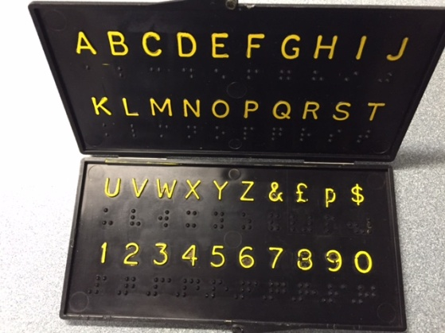

Product submission was made in August 2015, and the product was reviewed in September 2015. It was approved through a PET meeting in October 2015, and PARC in December 2015.

Attempts to verify whether or not the Brailtalk still existed were made via an Internet search; e-mail contact with former distributors both in the UK and United States; a letter to the company who originally made the product; and a search of worldwide databases of patent, trademark, or registered design rights. The product is not traceable, and there is no evidence of it being available for purchase.

Relevance
For many DeafBlind people, having a simple, low-tech tool is beneficial especially when traveling in the community or interacting with members of the public. When a person is DeafBlind, conditions such as bad weather, noisy streets, glare, or poor lighting can make communicating even more challenging. Not everyone is comfortable with using high tech devices and many people aren’t fluent in sign language. For this reason, the DeafBlind Pocket Communicator was created to support efficient communication for both children and adults in a variety of community or educational settings.

Nothing is more important than communication. For individuals who are DeafBlind, having combined vision and hearing loss can create a profound sense of isolation. It is not surprising that having access to reliable tools for communication and connection is a top priority for both children and adults. 3-D printing allows for rapid prototyping to develop and share files with the community who represents a low-incidence market for product sales.

This product will be fully accessible to the population who will use it. The DBPC materials will be available in print, BRF, text file, and HTML to meet APH requirements for accessibility.

Research
The project leader contacted two agencies working with the DeafBlind population: Michelle Cline at Phillip Rock Center in Chicago, IL; Diane Haynes, State Coordinator at the Kentucky DeafBlind Project in Lexington, KY; as well as the product’s submitter Jackie Souhrada, supervisor, Adaptive Skills in Austin, TX, asking about relevance of the product and guidance in what they thought the product should look like and include. All believed that the product was appropriate for those who lost sight or hearing quickly and would need a way to communicate in his community. “If vision and hearing are lost together, quickly, but the person could read the English alphabet, it is a lifesaver for emergency receptive language!” A card that explains how to use the communicator was suggested to be included with the product: English on one side, Spanish on the other. The product would need both raised print letters with high contrast and braille in order to be accessible to both populations. Desire for a downloadable 3-D file available to print the DeafBlind Pocket Communicator in emergency situations was voiced.

Prototypes were made that were similar to the original Brailtalk design. They were pocket-sized (6 inches long, 3 inches across, and 1/4 inches high), with a hinged case that opened to display braille symbols embossed beneath the corresponding raised, high contrast, print letters, numbers zero through nine, “$” sign, “cent” sign, question mark, and yes/no option.

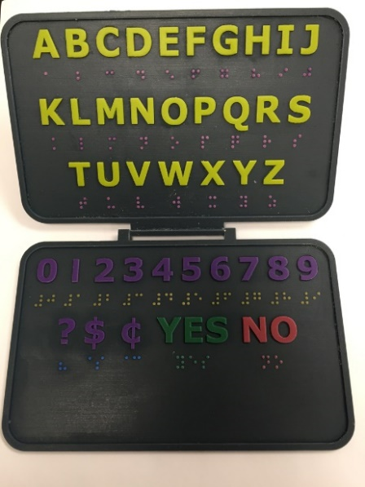

The first review period took place March through April 2017. Expert reviewers reported that the hinge connecting the two surfaces was very fragile. Fifty-seven percent arrived broken, and another broke after only a couple of uses. Additional suggestions included the addition of “@” and period symbols.

The APH team held a Product Development Committee (PDC) meeting to discuss changes to the 3-D file addressing expert reviewer requests. The updated prototype would be printed as a two sided piece, eliminating the need for a hinge, adding “@” and period symbols. A notch in the product’s top right corner would be added to aid in orientation for the hands as well as provide an ideal location to attach a break-away lanyard to allow wearing the communicator increasing freedom for the user’s hands.

The second set of prototypes was sent to expert reviewers in May 2017 with surveys completed by July 2017. Eighty-eight percent shared they found the DBPC to be “just right” in size, with 12% believing it was too big. Eighty-eight percent believed the product had the appropriate contrast in presenting yellow letters, numbers, and symbols. Sixty-three percent reviewed the quality of braille as high, 25% had no opinion, and 12% reported poor quality of braille.

Seventy-five percent of the reviewers found the visual clarity of the font to be high, with 25% having no opinion. Sixty-three percent reported high quality of tactile quality of font, 25% had no opinion, and 12% believed the tactile clarity of font to be poor. One hundred percent believed the new prototype to be very durable and easy to clean.
Sixty-five percent voiced the need for communication cards to accompany the product as an introduction to communication partners or to provide a specific request.
The project leaders acknowledge the helpfulness of this suggestion, but agree that each consumer would need a unique communication card, and agree that a product insert would be packaged with the DBPC guiding to research, resources, and even a template for consumers to create their own communication cards.

One hundred percent of the expert reviewers shared the prototype with colleagues for feedback, reaching over 35 additional professors, resource teachers, interveners, DeafBlind specialists, rehabilitation staff, orientation & mobility instructors, and students. Most consumers used the DBPC to purchase items, take a taxi, or communicate during an O&M lesson. Fifty-seven percent of reviewers reported the usefulness of the product for people who are DeafBlind to be excellent, 29% good, and 14% fair.

When asked if they had access to a 3-D printer for printing their own DBPC, 33% reported yes, 33% reported no, and 33% reported maybe. Reply to being asked if they would prefer to purchase the product from APH or print their own on their 3-D printer, 100% replied that they would prefer to purchase from APH. Project leaders agree that the 3-D file will be available on the APH Tactile Graphic Image Library for quick availability in emergency situations when a consumer needs the product immediately.

Work during FY 2017
Changes were made to the original design and two rounds of expert reviews took place. Survey results were collected in July. A PDC meeting took place in July. Changes were made to the 3-D file per expert review requests. Project leaders created an online resource for the product, placed the 3-D file in the APH Tactile Graphic Image Library, and moved the project toward production.

Work planned for FY 2018
The project leader will send a survey to the field after 6 months of sale to determine customer satisfaction of the DeafBlind Communicator. Results may drive changes to the 3-D file. The project leader will monitor sales and turnaround time for the 3-D printing as this is a new process for producing products.

Let’s Join In [Modernization]
(New)

Purpose
To provide educators of children with multiple sensory impairments a new perspective for inclusion in the educational setting. Dr. Jan van Dijk is working to expand his Child Guided Strategies into the standard education curriculum.

Project Staff
Susan Sullivan, CVI Project Leader
Jan van Dijk, Consultant

Product Description
Assessment guiding intervention will be demonstrated through video case studies of 10-12 students over time. Based on the outcome of the initial assessment, recommendations will be formulated. Discussion will demonstrate how these recommendations can be included in the standard classroom practice. The session and the discussion will be filmed, as well as follow up filming after 6 months to capture how interventions worked.

Background
APH published Child-guided Strategies: The van Dijk Approach to Assessment – For Understanding Children and Youth with Sensory Impairments and Multiple Disabilities, written by Catherine Nelson, Jan van Dijk, Teresa Oster, and Andrea McDonnell, in 2009. Since then, Dr. van Dijk has lectured internationally using the work as the basis of his work. Professionals from the field of visual impairment and blindness have struggled to integrate his work with children learning in inclusive educational settings. Let’s Join In is being developed in collaboration with Dr. Jerry Petroff, Professor at New Jersey College of Education, as well as staff from the Maryland DeafBlind Project and Alabama Institute for Deaf and Blind. Filming and editing is ongoing.

Relevance
There is evidence that for about 1% of the children with multiple sensory impairments, even an adapted form of the standard curriculum is inadequate. Collaboration with the regular classroom teacher, professionals, administration, as well as parents is needed so that the team is working together to utilize the child’s strengths and formulate goals that are important to the child.

Reference: Nelson, C., Van Dijk, J., Oster, T., & McDonnell, A. (2009). Child-guided strategies: The Van Dijk approach to assessment – For understanding children and youth with sensory impairments and multiple disabilities. Louisville, KY: American Printing House for the Blind.

Work during FY 2017
Dr. van Dijk and Dr. Petroff filmed video clips of the children. They are working on an outline to show how others can implement the van Dijk child-guided assessment, how this approach is rooted in other foundational values and practices of effective approaches to assessment (literature review), and how this assessment approach can yield intervention that is critical to teaching the general education curriculum.

Work planned for FY 2018
Filming will be completed with the clips and written materials placed into an eLearning format for access via the Internet.

SLK: Sensory Learning Kit (Revision)
(Continued)

Purpose
To update this successful product using feedback from the field and to add a video component to match its sister product, SAM: Symbols and Meaning

Project Staff
Tristan Pierce, Multiple Disabilities Project Leader
Millie Smith, Consultant/Author
Stacey Chambers, Teacher of Students with Visual Impairments
Monica Vaught-Compton, Project Assistant
Frank Hayden, Director of Technical & Manufacturing Research

Production Description
The Sensory Learning Kit (SLK) is the first of three sequential products that APH offers as an intervention continuum—Sensory Learning Kit, SAM: Symbols and Meaning, and Tactile Connections: Symbols for Communication. The SLK contains two books, three switches, one power control unit, and a variety of manipulatives.

Background
The SLK has been on the market since 2005. During that time, APH has co-hosted numerous training events across the country. Based on input from the field, we have learned additional information, resources, and educational aids that teachers and parents would like to have in the kit. Through field testing SAM, the second product of the continuum, we learned how valuable videos are to the user. We decided to incorporate videos into the revision of the SLK.

In FY 2013, Millie Smith continued to write the guidebook. Smith and the project leader convened in Frisco, TX, in February, April, and May to take photos and direct the filming of five students in three active learning classrooms as they progressed through the Attention, Exploration, and Function zones of the new SLK. In 2014, filming took place at the New Mexico School for the Blind and Visually Impaired. The project remained on hold for the rest of the year because other projects had timeline precedence.

In FY 2015, filming took place in Coppell, TX, in February, March, April, and May to establish a baseline on four students and to then follow them as they progressed through the SLK levels. The project leader and Smith reviewed the videos from Frisco, TX; New Mexico School for the Blind and Visually Impaired; and Coppell, TX, to decide what is usable for the project.

Work during FY 2017
Work on the videos began again in early summer of 2017. Smith, Chambers, and Pierce continued work on an article that they will submit to a peer-review publication.

Work planned for FY 2018
Work will continue on the videos along with editing the product documentation.

Cortical Visual Impairment

Color Raceway
(Continued)

Purpose
To provide a recreational game developed for players with low vision, including those diagnosed with cerebral/cortical visual impairment (CVI), who demonstrate color vision and emerging matching skills. It will target the key characteristics of movement, complexity, and color by engaging players to use their vision while participating in a fun, social activity.

Project Staff
Susan Sullivan, CVI Project Leader
Laura Zierer, Research Assistant
Leasha Twyman, Research Assistant
Frank Hayden, Director of Technical & Manufacturing Research
Andrew Moulton, Manager of Technical & Manufacturing Research
Adam Clark, Manufacturing Specialist
Anthony D. Jones, Art Production/Design Manager
Laura Greenwell, Graphic Designer
Katherine Corcoran, Model/Pattern Maker
Beth Ramella, Consultant

Product Description
Color Speedway is designed to utilize the CVI characteristics of color, movement, and low-to-high complexity, to encourage players to use their vision in a functional and fun way. Up to four players compete by “racing” their cars around the speedway. Players take turns activating the spinner that is color coded with reflective green, yellow, and red. Each player will match the chosen spinner color to the appropriate color card from his set of playing cards, and move his race car: two spaces for “go fast” green, one space for “go slow” yellow, or zero spaces for “stop” red.

Background
From 2009–2011, a group of professionals from the Western Pennsylvania School for Blind Children (WPSBC) participated in a 2-year CVI Mentor training program. As an outcome of their training, professionals developed CVI recreational games and activities. The games are being developed by APH one at a time. Match Sticks was the first game completed and released in 2014. Color Speedway is the next game in development. Beth Ramella, Outreach Director/CVI Project Leader at WPSBC, is the consultant for these products.

Relevance
Recreation and leisure as well as social interaction skills are considered part of the Expanded Core Curriculum for children with visual impairments. Often children who are visually impaired do not experience the same opportunities for recreation and leisure that children with no vision loss have in the early years (Pogrund, 2002).

For turn taking and social interaction to develop, the child must first recognize and understand that there is a surrounding world with people who provide interest (Lueck & Dutton, 2015). Children with CVI need specific, individualized environmental adaptations in order for them to participate. The Color Speedway is being developed to provide ways to make adaptations for each child who plays the game.

It is often difficult for young children who are blind or visually impaired to interact appropriately with their peers. They may not be able to maintain visual attention to toys that their friends are interested in (Fazzi, 2002). Using toy cars for game pieces will promote socialization and inclusion with peers, and siblings.

This product will be fully accessible to the population who will use it. The Color Speedway materials will be available in print, BRF, text file, and HTML to meet APH requirements for accessibility.

References
Fazzi, D. L. (2002). Social focus: Developing social skills and promoting positive interactions. In Pogrund, R. L. & Fazzi, D. L. (Eds.), Early focus: Working with young children who are blind or visually impaired and their families (p. 199). New York, NY: AFB Press.
Lueck, A. H., & Dutton, G. N. (Eds.) (2015). Vision and the brain: Understanding cerebral visual impairment in children. New York, NY: AFB Press.
Pogrund, R. L. (2002). Independence focus: Promoting independence in daily living and recreational skills. In Pogrund, R. L. & Fazzi, D. L. (Eds.), Early focus: Working with young children who are blind or visually impaired and their families (p. 242). New York, NY: AFB Press.

Research
The evaluation period took place January–March 2017. Eight educational sites were selected for the field evaluation. Sites were located in the following states: Connecticut, Florida, Illinois (two sites), Kentucky, Pennsylvania, South Dakota, and Texas. Two of the sites were residential schools, four were public school settings, and two were early intervention home sites. Twenty-nine percent were located in rural areas, and 71% were in suburban settings.

Forty students participated in the field test. Five were braille readers without the diagnosis of CVI. Thirty-nine were diagnosed with CVI. Numerous peers and siblings played the game as well.

Teachers self-reported their experience working with children diagnosed with CVI. Fourteen percent reported little experience, 29% reported moderate experience, and 57% reported lots of experience.

Field testers were asked which characteristics of CVI the Color Raceway addresses. They answered color, movement, visual motor/reaching, distance viewing, and levels of complexity.

The aspects of the game that the students with CVI were most interested in were the spinner, the cars, moving the car around the track, and holding/looking at the color cards for their reflective quality. The students most loved winning, selecting their car, spinning the spinner, and the cars themselves.

Field testers agreed 100% that the game is appropriate for children with visual impairment or blindness other than CVI. “Yes! Nice adaptations for a child with low vision or blindness,” one said in referencing the braille color words on the spinner and the cards, the raised line spaces for the cars, and the braille numbers.

Field testers reported positive comments about the design of the board. “I like that you can add or take away the pieces from the green infield.” Seventy-one percent thought the game board was very durable; 29% said it was durable.

Field testers reported challenges of the game board: “Make board foldable for transportation,” and “Need a case with a handle or some other way of making transportation easier.”

The project leader met with the manufacturing specialists and production to discuss final design changes needed according to field tester comments. The game board will not be able to fold because of the material it is made with, but the team has decided to ship the game in a box with a handle that can be used for transporting.

Work during FY 2017
Field testing was completed. The Product Development Committee meeting was held to discuss any challenges associated with production. Mattel® Hot Wheels® denied the project leader’s request to include their cars in the game kit. The project leader worked with the manufacturing specialist to choose a non-name die cast set of cars for inclusion. The guidebook with photos was completed and sent to graphic design.

Work planned for FY 2018
The specification meeting will be held, and Color Raceway will be on its way to production.

Cortical Visual Impairment (CVI) Projects and Needs
(Ongoing)

Purpose
To assess needs and manage product development to better serve individuals with CVI

Project Staff
Susan Sullivan, CVI Project Leader
Leasha Twyman, Research Assistant

Background
In July 2014, APH hired a full-time CVI Project Leader.

APH’s CVI Web site was completely revamped in 2015 through updates of medical information, current APH products appropriate for the population, parent information, assessments, strategies for expanded core curriculum, orientation & mobility, teaming, literacy, and play, as well as resource links to research articles, books, websites, webinars, tablet apps, social media support groups, and project sharing sites.

Work during FY 2017
In addition to working on product development and updating the CVI Web site, the CVI Project Leader responded to customer service calls and e-mails to support professionals working with children diagnosed with CVI through product recommendations.

The project leader presented a CVI APH Product Showcase to future teachers for the visually impaired (TVIs) visiting APH from University of Kentucky (July), and to the 148th Annual Meeting of the American Printing House for the Blind (October).
Other presentations included the following: Lights Everyone? Light Box materials for collaboration within the general education classroom. American Printing House for the Blind Annual Meeting, Louisville, KY (October); Cerebral/Cortical visual impairment: Resources at your fingertips. Division for Early Childhood’s 32nd Annual International Conference on young children with special needs and their families. Louisville, KY (October); CVI: Controlling the Complexity. Illinois AER Conference, Naperville, IL (February); Academic CVI: Supports for Curriculum Access. Illinois AER Conference, Naperville, IL (February); and Intro to Cerebral/Cortical Visual Impairment (CVI), Opening Doors: Parent-Infant Retreat, Illinois School for the Visually Impaired, Jacksonville, IL (June).

The project leader attended the International Brain Injury Association Conference, New Orleans, LA (March).

Work planned for FY 2018
The CVI Project Leader will continue to work on products recommended by surveys and submissions from the field, and on existing APH products that need to be updated to meet current APH and educational standards.

CVI Book Builder [Modernization]
(Continued)

Purpose
To provide materials for assembling individualized first books for young children diagnosed with cortical visual impairment (CVI)

Project Staff
Susan Sullivan, CVI Project Leader
Laura Zierer, Research Assistant
Frank Hayden, Director of Technical & Manufacturing Research
Andrew Moulton, Manager of Technical & Manufacturing Research
Anthony D. Jones, Art Production/Design Manager

Product Description
The CVI Book Builder provides materials that will allow parents and teachers to build first books appropriate for their reader, by using photos taken of the child’s favorite objects. The kit provides a variety of black pages and black binders to use as low complexity backgrounds against which to present objects, pictures, and letters.
These first books will help to build a bridge between an actual object that the child has experience with and a photo of that exact object, teaching that photos (symbols) have meaning.

Background
The Emergent Literacy Project Leader created Tactile Book Builder for use with children who are blind or have low vision. Field test results from that project showed a desire from the field for more black pages and black binders to be used with children diagnosed with CVI.

The CVI Project Leader submitted this product as a modernization of Tactile Book Builder. It moved through the Product Evaluation Team and then through the Product Advisory and Review Committee.

The CVI Project Leader worked with the original Tactile Book Builder prototype to determine which pages should be included in CVI Book Builder kit. The manufacturing specialist ordered black binders to pair with the black pages for guidebook photos.

Relevance
According to recommendations received at the 2014 Meeting of the Minds, the 2014 APH Annual Meeting and the 2014 APH News CVI Survey, literacy materials for the child with CVI are highly desired. Parents, early interventionists, TVIs, and university faculty are asking for products to use with children in all stages of CVI.

Barclay (2015) noted that understanding the typical development of early literacy is important when assessing whether students with CVI possess the foundational skills necessary for progress in reading. A child must understand that a picture/photograph or letter/word has meaning in order for them to comprehend content in books. Making simple first books will help to build a connection between an actual object that the child has experience with and a photo of that exact object, teaching that photos (symbols) have meaning.

This product will be fully accessible to the population who will use it. The CVI Book Builder materials will be available in print, BRF, text file, and HTML to meet APH requirements for accessibility.

Reference:
Barclay, L. A. (2015). Assessments linked to interventions: Literacy and math. In Lueck, A. H., & Dutton, G. N. (Eds.), Vision and the brain: understanding cerebral visual impairment in children (p. 419). New York, NY: AFB Press.

Work during FY 2017
Staff are waiting on the product specification meeting.

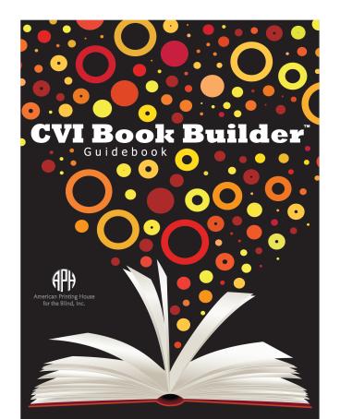

Work planned for FY 2018
The manufacturing specialist will complete product specifications report. The product will be produced and become available for sale.

CVI Practitioner’s Guide
(Discontinued)

Purpose
To provide a comprehensive, but concise framework that will guide selection of assessments, strategies, IEP resources, and teaming tools for appropriate use with the student diagnosed with cerebral/cortical visual impairment (CVI)

Project Staff
Susan Sullivan, CVI Project Leader
Mindy Ely, Consultant
Melody Furze, Consultant
Laura Zierer, Research Assistant

Product Description
The CVI Practitioner’s Guide will be a concise informational handbook providing information on multiple assessments, strategies, IEP resources, and teaming tools with links to the most current information about CVI on APH’s CVI Web site.

Background
The product was presented to the Product Evaluation Team for approval and then sent to the Product Advisory and Review Committee for approval.

Work during FY 2017
Two consultants were hired to contribute content to the project: Mindy Ely, M.S.Ed., Coordinator EL VISTA Project, Illinois State University, Department of Special Education and Melody Zagami Furze, M.S.Ed., Teacher for children with visual impairments, Tacoma Public Schools, Washington State. Writing commenced, but the team came to the conclusion that the only way to keep the information on CVI current would be to make it available electronically. Plans ceased for creating a book; material will be added to the APH CVI Web site.

Work planned for FY 2018
This product has been abandoned due to the team’s decision that the material would be more accessible and available to keep updated by including on the APH CVI Web site.
No further work to be completed on this grant number.

CVI Web site
(Ongoing)

Purpose
To provide a current resource for research articles, books, websites, blogs, strategies, and support for parents, teachers, university faculty, and students as we strive to learn more about cerebral/cortical visual impairment (CVI)

Project Staff
Susan Sullivan, CVI Project Leader
Michael McDonald, Programmer
Leasha Twyman, Research Assistant

Background
CVI Synergy, a group of nine professionals, representing both educational and medical fields, met at APH in May 2002. The group agreed to act as advisors via an electronic mailing list to help APH develop a new website dedicated to CVI. Unable to attend the meeting, Dr. Jim Jan served via telephone and e-mail as the medical advisor.

In 2003, the Multiple Disabilities Project Leader developed an outline for the CVI website and began writing text and requesting submissions from the field. The APH Librarian obtained permissions on articles recommended by CVI Synergy to be placed on the website. Photographs of children using homemade and APH products were taken.

Dr. Jan organized CVI Synergy West in Vancouver, British Columbia, Canada. This second group, also representing educational and medical fields, addressed the issue of definitions associated with CVI. This meeting resulted in the education-based definition and the medical-based definition for CVI that APH used on the initial website.

In 2015 the APH CVI Web site was completely revamped through updates of medical information, current APH products appropriate for this population, parent information, assessments, expanded core curriculum, orientation and mobility, teaming, literacy, and play, as well as resource links to research articles, books, websites, webinars, tablet apps, social media support groups, and project idea sites.

Work during FY 2017
New content including Acquired Brain Injury Vision Loss, Reading after Acquired Brain Injury, Face Blindness, and Hearing Concerns was added. As APH released new products that are appropriate for children with CVI, they were added to the website.

Work planned for FY 2018
The CVI Web site will be monitored for content, format, and accessibility as technology is updated, and more resources about CVI become available.

Increasing Complexity Pegset
(Continued)

Purpose
To provide a product that promotes pairing vision with fine motor skills. The overlays will allow early interventionists and teachers for children with visual impairments (TVIs) to individualize the level of complexity needed for each student.

Project Staff
Susan Sullivan, CVI Project Leader
Laura Zierer, Research Assistant
Frank Hayden, Director of Technical & Manufacturing Research
Andrew Moulton, Manager of Technical & Manufacturing Research
Rod Dixon, Manufacturing Specialist
Anthony D. Jones, Art Production/Design Manager
Laura Greenwell, Graphic Design

Product Description
The Increasing Complexity Pegboard was created for children with visual impairments, including those diagnosed with cerebral/cortical visual impairment (CVI). Paired with diagnostic teaching strategies, the pegboard set helps to determine and support the
child’s color, lighting, movement, and complexity needs. Children diagnosed with CVI frequently have difficulty in understanding objects presented in a complex array. The Increasing Complexity Pegboard provides materials for parents and teachers to create background templates specifically for their learner. The product provides a black pegboard with 25 holes, a variety of black templates with openings for peg placement,
colorful reflective stickers to add increasing degrees of complexity, and hook and loop coins for optional re-use of stickers.

The pegboard can be paired with the APH All-In-One Board, allowing the pegboard to slant at different angles to accommodate student's physical needs.

Background
The project leader submitted the product idea, which moved through the Product Evaluation Team and was approved by Product Advisory and Review Committee in August 2015.

Relevance
Results from the 2014 CVI Survey posted in the APH News showed that 85% of the 46 respondents would find a pegboard with increasing complexity overlays to be useful when working/playing with a student diagnosed with CVI.

Respondents emphasized the value of pegs and pegboard as a tactile and multi-sensory experience. Comments included the following: "Something with a variety of textures and possibly with other sensory feedback for those with DHH issues"; "make sure the pegs are made easy to grasp for those students with fine motor challenges or offer two different types of pegs"; "easy to grip pegs; textured pegs could help the student have a multisensory experience"; and "differing sized pegs for those with OT/fine motor skills (i.e., fat pegs, long pegs, pegs with ridges, etc.)." "I would like it to be easily used by children with physical impairments as many of my students have difficulty using their hands," one respondent commented. Additional important features requested were appropriate colored pegs, light factor, black background, high contrast, and simple to complex pegboard patterns.

The project leader took all comments into consideration when the prototypes were made. The pegs were made 3 inches long with textured ridges to fit into small hands, but still have the bright colors observable. The overlays build complexity from one hole on a black background to a full 25-hole pegboard. Colored stickers will provide an additional way to add more complexity and visual interest.
This product will be fully accessible to the population who will use it. The Increasing Complexity Pegboard materials will be available in print, BRF, text file, and HTML to meet APH requirements for accessibility.

Research
The evaluation period took place February through April 2016. Twelve educational sites were selected for the field evaluation. Sites were located in the following states: Illinois (two sites), Kentucky, Michigan (three sites), New Mexico (two sites), North Carolina, Pennsylvania, Utah, and Washington. Four of the sites were residential schools, and seven were public school settings.

Twenty-seven students participated in the field test. Breakdown of demographics follows:
- Gender: 15 female students, 12 male students
- Chronological age ranged from 4 to 10 years
- Primary reading medium was listed as: Two large print, six regular print, and 19 not yet determined
- Five students were reported to have severe CVI, 13 moderate CVI, and nine mild CVI
- Additional eye conditions: Hyperopia, strabismus, optic atrophy, nystagmus, esotropia, optic nerve hypoplasia, myopia, amlyopia, retinopathy of prematurity, oculocutaneous albinism
- Additional disabilities: Down Syndrome, hypothyroidism, hydrocephaly, cerebral palsy, agenesis of the corpus callosum, seizure disorder, cytomegalovirus, Dandy Walker syndrome, Deaf-Blind, and developmental delays

Field testers were asked if they were able to incorporate the Increasing Complexity Pegboard into IFSP/IEP goals for their students. Specific examples given were: Use colors to touch/pull the different or same colored pegs, color identification, create patterns with colored pegs, to pair look and reach, visual scanning, fixation, remove/replace pegs with high complexity background, shift gaze, grasp pegs, and drop pegs into a container. Many field testers noted that the pegboard was helpful in their student’s play-based functional vision assessment.

Field testers reported the advantages of using the pegboard with their students as follows: tactual interest, easy to grasp, simplicity of design, drawn to bright colors on black background, ability to create the templates according to child’s level of engagement, assessment possibilities, ability to pair with APH All-In-One Board to provide a slant, and place on wheelchair tray.

Field testers reported the disadvantages of using the pegboard with their students as follows: Difficult for student to put the pegs in due to motor ability, make black screens but paint holes yellow, paint base to pop color, need a way to organize the pegs, different colored overlays, pre-made complexity overlays, and need to incorporate light.

The project leader met with the manufacturing specialist to discuss final design changes needed according to field tester comments. Changes included the following:
- Drill the holes all the way through the pegboard. This allows the board to be set on the Light Box. Different colored Light Box overlays can be placed behind the board to provide lighted color cues for peg placement and matching.
- Include a fine motor milestones list to help teachers understand the progression of fine motor skills needed to facilitate play with the pegboard
- Include photos of the pegboard on the All-In-One-Board so that they can see the ability to provide a slant
- Include photos of examples of increasing complexity of the templates from very simple to very complex

Work during FY 2017
Final production specifications were written. A pilot run will be completed in July 2017.

Work planned for FY 2018
The product will become available for sale by December 2017.

Mini-Lite Box Overlays
(Continued)

Purpose
To provide overlays designed to fit the APH Mini-Lite Box. Materials will be created to individualize levels of visual complexity by layering one overlay at a time, accommodating for each child’s needs. Overlays can be used for shape and color identification, initiating and maintaining visual attention, as well as providing additional complexity behind the APH Spinners, APH Swirly Mats, APH Light Box puzzles, APH Pegs and Pegboard, or APH Threading Beads.

Project Staff
Susan Sullivan, CVI Project Leader
Laura Zierer, Research Assistant
Frank Hayden, Director of Technical & Manufacturing Research
Andrew Moulton, Manager of Technical & Manufacturing Research
Adam Clark, Manufacturing Specialist
Anthony D. Jones, Art Production/Design Manager
Laura Greenwell, Graphic Design

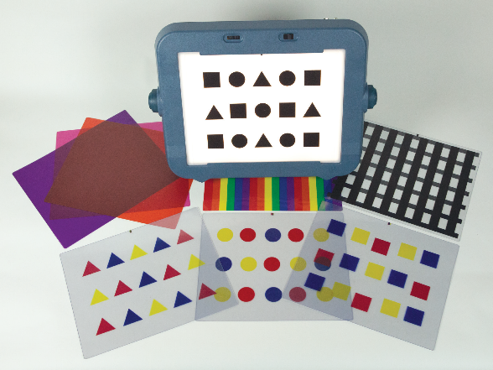

Product Description
The product is a set of overlays, sized to fit the Mini-Lite Box. The set will include patterned overlays including red circles, squares, triangles; blue circles, squares, triangles; yellow circles, squares, triangles; black multi-shapes, black horizontal lines, black vertical lines, rainbow stripes, solid orange, solid pink, solid purple. The overlays may be presented one at a time or layered to provide learning opportunities for color identification, shape matching, counting, visual skills, and for assessing the level of complexity with which a student is able to be successful.

Background
The project leader submitted the product idea, which moved through the Product Evaluation Team and was approved by Product Advisory and Review Committee in August 2015.

Relevance
Early interventionists and teachers for children with visual impairments have requested overlays made to fit the Mini-Lite Box through the APH News CVI Survey conducted in October 2014 and through discussion at an APH presentation at Kentucky AER 2015.

Requests included a variety of levels of complexity, smaller set of visual patterns that fit on the Mini-Lite Box, more solid colored backgrounds (pink, orange), more artwork for the Light Box, and stories that could be presented on the Light Box.
The project leader took all comments into consideration when the prototypes were made. Overlays were designed to build complexity based on student ability. By breaking down the detail of the design, more concepts can be assessed.

This product will be fully accessible to the population who will use it. The Mini-Lite Box Overlays materials will be available in print, BRF, text file, and HTML to meet APH requirements for accessibility.

Research
The evaluation period took place April through June 2016. Eleven educational sites were selected for the field evaluation. Sites were located in the following states: Colorado, Illinois (two sites), Kentucky, Massachusetts (two sites), New Mexico, Oregon, Pennsylvania, Texas, and Utah. Six of the sites were residential schools, and five were public school settings.

Thirteen students participated in the field test. Breakdown of demographics follows:
- Gender: 5 female students, 8 male students
- Chronological age ranged from 1 to 17 years
- Primary reading medium was listed as: 1 large print, 3 regular print, 2 auditory, and 7 not yet determined
- Eye conditions: CVI, hyperopia, astigmatism, optic atrophy, nystagmus, esotropia, optic nerve hypoplasia, myopia, amlyopia, von Hippel-Lindau Syndrome, Pseudopapilledema, hemifield loss, aniridia, exotropia
- Additional disabilities: Fetal Alcohol Syndrome, schizencephaly, leukodystrophy, Chromosome 3P Deletion, plagiocephaly, WAGR Syndrome, Wieacker-Wolff Syndrome, hydrocephaly, cerebral palsy, seizure disorder, and developmental delays

Field testers were asked if they were able to incorporate the Mini-Lite Box Overlays into IFSP/IEP goals for their students. Eleven out of 13 responded yes. Specific examples given were sequencing, maintaining visual attention and focus, and horizontal lines used as a reading guide.

When asked if the Mini-Lite Box Overlays had an impact on the student’s use of the Mini-Lite Box, 13 out of 13 responded yes. Successful interventions included the following: The orange overlay was the student’s preferred color so it drew attention to whatever she put on the Mini-Lite Box for the child to work with, shape identification, and labeling.

Field testers were asked to share impressions of individual overlays
Color | Liked | Neutral | Disliked
Pink | 62.5% | 37.5% | 0%
Purple | 62.5% | 37.5% | 0%
Orange | 75% | 25% | 0%
Rainbow | 75% | 12.5% | 12.5%
Horizontal stripes | 87.5% | 0% | 12.5%
Vertical stripes | 75% | 0% | 25%
Blue shapes | 87.5% | 12.5% | 0%
Red shapes | 100% | 0% | 0%
Yellow shapes | 100% | 0% | 0%

Suggestions for changes or additional light box overlays for future development were as follows: more complexity, grid outlines for object placement, solid color yellow or patterns of yellow, textured overlays, different size shapes on the overlays, story overlays, colors as highly saturated as possible, and make colors more intense.

The project leader met with the manufacturing specialist and graphics production supervisor to discuss final design changes needed according to field tester comments. Changes included the following:
- Make the vertical lines thinner, the same size as the horizontal lines
- Include information for the grid overlay available from another product
- Fix registration issues on the Roland® Flatbed to adjust printing placement of red squares.

Changes were incorporated into the product.

Work during FY 2017
Product guidebook was completed; braille and HTML translations were completed.
Specifications were written by the manufacturing specialist and presented to APH team in June 2017.

Work planned for FY 2018
A pilot run will be completed, and the final product will be available for purchase.

Spinner Overlays for the Light Box
(Completed)

Purpose
To provide a spinning color and pattern light box activity that reinforces the association of vision with movement and function for children and students with cortical visual impairment (CVI)

Project Staff
Rosanne Hoffmann, STEM Project Leader
Susan Sullivan, CVI Project Leader
Denise Snow Wilson, Research Assistant
Frank Hayden, Director of Technical & Manufacturing Research
Rod Dixon, Manufacturing Specialist
Beth Ramella, Consultant

Background
Beth Ramella, Outreach Director at the Western Pennsylvania School for Blind Children, made a set of spinner overlays to use in conjunction with the APH Plexiglas® Spinner and Light Box to augment activities with her own students in previous and current school years. Positive feedback from parents and TVIs inspired Ramella to suggest the development of a product of similar design by APH in May 2013. Although it is a simple idea, ready access to props and activities saves time for both TVIs and parents. The consultant prepared an additional set of overlays for APH that were used by the project leader for development of a prototype set. The collection originally included transparent, colored, patterned, and sparkle-paper spinner overlays to be used as is or modified for a particular child. The entire set provides appropriate and increasingly complex activities for children and students who are diagnosed with profound to resolving CVI. Spinner Overlays for the Light Box entered the product development pipeline in June 2013 after approval from the Product Evaluation Team and the Product Advisory and Review Committee.

The project leaders and the consultant discussed the design of the prototype to prepare for field testing. Each prototype set included pre-cut transparent plastic overlays in red, blue, green, yellow and clear; six pre-cut overlays with different colored patterns; and pre-cut red, blue, green, and yellow sparkle and holographic paper overlays. Stickers in various shapes and colors were also included for modification of any of the spinners. Eight supplemental cards, each with one of the eight different target images used in the patterned overlays, completed the set to be used to assist in visual recognition of a target. The consultant provided a draft guidebook with information about CVI and instructions for use of the product.

Photos of the prototype were taken in September 2014 in preparation for field testing. In October 2014, the product name was changed from CVI Spinners for the Light Box to Spinner Overlays for the Light Box, which more accurately describes the product; this name change was approved by both the consultant and the APH CVI Project Leader. Ten sets of prototype materials (including spinner overlays, supplemental cards, and pre-cut stickers) and evaluation documents were sent out for field testing by late November 2014. Field test sites were solicited via the online APH News; final choices covered a wide US geographic area. Evaluations were returned by the end of February 2015 and discussed with the CVI Project Leader in March. Several changes recommended by field reviewers were agreed upon: increasing the number of red and yellow transparent overlays from two to five per kit, making the yellow transparent overlay a bit darker, adding two orange transparent overlays to each kit, and separating the patterned overlays with respect to target image size or color (e.g., the green shamrock overlay was redesigned to two overlays, one with small green shamrocks and one with large green shamrocks). All other aspects of the product remained the same.

Spinner Overlays for the Light Box received Quota approval in May 2015 during the spring meeting of Ex Officio Trustees at APH. In June 2015, the final guidebook text and photographs were submitted to graphic design for layout. Silkscreen tooling began for the updated versions of the patterned overlays. The original sparkle overlays in four colors were replaced with the same color plastic overlays vacuum-formed with a textured pattern after concern was expressed by members of the APH Production Department about stray “sparkles” in the hands of small learners using the product, even under supervision.

All tooling, including layout of the print Spinner Overlays for the Light Box Guidebook, was completed in March 2016. Accessible versions of the guidebook in BRF and HTML format were prepared for free download from the APH Web site with purchase of the product. A specifications meeting took place in May 2016, and a pilot run of 50 units took place in December 2016.

Work during FY 2017
Spinner Overlays for the Light Box became available for sale on March 9, 2017. The project leaders provided guidance in writing the product brochure and an APH Quick Tips video explaining the use of the overlays immediately after release.

Work planned for FY 2018
No further work on this product is planned.

Visual Organization Toolbox
(New)

Purpose
To provide a toolbox of materials on hand to allow specialists a variety of supports, determine what is useful, and then be able to order that specific tool

Project Staff
Susan Sullivan, CVI Project Leader
Leasha Twyman, Research Assistant
Frank Hayden, Director of Technical & Manufacturing Research
Andrew Moulton, Manager of Technical & Manufacturing Research
Adam Clark, Manufacturing Specialist
Anthony D. Jones, Art Production/Design Manager
Laura Greenwell, Graphic Designer

Product Description
This product will be a collection of APH products and future products that will be used to determine which types of assists are helpful for specific learners with low vision and/or neurological visual impairment.

Background
Product was submitted in October 2016, passed through the Product Evaluation Team in January 2017, and the Product Advisory and Review Committee in February 2017.

Relevance
Learners with brain based visual impairments including Cerebral/Cortical Visual Impairment (CVI), Traumatic Brain Injury (TBI) and Acquired Brain Injury (ABI) often have difficulty accessing complex visual tasks. They need tools to help them simplify complexity by organizing visual input.

The aging adult population who are developing visual impairments as well as those with ocular visual impairments or print disabilities may also benefit from the Toolbox. Teachers and rehabilitation counselors are challenged with trying many tools to find what will provide access for their learners. Having a toolbox of materials on hand will allow specialists to try a variety of supports, determine what is useful, and then be able to order that specific tool.

This product will be fully accessible to the population who will use it. The Visual Organization Toolbox materials will be available in print, BRF, text file, and HTML to meet APH requirements for accessibility.

Research
Learning media assessment for learners with visual impairment are essential to determine the primary mode of sensory input for each learner. When vision is determined to be the primary mode for learning, challenges occur as the student tries to access print materials. Visual functions that may be affected include visual acuity, contrast sensitivity, color vision, visual field, light sensitivity, motility, and complexity of array.

Simple accommodations provided by the teacher can make a big difference in easing the challenge by altering the physical environment. “Teachers who understand their students’ visual impairments and the functional implications of their visual impairments can use this information to ensure their instruction supports authentic and efficient access to visual representation” (Lueck, Chen, Kekelis, & Hartmann, 2008).

The Visual Organization Toolbox will offer a variety of tools that the teacher can try with the learner to determine which help to access the visual environment and print materials.

Lueck, A. H., Chen, D., Kekelis, L., & Hartmann, E. (2008). Developmental guidelines for infants with visual impairments: A guidebook for early intervention (2nd ed.). Louisville, KY: American Printing House for the Blind.

Work during FY 2017
Informal surveys of teachers, professors, and consumers concerning which products will be needed in the Toolbox has begun. However, because of the project leader’s priorities, active development has not started.

Work planned for FY 2018
The project leader will send out a formal survey to determine the products needed to be included in this product to make it a success. The materials will be assembled for a group of expert reviewers that are knowledgeable in completing learning media assessments and functional vision assessments for the target population.

The input provided will determine the actual components of the Toolbox, which will be assembled in 2018.

Low Vision

Barraga Visual Efficiency Program
(Continued)

Purpose
To update and bring the intervention models of APH’s Program to Develop Efficiency in Visual Functioning, originally created by Dr. Natalie Barraga, in line with current research

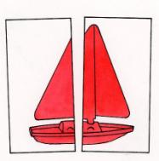

Project Staff
Tristan Pierce, Multiple Disabilities Project Leader
Millie Smith, Lead Author
Monica Vaught-Compton, Project Assistant
Kelly Kennedy Mimms, Research Assistant
Leasha Twyman, Research Assistant

Product Description
The Barraga Visual Efficiency Program (BVEP) includes a book divided into three unit books: guidebook, evaluation, and design for instruction. The program includes four objects (hats, spoons, mini books, and toy sailboats) each in four colors (red, yellow, blue, and green) and three sizes. An additional book is the assessment tool teachers use to present pictures of the four objects to the young student. The program will be an aid to teachers and other professionals who work with young learners who have low vision.

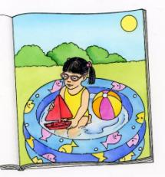

Background
APH first published Dr. Barraga's Program to Develop Efficiency in Visual Functioning (PDEVF) in 1978. This low vision program was a cornerstone product for APH for many years. All scholarship needs to be up-to-date and intervention models brought in line with current research. This was the case with the PDEVF. Also, it was more and more difficult for APH to obtain the many commercially available items in the kit that were used to assess a child's vision. APH and Dr. Barraga agreed that it was time to revise the program. Dr. Ralph Bartley, Director of Research, met with Dr. Barraga and upon her request, APH asked Millie Smith to be the lead consultant and author for the revision. As a graduate student, Smith studied under Dr. Barraga and worked with Dr. Barraga on the original product. APH created an advisory panel that convened at the Texas School for the Blind and Visually Impaired (TSBVI) in 2009 to establish an outline for the project. Dr. Barraga attended the 2-day meeting.

BVEP provides information and materials to evaluate needs and to design instruction to maximize the use of available vision. The program addresses the needs of students with low vision who have ocular impairments and who have achieved cognitive developmental skills at or beyond the 3-year-old level.

Visual efficiency is the extent to which one uses available vision effectively (Corn & Erin, 2010). Smith (2015), lead consultant and author of BVEP, states the following:

Visual efficiency is the extent to which one uses available vision effectively (Corn & Erin, 2010). Smith (2015), lead consultant and author of BVEP, states the following:

Visual efficiency is also an area of instruction included in the Expanded Core Curriculum (ECC). The ECC defines nine crucial areas of instruction that are unique to visual impairment. One of these is Sensory Efficiency. The area of Sensory Efficiency addresses needs related to the use of all sensory systems: visual, tactile, auditory, gustatory, olfactory, proprioceptive, and vestibular. The BVEP addresses one of these areas—the use of vision. (p. 2)

Relevance
There is evidence that APH made the decision to revise this product based on a standardized process of product modernization. The Program to Develop Efficiency in Visual Functioning (PDEVF) was a longtime selling and very successful APH product created by Dr. Barraga. To reflect current APH and educational standards, APH Executive Director of Research, Ralph Bartley, Ph.D., presented to Dr. Barraga the possibility of revising the product. She was happy to learn that her life's work may reach another generation of children with low vision. The project leader, Tristan Pierce, organized a 2-day meeting and work session with Dr. Barraga and an advisory panel in Austin, TX, to review the existing product and to outline the potential new one. Upon return from Austin, Pierce submitted a Product Modernization Form on August 17, 2009. Pierce submitted the product under the name Program to Develop Efficiency in Visual Functioning, the same name as the original Barraga product. Eventually, APH and the advisory panel decided to name the new product in honor of Dr. Barraga, the Barraga Visual Efficiency Program (BVEP). The significant focus of the new BVEP is the same as the old PDEVF—development of visual skills in young children.

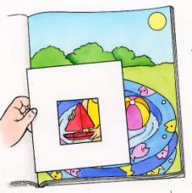
BVEP is fully accessible to the population using it. APH produces the kit documentation in enlarged type (14 point) with an HTML file for individuals who use screen readers and a braille-ready file (BRF) for personal download available on the Internet. Teachers complete the accessible assessment forms online. The kit items are in three primary colors (red, yellow, and blue) and one secondary color (green), which are high-contrast colors and typically known by very young learners.

BVEP follows APH guidelines for determining relevance of a product. The Advisory Panel agreed with Dr. Barraga that the panel should conduct a meta-analysis on low vision studies. Charged with this task were Smith and Pierce. They looked to a just completed meta-analysis—conducted on the request of APH—on the educational applications of low vision research; it was conducted by Kay Alicyn Ferrell, Ph.D.; Cherylann Dozier, Ph.D.; and Martin Monson, Ed.D., at the National Center on Severe and Sensory Disabilities (NCSSD) in Colorado. APH also hired Jon Howe, University of Arizona doctoral student, to conduct a literature review based on a list of key words created by the group in Austin. Howe's report and the statistical results of eight articles he used were not helpful for APH's purposes because he addressed one specific visual impairment and one visual behavior. However, some articles in the 36 pages of Howe's larger literature review, his narrative analysis, were significant. Smith and Pierce reported results of the meta-analysis and the literature review to the Advisory Panel and recommended that in addition to looking at research on learning visual skills, we also look to research on learning in general. Smith was particularly interested in research that shows performance improves as a result of practice and that providing opportunities to practice skills using highly effective strategies is the basis of good teaching in any skill area. Smith and Pierce proposed to the Advisory Panel that the new product include three components: 1) a teacher's guide to give TVIs information and materials that they need to provide learners opportunities to practice targeted visual skills and experiences that are highly motivating and meaningful, 2) a visual efficiency assessment procedure, and 3) a set of intervention activities/lessons.

There is evidence of an examination of the need to revise this product. The need to revise the original product has evolved with documentation for many years: Barraga demonstrated that school-age children with low vision could learn to use their vision more efficiently within a program that taught visual perceptual skills.
Barraga, N., & Morris, J. (1978). Source book on low vision: Program to develop efficiency in visual functioning. Louisville, KY: American Printing House for the Blind.

Hall and Bailey conceptualized a model for training vision functioning that incorporated three methodologies: 1) visual skills training, 2) visual environment management, and 3) visual dependent task training.
Hall, A., & Bailey, I. L. (1989). A model for training vision functioning. Journal of Visual Impairment & Blindness, 83, 390-396.

Ferrell and Muir suggest that the environment be designed so that the use of vision is practical, and instruction in the use of vision be incorporated into daily tasks rather than as an individual lesson or component of a program.
Ferrell, K. A., & Muir, D. W. (1996). A call to end vision stimulation training. Journal of Visual Impairment & Blindness, 90, 364-366.

APH also identified the need for this product revision in two domains: manufacturing and educational. APH purchased many items in the PDEVF from the commercial market. Over the years, manufacturers discontinued some items and or items became economically prohibitive to purchase in small quantities for the kit. To provide the best service and avoid backorders, APH decided to manufacture most of the items in house: Reliance on the commercial market is not always practical for maintaining educational value and ensuring availability for the lifetime of a product. Educationally, APH published the original PDEVF in 1970 (based on Dr. Barraga's dissertation from 1963) with occasional updates through 1998. It was time to update it. Policymakers, educators, and parents expect increased accountability in how public funds are spent in education and if there are measurable student outcomes. As stated previously, APH asked NCSSD to examine the educational research literature on low vision stimulation, development, and devices for evidence to support teaching procedures commonly practiced by teachers of students with visual impairments. The online and manual search resulted in 2,011 articles or other pieces of literature from 1964–2008. Only 46 articles met the specified criteria; and in final analysis, just 31 studies were included because of effect size. The initial 2,011 articles show a plethora of research continues and articles are written about visual impairment to educate readers and to validate the continued need for low vision assessment procedures and intervention activities/lessons. NCSSD's meta-analysis and Howe's literature review show that there are few published studies that meet all criteria to ensure a sufficient quantitative result. Visual efficiency evaluations are one of the most important sources of information that a teacher of persons with visual impairment can use to guide the decision-making needed to plan instruction and select intervention approaches for persons with low vision (Lueck, 2004). Going back to Howe's literature review, many of the articles pointed to evidence of positive effects for training of ocular visual skills and visual perceptual skills. Reputable journals from a variety of fields including neuroscience, cognitive psychology, ophthalmology, aging, rehabilitation, and education published these articles.

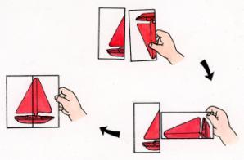

There is evidence that APH sought opinions of knowledgeable individuals to determine the need for the revision of this product. Dr. Barraga requested that Smith, be the lead consultant. Smith taught many years in Texas public schools and at TSBVI. Smith, honored by her peers, is the recipient of numerous awards. Smith has authored books for APH, American Foundation for the Blind® (AFB), and TSBVI. With Dr. Barraga's help, Smith and Pierce created a list of potential vision professionals to participate as an advisory panel. Dr. Barraga accepted the selection of the BVEP Advisory Panel in May 2009, and several members met with Dr. Barraga in Austin that August.

BVEP Advisory Panel
William Daugherty
Jane Erin, Ph.D., contributing writer
Amanda Lueck, Ph.D.
Deborah Orel-Bixler, Ph.D., O.D., contributing writer
Rona Pogrund, Ph.D., contributing writer
Christine Roman-Lantzy, Ph.D., contributing writer
L. Penny Rosenblum, Ph.D., contributing writer
Irene Topor, Ph.D., contributing writer

Anne Corn, Ph.D., joined the Austin group one afternoon to share ideas. Kay A. Ferrell, Ph.D., wrote an appendix for the program, and the AFB Press granted permission to reprint a second original work by Ferrell. APH Low Vision Project Leader, Elaine Kitchel, served as an in-house, low vision advisor. The willingness of such a prestigious group of professionals from the vision field to volunteer time to review and provide feedback validates the need for the revision of this product.

BVEP addresses an identified need for a person who meets the definition of “visually impaired,” specifically, a young individual with low vision. The kit items are available in four, high-contrast colors that young children typically know: red, yellow, blue, and green. The items, picture drawings, and graphic symbols (letters, numbers, and words) are available in small, medium, and large with a size sequence—recommended by Kitchel—that follows a progression in which each is 60% the size of the previous (proportional differentiation between sizes) (Lueck et al., 2003). The evaluation tools help teachers to identify regularly occurring activities that have a low, medium, or high need for instruction. They identify the media/object affected by poor visual efficiency, and then they help plan and organize interventions (e.g., accommodations, skills, or strategies) to address the previously identified needs for instruction. Through the Barraga evaluation tools, teachers pair related developmental sequences (e.g., simple/complex, part/whole, outer edges/internal detail, etc.) with interventions. Most importantly, teachers use the Perceptual Skills Evaluation to determine the perceptual deficits related to poor visual efficiency performance for media items previously identified through the Barraga tools. The three media categories in which the program evaluates specific perceptual skills are objects, pictures, and graphic symbols (letters, numbers, and words). Through instruction, teachers use a collaborative visual skills lesson plan for instruction of visual efficiency skills in regularly occurring activities and they use a direct instruction visual skill lesson plan for vision specific activities.

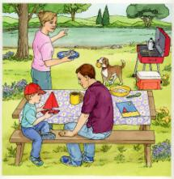
Research
APH gathered data on BVEP using an appropriate method. APH sent the BVEP guidebook, evaluation book, and design for instruction book to the evaluators, who read them over the December 2014 school break. In early January 2015, APH shipped the prototype kits to field test sites. Evaluators field tested BVEP (3 books; hats, spoons, toy sailboats, and miniature books—in four colors and three sizes; the same items as picture card drawings along with letters, numbers, and words; five designs each of sample placemats and array placemats; and two white, visual closure cloths of different sizes and fabric) in their classrooms through mid-March 2015.

The student demographic form and the product evaluation form were Google Drive™ forms, which the evaluators completed online. The evaluation form incorporated rating scales, multiple choices, open-ended questions, and comment sections. The rating scales were unbiased (1 = low to 5 = high); participants had an equal number of negative choices as they did positive choices. Some questions included measurable outcome responses (e.g., “Prior to using…” and “After using…”). Though not required, one teacher recorded the number of successful trials versus unsuccessful trials on her student's Perceptual Skills Evaluation Procedure.

Evaluators submitted evaluation tools (described in previous section) on their students by completing them electronically and sending the Word documents to APH via e-mail; or they printed out the files, completed them by hand, and returned them to APH with their kits. This field test/project report presents the evaluator comments verbatim.

There is evidence that APH considered research data as part of decision-making in product completion. In response to field testing results, in May 2015, Smith and the project leader decided to combine the multiple guides (e.g., Intervention Guide, Developmental Sequences and Perceptual Skills Guide, etc.) into one guide; provide additional hat bills, boat sails, and spoons to be used exclusively for the internal detail activities; reduce the number of objects and pictures used for each activity; combine the three books into one book with three units titled, Guidebook, Evaluation, and Design for Instruction; and to create a flip book to present the pictures to students—eliminating all the cards.

APH completed the following APH Research Guidelines during the development of BVEP:
- Input from the field—APH used an advisory panel from the field whose members reviewed the manuscript and provided professional feedback.
- Safety Report/Technical Review—All kit items are manufactured by APH except the visual closure cloth, which has a safety data sheet (SDS) on file at APH.
- Representative product prototype—APH printed and spiral-bound the documentation; manufactured the kit objects, picture cards, and placemats; and purchased visual closure cloths.
- Outside evaluators—APH used an advisory panel of respected and published professionals from the vision field to create and review the product. APH field tested the prototype at sites selected by geographic location, student/client sample, and evaluator qualifications.
- Evaluation tool and collection—Field test site evaluators used an electronic field test evaluation, and hard copy instructions were sent along with the prototype. Evaluators returned the guidebooks with mark-ups.
- Sufficient time—Field test sites were given 3.5 months to use and evaluate the product.
- Reporting—Product development updates were submitted in writing in the APH Annual Research Report, and presented orally and in writing at monthly New Products Meetings. Field test data were compiled into a final BVEP Field Test Report.
- Product modifications—Changes to the product were determined and made based upon evaluator input, discussions with the lead author, and the Product Development Committee.
- Quota Approval—The BVEP Quota Approval Form was submitted to and accepted by the Educational Products Advisory Committee in the Spring of 2017.
- Upon completion, APH will hold a specification meeting and all materials for production will be turned over to the manufacturing specialist.
- APH will create the BVEP Product Brochure and Quick Tip video.

APH gathered data from a geographically diverse U.S. population. The seven evaluators teach in California, Kansas, North Carolina, and Ohio. An eighth evaluator from Missouri failed to submit the evaluation forms or the Barraga tools. Six evaluation sites were in public schools, and one was in a private school.

APH gathered data from appropriately qualified individuals. The seven evaluators are teachers of students with visual impairments, and four hold an additional certification as orientation and mobility specialists. The three evaluators who submitted the most information with useful details on the evaluation form and the tools are the three with 15 to 23 years of experience working as a TVI. Before using BVEP, five (71.4%) evaluators used another program to evaluate vision efficiency with students. Four used Barraga's earlier programs, and one used TAPS, Oregon Project.

APH gathered data from an adequate number of sources. Eleven students participated in the BVEP field testing. Their chronological ages ranged from 5 years old to 14 years old. Their cognitive ages ranged from 3 years old to 13 years old. The students' eye conditions included <20 degree vision field, achromatopsia (with field loss), bilateral cystoid macular edema, CVI (from a traumatic brain injury), esotropia, exotropia (intermittent), myopia (high), night blindness (congenital, stationary), nystagmus, ocular albinism, optic nerve abnormalities, optic nerve atrophy, optic nerve neuropathy, retinitis pigmentosa, retinopathy of prematurity, and rod cone dystrophy.

The BVEP guidebook identifies the type of student who is an ideal candidate to use the product. Evaluators selected the identifier that best represented their student(s). Two evaluators selected multiple identifiers.
- Five (45.5%) students' visual skills and behaviors are still developing.
- Five (45.5%) students have developed visual skills but need to apply them in new context.
- Two (18.2%) students are recovering from neurological insult.
- One (9.1%) student has experienced recent vision loss and is learning to use his/her visual capabilities.
- No student has no visual skill or no rudimentary visual skill.
- No student has experienced sensory deprivation.

APH targeted and solicited academic students for field testing; however, the Student Evaluation Forms indicate that some students did have additional handicapping or health conditions. The evaluators listed cardiofaciocutaneous syndrome, undiagnosed attention [deficits] and autism, developmental delays, speech/language/articulation, and brain tumor accompanied with diabetes

As requested, the evaluators identified the students' functional vision assessment/evaluation that they used in tandem with BVEP. Some responded with the year of the FVA/E while others wrote descriptive answers.
- SJ was diagnosed just two years ago just as she moved into our school system, her functional vision was good in most areas, biggest area of concern for her parents was her inability to read and comprehend at grade level, (fourth at that time) and her frequent headaches. SJ routinely sees her eye doctor to prevent further damage from cystoid macular edema, most recent eye report is 2/17/15, noted acuity distance 20/70, night vision loss, peripheral vision loss OU partial superior temporal, inferior temporal, superior nasal, and inferior nasal, extraocular movement full, teacher reports that SJ participates fully in class, grades at that time were average, has a prescribed magnifier that she rarely uses, and that SJ tells her that her eyes get tired and words start dancing off the page after a while. No problems maneuvering around the classroom or the school, TVI eval-color vision intact, 8/8 colors identified, matched; she is able to fixate, shift gaze, track and scan. SJ's visual condition is unstable, with buildup of fluid monitored, she takes daily meds for pain and edema.
- AH functions well considering the field loss and extreme photophobia that he experiences, he wears his prescribed glasses and has maintained them well for the past year. Prior to this, in his elementary years, he constantly broke them. AH is colorblind, distance impaired and photophobic, despite this, he maneuvers well, O&M eval stated he does not need the use of direct instruction or the use of a cane at this time. He has good visual skills, fixation, shift of gaze, tracking and scanning. His reading ability is most affected by his visual condition, due to lack of progress in print reading efficiency and large print, team decided that braille instruction was needed. He is disinterested in braille instruction also and not progressing.
- AA has a field loss, is sensitive to lighting changes, and figure-ground material.
- 2013
- 2011
- Last FVA/triennial was 2014
- Visual Reflex-None, Eye Preference-Left, Convergence-Difficult, Visual Field-20 degrees, Visual Acuity Near: R-20/100 L-20/50 Both 20/100, Visual Acuity Distance: R-20/100 L-20/50 Both 20/100
- FVA, February, 2014
- Medical report from ophthalmologist, Functional Vision Assessment that included function acuities, observations in indoor and outdoor environments, interviews of parents, student and teacher, visual fields, ocular motor skills, and learning media assessment
- Medical report from ophthalmologist, Functional Vision Assessment that included function acuities, observations in indoor and outdoor environments, interviews of parents, student and teacher, visual fields, ocular motor skills, and learning media assessment
- Medical report from ophthalmologist, Functional Vision Assessment including functional acuities, visual field, ocular motor skills, observations in various environments, and observation of sensory channels for learning media assessment.

Three (27.3%) of the students' teams (i.e., family, teachers, specialists) incorporated BVEP into the student's IEP. Evaluators wrote the following comments on seven of the eight students who did not incorporate BVEP into an IEP. Incorporation of BVEP into an IEP was not required for the field testing.
- SJ had already been evaluated and IEP done prior to participating in this study, visual efficiency and technology goals were already in place, SJ uses a typoscope and reading guides to help eliminate eyestrain, extraneous information and to keep from losing her place. She still does not like to use her magnifier. She is learning to use shortcut keys in technology.
- Preestablished, braille instruction, technology goals, and organization skills
- Made some accommodations
- Just Christine Roman materials, acuity/field measures, etc.
- IEP included a vision specific goal and no new needs were found following BVEP.
- IEP was in December. Will add all new information gained in next IEP.
- IEP is com in [sic] up and information from BVEP will be incorporated.

Data were gathered on student outcomes. Evaluators stated that nine (81.8%) students demonstrated some visual examining behaviors prior to using BVEP. After using BVEP, evaluators stated that 11 (100%) students demonstrated visual examining behaviors. One evaluator documented successful and unsuccessful trials on the Perceptual Skills Evaluation Procedure. Three evaluators submitted comments:
- I didn't realize that AA wasn't looking at all her choices and she could match color, but didn't realize when I was referring to match mine and it was by size.
- identifies isolated print letters, numbers
- Student has a degenerative eye condition but acuities remain stable. She is primarily a visual learner with continuing needs for learning to use low vision devices and computer/assistive technologies.

Evaluators responded that six (54.5%) students demonstrated visually guided movements of the body prior to using BVEP. After using BVEP, evaluators responded that nine (81.8%) students demonstrated visually guided movements of the body. Two teachers submitted comments:
- We continue to use the accommodations for morning routine but we also remember to have her wait while she looks at all of her choices before selecting.
- She uses her sight for travel; she exhibits proper head and body alignment, as well as adequate cane technique. She utilizes her cane for travel in unfamiliar environments, although her usage is generally to alert other persons to her low vision rather than any great need on her part to judge safe pathways and drop-offs. She continues to use the cane in order to maintain her skill with the device.

The research method used on BVEP collected sufficient information. APH collected information on the students through the Student Evaluation Form and information on the teacher evaluators and the prototype through the Product Evaluation Form. APH requested that the evaluators complete and submit the following tools on their student(s): Activity Inventory, Developmental Sequences and Perceptual Skills Guide, Perceptual Skills Performance Record, and Intervention Guide. Some teachers completed and submitted more tools than others. A teacher may have submitted information on two students in the Product Evaluation Form, but only submitted the Barraga tools on one student.

Barraga Tools
Activity Inventory
Evaluators submitted Activity Inventories on nine students as displayed in Table 1. Reading and math list as the most common regularly occurring activities that are in need of instruction during the students' school day. The regularly occurring activity that appears most often and identified as the most in "high need" of instruction is reading. These activities are tagged, "priority activities."

Table 1. Activity Inventory of most frequently listed regularly occurring activities identified as needing instruction
Number of Students Regularly Occurring Activity
6 Reading (Low need of instruction=2, M=0, H=4)
5 Math, (L=2, M=2, H=1)
4 Writing
4 Physical Education
4 Lunch
4 Language Arts
3 Social Studies
3 Science
3 Recess
3 Arrival

Intervention Guide
Evaluators submitted Intervention Guides on seven students. Teachers listed 17 activities on the students' Intervention Guides. Reading, language arts, and group activity/time appear as priority activities on three students' Intervention Guides. These three activities sometimes overlap, such as "print comprehension" during language arts. Other priority activities listed at least once are recess, writing, arrival time, physical education, math, lunch, putting toys away, independent seatwork, library, feeding the dog, brushing teeth, indoor soccer, centers, and circle time. Table 2 displays an Intervention Guide with three priority activities for three students; a different evaluator submitted each priority activity.

Table 2. Intervention Guides of three students

Priority  activities | Media/Object  affected by poor  visual efficiency | Intervention  Accommodation (A)  Skill (S)  Strategy (St)
Reading | Multiple lines of print on page  Glare | A: Line marker to keep place or typoscope to isolate each word  St: Finger point to each word  A: Pink acetate overlay to reduce glare on page
Group Activity | Directions and parts of task are presented visually at a distance | St: Student previews or reviews the presentation up close to see details  A: Teacher verbalizes each step using descriptive language  S: Student uses a monocular to view the presentation  A: Teacher checks for understanding before student begins task
Putting toys away | Locating dropped objects  Finding correct bins to put toys away | S: Scan from left to right to locate objects  S: systematic search pattern to locate small items on floor  S: Scan bins on shelf from left to right  S: Identify label on desired bin  A: Provide 20 pt san serif font on bin labels

Evaluators submitted Developmental Sequences and Perceptual Skills Guides on six students. Table 3 shows two priority activities of two students submitted by two evaluators.

Table 3. Developmental Sequences and Perceptual Skills Guides on two students

Priority  activities | Media/Object affected by  poor visual  efficiency | Related developmental sequences | Related  perceptual  skill deficit
Putting toys away | Locating dropped objects  Finding correct bins to put toys away | Tracking-Scanning  Tracking-Scanning | Visual memory
Physical Education | Distance activities | Large, small, and high contrast | Figure ground

Evaluators submitted Perceptual Skills Performance Records (PSPR) on nine students. The PSPR has three parts: objects, pictures, and graphic symbols (letters, numbers, and words). The skills are presented sequentially. "Skill 2.10: Match item in scene to single item" is the most difficult skill of the picture cards. For example, for a student to identify the three-color book lying on an angle on the picnic table with a floral tablecloth, the student will need to use skills 2.1-2.9 (e.g., match color, shape, size, internal detail, orientation, etc.) Three evaluators completed the PSPR slightly differently from what was suggested, but the three showed good documentation and were completed in a way that the data could be merged with the remaining responses. As stated earlier, one evaluator documented the number of successful and unsuccessful trials for each skill, another evaluator documented the success of each object or picture within each skill, and one incorporated an intermediate level (o=had some problems) between skill success (+) and unable to do skill (–). Table 4 displays the merged data showing the number and percentage of students who were successful (+), had some problems (o), or were unable to do the skill (–). Not every student listed attempted each skill across every domain. For example, if a student was unsuccessful at matching constancy with three-color items, then the evaluator decided not to evaluate the student on constancy with internal detail. Percentages are based on the number of students who attempted each skill.

Table 4. Average percentages of success for students using the Perceptual Skills Performance Record
Objects | Perceptual  skill | 1 Color | 3+  Colors | Internal  detail
1.1 Skill: Match color | Identification | +8 (99%)  –1 (1%) | +7 (78%)  –2 (22%)
1.2 Skill: Match shape | Identification | +9 (100%) | +8 (99%)  –1 (1%)
1.3 Skill: Match  size | Identification | +8 (99%)  –1 (1%) | +8 (99%)  –1 (1%)
1.4 Skill: Match internal detail | Identification | +7 (78%)  o1 (11%)  –1 (11%) | +7 (89%)  –1 (11%) | +4 (100%)
1.5 Skill: Match whole  and partially obscured objects | Visual closure | +9 (100%) | +8 (100%) | +8 (100%)
1.6 Skill: Match objects  on patterned background | Figure-ground | +9 (100%) | +8 (99%)  –1 (1%) | +8 (100%)
1.7 Skill: Name missing object | Visual memory | +7 (78%)  o1 (11%)  –1 (11%) | +7 (78%)  – –2 (22%) | +7 (87.5%)  –1 (12.5%)
1.8 Skill: Match orientation | Constancy | +9 (100%) | +8 (89%)  –1 (11%) | +8 (100%)
1.9 Skill: Match object to embedded object | Part-whole | +9 (100%) | +8 (89%)  –1 (11%) | +8 (100%)

Pictures | Perceptual  skill | 1  Color | 3 or more  Colors | Internal detail | Outline
2.1 Skill: Match object to picture | Identification  (3D to 2D) | +9(100%) | +9 (100%) |  | +8 (100%)
2.2 Skill: Match color | Identification  (2D to 2D) | +8 (89%)  –1 (11%) | +8 (89%)  –1 (11%) |  | +8 (89%)  –1 (11%)
2.3 Skill: Match shape | Identification | +9 (100%) | +9 (100%) |  | +8 (100%)
2.4 Skill: Match size | Identification | +8 (89%)  –1 (11%) | +8 (89%)  o1 (11%) |  | +7 (87.5%)  o1 (12.5%)
2.5 Skill: Match internal detail | Identification | +9 (100%) | +8 (89%)  o1 (11%) | +5 (83%)  o1 (64%) | +8 (89%)  o1 (11%)
2.6 Skill: Match fully drawn picture to partially drawn picture | Visual closure | +8 (89%)  o1 (11%) | +7 (78%)  o1 (11%)  –1 (11%) | +8 (89%)  o1 (11%) | +8 (89%)  o1 (11%)
2.7 Skill: Match pictures on patterned background | Figure-ground | +8 (89%)  o1 (11%) | ++8 (89%)  o1 (11%) | +8 (89%)  o1 (11%) | +8 (89%)  o1 (11%)
2.8 Skill: Name missing picture | Visual memory | +7 (78%)  o1 (22%) | +6 (67%)  o1 (11%)  –2 (22%) | +5 (56%)  o1 (11%)  – – –3 (33%) | +7 (78%)  o1 (11%)  –1 (11%)
2.9 Skill: Match orientation | Constancy | +7 (87.5%)  o1 (12.5%) | +7 (87.5%)  o1 (12.5%) | +7 (87.5%)  o1 (12.5%) | +7 (87.5%)  o1 (12.5%)
2.10 Skill: Match item in scene to single item | Part-whole | +7 (87.5%)  o1 (12.5%) | +7 (87.5%)  o1 (12.5%) | +7 (87.5%)  o1 (12.5%) | +7 (87.5%)  o1 (12.5%)

Graphic  Symbols | Perceptual  Skill | Single  letters and  numbers | Words and  numbers  sequences
3.1 Skill: Match  shape symbol | Identification | +7 (87.5%)  o1 (12.5%) | +7 (87.5%)  o1 (12.5%)
3.2 Skill: Match size | Identification | +7 (87.5%)  o1 (12.5%) | +7 (87.5%)  o1 (12.5%)
3.3 Skill: Match manuscript symbols | Identification | +6 (75%)  –2 (25%) | +6 (75%)  –2 (25%)
3.4 Skill: Match cursive symbols | Identification | +5 (62.5%)  –3 (37.5%) | +5 (62.5%)  –3 (37.5%)
3.5 Skill: Match symbols on patterned background | Figure-ground | +7 (87.5%)  –1 (12.5%) | +7 (87.5%)  –1 (12.5%)
3.6 Skill: Name missing symbol | Visual memory | +7 (87.5%)  –1 (12.5%) | +7 (87.5%)  –1 (12.5%)
3.7 Skill: Match orientation | Constancy | +7 (87.5%)  –1 (12.5%) | +7 (87.5%)  –1 (12.5%)
3.8 Skill: Match symbol to embedded symbol | Part-whole | +6 (75%)  –2 (25%) | +6 (75%)  –2 (25%)
Graphic  Symbols | Perceptual  Skill | Single  letters and  numbers | Words and  numbers  sequences
3.1 Skill: Match  shape symbol | Identification | +7 (87.5%)  o1 (12.5%) | +7 (87.5%)  o1 (12.5%)
3.2 Skill: Match size | Identification | +7 (87.5%)  o1 (12.5%) | +7 (87.5%)  o1 (12.5%)
3.3 Skill: Match manuscript symbols | Identification | +6 (75%)  –2 (25%) | +6 (75%)  –2 (25%)
3.4 Skill: Match cursive symbols | Identification | +5 (62.5%)  –3 (37.5%) | +5 (62.5%)  –3 (37.5%)
3.5 Skill: Match symbols on patterned background | Figure-ground | +7 (87.5%)  –1 (12.5%) | +7 (87.5%)  –1 (12.5%)
3.6 Skill: Name missing symbol | Visual memory | +7 (87.5%)  –1 (12.5%) | +7 (87.5%)  –1 (12.5%)
3.7 Skill: Match orientation | Constancy | +7 (87.5%)  –1 (12.5%) | +7 (87.5%)  –1 (12.5%)
3.8 Skill: Match symbol to embedded symbol | Part-whole | +6 (75%)  –2 (25%) | +6 (75%)  –2 (25%)

Guidebook

All (100%) evaluators responded that the guidebook establishes the goal and rationale for the program.

Comments:
- The appendices are great. A wealth of information.
- Guidebooks were excellent.
- This was something new that I haven't worked on with my students. It gave me great information.

All (100%) respondents said the guidebook clearly defines unfamiliar terms and it explains the two categories of visual skills for which BVEP provides methods for instruction. One evaluator commented, "I think it will be very helpful to new teachers."

All (100%) respondents said the guidebook clearly defines visual perception and the six areas that are often included in tests of visual perceptual skills. One evaluator provided the following comment:

I think this is an area that is overlooked in higher education now (the programs for educating future teachers). Intervention Specialists are not learning how to teach strategies to students with deficits in visual perceptual skills. Often times, the TVI is asked to help with these skills. If you can add some strategies in just to give the TVI something to help the IS's that would fill a void in everyone's education.

Teachers rated the educational value (1=no value, 5=great value) of the four appendices.

Appendix A: Continuum of Visual Development
- some value… 14.3%
- good value… 14.3%
- great value… 71.4%

Appendix B: Differential Criteria for Assessment and Instruction of Needs Resulting From Cortical Visual Impairment
- good value… 71.4%
- great value… 28.6%

Appendix C: Traumatic Brain Injury and Children: Incidents, Causes, and Intervention
- good value… 57.1%
- great value… 42.9%

Appendix D: Best Practices in Educating Students With Low Vision
- good value… 57.1%
- great value… 42.9%

Comments about appendices:
- Wonderful information--have--you considered having these as separate documents available for purchase outside of the kit.
- Loved Appendix A--helped guide me to where students need to go. I have more students with CVI. I would love to see how this could help them as well.

When asked if they are interested in an appendix on Vision Therapy, five (71.4%) answered yes.

Evaluation Book

The evaluators reported that the evaluation book helped them identify the vision needs of eight (72.7%) students.

Comments:
- Not this student, I think she may have too well developed visual skills for this evaluation, she had no issues with the colors, embedded detail or print cards portion of evaluation, she was able to identify all detail and color, size and constancy questions.
- Not this student, color blindness prevented some of the eval, he was able to do all other parts, but became bored with tests, saying they were too easy and he just started saying off the wall answers, eval was stopped
- AA had to be directed to my selected item most of the time. She wouldn't scan to notice them all.

Six (85.7%) of the evaluators said the evaluation book helped them determine appropriate instructional methods. The one evaluator who said "no," wrote, "I think it will for younger students that [sic] I will assess in the future."

Again, six (85.7%) of the evaluators said that the evaluation book helped them determine students' activities that occur regularly.

Comments:
- It was difficult to gather data from everyone in the short time period for the trial but I think this is a good piece for looking at the child in everyday situations.
- I like having the template. It helps ensure that no part of the student's day is overlooked in planning for instruction and/or modifications.
- Really liked that part of the evaluation tools, it helps to stop and think about all aspects of the student's day and what does go on routinely.
- The evaluation book really helped break it down and helped me to see how the student's schedule words [sic].

The evaluators were asked to rate on a scale of 1 to 5 (1=difficult, 5=easy), the ease of use of the Barraga Visual Efficiency Evaluation (BVEE) tools:

Activity Inventory
- difficult… 0%
- somewhat difficult… 14.3%
- moderate… 0%
- somewhat easy… 14.3%
- easy… 57.1%

Intervention Guide
- difficult… 0%
- somewhat difficult… 14.3%
- moderate… 0%
- somewhat easy… 28.6%
- easy… 42.9%

Developmental Sequences and Perceptual Skills Guide
- difficult… 0%
- somewhat difficult… 14.3%
- moderate… 0%
- somewhat easy… 28.6%
- easy… 42.9%

The evaluators were then asked to rate on a scale of 1 to 5 (1=not beneficial, 5=extremely beneficial), the beneficial value of the BVEE tools.

Activity Inventory
- not beneficial… 0%
- somewhat beneficial… 14.3%
- beneficial… 0%
- very beneficial… 57.1%
- extremely beneficial… 28.6%

Intervention Guide
- not beneficial… 0%
- somewhat beneficial… 14.3%
- beneficial… 14.3%
- very beneficial… 28.6%
- extremely beneficial… 42.9%

Developmental Sequences and Perceptual Skills Guide
- not beneficial… 0%
- somewhat beneficial… 14.3%
- beneficial… 14.3%
- very beneficial… 57.1%
- extremely beneficial… 14.3%

Teachers rated on a scale of 1 to 5 (1=poor, 5=excellent) the three parts of the Perceptual Skills Evaluation Procedure: objects, pictures, and graphic symbols.

Part 1: Objects
- poor… 0%
- fair… 28.6%
- good… 14.3%
- very good… 42.9%
- excellent… 14.3%

Part 2: Pictures
- poor… 0%
- fair… 0%
- good… 14.3%
- very good… 14.3%
- excellent… 71.4%

Part 3: Graphic
- poor… 0%
- fair… 0%
- good… 14.3%
- very good… 14.3%
- excellent… 71.4%

Evaluators were asked if there is a skill (e.g., 2.8 Skill: Name missing picture) that they felt should be added to the Perceptual Skills Evaluation Procedure. All (100%) said there were no skills that need to be added to the evaluation. One evaluator commented, "These were very good and I think they will be very good for beginning teachers as well."

Design for Instruction Book

Six (85.7%) evaluators said Table 1.1: Sample Accommodations, Modifications, and Supports provided insight to help them prepare independent education plans more efficiently in the future.

Comments:
- I think it is helpful to have a resource like the BVEP that I can check to be sure I have considered all the needs of my students. Often times, TVI's have a very busy caseload and some things can be forgotten when you are rushing from school to school, meeting to meeting.
- Not enough time

Three (42.9%) evaluators used the Intervention Guide with a classroom teacher who did not have experience working with students with visual impairment.

Comments:
- I finished assessing one student and ran out of time. However, this section is well written and clear.
- I think all of these forms will be helpful for future plans and keeping things organized.
- My classroom teachers and I collaborate very well so this was not needed. I think it is helpful when you do have a teacher who is not following the IEP. It is something concrete to show the steps that have been taken to educate the staff about the student's unique needs.
- It helped guide me in my selection.

The Design for Instruction book includes templates for direct instruction lesson plans (vision specific activities) and collaborative visual skills lesson plans (transition skills from vision specific activities to regularly occurring activities). The evaluators reported that seven (63.6%) of the students used direct instruction lesson plans and collaborative visual skills lesson plans.

Comments:
- SJ is using vision skills in her regularly occurring activities that were implemented prior to taking this evaluation
- I felt the morning routine was very important to get the day started off right. Plus, I felt getting her independent with these skills could carry over in the classroom during additional activities.
- functional handwriting... name, phone #, etc.
- Teacher mentioned that she is seeing the student use some strategies in her classroom.
- Still needs prompting from classroom teacher but is able to demonstrate skills.
- Teacher and I are working on same goals in classroom as part of routine, with me on increasing difficulty of task.

BVEP provides a team training plan for those teams who may need it. Two of the students' teams used the team training plan and stated that the team training plan was helpful.

Six (85.7%) evaluators felt that the Design for Instruction tools (e.g., Collaborative Visual Skills Lesson Plan, Direct Instruction Lesson Plan, Team Training Plan) provide for the implementation of the intervention methods described in the Intervention Guide.

Comments:
- The teacher and I collaborated about the benefits of each item on the guide.
- I think these tools will be helpful to parents, therapists, and teachers who are new to the field.

Kit Items

Stickers
All (100%) evaluators said that the four sticker designs (i.e., stars, peace signs, smiley faces, and crescent moons) are sufficient to conduct an evaluation.

Comments:
- My student loved the different designs.
- I think the designs are sufficient, but sticking and removing the stickers was extremely frustrating during the evaluation. It was too time consuming and my students were either bored waiting for me or lost focus on the activity. I think the stickers should not be used. Instead the products should have inner detail on them.
- They provide good fine detail to help me observe visual behaviors.

The prototypes included yellow stickers and blue stickers. All (100%) evaluators said that the two colors are sufficient to conduct an evaluation. Six (85.7%) said the quantity of each design is sufficient to conduct an evaluation.

Fabrics
The prototype kits contain two types of fabric, which are used to evaluate visual closure. The majority (57.1%) preferred the white micro fabric over the white blackout fabric. Evaluators were also given fabric in two sizes. While 42.9% preferred the small size and 28.6% preferred the large size, 28.6% would like APH to include both sizes of fabric.

Placemats
The prototype kit included placemats in five designs, each in two sizes: The sample placemat measures 9 x 11 inches, and the array placemat measures 19.5 x 11 inches. The designs include white, marble, floral, blue plaid, and black plaid. APH's Low Vision Project Leader recommended the designs. The back of each placemat indicates the top of the placemat and where the card should be positioned on the front.

Six evaluators (85.7%) said the sample placemats and the array placemats are appropriately sized. One evaluator would like the array placemat to be a "little bit longer."

The prototype kit did not include a blackline (without color) floral design placemat. Instructions to the evaluators said to use the white placemat with the blackline floral picture cards. Four (57.1%) evaluators felt that accommodation was sufficient and APH did not need to include blackline floral placemats. Three (42.9%) evaluators would like APH to include blackline floral placemats in the final product. One evaluator wrote, "The easier and standardized this kit is to implement, the better/more valid the results."

Objects
Spoons
The spoons were designed with a 60% proportional differentiation (distinguishing small to medium to large). Four (57.1 %) evaluators responded that the proportional differentiation of the spoons is adequate, and three (42.9%) responded that it is not adequate. The three submitted comments.
- I had trouble figuring out sizing with short notice.
- I had a very hard time distinguishing size of all the objects, this may just be my own problem, but I would imagine some other people could have the same difficulty. I think they should be marked with the size.
- Too small

Five (71.4%) said the design of the spoons allows them to create one-color, two-color, and three-color spoons easily. Of the two evaluators who differed with the majority, one said she was worried she would break the spoons if she pulled the sections apart and the other one said the hook and loop material came off the spoons when she pulled the sections apart. The spoons are made of vinyl. APH chose the material because of its durability; the pieces will not break if pulled apart. If someone tried to break a spoon in half purposefully, it might bend.

Four (57.1%) evaluators said the quantity of spoons, supplied in the prototype, was not sufficient to conduct an evaluation. Two evaluators submitted comments; both preferred multiple sizes in each color.

Toy Sailboats
APH designed the toy sailboats with a 60% proportional differentiation. Six (85.7 %) evaluators responded that the proportional differentiation of these sailboats is adequate. One evaluator said she had difficulty with the task and requested that each size be marked.

Five (71.4%) said the design of the toy sailboats allows them to create one-color, two-color, and three-color toy sailboats easily.

Comments:
- I felt if the quality of the materials were better, they would be easier to put together and not fall apart during assessment.
- Although again, since I had a problem figuring out the sizes, [sic] could not get the items ready quickly. This was very frustrating for me and the student.
- Once again, it was hard to put them together as I was testing. My student was already ready to move on. I needed to be fast.
- These are good for boys, it makes them want to look at it.

All (100%) evaluators said the quantity of toy sailboats as supplied in the prototype was sufficient to conduct an evaluation. Evaluators did not submit comments for this question.

Hats
APH designed the hats with a 60% proportional differentiation. Four (57.1%) evaluators said there was not enough proportional differentiation of the hats. Each submitted a comment.
- I would recommend a larger proportional differentiation. It was difficult to tell.
- See comments from above.
- It was hard to tell.
- Seemed too close in size.

Six (85.7%) evaluators said the design of the hats allows them to create one-color, two-color, and three-color hats easily. One teacher felt it was too difficult to change the hat brim/bill to a different color.

Five (71.4%) evaluators said the quantity of hats supplied in the prototype was sufficient to conduct an evaluation. One teacher wrote, "It would be best to have enough to do each sample item without switching the products around or adding detail. The student is quick to answer and it took me several minutes to prepare the next array."

Miniature Books
APH designed the miniature books with a 60% proportional differentiation. All (100%) evaluators said the proportional differentiation of the books is adequate and that the quantity of books supplied in the prototype was sufficient to conduct an evaluation. The miniature books were supplied in one-color and three-color formats; therefore, the evaluators did not need to make the color changes themselves.

In summary, the 60% proportional differentiation was successful for the spoons, toy sailboats, and miniature books; it was not successful for the hats. The quantity of toy sailboats and hats provided in the prototype is sufficient to conduct an evaluation; however, more spoons are required. APH did not ask this for the miniature books because APH provided the preprinted books in multiple colors and internal detail; therefore, evaluators did not switch out parts. No evaluator made a general comment that she needed more miniature books.

Picture Cards
All (100%) evaluators said the proportional differentiation of the picture cards and the graphic symbols (letters and numbers) cards is adequate. Five (71.4%) evaluators said the pictures are good representative drawings of the objects.

Comments:
- The book was not a good representation. One student did not know it was a book. If there is a way to show the spine and pages, it might look more like a book.
- perfect

All (100%) evaluators responded that the graphic difference of the four type fonts (Century Gothic, KG Penmanship, Times Roman, and D'Nealian Cursive) is adequate.

When asked if additional cards, not provided in the prototype, are needed to conduct an evaluation, 100% of the evaluators answered no.

The cards with multiple colors and internal detail had skill numbers printed on the backside to help evaluators identify which cards to use with each assessment activity. Some cards had multiple numbers on the back. Evaluators selected which scenario would serve them and their students better in the final product.

- 28.6% ‒ Keep the cards as presented in the prototype—multiple numbers on the back of some cards.
- 71.4% ‒ Have multiple copies of the same card, each with its own skill number.

Packaging

Keeping the objects and, especially the cards, organized is a huge task. The correct type of packaging and storage can help make a teacher's job easier and allow an evaluation to proceed more smoothly. Evaluators selected from the following options to help APH determine the best way for teachers to store the kit items. Unfortunately, there is no majority response to this question.

- One (14.3%) evaluator recommends that APH provides the cards in plastic bags by object drawing. For example, all hat drawings (regardless of color, size, internal detail) would be in one bag. This option would have cards similar to the prototype (multiple skill numbers on the back of some cards).
- One (14.3%) evaluator recommends that APH provides the cards for each skill in small plastic bags with each bag marked with the Skill number. This option requires having multiple copies of the same card, each with its own skill number.
- One (14.3%) evaluator recommends that APH provides the cards as if they were a deck of playing cards (in a box) by object drawing. For example, all hat drawings (regardless of color, size, internal detail) would be one deck of cards and in its own box. This option would have cards similar to the prototype (multiple skill numbers on the back of some cards).
- One (14.3%) evaluator recommends that APH provides the cards (in a box) by Skill number. For example, all cards used in "2.2 Skill: Match color" would be in one deck of cards and in its own box. This option would require having multiple copies of the same card, each with its own skill number.
- Three (42.9%) evaluators recommend that APH provides the cards in plastic window sleeves in a binder. For example, label a window sleeve 2.5, which stands for "2.5 Skill: Match internal detail." Inside that sleeve are all the cards used during that skill assessment. This option would require having multiple copies of the same card, each with its own skill number.

APH solicited alternative packaging and storage ideas from the evaluators, but no one submitted an idea. Four evaluators submitted general comments about the cards.
- They were a bit overwhelming, storing by object drawing might help.
- I would like to see all the same sizes grouped alike.
- I tried to divide cards into sets and place in zip lock bags, but like the option I chose in #56.
- I definitely think you need multiple cards. I had piles going for each item number and I still was searching for cards. I think it would be easier to keep the cards in plastic bags (easier than sliding in/out of sleeves) but the bags need to be kept organized. Perhaps pouches that can be help in a binder would work. It also needs to be portable because I had a hard time fitting everything into bags while I carried around all my other materials.

Evaluators provided general comments about the BVEP.
- Overall, very good, I think my kids were a bit too old to use it with, bored with it, too well developed visual skills already, since I've had them for awhile and had worked on these skills beforehand, with younger ones, which I would do it with had I had more time, I think it would have helped lots.
- This test requires a teacher to be more organized and have everything ready. I feel that the more I would give this test, the easier it would be to manipulate the objects and cards. I also found that I need a bigger work space and time to work with the students for a little bit longer. I feel that this test could give me some valuable information in regards to how the student uses their [sic] vision. I feel that the more I could give this test, the better I would become at it.
- Organization is the key to making this product user-friendly. The books are excellent. Organization of the materials was cumbersome and labor intensive. I would recommend it arrive with as little 'assembly required' as possible and in order, to match the assessment protocol. I would use it then...but I would not order or use this product if it arrived the way it did. All the parts and pieces were too overwhelming and disorganized. I would continue to use the older Barraga screening, with is just 2-D black line, and not as comprehensive as this updated version.
- The test could provide a vast amount of visual information, but with my population of VI students I could not use this because all have additional disabilities and did not fit the profile.
- Overall, it's OK . . . I like the original Barraga better because of its portability.
- I have always valued Barraga products. I think this program is a comprehensive tool for Teachers of Students with Visual Impairments that can be used as a guide for assessment and instruction of visual efficiency skills, which is one component of the expanded core curriculum.

Four (57.1%) evaluators said they would recommend that their school or agency purchase the BVEP. Three (42.9%) said they are undecided about recommending the product. APH requested clarification on undecided responses. Two of the evaluators said that it depends on how the final product is packaged and organized. The third evaluator suggested eliminating redundancy, which would reduce the amount of time needed to conduct an evaluation.

Work during FY 2017
APH made final changes to the books, and the project leader submitted them for HTML and braille transcription (still in process at this writing). The model maker completed all the molds for the objects. The reduced number of hats in the kit allowed APH to have tri-color hats ready-made so teachers will not have to assemble them. APH tested (out-of-house) silk-screened colors for the tri-color spoons by having blue and red applied to yellow plastic. The colors are a nice match with the fabric and plastic in the kit. APH will continue to thermoform and die-cut the spoons in house. This also allows APH to provide ready-made tri-color spoons so teachers do not have to assemble them. The project leader finished the product videos. The Barraga team programmer constructed the Barrraga website, which contains the electronic assessment forms, accessible formats of the books, the “Message From Dr. Barraga” video, the “Millie Smith Interviews Dr. Barraga” video, and outline drawings of the kit objects for children to color for expansion or take-home activities. The project leader approved the canvas carry-all case for the kit.

Work planned for FY 2018
APH will manufacture the kit and make it available for sale.
References
Corn, A. L., & Erin, J. N. (Eds.). (2010). Foundations of low vision: Clinical and functional perspectives (2nd ed.). New York: AFB Press.
Ferrell, K. A., Dozier, C., & Monson, M. (2011). A meta-analysis of educational applications of low vision research. Greeley, CO: University of Northern Colorado. Available at http:///www.unco.edu/ncssd/research/LowVisionMeta-Analysis.shtml
Howe, J. (2010). Eccentric viewing training and its effect on reading rate for individuals with absolute central scotomas. Unpublished draft, University of Arizona, Tucson, Arizona.
Lueck, A. H. (2004). Overview of intervention methods. In A. H. Lueck (Ed.), Functional vision: A practitioner's guide to evaluation and intervention (pp. 257-275). New York: AFB Press.
Lueck, A. H., Bailey, I. L., Greer, R. B., Tuan, K. M., Bailey, V. M., & Dornbusch, H. G. (2003). Exploring print-size requirements and reading for students with low vision. Journal of Visual Impairment & Blindness, 97, 335-354.
Smith, M. (2015). Barraga visual efficiency program: Guidebook (prototype). Louisville, KY: American Printing House for the Blind.

Decision Making Guide
(Continued)

Purpose
The purpose/need for this project is twofold:
- Conduct basic research to determine visual accommodation needs, requirements, and strategies of students with low vision when reading passages of continuous text
- To provide teachers and practitioners with a decision tree product, based on the results of data analysis from the basic research that would assist them with the selection of print/font size for their students

Project Staff
Martin Monson, Project Leader
Elaine Kitchel, Low Vision Project Leader
Amanda Hall Lueck, Ph.D., Project Consultant
Ian Bailey, O.D., Consulting Research Optometrist
Jane Erin, Ph.D., Consulting Low Vision Education Expert
Rajiv Pannikar, Ph.D., Consulting Low Vision Education Expert
Anthony D. Jones, Art Production/Design Manager
Frank Hayden, Director of Technical & Manufacturing Research
Andrew Moulton, Manufacturing Specialist
Kelly Kennedy Mimms, Research Assistant

Background
This project was the third in a sequence of studies on how magnification, accommodation, and the visual reserve affect reading efficiency in students with low vision who already know how to read.

Production of reading passages was completed. The team developed comprehension questions for the selected passages and conducted field testing on the passages. Data were collected, analyzed, and published.

The data analysis was incorporated into a report and published in the Journal of Blindness & Visual Impairment in 2006. A decision tree to help teachers and interventionists select appropriately sized print for students who are print users has now been developed. A model of the decision tree and a user’s guide were developed and reviewed by APH and outside experts.

Preliminary Research
A first step for any project leader is to search for any existing products that might eliminate the need for development of this project. For this reason, Internet searches of the following Boolean terms were conducted: print size, visual impairment and learning media, vision and print size, and vision and learning media.

In addition, APH Library Services helped search the patent office database to see if any products had the same basic contents as the proposed one. It was determined that no such product existed.

The following articles and books were read by the project leader during the development of the product as content development revealed that specific kinds of information were needed.

Anderson, R. C., & Pearson, P. D. (1984). A schema-theoretic view of basic processes in reading comprehension. In P. D. Pearson (Ed.), Handbook of reading research (pp. 255-291). New York, NY: Longman.
Bailey, I. L., Lueck, A. H., Greer, R., Tuan, K. M., & Dornbusch, H. (2003). Understanding the relationships between print size and reading in low vision. Journal of Visual Impairment & Blindness, 97, 325-334.
Block, C. C., & Pressley, M. (2001). Comprehension instruction: Research-based best practices. New York: The Guilford Press.
Bosler, D. (2012). Mastering type: The essential guide to typography for print and web. Palm Coast, FL: Howe Books.
Holbrook, C., & Koenig, A. (2000) Foundations of education: Instructional strategies for teaching children and youths with visual impairments. New York, NY: AFB Press.
Legge, G. E. (2007). Psychophysics of reading in normal and low vision. Mahwah, NJ: Lawrence Erlbaum Associates.
Lueck, A. H., Bailey, I. L., Greer, R., Tuan, K. M., Bailey, V., & Dornbusch, H. (2003). Exploring print-size requirements and reading for students with low vision. Journal of Visual Impairment & Blindness, 97, 335-354.
Moore, D. M., & Dwyer, F. M. (1994). Visual literacy: A spectrum of visual learning. Englewood Cliffs, NJ: Educational Technology Publications.

Relevance
APH made the decision to produce this product based on a standardized process of product selection. Dr. Amanda Hall-Lueck submitted the project idea in October 2007. The project leader presented the product submission to the Product Evaluation Team (PET) in January 2008. PET voted to move the project forward. The Product Advisory and Review Committee approved the project, and it was assigned grant #419.

This product will be fully accessible to the population who will use it. It is for teachers and practitioners who work with students who have visual impairments. Since many of those teachers and practitioners are themselves visually impaired, the materials will be presented in braille and/or braille-ready format file, and HTML as accessibility options.

This product follows APH guidelines for determining relevance of a product. The consultants conducted research with more than 30 children with visual impairments in the San Francisco/Bay Area. As expected, they found that when students find the smallest print that they can read, they read at maximum efficiency when that print is enlarged by 60%. Their findings were published in the Journal of Visual Impairment & Blindness. This ability to read at maximum efficiency promotes and enhances reading as an activity, and improves students’ overall feelings about reading. This makes reading overall a more desirable activity.

There is evidence of an examination of the need for this product. The research showed that students in the study were not reading at their maximum efficiency. Teachers did not know how to select print size because no mathematical formula had yet been devised and tested. However, the development of Decision Making: A Guide to Print Size Selection, offers a selection system based on the student’s vision and his “visual reserve.” This simple mathematical process is easy to understand and apply. It provides the teacher/practitioner with a foolproof way to determine print size for each and every student with a visual impairment.

APH sought opinions of knowledgeable individuals to determine the need for this product. An in-house panel reviewed the materials and decided to show them to two experts for their opinions. Both experts, Dr. Jane Erin and Dr. Rajiv Panikkar found the method helpful, and stated a need for the materials. But they stated the materials were in need of a little simplification, which was later achieved. The materials were then reviewed by five working teachers of students with visual impairments. Three of the five supported the development and publication of the materials.

This product addresses an identified need for a person who meets the definition of “visually impaired” as evidenced by the fact that until this product came to light, no method existed for the determination of print size for students and adults with visual impairments. The need was further affirmed by the experts who reviewed the materials.

The expert review was begun. Edits of the text and decision tree got underway. The project leader used the decision tree and found it very difficult. Not only was it difficult to see, but translation of the concepts into numeric values and modification of those values was confusing. APH in-house experts believed educators would not use it. The overly-technical text was of little assistance.

Seven experts completed reviews of the product and generated these opinions and conclusions:
- The text that accompanies the decision tree is much too technical and would require too much homework for the educators who might want to use it. Educators might abandon the use of the product; therefore the text should be more user-friendly.
- The text and directions for use of the decision tree are far too complex and should be simplified.
- The decision tree itself is too complex and intimidating. Efforts should be taken to see if it could be simplified.
- The decision tree, and perhaps the text, should be available electronically.
- The decision tree should be downloadable.

APH staff concluded that a rewrite of the text and decision tree into a more user-friendly language and format should take place. The originators agreed to develop a simpler version that they completed and submitted to APH. The resultant version was simple enough that only two calculations are needed to reach the necessary conclusions. These can easily be done in one’s head or on paper and do not warrant the development of an electronic product at this time.

Layout of the guidebook was completed. Changes to the cards were determined. There were many discussions about the sizes of the samples on the cards because some were as small as 1.6 millimeter. The cards content and size was determined, and layout took place in October 2015. Many fine-tuned changes had to be made to accommodate the super-tiny print on the cards. Only one printer could be found to print the cards at the 1.6 mm print size. Braille translation of the text and cards began in August 2016.

Work during FY 2017
A review of the Guidebook, grade level passages, and sentence and word charts found several errors. Several revisions were made with input from Drs. Lueck and Bailey, product consultants. Final copies were then sent to Ingrid Design for file preparation. Ingrid Design completed preparing the files. Once a specifications meeting has been held, the files will be sent to the identified vendor for printing.

Work planned for FY 2018
This product should be ready for sale in FY 2018.

Detachable Light Box Ledge
(New)

Purpose
To design a detachable ledge to hold 3-D items on the APH Light Box and Mini-Lite Box
Project Staff
Tristan Pierce, Multiple Disabilities Project Leader
James Robinson, Manufacturing Specialist
Patrick White, Model Maker
Frank Hayden, Director of Technical & Manufacturing Research

Additional Project Staff
Dawn Wilkinson, Early Childhood Project Leader
Susan Sullivan, CVI Project Leader

Work during FY 2017
The project staff met to become familiar with the product request.
Work planned for FY 2018
Project staff will conduct various tests on how to hold 3-D items on the light box when positioned on an angle when using the detachable ledge.

Explorer Bright Ray: LEDs for Persons with Low Vision
(Continued)

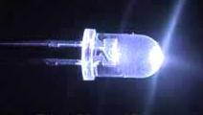

Purpose
Students and teachers have long requested a good head-borne light that students could wear to keep their hands free and their desks clear of clutter and hazards. The Explorer Bright Ray light is designed to be worn on the head. It is an extra-bright LED lamp that has three brightness levels, three directional settings, and is easy to use. The lamp is designed to provide light to
- Students who do not have enough desk space for a task lamp.
- Students who cannot get access to an electrical outlet.
- Students for whom task lamps and cords present a hazard.
- Students who must hold their text very close to their faces.
- Students who need light to supplement task lamp emissions.
The Explorer Bright Ray light comes with an informational book about light, head-borne lights, lighted magnifiers, and LED lights specifically.

Project Staff
Martin Monson, Project Leader
Elaine Kitchel, Project Leader
Frank Hayden, Director of Technical & Manufacturing Research
Anthony D. Jones, Art Production/Design Manager
Yoshi Miyake, Artist
Adam Clark, Manufacturing Specialist

Background
Even though students, teachers, and parents have requested head-borne, bright light for several years, until recently nothing was on the market that was bright enough, adjustable, affordable, and offered the right emissions for people who had low vision.
In the first decade of the 21st century, many head-borne lights became available as the possible uses of light emitting diodes (LEDs) were realized. Many almost met the needs of persons with low vision, but nothing was quite bright enough or flexible enough.

The problem with LEDs is that they do not project the light very far compared to other sources of light. Much improvement has taken place recently to equip LEDs with reflectors and other technology that will project the light several feet. Fortunately, APH can take advantage of this new development to provide students with the head-borne light that they need. This item is now the Explorer Bright Ray light.

Project Research
The project leader has researched the lighting weblogs, websites, and literature for several years to monitor the development of the well-projected LEDs. When they became available, the project leader accessed the following sources:

Klipstein, D. L., Jr. (2008). LED types by color, brightness, and chemistry. Available from http://donklipstein.com/ledc.html
Klipstein, D. L., Jr. (2009). LEDs 101. Available from http://donklipstein.com/ledd.html
Klipstein, D. L., Jr. (2009). The most efficient LEDs and where to get them! Available from http://donklipstein.com/led.html
Li, R. (2010, April 12). LED flashlight mysteries, What is a LED emitter? Retrieved August 23, 2011, from http://ezinearticles.com/?LED-Flashlight-Mysteries,-What-is-a-LED-Emitter?&id=4094084
Murray, M. (2010). Revolutionary 100mm LED downlight. Durham, NC.

Utility Research
The project leader purchased two samples and tested them for color temperature, brightness, durability, flexibility, utility, emission projection, and luminosity. She then proposed the Explorer Bright Ray light as a product to the Product Advisory and Review Committee (PARC), and it was accepted. Additional research is now underway to provide information for a booklet called LEDs. This booklet will be part of the Explorer Bright Ray light kit.

Relevance
APH made the decision to produce this product based on a standardized process of product selection. The product was proposed by the project leader and presented as a submission. In-house and out-of-house experts were asked to review the submission and give an opinion as to whether the product idea should move forward toward production. The product idea was then presented to the Product Evaluation Team and PARC where it was subjected to questions and had to meet certain qualifying standards for APH product development.

This product is fully accessible to the population who will use it. Materials are available in large print, braille, and HTML files so all teachers/practitioners who need accessible materials will have them.

This product follows APH guidelines for determining relevance of a product. It was affirmed by field tester teachers that their students with visual impairments often benefitted from head borne lighting. This fact was also affirmed by the students themselves who tested the product in at least 12 different environments.

There is evidence of an examination of the need for this product. There is currently no head borne lighting product that has been tested for and with students with visual impairments. This product was tested by in-house experts, students with visual impairments, and their teachers. All groups affirmed that there was an identifiable need for head borne light for both students and teachers who have visual impairments.

This product addresses an identified need for a person who meets the definition of “visually impaired” as evidenced by the responses by both teacher and student field testers. Both groups indicated that they needed such a product.

Research continued until the booklet LEDs was in rough draft state. The booklet text was completed and edits began in earnest. Text was edited, and procurement of photos and graphics began. Some items required drawing from scratch. Arrangements were made to engage an artist to draw them. Clean text files were developed for translation/transcription process.

In FY 2015, the Explorer Bright Ray device and booklet were field tested. Data showed the field testers had no complaint about the device, except that it tended to slide down and rest on children’s noses. It was decided to include a hat for the user to wear under the device to prevent the slippage. Testers also wanted a pouch to protect and carry the Explorer Bright Ray in. This change was made. The booklet was finished and readied to be translated into braille.

Work during FY 2017
The specifications meeting was held in January 2017. Various portions of the product have come in from outside vendors over the year. All pieces should come in by the end of FY 2017, and the product should be available for sale.

Work planned for FY 2018
No work is planned for this product in FY 2018.

LED Mini-Lite Box
(New)

Purpose
To provide an LED, lightweight mini-lite box for all students with visual impairments, including said students who spend a portion of their awake hours in a wheelchair (upright or reclining) or a bed

Project Staff
Tristan Pierce, Multiple Disabilities Project Leader
Suzette Wright, Emergent Literacy Project Leader
Kelly Kennedy Mimms, Research Assistant
James Robinson, Manufacturing Specialist
Frank Hayden, Director of Technical & Manufacturing Research

Additional Project Staff
Dawn Wilkinson, Early Childhood Project Leader
Susan Sullivan, CVI Project Leader

Background
The light bulbs inside APH’s Mini-Lite Box are no longer available. APH recognizes that with today’s new light-emitting diodes (LEDs) that it is possible to provide consumers with a more evenly distributed glow and a more consistent plate of light. Just as technical advancement offers smaller and longer-lasting lights, it also offers a new family of batteries that are smaller and longer lasting. The use of LEDs and flat batteries allows APH to design a thinner and more lightweight light box. APH decided that the new design should accommodate a “yet to be determined or designed” mounting stand/system, which will allow a variety of learners to use the light box comfortably. This includes learners sitting at a traditional desk or at a table with a chair; learners in wheelchairs, including reclining wheelchairs; learners in standers; and learners who spend a portion of their awake hours in a bed. The new design will maintain well-researched and trusted features from the existing Mini-Lite Box, such as the capacity to dim and brighten the light and the ability to receive slide-in overlays, such as the Mini-Lite Box overlays and the Sense of Science Series overlays.

Work during FY 2017
APH tested a variety of commercially available LED light panels and batteries in order to evaluate luminosity and how the APH light box materials present from dim to vibrant light. The product development team (team) agreed to use—at least in prototype field testing—an LED light panel that produces a warm white light. The team made this decision by visual comparisons and research-based articles recommended by retired Low Vision Project Leader, Elaine Kitchel. The team agreed to use rechargeable lithium polymer batteries, which after a 3-4 hour charge will last 6-8 hours. This battery choice allows the new design to be lighter in weight and smaller, which is a key factor in the ability to mount it for reclining wheelchair use. The team, along with input from the Early Childhood Project Leader and the CVI Project leader, brainstormed designs to include a detachable ledge that will allow students to use puzzle pieces and translucent blocks on the light box when positioned on an angle. APH talked to various manufacturers of assistive technology mounting systems while attending conferences. With this information and upon the recommendation of the educator from the field who submitted the request to use the light box with wheelchairs and beds, APH selected two of the manufacturers and ordered mechanical parts, such as a universal device socket and VESA plate, to help the team design the back of the light box.

Work planned for FY 2018
The team will continue to build the prototype, including a casing to accommodate the targeted populations.

Light Box and Reading Stand Mounting System
(New)

Purpose
To provide a way that individuals with visual impairments who spend a portion of their awake hours in a wheelchair (upright or reclining) or a bed can use a light box and or reading stand. This product may become void if APH is able to design the LED Mini-Lite Box to accommodate existing mounting systems.

Project Staff
Tristan Pierce, Multiple Disabilities Project Leader
Nick Hadfield, Consultant
James Robinson, Manufacturing Specialist
Frank Hayden, Director of Technical & Manufacturing Research

Background
APH received a request from a teacher of students with visual impairments who stated that, “Nearly 70% of our visually impaired students have multiple impairments and I work with a significant amount of students who are wheelchair-bound or non-ambulatory. This requires a variety of products that are very hard to maneuver around feeding tubes, tracheotomy/oxygen tubes, wheelchairs, etc…….but there is no real safe or effective way [to mount iPads, light boxes, and reading stands] to do this.” This request coincided with APH’s plans to redesign the Mini-Lite Box; so after many discussions, the product development team for the new light box accepted this challenge as well.

Work during FY 2017
The project leader reviewed online many manufacturers and distributors of assistive technology mounting systems and then talked to various manufacturers of these mounting systems while attending conferences. APH decided to concentrate on our history and knowledge of designing light boxes and to partner with one or two manufacturers of mounting stands to meet this need. With this information and upon the recommendation of the educator who submitted the request to use the light box with wheelchairs and beds, APH selected two manufacturers and ordered mechanical parts, such as a universal device socket and VESA plate.

Work planned for FY 2018
The team will continue to test the component parts with the prototype of the revised Mini-Lite Box. If the new design works for the new light box, APH will incorporate the same design on the plate of a reading stand.

MATT Connect
(New/Completed)

Purpose
APH was interested to develop a tablet-based magnifier for near and distance viewing. Its purpose would be to allow low vision students in a classroom setting to access information electronically (shared desktop/whiteboard) and would also function as a typical electronic magnifier. The device would have the added functionality to access information at a distance through the use of a separate camera connected by Wi-Fi. As the device is also a tablet, students could use any number of mainstream or specialized apps.

Project Staff
Martin Monson, Project Leader
Leasha Twyman, Research Assistant
Laura Greenwell, Graphic Designer

Background
The MATT Connect is a partnership project with HumanWare™. As APH was interested in developing a tablet-based magnifier, Martin Monson, the project leader, submitted a product submission idea form. It was approved by both the Product Evaluation Team (PET) and the Product Advisory and Review Committee (PARC).

Product Description
The MATT Connect is a tablet-based magnifier. It uses a dual-boot operating system: Prodigi™ and Android™. Prodigi™ is the low vision access software. It allows the user to view documents live or capture information via Android™ apps from an instructor’s whiteboard or via the included Wi-Fi camera. Once the image is captured, the Prodigi™ Optical Character Recognition (OCR) software allows users to manipulate it to meet their viewing needs. The text can be enlarged, text and background colors can be changed, and text can be read aloud. The product is shipped with a collapsible stand that protects the tablet and functions as a way to carry the device. It also comes with a high-megapixel Wi-Fi camera, camera mounting stick, glare-reduction shields for the tablet, all necessary cables, and a carrying case similar to a laptop bag to transport everything. The APH MATT Connect is unique in that it comes bundled with the Wi-Fi camera and the APH Toolbox. The APH Toolbox is accessible through the Prodigi™ menu and contains a list of special and mainstream apps designated by the expert reviewers to be beneficial to students participating in typical K–12 classrooms.

Work during FY 2017
This project began with APH developing and publishing a Request for Proposals (RFP) for a tablet magnifier. The RFP was released in March 2017. APH staff received the proposals and as a group came together to select the best one. HumanWare™ was chosen as the company to best fulfill the RFP requirements. HumanWare™ was able to furnish APH with prototype units, which were used in the expert review process. Expert reviewers were solicited via an advertisement on various social media group pages related to the education of students with a visual impairment. Reviewers were chosen based on their willingness to review the product, experience with assistive technology specific to the visually impaired, and geographic location. The intent was to pick one reviewer from six different regions of the United States. Input was gathered from the reviewers and used to shape the final appearance and app composition of the APH Toolbox. A pilot run of 10 MATT Connects was sent to APH in July 2017 with the complete order delivered later in the fiscal year. The product was then offered for sale.

See Like Me: Low Vision Simulators
(Continued)

Purpose
APH has been asked many times to provide vision practitioners with a low vision simulation product of some kind to show parents, education professionals, paraprofessionals, and peers of students with visual impairments what it may be like to work with low vision of one of eight more common types. We believed that existing products were not adequate because while they attempt to simulate particular visual pathologies, they show neither the color changes that often accompany the problem, nor the differences that occur between the two eyes.

Project Staff
Martin Monson, Project Leader
Elaine Kitchel, Project Leader
Frank Hayden, Director of Technical & Manufacturing Research Director
Anthony D. Jones, Art Production/Design Manager
Katherine Corcoran, Model Maker
Rachel White, Research Assistant
Leasha Twyman, Research Assistant

Background
For several years, APH has been asked by the field of practitioners in visual impairments to provide a set of low vision simulation devices that would more adequately demonstrate the vision of someone with one of the eight primary eye conditions. Until recently, the technology that could show both color differences and differences in the vision in two separate eyes was not economically feasible. As soon as that technology became affordable, APH responded to the need and has developed eight different filters that show simulation of disease or disorder and also differences between the eyes.

Utility
A field test will be conducted to make sure the product is usable, safe, useful, durable, and helpful. Both students and their teachers will be asked to respond to questions about the product. The results of the field test will be analyzed to determine if changes to the product or its accompanying documentation are appropriate.

Relevance
APH made the decision to produce this product based on a standardized process of product selection. The product was proposed by various teachers and practitioners over the past 8 years. In-house and experts were asked to review the submission and give an opinion as to whether the product idea should be accepted as a product. The product idea was then evaluated to see if existing production methods could meet the need in a cost effective way. The answer was in the affirmative, so the idea went to the Product Evaluation Team and Product Advisory and Review Committee where it was subjected to questions and had to meet certain qualifying standards for APH product development.

This product is fully accessible to the population who will use it. It is designed specifically for people who have typical vision but who would benefit from the experience of a simulation of low vision. Documentation materials will be available in large print, braille, and HTML. Therefore all teachers and practitioners or parents who need accessible materials will have them.

This product follows APH guidelines for the determination of the relevance of a product because it has been requested by teachers of students with visual impairments and other vision practitioners. It will be field tested by potential users with typical vision and general education teachers.

There is evidence of an examination of the need for this product. There is currently no affordable low vision simulation kit that has the features of this one. This product will be tested by in-house experts, teachers, vision professionals, and people with typical vision. Changes suggested by these responders will be considered and where appropriate, implemented.

This product addresses an identified need for a person who meets the definition of “visually impaired.” The product meets the identified need as a way of explanation and experience of people with typical vision to reach an understanding of what the student with a visual impairment deals with every day. Many people, such as parents, peers, general education teachers, and others can assist the student with a visual impairment far better once they experience the simulation of vision loss.

Work during FY 2017
The Model Shop produced several pilot kits for field testers to use. The kits included a handled, waxed cardboard carrying box; a key of the simulators adhered to the inside top of the box; a user-guide that gives a brief explanation of each of the etiologies; the simulators; and a piece of egg-crate foam to hold the simulators in place. The simulators were used by 13 evaluators in an in-service type of environment with multiple participants. The results of the field test follow with direct quotes from the evaluators on the various components of the kit.

Kit Component:
- Simulator, overall rating (out of 5 possible points), and specific feedback from the evaluator:
- Hemianopsia 3.42
  - I felt like this simulator blocked too much vision to be considered a simulation of hemianopsia. First the darker area covered more than half of the visual field, also the "clear" portion of vision on the lens was impossible to see anything through. It was basically totally blinding.
  - I would reduce the field a bit more since the simulator allows individuals with full field to kind of peek around the blockage in the visual field on the lenses.
  - Blocked vision to both sides - inability to see both left and right when on. Stroke patient would be able to see in one visual field
  - I found that while I really liked the surround style of the simulator set, different from the old-style simulator, and significantly more comfortable, what were supposed to be clear areas of the PVC inserts were not adequately clear enough to simulate areas of clear vision.
- Myopia 4.69
  - This was by far the most popular and had the most dramatic reaction from individuals. I would like to have a full set of just Myopia with different acuities 20/70-20/600 to show teachers more accurately what their VI student can and cannot see.
  - This was the one simulator that I felt did a very good job of simulating the visual impairment.
- Macular Degeneration 4.00
  - The central scotoma was too large and the other smaller and more disperse black portions blocked too much vision to simulate AMD Though there may be different degrees of vision loss depending on the severity of the condition(s)
  - See hemianopsia above. [clear non-affected parts of lens]
- Retinitis Pigmentosa 4.15
  - I used this one a lot, it really allows the user to understand what a severely reduced field looks like.
  - The simulator only represented one pattern of vision voids. The student for whom it was being tested did not have the pattern represented, but rather the opposite- outer field compared to inner.
  - See hemianopsia above. [clear non-affected parts of lens]
  - However, the participant indicated that the student had the reverse of the simulator vision with central vision absent and the peripheral vision retained.
- Diabetic Retinopathy 4.00
  - See hemianopsia above. [clear non-affected parts of lens]
- Cataracts 4.00
  - See hemianopsia above. [clear non-affected parts of lens]
- Retinal Detachment 3.69
  - See hemianopsia above. [clear non-affected parts of lens]
- Glaucoma 4.00
  - See hemianopsia above. [clear non-affected parts of lens]
  - Again the degree may vary depending on severity
- Carrying Case 2.92 out of 5
- If you carry the box with the handle all the simulators become loose in the box and are not in place when you open the box.
- Thicker foam or deeper lens holders or both-Lenses are not held in place at all and fall around inside the kit.
- very light, I travel to community and it’s great, could improve it by having an elastic band to hold the goggles in the slots, when you carry it they all fall to the bottom
- Smaller storage box would be easier to transport
- the box didn't always stay closed and the simulators often became dislodged from their slots
- Box could be more stable and protective
- Sturdy
- Smaller box would be easier for transportation
- making the simulators stay in place while carrying
- when you carry to box by the handle the glasses fall out from resting position in the foam
- the simulators fall out of their spots when it is carried by the handle.
- As soon as I picked up the box the simulators would fall out of their slots. Someway to snap them in would be helpful. A smaller box would also be better.
- When you pick up the box the lenses fall out of the slots they are in. You need to carry the box flat in order for the lenses to stay in place.
- Matching Key: 4.08 out of 5
- Good and I think this is the correct labeling for Glaucoma and cataracts.
- This was helpful.
- Very easy to match
- no changes recommended
- simulator glasses could be marked in some way so that users who may not have the box in front of them could know which condition they were "trialing"
- works okay
- good
- Labeling the simulators
- could be larger - Tag could be attached to glasses themselves
- Fine- could be on the arm of the simulators too.
- The key was good, but tags on the simulators themselves would be helpful.
- Brochure: 4.15 out of 5
- The key and the brochure did not match for Glaucoma and cataracts (was flipped in brochure) but otherwise good.
- I printed, laminated and bound these into a book. I also used laminated pages to display the simulators on a table with the description below the lenses.
- Basic information is good for teens to adults
- Good information
- Beautiful - large print – color
- This is okay but if you have the simulators on a brochure describing the condition was not really needed
- Good
- Very good
- Compared to other kits:
- If improvements are made to the AMD and Hemianopsia filters I think this kit would be much better. I like that the glasses are wrap around and cover the peripheral field as well. The other kits we have had are actual goggles with and elastic strap with screw in lenses which block the peripheral field. The glasses in this kit are much more comfortable for the wearer and are easier to use. Also you have the simulation OU whereas our other kids only had a lens with one eye to simulate the eye condition.
- Other simulators are clumsy to put together and change, have elastic bands and plastic lenses and people shy away from them. I like that these function as easily as sunglasses and the user is not as self-conscious about the way they look to others.
- We have an old (really old) DAAS kit that we have used, but it’s hard to use because you have to keep changing out the disks in the goggle form (I think they are made from welding glasses). We have tried cardboard ones, but they are flimsy and don't hold up. These are a good compromise between the two.
- I liked the idea of safety glasses (this kit) vs. goggles (other kits that I've used).
- The simulator inserts mimicking the various conditions were very informative and gave the users an excellent experience. However, they seemed a little "temporary" - I'm not confident that they would hold up under even moderate use.
- See above... What I found is these were good for more "generalizations" of vision conditions but if I was to use these for my individual students I could not really customize them in a way that provided for the variation between vision in both eyes. What I got from participants was "is this how so and so sees?" I would prefer more flexibility for customization
- The glasses are much more comfortable to wear than goggles.
- These give a more accurate insight on the eye conditions
- Previously I have used a lab goggle style that seems to be easier for older individuals to put up to their eyes for quick demo. If using for student activities at PT school your glasses are more comfortable to wear for lab activities and change full field of vision (which makes it more "real")
- The ease of putting on, the key. the actual simulations are all superior.
- I can't pick one because they are not consistently better or worse. As I have described above, the viewing area, comfort, and the surround, is significantly better. But the quality of the PVC insert is a significant issue.
- Slightly easier to put on for demonstrations.
- Rate the design: 4.36 out of 5
- Very simple yet effective design, uses a product people are already familiar with.
- A few of the largest students had trouble getting them on, too narrow on their heads, but most had no trouble.
- Design is very good.
- Sometimes the overlays slipped away from the glasses themselves, and the glasses did not always fit snugly around the person's face, even though the stems were adjustable. They felt much less durable than simulators that have been previously available.
- The simulator inserts mimicking the various conditions were very informative and gave the users an excellent experience. However, they seemed a little "temporary" - I'm not confident that they would hold up under even moderate use.
- I guess what comes to mind is these are somewhat flimsy and I am wondering if these would hold up over time with a lot of use. I live in a state that has a lending library, a set of these could get a lot of use and I could see them wearing quickly
- Some of the glasses didn't cover lower and side fields.
- The eye condition sheet that goes in the glasses may get torn or damaged
- Light weight, easy to don.
- I wonder if it would be possible to put the simulations directly on the glasses, as opposed to using a PVC insert, though I understand that this would increase costs. Or explore other overly materials.
- Would you like to see more eye conditions?
- No
- More Myopia acuities represented 20/70-20/600 and one with 2 different acuities in each eye such as L 20/40 R 20/200. A variety of different field losses
- not that I can think of, perhaps double vision but I am not sure how it could be done
- I would like to see general vision acuity added to the set to give users an idea based on the eye report. I have seen kits with 20/200 or 20/400 goggles.
- Field loss, or visual processing disorders
- 20/200, 20/400, monocular vision, optic nerve atrophy
- The myopia only shows one acuity. In the kit that I made I had three, one for under 20/100 20/200 and 20/400. The kids all vary and one size myopia might not be a good representation
- Cortical visual impairment, color blind
- Optic Atrophy because it is very common for our VI students. A basic blindfold to describe the students with no vision.
- Different degrees of severity, could be built into same glasses, left side vs right side.
- different acuities
- I thought your selection was good.
- albinism possibly
- All 13 respondents did not want any included conditions removed.
- Please list positive outcomes of participants.
- I had a father who's 40 y/o daughter has severe PDR. He said it helped him understand what she was dealing with.
- Many people used the Myopia simulator and had a better understanding of what their child or student could see. Many teachers responded that they understand the large print and magnification requirements of their students now that they have used the simulator.
- the students reported that they had never really thought about the variety of types of vision loss until they put on the goggles.
- Participants noted it was difficult to observe objects in their visual fields once they tried moving around with the glasses on. They also seemed to empathize more with the student's visual condition.
- The participants in our training reported that the simulators gave them a good first-hand experience of the vision condition.
- My leadership team was VERY impressed and are already talking about ways to utilize the kit with board of directors, volunteers and visitors to the agency.
- As I have found in other times when I have used simulators an experience where you actually are visually limited speaks volumes over just talking about the limitations. These are enormously helpful in promoting understanding and empathy not sympathy
- People were amazed by the glasses and appreciated having an understanding of how their child/student uses his or her vision.
- The in-service was fantastic! The participants described the simulators as an eye opening experience and they realized they needed to be more patient.
- Help them realize how much a person vision can be impacted by certain eye conditions.
- The teachers were very strongly influenced by experiencing a bit of their students' visual experiences.
- None noted.
- They liked exchanging them and completing the tasks under different simulations. When compared to the older simulators that were present they liked the ease of using these (See Like Me).
- Did the participants list or did you notice any negative outcomes?
- None
- No negative comments.
- none
- No negative outcomes, remarks, or reactions.
- Fit and comfort of the simulators
- Only concern is about how long the simulators would last with frequent use.
- There were a few people who didn’t like having reduced vision and were somewhat negative there...I put them under some specific tasks and it was frustrating. (Duh?)
- Many people were not able to keep the high myopia glasses on. Some people felt some of the simulators were the extreme version of the diagnoses.
- The glasses were not labeled when given out
- Older individuals felt the frame arms were tight - think they did not know that they were able to be pull apart further without damaging them. PT students ?? hemianopsia glasses as vision impaired in both visual fields
- None noted.
- Any other feedback?
- No additional feedback
- none
- Would love to see these in production soon, I can really use them with family, institutional caregivers, donors, and lots of other types of groups who need experiential learning on vision loss
- Can you make the brochure condensed and able to be copied in order to give it to participants?
- Improving the carrying case would help significantly, in addition to making the overlays fit better with the glasses themselves
- Could be helpful to have a "lesson plan" included to help the facilitator complete the experience.
- Has anyone from APH seen the kits that George Zimmerman puts together? He is a OM/Consultant from Pennsylvania. I am wondering why you couldn't work a deal with George to distribute his kits?
- Great job!
- A blindfold included
- The carrying case more compact
- Simulators labeled

Based on the feedback from the field testers, the following components of the kit were changed:
- The non-occluded portions of the lenses were cleared up.
- The diabetic retinopathy and cataract lenses were changed so that they allowed in more light and as a result occluded less.
- The macular degeneration lens was changed to have more of a central field loss in the left eye.
- The carrying case was changed significantly. It is now purchased through an outside vendor and is made of hard plastic and includes a handle and a secure closure. A much smaller case will be used so that the lenses inside of it will not move.
- While the key will be adhered to the inside top of the simulator carrying case, the Guidebook will be available for online download only.
- Due to the close proximity of the lenses to each other in the smaller carrying case, each lens will be put into its own small cloth bag to prevent scratching of the lenses.

Information from the field test results was used to modify the product before it went to Production. The following changes were made:
- A hard plastic box with a handle and snap closure was found from one of APH’s current vendors. The glasses fit snugly inside, and there is no room for movement.
- The lenses for diabetic retinopathy, glaucoma, and cataracts were all lightened to allow more light to pass through the lens but are still opaque enough as to present as a significant visual impairment.
- The non-occluded portions of the hemianopsia lens and the retinal detachment were cleared up to more accurately reflect those types of vision loss.
- The decision was made not to include the brochure in the kit as the new case will not allow an 8.5 x 11-inch paper to be placed inside without being folded. The brochure will be available on the APH Web site as a free download.

Work planned for FY 2018
No additional work is planned for FY 2018. The product should be sent to Production in late FY 2017 or early FY 2018 once the specifications meeting has been held.

TADPOLE Overlay Electronic Version [Modernization]
(Completed)

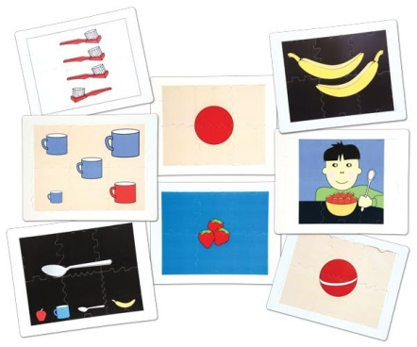

Purpose
In late FY 2015, APH was notified by one of its printers that the price on TADPOLE overlays was about to double. This increase was not due to an increase in the paper that the images were printed on, but on the printing process itself. The project leader considered what other media were available for presentation of the TADPOLE images. She sought information about a tablet app as a possibility. By using an app, the images could be presented with sound and instruction, so it was decided to do it that way.

Project Staff
Martin Monson, Project Leader
Elaine Kitchel, Low Vision Project Leader
Frank Hayden, Director of Technical & Manufacturing Research
John Hedges, Programmer
Heather Kennedy-MacKenzie, Project Leader/Technology Liason
Steve Mullins, Studio
Anthony D. Jones, Art Production/Design Manager

Background
The search to substitute something for Light Box overlays due to increases in costs of screen printing led to the development of an e-pub application that could present the TADPOLE images on tablets or computers with music, instruction, and responses.

Utility
Usefulness of the images was established with the TADPOLE product. However, the use of the image on a notepad instead of the Lite Box is a different medium. Other products have established utility on notepads, and we are extrapolating from that knowledge that the TADPOLE images will be useful as well. But it has yet to be proved.

Relevance
APH made the decision to produce this product based on a standardized process of product selection. The product was proposed by the project leader and presented as a submission. In-house and out-of-house experts were asked to review the submission and give an opinion as to whether the product idea should move forward toward production. The product idea was then presented to the Product Evaluation Team and Product Advisory and Review Committee where it was subjected to questions and had to meet certain qualifying standards for APH product development.

This product is fully accessible to the population who will use it. Materials are available in large print, braille, and HTML files so all students, teachers, and practitioners who need accessible materials will have them.

This product follows APH guidelines for determining relevance of a product. It was affirmed by field tester teachers that their students with visual impairments often benefitted from the TADPOLE overlays. This fact was also affirmed by the students themselves who used the product in its original form.

There is evidence of an examination of the need for this product. There is currently no cost-effective method to produce the overlays that has been tested for and with students with visual impairments. This product was tested by in-house experts, students with visual impairments and their teachers. All groups affirmed that there was an identifiable need for the overlays in some accessible form for both students and teachers who have visual impairments.

This product addresses an identified need for a person who meets the definition of “visually impaired.” The need has been established because users are asking for it, and the responses by in-house experts and other testers of the materials indicate the beta product will fill that need.

In FY 2015, the overlay images were ordered to present concepts from simple to complex. They were arranged also to indicate and teach such concepts as off-on, inside-outside, part-whole, and so forth. A script was written, edited, and finalized. It was then sent to Steve Mullins to be recorded as WAV files. Meanwhile, John Hedges began the programming part of the effort. Anthony Jones prepared some SRG files to provide the layers that are needed for the graphics.

Work during FY 2017
The programming and tests of the images were completed. The program was made available to the public as a free download in November 2016.

Work planned for FY 2018
No further work is expected as this product is complete and available for customer use.

Topaz Filters [Modernization]
(New)

Purpose
To expand the line of UltraLens offerings to include topaz-tinted filters

Project Staff
Martin Monson, Project Leader

Background
The expansion of the UltraLens offerings to include topaz allows APH to offer customers an option that addresses the amount of blue light they are exposed to through computer screens, overhead lights, and so forth. However, its primary use is in conjunction with personal devices, such as tablets or smartphones given the large amount of blue light these devices emit and their close proximity to the eye when used by low vision users.

Product Description
The product will be offered in the same frame sizes and styles as the UltraLens but will be a topaz shaded filter.

Work during FY 2017
The modernization of the UltraLens to include topaz filters followed the process established at APH. To determine if there was a need for the topaz filters, a survey was created via SurveyMonkey®, and the survey notice was listed in the APH News.
According to the results of the completed survey, APH consumers thought APH should offer both a yellow and a topaz UltraLens. The majority of respondents (14/15) said they would buy both colors, try each with their students/clients, and give their students the one that seemed to meet their needs best. Several of the comments supporting the addition of a topaz UltraLens follow. These comments are representative of the type of comment received. While one of the respondents indicated APH should offer only the topaz lens, all of the supplied comments indicate a choice is preferred.
- Any additional lens options would be a benefit and all sizes would be so helpful. The lighting in most schools and the increase in technological demands causes the need for tinted lenses for so many students.
- It would be nice to have a choice of the topaz lens to help other students. Since other companies are difficult to find child size options in.
- I had a kiddo that would not wear sunglasses although he was light sensitive. But he would wear these glasses
- Yellow doesn't work for everyone!

While the number of respondents to the survey was small, and the annual sales of the yellow UltraLens are not great, it seems there is a group of people who would find a topaz UltraLens beneficial to the students/clients with whom they work. The product was approved by both the Product Evaluation Team and the Product Advisory and Review Committee.
After approval by the product committees, several samples were ordered from two companies, Eschenbach and Noir. The samples sent from both companies were off-the-shelf products. All of the samples were for outdoor use and as such occluded too much light for the intended use. As Eschenbach produces a line of lenses titled “night drivers” that have a very small amount of tint in them, it was decided to work with that company to produce the topaz lenses. However, after continuing to try to develop this line of lenses with Eschenbach throughout most of the year, it was decided to develop the lenses with Noir instead. This decision was due to the fact that Eschenbach couldn’t economically provide the lenses in the frame sizes APH needed and in the small quantity that past sales have indicated is required. Noir does produce lenses in the sizes that APH requires. Noir is the current vendor for the yellow UltraLens and can meet our low-volume purchasing requirements.

Work planned for FY 2018
Work planned for FY 2018 will involve working with the second identified producer of colored filtered lenses, Noir. Noir currently produces the yellow UltraLens that APH sells. As such, the frame sizes should be available and in the small quantities that APH requires. The work of FY 2018 will focus on working with Noir to determine their ability to produce the topaz lens in the desired range of light occlusion. This product modernization should be finalized in FY 2018.

VisioBook® Bag [Modernization]
(New/Completed)

Purpose
To design and develop a carrying case for the VisioBook® and its power cord

Project Staff
Elaine Kitchel, Project Leader
Martin Monson, Project Leader
Frank Hayden, Director of Technical & Manufacturing Research

Background
Since it has been offered for sale, APH has received requests for a computer-bag-style carrying bag for the VisioBook®. Requests have come from Ex Officio Trustees, consumers, and others.

Product Description
The carrying bag is a heavy-duty, black nylon bag that has zippered compartments with measurements designed to allow a VisioBook® to fit snugly inside. It also has a separate compartment designed to carry the power cord. The bag comes with a bright orange zipper pulls to allow users with a visual impairment to find the zippers quickly and easily.

Work during FY 2017
Several manufacturers were contacted and given measurements and a list of desired features. The manufacturers replied with price quotes, and a sample was procured. The sample was examined by several employees at APH who use a VisioBook®. Comments were gathered from those employees on ways to improve the bag. One result of this was the inclusion of the bright, high-contrast orange zipper pulls. The VisioBook® carrying bag was offered for sale in February 2017.

Work planned for FY 2018
There is no work planned for FY 2018 as this product is complete.

SOCIAL INTERACTION SKILLS

For FY 2017, there are no active Social Interaction Skills products to report.

TESTS AND ASSESSMENTS

Boehm Test of Basic Concepts, Third Edition (Boehm-3): Tactile and Large Print Adaptations
(Completed)

Purpose
To fill the need, expressed by the field, for a large print and a tactile version of this test of basic concept acquisition in visually impaired children ages 6 through 8 (kindergarten through 2nd grade)

Project Staff
Ann E. Boehm, Project Advisor
Kay Alicyn Ferrell, Project Leader
Catherine Smyth, Project Consultant
Katherine Corcoran, Model Maker
Frank Hayden, Director of Technical & Manufacturing Research
Anthony D. Jones, Art Production/Design Manager
Anthony Slowinski, Graphic Designer
Carolyn Zierer, Project Advisor
Laura Zierer, Research Assistant

Background
Based upon feedback from the field, it was determined that a student large print and a tactile adaptation of this testing instrument should be developed using a research-based model. The first Boehm Test was adapted in tactile format by APH in the 1970s, so there was a tradition of interest in and recognition of the importance of this testing instrument for our populations. Evaluation of the development of basic relational concepts in visually impaired children is now known to be crucial. The tactile and big picture version of the K-2 Boehm is an extension of the Boehm-3 Preschool, a project completed in FY 2014.

Permission to do an adaptation of the Boehm 3rd edition was sought from the publisher, Pearson Assessment, as part of a research project using the adapted preschool materials. The project to do the school age Boehm-3 was proposed by Dr. Kay Ferrell and Dr. Jane Farber, with the approval of Dr. Ann Boehm (author of the test).

The idea to adapt the preschool and school-age versions of the Boehm Test of Basic Concepts was brought forward through the Product Evaluation Team and the Product Advisory and Review Committee initially in the 3rd quarter of FY 2010. The project leader did preliminary library research into the Boehm Test, including past research studies and publications about basic concept and haptic development in blind children. The concepts covered in the Tactile Treasures Kit by Karen Poppe at APH were partially based upon those in the original Boehm Test. Poppe’s insights about production methods on Tactile Treasures helped to inform the model maker’s development of the Boehm-3 school-age prototype.

Once the preschool project was near completion in FY 2012, Catherine Smyth was hired as the consultant for the school-age edition. Elaine Kitchel and then project leader Barbara Henderson reviewed the Boehm-3 test Form E for low vision and color vision deficiency considerations. During FY 2014 and 2015, Smyth met with Dr. Boehm to begin designing the tactile adaptations to Form E of the school-age version. Work was suspended on the school-age version when revisions to the Boehm-3 Preschool became the priority and resumed again with the June 2014 publication of the Boehm-3 Preschool.

Catherine Smyth, consultant to this project and a doctoral candidate at the University of Northern Colorado, is collecting data for a validation study of the Boehm-3 Preschool. Her research design requires 120 participants between the ages of 3-0 and 5-11 years. She hopes to defend her dissertation in FY 2017.

The Boehm-3 Preschool was presented at the Getting in Touch with Literacy Conference in New Mexico in November 2015. It was also presented at the International Society on Early Intervention Conference, “Children’s Rights and Early Intervention,” in Stockholm, Sweden, in June 2016. The session in Stockholm attracted the attention of several international participants, including a colleague from the Netherlands who has worked on the Tactual Profile assessment.

Field testing of the Big Picture and Tactile editions of the Boehm-3 was completed in FY 2015 and included in the Annual Research Report for that fiscal year. Revisions to the Big Picture Edition continued during the first part of FY 2016, while simultaneously the Tactile Edition was completed by the model maker. Scripts for administering the test were finalized and translated into Spanish. Braille-ready files (BRF) of the scripts were prepared. Both editions have gone through numerous revisions to correct errors.

Work during FY 2017
A Specifications Meeting convened on October 31, 2016. The product was placed into production. An airplane was released on May 16, 2017, making this product available for our customers.

Functional Skills Assessment
(Continued)

Purpose
To provide assessment tools for daily living/functional skills for students in primary grades, middle school, secondary school, and transition classes

Project Staff
Terrie (Mary T.) Terlau, Adult Life Project Leader
Diane Bender, Project Author/Consultant
Laura Zierer, Project Assistant
Laura Greenwell, Graphic Designer
Monica Vaught-Compton, Project Assistant
Kelly Kennedy Mimms, Research Assistant
Michael McDonald, Programmer
Andrew Moulton, Manufacturing Specialist

Background
As the expanded core curriculum becomes increasingly important in the education of students who are blind or visually impaired, a systematic method to assess a student’s progress in learning functional skills becomes essential. Dianne Bender’s assessment system for functional skills has been developed during her extensive teaching career in a residential school for the blind setting. Her system is comprehensive and provides scoring procedures so that students' progress can be tracked from year to year.

Preliminary Research
Terlau has collected skills assessment protocols used by schools for the blind and rehabilitation centers. She has also monitored e-mail lists in which assessments of functional skills have been discussed. Examination of these resources supports the conclusion that many schools for the blind, university training programs, and rehabilitation agencies have developed their own strategies for assessing different aspects of self-care and daily living tasks. However, a systematic assessment process that incorporates a criterion-based scoring system and utilizes core curriculum skills in all levels of its functional assessment has not been made widely available. The need for such a comprehensive system has been expressed by numerous educators of persons who are blind or visually impaired. Bender’s system is being used as the basis for the Functional Skills Assessment project because of its comprehensive coverage of functional skill areas; scorable testing protocols; and concise, clear testing directions.

Initial Product Development
Telephone conferences with Bender resulted in the finalization of four areas to be included in the Functional Assessment: Food Management, Clothing Management, Self Management, and Home Management. Based on this plan, Bender submitted revised materials for all four levels of each module. Item editing and revision and creation of additional items by Bender and the project leader have continued.

During FY 2009, the project leader reviewed all items at all levels in all modules of the system. She prepared suggested item changes throughout all modules and levels of the assessment to support more standardization across assessors and to equalize weights given to similar items across module levels. She spoke with Bender about these issues, provided general descriptions of and rationale for item changes, and prepared specific item change suggestions in spreadsheet format. Spreadsheets with specific item content changes were sent to Bender for consideration and review.

During FY 2010, in monthly teleconferences, Bender and the project leader reviewed changes to support test-retest and inter-rater reliability, redesigned the scoring system to enhance psychometric properties of the test, determined final rewrites of items in the Clothing Management and Food Management modules, wrote scoring scenarios and item explanations for these modules, and developed plans for content of the Home Management and Personal Management modules.

During FY 2011, Bender and the project leader continued to refine the test scoring system, rewrote scoring scenarios for previously completed modules to conform to new test scoring procedures, and wrote items and scoring scenarios for the Self Management Module. Because of extensive reworking of previously completed modules in order to improve standardization strategies and potential for high inter-scorer reliability, new item development was confined to the Self Management Module, with work on the Home Management Module postponed to FY 2012.

During FY 2012, item content, item explanations, scoring criteria, and scoring scenarios were completed for the Home Management Module. The Self Management Module was revised to include self-care, social skills, and consumer skills.

During FY 2013, the Scoring Booklet for the Home Management Module was developed and revised to include not only information needed to score each item, but also information that teachers would want to know about techniques and skills that the student used as the testing task was performed. Excessive detail was omitted from the Scoring Booklet, and language for all test items in the Assessment Manual was changed to conform to this Scoring Booklet style. Terlau prepared Scoring Booklet draft item layouts for the remaining three modules.

During FY 2014, Scoring Booklets for Home Management Assessment and Clothing Management Assessment were edited and redrafted to request more material from examiners about how various tasks were performed. Scoring Booklet layout was finalized. Terlau prepared drafts of Food Management Assessment and Self Management Assessment to conform to improved layout and data collection procedures.

During FY 2015, Terlau completed the first chapter of the assessment manuals. All manuals and scoring books were edited and made ready for field testing. Field test evaluation forms were prepared, and field test sites in K-12 and adult settings were identified. Field test materials were sent to 19 testers: 11 testers and one expert reviewer for use with K-12 students; and three testers and four expert reviewers for use with adults. Useable field test materials were returned by 12 testers (63% of the total group): six testers and one expert reviewer for use with K-12 students; and two testers and three expert reviewers for use with adults.

Table 1 displays the regional distribution of the 19 initial testers and the 12 who returned useable material as a whole and according to whether they tested K-12 students or Adults.

Table 1
Regional Distribution of Field Test Sample

 | Initial Tester Sample |  |  |  |  | Testers Returning Useable Materials
 | Northeast | Midwest | South | West | Total | Northeast | Midwest | South | West | Total
K-12 | 2 | 5 | 3 | 2 | 12 | 0 | 4 | 3 | 0 | 7
Adult | 3 | 0 | 3 | 1 | 7 | 2 | 0 | 2 | 1 | 5
Total | 5 | 5 | 6 | 3 | 19 | 2 | 4 | 5 | 1 | 12

Table 1 shows that the initial 19 testers were fairly equally distributed across the Northeast, Midwest, and South, but were somewhat under-represented in the West. However, the 12 testers who returned useable materials were not equally distributed across regions, with the Northeast and West being very under-represented. Functional Skills Assessment results are analyzed separately for use with K-12 students and for use with adults. The seven testers who returned useful materials for K-12 students and the five testers who returned materials for adults, considered separately, display very poor regional variation. Because factors that vary across geographic region were not expected to impact evaluations of Functional Skills Assessment, the limited geographical distribution of testers did not reduce the value and utility of field test results.

Three expert reviewers and two testers working with adults strongly suggest that the developmental focus of this assessment is not useful for adults who have been visually impaired and for adults who lose vision in adulthood. Because this product was constructed primarily for use with K-12 and transition students, the finding that this assessment was not appropriate for use with adult students was not surprising. Responses from the five testers regarding adult functional skills assessment needs offer directions for future product development for this population.

Overall, the six field testers who used parts of the assessment with their K-12 students and the expert reviewer found this assessment to be a valuable tool for tracking student progress. Testers agreed that test items were age/level appropriate, that administration directions were clear, and that the scoring criteria and scoring scenarios were helpful. Two testers commented that assessing a task (e.g., doing laundry) helped the student take more responsibility for doing the task at home.

Results suggest that scoring books should be simplified. Scoring Books should retain the summary description of the task, the table for recording which aspects of the task the student performed correctly, the scoring criteria, and the line for the item score and date. However, testers did not fill in approximately half of the scoring book fields for descriptions of how the student performed the task, and several testers commented that several of these fields were not necessary. Based on this feedback, a thorough review of qualitative fields in the scoring book was undertaken. Approximately 50% of the qualitative questions were omitted.

During FY 2016, it was decided that the field test results supported the need for a redesign of scoring books. Abandoning the item layout on two facing pages, the new scoring book design provided summary information on the first page and scoring tables for three administrations of the test item on the next three pages. Items adapted for students with multiple disabilities were included in their own scoring pages pack. In addition, pages were provided for administrations of an item beyond the three administrations in the scoring book, and other scoring pages were designed so that examiners could create and score their own test items. Further examination of expert review and field test results obtained from professionals working with adults with vision loss support the inapplicability of this developmentally focused assessment for adults.

In a meeting with the graphic designer and manufacturing specialist, the project leader clarified the product structure so that layout and specifications could be completed appropriately.

Work during FY 2017
Layout and content were finalized. Clean electronic files and printouts of the final layout of the four assessment manuals were provided to Braille Translation, with formatted braille files of the manuals to be made available as free downloads from the APH Web site. McDonald began working on the development of Web forms to supply scorebooks digitally. These forms will allow the user to store information on multiple students without the need for hardcopy scorebooks.

Work planned for FY 2018
It is anticipated that specifications will be completed and a Specifications Meeting held in FY 2018.

KeyMath™-3 Braille Adaptation
(Continued)

Purpose
In keeping with a long-time collaborative tradition between AGS/Pearson Assessment and APH, a braille/tactile adaptation will be developed. This instrument has been widely used to assess math skills of students who are visually impaired.

Project Staff
Carolyn D. Zierer, Project Leader
Laura Zierer, Project Assistant
Adam Clark, Manufacturing Specialist
Andrew Moulton, Manufacturing Design
InGrid Design, Graphic Design

Background
Continuing a long tradition of working with AGS Publishing to develop the original KeyMath™ and KeyMath™-Revised in braille/tactile formats, APH requested permissions from the new publisher, Pearson Assessment, to develop adapted versions of KeyMath™-3. APH requested the approved pre-production copy ahead of the print publication date in order to expedite production of the braille and large print editions. The project leader reviewed all test materials. Progress on the project stalled while waiting for copyright approval, during which time, the project was placed back on the PARCing (Product Advisory and Review Committee) Lot.

Application for copyright permissions was resubmitted, as better communications with the publisher were established during the last quarter of FY 2011. The project was removed from the PARCing Lot and brought into active development again. Debra Sewell was selected as a project consultant, and a project assistant was assigned.

During FY 2012, editing for braille translation resumed. The project leader and the consultant held a 2-day work meeting at APH in July 2012. The majority of the editing took place at that time. Several teleconferences were held in August and September to continue the work.

During FY 2013, a working meeting was scheduled during Annual Meeting in October for Sewell and the project leader to complete the remaining sections. Sewell and the project leader participated in an input session on KeyMath™-3 at Annual Meeting.

During FY 2014, work on this project was delayed.

During FY 2015, work resumed on this project with the project leader conducting a complete review for large print and braille adaptations. The adaptations were shared with three expert reviewers (Susan Osterhaus, Derrick Smith, and Sean Tikkun); each contributed feedback. A Product Development Committee meeting was held in February 2015 to introduce the components and layout of the large print and braille products. The project leader initiated contact with Pearson to inform them of our intentions to resume work on the project. The electronic PDF files were obtained from the publisher, and work resumed on the adaptation process for the large print. InGrid Design is working with APH to recreate the images and layout of the large print student book and teacher administration pages. Elaine Kitchel, APH Low Vision Project Leader, was consulted regarding the adaptations needed for students with eye conditions that may affect their ability to complete the large print assessment. Keeping in mind examiners who may need materials in an accessible format, the teacher pages will be produced in large print. A BRF will be supplied for teachers who are braille readers upon request. Laura Zierer, research assistant, created image descriptions for each of the images to be included with the administration directions. A meeting was held with the APH translation department to outline the details for braille translation and graphic illustration.

In FY 2016, work continued on the adaptation of the large print and braille forms of the assessment. InGrid Design continues to create the adaptation of the images for the large print, which has been an intense undertaking due to the changes needed to colors, spacing, and deletion of excessive details. Formatting the material in large print to be accessible for both teachers and students with visual impairments creates unique challenges while maintaining an assessment that is easily administered. Work resumed in translation on the braille adaptation and graphics in April after having been on hold due to other production commitments. An adjusted timeline was established.

Work during FY 2017
Work continued on both the large print and braille adaptations. After careful consideration and in the interest of time constraints with limited resources in braille translation, it was decided that only the student materials would be produced in braille. The administration manual and test record forms for the braille would be presented to the examiner in large print but not braille. The adapted versions were sent to three expert reviewers: Kathyrn Botsford, Sara Larkin, and Derrick Smith.

Work planned for FY 2018
A final specifications meeting will occur after completion of modifications as suggested by the expert reviewers. Production should follow soon after the final specification meeting, making the product available to our customers.

NewT: New Tools for Use with FV/LMA
(Continued)

Purpose
FV/LMA, a set of protocols for conduction of functional vision and learning media assessments, requires a set of tools for practitioners to use. The protocols within FV/LMA often require such tools as colored markers, print samples of varied sizes, photos, pictures, cartoons, rulers, and so forth to be used with them. In the past, practitioners have been responsible for the development of their own sets of tools. However, there is value in standardization and accessibility. When tools are standardized, other practitioners, optometrists, teachers and all people of a student’s vision care/educational team understand how the results of the functional vision and learning media assessments were gathered and analyzed. They all understand what the results mean. With the development of NewT, practitioners across the country will be able to interpret results from their colleagues’ reports when a child moves to a different state, for example. The NewT product will be accessible to all persons with blindness or low vision.

Project Staff
Martin Monson, Project Leader
Elaine Kitchel, Project Leader
La Rhea Sanford, Ed.D. Consultant
Rebecca Burnett, Ed.D. Consultant
Laurianne Matheson, Consultant
Bryan Rogers, Manufacturing Specialist
Katherine Corcoran, Model Maker
Anthony D. Jones, Art Production/Design Manager
Yoshi Miyake, Freelance Graphic Artist
InGrid Design, Graphic Design Firm
Denise Snow Wilson, Technology Product Specialist
Kelly Kennedy Mimms, Research Assistant

Background
FV/LMA became available in 2008. Dr. LaRhea Sanford, one of the originators of FV/LMA held several workshops through the National Instructional Partnership. After each of her presentations, practitioners, teachers, and early interventionists called APH to request sets of tools such as the kind NewT would provide. They want to procure the tools to complement their FV/LMA products. During the development of FV/LMA, Sanford and Burnett developed their own set of tools and made a list of those items. The project leader and other staff worked out ways to make all the tools and materials accessible for practitioners who have blindness or low vision. The project leader and consultant met in June of 2009 to determine the scope of the product, and to brainstorm about which items would go into the array of tools in NewT. The project leader then met with the manufacturing specialist assigned to the product and talked over the projected specifications.

Research
Burnett, R., & Sanford, L. (2008). FV/LMA: Functional vision and learning media assessment for students who are pre-academic or academic and visually impaired in grades K-12. Louisville, KY: American Printing House for the Blind.
Koenig, A. J., & Farrenkopf, C. (1995). Assessment of braille literacy skills. Houston, TX: Region IV Education Services Center.
Koenig, A. J., & Holbrook, M.C. (1995). Learning media assessment. Austin, TX: Texas School for the Blind and Visually Impaired.
Roman-Lantzy, C. (2007). Cortical visual impairment: An approach to assessment and intervention. New York, NY: AFB Press.
Sewell, D. (1997). Assessment kit of informal tools for academic students with visual impairments, part 1 – assessment tools for teacher use. Austin, TX: Texas School for the Blind and Visually Impaired.

Note: These are the first five of many sources. For a complete list of sources, please contact the project leader.

Relevance
APH made the decision to produce this product based on a standardized process of product selection. Drs. Sanford and Burnett brought the request to develop a kit of tools to accompany FV/LMA. They submitted a formal product idea submission through the Low Vision Project Leader in 2009. Among requests for the tool kit to accompany FV/LMA from the field, requests from the developers of FV/LMA, and requests from attendees at National Instructional Partnership need was established. The product idea was presented to the Product Evaluation Team and Product Advisory and Review Committee and accepted as a product.

This product is fully accessible to the population who will use it. Materials are available in large print, braille, and HTML files so all teachers and practitioners who need accessible materials will have them.

This product follows APH guidelines for determining relevance of a product. The NewT materials support the FV/LMA while the FV/LMA supports the practitioner and the optometrist as they do their parts of the functional vision and learning media assessments. The project leader solicited information from those who attended the FV/LMA workshops to make sure the NewT contained what they needed. In field testing, practitioners were again able to suggest what might be of use to them in the kit. Most of those suggestions were fulfilled.

There is evidence of an examination of the need for this product. The research showed that professionals wanted this kit of materials to use in conjunction with the FV/LMA product. An in-house panel reviewed the materials and forwarded them to field testers who also affirmed the need for the product in their practices. Additionally, APH receives phone calls each month from practitioners who want to know when the product will be released for sale.

This product addresses an identified need for a person who meets the definition of “visually impaired” as evidenced by the fact that the FV/LMA is an assessment for use with school-aged students who are visually impaired and on an academic track. It calls for a whole list of tools to use with it. APH has standardized that set of tools and made it available as a way to ensure the validity of the outcome of the FV/LMA when it is used to assess a student. The need was further affirmed by the experts who reviewed the materials.

In FY 2012, the project leader enlisted feedback from many of those who had attended the FV/LMA workshops to determine specific guidelines and grade levels for the NewT materials to meet. She and Dr. Sanford discussed this as well. The manufacturing specialist then identified which items in the tool array would be made within APH walls, and which ones would need to be procured outside APH. The project leader then examined several items procured outside APH to determine if they would be suitable for use in the NewT array. The project leader worked with the consultants who had specific requests about what they wanted in Nigel Newt’s Portfolios. Work continued on the products to be made within APH.

In FY 2013 and FY 2014, the consultants have developed a short informational booklet for use by the consumer. The project leader wrote and pursued layout options of grade-specific materials for use by teachers and practitioners who have low vision. These are the materials in Nigel Newt’s Portfolios. The project leader developed, formatted, and finalized Nigel Newt’s Portfolios. Field testing took place and data were analyzed.

In FY 2015, revisions were made based upon field test data. A search for an appropriate carrying case took place, and two additional cloth carrying bags were requested by the field testers. The project leader completed edits on student portfolios. The field testers requested a booklet that showed all the items in the kit and pictures and descriptions of how these are used. This booklet was developed and finalized. Braille translation was completed.

Work during FY 2017
Various portions of this product were proofed as the respective pilot run was completed for each of them.

Work planned for FY 2018
The portions of the product will continue to be proofed as pilot runs are made. All portions should have pilot runs completed, and the full product will be available for sale in FY 2018.

Test and Assessment Needs
(Ongoing)

Purpose
To determine the needs of the field with regard to testing and assessing students who are blind or visually impaired

Project Staff
Carolyn D. Zierer, Project Leader
Leasha Twyman, Research Assistant

Background
Meeting the needs of TVIs and others who are called upon to assess students who are visually impaired is the focus of this home project. The project leader worked with the staff of Accessible Tests and Communications in FY 2007 to develop the first Accessible Tests Web site. Comments received on how the field has come to view the Accessible Tests Web site included "the best information source out there."

Commercially-available products for development of Daily Living Skills, Job Skills Assessment, and Career Interest Inventories were reviewed by project staff because of their particular importance for instructors who transition students who are visually impaired.

During FY 2010, the project leader spent a lot of time with customers answering questions about the newly released Woodcock-Johnson® III Tests of Achievement- Braille Adaptation.

The project leader was asked to concentrate on the TEST READY® project as a priority. As a result, the project leader returned to the Research Department where projects were re-evaluated and new projects planned for FY 2011. One new project was brought forward in FY 2010 [Boehm-3].

In FY 2011, the project leader reviewed several new commercially-available assessments. Due to the division of responsibilities, Debbie Willis, Director of the Accessible Tests Department and staff took over the project to update Test Access: Guidelines for Computer-Administered Testing. Henderson agreed to assist Willis with finding resources and reviewing drafts. A package of articles and references were shared with Willis and staff in early FY 2011. The project leader also assisted Willis by reviewing chapters in a best practices document that Willis was reviewing for a test publisher. In August 2011, the project leader was invited to serve on a Common Core Curriculum advisory panel as Senior Advisor regarding accommodations for students who are visually impaired.

During FY 2012, the project leader served on the GED® Fairness Review Committee and attended three meetings to develop the new GED® test, which will be released in 2014. She also worked with Measured Progress™, ETS®, and SBAC to develop computerized testing guidelines for students who are visually impaired.

During FY 2013, the project leader considered the development of a new survey to determine the kind of guidance school systems need to ensure that their students with visual impairments make a successful transition to the Common Core Standards.

During FY 2014, a new project leader was placed in this position. Work began on projects that had been delayed.

During FY 2015, the project leader continued to seek input and explore commercially available assessments requested by professionals in the field of visual impairment. A survey was created using SurveyMonkey® online software to seek input from professionals in the field of visual impairment regarding assessments used in their districts for all students for kindergarten readiness, specific learning disabilities, and gifted education. The survey asked for input on which, if any, of these assessments were needed for the students who are blind and visually impaired. The Developmental Indicators for the Assessment of Learning™, Fourth Edition (DIAL™-4) was most often listed for Kindergarten readiness, Woodcock-Johnson® IV is most widely used for identifying specific learning disabilities, and Wechsler Intelligence Scale for Children®-Fifth Edition (WISC®-V) was listed for identifying students for acceptance into gifted and talented programs. When asked for input on what they most needed, the Woodcock-Johnson® IV and WISC®-V were most often listed.

An informational meeting with Houghton Mifflin Harcourt™-Riverside™ Publishing was conducted to share information about how to create materials in an accessible format for students who are blind and visually impaired. Overviews of best practice and guidelines were presented for creating accessible print content as well as points to consider when creating assessments for students who are braille readers.

The project leader continued to seek input from the field in regard to most needed assessments. The priority of developing partnerships with publishers and evaluating various commercially available products continued to be a primary focus as we strive to provide assessments for our TVIs and psychologists who serve the needs of our students. Houghton Mifflin Harcourt™ accepted our offer to assist in reviewing items in the development phase for accessibility prior to piloting. We are excited to embark on this venture to participate in the development phase and eliminating the task of retrofitting an assessment after it has been released.

Work during FY 2017
Input from the field was our first priority in order to become aware of the specific needs in the area of assessment. The project leader reviewed assessments that have been updated or revised by publishers and sought input from TVIs, school psychologists, and others on their priority needs in the field.

The project leader continued efforts to establish and maintain relationships with publishers, making it a high priority to seek representatives to discuss products available and our needs in the adaptation process while attending conferences throughout the year. The project leader encouraged publishers to invite APH to become a partner in the development process for new and revised assessments prior to piloting them with students.

Work planned for FY 2018
The project leader will continue to work with production to prepare needed assessments for our customers. The project leader will again survey end users as to what the needs are in the area of diagnostic assessments. Work will continue on fostering and establishing new relationships with publishers in order to increase the awareness of working in tandem on development of assessments.

Woodcock-Johnson® IV – Tactile and Large Print Adaptation
(Continued)

Purpose
To adapt this widely used psycho-educational assessment instrument for braille and tactile format

Project Staff
Carolyn D. Zierer, Project Leader
Cathy Senft-Graves, Project Consultant
Lynne E. Jaffe, Project Consultant
Jane Erin, Project Consultant
Sara Lee, Research Assistant
Laura Zierer, Research Assistant
Rod Dixon, Manufacturing Specialist
Anthony D. Jones, Art Production/Design Manager
InGrid Design, Graphic Design

Background
Tests of achievement are commonly used to assess academic strengths and weaknesses in children and adults. More than any other single title, practitioners in the field of visual impairment have expressed their desire to have APH provide an adaptation of the Woodcock-Johnson® IV (WJ IV™) for braille and large print readers. Many schools are moving beyond the Woodcock-Johnson® III and are now asking that the WJ IV™ be used since it is a more comprehensive battery of assessments.

Related Research
The Woodcock-Johnson® IV (WJ IV™) assessment is comprised of three batteries of assessments (WJ IV™ Tests of Achievement, the WJ IV™ Tests of Cognitive Abilities, and the WJ IV™ Tests of Oral Language). The three batteries of tests can be administered together or separately. There are additional assessments that have been added to the WJ IV™ such as phonological processing and verbal awareness. With the additional batteries, the WJ IV™ is a more comprehensive assessment that provides the teacher an even better picture of student strengths and areas of need.

During FY 2014, copyright permissions were sought from Houghton Mifflin Harcourt™-Riverside™ Publishing (HMH®-Riverside™) in June 2014. Planning discussions began with the publisher in July 2014. Lynne Jaffe, Ph.D., and Jane Erin, Ph.D., will be the project consultants completing the adaptation of the assessments for the WJ IV™.

During FY 2015, work continued on the large print and the adaptation for the tactile version. Electronic files were provided for the WJ IV™, and work began on the large print edition. InGrid Design is creating the images for the large print in an accessible format for large print readers. This process has been very labor intensive and time consuming, thus delaying the project. Many meetings were held to discuss layout issues. Much progress was made, and some of the components approved.

A preliminary Product Development Committee meeting was held in May 2015 to discuss the development of the braille edition. The braille adaptation was delayed due to unforeseen issues experienced by the consultant. Work did commence, and much progress accomplished. Several conference calls were held with HMH®-Riverside™ to discuss the progress of obtaining needed materials to complete the adaptation for a braille reader. Dr. Woodcock retains some of the data needed in order to make item substitutions for item accessibility. A conference call was conducted including Dr. Woodcock, HMH®-Riverside™, Jaffe, and representatives from APH. In our discussion with Dr. Woodcock, he was assured of our awareness of security as well as the availability of the instrument to only those persons who have received the necessary training to administer the assessment. With Dr. Woodcock’s approval, the consultants were able to obtain the needed files and work began on the braille edition. Each item was reviewed and necessary changes made to the Examiner’s Manual.

In FY 2016, Jaffe continued work on the development of the braille adaptation of the three batteries completing the examiner manuals for each battery as well as an administration guide. Test records and student materials were adapted for those tests, which are able to be adapted. All teacher materials were made accessible in large print for test administrators.

Negotiations with the Dailey Data Group (DDG), developer of the WJ IV™ scoring report software for Houghton Mifflin Harcourt™, were finalized. DDG is in the development phase of creating the scoring software for the braille adaptation. The APH Technology Product Research department and the project leader reviewed each of the versions of the software for accuracy and functionality.

The student test books were transcribed and proofread in the APH translation department. Cathy Senft-Graves conducted a quality assurance review of the braille. Most tests were completed, but work was paused until BANA published new guidelines on the treatment of mathematics being translated in UEB with Nemeth.

The large print WJ IV™ is currently in field testing. The initial prototypes were sent to eight sites in California, Texas, Arizona, Indiana, Illinois, Kentucky, Ohio, and Alabama. Due to a variety of circumstances, not all sites were able to complete their commitment to field test. One of the primary reasons was a result of the site not having access to the required publisher materials in order to complete field testing. Several sites had ordered their materials from the publisher but had not yet received them. Preliminary feedback received from the sites able to complete their evaluation of the large print prototype was extremely positive.

Work during FY 2017
During FY 2017, the evaluations and recommendations of the large print field test evaluators were carefully reviewed and all suggested modifications were addressed.

The field test was conducted by eight field evaluators representing six state sites: Alabama, Arizona, Illinois, Indiana, Ohio, and Texas. Their experience ranged from 0 years to 21+ years. The prototype was used with 15 students, 10 males and five females, representing three ethnic backgrounds. The students ranged from ages 5 to 19 years in grades 2-12. Twenty percent of the students were enrolled in primary grades, 40% were enrolled in middle school, and 41% were enrolled in high school. Eighty percent of students had additional disabilities such as SLD, CVI and deaf/blindness. Of the 15 students, 53% of the students’ primary reading medium was listed as only large print, 7% of the students used magnified print, and 40% of the students used a combination of large print and braille. Students participating in the field test were primarily selected based on the recommendation of their TVI. Accommodations were only permitted during the administration of the test contingent upon these being documented on the student’s current educational plan.

Summary: In the adapted large print WJ IV™, 90% of the tests within the three batteries were administered to students. Evaluations of the tests were very favorable in regard to utility. Field test results reflect that 94.5% of the evaluators agreed (51.3%) or strongly agreed (43.2%) that the student books provided in large print were functionally and adequately presented for students with low vision. Only 5.4% disagreed the material was not presented in an adequate manner. The issues presented by the evaluators were primarily focused on the construction of the books. It was suggested the spiral binding be larger to make it easier for the students to turn the pages independently. This was resolved by increasing the size of the spiral binding. Secondly, for tests that needed to be produced on wider paper, it was stated that the fold allowing the set to be inserted in a folder was a problem for a student. This issue was resolved by not folding and inserting these tests in a folder. Instead, these tests were spiral bound individually and presented under separate covers on the wider paper without folding. Thirdly, a concern was listed regarding the number of items per page and suggested the number of items per page be reduced in order for the size of the image and the number of lines provided for the student to respond could be increased. This issue was resolved by decreasing the number of images per page and increasing the number of provided lines per item for student responses. One concern was not addressed. It specifically pointed out that the Tests of Oral Language Test 6 Following Oral Directions was not accessible for students with CVI. This was discussed with experienced professionals in the area of CVI. It was said due to the complexity of the picture, a student with CVI would have difficulty with this test. She suggested that the test administrator allow the student to use windows to frame certain parts of the full page picture, thus allowing them to better view the scene.

Suggested changes were carefully considered and modifications were made accordingly. The WJ IV™ large print was released for sale on April 4, 2017.

Work planned for FY 2018
The goal was met for the WJ IV™ braille adaptation to have the completed adaptation of the student materials, authoring of the manuals, and preparation of the prototype for field test produced. Field test evaluators were sought through the APH News. The 10 evaluators are geographically diverse spanning from Hawaii to New York. All field test data will be compiled, analyzed, and modifications begun for the braille adaptation.

TECHNOLOGY PRODUCT RESEARCH

Larry Skutchan, Director

40-Cell Braille Display with a QWERTY Keyboard
(Continued)

Purpose
To develop a 40-cell braille display with QWERTY keyboard and local file reading and simple editing capabilities.

Project Staff
Keith Creasy, Project Leader
Larry Skutchan, Director, Technology Product Research
Ken Perry, Consultant

Background
In 2016, APH began the process of developing a 40-cell braille display with a QWERTY keyboard with simple reading and editing capability. Along with other goals, APH wants the device to be as inexpensive as possible and to work as a keyboard and a braille display when connected to most mobile devices and personal computers.

During FY 2017 the project was mostly stalled, due to updates in the technical specifications made in response to feedback from customers and a mandate for APH to “innovate” and not just “follow.” Additional funds were secured for making improvements and enhancements.

Work during FY 2017
Project staff completed the following:
- Developed specifications for improvements and enhancements to the original design
- Updated the budget and timeline for the project based on the new specifications
- Secured approval for additional funds for development
- Worked on the final contract (ongoing)

Work planned for FY 2018
- Finalize contract and timeline
- Begin development

Book Port Plus
(Continued)

Purpose
To develop a portable electronic device that is simple enough for anyone to use both for playback and recording of Digital Talking Books (DTBs) and to harness the capabilities of wireless networking to obtain content

Project Staff
Larry Skutchan, Director, Technology Product Research
Takuro Shiroki, Consultant
Mark Klarer, Programmer
Rob Meredith, Programmer
Keith Creasy, Programmer
Ken Perry, Programmer
Robert Conaghan, Technology Product Specialist
Denise Snow Wilson, Technical Communications Specialist
William Freeman, Quality Assurance Analyst
Rosanne Hoffmann, STEM Project Leader

Background
The National Library Service (NLS) transitioned to online and cartridge distribution of its titles. As the ever quickening capabilities of the Internet for educational and content distribution purposes explodes, the need for a portable, reliable, expandable reading device for a student who is blind in a technological classroom setting became apparent. In the time during the life of this product, most audio playback and reading functionality for many readers transitioned into apps running on smartphones.

Of the existing DTB players, the PLEXTALK® Pocket was identified as the hardware base that most closely met the desired characteristics. The PLEXTALK® Pocket contains 12 large telephone keys with a very pronounced dot on the 5 key, a five-way arrow/selection control, and six additional, easily distinguishable keys for various purposes including recording. Its keys are well spaced and arranged in a familiar telephone keypad layout.

In addition to its desirable key controls, the PLEXTALK® Pocket features state-of-the-art hardware that allowed it to advance over the next few years with quickly evolving standards. Standards of particular interest from the DAISY consortium are the online specifications that define methods for transferring content directly from the provider to the patron's device and specifications that will eventually let users answer test questions in a DAISY title.

APH contracted with Shinano Kenshi Co., Ltd., to adapt the existing PLEXTALK® Pocket (PTP1) DAISY player recorder to meet the following goals:
- Make the player and recorder easy enough for anyone to use
- Enable recording of DTBs with section support and the ability to edit and continue recording
- Make the player flexible enough for any kind of DAISY book or common file type including NLS, RFBD, and bookshare.org
- Make playback and navigation extremely responsive and intuitive to use
- Make text files editable
- Create input techniques (including ABC and Thumb Braille)
- Add support for braille files

The hardware already supported the following goals:
- Easily distinguishable keys
- Built-in speaker
- Microphone 3.5 MM stereo line-in/microphone jack
- 3.5 MM stereo headphone jack
- Replaceable battery
- Rechargeable battery
- High capacity secure digital card removable storage
- USB On-the-Go (OTG) support 802.11 B and G support
- Ability to play NLS cartridges
- Support for playing audio or Learning Ally™ CDs via an optional USB CD drive
- Built-in high quality text-to-speech (TTS) capabilities

Work during FY 2017
Development is complete.

Work planned for FY 2018
Work is complete. Future directions are driven by user feedback. Staff will continue search for the next generation of hardware or software solutions for educational reading tools.

APH continues to develop the Daisy Online server, which opens the possibility of creating a service that can run on commercial devices such as the Amazon Echo®.

Book Wizard Producer
(Continued)

Purpose
To continue to support Book Wizard Producer (BWP) by providing updates and support to the APH studio and other users

Project Staff
Keith Creasy, Project Leader
Mark Klarer, Programmer
Robert Conaghan, Technology Product Specialist

Background
BWP was developed from 2002-2005 to be used in the production of digital talking books (DTBs) for the Library of Congress, National Library Service for the Blind and Physically Handicapped (NLS), as well as the production of DTBs within APH and other organizations. Over the years, there have been additional needs and requirements as well as periodic updates to maintain compatibility and fix defects.

With the introduction of the “Hindenburg” system, commissioned by the NLS, we plan to suspend further development of BWP and only offer support and critical bug fixes for the currently available version.

Work during FY 2017
Staff completed the following tasks:
- Supported the studio in making the validation and protection tools work independently to support the use of Hindenburg

Work planned for FY 2018
Staff will continue to update and correct defects as needed.

BrailleBlaster
(Continued)

Purpose
To develop an application program to make the production of braille quicker, easier, and less expensive by taking advantage of the rich semantic markup found in National Instructional Materials Accessibility Standard (NIMAS) and EPUB® digital publications

Project Staff
Keith Creasy, Project Leader
Rezylle Milallos, Programmer
Michael Whapples, Programmer
Corey Knapp, Programmer
Leon Blakey, Programmer
Mike Gray, Programmer
Rebecca Luttmer, Programmer
William Tribbey, Programmer
Leyvis Valdez, Programmer
William Freeman, Quality Assurance Analyst
Jonathan Carson, Transcriber consultant
Denise Snow Wilson, Technical Communications Specialist
Jane Thompson, Product Owner
Julia Myers, Director, REAL Plan

Background
Currently the production of braille textbooks is a very labor-intensive process involving many hours of manual editing by professional and volunteer transcribers. The result is braille textbooks that are very expensive to produce and often take several months to complete. APH has committed—as part of The REAL Plan—to create tools and strategies to reduce the amount of labor required and thus the time and cost associated with producing braille textbooks.

APH began work on this new software tool in early 2012 and adopted the BrailleBlaster open-source project as our future braille production software system. Using BrailleBlaster, we are seeking to take full advantage of the rich markup found in NIMAS and EPUB® 3 files to translate into braille accurately and to quickly do much of the formatting work before a transcriber even begins to work with a textbook.

We found that while BrailleBlaster was an excellent concept, there was a great deal of work to be done in order for it to become a tool capable of meeting APH’s need to produce quality braille textbooks quickly. In particular, the very precise and detailed requirements of Braille Authority of North America (BANA), and Braille Formats 2011, were not well addressed.

Work during FY 2017
Staff worked on the following tasks:
- Continued to improve BrailleBlaster’s ability to format braille automatically
- Continued to improve the editing capabilities of BrailleBlaster
- Added and improved support for Unified English Braille (UEB) and Nemeth math
- Fixed defects, and made improvements based on user feedback and requests
- Introduced a new, simpler document model and better modularization to make BrailleBlaster more stable and easier to develop
- Added new features for editing math and technical material
- Added more support for translation and formatting of math, in both UEB and Nemeth
- Added importer and exporter framework
- Began work on supporting additional document types
- Added support for uncontracted Spanish
- Held several significant training and feedback events

Work planned for FY 2018
Staff will work on the following tasks:
- Continue to improve BrailleBlaster’s ability to format braille automatically
- Continue to improve the editing capabilities of BrailleBlaster
- Continue to add features and fix issues based on user requests and feedback
- Add better support for various embossers in both text and graphics modes
- Add more features for working with tactile graphics in BrailleBlaster
- Complete support for documents such as Word®, EPUB®, and text
- Continue developing features for STEM content

Graphiti™
(Continued)

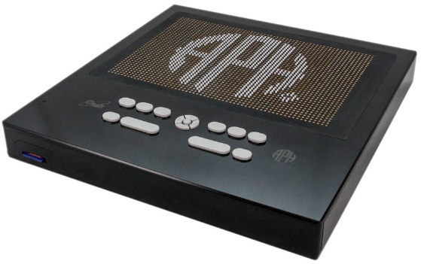

Purpose
To develop an affordable refreshable tactile graphic display that will work as a standalone unit and with a PC or other devices to display graphics on demand

Project Staff
Ken Perry, Project Leader
Jeanette Wicker, Project Leader (Core Curriculum Consultant)
Larry Skutchan, Director of Technology Product Research
Heather Kennedy-MacKenzie, Technology Program Manager
Venkatesh Chari, Consultant
William Freeman, Quality Assurance Analyst
Frank Hayden, Director of Technical and Manufacturing Research
Joseph Hodge, Quality Assurance Analyst
Ricky Irvine, Website and Video Designer
Stephanie Lancaster, Graphic Designer
Andrew Moulton, Manager of Technical and Manufacturing Research
Cecilia Peredo, Director of Grants
Denise Snow Wilson, Technical Communications Specialist

Background
The need for a refreshable tactile graphic display has been known for a long time, but has recently become critical as trends in the distribution of educational and testing materials are changing. While there are products that provide a proven solution, the inherently expensive nature of the piezoelectric actuator technology utilized leads to un-affordably high costs and consequently low adoption rates.

Past attempts to develop technically and commercially viable alternatives to piezoelectric actuator technologies have met with very limited success. While new technologies utilizing exotic materials and experimental fabrication methods hold promise, the investments involved remain prohibitively high and, as a result, the timeline to realize a mass-producible product is a long one.

In FY 2016, a product submission by Larry Skutchan was approved by the Product Evaluation Team and the Product Advisory and Review Committee

APH worked with Orbit Research to develop a contract for the development of the Refreshable Tactile Graphic Display through the winter of 2016. Orbit Research has extensive experience in the development and manufacture of products for the blind and has developed and demonstrated the essential technologies required for this product. A contract was signed by Orbit and APH in March 2016.

APH developed hardware and software specifications for the display. Orbit Research began work to develop and manufacture a low-cost refreshable tactile graphic display by utilizing conventional technologies, Commercially available Off-The-Shelf (COTS) materials and components, and proven mass-production methods.

The first prototype of Graphiti™ was presented to APH in April 2016. The first prototype was an array of 6 x 4 pins. The primary goal of Proto 1 was to develop and evaluate the motor design, the Force Limiter (springs), and the performance, reliability, and durability of the system design.

The second prototype, delivered in July 2016, was an array of 30 x 20 pins. It utilized the finalized design of the elements of Proto 1. The display connected to a PC and displayed graphics from an image library through software loaded on the PC. APH announced the development and exhibited the Graphiti™ prototype at AER International in July 2016.

The Director of Grants, Cecilia Peredo, procured a grant for $200,000 from the William Wood Foundation to provide the prototypes for expert review and field evaluation by teachers and students.

Work during FY 2017
Orbit Research delivered five Graphiti™ Proto 3 units by the spring of 2017. These units were a 30 x 20 array of pins but featured a “touch” interface that allowed the end user to “draw” on the display. APH began the first phase of evaluation with an expert reviewer in December 2016 using the first Proto 3. APH expanded the evaluation in the spring of 2017 to include three additional experts in the field of assistive technology and/or tactile graphics who provided input that was used to refine software and hardware for the full size units. APH and Orbit Research began the development of support for the interface of the Orion TI-84 Talking Graphing Calculator with the Graphiti™.

Orbit Research began delivering Graphiti™ Proto 4 units in June 2017. These are full size units of the Graphiti™ with a 60 x 40 array of pins and featuring the touch interface. APH began the expert review of these full size units.

Staff from APH presented or exhibited the Graphiti™ at several conferences including CSUN, California; Island Conference, Indiana; Sight City, Germany; Gateways, Kentucky; National Federation of the Blind (NFB), Florida; and American Council for the Blind (ACB), Nevada. A Proto Unit 3 is currently on display at the Kennedy Center in Washington, D.C.

Work planned for 2018
APH will expand the expert review and begin field testing full size displays of the Graphiti™ with a 60 x 40 array of pins and featuring the touch interface with teachers and students. APH and Orbit Research will finalize the form factor and prepare for production based on the feedback from expert reviewers and teachers in the field.

Indoor Explorer Feature for Nearby Explorer
(Continued)

Purpose
To add features to Nearby Explorer that allow a blind traveler to discover and locate indoor features independently

Project Staff
Larry Skutchan, Director, Technology Product Research
Keith Creasy, Project Leader
Ken Perry, Programmer
Rob Meredith, Programmer
Mark Klarer, Programmer
Jeremiah Rose, Research Assistant, Indoor Mapping
Joseph Hodge, Quality Assurance Specialist

Background
In FY 2016, APH began developing a new feature in the popular Nearby Explorer app that allows users to locate indoor features. While GPS is very useful for locating points of interest, intersections, addresses, and other features outdoors, it is often not accurate enough to make its use indoors practical. Using Bluetooth® beacons, APH has begun to add this new feature to Nearby Explorer. APH is also tracking and considering other techniques to allow for accurate indoor positioning.

Work during FY 2017
Project staff completed the following:
- Added the new “Indoor Explorer” feature to Nearby Explorer for iOS®
- Continued work on adding the indoor capabilities to Android™
- Collaborated with TRX to use Nearby Explorer for Android™ to test and possibly use their indoor location technology
- Mapped and deployed beacons in several venues such as APH, Crescent Hill Branch of the Louisville Free Public Library, the Louis Lab center for innovation, The Windham Grand Pittsburg hotel
- Developed a technique for mapping indoor spaces, and adding that data to OpenStreetMap®
- Added support for searching OSM for indoor features and available beacons
- Developed relationships with and acquired memoranda of agreement from several Louisville area venues
- Held meetings and collaborated with other indoor projects to develop a standard for shared indoor information, to avoid redundancy

Worked planned for FY 2018
Staff will work to complete the following:
- Continue to test and improve indoor location accuracy
- Develop OSM support library or SDK to allow it to be added to other apps
- Map at least 20 new venues and deploy beacons
- Complete development for indoor features in Nearby Explorer for Android™
- Release a free version of Nearby Explorer for iOS® that includes indoor features
- Continue to develop mapping techniques, documentation, and tools with the goal of allowing anyone to replicate the process

Math Flash Online [Modernization]
(Continued)

Purpose
To develop an accessible software program that provides math drill and practice in a flash card format. This is a modernization of an existing product.

Project Staff
John Hedges, Project Leader/Programmer
Robert Conaghan, Technology Product Specialist
Denise Snow Wilson, Technical Communications Specialist
Background
Math Flash is a talking software program that currently runs under Windows®. Professionally narrated digitized speech present math problems in a flash card format and respond with fun positive and negative feedback. The program lets the teacher specify the kinds of math problems to use and the ranges of the numbers. It allows the use of the four basic arithmetic functions in any combination, as well as the use of positive and negative numbers. The teacher can also allow division with or without remainders. Math Flash generates the problems randomly, or the teacher can use specific problems and save the preferences to disk.

The program offers three main modes of presentation. Drill mode allows the student to practice problems and offers feedback after each answer is entered. Test mode presents the problems, but does not give feedback on the results until all problems have been completed. Auto mode presents problems, pauses for a group of students to shout out an answer, and then gives the correct answer and moves on to the next problem.

Math Flash received Quota approval from the Educational Products Advisory Committee and became available from APH in the spring of 2000. It has been a tremendous success and captures the attention of children and adults alike, both sighted and visually impaired.

The modernization of Math Flash will develop an online version with similar features that operates in a browser on multiple platforms.

Work during FY 2017
Initial prototypes show promise of techniques that can deliver the rich experience through Web standards.

Work planned for FY 2018
Staff plan to add features to the initial online version, conduct an expert review of the program, and make it available. Further enhancements will be added as feedback is obtained.

Money Talks
(Continued)

Purpose
To update Money Talks to support new features and fix outstanding issues in the Windows®-based bank account management software package that is easily accessible to persons who are blind and visually impaired

Project Staff
Terrie (Mary T.) Terlau, Adult Life Project Leader
Larry Skutchan, Director, Technology Product Research
Rob Meredith, Programmer
Michael McDonald, Programmer
Darleen Donhoff, Manufacturing Specialist

Background
Keeping bank account records on a computer provides a reliable method of maintaining check registers and account balances. However, mainstream bank account management software presents some access obstacles to visually impaired computer users and is generally not accessible to visually impaired persons. Money Talks is designed to perform the full range of account management functions needed by blind and visually impaired persons. It is fully accessible, with speech and large print output built into the program itself. This program is also designed to be intuitive and user-friendly for persons with little or no computer experience.

The software was last updated in 2010, and the goal is to update it to use current versions of Windows® tools and to add features that have been requested in that timeframe. A list of requested features and issues is being created, and we have updated the software to have access to the newest Windows® features and tools.

Work during FY 2017
Work on Money Talks has been stalled as priorities shift.

Work planned for FY 2018
Staff will update the following:
- Add a field for Notes
- Project files
- Improve check alignment
- User interface updates
- Generate summarized reports

Monitoring Technological Developments and Educational Applications
(Continued)

Purpose
To identify and develop technological solutions that support educational needs; to monitor technological developments and educational applications of technology; to provide support to the other project leaders in the Education Research Department; to provide support to the Production area for various braille and Digital Talking Book production issues; to disseminate information on current uses of assistive technology

Project Staff
Larry Skutchan, Director of Technology Product Research
Heather MacKenzie, Program Manager, Technology Product Research
Rob Meredith, Programmer
John Hedges, Programmer
Keith Creasy, Programmer
Mike McDonald, Programmer
Rezylle Millalos, Programmer
Ken Perry, Programmer
Mark Klarer, Programmer
Corey Knapp, Programmer
Lawrence Lovelace, Programmer
Leon Blakey, Programmer
Rebecca Luttmer, Programmer
Michael Gray, Programmer
William Tribbey, Programmer
Lavis Valdas, Programmer
Rene Meza, Consultant
Haden Pike, Programmer
Michael Whapples, Consultant
Robert Conaghan, Technology Product Specialist
Denise Snow Wilson, Technical Communications Specialist
William Freeman, Quality Assurance Analyst
Joseph Hodges, Quality Assurance Analyst

Background
The rapid advances in use and development of software, hardware, accessibility, and educational theories require significant attention. The Technology Product Research (TPR) Department monitors and participates in numerous activities to keep abreast of developing trends and current implementations and encourages trends, policies, and standards that use technology to promote APH's mission. These ongoing endeavors help keep APH personnel knowledgeable and influential in the areas of regular and assistive technology.

TPR staff stays informed through participation in numerous electronic mailing lists that focus on programming and accessibility issues. The group actively uses and beta tests pre-releases of operating system code, key applications, accessibility APIs, screen enlargement, and speech or braille output accessibility aids. The group attends conferences, presents products and activities, and demonstrates APH products related to technology.

The TPR Department creates software for both internal research and use as direct products, applies expertise to help make APH effective and accessible in its production of braille and large print and its application of new and emerging technologies to these processes, and disseminates information to APH and directly to users. The group promotes accessibility within APH by establishing techniques that make the entire company accessible.

TPR staff regularly works with other project leaders to suggest and implement technologies for projects that have technological components in specific areas of interest. Such projects include a Web-based early trade book learning and management system for braille readers (see report for Early Braille Trade Books), an orientation and mobility instructor tool to help disseminate useful information to a client's parents, an interactive EPUB® for CVI, and a Web-based manual for wheelchair users that includes both video description and accessible captioning.

Work during FY 2017
- Staff continued to enhance several Web-based applications including some that define techniques for accessible closed captioning.
- Staff continued working closely with the Studio in order to create an efficient means of creating Digital Talking books and finding ways to improve the process.
- Staff continued work with the hardware and firmware for the Braille Buzz project.
- TPR continued to participate in beta testing, monitor electronic mailing lists, attend conferences, collaborate with other developers, and disseminate information.
- Staff provided advice and expertise at Product Advisory and Review Committee meetings, evaluated products submitted to APH for possible production or sale, helped ensure the accessibility of the APH Web site and online ordering systems, and participated in modernizing APH's recording studios.
- Staff regularly provided advice and technical assistance to APH's Business Contract Department and meets with staff from Customer Relations and Field Services to familiarize them with new products as they near their introduction date. Staff regularly consulted and assisted with technical or information requests via phone and e-mail.
- Staff worked with Human Resources to ensure that online documents for employees are accessible.
- Staff worked with the Computer Training Services on issues such as telephone systems and accessibility.
- Staff continued investigation into 3-D haptic feedback controllers as a method of providing tactile graphics or mapping information and actively monitored the development of 3-D printing devices.
- Staff provided support and markup services to other project leaders so that all product documentation is accessible in electronic format.
- Staff worked with project leaders to find methods to display rich media with accessible subtitles.
- Staff implemented and continues to refine a request tracking system and project management system for both software and hardware projects.
- Staff wrote and implemented a DAISY Online server and integrated four content providers (see tech.aph.org/bpdt_online.htm).
- Staff took over the Braille Blaster project and made major advancements to that project (see brailleblaster.org).
- Staff performed the executive functions of the Transforming Braille Group with the project to identify and execute a disruptive technology to dramatically reduce the cost of refreshable braille displays (see Orbit Reader 20).
- Staff began working with hands-on educational STEM content to find ways to make mainstream components accessible.
- APH joined the w3C and IMS Global.
- Staff consulted with project leaders on numerous software projects, including exploration of apps for Amazon Echo® and Google Home device.
- Staff wrote key generation functionality that lets legacy Windows® software get placed into stock and electronically distributed.

Work planned for FY 2018
The TPR Department will increase its involvement in the following:
- Digital document access
- Web app and streaming technology
- Rich media content distribution and accessibility
- Universal design concepts and alternative user interfaces
- Critical accessibility assurance of system components and emerging systems
- Information dissemination and advisement to government, manufacturers, and consumers about accessibility issues
- Develop high-quality, educationally-sound software and hardware solutions for students and adults who are blind and visually impaired
- Advance the accessibility of Web applications
- Continue to pursue ways of applying technology to the production of tactile graphics, help educate other project leaders, and look for ways to use technological solutions to further APH's mission
- Pursue funding for special projects and experiment with emerging technologies
- Continue to expand the APH network site license
- Continue to host and maintain Early Braille Trade Books and broaden its scope
- Complete an online UEB Math Tutorial modeled after the Nemeth tutorial
- Continue to make high-interest demonstrations, trainings, and presentations
- Continue to advance the Braille Blaster project and put it into production
- Continue development of the Transforming Braille Display (now Orbit Reader 20)
- Continue working toward partnering with commercial companies to make hands-on educational STEM learning materials accessible
- Continue development on Graphiti™ tactile graphics display and research developments in ways to deliver interactive tactile graphics

Nearby Explorer
(Continued)

Purpose
To improve orientation and mobility for blind users by providing contextual location based queues about configuration and proximity on common devices

Project Staff
Rob Meredith, Project Leader
Keith Creasy, Indoor Project Leader
Ken Perry, Programmer
Mark Klarer, Programmer
Laurence Lovelace, Programmer
Jeremiah Rose, Research Assistant
Robert Conaghan, Technology Product Specialist
Denise Snow Wilson, Technical Communications Specialist
William Freeman, Quality Assurance Analyst
Joseph Hodge, Quality Assurance Analyst
Tim Allen, Consultant
Michael Borsuk, Programmer

Background
The Nearby Explorer app began as a tool for the Braille Plus 18 Android™ braille smart phone/tablet and was offered to Android™ smartphone and tablet users through the Google Play™ Store in 2013.

Providing unique feedback via speech synthesis and braille with device positioning for targeted locations, this GPS tool gives blind users an interface that provides the information necessary to successfully navigate through both familiar and new areas with confidence.

The original goals of the project were the following:
- Provide location based information in outdoor spaces
- Share points of interest with other users
- Provide information about indoor spaces

The first two goals were successfully completed early in the project. Much progress was made toward the third goal this fiscal year.

In 2014, a blind pedestrian submitted a product suggestion through the APH Web interface to bring a similar tool to the iOS® platform.

In 2015, APH released a free, world-wide version of the app for the Android™ platform that does not use proprietary map data. Although it has not been translated into additional languages and requires a network connection for use, it has over 1,300 downloads.

In 2016, APH released a version of the app for the iOS® platform.

Work during FY 2017
APH continued to receive constructive feedback from users. Many features were added to the iOS® version, including an onboard map update, support for contacts, and an initial implementation of indoor support. Four updates were issued for the iOS® version, while one update was issued for the Android™ version.

Indoor Lead, Keith Creasy, began work on a plan to implement the results of research conducted by consultant Tim Allen and other staff toward a solution that brings the feedback currently provided for outdoor spaces to GPS denied areas such as indoor spaces.

The plan combines locating beacons at exact positions and using multiple beacons to triangulate an accurate position, and then to use the position with regular point of interest objects.

Android™ Lead, Ken Perry, completed support for the Fused API in the full version of the app, and began porting the source code for the free version to modern development tools.

OSM Specialist, Mark Klarer, implemented a plan to use OpenStreetMap.org map data in the iOS® version. Data from OpenStreetMap® are converted to a special format for efficient access by Nearby Explorer and stored locally on the device. Five U.S. states from OpenStreetMap® are available for use in the app, at the time of this writing.

Technology Specialist, Robert Conaghan, continued to maintain the transit databases used by the program. Over 100 metropolitan areas are now supported by the Transit feature.

Work planned for FY 2018
Staff will work to complete the following:
- Improve both Android™ and iOS® versions as strategically necessary
- Refine indoor capabilities
- Provide documentation for venues detailing how to mark indoor spaces for use with the app
- Add more regions to OpenStreetMap® data

Nemeth Tutorial
(Continued)

Purpose
To provide a device-independent method for learning the Nemeth Braille Code for Mathematics that is both visually appealing and operates with refreshable braille displays for learners who are blind

Project Staff
Michael McDonald, Project Leader
Gaylan Kapperman, Project Leader (Consultant)
Shannon Pruit, Consultant
Ken Perry, Programmer
Keith Creasy, Programmer
Jeanette Wicker, Consultant
William Freeman, Quality Assurance Analyst
Denise Snow Wilson, Technical Communications Specialist

Background
Nemeth code is a humanly readable markup language that uses a system of symbols and rules to allow technical literature be presented and read in braille. It is designed to give as accurate a representation as possible to help facilitate communication between a user who is blind and his classmates, colleagues, and the world.

Designed by Abraham Nemeth, a Mathematics professor who was blind, this code was officially adopted for the United States in 1952. The official Nemeth Codebook was published by APH shortly thereafter.

The University of Northern Illinois (NIU) created a comprehensive Nemeth code training course that ran on Windows® based computers. It logically presented concepts in learning order along with exercises for the learner.

Later, a team of programmers modified the software to work with the Braille Lite from Freedom Scientific® and the BrailleNote™ from HumanWare™. As those hardware devices became obsolete and trying to maintain the code to continue working on Windows® became burdensome, the project creator sought a means of making the material available to more people and to find a platform that could be maintained easily.

In 2012, NIU staff and APH proposed creating a Web-based learning environment that could work on a variety of devices and would look good to a sighted teacher. Staff began investigating what interfaces could be used to work with Windows®, OSX, iOS®, and Android™ that would both be visually appealing and show proper braille content on a refreshable braille display connected to a device running a screen reader on one of those platforms. Taking advantage of the screen reader's braille interface meant the user could run the tutorial without the requirement of installing any software, but getting proper Nemeth code braille to show up for each screen reader became a challenge.

During the first phase of the research, project staff worked to complete the following:
- Examined how each of the screen readers automatically translated braille and noted that none was able to show Nemeth code output. During this phase, Apple® Inc., released iOS® 7, which included support for Nemeth code output to a braille display from properly encoded Web pages.
- Wrote Web pages that used the SimBraille font for visual learners
- Encoded Nemeth examples in unicode braille, so each screen reader displayed it properly
- Wrote exercise functions to examine student input
- Converted lessons to HTML
- Wrote exercise functions to evaluate and provide feedback
- Recruited field testers
- Coded test suggestions

In FY 2015, staff completed all of the lessons and exercises, released the Nemeth Tutorial, added six-key input support for users without access to a braille display, and updated the layout and look of the site

Work during FY 2017
Staff updated the tutorial to add instruction for the use of UEB braille in conjunction with the Nemeth code.

Work planned for FY 2018
Staff will finish up the UEB braille updates, as well as continue to correct any issues in the site.

Orbit Reader 20™
Formerly Transforming Braille Display
(Continued)

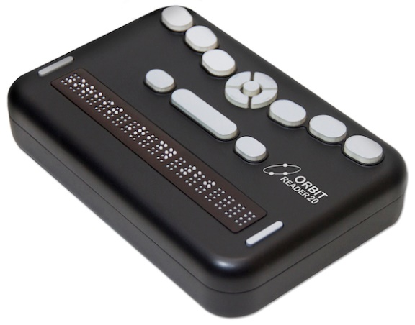

Purpose
To develop a low cost refreshable braille display

Project Staff
Ken Perry, Project Leader
Jeanette Wicker, Project Leader (Core Curriculum Consultant)
Larry Skutchan, CEO, TBG LCC and Director of Technology Product Research at APH
Heather Kennedy-MacKenzie, Technology Program Manager
Venkatesh Chari, Consultant
William Freeman, Quality Assurance Analyst
Frank Hayden, Director of Technical & Manufacturing Research
Joseph Hodge, Quality Assurance Analyst
Ricky Irvine, Website and Video Designer
Stephanie Lancaster, Graphic Designer
Andrew Moulton, Manager of Technical & Manufacturing Research
Bryan Rogers, Manufacturing Specialist
Rachel White, Research Assistant
Denise Snow Wilson, Technical Communications Specialist

Special Recognition
Kevin Cary, President, Transforming Braille Group (TBG) LLC
Luiza Aguiar, Perkins School for the Blind
Neil Jarvis, Blind Foundation, New Zealand
Clara Van Gerven, National Federation of the Blind

Managing Members of the TBG LLC
Association Valentin Haüy (AVH) in France
American Printing House for the Blind (APH) in the USA
Blind Foundation (formerly RNZFB) in New Zealand
National Federation of the Blind (NFB) in the USA
Norwegian Association of the Blind and Partially Sighted (NABP) in Norway
Perkins School for the Blind in the USA
Royal National Institute of Blind People (RNIB) in the United Kingdom
Sight Savers in India
Vision Australia in Australia

Advisory Board for the TBG LLC
CNIB (Canada)
CBM
Celia Library in Finland
The International Council on English Braille (ICEB)
National Library Service of the Library of Congress (NLS) in the USA
Sense International
Spanish National Organization of the Blind (ONCE) in Spain
World Braille Council (WBC)

Background
The Transforming Braille Group (TBG), an international collaboration of blindness organizations, works to increase literacy among blind people by dramatically lowering the cost to participate in the information revolution.

The prohibitive cost of refreshable braille displays limits many braille readers to a hard copy reading experience only. Refreshable displays are generally attainable only in the most prosperous countries, often supplied by government programs for education and employment. The market for a new device produced with a substantially less expensive technology consists almost entirely of readers who do not have access to the current displays. The TBG project is not meant to compete with the sophisticated multi-feature products now available, rather it is intended to bridge the gap between the abundance of accessible text files and the blind readers worldwide who have no tactile means of accessing them.

The objective of the TBG is to identify and implement a breakthrough solution that will radically reduce the cost of refreshable braille technology so that it both comes within the reach of blind people in developing countries and also allows braille libraries everywhere to give readers the choice of inexpensive electronic text files in addition to expensive hard copy braille.

The high cost of refreshable braille has remained constant for over 30 years. Recognizing this fact, in 2012, TBG resolved to disrupt the market by developing a technique to produce comparable refreshable braille at one-fifth the cost of units currently on the market.

By the middle of 2012, TBG had ranked all the existing projects and determined the top two choices. The group analyzed 63 projects for feasibility, likelihood, and maturation rate. This was a snapshot of activity at the time, and projects continue to develop. Some of the technologies hold significance, but maturation is too far away. Some cannot be mass-produced, others are too expensive, and others are great ideas, but not feasible.

On August 6, 2014, Orbit Research LLC and the Transforming Braille Group LLC announced an agreement to produce a low cost refreshable braille display. Orbit, an international engineering company based in Wilmington, Delaware, specializes in high quality, low cost products for blind and partially sighted people, is undertaking the research, development, and manufacture of this unique product.

Orbit Research provided multiple designs for review by members of the group. Most of the initial designs focused on form factor and key layout. There were eight different key layouts. Members met four times to evaluate the form factor and provided feedback about size and layout.

Representatives from APH, Perkins (Luiza Aguiar), NFB (Clara Van Gerven), and RNIB (Neil Jarvis) began bi-weekly phone conferences in August 2015 and continued through March 2016. Members of the group developed five different surveys to be used during field evaluation. APH, Perkins, NFB, and RNIB conducted the field evaluation of the Transforming Braille Display.

The five surveys included:
- Short Survey – to be used at conferences and presentations (Both USA and International)
- International Survey
- Adult Users (USA)
- Experts in the Field of Education and/or the Field of Blindness and/or Accessible Technology (USA)
- Teachers with Students (USA)

Also, during the meetings group members were advised of revisions and updates to the hardware and software, issues and concerns with the units, and members shared their progress with field evaluations.

An electronic mailing list was developed for all participants in the field evaluation so that questions and concerns could be addressed quickly during the evaluation period.

In October 2015, the APH News posted a call for field evaluators. Contact information for Perkins and NFB was included in the announcement and noted the different target audience of the three agencies. APH received 48 responses and chose 16 sites including three expert reviewers and 14 teachers at 13 sites. Field evaluators were chosen based on geographic distribution, age of students, the type of agency, and the expertise of the evaluator.

The Transforming Braille Group received a total of 103 evaluations.
- Short Survey – 40 responses
- International Survey – 17 responses
- Adult User (USA) – 17
- Experts in the Field of Education and/or the Field of Blindness and/or Accessible Technology (USA) – 15
- Teachers with Students (USA) – 14

The Transforming Braille Device was evaluated in the following locations:
- Australia - Melbourne, Victoria, Sydney, and New South Wales
- Canada – Alberta, British Columbia, New Brunswick, Nova Scotia, Ontario, Vancouver, and Quebec
- New Zealand – Auckland and Wellington
- United States – Washington D.C. and 20 states including Alabama, California, Colorado, Florida, Georgia, Illinois, Kentucky, Louisiana, Maryland, New York, Massachusetts, Michigan, Minnesota, Missouri, Montana, South Carolina, Virginia, West Virginia, and Washington

Field Evaluators
The field evaluators had a wide range of expertise.
Field Evaluators
 | Adult Braille User | Technology Instructor | Teacher of the Visually Impaired | Student/  Graduate Student | Professor
Short Evaluation | 31 |  | 9
International | 15 |  | 1 | 1
Adult User | 17
Expert | 4 | 3 | 5 | 1 | 2
Teacher with Students |  |  | 14
Total | 67 | 3 | 29 | 2 | 2

Neither the Short Survey nor the International Survey asked for Years of Experience.

Years of Experience were reported by Adult Users (reading braille), the Teachers with Students, and Experts in the Field of Education and/or the Field of Blindness and/or Accessible Technology.

Years of Experience
 | 0-5 yrs | 6-10 yrs | 11-15 yrs | 16-20 yrs | 21+ yrs
Adult User | 0 | 1 | 1 | 3 | 21
Expert | 1 | 1 | 3 | 0 | 10
Teacher with Students | 4 | 4 | 1 | 2 | 3
Total | 5 | 6 | 5 | 5 | 34

Neither the Short Survey nor the International Survey requested the ethnicity of the reviewer. Additionally, some reviewers declined to list their ethnicity.

Ethnicity
 | Hispanic | Amer. Indian | Black or African American | Asian | White | Two or more races
Adult User | 1 | 0 | 0 | 1 | 12 | 2
Expert | 0 | 0 | 0 | 1 | 14 | 0
Teacher with Students | 2 | 0 | 1 | 0 | 10 | 1
Total | 3 | 0 | 1 | 2 | 36 | 2

Neither the Short Survey nor the International Survey asked whether the evaluator had used a refreshable braille display prior to the use of the Orbit Reader 20.

Have you used a Refreshable Braille Display before? | Yes | No
Adult User | 16 | 1
Expert | 13 | 2
Teacher with Students | 13 | 1
Total | 42 | 4

Students
Nineteen students used the Orbit Reader 20 and ranged in ages from 5-18. One student was 5, one student was 7, one student was 9, one student was 10, three students were 12, three students were 13, three students were 14, two students were 16, one student was 17, and two students were 18 years old. One student’s age was not reported.

Students were enrolled in classes from Pre–K through 12th grade. One student was enrolled in Pre-K, one student was enrolled in second grade, two students were enrolled in third grade, one student was enrolled in fourth grade, three students were enrolled in sixth grade, three students were enrolled in seventh grade, two students were enrolled in eighth grade, one student was enrolled in ninth grade, one student was enrolled in tenth grade, two students were enrolled in eleventh grade, and two students were enrolled in twelfth grade.

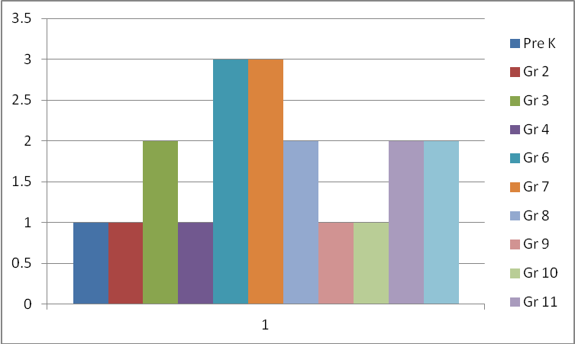

Six students were males, and 13 students were female. Fourteen students had no other disabilities/conditions that might impact braille reading skills, and five had additional disabilities/conditions that might impact their braille reading skills.

Thirteen students had a reading medium of braille, four students use a combination of print and braille, and two students use electronic braille.

Five students were enrolled in a residential setting, 12 students were enrolled in a mainstream classroom, one student received services in a resource room, and one student was enrolled in a special day class.

Ten students were reported as white, three were reported as Black or African American, two were reported as Hispanic, two were reported as Asian, one was reported as one or more race, and the race of one student was not reported.

Six students were reported to have beginning level braille skills, three were reported to have intermediate level braille skills, and 10 were reported to have advanced level braille skills. All students used braille on a regular (weekly) basis. Sixteen of the students had used a braille display before the field test, and three had never used a braille display.

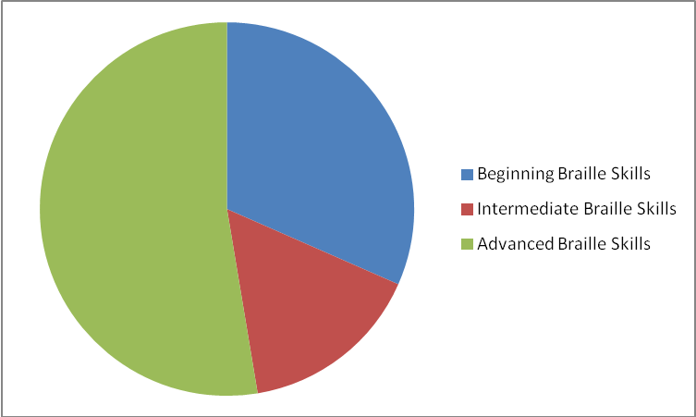

Seven of the students reported difficulties using the Transforming Braille Display, and 12 reported that they had no problem using the device. Of those reporting problems, five reported problems pairing the TBD with another device, one reported that the unit froze occasionally, one reported noise of the pins as an issue, and one student had difficulty finding and opening a document.

After instruction, 18 of the students were able to read independently using the TBD. The teacher of the Pre-K student noted, “She is not ready to be independent with any braille display. Her hands are not big enough or her fingers are not strong enough or coordinated enough to advance or go back without taking her hands off the pegs. She was not far from being independent with this display.”

Evaluations
Evaluators were asked to evaluate the mechanical design as well as the software and applications. The short survey only asked eight questions, and thus their responses are reflected in only a few of the questions.

It should be noted that all units were hand built and have some inherent differences. One unit was returned to Orbit for repair as the battery/charging circuitry had to be replaced.

The cells are spaced properly for easy reading.
 | Strongly Agree | Agree | Disagree | Strongly Disagree
Adult User | 10 | 7 | 0 | 0
Expert Reviewer | 10 | 5 | 0 | 0
Teacher with Students | 10 | 4 | 0 | 0
International | 12 | 5 | 0 | 0
Total/Percent | 42/67% | 21/33% | 0/0% | 0/0%

The dot height and spacing are suitable for easy reading.
 | Strongly Agree | Agree | Disagree | Strongly Disagree
Adult User | 12 | 5 | 0 | 0
Expert Reviewer | 10 | 3 | 0 | 2
Teacher with Students | 9 | 5 | 0 | 0
International | 10 | 7 | 0 | 0
Total/Percent | 41/65% | 20/32% | 0/0% | 2/3%

The refresh rate (the speed at which the pins change) is suitable
for efficient reading.
 | Strongly Agree | Agree | Disagree | Strongly Disagree
Adult User | 6 | 8 | 3 | 0
Expert Reviewer | 3 | 7 | 2 | 3
Teacher with Students | 4 | 8 | 2 | 0
International | 1 | 14 | 2 | 1
Short Survey | 9 | 21 | 8 | 2
Total/Percent | 23/22% | 57/55% | 17/17% | 6/6%

The position of the controls, keys (position and feel),
and braille display is suitable for comfortable reading.
 | Strongly Agree | Agree | Disagree | Strongly Disagree
Adult User | 5 | 8 | 4 | 0
Expert Reviewer | 5 | 6 | 3 | 1
Teacher with Students | 5 | 7 | 2 | 0
International | 4 | 9 | 4 | 0
Short Survey | 10 | 21 | 8 | 1
Total/Percent | 29/28% | 51/50% | 21/20% | 2/2%

The operation of the device was easy to understand.
 | Strongly Agree | Agree | Disagree | Strongly Disagree
Adult User | 6 | 9 | 2 | 0
Expert Reviewer | 5 | 9 | 1 | 0
Teacher with Students | 5 | 8 | 1 | 0
International | 9 | 8 | 0 | 0
Total/Percent | 25/40% | 34/54% | 4/6% | 0/0%

It was easy to recharge the device.
 | Strongly Agree | Agree | Disagree | Strongly Disagree | Did Not Attempt
Adult User | 9 | 5 | 2 | 0 | 1
Expert Reviewer | 9 | 5 | 0 | 0 | 1
Teacher with Students | 9 | 4 | 1 | 0 | 0
International | 7 | 4 | 0 | 0 | 8
Total/Percent | 34/54% | 18/29% | 3/5% | 0/0% | 8/12%

It was easy to determine the battery level.
 | Strongly Agree | Agree | Disagree | Strongly Disagree | Did Not Attempt
Adult User | 5 | 6 | 3 | 0 | 3
Expert Reviewer | 7 | 7 | 0 | 0 | 1
Teacher with Students | 9 | 3 | 1 | 0 | 1
International | 6 | 4 | 3 | 0 | 4
Total/Percent | 27/43% | 20/32% | 7/11% | 0/0% | 9/14%

How would you rate the battery life?
 | Very Good | Good | Adequate | Needs Improvement | N/A
Adult User | 8 | 4 | 0 | 3 | 2
Expert Reviewer | 8 | 3 | 1 | 0 | 3
Teacher with Students | 6 | 3 | 1 | 2 | 2
International | 5 | 4 | 3 | 0 | 5
Total/Percent | 27/43% | 14/22% | 5/8% | 5/8% | 12/19%

It was easy to find titles on the SD card.
 | Strongly Agree | Agree | Disagree | Strongly Disagree
Adult User | 8 | 9 | 0 | 0
Expert Reviewer | 9 | 5 | 1 | 0
Teacher with Students | 7 | 7 | 0 | 0
International | 9 | 6 | 1 | 0
Short Survey | 12 | 24 | 0 | 4
Total/Percent | 45/44% | 51/50% | 2/2% | 4/4%

It was easy to open a title saved on the SD card.
 | Strongly Agree | Agree | Disagree | Strongly Disagree
Adult User | 10 | 7 | 0 | 0
Expert Reviewer | 9 | 6 | 0 | 0
Teacher with Students | 10 | 3 | 1 | 0
International | 8 | 8 | 0 | 0
Total/Percent | 37/59% | 24/39% | 1/2% | 0/0%

It was easy to transfer a file from a computer.
 | Strongly Agree | Agree | Disagree | Strongly Disagree | Did Not Attempt
Adult User | 1 | 5 | 1 | 0 | 10
Expert Reviewer | 3 | 2 | 0 | 1 | 9
Teacher with Students | 6 | 3 | 2 | 0 | 3
International | 3 | 4 | 1 | 0 | 8
Total/Percent | 13/21% | 14/23% | 4/6% | 1/2% | 30/48%

It was easy to connect the TBD to a smart phone or tablet.
 | Strongly Agree | Agree | Disagree | Strongly Disagree | Did Not Attempt
Adult User | 2 | 7 | 2 | 3 | 4
Expert Reviewer | 2 | 4 | 1 | 1 | 5
Teacher with Students | 4 | 5 | 2 | 2 | 1
International | 3 | 5 | 4 | 0 | 4
Total/Percent | 11/18% | 21/35% | 9/15% | 5/8% | 14/23%

What do you consider the most important benefits of the TBD? (This was an open ended question. Responses from all five surveys have been combined.)
- Price – 36
- Portability – 17
- Good braille – 13
- Increased access to braille – 13
- Easy to use – 13
- Pairs with other devices – 12
- Size – 11
- Capable of holding many files – 6
- Battery – 2

Please list the major areas of difficulty or areas of needed improvement for the TBD. (This was an open ended question. Responses from all five surveys have been combined.)
- Bluetooth® connection/pairing devices – 14
- Noisy – 11
- Clunky keys/sticky keys – 10
- Keyboard layout and spacing between keys/too tight – 8
- Need note-taking ability – 6
- Need cursor routing keys – 6
- Refresh rate – 5
- Battery life – 4
- SD card slot not properly oriented – 3
- Needs a case – 3
- Needs “Find” command – 3

Expert reviewers and Teachers with Students were asked an additional question.

The TBD is appropriate for: (Check all that apply.)
 | Expert Reviewers | Teachers with Students
Elementary student who are braille readers | 73.33% | 100%
Braille students who are reading below grade level | 66.67% | 85.71%
Braille students who have a mild cognitive disability | 60% | 64.29%
Middle School students who are braille readers | 66.67% | 100%
High School students who are braille readers | 66.67% | 92.86%
Adult braille readers | 73.33% | 85.71%
School libraries that provide braille materials for patrons | 80% | 92.86%
Home settings – Parents and young students | 60% | 85.71%
Other – please list | 40%  Rehab agencies  Professionals  Patrons of NLS and Bookshare  TVIs | 21%  Newly blind  TVIs  DSS offices

Overall, how would you rate the TBD?
 | Good | Adequate | Needs Improvement
Adult User | 9 | 5 | 2
Expert Reviewer | 6 | 4 | 5
Teacher with Students | 7 | 5 | 2
International | 12 | 2 | 2
Total/Percent | 34/56% | 16/26% | 11/18%

Final Recommendations

Would you purchase or recommend the TBD for purchase by a braille reader?
 | Yes | Maybe | No
Adult User | 9 | 6 | 1
Expert Reviewer | 7 | 4 | 4
Teacher with Students | 11 | 3 | 0
International | 11 | 4 | 1
Short Survey | 21 | 17 | 2
Total/Percent | 59/58% | 34/34% | 8/8%

Evaluator Comments
Evaluators were asked to include any general comments.
- “The future is NOW. I love this device and just hope the cost delivers on the promise.”
- “The TBD has the potential to become a very useful device, which would be helpful to Braille readers of all ages in many settings.”
- “Looking forward to when the TBD becomes available.”
- “I personally think this is going to be a great addition for the braille students. My student loved it. It was easy for her to use and easy for her to move around.”
- “I really like it! Please let me know when it is available for purchase.”
- “Excellent, and this is just the Beta version.”
- “I can’t wait to get one for myself. I expect that it will be the primary way I read braille.”

Changes/upgrades made based on field evaluations and comments during field evaluation
- During the field test, hardware was upgraded several times. Many of these were to improve reliability. It was determined early on, for example, that the hand fabricated pins were not precise enough.
- The Power button was extended to make it easier to identify.
- The SD card orientation was slated to be changed.
- Experimented with key sound dampening and travel adjustments
- Replaced fixed pins with spring pins

Software also saw multiple iterations during field evaluation. Some of the software improvements included:
- Better screen reader support
- Enhancement of Bluetooth® communication
- Software update utility improvements
- Documentation
- Gross file movement commands added
- Enhanced refresh rate

Changes planned before release for sale
Hardware changes planned:
- Change the SD card orientation
- Change the input button mechanism type to scissor
- Change the navigation key mechanism type to dome
- Change both single pan buttons to dual rockers for more functionality
- Revise keyboard layout and spacing
- Add indent around braille pins for comfort and ease of reading
- Final positioning of tactile power button
- Add tactile indicators for USB and SD card slot
- Add entire device sound dampening
- Add rings to case enclosure to accommodate user supplied strap

Software and feature upgrades planned include:
- Basic note-taking capabilities
- Better file management commands
- Larger buffers
- Navigation compatible with traditional braille displays
- Better standby handling
- Several changes to the menus and menu user interface
- Language changing support for the user interface
- Refine Bluetooth® communication
- Improve power management
- Software enhancements to improve refresh rate
- Add “Find” command
- “Blinking” braille cell to indicate the device is “booting up”

During the field testing of the Transforming Braille Display, APH approved the development of the unit as an APH product. The Product Evaluation Team and the Product Advisory and Review Committee approved the Transforming Braille Display in January 2016. The Educational Products Advisory Committee gave Quota Approval in May 2016.

The Transforming Braille Display was announced at CSUN in March 2016, and the name was changed from the Transforming Braille Display to the Orbit Reader 20.

Work during FY 2017
APH staff continued the ongoing revision of the user manual, revised and updated the website, and shepherded the product through production and release for sale. APH continued field testing the Orbit Reader with users in the field. Staff monitored the shipments of units for quality control, provided workshops and training sessions on the Orbit Reader 20, and continued to update the software. Working with Orbit Research, staff developed the Spanish language files to allow the Orbit Reader 20 to be used in Spanish speaking countries.

Work planned for 2018
APH will acquire a stockable amount of units and begin selling the Orbit Reader 20. Staff will continue to update the software and revise the user manual to reflect any needed changes.

Orion TI-30XS MultiView™ Talking Scientific Calculator – Software Upgrade
(Continued)

Purpose
To provide software upgrades to the TI-30XS MultiView™ Talking Scientific Calculator

Project Staff
Ken Perry, Project Leader
Venkatesh Chari, Consultant
William Freeman, Quality Assurance Analyst
Jeanette Wicker, Core Curriculum Consultant
Denise Snow Wilson, Technical Communications Specialist

Background
The TI-30XS MultiView™ Talking Scientific Calculator was released in August 2015. The calculator is a modified TI-30XS MultiView™ that adds accessibility and additional controls providing a fully-accessible handheld scientific calculator—ideal for all students, middle school through college. Based on user reports to customer service, Orbit Research and APH determined a minor software upgrade was needed to fix bugs that were found after field testing.

APH staff has worked with Orbit Research to develop Version 1.0.12 Software Upgrade. The beta version of the software was offered to any Orion TI-30XS user through the TI-30XS List Serve. The beta software was also demonstrated at COSB STEM conference, the NFB National Conference, CSUN, and the IsLAND Conference. Feedback from beta users and conference participants was used to test the additional features and modifications to Version 1.0.

The final Version 1.0.12 Software Upgrade was announced in the August 2016 APH News. The upgrade is a free download and can be found on the Orion TI-30XS document page. The software enhancements and improvements include:
- Changes in recordings for some keys in learn mode to match what is displayed on the key. For example, the previous learn mode announcement for the fraction key was "Fraction" now, it is "N over D." This allows a user to find the key when it is described by a teacher.
- Corrected an error that sometimes caused the omission of negative numbers when announcing a list of numbers.
- Fix made to review navigation that did not work in some rare cases.

Work during 2017
Project staff continued to provide maintenance to the current software version. APH and Orbit Research listened to the input of users and educators as to possible software upgrades needed to improve the Orion TI-30XS including research on multi-language versions of the software.

Work planned for 2018
Project staff will continue to provide maintenance and updates to the current software version. APH and Orbit will continue the research of multi-language versions of the current software.

Orion TI-84 Plus Talking Graphing Calculator™ – Software Upgrade
(Ongoing)

Purpose
To provide software upgrades to the Orion TI-84 Plus Talking Graphing Calculator

Project Staff
Ken Perry, Project Leader
Venkatesh Chari, Consultant
William Freeman, Quality Assurance Analyst
Jeanette Wicker, Core Curriculum Consultant
Denise Snow Wilson, Technical Communications Specialist

Background
The Orion TI-84 Plus Talking Graphing Calculator, released in July 2013, has been a game changer in the STEM fields for the students who are blind and visually impaired. APH sold over 2,500 units in the first year following the release. Based on customer feedback gathered through e-mails, phone calls, and presentation at conferences, APH and Orbit Research determined a need for software upgrades.

APH worked with Orbit Research to develop and release multiple software upgrades for the Orion TI-84. All upgrades were free downloads and were made available on the Orion TI-84 documents page.

During 2016, APH staff has worked with Orbit Research to develop the Version 2.0.41 Software Upgrade. The beta version of the software was offered to any Orion TI-84 user through the TI-84 List Serve. Feedback from beta users and conference participants was used to develop the additional features and modifications to Version 2.0.41.

The Version 2.0.41 Software Upgrade was announced in the August APH News. The upgrade is also a free download and can be found on the Orion TI-84 documents page. With the 2.0.41 upgrade problems with speech quality are improved, mislabeled keys are fixed, and answers in some calculations that previously did not speak correctly are now fixed.

Work began on Version 3.0 and is planned for release early 2017. The early beta version has been demonstrated to APH staff, in-house testers, and at the AER International Conference.

Work during 2017
Project staff continued to provide maintenance to the current software. A contract was signed with Orbit Research to provide a direct connection of the Orion TI-84 Plus to the Graphiti™. The following milestones were completed:
- Development of a communication protocol between the Orion TI-84 Plus and the Graphiti™.
- The ability to display in a dynamic tactile way - what is on the Orion TI-84 Plus screen will display on the Graphiti™ both in text and graphs.
- Ability to scroll to portions of the graph that may be off the Graphiti™ display using the Graphiti™ touch function and keys.
- Ability to zoom to get better resolution on any part of a graph.

Work planned for 2018
Project staff will continue to provide maintenance to the current software. Working with Orbit Research the following milestones will be completed:
- The ability for the Graphiti™ to refresh when the screen scrolls under control of the Orion TI-84 Plus. For example, when arrowing through a trace screen and the calculator scrolls new content, the Graphiti™ will refresh.
- During an interaction with trace, graph, or draw screens, the cursor will be shown at the highest point. In the draw screen, the Graphiti™ will refresh as the line is drawn.
- The ability to have axis points and tick marks at different levels from the screen.
- Default the screens to a zoom level that would allow for the reading of text on all screens.

Studio Recorder
(Continued)

Purpose
To produce a simple-to-use, robust digital audio recording tool geared toward spoken word content

Project Staff
Larry Skutchan, Project Leader
Steve Mullins, Studio Director
John Zinninger, Studio Engineer

Background
Studio Recorder is a powerful digital recording and editing software package for making recordings of the spoken word. It includes features not found in audio recording and editing programs primarily designed for music production.

Studio Recorder was originally written for internal use at APH to serve as a tool for creating direct to digital audio recordings for the National Library Service (NLS). It was developed in the early 2000s. It contains many features that ease the task of recording, editing, and proofreading audio books.

While Studio Recorder was originally written for use by the professional narrator and narration monitor, its simple operation makes it ideal for nearly anyone interested in recording, editing, and producing spoken word audio documents in an efficient manner. For this reason, APH brought the product to market in 2002.

Work during FY 2017
For several years, Studio Recorder has been maintained on an emergency-only basis. There were no changes to the program in this fiscal year. While some minor changes would have been desirable, there was no staff time available.

Work planned for FY 2018
No work is planned at this time. The Technology Products Research department is considering requesting funds from the APH endowment to continue this project.

Talking Typer for iOS® [Modernization]
(Continued)

Purpose
To provide an app that teaches typing and improves speed and accuracy using iOS® devices

Project Staff
Lawrence Lovelace, Project Leader
Denise Snow Wilson, Technical Communications Specialist
William Freeman, Quality Assurance Analyst
Joseph Hodge, Quality Assurance Analyst

Background
Talking Typer is a self-voicing, typing, and computer keyboard training program. It helps instruct, drill, practice, and play games through typing lessons. For more than 10 years, it was only available on the Windows® platform. The iOS® version was created in response to a growing demand for iOS® applications and the need to modernize the current application. Talking Typer for iOS® provides letter, word, and phrase drills that are simple to use, keeps track of score, and provides visual and audible feedback. It also includes the Hurry Scurry game that appears in the Windows® version.

In response to this request, APH began work with the following tasks:
- Started a formal requirements document
- Created mailing lists to promote communication among APH and its testers
- Met with the graphic design team to discuss requirements
- Researched and compared existing typing applications

Work during FY 2017
The following project-related tasks were completed:
- Data framework and UI was replaced with Core Data
- Additional round of field testing was conducted
- Completed the quick start guide
- Completed the user guide
- Processed applications from field testers
- Support website was created
- Created the Quota version of the project
- Submitted the final version for approval by Apple®, Inc.
- Released to the public on the App Store® on April 14, 2017

Work planned for FY 2018
Project staff will work to complete the following tasks:
- Work on creating an additional game
- Start planning a “sharing lesson” feature
- Update documentation as necessary
- Ensure compatibility with the forthcoming iOS® 11

Talking Typer Web Application
(Continued)

Purpose
To provide a platform-independent Web application of Talking Typer, APH’s accessible, interactive keyboard training software

Project Staff
Robert Conaghan, Project Leader
Heather Kennedy-MacKenzie, Program Manager, Technology Product Research
Larry Skutchan, Director, Technology Product Research
Rene Meza, Consultant/Programmer
Lawrence Lovelace, Consultant
Michael McDonald, Programmer
Leon Blakey, Programmer
Denise Snow Wilson, Technology Product Specialist
William Freeman, Quality Assurance Analyst
Joseph Hodge, Quality Assurance Analyst

Background
Talking Typer Web is a standards compliant Web application for modern browsers building on APH’s four previous Talking Typer programs: Talking Typer for Apple® II, PC Typer, Talking Typer for Windows® (v. 1.14 released FY 2013), and Talking Typer iOS® (in development). Talking Typer for Windows® is a tremendously successful program that includes features that allow users to create and modify drills and dictation exercises. It also includes features for recording, storing, and examining student records. Feedback from the field and Educational Products Advisory Committee indicated the demand for an updated online version of this program.

In FY 2015, staff completed the following:
- Researched and reviewed current online typing tutorials for accessibility and function
- Created functional specifications
- Contracted and began work with software development company, Prosoft, LLC
- Implemented letter, word, and phrase drills and the ability to add custom drills
- Began work on universal sign-in to be used for Talking Typer and future APH web applications

In FY 2016, staff completed the following:
- Added library of default letter, word, and phrase drills
- Implemented admin, teacher, and student dashboards for managing content and progress
- Implemented keyboard explorer feature to explore keyboard with speech feedback
- Finished universal sign-in as a Web service to allow for student management and lesson creation and sharing from any modern browser
- Solicited feedback through field testing 4th quarter of FY 2016

Work during FY 2017
- Rebuilt development environment for better maintainability and to implement unit and regression testing
- Created application backend for managing users and lessons
- Refocused lessons to reflect Web standards, removed code that targeted non-conformant platforms
- Released core functionality for beta testing 4th quarter FY 2017

Work planned for FY 2018
- Review feedback from beta testers and update application accordingly
- Polish and test student and teacher dashboards, lesson assignment, and lesson scoring
- Implement “Hurry Scurry” or similar game to make typing practice more engaging
- Evaluate possibility for subscription sales within APH’s available systems
- Release product

Talking Word Puzzles [Modernization]
(Continued)

Purpose
To produce a Web-based educational game that uses hidden word or crossword-type puzzles with universal design concepts

Project Staff
Haden Pike, Programmer
Rebecca Lutmer, Programmer
Joseph Hodges, Quality Assurance Analyst
Robert Conaghan, Consultant
Denise Snow Wilson, Technical Communications Specialist

Background
The need for an educational type of game like hidden word and crossword puzzles has been long expressed by customers and experts in the field. APH's Product Advisory and Review Committee supported the idea for such a project in May 1998, and the programming group began work on the program in FY 2000 and released Talking Word Puzzles shortly thereafter.

Since the release of the program, requests for additional platforms have been most prominent.

Staff began work on an HTML5- and JavaScript-based version of the app that is platform independent and uses the most modern Web accessibility guidelines and principles.

Features include an intuitive and standards based approach to working with screen readers and other assistive technology to provide text-to-speech, refreshable braille, and large print navigation system through the puzzle grid. The interface includes appropriate, responsive speech, and highlighting feedback as the student uses the shift key along with the arrow keys to mark a word in the grid and distinguishable characteristics as the student moves across words already marked.

Specifications also call for a creation process that allows the teacher to enter either a list of words or a list of words and clues to those words in the case of a crossword puzzle. This data gets committed to persistent storage and all puzzles get dynamically generated from this information.

Work during FY 2017
Programmers are writing code to implement the specifications using Web standards, like ARIA, so the app works with every assistive technology.

Complete areas of functionality include:
- Grid Navigation through the puzzle
- Appropriate feedback as focus moves to a square in the grid that contains a number, letter, blank space, or black space
- Hot keys to move from the clue to the appropriate place in the grid
- Loading puzzles in XWC format

Work planned for FY 2018
Staff will finalize coding, field test the product, refine the product based on field test results, and release.
Talks remaining to complete include the following:
- Puzzle generation
- Additional file formats
- Online publishing
- Exportable embeddable Web component

Teacher’s Pet Web Application
(Continued)

Purpose
To provide a platform-independent Web application of Teacher’s Pet, software developed by APH to create and take tests, practice drills, and provide student progress record keeping

Project Staff
Robert Conaghan, Project Leader
Heather Kennedy-MacKenzie, Program Manager, Technology Product Research
Larry Skutchan, Director, Technology Product Research
Rene Meza, Consultant
John Hedges, Programmer
Michael McDonald, Programmer
Denise Snow Wilson, Technical Communications Specialist
William Freeman, Quality Assurance Analyst

Background
Teacher’s Pet Web is a standards compliant Web application for modern browsers designed to bring the functionality of Teacher’s Pet to the Web. Teacher’s Pet provides an accessible means of creating and delivering test and drill content to students with visual impairment though a variety of question types. Previous versions for the Apple® II and Windows® have been very successful, and feedback from users and the Educational Products Advisory Committee indicate the demand for an updated online version of this program. The universality of the Web offers opportunities to expand the functionality and convenience of Teacher’s Pet to correspond with the ever-increasing means of connectivity and interaction.

In FY 2015, staff researched benefits and limitations of Web as a platform for Teacher’s Pet, created functional specifications, and began exploring potential consultants. In FY 2016, staff completed selected consultant for application development and began work on website backend.

Work during FY 2017
- Work on Teacher’s Pet Web Application was paused during FY 2017

Work planned for FY 2018
Project staff will work to complete the following tasks:
- Implement basic feature set as test concept
- Work with experts to create sample and/or default question database
- Implement student and teacher dashboards
- Evaluate benefits of including student study features such as spaced repetition flash cards

Visual Brailler
(Continued)

Purpose
To provide a mobile version of a braille editor and exercise tool

Project Staff
Heather MacKenzie, Project Leader
Lawrence Lovelace, Programmer
Bryan Enders, Project Leader
Cathy Senft-Graves, Braille Literacy & Technology Project Leader
Denise Snow Wilson, Technical Communications Specialist

Background
APH has shifted its technological focus to portable devices, such as those running on iOS® platforms, in response to teachers, students, and consumers. One such request was for a braillewriter for iOS®. (See tech.aph.org/vbrl_info.htm.) Visual Brailler provides a tool for transcribers or those who want to practice braille.

In response to this request, APH began work on the following tasks:
- Hired an iOS® programmer
- Wrote objective coding guidelines
- Made app compatible with external hardware including Bluetooth® keyboards and braille displays
- Developed user interface art
- Developed user interface
- Developed the ability to send documents
- Provided a feature to cut, copy, and paste braille manipulation
- Made compatible with refreshable braille display input and output devices
- BRL (unformatted) and BRF (formatted) braille file export

Work during FY 2017
The following project tasks were completed:
- Worked on a Universal version to be compatible with the iPhone®, in addition to the iPad®; approximately 50% of the work complete
- Started working on the save and retrieve documents feature

Work planned for FY 2018
Project staff will work to complete the following tasks:
- Complete the universal version
- Complete work that allows documents to be saved and retrieved
- Ensure the current version is compatible with the forthcoming iOS® 11

UEB Math Tutorial
(New)

Purpose
To provide a device-independent method for learning the Unified English Braille (UEB) Braille Code used for mathematics that is both visually appealing and operates with refreshable braille displays for learners who are blind

Project Staff
Michael McDonald, Project Leader
Wendy Buckley, Consultant
Sandy Smith, Consultant
William Freeman, Quality Assurance Analyst

Background
APH will develop a web-based UEB Math Code Tutorial to assist blind students and adult learners in transitioning to the new UEB code. The tutorial will be a valuable tool for students and adults as they learn to read and write braille mathematics independently or with minimal assistance of a teacher assistant or rehabilitation instructor. The UEB Math Tutorial will follow the model of the successful Nemeth Code Tutorial developed by APH in 2015.

The project is being funded by a grant from the William M. Wood Foundation, Bank of America, N.A., Trustee. The grant will fund the content creation by Wendy Buckley and Sandy Smith, as well as the design and development of the website.

The UEB Math Tutorial will consist of four sessions, which introduce the rules governing the use of UEB Math Symbols and interactive activities to practice reading, writing, and proofreading UEB math. For an optimal experience, blind learners can use the UEB Math Tutorial in conjunction with a refreshable electronic braille display—a readily-available assistive-technology device that can be used to tactually read text displayed on a computer monitor. The explanatory session and three sessions on reading, writing, and proofreading are described below:

Explanatory Section
- Instructs users regarding the rules governing the use of UEB Math Symbols
- Defines UEB Math Symbols
- Provides appropriate examples to clarify UEB Math rules

Interactive Sections
Learning to Read UEB Math Symbols
- Displays UEB math expressions on a refreshable braille display for the learner to read aloud
- Allows users to compare their responses with an automated spoken expression using a simple key command

Learning to Write UEB Math Symbols
- Provides an automated spoken UEB math expression without tactually displaying it on the refreshable electronic display
- Directs the learner to write the expression in braille using the keys on the refreshable braille display
- Praises the learner when the correct response is given, and offers a humorous admonishment with encouragement for incorrect responses
- Allows learner to use edit commands to correct the error and reassess

Learning to Proofread UEB Math Symbols
- Asks learners to find the error in incorrectly written expressions on the braille display by listening to the automated correct expression
- Allows learner to use edit commands to correct the error and judge again

The UEB Math Tutorial will be aligned with the Common Core State Standards for Mathematics by grade level and is ideal for the following:
- Middle and high school students learning UEB Math for the first time
- Middle and high school students transitioning from the former English Braille American Edition (EBAE) code to the new UEB Math code
- Secondary school students—especially those going into STEM fields (science, technology, engineering, and math)
- Preparing students to transition to post-secondary programs
- Adults who have lost their sight later in life who want to learn braille
- Teachers of the Visually Impaired (TVIs)

We anticipate approximately 10,000 people will access the program online to learn and practice their UEB math skills. The UEB Math Tutorial will be made available for free at https://www.uebmath.aphtech.org.

Work during FY 2017
With the consultants Wendy Buckley and Sandy Smith, staff worked on outlining and creating the content for the UEB Math Tutorial. The content will be converted into interactive webpages for the online tutorial that will include lessons as well as interactive exercises.

Work planned for FY 2018
The work from FY 2017 will continue, and the work on the content and website should be complete early in FY 2018. Once the content and website are complete, the site will run through a quality assurance process to verify the correctness of the lessons and their accessibility. Once this process is complete, the site will be sent out for expert review.

TECHNICAL & MANUFACTURING RESEARCH

Frank Hayden, Director

Technical & Manufacturing Research Activities
(Continued)

Purpose
Technical & Manufacturing Research (TMR) functions as a “bridge” between the concepts of the project leader’s product and the concrete reality on the production floor. These areas are concentrations of specialized skill sets within the Research Department. The purpose of this area is to remain as faithful as possible to the project leader’s intent and function of the product while making it as inexpensive and as easily produced on the manufacturing plant floor as possible. This area is involved in all aspects of the product including design work, materials selection, tooling development, vendor selection, and process development. While both areas are involved in process and tooling development, the model makers’ primary focus is the physical development of tooling. TMR is heavily involved in tooling, materials, and process development and research with an emphasis on the documentation of the product’s specifications and manufacturing processes. After developing and documenting product specifications, TMR works with production workers, floor supervisors, upper levels of APH management, and outside vendors to shepherd the project leader’s product throughout its entire pilot and first production runs.
Some of the contributions that TMR makes to product development on a regular basis include the following:
- Development of conceptual drawings and the construction of prototypes for field testing purposes
- CAD (computer aided drafting) layout and design of injection molds, cutting dies, and some product artwork
- Development of 3D CAD files for rapid prototyping of products for hands-on evaluation of a concept when appropriate
- Creation of an in-house 3D printing station for rapid prototyping of products, reducing the need for outside rendering of 3D CAD files
- Development of CAD files and fixtures for in-house machining of parts on a CNC (computer numerically controlled) router
- Development and fabrication of in-house tooling (vacuum-form molds, assembly fixtures, special assembly tools, etc.)
- Researching new materials and vendors
- Researching and implementing new processes
- Development and documentation of product packaging, particularly any special packaging or packaging needs
- Documentation of all aspects of a product for both in-house production use and outside vendor manufacture
- Entry of the initial bill of materials into the APH materials resource planning program (SYSPRO)
- Distribution of product specifications to all APH production and production support areas as well as to any outside vendors that may be involved
- Monitoring the progress of a product under development
- Shepherding the project through its entire production process both on the APH production floor and with any outside vendors that may be involved

This development, documentation, and preparation of the product for actual manufacture, along with the monitoring of the manufacturing process by this area, help to ensure the greatest probability of success for a new product.
Division staff
Frank Hayden, Director of Technical & Manufacturing Research
Andrew Moulton, Manager of Technical & Manufacturing Research
Nancy Etter, Administrative Assistant
Adam Clark, Manufacturing Specialist
Bryan Rogers, Manufacturing Specialist
James Robinson, Manufacturing Specialist
Rod Dixon, Manufacturing Specialist
Andrew Dakin, Model/Pattern Maker
Katherine Corcoran, Model/Pattern Maker
Patrick White, Model/Pattern Marker
Tom Poppe, Model/Pattern Maker (part time)

Work during FY 2017
(PMF) ABC’s of Braille
(Modernization)

Added per the May 24, 2017, Product Advisory and Review Committee meeting. TMR will develop product specifications once more information has been received.

Adapted Biology Lab Manual
(New)

Name changed from General Biology Lab Activity Manual. Added per the February 6, 2017 Product Advisory and Review Committee meeting. Content for this product is currently under development. TMR will develop product specifications once more information has been received.

Adapted Science Materials Kit
(Continued)
In March 2017, a vendor was located to laminate the Information Card, as that process could no longer be performed in-house. An initial version of specifications was completed in that same month, but after TMR met with Operations Engineering to review the bills and routings prior to scheduling a specification meeting, Production raised concerns about printing and cutting the Meter Tape, 50ml scales, and 100ml scales entirely on the Roland®. TMR performed time studies in April to determine the amount of time necessary to specifically print and cut the Meter Tape on the Roland®. After discussing these results with Production, it was decided the aforementioned components could be printed in-house, but would need to be die-cut rather than cut in-process during printing. The Meter Tape was too large to cut on the presses used by APH, so an outside vendor had to be found. TMR found and met with a vendor in early June that had the capability to cut parts over 39” in length. The specifications were updated shortly thereafter, and a specification meeting was held in July. TMR will continue to work with the project leader and monitor the progress of this project.

Animal Recipes
(New)
Added per the December 2016 Product Advisory and Review Committee meeting. The components of the kit were finalized and the model maker has made seven vacuum-form molds with seven additional molds needed. Work is currently underway to both complete the molds and to make prototypes for field testing. The prototypes have been made from the original seven molds completed with the remainder to be made after the remaining seven molds are completed. TMR will continue to monitor the progress of this project.

AnimalWatch VI Suite
(Continued)

TMR met with project leader in late August 2015 to discuss revisions to the tactile graphic tooling. Plans were made to work together and make these changes in early September. TMR created preliminary Table of Contents files for the three large type volumes in October. TMR met with the project leader to discuss the cost of producing the kit that same month. This figure was higher than anticipated. Numerous problems have been discovered with terminology in the solution videos of this product. The videos were evaluated to determine the extent of corrections needed. The amount of corrections was extensive. The consultant and project leader determined the corrections needed were so extensive that the videos would need to be completely re-recorded. The decision was made to drop the solution videos from the product. The graphic portion of the product was sent out to two vendors for bidding and for samples to review quality. The first vendor’s quality was insufficient. The second vendor’s quality was excellent, but the costs of the graphics were prohibitive. TMR and the APH Production areas experimented with in-house processes to make the graphics for this product. Testing is ongoing. The project leader is currently discussing this information with the consultants involved with the project. TMR will continue to work with the project leader on this product.

AnyMath Kit
(Continued)

Formerly Math Graphing Kit and Graphic Aid for Mathematics. This product has many very small parts in the kit. The parts are so small that traditional die cutting methods are insufficient. Due to the small area of the parts, they are deformed by the pressures caused by traditional die cutting. Laser cutting of the parts was investigated, but this cannot be done due to the materials the parts are made of. They are not suitable for laser cutting. Waterjet cutting was also investigated. This process will work and produced very good parts in testing. However, most waterjet cutting shops will not cut smaller parts. They prefer larger parts because smaller parts can be lost in the water flow of the cutting and are hard to keep track of. Another method that was investigated was a specialized die cutting rule. The rule is a special die cutting rule blade made in Japan that has a much more acute cutting angle to the bevel of the blade. This was decided to ultimately be too expensive of an upfront cost for the tooling and was abandoned. The waterjet vendor who ran test parts continued to work with TMR to come up with a solution and tested the cutting of the parts on a new piece of equipment at the vendor that cuts the pieces using a sharp gimbal mounted blade. This proved to be the best method yet as it produced extremely high-quality parts without the large upfront tooling cost. The vendor is working on a quote to send to APH for these parts. TMR will continue to work on this project and to monitor the progress of this project.

APH Insights Calendar 2018
APH Insights Calendar, Custom 2018
(Completed)

TMR worked to coordinate print files and braille tooling to make this series of products. Full production runs were completed in March and the products made available for sale March 16, 2017.

APH Insights Calendar 2019
APH Insights Calendar, Custom 2019
(New)

A meeting has been scheduled for September 2017 to monitor the process of tooling.

APH Insights Calendar 2020
APH Insights Calendar, Custom 2020
(New)

APH is currently working to try to have all tooling and SYSPRO work done for a calendar approximately two years prior to the calendar’s date. Work will begin on this project in early FY 2018.

(PMF) Astro Adventure Balls
(Modernization)

Name changed from Revolution Sports Ball. A Product Development Committee meeting was held in April 2017 to discuss the history and makeup of this product. The Model Shop drilled out some of the existing balls that same month so that the size of the bearings inside could be determined. The project leader reviewed the effect of using small sized bearings in May, but found they did not make noise as long as the initial 9mm bearing. TMR ordered samples of larger sized bearing in June, and will continue to work with the project leader on developing this product.

(PMF) Azer’s Interactive Periodic Table Set
(Modernization)

Added per the May 24, 2017, Product Advisory and Review Committee meeting. This update involves four APH catalogue items; the updating of the original Azer’s products and the creation of two new periodic table products in UEB. A meeting was held June 13 to discuss the priorities of the four products. It was decided to update the existing tooling for Azer’s to include new elements and then create all new tooling for UEB versions of the two Azer’s products. TMR will develop product specifications once more information has been received.

Barraga Visual Efficiency Program
(Continued)

Formerly Develop Efficiency in Visual Functioning, 2nd Edition. A meeting was held to go over the revisions to the product based on field test evaluations on August 13, 2015. Field test results noted the large number of parts to the product and the complexity of the product. Based on the recommendations from field testing, it was decided to reduce the number of parts by reducing the number of different sizes of the parts. This necessitated modifying the sizes of the remaining parts of the product to achieve easier discrimination between the two different sizes. The project leader and model maker worked together to determine the optimum sizes for the remaining parts. Work is now complete in the Model Shop to make tooling reflecting the new, smaller number of parts as of June 2017. There is minimal work to be completed on tooling as a whole. Cutting dies need to be designed and ordered; work continues on translation. Specifications are nearing completion after part numbers were assigned in June 2017. TMR will continue to work with the project leader and monitor the progress of this project..
Bear Hunt
(Completed)

This product was a purchased item and a pass through. It did not impact the APH production floor. TMR worked to fill out the pass through paperwork and establish this product in SYSPRO (catalogue number, costs, and warehouse) in order to enable this product to be made available for sale. This product was made available for sale July 17, 2017.

(PMF) Best for a Nest UEB Update
(Modernization)

This a UEB update to The Best for a Nest Kit that required new tooling for the print/braille book as well as the Braille User Guide. The manipulatives remain unchanged. The updated tooling was completed in April 2017; updated specifications were finalized in June 2017. A specification meeting is anticipated for July 2017. TMR will continue to monitor the progress of this project.
Boehm 3, K-2
(Completed)

TMR met with the project leader and outside consultant in February 2016 to review final changes. TMR met with the project leader in April 2016 to ensure the changes made were correct. Changes were made to the vacuum-form patterns for this product. The vacuum-form patterns for the product were completed, and a specification meeting was held October 31, 2016. A desired production date was set for February 2017. Production was completed, and the final product was made available for sale May 16, 2017.

Braille Badges
(Completed)

This item is an electronic download. TMR worked to fill out the pass through paperwork and establish this product in SYSPRO (catalogue number, costs, and warehouse) in order to enable this product to be made available for sale. This product was made available for sale December 9, 2016.

Braille Buzz
(Continued)
The units were assembled and sent out for field testing in December 2015. Field test results were received in March 2016. Some minor programming changes were proposed, but nothing that affects the physical design of the unit. Bid packages along with 3D printed prototype cases were sent out in March 2017. The case for this product was designed using the haptic device in the Model Shop. Unfortunately, late in the bidding process, it was discovered the output files of the haptic did not import into most outside vendor mold-making programs. Modifications have been made to the way the drawings were developed and the files saved in a different format. This was completed in early July 2017 with copies of the new files going out to all interested bidders. Final price quotes are underway; it is anticipated a vendor will be selected in late July or early August 2017. Very basic work has begun on in-house product specifications and documentation. TMR will continue to work with the project leader and monitor the progress of this product.

(PMF) Braille Contraction Cards
(Modernization)
(PMF) Expanded Dolch Cards
(Modernization)

In August 2016, TMR worked with Graphic Design and Braille Translation to create a template for laying out the braille and print of the cards. The existing die was sent out for repairs in October 2016 to fix poor cutting on the corners of some cards. In January 2017, TMR worked with the box vendor to remove the print from the existing presentation boxes, switching instead to adhesive labels produced in-house. This allowed the use of a single box for both kits, removing a now superfluous box from inventory. A specification meeting was held on February 8, 2017. In June the project leader was alerted by Production of issues with the alignment of the braille on some of the plates, and difficulty die-cutting due to the close proximity of the indicator lines to the edge of the card. TMR has worked with Production and the project leader to resolve the issue with the indicator lines. Three meetings were held in July 2017 to examine the material and the layout specifications to try to determine the correct layout. It was learned in those meetings that the registration of the new Heidelberg presses is somewhat different from the clamshell presses (clamshells are no longer run). Currently work centers on developing new standards for layout to the new Heidelberg presses. This will help with this product as well as future products requiring exact registration of the braille. TMR will continue to monitor this project and will be available to assist Production however it can.

Braille DateBook 2017 Calendar
Braille DateBook 2017 Calendar Tabs
(Completed)

This product was placed on the active time line schedule in late 2015. Tooling for the plates was completed in early February 2016. This product completed and available for sale in September 2016.

Braille DateBook 2018 Calendar
Braille DateBook 2018 Calendar Tabs
(Completed)

Tooling for the plates was completed in April 2017. The kit is on the Production floor as of June 2017 and is anticipated for sale in September 2017. TMR will continue to monitor the progress of this project.

Braille Reading Readiness Workbook
(New)

Added per the May 24, 2017, Product Advisory and Review Committee meeting. TMR will develop product specifications once more information has been received about this product.

Bright Ray Explorer Kit
(Completed)

Formerly Explorer LED Headlamp Kit and WOW Light. This kit will be the headlamp, two different sized hats (1 adult, 1 child), and will have a guidebook available in print and in braille. A specification meeting was held on January 30, 2017. The product is currently on the Production floor with a successful pilot being completed in July 2017. A full production run was completed in July and the product was released for sale July 25, 2017.

Bright Shapes Knob Puzzle
(Completed)

Specifications for this product were completed in June 2016. The product was originally going to be assembled from existing pieces in APH inventory. After the specifications meeting, the production and engineering departments wanted these pieces injection molded instead of assembled. APH began working with an injection molder to develop tooling. Tooling was completed and color matching to the original components that were going to be used started. The blue and yellow color matches were approved. However, multiple tests and formulations were needed for the red color match. The red was approved, and vendor began molding the parts. The kits were assembled and the product was made available for sale April 2017. APH received a customer complaint of residue on the red parts in June 2017. Upon investigation, it was discovered that the special red formulation was incompatible with the plastic’s base and, over time, a thin film would develop on the red parts. This was not the case with either the blue or yellow parts. All product was quarantined and returned to the vendor. The red parts are being discarded and replaced with newly molded parts from a new, compatible red colorant. All parts will be returned to stock for sale once the red pieces have been replaced.

Build-a-Cell
(Continued)

This product was placed on the active timeline schedule in January 2016. It is an extension of the DNA Twist and related products line. Design work to develop the concept of the product began in January and was completed in May 2016. Tooling for prototypes began in May 2016. The prototypes were wrapped up in early April 2017 and sent out for field testing later that month. Evaluation of field test results is anticipated in August 2017. TMR will continue to monitor the progress of this product as it goes through production.

Building on Patterns (BOP) Pre-K
(Revision)

TMR has ordered and received all of the manipulative items needed for the prototypes. Most were existing items and pulled from APH stock. One item (the fish) was a custom designed 3D printed part. Those parts were produced on the 3D printer and assembled. Purchased print books needed were purchased and packaged together in boxes for field testing in August 2016. Technical and Manufacturing completed “mini-specs” for the in-house made portions of the prototypes and turned them over to production in stages as work was completed. Target date for completion of APH produced items was September 2016. Several complications happened during production of these parts. All parts were finished and sent out for field testing as of May 17, 2017. Field test results are beginning to be evaluated and revisions to the product are underway. TMR will continue to monitor the progress of this project through development.

Building on Patterns (BOP) Kindergarten
(Revision)

Meetings were held with the BOP writing committees in June 2017. Work is just beginning on the concepts for the revision of the BOP Kindergarten series of products. TMR will continue to work with the project leader and monitor the progress of this project.

(PMF) Carousel of Texture II
(Modernization)

Added per the May 24, 2017, Product Advisory and Review Committee meeting. TMR will develop product specifications once more information has been received.

Color-By-Texture CIRCUS Coloring Pages
(New)

A Product Development Committee meeting was held in March 2017 to discuss the basic makeup of the kit. Tooling was completed in May, and a specification meeting was held on June 13, 2017. At this time, Production has not furnished Educational Research with an anticipated production date. TMR will continue to monitor this project and will be available to assist Production as it moves through the floor.

Color-by-Texture Marking Mats
(Completed)

This product was completed and available for sale August 19, 2016.

Color Raceyway
(Continued)

Formerly APH Speedway and Color Speedway. Field tests were sent out in January 2017, with the results returned in April. Changes based on the field test results are being incorporated into the tooling. Part numbers have been requested, and work has begun on the product specifications. TMR will continue to monitor the progress of this project through development.

Count Me In: Motor Development in a Box
(Continued)
There has been no major work done on this project in the last year. This product is now starting development. The project leader was focused on composing the curriculum for Gross Motor Development. The curriculum for that product is now complete. This frees up time for the project leader to begin work with TMR on this product. TMR will continue to work with the project leader and monitor the progress of this project.

Crossing With No Traffic Control: Teaching Concepts and Skills to Deal With Them
(Continued)

Formerly Concepts and Skills for Crossing with No Traffic Control. A new project leader was assigned to this project in early 2017. In February and March, TMR gathered the headphones, Y splitters, and thumb drives needed for field testing. In March, TMR assisted in uploading the demo software to the field test thumb drives. Field test kits went out in April. When the results of field testing are completed and the storage size needed for the thumb drive is known, TMR will contact the vendor for thumb drive duplication and screen-printing quotes, and complete the specifications. Once specifications are complete, this item will be entered into SYSPRO and a specfication meeting will be held.

CVI App
(New/to be abandoned)
Added per the August 8, 2016, Product Advisory and Review Committee meeting. Announced in the July 2017 New Products Meeting that it is going to be abandoned.

CVI Practitioner’s Guide
(Abandoned)

This project was abandoned per the May 24, 2017, Product Advisory and Review Committee meeting. Content will be placed on the APH CVI website.

CVI Tactile Book Builder
(Continued)

Specifications for this product are well underway. Specification turnover for this product is anticipated prior to the end of FY 2017 since this borrows a lot of components from the Tactile Book Builder Kit, which is nearing completion. TMR will continue to work on this product and monitor its progress through the development process.

Deafblind Pocket Communicator
(Continued)

Formerly Braille Talk and Deafblind Tactile Communicator. This project was added December 2015. This product is a 3D printable part that can be made on a wide variety of 3D printers in the field. In addition, the part will be available from APH and will be printed on demand using the TMR department’s 3D printer. Prototypes were sent out for field testing in February 2017. These prototypes featured a hinge that was simple enough in design that tabletop 3D printers in the field could reproduce the design. Field test evaluations were completed May 2017; some changes to the design were made to eliminate the hinge, to make the part smaller, and to make it a single piece with content on the front and back. This updated design was sent out for expert review and the results came back in June 2017. Work is underway by the project leader to finalize the content of any print or braille inserts for the product. Following that, a final cost and selling price for the product will be established and the product released for sale. This is anticipated in September or October 2017. TMR will continue to work with the project leader and monitor the progress of this project.

Decision Making Guide
(Continued)

As of June 2016, work has progressed enough that a clean file for the guidebook was ready to turn over to Braille for translation. Braille translation is in progress. A vendor has been chosen to produce the print charts for this kit. The product specifications are well underway and a specification meeting is anticipated to be held by the end of FY 2017. TMR will continue to work with the project leader and monitor the progress of this project.

Detachable Light Box Ledges
(Continued)

Combination of two projects APH Light Box Ledge and APH Mini-Lite Box Ledge. This is an adaptive ledge/work surface that can be fitted to the existing APH Light Box and APH Mini-Lite Box to prevent materials from sliding off the lighted surface when the light box is in an upright or semi-upright position. A manufacturing specialist has been assigned. Brainstorming has begun on potential designs. The criteria for the designs include the ledges must easily attach and remove them the mini or light box; they must be producible with existing APH processes; and they must be designed and sized to accept existing light box and mini light box materials. TMR will continue to work with the project leader and monitor the progress of this project.

Draw2Measure Protractor
(Completed)

Name changed from iTalk Protractor. This project was completed and released for free download August 2016.

Earth Science Tactile Graphics
(Continued)

The Model Shop and TMR worked in tandem through the months of September 2016 through May 2017 to produce the tooling necessary for this project. This process involved revising and tweaking the digital artwork provided by the project leaders and producing initial masters on the Roland®, which the Model Shop used in the creation of vacuum-form molds. The project leaders and Production were consulted continuously through this process in order to ensure the product met expectations as well as to minimize any potential bumps in future production runs. Specifications are in-process; once complete, this item will be entered into SYSPRO and a specification meeting will be held.

Echolocation and FlashSonar
(Completed)

Formerly Echolocation. This project was completed and released January 30, 2017..

Emergent Numeracy for Preschool Students 3-5
(Continued)

Prototypes for product components have been approved by the project leaders. Material requisitions have begun for field tests. Pages are in process of being embossed with the braille plates for a second time. TMR will continue to monitor the progress of this product through development.

Expanded Core Curriculum Poster
(Completed)

This project added per the February 2016 Product Advisory and Review Committee meeting. Product content and final revisions were completed in May2016. TMR met with the project leader and model maker to suggest the poster’s size be reduced slightly. This would result in a 100% increase in material yield. The poster’s size was not changed. This poster was designed to be printed on the Roland® and vacuum-formed before being backed with a stiffener, very similar to the Skeleton Poster Kit. This kit is meant to supplement the Quick and Easy ECC Kit. The specification meeting was held in January 2017. At that meeting, Production requested the poster size be slightly reduced to allow for better material yield. This was investigated, and the print file and method of die cutting were altered slightly to improve the material yield. The first pilot run was successfully completed in May 2017. The full scale Production run was successfully completed in July 2017. The product was made available for sale July 27, 2017.

EZ Track Calendar 2018
(Continued)

All tooling, layout, and specifications were completed in March 2017. This product has a production date of July 2017. First piece proofs were approved in June. The product is currently on the floor awaiting production. TMR will continue to monitor the progress of this project.

Feel ‘N Peel Stickers: Braille/Print Capital Letters A-Z
(New)
This project added per the December 2016 Product Advisory and Review Committee meeting. Part numbers have been requested, and tooling is underway. TMR will continue to monitor the progress of this project.

(PMF) Feel ‘N Peel Stickers: Negative Numbers
(Modernization)

Added per the February 6, 2017, Product Advisory and Review Committee meeting. TMR will develop product specifications once more information has been received.

(PMF) Feel ‘N Peel Stickers II Numbers
(Modernization)

Added per the May 24, 2017, Product Advisory and Review Committee meeting. TMR will develop product specifications once more information has been received.

Feel the Beat: Teaching Music
(New)

Added per the August 8, 2016, Product Advisory and Review Committee meeting. TMR will develop product specifications once more information has been received.

Finger Walks
(Continued)

Name changed from Walking in the Dark. This product was added to the new product’s schedule in June 2016. The project leader held a meeting on May 23, 2017, to discuss the product and how to produce it. Several methods were considered. The most favorable method for making the product is to vacuum- form the sheets using molds made in the Model Shop. Other methods are still being considered, so the production method has not been finalized at this time. TMR will begin to develop product specifications once more information has been received.
Five Frame and Ten Frame
(Continued)

This was added per the August 2015 Product Advisory and Review Committee meeting. Early in 2016, the vacuum-form patterns for two versions of trays were completed. Approximately 60 pieces of each tray were vacuum-formed and printed for use in field testing. Field testing concluded in January 2017. Revisions of both the five compartment tray and the 10 compartment tray were required. Work has begun on finalizing Production tooling and completion of the product specifications. TMR will continue to work with the project leader and monitor the progress of this project.

Flip-Over Concept Book: Fractions
(Continued)
Formerly Flying Through Fractions. Tooling was completed, and work begun to fabricate prototypes for field testing. Prototypes were sent out for field testing in September 2015; results came back in February 2016. Field test evaluation was completed in March. Revisions and final product content were completed in April. TMR met with the project leaders to discuss breaking this kit into two catalog items, one for UEB and one for Nemeth. A decision was made to go through with splitting the kit. Work has begun in developing tooling for the UEB kit. Ten or more total vacuum-form patterns will be needed to make all the parts for the UEB and Nemeth versions of this product. The vacuum-form tooling has been completed. Cutting dies still need to be ordered. Product specifications for the Nemeth version are well underway. Once those are completed, they will be adapted to reflect the UEB version. Once both specifications are competed, a specification meeting will be scheduled. TMR will continue to monitor the progress of this project.
Flip Over Concept Book: Make-A-Face
(New)

Added per the May 24, 2017 Product Advisory and Review Committee meeting. TMR will develop product specifications once more information has been received.

Flip Over Concept Book: Time
(Continued)

Name changed from Analog Clock Flash Cards. This product was moved into active development in June 2016. A basic design for the product has been established. This project has a lot of components that will require time from TMR and Model Shop to design and develop tooling. Several small scale experiments have been conducted on the best way to produce the clock hands and assemble them to a vacuum-formed clock. Product specifications have started, and will be wrapped up once the design for all the tooling has been finalized. A majority of the work on this project is anticipated to start at the beginning of FY 2018. TMR will continue to monitor the progress of the product as it moves through the development process.

Functional Skills Assessment
(Continued)
As the project leader developed content for this series of products, it was found the assessment manuals were becoming so large that they would require being many multiple volumes. The decision was made to break the assessment manuals apart based on the module of skill they covered (clothing, home, food, and self) rather than trying to put all modules in one book. This product will now split into 12 catalogue items. Content for the products has been written, and the products are currently in the process of having print layout files and tooling created. These products will be available as print media and as on-demand produced braille books. In addition, the braille books will be offered as free downloads. Work has begun in Braille Transcription to translate the four main guidebooks into braille. Technical and Manufacturing will continue to assist the project leader and will continue to monitor the progress of this project.

GS10 Cylinder and Cone
(Completed)

Name changed from Geometro Cylinder and Cone. A specification meeting was held on July 8, 2016. At the meeting, it was decided to explore eliminating all in-house packaging for this product, and to instead send the components produced by APH to the vendor and thus make GS10 a purchased-out item. This change was finalized in late July 2016. The kit was made available for sale August 19, 2016.

Graphiti™
(New)

The vendor has furnished four handmade prototypes of this item. The first prototypes were full size but had a fourth of the total pins in place. Several non-working prototypes are being 3D printed for display and concept conveyance. One of the 3D printed non-working prototypes is being displayed in the entry of the Kennedy Center for the Arts in Washington, DC. TMR will begin to develop product specification once more information has been received.

Gross Motor Development Curriculum
(Completed)

Field test samples were produced in September 2015. Field test evaluations were completed in May 2016. A specification meeting was held on July 19, 2016. The product was completed and released for sale September 23, 2016.

Health Education for Students With Visual Impairments: A Guidebook for Teachers
(Continued)

Formerly Health Education for Students With Visual Impairments Teachers Manual. Prototypes were completed and sent out for field testing The field test results have been evaluated. A meeting was held July 18, 2017, to discuss changes to the product. The product was originally a book. The product has now been split in to two products; the original book, and a set of vacuum-formed tactile graphics. It was decided the graphics set will be 20 graphics 11.5”x11” and will be vacuum-formed 4-up using traditional methods. Vacuum-form molds are anticipated to take the Model Shop until the end of the 2017 calendar year. Pproduct specifications are anticipated in early spring 2018. TMR will continue to work with the project leader and monitor the progress of this project.

Holy Moly: First Touch Books
(Continued)
Field testing began in February 2015 with the results being evaluated in April 2015. The revisions required from field test recommendations were completed in June 2015. This book will be a sub-contracted item. The textured items used in the books will be furnished by APH to the vendor. The vendor will print the book and then assemble the textures and items into the book and bind the book. APH does not have the binding capabilities needed for this book. Specifications were turned over in May 2017 with all tooling completed in June 2017. The first print proof of the book was received in June 2017. It is suspected the vendor used an older file for the proof. Graphic Design sent the most recent file for a second round of proofs. Those arrived in July 2017. These will be reviewed by the project leader and the manufacturing specialist in late July 2017. Preliminary examinations of the second round of proofs look promising, and it is anticipated the proofs will be approved and printing on the book will start in August. TMR will continue to work with the vendor and the project leader and monitor the progress of this project

Hop-A-Dot Mat
(Continued)

Prototypes for field testing were completed and sent out in March 2016. Field test evaluations were completed in June. A Product Development Committee meeting was held in July 2016 to finalize the product content. The project leader is currently writing content for the product. Work has begun to finalize tooling and product specifications. It is possible the 2 spinners in this product (1 alpha based and 1 numeric based) will be released prior to the full kit for customer use on other educational games. TMR will continue to assist on the project and will continue to monitor the progress of the product through the development process.

(PMF) Hundreds Board
(Modernization)
APH will be updating the current Nemeth hundreds board and will offer a new, UEB version of the hundreds board. Tooling is being determined, and part numbers have been received. Specifications are being developed. TMR will continue to monitor the progress of this project.

I-M-ABLE Practice Guide Kit
(Continued)

This product was field tested and was in-process of revisions when the manufacturing specialist learned the “Chunk Stacker” word game was being discontinued and replaced by a different version of the game. This new version was evaluated and found to be suitable for inclusion in the kit. However, this required re-tooling of the braille labels used to adapt the game for the visually impaired. The tooling for the braille labels was re-designed and re-made. About the time this was being completed, the manufacturing specialist learned the card reader was being discontinued by the vendor and would no longer be available. A replacement for this item was researched extensively but could not be found. It was decided to replace the card reader and the magnetic strip cards with the APH Word PlayHouse product. TMR is now in-process of writing the specifications for this product. It is anticipated being turned over to production in the fall of 2017. The re-evaluation is complete, and changes are being implemented. TMR will continue to assist on this project and to monitor the progress of this project through development.

(PMF) Illinois Braille UEB Update
(Modernization)

In September 2016, Translation began work on the UEB modernization of Book 1 of this product. There was an early hiccup when the initial revisions were made in BRF format rather than the specific Interpoint55 file as needed, but this misunderstanding was discovered and resolved in November 2016. The dot bit graphics in Book 1 have presented a number of challenges with regard to properly formatting the book, but it is expected that translation will soon be complete, at which point a text file will be created from the Braille for Graphic Design to use in revising the large type version of this product. Book 2 does not contain any dot bit graphics, so should be much easier to translate. Book 3 will no longer be a part of this product. It is anticipated the specifications and tooling will be completed, and this product will be turned over to production in October or November 2017. TMR will continue to work with the project leader in the modernization of this product.

Increasing Complexity CVI Pegboard
(Continued)

In October 2016, TMR worked on the Production router to synch up the existing board drilling file with the new fixture created by the Model Shop. The rest of the tooling for this product was completed in January 2017, and a specification meeting was held on February 28, 2017. At the meeting, Production expressed concerns about the dust that would result from drilling the boards in-house and asked if it was possible for the boards to come in pre-drilled. Purchasing and TMR worked with the vendor to make the boards an entirely bought part, with no significant delays to the product. Product specifications, bills of material, and routings were revised to reflect this change. The formed Pegs arrived at APH in May, and the pre-drilled boards arrived in early June. TMR will continue to monitor this project and will be available to assist Production as it moves through the floor.

Key Math 3
(Continued)

The expert reviews for both print and braille editions were sent out in May and June 2017, respectively. Work continues on the product reviews. Specifications, tooling, and other pre-production work needed will begin after final evaluation of field test results. TMR will continue to monitor the progress of this project through development.

Laptime and Lullabies
(Continued)

Formerly Focus On Fingers: Preparing Little Hands to Enjoy Tactile Learning and Literacy. Work on prototype development began in November 2015. The two versions of artwork had test copies run for review, and a selection was made for the final artwork. Dies were ordered for the butterfly parts. Materials were gathered for both books with the Where’s Fuzzy? book prototypes being completed by the Model Shop in early January 2016. The Butterflies book prototypes were fabricated next. Both sets of prototypes were sent out for field testing in March with field test results being evaluated in December 2017. Following field test results, the product was revised based on the recommendations from the field. Work is nearly completed on production tooling and on the product specifications. TMR will continue to work with the project leader and monitor the progress of this project.

Large Magnetic Dry Erase Board
(New)

This project was split off from the Sports Courts Kit to be its own kit and was released ahead of Sports Courts. A final design of the product was finished in February 2017. Tooling and specifications were finalized in May 2017, and a specification meeting was held in June 2017. This product is currently in process of ordering materials and being produced. TMR will continue to monitor the progress of this project as it moves through the Production floor.

(PMF) LED Mini-Lite Box and Universal Mounting System
(Modernization)

In early 2017, TMR learned that fluorescent lighting tubes are being gradually phased out. Specialty tubes, like those used in the mini light box are the first being phased out from production. A supply of tubes was secured to allow production to continue on the current design of mini light box until early to mid-2019. By March 2017, work was started to research parts and designs for an LED-based mini light box. To date, a light panel has been chosen, batteries for the unit have been chosen, and the circuitry is nearly complete in design. Work is progressing on the case design. The size of the lighting area on the current mini-light box will be maintained in order to allow the use of all current mini light box materials already developed and sold. The mini-light box itself will be somewhat smaller and lighter than the current design. Work is also underway to accommodate mounting plates for at least or possibly two commercially available stands in order to more easily use the LED mini light box with wheelchair users or for use other than on a standard table. Technical Research will continue to work on this project and monitor its progress with the ultimate goal of having the new LED design available as the current fluorescent tube design is sold out.

Let’s Join In (Child Guided Strategies: The Van Dijk Approach to Assessment)
(New)

Added per the August 8, 2016, Product Advisory and Review Committee meeting. TMR will develop product specifications once more information has been received. Online curriculum.

Light In-Sight: Reflection and Refraction Kit
(Completed)

Formerly Light Reflection and Refraction. Field test revisions and documentation on this product were completed in April 2016. The parts in this kit are very small, and it was found the parts could not be made using traditional fabrication methods on a production scale. Extensive research was conducted into laser cutting and waterjet cutting of these parts. Waterjet cutting was found to be the most suitable method. Specifications and tooling were completed and the product turned over to production in February 2017.

Lighted Cane
(New)

Added per the May 24, 2017, Product Advisory and Review Committee meeting. Three different prototypes of lighted canes have been fabricated by TMR. These are being evaluated in-house as well as being reviewed by outside personnel. Once a design is selected, it will go through the regular product development process. TMR will develop product specs once more information has been received.

Little Breath of Wind (UEB)
(Completed)

This product was a purchased item and a pass through. It did not impact the APH production floor. TMR worked to fill out the pass through paperwork and establish this product in SYSPRO (catalogue number, costs, and warehouse) in order to enable this product to be made available for sale. This product was made available for sale December 15, 2016.

Little Dots
(Completed)

This product was a purchased item and a pass through. It did not impact the APH production floor. TMR worked to fill out the pass through paperwork and establish this product in SYSPRO (catalogue number, costs, and warehouse) in order to enable this product to be made available for sale. This product was made available for sale June 15, 2017.

MATCH-IT-UP Frames
(Completed)
A specification meeting was held in May 2016. During the pilot run, it was discovered that processes would need to be changed and new components added. This required re-writing of product specifications, bills of materials, and routings, and the selection of a new vendor for the new parts in this kit. This product was completed and available for sale June 14, 2017.

(PMF) Math Flash Online
(Modernization)
Added per the February 6, 2017, Product Advisory and Review Committee meeting. This will be an electronic product. It is not a traditional, physical product that would be produced on the APH production floor. TMR will develop product specifications once more information has been received.

Math Homework Kit
(Continued)

This project was added per the February 2016 Product Advisory and Review Committee meeting. This is another product with small pieces that require an alternate method of cutting as opposed to traditional die cutting methods as was encountered with the Light In Sight small pieces. Traditional die cutting methods will deform these parts due to their small size and surface area. TMR worked with a long time die cutting vendor to explore alternate methods for cutting the parts. The die cutting company recommended a special Japanese made cutting die rule. This rule is specially made with a more acute bevel on the die. This reduces the lateral pressure on the material as the die blade cuts through the material. TMR designed and selected two of the smaller dies to have made in the Japanese rule. After designing the dies for the Japanese cutting rule, it was determined the dies would be too expensive to be economically feasible for producing these parts. About this same time, research was being conducted on the Light In Sight pieces with waterjet cutting being a promising and more economical approach. With the method of cutting the parts determined, work can begin on fabrication of prototypes for field testing. TMR will continue to work with the project leader and monitor the progress of this project.

MathBuilders Units 2, 3, and 4
(Continued)
The project leader and consultant continue work on the product’s curriculum. At this time, limited work can be done on the tooling and specifications for this product. TMR will continue to work with the project leader and monitor the progress of this project.

MATT Connect
(New)

Formerly Table Magnifier. Added per the May 24, 2017, Product Advisory and Review Committee meeting. TMR worked to complete the pass through process for a purchased product. This included filing the pass through form, and working to establish the product’s cost, warehouse value, and sales price. The first 10 pieces were received from the vendor the first week in July. A sample was reviewed by the project leader and approved. The remaining 240 units should arrive at APH near the end of July or the first week in August. TMR will continue to work to ensure the product is received in to stock and made available for sale.

Mini Light Box Overlays
(Continued)

Prototypes for field testing this kit were made in April 2016. The prototypes were made by silkscreening the patterns on clear plastic. After the field test results were received and evaluated, APH discontinued silkscreening in the plant. TMR worked with the project leader and Production to match the colors of the new process (digital ink jet printing) to the original silkscreened parts. Specifications were turned over June 2017, and the product is in-process on the APH production floor. TMR will continue to work with the project leader and monitor the progress of this project.

(PMF) Nearby Explorer Web
(Modernization)

This is an update of the original Nearby Explorer product. This is an electronically distributed product and will not require the APH Production floor. TMR will work with Technology Products group to establish the product is SYSPRO and make the product available for sale once it is completed. TMR will continue to work with the project leader and monitor the progress of this product.

Nemeth Code Reference Sheet
(Continued)

This project is a more extensive version of the current reference sheet. Work is progressing on the content of the product. TMR will continue to work with the project leader and monitor the progress of this project.

NewT: New Tools for Functional Vision Assessment
(Continued)
Field test evaluations for this series of products were completed in April 2015. Work began to create a product structure in the APH computer system and to request part numbers for the product. Work was started on product specifications in November 2015. Multiple meetings were held to review first drafts of the product specifications in order to finalize them. At several meetings, the product content was augmented and had to be accounted for in the product specifications and in the APH computer system. In late June 2016, the specifications were deemed final. A specification meeting was held on August 18, 2016. A desired pilot production date was set for November 2016. Production is in process of producing the pilot run, but running into issues because the laminators were removed between the release of the specifications and producing the product on the floor. The parts were laminated outside APH and have been returned to APH for further processing. Also, an in-house produced tactile measuring cord was dropped due to safety concerns from production. This part was researched and replaced with a purchased tactile measuring tape. Work is progressing on this product. TMR will continue to work on product and to monitor the progress of this product as it makes its way through production.

O&M for iPad®
(Continued)

This project was added per the June 2016 Product Advisory and Review Committee meeting. Multiple concept prototypes were made for the project leader’s review. The original frame design was a snap on style frame. This proved to be troublesome due to variance in the iPad® devices. A “stick on” frame was designed and found to work very well. Content for the tactile clear overlays was developed. In July, TMR began fabricating sets of the overlays and the frame as prototypes for field testing. TMR will continue to work with the project leader to monitor the progress of this product.

O&M Trivia
(New)

Formerly Don’t Get Creamed. Added per the May 24, 2017, Product and Advisory Review Committee meeting. TMR will develop product specifications once more information has been received.

On the Way to Literacy Storybooks, Revised
(Continued)

TMR developed specifications on the new in-house production of digitized printing files for the On the Way to Literacy series. The re-design of the tooling is nearly complete for Geraldine’s Blanket. Samples of the new print tooling were received in July 2016. New braille plates were made for this book, and work is in-progress to verify the correct registration between the print tooling and the braille plates. Once this has been verified, specifications will be written and turned over to production on this book. The next book to be revised will be The Caterpillar. This book is being totally revised. Artwork for the book will be more colorful; there will be moving caterpillars in the book that can be articulated by either the parent or the child. The book is more rich in textures and is more interactive than the original version. Over the past 12 months, materials have been selected and multiple prototypes were fabricated in the Model Shop in TMR. Work has been ongoing with Production to develop a design that is both pleasing and functional to the user as well as a practical design for the production floor. Final design phases are in-progress for the cover of the book and the interior flysheet in the cover. Braille has been verified as being in register with the print. One of the design considerations at this point are stick on braille labels and possibly fabricating the book at an outside vendor. Request for proposals are underway for this book. Once the bids have been received, a final decision will be made on the type of production for this book. Also, there has been a 1-day all day design session held on the original Jellybean Jungle book. This is in the early stages of design at this time. TMR will continue to work with the project leader and monitor the progress of this project throughout the remaining titles in the series.

Orbit Reader 20
Orbit Reader Bulk Pack
(New)

A specification meeting was held on December 6, 2016. A pilot production date was set for January 2017, with a subsequent production run was scheduled for February 2017. Due to worries about immediate back orders, APH has not made this product formally available for sale yet. TMR worked with the Technology Product research department to update the firmware, inspect, and stock 90 units received from the vendor. Of the 90 units, 55 passed incoming inspection and were packaged. These units were sold at two conventions in July. The 45 units that did not pass inspection were returned to the vendor for repair. As of late July, there is not a firm schedule for shipments from the vendor. The current plan is to wait until we have sufficient stock in-house before the product is officially made available for sale. TMR will continue to monitor the progress of this project.

Paint-By-Numbers Safari™: Tropical Rainforest
(Continued)

Formerly Tactile, Braille, and Fun Facts Paint-by-Number Kit. This product is manufactured by an outside vendor and not on the APH Production floor. The project leader worked with the vendor to obtain prototypes that were sent out for field testing in February 2015. Field testing was completed in May 2016. Content was finalized in February 2017. TMR worked to complete the pass through form and establish the product’s cost and warehouses in the APH computer system (SYSPRO). The parts have been ordered; delivery is anticipated in late July or early August. TMR continue to work with the project leader and monitor the progress of this project.

PermaBraille
(Continued)

Several years ago, investigation of this material with the Maryland vendor found very high minimum quantities needed for purchase. An order for 66,000 sheets was the effective minimum order quantity. This product was also found to be nearly twice as expensive as the current American Renotherm product. Due to these two factors, this product was not used at that time. It was requested that further testing be conducted on this material in early 2017. APH production tested the material but found it to web (wrinkle) extensively. Following production testing, TMR conducted tests as well in early April. The webbing was very common when run using the normal production procedures. However, it was found that by adjusting regular production procedures slightly the material could run with no webbing whatsoever. TMR conducted an on-floor demonstration of the process June 21, 2017, at the request of the company president. The only other flaw in using the material was that the new material is slightly thicker than the standard material used. This results in a slight loss of the finer details on tactile graphics. Production requested the material be sampled in a thinner gauge to match the gauge of the current material being used. This thinner gauge material is a non-standard material for this manufacturer. APH currently has this material on order and will test it when it arrives at the APH dock. TMR will continue to work with all areas to facilitate the use of this material if it is found suitable for use.

Place Value Setter
(Continued)

This product requires silkscreen printing on a substrate known as polyblend. Prototypes were made at APH for field testing; but after the prototypes were made, APH discontinued silkscreening. An outside vendor was found that would silkscreen the parts. Those parts that still could be printed at APH required different tooling and fixturing to work on the new digital output Roland® flatbed printer. Specifications have been written, and testing has been taking place for perfecting production methods for the arrows. A specification meeting will likely be scheduled in August 2017. TMR will continue to monitor the progress of this project through development.

Portable Embosser
(New)

Added per the December 15, 2016, Product Advisory and Review Committee meeting. Two meetings have been held to discuss the product specifications for RFPs proposals (one in early 2017 and a second on June 28, 2017). TMR will develop product specifications once more information has been received.

Possibilities: Recreation Experiences of People Who Are Deaf-Blind
(Continued)
This product is an electronic version that will not be made as a physical product on the APH production floor. TMR will assist on this project to obtain a catalogue number and move the product through development to its availability for sale.

Practice2Master Fractions
(New)

Added per the February 6, 2017, Product Advisory and Review Committee meeting. This product is an electronic app that will not impact the APH production floor. The project leader is currently working on the app with the intent of Beta testing at field test sites. TMR will work to complete the pass through for and establish this product in SYSPRO (establish part numbers, a warehouse, and cost) to facilitate making this app available for sale.

Product Modernization Landform and Map Study
(Continued)

The modernization of this product is currently in the process of being abandoned.

Protein Synthesis Kit
(Completed)

Originally designed to be created using silkscreening, this project was converted over to Roland® graphics during the development stage after field test results came back. The conversion of the art and the specifications were completed in June 2016. A specification meeting was held in July 2016. In the meeting, a preferred for sale date of December 2016 was expressed. The first pilot run wrapped up at the end of March 2017. Evaluating the kit with Production during the pilot run resulted in additional cutting dies being ordered to cut more parts per cycle as well as a slight change in how the foam was cut for the backs of the printed and vacuum-formed pieces. The full production run wrapped up in early June 2017. The airplane was sent out mid-June 2017. There is a new policy that products are not made available for sale at the end of a successful pilot run. They are only made available for sale after the first full production run. This concludes the project, and the kit is now available for sale.

Publisher Collaboration—Pearson
(Continued)

TMR assembled five field test kits in October 2016. Field testing was delayed because of ongoing revisions needed to the product documentation. As soon as content is finalized, TMR will assist getting the field test kits shipped out.

Reach & Match®
(New)

Added per the December 15, 2016, Product and Advisory Review Committee meeting. This product is a pass through item and will not impact the APH Production floor. TMR is working to complete the pass through form on this product and establish the product in SYSPRO (warehouse, costs, sales price, etc.). The first shipment of 56 kits will arrive without print manuals. Educational research will print the manuals in the department and add the manuals and appropriate catalogue number stickers to the kits when they are received. The plan is to have the book in the kit and the labeling done before the next shipment of kits arrives at APH. A braille translation is underway of the manual for a free download file. TMR will continue to monitor the progress of this product.

Rigby UEB Update
(Revision)

TMR worked with Ops Eng to set up part numbers and catalog numbers for the UEB update of this series of products. Part numbers were assigned and a specifications meeting held for the first six kits (three contracted and three uncontracted) March 9, 2017, with a tentative available for sale date of May 2017. APH Production has requested these kits be released in small batches as opposed to all kits at one time to aid in the flow of product through the Production floor. The first proofs of the braille labels were received in April but rejected due to improper placement of a trim guide line on the labels. This was corrected and new proofs were received in June. These proofs were approved, and production is progressing on these first six kits. A second round of specifications for kits is in process right now. TMR will continue to work with the project leader and monitor the progress of this project.

Room with a View
(Continued)

The Model Shop began work to design prototypes for field testing for this product in late 2015. Prototypes will consist of 3D printed scaled down versions of common household furnishings, loop mats for layout of the pieces, and tactile diagrams of suggested room layouts. The 3D printing of the parts took place at APH, first running the parts on the Objet 30Pro and eventually moving that over to the newer Objet 260 Connex3 since this allowed more parts to be printed with a faster turn-around time. The field test concluded in April 2017. Work has begun on the design of additional parts and production tooling for the vacuum-formed items. Product specifications have been started. TMR will continue to monitor the progress of this project.
SALS (Submersible Audio Light Sensor)
(Continued)

This product was originally designed to be an electronic probe sealed in glass with a dedicated hardware unit to read and announce the probes readings when submersed in various solutions. After some experimentation and design, it was decided to retain the glass enclosed probe but to replace the dedicated unit with an app. The app would be much more versatile than the dedicated hardware unit and could be adapted by altering the app programming and not requiring extensive circuit alterations. Work is progressing on researching and verifying this approach. TMR will continue to work with the project leader and monitor the progress of this project.

See Like Me: Low Vision Simulators
(Continued)

Name changed from Simulation Filters for Print Materials. Field test results were discussed in February 2017. The kit was redesigned for cost-effectiveness. A less expensive carry case as well as cloth protectors for the simulation filters were researched. Part numbers have been requested. TMR will continue to monitor the progress of this project.

Sensory Learning Kit (SLK)
(Continued)
DC Supplement Adapter (for SLK)
(New)

Work is planned late in FY 2017 to begin writing the curriculum content for this product. TMR will continue to work with the project leader and monitor the progress of this project.

Slapstack Math iOS® App
(Completed)

This product is an electronic app and did not involve the APH Production floor. TMR worked to complete the pass through for and to establish this product in SYSPRO (catalogue number, costs, warehouses, etc.) in order to enable this product to be made available for sale. This product was completed June 2017.

Snap Circuits Jr.® Access Kit
(Continued)

Name changed from Basic Electronics and Robotics. In January representatives from Research, Production, TMR, the Technology group and other departments met with the project leader to discuss the layout of the braille labels and how to make their application as easy as possible for Production. Utilizing the input given in this meeting, TMR worked with the vendor to revise the layout and design of the labels. This redesign was approved by the project leader in March and a purchase order for the necessary dies and photo embossed pates was sent to the vendor in April. In May, the project leader informed Technical and Manufacturing Research that there would be an additional catalog item associated with this project, which would only include the braille labels for the customer to apply to a Snap Circuits Jr.® unit themselves. The user’s guide was sent out for braille translation in early June. The specs are in-process and nearing completion. Once page counts for the braille guide are finalized and all tooling is complete, the specs will be completed, the items will be entered into SYSPRO and a specification meeting will be held in August 2017. TMR will continue to work with the project leader and monitor the progress of this project.

Spinner Overlays for the Light Box
(Completed)

Formerly CVI Spinners for the Light Box. In September 2016, Production alerted TMR of issues with high scrap rates while laminating the holographic material to the polycarbonate sheets during the pilot run. TMR initially worked with the vendor and Production to explore if different adhesives or face materials would resolve this issue. When this yielded unsatisfactory results, a combination of moving the score line on the back of the holographic sheet, and utilizing a fixture created by the Model Shop, was suggested. Production reported a significant drop in scrap rates as a result of these changes. This product was completed and available for sale March 9, 2017.

SPORTS COURTS
(Continued)

Field test results were received and field test evaluation completed in April 2016. This is a product that was going to heavily rely on silkscreening for the printing of the parts. In addition to the revisions to the parts being made to conform to field test recommendations, these parts are currently being re-designed to be printed on the new Roland® printing methods that production now has. It was decided to take one vacuum-form pattern of the eight required to prove out the process for converting the artwork to use the Roland® printing process. Revisions will be made to the vacuum-form pattern and the silkscreening art, and the art will be digitally scanned to import it into files that can be run on the Roland® printers. This test was successful and the remaining patterns are in-process of being revised. Converting the tooling will take a little longer to complete and turn over to production; but, once done, the product will be easier to produce on the Production floor. This is a joint venture between TMR, Model Shop, and Graphic Design. TMR will continue to monitor this project.

Strike-A-Pose
(New)

Added per the May 24, 2017, Product Advisory and Review Committee meeting. TMR will develop product specifications once more information has been received.

Student Math Kit
(Continued)

TMR has no new information on this product. Product specifications will be developed once more information has been received.

Tactile Algebra Tiles
(Continued)

Translation of the braille components was completed in October 2016. TMR designed the print artwork and located a vendor for the Magnetic Journal in November. Due to the phasing out of in-house silk-screening, the specifications for this product were revised and new artwork created for producing the print of the tiles on the Roland®. TMR reviewed the initial revisions to the specifications with the project leader in February 2017. The specifications were subsequently completed and a meeting held on May 3, 2017. A target date for this product to be available for sale is September 2017. TMR will continue to work on and monitor the progress of the product.

Tactile Book Builder
(Continued)

Revisions to the product were completed based on field test recommendations. Specifications and tooling were completed; a specification meeting for this product was anticipated for July 2017. After the specifications were nearly complete, it was discovered that several of the materials were stocked by the vendor in a different form than the sample materials obtained. TMR is continuing to re-write the specifications to conform to the vendor’s stocking practices. It is anticipated the specifications meeting can still be held in late July to early August 2017. TMR will continue to work on the product specifications and to monitor the progress of this project.

Tactile Book Builder Texture and Item Add-On Pack
(New)

Added per the February 6, 2017, Product Advisory and Review Committee meeting. TMR will develop product specifications once more information has been received.

Tactile Compass for Math and Art
(Completed)

Formerly APH Tactile Compass Modernization. This product was completed and available for sale September 2016.
Tactile World Globe
(Revision)

Name changed from Tactile Globe. Tooling work was started on this project in late September 2015 following field test evaluations. Tooling for the overlays is nearly complete. The field test results recommended a nonskid base for the globe. A nonskid base was researched to determine whether to have the vendor supply a different base that we can adhere nonskid dots to the bottom or to keep the current base and create our own nonskid base. It was decided to go with creating our own due to significant cost increase to switch to a different base. Tooling is complete and product specifications are nearing completion. A specifications meeting will be held before the end of FY 2017. TMR will continue to work with the project leader and monitor the progress of this project.

Tactile Graphic Line Slate
(Completed)

The slate is an injection molded part, and the stylus is a part made by turning Delrin stock on a lathe. Field testing was conducted using hand cast parts made by the Model Shop. CAD drawings were made of the final product after field testing, and mold fabrication began in late 2015. Tooling was completed in February 2016 and specifications were completed in March 2016. This product was made available for sale September 2016.

Tactile Skills Online Matrix
(Continued)

This product is an online electronic version only. There will be no physical product manufactured on the APH production floor. TMR will continue to work with the project leader as needed and monitor the progress of this project.

TactileDoodle
(Continued)

Name changed from Sketch-A-Doodle. Vacuum-formed samples of the top portion of the board were completed by the Model Shop in April 2017. In June 2017, TMR began designing and testing the file needed to cut the bottom portion of the board on the router. Cutting dies needed for the top of the board, as well as the rubber board liner, were ordered in early July. When the dies arrive, TMR will work with the Model Shop to proof out the tooling and to create a fixture for cutting the bottom portion of the board on the Production router. Specifications are in-process and currently 50% complete. Once the specifications and tooling is complete, this item will be entered into SYSPRO and a specifications meeting will be held. TMR will continue to monitor this project.

Tactual Profile
(New)

Added per the February 6, 2017, Products Advisory and Review Committee meeting. TMR will develop product specifications once more information has been received.

Tadpole Overlays for EPUB®
(Completed)

This item is an electronic download. TMR worked to fill out the pass through paperwork and establish this product in SYSPRO (catalogue number, costs, and warehouse) in order to enable this product to be made available for sale. This product was made available for sale November 21, 2016.

Tadpole Overlays for Ibook
(Completed)

This item is an electronic download. TMR worked to fill out the pass through paperwork and establish this product in SYSPRO (catalogue number, costs, and warehouse) in order to enable this product to be made available for sale. This product was made available for sale November 21, 2016.

Talking Scientific Balance
(Continued)

Formerly Talking Balance. This project was added per the June 2016 Product Advisory and Review Committee meeting. Work has not yet started on this project. TMR will begin work on this product once more information has been received.

Talking Thermometer
(Discontinued)

This project was abandoned in February 2017.

Talking Typer iPad® App (Quota Sales)
(Completed)

This item is an electronic download. TMR worked to fill out the pass through paperwork and establish this product in SYSPRO (catalogue number, costs, and warehouse) in order to enable this product to be made available for sale. This product was made available for sale April 3, 2017.

Talking Typer iPad® App (Cash Sales)
(Completed)

This item is an electronic download. TMR worked to fill out the pass through paperwork and establish this product in SYSPRO (catalogue number, costs, and warehouse) in order to enable this product to be made available for sale. This product was made available for sale April 3, 2017.

Teaching Street Crossings to Students With Visual Impairments: How to Teach, Not What to Teach
(Completed)

Name changed from Teaching Street Crossings. Product was completed and available for sale September 30, 2016.
Textured Graphic Art Tape
(New)

Added per the May 24, 2017, Product Advisory and Review Committee meeting. TMR will develop product specs once more information has been received.

TG TV
(Continued)

This is a series of short videos for use on the Internet. This project does not involve production floor fabrication of materials. The series of videos is ongoing. TMR will continue to monitor this project and assist in any way needed.

Topaz Filters
(New)

Added per the August 2016 Product Advisory and Review Committee meeting. This product is a coated type of visor similar to the existing Ultravisor tinted products but in a different color of tint. Samples have been received from an alternative vendor but were deemed too darkly tinted. In discussing the tint with the vendor, it was determined the tint was the lightest the vendor could make. At this time, discussions are underway with the vendor of the current Ultravisor products to see if they are able to tint materials in the colors and opacity required. TMR will continue to monitor this project and assist in any way possible.

Transition Program Components
(New)

Added per the December 2016 Product Advisory and Review Committee meeting. TMR will develop product specifications once more information has been received.

UEB Math Tutorial
(Continued)

This is an electronic software product. It will not be a physical product made on the APH Production floor. When software is finalized, TMR will work to complete the pass through form and to establish this product in SYSPRO (catalogue number, cost, warehouses, etc.) in order to facilitate this product becoming available for sale.

V-File Vision Portfolio
(Continued)

A new consultant has been selected for this project. The original consultant, project leader, and new consultant had a meeting on December 27, 2016, to discuss the turnover. Some time ago, TMR created prototype pieces to use as models for the eye (polyblend pieces backed with hook material to use on a loop board). It is anticipated these manipulatives will be used in the prototypes once the curriculum is complete. TMR will continue to monitor the progress of this project.

Video Mag HD
(Completed)

Name changed from APH Handheld Video Magnifier. This product was completed and available for sale in September 2016.

VisioBook® Bag
(Completed)

This is a purchased item and is a pass through item. It does not impact the APH Production floor. TMR worked to fill out the pass through paperwork and establish this product in SYSPRO (catalogue number, costs, and warehouse) in order to enable this product to be made available for sale. This product was made available for sale January 30, 2017.

Visual Organization Toolbox
(New)

Currently, the project leader is brainstorming with TMR as well as other project leaders as to the materials to include in this kit. TMR will assist in the development of prototypes for field testing once the product is more clearly defined.

Woodcock-Johnson® IV Tests of Achievement
(Continued)

Woodcock-Johnson® IV Tests of Achievement, Braille
(Completed)

Specifications and tooling for this product were completed in September 2016. A production run was successfully completed in March 2017. The product was made available for sale April 3, 2017.

Woodcock-Johnson® IV Tests of Achievement, Braille
(Continued)

Research and TMR worked together in November 2016 to create rubbings of the braille plates and check their accuracy against the print. Only a couple of plates were found to be in error, and these were promptly revised and remade by Translation. In January, Research and TMR met with the staff from Production to develop a game plan for collating the field test kits. As a result of this meeting the project leader produced an Excel® file, listing whether every page of every test had either braille, print, or thermoform graphics. This file was given to Large Type to aid in collation. The field test kits were mailed out in March 2017. When the results are all back at APH, the tooling and specifications will be finalized. Once these are completed, this item will be entered into SYSPRO and a specification meeting will be held.

Other Technical and Manufacturing Research Projects
Plant Safety
The Technical and Manufacturing Research area is the lead area for safety programs in the basement floor in the front of the plant. The areas covered by TMR include the Technology Group, TMR, Model Shop, electronics shop, basement restrooms, vacuum-forming area, Roland® and 3D printing area, and dark room/film developing area. TMR continues to conduct monthly safety meetings and monthly safety inspections of all departments in this section of the plant. All paperwork and recordkeeping are maintained and turned in monthly in a timely fashion. No safety incidents have been reported in any department in the area. TMR has the longest running record of consistent record keeping in the safety program. Not one meeting has been missed nor has one report not been filed on time in the 15-year history of the safety program. TMR is the only area that has this uninterrupted record of holding meetings, making inspections, and filing the proper paperwork in the entire safety program.

Product Updates/Redesigns and Special Projects
TMR worked on redesigns and updates for several products this year including the following: 2018 APH Insights Art, EZ Track, and Braille Datebook Calendars, various UEB updating products, and others.

BilCare material
(Special Project – Continued)

About 3 years ago, APH worked with a material called BilCare for use in table top vacuum-forming. This material was preferred by users and APH staff for its “feel” and readability. After looking at APH usage and potential demand for the product, it was decided this material, while it was good quality, was not economically feasible. Early in 2017, TMR was asked to re-investigate this material. Production was asked to perform testing on the material. Production tests showed quality issues with the material in the form of webbing (tactile graphic wrinkling upon vacuum-forming). This seemed puzzling because the material had done so well 3 years before. TMR obtained permission to run tests on the Production floor equipment. Tests were conducted April 11, 2017. Preliminary results did show some webbing issues just like production testing had shown. However, the process was monitored and adjusted with detailed notes being kept on results. The process originally was to apply heat first and then vacuum. TMR found if you first apply vacuum and then heat, webbing issues drop from nearly 100% down to 0%. The test results were communicated to the President of APH, Vice President of Research and Advisory Services, and to various Production and support areas. It was requested that TMR conduct a live demonstration to verify the improvement in quality and reduction in scrap rate. TMR conducted a live demonstration at the vacuum-form machines on the Production floor for approximately 24 people on June 21, 2017. The demonstration replicated all results from the April 11 testing. Production requested the material be made available in a 0.005” thickness. This is the same thickness that the current braillon material is purchased in. The stock thickness for the BilCare material is 0.0067.” Purchasing has ordered this material, but it is a non-standard material thickness for this vendor. It will take some time to have some made for testing. Once this material is received, it is anticipated Production will test this. TMR will continue to monitor the situation and help with testing any way possible if asked. This project is ongoing.

Dolly Parton Imagination Library Series (DPIL)/Braille Tales
(Special Project - Continued)

The DPIL Series of books are printed books that are sent on a periodic basis to young children to foster an interest in reading. APH partnered with DPIL to select six titles in FY 2017 to adapt and make accessible to children who are blind or have low vision. The name of the series was changed to “Braille Tales.” APH maintains a registration database for children eligible for the program. TMR help to facilitate the procurement of the books and the materials to modify them as well as writing product specifications for each book. These books are being done outside of the regular APH manufacturing resource planning program (known as SYSPRO). TMR has worked with the Planning Department over the past year to keep them informed as to what amounts of materials would be required to make a certain book and its timing as to production. These books are timed to be released approximately every other month. Up to this point, all titles have been produced in the timeframe anticipated. This is an ongoing project.

Mini Light Box
(Product Maintenance)

In January 2017, Technical and Manufacturing learned that fluorescent bulbs are being phased out. The common 4-foot tubes will be the last phased out, but specialty bulbs are being phased out first. The 12” small tubes in the Mini Light Box are among those being phased out first. TMR worked with the Mini Light Box vendor to secure enough tubes for the next 24 months of sales for the Mini Light Box. This will allow time to develop a new, LED-based Mini Light Box. The new product will be slightly more compact with plans to incorporate mounting capabilities to at least one or two of the stands currently on the market. As of July 2017, an LED light panel was selected, the circuitry designed, the batteries selected, and work begun on the case design. TMR will continue to refine the design of the LED version of the Mini Light Box. An LED U-tube has been located that will work with the full size light box when it is needed.

Rapid Prototype Modeling (RPM)
(Special Project - Continued)

TMR secured a third 3D printer in October 2016. This was accomplished largely through a grant secured by the APH Development Department that funded over 50% of the project. Correct power and ventilation for the 3D printer was installed as well as a UPS (uninterruptable power supply) in case of a power failure during mid-run of a pert. The new 3D printer allows parts to be printed in multiple colors (all other printers in the department are monochromatic). The new 3D printer also has a wider array of materials it can print including flexible materials and materials that can withstand higher temperatures. The deaf/blind communicator is the first multi-colored product that was produced by the 3D printer. Over two dozen prototypes were made for field testing and expert reviews. It is likely this will be the first product in the history of APH to be 3D printed on demand. There will be no injection molding tooling made for this product. The cost to amortize the cost of the mold would have made the production of this item cost prohibitive given the limited sales anticipated. The direct 3D printing of the product eliminates the cost of the mold and makes the product viable and affordable.

PRESENTATIONS & WORKSHOPS

Barry, M., LaCortiglia, M., Lieberman, L., Mowling, C., Pierce, T., & Wert, J. (2017, March). Making play possible for children with visual impairments: Modifications & adaptations. Presentation at SHAPE America, Boston, MA.
Herndon, K., & Lee, S. (2017, July). Building on Patterns: A literacy program for children who will be braille readers. Presented to University of Kentucky In-Service Training, American Printing House for the Blind, Louisville, KY.
Hodges, J., Perry, K., & Wicker J. (2017, July). Tech Tuesday – Products from APH. Presented at the Gateways Conference, Louisville, KY.
Hoffmann, R. (2016, October). Introducing the Health Education for Students With Visual Impairments Teacher’s Manual. Concurrent session presented at the 148th Annual Meeting of Ex Officio Trustees of the American Printing House for the Blind, Louisville, KY.
Hoffmann, R. (2016, October). Introduction to Build-A-Cell. Talk presented during the STEM Consortium at the 148th Annual Meeting of Ex Officio Trustees of the American Printing House for the Blind, Louisville, KY.
Hoffmann, R. (2017, April). New science products from APH. Breakout session presented at the 4th Biennial POSB Math and Science Institute, Texas School for the Blind & Visually Impaired, Austin, TX.
Hoffmann, R. (2017, July). Teaching health education to students with visual impairments. Presentation to students enrolled in the Teacher Preparation Program in Visual Impairments at the University of Kentucky, American Printing House for the Blind, Louisville, KY.
Hoffmann, R. (2017, September). SALS redux: A submersible audible light sensor that connects to smart devices with a downloadable app. Talk presented at the 2017 IsLAND Conference, Kurz Purdue Technology Center, West Lafayette, IN.
Holbrook, C., & Senft-Graves, C. (2016, October). All hands on braille! Building on Patterns Prekindergarten. Product information session presented at the 148th Annual Meeting of Ex Officio Trustees of the American Printing House for the Blind, Louisville, KY.
Kennedy-McKenzie, H., & Pierce, T. (2017, January). And to think I saw it at APH. Presented to ATIA, Orlando, FL.
Perry, K., & Wicker, J. (2016, November). The Graphiti. Presented at Bourbon and Braille, Louisville, KY.
Perry, K., & Wicker, J. (2017, April). Breaking boundaries in tactile graphics – The Graphiti. Presented at the Principals of Schools for the Blind (POSB) Math and Science Institute, Austin, TX.
Perry, K., & Wicker, J. (2017, March). Got to get you into my life – Technology from APH. Presented at the Kentucky Association for Education and Rehabilitation of the Blind and Visually Impaired (KAER), Lexington, KY.
Perry, K., Venkatesh, C., & Wicker, J. (2016, October). Breaking boundaries in tactile graphics – The Graphiti. Product input session presented at the 148th Annual Meeting of the Ex Officio Trustees of the American Printing House for the Blind, Louisville, KY.
Perry, K., Venkatesh, C., & Wicker, J. (2016, October). Introducing the Orbit Reader 20. Product training session presented at the 148th Annual Meeting of the Ex Officio Trustees of the American Printing House for the Blind, Louisville, KY.
Perry, K., Venkatesh, C., & Wicker, J. (2017, March). Introducing the Graphiti – An interactive tactile graphics display. Presented at the Annual International Technology and Persons with Disabilities Conference (CSUN), San Diego, CA.
Perry, K., Venkatesh, C., & Wicker, J. (2017, March). Transforming braille with the Orbit Reader 20. Presented at the Annual International Technology and Persons with Disabilities Conference (CSUN), San Diego, CA.
Perry, K., Wicker, J., & Poppe, K. (2016, October). Breaking the boundaries in tactile graphics. Concurrent session presented at the 148th Annual Meeting of Ex Officio Trustees of the American Printing House for the Blind, Louisville, KY.
Pierce, T. (2016, October). Appropriate products and services for adults with multiple disabilities. Roundtable Discussion at the 148th Annual Meeting of Ex Officio Trustees of the American Printing House for the Blind, Louisville, KY.
Pierce, T. (2016, October). Count Me In: Motor Development in a Box. Roundtable Discussion at the 148th Annual Meeting of Ex Officio Trustees of the American Printing House for the Blind, Louisville, KY.
Pierce, T. (2017, April). Product showcase: Products for students with multiple disabilities/Adapted PE products & websites. Presented to Vanderbilt University In-Service Training, American Printing House for the Blind, Louisville, KY.
Pierce, T. (2017, July). Product showcase: Multiple disabilities products. Presented to University of Kentucky In-Service Training, American Printing House for the Blind, Louisville, KY.
Poppe, K. J. (2016, October). Bold, beautiful, and tactile: Make and take art creations. Concurrent session presented at the 148th Annual Meeting of Ex Officio Trustees of the American Printing House for the Blind, Louisville, KY.
Poppe, K. J. (2016, October). Zickel award presentation to Patti Maffei for the Quick and Easy ECC: The Hatlen Center Guide. Award presented at the at the 148th Annual Meeting of Ex Officio Trustees of the American Printing House for the Blind, Louisville, KY.
Poppe, K. J. (2017, April). Tactile literacy products. Presented to DVIDB Teacher and Intervener Community Forum at the Council for Exceptional Children 2017 Convention and Expo, Boston, MA.
Poppe, K. J. (2017, April).Tactile graphic products. Presented to Vanderbilt University Personnel Prep In-Service Training, American Printing House for the Blind, Louisville, KY.
Poppe, K. J. (2017, August). Tactile literacy products. Presented at Meeting of the Minds Meeting, American Printing House for the Blind, Louisville, KY.
Poppe, K. J. (2017, July). SENSE-able ways to build tactile literacy skills. Presented at AER International O&M Conference, Pittsburgh, PA.
Poppe, K. J. (2017, July). Tactile graphic products. Presented to Kentucky University Personnel Prep In-Service Training, American Printing House for the Blind, Louisville, KY.
Poppe, K. J. (2017, June). Room with a View: Product overview. Presented to Building on Patterns writing team, American Printing House for the Blind, Louisville, KY.
Poppe, K. J. (2017, March). Color-by-Texture Marking Mats. Presented to the U.S. Department of Education Panel, American Printing House for the Blind, Louisville, KY.
Poppe, K. J. (2017, March). Considerations for tactile graphic design and early instruction. Presented to In-house Braille Trainees, American Printing House for the Blind, Louisville, KY.
Poppe, K. J. (2017, March). Interactive U.S. Map with Talking Tactile Pen. Presented to the U.S. Department of Education Panel, American Printing House for the Blind, Louisville, KY.
Poppe, K. J. (2017, March). Magical mystery tour of tactile art materials. Presented at Kentucky AER Conference, Lexington, KY.
Poppe, K. J. (2017, March). Tactile graphic recreational products. Presented at VIPS Family Day Demos, American Printing House for the Blind, Louisville, KY.
Senft-Graves, C. (2017, April). Building on Patterns curriculum, UEB updates to the student materials, and UEB teacher supplements product presentation. Presented to Vanderbilt University In-Service Training, American Printing House for the Blind, Louisville, KY.
Sullivan, S. (2016, October). Cerebral/Cortical visual impairment: Resources at your fingertips. Division for Early Childhood’s 32nd Annual International Conference on young children with special needs and their families. Louisville, KY.
Sullivan, S. (2016, October). Exploring together! Future CVI products. Presented at the 148th Annual Meeting of Ex Officio Trustees of the American Printing House for the Blind, Louisville, KY.
Sullivan, S. (2017, February). Academic CVI: Supports for curriculum access. Presented at Illinois AER Conference, Naperville, IL.
Sullivan, S. (2017, February). CVI: Controlling the complexity. Presented at Illinois AER Conference, Naperville, IL.
Sullivan, S. (2017, July). CVI Product Showcase for University of Kentucky, American Printing House for the Blind, Louisville, KY.
Sullivan, S. (2017, June). Intro to Cerebral/Cortical visual impairment (CVI). Opening Doors: Parent-Infant Retreat, Illinois School for the Visually Impaired, Jacksonville, IL.
Sullivan, S., & Wilkinson, D. (2016, October). Lights everyone? Light Box materials for collaboration within the general education classroom. Presented at the 148th Annual Meeting of Ex Officio Trustees of the American Printing House for the Blind, Louisville, KY.
Wicker, J. (2017, April). Transforming braille with the Orbit Reader 20. Presented at the Gulf Region Education Assistive Technology Conference, Doha, Qatar.
Wicker, J. (2017, July). Using technology tools in the core curriculum. Presented to University of Kentucky Personnel Prep Program Visit, American Printing House for the Blind, Louisville, KY.
Wicker, J. (2017, June). Using the Orbit Reader 20 and the Graphiti with young students. Presented at the Building on Patterns Writers Meeting, Louisville, KY.
Wilkinson, D. (2017, July). Early childhood products. Presented to University of Kentucky, In-Service Training, American Printing House for the Blind, Louisville, KY.
Wilkinson, D. (2017, March). Early childhood products. Presented to Vanderbilt University, In-Service Training, American Printing House for the Blind, Louisville, KY.
Wilkinson, D. (April, 2017). The Visio Tactual Profile and APH products in the United States. Poster session at the International Tactile Reading Conference, Stockholm, Sweden.
Wilkinson, D. (March, 2017). Preschoolers, technology, and braille readers. Concurrent session at the International CSUN Technology Conference, San Diego, CA.
Wilkinson, D. (November, 2017). Early childhood at APH: Products for the little ones. General session at Arkansas AER, Little Rock, AR.
Wilkinson, D. (October, 2017). Parents and their infants with visual impairment. Poster session at the Division of Early Childhood Conference, Louisville, KY.
Wright, S. (2016, April). Emergent literacy products. Presented to Vanderbilt University In-Service Training, American Printing House for the Blind, Louisville, KY.
Wright, S. (2016, October). APH’s new book production. Product training session presented at the 148th Annual Meeting of Ex Officio Trustees of the American Printing House for the Blind, Louisville, KY.
Zhou, L. (2016, October). Upcoming products in math. Product input session presented at the 148th Annual Meeting of Ex Officio Trustees of the American Printing House for the Blind, Louisville, KY.
Zhou, L. (2017, April). Upcoming products in math. Presented at the POSB Math & Science Institute for Instruction, Austin, TX.
Zierer, C. (2016, October). Let’s talk tests. Presented at the 148th Annual Meeting of Ex Officio Trustees of the American Printing House for the Blind, Louisville, KY.
Zierer, C. (2017, April). What is WJ IV™? Presented at the American Printing House for the Blind, Louisville, KY.
Zierer, C. (2017, June). Innovations in accessibility for students with visual impairments: is the assessment cart ahead of the curriculum horse? Presented at the CCSSO/NCSA Conference, Austin, TX.
Zierer, L. (2017, March). Teaching street crossing to students with visual impairments: How to teach, not what to teach. Presented to the U.S. Department of Education Panel, American Printing House for the Blind, Louisville, KY.
Zierer, L., & Sauerburger, D. (2017, July). Using simulation software to teach students how to deal with uncontrolled crossings. Presented at the AER International Orientation & Mobility Conference 2017, Pittsburgh, PA.

PRODUCT MATERIALS

Hoffmann, R. (2017). AnimalWatch VI Suite. Louisville, KY: American Printing House for the Blind.
Hoffmann, R. (2017). Protein Synthesis Kit. Louisville, KY: American Printing House for the Blind.
Hoffmann, R. (2017). Spinner Overlays for the Light Box. Louisville, KY: American Printing House for the Blind.
Otto, F. (2017). Instructions for play: Slapstack Math iOS App. Louisville, KY: American Printing House for the Blind.
Poppe, K. J. (2016). MATCH-IT-UP Frames (Large Set and Small Set): Instruction booklet. Louisville, KY: American Printing House for the Blind.
Poppe, K. J. (2017). Color-by-Texture: CIRCUS Coloring Pages: Product insert. Louisville, KY: American Printing House for the Blind.
Poppe, K. J. (2017). ECC Icon Poster: Flyer. Louisville, KY: American Printing House for the Blind.
Poppe, K. J. (2017). Feel ꞌn Peel Stickers: Braille/Print Alphabet Letters A-Z: Product insert. Louisville, KY: American Printing House for the Blind.
Poppe, K. J. (2017). Flip-Over Concept Books: TELLING TIME: Instruction booklet (Nemeth version). Louisville, KY: American Printing House for the Blind.
Poppe, K. J. (2017). Flip-Over Concept Books: TELLING TIME: Instruction booklet (UEB version). Louisville, KY: American Printing House for the Blind.
Poppe, K. J. (2017). Hop-A-Dot Mat: Activity booklet. Louisville, KY: American Printing House for the Blind.
Poppe, K. J. (2017). TactileDoodle: Instruction booklet. Louisville, KY: American Printing House for the Blind.
Sullivan, S. (2017). CVI Book Builder guidebook. Louisville, KY: American Printing House for the Blind.
Sullivan, S. (2017). Increasing Complexity Pegboard. Louisville, KY: American Printing House for the Blind.
Sullivan, S. (2017). Mini-Lite Box Overlays. Louisville, KY: American Printing House for the Blind.
Zhou, L., & Poppe, K. J. (2017). Flip-Over Concept Books: FRACTIONS: Instruction booklet (NEMETH version). Louisville, KY: American Printing House for the Blind.
Zhou, L., & Poppe, K. J. (2017). Flip-Over Concept Books: FRACTIONS: Instruction booklet (UEB version). Louisville, KY: American Printing House for the Blind.

PUBLICATIONS

Poppe, K. J. (2016, November). Tactile art products and materials. Available from http://www.aph.org/products/tactile-art-products-and-materials/
Poppe, K. J. (2017, April). Tactile skills matrix. Available from: http://www.aph.org/tactile-skills/

FY 2017

NEW PRODUCTS

PRODUCT NAME | GRANT # | CATALOG #
APH Insights Calendar 2018 | 576 | 5-18971-18
APH Insights Custom Calendar 2018 | 576 | 5-18972-18
Bear Hunt (Updated UEB Contracted Braille) | 491 | 6-77955-00
Boehm 3 K-2 Big Picture Kit | 467 | 1-03883-00
Boehm 3 K-2 Big Picture Manual | 467 | 7-03883-00
Boehm 3 K-2 Tactile Edition Kit | 467 | 1-03884-00
Braille Badges | 90-908-0200 | D-30024-AP
Bright Ray LEDS Manual, Braille | 485 | 5-08943-00
Bright Ray LEDS Manual, Print | 485 | 7-08943-00
Bright Shapes Knob Puzzle | 585 | 1-03722-00
ECC Icon Poster | 620 | 1-08205-00
Echolocation | 489 | 8-75975-00
Echolocation (Braille – Free Download) | 489 | 6-75975-00
Explorer Bright Ray Kit | 485 | 1-08943-00
EZ Track Calendar 2018 | 578 | 1-07900-18
Insert EZ Track Calendar 2018 | 578 | 1-07901-18
Little Breath Of Wind – UEB | 491 | 6-77950-00
Match-It-Up Frames: Large Set | 454 | 1-08827-00
Match-It-Up Frames: Small Set | 454 | 1-08828-00
MATT Connect | 694 | 1-03941-00
NewT Cards W/B+W/Color Photos | 475 | 1-08149-03
NewT Charts W/Measuring Cord | 475 | 1-08149-02
NewT Guidebook Set (2 Vols) | 475 | 7-08149-00
NewT Set of 3 Portfolios | 475 | 1-08149-01
NewT: Braille Guidebook Set | 475 | 5-08149-00
NewT: New Tools to Use w/ FVLMA | 475 | 1-08149-00
Paint By Number Safari™ | 569 | 1-03934-00
Protein Synthesis Kit | 525 | 1-08975-00
Push-Button Padlock | 68 | 1-03990-01
Rigby Pm Plat Kit #1 UEB Contracted | 391 | 3-00301-00
Rigby Pm Plat Kit #1 UEB Uncontracted | 391 | 3-00302-00
Rigby Pm Plat Kit #2 UEB Contracted | 391 | 3-00303-00
Rigby Pm Plat Kit #2 UEB Uncontracted | 391 | 3-00304-00
Rigby Pm Plat Kit #3 UEB Contracted | 391 | 3-00305-00
Rigby Pm Plat Kit #3 UEB Uncontracted | 391 | 3-00306-00
Six Little Dots (UEB Contracted Braille) | 491 | 6-77954-00
Slapstack Math iOS® App | 670 | D-30025-AP
Spinner Overlays for Lightbox | 535 | 1-08692-00
Tadpole Overlays EPUB | 604 | D-03620-ED
Tadpole Overlays Tadpole Ibook | 604 | D-03620-AP
Talking Typer iOS® | 544 | D-30021-APL
Talking Typer iOS® | 544 | D-30021-AP
VisioBook® Bag | 649 | 1-03937-00
WJ IV™ Test of Achievement Large Print Edition | 528 | 4-66003-00

Complete Projects
(Chart I)
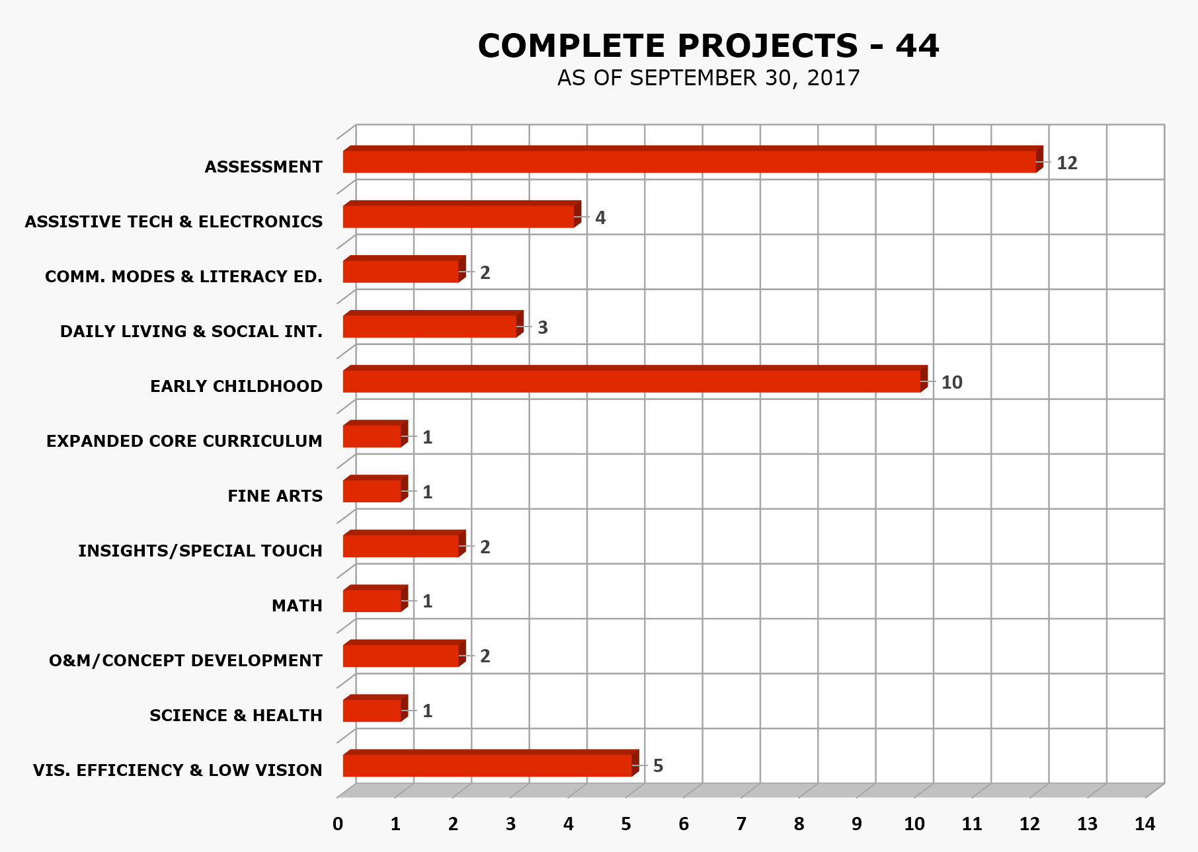

Active Projects
(Chart II)
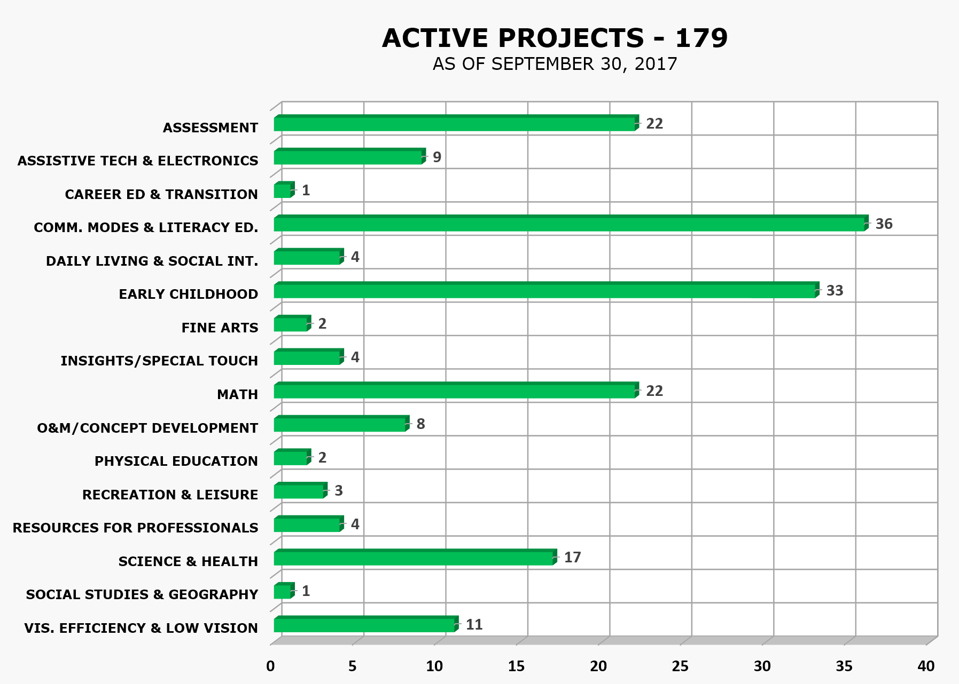

Pipeline Projects
(Chart III)
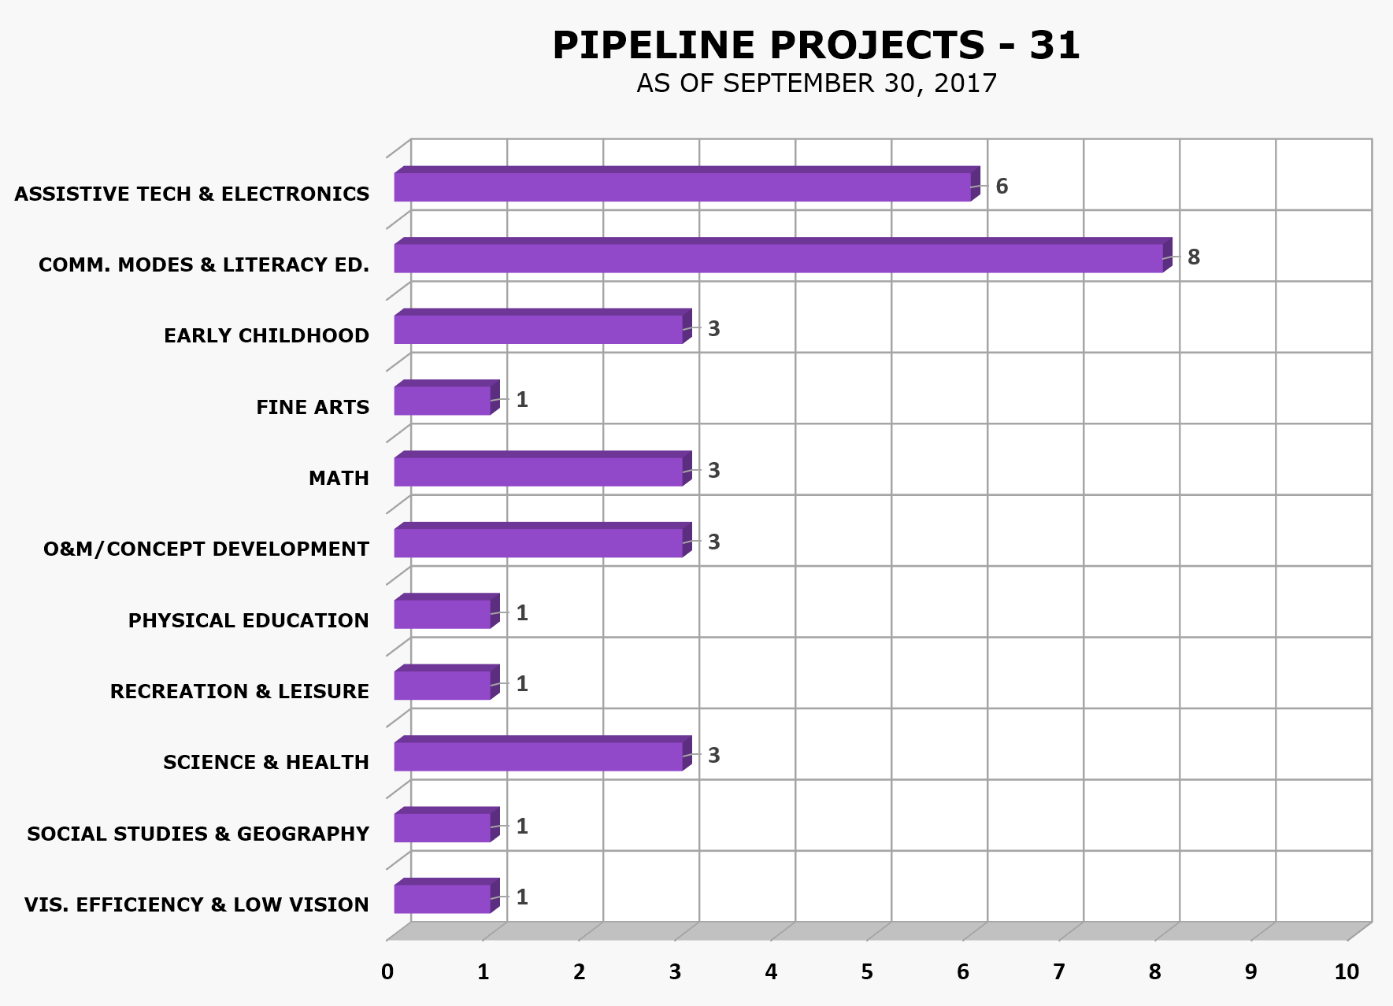

Compilation of Projects
(Chart IV)
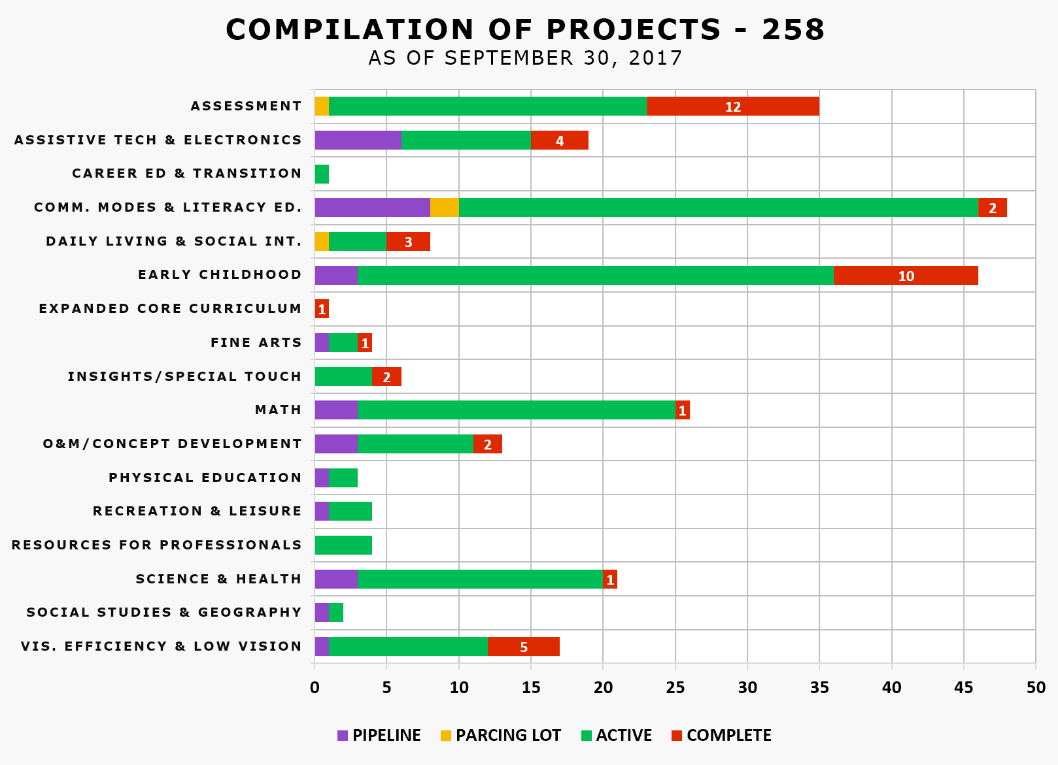

Status of Product Development
(Chart V)
Status of Product Development
as of September 30, 2017
CATEGORY | PIPELINE | PARCING LOT | ACTIVE | COMPLETE | GRAND TOTAL
Assessment | 0 | 1 | 22 | 12 | 35
Assistive Technology & Electronics | 6 | 0 | 9 | 4 | 19
Career Education & Transition | 0 | 0 | 1 | 0 | 1
Communication Modes & Literacy Education | 8 | 2 | 36 | 2 | 48
Daily Living & Social Interaction | 0 | 1 | 4 | 3 | 8
Early Childhood | 3 | 0 | 33 | 10 | 46
Expanded Core Curriculum | 0 | 0 | 0 | 1 | 1
Fine Arts | 1 | 0 | 2 | 1 | 4
InSights / Special Touch | 0 | 0 | 4 | 2 | 6
Math | 3 | 0 | 22 | 1 | 26
O&M/Concept Development | 3 | 0 | 8 | 2 | 13
Physical Education | 1 | 0 | 2 | 0 | 3
Recreation & Leisure | 1 | 0 | 3 | 0 | 4
Resources for Professionals | 0 | 0 | 4 | 0 | 4
Science & Health | 3 | 0 | 17 | 1 | 21
Social Studies & Geography | 1 | 0 | 1 | 0 | 2
Visual Efficiency & Low Vision | 1 | 0 | 11 | 5 | 17
Grand Total | 31 | 4 | 179 | 44 | 258
Product Families Represented | 31 | 4 | 106 | 22 | 163
In FY 2017, 77 product ideas were submitted.

Proper Trademark Notice and Attribution

ACT® is a registered trademark of ACT, Inc.
Adobe® and Illustrator® are registered trademarks of Adobe Systems, Inc.
Amazon® and Amazon Echo® are registered trademarks of Amazon Technologies, Inc.
American Foundation for the Blind® is a registered trademarks of American Foundation for the Blind, Inc.
American Institutes for Research® and AIR® are registered trademarks of American Institutes for Research in the Behavioral Sciences.
Android™, Google™, Google Apps™, Google Chrome™, Google Docs™, Google Drive™, Google Hangouts™, Google Play™, and YouTube™ are trademarks of Google Inc.
AP®, College Board®, and SAT® are registered trademarks of the College Board.
App Store®, Apple®, iPad®, iPhone®, iPod touch®, and Mac® are registered trademarks or service marks of Apple Inc., registered in the U.S. and other countries.
Assessment of Learning™, BOT™, Developmental Reading Assessment®, DIAL™, KeyMath™, Wechsler Intelligence Scale for Children®, and WISC® are trademarks in the U.S. and/or other countries of Pearson Education, Inc., or its affiliate(s).
Bluetooth® is a registered trademark of Bluetooth SIG, Inc.
BrailleNote™, HumanWare™, and Prodigi™ are trademarks of HumanWare Inc.
Califone® and CardMaster™ are registered trademarks of Califone International Inc.
Camtasia® is a registered trademark of TechSmith Corporation.
CASAS® is a registered trademark of CASAS - Comprehensive Adult Student Assessment Systems.
CorelDRAW® is a registered trademark of Corel Corporation.
Delta Education® is a registered trademark of Delta Education, LLC.
Discovery Communications™ is a registered trademark of Discovery Communications, Inc.
Dropbox™ is a trademark of Dropbox, Inc.
Dynamic Learning Maps™ and DLM® are trademarks of The University of Kansas state educational institution.
Elenco®, Snap Circuits®, and Snap Circuits Jr.® are registered trademarks of Elenco Electronics, Inc.
EPUB® is a registered trademark of International Digital Publishing Forum.
ETS® is a registered trademark of Educational Testing Service.
Excel®, Microsoft®, and Windows® are registered trademarks of Microsoft Corporation in the United States and/or other countries.
FITNESSGRAM® is a registered trademark of The Cooper Institute.
Freedom Scientific® and JAWS® are registered trademarks of Freedom Scientific, Inc.
GED® is a registered trademark of the American Council on Education.
Hot Wheels® and Mattel® are registered trademarks of Mattel, Inc.
IGEN® is a trademark of Xerox Corporation.
Imagination Playground™ is a trademark of Rockwell Investments, LLC.
iOS® is a registered trademark of Cisco in the U.S. and other countries and is used under license by Apple Inc.
Learning Ally™ is a trademark of Recording for the Blind & Dyslexic Incorporated.
Math Window® is a registered trademark of Wolf, Roger P.
Measured Progress™ is a trademark of Measure Progress, Inc.
Measurement Incorporated® is a registered trademark of Measurement Incorporated.
MultiView™ is a trademark of Texas Instruments, Inc.
OpenStreetMap® is a registered trademark of OpenStreetMap Foundation.
Perkins Brailler® is a registered trademark of Perkins School for the Blind.
Paint-by-Number Safari™ and PlayAbility Toys™ is a trademark of Josephine Baldacchino Lopez.
PLEXTALK® is a registered trademark of Shinano Kenshi Co., Ltd.
Questar Assessment, Inc.™ is a trademark of Questar Assessment, Inc.
Riverside™ is a trademark of Riverside Publishing.
Roland® is a registered trademark of Roland DGA Corporation.
Sticky Dots™ is a trademark of Therm O Web, Inc.
SurveyMonkey® is a registered trademark of SurveyMonkey.com, LLC.
Talking LabQuest® is a registered trademark of Vernier Software & Technology.
TEST READY® is a registered trademark of Curriculum Associates, Inc.
Trello™ is a Trademark of Trello, Inc.
Twister® is a registered trademark of Hasbro, Inc.
VELCRO®, VELTEX® and VELCOIN® are registered trademarks of Velcro Industries B.V.
VisioBook® is a registered trademark of Baum Retec AG.
VoiceOver® is a registered trademark of Voicebrook, Inc.
WiDA™ is a trademark of Wisconsin Center for Education Research.
Wiffle® is a registered trademark of Wiffle Ball, Inc.
Wikki Stix® is a registered trademark of Omnicor, Inc.
Woodcock-Johnson®, WJ IV™, Houghton Mifflin Harcourt™, and HMH® are trademarks or registered trademarks of Houghton Mifflin Harcourt Publishing Company.
WordPress® is a registered trademark of WordPress Foundation.
Ziploc® is a registered trademark of S.C. Johnson & Son, Inc.

Copyright © 2017
American Printing House for the Blind, Inc.
1839 Frankfort Avenue
Louisville, KY 40206
Toll-free 1-800-223-1839
E-mail: info@aph.org
Web: www.aph.org
Shop: shop.aph.org

