Social Media Toolkit

TWITTER

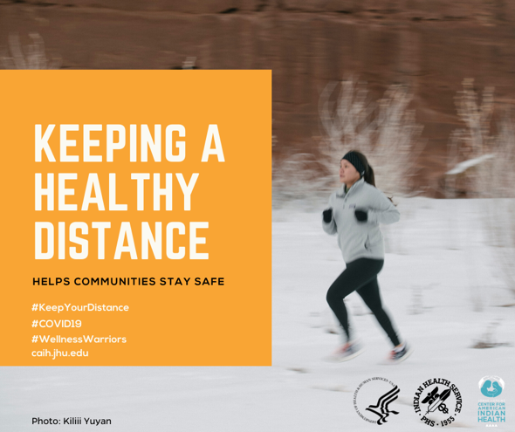
Protect your loved ones from #COVID19 germs🦠 by keeping a healthy distance. Wear a mask when in public!
Learn more: CDC.gov/COVID19
#WellnessWarriors 🤜
#coronavirus #COVID2019 #COVID #COVID19 #FlattenTheCurve #KeepYourDistance
HT @BmoreHealthy 🙏
Photo @kiliiiyuyan

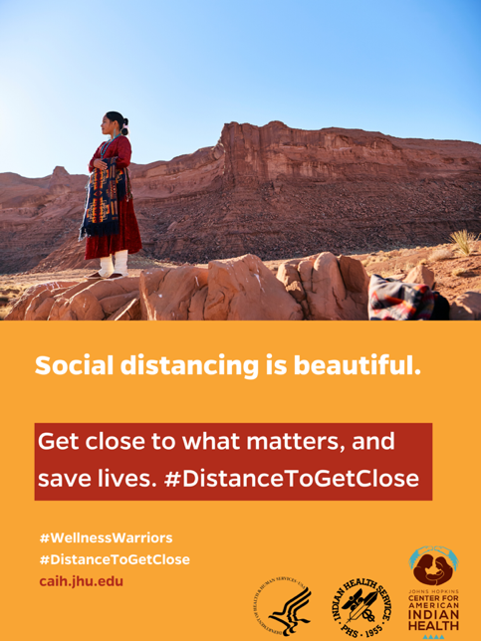

Social distancing can be done in the beauty of nature. Expand your horizons & protect loved ones from germs🦠. Wear a mask😷 in public. Photo @cunicelliphoto

Learn more: CDC.gov/COVID19
#WellnessWarriors 🤜
#coronavirus #COVID2019 #FlattenTheCurve #KeepYourDistance
HT @BmoreHealthy 🙏

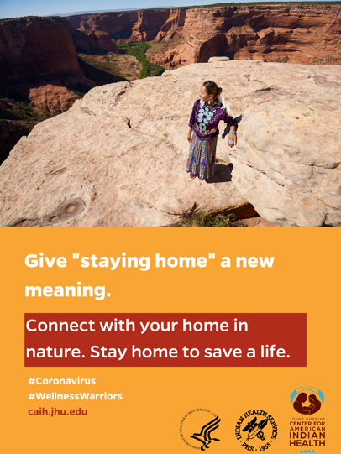
Social distancing can be done in the beauty of nature. Expand your horizons & protect loved ones from germs🦠. Wear a mask 😷when in public. Photo @cunicelliphoto
Learn more: CDC.gov/COVID19
#WellnessWarriors 🤜
#coronavirus #COVID2019 #COVID #COVID19 #FlattenTheCurve #KeepYourDistance
HT @BmoreHealthy 🙏

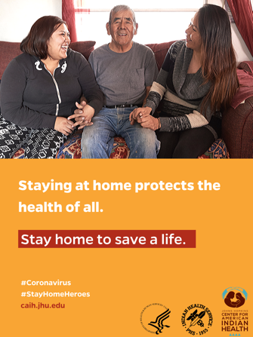
DYK? Elders are at high risk for #COVID19. Protect your loved ones by #StayingHome. Wear a mask when out in public.😷 Photo @cunicelliphoto

Learn more: CDC.gov/COVID19
#StayHomeHeroes
#WellnessWarriors 🤜
#coronavirus #COVID2019 #COVID #FlattenTheCurve #KeepYourDistance
HT @BmoreHealthy 🙏

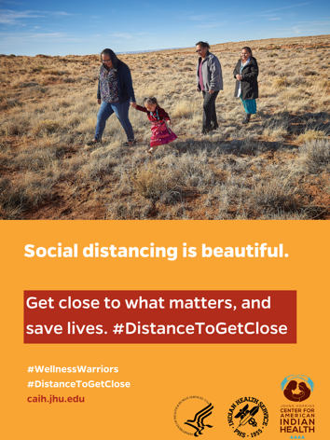

Social distancing can be done in the beauty of nature. Expand your horizons & protect loved ones from germs🦠. Wear a mask 😷 if out in public. Photo @cunicelliphoto
Learn more: CDC.gov/COVID19
#WellnessWarriors 🤜
#coronavirus #FlattenTheCurve #KeepYourDistance
HT @BmoreHealthy 🙏

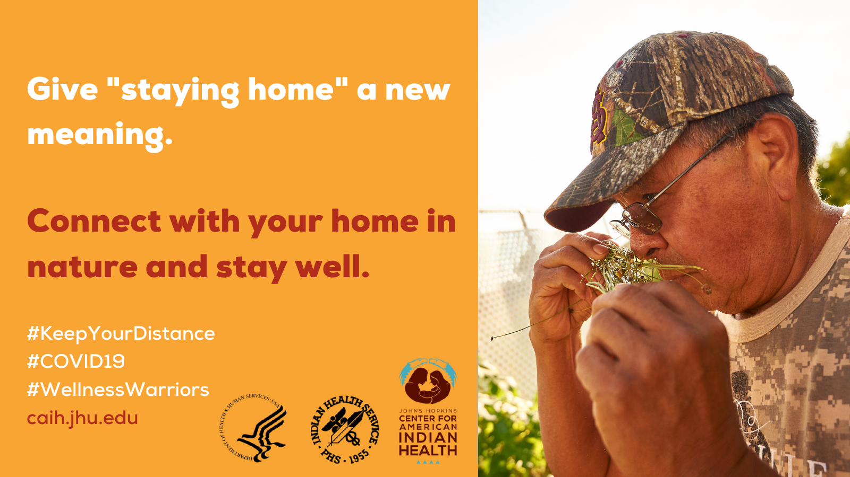

Social distancing can be done in the beauty of nature. Expand your horizons & protect loved ones from germs🦠. Wear a mask 😷 if out in public.
Learn more: CDC.gov/COVID19
#WellnessWarriors 🤜
#coronavirus #FlattenTheCurve #KeepYourDistance

INSTAGRAM

[share message with all visuals listed above]

Social Distancing Saves Lives! Now that there are confirmed cases in all 50 U.S. states, everyone has a role to play in preventing the spread of germs🦠. Stay home as much as possible. 🏠 Wear masks😷 when out in public. Consider doing your grocery 🍎shopping in off-peak hours. Avoid crowded places such as shopping centers, bars, and movie theatres. When out in public, keep a distance of at least 6 feet from others even if wearing a mask! If you are sick🤒, stay home!

For more information, visit CDC.gov/coronavirus
Materials for tribal communities 👉 Bit.ly/TribesFightCOVID19
#StayHomeHeroes
#WellnessWarriors
#KeepYourDistance
#FlattentheCurve
#COVID19

*Thanks to @Bmore_Healthy for letting us adapt their #StayHomeHeroes campaign 🙏

