Men’s Health Week Social Media Toolkit

June 15-21, 2020

Proposed Content Sharing Partners
- Indian Health Service
- National Indian Health Board
- National Council for Urban Indian Health
- National Institutes of Health/NIAMS
- Northwest Portland Area Indian Health Board
- Healthy Native Youth
- Robert Wood Johnson Foundation
- Annie E. Casey Foundation
- Indian Country Today
- Urban Indian Health Institute
- Illuminatives

Facebook

While COVID-19 infects men and women equally, men with COVID-19—especially those with underlying health conditions—seem to be at a higher risk for worse outcomes and death across the world. Protect yourself and your family by social distancing. Wear a mask outside the home. Contact a health provider to get tested if you have symptoms such as cough, fever, or shortness of breath. Learn more about COVID-19 and its impact on the body. https://bit.ly/3fvase9

[Insert any of images below]

Twitter

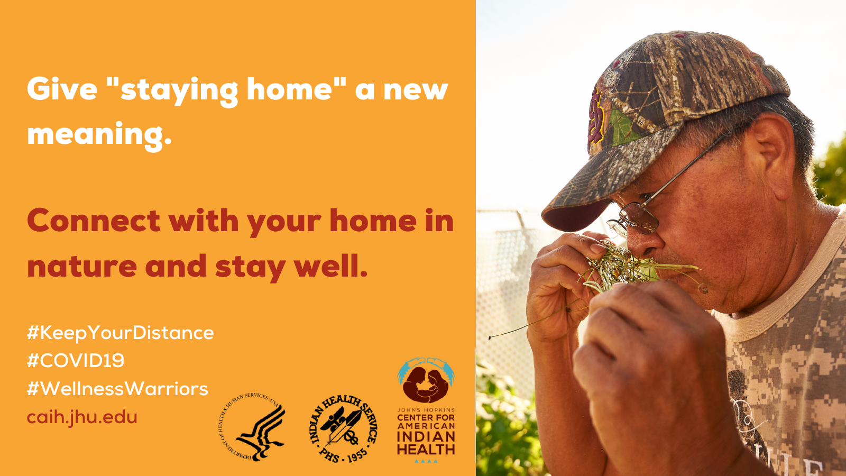
Across the world, men 👨🏽are more likely to become severely ill🦠 from #COVID-19. Protect yourself by social distancing in the beauty of nature🌲. #TheMoreYouKnow #BreatheDeep #PreventCOVID Learn how to stop the spread https://bit.ly/2YIaybE

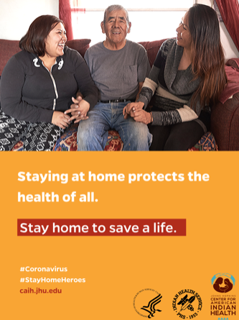
DYK? Elders are at elevated risk for severe #COVID19 disease🦠. Call your health care provider if you have 🌡️fever, cough, headache, or other symptoms. Care for yourself at 🏠 home with these tips. https://bit.ly/WYSWN8j

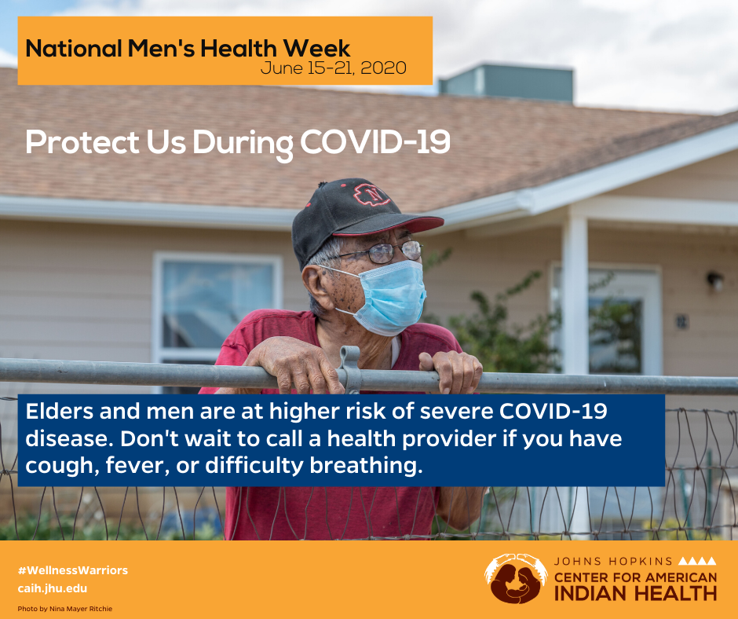
Elders are at elevated risk for severe #COVID19 disease🦠. Call your health care provider if you have 🌡️fever, cough, headache, or other symptoms. Care for yourself at 🏠 home with these tips. https://bit.ly/WYSWN8j

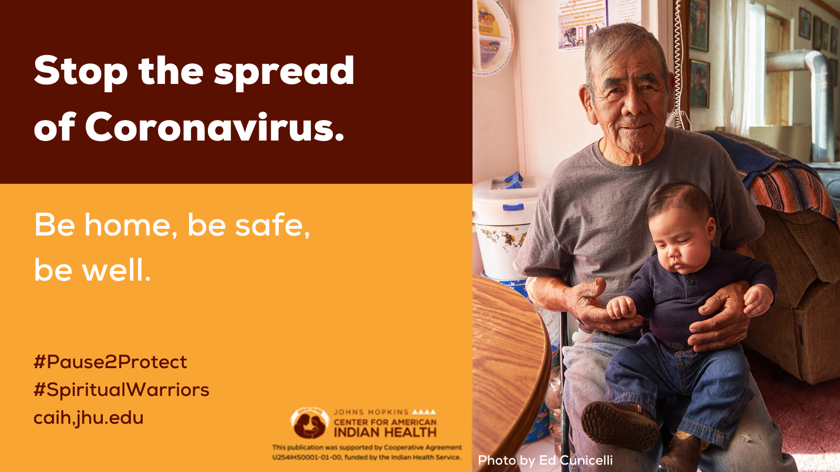Life during #COVID19 can feel stressful. There are ways to practice traditional healing while keeping your distance socially—like sharing traditional stories by 📱phone. Learn more https://bit.ly/2YIaybE

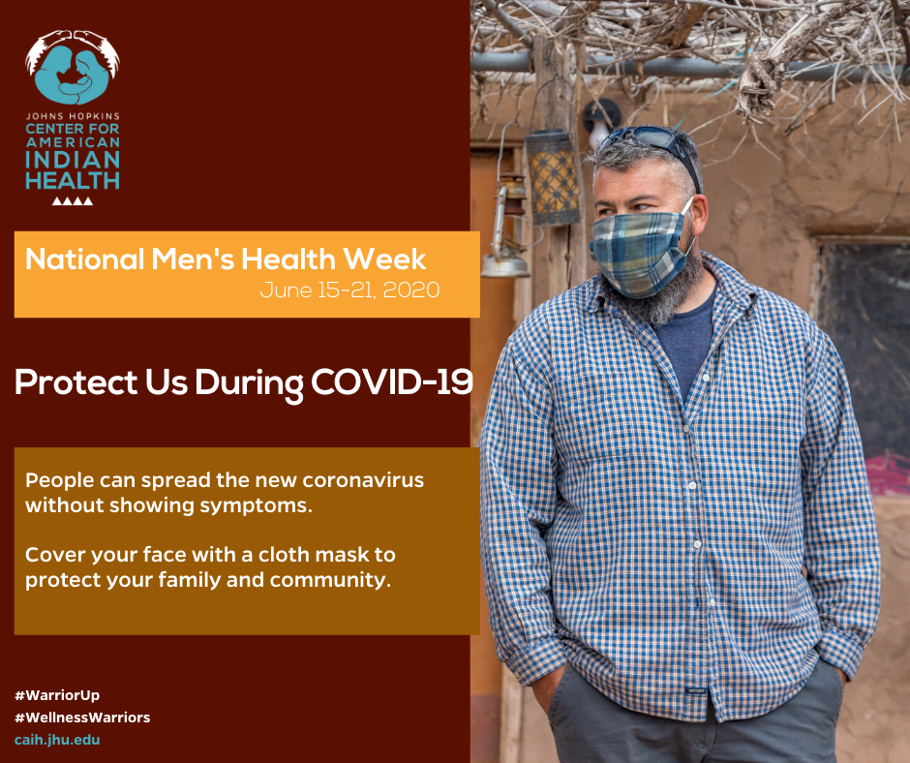

#WarriorUP and cover your face😷 to slow the spread of #COVID19 when leaving home. Cloth masks and bandanas should be worn over nose and mouth. Learn more https://bit.ly/2zDbZj0

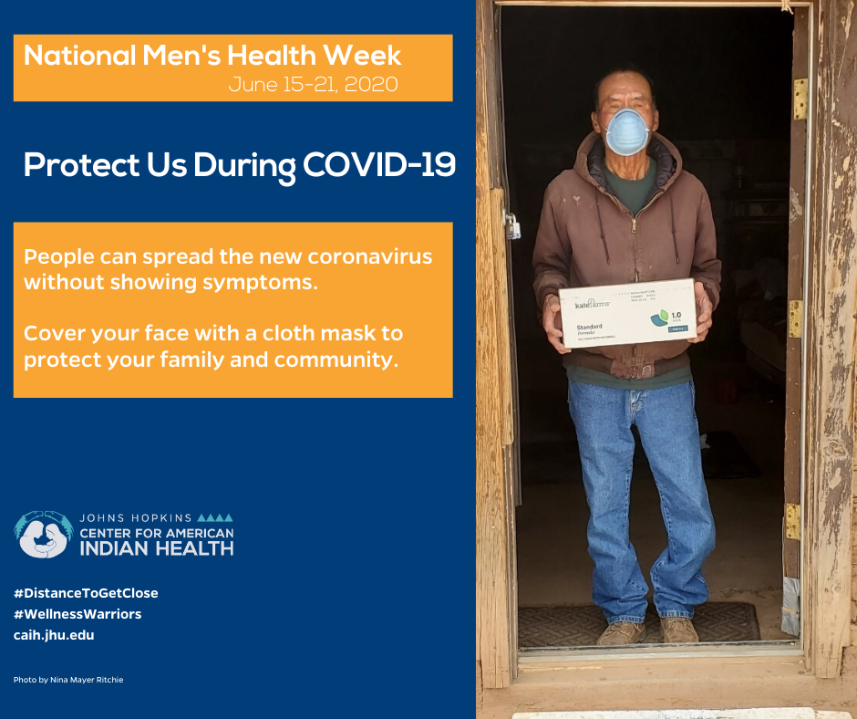
#WarriorUP and cover your face😷 to slow the spread of #COVID19 when leaving home. Masks and bandanas should be worn over nose and mouth. Learn more https://bit.ly/2zDbZj0

Instagram

While COVID-19 infects men and women equally, men with COVID-19—especially those with other health ❤️conditions—seem to be at a higher risk for worse outcomes and death across the world. Protect yourself and your family by social 👉 👉 distancing. Wear a mask 😷 outside 🏠 home. Call a health provider 🏥to get tested if you have symptoms such as cough, 🌡️fever, or shortness of breath. Learn more about COVID-19 and its impact on the body. https://bit.ly/3fvase9
[Insert any of images above]

