Contact Tracing Social Media Toolkit
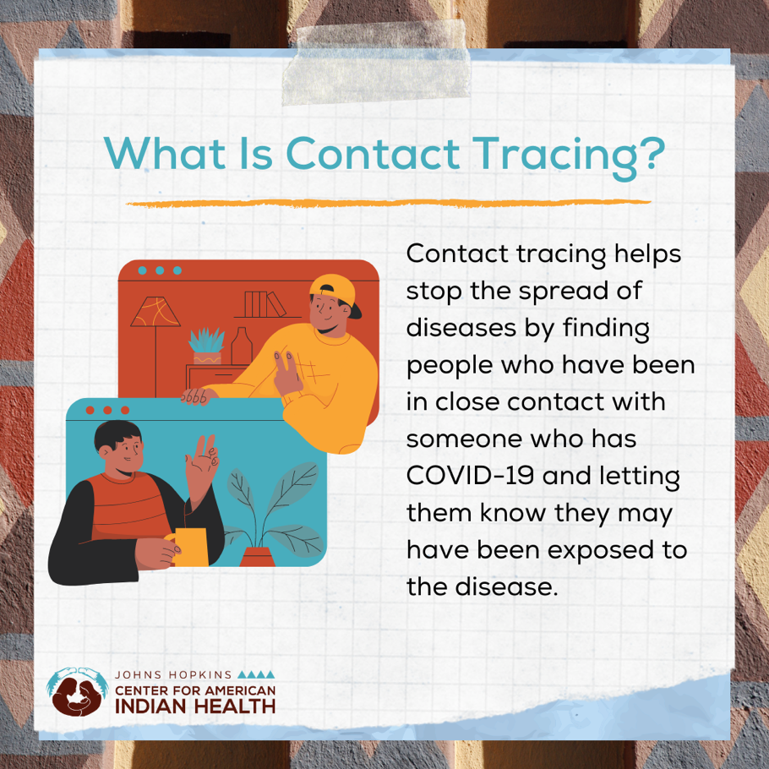

Facebook + Instagram message: If you have been around a person who has COVID-19, health department staff may call to let you know you’ve been exposed and ask you to stay at home away from others and quarantine. Doing so helps protect you, our families, and our communities. Be part of the solution and help #SlowtheSpread of #COVID19. https://bit.ly/3koxOnH

Twitter message If you have been around someone with #COVID19, someone from the health department might call you to tell you that you’ve been exposed and ask you to stay at home away from others. Answer the call to #SlowtheSpread: https://bit.ly/3koxOnH

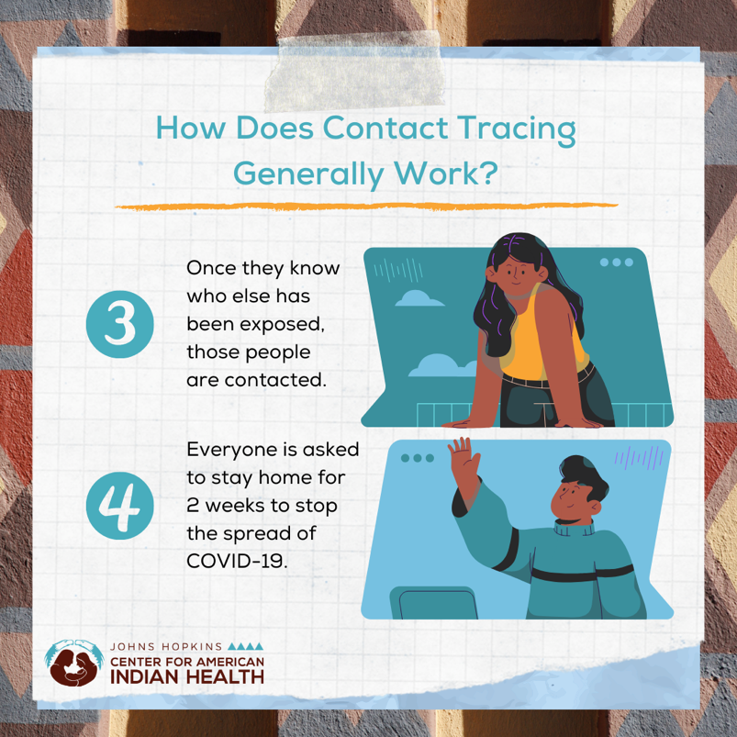

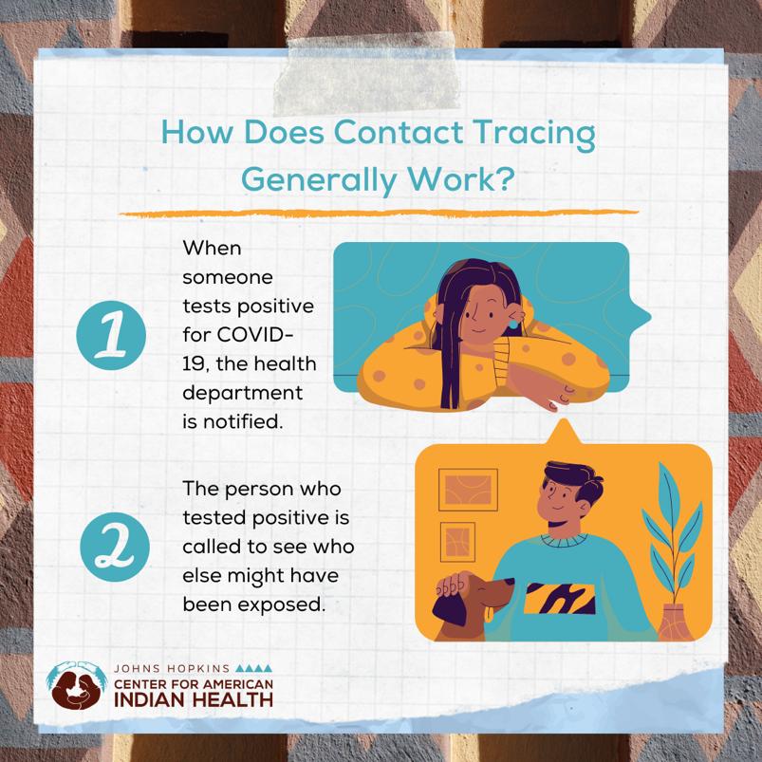

Facebook + Instagram message: If you are waiting for a #COVID19 test result, get ready in case someone from the health department calls you to check on your health, discuss who you’ve been around recently, and ask you to stay home to self-isolate, if you aren’t doing so already. Tell people who you have been around that they may have been #exposed to COVID-19. Answer the call to #SlowTheSpread: https://bit.ly/3neCWMX
Please check with your local health departments for up-to-date information in your community.

Twitter message: If you are sick with #COVID19, a public health worker may contact you to check on your health, discuss who you’ve been in contact with, and ask you to stay at home and self-isolate, if you’re not doing so already. Answer the call to #SlowTheSpread. https://bit.ly/3neCWMX

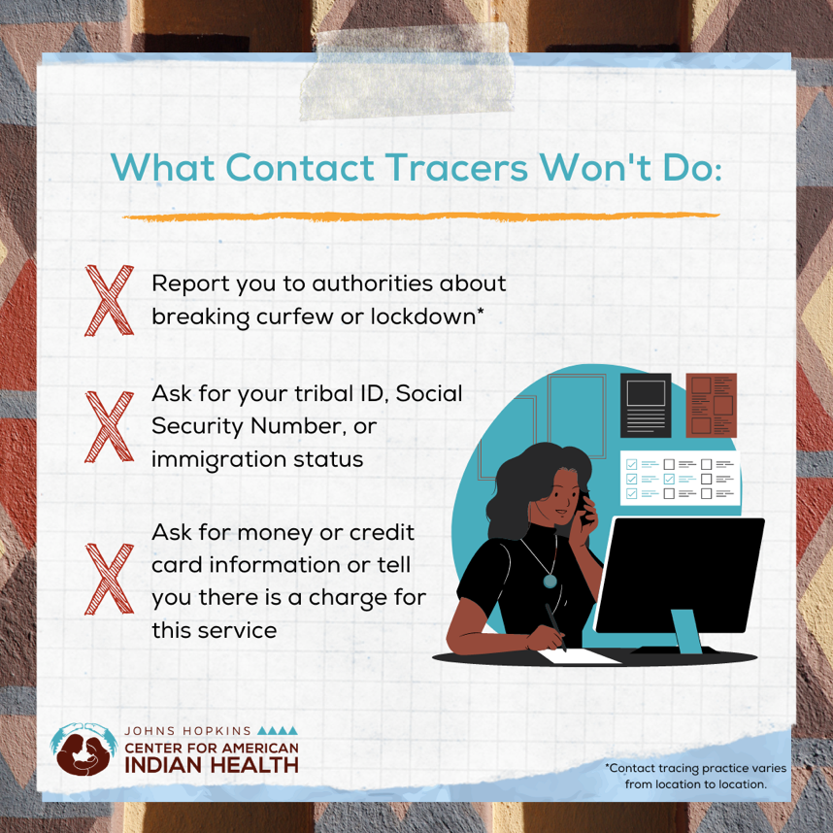

Facebook + Instagram message: If you are sick with #COVID19, a public health worker may contact you to check on your health, discuss who you’ve been in contact with, and ask you to stay at home and self-isolate, if you’re not doing so already. They will not ask about travel, your tribal ID, social security, immigration status, or for money or credit card information. Answer the call to #SlowTheSpread. https://bit.ly/3koxOnH

Twitter message: Contact tracing is essential to slowing the spread of #COVID19. Any information you tell the health department is confidential. Learn more about how the health department will work with you to help slow the spread of COVID-19: https://bit.ly/3koxOnH

