Mask Social Media Toolkit

Set 1: Choosing the best mask against COVID-19 — a series of four graphics meant to be combined as a “swipe-through” set for one post.

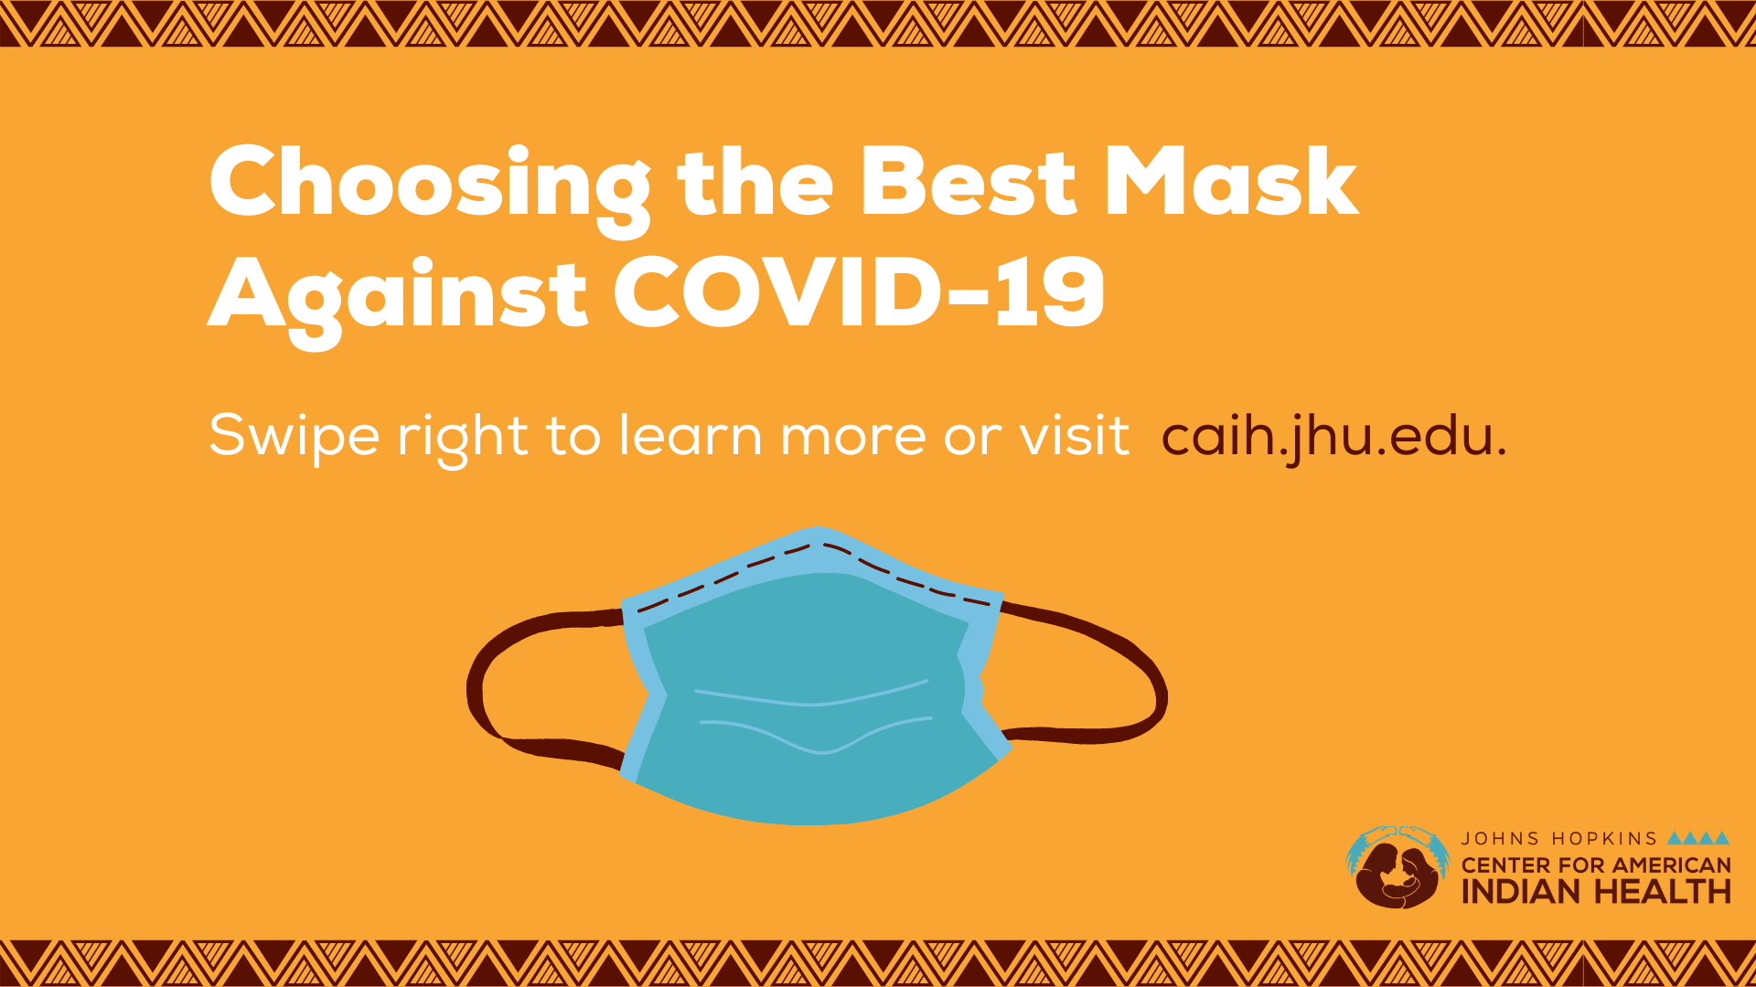

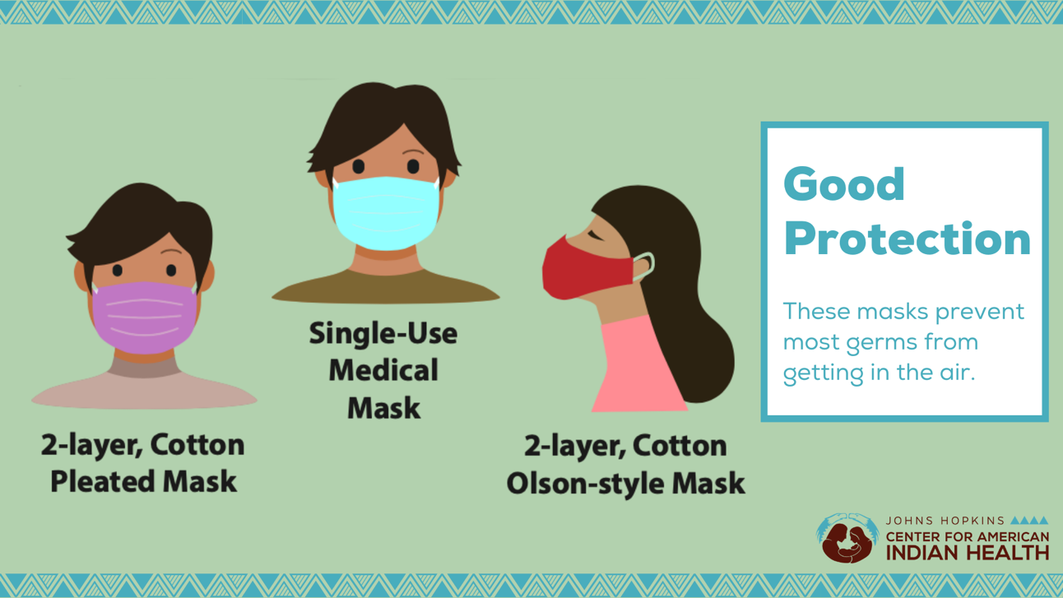
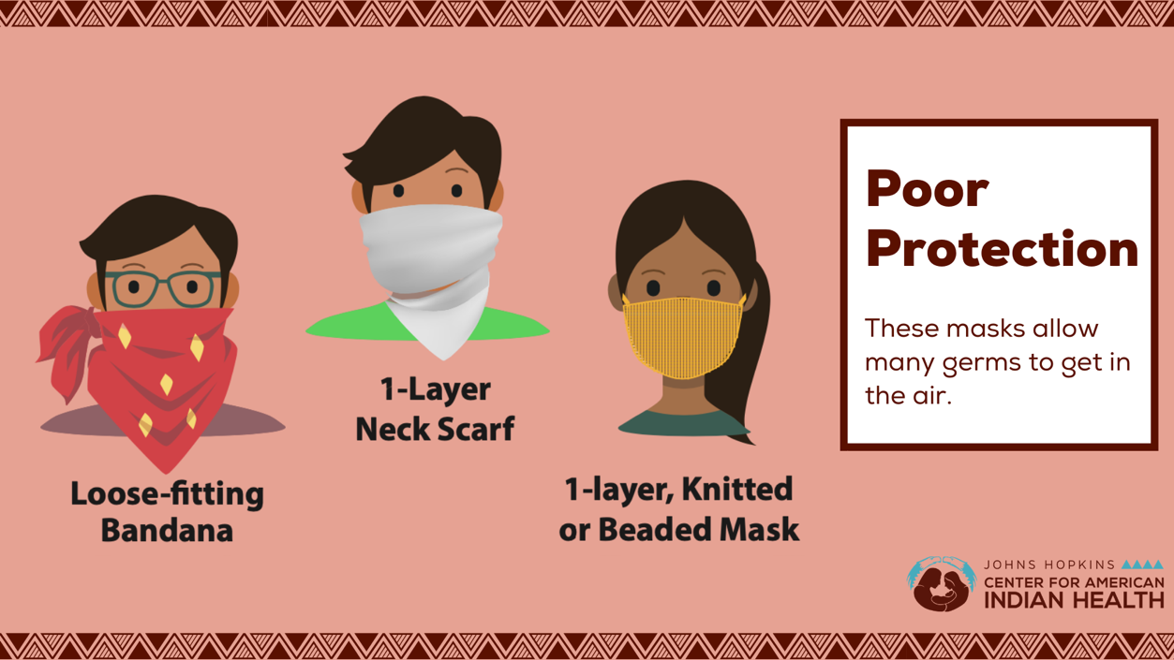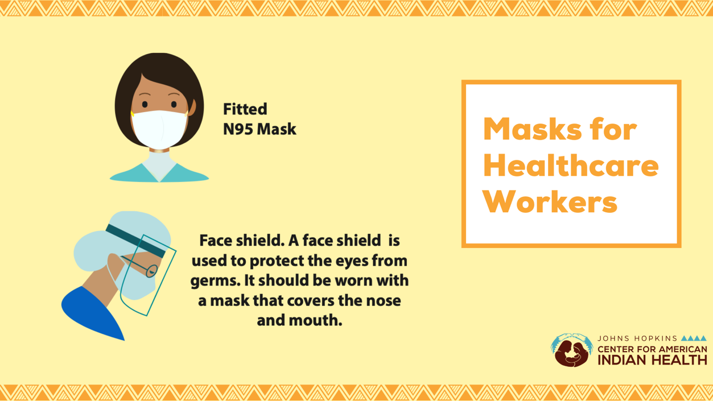

Message: #DYK that different types of #masks offer different levels of protection against COVID-19? When selecting a mask, avoid masks that have valves or vents that allows germs to escape, those that that should be saved for healthcare workers, or those that are loose-fitting. The best mask is one with two or more layers and one that fits tightly around the nose and mouth. Swipe right to learn more about which masks can help #stopthespread of #COVID19 or visit https://bit.ly/3joUUuL!
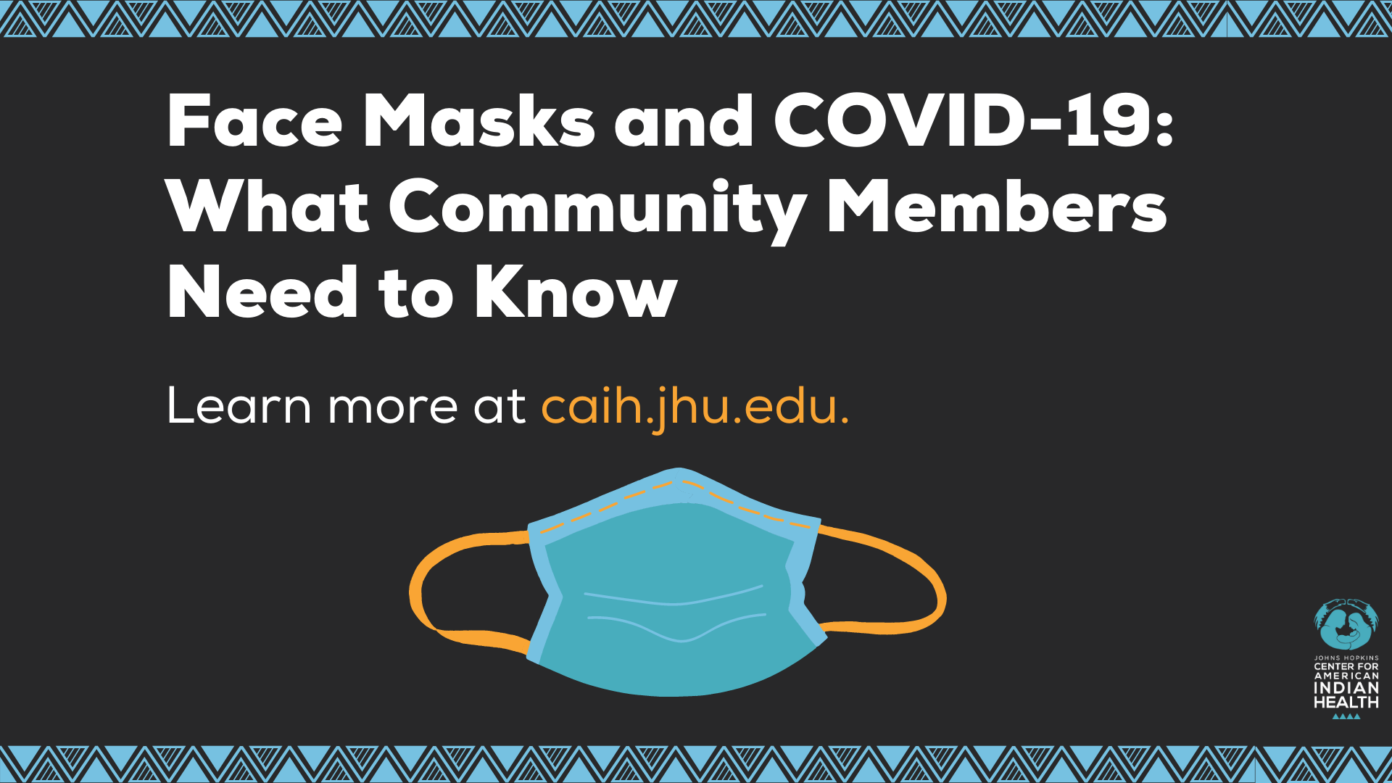

Message: Do you have questions about masks? Find information about the best types of #masks, how to wear a mask correctly, and how to make your own mask at home by visiting the #COVID19 Resources for #Tribes at caih.jhu.edu. Click here for more on masks: https://bit.ly/3joUUuL

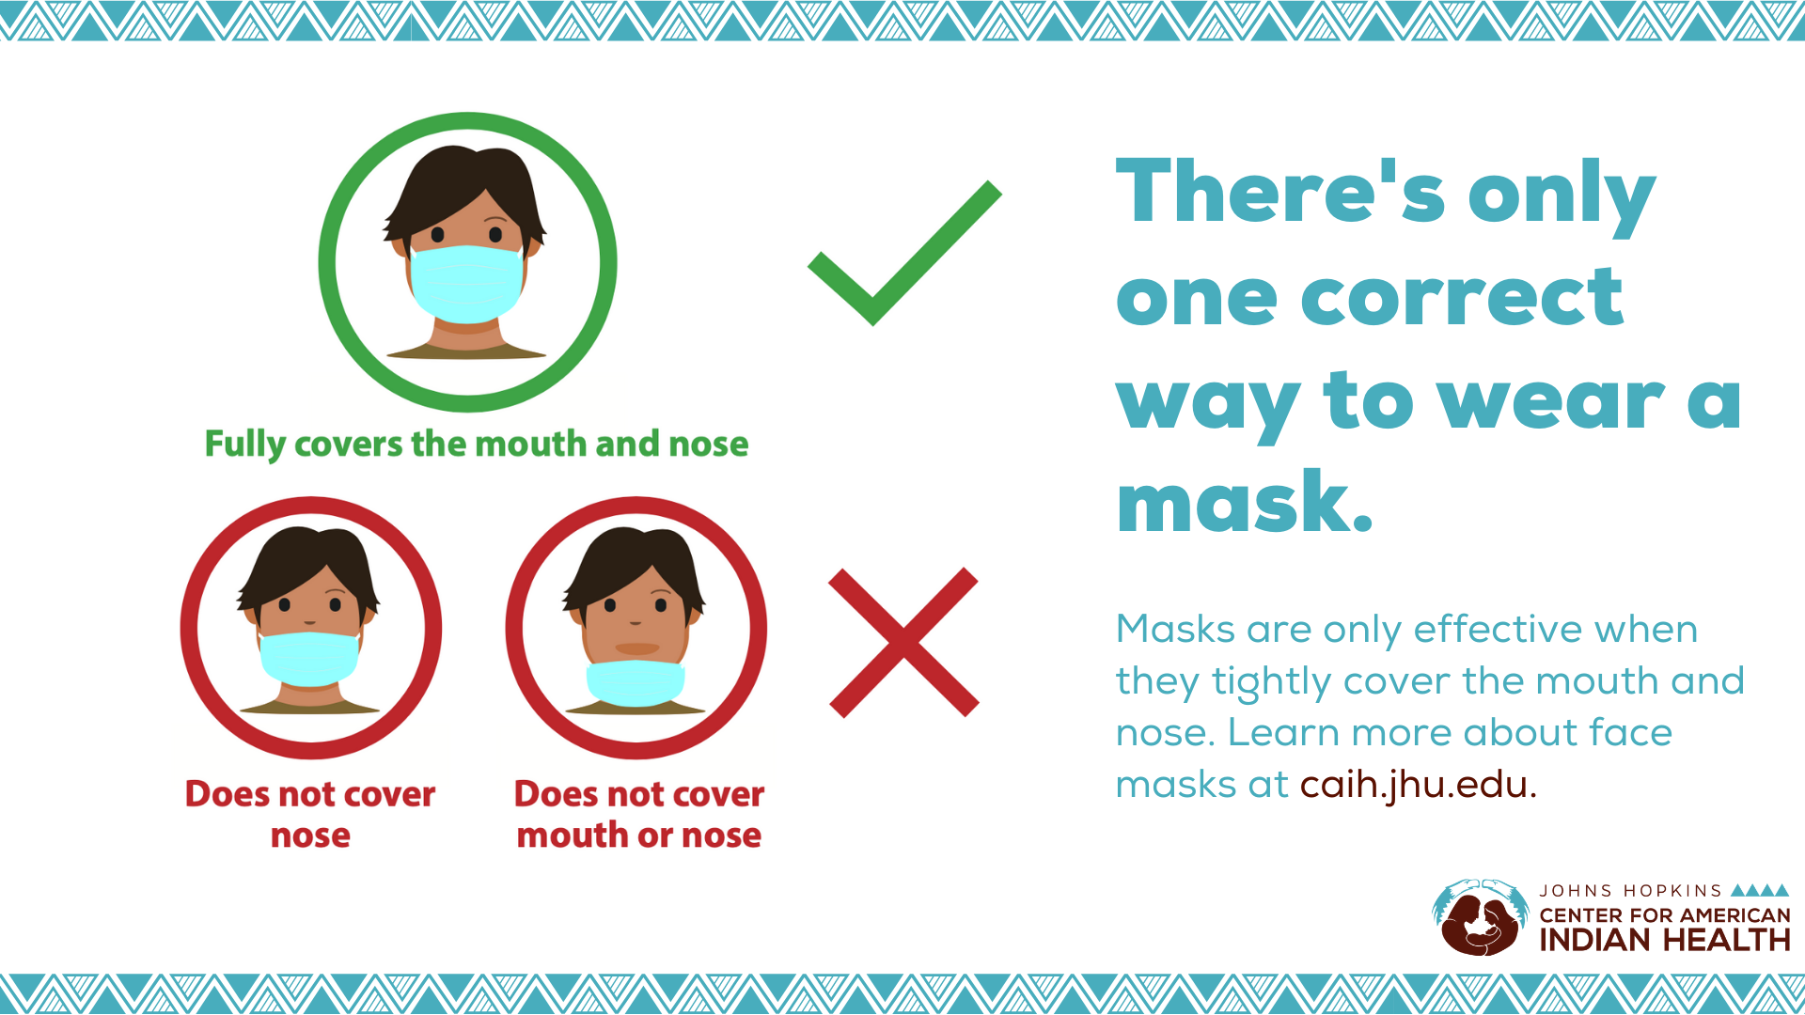

Message: Wearing a mask can help #stopthespread of #COVID19 in our communities but are only effective if worn correctly. Make sure your #mask tightly covers your nose and mouth and practice physical distancing. Want to learn more about masks? Visit the COVID-19 resources for Tribes page at caih.jhu.edu below or click here: https://bit.ly/3joUUuL.

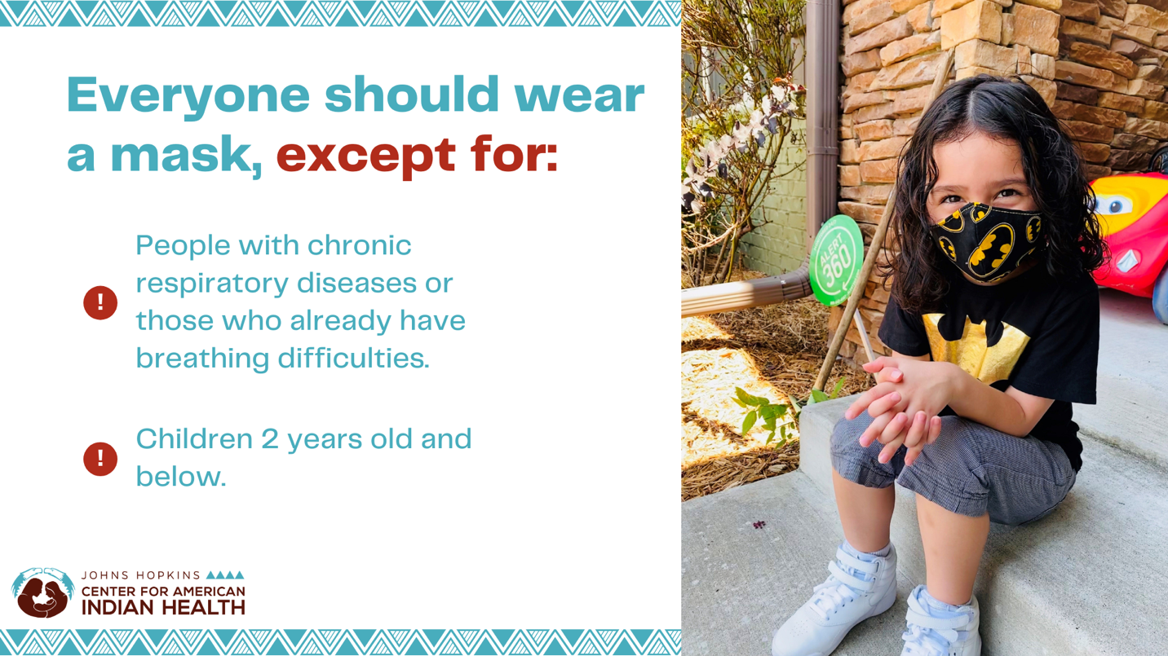

Message: It’s important to #WearAMask in public when around other people not in your household in order to protect our communities from #COVID19, but #masks should NOT be worn by children under 2 or anyone who has trouble breathing, is unconscious, incapacitated, or otherwise unable to remove the mask without assistance. Get more information on masks by visiting caih.jhu.edu or clicking here: https://bit.ly/3joUUuL.

Hashtags to use at end of posts:
#covidWarrior
#protectourelders
#indigenouselders
#Nativehealthcare
#wearamask
#protectourpeople
#strongresilientindigenous
#nativehealthmatters

