Reducing COVID-19 Risk Social Media Toolkit

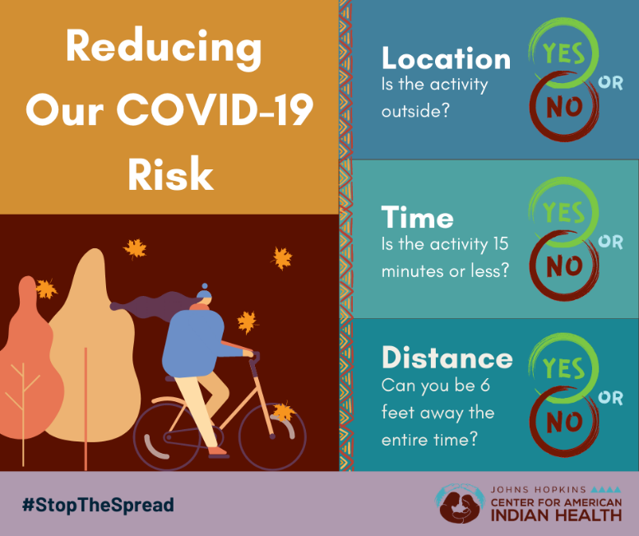

Social Media Message: #ProtectOurFamilies and communities and #StoptheSpread of #COVID19. Enjoy activities that are outdoors and allow you to stay 6 feet apart. Always wear a mask. Read more about how to measure your risk during daily activities here: https://bit.ly/3gmtdBV.

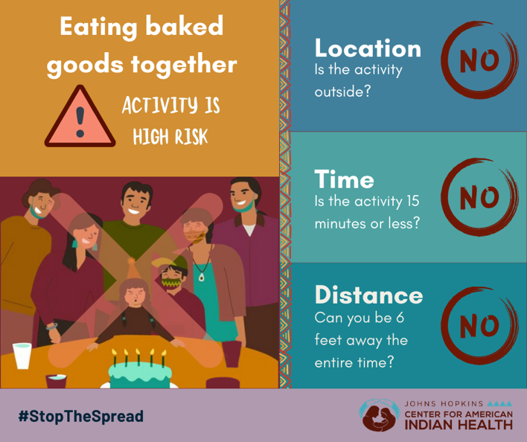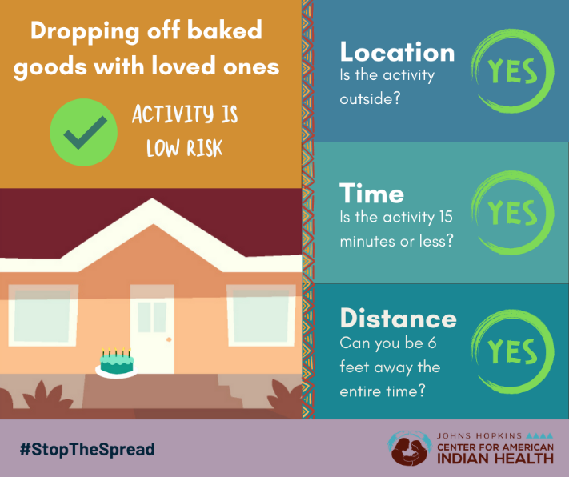

Social Media Message: We can #ProtectOurFamilies this holiday season with new ways to celebrate and connect. Need inspiration? Swipe right for ideas and activities to help #StoptheSpread of #COVID-19 in our communities. Be sure to always wear a mask and stay 6 feet apart. Get more information on how to measure your risk here: https://bit.ly/3gmtdBV.

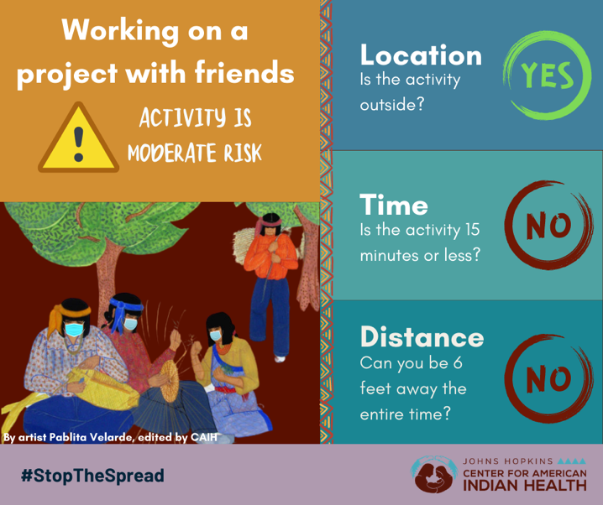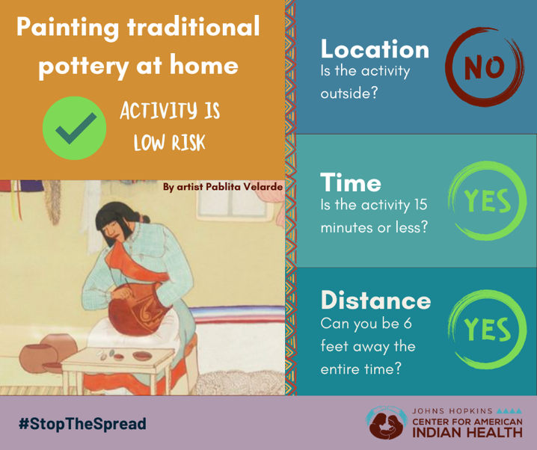

Social Media Message: #StopTheSpread of #COVID19 while keeping our traditions alive. This holiday season, let’s use our Indigenous skills in ways that keep us safe. Be sure to #WearAMask and stay 6 feet apart to keep risk low. Swipe right or click here to learn how to reduce your risk during daily activities: https://bit.ly/3gmtdBV.

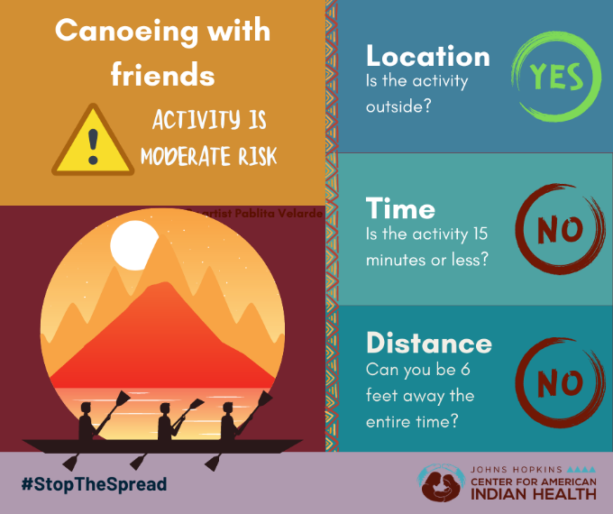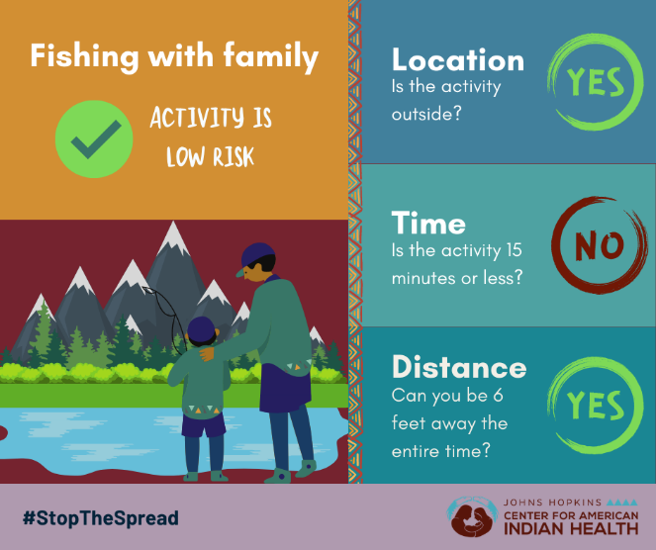

Social Media Message: Spending time outside doesn’t have to be risky. #ProtectOurFamilies and communities and #StopTheSpread of #COVID19 by social distancing. To keep risk low, #WearAMask and stay at least 6 feet apart from anyone you don’t live with. Swipe right for inspiration or click here to learn how to reduce daily risk: https://bit.ly/3gmtdBV

