Stop the Spread Video Stills - Social Media Toolkit
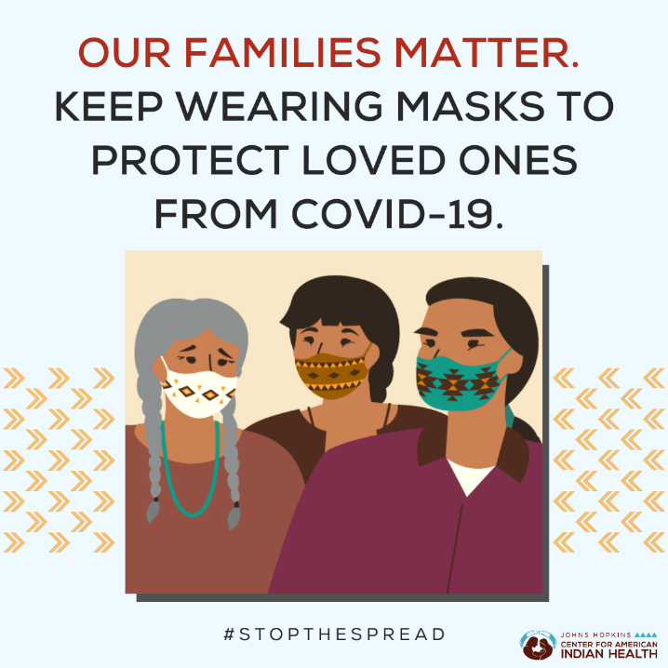
Social Media Message: Wearing masks to #StoptheSpread of #COVID19 is more important now than ever! Be sure to wear a mask that fits snugly over your mouth and nose when in public or around anyone outside your household. Keep it fun by finding masks that show off your personality or tribal flair. For more about the importance of masks, watch at https://bit.ly/3ayd63x or check out https://bit.ly/3joUUuL.
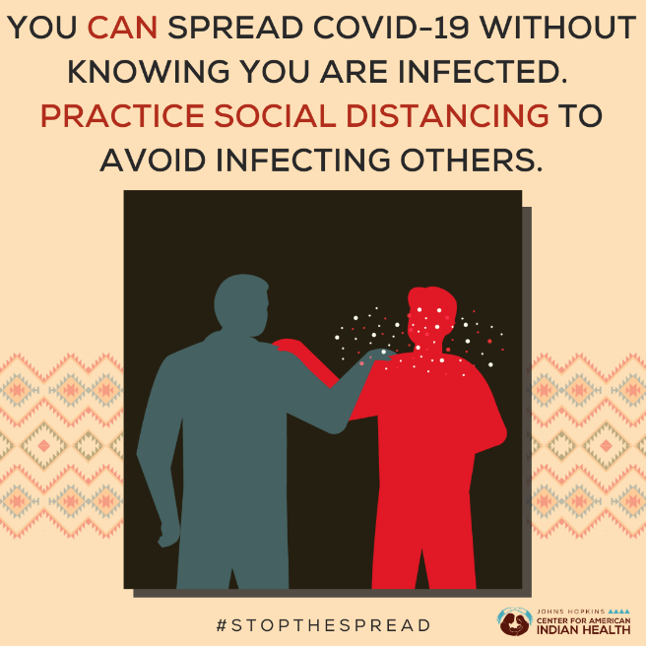
Social Media Message: If you are infected with #COVID19, you can spread the virus before you have symptoms or without having any symptoms at all. Over half of all COVID-19 cases are spread by people without symptoms. Stay safe by practicing #SocialDistancing and wearing a mask around others. Spread the word, not the virus! For more: https://bit.ly/3ayd63x
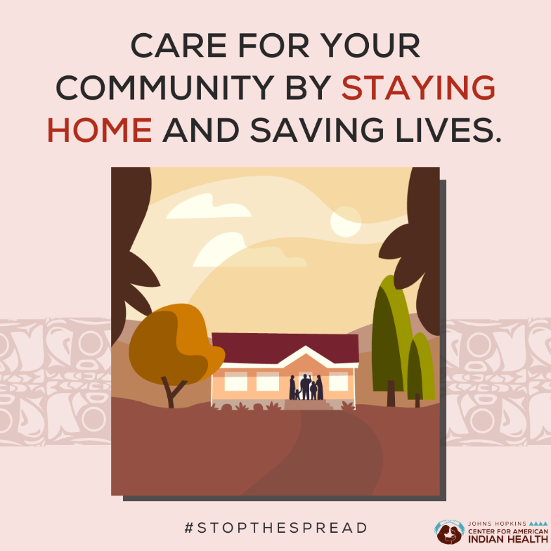
Social Media Message: #StoptheSpread of #COVID19 and show your community you care by staying home and #SocialDistancing. Avoiding close contact with others outside your household protects you, them, and others in your community. Learn more by watching: https://bit.ly/3ayd63x.
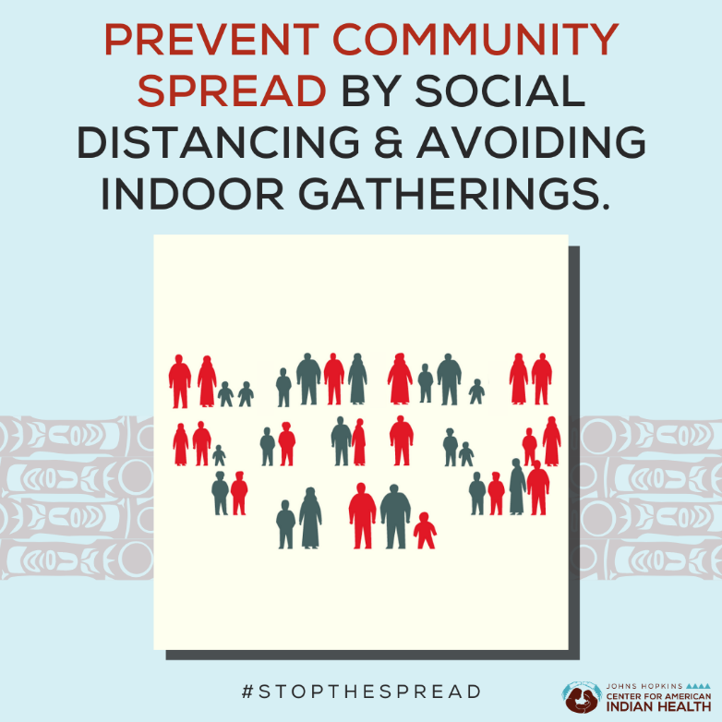
Social Media Message: Gathering indoors or in large groups gives #COVID19 a chance to spread throughout our communities. It is important to #SocialDistance to #StoptheSpread since a single event can potentially lead to many infections. Learn more by watching the story of one family’s super-spreader celebration: https://bit.ly/3ayd63x.

