What [insert tribal name] Tribal Members need to know about COVID-19
(Updated January 2021)
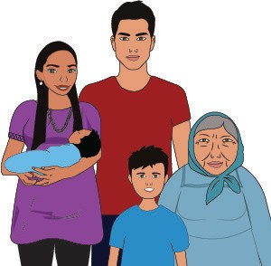

What is coronavirus disease 2019 (COVID-19)?
Coronaviruses are a type of virus (germ) that can cause cold-like symptoms and sometimes serious problems with lungs and breathing. COVID-19 is a novel (new) coronavirus.

What are the symptoms of COVID-19?
Not everyone who has COVID-19 has symptoms, but symptoms may include:
- Fever, chills, cough, shortness of breath, tiredness, muscle or body aches, headache, sore throat, new loss of taste or smell, congestion or runny nose, nausea or vomiting, or diarrhea.

How does COVID-19 spread?
Most often, COVID-19 is spread person to person through close contact. When people cough, sneeze, talk, sing and breathe, the virus is released into the air and can spread to others.
Someone with mild symptoms may spread the disease without knowing they are sick.
Sometimes, there is also airborne transmission when very small drops of the virus stay in the air even after a person with COVID-19 has left the area.

Who is most at risk?
Anyone can get COVID-19. Those at risk of severe illness are:

Elders and adults over 60 years of age,
- People with heart disease, lung disease, or diabetes.

How can I protect myself and my family?
Stay at home. “Social distancing” is recommended. This means keeping your family at home and away from others who may be sick.
- If you must go out, wear a mask and try to stay at least 6 feet away from others.
- Avoid gatherings with other people, especially indoors.
- Avoid touching your eyes, nose, and mouth.
- Do not shake hands, hug, or touch others.
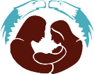
- Wash your hands often with soap and water for at least 20 seconds or use hand sanitizer.

If someone gets sick, what can they do?

If someone thinks they have been around someone with COVID-19 and they get a fever and symptoms such as cough or trouble breathing, they should call their healthcare provider or local Indian Health Service unit at _[insert phone number] for medical advice. They can also get tested to see if they are infected.
- In an emergency, call 911.
- People who are mildly sick with COVID-19 do not need to see a healthcare provider and are able to recover at home.
- Cover coughs and sneezes with a tissue, then throw the tissue in the trash and wash hands.
- Stay home and away from others for 14 days to avoid getting others sick.
- Caregivers should keep sick family members away from others in the home and clean and disinfect surfaces and items that are touched often, like door handles, sink
handles, toilets, remote controls, etc.

Is there a vaccine or treatment?
Some vaccines are now available. They are being distributed across the country, but will take several months before they are available to everyone in the community. The best way to continue to reduce the risk of getting sick with COVID-19 is to
wear a mask, keep social distancing and practice healthy habits like washing hands regularly.
Medical care can help relieve symptoms of COVID-19. Some people may also be offered monoclonal antibodies for treatment. These help the immune system fight COVID-19. If you are sick, call your healthcare provider for instructions.
For more information:
CDC.gov/coronavirus

Effective January 11, 2021

Source: CDC

