Mask Reminders Social Media Toolkit

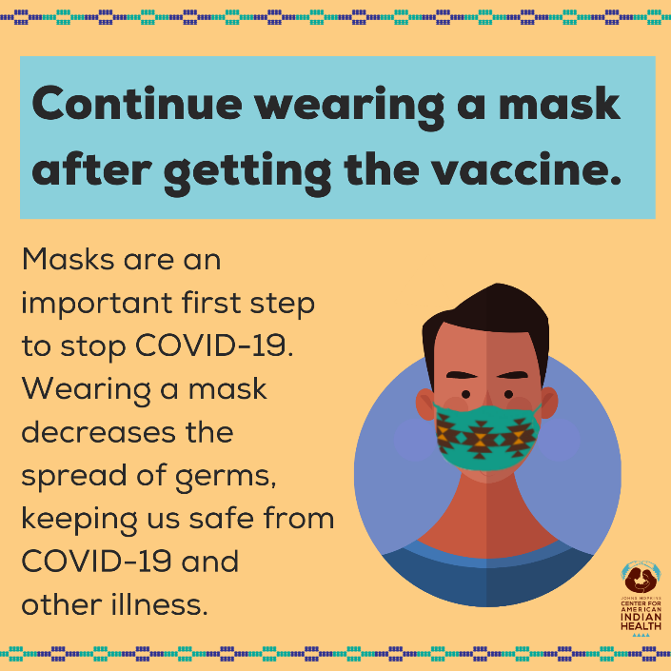
Social Media Message: The #vaccine protects you from getting really sick with COVID-19 disease, but we still need to protect elders and others in our community until everyone can get the vaccine. Be safe and keeping using tools like masks to #stopthespread.

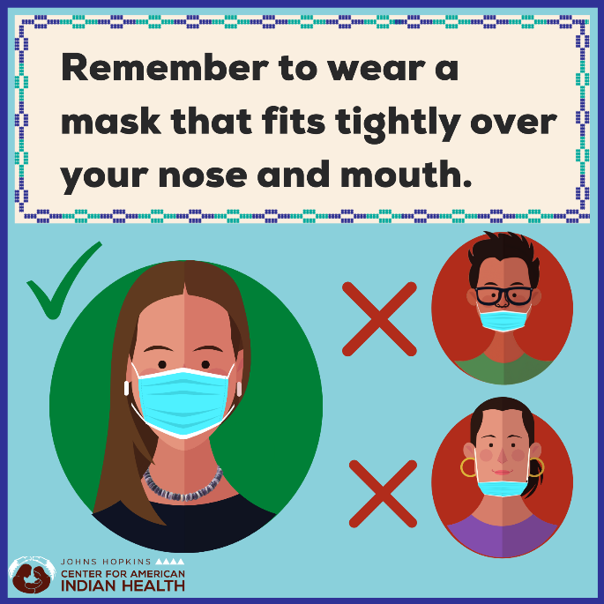
Social Media Message: Masks protect you and others from #COVID19. Your mask should fit close to your face and cover your nose and mouth. Wearing a mask when you are in public or with people outside of your household shows your community you care. By looking out for one another, we can #stopthespread of the virus.
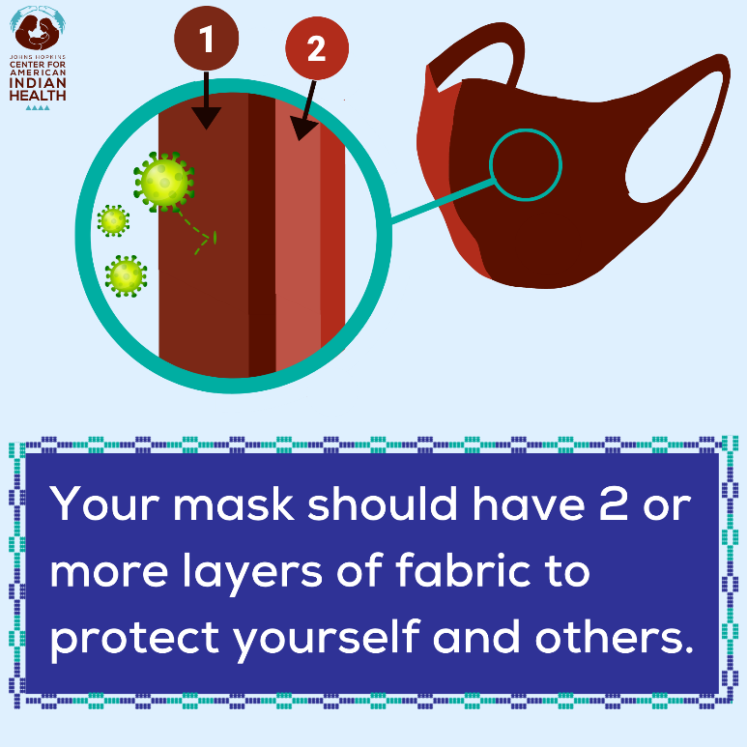
Social Media Message: The @CDC recommends that your mask have at least two layers to keep you and others safe from #COVID19. Reusable masks should be breathable, washable, and fit close to your face. Show your community you care by keeping your mask on in public.
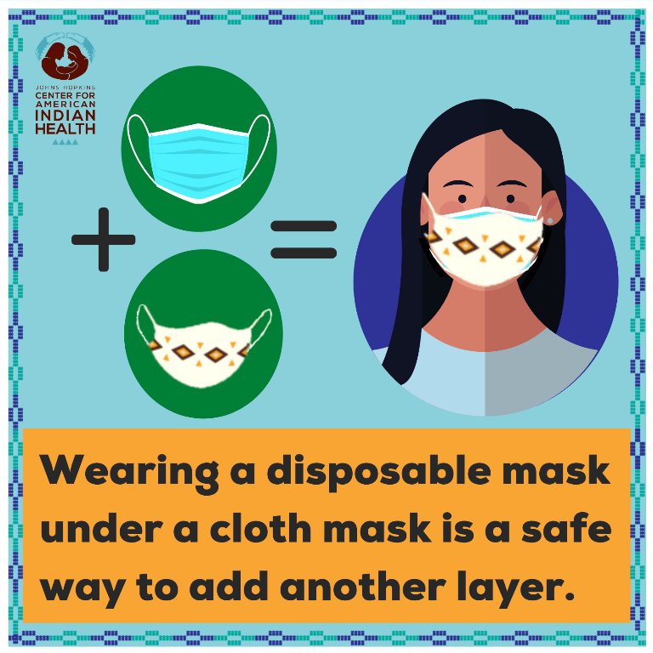
Social Media Message: Did you know you can wear two masks to better protect yourself from #COVID19? Improve your protection by wearing a disposable mask underneath a cloth mask so that they fit tightly against your face. Do not combine two disposable masks or use a KN95 mask with any other mask.
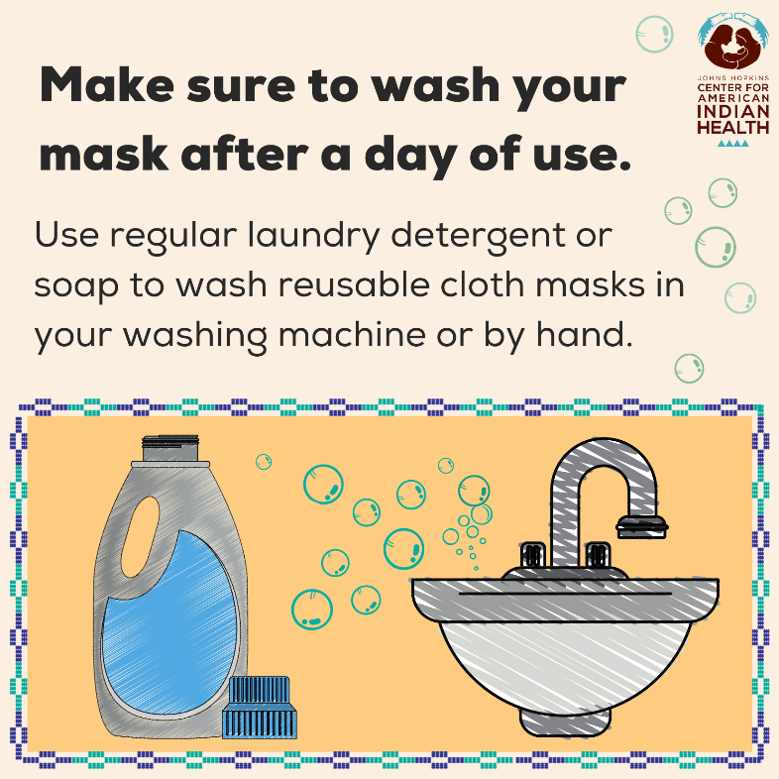
Social Media Message: Clean your cloth masks to keep them strong against #COVID19. You can wash reusable masks with your regular laundry and soap. Use a washing machine and dryer or wash by hand and hang until completely dry. Always wash your hands after touching your used masks and throw away disposable masks after one use. #StoptheSpread
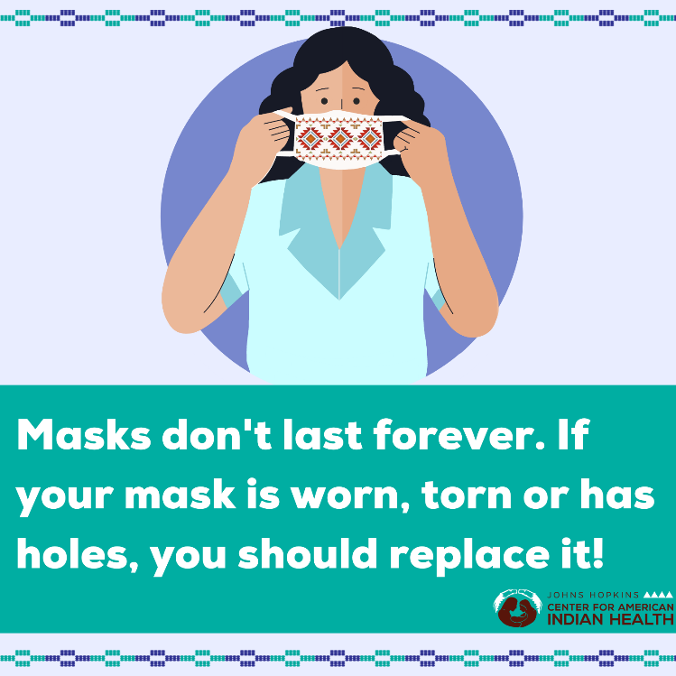
Social Media Message: Is your mask still keeping you protected from #COVID19? Be sure to replace your reusable cloth masks if they start to show signs of use like holes, worn out spots, or tears. One tip is to hold your cloth mask up to a light to show any see-through spots! Keep wearing good quality masks to #stopthespread.

