Staying Well Social Media Toolkit

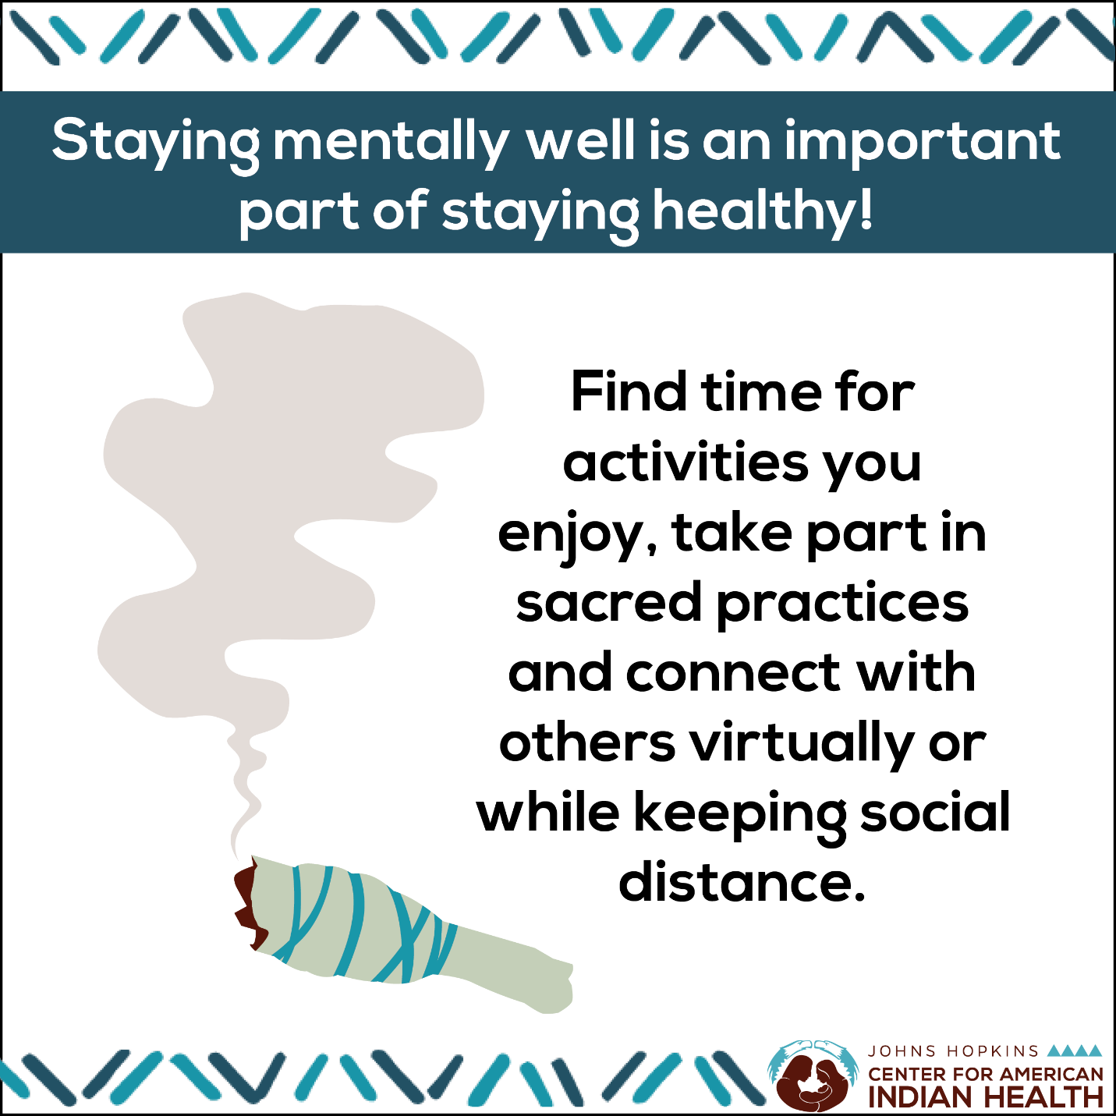

Social Media Message: How do you relieve stress? Staying #mentallywell is an important part of staying healthy. Participate in activities you enjoy while staying safe from #COVID-19. Take part in sacred practices and connect with others virtually or while keeping physical distance. For more information: https://bit.ly/3ado0de.

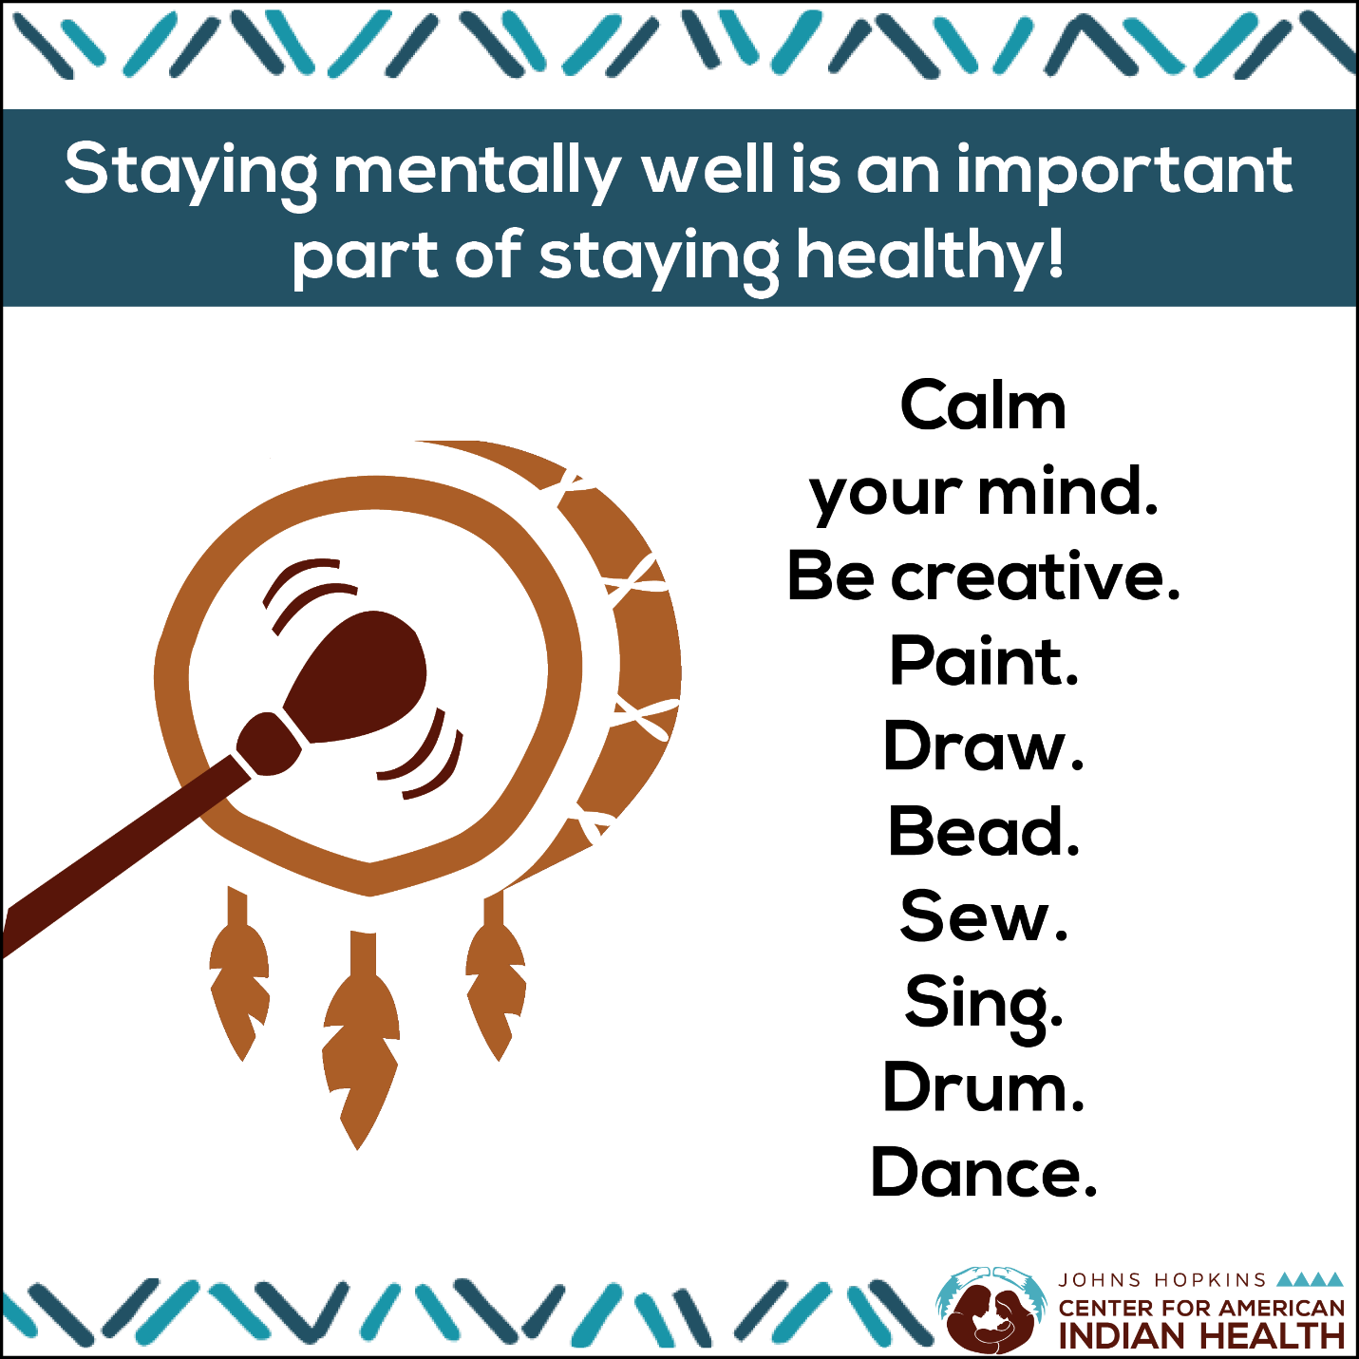

Social Media Message: We might not be able to do everything as we used to before #COVID-19, but we can continue findings ways to stay #mentallywell. Creativity can help keep your spirits up. Try painting, drumming, or beading. For more information: https://bit.ly/3ado0de.

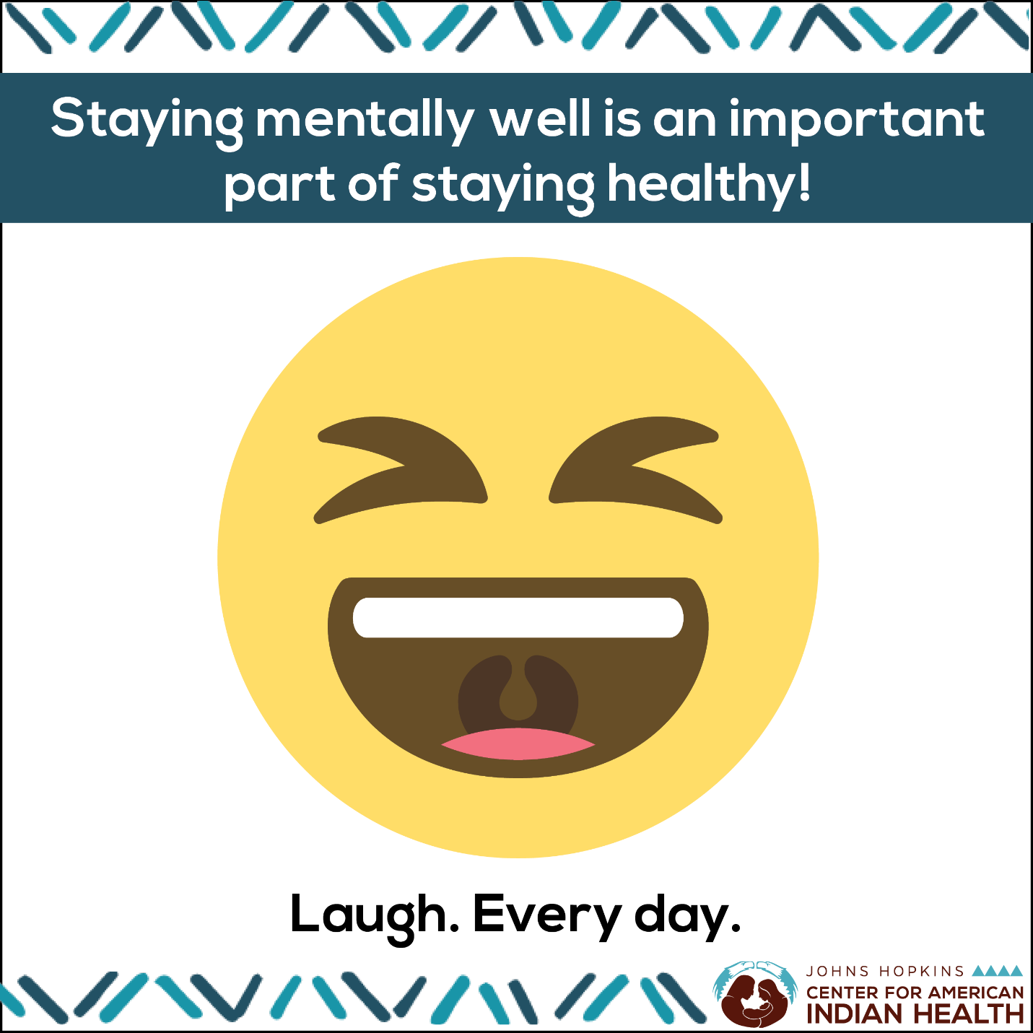

Social Media Message: We all know laughter is the best medicine. Talk with your funniest friend or relative, listen to a podcast, or watch a good comedy. Find time in your day to laugh, smile, and stay #mentallywell. For more information: https://bit.ly/3ado0de.

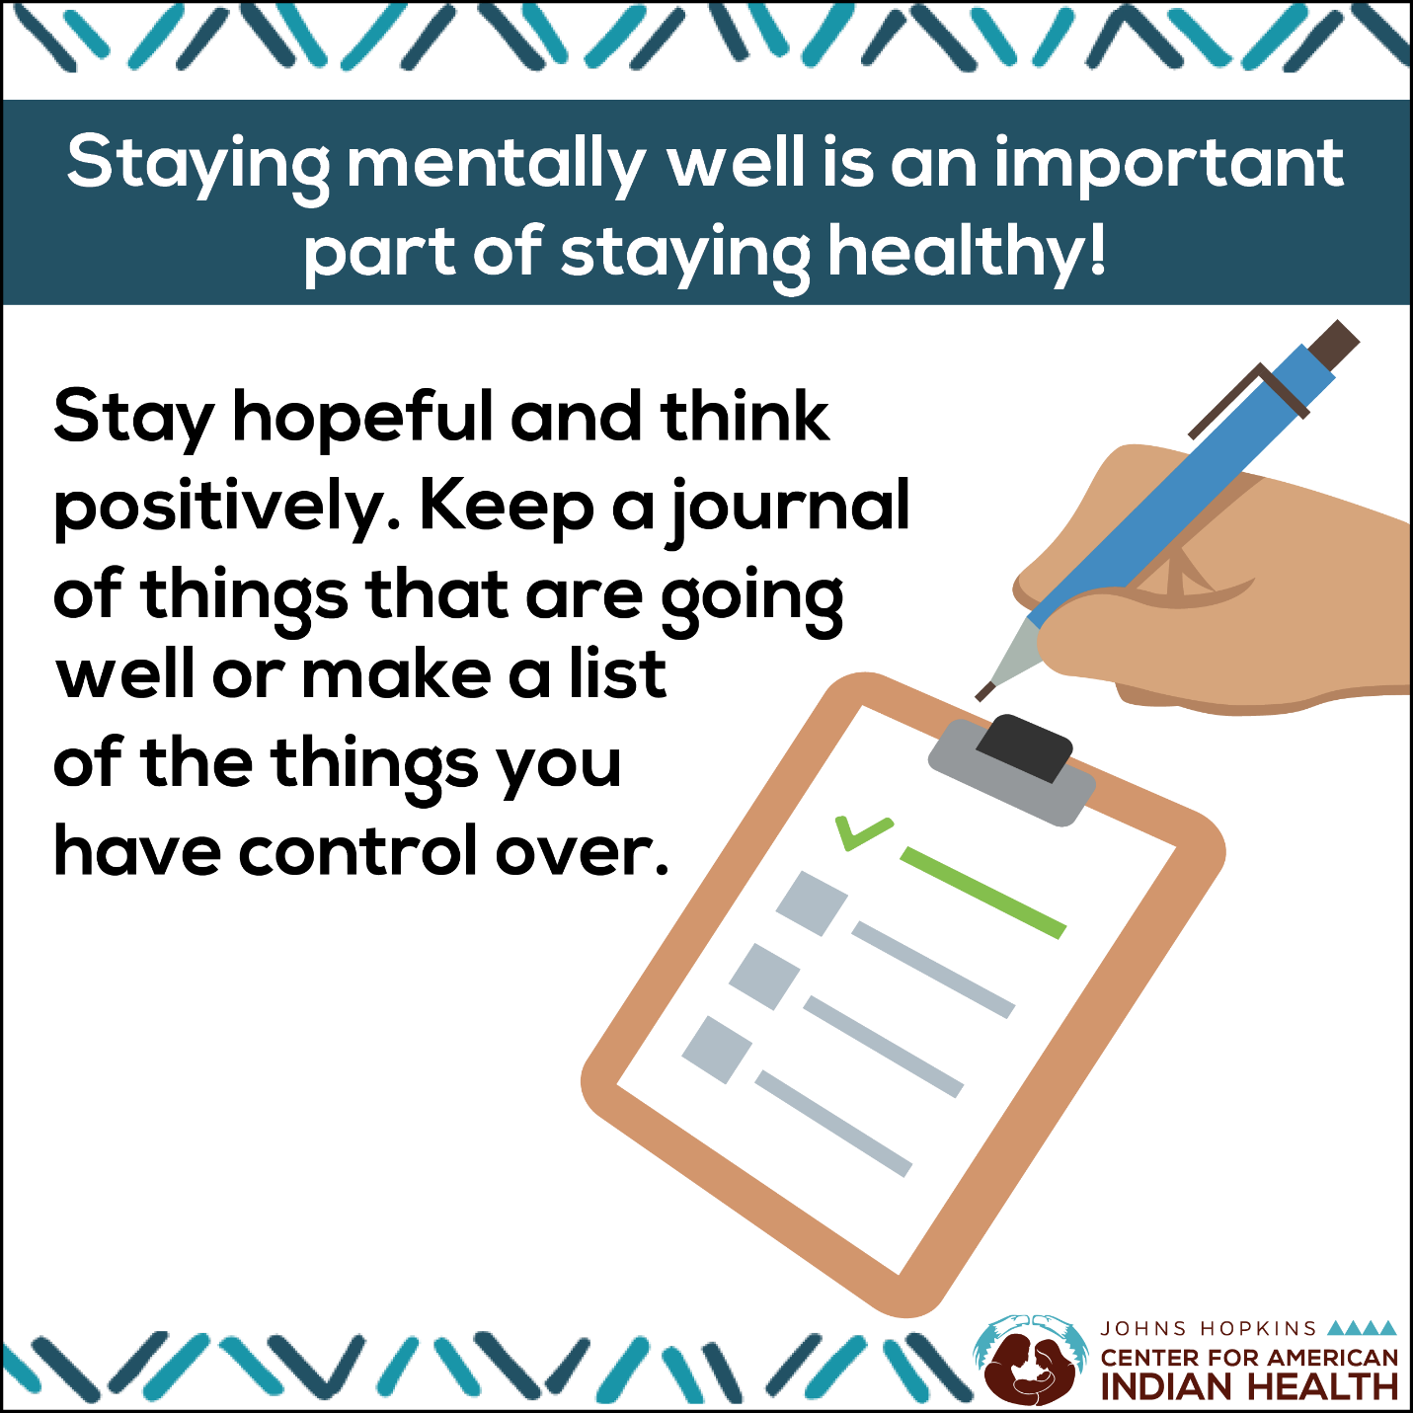

Social Media Message: Some days will be harder than others, but remember that each day is a new day. Keep a journal of things that are going well or make a list of things you have control over. Writing can help you stay hopeful, positive, and #mentallywell. For more information: https://bit.ly/3ado0de.

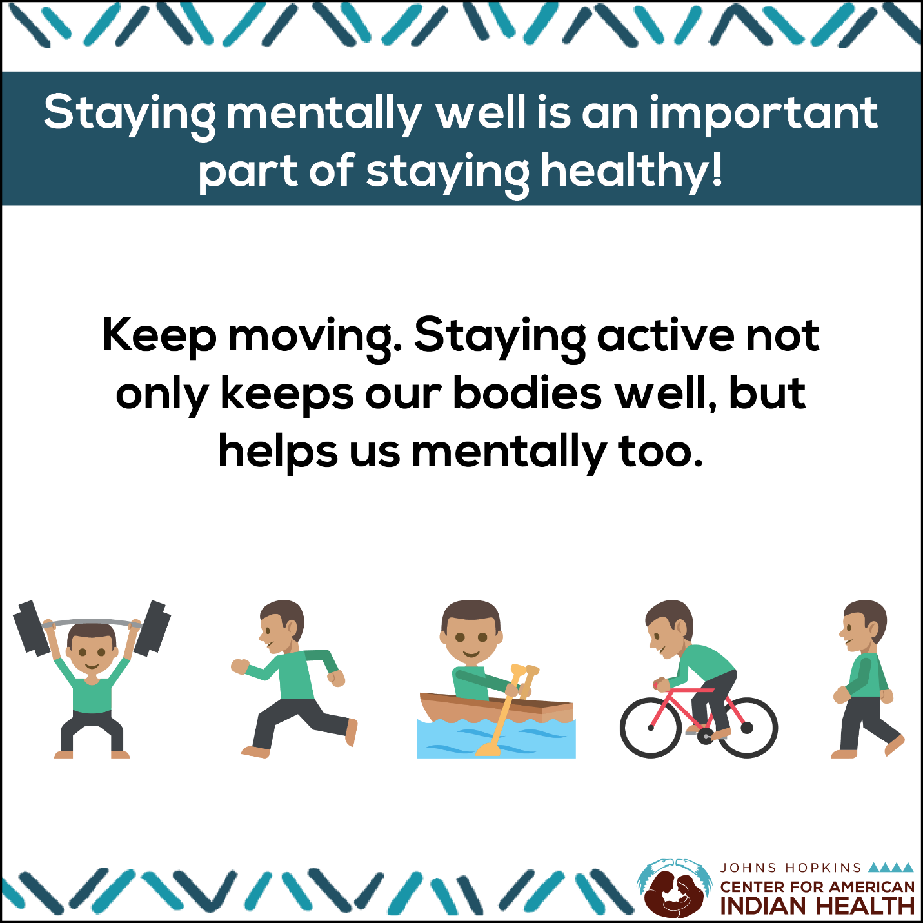
Social Media Message: Maintaining physical health well helps us mentally, too. Sleeping well, eating healthy meals, and being active can help ease depression and anxiety. Stay on top of any health conditions, and do what you can to safely stay physically and #mentallywell. For more information: https://bit.ly/3ado0de.

