Boujee Natives
Social Media Toolkit
All designer permissions obtained via DM, as long as we tag them. Tags below.
#1 Monday May 24, 2021
Instagram:
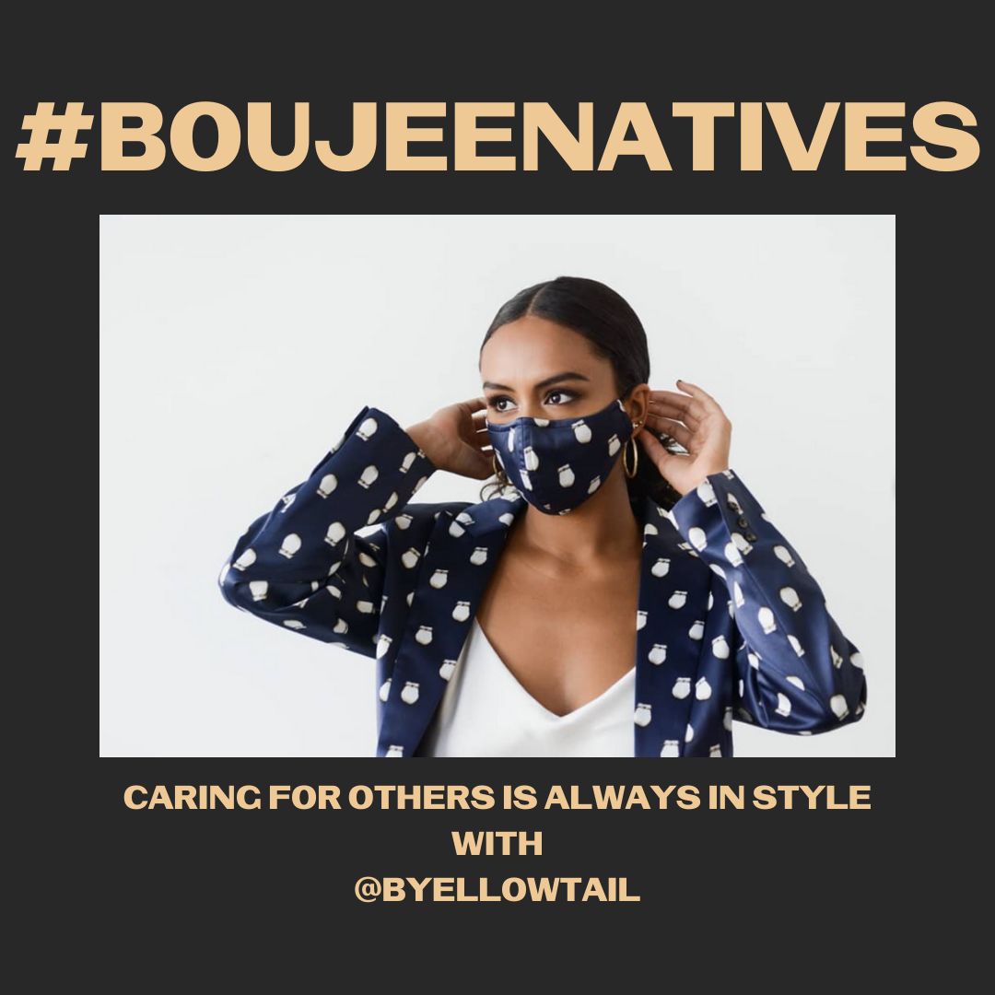

Note: Tag @byellowtail
Description: #NativeYouth it’s always in fashion to care for your communities. It’s beautiful to be a part of the #NativesStopTheSpread movement. Designer mask by @byellowtail. Don’t forget to check your tribal or local guidelines on mask requirements. Native youth and young adults, what are you doing to protect yourselves, families, and communities? DM us a photo to be included in a future post, or tag us in your post!
#NativesDoingTheirPart #NativeAmericanHealth #IndigenousHealth #NativeAmerican #AmericanIndian #AlaskanNative #HealthyTribes #IndigenousPeople #NativeHealth #TribalHealth #COVIDWarrior #NativesVaxUp #NativesMaskUp #SkoVaxDen #VacciNative #VACCINation #NDNCommunityImmunity #IndigiFabulous #BoujeeNatives

Twitter and Facebook:
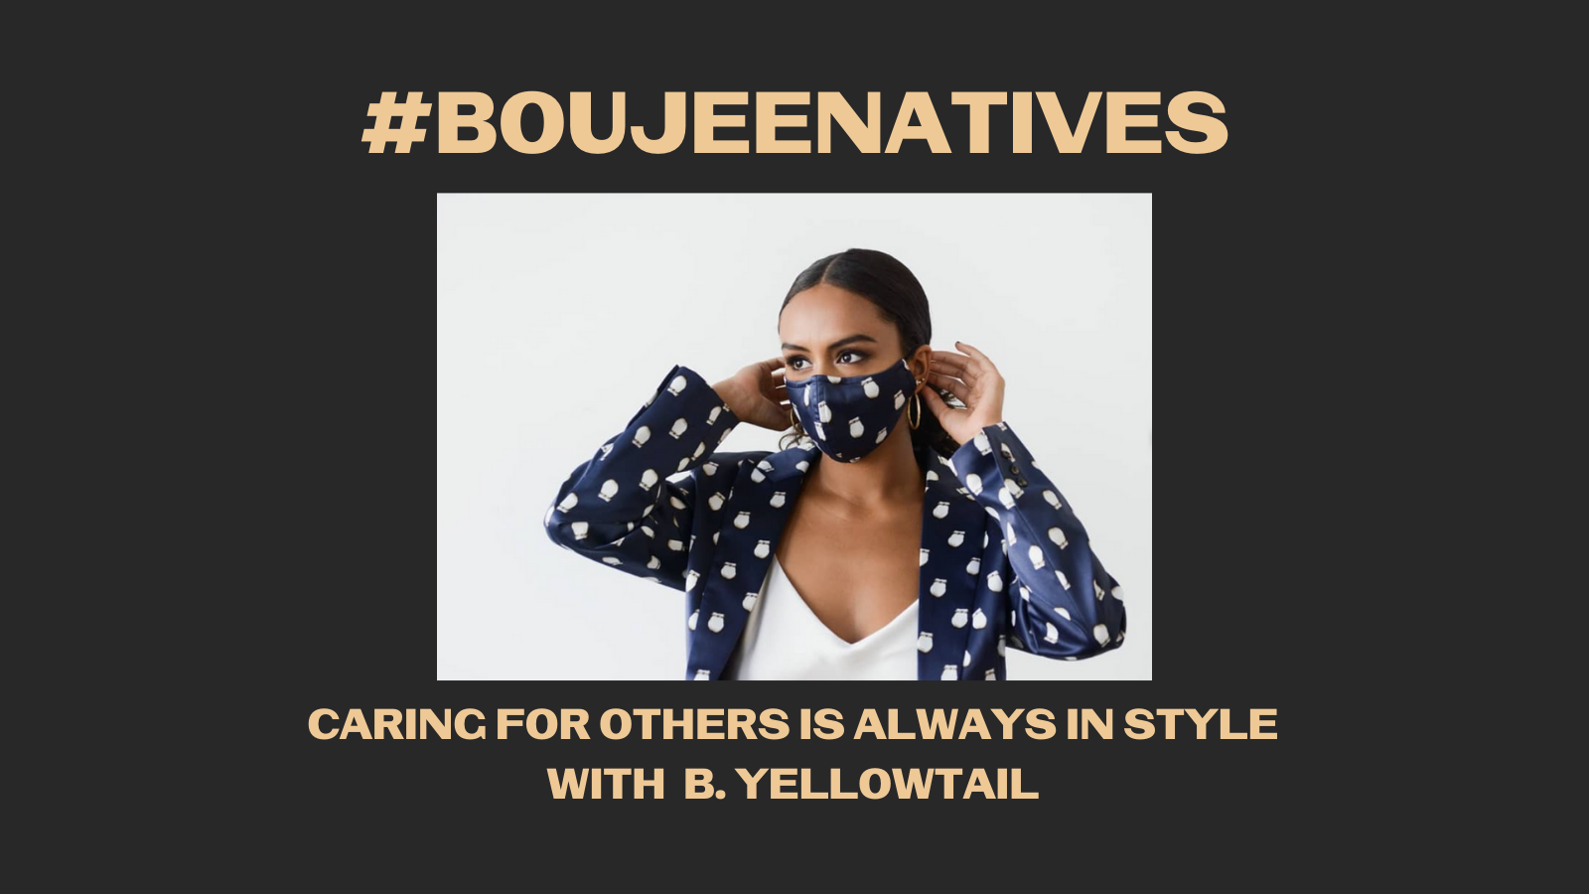

Note: Bethany Yellowtail does not appear to be on Twitter but is on Facebook @byellowtail
Description: #NativeYouth it’s always in fashion to care for your communities. It’s beautiful to be a part of the #NativesStopTheSpread movement. Mask by B. Yellowtail. What are you doing to protect yourselves, families, and communities? DM us a photo, or tag us in your post! #BoujeeNatives

#2 Wednesday May 26, 2021
Instagram:
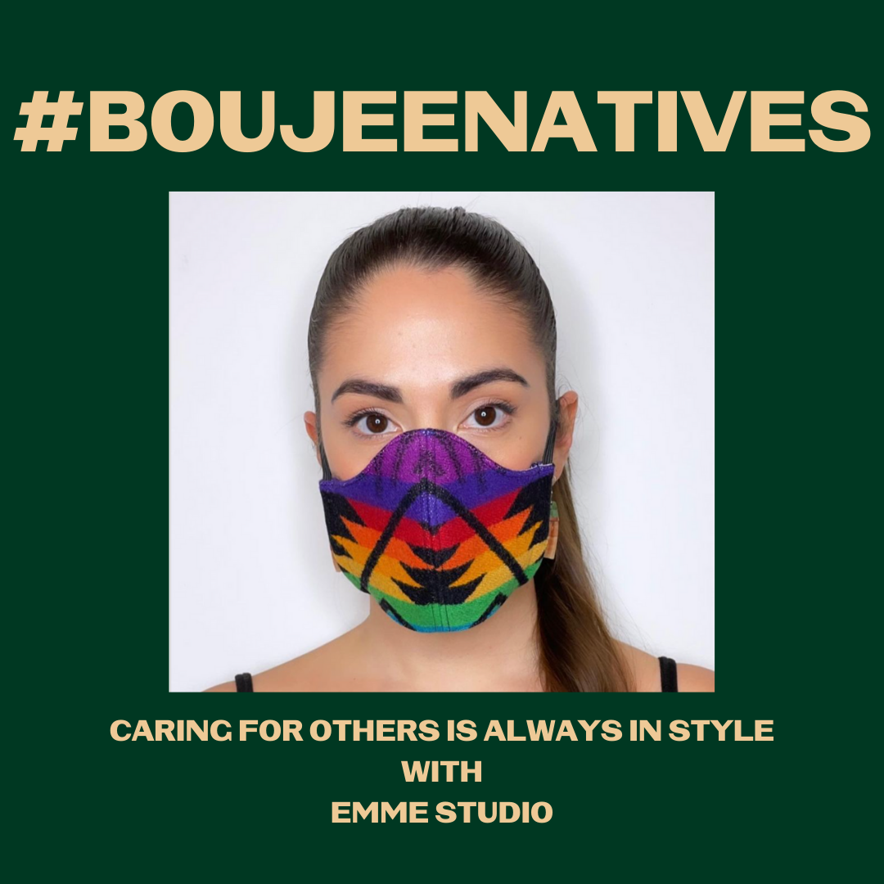

Note: Tag @korinaemmerich
Description: #NativeYouth you are being a good relative and serving it fresh and #IndigiFabulous. Thank you for caring for others, it looks good on you. Designer mask by EMME Studio. Don’t forget to check your tribal or local guidelines on mask requirements. Native youth and young adults, what are you doing to protect yourselves, families, and communities? DM us a photo to be included in a future post, or tag us in your post!
#NativesStopTheSpread #NativesDoingTheirPart #NativeAmericanHealth #IndigenousHealth #NativeAmerican #AmericanIndian #AlaskanNative #HealthyTribes #IndigenousPeople #NativeHealth #TribalHealth #COVIDWarrior #NativesVaxUp #NativesMaskUp #SkoVaxDen #VacciNative #VACCINation #NDNCommunityImmunity #BoujeeNatives

Twitter and Facebook:

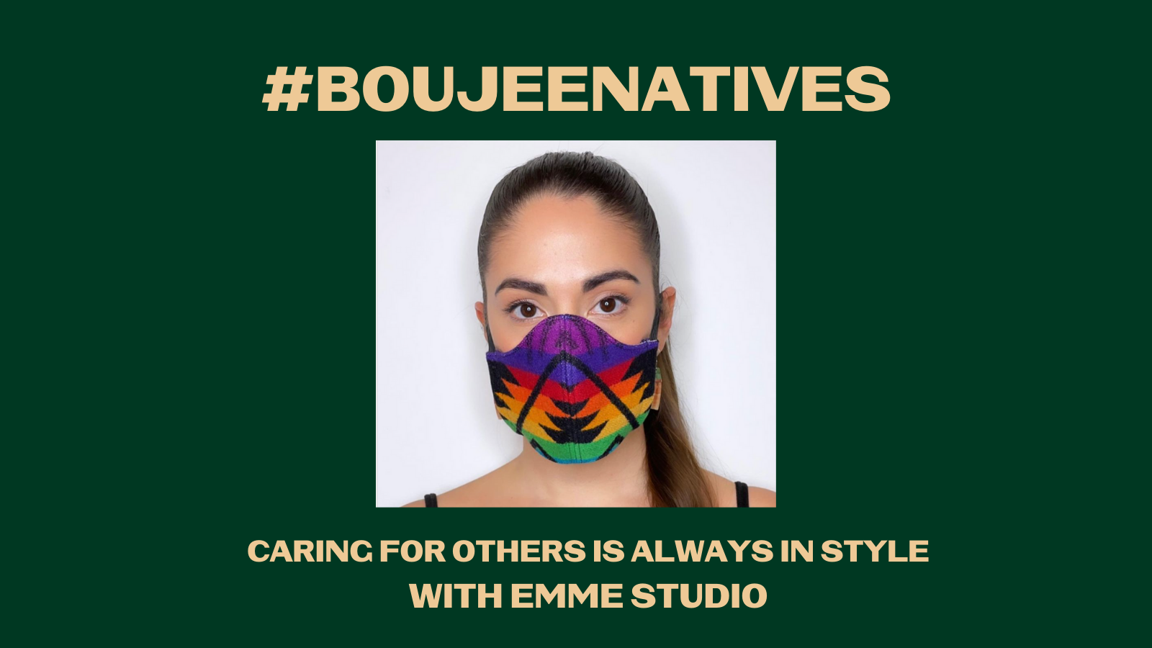
Note: Not on Twitter but tag on Facebook: @korinaemme
Description: #NativeYouth you’re being a good relative and serving it #IndigiFabulous. Thank you for caring for others, it looks good on you. Mask by EMME Studio by Korina Emmerich. What are you doing to protect yourselves, families, and communities? DM us a photo, or tag us! #BoujeeNatives

#3 Friday May 28, 2021
Instagram:
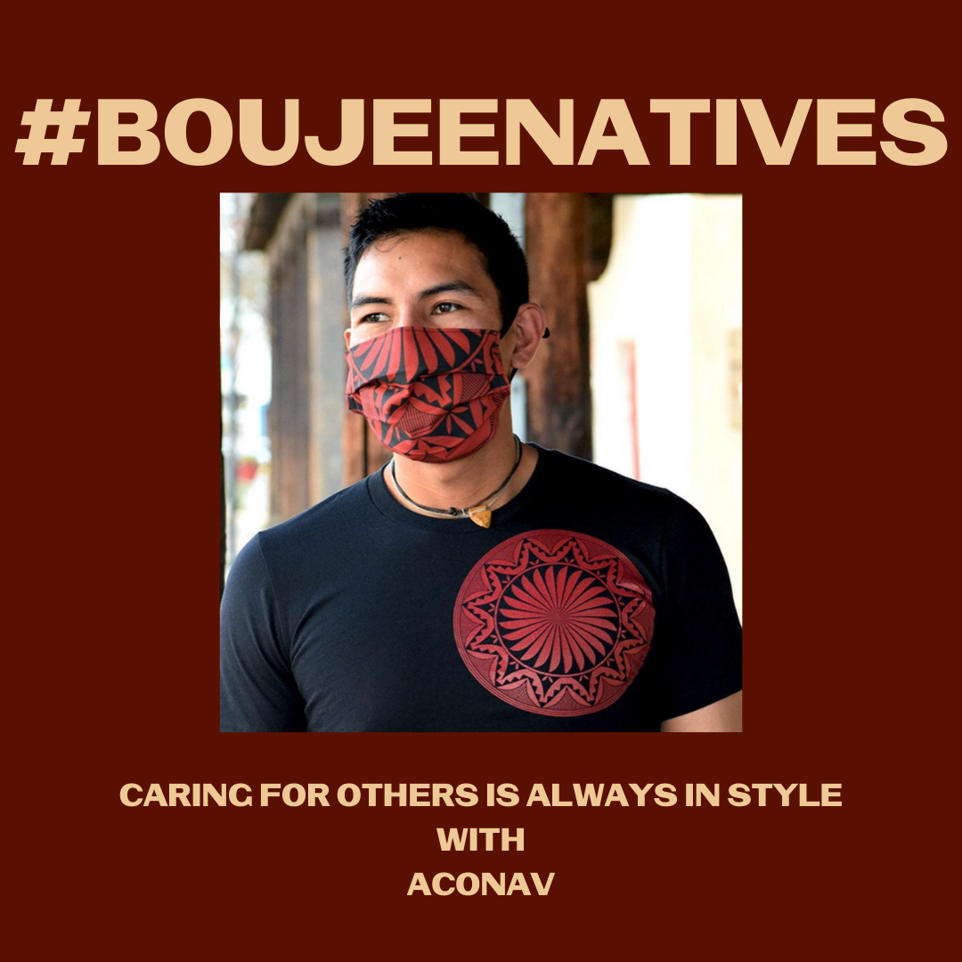

Note: Tag @aconav
Description: #NativeYouth getting vaccinated shows your inner beauty, and wearing a mask to keep others healthy is also #IndigiFabulous. Designer mask by Aconav‘s Loren Aragon. Don’t forget to check your tribal or local guidelines on mask requirements. Native youth and young adults, what are you doing to protect yourselves, families, and communities? DM us a photo to be included in a future post, or tag us in your post!
#NativesStopTheSpread #NativesDoingTheirPart #NativeAmericanHealth #IndigenousHealth #NativeAmerican #AmericanIndian #AlaskanNative #HealthyTribes #IndigenousPeople #NativeHealth #TribalHealth #COVIDWarrior #NativesVaxUp #NativesMaskUp #SkoVaxDen #VacciNative #VACCINation #NDNCommunityImmunity #BoujeeNatives

Twitter and Facebook:
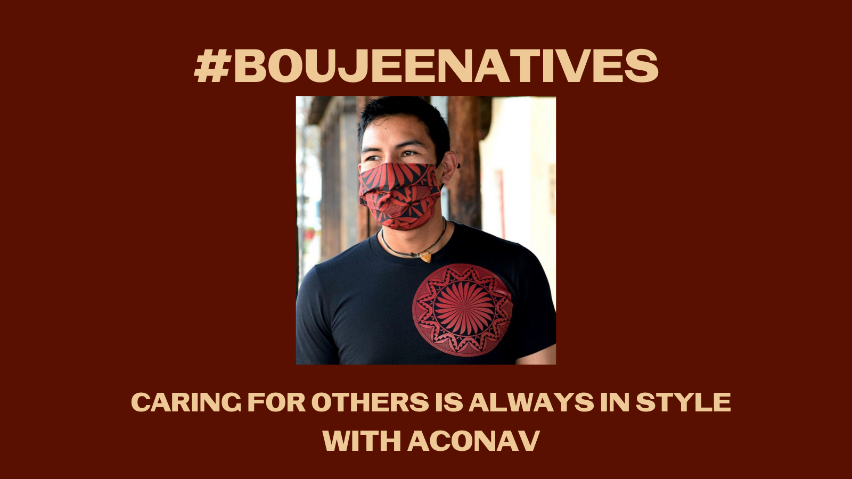
Twitter tag @aconav_fashion and Facebook @ACONAV
Description: #NativeYouth getting vax'd shows your inner beauty, and wearing a mask for loved ones is #IndigiFabulous. Designer mask by Aconav‘s Loren Aragon. What are you doing to protect yourselves, families, and communities? DM us a photo or tag us in a post! #BoujeeNatives

