COMING OF AGE
Social Media Toolkit
#1 Monday May 10, 2021
Instagram:
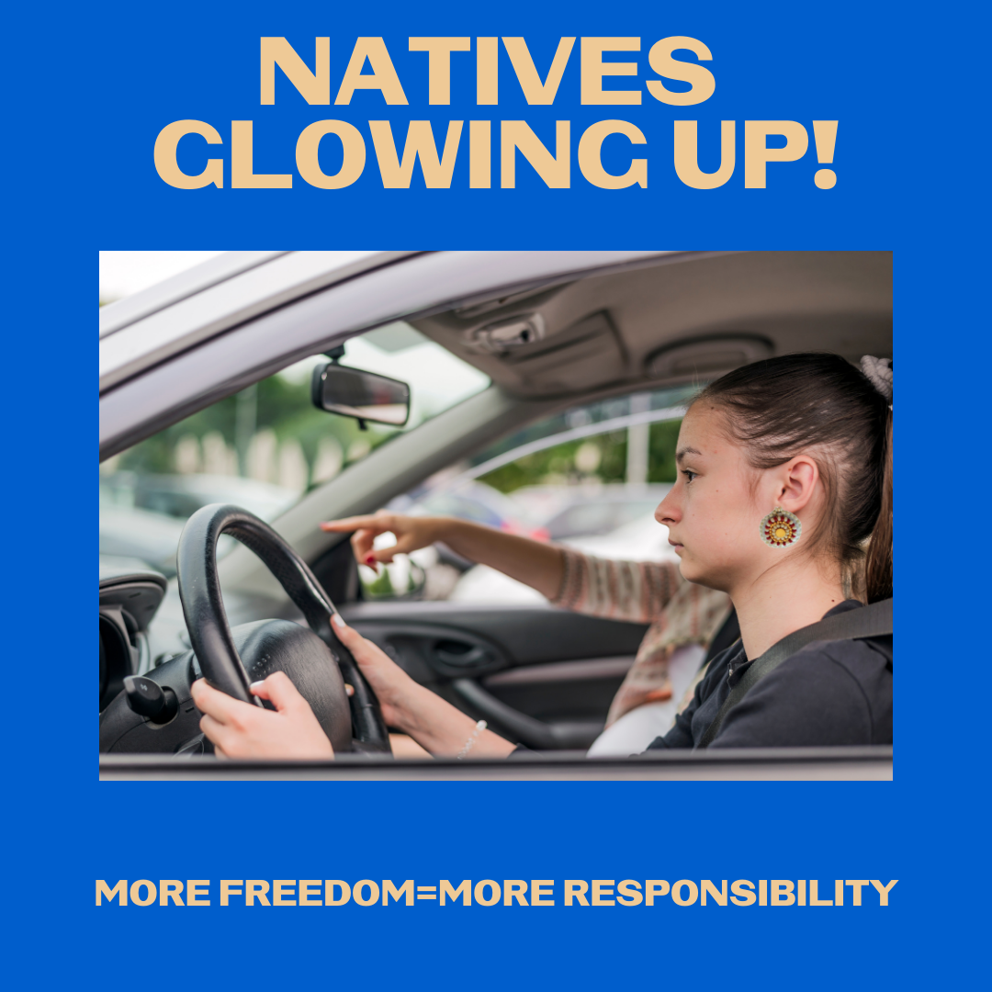
Description: #NativeYouth, you’re growing up and glowing up, earning more freedom, and embracing more responsibility. Just like when you learn to drive, you learn to watch for others. Thank you for also watching out for our communities by getting vaccinated.
Native youth and young adults, what are you doing to protect yourselves, your families, and your communities? DM us a photo to be included in a future post or tag us in your post!
#NativesStopTheSpread #NativesDoingTheirPart #NativeAmericanHealth #IndigenousHealth #NativeAmerican #AmericanIndian #AlaskanNative #HealthyTribes #IndigenousPeople #NativeHealth #TribalHealth #COVIDWarrior #NativesVaxUp #SkoVaxDen #VacciNative #VACCINation #IndigenousLanguage #NDNCommunityImmunity

Twitter and Facebook:
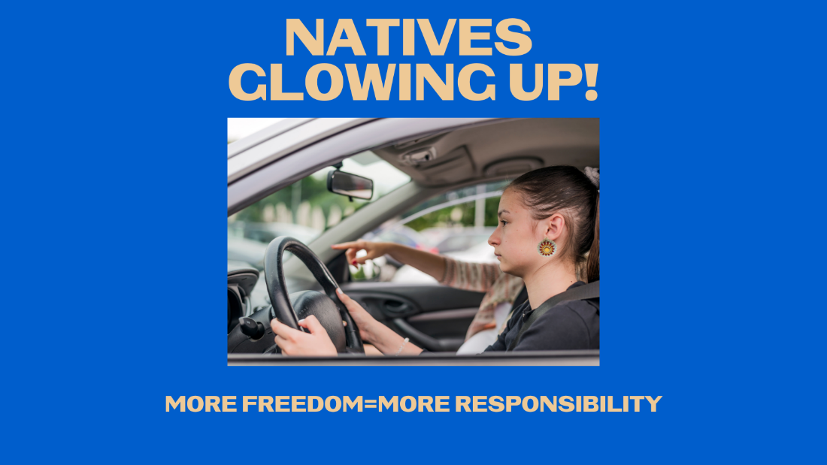
Description: #NativeYouth, you’re growing up and glowing up, earning more freedom, and embracing more responsibility. Just like when you learn to drive, you learn to watch for others. Thank you for also watching out for our communities by getting vaccinated. #NativesStopTheSpread

#2 Wednesday May 12, 2021
Instagram:

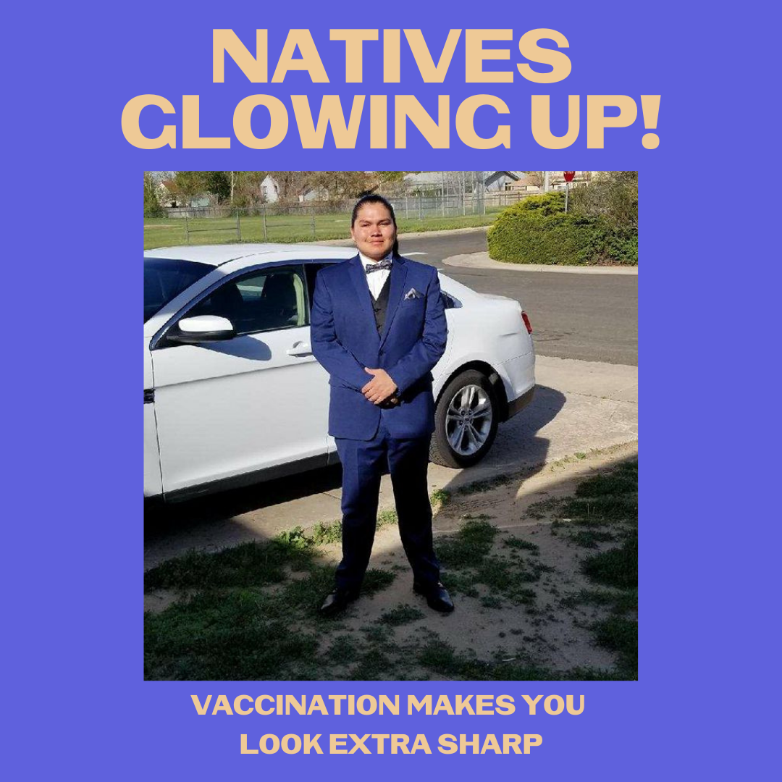
Description: #NativeYouth, you’re growing up, earning more freedom, and embracing more responsibility. You’re taking care of yourself, your families, and your communities. Vaccination is the real glow up. #IndigiFabulous #BoujeeNative
Native youth and young adults, what are you doing to stand up for your communities? DM us a photo to be included in a future post or tag us in your post!
#NativesStopTheSpread #NativesDoingTheirPart #NativeAmericanHealth #IndigenousHealth #NativeAmerican #AmericanIndian #AlaskanNative #HealthyTribes #IndigenousPeople #NativeHealth #TribalHealth #COVIDWarrior #NativesVaxUp #SkoVaxDen #VacciNative #VACCINation #IndigenousLanguage #NDNCommunityImmunity

Twitter and Facebook:

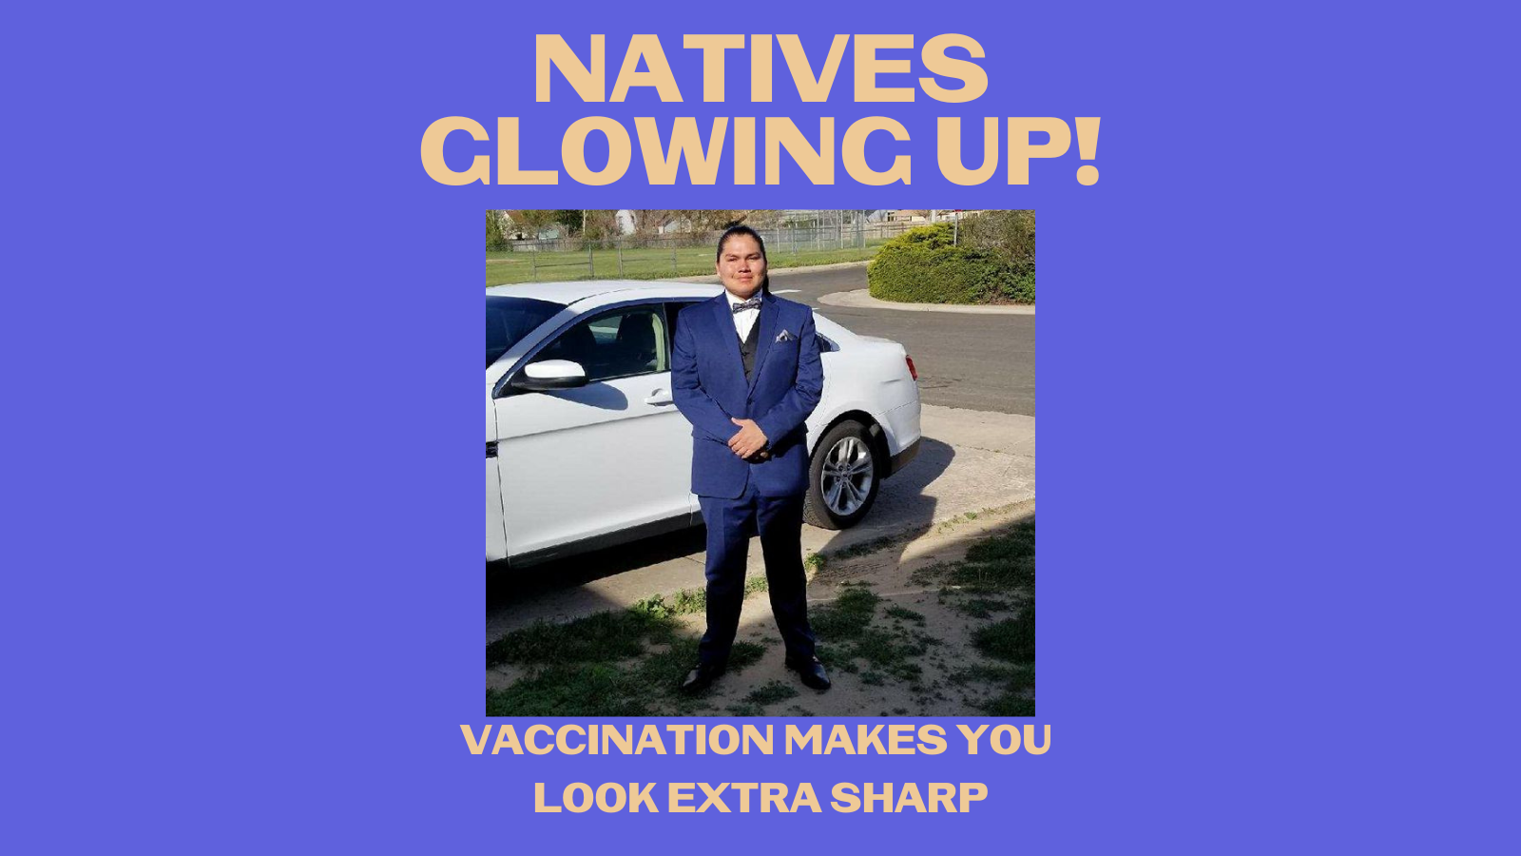

Description: #NativeYouth you’re growing up and glowing up, earning more freedom, and embracing more responsibility. You’re taking care of yourself, your families, and your communities. Vaccination is the real glow up. #IndigiFabulous #BoujeeNative #NativesStopTheSpread

Facebook add at the end: Native youth and young adults, what are you doing to protect yourselves, your families, and your communities? Tag us or DM us a photo to be featured!

#3 Friday May 14, 2021
Instagram:

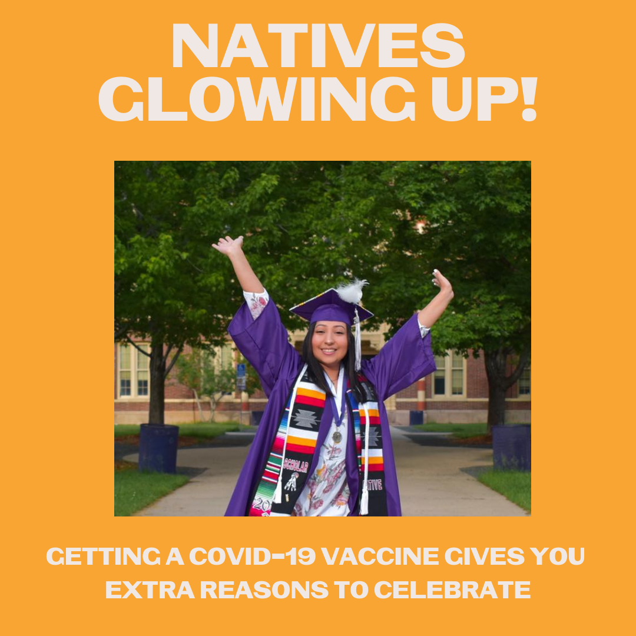
Description: #NativeYouth you’re growing up and glowing up, celebrating milestones and ready for more responsibility. You’re taking care of yourself, your families, and your communities. Vaccination is the real glow up. #IndigiFabulous #BoujeeNative
Native youth and young adults, what are you doing to stand up for your communities? DM us a photo to be included in a future post or tag us in your post!
#NativesStopTheSpread #NativesDoingTheirPart #NativeAmericanHealth #IndigenousHealth #NativeAmerican #AmericanIndian #AlaskanNative #HealthyTribes #IndigenousPeople #NativeHealth #TribalHealth #COVIDWarrior #NativesVaxUp #SkoVaxDen #VacciNative #VACCINation #IndigenousLanguage #NDNCommunityImmunity

Twitter and Facebook:
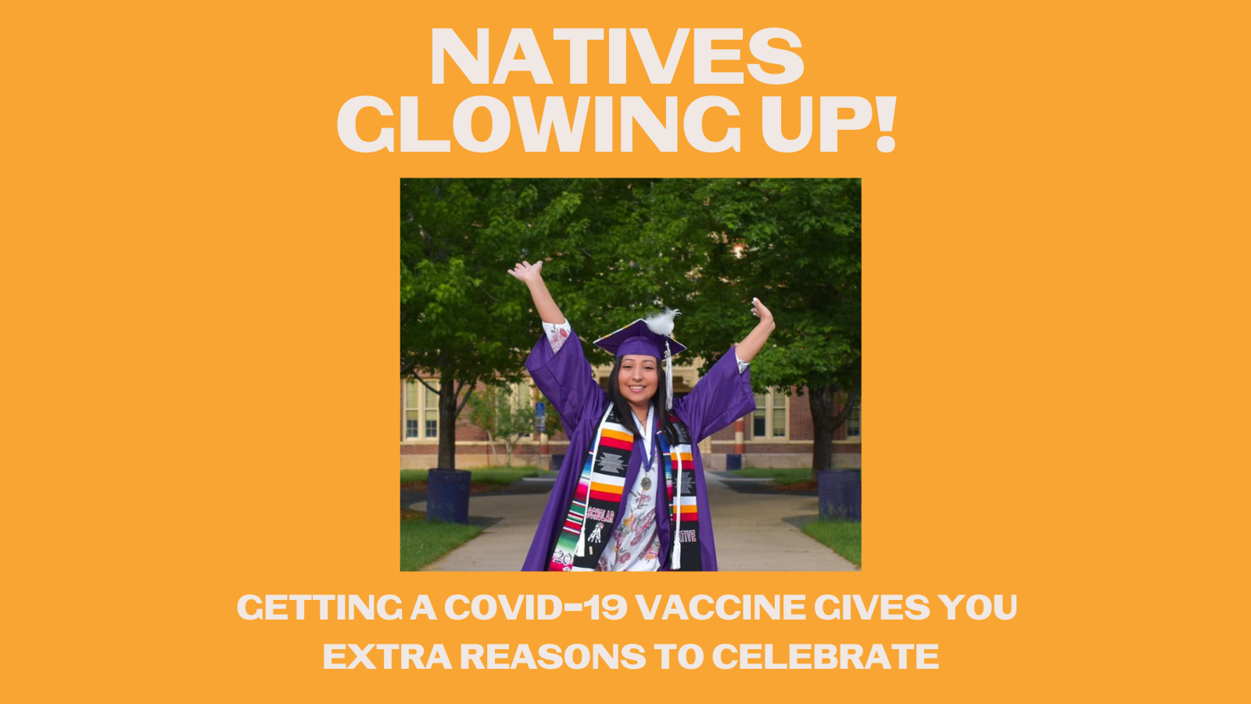
Description: #NativeYouth you’re growing up and glowing up, celebrating milestones and ready for more responsibility. You’re taking care of yourself, your families, and your communities. Vaccination is the real glow up. #IndigiFabulous #BoujeeNatives #NativesStopTheSpread
Facebook add at the end: Native youth and young adults, what are you doing to protect yourselves, your families, and your communities? DM us a photo to be included in a future post or tag us in your post!

