Snagging Words
Social Media Toolkit
#1 Monday
Instagram:
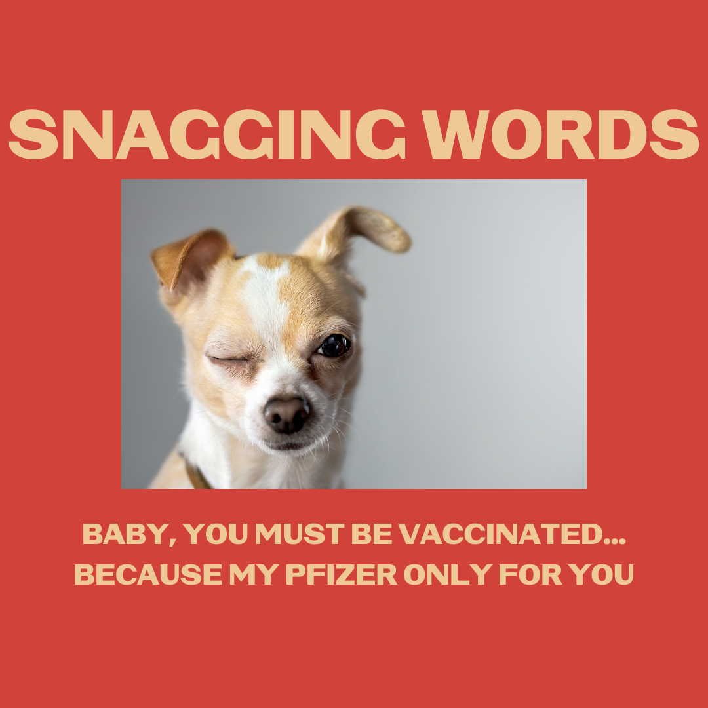

Description: As restrictions loosen in some communities for vaccinated individuals, you may be ready to get back out there and meet the babes. We’re here to help. Tell them you only have eyes for them. It’ll work like a charm.
Check your tribal and local guidelines for restrictions in your community.
#NativesDoingTheirPart #NativeAmericanHealth #IndigenousHealth #NativeAmerican #AmericanIndian #AlaskanNative #HealthyTribes #IndigenousPeople #NativeHealth #TribalHealth #COVIDWarrior #NativesVaxUp #NativesMaskUp #SkoVaxDen #VacciNative #VACCINation #NDNCommunityImmunity #NativeHumor #snaggingwords

Twitter and Facebook:
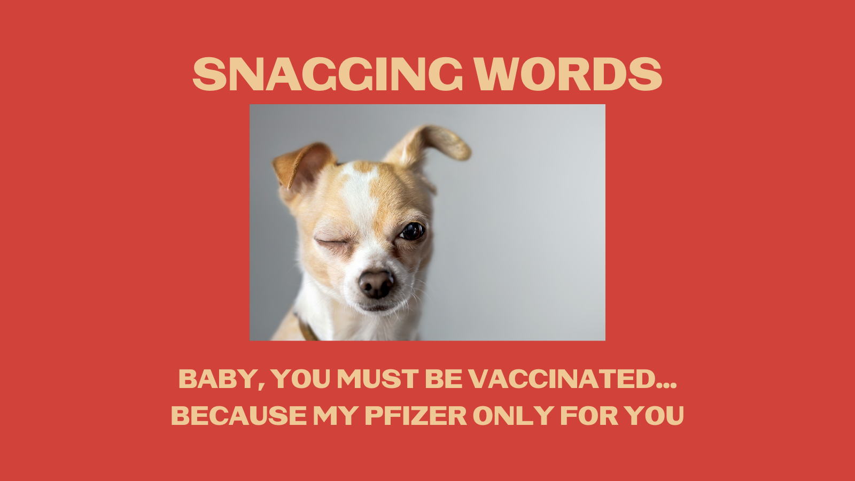

Description: As restrictions loosen in some communities for vaccinated individuals, you may be ready to get out there. We’re here to help you meet the babes. Tell them you only have eyes for them. It’ll work like a charm. Check tribal/local guidelines & community restrictions. #nativehumor

#2 Wednesday
Instagram:
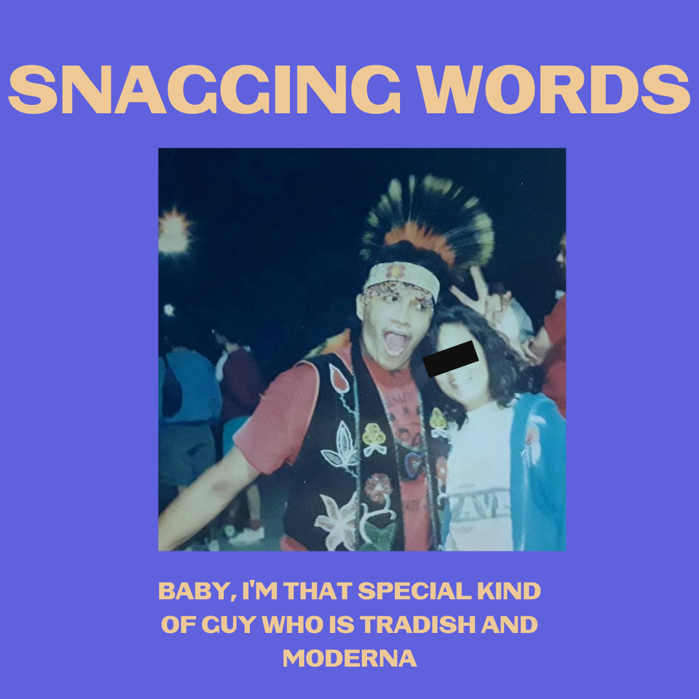

Description: Are you that special kind of Native who can honor those #OldWays and embrace the new, safe and effective tools for our people? People like that, so now that you’re vaccinated, go get ‘em tiger.
Check your tribal and local guidelines for restrictions in your community.
#NativesStopTheSpread #NativesDoingTheirPart #NativeAmericanHealth #IndigenousHealth #NativeAmerican #AmericanIndian #AlaskanNative #HealthyTribes #IndigenousPeople #NativeHealth #TribalHealth #COVIDWarrior #Anishinaabe #NativesVaxUp #NativesMaskUp #SkoVaxDen #VacciNative #VACCINation #NDNCommunityImmunity #NativeHumor #SnaggingWords

Twitter and Facebook:

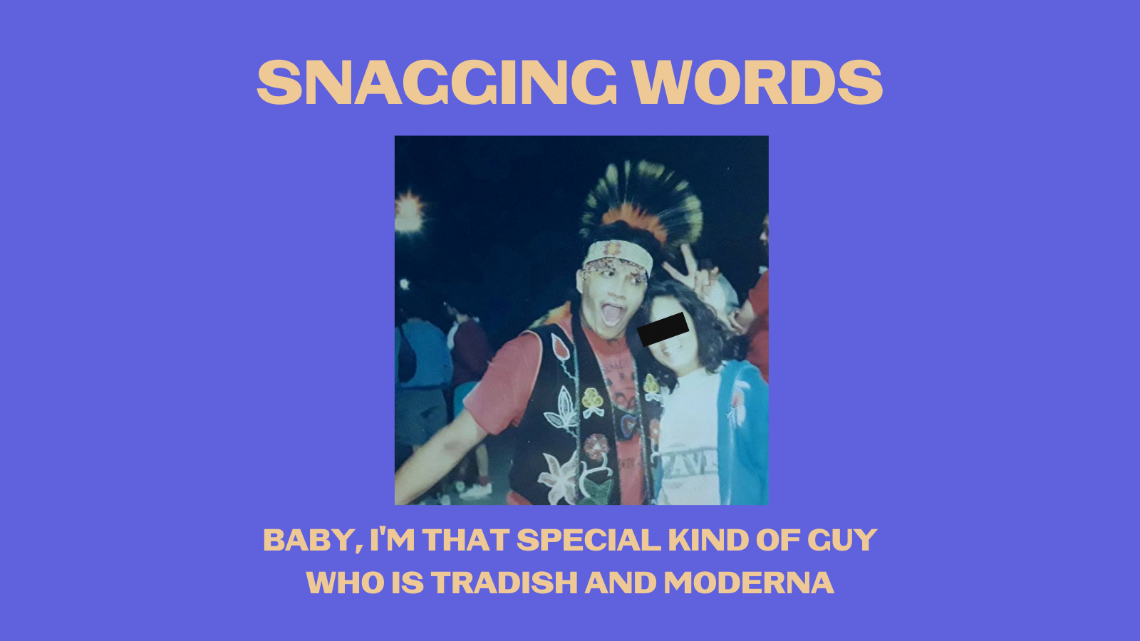

Description: Are you that special kind of Native who can honor those #OldWays and embrace the new, safe and effective tools for our people? People like that, so now that you’re vaccinated, go get ‘em tiger. #NativeHumor #SnaggingWords

Facebook add: Check your tribal and local guidelines for restrictions in your community.

#3 Friday
Instagram:

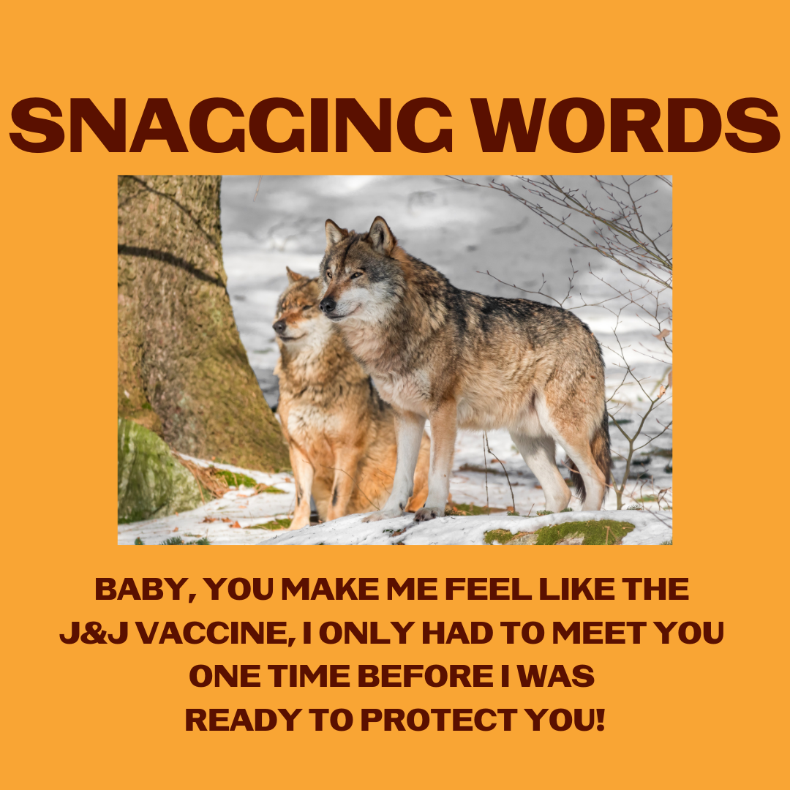
Description: Now that you’re vaccinated and restrictions are loosening, we’re sure these #SnaggingWords will help you win the babes. Thank us later. #NativeHumor
Check your tribal and local guidelines for restrictions in your community.
#NativesStopTheSpread #NativesDoingTheirPart #NativeAmericanHealth #IndigenousHealth #NativeAmerican #AmericanIndian #AlaskanNative #HealthyTribes #IndigenousPeople #NativeHealth #TribalHealth #COVIDWarrior #NativesVaxUp #NativesMaskUp #SkoVaxDen #VacciNative #VACCINation #NDNCommunityImmunity

Twitter and Facebook:

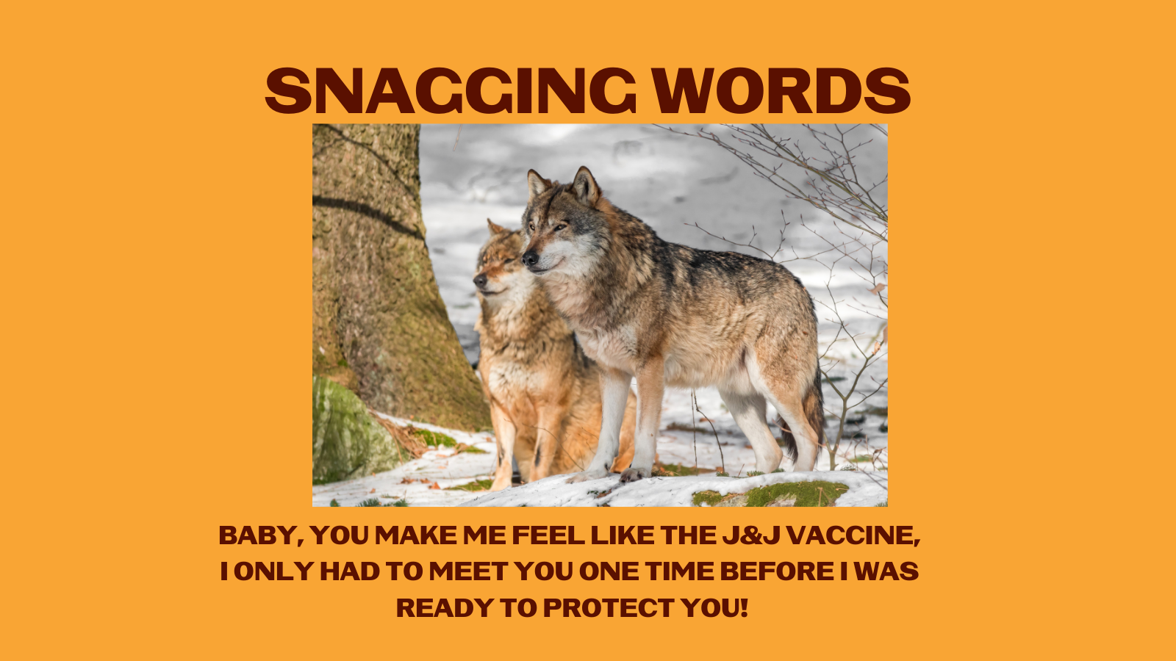

Description: Now that you’re vaccinated and restrictions are loosening, we’re sure these #SnaggingWords will help you win the babes. Thank us later. #NativeHumor #NativesStopTheSpread

Facebook add: Check your tribal and local guidelines for restrictions in your community.

