What You Can Do When Vaccinated SM Toolkit
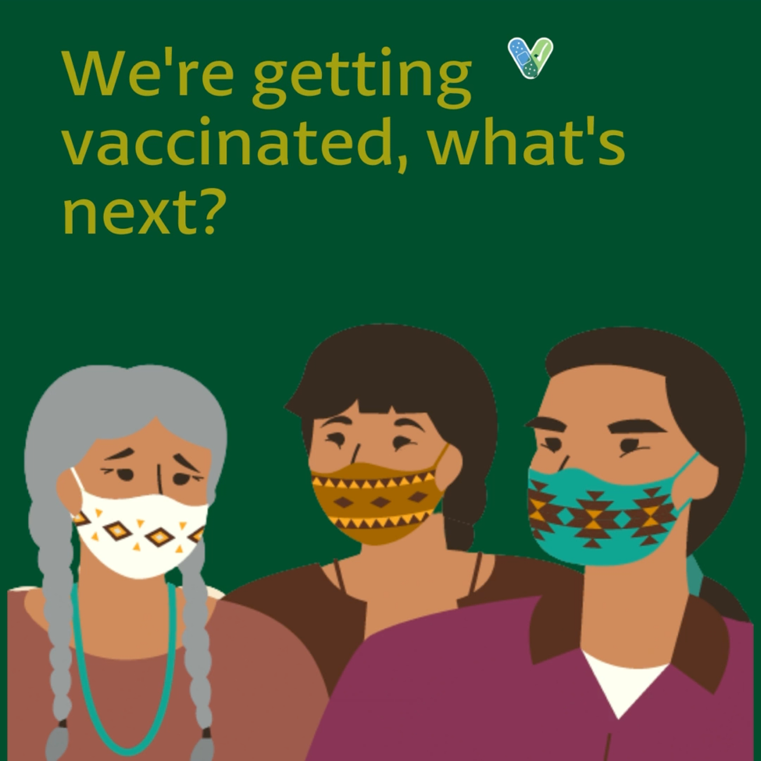

Link to download video: https://www.dropbox.com/s/e76meanxuyhxu0m/We%27re%20vaccinated%20%E2%80%94%20now%20what.mp4?dl=0

Message: When everyone is fully vaccinated, #COVID19 #vaccines will let us get back to our lives! Get back to group sports, connect with your family, and reconnect with friends, safely. Want to learn more about what you can do in vaccinated groups? Visit https://www.cdc.gov/coronavirus/2019-ncov/vaccines/fully-vaccinated.html to learn more.

#NativeHealth #VaccinesWork

