Youth Leaders Social Media Toolkit
#1 for Monday May 3, 2021
Instagram:
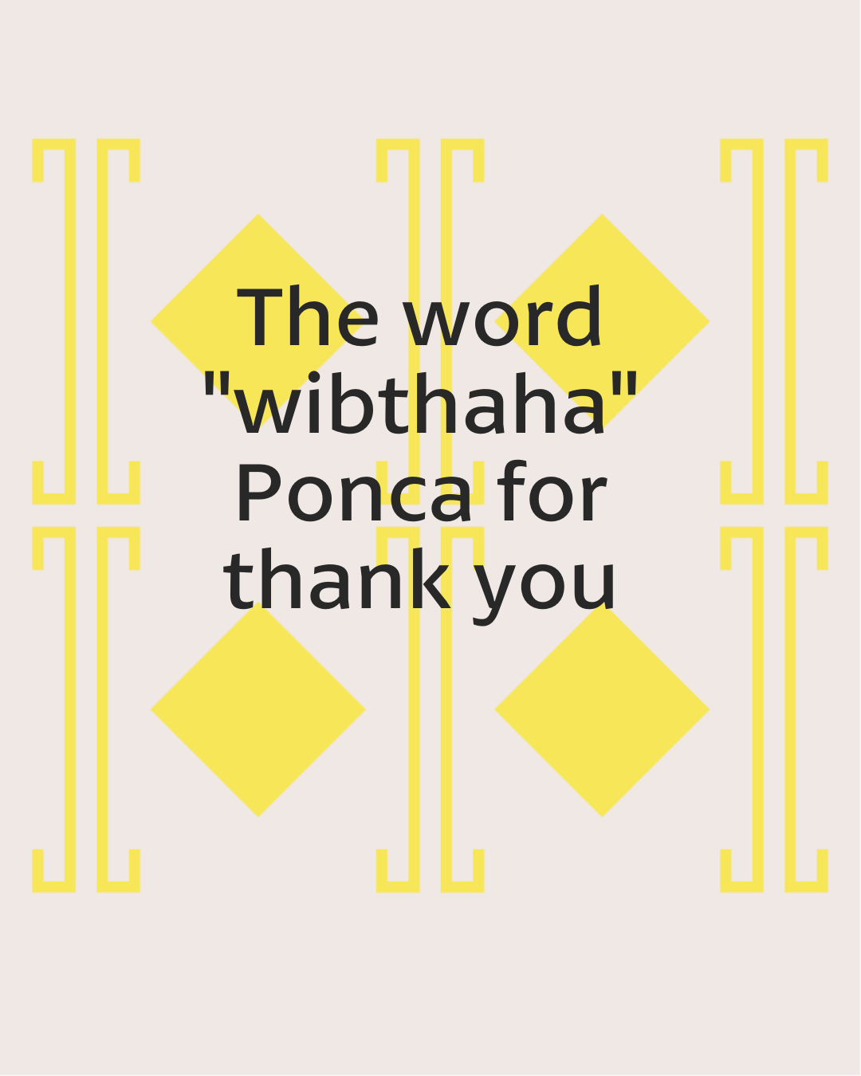
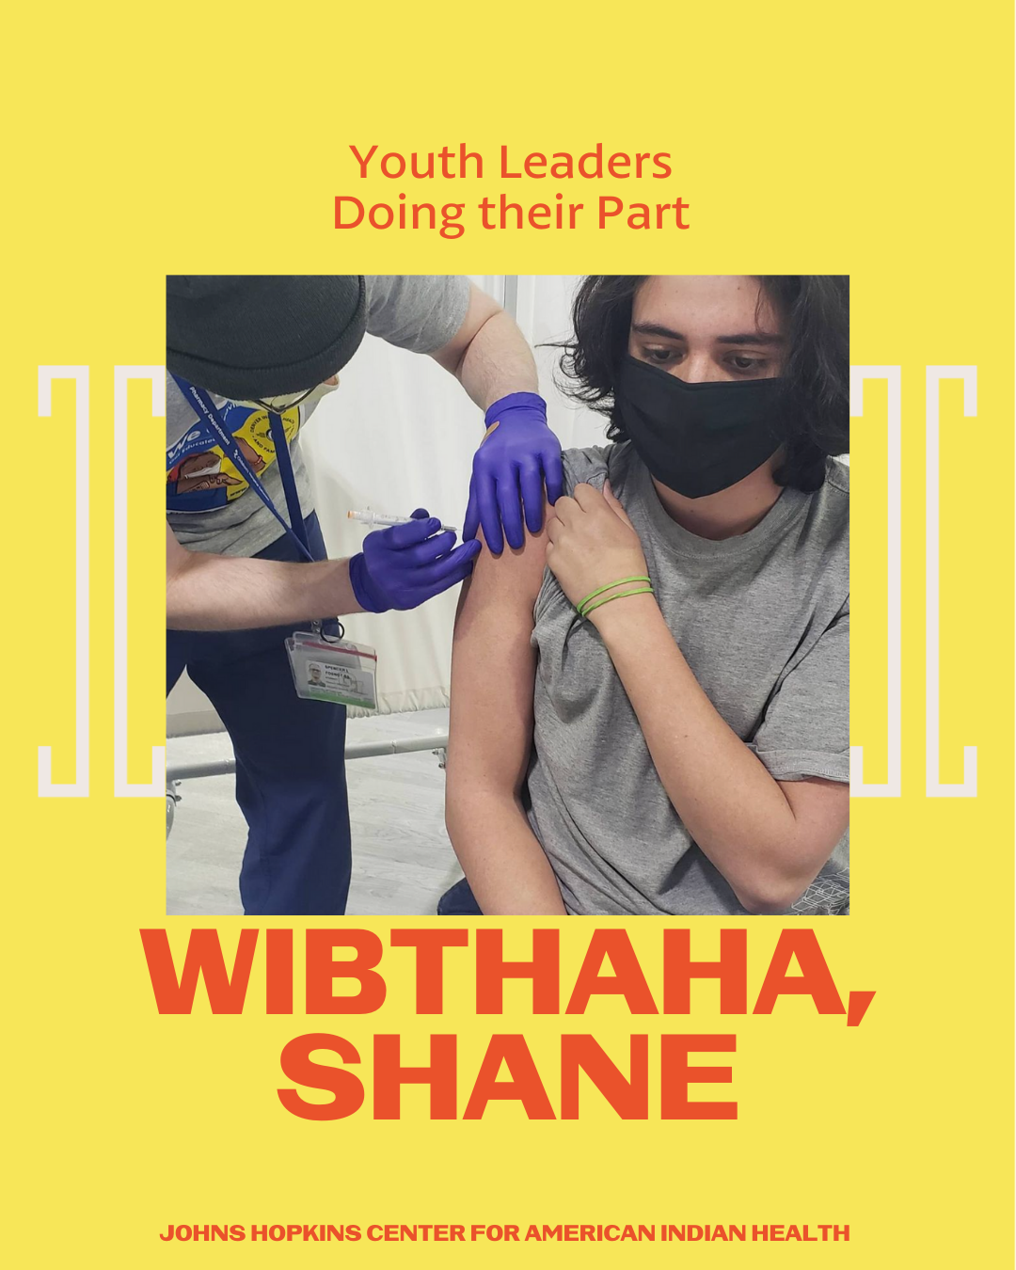

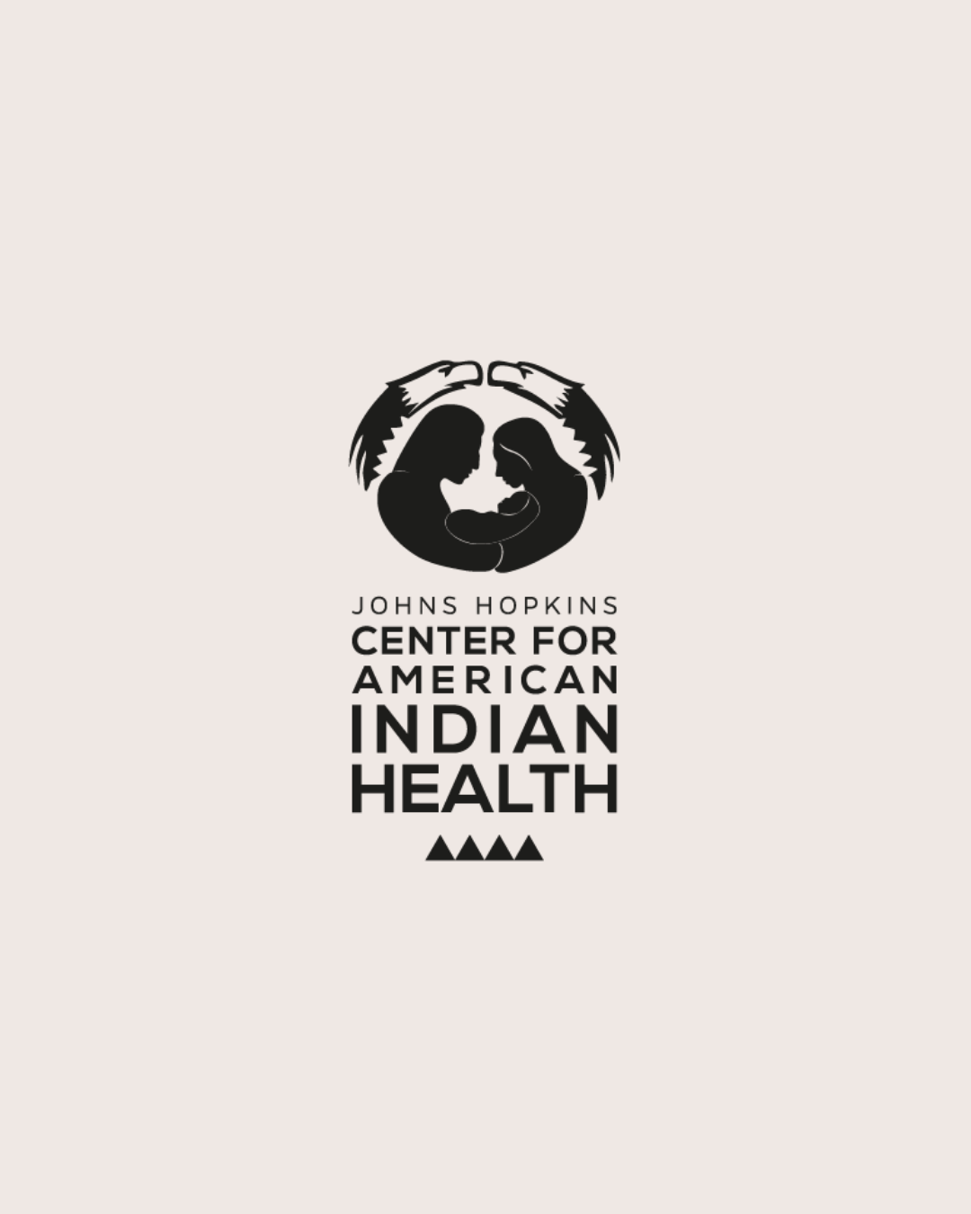
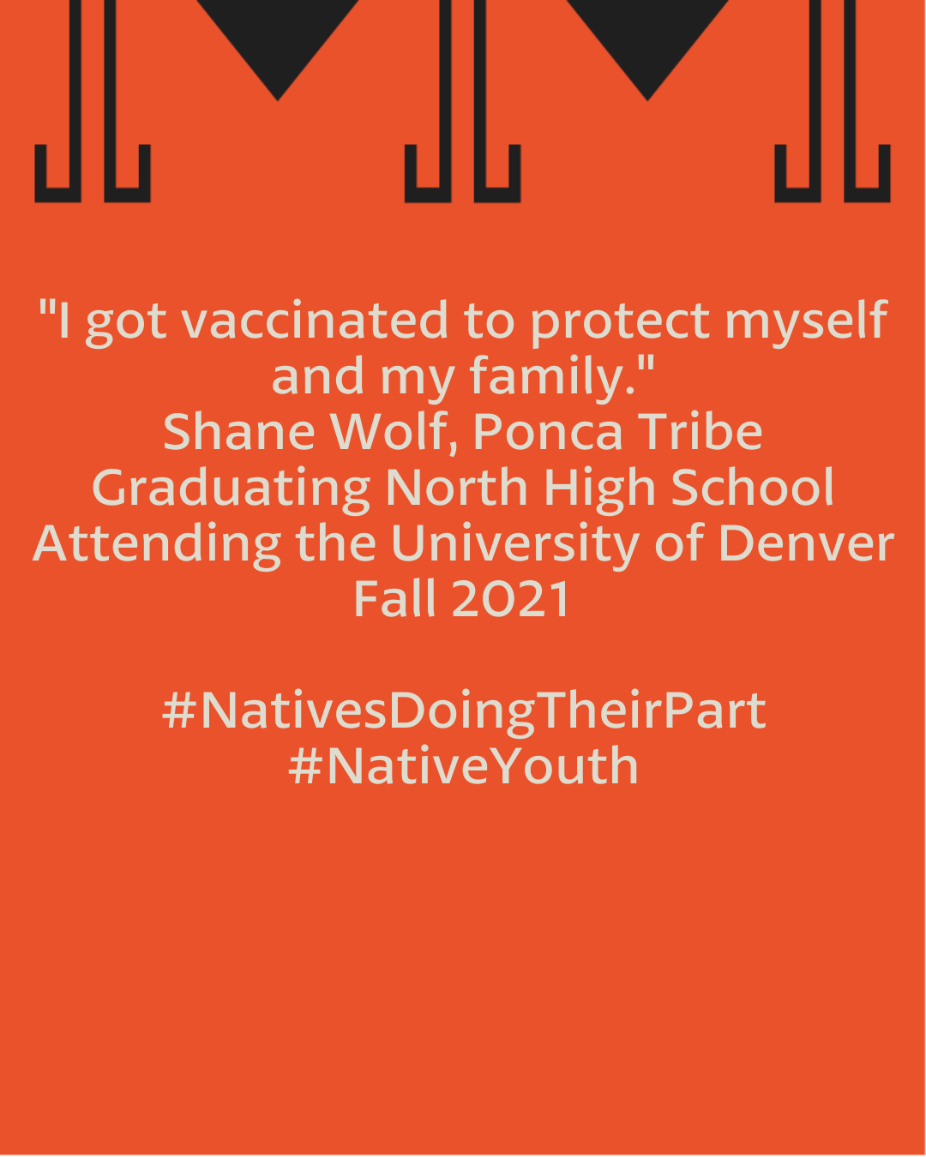

Description: #NativeYouth are doing their part and getting vaccinated to protect our communities. What are you doing to protect yourselves, your families, and your communities? DM us a photo to be included in a future post or tag us in your post. #NativesDoingTheirPart #NativeAmericanHealth
#IndigenousHealth #NativeAmerican #AmericanIndian #AlaskanNative #HealthyTribes #IndigenousPeople #NativeHealth #TribalHealth #COVIDWarrior #NativesVaxUp #SkoVaxDen #VacciNative #VACCINation #Ponca #IndigenousLanguage #NDNCommunityImmunity

Twitter and Facebook:
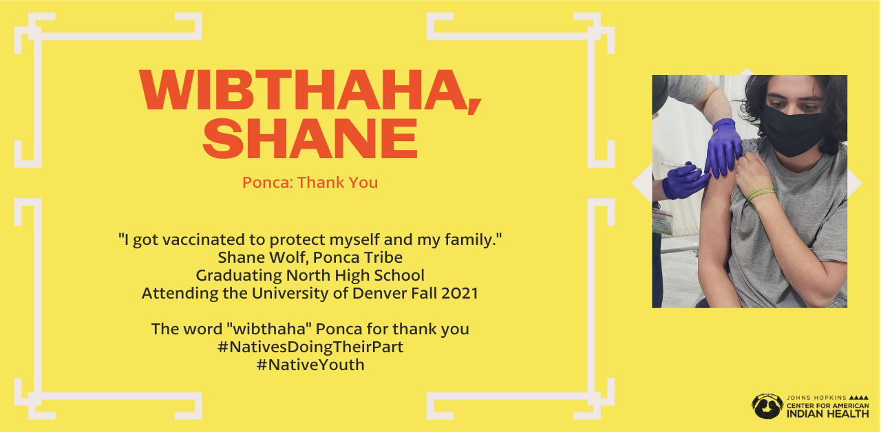

Description: #NativeYouth are doing their part and getting vaccinated to protect our communities. DM us a photo of your example of #NativesDoingTheirPart to be featured in an upcoming post or tag us. #NativeTwitter #HealthyTribes

#2 for Wednesday, May 5th, 2021
Instagram:
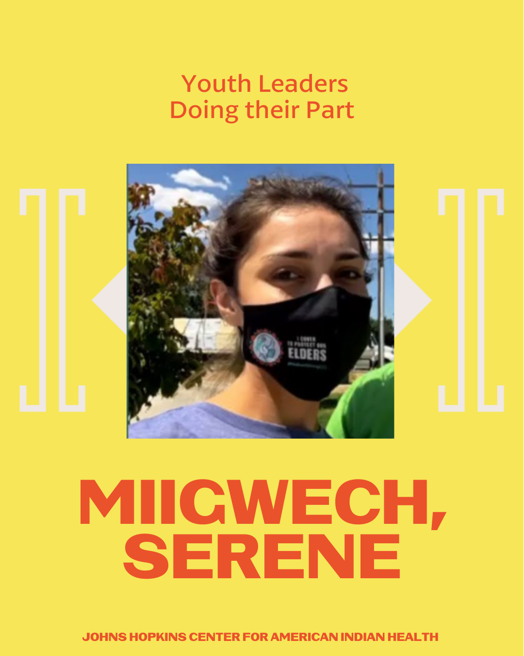
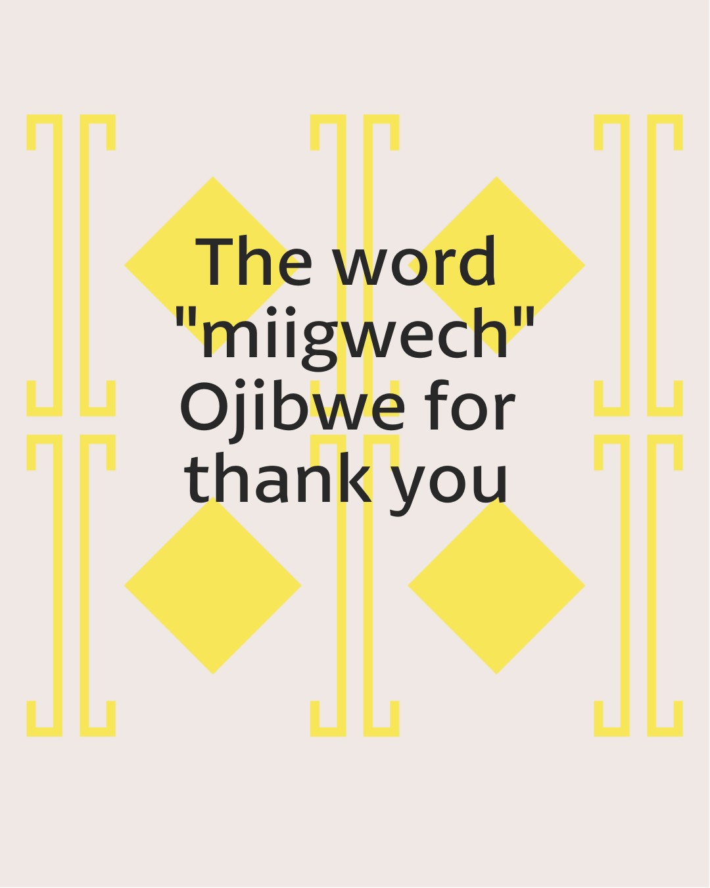
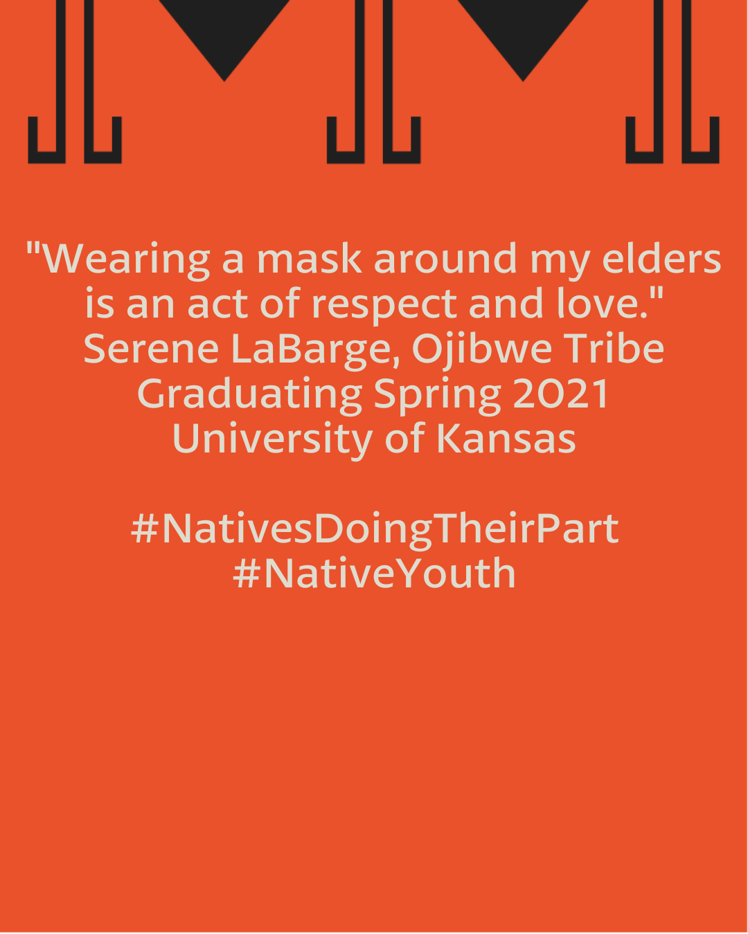
Description: Native youth and young adults, what are you doing to protect yourselves, your families, and your communities? Tag us in your post or DM us a photo for a chance to be featured. #NativesDoingTheirPart #NativeAmericanHealth #IndigenousHealth #NativeAmerican #AmericanIndian #AlaskanNative #HealthyTribes #IndigenousPeople #NativeHealth #TribalHealth #COVIDWarrior #NativesVaxUp #SkoVaxDen #VacciNative #VACCINation #Anishinaabe #IndigenousLanguage #NDNCommunityImmunity

Twitter:

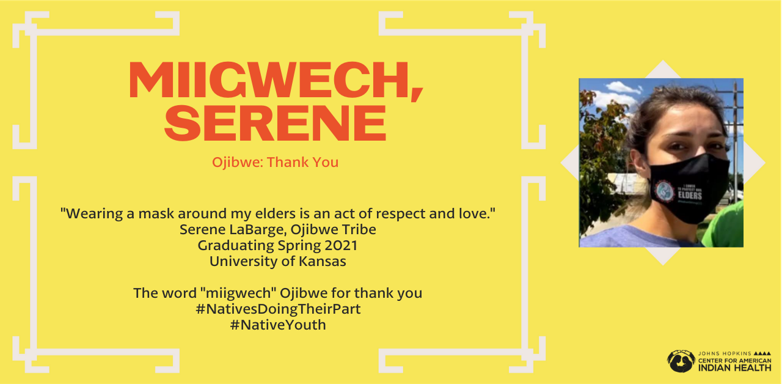

Description: #NativeYouth are doing their part and engaging in healthy behaviors to protect our communities. Native youth and young adults, DM us a photo example of #NativesDoingTheirPart to be featured in an upcoming post or tag us. #HealthyTribes #NativesTwitter

#3 Friday, May 7, 2021
Instagram:
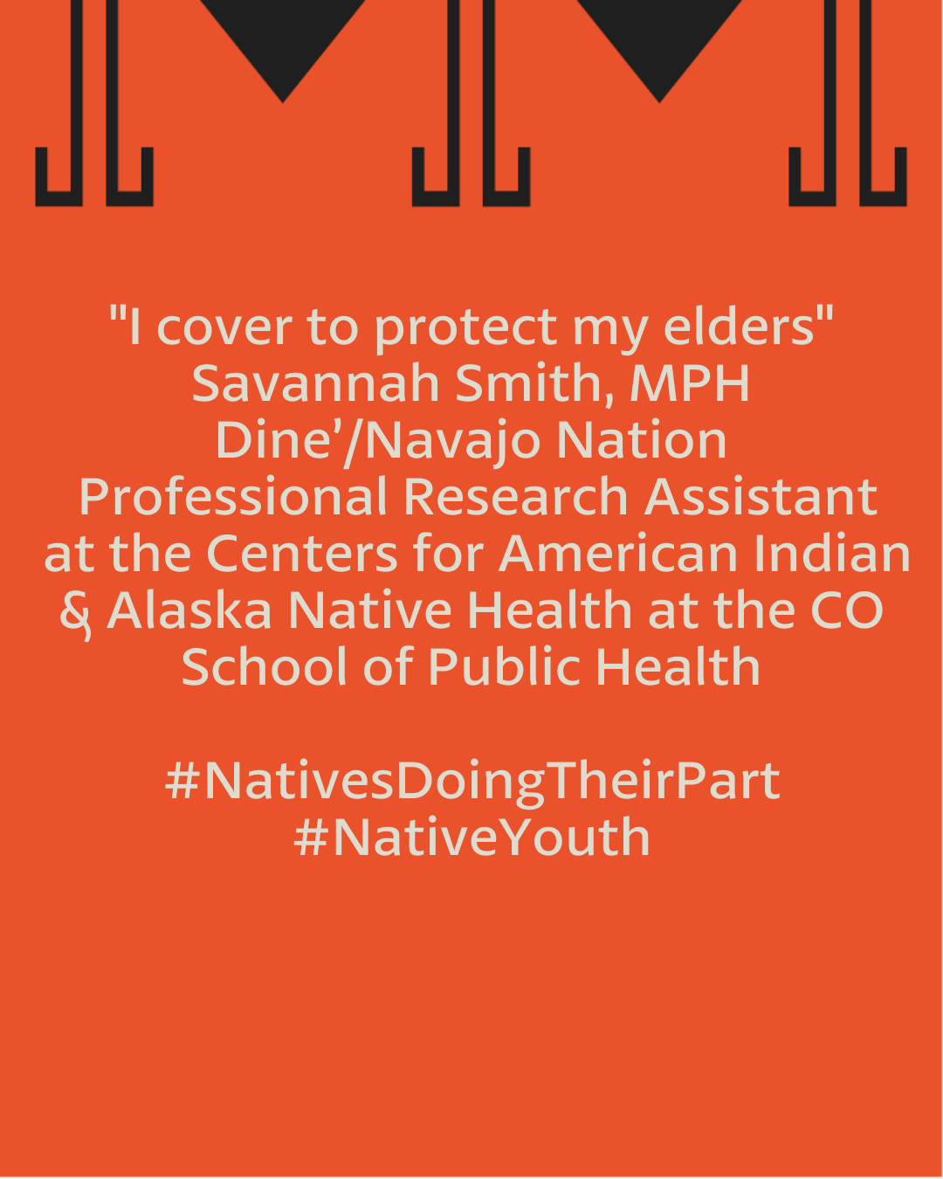
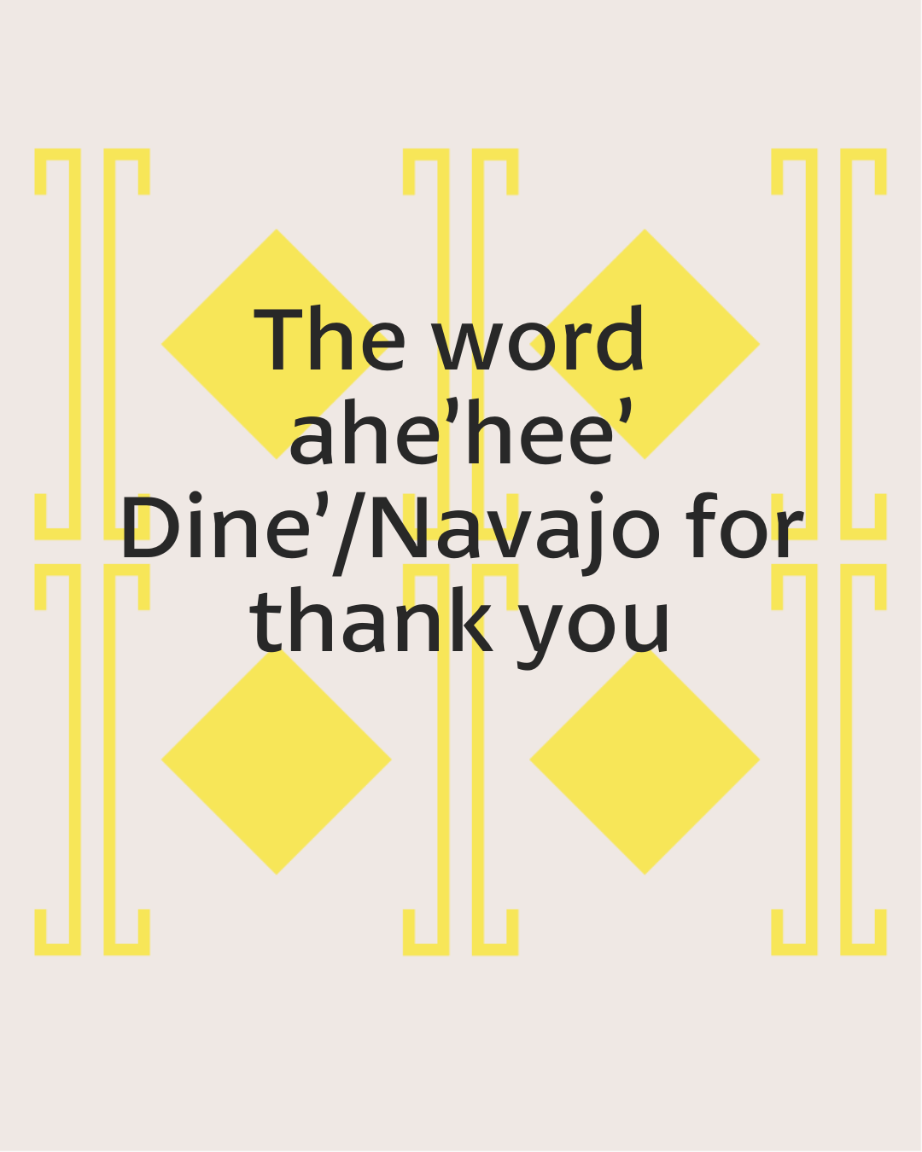
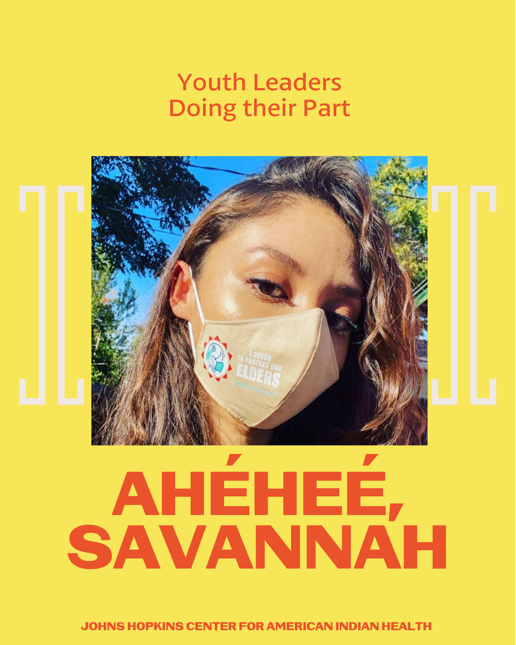

#NativeYouth are doing their part and engaging in healthy behaviors to protect our communities. #Native youth and young adults, DM us a photo of #NativesDoingTheirPart to be featured in an upcoming post or tag us. #NativeAmericanHealth #IndigenousHealth #NativeAmerican #AmericanIndian #AlaskanNative #HealthyTribes #IndigenousPeople #NativeHealth #TribalHealth #COVIDWarrior #SkoVaxDen #VacciNative #VACCINation #NavajoNation #IndigenousLanguage #NativesMaskUp #NativesVaxUp
Twitter:

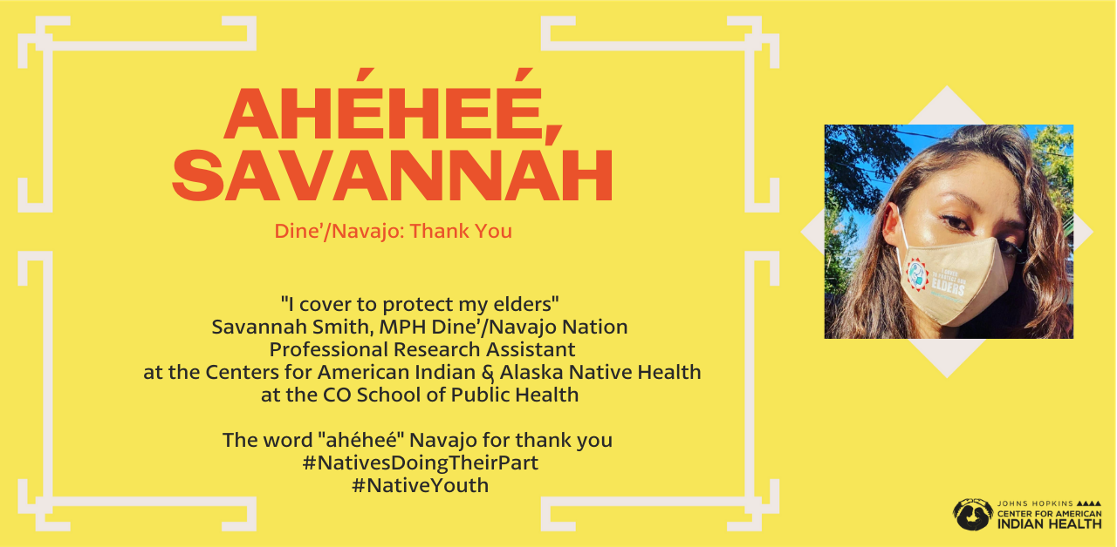

Description: #NativeYouth are doing their part and engaging in healthy behaviors to protect our communities. DM us or tag us in a photo of #NativesDoingTheirPart. You could be featured in an upcoming post. #HealthyTribes #NativesTwitter

