Attention Natives
Social Media Toolkit
#1 Monday
Instagram:
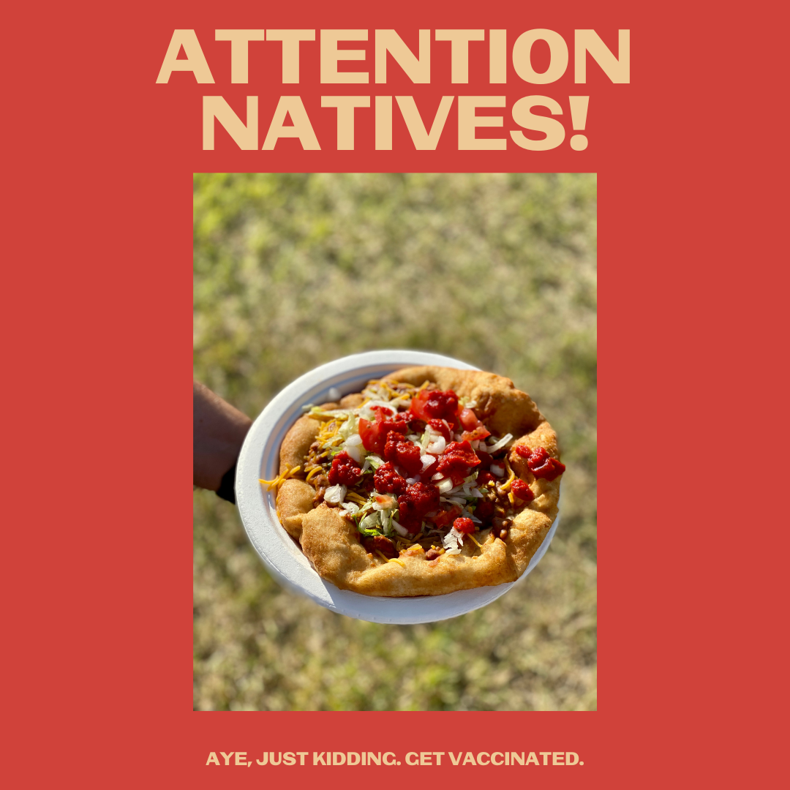
Description: Now that we’ve got your attention, in the Indian Taco of life, some of us are the meat, the bread, the lettuce, the beans. It takes all of us to do our part, and getting vaccinated is an essential ingredient.
#NativesStopTheSpread #NativesDoingTheirPart #NativeAmericanHealth #IndigenousHealth #NativeAmerican #AmericanIndian #AlaskanNative #HealthyTribes #IndigenousPeople #NativeHealth #TribalHealth #COVIDWarrior #ModernWarrior #NativesVaxUp #SkoVaxDen #VacciNative #VACCINation #NDNCommunityImmunity #IndianTaco #IndianTacoOfLife #NativeHumor

Twitter and Facebook

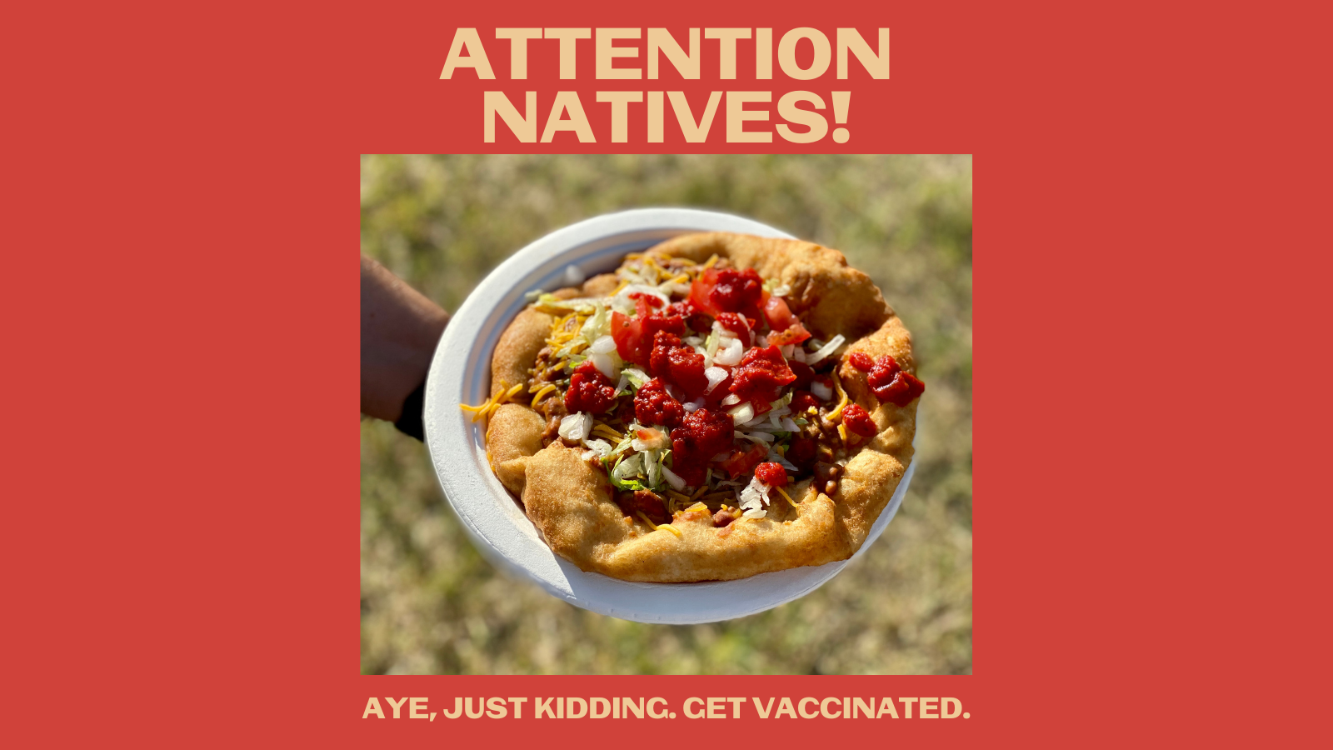

Description: Now that we have your attention, in the Indian Taco of life, some of us are the meat, the bread, the lettuce, the beans. It takes all of us to do our part, getting vaccinated is an essential ingredient. #NativesStopTheSpread #NativesDoingTheirPart #NativeTwitter #NativeHumor

#2 Wednesday
Instagram:
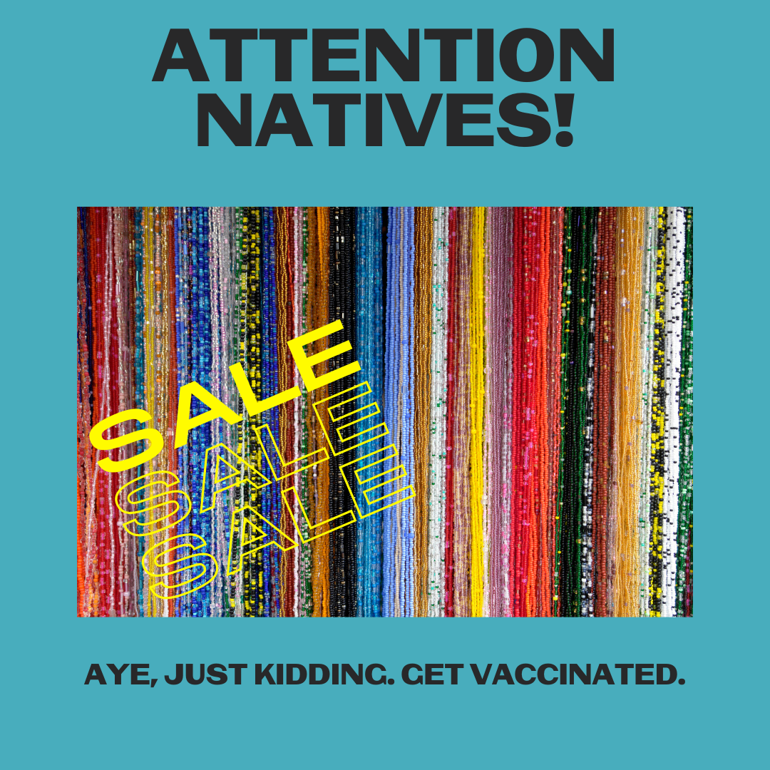
Description: We got your attention, but it was really to thank those who have gotten vaccinated, and to ask those who haven’t yet to please do so. Our communities are counting on you, we need all the beads in the strand to be strong.
#NativesStopTheSpread #NativesDoingTheirPart #NativeAmericanHealth #IndigenousHealth #NativeAmerican #AmericanIndian #AlaskanNative #HealthyTribes #IndigenousPeople #NativeHealth #TribalHealth #COVIDWarrior #NativesVaxUp #SkoVaxDen #VacciNative #VACCINation #NDNCommunityImmunity #NativeBeadwork #NativeHumor

Twitter and Facebook:
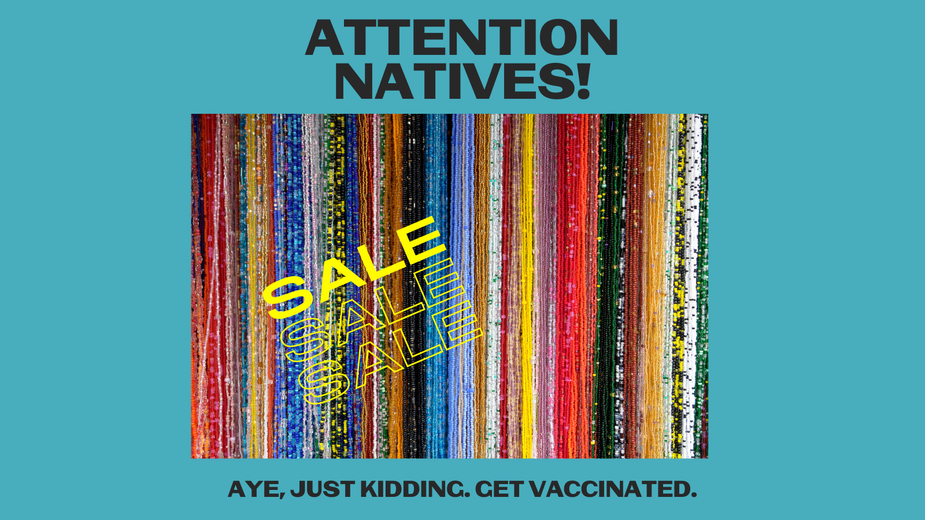

Description: We got your attention, but it was really to thank those who have gotten vaccinated, and to ask those who haven’t yet to please do so. Our communities are counting on you, we need all the beads in the strand to be strong. #NativesStopTheSpread #NativeTwitter #NativeHumor

#3 Friday
Instagram:
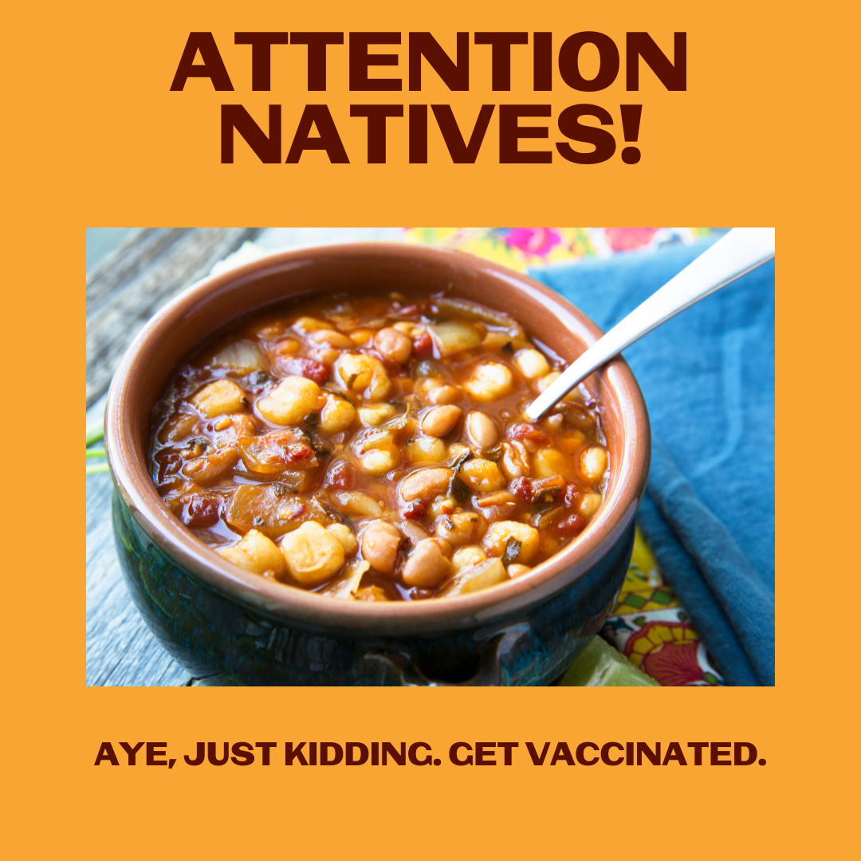

Description: We used this delicious bowl of grandma’s soup to nab your attention to remind you to schedule that vaccination. Don’t put it off. Take a friend or relative, then celebrate with something delicious like a bowl of posole or flint corn stew.
#NativesStopTheSpread #NativesDoingTheirPart #NativeAmericanHealth #IndigenousHealth #NativeAmerican #AmericanIndian #AlaskanNative #HealthyTribes #IndigenousPeople #NativeHealth #TribalHealth #COVIDWarrior #NativesVaxUp #SkoVaxDen #VacciNative #VACCINation #NDNCommunityImmunity #IndigenousFood

Twitter and Facebook:

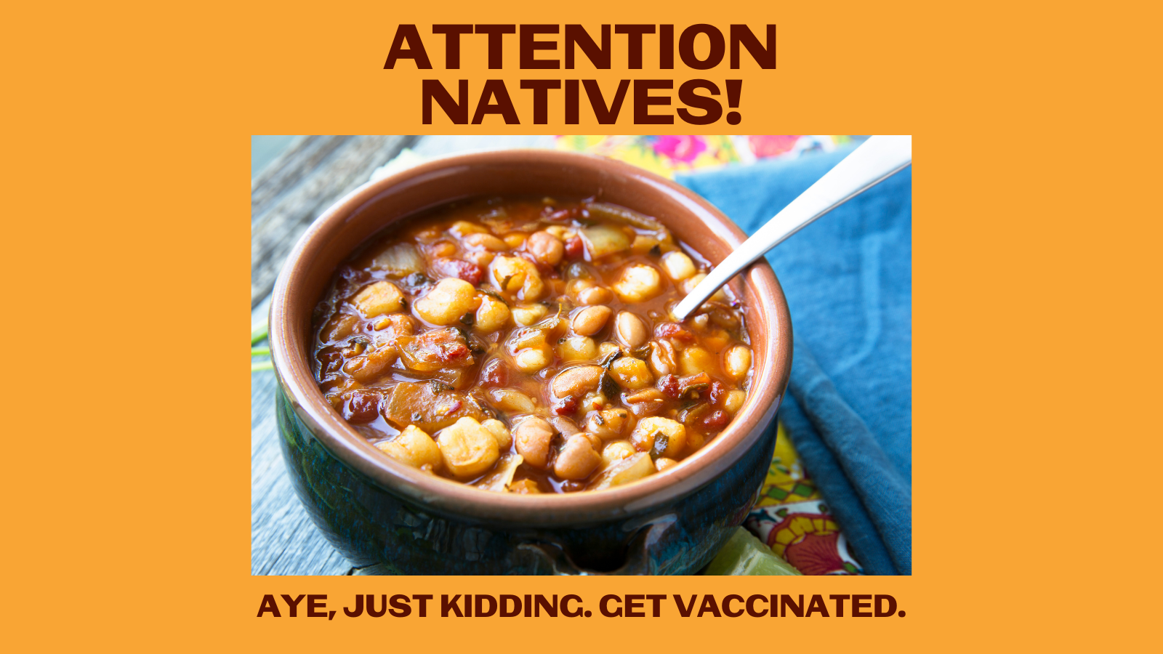

Description: We used this delicious bowl of grandma’s soup to nab your attention to remind you to schedule that vax! Don’t delay. Take a friend/relative, then celebrate with something delicious like posole or flint corn stew. #NativesStopTheSpread #NativesDoingTheirPart #IndigenousFood

