Classic Memes
Social Media Toolkit
#1 Monday
Instagram:
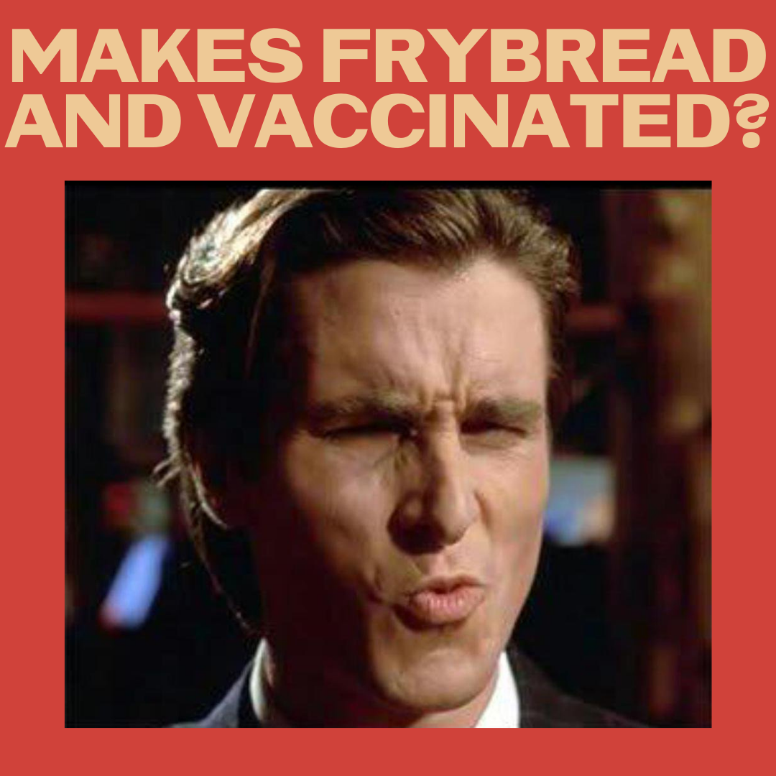
Description: Daaaang! Hold your head up high and swish your hair because you are fierce with those frybread skills AND antibodies!
#NativesStopTheSpread #NativesDoingTheirPart #NativeAmericanHealth #IndigenousHealth #NativeAmerican #AmericanIndian #AlaskanNative #HealthyTribes #IndigenousPeople #NativeHealth #TribalHealth #COVIDWarrior #NativesVaxUp #NativesMaskUp #SkoVaxDen #VacciNative #VACCINation #NDNCommunityImmunity #Frybread #NativeHumor #OooWee #Daaang

Twitter and Facebook:

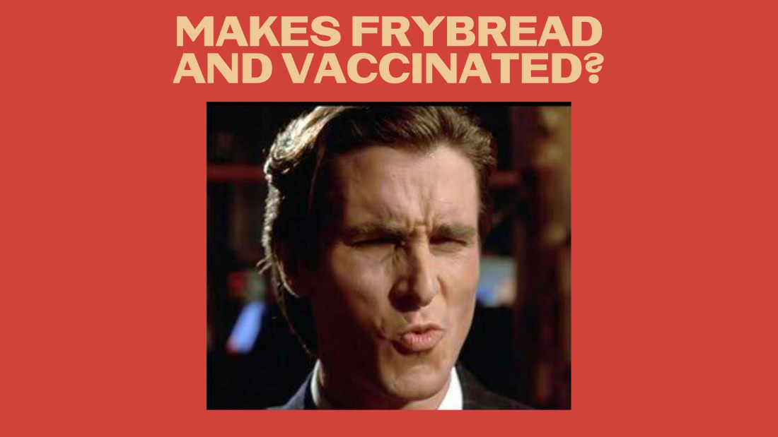

Description: Daaang! Hold your head up high and swish your hair, you're fierce with those frybread skills AND antibodies! #NativesStopTheSpread #NativesDoingTheirPart #NativeAmericanHealth #IndigenousHealth #HealthyTribes #NativeHealth #TribalHealth #NativeHumor #NativeTwitter #NativesVaxUp

#2 Wednesday
Instagram:

Description: Our people have been devastated by infectious diseases for over 500 years, and we are fighting back. Vaccines are a tool of resilience. Foil Coronavirus and its evil plan. Across #IndianCountry, IHS has distributed over ONE MILLION doses!
#NativesStopTheSpread #NativesDoingTheirPart #NativeAmericanHealth #IndigenousHealth #NativeAmerican #AmericanIndian #AlaskanNative #HealthyTribes #IndigenousPeople #NativeHealth #TribalHealth #COVIDWarrior #NativesVaxUp #NativesMaskUp #SkoVaxDen #VacciNative #VACCINation #NDNCommunityImmunity

Twitter and Facebook:

Description: Our people have been devastated by infectious diseases for 500+ years, and we are fighting back. Vaccines are a tool of resilience. Foil Coronavirus and its evil plan. Across #IndianCountry, IHS has distributed over ONE MILLION doses! #NativesStopTheSpread #NativesDoingTheirPart

#3 Friday
Instagram:

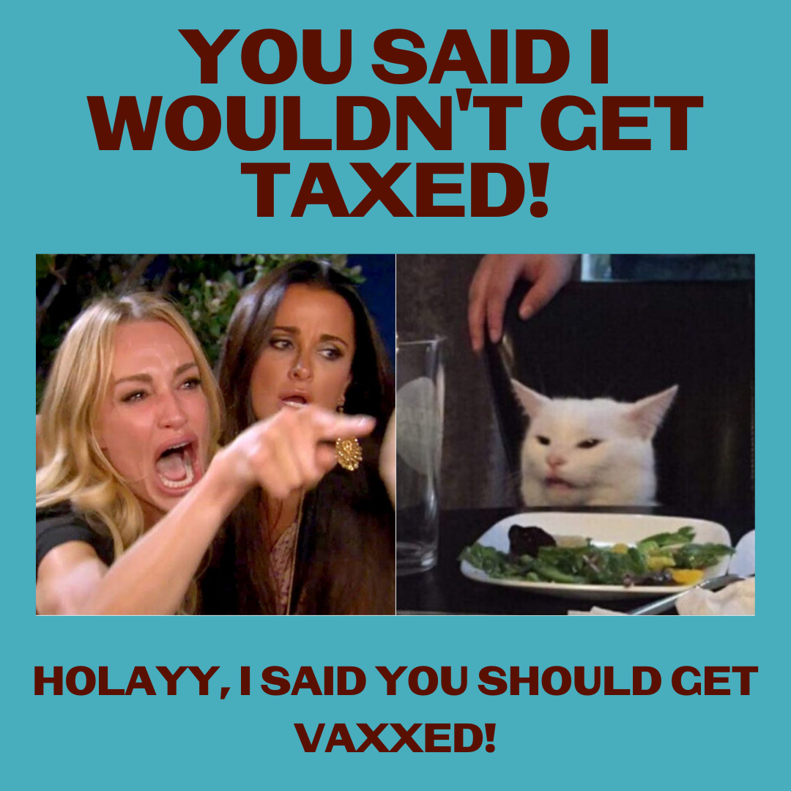

Description: Save the drama for your mama and listen to this wise cat! #RezCatKnowsBest
#NativesStopTheSpread #NativesDoingTheirPart #NativeAmericanHealth #IndigenousHealth #NativeAmerican #AmericanIndian #AlaskanNative #HealthyTribes #IndigenousPeople #NativeHealth #TribalHealth #COVIDWarrior #NativesVaxUp #NativesMaskUp #SkoVaxDen #VacciNative #VACCINation #NDNCommunityImmunity #NativeHumor

Twitter and Facebook:

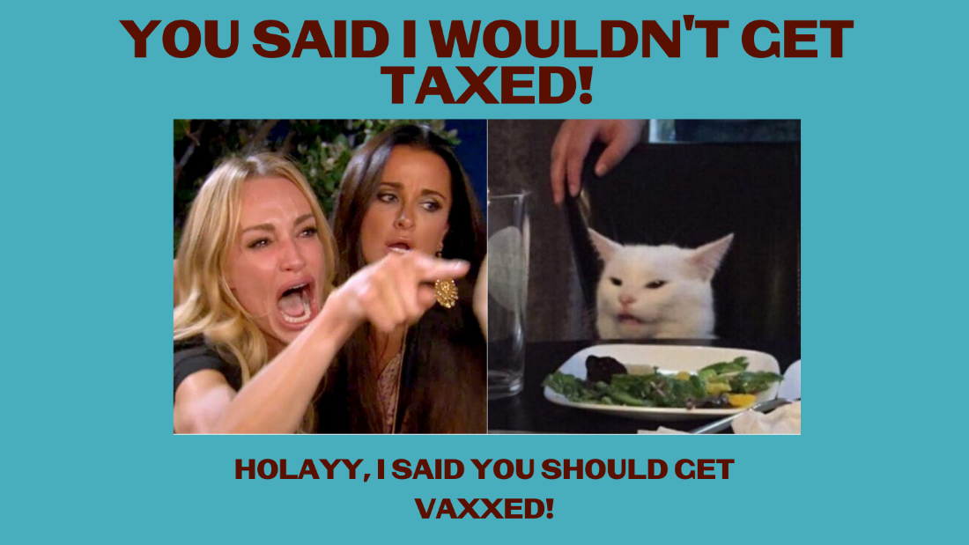

Description: Save the drama for your mama and listen to this wise cat! #RezCatKnowsBest
#NativesStopTheSpread #NativesDoingTheirPart #NativeAmericanHealth #HealthyTribes #IndigenousPeople #NativeHealth #SkoVaxDen #VacciNative #NativeTwitter #NDNCommunityImmunity #NativeHumor

