Natives Outdoors
Social Media Toolkit
#1 Monday
Instagram:
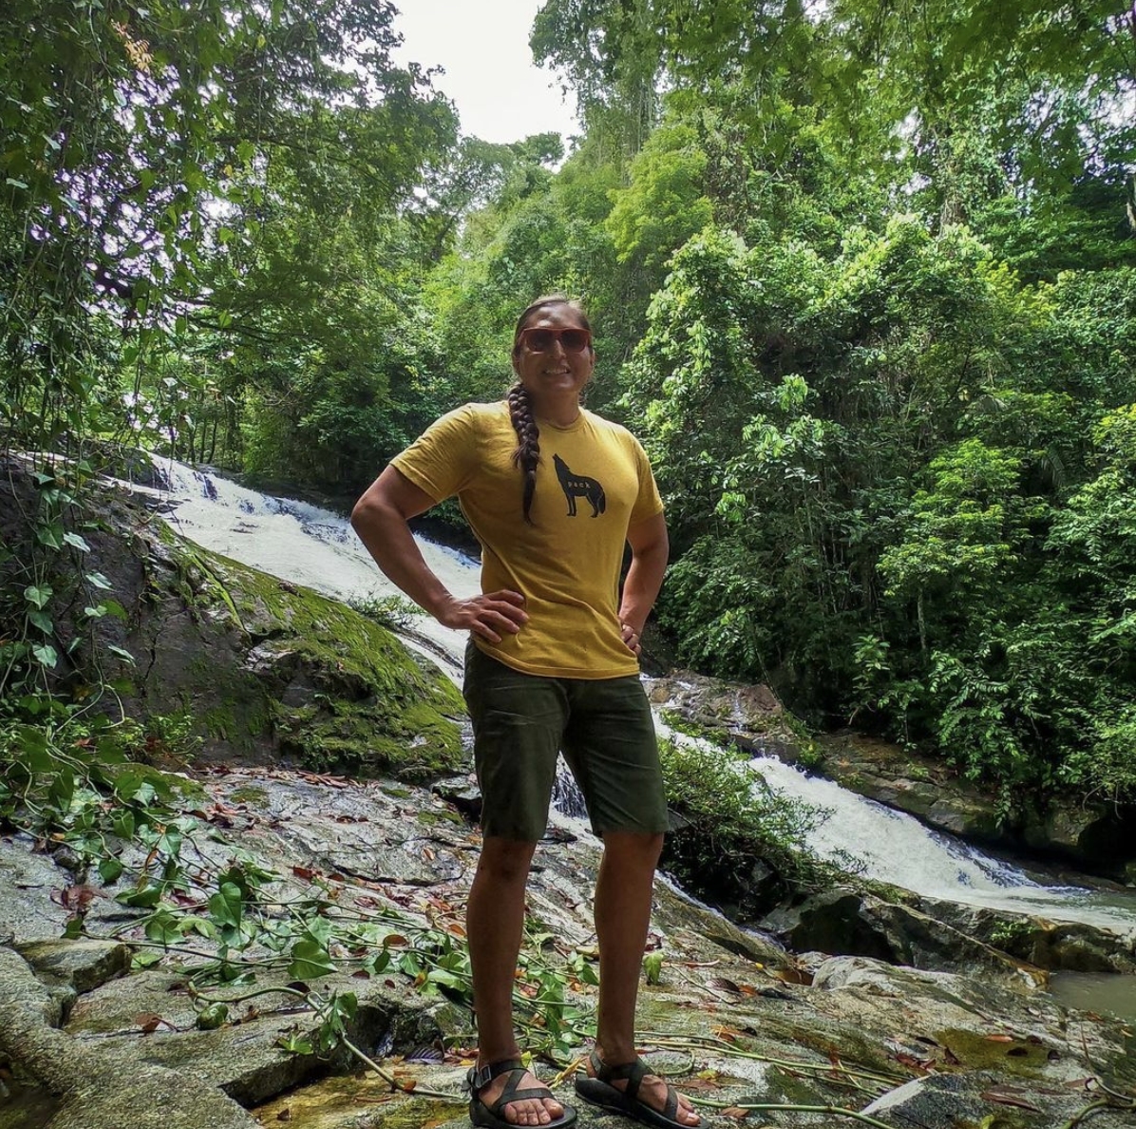
Note: Tag @modern_warrior__, @nativesoutdoors
Description: As restrictions loosen in some communities and summer arrives, it’s time to get out and enjoy nature. Natives, do your “Native thing” and keep being your #Indigifabulous selves outdoors with confidence. Lance Tsosie, Navajo, is an avid rock climber and has taken youth from across the country on camping excursions. During the peak of the pandemic, he advised “Act as if you are infected and do not want to spread the virus.” Lance is always looking out for others, but finding ways to take care of his health outdoors too!
#NativesDoingTheirPart #NativeAmericanHealth #IndigenousHealth #NativeAmerican #AmericanIndian #AlaskanNative #HealthyTribes #IndigenousPeople #NativeHealth #TribalHealth #COVIDWarrior #ModernWarrior #NativesVaxUp #SkoVaxDen #VacciNative #VACCINation #NDNCommunityImmunity #NativesOutdoors #NativeHikers #NativeClimbers

Twitter and Facebook
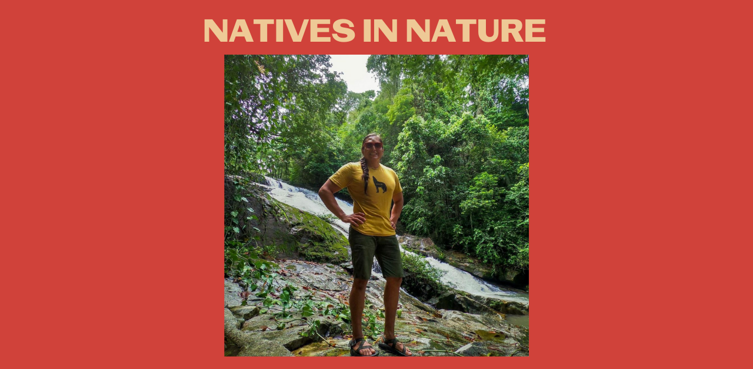

Note: Twitter Tag @supertsosie

Description: As restrictions loosen in some communities and summer arrives, it’s time to get out and enjoy nature. Natives, do your “Native thing” and keep being your #Indigifabulous selves outdoors with confidence. Lance Tsosie, Navajo, is an avid rock climber. #ModernWarrior

#2 Wednesday
Instagram:

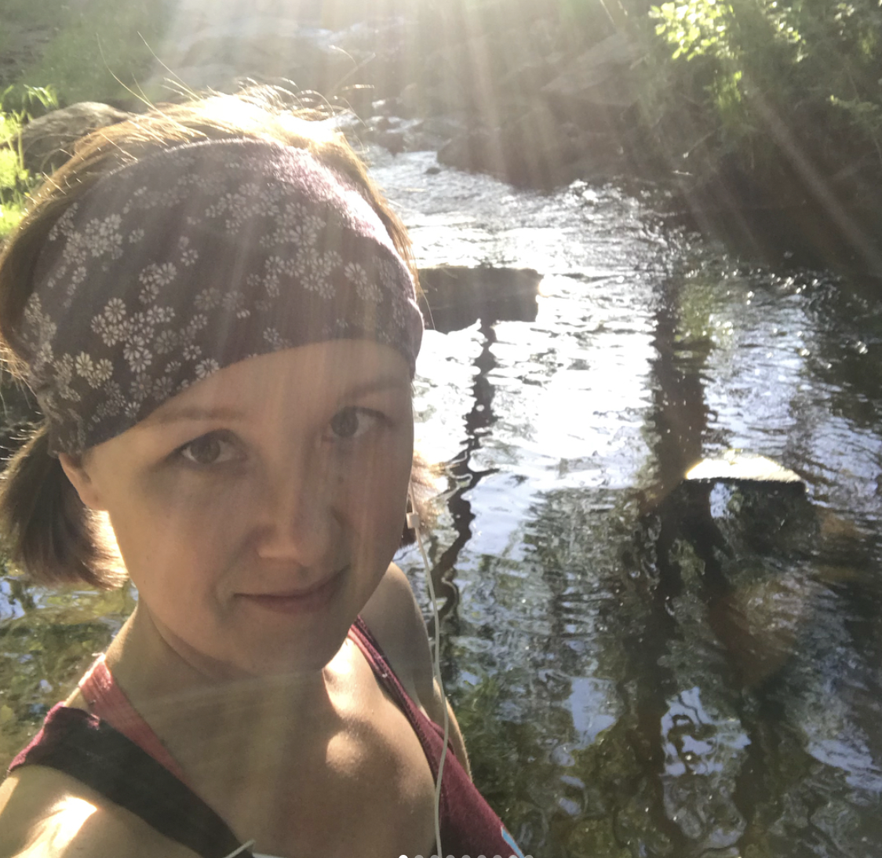
Note: Tag @mlwalls @caih_greatlakeshub
@native_women_running @nativewomenswilderness @she_colorsnature

Description: The best way for Natives to recharge is to get outside and connect with our natural environment. Now that COVID-19 restrictions are loosening, tuck that mask in your back pocket and get outdoors. Our own Dr. Melissa Walls is an avid runner, but whether you run or walk or stroll, enjoy that sunshine.
Check your tribal and local guidelines for restrictions in your community.
#NativesDoingTheirPart #NativeAmericanHealth #IndigenousHealth #NativeAmerican #AmericanIndian #AlaskanNative #HealthyTribes #IndigenousPeople #NativeHealth #TribalHealth #COVIDWarrior #NativesVaxUp #SkoVaxDen #VacciNative #VACCINation #NDNCommunityImmunity #NativesOutdoors #NativeWomenRun #NativeRunners #NativesRun

Twitter and Facebook:

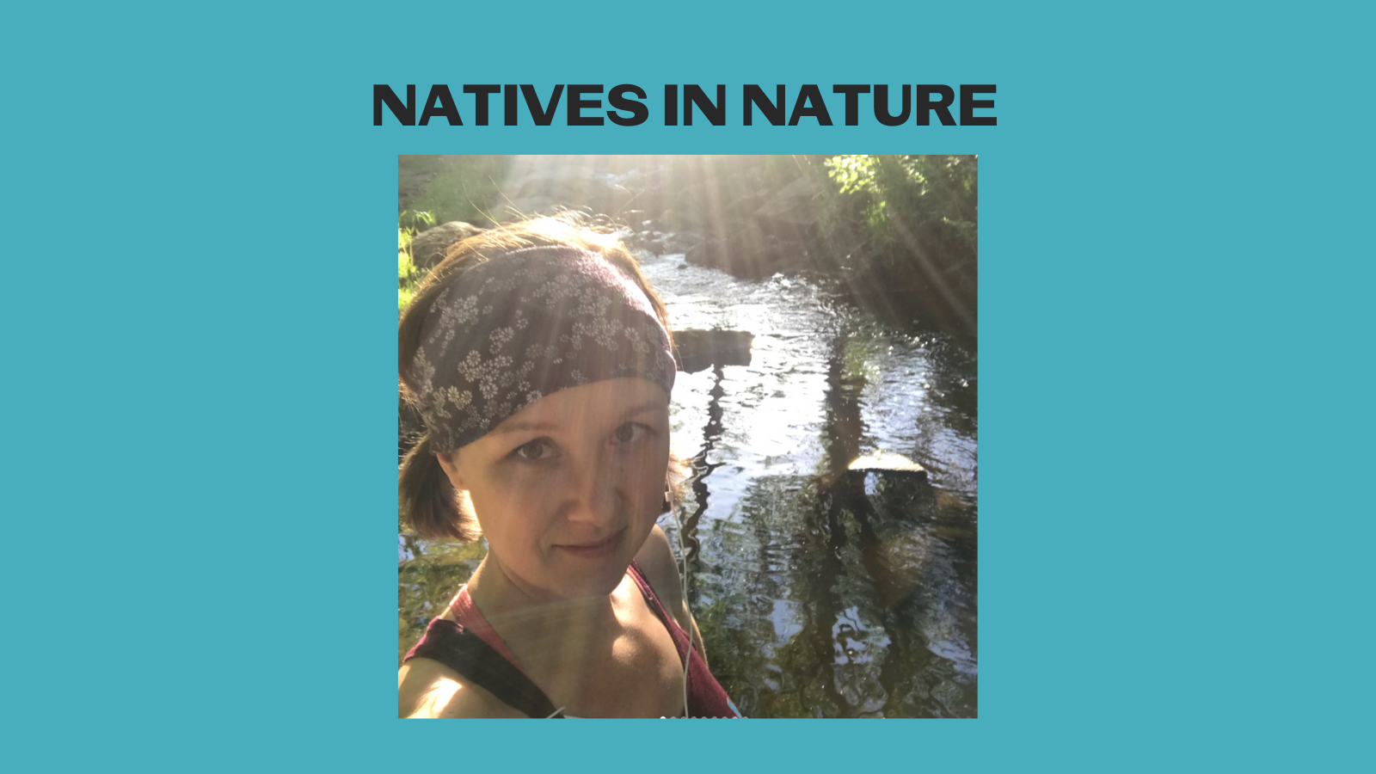

Note: Twitter tag @MelissaLWalls
Description: The best way for Natives to recharge is to get outside and connect with our natural environment. Now that COVID-19 restrictions are loosening, get outdoors. Our own Dr. Walls is an avid runner, but whether you run or walk or stroll, enjoy that sunshine. #NativesStopTheSpread
Facebook add: Check your tribal and local guidelines for restrictions in your community.

#3 Friday
Instagram:

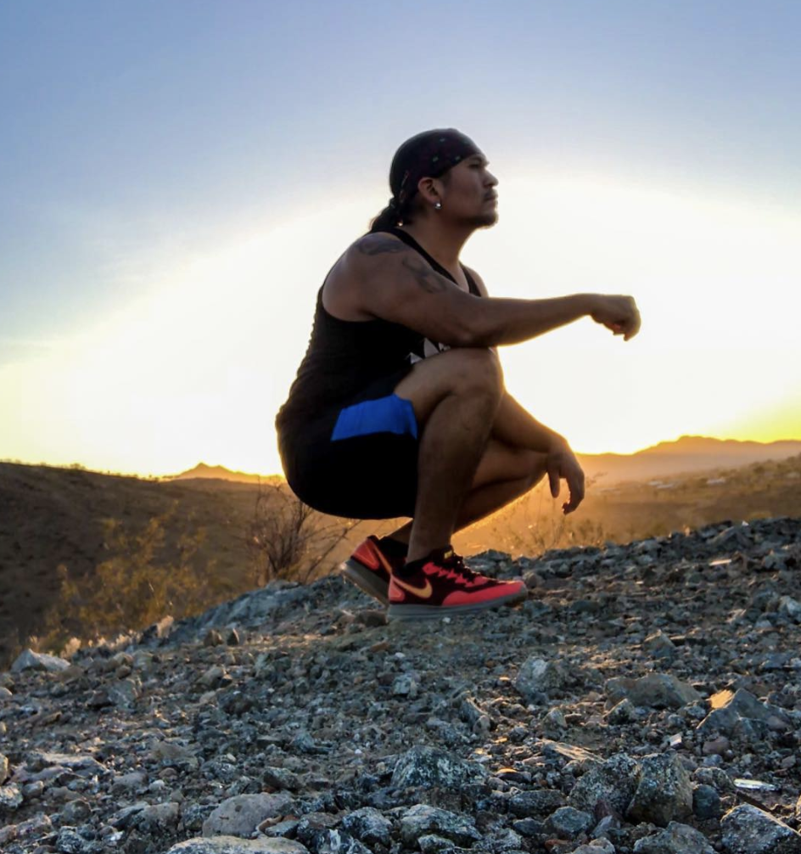
Note: Tag @nativesoutdoors @pahona52 spokesperson for @tankabar
Description: Are you a #HealthyActiveNative? You don’t have to start a movement, like @pahona52, just move! He just spent time on a 360-mile journey with inspirational young men and women for the Running as Medicine Indigenous Youth Prayer Run. Now that restrictions are loosening, you can enjoy time outdoors without a mask in many communities.
Check your tribal and local guidelines for restrictions in your community.
#NativesDoingTheirPart #NativeAmericanHealth #IndigenousHealth #NativeAmerican #AmericanIndian #AlaskanNative #HealthyTribes #IndigenousPeople #NativeHealth #TribalHealth #COVIDWarrior #NativesVaxUp #SkoVaxDen #VacciNative #VACCINation #NDNCommunityImmunity #HealthyActiveNatives #NativeRunners #NativesRun

Twitter and Facebook:

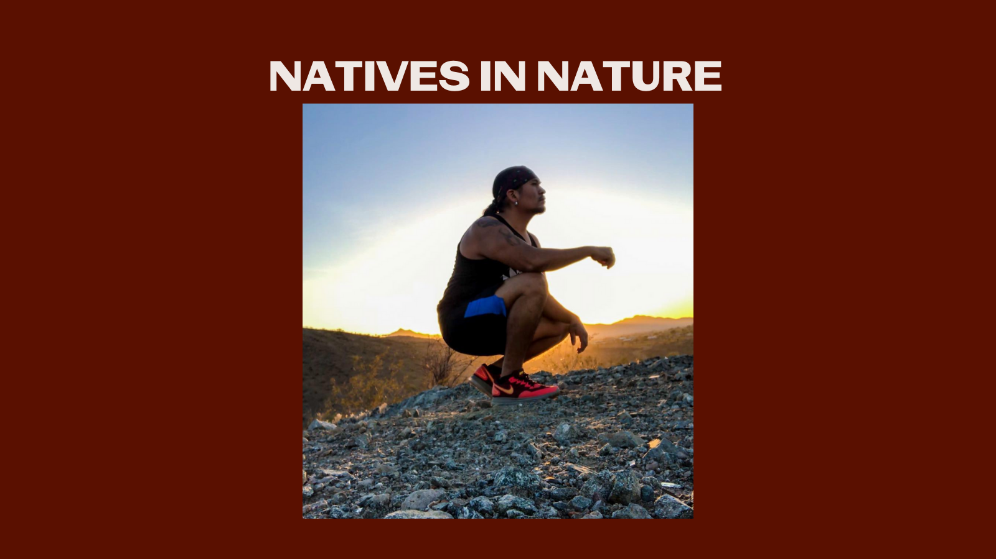

Note: Facebook tag @HEALTHY ACTIVE NATIVES!!! (A group he started with over 75K members, and yes, the exclamation marks are part of it) and tag @tankatalk
Description: Are you a #HealthyActiveNative? You don’t have to start a movement, like Waylon Pee Pahona, just move! He just spent time on a 360-mile journey with inspirational young men and women for the Running as Medicine Indigenous Youth Prayer Run. #NativesOutdoors

