Rez Lingo
Social Media Toolkit
#1 Monday
Instagram:

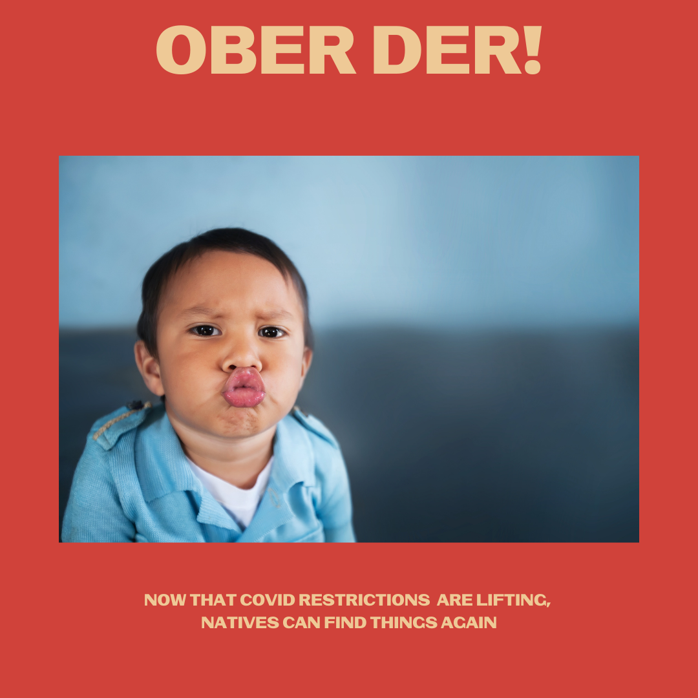

Description: Now that mask restrictions are lifting, we can see your lips and can find things again. What’s makes being outside or with loved ones without a mask extra safe? Being vaccinated.
Check your tribal and local guidelines for restrictions in your community.
#NativesStopTheSpread #NativesDoingTheirPart #NativeAmericanHealth #IndigenousHealth #NativeAmerican #AmericanIndian #AlaskanNative #HealthyTribes #IndigenousPeople #NativeHealth #TribalHealth #NativesVaxUp #SkoVaxDen #VacciNative #VACCINation #NDNCommunityImmunity

Twitter and Facebook:
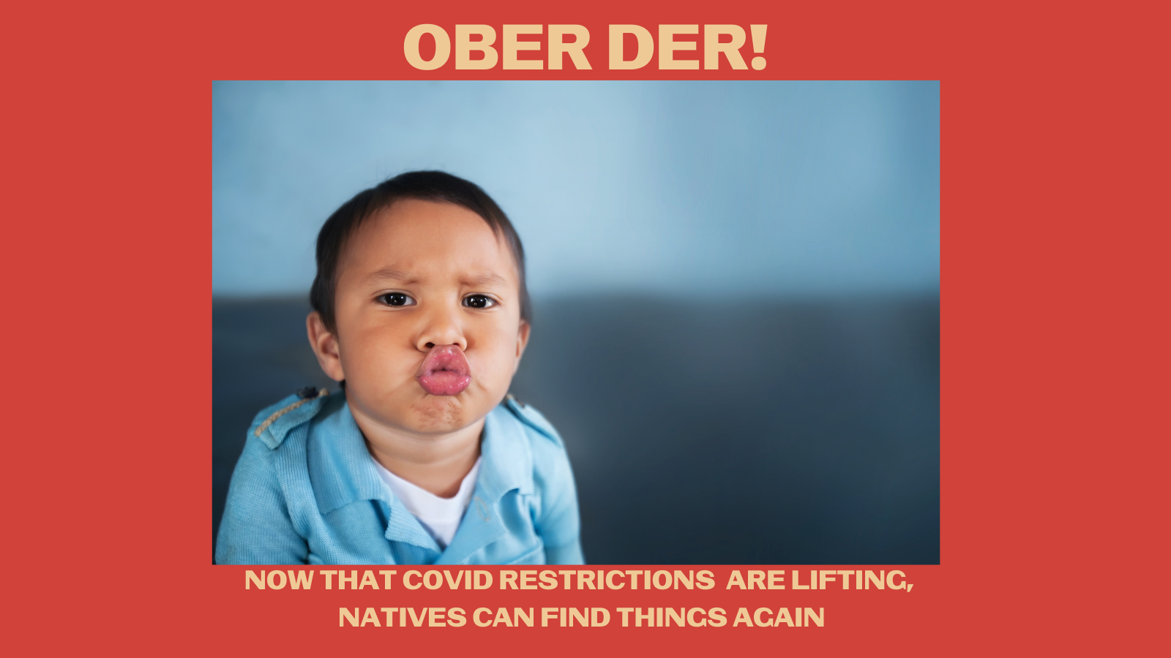
Description: Now that mask restrictions are lifting, we can see your lips and can find things again. What’s makes being outside or with loved ones without a mask extra safe? Being vaccinated. Check your tribal and local guidelines for restrictions in your community. #NativesStopTheSpread

#2 Wednesday
Instagram:
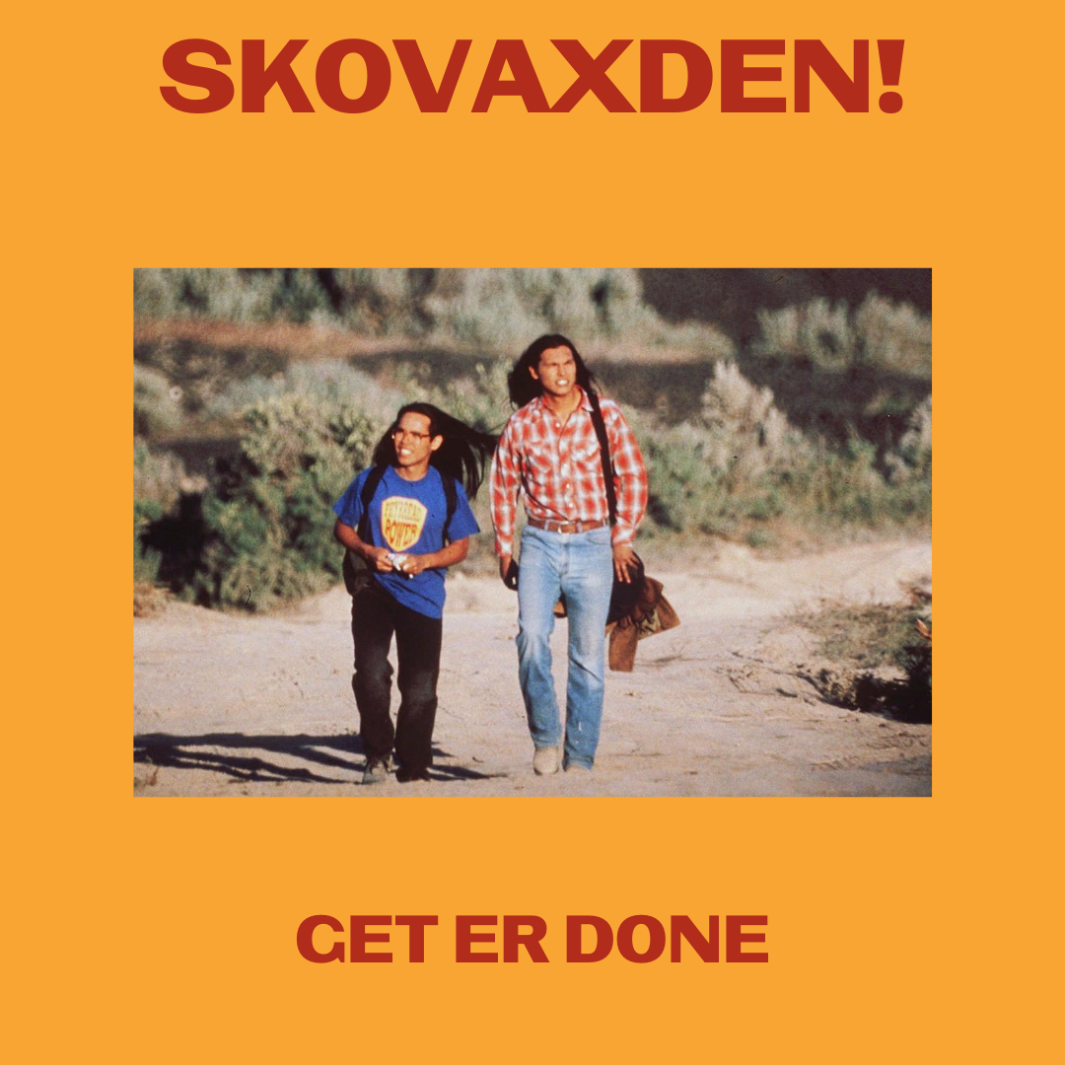

Description: What’s even better than frybread power? Vaccine power. Well, you might want both.
#NativesStopTheSpread #NativesDoingTheirPart #NativeAmericanHealth #IndigenousHealth #NativeAmerican #AmericanIndian #AlaskanNative #HealthyTribes #IndigenousPeople #NativeHealth #TribalHealth #COVIDWarriors #NativesVaxUp #SkoVaxDen #VacciNative #VACCINation #NDNCommunityImmunity #SmokeSignals #HeyVictor #FrybreadPower #DrEvanAdams

Twitter and Facebook:

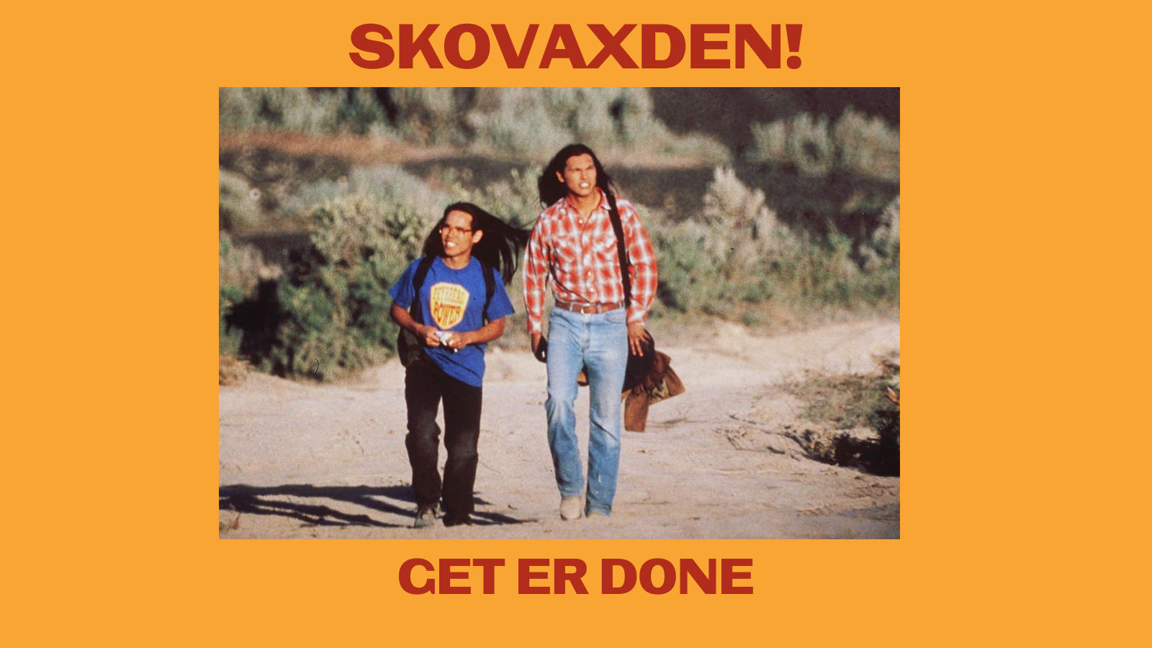
Twitter tag: @doctoreonline (Thomas Builds the Fire played by Dr. Evan Adams, Indigenous Vaccine advocate)

Description: What’s even better than frybread power? Vaccine power. Well, you might want both. #NativesStopTheSpread #NativesDoingTheirPart #NativeTwitter #Indigenous #IndigenousHealth #SmokeSignals #HeyVictor

#3 Friday
Instagram:

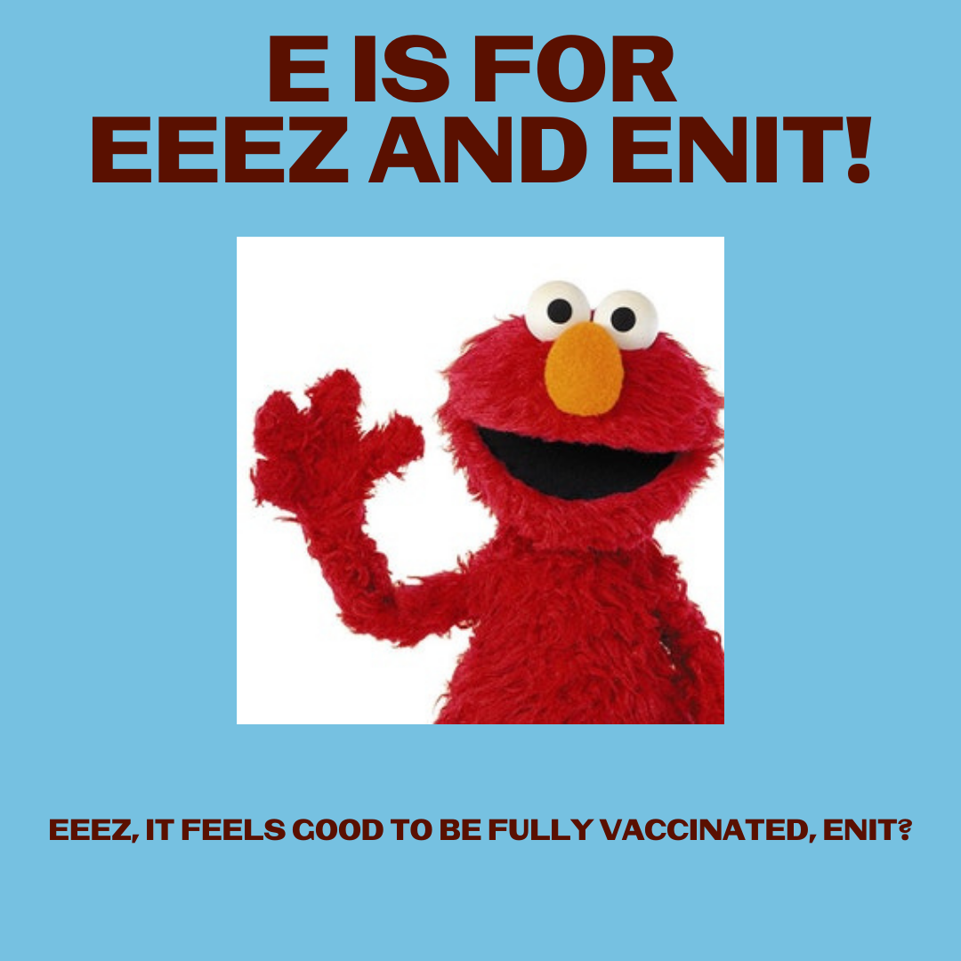
Description: That good feeling of doing your part to keep yourself, your family, and your community healthy.
#NativesStopTheSpread #NativesDoingTheirPart #NativeAmericanHealth #IndigenousHealth #NativeAmerican #AmericanIndian #AlaskanNative #HealthyTribes #IndigenousPeople #NativeHealth #TribalHealth #NativesVaxUp #SkoVaxDen #VacciNative #VACCINation #IndigenousLanguage #NDNCommunityImmunity

Twitter and Facebook:
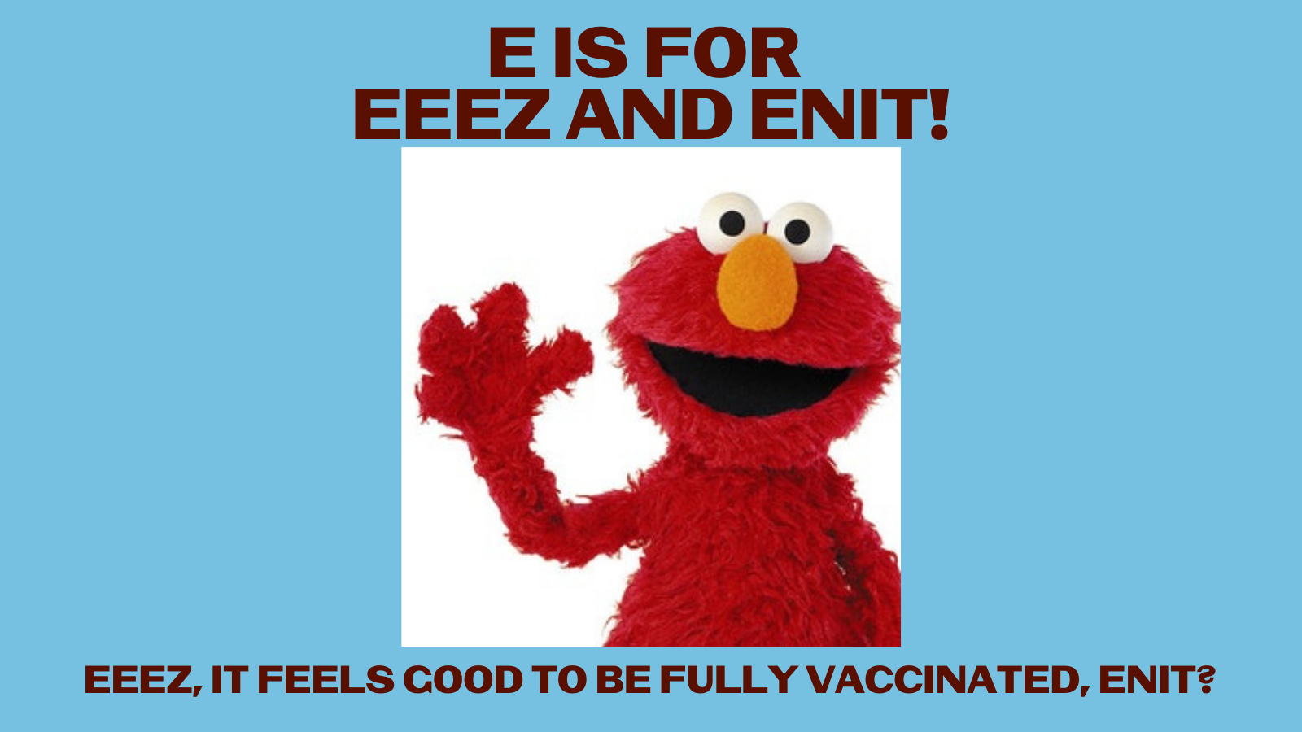
Description: That good feeling of doing your part to keep yourself, your family, and your community healthy. #NativesStopTheSpread #NativesDoingTheirPart #NativeAmericanHealth #IndigenousHealth #NativeAmerican #AmericanIndian #AlaskanNative #HealthyTribes #IndigenousPeople #NativeHealth

