97% of people hospitalized are unvaccinated: SM toolkit
SM Message: #DYK that more than 97% of people hospitalized with #COVID19 are unvaccinated? Getting a COVID-19 #vaccine is an effective way to protect yourself and your family from dangerous symptoms of the virus. Everyone 12 and up is eligible to receive a vaccine – get yours today! Read more at: https://www.npr.org/2021/07/16/1017012853/97-of-people-entering-hospitals-for-covid-19-are-unvaccinated.
Instagram:
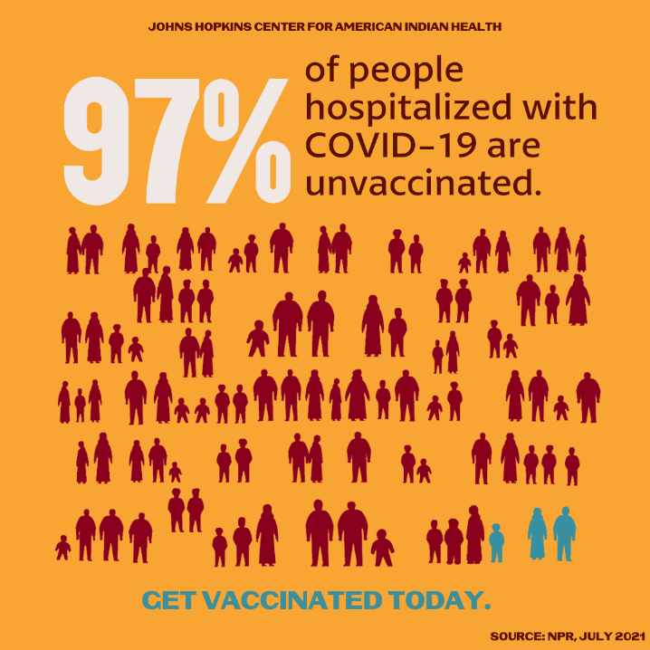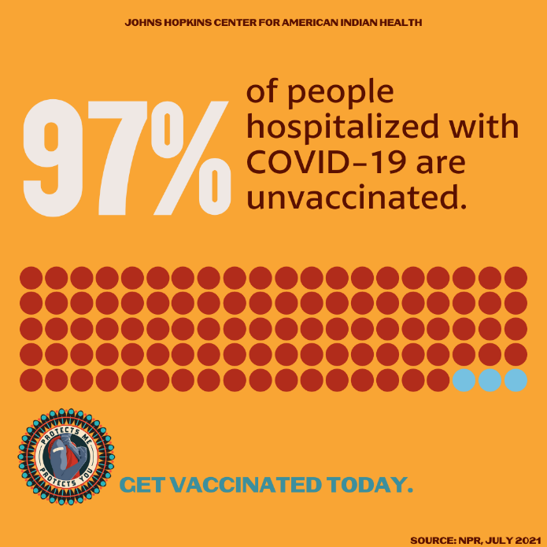
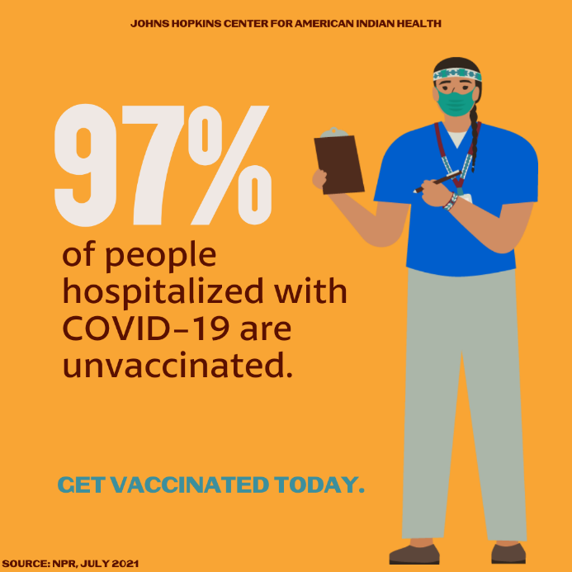

Facebook:
