Booster Shot 101: Social Media Toolkit
Social Media Message: Booster shots may be recommended for Pfizer and Moderna COVID-19 #vaccines to extend protection against #COVID19. Booster shots strengthen the response our bodies have already built through vaccination. Current vaccines are still very effective against severe disease and death, so get vaccinated today!
#VacciNation #NativesStopTheSpread #NativesDoingTheirPart #IndigenousHealth #NativeAmerican #AmericanIndian #AlaskanNative #HealthyTribes #IndigenousPeople #NativeHealth #TribalHealth #COVIDWarrior
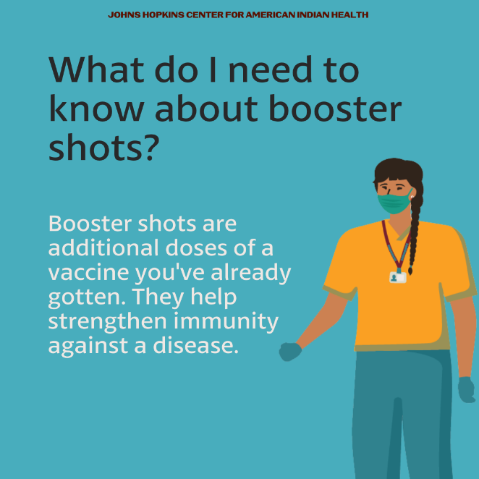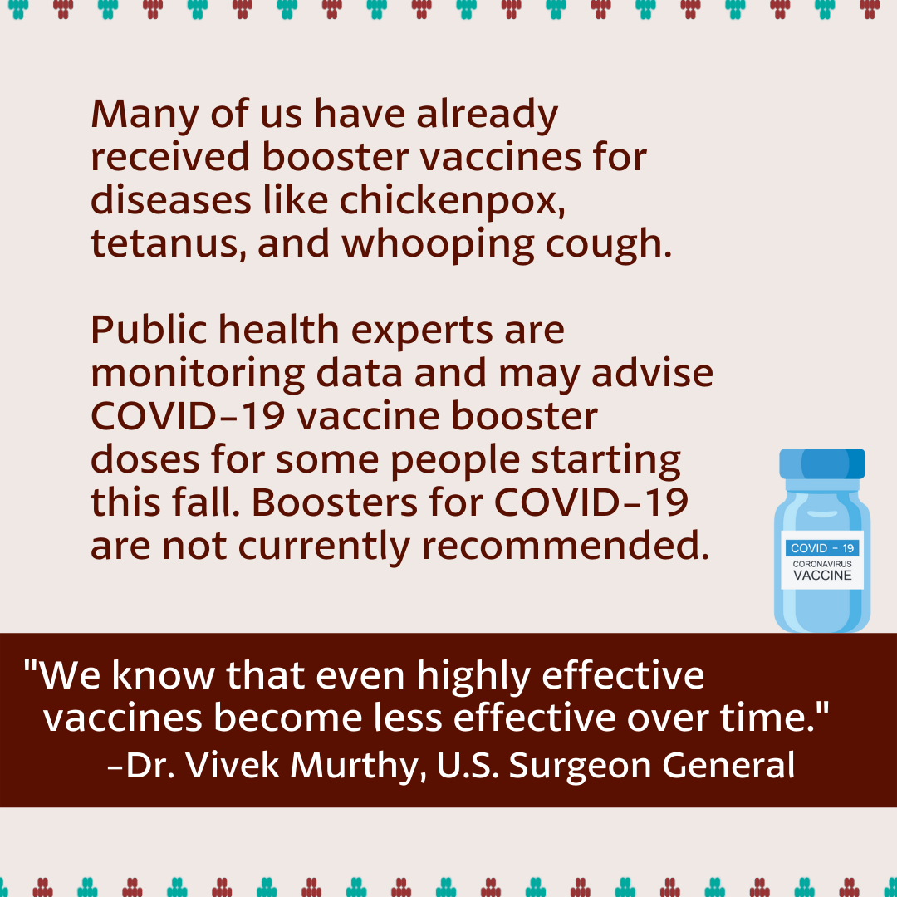
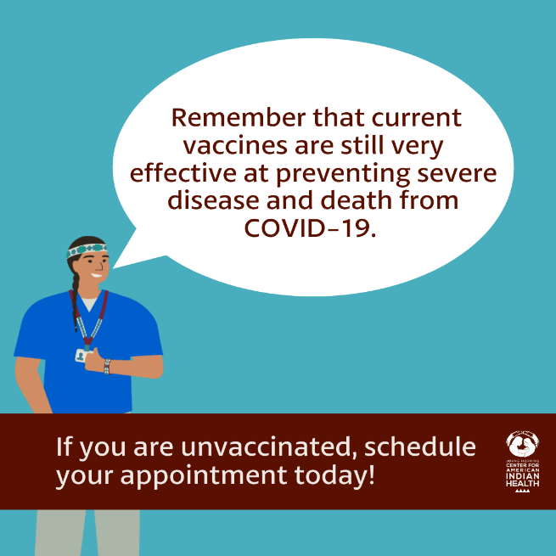
Partners to Tag: @Anthctoday @Aaipdocs @CDCgov @HealthyNativeYouth @HonoringNations @IndianCountryToday @_IllumiNatives @IndianHealthBoard_Minneapolis @IndianHealthService
@Indianz @JohnsHopkinsSPH @NationalIndianHealthBoard @Npaihb @Nihb1 @NationalNativeNews @NativeAmericans @NativeAmericanLifelines @Nimhgov @NNNnativenews @ProjectMosaicllc @SeattleIndianHealthBoard @UrbanIndigenousCollective@UrbanIndianHealth
@UrbanIndianHealthInstitute @WeAreHealers @WeRNative

