Back to School Checklist
Delta Meme Toolkit
Instagram:
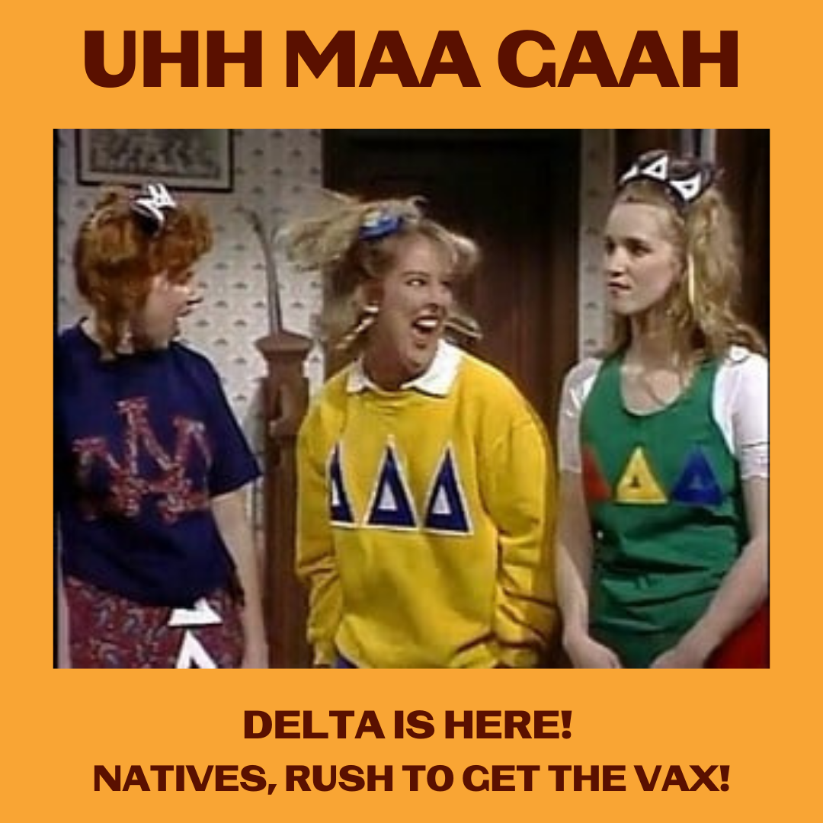

Description:
While at colleges across the country, it's time for fraternity and sorority rush, in Indian Country, people have been RUSHING to get the vaccine. Congrats to our communities who have some of the highest vaccination rates in the U.S.! Let’s head to college and back to school protected from Delta.
#NativesStopTheSpread #NativesInCollege #NativeHigherEd #CollegeNatives #NativeScholars #NativesStopTheSpread #HealthyNatives #BacktoSchool #SkodenCollegel #HealthyN8Vs #ProtectedFromDelta

Twitter and Facebook

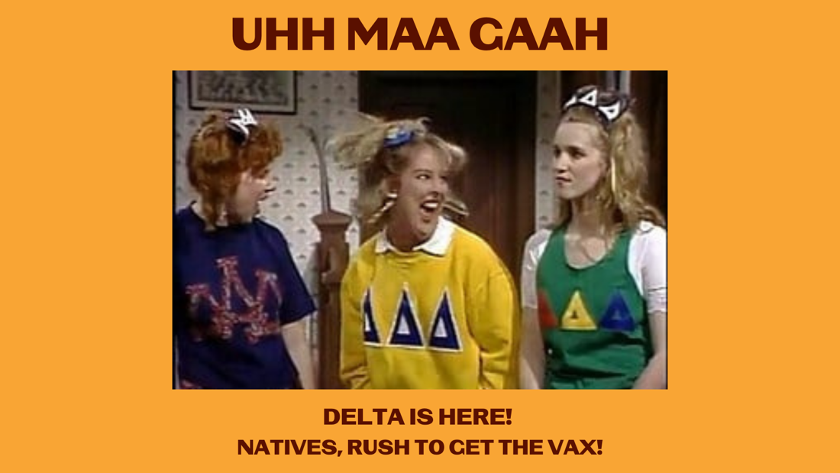
Description:
While at colleges across the country it's time for frat and sorority rush, in Indian Country, people have been RUSHING to get the vaccine. Native communities have some of the highest vaccination rates in the U.S.! Let’s head to college and back to school protected from Delta.

