Back to School Checklist
Mask Meme Toolkit
Instagram:

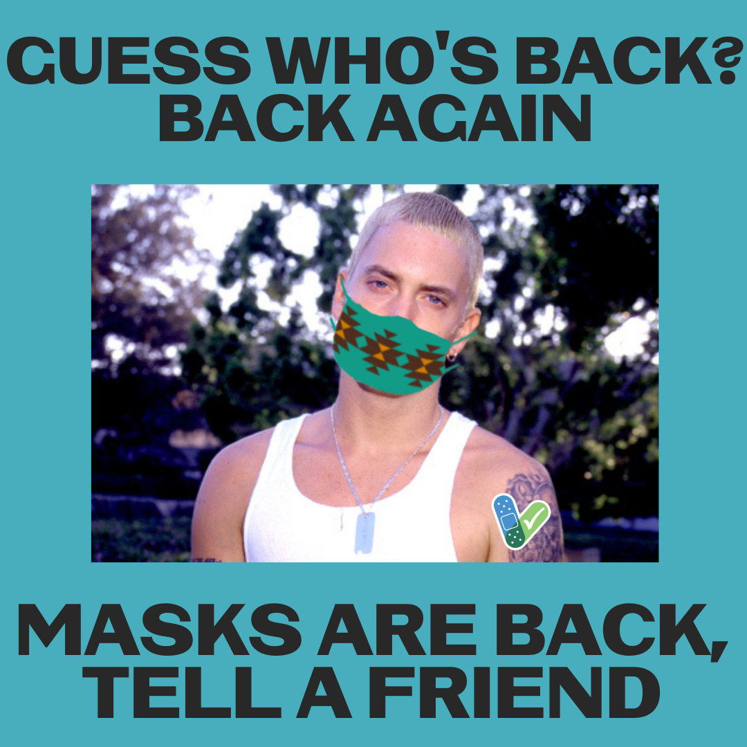

Description:
Safely returning our Native students to in-person instruction in the fall 2021 is a priority. Although Slim Shady doesn’t seem particularly excited about masks, they are in important tool in a multilayer prevention strategy, including vaccination for 12+.
#NativesStopTheSpread #TraditionalValues #IndigenousValues #NativesStopTheSpread #HealthyNatives #BacktoSchool #SkodenSchool #HealthyN8Vs

Twitter and Facebook

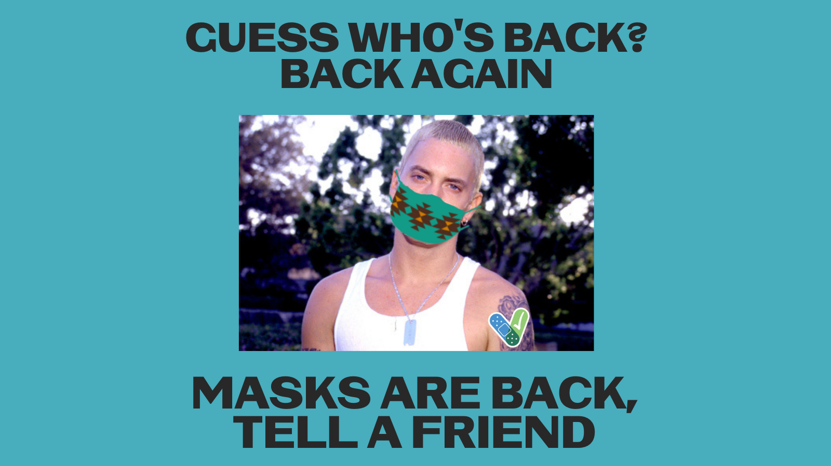
Description:
Safely returning our Native students to in-person instruction in the fall 2021 is a priority. Although Slim Shady doesn’t seem particularly excited about masks, they are in important tool in a multilayer prevention strategy, including vaccination for 12+. #NativesStopTheSpread

