Pregnancy & COVID-19 Vaccines: Social Media Toolkit
Social Media Message: All #COVID19 #Vaccines are now officially recommended for pregnant people by the CDC. Vaccination is especially important because pregnant people are more likely to have complications from COVID-19 disease. Keep our communities and future generations healthy – get your vaccine today! #VacciNation #NativesStoptheSpread #SkoVaxDen #HealthyMotherHealthyBaby

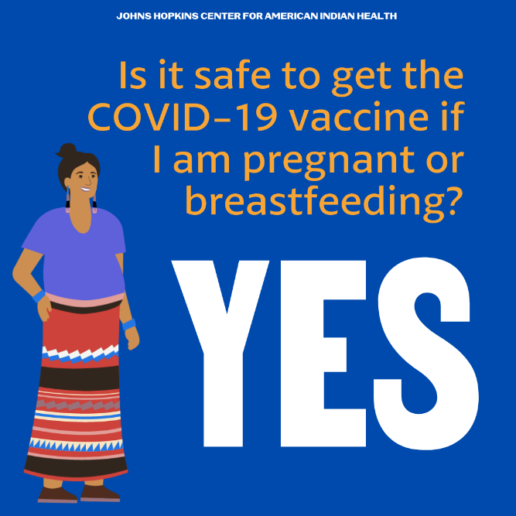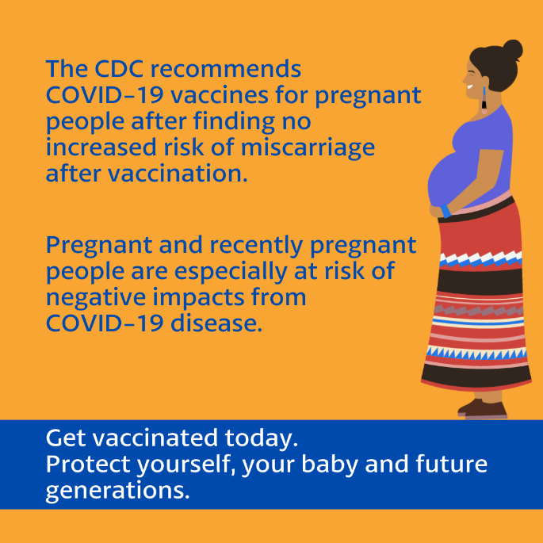
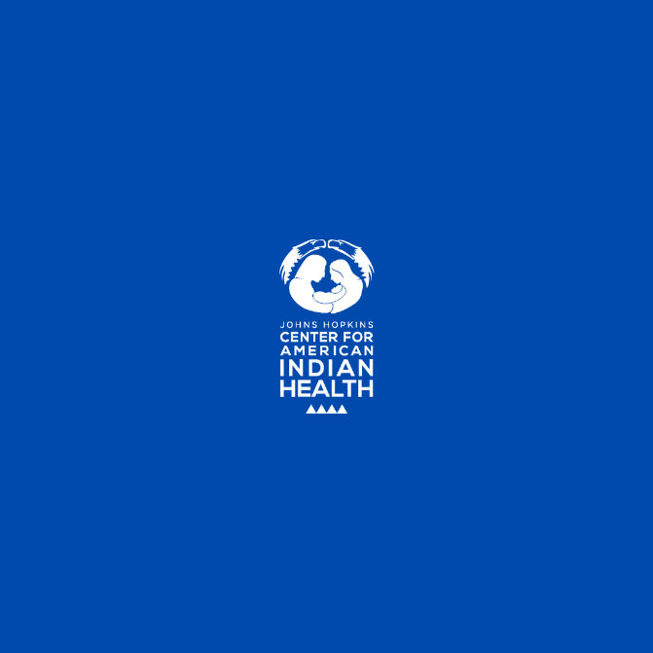

FB/Twitter:
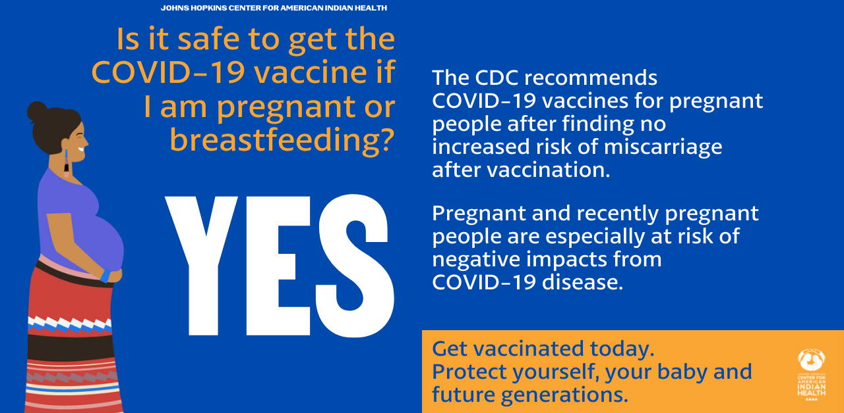

Tag: @Anthctoday @Aaipdocs @CDCgov @HealthyNativeYouth @HonoringNations @IndianCountryToday @_IllumiNatives @IndianHealthBoard_Minneapolis @IndianHealthService
@Indianz @JohnsHopkinsSPH @NationalIndianHealthBoard @Npaihb @Nihb1 @NationalNativeNews @NativeAmericans @NativeAmericanLifelines @Nimhgov @NNNnativenews @ProjectMosaicllc @SeattleIndianHealthBoard @UrbanIndigenousCollective@UrbanIndianHealth
@UrbanIndianHealthInstitute @WeAreHealers @WeRNative

