Knifeman Meme Toolkit
Instagram:
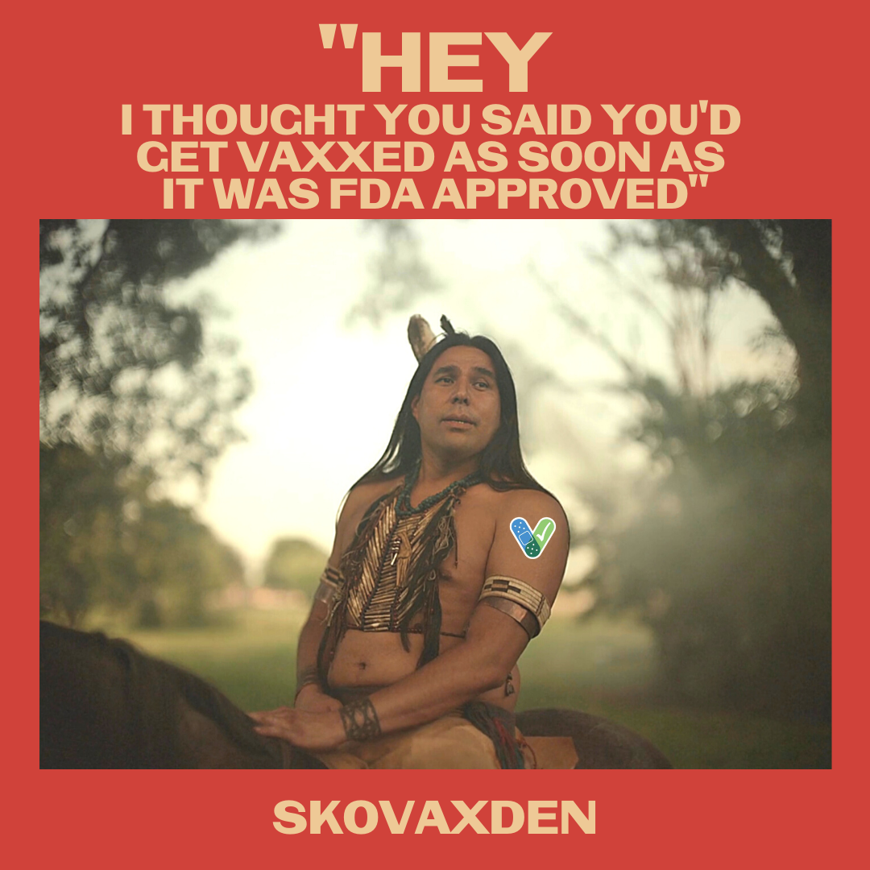
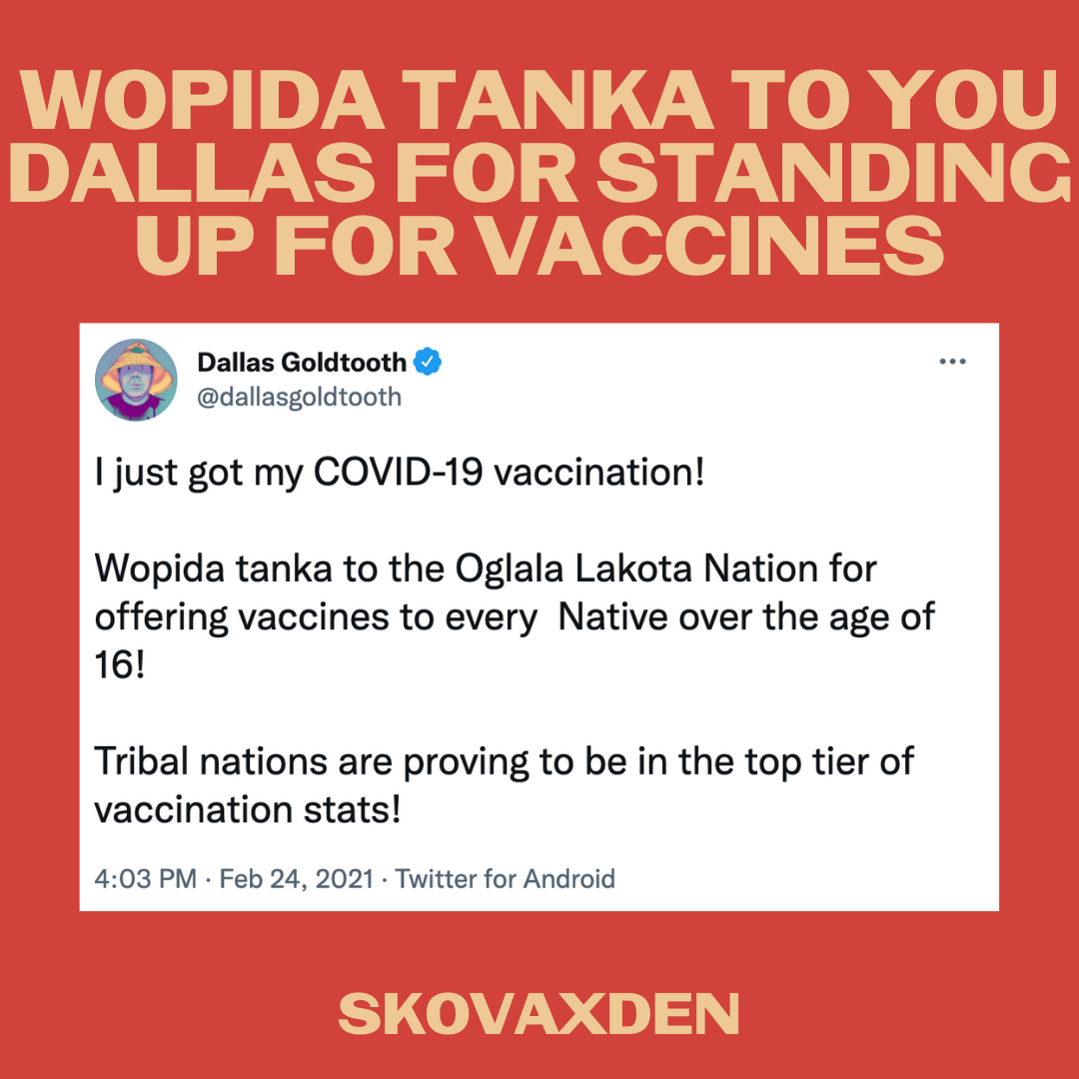
Tag on IG: @dallasgoldtooth @rezdogsfxonhulu
Description:
William Knifeman doesn’t want any more excuses. #WarriorUp and #SkoVaxDen
Pidamaya to Dallas Goldtooth (Dakota/Navajo), who plays #WilliamKnifeman in #ReservationDogs, for using his platform to help #NativesStopTheSpread #StoodisVax
Twitter and Facebook:
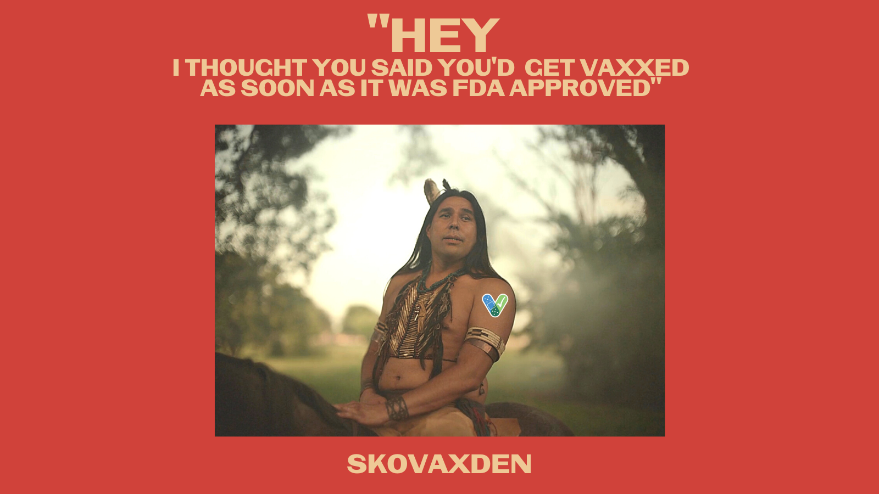
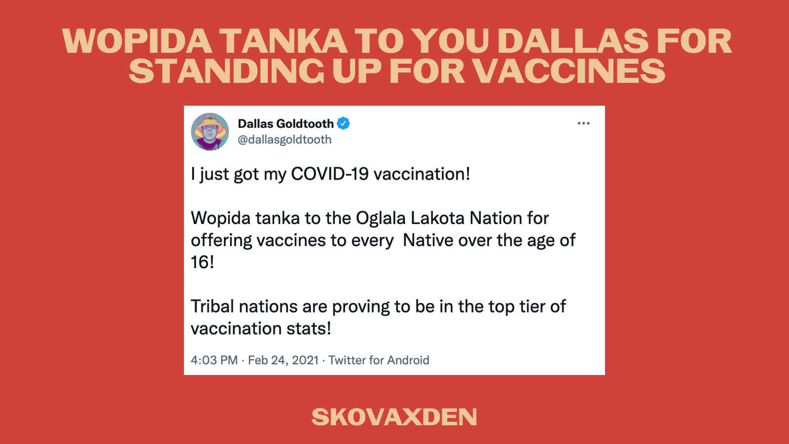
Tag: @dallasgoldtooth @rezdogsfxonhulu
Description:
William Knifeman doesn’t want any more excuses. #WarriorUp and #SkoVaxDen
Pidamaya to Dallas Goldtooth (Dakota/Navajo), who plays #WilliamKnifeman in #ReservationDogs, for using his platform to help #NativesStopTheSpread #StoodisVax

