Safe Schools Social Media Toolkit 1
Social Media Message #1: Schools are an important part of our communities. With layered approaches like #MaskingUp and #Testing, we can protect children from #COVID19 and create safe opportunities to learn in person. Check with your school about their reopening plan and watch our newest video to learn more: https://bit.ly/399Icwx. #SafeSchools #NativesStopTheSpread
Instagram:
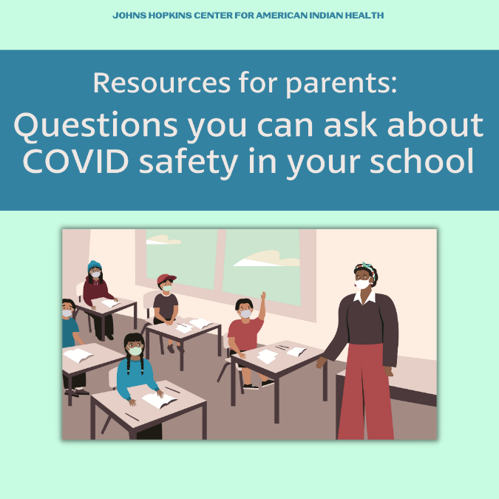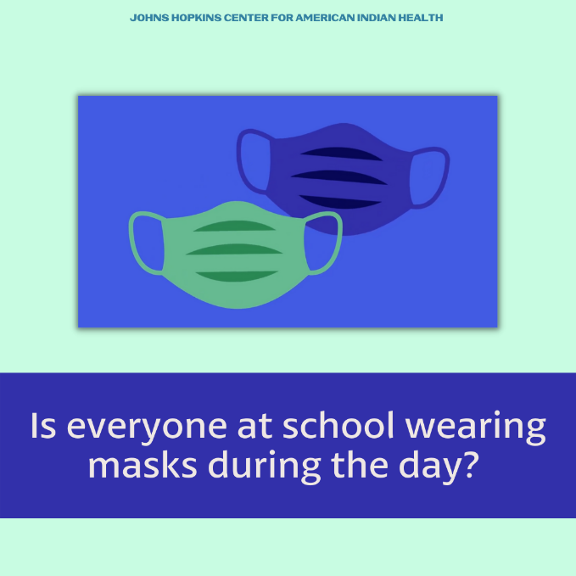
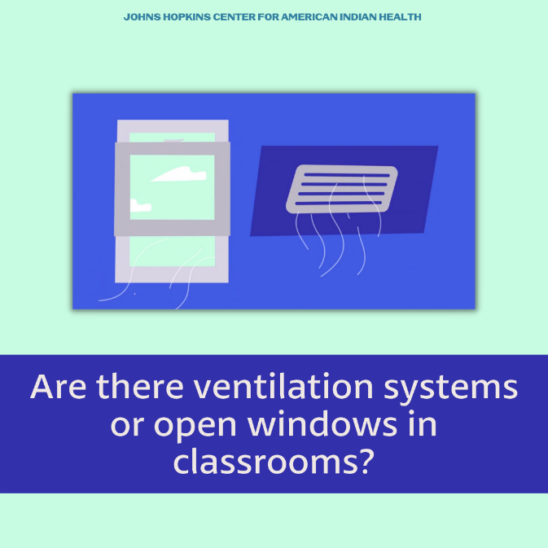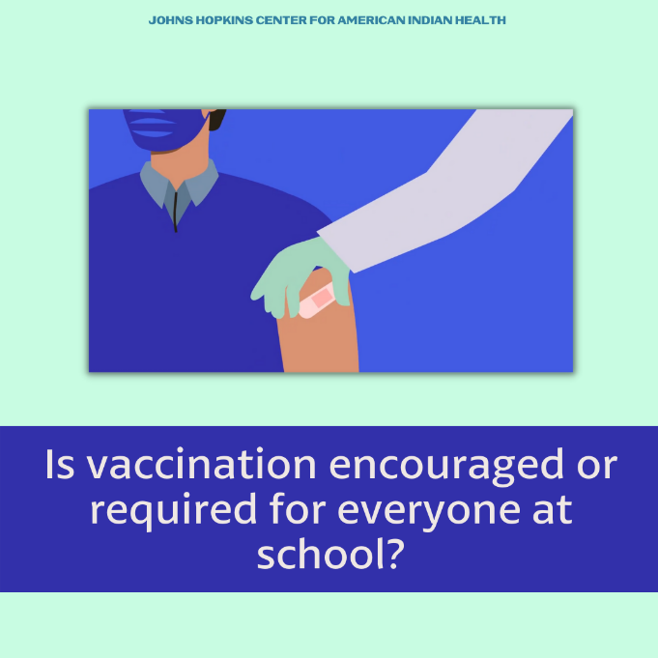
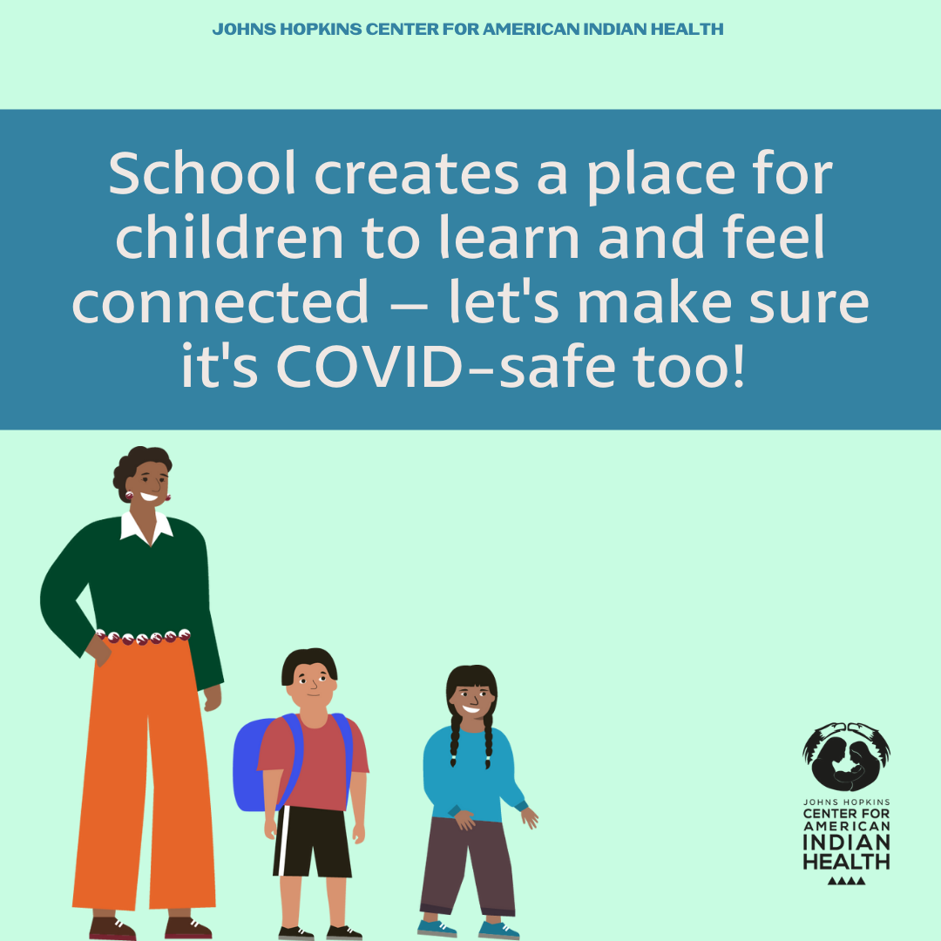
Facebook/Twitter:
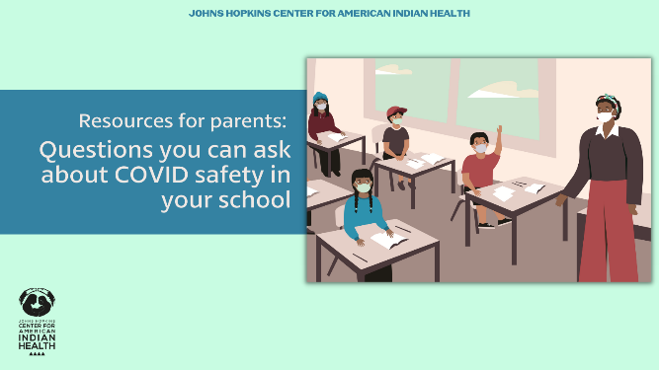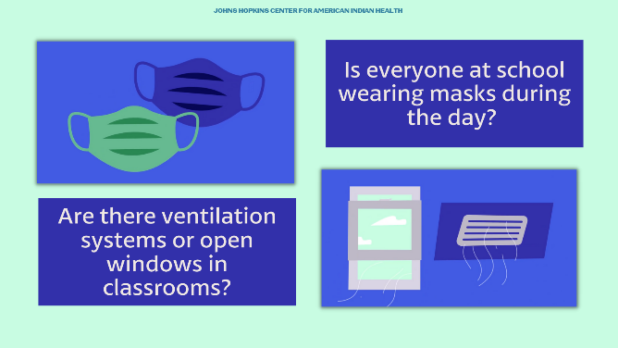
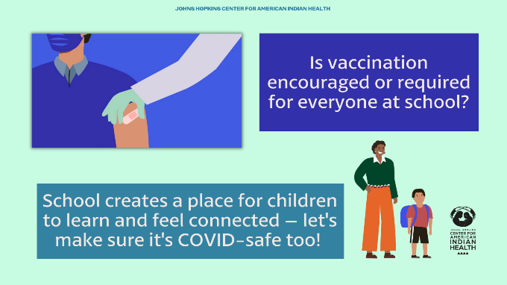
Tag: @HealthyN8Vyouth @HonoringNations @_Illuminatives @JohnsHopkinssph @Npaihb @ProjectMosaicLLC @UrbanIndigenousCollective @Nimhgov @Nimhd @Nihb1 @UrbanIndianHealth @WeAreHealers @WeRNative

Safe Schools Social Media Toolkit 2
Social Media Message #2: Schools are taking important steps to stay safe from #COVID19 such as masking, social distancing, and COVID testing. Along with community vaccination, this helps make schools safe for learning and playing! Ask your school about their COVID safety and watch: https://bit.ly/399Icwx #SafeSchools #NativesStopTheSpread
COVID-safe
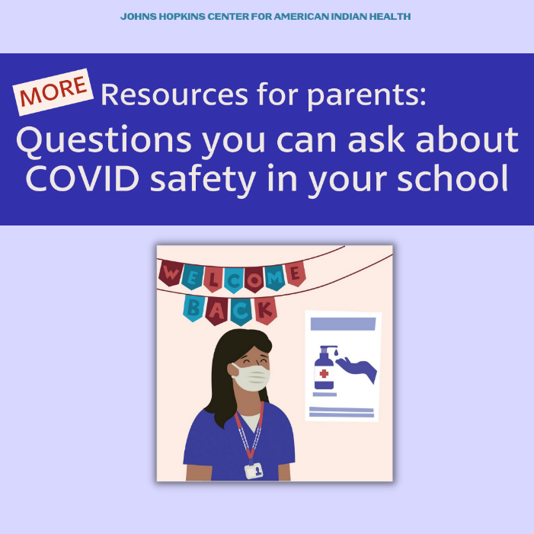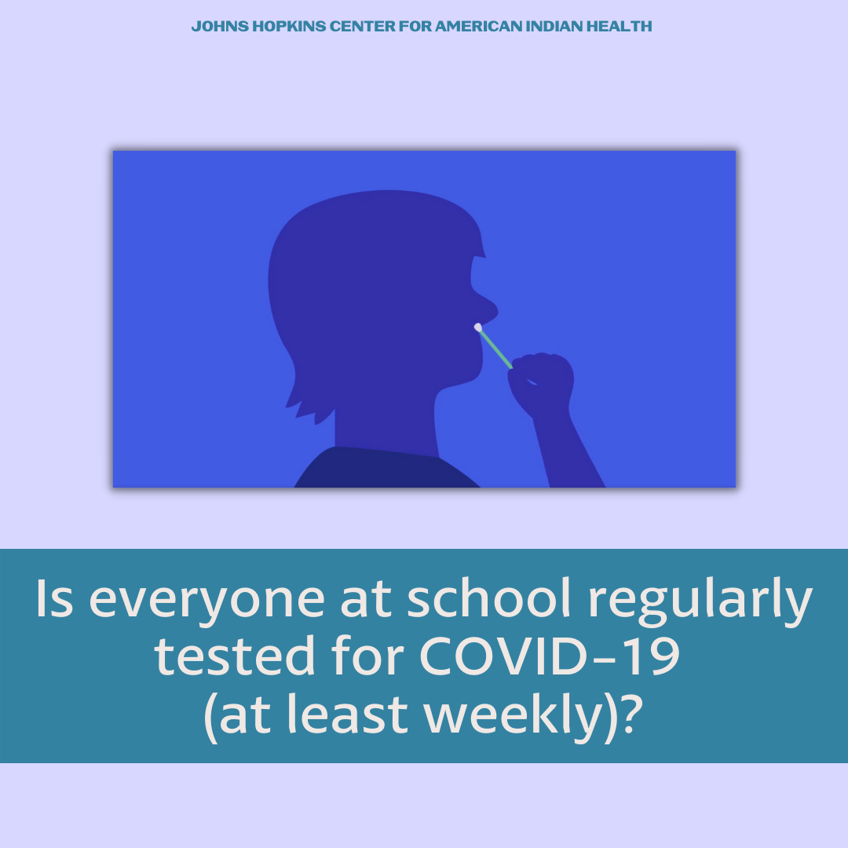
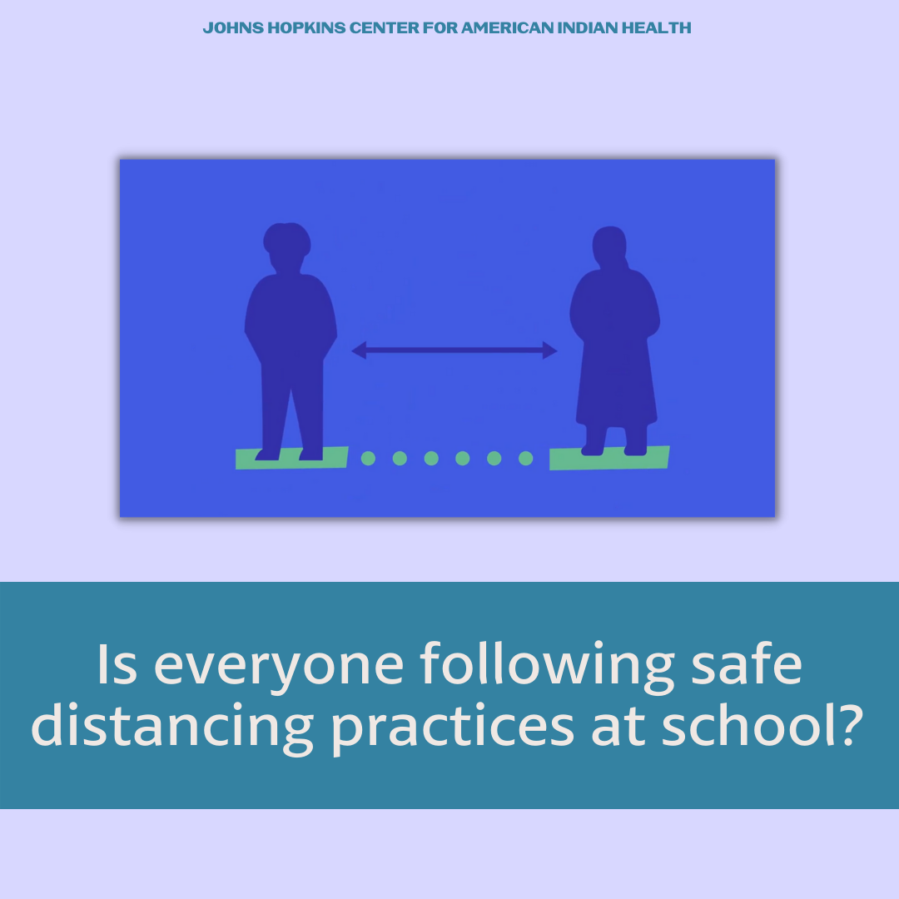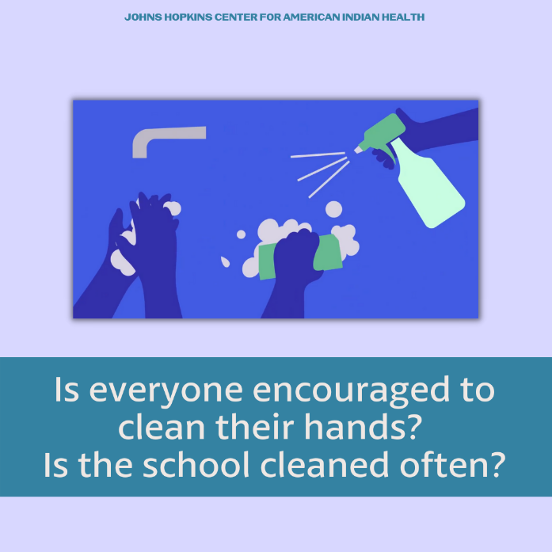

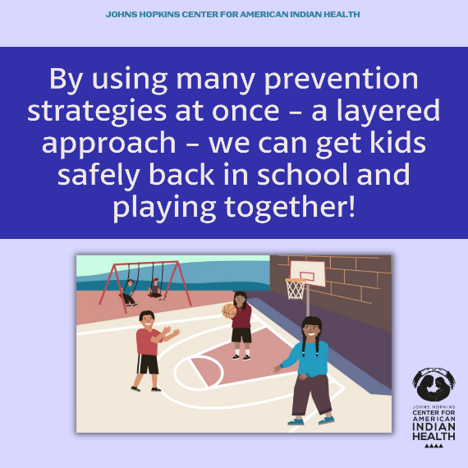
Facebook/Twitter:
Twitter message: Schools are taking important steps to stay safe from #COVID19 such as masking, social distancing, and COVID testing. Along with community vaccination, this helps make schools safe for learning! Ask your school about their COVID safety and watch: https://bit.ly/399Icwx.
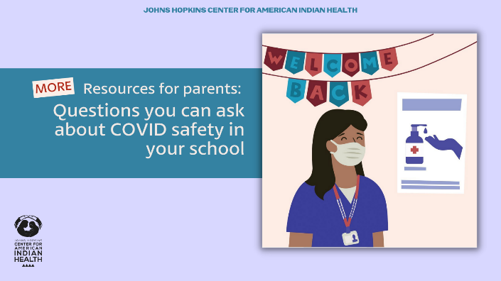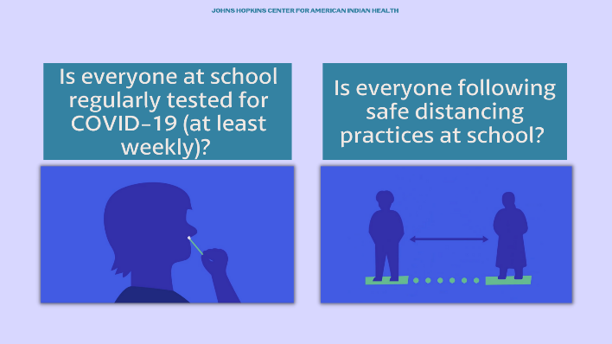
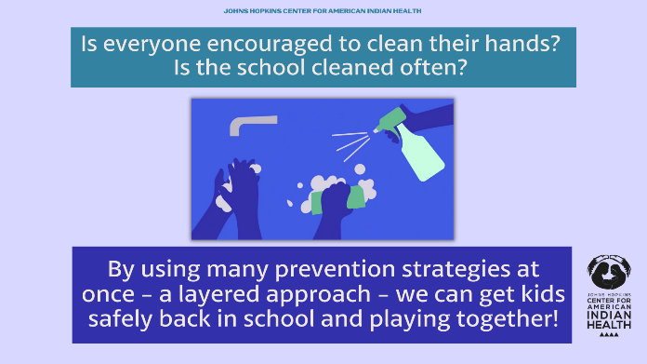
Tag: @HealthyN8Vyouth @HonoringNations @_Illuminatives @JohnsHopkinssph @Npaihb @ProjectMosaicLLC @UrbanIndigenousCollective @Nimhgov @Nimhd @Nihb1 @UrbanIndianHealth @WeAreHealers @WeRNative

Safe Schools Social Media Toolkit 3
Social Media Message #2: This year, #COVIDSafety is important so kids can get back in school and back to their routines. Prevention measures like masking, distancing, and cleaning your hands have been effective at stopping the spread of #COVID19. Ask your school about their reopening plans and learn more by watching https://bit.ly/399Icwx. #SafeSchools #NativesStopTheSpread
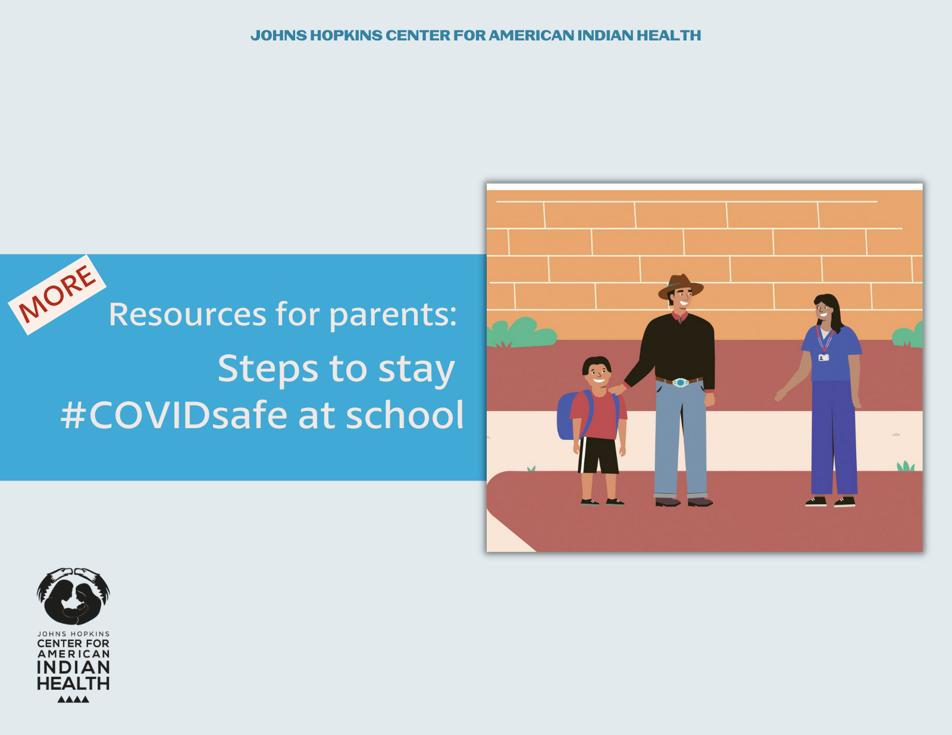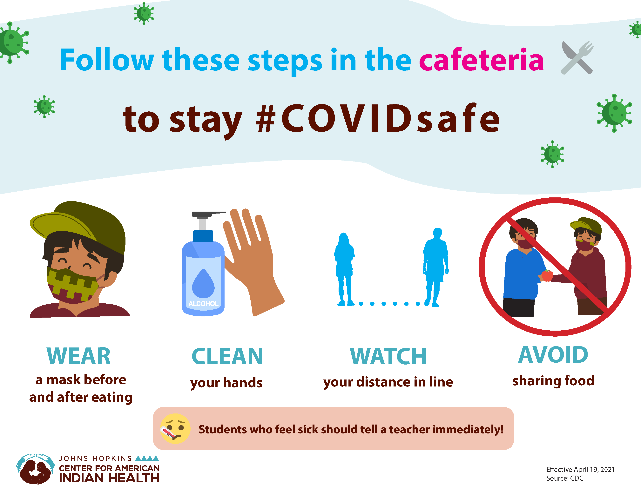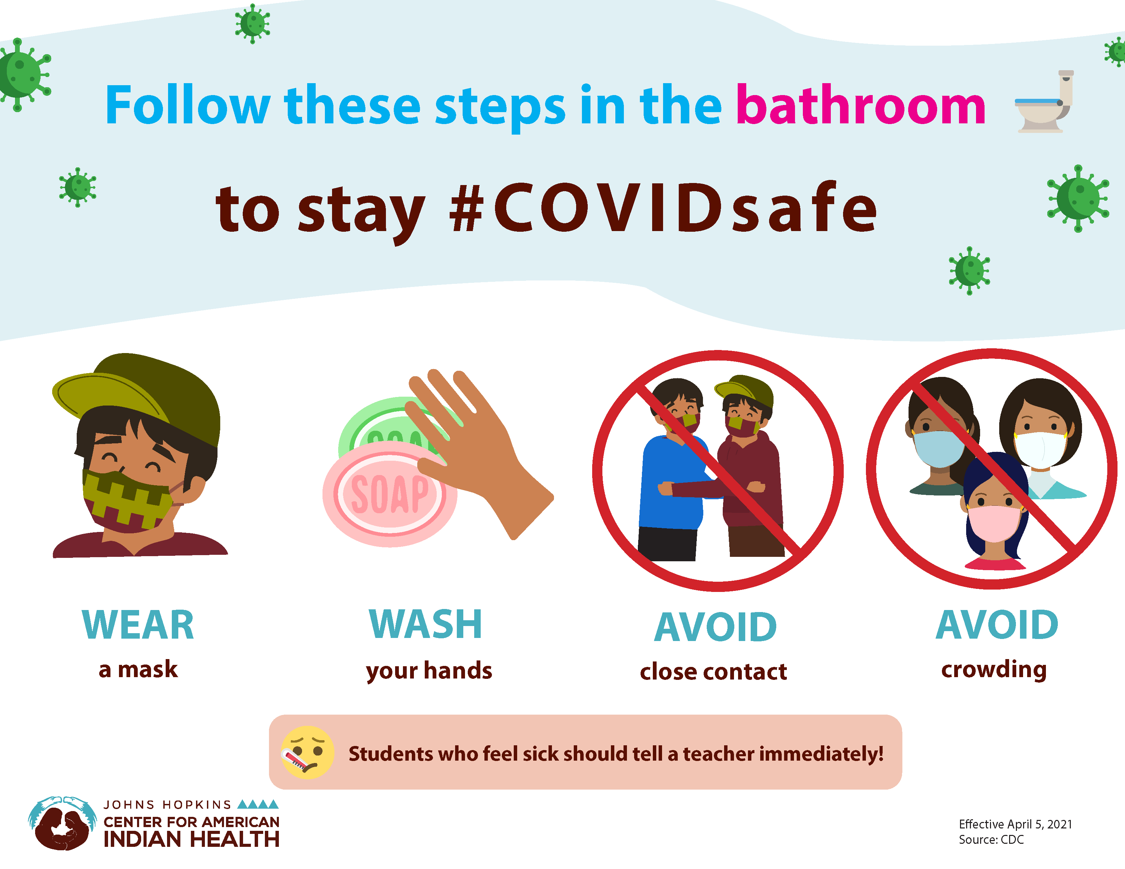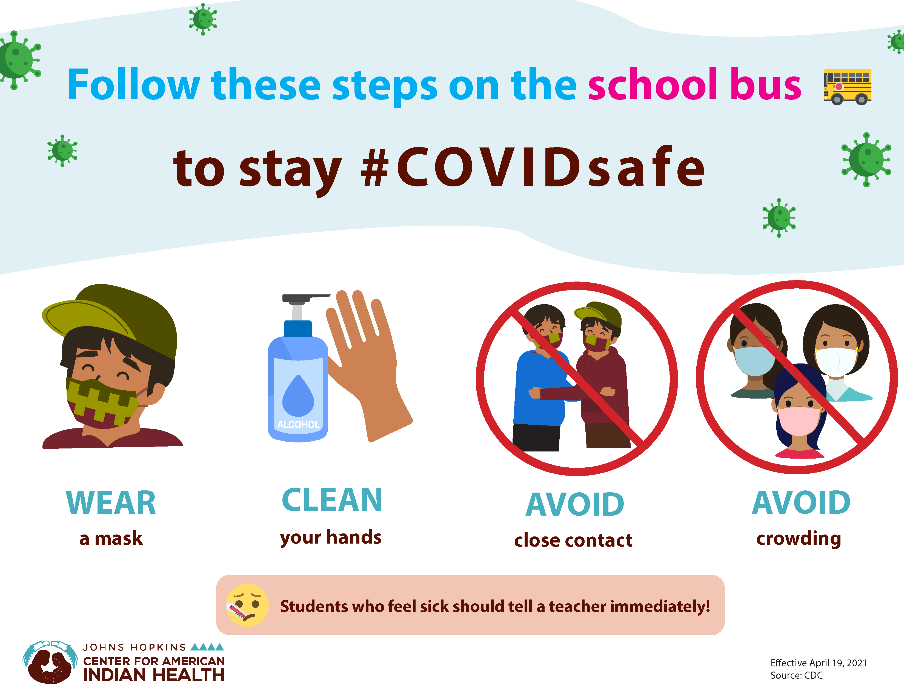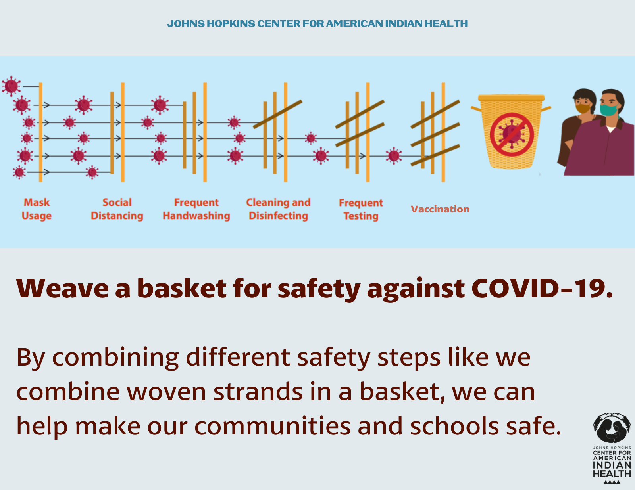
Tag:@HealthyN8Vyouth @HonoringNations @_Illuminatives @JohnsHopkinssph @Npaihb @ProjectMosaicLLC @UrbanIndigenousCollective @Nimhgov @Nimhd @Nihb1 @UrbanIndianHealth @WeAreHealers @WeRNative

