Bucky Copper Meme Toolkit
Instagram:

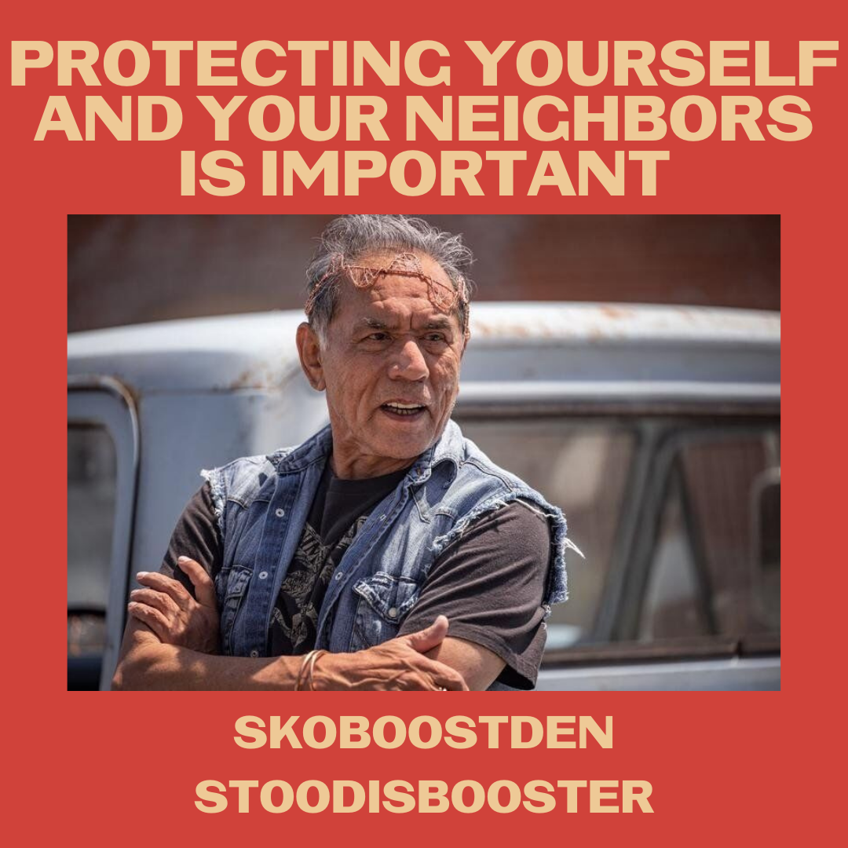
Tag on IG: @rezdogsfxonhulu
Description:
Bucky wants to protect himself and his neighbors and one of the best ways to do that is to get his COVID-19 booster when you are eligible. For those 65+ and other qualified people, it’s time to #SkoBoostDen and #StoodisBooster
#NativesStopTheSpread

Twitter and Facebook:

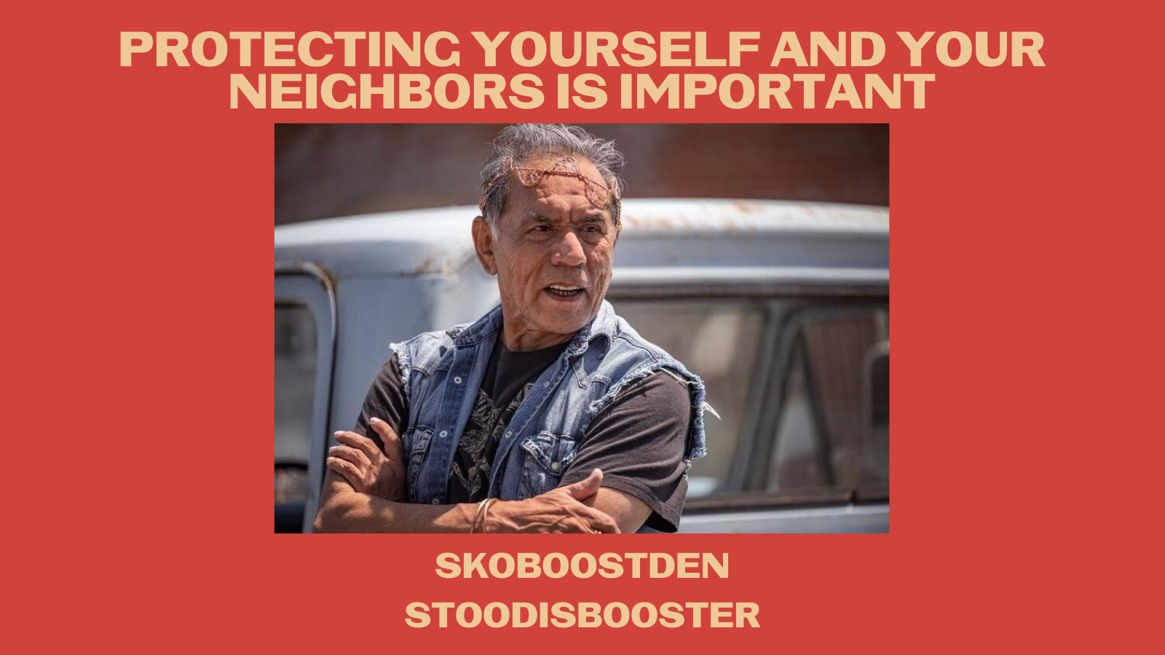
Tag: @rezdogsfxonhulu
Description:
Bucky wants to protect himself and his neighbors and one of the best ways to do that is to get his COVID-19 booster when you are eligble. For those 65+ and other qualified people, it’s time to #SkoBoostDen and #StoodisBooster
#NativesStopTheSpread

