Bunky Echo-Hawk Art Toolkit
Instagram:

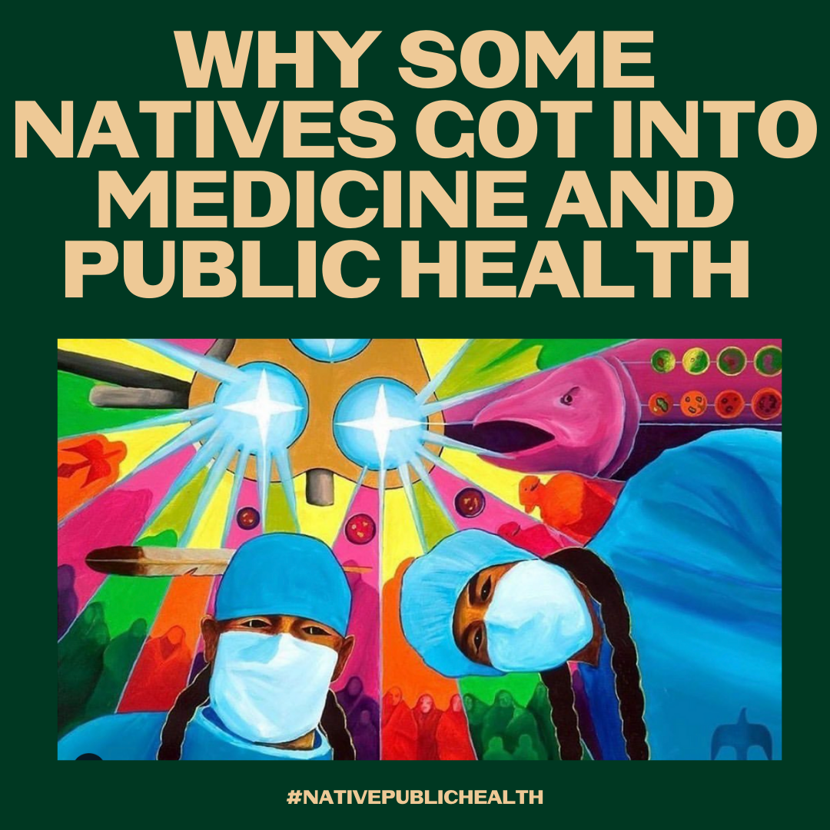
Tag on IG: @bunkhaus
Description:
Institutional mistrust is valid, but please remember that there are Native doctors, researchers, & epidemiologists working hard to keep us safe & maintain data sovereignty. Many of us chose our path out of institutional mistrust. Native scientists and providers are on your side. #NativeProviders #NativeScientists #NativePublicHealth #NativesStopTheSpread
Art courtesy of Bunky Echo-Hawk

Twitter and Facebook:

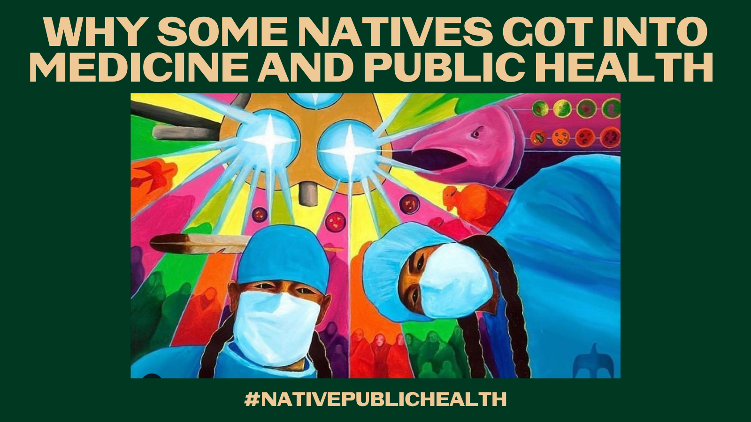
Tag: @bunkhaus
Description: Institutional mistrust is valid, but please remember that there are Native doctors, researchers, & epidemiologists working hard to keep us safe & maintain data sovereignty. Many of us chose our path out of institutional mistrust. Native scientists and providers are on your side.

