Women’s Fertility Social Media Toolkit
Social Media Message: There is no evidence that #COVID19 #Vaccines can impact your ability to have a healthy child. Many people have already become pregnant and had healthy children after getting #Vaccinated. Protect yourself and future generations by getting your vaccine today!
#NativesStopTheSpread #WomensHealth #Pregnancy #COVIDWarrior #VacciNation
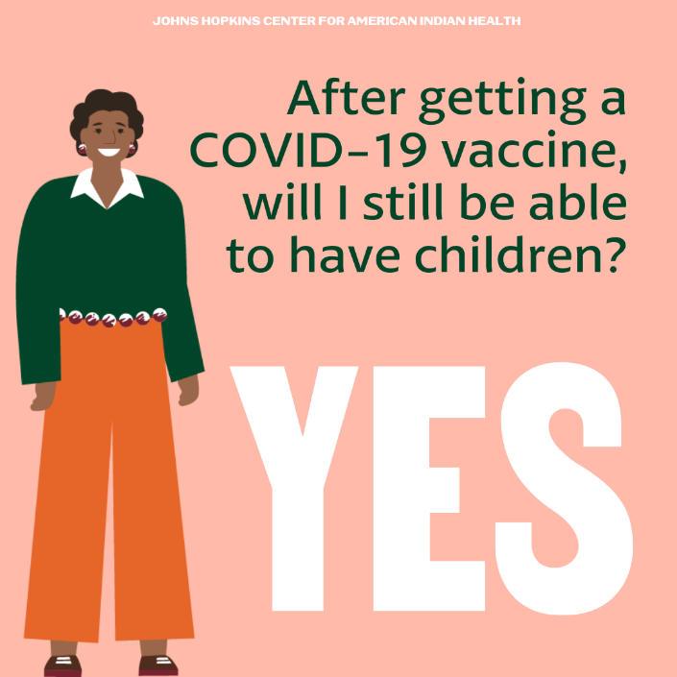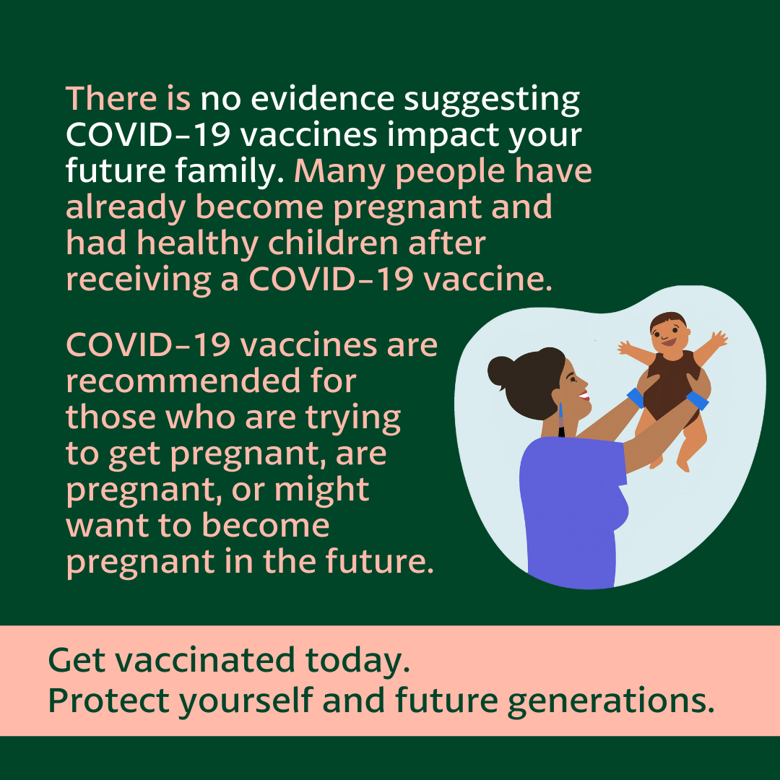
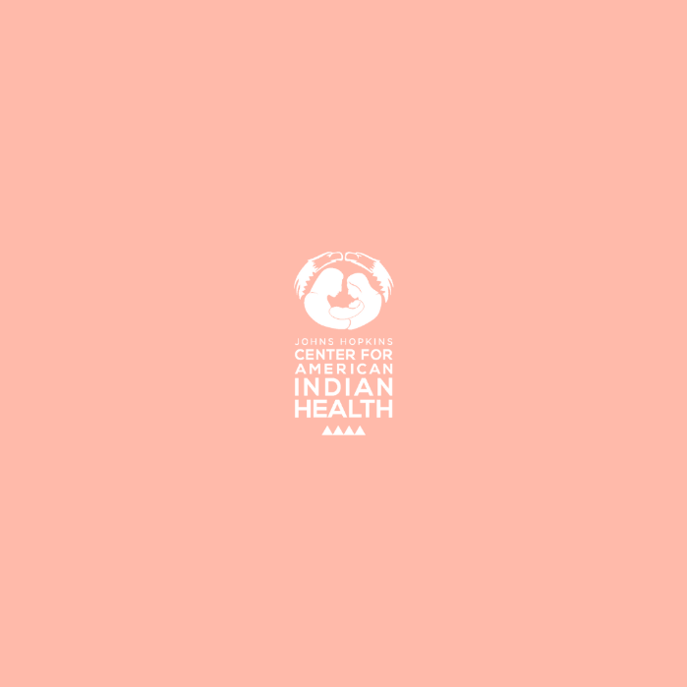
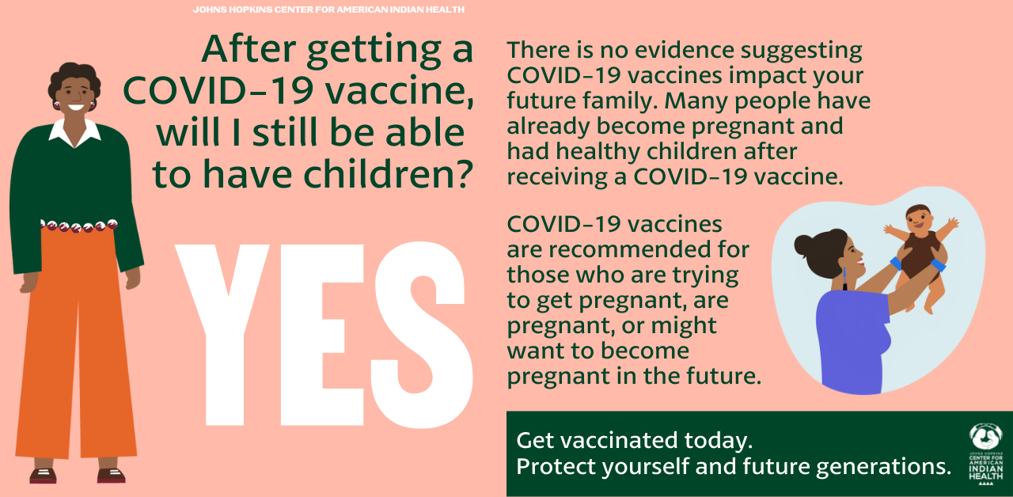

Tag: @HonoringNations @_Illuminatives @JohnsHopkinssph @Npaihb @ProjectMosaicLLC @UrbanIndigenousCollective @Nimhgov @Nimhd @Nihb1 @UrbanIndianHealth @WeAreHealers @WeRNative @HealthyN8Vyouth

