Men’s Fertility: Social Media Toolkit
Social Media Message: There is no evidence that getting your #COVID19 #Vaccine can impact your reproductive health. In fact, the vaccine protects you from potential negative side effects of COVID-19 disease like erectile dysfunction. Get vaccinated today to protect yourself and future generations #StoptheSpread #MensHealth #COVIDWarrior #VacciNation
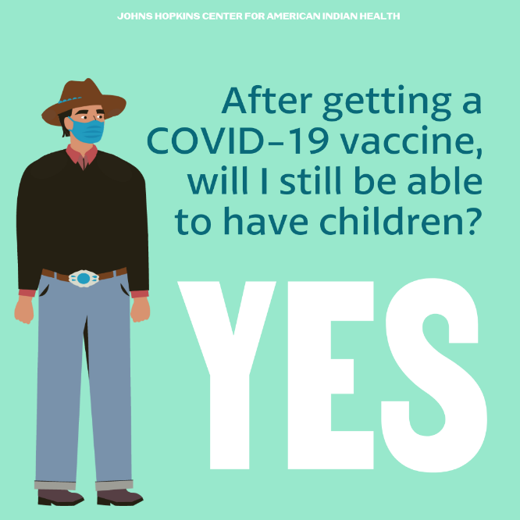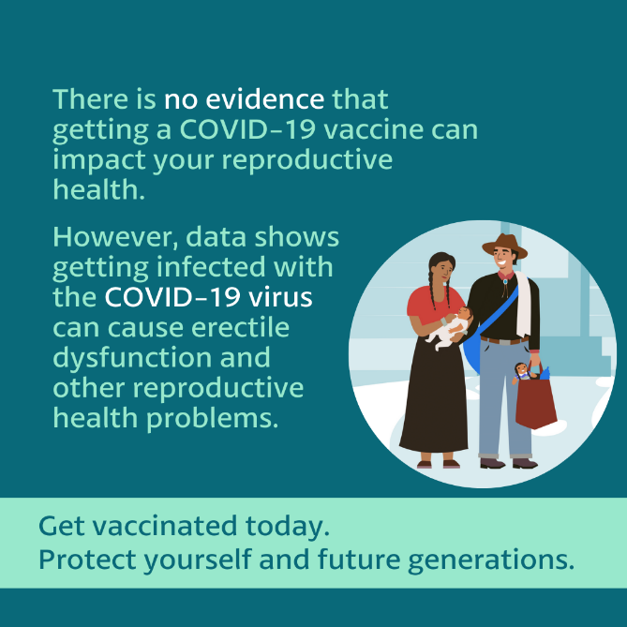
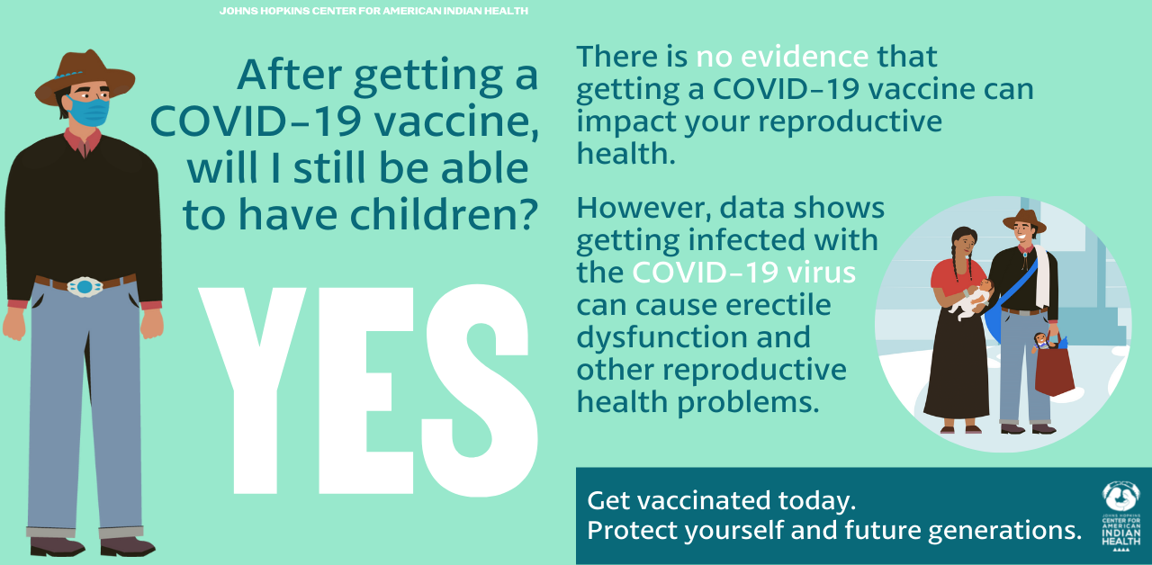

Tag: @HealthyN8Vyouth @HonoringNations @_Illuminatives @JohnsHopkinssph @Npaihb @ProjectMosaicLLC @UrbanIndigenousCollective @Nimhgov @Nimhd @Nihb1 @UrbanIndianHealth @WeAreHealers @WeRNative

