Protecting Babies Social Media Toolkit
Social Media Message: Getting a #COVID19 #Vaccine benefits you and protects your baby! Evidence has suggested that you can give antibodies that fight COVID-19 to your baby while #pregnant or #breastfeeding. Protect yourself and future generations by getting vaccinated today!
#NativesStopTheSpread #WomensHealth #VacciNation #ChestFeeding #BodyFeeding
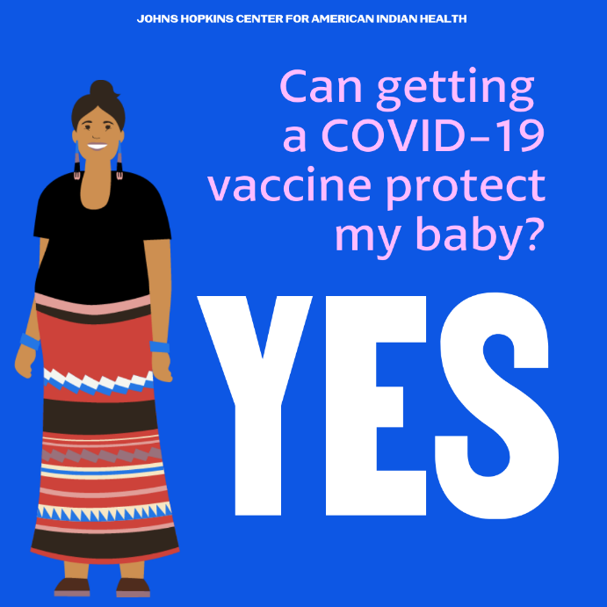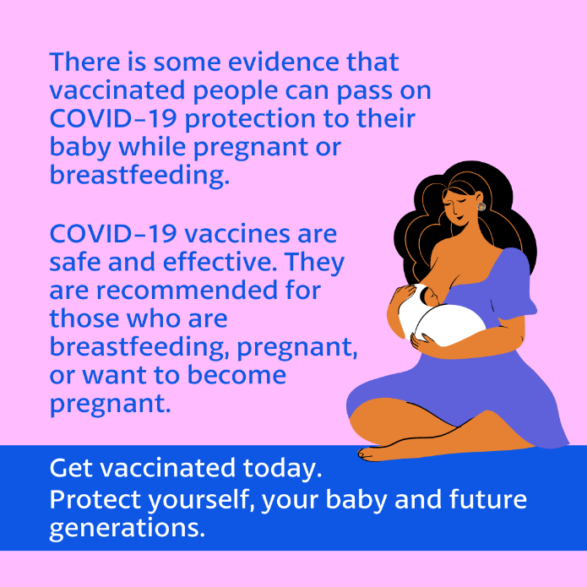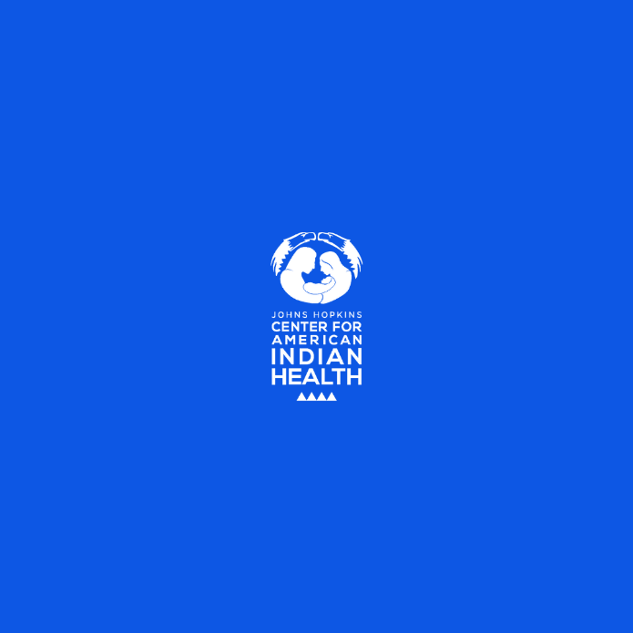
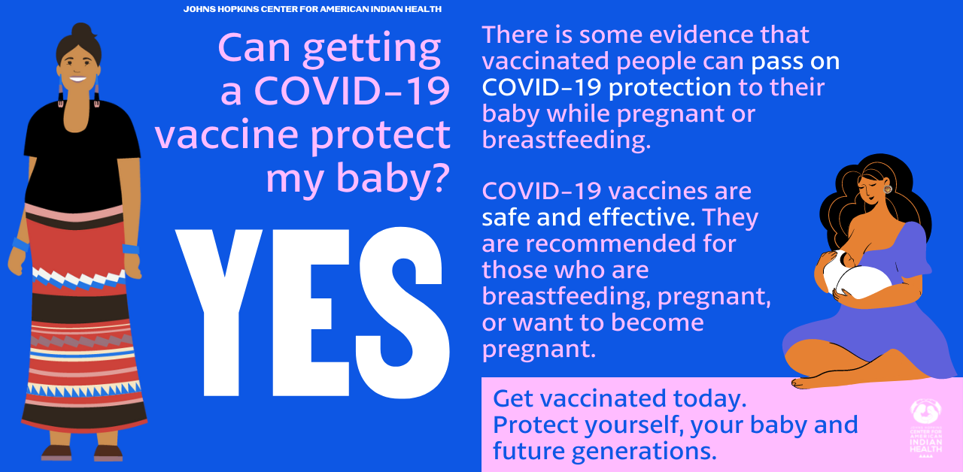
Tag: @HonoringNations @_Illuminatives @JohnsHopkinssph @Npaihb @ProjectMosaicLLC @UrbanIndigenousCollective @Nimhgov @Nimhd @Nihb1 @UrbanIndianHealth @WeAreHealers @WeRNative

