Children and COVID-19 Social Media Toolkit
Social Media Message: Children can get sick with and spread #COVID19, so it’s important we take precautions to keep them safe. Encourage your kids to #CleanYourHands and #MaskUp if they are over age 2 and get #Vaccinated if they are 5 or older. We can also protect children who can’t yet be vaccinated by getting our COVID-19 #Vaccine and reducing the spread in our communities.
#NativesStopTheSpread #ProtectOurKids #VacciNation
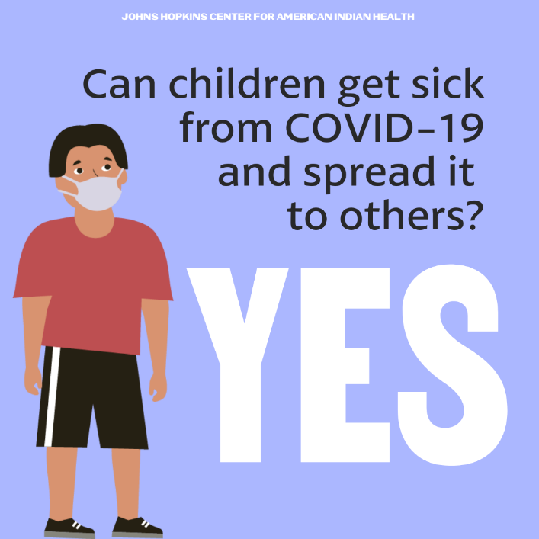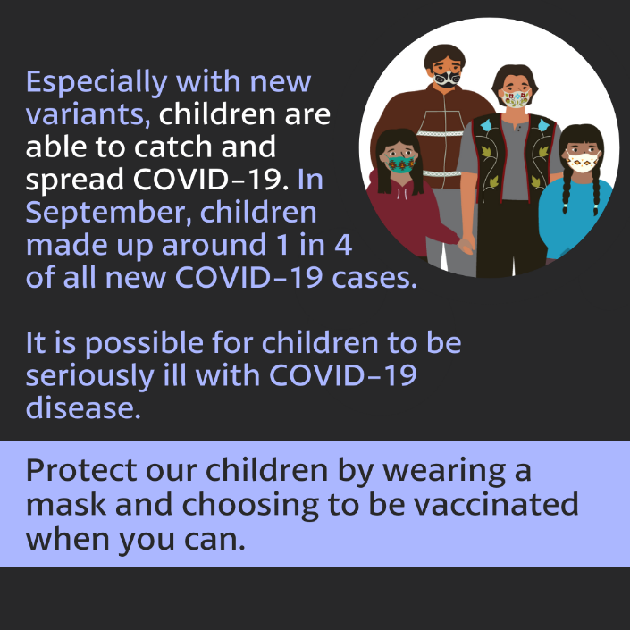
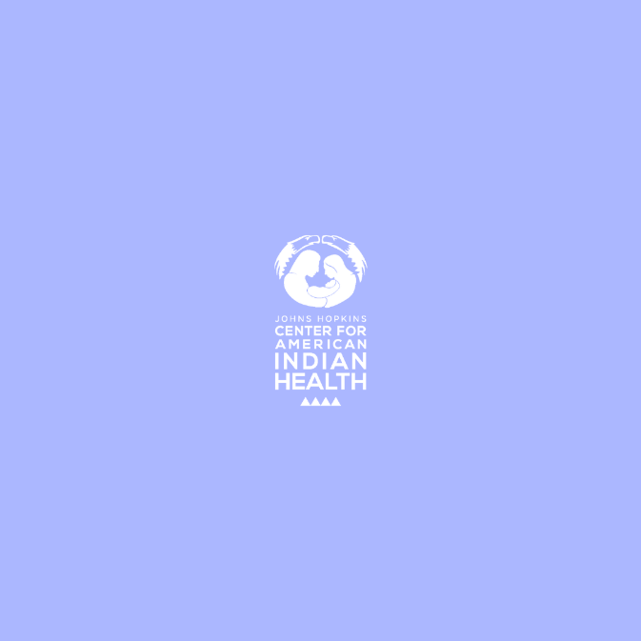

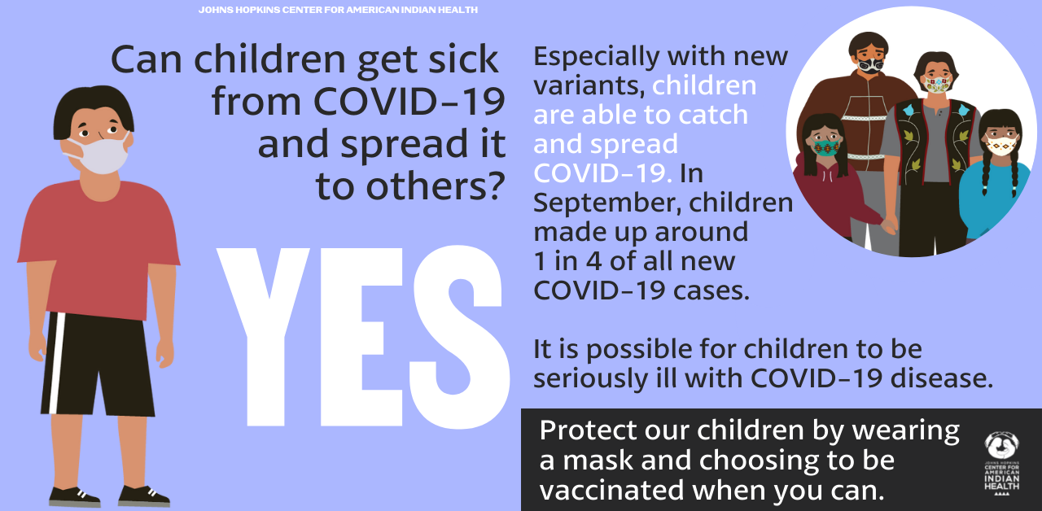
Tag: @HealthyN8Vyouth @HonoringNations @_Illuminatives @JohnsHopkinssph @Npaihb @ProjectMosaicLLC @UrbanIndigenousCollective @Nimhgov @Nimhd @Nihb1 @UrbanIndianHealth @WeAreHealers @WeRNative

