Pediatric COVID: Social Media Toolkit
Social Media Message: With school in session and a rise of #COVID19 cases among children under 18, it’s important to take steps to protect our kids. #MaskUp and get #Vaccinated today to reduce the spread of COVID-19 in our communities. #NativesStoptheSpread #VacciNation
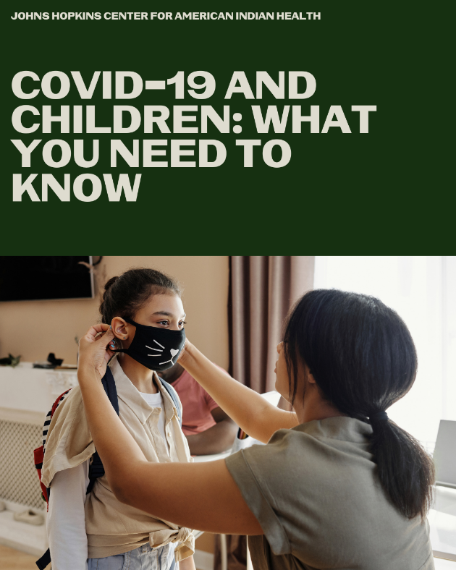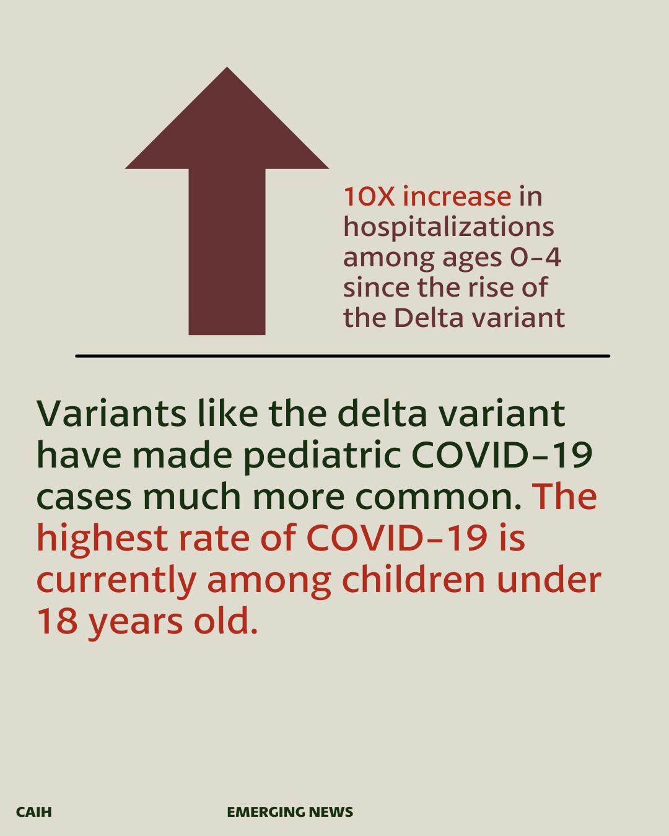
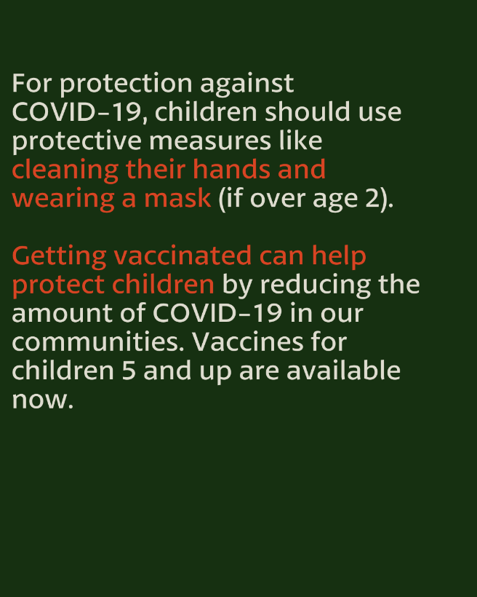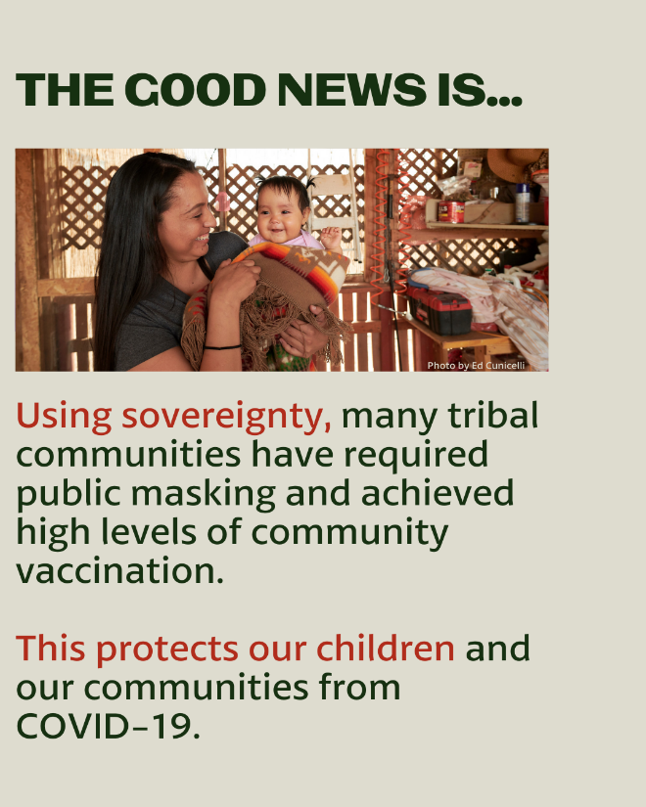
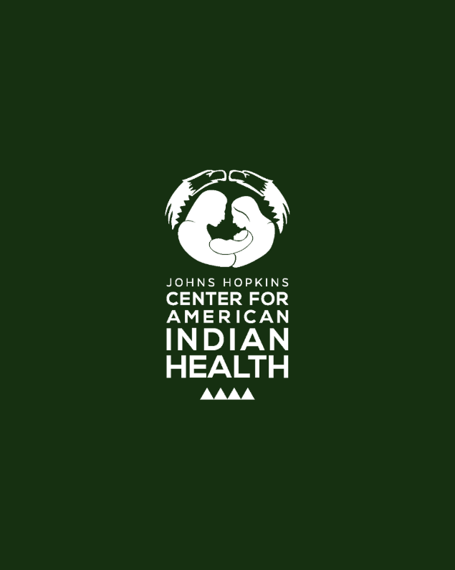

Tag: @HealthyN8Vyouth @HonoringNations @_Illuminatives @JohnsHopkinssph @Npaihb @ProjectMosaicLLC @UrbanIndigenousCollective @Nimhgov @Nimhd @Nihb1 @UrbanIndianHealth @WeAreHealers @WeRNative

