Stick with your Pack Meme Toolkit
Instagram:
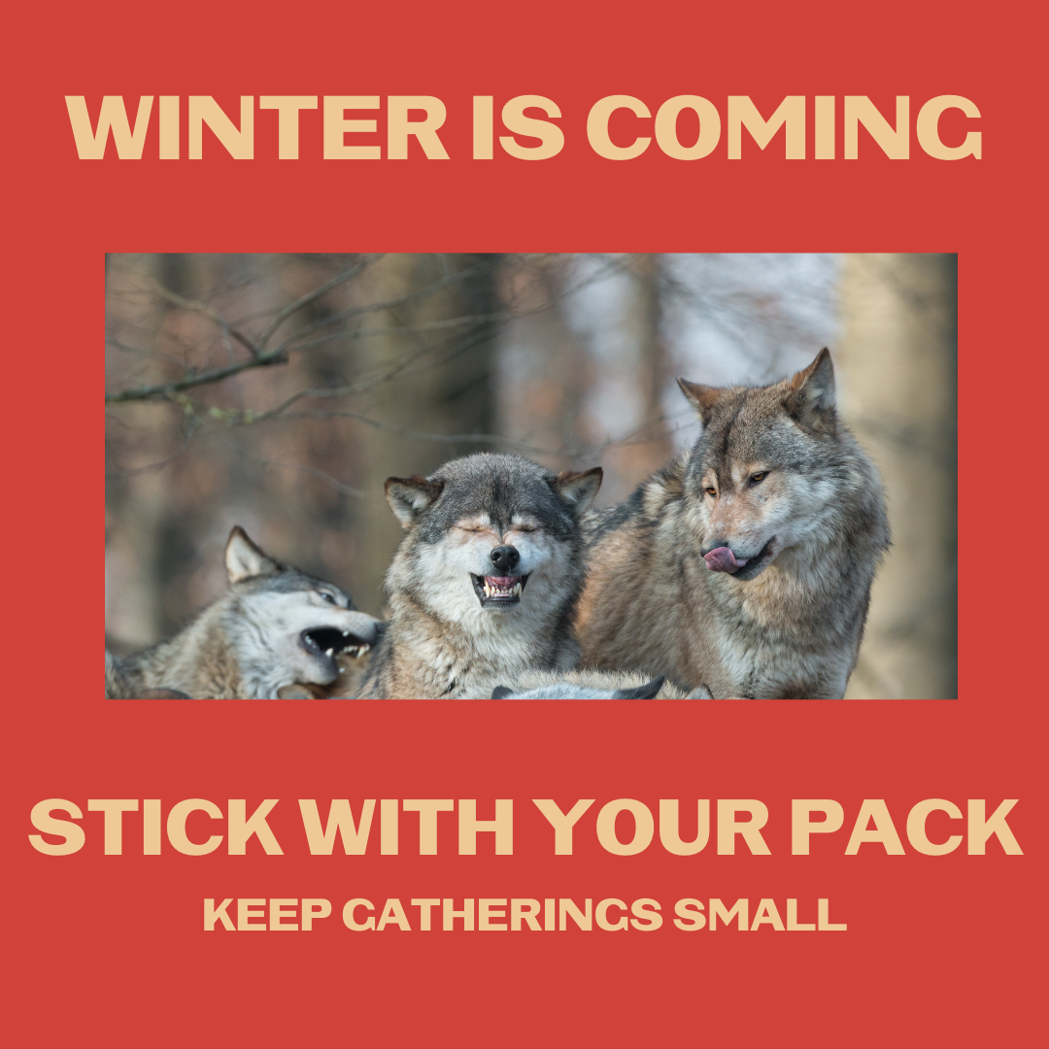

Description: As the weather turns colder, it’s family time, sweater weather and soup season. Enjoy this quiet time with those close to you and if you must gather in large groups, wear your mask and keep your distance. #WinterIsComing #StickWithYourPack #NativesStopTheSpread #NativesDistanceUp #NativeHealth

Twitter and Facebook:
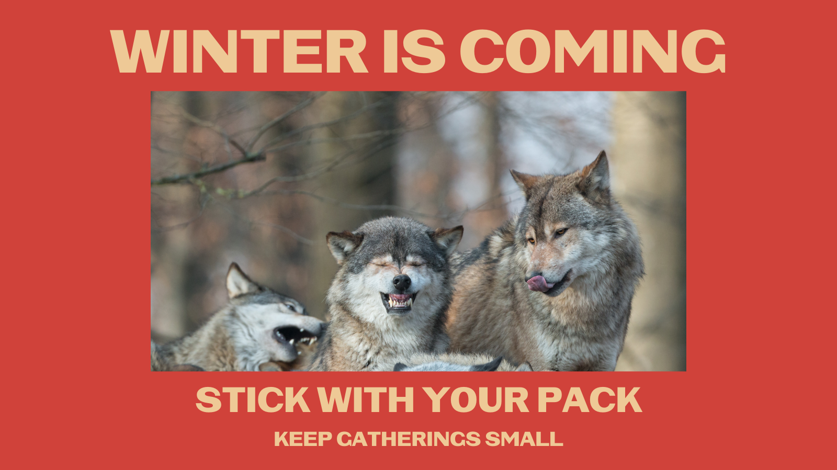

Description: As the weather turns colder, it’s family time, sweater weather, and soup season. Enjoy this quiet time with those close to you and if you must gather in large groups, wear your mask and keep your distance. #WinterIsComing #StickWithYourPack #NativesStopTheSpread

