Child Vaccine Social Media Toolkit

Batch #1:

Social Media Message: Children (emoji) ages 5 and up can now receive a #COVID-19 #vaccine (emoji). This vaccine is safe and effective. Children who get the vaccine will receive strong protection (strong arm emoji) against COVID-19 disease. Vaccinated children will also be less likely to spread the virus to others, keeping our families and communities safe from COVID-19. Contact your child’s healthcare provider or tribal health department to schedule their vaccine today!

#VacciNation #NativesStopTheSpread #NativesDoingTheirPart #IndigenousHealth #NativeAmerican #AmericanIndian #AlaskanNative #HealthyTribes #IndigenousPeople #NativeHealth #TribalHealth #COVIDWarrior

Tags: @Anthctoday @Aaipdocs @CDCgov @HealthyNativeYouth @HonoringNations @IndianCountryToday @_IllumiNatives @IndianHealthBoard_Minneapolis @IndianHealthService
@Indianz @JohnsHopkinsSPH @NationalIndianHealthBoard @Npaihb @Nihb1 @NationalNativeNews @NativeAmericans @NativeAmericanLifelines @Nimhgov @NNNnativenews @ProjectMosaicllc @SeattleIndianHealthBoard @UrbanIndigenousCollective@UrbanIndianHealth
@UrbanIndianHealthInstitute @WeAreHealers @WeRNative @HealthyN8Vyouth @HonoringNations @_Illuminatives @JohnsHopkinssph @Npaihb @ProjectMosaicLLC @UrbanIndigenousCollective @Nimhgov @Nimhd @Nihb1 @UrbanIndianHealth @WeAreHealers
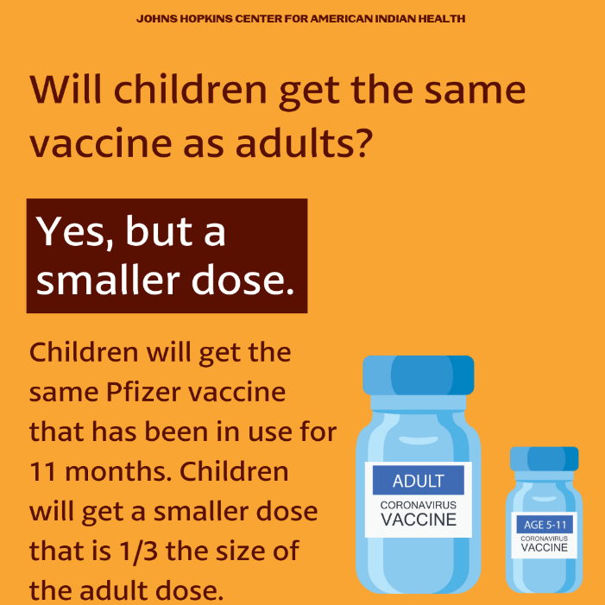
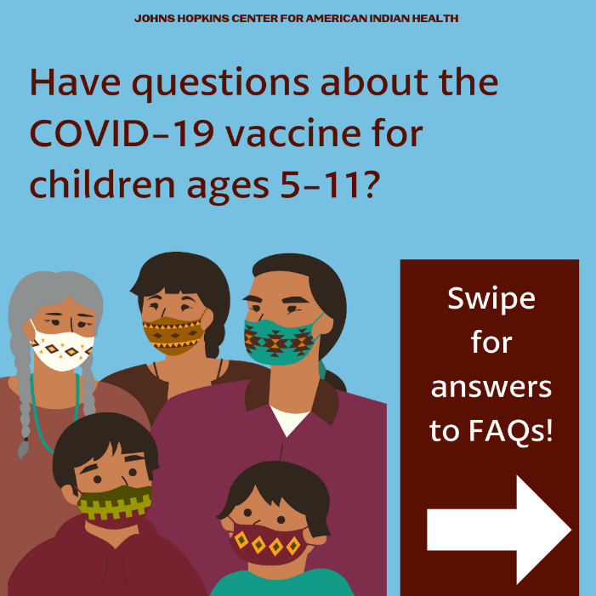

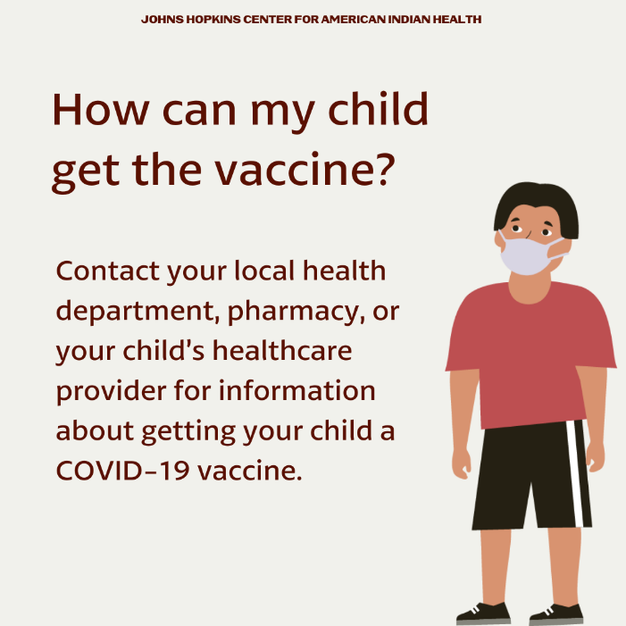
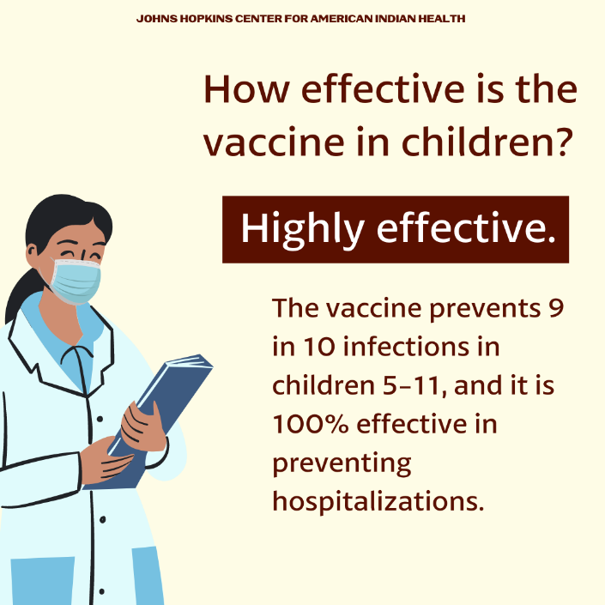
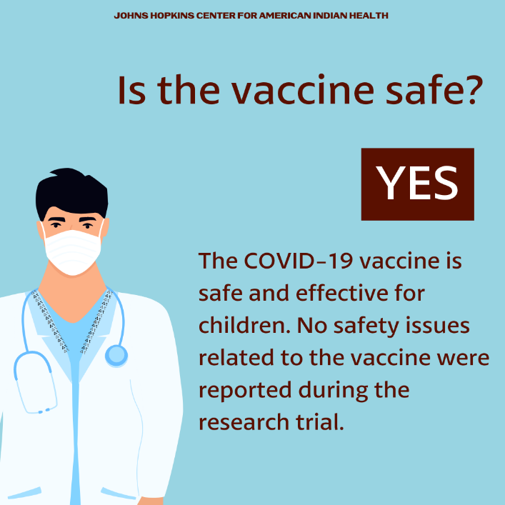

Batch #2:

Social Media Message: Children (emoji) ages 5 and up can now receive a #COVID-19 #vaccine (emoji). This vaccine is safe and effective. Children who get the vaccine will receive strong protection (strong arm emoji) against COVID-19 disease. Vaccinated children will also be less likely to spread the virus to others, keeping our families and communities safe from COVID-19. Contact your child’s healthcare provider or tribal health department to schedule their vaccine today!

#VacciNation #NativesStopTheSpread #NativesDoingTheirPart #IndigenousHealth #NativeAmerican #AmericanIndian #AlaskanNative #HealthyTribes #IndigenousPeople #NativeHealth #TribalHealth #COVIDWarrior

Tags: @Anthctoday @Aaipdocs @CDCgov @HealthyNativeYouth @HonoringNations @IndianCountryToday @_IllumiNatives @IndianHealthBoard_Minneapolis @IndianHealthService
@Indianz @JohnsHopkinsSPH @NationalIndianHealthBoard @Npaihb @Nihb1 @NationalNativeNews @NativeAmericans @NativeAmericanLifelines @Nimhgov @NNNnativenews @ProjectMosaicllc @SeattleIndianHealthBoard @UrbanIndigenousCollective@UrbanIndianHealth
@UrbanIndianHealthInstitute @WeAreHealers @WeRNative @HealthyN8Vyouth @HonoringNations @_Illuminatives @JohnsHopkinssph @Npaihb @ProjectMosaicLLC @UrbanIndigenousCollective @Nimhgov @Nimhd @Nihb1 @UrbanIndianHealth @WeAreHealers
