No Bones Day Toolkit
Instagram:

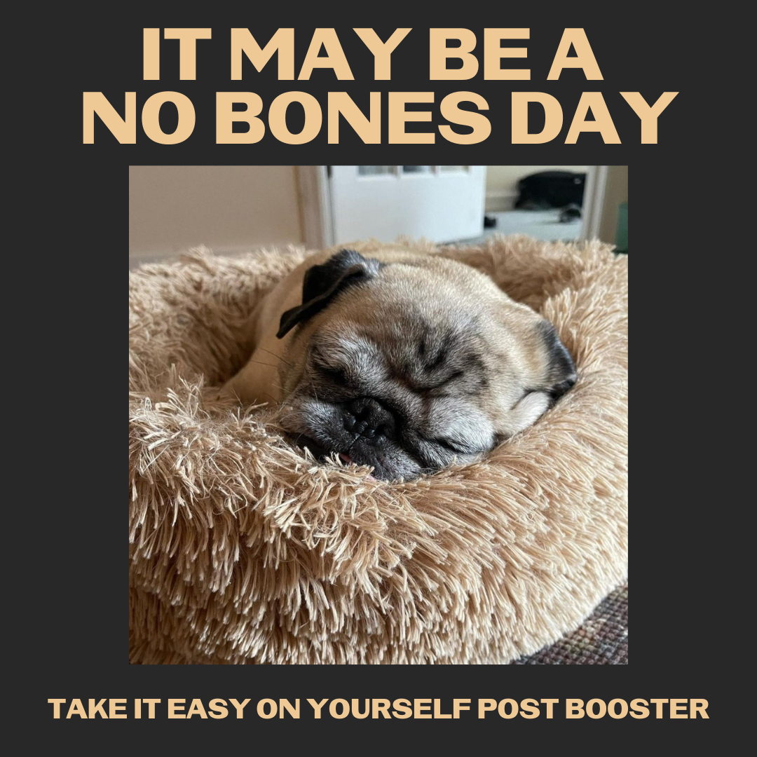
Description:
Noodles the Pug gives you permission to take care of yourself the day after your booster, as the temporary side effects may be similar to your other doses. Your body is actually hard at work making antibodies to the COVID-19 virus to keep you protected. Grab those fuzzy socks, a blankie, some soup and the remote control.
#NativesStopTheSpread #HealthyNatives #HealthyTribes

Twitter and Facebook:
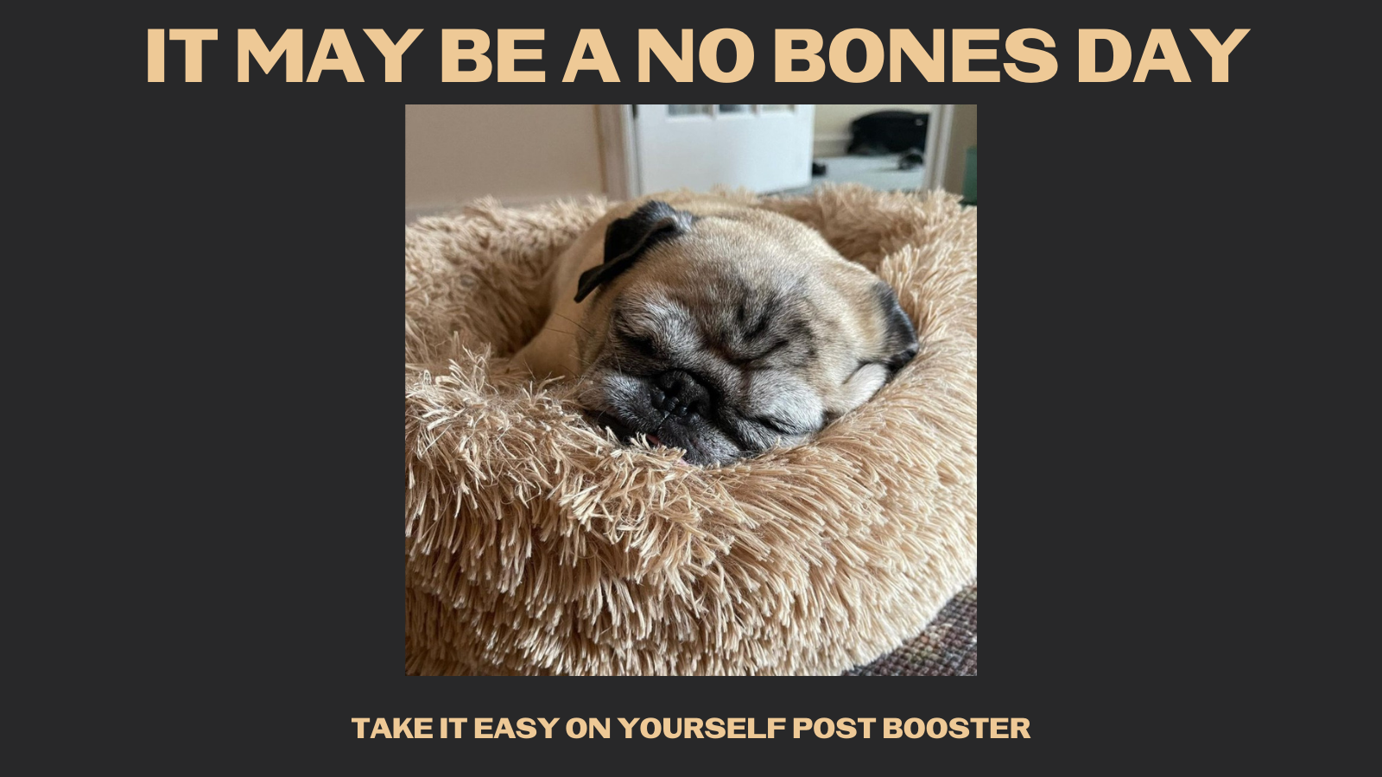

Description: Noodles the Pug gives you permission to take care of yourself the day after your booster, as the temporary side effects may be similar to your other doses. Your body is actually hard at work making antibodies to the COVID-19 virus to keep you protected. Grab a fuzzy blanket.

