Florida Power & Light Company EmPOWERing STEM Educators Grant Program Communications Toolkit for Local Grant Recipients 2024-2025

NAME AND LOGO USAGE
A reminder, though this funding is being facilitated by the Consortium, Florida Power & Light Company is the source of the funding. Please acknowledge them in your communications at the appropriate level just as you would a donor who gives directly to your education foundation.
Please use the company’s full name, Florida Power & Light Company, for all first references in your communications. On second reference, it may be FPL.
Please use the following logo in all your communications (website, annual reports, social media, etc.) when referencing the funding:

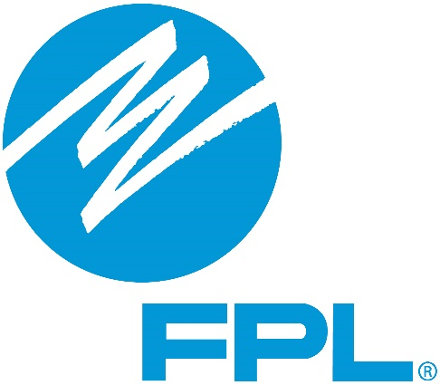

NEWSLETTER
NAME OF LOCAL EDUCATION FOUNDATION Receives $$$ to… EmPOWER STEM Educators
(Local photo of teacher leadership work in action)
As part of a statewide $150,000 grant from Florida Power & Light Company, we have received $$$ for STEM-focused teacher peer-to-peer learning opportunities. BRIEF DESCRIPTION OF LOCALIZED INFORMATION ABOUT YOUR PROJECT – CAN INCLUDE MAIN GOALS, TIMELINE, ETC.
[Add Quote from FPL] "These investments in STEM education play a pivotal role in empowering students with the knowledge and skills necessary to drive innovation, strengthen our economy and shape the future of education," name/title said. "These grants create a lasting impact, shaping a brighter future for all of Florida."
[Attribute quote to your regional rep, noted below by county]
Brevard and Indian River - Michelle Murrell, Senior External Affairs Advisor for FPL

Broward - Juliet Roulhac – Director of External Affairs for the Broward County region for FPL
Collier – Charlotte Miller – External Affairs Manager for FPL
Escambia – Rick Byars – Senior External Affairs Manager for FPL
Desoto – Devaney Iglesias, External Affairs Manager for FPL
Flagler and Volusia – Linda Webster, External Affairs Manager for FPL
Holmes – Tracy Andrews, External Affairs Manager for FPL
Martin – Marshall Critchfield, Senior External Affairs Advisor for FPL
Okeechobee and Palm Beach – Ilan Kaufer, External Affairs Manager for FPL
Putnam and St Johns – Carol Saviak, External Affairs Manager for FPL

Learn more about our work to support teachers/STEM education here (link to website).

SOCIAL MEDIA POSTS
Don’t forget to tag FPL in your posts with #FPLCares and #KnowledgeIsPower by using the following handles so we can share and re-tweet:
Facebook –@FPLconnect
🌟 Great News for STEM Educators! Thanks to a generous grant from @FPLconnect, we're thrilled to enhance COUNTY NAME’s STEM programs. This initiative allows local teachers to collaborate and share best practices, ensuring our students receive top-notch science and math education. Join us in celebrating this achievement and stay tuned as we share updates and success stories from our classrooms! 📚🔬 #FPLCares #KnowledgeIsPower #STEMEducation
Instagram – @InsideFPL
🌟 Sparking Innovation in STEM! With a boost from @InsideFPL, we're excited to connect our teachers across the district to share and learn the best in STEM education. 🚀 Expect to see our classrooms transform with innovative teaching techniques that bring science and math to life! Stay tuned for more updates. ✨📚 #STEMInnovation #FPLCares #KnowledgeIsPower
LinkedIn - @FPL/ Florida Power & Light Company
We are proud to announce a significant grant from @FPL, aimed at enhancing STEM education across our district. This funding will foster an enriching environment for peer-to-peer learning among our teachers, sharing best practices and elevating our educational standards in math and science. Follow our journey as we build a stronger foundation for our future leaders in STEM. #ProfessionalDevelopment #STEMEducation #FPLCares #KnowledgeIsPower
X / Twitter - @insidefpl
🎉 Exciting news! Thanks to a grant from @insideFPL, we're boosting STEM education by enhancing teacher collaboration across our schools! 🌍🔬 Watch as our educators share their best practices to inspire and engage our students. #STEMEducation #FPLCares #KnowledgeIsPower

