School District Education Foundation Matching Grant Program
Communications Toolkit for Local Grant Recipients 2024-2025
NAME AND LOGO USAGE
A reminder, though this funding is being facilitated by the Consortium, the State of Florida is the source of the funding. Please acknowledge them in your communications at the appropriate level just as you would a donor who gives directly to your education foundation.
Please use the program’s full name (State of Florida’s School District Education Foundation Matching Grant) for all first references in your communications. On second reference, it may be Matching Grant or School District Ed Foundation 1:1 Matching Grant.
Please use the following logo in all your communications (website, annual reports, social media, etc.) when referencing the funding:

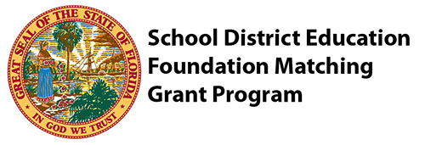
(Click logo to copy and save)
LOCAL PRESS RELEASE

Customize and print on your letterhead for press release. It can also be adapted for newsletter and website stories. Use this logo to recognize the appropriate program in online press releases, web posts, social media, annual reports and newsletters:

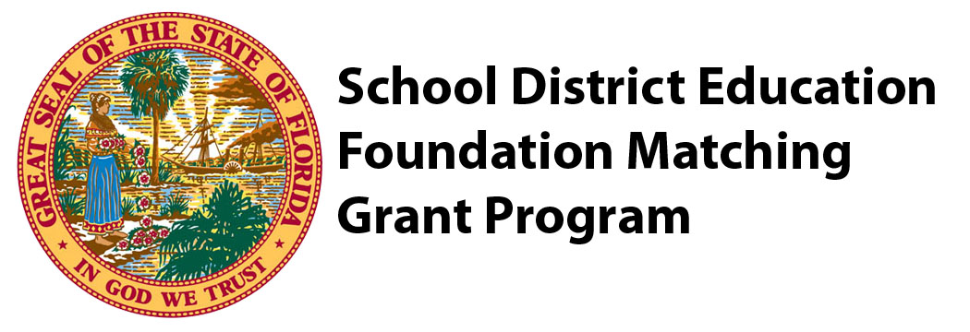

For Immediate Release – Date
For More Information Contact: Local Executive Director Name 000/000-0000 or (email)

Local Education Foundation Receives Grant to…..

The Consortium of Florida Education Foundations (Consortium) recently awarded Foundation Name Here $$$$$$ in matching funds through the School District Education Foundation Matching Grant Program.

One or two paragraphs of localized information about your project goes here, including:
Project Title
Who, What, When, Where, Why?
Timeline of project
Quote from Participant(s)
Were there any additional partners involved?
Include photo if possible
The Consortium has received legislative matching funds which provide a dollar-for-dollar incentive for local education foundations to raise private contributions for eligible projects for more than 20 years. Since the inception of the program, more than $156 million in combined private and state dollars has been provided for local projects that serve students, literacy initiatives, encourage STEM and career/technical education, increase classroom innovation, support teachers, and/or increase graduation rates.
The Consortium is the membership organization for Florida’s school district-wide local education foundations. Established in 1987, the Consortium connects individuals, organizations, and financial resources to build the capacity and effectiveness of local education foundations throughout the state in achieving student success. The Consortium now has 62 member foundations with 1,200 business and community leaders serving as volunteer board members. Collectively, the local education foundations raise $85 million annually to support students, teachers, and schools through a variety of programs. The Consortium has facilitated more than $75 million to local education foundations since 2002 through various private- and public-sector partnerships, including the State of Florida School District Education Foundation Matching Grant Program.

To learn more about the Consortium and the statewide impact of the program, visit www.educationfoundationsfl.org.
###

NEWSLETTER
NAME OF ED FOUNDATION Receives $$$ to…
(Local photo of your work in action)
As part of a $6 million grant from the State of Florida’s School District Education Foundation Matching Grant statewide, we have received $$$ to match private dollars 1:1 in our community to support public education.
This year, our portion of the Matching Grant will focus on BRIEF DESCRIPTION OF LOCALIZED INFORMATION ABOUT YOUR PROJECT – CAN INCLUDE MAIN GOAL, PROJECT TITLE, TARGET POPULATION, OTHER PARTNERS, ETC. Learn more about our work to… here (link to website).

THANK YOU LETTER TO KEY LEGISLATORS (SEE AT BOTTOM)
Below is a sample letter for you to send on your letterhead:
DATE
NAME/ADDRESS (See Page 2)

Dear Senator/Representative ______________________:
On behalf of NAME OF FOUNDATION and our statewide network of local education foundations, please accept our tremendous gratitude for your support of the $6 million in recurring funds for the School District Education Foundation Matching Grant Program for 2024-2025.
The ability to leverage a 1:1 match for business, philanthropic and individual contributions to innovate learning and provide impactful support for our students and teachers is incredibly powerful for our local fundraising efforts!
BRIEFLY PROVIDE EXAMPLE/STORY TO DEMONSTRATE HOW YOU USE YOUR SHARE OF THE 1:1 MATCH AS APPROPRIATE FOR LOCAL NEEDS AND CONTEXT WITH DATA POINT OR OUTCOME AND/OR SHARE HOW THE MATCH WILL HELP FUNDRAISING EFFORTS FOR NEXT SCHOOL YEAR (ENCOURAGING PRIVATE INVESTMENTS)
Thank you for your confidence in our ability to power the potential of Florida’s students and teachers through this proven statewide program. We look forward to sharing the results with you!
With Gratitude,
Items you might include:
- Collateral material
- Student/teacher thank you notes
- Program information
- Invitation to upcoming event
SIGNATURE
NAME
TITLE

THANK YOU SOCIAL MEDIA POSTS
Tag US, your private donors, local legislators, and/or Key Legislative Contacts!
- 🌟 A big thank you to [Legislator's Name] for their unwavering support of The School District Education Foundation Matching Grant Program! Since 2001, this program has been transforming education in our community, leveraging public funds and encouraging private-sector investment to advance student achievement. Your dedication to education is making a real difference! #ThankYou #EducationFoundation #SupportEducation
- 🙌 We extend our heartfelt gratitude to [Legislator's Name(s)] for prioritizing The School District Education Foundation Matching Grant Program. Together, we're building a brighter future for our community! #SupportEducation #EducationFoundation #ThankYou
- 💙 Today, we express our gratitude to [Legislator's Name] for their vital support of The School District Education Foundation Matching Grant Program. Their commitment to education is making a significant impact on student achievement in our county. Thank you for being a champion for education! #ThankYou #EducationSupporter #EducationFoundation
SOCIAL MEDIA COLLATERAL
- Photos/Videos of your project in action!
- Photos of you with legislators at Capitol Days or in local schools

KEY LEGISLATORS CONTACT INFO & SOCIAL MEDIA HANDLES FOR THANK YOUS
Please send a thank you letter to the following key legislators who were instrumental in securing our funding this year AND to your local delegation:

House of Representatives  House Speaker Paul Renner  4877 Palm Coast Parkway NW, Suite 1  Palm Coast, FL 32137  Social:  FB @RepPaulRenner  TW @Paul_Renner  Representative Chuck Clemons  105 Southwest 140th Court, Suite 1  Newberry, FL 32669  Social:  FB @ChuckClemons22  TW @ChuckClemons21  Representative Tom Leek  1540 Cornerstone Boulevard, Suite 240  Daytona Beach, FL 32117  Social:  FB @tomleekforstatesenate  TW @leek_tj  Representative Josie Tomkow  315 Pontotoc Street  Auburndale, FL 33823  Social:  FB @josietomkowcampaign  TW @JosieTomkow  Representative Ralph Massullo  106 East Dampier Street  Inverness, FL 34450  Social:  FB @repralphmassullo  TW @RalphMassullo | Senate  Senate President Kathleen Passidomo  3299 East Tamiami Trail, Suite 203  Naples, FL 34112  Social:  FB: @KathleenPassidomo  TW: @Kathleen4SWFL  Senator Dennis Baxley  206 South Hwy 27/441  Lady Lake, FL 32159  Social:  FB @senatordennisbaxley  TW @dennisbaxley  Senator Doug Broxson  418 West Garden Street, Room 403  Pensacola, FL 32502  Social:  FB @dougbroxsonfl  TW @DougBroxson  Senator Keith Perry  5700 SW 34th Street, Suite 225  Gainesville, FL 32608  Social:  FB @KeithPerryFL  Senator Corey Simon  302 Senate Building  404 South Monroe Street  Tallahassee, FL 32399-1100  Social:  FB @SimonForFL  TW @csime90

