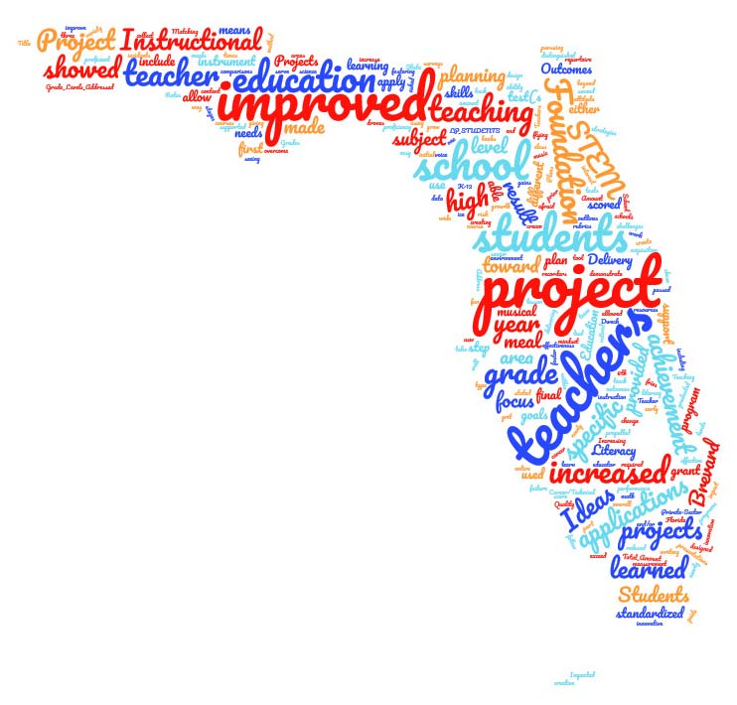

Goal: Developing a common appeal with a unifying message that starts with WHY we do what we do, then explaining HOW and WHAT.

<https://startwithwhy.com/>

*Dear Senator X:*

*Every student deserves to realize their full potential.  Our future economy depends on a well-educated workforce.  Teachers and schools can’t do it alone.  They need business and community support to try innovative strategies and meet individual student needs.*

*Florida has a strong network of local education foundations in virtually every school district (educationfoundationsfl.org).  We bring communities together to provide that support with 1,100 volunteer board members working in partnership with school district leaders.*

*With the $1 for $1 match through the* ***School District Education Foundation Matching Grant Program****, the XYX Foundation is QUICK PROGRAM DESCRIPTION OF WHAT THE PROGRAM MEANS IN HOME DISTRICT.  ADD:  BRIEF DATA POINT AND/OR SPECIFIC STORY – two sentences max – can attach detail, board list if you choose.*

*We have expanded our reach with the statewide program. Nearly all school districts are now benefiting from these funds while our funding has been cut to $4 million in recent years.  We ask for an additional $1 million in non-recurring funds for the 2019-20 school year, so we can expand our focused support for students and schools.  We pledge to double every $1 the Florida Legislature appropriates and look forward to sharing the results of this investment in Florida’s future with you.*

*Thank you for your leadership.  (Good place to add invitation, follow up opportunity or personal note.)*

*Sincerely,*

*Board Chair and ED*