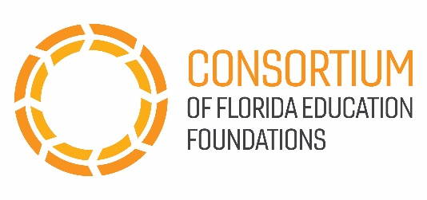

**Florida Lottery “Lighting the Way to a Brighter Future”**

**Social Media Posts**

We have received the following social media scripts and images that have been approved for use by the Florida Lottery Community Outreach team. Please feel free to post and tweet!

**Social media caption:** The Florida Lottery has contributed more than $8 billion to the Bright Futures Scholarship program, allowing nearly 1 million students to attend college! @floridalottery #fundingfutures

**Social Media caption:** Thanks to the Florida Lottery’s dedication to education, students can pursue their passions while attending college with the Bright Futures Scholarship. @floridalottery #fundingfutures

