Workbook 03: Capacitance
PSCI 1102 Sec #: |  | Date:
Name:

- Open up the simulation: http://phet.colorado.edu/en/simulation/capacitor-lab.
- You should see the image below:
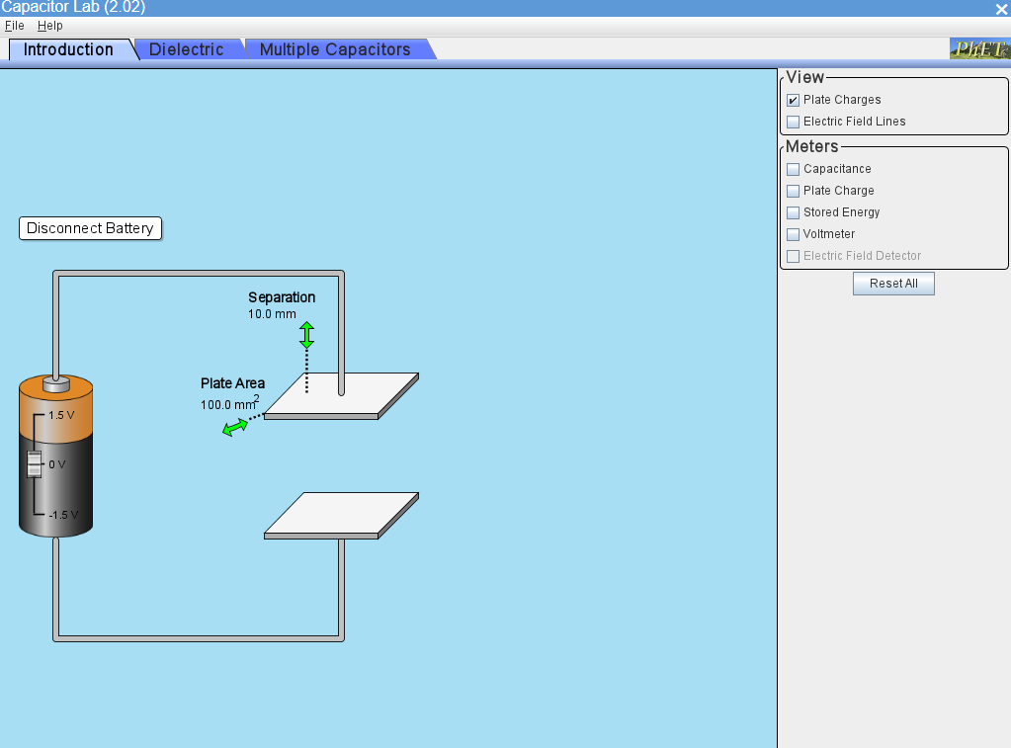

- When the simulation is open, make sure you check the boxes on that say plate charge, electric field lines, capacitance, plate charge, stored energy, and voltmeter.
- In the Exercises below you will make 4 graphs. Make sure you title your graph, put x and y axis titles with units, trendline, equation on graphs, and r squared value. You also mush show all work!

Exercise 1: Graph of Voltage vs. Charge
- Write down the measured capacitance in the space provided below.
Capacitance:_________________________________
- Write down the top plate charge for the different voltage values given in table 1.
- Voltage (V) | Top Plate Charge (C)
0
0.5
1.0
1.5
Table 1.

- Once you have completed the table, graph charge (second column) on the y- axis and the voltage on the x-axis.
- Include an equation on the graph and R² value.
- Once you have the equation, find the value of the capacitance from your graph.
Show Work! You can copy and paste your written work below.

Exercise 2: Graph of Capacitance vs. Plate Area
- Reset the simulation.
- Set the plate separation to 10 mm.
- Record the capacitance for each of the area settings you see in table 2 below. (Move the plate arrow to control the area settings in the simulation.)
Plate Area (mm²) | Plate Area (m²) | Capacitance (F)
0
100
150
200
www250
300
350
400
Table 2.

- In Excel, Graph the Capacitance on the y-axis (third column) versus the Area (second column) on the x-axis.
- Include an equation and R² value on your graph.
- Once you have the equation, find the plate separation from your graph.
Show Work! You can copy and paste your written work below.

Exercise 3: Graphs of Capacitance vs. Separation Distance (d) and Capacitance vs. 1/d.
- Reset the simulation.
- Set the plate area to 100 mm².
- Record the capacitance for each of the separation settings in the table below. (You can change the values for d by moving the arrows.)
Separation (mm) | 1/separation (m⁻¹) | Capacitance (F)
5.0
6.0
7.0
8.0
9.0
10.0

- In Excel, graph the Capacitance (4th column) on the y-axis versus the plate separation (First column) on the x-axis. You do not need to put an equation or R² value on this graph.
- You will need to linearize this graph. To do this, make a second graph in Excel with the Capacitance (third column) on the y-axis and 1/d (second column) on the x-axis.
- Include an equation and R² value on your graph.
- Once you have the equation find the, plate area from your graph.
Show Work! You can copy and paste your written work below.

