Hands-on Lecture Workbook 04
PSCI 1102 Sec #: |  | Date:
Name:

- Blackbody Radiation
Part 01: Black Body Radiation Curves
- Open up the simulation: https://phet.colorado.edu/en/simulations/blackbody-spectrum
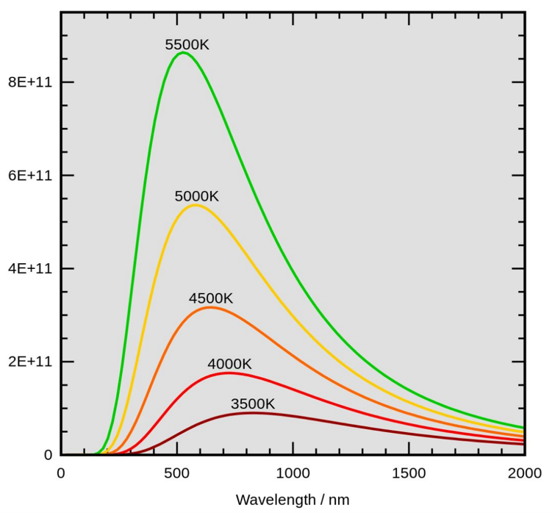
- The following is a black body radiation curve plot with different temperature.

Questions:
- What type of relationship is there between a star color and its temperature?

- How about the star temperature vs. the intensity of radiation?

- Tell me about all blackbody radiation curve characteristics of a Sirius A star.

- Tell me about all blackbody radiation curve characteristics of a light bulb.

Part 02: Wein’s Law 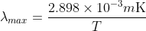
- Complete table 1.
Temperature (K) | Wavelength (μm)
2000
3000
4000
5000
6000
7000

- Plot a graph of peak wavelength (y-axis) vs. temperature (x-axis) with MS Excel. Copy and paste your plot to here.

- What type of relationship does wavelength and temperature have?
Ex. Linear, Inverse, Quadratic, or other

Answer:

7-segment Display
The 7-segment display is a device that has a figure 8 and a decimal point. Each of the rectangular shaped LED's is called a segment. Within the one figure, you can display several different types of numbers from 0 through 9. An additional eighth LED is sometimes displayed as a decimal point.

After the appropriate pins have been placed, the LED segment will display numbers in a certain pattern, and some segments will be darkened while others will be illuminated.

Part 01: 7 - S E G M E N T D I S P L AY

This activity will introduce the operation of a 7-segment display.

Component list:
• Arduino Uno R3
• Breadboard
• 1-digit-7-segment display
• 74HC595
• 8x Resistor 330 Ω

Create the 1-digit 7-segment display below:

Questions:
- What is the 7-segment display displaying?

- What does the 74HC595 do?

- If the 74HC595 is removed, do you think the Arduino program will be harder or easier? Why?

