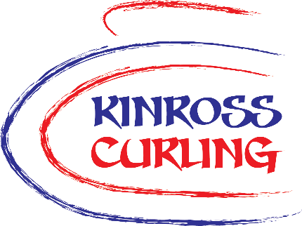**ADOPT A STONE**

**Sponsorship at Kinross Curling**

**ORDER FORM**

Contact Details:

|  |  |
| --- | --- |
| Business / club name (if relevant) |  |
| Contact name |  |
| Address including postcode |  |
| Contact number |  |

Label Details:

|  |  |
| --- | --- |
| Name on label |  |
| Logo to be included? | yes  no |

If you would like a logo included on the label, please email it to us along with this form.

Sponsorship Details:

|  |  |
| --- | --- |
| Number of stones |  |
| Length of sponsorship1 | 1 season  2 seasons  5 seasons |
| I want to Gift Aid my donation2 | yes  no |

1 The current costs for the various time frames are shown on the sponsorship page of our website.  
2 You must be a UK taxpayer. Gift aid boosts your contribution by 25p for every pound donated.

Any Other Information:

|  |
| --- |
|  |

Payment and submission:

|  |  |  |  |
| --- | --- | --- | --- |
| I will pay by | Bank transfer to  Kinross Curling Trust  Account Nr: 10543764  Sort Code: 80-02-27 | OR  By cheque  to Kinross Curling Trust | OR  By invoice  We will send you an invoice |
| Total amount |  | Date |  |

Email your form to office@kinrosscurling.co.uk or post it (with the cheque) to Kinross Curling, Green Road, Kinross, KY13 8TU. Logos must be emailed to us.

Thank you for your support.