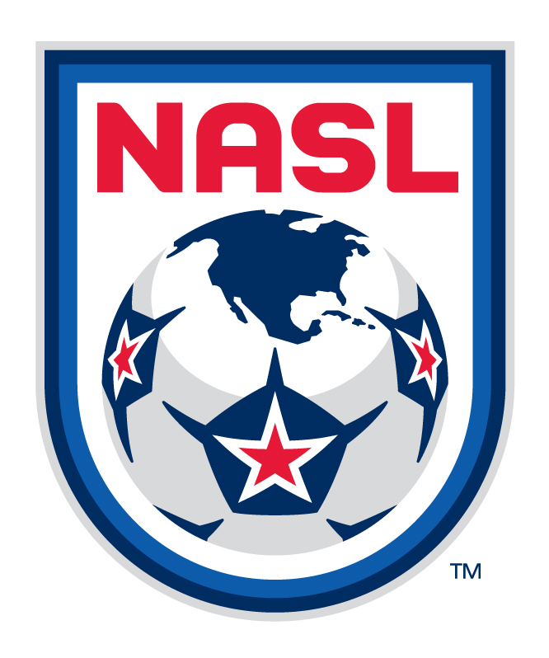
North American Soccer League
2013 Referee Handbook

This updated and final 2013 North American Soccer League Referee Handbook was produced by the League’s Operations Department in cooperation with the newly created Professional Referee Organization (PRO) and two national associations, US Soccer and the Canadian Soccer Association (CSA).

The focus of this NASL publication is global but is principally intended for use by game officials assigned under the aegis of PRO (www.proreferees.com) and as it relates directly to those game officials working NASL games at the home venues of the seven U.S. based teams in the NASL as well as its associated use as needed for game officials from Canada working FC Edmonton home games.

CSA game officials selected to work 2013 NASL games in Edmonton should consult with either Tiger Liu or Jules Alie of the CSA’s referee department for direction on specific responsibilities not covered in this referee handbook relating to North American Soccer League assignments:

Canadian Soccer Association
Attn: Mr. Jules Alie/Referee Program Admin or Tiger Liu/Head of Refereeing
Tel: 613/237 7678 ext 236 613/282-5742 Cell
Fax: 613/237 1516 tigerliu@canadasoccer.com
Cell: 613/898 8934
jalie@canadasoccer.com

Information contained herein is valid as of March 20, 2013. Please note that the use of ‘he’ or ‘his’ throughout this handbook refers to both the male and female gender, as applicable.

Important: Permission to stage any friendly games involving an NASL Team hosting an international opponent (except when FC Edmonton plays other NASL teams) must be applied for through the US Soccer Federation (with game officials assigned thru PRO) or thru the CSA when FC Edmonton is the host of a match of this type. These games involve an entirely different set of competition rules and referee assignment and payment procedures than the games highlighted in this League Handbook that primarily cover 2013 NASL regular season and any possible 2013 post season League matches.

2013 NASL Referee Fees

Pre-Season Scrimmage Game Fees (Non-gated game; i.e. admission tickets not sold)

NASL Team vs NASL Team; NASL Team vs US based Pro/Semi Pro/Amateur or other teams)
(For games hosted in Canada contact the CSA directly for this type game)

Referee $125
AR1 $ 60
AR2 $ 60
4th Official $ 40 (Optional; No 4th official needed for non-gated games)
(Match Fee checks should be available from the host team or promoter at the stadium post game).

Per Diem: Per Diems will not be paid to any crew members working these games.

More…
-1-
2013 NASL Referee Handbook
March 20, 2013
Page 2 of 16

Pre-Season Scrimmage Game Fees (Continued)

Mileage: Mileage reimbursement is not paid to any crew member working these games. A flat fee mileage reimbursement may be paid by the team (but only with the written permission of the League if this request is received in advance of the game) in only cases where the referee (only) drives further than 500 miles RT.

Pre-Season Game Fees (Paid Gate; Games were admission tickets are sold)
(For CSA rates contact the CSA directly if they differ for this type game)

NASL Team vs NASL Team or NASL Team vs Pro/Semi-Pro/Amateur/Adult Team

Referee $225
AR1 $125
AR2 $125
4th Official $75

Per Diem: Up to a one day Per Diem of $60USD will be paid only to the Referee (or other crew member who have only travelled by air) but only when such air travel is authorized in advance by the League thru PRO. It is also only paid to those crew members driving more than 250 miles RT to this level match and only when authorized in advance by the League (again, only in advance and thru PRO) in which case up to a $60 per diem per day is paid by the Host Team or organizer and is calculated from the time the official leaves his home until his normal, expected return is documented. It is to be paid in 6 hour increments (0-6 hours $15.00; 7-12 hours $30.00; 13-18 hours $45.00; 19-24 hours= $60USD).

Mileage: Mileage reimbursement is not paid to any crew member working these games. A flat fee mileage reimbursement will be paid (but only with the written permission of the League again thru PRO and only if received in advance of the game) in cases where the referee (only) drives further than 500 miles RT. Any such Official should be prepared to provide mileage proof of distance(s) driven from their domicile to/from match venue via MapQuest /Google maps/Microsoft Street & Trips since this information will be requested by the League or hosting authority.

Note: PRO will NOT assign game officials to any games scheduled between an NASL team (no distinction made between non paid and/or paid gated games) and U.S. based collegiate teams. All financials and other arrangements for pre-season or other games involving any NASL team and a U.S. based collegiate team is solely the responsibility of the NASL team(s) and/or any outside organizers or the college host(s). NASL teams are encouraged to contact their local assignors for assistance with these matches. A list of Local Area Coordinators for all U.S. based teams is located further on in this document.

2013 NASL Regular Season Game Fees

(For ALL US games assigned by PRO); Fees for 2013 NASL regular season games in Canada are the same as in 2012

All regular season game fees and travel reimbursement rules and policies governing Referee Crew (Referee; ARs and 4th officials also called Reserve Referees) Game Fees, Travel Policies including rules governing all locally based officials assigned by PRO and/or their Local Area Coordinators (LACs) for 2013 are under financial terms set by and reimbursed by the accounting department at PRO thru their New York, NY Offices. For any questions regarding those rates, fees and travel rules, please contact PRO directly.
More…

-2-

2013 NASL Referee Handbook
March 20, 2013
Page 3 of 16

All CSA officials working 2013 FC Edmonton games will continue to receive the same Game Fees as were paid during the 2012 regular season and all such fees and expenses will be reimbursed directly to each CSA NASL official by FC Edmonton upon completion and submission of 2013 Referee Expense Reimbursement Forms. All air travel and local travel to and from assignments to 2013 FC Edmonton home games will be coordinated and approved in advance by the CSA for the specific game official.

2013 NASL Regular Season Game Fees (Continued)
For 2013 FC Edmonton home NASL Regular Season games the game fee structure is:

Referee $300 USD
AR1 $175 USD
AR2 $175 USD
4th Official $100 USD

2013 NASL Post Season Playoff Games Fees
The 2013 NASL season will culminate with the outright winner of its Spring Season playing the outright winner of its Fall Season in a one game Championship Final at a venue and time to be confirmed. This match will be played during the weekend of November 8-10, 2013.

If the 2013 NASL Championship final is hosted by a U.S. based NASL team then PRO will assign the match officials for this game and all travel and game fee considerations for the officials assigned to this game will be administered under the aegis of PRO. If the game is hosted by FC Edmonton, then all assignment and travel protocols will be administered by the CSA.

2013 NASL FC Edmonton Regular Season/ Playoff Game Per Diem/ Mileage Reimbursement Rules
Local Mileage reimbursement for all game officials assigned by the CSA to work 2013 FC Edmonton games will be reimburse for personal car use at the approved 2013 U.S. IRS Rate of $.555 per mile for round trip to/from home-venue travel for the Referee, Assistant Referees and 4th Officials. All Officials requesting mileage reimbursement are required to provide written mileage proof their mileage reimbursement request from their domicile to/from the match venue via MapQuest/Goggle maps or Microsoft Street & Trips printouts as part of their expense report request for mileage reimbursement.

If a game official’s day of game or travel day(s) transportation is handled by another assigned crew mate (which is strongly encouraged) or if local transportation offered by a local referee liaison is NOT available, match officials can rent a maximum of one car per crew as an accepted method of getting to and from their hotel and the assigned match venue but only if the rental is booked in advance of any travel thru an accepted CSA Rental Car company and only if reserved at the time of making the initial travel arrangements and before accepting the match assignment. Prior approval from the CSA is required for any rental car use. Game Officials not following this protocol will be responsible for these charges.

Per Diem: A per diem of $60USD/day will be paid to any crew member who has travelled for a game when assigned by the CSA and is calculated from the time the official leaves his home until his normal, expected return is documented. It is to be paid in 6 hour increments (0-6 hours $15.00; 7-12 hours $30.00; 13-18 hours $45.00; 19-24 hours= $60USD).

Note: Separate per diems at the rates outlined above will be paid to each official who drive together to a game but they are required to use only one personal or rental car which ever is cheaper or where practical when two officials or more officials live in the same general area and drive to the same assignment. In this case, only one mileage or car rental (and gas) reimbursement will be paid upon submission of a receipt for the rental. Rental car gas MUST be bought BEFORE returning the car. Rental car gas purchase receipts MUST be included as part of an official’s expense reimbursement request(s).
-3- More..

2013 NASL Referee Handbook
March 20, 2013
Page 4 of 16

Air Travel: Any NASL official who needs to fly to their 2013 assignments must use the services of PRO’s Official Referee Travel Provider (no exceptions). All 2013 NASL Air Travel will be in Coach Class or the equivalent. Please contact PRO regarding ALL Air and Local travel issues for 2013 NASL games hosted by U.S. based clubs and the CSA for all air travel issues for games played in Canada.

Generally, NASL Referees (or ARs and/or 4th officials, if applicable) travelling by air and thru more than one time zone from their home to an assignment will be allowed to arrive in the match venue the day before match day and leave the day after the match depending on kickoff times and airline schedules with the final decision left up to PRO. Generally, Referees travelling to assignments within the same time zone and with flights lasting less than 2 1/2 hours (airline schedules permitting) should arrive in venue on the same day as their game and no later than 7 hours before kickoff. Again, all travel questions should be addressed to PRO or the CSA. When PRO and/or CSA air travel policies differ from those outlined here by the NASL, then either the PRO or CSA Travel Policy will be followed first and the NASL policy second.

All NASL Game Officials are also encouraged NOT to book air travel or expect to leave the match venue within 4 hours of the expected end of any NASL game so as to account for any in-game unforeseen circumstances (i.e. weather; or a serious player injury that causes a delay in play) that might occur and therefore might delay an official from leaving the match venue post game.

In addition, All NASL Game Officials who drive to their assignment are encouraged NOT to expect to leave the match venue earlier than 2 hours after the expected end of any regular season game so as to account for any in-game unforeseen circumstances (i.e. a serious weather issue; preparation of post match reports or a serious player injury that causes a delay in play) and therefore might delay an official from leaving the match venue post game. This applies to both PRO and CSA assigned game officials.

PRO will attempt to have Referees (or ARs and/or 4th officials when applicable) who must travel by air to an assignment to travel via a direct, non-stop flight although air travel via connecting flights might be unavoidable because of available air schedules or air fare financial issues.

Transmission of all appropriate/required TSA information (i.e. the complete name of the travelling official as it appears on the government issued ID the traveler will use at TSA checkpoints) to the appropriate PRO travel partner is solely the responsibility of the traveler, not the NASL /CSA or PRO. It is the sole responsibility of the game official to ensure his air ticket is issued in the same name as depicted on the personal identification document to be used by the game official at any security checkpoint(s).

Hotels: PRO will make ALL arrangements for any hotels needed for any game official who might arrive into the match venue the day before the match day and departs either on match day night (if the match is an afternoon kickoff) or on the day following the match day. This hotel information will appear on the Game Notice (see more on NASL League generated Game Notices further on in this Handbook) along with known hotel reservation details.

More..

-4-

2013 NASL Referee Handbook
March 20, 2013
Page 5 of 16

2013 NASL Home Stadiums

Atlanta Silverbacks
Atlanta Silverback Park
3200 Atlanta Silverbacks Way
Atlanta, GA 30340 (112 x 72 yds; Artificial)

Carolina RailHawks
WakeMed Soccer Park
201 Soccer Park Drive
Cary, NC 27511 (120 x 75 yds; Natural)

FC Edmonton FC Edmonton NASL Referee Hotel
Clarke Stadium Four Points Sheraton Edmonton South
10839 91st Street 7230 Argyll Road
Edmonton, Alberta Edmonton, Alberta
Canada T1Y 1L8 (110 x 76 yds; Artificial) Canada T6C 4A6
780/465-7931
Ft. Lauderdale Strikers
Lockhart Stadium
5201 NW 12th Ave
Ft Lauderdale, FL 33309 (116 x 73 yds; Natural)

Minnesota United FC
Metrodome (110 x 70 yds; Artificial)
900 South Fifth Street
Minneapolis, MN 55415

And

National Sports Center
Stadium Field
1700 105th Avenue NE
Blaine, MN 55449 (115 x 72 yds; Natural)

New York Cosmos (Spring Season only)
Shuart Stadium (110 x 70 yds; Artificial)
Hoftstra University
900 Fulton Avenue
Hempstead, NY 11549

Tampa Bay Rowdies
Al Lang Field
230 First Street NE
St. Petersburg, FL 33701 (107 x 70 yds; Natural)

San Antonio Scorpions
Toyota Stadium
5103 Edwards Drive
San Antonio, TX 78233 (110 x 70 yds; Natural Turf)

-5-

2013 NASL Referee Handbook
March 20, 2013
Page 6 of 15

2013 NASL Day of Game Operations Contacts 2013 NASL Day of Game Referee Liaisons

Atlanta Silverbacks Atlanta Silverbacks
Nathan Charlton/ Operations Nathan Charlton
404/410-7403 office 404/410-7403 office
404/239-9320 cell 404/239-9320 cell
nathan.charlton@atlantasilverbacks.com guido.gonzales@atlantasilverbacks.com

Carolina Railhawks Carolina Railhawks
David Vaught / Operations Dave Vaught
919/459-0722 office 919/459-0722 office
336/971-6153 cell 336/971-6153 cell
dvaught@carolinarailhawks.com dvaught@carolinarailhawks.com

FC Edmonton FC Edmonton
Derryn Donaghey/ Operations Derryn Donaghey
780/439-7529 office 780/439-7529 office
587/991-8214 cell 587/991-8214 cell
ddonaghey@fcedmonton.com ddonaghey@fcedmonton.com

Ft. Lauderdale Strikers Ft. Lauderdale Strikers
Miguel Lopez / Operations Matheus Brasil
305/728-2622 office 305/728-2644 office
305/588-6111 cell 954/918-4482 cell
MLopez@strikers.com Mbrasil@strikers.com

Minnesota United FC Minnesota United FC
Angie Blaker / Operations Angie Blaker
763/792-7348 office 763/792-7348 office
651/335-3055 cell 651/335-3055 cell
angie@mnstarsfc.com angie@mnstarsfc.com

New York Cosmos New York Cosmos
John Dugan/ Operations John Dugan/Operations
212/369-7000 office 212/369-7000 office
917/207-1784 cell 917/217-1784 cell
john@newyorkcosmos.com john@newyorkcosmos.com

San Antonio Scorpions San Antonio Scorpions
Matt Levenshus/ Operations Matt Levenshus/Operations
210/379-4228 cell 210/379-4228 cell
mlevenshus@sanantonioscorpions.com mlevenshus@sanantonioscorpions.com

Tampa Bay Rowdies Tampa Bay Rowdies
Lee Cohen / COO Lee Cohen
813/287-1650 office 813/287-1650 office
321/698-1250 cell 321/698-1250 cell
lcohen@rowdiessoccer.com lcohen@rowdiessoccer.com

More…

-6-

2013 NASL Referee Handbook
March 20, 2013
Page 7 of 16

2013 U.S. NASL Team Local Area Coordinators (LACs)
Atlanta Silverbacks LAC
Michael D Wright
1155 Bridgewater Walk
Snellville, GA 30078
(770) 972-0246 home
(770) 736-0850 work
(404) 409-4960 cell
mikewright@mindspring.com

Carolina RailHawks LAC
Roger Morton
PO Box 13946
Greensboro, NC 27415
(336) 370-9898 work
(336) 686-7901 cell
ncpsoa1@aol.com

Ft. Lauderdale Strikers & Tampa Bay Rowdies LAC
Newman W. “Zoom” Stemple
931 Corkwood St.
Hollywood, FL 33019
954-925-2383 h/o
954/665-4567 cell
zoomstemple@netzero.net

Minnesota United FC LAC
Troy R. Cohrs
900 Superior Drive
Northfield, MN 55057
(612) 280-7857 cell
(507) 664-2044 home
troy.cohrs@nfld.k12.mn.us

New York Cosmos LAC
Brenda Wright
11 Butler Lane
Rock Tavern, NY 12575
[h] (845) 496-5215
[c] (845) 742-1724
brendawright@frontiernet.net

San Antonio Scorpions LAC
Dick Triche
20810 Meadowhill Drive
Spring, TX 77388
832/ 295-9601 work
832/577-7191 cell
r.triche@yahoo.com

-7-
More…

2013 NASL Referee Handbook
March 20, 2013
Page 8 of 16

Getting to/from the Airport OR Stadium: The NASL requests that each assigned Referee Crew discusses and also confirms amongst its crew members as part of its pre-match email/phone communications exactly how they each individually and collectively are getting to and from the stadium on Game Day and/or to and from the airport and hotel on travel days if they are coming to the game via air or driving from a long distance. The League requests that this travel be done as efficiently as possible for all concerned and as outlined previously in this 2013 Handbook while utilizing any PRO travel guidelines outlined in the previously published PRO or CSA travel policy manual.

Parking: Only NASL Game officials assigned to the game by PRO or the CSA will be provided secured complimentary parking on the day of game by the individual host team either thru the use of a physical pass or by having the name of the official(s) driving on a parking list at the parking lot entry gate. This is also coordinated thru the home team Operations Director or the home team Referee Liaison.

Referee Expense Payments

Again, please note as first outlined on Page 2 of this 2013 NASL Referee Handbook, that the NASL will NO LONGER directly handle any part of an official’s NASL Game Fee payments or any part of the reimbursement process for any official working 2013 NASL games played in the US. This will all be handled by the Finance Department at PRO in New York. FC Edmonton is the first contact for all payment issues for CSA based officials.

2013 NASL Expense Form: All 2013 NASL game officials are to use the reimbursement form developed and distributed by PRO. This PRO Form can be downloaded from USSoccer.GameOfficials.net under the News/Info Section. Contact PRO Accounting Manager John Loder at PRO/New York for any questions in that regard.
CSA game officials should download and use the NASL Expense form from the CSA GameOfficials website.

Game Related Information

Game Day Rosters: A minimum of 16 players will be listed on a roster for the Visiting Team. Visiting Teams may have up to 18 on their roster if they are on a multi-game road trip. Home Teams can list no more than 18 eligible players on a roster.

Eligible Substitutes: Each team can only use up to 3 (three) subs (3 subs including a goalkeeper) from the list of up to seven (7) eligible subs named on their day of game Official NASL Roster Form.

Day of Game Documents:

Day of Game Referee Report: For all 2013 NASL games, the NASL League’s mandatory post game Referee Report will be available and completed as part of the Referee’s post game obligations as an electronic, computerized form provided by the home team operations personnel and on a laptop computer provided by the home team operations director.

Competition Incident Report Forms: For all 2013 NASL games (and if needed) the League’s Competition Incident Report (CIR) form will be available as a paper form, not computerized, and should be used in reporting all serious pre-, in-game or post-game incidents. It is an NASL League requirement that ALL send-offs and any other serious game-related incident(s) that occur before, during and after a game MUST be completed and given to the Home Team Operations contact or Referee Liaison BEFORE the Referee leaves the venue post game

The Home Team Director of Operations will be responsible for sending the completed Referee Game Report form to the NASL League Office, not the match referee.
More…
-8-

2013 NASL Referee Handbook
March 20, 2013
Page 9 of 16

Day of Game Roster Form: For all 2013 NASL games, the Day of Game Roster Form for all games will be an electronic form that will be available and completed as an electronic, computerized form for use by the game officials crew by NASL home team operations personnel. Both team roster forms must be submitted and completed no later than 60 minutes before kickoff. If there are timing issues re: submittal times relating to roster completion and production, the home team is required to complete its roster first.

Day of Game Player Substitution Cards: For all NASL games in 2013, the Player Substitution cards will continue to be available in the Referee Locker room pre-game and will be available as a paper form, not computerized. Ample supplies of this form will be supplied by home team operations to the referee crew in the referee locker room pre-game.

PDF samples of these documents are also available for examination in the NASL documents section at the News/Info Section at GameOfficials.net.

The Home Team Operations Director or the Home Team Referee Liaison will be responsible for collecting both the Home Team and Visiting Team Rosters, getting them to all appropriate home and visiting team reps and the match referee.

(Note: There should be only one captain’s listed for any team on the team roster form.

All PRO game officials assigned to work a 2013 NASL game (meaning all referees, ARs and 4th officials) will be sent an electronic copy via email of the League’s 2013 Referee Handbook before their first game as well as the League’s 2013 Operations Manual.

The 2013 NASL Operations Manual will contain additional and/or more complete information on 2013 NASL League competition rules, team bench issues and rules and regulations regarding suspended players and/or coaches etc. Both the 2013 NASL Referee Handbook and the 2013 League Operations manual will be posted in the News/Info Section at GameOfficials.net and on the CSA version of GameOfficials.

Game DVDs for Referees: The Home Team Operations Director or the Home Team Referee Liaison will be responsible for hand delivering one (1) copy of a DVD of the game to the match referee within a reasonable time after the game. Referees are asked to wait for their copy of the game DVD post match since teams will not incur mailing or courier costs sending copies to the referee crew.

Match Ball: The 2013 NASL Match Ball is the JOMA Final Pro White. The Home Team will provide 8 new JOMA match balls and have them ready for inspection by the Referee 90 minutes before each match. Recommended ball pressure is 12.5 to no more than 13 psi.

Game Notices: The NASL Operations Department will issue a game specific Game Notice for all 2013 NASL matches. Similar to other US professional soccer league Game Notices, each 2013 NASL Game Notice will be sent via email from the League Operations Department to the Home and Visiting Team Directors of Operations, all four members of the referee crew and other applicable personnel (i.e. referee assessors and/or ref coach mentors assigned by the Professional Referee Organization) no later than 5 days before the date of the game.

Email addresses and cell phone numbers for the 1) Home Team’s Operations contact; 2) the Referee Assessor/ Ref Coach Mentors if applicable and assigned by the PRO and 3) the Referee Liaison (if different than the Home Team Operations contact ) along with a 4) a Visiting Team contact, all four members of the game officials crew and emergency League Operations/Referee Operations as well as PRO Travel contacts will all be listed on each Game Notice along with the mandated uniform colors for both teams and the game officials crew.

More…
-9-
2013 NASL Referee Handbook
March 20, 2013
Page 10 of 16

Team Uniform Colors: Team colors listed on the Game Notice should be followed without deviation with only the Match Referee empowered to change specific team related colors from what is listed on the Game Notice should the referee feel the change is absolutely necessary to avoid color conflicts between teams. Reasons for the game day change of uniform color(s) –especially if it delays a team processional or kickoff etc. should be noted on the Referee Game Report form.

Home Teams should have their change uniform colors available at the venue and should be asked first to make any changes required, followed then by asking the visiting team to change. Both teams are required to travel with at least two different sets of goalkeeper shirt colors. (Note: Both the starting GK and the reserve GK should wear the same color shirts).

The Referee is requested to verify the colors to be worn by both teams at least 75 minutes before kickoff either by going himself directly and personally (or by having a member of his crew) go directly to visually check with each team OR by having the Home Team Director of Operations or the Referee Liaison bring BOTH sets of home and visiting team uniforms (including both starting & reserve goalkeeper colors scheduled to be used for the game) to the Referee Dressing Room pre-game.

Referee Uniforms: All NASL match officials are requested to wear OSI referee clothing for all 2012 NASL matches in the United States. The match officials assigned to specific games should check the Game Notice for the suggested OSI Referee colors (Green/Red/Gold/Black or Blue Shirts) to be worn for their game. Referee shorts and sock colors will always be Black.

It is also recommended that referee crew communicate amongst themselves in advance of travelling to the match city and game day to ensure that all four match officials wear the same shirt color and that they bring at least three different color alternate non-conflicting referee shirts to the stadium on match day. For uniformity sake, Referee Crew should also decide amongst themselves whether they wish to wear long or short sleeves for their assigned match based on expected weather conditions. CSA officials should be governed by this same suggested approach to their in game uniform colors. Travel and day of game attire for all NASL referee crews should be governed by rules outlined by PRO or the CSA when their game officials travel to professional games.

PLEASE NOTE: The 2013 matrix of all known and available NASL team (field players and goalkeepers) and PRO and CSA referee shirt/shorts and sock possibilities are outlined further on in this 2013 NASL Referee Handbook and will also be uploaded to Gameofficials.net on or before April 1, 2013.

4th Officials: Unless it conflicts with the colors worn by either team, 4th Officials can wear an OSI or official CSA branded (or non-branded i.e. PRO or CSA logoed) black windbreaker jacket and/or black windbreaker-type long pants over their referee shorts on cold or inclement days. No other commercial identification is permitted.

Substitution Numbers: The Home Team will provide for the game officials in the locker room before the game a set of substitution numbers in different colors; one set usually outlined in red for the player leaving the match and one set outlined in green for the player entering the match. The set of two numbers will likely be a manual set and is not required to be an electronic sub board.

Time of Day: All members of the match official’s crew are encouraged to set their own time of day watches to the correct time of day via their own computer at www.time.gov or by calling 1-303/499-7111 before arrival at the match stadium. Either the Home Team Director of Operations or the Home Team Referee Liaison (if applicable) will do a time ‘hack’ before kickoff and after the match officials arrive at the stadium game day and that time of day setting should be considered official. Day of Game timelines will be provided in advance. Please check PRE-GAME with the home team operations or referee liaison to be clear on all pre- and post-game referee and player introductions/ceremonies procedures as well as pre- and post-game field entry/exit paths as part of the referee crew’s conversation with home team operations.

-10-

2013 NASL Referee Handbook
March 20, 2013
Page 11 of 16

Atlanta Silverbacks – Spring & Fall Season

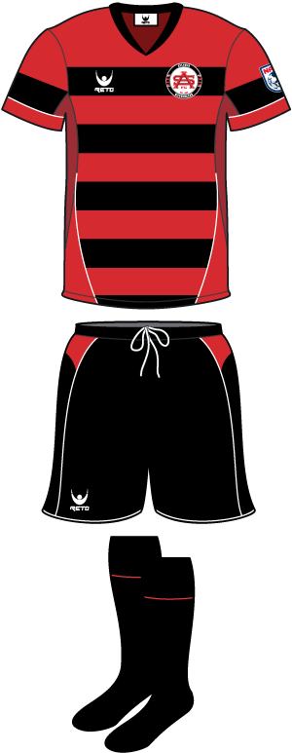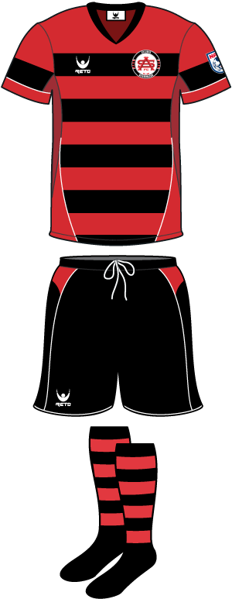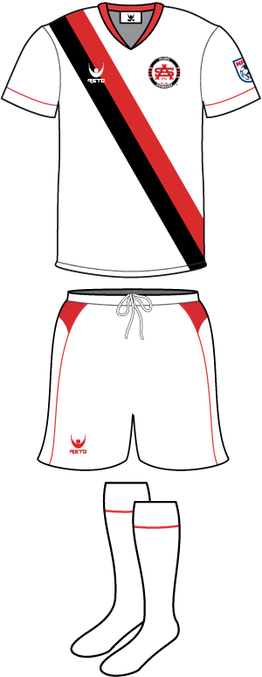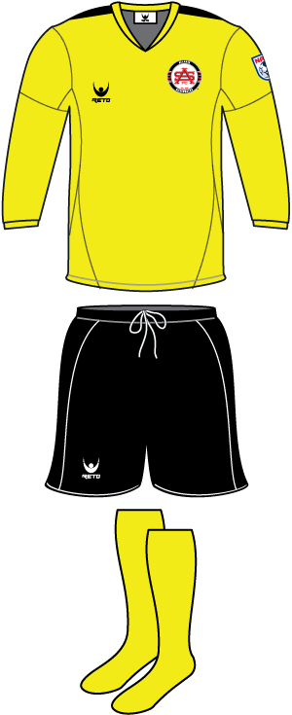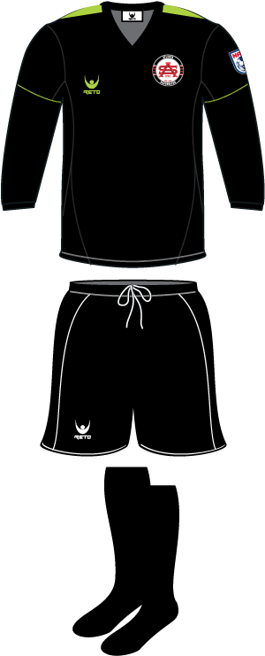

Carolina Railhawks – Spring & Fall Season

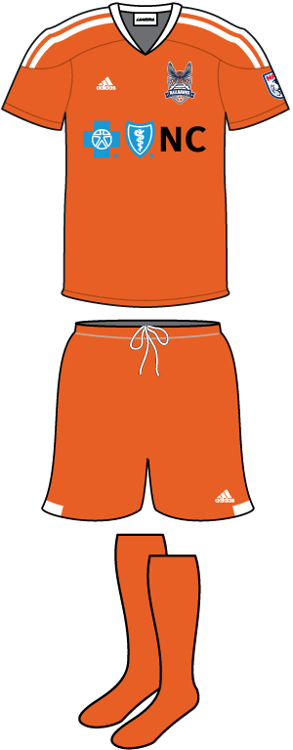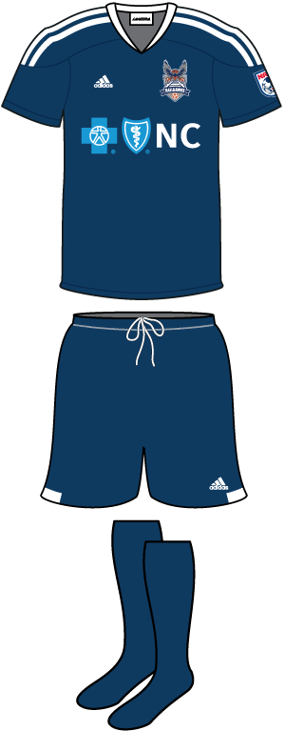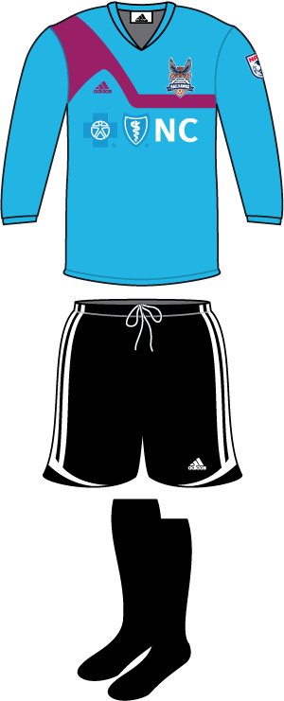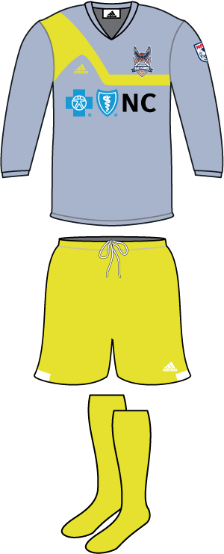

More…
-11-

FC Edmonton – Spring & Fall Season

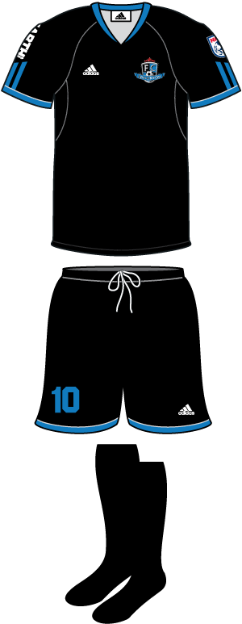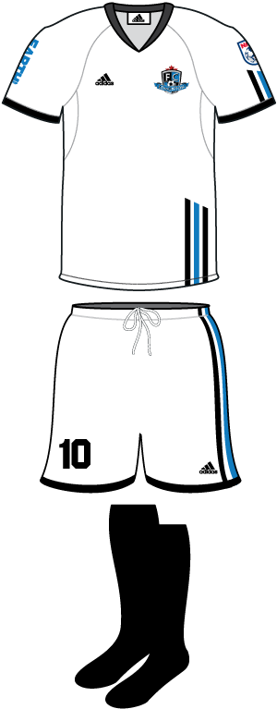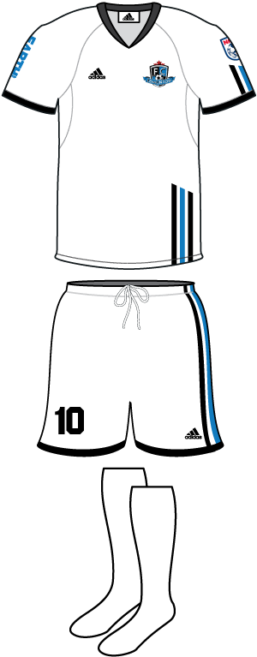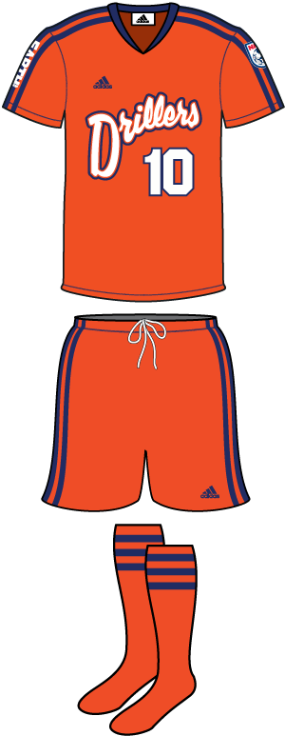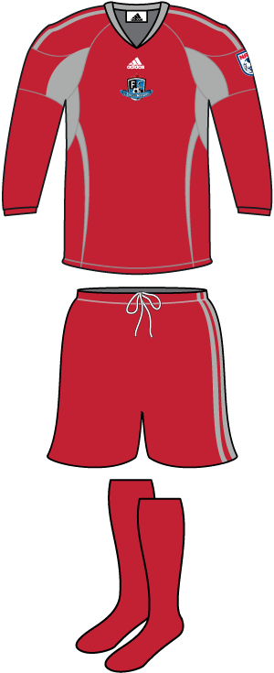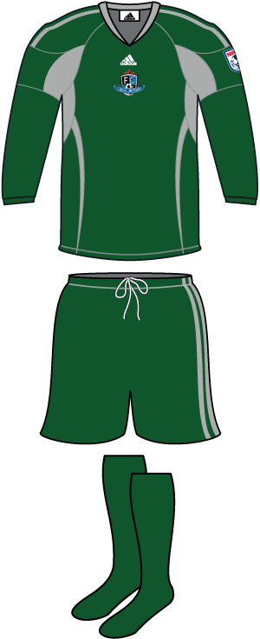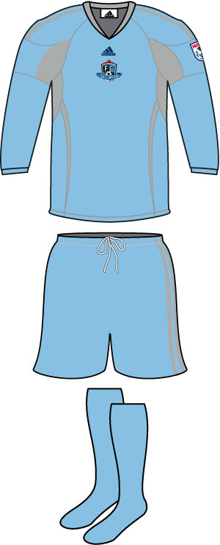

Fort Lauderdale Strikers – Spring & Fall Season

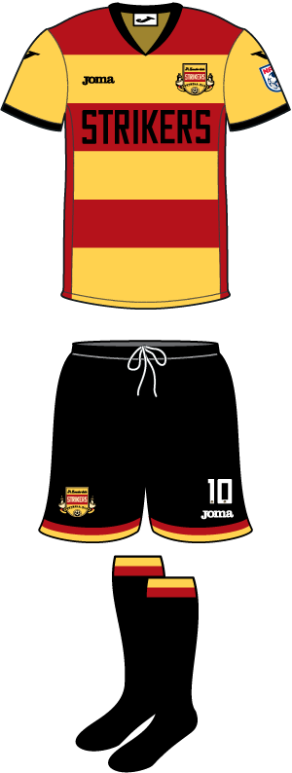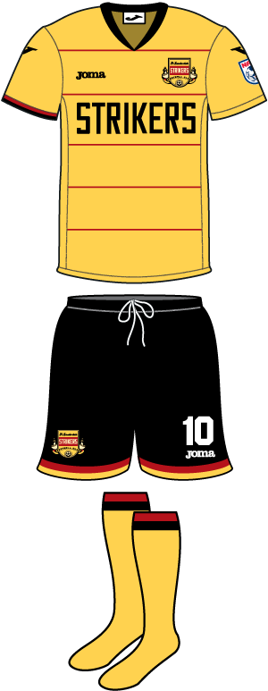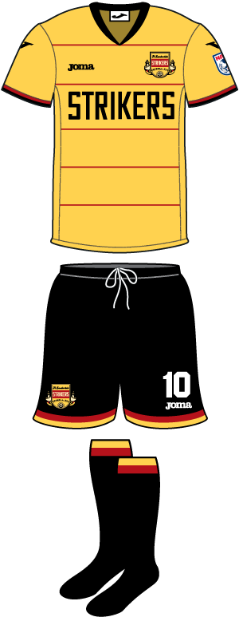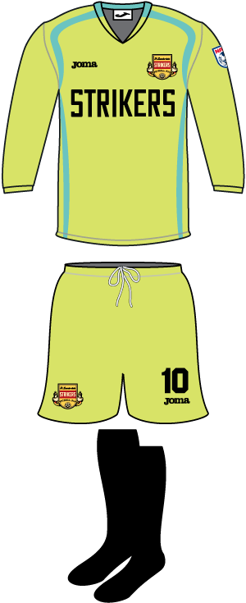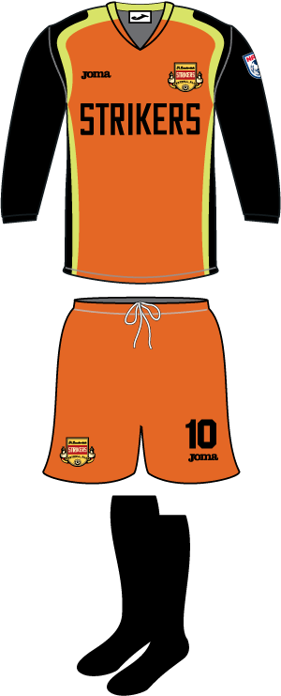

-12-

New York Cosmos – Fall Season – Uniform TBD

Minnesota United FC – Spring Season

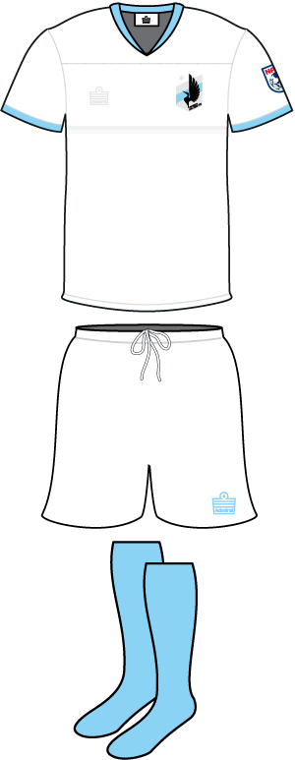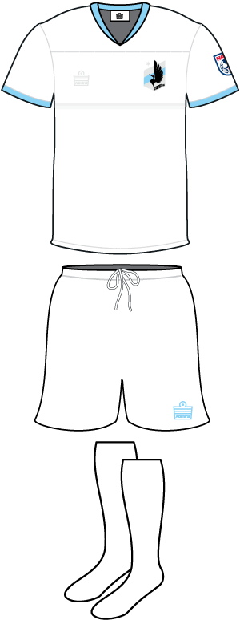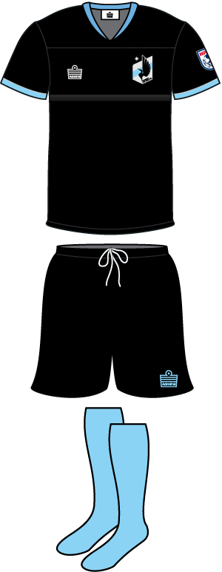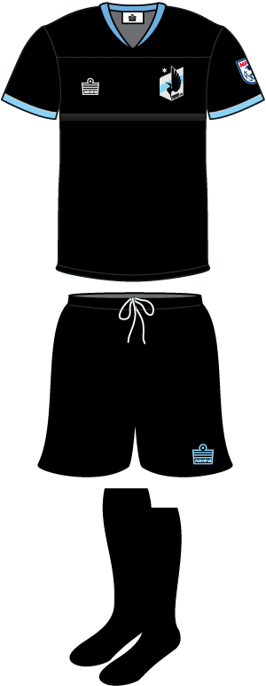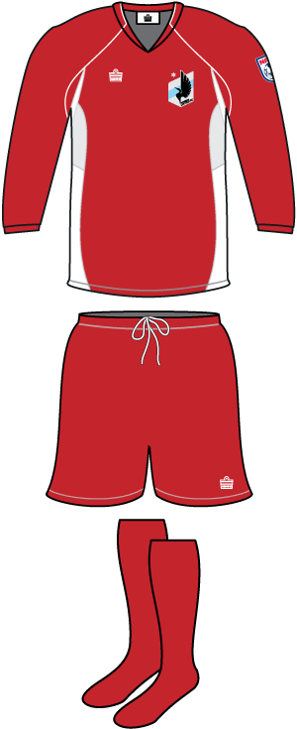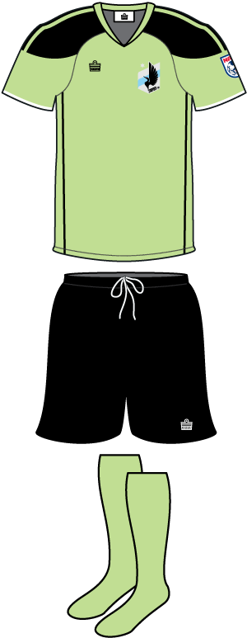

San Antonio Scorpions – Spring & Fall Season

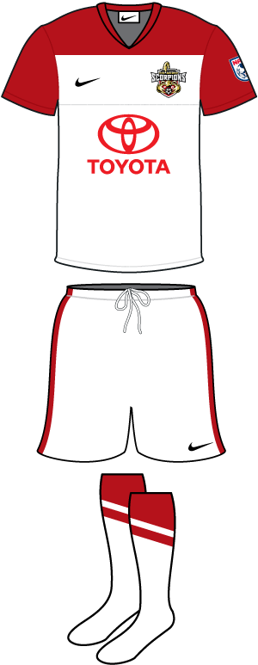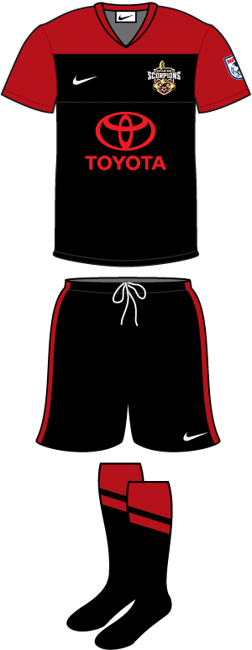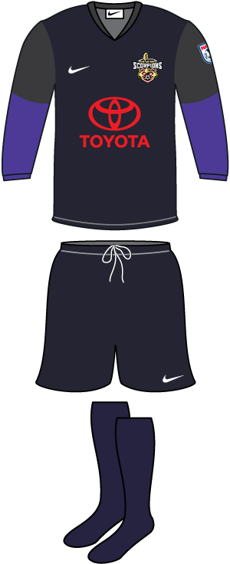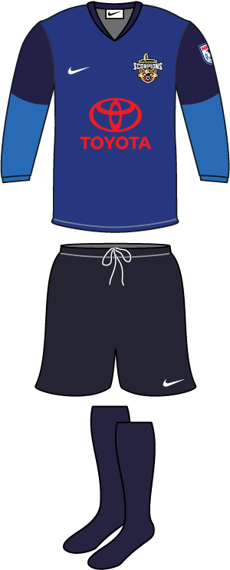

Tampa Bay Rowdies Spring & Fall Season

-13-
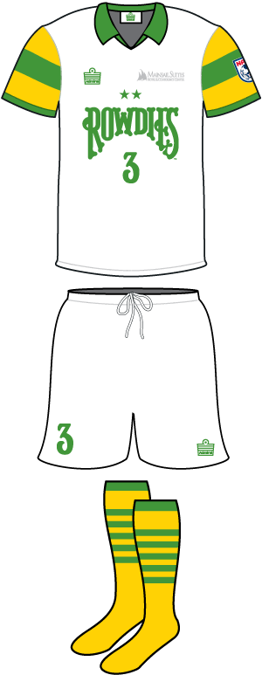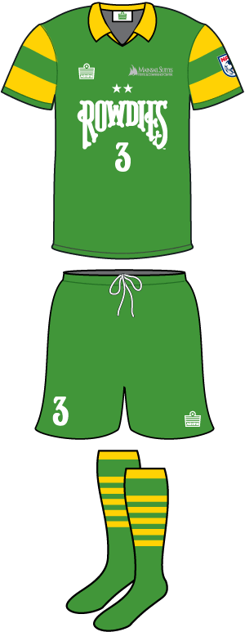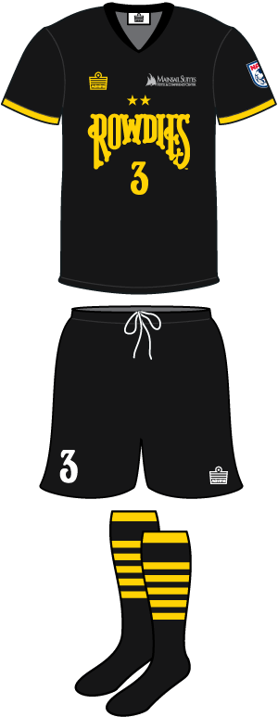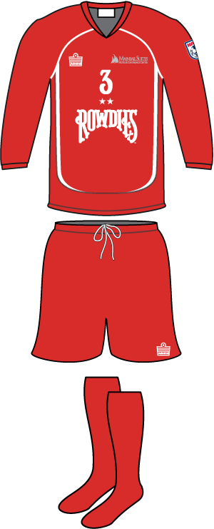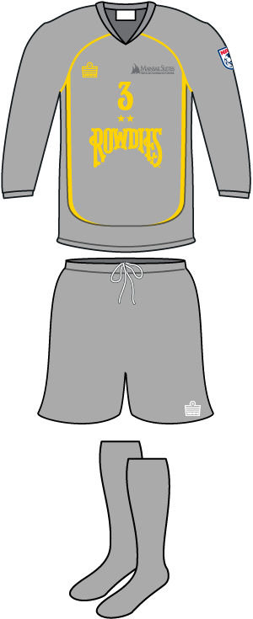

Professional Referee Organization

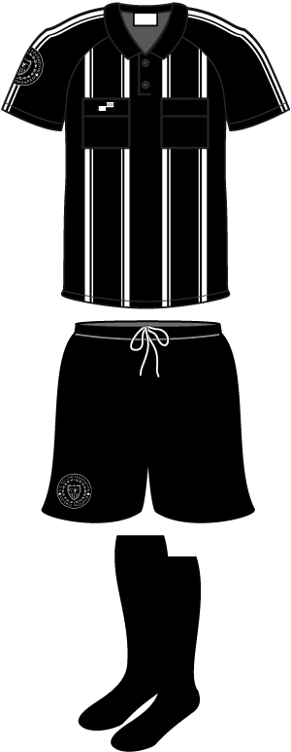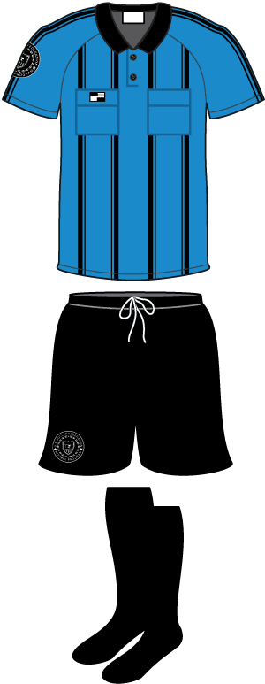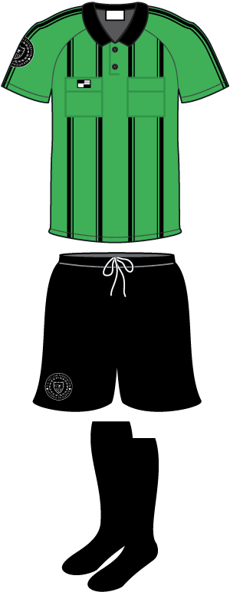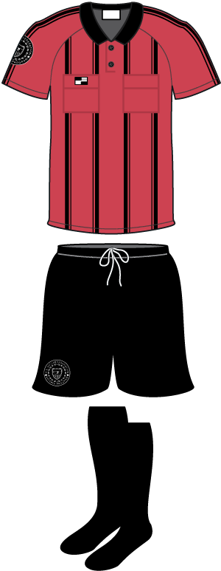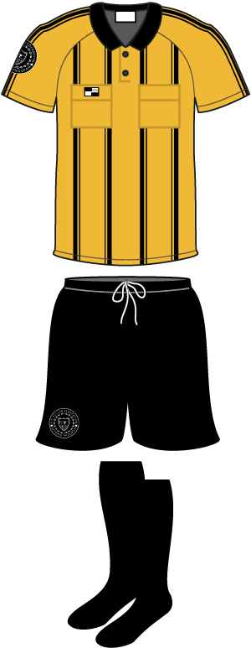

Canadian Soccer Association

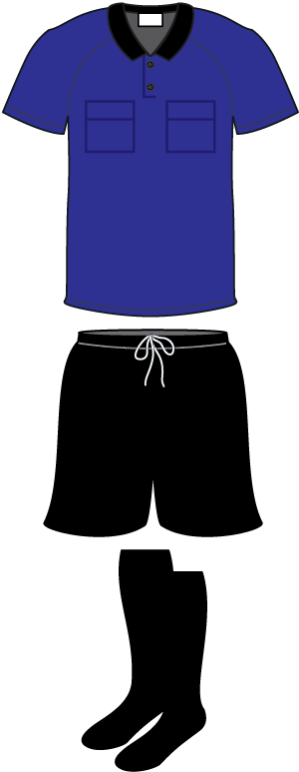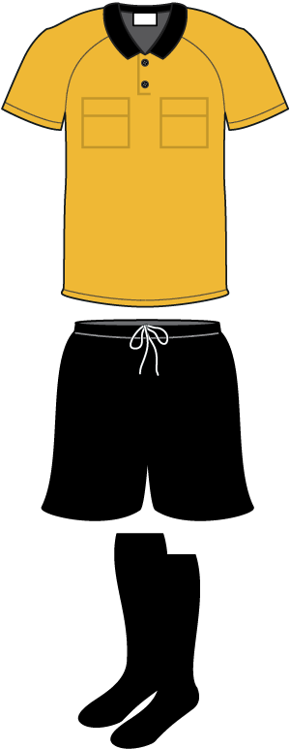
2013 NASL Referee Handbook
March 20, 2013
Page 15 of 16

Serious Weather Issues: While it is important to note that the Match Referee is considered an integral member of any group who meets at any time on match day to determine whether it is safe to play or to possibly suspend play during a 2013 NASL match because of serious weather conditions or some other serious situation or condition in or around the stadium, the final decision as to whether a game is temporarily suspended or, in extreme cases (and then only in consultation with the NASL League office and appropriate personnel) cancelled, rests with the senior HOME team administrative official in charge (the GM or Director of Operations), a senior venue official or the senior law enforcement official(s) on site, not solely the referee.

If serious weather conditions are present or expected during the entire period of time when an NASL game is going to be played in a venue, a written outline of the overall plan of action for all concerned has been vetted and sanctioned by the League in advance for the 2013 season and includes the signal the home team representative will use to communicate a possible suspension of play to the referee and thru the 4th Official should these conditions present themselves.

This signal protocol MUST be part of a pre-game conversation between the Referee Crew and the official home team representative. Any game official with additional questions on specific game related issues can contact the League’s Thom Meredith or Darren McCartney at any time at the contact numbers or email listed in this document or on the Game Notice and especially if questions arise match day. This protocol is outlined more completely in the League’s 2013 Operations Manual available at GameOfficials.net under the News/Info section.

AR Flags: NASL Teams will not provide Flags (either beeper or manual type) to any Assistant Referees working 2013 NASL games.

Game Day Credentials for Referee Crews: Match Officials and the Referee Assessor will usually be issued a temporary Day Pass credential by the Home Team Operations Department for use at their assigned League game. These credentials are non-transferable and should worn and presented when ever requested by security personnel etc. There is a strict one person/one pass policy. In some cases an All Venue/All Area credential for 2013 NASL Referee Coach mentors has been created by PRO, the CSA or distributed by the League. These are valid for entry to the stadium match day and are non-transferable.

Referee Game Tickets: Each game official assigned to work an NASL League game is entitled to two (2) Category Two (2) complimentary tickets. The tickets will be available in the referee locker room before the game. Every US PRO and/or CSA Referee Assessor or Referee Coach Mentor assigned to work an NASL League game is entitled to two (2) Category 2 (two) complimentary tickets if requested as well as a seat in the press box if available for only the assigned referee assessor, NOT family members. These referee and referee assessor tickets will be available in the referee locker room before the game.

Referee Locker Room Materials: As a minimum, here is a list of what will be provided and what should be in the Referee Locker Room when the Game Officials crew arrives at the stadium game day. Security should also be in place when you arrive:

- 4 Separate Lockers and 5 chairs or a bench to sit on. An area to sit and complete required reports.
- Towels and Soap for 4x people.
- 8 Game Balls & Ball Bag and a pump (if necessary).
- 5x Game Programs (if one is produced).
- 10x comp tickets/5 comp ticket envelopes. More if Ref Coach tickets are requested.
- Water and/ or isotonic drinks (either bottles or in a container); Cups; ice and ice chest for drinks.
- Substitution paddles; Referee Game Report Form; Substitution Cards & blank Official Roster Forms and Day of Game Timelines.
More..
-15-
2013 NASL Referee Handbook
March 20, 2013
Page 16 of 16

2013 Lamar Hunt U.S. Open Cup: All US based NASL teams will play in the 2013 Lamar Hunt U.S. Open Cup tournament played under the supervision, direction and rules mandated by US Soccer and/or PRO. Any deviation from game and/or referee protocols outlined in this 2013 NASL Referee Handbook and implemented or followed in the staging of any Open Cup game hosted by an NASL team will be communicated to the host team by US Soccer or PRO since US Soccer is responsible for the management of this tournament, not the NASL.

NASL Referee Crew Personal Information: Communication between the NASL Operations Department and PRO game officials assigned to 2013 League Games will be primarily thru email although it is requested that every Game Official assigned to 2013 NASL games keeps his own personal contact information (especially his email address and cell phone number) updated on the US Soccer or CSA Referee GameOficials.net webpage to facilitate efficient communication in advance of and on the day of the match (if necessary) during emergency situations.

Only authorized NASL League office personnel ( i.e. League Commissioner Bill Peterson, League Director of Legal & Business Affairs Rishi Sehgal, League Director of Operations Darren McCartney or League Referee Administrator Thom Meredith) or the Home Team Operations Directors are allowed to contact game officials prior to or after a game and only then to communicate specific game-related operations information about the stadium, weather conditions, important day of game safety issues or information on pre- or post-game ceremonies etc. or other information about the two teams.

Unauthorized Contact: Game Officials are requested to report unauthorized contact by anyone other than those highlighted above to NASL League Operations Consultant /Referee Administrator Thom Meredith and/or League Director of Operations Darren McCartney:

Darren McCartney Thom Meredith
Director of Operations NASL Referee Administration
North American Soccer League 13 Skyview Way
501 Brickell Key Drive #405 Newtown, PA 18940-1185
Miami, FL 33131-2624 267/364-5356 office
Office number 786/728-8973 267/430-0305 Fax
Office Fax: 786/221-4873 609/213-2053 cell
McCartney cell 310/987-0846 thommeredith@comcast.net
dmccartney@nasl.com

Peter Walton (212/450-1401); Alan Brown (212/450-1403); John Loder (212/450-1404)
Professional Referee Organization (PRO)
420 Fifth Avenue 7th Floor
New York, NY 10018
212/450-1401
www.proreferees.com

---

The North American Soccer League would like to thank in advance each official assigned to 2013 NASL games for the work each referee, assistant referee and 4th official will do to ensure the success of the League during the 2012 season. It is sincerely appreciated by every one connected with the NASL League office and its member teams.

-north american soccer league- Ver 4.1.13 Revised

